eriss research summary 2008–2009

Edited by DR Jones & AL Webb

It is SSD policy for reports in the SSR series to be reviewed as part of the publications process.
This SSR is a summary of the 2008–09 research program of the Environmental Research Institute of the Supervising Scientist and has been reviewed internally by senior staff and the editors of the volume.

How to cite this Supervising Scientist Report
Jones DR & Webb A (eds) 2010. eriss research summary 2008–2009. Supervising Scientist Report 201, Supervising Scientist, Darwin NT.
Example of citing a paper in this report:
A Hogan, R van Dam, A Harford, K Cheng & K Turner 2010. Effects of magnesium pulse exposures on aquatic organisms. In eriss research summary 2008–2009. eds Jones DR & Webb A, Supervising Scientist Report 201, Supervising Scientist, Darwin NT, 27–31.

NOTE: the title page and this verso title page are replaced by final pages produced in Pagemaker. Use the print quality PDF file to print copies of this report from.

Contents
Preface viii
Maps x
PART 1: RANGER – CURRENT OPERATIONS 1
1.2 ONGOING OPERATIONAL ISSUES
KKN 1.2.1 Ecological risks via the surface water pathway
Contaminant pathway conceptual models for Ranger uranium mine 2
S Parker, R van Dam & R Bartolo
KKN 1.2.2 Land irrigation
Characterisation of contamination at land application areas at Ranger (collaborative project with EWLS) 5
A Bollhöfer, R Akber, P Lu, B Ryan & G Passmore
KKN 1.2.4 Ecotoxicology
Chronic toxicity of uranium to larval purple-spotted gudgeon (Mogurnda mogurnda) 12
K Cheng, D Parry, S Markich, A Hogan, A Harford & R van Dam
Amelioration of uranium toxicity by dissolved organic carbon 16
M Houston, J Ng, B Noller, S Markich & R van Dam
Development of a reference toxicity testing program for routine toxicity test species 23
K Cheng, R van Dam, A Hogan, A Harford, C Costello, D White
& M Houston
Effects of magnesium pulse exposures on aquatic organisms 27
A Hogan, R van Dam, A Harford, K Cheng & K Turner
The effects of suspended sediment on tropical freshwater biota 32
A Harford, M Saynor, R van Dam, A. Hogan & D White
The toxicity of uranium to sediment biota of Magela Creek backflow billabong environments 37
R van Dam, C Humphrey, A Harford, S Simpson, K Gibb & J Stauber
KKN 1.3.1 Monitoring
Atmospheric radiological monitoring in the vicinity of Ranger and Jabiluka 46
A Bollhöfer, R Cahill, R Thorn, J Pfitzner & A Esparon
Monitoring of radionuclides in groundwater at Ranger 50
B Ryan
Surface water radiological monitoring in the vicinity of Ranger and Jabiluka 54
P Medley, A Bollhöfer & K Turner
Surface water transport of mine-related solutes in the Magela Creek catchment using continuous monitoring techniques 58
K Turner & D Jones
Review of solute selection for water quality and bioaccumulation monitoring 66
K Turner & D Jones
Results from the routine stream monitoring program in Magela Creek catchment, 2008–09 73
Introduction 74
C Humphrey, A Bollhöfer & D Jones
Chemical and physical monitoring 75
J Brazier
Toxicity monitoring in Magela Creek 81
C Humphrey, C Davies & D Buckle
Bioaccumulation of uranium and radium in freshwater mussels from Mudginberri Billabong 83
A Bollhöfer, C Humphrey, B Ryan & D Buckle
Monitoring using macroinvertebrate community structure 85
C Humphrey, L Chandler & C Camilleri
Monitoring using fish community structure 88
D Buckle, C Humphrey & C Davies
Stream monitoring program for the Magela Creek catchment: research and development 93
Introduction 94
C Humphrey, A Bollhöfer & D Jones
Enhancements to SSD’s stream monitoring program for Ranger 95
J Brazier, C Humphrey, K Turner, D Jones & D Buckle
A study of radionuclide and metal uptake in mussels from Mudginberri Billabong 99
A Bollhöfer, C Humphrey, B Ryan & D Buckle
PART 2: RANGER – REHABILITATION
KKN 2.1.1 Defining the reference state and baseline data
Define the geomorphic characteristics of Gulungul Creek catchment 106
D Moliere, K Turner, K Evans & M Saynor
KKN 2.2.1 Landform design
Revegetation trial and demonstration landform – erosion and chemistry studies 109
M Saynor, K Turner, R Houghton & K Evans
KKN 2.2.4 Geomorphic behaviour and evolution of the landscape
Assess the impact of extreme rainfall events on Ranger rehabilitated landform geomorphic stability using the CAESAR landscape evolution model 113
KG Evans, GR Hancock, TJ Coulthard & JBC Lowry
Validation of the SIBERIA model, its erosion parameters and erosion rate predictions 115
G Hancock & K Evans
Definition of sediment sources and their effect on contemporary catchment erosion rates in the ARR: landslips 119
GW Staben, MJ Saynor & JBC Lowry
Assess the impact of tailing subsidence on rehabilitated landform erosional stability 125
R Houghton
KKN 2.2.5 Radiological characteristics of the final landform
Pre-mining radiological conditions at Ranger mine 130
A Bollhöfer & A Esparon
Radon exhalation from a rehabilitated landform 135
A Bollhöfer, B Ryan, A Esparon & J Pfitzner
KKN 2.5.1 Development and agreement of closure criteria from ecosystem establishment perspective
Development of surface water quality closure criteria for Ranger billabongs using macroinvertebrate community data 140
C Humphrey, D Jones D & K Turner
Effects of fine suspended sediment on billabong limnology 143
D Buckle, C Humphrey & D Jones
KKN 2.5.2 Characterisation of terrestrial and aquatic ecosystem types at analogue sites
Use of vegetation analogues to guide planning for rehabilitation of the Ranger mine site 150
C Humphrey & G Fox
KKN 2.5.3 Establishment and sustainability of ecosystems on mine landform
Charles Darwin University seed biology research 155
S Bellairs, M McDowell, C Humphrey, M Daws & P Christophersen
KKN 2.5.4 Radiation exposure pathways associated with ecosystem re-establishment
Investigating radium uptake in Passiflora foetida (bush passionfruit) 164
P Medley, A Bollhöfer & D Parry
Storing, accessing and communicating the bushtucker project information 169
D Walden, R Bartolo, B Ryan & A Bollhöfer
KKN 2.6.1 Monitoring of the rehabilitated landform
Radio- and lead isotopes in sediments from the Nourlangie and Koongarra catchments (PhD project) 174
A Frostick, A Bollhöfer & D Parry
KKN 2.6.2 Off-site monitoring during and following rehabilitation
Assessment of the significance of extreme events in the Alligator Rivers Region – impact of Cyclone Monica on Gulungul Creek catchment, Ranger mine site and Nabarlek area 179
K Evans & D Moliere
Assessment of suspended sediment movement upstream and downstream of Ranger 185
K Evans & D Moliere
PART 3: JABILUKA
KKN 3.1.1 Monitoring during the care and maintenance phase
Monitoring sediment movement in Ngarradj 188
K Evans, K Turner & M Saynor
PART 4: NABARLEK
PART 5: GENERAL ALLIGATOR RIVERS REGION
KKN 5.2.1 Assessment of past mining and milling sites in the South Alligator River valley
Remediation of the remnants of past uranium mining activities in the South Alligator River Valley 194
A Bollhöfer, B Ryan, M Fawcett, K Turner & D Jones
RESEARCH CONSULTANCIES 201
Ecotoxicological assessment of mine site seepage water 202
A Harford, R van Dam, A Hogan & A Storey
TRaCK 4.1 – Flood inundation mapping for the Mitchell and Daly River catchments 203
R Bartolo, D Ward & D Jones
APPENDICES
Appendix 1 SSD publications and presentations for 2008–09 204
Appendix 2 ARRTC membership and functions 213
Appendix 3 ARRTC Key Knowledge Needs 2008–2010: Uranium mining in the Alligator Rivers Region 214

Preface
The Environmental Research Institute of the Supervising Scientist (eriss) is part of the Supervising Scientist Division (SSD) of the Australian Government’s Department of the Environment, Water, Heritage and the Arts. eriss provides specialist technical advice to the Supervising Scientist on the protection of the environment and people of the Alligator Rivers Region (ARR) from the impact of uranium mining. A major part of its function is to conduct research into developing best practice methodologies for monitoring and assessing the impact of uranium mining on water and air (transport pathways) and soil, and on the bushfoods that are consumed by the local indigenous people. This research spans the operational, decommissioning, and post rehabilitation phases of uranium mining in the ARR.
eriss also applies its expertise to conducting research on the sustainable use and environmental protection of tropical rivers and their associated wetlands, and engaging in a limited program of contract research on the impacts of mining elsewhere in the north Australian tropics.
The balance and strategic prioritisation of work within the uranium component of eriss’s project portfolio is defined by Key Knowledge Needs (KKNs) developed by consultation between the Alligator Rivers Region Technical Committee (ARRTC – see ARRTC membership and function in Appendix 1), the Supervising Scientist, Energy Resources of Australia and other stakeholders. The KKNs are reviewed periodically (approximately every three years) to ensure their currency in the context of any significant changes that may have occurred in U-mining related activities and issues in the ARR. The current revision of the KKNs will apply until the end of 2010.
The KKNs comprise six thematic areas based primarily on geographic provenance (Appendix 2). The content of the research programs developed for each of these areas is assessed and reviewed annually by ARRTC in consultation with stakeholder groups.
Not all of the KKN research areas are able to be covered by eriss, since not all of the required disciplines are available within the Institute. To address these particular gaps, collaborative projects are conducted between eriss and researchers from other organisations, or consultants are commissioned by eriss and others to undertake specific pieces of work. For example, KKN projects related to detailed hydrogeology or tailings management on the Ranger lease are conducted and reported separately by consultants engaged by Energy Resources of Australia Ltd. A more complete picture of the scope of research work that is conducted by all parties can be obtained by referring to the minutes that are produced for the meetings of ARRTC www.environment.gov.au/ssd/communication/committees/arrtc/meeting.html.
This report documents research projects undertaken by eriss over the 2008–09 financial year. Much of the monitoring and research work conducted by eriss is focused on the wet season and its immediate aftermath since it is during this period that the environment is potentially at most risk from past and current uranium mining activities. By way of context the wet season rainfall of 1186 mm for 2008–09 was well below the running average of 1583 mm, with decreasing annual rainfall now having been recorded over each of three successive wet seasons (2006–07, 2540 mm; 2007–08, 1658 mm).
The U-mining-related section of the research summary has been structured under five main headings, consistent with the KKN framework:
1 Ranger – current operations
2 Ranger – rehabilitation
3 Jabiluka
4 Nabarlek
5 General Alligators Rivers Region
Three maps (following this Preface) provide the regional context for the locations that are referenced in the research papers. Map 1 shows Kakadu National Park and the locations of the Ranger Mine, Jabiluka project area, the decommissioned Nabarlek Mine, and the South Alligator River Valley. A schematic of the Ranger mine site is provided for reference in Map 2. Map 3 shows the locations of billabongs and waterbodies used for the aquatic ecosystem monitoring and research programs for assessing impacts from Ranger mine.
The final section of the report contains summaries of the non-uranium mining related external projects. Commercial-in-confidence projects have been excluded from this compilation.
For additional information, readers are referred to the annual publications list (Appendix 3) that details all of the material published, and conference and workshop papers presented by eriss staff in 2008–09.

Dr DR Jones
Director, Environmental Research Institute of the Supervising Scientist

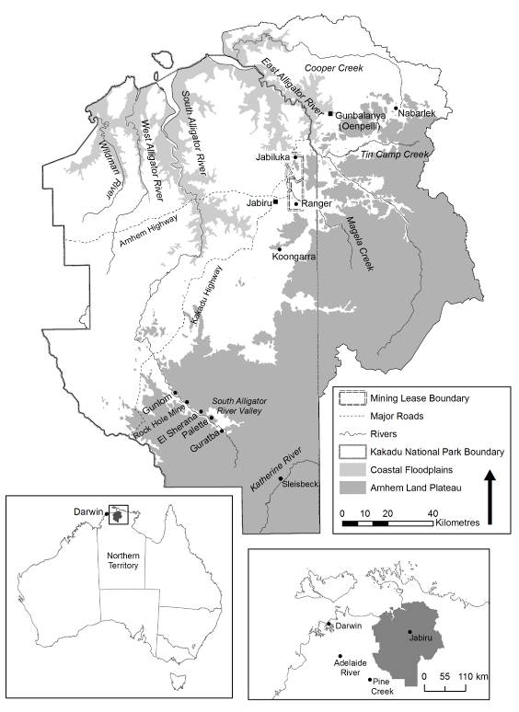

Map 1 Alligator Rivers Region

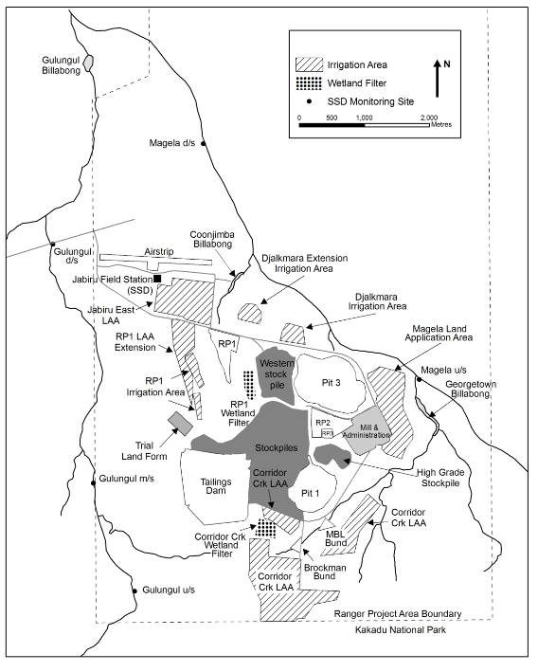
Map 2 Ranger minesite showing adjacent billabongs, creek systems
and key water quality monitoring sites

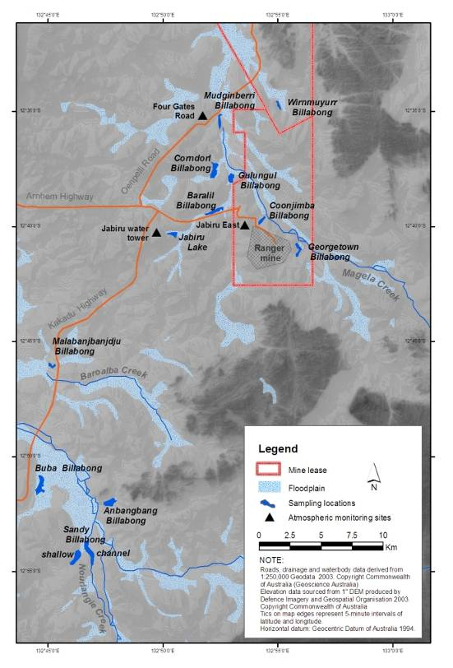
Map 3 Location of waterbodies and atmospheric monitoring sites used in the SSD environmental monitoring programs

