202
supervising scientist report



eriss research summary

2009–2010

DR Jones & AL Webb (eds)
It is SSD policy for reports in the SSR series to be reviewed as part of the publications process.
This Supervising Scientist Report is a summary of the 2009–2010 research program of the Environmental Research Institute of the Supervising Scientist and has been reviewed internally by senior staff and the editors of this volume.

Dr David R Jones – Director & Branch Head, Environmental Research Institute of the Supervising Scientist, GPO Box 461, Darwin NT 0801, Australia
Ann L Webb – Office of the Supervising Scientist, GPO Box 461, Darwin NT 0801, Australia
This report should be cited as follows:
Jones DR & Webb A (eds) 2011. eriss research summary 2009–2010. Supervising Scientist Report 202, Supervising Scientist, Darwin NT.
Example of citing a paper in this report:
Hogan A, van Dam R, Harford A, Cheng K & Costello C 2011. Effects of magnesium pulse exposures on aquatic organisms. In eriss research summary 2009–2010. eds Jones DR & Webb A, Supervising Scientist Report 202, Supervising Scientist, Darwin NT, 24–27.

The Supervising Scientist is part of the Australian Government Department of Sustainability, Environment, Water, Population and Communities

© Commonwealth of Australia 2011
Supervising Scientist
Department of Sustainability, Environment, Water, Population and Communities
GPO Box 461, Darwin NT 0801 Australia
ISSN 1325-1554
ISBN-13: 978-1-921069-14-7
This work is copyright. Apart from any use as permitted under the Copyright Act 1968, no part may be reproduced by any process without prior written permission from the Supervising Scientist. Requests and enquiries concerning reproduction and rights should be addressed to Publications Inquiries, Supervising Scientist, GPO Box 461, Darwin NT 0801.
e-mail: publications_ssd@environment.gov.au
Internet: www.environment.gov.au/ssd (www.environment.gov.au/ssd/publications)
The views and opinions expressed in this report do not necessarily reflect those of the Commonwealth of Australia. While reasonable efforts have been made to ensure that the contents of this report are factually correct, some essential data rely on references cited and/or the data and/or information of other parties, and the Supervising Scientist and the Commonwealth of Australia do not accept responsibility for the accuracy, currency or completeness of the contents of this report, and shall not be liable for any loss or damage that may be occasioned directly or indirectly through the use of, or reliance on, the report. Readers should exercise their own skill and judgment with respect to their use of the material contained in this report.
Printed and bound in Darwin by uniprint NT

Contents
Preface viii
Maps ix
PART 1: RANGER – CURRENT OPERATIONS 1
1.2 ONGOING OPERATIONAL ISSUES
KKN 1.2.1 Ecological risks via the surface water pathway
Conceptual models of contaminant pathways for operational phase of Ranger uranium mine 2
S Parker, R van Dam & R Bartolo
KKN 1.2.2 Land irrigation
Radiological characterisation of Ranger mine land application areas 6
R Akber, A Bollhöfer & P Lu
KKN 1.2.4 Ecotoxicology
Influence of dissolved organic carbon on the toxicity of aluminium to tropical freshwater biota 13
M Trenfield, J Ng, B Noller, S Markich & R van Dam
Development of a reference toxicity testing program for routine toxicity test species 18
K Cheng, R van Dam, A Hogan, A Harford, C Costello & M Trenfield
Effects of magnesium pulse exposures on aquatic organisms 24
A Hogan, R van Dam, A Harford, K Cheng & C Costello
Toxicity testing of Ranger process water permeate 28
R van Dam, A Hogan, A Harford, K Cheng & C Costello
The toxicity of uranium to sediment biota of Magela Creek backflow billabong environments 32
A Harford, R van Dam, C Humphrey, D Jones, S Simpson, J Stauber, K Gibb & C Streten-Joyce
KKN 1.3.1 Monitoring
Atmospheric radiological monitoring in the vicinity of Ranger and Jabiluka 37
A Bollhöfer, R Cahill, J Pfitzner & J Matthews
Surface water radiological monitoring in the vicinity of Ranger and Jabiluka 42
P Medley & A Bollhöfer
Results from the routine stream monitoring program in Magela Creek catchment, 2009–10 46
Introduction 47
C Humphrey, A Bollhöfer & D Jones
Water chemistry monitoring program 48
A Frostick, K Turner, K Tayler & D Jones
Toxicity monitoring in Magela Creek 56
C Humphrey, C Davies & D Buckle
Bioaccumulation of radionuclides in freshwater mussels 66
A Bollhöfer, B Ryan, C Humphrey & D Buckle
Monitoring using macroinvertebrate community structure 70
C Humphrey, L Chandler & C Camilleri
Monitoring using fish community structure 74
D Buckle, C Davies & C Humphrey
Stream monitoring program for the Magela Creek catchment: research and development 77
Introduction 78
C Humphrey, A Bollhöfer & D Jones
In situ biological monitoring in Gulungul Creek 79
C Humphrey, D Buckle & C Davies
PART 2: RANGER – REHABILITATION 81
KKN 2.2.1 Landform design
Assessing the geomorphic stability of the Ranger trial landform 82
J Lowry, TJ Coulthard, G Staben & A Beraldo
Monitoring of erosion and solute loads from the Ranger trial landform 86
M Saynor, K Turner, K Tayler & R Houghton
KKN 2.2.4 Geomorphic behaviour and evolution of the landscape
Assess the impact of extreme rainfall events on Ranger rehabilitated landform geomorphic stability using the CAESAR landscape evolution model 95
JBC Lowry, TJ Coulthard & GR Hancock
KKN 2.2.5 Radiological characteristics of the final landform
Pre-mining radiological conditions at Ranger mine 101
A Bollhöfer, A Esparon & K Pfitzner
Radon exhalation from a rehabilitated landform 107
A Bollhöfer & J Pfitzner
KKN 2.5.1 Development and agreement of closure criteria from ecosystem establishment perspective
Development of surface water quality closure criteria for Ranger billabongs using macroinvertebrate community data 112
C Humphrey, K Turner & D Jones
Effects of fine suspended sediment on billabong limnology 119
C Humphrey, D Buckle & D Jones
KKN 2.5.2 Characterisation of terrestrial and aquatic ecosystem types at analogue sites
Use of vegetation analogues to guide planning for rehabilitation of the Ranger minesite 122
C Humphrey, G Fox, G Staben & J Lowry
KKN 2.5.3 Establishment and sustainability of ecosystems on mine landform
Charles Darwin University seed biology research 125
S Bellairs & M McDowell
KKN 2.5.4 Radiation exposure pathways associated with ecosystem re-establishment
Bush food concentration ratio and ingestion dose assessment database 129
B Ryan, C Doering & A Bollhöfer
The Bushtucker database 133
D Walden
KKN 2.7.1 Ecological risk assessments of the rehabilitation and post rehabilitation phases
Remote sensing framework for environmental monitoring within the Alligator Rivers Region 136
R Bartolo, G Staben, K Pfitzner, J Lowry & A Beraldo
PART 3: JABILUKA 141
PART 4: NABARLEK 143
PART 5: GENERAL ALLIGATOR RIVERS REGION 145
5.2.1 Assessment of past mining and milling sites in the South Alligator River valley
Assessing the success of remediation works at former uranium mining and milling sites in the South Alligator River Valley 146
C Doering, B Ryan, A Bollhöfer, J Sellwood, T Fox & J Pfitzner
RESEARCH CONSULTANCIES 153
Ecotoxicological assessments of discharge waters from Cosmo Howley, Pine Creek, Tom’s Gully and Brocks Creek Project Areas 154
AJ Harford & RA van Dam
Surface water quality monitoring at the Rum Jungle minesite, 2008–09 wet season 155
DR Jones & K Turner
Characterisation of groundwater at the Rum Jungle minesite 158
B Ryan, F Bradley & A Bollhöfer
Flood inundation mapping: Daly and Mitchell river catchments 160
R Bartolo, D Ward & DR Jones
APPENDICES
Appendix 1 SSD publications and presentations for 2009–10 165
Appendix 2 ARRTC membership and functions 170
Appendix 3 ARRTC Key Knowledge Needs 2008–2010: Uranium mining in the Alligator Rivers Region 171

Preface
The Environmental Research Institute of the Supervising Scientist (eriss) is part of the Supervising Scientist Division (SSD) of the Australian Government’s Department of Sustainability, Environment, Water, Population and Communities (SEWPaC). eriss provides specialist technical advice to the Supervising Scientist on the protection of the environment and people of the Alligator Rivers Region (ARR) from the impact of uranium mining. Its major function is to conduct research into developing best practice methodologies for monitoring and assessing the impact of uranium mining on water and air (transport pathways) and soil, and on the bushfoods that are consumed by the local indigenous people. This research spans the operational, decommissioning, and post rehabilitation phases of mining.
eriss also applies its expertise to conducting research on the sustainable use and environmental protection of tropical rivers and their associated wetlands, and engaging in a limited program of contract research on the impacts of mining elsewhere in the north Australian tropics.
The balance and strategic prioritisation of work within the uranium component of eriss’s project portfolio is defined by Key Knowledge Needs (KKNs) developed by consultation between the Alligator Rivers Region Technical Committee (see ARRTC membership and function in Appendix 2), the Supervising Scientist, Energy Resources of Australia Ltd (ERA) and other stakeholders. The KKNs are reviewed periodically (approximately every three years) to ensure their currency in the context of any significant changes that may have occurred in U-mining related activities and issues in the ARR. The current revision of the KKNs will apply until the end of 2010.
Not all of the KKN research areas (Appendix 3) are able to be covered by eriss, since not all of the required disciplines are available within the Institute. To address these particular gaps, collaborative projects are conducted between eriss and researchers from other organisations, and consultants are commissioned by eriss and others to undertake specific pieces of work. For example, KKN projects related to detailed hydrogeology or tailings management on the Ranger lease are conducted and reported separately by consultants engaged by ERA. A more complete picture of the scope of research work that is conducted by all parties can be obtained by referring to the minutes that are produced for the meetings of ARRTC: www.environment.gov.au/ssd/communication/committees/arrtc/meeting.html.
This report documents research projects undertaken by eriss over the 2009–10 financial year (1.7.09 to 30.6.10). A particular focus was the consolidation of all components of the research program that underpin the acquisition and interpretation of continuous water quality monitoring data, as SSD moves towards this being its primary monitoring method for the 2010–11 wet season and beyond. A key component was continuing with the extensive ecotoxicological testwork, involving exposure of a suite of five aquatic test organisms to pulses of magnesium over periods of 4, 8 and 24 h, required to derive appropriate trigger values spanning this range of exposure durations. Other major areas of activity related to the acquisition of data from erosion plots constructed on the Ranger Trial Landform and assisting Parks Australia Operations with the final phases of radiological assessment for rehabilitation activities in the South Alligator River valley. The final phases of data analysis and reporting were also completed for projects to assess the current status of surface and groundwater at the Rum Jungle legacy site.
The uranium mining section of the research summary is structured according to the five major topic areas in the KKN framework, noting that this year there are no research papers for Jabiluka or Nabarlek.
1 Ranger – current operations
2 Ranger – rehabilitation
3 Jabiluka
4 Nabarlek
5 General Alligators Rivers Region
The Jabiluka site is in long-term care and maintenance and the current work of the Supervising Scientist is focused on maintaining a routine continuous monitoring program for flow and electrical conductivity downstream of the formerly disturbed area. The Nabarlek lease was taken over by Uranium Equities Ltd to pursue exploration activities. Environmental monitoring and assessment for this site is being conducted via Mining Management Plans submitted to the Northern Territory Government.
Three maps (following this Preface) provide the regional context for the locations that are referenced in the research papers. Map 1 shows Kakadu National Park and the locations of the Ranger mine, Jabiluka project area, the decommissioned Nabarlek mine, and the South Alligator River valley. A schematic of the Ranger minesite is provided for reference in Map 2. Map 3 shows the locations of billabongs and other waterbodies used for the aquatic ecosystem monitoring and atmospheric and research programs for assessing impacts from Ranger mine.
The final section of this report contains summaries of the non-uranium mining related external projects. Commercial-in-confidence projects have been excluded from this compilation.
For additional information, readers are referred to the annual publications list (Appendix 1) that details all of the material published, and conference and workshop papers presented by eriss staff in 2009–10.

Dr DR Jones
Director, Environmental Research Institute of the Supervising Scientist

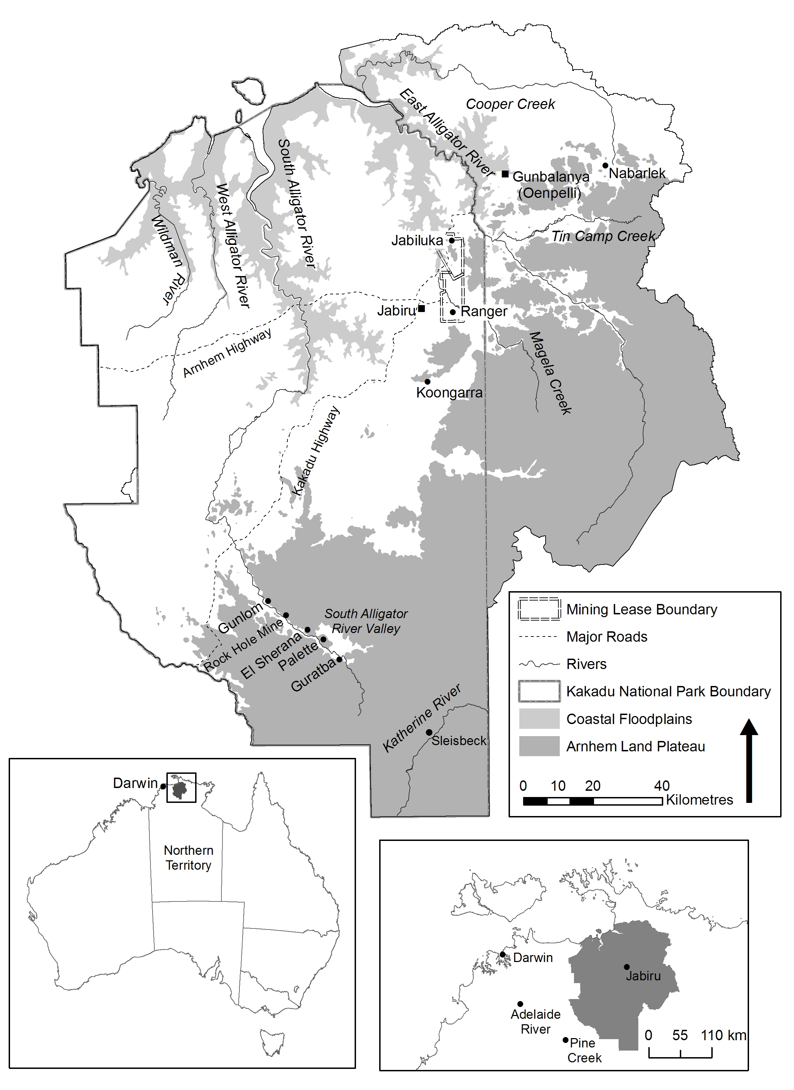

Map 1 Alligator Rivers Region

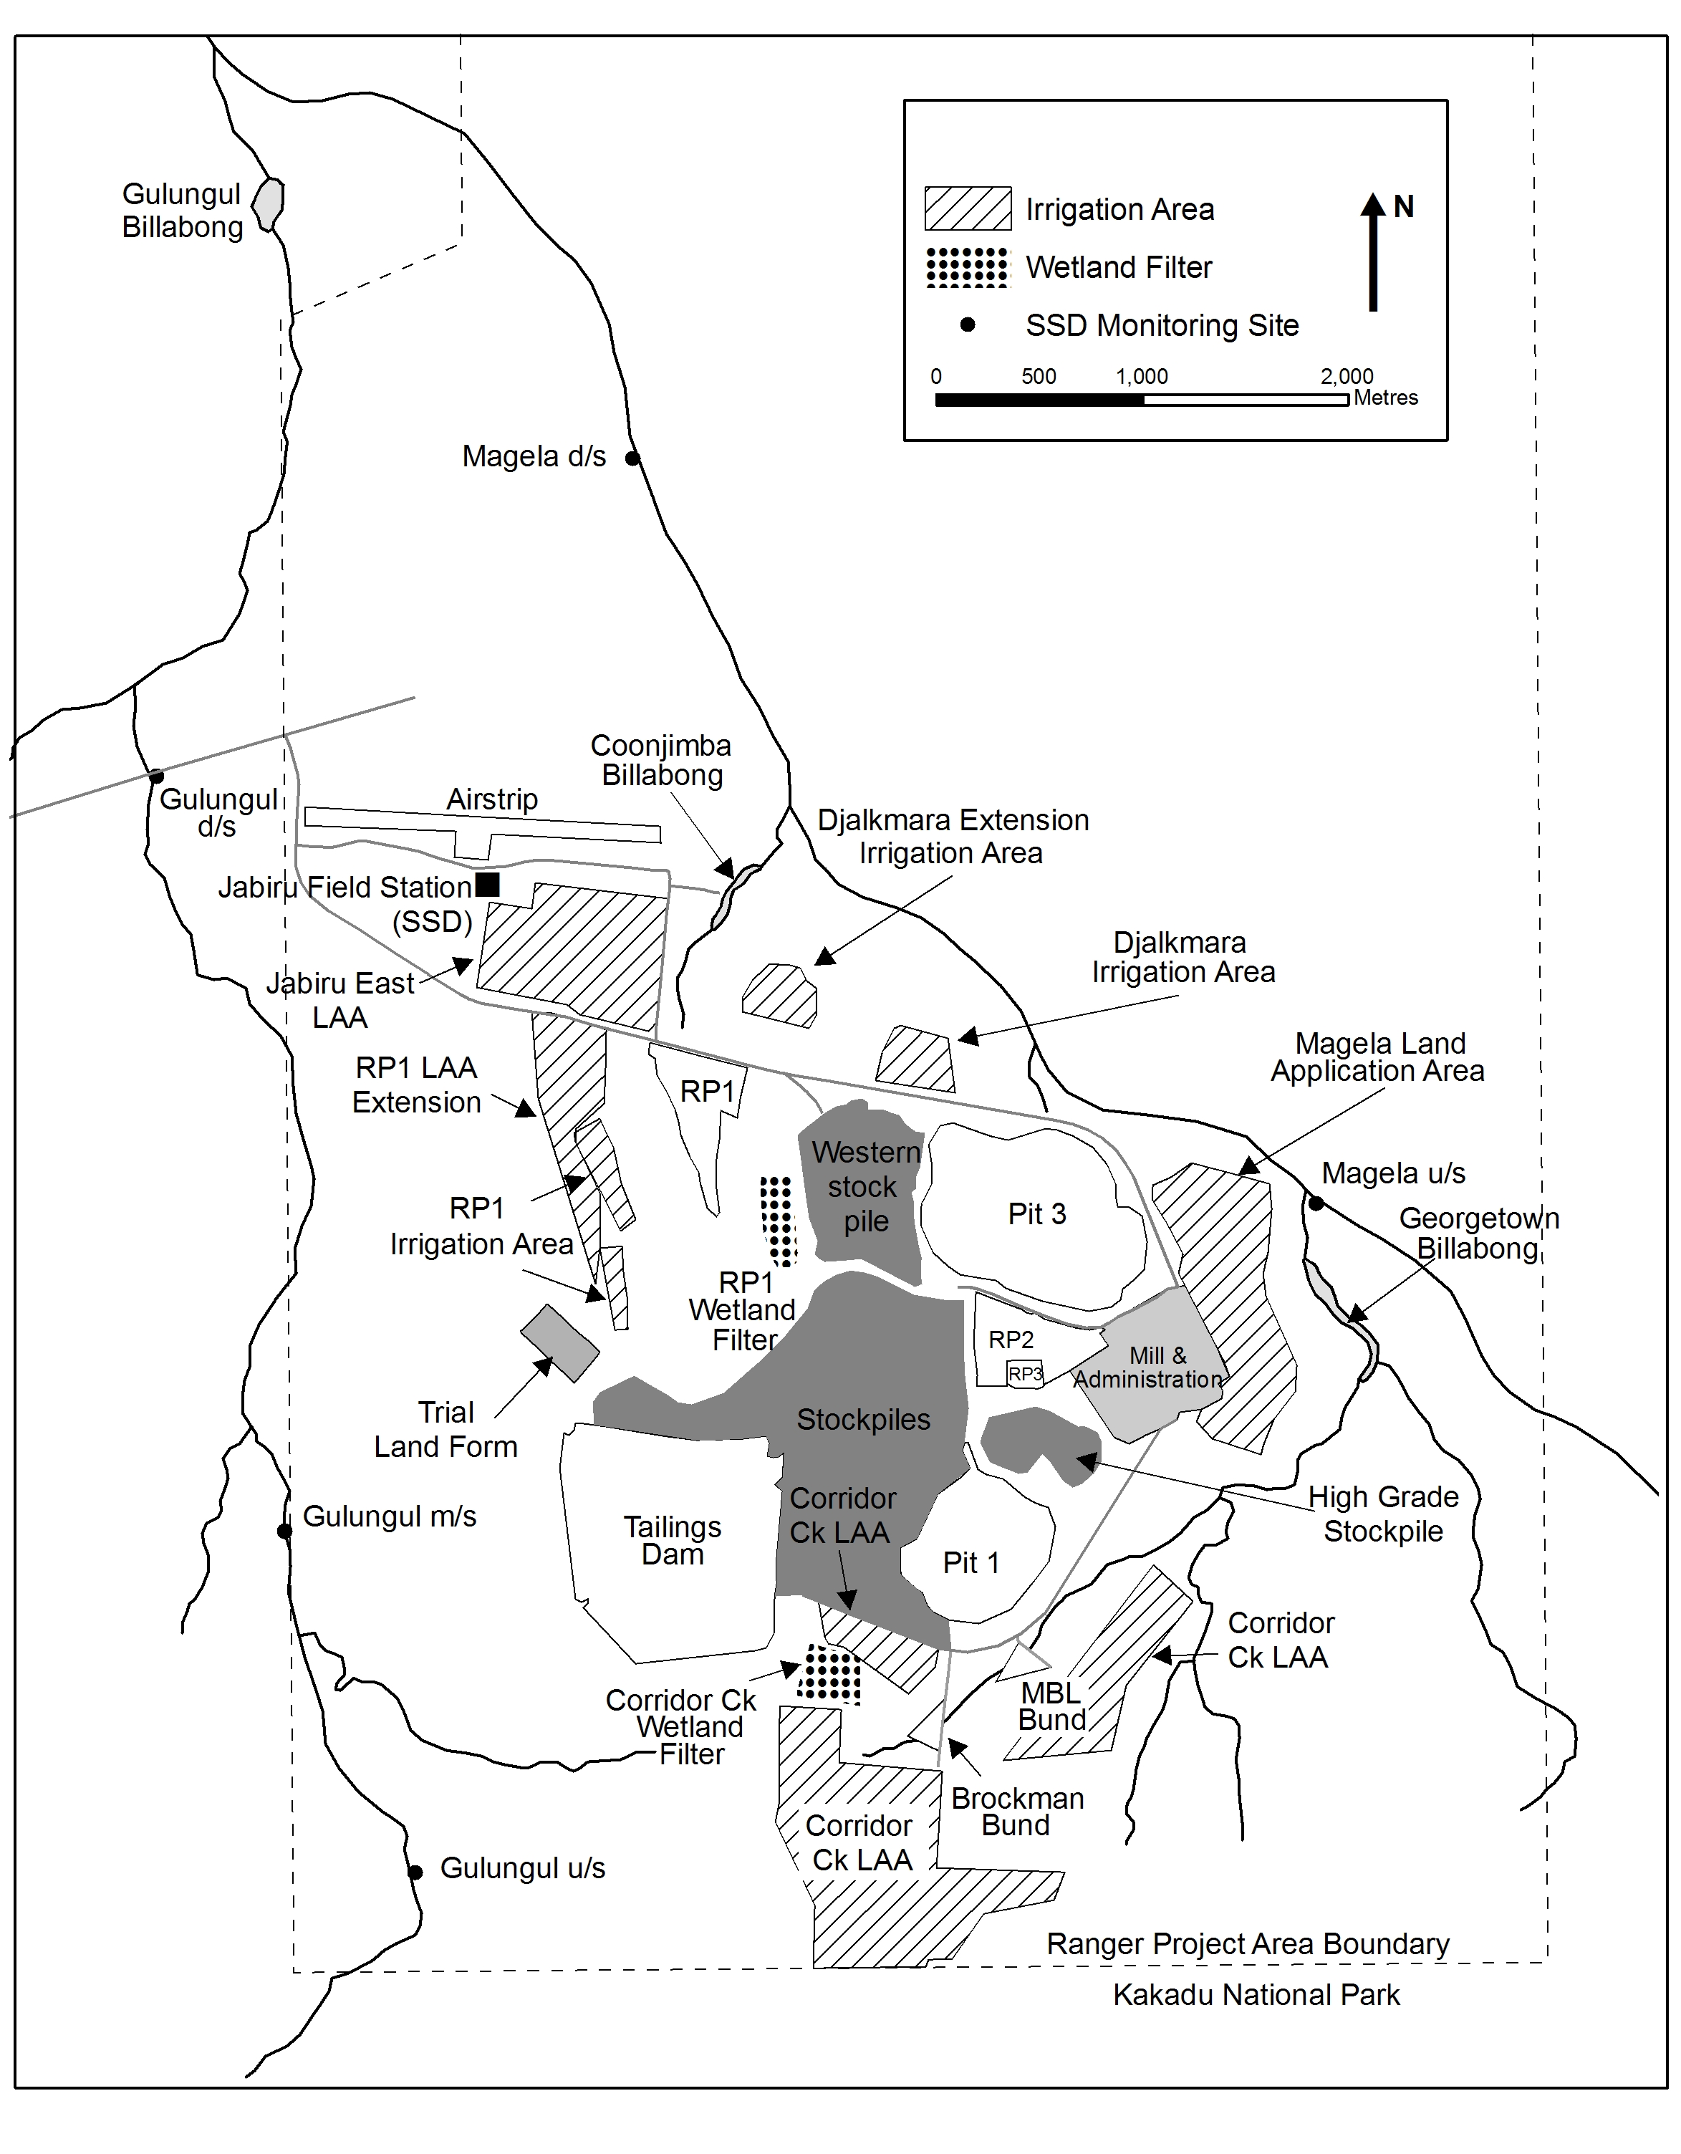
Map 2 Ranger minesite showing adjacent billabongs, creek systems
and key water quality monitoring sites

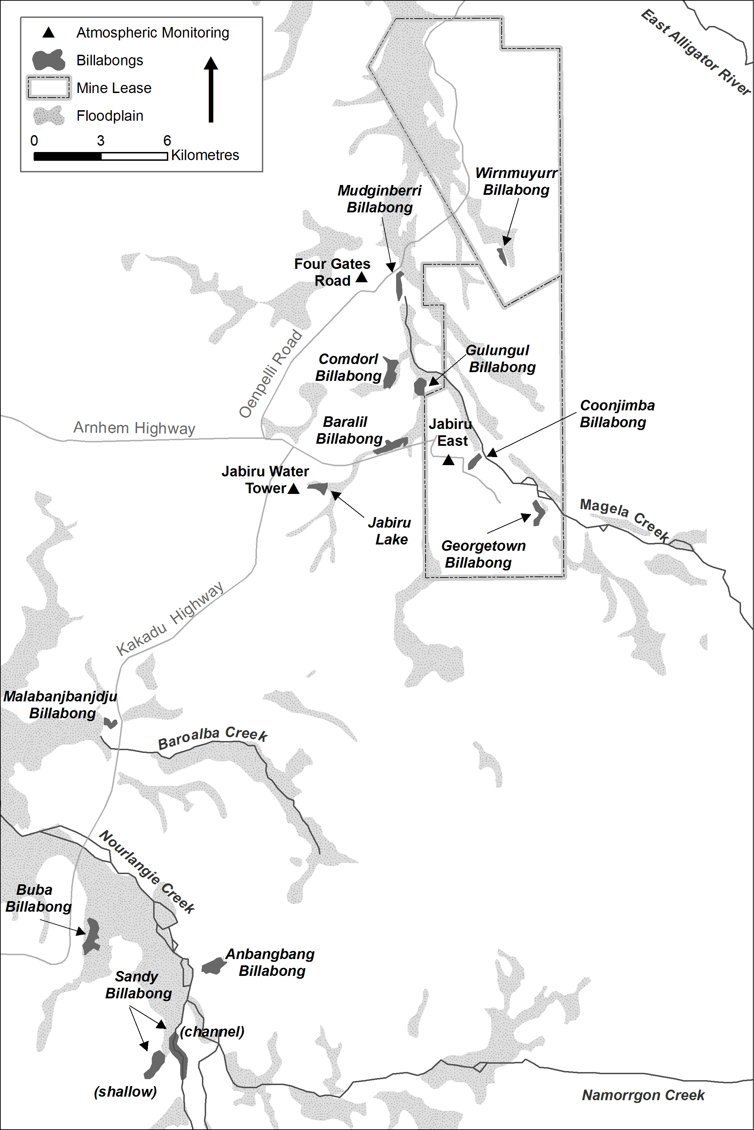
Map 3 Location of waterbodies and atmospheric monitoring sites used in the SSD environmental research and monitoring programs

