# Research consultancies

This section contains a summary of non-uranium mining related research consultancies carried out by ***eriss*** during 2010–2011. Most of these reports are commercial-in-confidence and are not available for public release.

# Ecological risk assessment for aquatic ecosystems of northern Australia

RE Bartolo

## Background

The Northern Australia Water Futures Assessment (NAWFA) is a multidisciplinary program being managed by the Environmental Water and Natural Resources Branch within SEWPaC. The objective is to provide an enduring knowledge base to inform development of northern Australia’s water resources, so that development proceeds in an ecologically, culturally and economically sustainable manner. Ecological risk assessment has been undertaken for the Ecological Program of NAWFA in collaboration with a team of researchers led by the University of Western Australia. The project is titled ‘Assesing the likely impacts of development on aquatic ecological assets in northern Australia’ and builds on the ecological risk assessments previously undertaken by ***eriss*** for the Tropical Rivers Inventory and Assessment project (TRIAP) (Bartolo et al 2008).

## Summary of work

A key challenge in conducting ecological risk assessments at the regional scale is incorporating multiple pressures/threats and their effects pathways on multiple ecological assets over large areas. Like the previous TRIAP work, we applied the Relative Risk Model (RRM) and tested the utility of this tool for ecological risk assessment for tropical rivers at two scales: northern Australia (62 risk regions) and a focus catchment, the Finniss River catchment (52 risk regions).

The results of the RRM appear to be in agreement with general knowledge of risk to catchments within northern Australia. That is, those risk regions that were ranked as higher risk concord with our knowledge of risk and general information at hand. Figure 1 shows the results of the total relative risk for the 62 risk regions (catchments) across northern Australia. The analysis showed that grazing natural vegetation is the threat with the largest relative score followed by river disturbance and sea level rise for catchments across northern Australia. Also, for northern Australia, the ecological assessment endpoint with the highest total risk is water quality to meet or exceed a specified standard. Conversely, the ecological assessment endpoint with the lowest total risk is maintenance of flow regime

The ability to output various components of the RRM as maps facilitates visual communication with stakeholders and decision makers who can readily relate to interpreting a map.

We have built upon the work undertaken for the TRIAP and extended the assessment to include the North-East Drainage Division (ie the North-East Queensland coastal catchments from Cairns to Somerset). This resulting RRM has provided a high level screening tool for prioritising areas for further research in terms of ecological risk assessment for aquatic ecosystems with a focus on development scenarios, in northern Australia.

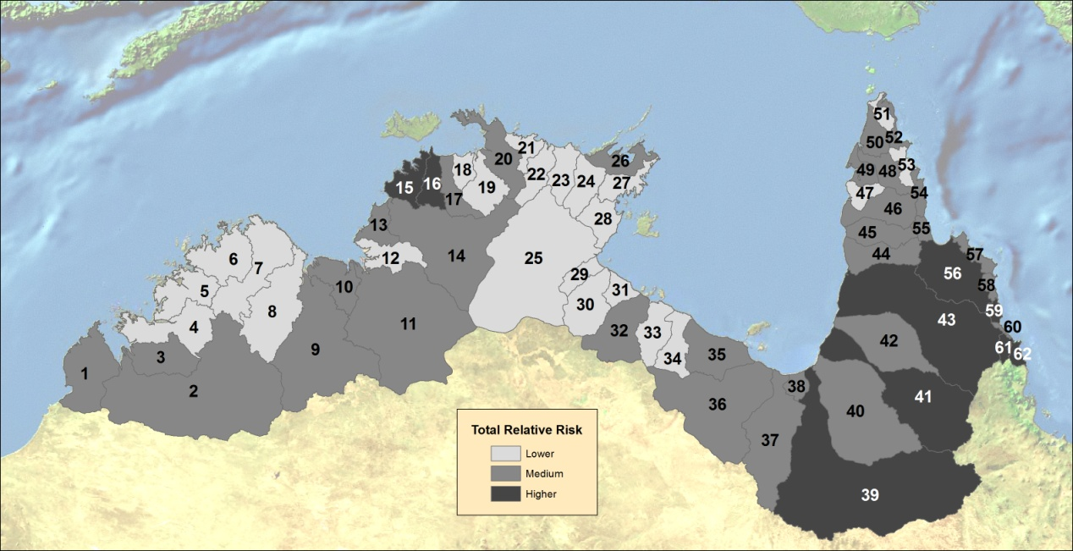Further work should be conducted on the application of filters and weights to the input pressures and threats to further refine the models and quantitative uncertainty measures should be included.

|  |  |  |  |  |  |  |  |
| --- | --- | --- | --- | --- | --- | --- | --- |
| **1** | Cape Leveque Coast | **17** | Mary River | **33** | Robinson River | **49** | Embley River |
| **2** | Fitzroy River | **18** | Wildman River | **34** | Calvert River | **50** | Ducie River |
| **3** | Lennard River | **19** | South Alligator River | **35** | Settlement Creek | **51** | Jardine River |
| **4** | Isdell River | **20** | East Alligator River | **36** | Nicholson River | **52** | Jacky Jacky Creek |
| **5** | Prince Regent River | **21** | Goomadeer River | **37** | Leichhardt River | **53** | Olive-Pascoe Rivers |
| **6** | King Edward River | **22** | Liverpool River | **38** | Morning Inlet | **54** | Lockhart River |
| **7** | Drysdale River | **23** | Blyth River | **39** | Flinders River | **55** | Stewart River |
| **8** | Pentecost River | **24** | Goyder River | **40** | Norman River | **56** | Normanby River |
| **9** | Ord River | **25** | Roper River | **41** | Gilbert River | **57** | Jeannie River |
| **10** | Keep River | **26** | Buckingham River | **42** | Staaten River | **58** | Endeavour River |
| **11** | Victoria River | **27** | Koolatong River | **43** | Mitchell River | **59** | Daintree River |
| **12** | Fitzmaurice River | **28** | Walker River | **44** | Coleman River | **60** | Mossman River |
| **13** | Moyle River | **29** | Towns River | **45** | Holroyd River | **61** | Barron River |
| **14** | Daly River | **30** | Limmen Bight River | **46** | Archer River | **62** | Mulgrave-Russell Rivers |
| **15** | Finniss River | **31** | Rosie River | **47** | Watson River |  |  |
| **16** | Adelaide River | **32** | McArthur River | **48** | Wenlock River |  |  |

**Figure 1**  Total relative risk shown as higher, medium or lower for the 62 risk regions (catchments) of northern Australia

## References

Bartolo R, Bayliss P & van Dam R 2008. *Ecological risk assessment for Australia’s northern tropical rivers. Sub-project 2 of Australia’s Tropical Rivers – an integrated data assessment and analysis (DET18)*. A report to Land & Water Australia. Environmental Research Institute of the Supervising Scientist, National Centre for Tropical Wetland Research, Darwin NT. www.environment.gov.au/ssd/tropical-rivers/triap-sp2.html.

# Assessment of the radiological exposure pathways at Rum Jungle Creek South (Rum Jungle Lake Reserve) – Batchelor

A Bollhöfer, C Doering, G Fox, J Pfitzner & P Medley

## Summary

In November 2010 eriss was commissioned by the Northern Territory Department of Resources to determine the magnitude of the radiological exposure pathways at Rum Jungle Lake Reserve, a popular recreation area near the township of Batchelor that lies on the footprint of the rehabilitated Rum Jungle Creek South (RJCS) uranium mine. The assessment was considered necessary to determine whether or not radiation risks to the public from current recreational uses of the site are acceptable in the context of international recommendations for radiation protection. The assessment forms part of the works conducted under the *National Partnership Agreement on the Management of the Former Rum Jungle Mine Site.*

Radiological conditions at the site were determined through an extensive program of environmental sampling and measurement, which included a site-wide gamma survey, measurement of radon and radon decay product concentrations in air and analysis of radionuclides in bushfoods and water. Gamma radiation levels are generally similar to those from a radiological assessment conducted by Kvasnicka et al (1992) after site rehabilitation in 1990–91. The conclusion is that there has been no general deterioration in radiological conditions at the site in the ~20 years since rehabilitation works were completed.

For people accessing the RJCS site for daytime only picnics and associated recreation activities, external gamma radiation is the primary radiological exposure pathway that needs to be addressed, contributing an above background dose of only 0.0015 mSv per day (or 0.02 mSv per year if the site was accessed 14 times per year). There is effectively no above background contribution to daytime dose from radon decay products due to the air being well mixed during the day. The ingestion dose to people picnicking is considered to be zero, as it was assumed that no bushfoods or water from the site are consumed in this scenario.

For people accessing the site for camping and food gathering activities, external gamma radiation (~0.007 mSv per day), radon decay product inhalation (~0.012 mSv per day) and bushfood ingestion (~0.03 mSv per day) are the most important radiological exposure pathways and make similar contributions to the above background dose received by a member of the public. Average annual doses above background amount to 0.65 mSv, assuming that people camp on site for 14 days. It has to be emphasised that for this scenario it has been assumed that the majority of food ingested is hunted (wallaby, pig and fish) and collected (mussels, fruit and yam) on site, rather than reliance on shop bought food.

The total annual dose to a person that accesses the site for daytime visits is not appreciably different to the annual dose that would be received by a resident of Batchelor from natural background radiation. The total annual dose to a person camping and consuming bushfoods is higher, but the above background contribution from time spent on site is typically less than 1 mSv. This is below the general reference level band of 1–20 mSv per year recommended by the International Commission on Radiological Protection for existing exposure situations (which are exposure situations that already exist when a decision on control has to be taken) (ICRP 2007). The implication is that there is no unacceptable radiation risk to people accessing the site, both for daytime picnics and for camping and food gathering activities.

## References

ICRP 2007. *The 2007 Recommendations of the International Commission on Radiological Protection*. ICRP Publication 103, Annals of the ICRP 37(2–4).

Kvasnicka J, Li C-C & Robinson R 1992. Rum Jungle Creek South abandoned uranium mine: radiation fields before, during and after the site rehabilitation. Environmental Technical Report 92/2, Mines Environment Directorate, Northern Territory Department of Mines and Energy, Darwin NT, Australia.

# 

# Ecotoxicological assessment of seepage water from Woodcutters mine

K Cheng, A Harford & R van Dam

Newmont Asia Pacific is seeking to develop site-specific Trigger Values for specific metals (eg zinc; Zn) in Woodcutters Creek as part of its closure plan for the rehabilitated Woodcutter’s mine. As part of the ANZECC Guidelines process, toxicity testing was performed on ambient waters from Woodcutters and Coomalie creeks during 2007 (2006–07 wet season recessional flow and 2007–08 early wet season) and indicated, at worst, low effects on aquatic species. However, the testing had sampling limitations and it was proposed that a further laboratory testing program, addressing the limitations, be undertaken. Consequently, another ecotoxicological assessment, conducted in September 2011 focused on the effects of higher salinity shallow seepage water entering Woodcutters Creek to five freshwater species. Previous monitoring data identified a seepage water source that was representative of the highest possible solute (especially Zn) input from the site and should be of sufficient concentration to calculate protective concentrations for receiving waters. However, concentrations of zinc (Zn) and other metals were lower than expected, which may have been due to the higher than average wet season rainfall that occurred prior to testing. Nonetheless, some effects were measurable in two species, *Hydra viridissima* and *Moinodaphnia macleayi*, which may allow for the calculation of Trigger Values based on the salinity of the seepage water. A report for this study was in preparation at the time of publication of the Annual Research Summary.

# Identifying the cause of aquatic toxicity associated with a saline mine water

S Lunn[1], R van Dam, A Harford & M Gagnon1

## Introduction

In March 2009, the toxicity of saline seepage water (electrical conductivity 2300 μS/cm) from the Savannah Nickel Mine (SNM) in the East Kimberley was assessed using five tropical freshwater species (Harford et al 2009). Two species, the cladoceran, *Moinodaphnia macleayi*, and the green alga, *Chlorella* sp, were found to be significantly adversely affected by the seepage water. Whilst it was not possible to definitively identify the chemical constituents causing the observed toxicity of the seepage water to these two species, it was hypothesised that the observed effects were due to the elevated major ion concentrations, in particular, SO4, Ca, Mg and Na resulting in an ion imbalance that leads to osmotic stress (ie a salinity effect). However, exactly which ion/s contributed to the toxicity could not be determined without further specific assessment. Such knowledge would inform water management at SNM, whilst information on major ion toxicity and salinity effects on tropical freshwater biota in general would also have broader relevance across northern Australia. Consequently, an Honours project was undertaken, supported by funding from SNM, with the key aim of identifying the cause/s of toxicity of the saline seepage water.

## Methods

The laboratory-based project focused on the two above-mentioned species, and involved several distinct stages, as follows:

i Comparison of seepage toxicity in 2011 with 2009 seepage toxicity

ii Assessment of salinity/major ions as the cause of seepage toxicity

iii Assessment of specific major ions as the cause of seepage toxicity.

Seepage from SNM was collected from the same location (Mine Creek at the toe of the water storage facility) as the seepage that was assessed in 2009. Toxicity testing focused on two methods: the 72-h *Chlorella* sp growth rate test and the 3-brood (~6-d) *M. macleayi* reproduction test. Assessment of the contribution to toxicity by the major ions was achieved by assessing the toxicity of a synthetic seepage (SS) that simulated the major ion composition and concentrations in the natural seepage (NS), and comparing the results to those for NS toxicity. Identification of specific ion/s causing toxicity was achieved by assessing the toxicity of various combinations of the major ions in the SS and, in some cases, assessing the toxicity of single salts (eg NaCl).

## Results and discussion

Overall, some differences in seepage toxicity between 2009 and 2011 were observed (ie slightly higher 2011 toxicity to *M. macleayi* and slightly lower 2011 toxicity to *Chlorella* sp). However, a sufficient effect of NS relative to the control response (ie. >25% for *Chlorella* sp, ~80% for *M. macelayi*) was observed for both species to enable the subsequent assessment of the possible cause/s of toxicity.

The toxicities of SS and NS to *M. macleayi* were statistically similar and, hence, it was concluded that the cause of toxicity of the NS was most likely due to its major ion composition/concentration. In contrast, this could not be concluded for *Chlorella* sp, with SS exhibiting little to no toxicity compared to NS. More detailed analysis of the NS chemistry identified three metals, manganese (Mn), bromide (Br) and strontium (Sr), that might have been contributing to toxicity *Chlorella* sp. However, addition of these to SS did not increase its toxicity. Consequently, the cause of toxicity of NS to *Chlorella* sp could not be identified.

The results of a further experiment to identify the major ion/s causing toxicity to *M. macleayi*, focusing on Mg, SO4 and Ca, were equivocal. There were noticeable, but non-significant, reductions in SS toxicity when Mg or Ca were excluded, suggesting the experiment should be repeated. Notwithstanding this uncertainty, the evidence to date suggests that the observed toxicity may be due to the overall conductivity/salinity of the seepage rather than its composition of ions.

The Honours thesis was submitted in November 2011. Additional experiments to further inform this issue may be undertaken.

## References

Harford A, van Dam R & Hogan A 2009. Ecotoxicological assessment of seepage water from the Savannah Nickel Mines. Commercial-in-Confidence Report for Panoramic Resources Ltd, April 2009.

1. Department of Environmental Biology, Curtin University of Technology, PO Box U1987, Perth Western Australia 6845.