**203**

*supervising scientist report*



# *eriss* research summary 2010–2011



# Editors DR Jones & A Webb

It is Supervising Scientist Division policy for reports in the SSR series to be reviewed as part of the publications process.

This Supervising Scientist Report is a summary of the 2010–2011 research program of the Environmental Research Institute of the Supervising Scientist and has been reviewed internally by senior staff and the editors of this volume.

Editors

Dr David R Jones – Director & Branch Head Environmental Research Institute of the Supervising Scientist, GPO Box 461, Darwin NT 0801, Australia.

Ann Webb – Publications manager, Supervising Scientist Division, GPO Box 461, Darwin NT 0801, Australia.

*This report should be cited as follows:*

Jones Dr & Webb A (eds) 2012.***eriss*** research summary 2010–2011. Supervising Scientist Report 203, Supervising Scientist, Darwin NT.

*Example of citing a paper in this report:*

Parker S, Bartolo RE & van Dam RA 2012. Conceptual models of contaminant transport pathways for the operational phase of the Ranger mine. In ***eriss*** research summary 2010–2011. eds Jones DR & Webb A, Supervising Scientist Report 203, Supervising Scientist, Darwin NT, 2–4.

**The Supervising Scientist is part of the Australian Government Department of Sustainability, Environment, Water, Population and Communities**

© Commonwealth of Australia 2012

Supervising Scientist  
Department of Sustainability, Environment, Water, Population and Communities  
GPO Box 461, Darwin NT 0801 Australia

**ISSN 1325-1554**

**ISBN 978-1-921069-18-5**

This work is copyright. Apart from any use as permitted under the Copyright Act 1968, no part may be reproduced by any process without prior written permission from the Supervising Scientist. Requests and enquiries concerning reproduction and rights should be addressed to Publications Inquiries, ***Supervising Scientist***, GPO Box 461, Darwin NT 0801.

e-mail: publications_ssd@environment.gov.au

Internet: www.environment.gov.au/ssd (www.environment.gov.au/ssd/publications)

The views and opinions expressed in this report do not necessarily reflect those of the Commonwealth of Australia. While reasonable efforts have been made to ensure that the contents of this report are factually correct, some essential data rely on references cited and/or the data and/or information of other parties, and the Supervising Scientist and the Commonwealth of Australia do not accept responsibility for the accuracy, currency or completeness of the contents of this report, and shall not be liable for any loss or damage that may be occasioned directly or indirectly through the use of, or reliance on, the report. Readers should exercise their own skill and judgment with respect to their use of the material contained in this report.

Printed and bound in Darwin by Uniprint NT

# 

# Contents

Preface viii

Maps ix

PART 1: RANGER – CURRENT OPERATIONS 1

1.2 ONGOING OPERATIONS ISSUES

KKN 1.2.1 Ecological risks via the surface water pathway

Conceptual models of contaminant transport pathways for the operational phase of the Ranger mine 2

S Parker, RE Bartolo & RA van Dam

KKN 1.2.2 Land irrigation

Characterisation of contamination at land application areas at Ranger (collaborative project with ERA) 5

R Akber, A Bollhöfer & P Lu

KKN 1.2.4 Ecotoxicology

Dissolved organic carbon ameliorates aluminium toxicity to three tropical freshwater organisms 10

MA Trenfield, SJ Markich, JC Ng, B Noller, & RA van Dam

Ecotoxicological assessment of distillate from a pilot brine concentrator plant 16

AJ Harford & RA van Dam

Effects of magnesium pulse exposures on aquatic organisms 22

MA Trenfield, AC Hogan, AJ Harford & RA van Dam

Development of a reference toxicity testing program for routine toxicity test species 27

KL Cheng, AJ Harford & RA van Dam

The toxicity of uranium (U) to sediment biota of Magela Creek backflow billabong environments 33

AJ Harford, RA van Dam, CL Humprey, DR Jones, S Simpson, AA Chariton, KS Gibb & JL Stauber

Towards revising the Limit for uranium in Magela Creek: standardisation of toxicity data and incorporation of the effect of dissolved organic carbon 41

RA van Dam, AJ Harford, MA Trenfield, AC Hogan, SJ Markich & JL Stauber

Toxicity of uranium to *Euglena gracilis* and the influence of DOC 48

MA Trenfield, JC Ng, B Noller, SJ Markich & RA van Dam

1.3 MONITORING

KKN 1.3.1 Surface water, groundwater, chemical, biological, sediment, radiological monitoring

Recent developments in Magela Creek solute loads 53

K Turner, DR Jones & WD Erskine

Atmospheric radioactivity monitoring in the vicinity of Ranger and Jabiluka 59

C Doering, R Cahill, J Pfitzner & A Bollhöfer

Results of the stream monitoring program in Magela Creek and Gulungul Creek catchments, 2010–11 65

C Humphrey, A Bollhöfer & D Jones

Chemical and physical monitoring of Magela Creek 67

A Frostick, K Turner, L Curtis, S Fagan, L Chandler & WD Erskine

Chemical and physical monitoring of Gulungul Creek 73

A Frostick, K Turner, L Curtis & WD Erskine

Surface water radiological monitoring in the vicinity of Ranger and Jabiluka 77

P Medley, F Evans & A Bollhöfer

Toxicity monitoring in Magela and Gulungul creeks 81

C Humphrey, C Davies, M Ellis & D Buckle

Bioaccumulation of uranium and radium in freshwater mussels from Mudginberri Billabong 85

A Bollhöfer, B Ryan, C Humphrey & T Fox

Monitoring using macroinvertebrate community structure 88

C Humphrey, L Chandler, C Camilleri & J Hanley

Monitoring using fish community structure 93

D Buckle, C Davies & C Humphrey

Ranger stream monitoring research: Further analysis of toxicity monitoring data for Magela and Gulungul creeks 96

C Humphrey, D Buckle & C Davies

PART 2: RANGER – REHABILITATION 107

2.2 LANDFORM

KKN 2.2.1 Landform design

Revegetation trial demonstration landform – erosion and chemistry studies 108

MJ Saynor, J Taylor, R Houghton, WD Erskine & D Jones

Assessing the geomorphic stability of the Ranger trial landform using landform evolution models 115

J Lowry, T Coulthard & G Hancock & D Jones

Pre-mining radiological conditions at Ranger mine 120

A Bollhöfer, A Beraldo, K Pfitzner & A Esparon

Radon exhalation from a rehabilitated landform 127

A Bollhöfer & J Pfitzner

2.5 ECOSYSTEM ESTABLISHMENT

KKN 2.5.1 Development and agreement of closure criteria from ecosystem establishment perspective

Development of surface water quality closure criteria for Ranger billabongs using macroinvertebrate community data 132

C Humphrey & D Jones

KKN 2.5.2 Use of natural analogues to guide planning for rehabilitation of the Ranger minesite

Use of vegetation analogues to guide planning for rehabilitation of the Ranger mine site 135

C Humphrey, J Lowry & G Fox

KKN 2.5.4 Radiation exposure pathways associated with ecosystem re-establishment

Estimating radionuclide transfer to bushfoods and ingestion doses to the public 146

C Doering, A Bollhöfer & B Ryan

PART 3: JABILUKA 151

3.2 RESEARCH

KKN 3.2.1 Research required prior to any development

Importance of large wood for creating aquatic habitat and stable channels in the Ngarradj Creek catchment 152

WD Erskine, MJ Saynor, G Fox & AC Chalmers

PART 4: NABARLEK 159

PART 5: GENERAL ALLIGATOR RIVERS REGION 161

5.1 LANDSCAPE SCALE ANALYSIS OF IMPACT

KKN 5.1.1 Develop a landscape-scale ecological risk assessment framework for the Magela catchment that incorporates and places into context, uranium mining activities and relevant regional landscape

Empirical line calibration of WorldView-2 satellite imagery to reflectance data: using quadratic prediction equations 162

GW Staben, K Pfitzner, RE Bartolo & A Lucieer

KKN 5.2.1 Assessment of past mining and milling sites in the South Alligator River valley

External gamma dose rates and radon exhalation flux densities at the El Sherana airstrip near-surface disposal facility 168

C Doering & A Bollhöfer

RESEARCH CONSULTANCIES 175

Ecological risk assessment for aquatic ecosystems of northern Australia 176

RE Bartolo

Assessment of the radiological exposure pathways at Rum Jungle Creek South (Rum Jungle Lake Reserve) – Batchelor 178

A Bollhöfer, C Doering, G Fox, J Pfitzner & P Medley

Ecotoxicological assessment of seepage water from Woodcutters mine 180

K Cheng, A Harford & R van Dam

Identifying the cause of aquatic toxicity associated with a saline mine water 181

S Lunn, R van Dam, A Harford & M Gagnon

APPENDICES

Appendix 1 SSD publications and presentations for 2010–11 183

Appendix 2 ARRTC membership and functions 193

Appendix 3 Alligator Rivers Region Technical Committee Key Knowledge Needs 2008–2010: Uranium mining in the Alligator Rivers Region 194

# Preface

The Environmental Research Institute of the Supervising Scientist **(*eriss***) is part of the Supervising Scientist Division (SSD) of the Australian Government’s Department of Sustainability, Environment, Water, Population and Communities (SEWPaC). ***eriss*** provides specialist technical advice to the Supervising Scientist on the protection of the environment and people of the Alligator Rivers Region (ARR) from the impact of uranium mining. Its major function is to conduct research into developing leading practice methodologies for monitoring and assessing the impact of uranium mining on water and air (transport pathways) and soil, and on the bushfoods that are consumed by the local indigenous people. This research spans the operational, decommissioning, and post rehabilitation phases of mining.

***eriss*** also applies its expertise to conducting research into the sustainable use and environmental protection of tropical rivers and their associated wetlands, and to undertaking a limited program of contract research on the impacts of mining elsewhere in the north Australian tropics.

The balance and strategic prioritisation of work within the uranium component of ***eriss***’s project portfolio are defined by Key Knowledge Needs (KKNs) developed by consultation between the Alligator Rivers Region Technical Committee (see ARRTC membership and function in Appendix 2), the Supervising Scientist, Energy Resources of Australia Ltd (ERA) and other stakeholders. The KKNs are subject to ongoing review by ARRTC to ensure their currency in the context of any significant changes that may have occurred in U-mining related activities and issues in the ARR.

Not all of the KKN research areas (Appendix 3) are able to be covered by ***eriss***, since not all of the required disciplines are available within the Institute. To address these particular gaps, collaborative projects are conducted between ***eriss*** and researchers from other organisations, and consultants are commissioned by ***eriss*** and others to undertake specific pieces of work. For example, KKN projects related to detailed hydrogeology or tailings management on the Ranger lease are conducted and reported separately by consultants engaged by ERA. A more complete picture of the scope of research work that is conducted by all parties can be obtained by referring to the minutes that are produced for the meetings of ARRTC: www.environment.gov.au/ssd/communication/committees/arrtc/meeting.html.

This report documents the monitoring, research and consulting projects undertaken by ***eriss*** over the 2010–11 financial year (1.7.10 to 30.6.11). The uranium mining section of the research summary is structured according to the five major topic areas in the KKN framework, noting that this year there are no papers for Nabarlek.

1 Ranger – current operations

2 Ranger – rehabilitation

3 Jabiluka

4 Nabarlek

5 General Alligators Rivers Region

Of especial note for the Ranger Operations KKN is that continuous monitoring, with event-triggered automatic water sampling, was successfully implemented as SSD’s primary water quality monitoring tool in Magela and Gulungul Creeks during the 2010–11 wet season. This represented the culmination of five years of research and development work, the successive stages of which have been reported in previous annual research summaries. Also of note was the completion of the majority of testwork needed to develop a pulse exposure toxicity assessment framework for magnesium in Magela Creek. This framework will enable the results being obtained from the continuous monitoring of electrical conductivity to be put into an appropriate risk context. The wet season deployment of in situ biological monitoring in Gulungul Creek has now been undertaken for a second year and a substantive data set is now starting to be obtained for this waterway.

The acquisition of data from erosion plots constructed on the Ranger Trial Landform, and analysis of that data, continue to be major activities that will provide substantial inputs into the rehabilitation planning process for the Ranger mine site. The majority of research needed to derive a pre-mining radiological baseline for the Ranger Project Area has now been completed and the outcomes are reported here. The findings will inform the radiological component of closure planning for the site. ***eriss*** has been measuring the activity concentrations of radionuclides in bushfoods and associated environmental media from the ARR over the past 30 years. This extensive data set has now been compiled into a quality assured database that will enable the estimation of radiological ingestion doses from bushfoods for those circumstances where only the radionuclide concentrations present in soil or water are known.

Jabiluka is in long-term care and maintenance and the current work of the Supervising Scientist is focused on maintaining a routine continuous monitoring program for flow and electrical conductivity downstream of the formerly disturbed area. The Nabarlek lease was taken over by Uranium Equities Ltd to pursue exploration activities. Environmental monitoring and assessment for this site is being conducted via Mining Management Plans submitted by the company to the Northern Territory Government.

Three maps (following this Preface) provide the regional context for the locations that are referenced in the research papers. Map 1 shows Kakadu National Park and the locations of the Ranger mine, Jabiluka project area, the decommissioned Nabarlek mine, and the South Alligator River valley. A schematic of the Ranger minesite is provided for reference in Map 2. Map 3 shows the locations of billabongs and other waterbodies used for the aquatic ecosystem monitoring and atmospheric and research programs for assessing impacts from Ranger mine.

The final section of this report contains summaries of the non-uranium mining related external projects. Commercial-in-confidence projects have been excluded from this compilation.

For additional information, readers are referred to the annual publications list (Appendix 1) that details all of the material published, and conference and workshop papers presented by ***eriss*** staff in 2010–11.

**Dr DR Jones**

*Director, Environmental Research Institute of the Supervising Scientist*

Note: Authors were Supervising Scientist staff at time of research and/or write-up unless otherwise stated.

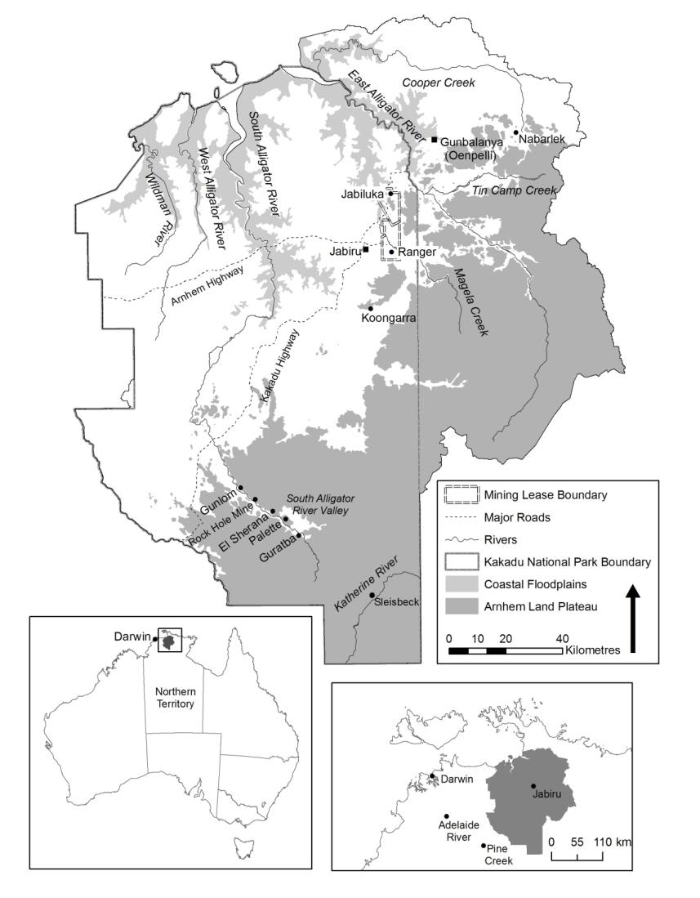

**Map 1**  Alligator Rivers Region

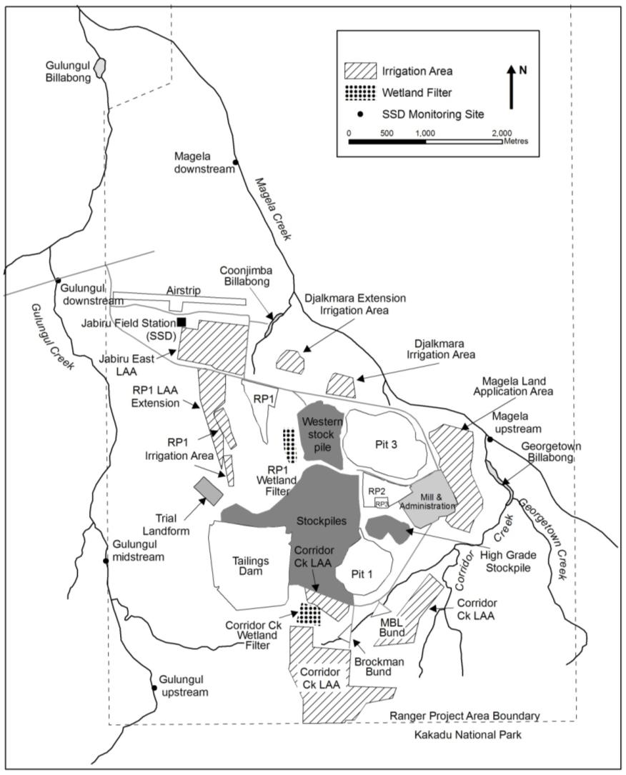

**Map 2** Ranger minesite

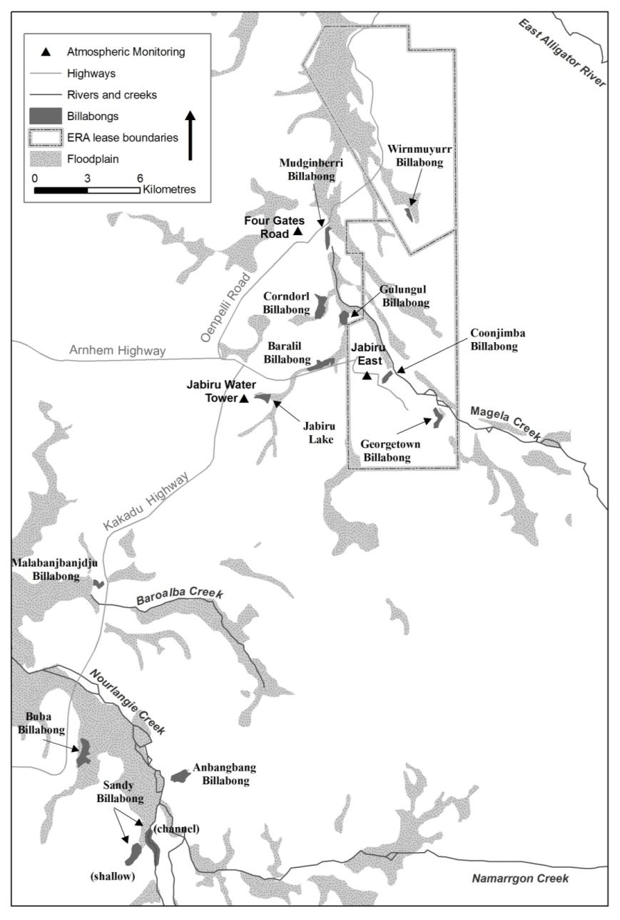

**Map 3** Sampling locations used in SSD’s research and monitoring programs