**208**

*supervising scientist report*

# River Reaches, Historical Channel Changes and Recommended Methods to Improve Macquarie Perch Habitat on Hughes Creek, Victoria

# Wayne D Erskine



It is Supervising Scientist policy for reports in the SSR series to be reviewed as part of the publications process. This Supervising Scientist Report has been formally refereed by two external independent experts.

*Author of this report:*

Dr Wayne D Erskine – Hydrological and Geomorphological Processes Group, Environmental Research Institute of the Supervising Scientist, GPO Box 461, Darwin NT 0801, Australia

*This report should be cited as follows:*

Erskine WD 2016. *River Reaches, Historical Channel Changes and Recommended Methods to Improve Macquarie Perch Habitat on Hughes Creek, Victoria,* May 2016. Supervising Scientist Report 208, Supervising Scientist, Darwin NT.

Copyright Image.tifThe Supervising Scientist is part of the Australian Government Department of the Environment

© Copyright Commonwealth of Australia, 2016.

SSR208 is licensed by the Commonwealth of Australia for use under a Creative Commons By Attribution 3.0 Australia licence with the exception of the Coat of Arms of the Commonwealth of Australia, the logo of the agency responsible for publishing the report, content supplied by third parties, and any images depicting people. For licence conditions see: http://creativecommons.org/licenses/by/3.0/au/

**1325-1554 (online)**

**ISBN-13: 978-1-921069-26-0**

**environment**.gov.au/science/supervising-scientist

The views and opinions expressed in this publication are those of the authors and do not necessarily reflect those of the Australian Government or the Minister for the Environment.

While reasonable efforts have been made to ensure that the contents of this publication are factually correct, the Commonwealth does not accept responsibility for the accuracy or completeness of the contents, and shall not be liable for any loss or damage that may be occasioned directly or indirectly through the use of, or reliance on, the contents of this publication.

# Contents

Executive summary v

Acknowledgments ix

1 Introduction 1

2 Catchment Characteristics 1

2.1 Geomorphology 1

2.2 Geology 2

2.3 Rainfall 3

2.4 Streamflow 7

2.5 2010 Flood 9

3 River Reaches 12

3.1 Mapping of River Reaches 12

3.2 River Reaches on Hughes Creek 15

3.3 Tributaries 21

4 Historical Channel Changes on Hughes Creek 35

4.1 Development of the sand slug 35

4.2 Recovery of the sand slug 46

4.3 Geomorphic impacts of the 2010 flood 48

4.4 Geomorphic model of historical channel changes on Hughes Creek 52

5 Macquarie perch 55

5.1 Taxonomy 55

5.2 Conservation Status 56

5.3 Life History 57

5.4 Distribution of Macquarie perch in Hughes Creek 59

6 Recommended River and Catchment Management Works to Improve the Macquarie perch population and Fish Habitat 62

6.1 Reduced sand supply 63

6.2 Reduced sand flux 64

6.3 Improved riparian vegetation condition 66

6.4 Increased length, area and cleanliness of gravel riffles 67

6.5 Increased number, length and depth of pools 67

6.6 Construction of pool improvement works 70

6.7 Reduced competition from alien fish species 71

6.8 Effective monitoring and species management of the Macquarie perch population in Hughes Creek 74

7 Conclusions 75

8 References 77

Appendix 1 ‘Survey of the River Goulburn from the New to the Old Crossing Place with a Tributary Hughes’s Creek on the East Side of it. Sheet No. 1. Surveyor W Pickering, State Library of Victoria Goulburn, Ovens Etc 60. 27 December 1841.’ 88

Appendix 2 ‘Survey of the River Goulburn from the New to the Old Crossing Place with a Tributary Hughes’s Creek on the East Side of it. Sheet No. 2. Surveyor W Pickering, State Library of Victoria Goulburn, Ovens Etc 15. 27 December 1841.’ 92

Appendix 3 ‘Survey of the River Goulburn from the New to the Old Crossing Place with a Tributary Hughes’s Creek on the East Side of it. Sheet No. 3. Surveyor W Pickering, State Library of Victoria Goulburn, Ovens Etc 15A. 27 December 1841.’ 96

Appendix 4 ‘Survey of the River Goulburn from the New to the Old Crossing Place with a Tributary Hughes’s Creek on the East Side of it. Sheet No. 4. Surveyor W Pickering, State Library of Victoria Goulburn, Ovens Etc 15B. 27 December 1841.’ 100

Appendix 5 ‘Survey of the Remaining Tributaries of Hughes’s Creek. Surveyor W Pickering, State Library of Victoria Goulburn, Ovens Etc 58. 19 April 1842.’ 104

Appendix 6 ‘Survey of the Remaining Tributaries of Hughes’s Creek. Surveyor W Pickering, State Library of Victoria Goulburn, Ovens Etc 59. 18 April 1842.’ 108

Appendix 7 ‘Survey of the Sydney Road between Hughes’s Creek and the Violet Ponds. Sydney Road No. 2. Surveyor W Pickering, State Library of Victoria Old Roads S3 and S4. 18 September 1843.’ 114

# 

Executive summary

The Goulburn Broken Catchment Management Authority commissioned this work to provide guidelines for improving the aquatic habitat and population of Macquarie perch in Hughes Creek, Victoria. Hughes Creek largely drains a Late Devonian granite batholith with a highly resistant metamorphic aureole. The catchment consists of a dissected plateau fronting the extensive Riverine Plain of southeastern Australia. At Avenel PO for 1900–2013, inclusive mean annual rainfall was 596.8 ± 14.5 mm (Standard Error), with a median annual rainfall of 585.6 mm. The maximum annual rainfall was 1034 mm in 1973 and the minimum was 260.2 mm in 1982. The lowest annual rainfall during the Millenium drought was 288.1 mm (2006) but there were two runs, one of three years and the other of four years (1997–1999 and 2006–2009 respectively) when annual rainfall did not exceed the long-term mean. Monthly rainfall at Avenel PO was lowest in February progressively increased until July and then progressively declined until February. A major flood occurred throughout northern Victoria in early September 2010. In the Hughes Creek catchment peak rainfall occurred on 4 September 2010 when the maximum 48 hour rainfall at Temagog (Caveat) was 73 mm. The maximum recorded gauge height at the Tarcombe Road gauge was 4.41 m which was higher than the maximum gauging. The estimated peak flow was 35800 ML/d (414.4 m3/s). The estimated average recurrence interval for the flood peak was about 30 years on the annual maximum series.

River reach analysis was used to classify Hughes Creek into eleven geomorphologically homogeneous river reaches for which the main biogeomorphic processes were outlined. In addition, the eight main tributaries (Woolshed, Boundary, Stewart, County, Ponkeen, Buckland, Discovery and Bunding creeks) were considered but the available aerial photography was only adequate to classify river reaches for four tributaries (Stewart, County, Ponkeen and Bunding creeks). However, the ecological significance of geomorphic reaches still remains to be demonstrated. The sand slug on lower Hughes Creek had formed by 1928 when the channel flowed through all six arches of the stone bridge on the former Hume Highway at Avenel. A large flood in 1916 was the most probable cause of the sand slug combined with the interaction and synchronization of a number of activities associated with European settlement that led to extensive channel incision and gullying that generated the large volumes of sand that created the sand slug. By 1970, Hughes Creek had started to contract and vegetation had colonized the higher parts of the former bed. The rate of contraction accelerated after 1973.

The September 2010 flood produced no detectable channel changes based on before and after vertical aerial photography in the upstream Reaches 8, 9, 10 and 11. Only minor channel changes were documented in Reaches 1, 2, 6 and 7. However, significant channel changes were found in the contiguous Reaches 3, 4 and 5, where Macquarie perch are present. The flood deposits were derived by reworking of channel sand storages within these three reaches. This important conclusion indicates that the catchment was disconnected from the main channel as a sand source during the September 2010 flood and so the completed Landcare and farm management works carried out to date have been highly successful. Channel recovery from the impacts of the September 2010 flood in Reaches 3, 4 and 5 are now well advanced.

Schematics of changes in river bed longitudinal profiles of Hughes Creek in Reaches 2, 3, 4 and 5 and major tributaries, except Buckland and Bunding creeks, since 1800 and channel and floodplain cross sections for the same reaches and tributaries for the same time period were constructed. Low order channels exhibited swampy reaches with percolines and chain of ponds at the time of first settlement. The tributaries eroded at different times but most had undergone at least one phase of incision by 1970. Following initial incision, the tributaries stored substantial amounts of sand in the channel for a short time period after which the sand was reworked and removed. Where riparian revegetation and fencing have been completed colonisation by rhizomatous emergent macrophytes has occurred and chain of ponds have recently reformed. Where no riparian fencing and revegetation have been completed, the sand has been totally removed and the formerly incised channel has started to recover slowly by revegetation. Hughes Creek was characterised by pools, runs, riffles and bars at the time of first settlement. The 1916 flood marked the erosional finale of the post-settlement phase of erosion on Hughes Creek, which produced an extensive sand slug in Reach 2 but with sand aggraded sections further upstream also. A reduction in sand input after 1970 resulted in reworking of sand in the bed with progressive bed degradation which also contracted the channel. Rhizomatous emergent macrophytes colonised and stabilised the channel margins and hastened the rate of contraction. There is currently a decoupling of the catchment from the channel network in terms of sand sources because of the extensive Landcare and farm management activities that have been completed over the last 35 years. There is still a large amount of sand stored in the channel which has impacted on the quality of aquatic habitat to support Macquarie perch.

Morphometrics, meristics, allozymes and genetics (mtDNA) demonstrate that there are (were?) three species of Macquarie perch, one in the Kangaroo River, possibly extinct, another in the Hawkesbury-Nepean system and a third in the Murray-Darling system. The status of the Georges River population is currently unknown but could be a fourth species. Macquarie perch in Hughes Creek belong to the Murray-Darling species. This species is listed throughout Australia as endangered. Macquarie perch is an obligate riverine spawner (rock and gravel spawners with benthic larvae) that seems susceptible to drought and water quality impacts on recruitment success. The conditions required for the spawning of wild Macquarie perch in the rivers flowing into Eildon Reservoir included:

1. A substrate of small boulders, pebbles and gravels;
2. Water depths of 0.2–0.9 m but usually 0.4–0.6 m;
3. A flow velocity of 0.3–0.6 m/s;
4. A pool, usually 15–30 m long and greater than 1.5 m deep, immediately upstream of the spawning site;
5. Fast-flowing broken water immediately downstream of the spawning site; and
6. Water temperatures of at least 16.5°C.

Detailed fish surveys by Arthur Rylah Institute for Environmental Research found Macquarie perch in Hughes Creek in the upstream section of Reach 2 and Reaches 3, 4 and 5. However, their abundance has varied greatly since 2007 because of the Millenium drought and the September 2010 flood, and consequent impacts on water and habitat quality. Recruitment of Macquarie perch is temporally variable due to sand deposition on spawning riffles and sand infilling of refuge pools. Predation, competition and transmission of the epizootic haematopoietic necrosis virus (EHN) by the alien Redfin perch (*Perca fluviatilis*) are also major causes of the decline in Macquarie perch in Hughes Creek. For this reason, control of Redfin perch and other alien fish species is recommended.

The purpose of the recommended works on Hughes Creek is to:

* Increase population size of Macquarie perch in Hughes Creek,
* Extend the range of Macquarie perch in Hughes Creek,
* Increase connectivity for Macquarie perch between patches of suitable habitat on Hughes Creek for all life cycle stages,
* Improve aquatic habitat for Macquarie perch, and
* Improve spawning areas for Macquarie perch.

The highest priority works are reduced sand flux and improved riparian vegetation in reaches 3, 4 and 5 of Hughes Creek. These strategies, in turn, if complemented by pool improvement works will improve the number, length and quality of gravel riffles as well as the number of pools and the depth and cover of existing remnant refuge pools. Interactions with alien fish species, especially Carp, English perch and Mosquito fish should also be reduced by periodic eradication measures.

To improve the Macquarie perch population and aquatic habitat in Hughes Creek it is necessary to address, to varying degrees, all of the following issues in the identified reaches:

1. Reduced sand supply from the catchment to Hughes Creek (catchment issue) by maintaining more than 70% ground cover on pastures to further disconnect the catchment from the channel network as a sand source.
2. Reduced sand flux by Hughes Creek in Reaches 2, 3, 4 and 5 to allow pool scour and clean open framework gravel riffle development.
3. Improved riparian vegetation condition and density on Hughes Creek in Reaches 2, 3, 4 and 5, and on formerly incised tributaries to stabilise remaining sand stores.
4. Increased length of gravel riffles in Reaches 3, 4 and 5 to improve Macquarie perch spawning areas.
5. Increased number, length and depth of pools in Reaches 3, 4 and 5 to improve Macquarie perch refuges.
6. Construction of pool improvement works in Reaches 3, 4 and 5 to improve existing Macquarie perch refuges.
7. Reduced predation, competition and interaction with alien fish species downstream of Reach 6. The essence of this recommendation is the reduction of alien fish populations, especially Carp, Redfin perch and Mosquito fish. Goldfish populations should also be reduced.
8. Effective monitoring and species management of the Macquarie perch population in Hughes Creek in Reaches 2, 3, 4 and 5 to determine temporal dynamics.

Reach 4 is the best Macquarie perch aquatic habitat and is the most closely bedrock confined reach, except for the two granite gorges at Dropmore. Reach 4 also has poor access which restricts amateur fishing. Consideration should be given to prohibiting fishing in Reach 4, similar to that on Seven Creeks downstream of Gooram Falls. The two adjoining reaches, Reaches 3 and 5, although of poorer quality, are connected to Reach 4 and are important for increasing the distribution of Macquarie perch in Hughes Creek.

# Acknowledgments

For their assistance and generous donation of time to share their knowledge of Hughes Creek and other rivers in the Strathbogies, and Macquarie perch, I thank Mark Turner, Emeritus Professor Sam Lake, Sandy McKenzie, Christine Glassford, Janet Hagen,   
Dr Paul Reich, Jarod Lyon, Dr Keith Bishop, Dr Mark Lintermans, Lynj James and Joanne Kearns. The State Library of Victoria provided important historical maps, James Boyden drafted maps, Dr Mike (Mouse) Saynor assisted with photos and Ms Yongping Ji helped with field work. This work was funded by the State Government of Victoria under the ECL3 program. I thank the late Wayne Tennant, Mark Turner, Dr Rick van Dam, Dr Craig Boys, Dr Dean Gilligan and Jo Kearns for their constructive comments on draft manuscripts. I thank Dr John Tilleard for supplying copies of the top two photos of Figure 44.

# 1 Introduction

The continued presence of the Perchichthyid Macquarie perch (*Macquaria australasica* Cuvier) in Hughes Creek upstream of Avenel (Figure 1), especially after the millennium drought of the 1990–2000s, is a significant management issue for the Goulburn Broken Catchment Management Authority (CMA). Macquarie perch is an endangered species and has persisted in Hughes Creek (Cadwallader 1981, Trueman & Luker 1992, Trueman 2012) despite the formation of a sand slug after European settlement (Erskine 1993a). However, the Hughes Creek population seems to be in decline possibly because of recent new deposits of sand (Kearns et al. 2012). Translocated specimens of Macquarie perch have also been introduced to the remnant native population in Hughes Creek from the Goulburn River (Cadwallader 1981) as in the nearby Seven and Faithfull Creeks further to the north (Cadwallader 1979, 1981).

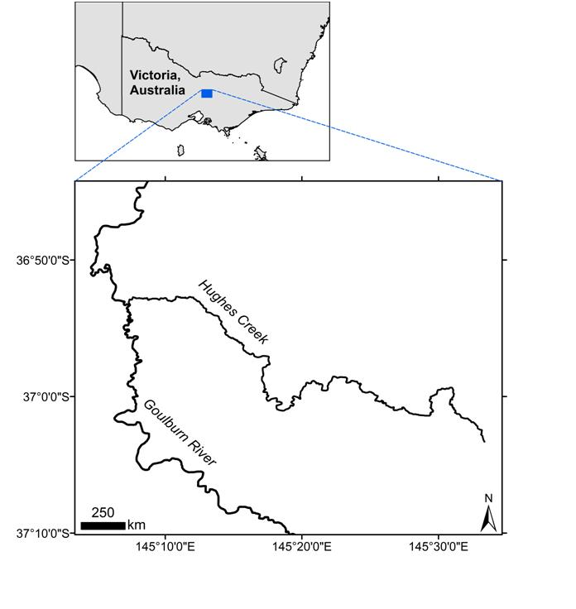

Gauging

Station

**Figure 1** Hughes Creek, a tributary of the Goulburn River in central Victoria.

Thirty-two individuals of Macquarie perch from Hughes Creek were temporarily relocated to aquaculture facilities at Snobs Creek in 2009 because of stress due to low streamflows at the end of the Millenium drought (Kearns & Lyon 2010). They were reintroduced into Hughes Creek on 16 Decenber 2009 when water quality and streamflows improved, and when alien fish species had been reduced in abundance (Kearns & Lyon 2010). However, the returned fish then experienced the 2010 flood. This demonstrates the significance of the Hughes Creek population of Macquarie perch and reinforces why the current work was commissioned by the Goulburn-Broken Catchment Management Authority. The endangered Trout cod (*Maccullochella macquarensis* Cuvier) was also abundant in Hughes Creek up to the 1920s (Trueman & Luker 1992, Trueman 2012).

The purpose of this report is to determine the current morphologic state of Hughes Creek, its pathway or trajectory to recovery from historical sand aggradation and recommended management actions to maintain and improve the aquatic habitat and population of Macquarie perch.

The following issues are addressed in the remainder of this report:

1. Review of the findings of Erskine et al. (1993) and an update of the results to 2014.
2. Briefly describe the current channel morphology, biogeomorphic processes and management issues in relation to the population of Macquarie perch.
3. Propose management actions that accelerate recovery from sanding so as to maintain existing Macquarie perch strongholds and eventually reconnect Hughes Creek to the Goulburn River.
4. Evaluate channel changes and sedimentation induced by a 1 in 30 year ARI flood in September 2010 from before and after flood air photographs, and
5. Use the improved geomorphic understanding of Hughes Creek to formulate management actions for trial by fish ecologists and river and catchment managers.

This report presents the results on all these issues as well as some additional contextual information to help understand the following information.

Catchment characteristics are discussed in Section 2 along with background information on geomorphology, geology, rainfall, streamflow and the 2010 flood. Geomorphologically homogeneous river reaches are then mapped and classified on Hughes Creek and the main tributaries, and the dominant biogeomorphic processes producing the current river morphology are outlined. Historical channel changes on Hughes Creek and the major tributaries are then discussed in detail, including the timing of sand slug development, recovery of the sand slug and the geomorphic impact of the September 2010 flood. This information is used to construct a conceptual model of historical channel behaviour. Important background information on Macquarie perch is then outlined including taxonomy, conservation status, life history and distribution in Hughes Creek. Finally recommended river management works and strategies to improve Macquarie perch habitat are proposed for discussion by the Goulburn Broken Catchment Management Authority with fish ecologists and other stakeholders. All locations used in this report refer to the formally named river reaches on Hughes Creek and some of the tributaries in Section 3.

# 2 Catchment Characteristics

The purpose of this section is to present some important information on the geomorphology, geology, rainfall, streamflow and the impact of the 2010 flood on Hughes Creek so that the context of much of the information presented below in subsequent sections is understood.

## 2.1 Geomorphology

The Hughes Creek catchment consists of a high upland which Phillips & Clemens (2013) called the *Highlands plateau*. This plateau is part of the Strathbogie batholith and is deeply dissected by Hughes Creek downstream of Highlands. The Hughes Creek valley narrows appreciably where it flows through the resistant hornfels of the metamorphic aureole surrounding the granite batholith. Hughes Creek again flows back through granite downstream of the metamorphic aureole before debouching onto the *Riverine Plain* just downstream of Avenel (Figure 2). The Riverine Plain is an extensive area of floodplains, abandoned floodplains and coalescing alluvial fans on the upper Murray River and its major tributaries in NSW and Victoria (Butler 1950, Butler et al. 1974)(Figure 2).

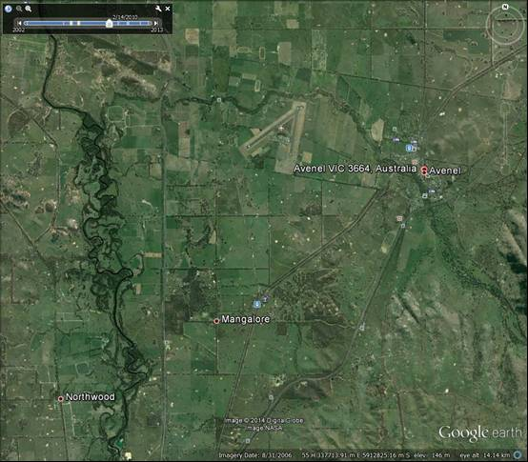

HIGHLANDS PLATEAU

RIVERINE PLAIN

GOULBURN RIVER

HUGHES CREEK

**Figure 2** Riverine Plain on lower Hughes Creek.

## 2.2 Geology

The Hughes Creek catchment largely drains a pluton or batholith of Late Devonian Strathbogie Granite (Summers 1914, Edwards et al. 2001, Phillips & Clemens 2013) which is a holocrystalline rock ranging from fine to coarse grained (Edwards et al. 2001). The granite body consists of a fine grained, cordierite-rich rock, a medium grained granite, and a coarse grained tourmaline-rich rock (Edwards et al. 2001, Phillips & Clemens 2013). Hughes Creek drains what Phillips & Clemens (2013) call the Highlands plateau. The Strathbogie Granite has yielded Rb/Sr ages (Rubidium/Strontium radiometric dating) of 365.3 Ma and 365.6 Ma (Richards & Singleton 1981) and has been dated at 374 ± 2 Ma using SHRIMP U-Pb analyses (SHRIMP Uranium Thorium Lead dating) of zircons (Bierlein et al. 2001). Sand forming the sand slug on Hughes Creek was sourced from Strathbogie Granite, its weathering products and alluvium. The granite has intruded the Wilson Creek Shale and Walhalla Group (Edwards et al. 2001). These sediments are variably contact metamorphosed for up to 4 km from the granite (metamorphic aureole). According to Edwards et al. (2001), close to the granite, pelitic rocks have been altered to black massive and hard cordierite hornfels, and psammitic rocks to intensely spotted cordierite hornfels. Figure 3 shows the metamorphic aureole on Hughes Creek Road near the Bucklands Creek junction.

The lower Hughes Creek catchment from just downstream of Avenel to the Goulburn River consists of contemporary and abandoned floodplains and coalescing alluvial fans of the Riverine Plain. The fluviatile units of the upper Riverine Plain are Holocene and Pleistocene in age (Bowler 1986, Page et al. 1996).

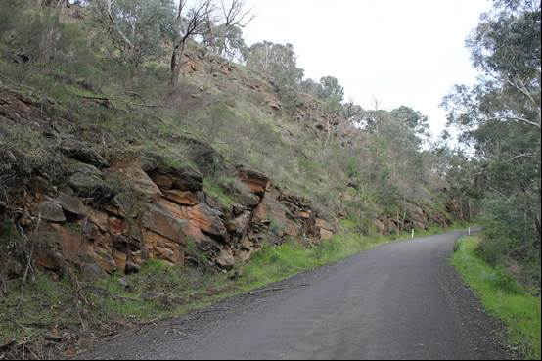

**Figure 3** Metamorphic aureole surrounding the Strathbogie pluton on Hughes Creek Road near the Bucklands Creek junction with Hughes Creek.

## 2.3 Rainfall

The Bureau of Meteorology’s rainfall data base was interrogated for long-term rainfall stations located within or near the Hughes Creek catchment. Avenel PO (Station No. 88002) had the longest record (1900–2014) for any station located within the catchment. Missing monthly values were estimated by regression with the neighbouring Seymour Depot station (No. 88053). A complete record was produced for Avenel PO for 1900–2013. All regressions were highly significant (ρ < 0.01) and selected examples are included in Figure 4.

|  |  |
| --- | --- |
|  |  |
|  |  |

**Figure 4** Examples of the regressions used to infill missing monthly rainfall at Avenel PO from   
Seymour Depot.

For 1900–2013, inclusive mean annual rainfall at Avenel PO was 596.8 ± 14.5 mm (Standard Error - SE), with a median annual rainfall of 585.6 mm. Close correspondence between mean and median annual rainfall indicates that annual rainfall is not significantly skewed. The maximum annual rainfall was 1034 mm in 1973 and the minimum was 260.2 mm in 1982. The lowest annual rainfall during the Millenium drought was 288.1 mm (2006) but there were two runs, one of three years and the other of four years (1997–1999, 2006–2009) when annual rainfall did not exceed the long-term mean.

### 2.3.1 Seasonal rainfall

For 1900–2013, inclusive mean and median monthly rainfall were lowest in February when mean monthly rainfall was 35.3 ± 3.7 mm (SE) and median monthly rainfall was 23.3 mm. Monthly rainfall then progressively increased until July when it peaked at a mean of 64.2 ± 2.8 mm (SE) and a median of 60.8 mm. Monthly rainfall then progressively declined until February. This seasonal Mediterranean rainfall trend is shown in Figure 5. Clearly there is a winter rainfall peak and a late summer minima in rainfall. Temperature varies inversely with rainfall.

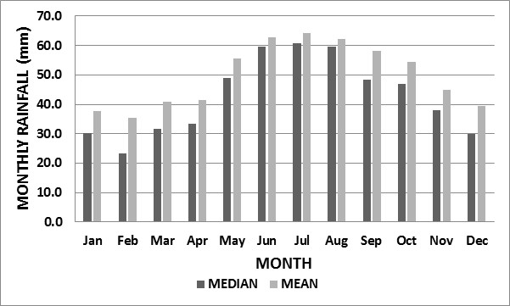

**Figure 5** Distribution of median and mean monthly rainfall at Avenel PO for 1900–2013.

### 2.3.2 Temporal variations in annual rainfall

Annual rainfall in southeastern Australia has been variable exhibiting systematic changes since at least the 1880s (Deacon 1953, Kraus 1958, 1963, Gentilli 1971, Pittock 1975, Russell 1981, Nichols & Lavery 1992, Kiem et al. 2003, Verdon et al. 2004). A cusum plot of annual rainfall is shown in Figure 6 for Avenel PO for 1900–2013 and indicates that the Avenel PO record has been possibly non-homogeneous. This means that the mean and variance have proably changed over time and is investigated below.

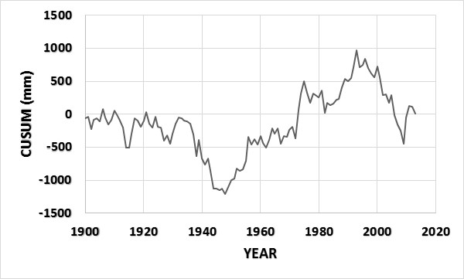

**Figure 6** CUSUM plot of annual rainfall at Avenel PO for 1900–2013.

To identify and analyse for temporal changes in the rainfall data, the following steps were undertaken (Helsel & Hirsch 1992, Kampata et al. 2008, Erskine & Townley-Jones 2009):

(i) Intervention analysis (CUSUM),

(ii) Step change analysis (Kruskal-Wallis test), and

(iii) Detailed comparison of time periods (Wilcoxon Rank Sum test).

Intervention analysis was carried out using the Cumulative sum technique (Page 1957, McGilchrist & Woodyer 1975) to detect changes in mean value of a sequence of ordered time observations. CUSUMS exhibit a positive slope when annual rainfall increases, a negative slope when annual rainfall decreases and a zero slope when annual rainfall oscillates about a constant value. From plotting CUSUMS, six changes were identified during the total time period, with the year of change (maxima or minima CUSUM) being *i1* = 1932, *i2* = 1948, *i3* = 1975, *i4*= 1982, *i5* = 1993 and *i6* = 2009.

A Kruskal-Wallis test was the non-parametric test used to determine differences in median for three or more subsets of data representing different interventions. To compute the test, data is ranked from smallest (1) to largest (N). Ranks are then used to compute the test statistic. If the null hypothesis is correct, the average rank for each group should be similar. If the alternative hypothesis is true, the average ranks for some of the groups would be dissimilar. The test statistic *H* follows a chi-square distribution with *k-1* degrees of freedom. Groups were defined as *k = 1* (data 1900–1932); *k = 2* (1933–1948), *k = 3* (1949–1975), *k = 4* (1976–1982), *k = 5* (1983–1993) and *k = 6* (1994–2009). Period 6 corresponds to the Millenium drought. The results of the Kruskal-Wallis test showed that average ranks for most groups were significantly different but did not show which groups were different.

The Wilcoxon Rank Sum test or Mann Whitney test is one of the most powerful of the non-parametric tests and was used to determine if annual rainfall for each time period belongs to the same distribution. Ranks are used to calculate the test statistic. The null hypothesis is that no change has occurred in rainfall distributions between the various time periods or that the samples come from the same population. The null hypothesis is rejected if the p-value is less than 5%. The complete annual rainfall record at Avenel PO is analysed independently of ENSO/IPO so that spurious associations are not found in the data.

Median annual rainfall at Avenel PO was essentially constant beween 1900 and 1932 but decreased between 1933 and 1948 although the decrease was non-significant (581.8 v 562.0 mm). Median annual rainfall then increased significantly after 1948 (562.0 v 677.2 mm) before decreasing again (677.2 v 556.2 mm) although the short record length meant that the decrease was non-significant. Median annual rainfall then increased significantly (556.4 v 659.7 mm) before decreasing significantly (659.7 v 484.9 mm). It was this last low rainfall period (1994–2009) that caused much concern for primary producers in southeastern Australia (the Millennium drought). While the Millenium drought was the driest since records started at Avenel PO in 1900 it was consistent with alternating decadal to multi-decadal wet and dry periods since rainfall records began (Erskine et al. 2011)(Figure 6). The effect of these alternating wet and dry periods on streamflow is investigated below.

Then the individual dry and wet periods were compared by the Mann Whitney test following Erskine et al. (2011). Each dry period (1933–1948, 1976–1982, 1994–2009) and wet period (1949–1975, 1983–1993) were not significantly different. Each wet period was significantly different to each dry period, except for the short dry period of 1976–1982. This lends weight to the finding that annual rainfall in south-eastern Australia has generally oscillated around two decadal to multi-decadal states of wet and dry (Erskine & Townley-Jones 2009, Erskine et al. 2011).

### 2.3.3 Spatial variations in annual rainfall

To determine spatial variations in annual rainfall over the Hughes Creek catchment the Bureau of Meteorology rainfall data base was again interrogated. It is essential to determine orographic (elevation) effects on rainfall, especially over the Strathbogie granite massif because it is the most significant landform in the area. Furthermore, the long-term Avenel PO station is located on the Riverine Plain and its record is not representative of the high elevation parts of the catchment. Only one rain gauge in the upper Hughes Creek catchment was found with a reasonable length of record. This was Terip Terip (Station No. 82089; elevation 552 m) which had a record for 1959–2012. Strathbogie (Station No. 82042), located just outside of the catchment to the north, was used to infill gaps in the Terip Terip record and vice versa. The Seymour Depot station, referred to earlier, was also used for this analysis and all gaps were infilled from Avenel PO. Figure 7 shows the variation in median and mean annual rainfall with elevation for these four stations for 1959–2012. These four stations were the only ones suitable for such an analysis. Clearly there is a strong influence of elevation on annual rainfall.

Median annual rainfall increases by 77.5 mm for each 100 m increase in elevation through the Hughes Creek catchment and mean annual rainfall increases by 81 mm for each 100 m increase in elevation. For the common period of record, 1959–2012, median annual rainfall increased from 607.9 mm at Avenel to 851.7 mm at Terip Terip and mean annual rainfall increased from 606 mm to 865.9 mm. The seasonal distribution of monthly rainfall is similar at Terip Terip to that outlined above for Avenel PO, except that August is the month of maximum rainfall.

|  |
| --- |
|  |

**Figure 7** Variations in median (top) and mean annual rainfall for 1959–2012 (bottom) for four stations (Avenel PO. Seymour Depot, Terip Terip and Strathbogie) located in and near the   
Hughes Creek catchment.

## 2.4 Streamflow

Peel et al. (2000) found that 23% of mean annual rainfall (815 mm) was converted to mean annual runoff (189 mm) at the Hughes Creek at Tarcombe Road gauging station (No. 205228). This station is located upstream of Avenel (Figure 1) and reflects the hydrology of the Strathbogie pluton and surrounding metamorphic aureole where grazing is the dominant land use (Highlands plateau).

The Victorian Department of Environment and Primary Industries Water Measurement Information System was searched for the available discharge data for the gauging station Hughes Creek at Tarcombe Road (No. 405228). Continuous data were available for May 1975 to March 2014. The following analyses refer to the time period 1976 to 2013, inclusive. Mean annual runoff was 137.9 mm and is substantially less than that calculated above by Peel et al. (2000). Presumably this is an artefact of the exclusion of the Millennium drought by Peel et al. (2000). As a check on the accuracy of the runoff record for Hughes Creek, the neighbouring gauge, Home Creek at Yarck (No. 405274; area 187 km2), was investigated and mean annual runoff for essentially the same time period was 119.4 mm. Therefore, the station record for Hughes Creek is most likely correct and Peel et al.’s (2000) estimate of mean annual runoff is an overestimate because of a short period of record that excludes most of the Millenium drought. A CUSUM plot of annual runoff for the period 1976–2013 is shown in Figure 8. Intervention analysis again shows that although there are two distinct maxima/minima (*i*1 = 1977; *i*2 = 1996) the year 2010 marked an upwards change in CUSUM during a long-term downward trend (Figure 8).

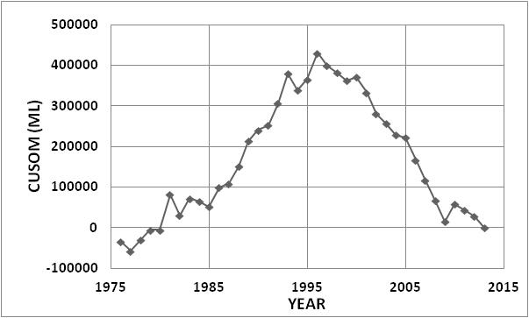

**Figure 8** CUSUM plot of annual runoff at Hughes Creek at Tarcombe Road (No. 405228) for   
1976–2013.

Furthermore, the rainfall and runoff trends are slightly different (compare Figures 6 and 8) with the 1976–1982 dry period missing and the Millenium drought starting later and continuing longer for the stramflow record. Nevertheless, the Mann Whitney test showed that median annual runoff decreased significantly between 1977–1996 and 1997–2013 ( 91262 v 37444 ML).

For 1976–2013, inclusive mean and median monthly runoff were lowest in February when mean monthly runoff was 991 ± 204 ML and median monthly runoff was 579 ML (Figure 9). Monthly runoff then progressively increased until August when it peaked at a mean of 14223 ± 1752 ML and a median of 13371 ML. Monthly rainfall then progressively declined until February. This seasonal Mediterranean runoff trend is shown in Figure 9. Clearly there is a winter runoff peak which occurs a month later than the rainfall peak and a late summer minima (February) in both rainfall and runoff (Figures 5 and 9).

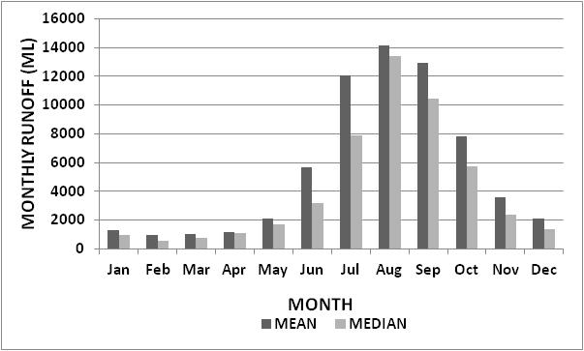

**Figure 9** Distribution of median and mean monthly runoff at Hughes Creek at Tarcombe Road   
(No. 405228) for 1976–2013.

## 2.5 2010 Flood

A major flood occurred throughout northern Victoria in early September 2010. In the Hughes Creek catchment peak rainfall occurred on 4 September 2010 when the maximum 48 hour rainfall at Temagog (Caveat) was 73 mm and at Strathbogie in the Seven Creeks catchment was 97 mm. Figure 10 shows the rating curve and Figure 11 shows the log Pearson Type III distribution flood frequency curve fitted to the annual maximum flood series at Hughes Creek at Tarcombe Road (No. 405228). The maximum recorded gauge height at the Tarcombe Road gauge was 4.41 m which is higher than the maximum gauging. The estimated peak flow is 35800 ML/d (414.4 m3/s). The estimated average recurrence interval for the flood peak is about 30 years on the annual maximum series. This was the largest flood for this storm north of the Goulburn River. Professor Lake suggested that hydrograph characteristics of the September 2010 flood should be investigated because he suspected that the flood had a very steep rising limb during which much sediment transport and geomorphic work could have been performed. The author downloaded the flood stage hydrograph from the Victorian Water Measurement Information System and it is included here as Figure 12. As suspected by Professor Lake, the rate of rise was very rapid after the flood reached a height just above 2.0 m to the first peak. Although the recession was much slower, overbank flow was maintained for about 24 hours.

The comparison of channel form before and after the flood of 4 September 2010 is undertaken below (Section 4.3) because this large event immediately followed the extended Millenium drought discussed above in Sections 2.3.2 and 2.4.

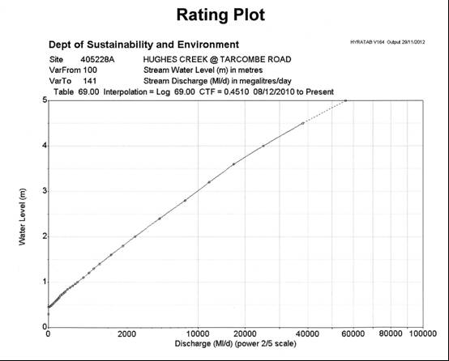

**Figure 10** Rating curve at Hughes Creek at Tarcombe Road (No. 405228) downloaded from <http://203.12.195.133/dseflood/basin%2005%20goulburn/4.5228%20-%20tarcombe> on 27 June 2014.

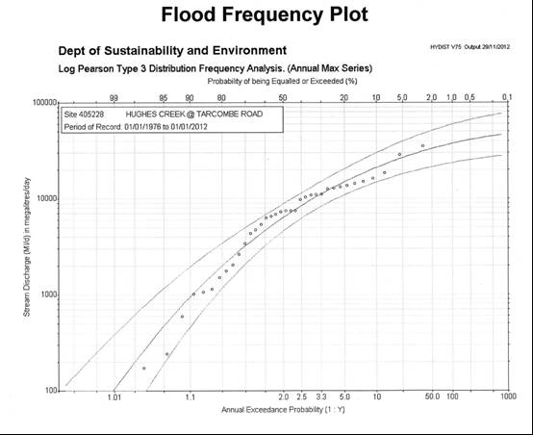

**Figure 11** Log Pearson Type III flood frequency curve at Hughes Creek at Tarcombe Road (No. 405228) downloaded from <http://203.12.195.133/dseflood/basin%2005%20goulburn/4.5228%20-%20tarcombe> on 27 June 2014.

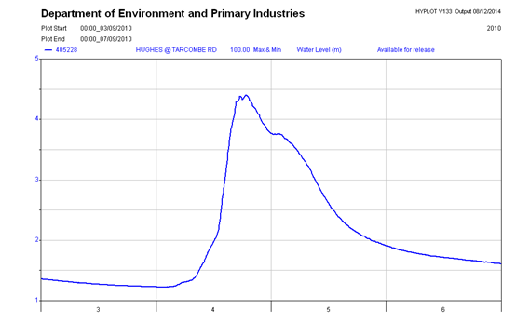

**Figure 12** Stage hydrograph for the 4-6 September 2010 flood at Hughes Creek at Tarcombe Road (No. 405228) downloaded from data.water.vic.gov.au/monitoring.htm on 8 December 2014.

# 3 River Reaches

## 3.1 Mapping of River Reaches

The approach adopted to identify, name and map river reaches on Hughes Creek follows Erskine (2005), Saynor & Erskine (2013, 2014) and Erskine et al. (2014). River reaches are homogeneous lengths of channel within which hydrologic, geologic and adjacent catchment conditions are sufficiently constant so that a uniform river morphology (Kellerhals et al. 1976) or a consistent pattern of alternating river morphologies is produced (Erskine et al. 2001). Alternatively, river reaches could be defined as relatively homogeneous associations of channel units which distinguish them from adjoining reaches (Bisson & Montgomery 1996, Brierley & Fryirs 2005). Channel units are quasi-discrete areas of relatively homogeneous depth and flow that are bounded by sharp physical gradients (Hawkins et al. 1993) and are usually called pools, riffles, runs, rapids and the like. Nevertheless, the bio- ecological significance of different river reaches has not been demonstrated to date despite previous attempts (Thomson et al. 2001) and river reaches may be too large a spatial unit to be important for aquatic and semi-aquatic species. Reaches are typically 2 to 100 km long but can be shorter or longer, depending on the size of the river. While it is relatively easy to identify the core length of a reach it is more difficult to define precisely the boundaries of a reach because of their transitional nature (Erskine 1996a). Floodplains should be included in the classification because they are important as potential sediment sources and sinks, and dissipate flood energy. Floodplain landforms and sediments usually covary with channel morphology (Mollard 1973).

Formal names have been given to reaches for local residents and river managers to identify with, and take a management interest in, their local reach of stream. Reach names comprise at least three terms. The first, is a geographic name for a location or feature within or near the reach. The second, is a geomorphological descriptor for one or more of the dominant characteristics of the reach. The terms commonly used are explained in Table 1 following Erskine et al. (2005). The third term, when needed, is the word, reach or zone. An example is the *Yea Meandering Reach* on the Yea River at and downstream of Yea. Yea is the town at the upstream end of this reach. The sinuosity (ratio of channel length to valley length and used as an index of the degree of meandering) is 2.1 which is very high indicating a highly meandering river.

River reaches can then be classified into specific river types using various approaches, such as those based on Rosgen (1994, 1996); River Styles of Brierley & Fryirs (2005) or the work of Erskine et al. (2005, 2014). However, broad river categories are preferred because each reach of the same river category has not necessarily progressed through the same evolutionary pathway or trajectory. Therefore, each reach of the same river category may not have behaved identically in the past, at the present as well as in the future.

Table 1 Types of river reaches commonly found in Australia

| **River Types** | **Geomorphic Characteristics** |
| --- | --- |
| *Anabranching River* | Anabranching rivers consist of multiple channels separated by unvegetated bars, ridges and/or vegetated islands. They can be either unconfined or bedrock confined (Saynor & Erskine 2013) |
| *Anabranching Bedrock River* | See anabranching river above. Multiple channels largely flowing over bedrock and separated by bedrock highs/bars. |
| *Avulsive River* | Avulsive rivers exhibit avulsions which are a major, usually abrupt shift in the location of a channel to a new, often lower part of the floodplain. Avulsions are much longer than cutoffs and can be tens of kms long. Sedimentation is often the stimulus for avulsion (Erskine 2013; Erskine et al. 2014). |
| *Backwater River* | Reach subjected to backwater because of high water levels on the main stream that impound the tributary. As a result, they are low energy reaches and can be characterised by muddy boundary sediments (Pickup & Marshall 2009). They occur on alluvial plains upstream of a junction with a larger river (Pickup 1984). |
| *Bedrock-Confined River* | Channel impinges against materials of limited erodibility (Lateral confinement in the sense of Lewin and Brindle (1977)) and/or has incised into erosion resistant materials (Vertically constrained after Schumm (2005)). Limited development of floodplains as pockets in localised valley expansions. Characterised by narrow valleys |
| *Chain of Ponds* | A diverse drainage form ranging from disconnected pools in broad valley floors to large pools in small continuous channels to extensive wetlands (Erskine 2013). Usually associated with muddy floodplains. A channel form worthy of consideration for geoheritage protection because of their rarity and ecological significance. |
| *Co-existent Mud-Braided and Anabranching River* | River occurs on very low slope, very wide valleys with highly variable streamflows and sediment load dominated by mud. The channel is narrow, has low specific stream power, exhibits multiple channels connected to deeper, permanent waterholes and dissect a broad muddy floodplain with braided shallow channels. |
| *Confined Meandering1 River* | River repetitively impinges against laterally confining media, such as bedrock or river terraces, and develops a regular meander amplitude and wavelength. These channels migrate downvalley, reworking all of the floodplain. |
| *Extensive Freshwater Wetlands and Billabongs* | Discontinuous channel which dissipates in extensive wetlands and/or lakes. Billabongs or waterholes often present in remnants of the atrophied original channel channel (Erskine et al. 2005, Saynor & Erskine 2013). |
| *Floodout* | Form of channel failure where all bedload is deposited and channel completely loses all definition (Melville & Erskine 1986, Erskine 2013). Intermediate and terminal floodouts have been identified (Tooth, 1999). Usually associated with the downstream part of incised channels/discontinuous gullies and sand slugs (Melville & Erskine 1986). |
| *Gorge* | Steep channel incised into bedrock containing very steep bedrock walls, pools, cascades, rapids, bedrock and boulder steps (Grant et al. 1990) and boulder bars with no floodplain. Waterfalls and plunge pools may be present. |
| *Gully* | Relatively deep recently formed, eroded channel that is cut into unconsolidated materials where no well-defined channel previously existed (Schumm et al. 1984). |
| *Incised Channel* | Deep, eroded channel incised into a formerly small capacity channel (Schumm et al. 1984). |
| *Recovering Incised Channel* | The recovery of a deep, recently eroded channel by the deposition of sediment on the bed and/or contraction of the channel by bank or bench deposition and vegetation colonisation of the boundary. |
| *Island- and Ridge-Anabranching River* | Multiple channels (usually two to four) separated by ridges, islands and/or floodplain. Islands and floodplains are usually well vegetated, particularly with trees. Often difficult to discriminate from wandering rivers (see below). |
| *Laterally Migrating Unconfined Meandering River* | River develops irregular and often tortuous meanders but still migrates downvalley by eroding the outside bank of bends downstream of the bend apex. Channel moves slowly across a broad floodplain |
| *Laterally Stable Unconfined Meandering River* | River is sinuous but does not currently migrate across the floodplain because of a combination of low energy, dense riparian vegetation, high large wood loading and/or resistant bank material. |
| *Low Sinuosity or Straight River* | Straight rivers have a low sinuosity and are usually flanked by a broad floodplain. They often occur in low energy environments where there are low valley slopes (Schumm & Kan 1971). However examples also occur on steep slopes where the channel follows straight structural lineaments, such as faults and joints. |
| *Non-Channelised Valley Floor with or without Percolines* | Swampy, unchannelled valley floors with or without percolines that are usually well vegetated and characterised by seasonally high water tables. They usually form relatively thin muddy sheets. Percolines are an underground network of water seepage zones and soil pipes enlarged by interflow (Jones 1979, Mayhew 2009). Here only percolines on valley floors are included and those on slopes and other landforms are ignored. Roof collapse of soil pipes can lead to gully formation. |
| *Sand Slug* | Historical sedimentation of thick sand as a wide wave which migrates downstream and completely buries the whole channel and/or floodplain. Can be produced by large sand inputs from hydraulic mining (Gilbert 1917), accelerated soil erosion and gully erosion (Happ et al. 1940), and substantial, rapid river bank erosion and channel widening (Erskine 1994, 1996b, 2013). |
| *Recovering Sand Slug* | Sand slug recovering from rapid sanding due to oversupply of sand. Recovery involves a reduction in upstream sand suppy which slows the rate of sedimentation and consequently allows vegetation colonisation of the sand margins. Actively contracting sand-bed channel with well vegetated margins, usually by Phragmites and/or Typha. Active overbank deposition of sand with rapid regeneration of floodplain vegetation (Chalmers et al. 2012; Erskine et al. 2012). Rates of sand progradation and aggradation can slow or even stop. |
| *Upland Bedrock Channel* | Channel excavated shallowly into bedrock on plateau surfaces with essentially no floodplain. Similar to Gorges, except for the shallow confining and constraining valley. |
| *Wandering River* | Intermediate form between meandering and braided rivers with multiple channels separated by floodplains. Islands or bars. Usually very active channels and either sand- or gravel-bed. |

1Meandering river types - According to Leopold & Wolman (1957) a meandering river has a sinuosity of at least 1.5 but there is a continuum of channel patterns between straight and meandering with sinuosities as low as 1.3 often characterising streams with a repeated pattern of bends (Schumm 1963).

## 3.2 River Reaches on Hughes Creek

Hughes Creek has been classified into eleven geomorphologically homogeneous river reaches using the approach described in Section 3.1. Figure 13 shows the spatial distribution of these reaches and Table 2 presents important data for each reach. Figure 14 shows the location of the river reaches on the long profile. The distribution of Macquarie perch in Hughes Creek in relation to river reaches is discussed in Section 5.4. For this work, Ian Drummond and Associates (1984) and the author’s ‘Field Notes No. 26’ from 1991 and 1992 and ‘Field Notes No. 27’ from 1994 and 1995 were read before completing the current river reach analyses which are contained in the author’s ‘Field Notes No.159’ from 2008 to 2014.

Hughes Creek commences in the Black Range (*Kendalee Headwaters Reach*) and flows across the Highlands plateau of Phillips & Clemens (2013) as swamps, percolines and chain of ponds (*Kendalee Headwaters Reach*, *Terip Terip Percolines Reach* and *Ruffy Chain of Ponds Reach*) before descending into the Hughes Creek Valley via two granite gorges (*Springfield* and *The Peak Granite Gorges*) separated by a short granite-confined reach (*Dropmore Granite-Confined Reach*)(Figure 13). There are few active sediment sources above the Springfield Granite Gorge and most sand supplied to the channel in the upper catchment originates from unsurfaced roads and tracks. Once below the Highlands plateau, Hughes Creek is closely confined by granite through Bungle Boori (*Bungle Boori Granite-Confined Reach*) before flowing through the highly resistant hornfels of the metamorphic aurole of the Strathbogie Batholith (*Kulaba Hornfels-Confined Reach*). The tributaries entering the Bungle Boori Granite-Confined Reach have been active sand sources in the past (Ian Drummond & Associates 1984) and include Stewart, County and Ponkeen Creeks. Hughes Creek re-enters the Strathbogie Batholith at Booroola (*Booroola Granite-Confined Reach*) before debouching onto the Riverine Plain just upstream of Avenel (*Avenel Recovering Sand Slug Reach*). The recovering sand slug continues until Hughes Creek almost reaches the Goulburn River where there is a short backwater-affected reach (*Goulburn Backwater Reach*). Landcare has been active in the Hughes Creek catchment (Halsall 1978, Barwick 2008) and there are now many tree plantings for various purposes and pasture improvement that have increased greatly ground cover over the last twenty years.

Bedrock and bedrock-confined reaches dominate on Hughes Creek occupying 57.4% of the total main channel length. However, the longest individual river reach is the Avenel Recovering Sand Slug Reach at the downstream end of the channel network, occupying 25.6% of the total main channel length. Catchment and stream erosion below the upper catchment generated the sand that formed the sand slug. While the chain of ponds and percolines reaches (7.1% of the total main channel length) are in good condition, they need protection to ensure that a new wave of sand aggradation does not move downstream through the whole main channel network. Chain of ponds and percolines are important for restricting sand fluxes and maintaining high quality fish habitat, at least in the ponds. The headwaters reach occupies 8.5% of the total main channel length and is sensitive to drainage works and the potential initiation of gullying. Chain of ponds are of geoheritage significance and the Springfield Granite Gorge severely restricts the upstream recruitment of most fish species, except those that can climb (natural barrier). Therefore protection of existing native fish populations in chain of ponds is essential because of the likely lack of recruitment from downstream. This is discussed in more detail below.

Table 2 River reaches on Hughes Creek. For location, see Figure 9.

| **Reach Name** | **River Length (km)** | **River Bed Slope (m/km)** | **Geomorphic Characteristics** | **Photos** |
| --- | --- | --- | --- | --- |
| Goulburn Backwater Reach  (Reach 1) | 0–1.1 | Essentially 0 | Well vegetated, low sinuosity, backwater-affected channel with many pools and a reasonable load of large wood. Probably warmer water than in Goulburn River and lower flow velocities, except when Hughes Creek is in flood. Refuge from a cold Goulburn River. Mud deposition is usual in backwater reaches (Pickup 1984; Pickup & Marshall 2009). Gullying of high right bank at junction with Goulburn River. | Hughes Creek at Goulburn River Junction |
| Avenel Recovering Sand Slug Reach  (Reach 2) | 1.1–21.9 | 1.04 to 2.67 | Narrow, low slope, low sinuosity, sand-bed stream, usually flanked by continuous Phragmites stands with a narrow floodplain vegetated by *Eucalyptus camaldulensis*. Short sections of island anabranching present. Significant recent recovery has occurred from the main period of sand aggradation and channel widening when the sand slug first formed. Channel contraction increases flow velocity which transports greater sand fluxes and increases the rate of channel recovery. Phragmites is essential for protecting banks from erosion. Sand size is likely to be increasing in response to reduced upstream supply. Many small sand extraction sites have been active since 2000 and were important for creating pools. | Narrow Phragmites-Lined Channel    Island Anabranching    Avenel |
| Booroola Granite (Bedrock) Confined Reach  (Reach 3) | 21.9–29.8 | 2.35 to 3.33 | Strathbogie Granite laterally confines the low sinuosity channel and significantly restricts lateral migration. Sand is present in large amounts but only in patches with gravel riffles and deep pools dominant in many discontinuous areas.  Alternating sections of sand-bed flanked by sandy side bars and gravel bed, pool-riffle channel are present. High level sand bars flank gravel bed, pool-riffle sections. Gravel-bed sections are protected by dense riparian vegetation but sand-bed sections tend to be relatively free of riparian vegetation. Gauging station 405228 (Hughes Creek at Tarcombe Road) located in this reach as well as timber groynes. Continuous riparian fencing and continuous riparian revegetation worthwhile in many sections, as shown by adjacent photos. | Gravel riffle on Booroola    Sandy side bar on Booroola    Pool |
| Kulaba Hornfels (Bedrock)-Confined Reach  (Reach 4) | 29.8–40.3 | 3.64 to 15.8 | Low sinuosity channel is more closely laterally confined by highly resistant hornfels (metamorphic rocks) of the metamorphic aureole into which Strathbogie Granite was intruded than immediately downstream and upstream. Pools and gravel riffles are more common than adjoining reaches. Spatially disjunct floodplains are less common than adjoining reaches. Sand was recently transported into this reach by the 2010 flood. Riparian vegetation is in good condition. | Gravel riffle    Gravel chute |
| Bungle Boori Granite (Bedrock)-Confined Reach  (Reach 5) | 40.3–55.6 | 1.82 to 3.08 | Granite often exposed in bed and banks and alternates with sand aggraded sections. Granite frequently exposed in bed immediately upstream and downstream of Bungle Boori where slope increases significantly. Sand bars common in sand aggraded sections. Limited pool development because of oversupply of sand, especially by the 2010 flood. Spatial distribution of sand indicates that tributaries of this reach have been but are no longer a significant source of sand. Short sections of anabranching present. Riparian vegetation is discontinuous. Limited sand extraction has occurred in the downstream part of this reach. Small amounts of extraction will not damage channel and floodplain. | Granite riffle at Bungle Boori    Bedrock riffle  Sandy point bar with chute |
| The Peak Granite Gorge  (Reach 6) | 55.6–61.1 | 13 .3 to 40.0 | Steep granite gorge where Hughes Creek completes its fall from the top of the Strathbogie Ranges/Highlands plateau into the Hughes Creek valley. Bedrock bars, boulder steps and step pools, cascades, rapids and long pools present. Some sand deposition and emergent macrophytes present in flatter sections. | Granite bar |
| Dropmore Granite (Bedrock)-Confined Reach  (Reach 7) | 61.1–64.8 | 3.91 to 40.0 | Short section of flatter, low sinuosity, sandy, vegetated channel confined by granite. Bedrock often exposed in bed and banks. Sand benches occasionally present. Emergent macrophytes present in flatter sections. | Pool at Dropmore |
| Springfield Granite Gorge  (Reach 8) | 64.8–68.5 | 40.0 to 100 | Very steep, deep, straight, granite gorge with boulder and bedrock bed. Channel units include bedrock and boulder steps, step pools, cascades and pools. Riparian vegetation is in good condition despite high stream energy. Emergent macrophytes common in flatter sections. Major natural barrier to fish passage. No alien fish species should be introduced upstream of this gorge because of potential impact on the fish biodiversity of chain of ponds and percolines. | Granite Gorge on Springfield |
| Ruffy Chain of Ponds Reach  (Reach 9) | 68.5–72.1 | 5.71 to 50.0 | Large pools or ponds separated by a well vegetated, narrow channel, flanked by a well vegetated floodplain. Submerged and emergent macrophytes present with a small load of large wood. Channel occasionally impinges against bedrock valley sides. Candidate site for geoheritage protection of remnant chain of ponds and their flora and fauna. | Pond called the Boathole |
| Terip Terip Percolines Reach  (Reach 10) | 72.1–74.3 | 2.86 to 5.00 | Well vegetated, swampy, unchannelled valley floor, except where shallow drains have been excavated. Very rare chain of ponds present but fewer and smaller than downstream. Drainage works could cause large-scale gully development. | Percolines near Terip Terip |
| Kendalee Headwaters Reach  (Reach 11) | 74.3–81.2 | 5.00 to 100 | Small steep well vegetated discontinuous channel in upper catchment. Slope decreases downstream. Swampy unchannelled valley floor often present, especially where drainage works have not been constructed. Drainage works could cause large-scale gully development. | Headwaters channel |

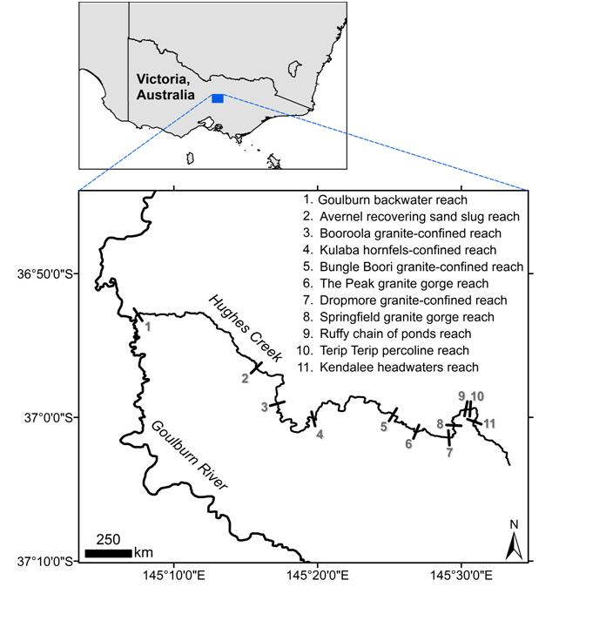

**Figure 13** Location of the river reaches described in Table 2 in the Hughes Creek catchment.

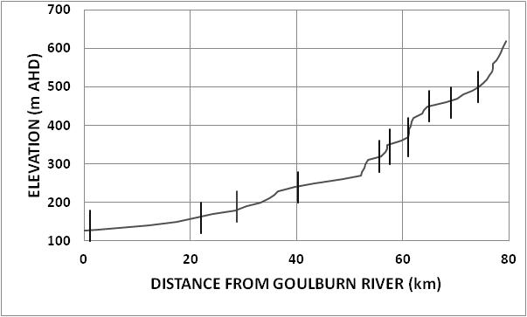

Reach 8

Reach 7

Reach 6

Reach 4

Reach 3

Reach 1

Reach 11

Reach 10

Reach 9

Reach 5

Reach 2

**Figure 14** Long profile of Hughes Creek showing location of river reaches. See Table 2 for details of river reaches.

## 3.3 Tributaries

The Goulburn-Broken Catchment Management Authority requested that the tributaries of Hughes Creek also be classified and discussed. River reach mapping is not intended to cover small tributaries because they are too small to be seen in detail on vertical aerial photography. Therefore, river reaches are only formally defined here where the tributary channel is clearly visible on Google Earth Pro for most of its length. Where the channel is not clearly visible, general comments only on downstream changes in channel morphology and current channel condition are presented. Again Ian Drummond and Associates (1984) and the author’s ‘Field Notes No. 26’ from 1991 and 1992, ‘Field Notes No. 27’ from 1994 and 1995, and ‘Field Notes No. 159’ from 2008 to 2014 were consulted before completing this work. The location of the eight tributaries discussed below is shown in Figure 15.

### 3.3.1 Woolshed Creek

Woolshed Creek is a left bank tributary of Hughes Creek in Reach 6 at Dropmore (Figure 15). Its riparian zone is well vegetated by remnant forest along most of its length and granite vertically constrains and laterally confines the channel in many locations. No significant historical information on the condition of the channel was found on the early Dropmore Parish map. Where the channel can be seen on the 2012 air photos, the channel is recovering from historical incision (Figure 16). Woolshed Creek is currently stable and is not a contemporary sand source.

### 3.3.2 Boundary Creek

Boundary Creek is a left bank tributary of Hughes Creek in Reach 6 downstream of Dropmore (Figure 15). It is similar to Woolshed Creek (Figure 17), discussed above. No significant historical information on the condition of the channel was also found on the early Dropmore Parish map. Boundary Creek is currently stable and is not a contemporary sand source.

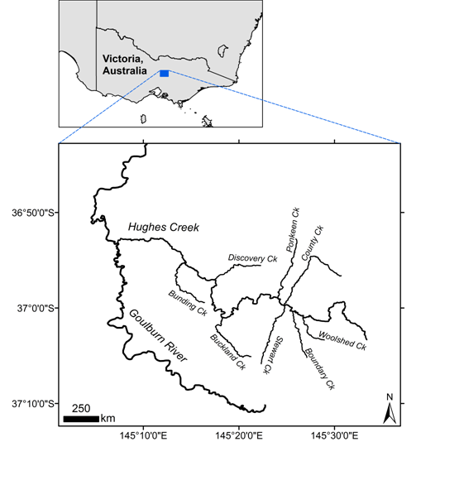

**Figure 15** The location of the eight tributaries of Hughes Creek investigated for this report.

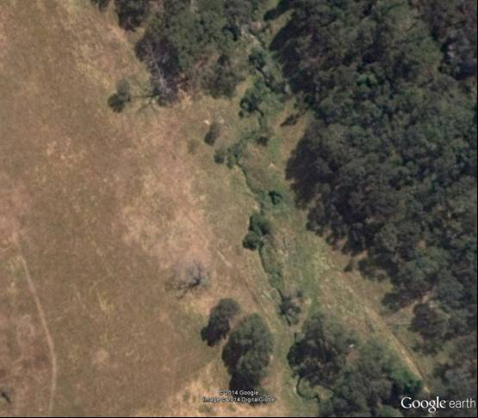

**Figure 16** A recovering section of formerly incised channel on Woolshed Creek in 2012.

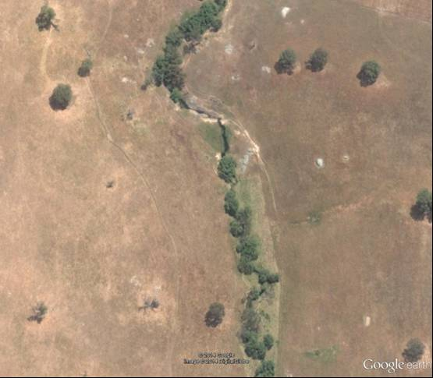

**Figure 17** A recovering section of formerly incised channel on Boundary Creek in 2012.

### 3.3.3 Stewart Creek

Stewart Creek is a left bank tributary of Hughes Creek in upper Reach 5 and drains the Highlands, ‘Habbies Howe’ and ‘Kobyboyn’ area (Figure 15). It was formerly an actively incised channel and supplied large amounts of sand to Hughes Creek before the adjoining tributaries (County and Ponkeen creeks) incised (Ian Drummond & Associates 1984). River reaches are identified because the riparian zone is clearly visible on the 2013 air photos. The reaches are defined in Table 3. No significant historical information on the condition of the channel was found on the early Kobyboyn Parish map.

Table 3 River reaches on Stewart Creek. For location of stream, see Figure 15.

| **Reach Name** | **River Length (km)** | **River Bed Slope (m/km)** | **Geomorphic Characteristics** | **Photos** |
| --- | --- | --- | --- | --- |
| Stewart Recovering Incised Channel Reach  (Reach 1) | 0–2.75 | 5.26 | Well vegetated, low sinuosity, formerly incised channel that has progressed a long way along a recovery trajectory. In-channel bars are still present. Sections of the riparian zone have been planted. Well developed pools are common. Many tributaries have not been extensively rejuvenated. | Recovering Incised Channel |
| Mt Helen Granite Gorge  (Reach 2) | 2.75–3.75 | 45.5 to 133 | Short reach of well vegetated, bedrock-ensconced channel which is continuously tree-lined. It is difficult to see the channel although pools are present. | Gorge |
| Kobyboyn Recovering Incised Channel Reach  (Reach 3) | 3.75–10.55 | 4.06 to 8.03 | Well vegetated, low sinuosity, formerly incised channel that has progressed a long way along a recovery trajectory. Sections of the riparian zone have been fenced and planted. Well developed pools are common and bars are being colonised. | 1991 Photo of Fencing  and Revegetation |
| Habbies Howe Dammed Reach  (Reach 4) | 10.55–11.23 | Essdentially 0 because of backwater | Farm dam with emergent macrophytes and occasional trees. This is a major sediment trap. | Farm Dam |
| Highlands Swamp Reach  (Reach 5) | 11.23–12.03 | 17.9 | Broad swamp with occasional ponds. Discontinuous well vegetated small capacity channel present in patches. | Swamp |
| Rockcliff Bedrock-Confined Reach  (Reach 6) | 12.03–12.69 | 14.6 to 16.4 | Short reach of well vegetated sinuous bedrock-confined channel containing small pools with large wood. | Bedrock-Confined |
| Hillcrest Percoline Reach  (Reach 7) | 12.03–14.73 | 29.4 to 37.0 | Broad well vegetated swampy valley floor with occasional depressions. Occasional ponds present in downstream area. Extensive recent catchment reafforeststion with *Eucalyptus* plantations. | Percolines |

The post-European phase of channel incision did not progress along the full length of the main channel. The reaches up- and downstream of the Mt Helen Granite Gorge incised after European settlement but recent river restoration works have assisted in stabilizing these reaches, to varying degrees. Upstream of Habbies Howe are extensive swampy valley floors and percolines, which will remain stable provided no drainage works are undertaken.

### 3.3.4 County Creek

County Creek is a right bank tributary of Hughes Creek in upper Reach 5 and flows into Hughes Creek almost directly opposite Stewart Creek (Figure 15). It originates near Ruffy. In Subsection 4.1 it is found that County Creek, when first surveyed for the Tarcombe Parish map, was a series of chain of ponds and swamps (Figure 27B), just like Ponkeen Creek. Gullying and incision occurred after first European settlement, probably in 1916 when Hughes Creek in Reach 7 was extensively eroded by a large flood (Trueman & Luker 1992, Trueman 2012, Davis & Finlayson 2000). In 1984 Ian Drummond & Associates (1984) found that there was no sand in the bed of Hughes Creek until downstream of County Creek and that channel erosion on County Creek had occurred during the 1970s.

The six channel reaches identified on County Creek are outlined in Table 4. A large farm dam is located above the Willowmavin Headwaters Reach. Most of the main channel length is characterized by recovering incised channels (Reaches 1, 3 and 5) and the downstream three reaches (Table 4) are well connected to Hughes Creek. Salinity may have contributed to initial channel incision, especially in Reach 3. County Creek is well advanced on a recovery trajectory from post-European incision. Contemporary sand supply to Hughes Creek is no longer significant.

### 3.3.5 Ponkeen Creek

Ponkeen Creek is a right bank tributary of Hughes Creek in upper Reach 5 at Tarcombe (Figure 15). This creek parallels Tarcombe Road from ‘Ardroy’ to ‘Tarcombe’. In Subsection 4.1 it is found that Ponkeen Creek, when first surveyed for the Tarcombe Parish map, was a series of chain of ponds and swamps (Figure 27A), just like County Creek. Gullying and incision occurred after first European settlement, probably in 1916 when Hughes Creek in Reach 7 was extensively eroded by a large flood (Trueman & Luker 1992, Trueman 2012, Davis & Finlayson 2000). In 1984 there were still erosion problems on the lower 2–3 km of Ponkeen Creek (Ian Drummond & Associates 1984).

Contemporary conditions were interpreted from imagery of 21 January 2014 held by Google Earth Pro. There are four reaches on Ponkeen Creek which are described in Table 5. Channel incision is no longer a significant source of sand to Hughes Creek. The upstream two reaches (Reaches 3 and 4) are sensitive to drainage works which could initiate a new phase of incision. The most downstream reach (Reach 1) has progressed a long way along the recovery trajectory because chain of ponds have reformed in places.

### 3.3.6 Buckland Creek

Buckland Creek is a left bank tributary of Hughes Creek in Reach 5 (Figure 15). Ian Drummond & Associates (1984) identified Buckland Creek as a source of sand to Hughes Creek and recommended a range of works to address salting, incision, bank erosion and stock management. Sand was identified as choking the bed of Bucklands Creek in places since 1973 (Ian Drummond & Associates 1984). However, when inspected by the author in February 1992 Buckland Creek was either a gravel bed stream or vegetated with emergent macrophytes (Figure 18). Similarly on 11 June 2014, the lower reaches of Buckland Creek were composed of both gravel and rhizomatous emergent macrophytes, and was not a significant source of sand.

No attempt has been made to identify river reaches on Buckland Creek because it is a discontinuous channel with limited connection to Hughes Creek and is covered by riparian vegetation. It also seems to drain part of the resistant metamorphic aureole of the Strathbogie Batholith and parts of the catchment have been recently reafforested with plantations. There is a large farm dam constructed on a gullied right bank tributary which traps all the bedload. Upstream of the dam are a series of headcuts (Figure 19) downstream of two farm dams (Figure 19). The author inspected a rock chute on the main stream on 25 January 1992 on Mr Lindsay Waite’s property which stabilized a headcut. Groynes of logs and gravels in mesh had also been constructed in about 1978–80. As noted by Erskine (1993a), Buckland Creek is an incised channel because a pre-existing channel was present before the post-European phase of incision started, as shown in Figure 20.

Table 4 River reaches on County Creek. For location of the stream, see Figure 14.

| **Reach Name** | **River Length (km)** | **River Bed Slope (m/km)** | **Geomorphic Characteristics** | **Photos** |
| --- | --- | --- | --- | --- |
| Stony Recovering Incised Channel Reach  (Reach 1) | 0–11.0 | 3.31 to 13.7 | Well vegetated, slightly sinuous, formerly incised channel that has progressed a short way along a recovery trajectory. Sections of the riparian zone have been planted. Well developed pools are common. Three significant bedrock outcrops are located at 1.1 km, 3.2 km and 3.7 km. A deferred tributary junction at junction with Hughes Creek indicates sand load higher in main stream. | Pool |
| Mt Monica Granite Gorge  (Reach 2) | 11.0–12.2 | 27.0 to 100 | Short reach of steep, well vegetated, granite-ensconced channel or gorge which is continuously tree-lined. Pools present. | Gorge |
| Kurrajong Recovering Incised Channel Reach  (Reach 3) | 12.2–16.2 | 10.3 to 33.9 | Well vegetated, slightly sinuous, formerly incised channel that has progressed a moderate way along a recovery trajectory. It appears that the banks of the former incised channel are subject to dryland salinity (appear white on the air photos) but they have not been inspected in the field. Sections of the riparian zone are very well vegetated and have been planted. Well developed pools are common. Chain of ponds are reforming in the bed of the recovering incised channel. Large granite outcrop is located at 13.5 km. Channel less clearly defined immediately downstream of this outcrop. | Recovering Incised Channel |
| Innisfail Chain of Ponds Reach  (Reach 4) | 16.2–19.2 | 12.0 | Swampy valley floor with a discontinuous well vegetated small capacity channel with chain of ponds alternating with disconnected chain of ponds. | Chain of Ponds |
| Strathearn Recovering Incised Channel Reach  (Reach 5) | 19.2–19.5 | 17.9 | Short section of straight (previously ditched?) recovering incised channel from post-European channel erosion. May extend further upstream into remnant forest but channel cannot be seen. Channel boundary well grassed but no river restoration works carried out to date. | Recovering Incised Channel |
| Willowmavin Headwaters Reach  (Reach 6) | 19.5–21.2 | 19.4 to 37.0 | Steep reach located in remnant forest downstream of a large farm dam. | Headwater Channel |

Table 5 River reaches on Ponkeen Creek. For location of stream, see Figure 14.

| **Reach Name** | **River Length (km)** | **River Bed Slope (m/km)** | **Geomorphic Characteristics** | **Photos** |
| --- | --- | --- | --- | --- |
| Ponkeen Recovering Incised Channel Reach  (Reach 1) | 0–9.6 | 4.66 to 10.0 | Often well vegetated, slightly sinuous, formerly incised channel that has progressed a long way along a recovery trajectory. Sections of the riparian zone have been planted and fenced. Well developed pools are common. Chain of ponds reforming where there are emergent macrophytes on the valley floor. | Ponds  Emergent Macrophytes |
| Upton Bedrock-Confined Reach.  (Reach 2) | 9.6–10.7 | 17.9 to 83.3 | Short reach of granite-confined channel in a small patch of remnant forest. Pools present. |  |
| Karep Chain of Ponds Reach  (Reach 3) | 10.7–12.0 | 11.4 to 18.7 | Well vegetated narrow valley floor with sections of small capacity channel containing chains of ponds and disconnected chains of ponds. | Small Capacity Channel |
| Ardroy Percolines Reach  (Reach 4) | 12.0–15.7 | 15.7 to 66.7 | Swampy valley floor and percolines with scattered farm dams at 14.0 km, 14.8 km and 15.6 km. | Swamp |

|  |  |
| --- | --- |
| A | B |

**Figure 18**(A) Middle section of Buckland Creek where it was a gravel bed stream flanked by an inset floodplain covered by thin post-settlement alluvium on 25 February 1992; (B) Buckland Creek where the bed was covered with rhizomatous emergent macrophytes on 25 February 1992. The macrophytes indicate that Buckland Creek is not a significant contributor of bedload to Hughes Creek.

|  |  |
| --- | --- |
| Headcuts | Headcut |

**Figure 19** Discontinuous gullies on a right bank tributary of Buckland Creek showing headcuts in 2013.

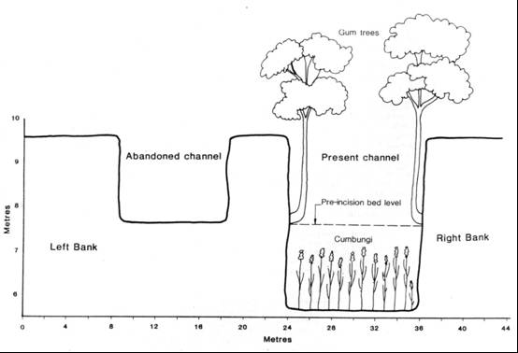

**Figure 20** Difference between current incised Buckland Creek and its pre-European unincised channel (abandoned channel) on the middle reaches of Buckland Creek (from Erskine 1993a: Figure 11.2).

Extensive gullying is apparent in the upper catchment (Figure 21) and field investigations are warranted to assess its significance.

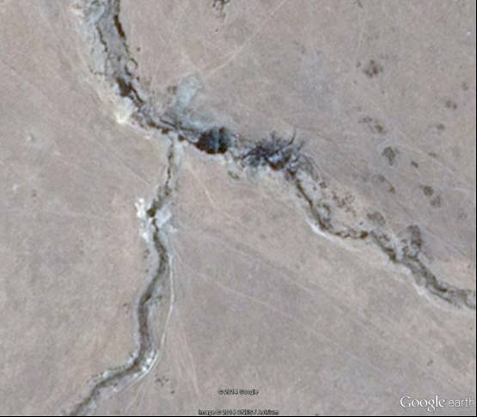

Gully

**Figure 21** Gullying in upper Buckland Creek catchment in 2014.

### 3.3.7 Discovery Creek

Discovery Creek is a right bank tributary of Hughes Creek in Reach 3 at ‘Booroola’ and drains a granite catchment (Figure 15). No attempt has been made to identify river reaches on Discovery Creek because it is often covered by dense riparian vegetation (Figure 22). Many tributaries of Discovery Creek are still actively gullying (Figure 22). Discovery Creek is largely a recovering incised channel that no longer supplies sand to Hughes Creek in any quantity. It is well advanced on a recovery trajectory.

|  |  |
| --- | --- |
| B  A  Discovery Creek | Tributary Gully |

**Figure 22** (A) Well treed channel of Discovery Creek upstream of Tarcombe Road in 2011;   
(B) Tributary gullying in upper Discovery Creek catchment in 2011.

### 3.3.8 Bunding Creek

Bunding Creek is a left bank tributary of Hughes Creek in Reach 2 (Figure 15). It flows into an anabranch of Hughes Creek upstream of the Hume Freeway on ‘Avenel Estate’. A small floodout occurs where Bunding Creek debouches onto the Hughes Creek floodplain. River reach mapping has been completed because the channel is highly visible on the 2013 aerial photos due to a lack of trees in the catchment. The four river reaches on Bunding Creek are described in Table 6.

Bunding Creek is the most active sand source to Hughes Creek of the eight tributaries investigated here. The two actively incising channel reaches on Bunding Creek are connected by a steep bedrock-confined channel and debouche directly onto the Hughes Creek floodplain. Furthermore, there is only a short length of swampy valley floor in the headwaters that has not been incised yet. Unlike the other tributaries, Bunding Creek has not started to recover from post-European incision. None of the historical sources consulted for this work mention erosion of Bunding Creek. While reduced sand input from Bunding Creek will only assist channel recovery in Hughes Creek in Reaches 1 and 2, the Bunding Creek junction is about 3 km downstream of the upstream boundary of Reach 2 on Hughes Creek. Therefore, reductions in sand flux from Reach 3 of Hughes Creek will be matched by reductions from Bunding Creek if river management works are undertaken.

Table 6 River reaches on Bunding Creek. For location of the stream, see Figure 14.

|  |  |  |  |  |
| --- | --- | --- | --- | --- |
| **Reach Name** | **River Length (km)** | **River Bed Slope (m/km)** | **Geomorphic Characteristics** | **Photos** |
| Avenel Incised Channel Reach  (Reach 1) | 0–3.6 | 6.83 to 25.6 | Poorly vegetated, meandering, active sand-bed channel, that has incised since European settlement. Outer bank on beds is eroding. There is a small floodout where the channel debouches onto the floodplain of Hughes Creek. The channel discharges into an anabranch of Hughes Creek. Connected to the next incised reach upstream by a steep bedrock-confined reach. | Incised Channel |
| Mittagong Bedrock-Confined Reach.  (Reach 2) | 3.6–6.3 | 21.5 to 58.8 | Short reach of granite-confined channel with granite pavement, boulders and pools interspersed with sand-bed sections. | Bedrock-Confined Channel |
| Mt Alexina Incised Channel Reach  (Reach 3) | 6.3–13.3 | 12.0 to 22.7 | Poorly vegetated, incised channel that is actively eroding and has rejuvenated tributaries. Most of the main channel length has now been eroded. | Incised Channel |
| One Tree Hill Percoline Reach  (Reach 4) | 13.3–14.0 | >31.5 | Short length of swampy valley floor with percolines and a farm dam at 13.8 km. | Percoline |

# 4 Historical Channel Changes on Hughes Creek

## 4.1 Development of the sand slug

Implicit in the river reach analyses in Section 3 is that significant channel changes have occurred since European settlement. In particular, the development of the sand slug on Hughes Creek in Reach 2 since European settlement has been poorly documented. Erskine (1993a) concluded that this sand slug developed during the early twentieth century based on a series of photographs of a sand aggraded Hughes Creek at Avenel from 1920 to 1937 that were held by the former State Rivers and Water Supply Commission. A sand slug is a bedload wave where sand oversupply produces substantial and rapid bed aggradation (up to 4 m in 4-5 years – Henry (1977), Erskine (1993a, 1993b, 1994a, 1994b, 1996b)) and sandy overbank deposition on the floodplain (Erskine 1993b, 1994b, 2013), and subsequent sand reduction causes bed degradation (Erskine & Melville 1983, Erskine 1994a, 1994b, 1996b, 1999). Channel recovery can be rapid, being effected by 4–5 events over 5–10 years or can persist for many decades (Henry 1977, Erskine & Melville 1983, 1984, Erskine 1994a, 1994b, 1996b). The sand slug can also migrate downstream at rates greater than 200 m/yr (O’Connor & Lake 1994). Gilbert’s (1917) research on the dynamics of hydraulic mining debris originating from gold mining by hydraulic sluicing in the Sierra Nevada mountains in California is the best known example of a sand slug and its impact on the Sacromento River and floodplain. In granite country in southeastern Australia, aggradation has taken longer and persisted for much longer periods than on the sand-bed channels in the sandstone, high flood variability area in NSW (Erskine 1986, 1996b, 2013; Erskine & Livingstone 1999, Rutherfurd 2000). The resultant sediments consist of a coarse channel facies and a slightly finer floodplain facies.

The first surveys of Hughes Creek and its tributaries were conducted by Pickering (1841a, 1841b, 1841c, 1841d, 1842a, 1842b, 1843) before the township of Avenel had been surveyed and are held by the State Library of Victoria. They are reproduced here as Appendices 1, 2, 3, 4, 5, 6 and 7, respectively and show all of the following:

1. Hughes Creek was a continuous channel from the headwaters to the Goulburn River,
2. What is shown as Hughes Creek on the 1:25000 topographic maps in the upper catchment is labelled as the South Branch,
3. Anabranches are only depicted on Hughes Creek up- and downstream of Avenel in Reach 2 (Avenel Recovering Sand Slug Reach),
4. Nothing that could be interpreted as a sand slug (Avenel Recovering Sand Slug Reach) was shown in Reach 2 or further upstream,
5. Close bedrock confinement of the channel was depicted in Reach 4 (Kulaba Hornfels-Confined Reach)(third degree confinement of Lewin & Brindle 1977),
6. “Water good” was annotated in Reach 5 (Bungle Boori Granite-Confined Reach),
7. A true short bedrock gorge was shown in the upper part of Reach 6 (The Peak Granite Gorge),
8. A series of true short bedrock gorges and “falls” were shown in Reach 8 (Springfield Granite Gorge),
9. A “rocky fall” was shown where Reach 2 is located on Stewart Creek (Mt Helen Granite Gorge), and
10. Small ponds were shown in Reaches 1 and 3 of Stewart Creek (Stewart Recovering Incised Channel Reach and Kobyboyn Recovering Incised Channel Reach).

**There is no doubt that the sand slug postdates European settlement and that tributary incision occurred after initial European settlement.**

Figure 23 shows an expanded set of photos of Hughes Creek at the Avenel stone arch bridge on the Hume Highway that were compiled from published sources, the internet and the author’s own photo collection. The photos only show a sand slug after 1920. As a result, it is tempting to simply transfer the better documented chronology from the neighbouring Granite Creeks (Creightons, Castle and Pranjip-Nine Mile creeks) by Davis & Finlayson (2000) to Hughes Creek. Davis & Finlayson (2000) concluded that the interaction and synchronization of a number of activities associated with European settlement caused extensive channel incision and gullying that generated the large volumes of sand that created sand slugs on Granite Creeks. In relation to the timing of erosion, the 1916 flood and the wet periods of the 1950s, 1960s and 1970s were important with a renewed phase during the 1993 flood (Davis & Finlayson 2000). The 1916 flood seemed to be responsible for synchronizing erosion throughout all three granite streams and was also important on upper Hughes Creek (Trueman & Luker 1992, Trueman 2012, Davis & Finlayson 2000). The sand slug created a section of channel that was relatively flat, shallow and ecologically featureless with low habitat complexity (O’Connor & Lake 1994, Erskine 1999). The purpose of this section is to define, as far as the historical data allows, the timing of sand slug development on Hughes Creek.

Burgoyne (1955) included Figure 23E on the cover of her book but does not mention the sand slug on Hughes Creek. Instead she traces her family’s involvement in Avenel from the first land sale in Melbourne in 1849, their settlement at Avenel later in 1849, the birth of her mother, the first white child born in Avenel in 1852 and town developments up to about 1954. There is reference to the drowning of a Frenchman named Levi in a pool on Hughes Creek in the early 1850s near a flour mill built on the banks of Hughes Creek at Avenel. Although the first squatters moved into the Hughes Creek catchment in 1838 (Bride 1898, Burgoyne 1955, Martindale 1958, Martindale & Breenan 1982) it would seem unlikely that the sand slug had formed in the early 1850s because most vegetation clearing was still to occur (Burgoyne 1955) and the presence of the pool seems incompatible with a sand slug. Similarly, when a boy, the infamous Victorian bushranger, Ned Kelly saved Richard Shelton from drowning in Hughes Creek in the 1860s when his family lived at Avenel. Again, if the sand slug had been present at that time it is unlikely that Richard Shelton could have drowned in the creek. The six arch, stone bridge across Hughes Creek on the former Hume Highway was completed in 1860 (Burgoyne 1955) although 1859 was listed on the plaque when the author first inspected the bridge on 27 November 1991. There was a large flood in 1870 which washed away two of the stone arches of the bridge (Burgoyne 1955). They were subsequently repaired.

Martindale (1958) noted that Hume and Hovell in 1824 camped near Mangalore in the vicinity of a chain of ponds. It is possible that these ponds were the pools in which Levi drowned and Richard Shelton was saved from drowning by Ned Kelly. Heywood-Outch and Outch (2014) reported that an eight year old boy drowned in Hughes Creek on 28 February 1873 and so it is also unlikely that the sand slug had developed then (Figure 23). Plate 14 in Martindale (1958) has a caption “Avenel Bridge, c 1850s” and is shown in Figure 23A. This must be incorrect because the stone arch bridge was not completed until 1859/1860. A search of the internet found Figure 23A at <http://www.bonzle.com/c/a?a=pic&fn=ud1hre92&s=3> on 5 September 2014 with a date for the photo of 1860. Furthermore, the quality of the photo was much better than that in Martindale (1958) and a pool was present under the bridge on the left bank where the channel occupied two arches. Martindale (1958: 165) noted that a shallow ford on Hughes Creek at Avenel was formerly deeper than it was in 1958. He goes on to say that “…much silting up having gone on within living memory.” The complete quote is contained in Erskine (1993a, p. 189). Living memory could be anywhere between 10 and 60 years. So the timing of sand slug development was likely to be in the twentieth century. This was supported by the residents of Avenel that the author interviewed for this project (Mr P Lewis, Mr J Newton).

Martindale (1958) noted that rabbits appeared in the catchment in about the latter part of the 1880s, apparently invaded the district from Tarcombe on Hughes Creek and became a major problem after 1900. This is consistent with the chronology known about the dispersion of rabbits into the Goulburn catchment cited by Erskine et al. (2014), based on their work in the Yea catchment to the south. Martindale (1958) also noted that in at least some cases the coming of the rabbit was the final blow to small land holders. Given that closer settlement occurred during the 1860s, extensive catchment vegetation clearing occurred after that and rabbits reduced land productivity during and after the 1880s up to the introduction of myxamatosis in the early 1950s (Burgoyne 1955, Martindale 1958, Barwick 2008), it seems most likely that the sand slug on Hughes Creek developed during or after the 1880s. However, it must be stressed that it was the interaction of clearing, grazing by livestock and rabbit invasion with drought that led to severe catchment overgrazing, as acknowledged in other parts of southeastern Australia (Erskine & Bell 1982).

The photos in Figure 23 indicate that the sand slug had formed by 1928 when the channel flowed through all six arches. By 1973, Hughes Creek had started to contract and vegetation had colonized the higher parts of the former bed (Figure 23F). The rate of contraction accelerated after 1973 (Figure 23G & H). While attempting to find the correct dates for the photos in Figure 23, the State Library of Victoria collection was found and the four extra photos in Figure 24 were located. Figure 24 confirms the conclusions made on the basis of Figure 23.

|  |  |
| --- | --- |
| 1860  A | 1928  B |
| 1937  C | 1951  D |
| E  1951 | F  1973 |
| G  27 Nov 1991 | H  11 June 2014 |

**Figure 23** Historical photographs of the stone arch bridge over Hughes Creek on the former Hume Highway at Avenel. Dates specified where known. (A) sourced from <http://www.bonzle.com/c/a?a=pic&fn=ud1hre92&s=3> on 5 Sep 2014 and dated as 1860; (B) sourced from internet, 1928; (C) sourced from the former State Rivers and Water Supply Commission’s collection, 1937; (D) sourced from Burgoyne (1955), 1951; (E) sourced from internet, 1951; (F) sourced from Field (1973: p. 69), probably 1973 ;(G) sourced from Wayne Erskine’s collection, 27 November 1991; and (H) sourced from Wayne Erskine’s collection, 11 June 2014.

|  |  |
| --- | --- |
| C  A | B |
|  | D |

**Figure 24** Historical photographs of the stone arch bridge over Hughes Creek on the former Hume Highway at Avenel. Dates specified where known. (A) sourced from State Library of Victoria, 1859; (B) sourced from State Library of Victoria image H40636/31, dated between about 1915 and 1925; (C) sourced from State Library of Victoria image H90 100/474, dated 18 October 1968; and (D) sourced from State Library of Victoria image H90 100/475, dated 9 November 1986. (C) and (D) taken by photographer John T. Collins.

The earliest Township of Avenel map (1800s but exact date cannot be deciphered) that the author found (Figure 25) shows an anabranching channel without any indication of a sand slug. A much later Township of Avenel map (Figure 26) shows that when it was surveyed after 1849 the channel through the town had not widened although an avulsion had occurred at and downstream of the old Hume Highway. The Parish of Avenel map extends further upstream but did not show a sand slug, similar to the Township maps. The Parish of Avenel map is not reproduced here because it is in poor condition.

The Parishes of Tarcombe and Dropmore maps were also inspected and no indication of sand slug formation on Hughes Creek was found. However, both Ponkeen and County creeks were shown with chain of ponds (Figure 27) which appear to have been destroyed by post-settlement channel incision (Section 3.3). Figure 28 shows the chain of ponds and percolines on upper Hughes Creek (Table 2) portrayed on the Parish of Dropmore map at the time of first survey. These ponds and percolines are still present today (Reaches 9, 10 & 11), as outlined in Section 3.2.

Davis & Finlayson (2000: 102-3) reproduced a hand written letter by Robert McKenzie who lived in the Strathbogie Ranges in the early 1900s and presented some interesting information about Hughes Creek. Trueman & Luker (1992) had earlier used the same letter. McKenzie described native fish inhabiting chains of ponds and the introduction of the alien species, *Salmo trutta*, *Tinca tinca* and *Oncorhynchus mykiss* to Hughes Creek and their survival. He went on to say:

“The Hughes Creek for two miles above Dropmore up until 1916 was a slow running stream with a series of very deep holes mostly edged with Capungi reeds. In 1916, a flash flood ripped through and tore the creek bed down to bedrock and left a long channel of sand and, in my opinion, swept away the Trout Cod breeding grounds in those Capungi edged pools for the whole of the Hughes Creek” (Davis & Finlayson 2000: 102).

Capungi was translated as *Phragmites* in the letter by an interpreter but is more likely to be *Typha* or both species*.* The reach described by McKenzie is the Dropmore Granite-Confined Reach (Reach 7) which is sandwiched between two granite gorges (Table 2).

McKenzie went on to say:

“Anyhow that flash flood was the end of the Trout Cod in the Hughes Creek in the Dropmore area” (Davis & Finlayson 2000: 103).

Clearly McKenzie was saying that the 1916 flood was the large-scale disturbance that caused channel erosion on Hughes Creek. Davis & Finlayson (2000) came to a similar conclusion for the Granite Creeks. Trueman (2012) interviewed and taped McKenzie and the transcript was reasonably similar to the letter in Davis & Finlayson (2000).

Figures 29 and 30 show bank exposures on Hughes Creek at Avenel which correspond to the floodplain facies of the sand slug. This facies consists of buff coloured interstratified medium, coarse and very coarse sand up to 1 m thick overlying the pre-European floodplain surface of dark coloured, homogeneous medium sandy mud. The presence of buff coloured sand beds indicates that the rate of overbank deposition was much greater when the sand slug migrated past Avenel than before European settlement.

It is concluded that the sand slug formed and reached Avenel by 1916. It is suspected that the 1916 flood was the erosional finale of the post-settlement phase of erosion but that sand transport continued for some decades thereafter. Ms Lynj James of the Avenel Neighbourhood House is continuing to search for additional historical photos that may better resolve the timing of sand slug development.

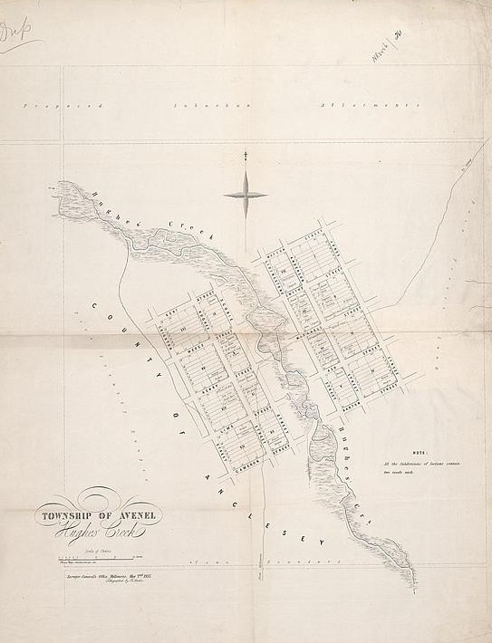

**Figure 25** The Township of Avenel map of the 1800s showing anabranching channel.

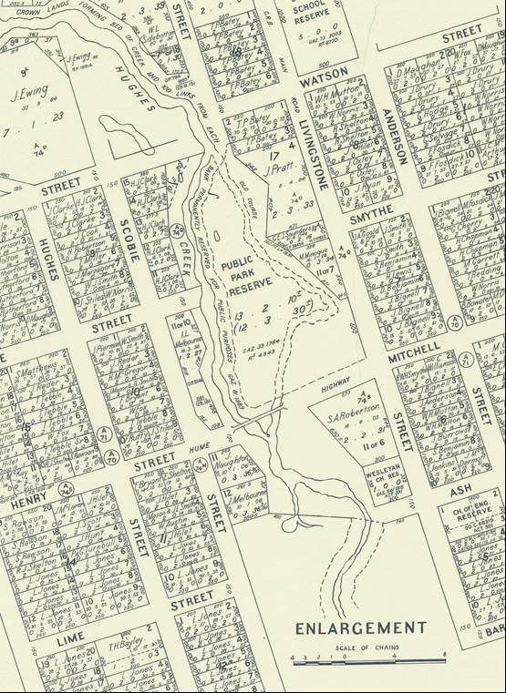

**Figure 26** Excerpt of the Township of Avenel map showing that Hughes Creek did not occupy all of the Hume Highway bridge span when the town was surveyed and that an avulsion had occurred with the “old course” shown on the right bank side of the channel downstream of the Hume Highway.

|  |  |
| --- | --- |
| A  Chain of Ponds  Swamp | B  Chain of Ponds  Swamp |

**Figure 27** (A) Ponkeen Creek showing chain of ponds and swamps on the Parish of Tarcombe map; (B) County Creek showing chain of ponds and swamps on the Parish of Tarcombe map. Ponds and swamps have been destroyed by post-settlement channel incision. Size of Parish map is too small to permit further enlargement.

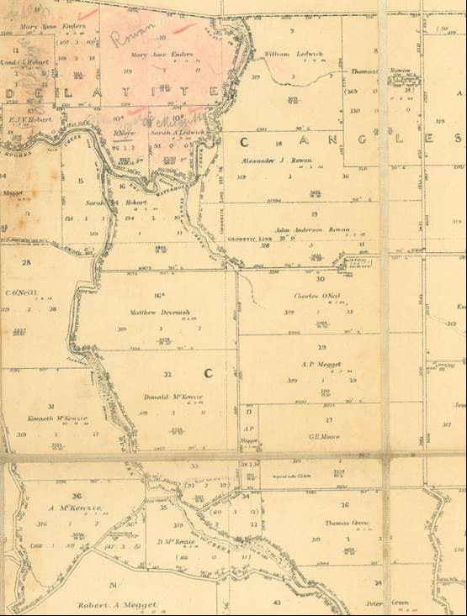

Waterholes

Chain of Ponds

Chain of Ponds

Swamp

Swamp

**Figure 28** Hughes Creek, Emu Waterholes Creek and Stony Creek showing chain of ponds (continuous channel and isolated waterholes) and percolines (swamps) on the Parish of Dropmore map. The area covered includes the Ruffy Chain of Ponds Reach, Terip Terip Percolines Reach and Kendalee Headwaters Reach from Section 3.2 and Figure 13.

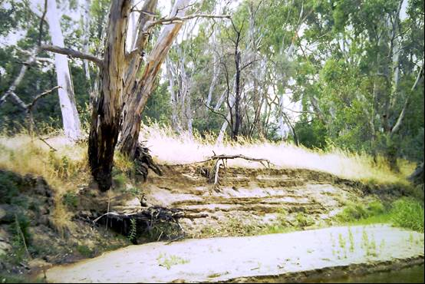

Pre-European floodplain surface

**Figure 29** Pre-European settlement floodplain surface on Hughes Creek at Avenel. The floodplain facies of the sand slug comprises 1 m of interstratified medium, coarse and very coarse sand sediments which bury and have killed *Eucalyptus camaldulensis* trees and contain buried fence posts. Pre-European floodplain sediments are dark coloured massive homogeneous medium sandy mud.

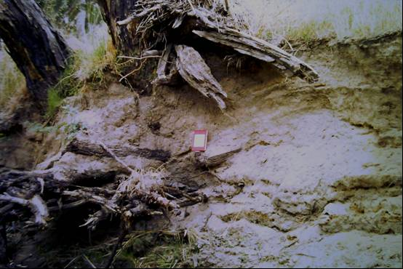

Pre-European floodplain surface

**Figure 30** A close up of the pre-European floodplain surface at Avenel.

## 4.2 Recovery of the sand slug

Erskine (1993a) first recorded that Hughes Creek was starting to recover from the sand slug by bed degradation, bank contraction, vegetation colonization by dense stands of *Phragmites* and substantial sand deposition on the floodplain. Recovery means that downstream sand progradation and aggradation slows or even stops and the slug becomes vegetated. However, he did not identify the time that contraction was initiated. Figure 23 indicates that this contraction had commenced by 1970. A series of photos of Hughes Creek at the old Hume Highway bridges (stone arch and concrete pier bridges) have been compiled from the author’s collection and presented in Figure 31. Minor channel contraction of 2–3 m has occurred immediately upstream of the stone arch bridge between 1991 and 2014 (Figure 31A and B). The present channel only occupies two of the six arches with flood flows occupying a third arch (Figures 31C, D, E and F). The current bed level is about 0.3 m below the bottom of the pile cap on the old Hume Highway bridge and has not changed for the last 23 years (Figures 31G and H). In NSW sand slug recovery has been identified on Wollombi Brook and tributaries by Erskine et al. (2008; 2010) and on the Macdonald River by Henry (1977) and Erskine (1986).

There are two photos of the Avenel stone bridge (Figure 32) which indicate that there was a pool at the bridge which was the local swimming hole (Figure 32). Discussions with Ms Lynj James of the Avenel Neighbourhood House indicate that the photos were taken between 1955 and 1961 when the Avenel Primary School used Hughes Creek for swimming before the local pool was built. Clearly this is after the main sanding period (Figures 23 and 24) and probably represents a period of constriction scour during the high rainfall of the 1950s, 1960s and early 1970s documented in Section 2.3.2 and also mentioned by Davis & Finlayson (2000) in relation to Granite Creeks. Scour would have occurred through the constriction at the arches before the invasion of the former sand aggraded bed by rhizomatous vegetation.

|  |  |
| --- | --- |
| A 27 Nov 1991 | B 28 Apr 2014 |
| C 27 Nov 1991 | D 11 June 2014 |
| E 27 November 1991 | F 11 June 2014 |
| G 26 Jan 1992 | H 11 June 2014 |

**Figure 31** Hughes Creek at the old Hume Highway bridges at Avenel showing partial recovery of the sand slug since at least 1991. (A) and (B) Immediately upstream of Avenel stone bridge showing minor channel contraction between 1991 and 2014. (C), (D), (E) and (F) Avenel stone arch bridge showing the low flow channel and flood channel. (G) and (H) scour below the pile cap on the old Hume Highway bridge. Note that discharge is different between the two dates.

|  |
| --- |
|  |
|  |

**Figure 32** Hughes Creek at the Avenel stone bridge on the original Hume Highway. Photos taken between 1955 and 1961.

## 4.3 Geomorphic impacts of the 2010 flood

The purpose of this section is to document the channel changes on Hughes Creek effected by the flood of 4 September 2010 which was discussed in Section 2.5. These changes will be discussed for each river reach outlined in Table 2.

### 4.3.1 Goulburn Backwater Reach (Reach 1)

Google Earth Pro was used to compare vertical air photos taken on 31 August 2006 and 4 January 2011, unless noted otherwise. The channel changes that occurred between these two dates in this reach were very minor and included:

* Minor trimming of bankside vegetation and emergent macrophytes in the bed;
* Transport and realignment of a few complete dead trees; and
* Erosion of the chute on the left bank of the most upstream bend in this reach.

Being backwater affected, only minor channel changes were expected because of the low stream power.

### 4.3.2 Avenel Recovering Sand Slug Reach (Reach 2)

Examples of channel changes in this reach produced by the September 2010 flood are shown in Figure 33 by before and after flood paired air photos and include:

* Minor but discontinuous bank erosion;
* Minor trimming of bankside vegetation;
* Reactivation of anabranches; and
* Minor sand splay deposition on floodplain.

B

|  |  |
| --- | --- |
| A |  |
| C | D |
| E | F |

**Figure 33** Channel changes produced by the September 2010 flood in Reach 2 of Hughes Creek. Photos on left taken on 31 August 2006 and photos on right, 20 January 2011. (A) and (B) upstream of Goulburn Valley Highway; (C) and (D) at Avenel; and (E) and (F) upstream of Hume Freeway.

### 4.3.3 Booroola Granite-Confined Reach (Reach 3)

Greater channel changes were detected in Reach 3 than further downstream and included:

* Minor bank erosion;
* Extensive sand deposited on side bars;
* Minor channel margin deposition of sand; and
* Extensive sand splays deposited on the floodplain.

### 4.3.4 Kulaba Hornfels-Confined Reach (Reach 4)

The January 2011 air photos show extensive sand bars in the channel and sand splays on the floodplain right through this reach. Figure 34 shows a sand-infilled anabranch after the 2010 flood. Riffle zones were significantly blanketed by sand and pools were also infilled. Recovery has already started.

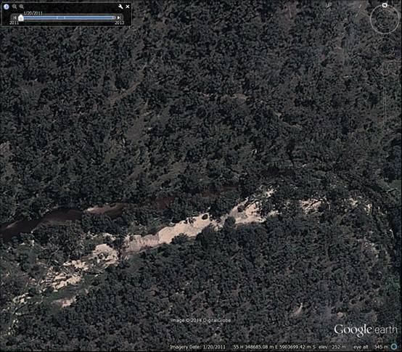

**Figure 34** Anabranch infilled with sand by the September 2010 flood in Reach 4 of Hughes Creek.

### 4.3.5 Bungle Boori Granite-Confined Reach (Reach 5)

Reach 5 was also significantly impacted by the 2010 flood with much sand being deposited in the bed, on channel margins, on bars and benches, and on the floodplain. There were no obvious sand inputs to the channel at tributary junctions so that the flood deposits appeared to be derived by reworking of sand storages within the reach. This is an important conclusion because it indicates that the catchment was disconnected from the main channel as a sand source during the September 2010 flood.

Figure 35 shows the range of sand deposits laid down by the September 2010 flood in Reach 5. They ranged from very discontinuous (Figure 35A) to blanketing bars and benches (Figure 35B) to extending right across the channel margin and floodplain (Figure 35C and D). All four sites in Figure 35 are located downstream of Bungle Boori although sand deposition continues upstream nearly to the downstream boundary of Reach 6. Again channel recovery is now well advanced.

|  |  |
| --- | --- |
| A | B |
| C | D |

**Figure 35** Various parts of Hughes Creek in Reach 5 on 20 January 2011. The sand was derived from reworking of channel sand storages within the reach by the September 2010 flood.

### 4.3.6 The Peak Granite Gorge (Reach 6)

Minor sand deposition was noted in the upstream part of this gorge, upstream of the Boundary Creek junction. No obvious sand erosion was apparent on Woolshed Creek so the sand was most probably derived by the reworking of sand stores in the flatter parts of the gorge.

### 4.3.7 Dropmore Granite-Confined Reach (Reach 7)

There was minor reworking of sand stores upstream of Dropmore on the inside bend of the big loop below Mt Tickatory. No detectable changes were found elsewhere in this reach.

### 4.3.8 Springfield Granite Gorge (Reach 8)

No detectable channel changes were produced by the September 2010 flood in Reach 8.

### 4.3.9 Ruffy Chain of Ponds Reach (Reach 9)

No detectable channel changes were produced by the September 2010 flood in Reach 9.

### 4.3.10 Terip Terip Percolines Reach (Reach 10)

No detectable channel changes were produced by the September 2010 flood in Reach 10.

### 4.3.11 Kendalee Headwaters Reach (Reach 11)

No detectable channel changes were produced by the September 2010 flood in Reach 11.

### 4.3.12 Conclusions

The overwhelming conclusions to be drawn from the above are that the September   
2010 flood:

1. Did not cause any channel changes in the headwater reaches (Reaches 8, 9, 10 and 11) of Hughes Creek;
2. Significantly reworked temporary sand stores only in the middle reaches of Hughes Creek (Reaches 3, 4 and 5) where there are Macquarie perch;
3. Caused minor channel changes in the remaining river reaches (Reaches 1, 2, 6 and 7); and
4. Channel recovery is now well advanced in the most impacted reaches (Reaches 3, 4 and 5).

There is now a disconnection of sand supply from the catchment to the channel of Hughes Creek. Therefore, future floods are unlikely to cause as much remobilisation of sand as the September 2010 flood. It is now essential that riparian revegetation, fencing and off-channel stock watering are extended as fast as possible in Reaches 3, 4 and 5 of Hughes Creek, on Bunding Creek and on untreated sections of Stewart, County and Ponkeen creeks. Stock exclusion and riparian revegetation in Reach 4 are essential because it is the Macquarie perch stronghold (see subsection 5.4). No additional road access to Reach 4 should occur because it is important to restrict access to the Macquarie perch stronghold.

## 4.4 Geomorphic model of historical channel changes on Hughes Creek

Figure 36 shows a schematic of changes in river bed longitudinal profiles of Hughes Creek in Reaches 2, 3, 4 and 5 and major tributaries, except Buckland and Bunding creeks, since 1800. Figure 37 extends the schematic to channel and floodplain cross sections for the same reaches and tributaries for the same time period.

Low order channels exhibited swampy reaches with percolines and chain of ponds at the time of first settlement. The tributaries eroded at different times but most had undergone at least one phase of incision by 1970. Following initial incision, the tributaries stored substantial amounts of sand for a short time period after which the sand was reworked and removed. Where riparian revegetation and fencing have been completed colonisation by rhizomatous emergent macrophytes has occurred and chain of ponds have reformed. Where no riparian fencing and revegetation have been completed, the sand has been totally removed and the formerly incised channel has started to recover slowly by revegetation.

HUGHES CREEK

REACHES 2, 3, 4 & 5

1830

TRIBUTARIES

1830

2014

Recovering Sand Slug

Ponds

2014

1970

Sand Slug

1950

Incised Channel

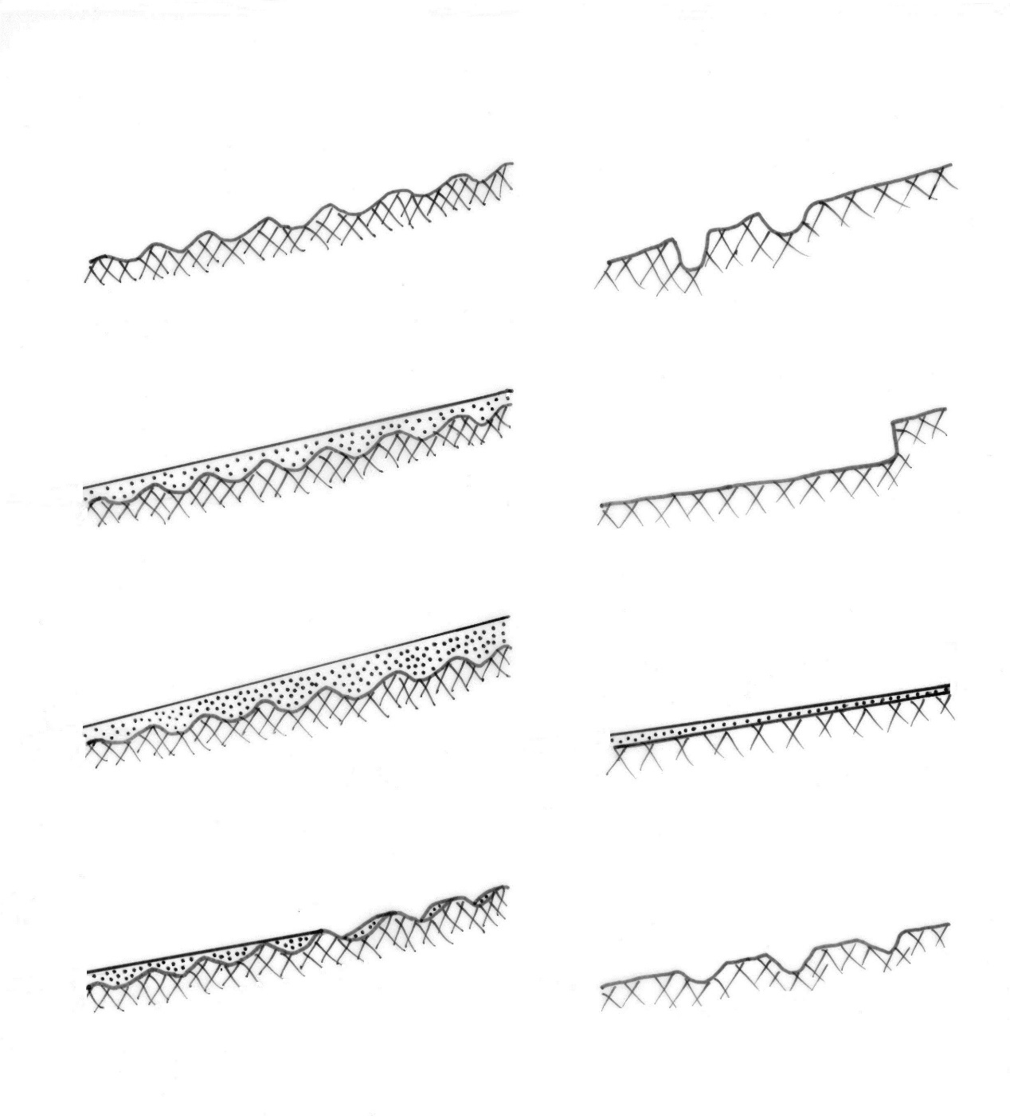

1970

Pools, Riffles, Runs

1916

Sand Slug

Ponds

Percolines

**Figure 36** Evolution of Hughes Creek in Reaches 2, 3, 4 and 5 and tributaries, except Buckland and Bunding creeks, since European settlement

Hughes Creek, was characterised by pools, runs, riffles and bars at the time of first settlement. The 1916 flood marked the erosional finale of the post-settlement phase of erosion on Hughes Creek, which produced an extensive sand slug in Reach 2 but with sand aggraded sections further upstream also. A reduction in sand input after 1970 resulted in reworking of sand in the bed with progressive bed degradation which also contracted the channel. Rhizomatous emergent macrophytes colonised and stabilised the channel margins and hastened the rate of contraction. There is currently a decoupling of the catchment from the channel network in terms of sand sources because of the extensive Landcare activities and improved farm management that have been completed. There is still a large amount of sand stored in the channel which has impacted on the quality of aquatic habitat to support Macquarie perch. This is discussed further below.

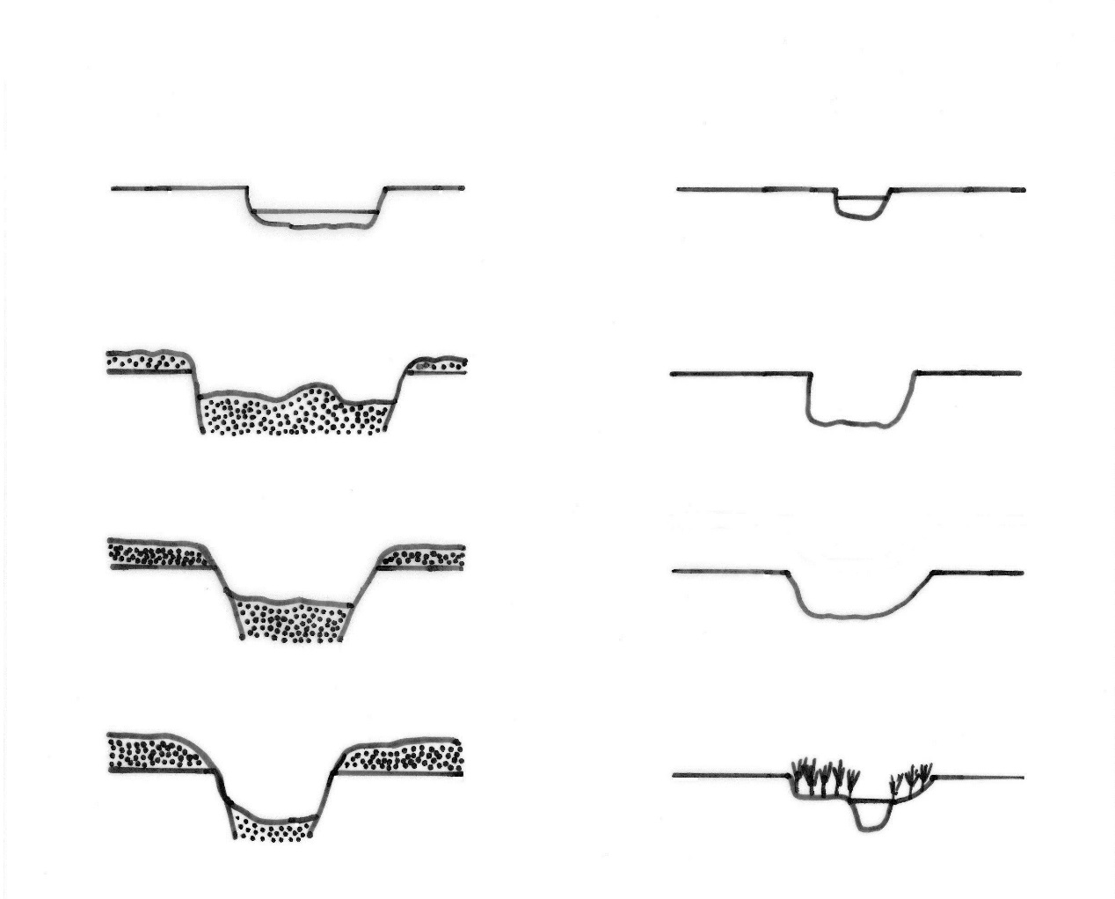

2014

Recovered Incised Channel

Pond

2014

Recovering Sand Slug

1970

Recovering Sand Slug

1970

Recovering Incised Channel

1950

Incised Channel

TRIBUTARIES

1830

Pond

HUGHES CREEK

REACH 2

1830

Pool

1916

Sand Slug

**Figure 37** Evolution of Hughes Creek in Reach 2 and tributaries, except Buckland and Bunding creeks, since European settlement.

# 5 Macquarie perch

## 5.1 Taxonomy

According to Harris & Rowland (1996) it is likely that there are two species of Macquarie perch, one in western (Murray-Darling basin) and the other in eastern-flowing rivers (Nepean, Georges and Shoalhaven rivers), respectively (Figures 38 and 39) but with the possibility of other genetic groups within these species. However, separate species have not yet been described. The unpublished thesis of Dufty (1986) established morphological and allozyme differentiation between populations from west and east of the continental divide. Allen et al. (2003) and Lintermans (2009) agreed with Harris & Rowland (1996) that Dufty’s (1986) research demonstrated separate species. The Hughes Creek population belongs to the western species. Translocated western species are also present in ‘eastern’ rivers, such as the Yarra River near Melbourne and the Mongarlowe River near Braidwood (Harris & Rowland 1996, Lintermans 2009). The Eastern species is present in the Nepean, Georges and Shoalhaven rivers but translocated western species

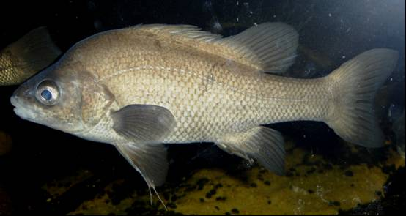

**Figure 38** Western Macquarie perch (*Macquaria australasica*) from the Murray-Darling River system.

|  |  |
| --- | --- |
|  |  |

**Figure 39** Eastern Macquarie perch (*Macquaria* nov. sp.) from the Nepean River system. Specimens are starting to turn mottled.

are also present in Cataract Dam (Nepean system) and Mongarlowe River (Shoalhaven system)(Harris & Rowland 1996, Lintermans 2009, Knight 2010).

The Eastern species is smaller than, and unusually exhibits a range of colours that appear, at least to this author, to be stress-related. From the author’s observations, undisturbed Eastern specimens are black but rapidly turn mottled when captured and, if kept for some time (hours), can turn white or very pale. Observations of fish kept in aquaria indicate that the stressed fish slowly return to mottled to black over 1–2 days. Merrick & Schmida (1984: Figures 183 and 184) show examples of the black and mottled colours, and Figure 40 shows mottled specimens from the Nepean River system. The Western species varies from black-grey to bluish grey although Lintermans (2009) notes that some individuals are distinctly mottled, particularly small juveniles and Kearns (2009) noted sressed western Macquarie perch were pale in colour.

|  |  |
| --- | --- |
|  |  |

**Figure 40** Left: Eastern Macquarie perch (*Macquaria* nov. sp.) from Erskine Creek about to have caudal fin clipped for genetic analysis by Dr Peter Unmack. Note onset of mottling. Right: Eastern Macquarie perch (*Macquaria* nov. sp.) from Nepean River being kept in bucket before having caudal fin clipped for genetic analysis by Dr Wayne Erskine. Specimens have already turned mottled.

Recent genetic analyses (mtDNA) by Faulks et al. (2010) indicate that there are probably three species of Macquarie perch; one in the Kangaroo River (Shoalhaven River system) and likely to be extinct; one in the Hawkesbury-Nepean River; and one in the Murray-Darling River. However, translocations have resulted in interbreeding/hybridisation between the Hawkesbury-Nepean and Murray-Darling species, complicating the genetic picture and having profound implications for conservation (Faulks et al. 2010). Dispersal of Macquarie perch from the Shoalhaven to the Hawkesbury-Nepean occurred ~2 mya and from the Hawkesbury-Nepean into the Murray-Darling Basin ~657 kya (Faulks et al. 2010). Faulks et al. (2011) also found no evidence of significant amounts of recent gene flow across the continental divide supporting their above finding of taxonomic distinction between the western and eastern populations.

## 5.2 Conservation Status

Western Macquarie perch are classified as endangered in Victoria under the Flora and Fauna Guarantee Act 1988, as endangered in the ACT under the Nature Conservation Act, as endangered in NSW under the Fisheries Management Act 1994 and nationally endangered under the Environment Protection and Biodiversity Conservation Act 1999. The Australian Society for Fish Biology also maintains a list of the conservation status of Australian freshwater fish and Macquarie perch is listed as endangered.

Of the eastern form, the ‘Shoalhaven’ species may be extinct and the Hawkesbury-Nepean Eastern form is under threat from the relatively recent introduction of the alien *Perca fluviatilis* and the fish virus, epizootic haematopoietic necrosis virus (EHN) carried by redfin perch (Knight 2010). Hammer et al. (2013) concluded that the ‘Shoalhaven’ species of Macquarie perch is the first documented extinction of an Australian freshwater fish, albeit of an undescribed species. Some populations of Macquarie perch have been locally extirpated since European settlement and most others have been greatly reduced in abundance (Cadwallader 1978, 1981, Lintermans 2013).

Causes of population decline include overfishing, increased competition following introductions of alien species (*Perca fluviatilis* and salmonids), habitat decline and fragmentation, sedimentation, thermal pollution, streamflow changes, installation of anthropogenic barriers and susceptibility to the EHN virus (Cadwallader 1978, 1979, 1981, Erskine 1996a, Ingram et al. 2000, Koster et al. 2014).

## 5.3 Life History

Macquarie perch is an obligate riverine spawner (rock and gravel spawners with benthic larvae – King et al. 2013) that seems susceptible to drought and water quality impacts on recruitment success (Lintermans 2013). The conditions required for the spawning of wild Macquarie perch have been discussed, to varying degrees, by Wharton (1968, 1973), Cadwallader & Rogan (1977), Cadwallader & Backhouse (1983), Gooley (1986), Cadwallader (1986), Battaglene (1988), Koehn & O’Connor (1990), Tonkin et al. (2010) and Koster et al. (2014). Wharton (1968, 1973) found that Macquarie perch in Lake Eildon schooled and migrated a short distance up the inflowing rivers for spawning when water temperatures were at least 16.5°C during spring and early summer. Flow velocities of 0.4–1.2 m/s were measured over spawning areas and fertilised eggs were found adhering to gravels in clear running water. Cadwallader & Rogan (1977) listed the following characteristics of spawning sites for this species on the rivers flowing into Eildon Reservoir:

1. A substrate of small boulders, pebbles and gravels

2. Water depths of 0.2–0.9 m but usually 0.4–0.6 m

3. A flow velocity of 0.3–0.6 m/s

4. A pool, usually 15–30 m long and greater than 1.5 m deep, immediately upstream of the spawning site

5. Fast-flowing broken water immediately downstream of the spawning site, and

6. Water temperatures of at least 16.5°C.

Cadwallader & Backhouse (1983) found that spawning may occur over the same gravel bed for about two weeks. Tagging experiments showed that Macquarie perch used the same river for spawning year after year.

Cadwallader & Rogan (1977: 413-5) described the spawning process thus:

“Spawning fish took up positions 0.6–1.8 m upstream of the head of a riffle area and on or near the downstream lip of a pool. Females……remained close to the substrate, usually in groups of two to four, and were accompanied by one or two males. Males were seen to nudge the females in the region of the vent. During those times of the day when the water temperature fell below 16.5°C the fish moved to the pool upstream of the spawning bed and returned to the downstream lip of the pool only when the critical temperature was again approached.

On release, the cream-coloured eggs had a diameter of 1–2 mm but became transparent and increased to about 4 mm diameter 20–30 min after fertilization. The eggs and milt were swept dowmstream until the adhesive eggs lodged between small boulders and pebbles. Most eggs were found more than 30 m downstream. Eggs hatched after 10–18 days and the newly hatched alevins sheltered amongst the pebbles.”

Cadwallader & Rogan (1977: Figure 2) mapped the distribution of eggs, empty shells and alevins in a Macquarie perch spawning bed on the Goulburn River and showed that the eggs could be washed more than 44 m downstream (no flow conditions, bedforms, substrate size and habitat characteristics were specified). Gooley & McDonald (1988) found that female perch which produced eggs which were fertilized were recovered from areas in Lake Dartmouth, Vic with daily minimum water temperatures of 7–21°C and with daily maximum water temperatures of 13–21°C. Fertilized eggs hatch in 13–18 days, depending on temperature, when the larvae are about 7 mm long (Battaglene 1988).

Broadhurst et al. (2012) found that Macquarie perch in Cotter Dam (Cotter River, ACT) migrated out of the reservoir to spawn and that the construction of a fishway at an artificial road barrier increased the length of river in which spawning occurred and juveniles were subsequently found. Broadhurst et al. (2013) proposed that a new self-sustaining riverine subpopulation of Macquarie perch established upstream of the former barrier but that Macquarie perch were slow dispersers and colonisers.

Research on the Burrinjuck Dam population of the Western species was conducted by Ms J. Burchmore who then worked for NSW Fisheries but this research has never been written up. The Burrinjuck population has since crashed and may no longer exist (Lintermans 2009). This is most likely due to the presence of *Perca fluviatilis* and the introduction of the EHN virus.

Lintermans (2013) documented the translocation of a population of Macquarie perch in Googong Dam, ACT to above a natural barrier, Curleys Falls, on the Queanbeyan River and the dynamics of the translocated population between 1980 and 2010 in a 17 km length of the river between two natural barriers. The population first declined then recovered before declining again during the Millenium drought. While fyke nets were the most effective capture method, Macquarie perch are long-lived (up to 26 years) and can be difficult to capture. Furthermore, long monitoring programs are essential to determine population trends (Lintermans 2013).

Tonkin et al. (2010) observed the spawning of the Lake Dartmouth population of Macquarie perch in the Mitta Mitta River, Vic in 2008 and 2009. While this work essentially confirmed the above results of Cadwallader & Rogan (1977) for Lake Eildon, it is important that the spawning conditions of Macquarie perch are well known. Tonkin et al. (2010) found that Macquarie perch moved out of the lake and held in pools, particularly the first upstream of the dam backwater. A natural rock barrier prevented fish from moving more than 3 km upstream from the lake in 2008 and 200 m in 2009 (higher lake level). Fish aggregations preferred the tail end of pools in slower-flowing areas with large wood, undercut clay banks or boulders. Fish in groups of two or three appeared to display courting behaviour such as rolling, chasing and nudging in areas of faster flow. Macquarie perch eggs were subsequently collected from these areas. Surface water temperatures were always above 16°C during spawning which was not flow dependent. Spawning seems to occur each year over several months.

Koster et al. (2014) examined movements of Macquarie perch in the Yarra River, Vic during the spawning season by radio-telemetry. They found complex, non-synchronous movements during the 2011 spawning season with most fish located in pools. Fish occupied restricted home ranges (<450 m) and there were no congregations of tagged fish either within or in the vicinity of riffles during the spawning season. However there was minimal evidence of spawning during the 2011 spawning season.

## 5.4 Distribution of Macquarie perch in Hughes Creek

Historically, Macquarie perch used to extend upstream on Hughes Creek to “Tarcombe” (Trueman & Luker 1992, Trueman 2012). This could mean either Bungle Boori or Tarcombe homestead. In the author’s opinion, Macquarie perch should be able to pass the low bedrock steps at Bungle Boori during floods (Figure 41) but would not be able to pass the higher, steeper more turbulent bedrock steps of The Peak Granite Gorge downstream of Dropmore (Figure 42). Furthermore, The Peak Granite Gorge is upstream of the confluence with Ponkeen, County and Stewart creeks. Therefore, discharge and hence flow depths are likely to be much less than at Bungle Boori. Trueman & Luker (1992) and Trueman (2012) concluded that Springfield Granite Gorge was a natural barrier to the passage of all native fish species. While climbing species like some of the morphotypes of *Galaxias olidus* would be able to climb the high energy bedforms (Raadik 2011), it is not known if these morphotypes inhabit Hughes Creek.

|  |  |
| --- | --- |
|  |  |

**Figure 41** Low bedrock steps at Bungle Boori on Ponkeen Creek Road.

|  |  |
| --- | --- |
|  |  |

**Figure 42** The lowest bedrock steps at the downstream end of The Peak Granite Gorge. There are steeper, shallower and more turbulent steps further upstream.

Anon (2007) conducted fish surveys of Hughes Creek in April 2006 at six sites in Reaches 2, 3, 4 and 5 between Avenel and Bungle Boori (Table 7) and in March 2007 in the same reaches as in 2006, except that the Boathole in Reach 9 (upstream of the very steep Springfield Granite Gorge)(Figure 43) was also inspected and described but not sampled. Macquarie perch were caught in Reaches 2, 3, 4 and 5 (Table 7). Macdonald (2008) also sampled an additional two sites on lower Hughes Creek (Reaches 1 and 2) and conducted filming of the population in Reach 4, which is the stronghold for Macquarie perch in Hughes Creek. Reach 4 consists of resistant hornfels which have created a more bedrock-confined reach than the granite bedrock-confined reaches further up- and downstream (Table 2). Macquarie perch were only found in Reach 4 (Table 7) but other Macquarie perch strongholds were not sampled. Macdonald (2008) also found the anchor worm parasite, *Lernaea* sp., on Macquarie perch in Hughes Creek.

|  |  |
| --- | --- |
| Feb 1995 Boat Hole |  |

**Figure 43** Left: Boathole in February 1995; Right: Boathole on 30 April 2014. This ‘hole’ corresponds to what have been called ‘natural ponds’ or ‘chain of ponds’.

Kearns (2009) sampled eight sites in Reaches 2, 3, 4 and 5 for Macquarie perch in March 2009 during a severe dry spell of the Millenium drought. Again *Lernaea* sp. was found on Macquarie perch and four dead Macquarie perch were collected in two pools in Reaches 3 and 4 where dissolved oxygen concentrations were less than 3 mg/L. The abundance of Macquarie perch was much less than for the previous surveys and no recruitment had occurred during the previous year. Kearns & Lyon (2010) removed Carp from eight sites on Hughes Creek before returning 32 individuals of Macquarie perch on 16 December 2009 that had been removed during a severe dry spell of the Millenium drought. One Macquarie perch was captured in Reach 4 during their electrofishing (Table 7).

Kearns et al. (2011) sampled Hughes Creek for Macquarie perch at seven sites in Reaches 2, 3, 4 and 5 in autumn 2011 and only found Macquarie perch at two sites in Reach 4 (Table 7). No young of year were captured, as in 2009. Kearns et al. (2012) sampled nine sites in Reaches 2, 3, 4 and 5 in March 2012. Only nine Macquarie perch were captured at three sites in Reaches 4 and 5 (Table 7). Significant recommendations were made for the survival of Macquarie perch and are repeated below in the next section, where relevant.

Kearns et al. (2013) sampled the same nine sites as in 2012 in March 2013 and found an increase in Macquarie perch abundance. Furthermore, two young of year fish were collected but no previously PIT or t-bar tagged fish. Carp also increased in abundance and extended their range further upstream in Reach 5. Figure 6 in Kearns et al. (2013) shows alarming sand deposition at a site in Reach 4 where a pool with a reasonable load of large wood was totally infilled between July 2009 and March 2013. This was a consequence of the September 2010 flood discussed in Subsection 4.3. Macquarie perch captured in Reach 3 exhibited signs of stress with pale body colour and the presence of the parasite, *Lernaea sp.* Bond (2004) found that this parasite can stress native fish already stressed by drought exacerbating the effects of drought.

Table 7 Results of sampling for Macquarie perch in Hughes Creek between 2006 and 2013. Not all surveys targetted specifically Macquarie perch.

|  |  |  |  |  |
| --- | --- | --- | --- | --- |
| **Year** | **No of Sample Sites** | **No. of Sites at which Macquarie perch were caught** | **Average No. of Macquarie perch per site** | **Source of data** |
| 2006 | 6 | 4 | 5.0 | Anon (2007) |
| 2007 | 7 | 3 | 9.0 | Anon (2007) |
| 2007 | 2 | 0 | 0 | Macdonald (2008) |
| 2009 | 8 | 3 | 6.6 | Kearns (2009) |
| 2009 | 8 | 1 |  | Kearns & Lyon (2010) |
| 2010 | NS | NS | NS | NS |
| 2011 | 7 | 2 | 2.1 | Kearns et al. (2011) |
| 2012 | 9 | 3 | 1.0 | Kearns et al. (2012) |
| 2013 | 9 | 4 | 2.9 | Kearns et al. (2013) |

NS – Not sampled

While Macquarie perch are still present in Hughes Creek, they are restricted predominantly to Reaches 3, 4 and 5. The sand slug limits their downstream dispersion and poor habitat quality and multiple migration barriers limit their upstream dispersion. Their population is highly variable and susceptible to reduced abundance during severe droughts. As pools are drought refuges, pool enhancement work would increase the survival of Macquarie perch during droughts. As gravel riffles are required as spawning sites, recruitment and hence recovery from hydrological and anthropogenic disturbances would be hastened by increasing the length, number and condition of riffles. Both actions would increase the resilience of the remaining population and help ensure a viable population. However, Emeritus Professor Lake highlighted in his comments on the draft manuscript that sand slugs are characterised by low macroinvertebrate productivity (Downes et al. 2006) and, as a result, Macquarie perch may be starved for food where sand slugs have occurred. This is an important point that further highlights the need for reinstatement of gravel patches on Hughes Creek even if the effects may be inconsistent between sand-bed streams (Downes et al. 2006). Furthermore, Carp may have a competitive advantage over Macquarie perch for accessing invertebrates in sand slugs (PS Lake, 2014, personal communication).

# 6 Recommended River and Catchment Management Works to Improve the Macquarie perch population and Fish Habitat

To improve the Macquarie perch population and aquatic habitat in Hughes Creek it is necessary to address, to varying degrees, all of the following issues in various reaches:

1. Reduced sand supply from the catchment to Hughes Creek, especially upstream of reach 4

2. Reduced sand flux by Hughes Creek, especially downstream of reach 6

3. Improved riparian vegetation condition and density on Hughes Creek in all reaches but especially reaches 2, 3, 4 and 5

4. Increased length of gravel riffles and gravel patches in reaches 3, 4 and 5

5. Increased number, length and depth of refuge pools in reaches 3, 4 and 5

6. Construction of pool improvement works in reaches 3, 4 and 5

7. Reduced competition from alien fish species downstream of reach 6

8. Effective monitoring and species management of the Macquarie perch population in Hughes Creek in reaches 2, 3, 4 and 5.

Each issue is discussed below. The purpose of these works is to:

* Increase population size of Macquarie perch,
* Extend the species range of Macquarie perch on Hughes Creek,
* Increase connectivity between patches of suitable habitat for all life cycle stages of Macquarie perch,
* Improve aquatic habitat of Macquarie perch, and
* Improve spawning areas of Macquarie perch (Anon 2007, Macdonald 2008).

The areas where each issue applies are listed in the following subsections and in Table 8. The priority of each action is outlined. *Priority 1* means it is essential and should be conducted whenever funding permits. The letter subscripts rank works within a priority group in alphabetical order. Priority 2 is needed works but the time needed to achieve a measureable outcome is usually much longer than Priority 1. Priority 3 requires even longer time than Priority 2 and will realistically not be carried out in the short-term despite requiring a long time period to succeed.

Table 8 Recommended river and catchment management works to improve the Macquarie perch population and habitat on Hughes Creek and the location and priority of each work.

|  |  |
| --- | --- |
| **Recommended River and Catchment Management Works to Improve Fish Habitat** | **Location/ Relevant Reach** |
| Reduced sand supply | Strathbogie Batholith, especially upstream of ‘Booroola’. The recommended works are catchment works and are best implemented by Landcare groups and farmers. Priority 2a because previous works have been highly successful but still need to be expanded. |
| Reduced sand flux | The most sensitive reach is Reach 4 so the bulk of works should be undertaken upstream in Reach 5, and tributaries (Bunding Creek and untreated sections of Stewart, Ponkeen and County creeks). Priority 1a because sand decreases the amount of available habitat and reduces suitability of riffle spawning areas. Sand slugs can cease to move when sand supply is greatly reduced rapidly transforming sand slugs to pool-riffle sequences (Erskine 2008).  To re-establish connectivity to the Goulburn River, works are required initially in Reach 3 and the upstream section of Reach 2 (upstream of Avenel). Priority 3 because it will take at least 20 years for pools to reform and sand to coarsen to gravel. |
| Improved Riparian Vegetation | The most sensitive reach is Reach 4 so the bulk of works should be undertaken in Reach 4 and upstream in Reach 5, and tributaries (Bunding Creek and untreated sections of Stewart, Ponkeen and County creeks). Priority 1a because this is the main way of achieving reduced sand flux.  To re-establish connectivity to the Goulburn River, works are required initially in Reach 3 and then in Reach 2. No works will be required in Reach 1. Priority 3 because this will take a long time to be successful (decades). |
| Increased Length of Gravel Riffles | The most sensitive reaches are Reaches 4, 3 and 5. Any works should be undertaken in this sequence. Priority 1b because recruitment of Macquarie perch is dependent on the presence of good quality, clean, gravel riffles. |
| Increased number, length and depth of pools | The most sensitive reaches are Reaches 4, 3 and 5. Any works should be undertaken in this sequence. Priority 1c because sand flux must be reduced first. |
| Construction of pool improvement works | The most sensitive reaches are Reaches 4, 3 and 5. Any works should be undertaken in this sequence. Any pool with a population of Macquarie perch should not be disturbed unless the fish are captured and temporarily kept at Snobs Creek facility as per Kearns (2009). Priority 1c because these are the core refuge areas and must be maintained. |
| Reduced competition from alien fish species | The most sensitive reaches are Reaches 4, 3 and 5. Priority 1c because alien fish species, especially *Perca fluviatilis* and the EHN virus, are a threat to Macquarie perch. |
| Effective monitoring and species management | The most sensitive reaches are Reaches 4, 3 and 5. Priority 1c because it is essential that the success of any works can be assessed and that the status of the Macquarie perch population is continuously updated. |

## 6.1 Reduced sand supply

Episodic but large fluxes of sand are still being transported by Hughes Creek in some reaches despite the completion of river and catchment management works (see Section 4.3), riparian fencing and revegetation, improved farm management, on-farm plantings of trees, pasture improvement and the like (Halsall 1978, Barwick 2008). Ian Drummond & Associates (1984) recommended land use planning, soil conservation works , fencing and other actions for the Hughes Creek catchment to address the then source of sand. While it was concluded in Section 4.3 that the catchment is now disconnected from Hughes Creek in terms of sand supply, renewed connection must be prevented at all costs. However, the implementation of Landcare, soil conservation and farm management works is highly dependent on funding which is episodic and which often reflects priorities not addressing these issues. Reduced water and sediment yields from the catchment are likely to stabilise channel units and convert sandy units to gravel (Wolman 1967).

To reduce sand supply to Hughes Creek, as much sand as possible should be retained on farm and in the catchment and hence should not be delivered to the channel network. Sand in the channel network can be transported faster and more efficiently than it can be eroded by overland flow. Pastures should be maintained in good condition because percentage ground cover is the most important variable minimising surface runoff and soil loss (Costin et al. 1960). Indeed, Lang (1979) found that surface runoff data for experimental plots in NSW showed that ground cover influenced both the occurrence and magnitude of runoff, with 75% ground cover a critical value above which runoff was slight but below which runoff increased rapidly. Lang & McCaffrey (1984) reported that soil losses from experimental plots with a ground cover of 75% are much less than rates of soil formation and that rates of soil loss increase at a faster rate with decreasing ground cover. Costin (1980) reported a similar threshold value of ground cover of 70% for improved pasture to reduce runoff and soil erosion in NSW. These results are very important for farm management and highlight the need to maintain pastures with at least 70–75% ground cover to reduce surface runoff and soil erosion, especially during the dry summer period. Landcare Groups and farmers are needed to continue protection of the chain of ponds and percolines of geoheritage significance in the upper catchment. The Hughes Creek Landcare Groups target the main sand sources to Hughes Creek and the Hughes Creek Catchment Collaborative is a good body to set priorities and targets for the whole catchment.

There are also small-scale mass movements in the Strathbogie Ranges. The landslide scars should be vegetated and the steepest slopes should be reafforested to prevent the reoccurrence of mass movements. While many mass movements are disconnected from the channel network, gully development and the collapse of soil pipes can rapidly connect mass movements with the channel network.

Tree planting should also be extended because of the excessive clearing in areas devoid of granite tors or boulders. While tree planting has been conducted as part of the Landcare works in the catchment (Barwick 2008), there is still opportunity for further plantings. Furthermore, salinity is a significant process and appropriate plantings will have a double benefit of reducing the area of salinity and reducing soil erosion.

## 6.2 Reduced sand flux

Reduced sand flux refers to reduced transport rates of sand. If sand delivery to the channel is reduced then sand stores in the channel will be initially reworked to maintain sand loads, as demonstrated during the September 2010 flood for Reaches 3, 4 and 5 on Hughes Creek. It is essential that natural channel adjustments are allowed to occur which reduce sand fluxes over time by reducing mean flow velocity or bed shear by exposing larger areas of armoured gravel, by maintaining and, where possible, increasing submerged and emergent rhizomatous macrophytes, by introducing large-scale roughness elements, such as large wood, by increasing the number and dimensions of pools to reduce flow velocity and by increasing the resistance of bar and bench surfaces by establishing vegetation.

By reducing sand fluxes the extent of sand slugs will be reduced, as first recommended by Ian Drummond & Associates (1984). This should enable the return of pool-riffle sequences with gravel riffles which are preferred by Macquarie perch for spawning. Revegetating riparian zones will increase the amount of sand in storage and also reduce the extent of sand slugs. Kearns et al. (2012) independently of this investigation also recommended a feasibility study for sand extraction from Hughes Creek above Reach 4 in Reach 5. This author believes that extraction should be encouraged by the Goulburn Broken Catchment Management Authority in Reaches 5 (upstream of the Macquarie perch stronghold), 3 (contains Macquarie perch) and the upstream part of Reach 2 near and downstream of Avenel. The purpose of the recommendation for Reach 5 is to reduce sand inputs to Reach 4 which is the best Macquarie perch habitat. Extraction from Reach 3 should be restricted to where there are no refuge pools containing Macquarie perch. Extraction here would accelerate the recovery of the downstream sand slug. Extraction from Reach 2 would also accelerate recovery of the sand slug with the purpose of reconnecting Hughes Creek to the Goulburn River for the unrestricted movement of Macquarie perch.

Appropriate sand extraction should be permitted where it will not disturb existing native vegetation, natural pools and gravel riffles. While it is always difficult to define “appropriate” extraction, such works would usually involve the removal of relatively small but prescribed quantities of sand at locations that will not be destabilised by the activity and that do not produce detrimental off-site environmental effects. It is ***recommended*** that sand quantities from 100 to a maximum of 5000 m3 only be approved where extraction will occur in areas with low environmental risk, such as:

1. on the inside of large radius bends
2. in a sand aggraded section dominated by bars
3. where the river bank will not be disturbed by the excavations (20 m undisturbed buffer distances are recommended)
4. where there are no riparian trees and shrubs to be damaged
5. where trucks do not need to cross the channel at a splash crossing or a pipe culvert that could act as artificial fish barriers
6. where the sand is relatively clean and contains minimal amounts of charcoal, silt and clay that could form a turbidity plume (water quality barrier to fish passage) when extracted and
7. where gravels are not removed from the channel. A screen of 10–20 mm diameter could be used to screen all sand removed from the channel, the material retained on the screen being returned to the channel to help form gravel riffles and armour layers.

Detrimental off-site environmental effects of extraction must not occur and include but are not limited to:

* up- and downstream progressing bed degradation (Galay 1983, Erskine 1990, Erskine & Green 2000)
* bank erosion caused by bed degradation (Erskine & Green 2000)
* loss of gravel armour layers (Erskine et al. 1985; 1996)
* increased turbidity and turbidity plumes (Erskine 1990)
* damage to riparian vegetation
* creation of artificial fish barriers by the installation of bunds, splash, pipe or   
  culvert crossings.

The Goulburn Broken Catchment Management Authority should consider the development of an extraction policy for Hughes Creek and should be the responsible management authority.

## 6.3 Improved riparian vegetation condition

Riparian-stream fish linkages are numerous for both direct and indirect secondary effects, and an array of tertiary impacts are mediated by direct and indirect impacts of fish on other organisms (Pusey & Arthington 2003). Riparian revegetation can help conserve freshwater biodiversity by re-establishing linkages between riparian systems and stream fish (Pusey & Arthington 2003). However the persistence of impacts between riparian zone degradation and stream fish communities can be much longer than commonly assumed (Harding et al. 1998).

Macquarie perch in Hughes Creek selected shaded overhanging vegetation in pools as refuge habitat as well as areas with large wood (Anon 2007, Macdonald 2008). To extend the range of Macquarie perch it is necessary to fence river frontages, provide off-channel stock watering points and reduce stock access to the riparian zone (Macdonald 2008) so as to improve the condition of riparian vegetation. Riparian revegetation, especially with species that are not recruiting at the same rate as common species, also needs to be undertaken. Anon (2007) noted that Macquarie perch were often associated with *Callistemon sieberi* and *Carex fascicularis* on Hughes Creek. Clearly these two species plus others should be included in any replanting programs which must only include native species.

As much sand as possible should be stored within the channel network and consolidated with vegetation so that it is not transported further downstream. Riparian fencing, riparian revegetation and appropriate stock watering are all important aspects of this strategy. Rhizomatous plants are important in colonising and stabilising sand (Erskine & Chalmers 2009, Chalmers et al. 2012). Grasses are also much more important than has been previously recognised (Erskine et al. 2010).

Large wood recruitment is dependent on having suitable source trees in the riparian corridor. As it takes a long time (>40 years) for trees to grow to a size where they have a diameter greater than about 0.3 m, it takes a long time for planted trees to be potentially converted to large wood. However, Hughes Creek is a relatively small creek and exhibits some anabranching so that the length of large wood only needs to be 10–40 m to span individual channels and potentially induce scour and hence pool formation (see Section 6.5).

## 6.4 Increased length, area and cleanliness of gravel riffles

Bond & Lake (2003) quite rightly pointed out that there is often a paucity of information on which habitat(s) to restore for native fish. The information presented above indicates that, at least for Macquarie perch in the Murray-Darling river system, this is not the case. Nevertheless, for the native fish community in the neighbouring Granite Creeks, they found that native fish species responded to the presence of habitat structure at the scale of metres. Native fish abundances were limited by the low availability of habitat at this scale and increased fish abundances could be achieved by augmenting the amount of available habitat by stream restoration. This approach has been followed below by concentrating on a number of aspects of aquatic habitat of Macquarie perch. In particular, the creation of large drought-refuge pools in sand slugged sections is very important (Bond & Lake 2004; 2005). However, it should also be emphasised that the addition of lage wood to sand slugged streams also created habitat with high levels of primary production in an otherwise strongly heterotrophic stream system (Bond et al. 2006). These hot spots of autotrophic production were quickly colonised by high numbers of macroinvertebrates (Bond et al. 2006).

Faulks et al. (2011) found that the area of riffles within a reach is one of the best predictors of the presence of Macquarie perch. This is likely to be the case because demersal eggs are laid and remain until hatching among the riffle gravels. Larvae also shelter among the gravels during development. Further details are provided in Section 5.3. Therefore, reducing sand and hence increasing gravel substrate should be an aim of restoration works. However, gravel riffles (i.e. steep, relatively shallow, relatively fast flowing patches of gravel) are preferred for spawning than gravel-floored pools. It is also important that the interstitial area between riffle gravels is open and not infilled with sand or silt and clay. Fertilized eggs must penetrate into the gravel and the interstitial area must be large enough for larvae to move through safely. The transport of gravel riffles at relatively frequent intervals (say, once to twice per year) is essential to maintain an open framework gravel on riffles. Dr Judd raised the possibility of seeding gravels (artificially supplying gravels to increase gravel riffles/patches) and this suggestion would need further investigation before it could be implemented.

Gravel transport is dependent on bed shear stress which is usually maximised during floods. Therefore, it is essential that any water licenses do not preferentially pump out water during floods. The temporal and flow-dependent nature of gravel transport on riffles should also be investigated to ensure that worthwhile outcomes are achieved by sand reduction programs.

Gravel tracers such as painted gravels should be used to determine the flow conditions for threshold of motion to be achieved. Riffle gravel sizes should also be measured and the compactness of the gravels determined. Threshold of motion criteria should also be tested and applied.

## 6.5 Increased number, length and depth of pools

Pools form naturally on bends, particularly on small radius or abrupt angle bends and where the channel alignment is constricted between highly resistant material or impinges against resistant material. Shelter, rest and feeding areas involving minimal movement are important for the rearing of Macquarie perch. Pools associated with meandering channels are formed by secondary currents where up to three helicoidal flow cells are present on bends and erode pools where secondary currents converge and deposit riffles where secondary currents diverge (Bathurst et al. 1977, 1979). Sometimes flow separation interacts with secondary currents to form pools (Carey 1963, Bridge & Jarvis 1976, 1977, Leeder & Bridges 1975). Pool-to-pool spacing in meandering channels is usually 4–8 bankfull channel widths apart (Leopold et al. 1964, Keller & Melhorn 1974). Hughes Creek is not a meandering stream (see Section 3.2) and so secondary currents are unlikely to be a significant causal factor for the development of most pools. Instead local channel curvature related to lateral confinement and exposure of resistant material, such as the bedrock valley sides, are more important.

Erskine et al. (2012) showed that where large wood loadings are high, large wood-induced scour can create pools in the spaces (4–8 channel widths apart) between bend-related pools. Indeed, a number of mechanisms have been identified by which large wood-induced scour can form pools (Erskine 2003, 2005; Webb & Erskine 2005). Table 9 outlines the various types of pools caused either by large wood-induced scour or damming by large wood.

River management works can attempt to recreate natural scour pools (Figure 43) or can be more engineered structures where cross members are attached to deeply driven timber piles to induce as much scour as possible (Figure 44). The Macquarie perch surveys on Hughes Creek (Macdonald 2008, Kearns et al. 2012, 2013) have highlighted the importance of large wood for Macquarie perch habitat. The author has also noticed an association of more Eastern Macquarie perch with large wood in the Hawkesbury-Nepean catchment where they are more usually found in rocky upland habitats. The combined presence of rock (sandstone boulders in this case) and large wood, especially with overhanging riparian vegetation or bedrock caves was superior habitat than any of the individual structural elements by themselves. In an innovative field experiment, Bond & Lake (2004; 2005) showed that large wood structures in the Granite Creeks did induce bed scour to which many native fish species responded by increasing in abundance. Large wood is also an important substrate for invertebrates (Bond et al. 2006).

Webb & Erskine (2006) proposed the classification of large wood induced scour pools for a *Tristaniopsis laurina* riparian vegetation community but provided the riparian vegetation community produces large wood of a length to either span the channel or lodge against immobile anchor logs and of a diameter and geometry to remain in place (hardwoods probably better than softwoods), characteristic pool types should be present wherever the riparian vegetation community produces reasonable loads of large wood. In the author’s experience scour pools are more complex than dammed pools. Presumably as slope declines, more debris dams and associated pools should be present than scour pools. River red gum (*Eucalyptus camaldulensis*) should produce sufficient large wood to form complex scour pools, provided that historical desnagging has not been carried out. The need for large wood recruitment means that the planting of native tree species must be practised so that decay and transport do not result in a net loss of large wood (Erskine 2003, 2005). Of course the above comments refer only to the channel but similar arguments along different lines could also be made for the floodplain.

**Table 9** Pool types produced by large wood (after Erskine 2003, 2005).

|  |  |  |  |
| --- | --- | --- | --- |
| **POOLS FORMED BY SCOUR** | | **POOLS FORMED BY DAMMING** | |
| *POOL TYPE* | *CHARACTERISTICS* | *POOL TYPE* | *CHARACTERISTICS* |
| 1. Log step pool | Small pool scoured by overfall over bed-attached laterally oriented log step | 1. Debris dam pool | Pool formed by damming upstream of a complex, anchored accumulation of large wood |
| 2.Transverse scour pool | Small pool scoured under suspended, bank attached, channel-spanning, large wood aligned transverse to channel | 2. Disconnected pool | Pool completely separated from main channel at low flows by a bar but is deep enough to be a window in the water table |
| 3. Eddy pool | Pool scoured by turbulent eddies downstream of bed-attached large wood obstructions | 3. Beaver dam pool | Pool formed by impoundment upstream of a beaver dam (*Castor canadensis; C. fiber*). Restricted to North America and Europe. |
| 4. Trench pool | Narrow, uniform, deep pools scoured between parallel, longitudinally oriented, bed-attached large wood | 4. Weir pool | Pool formed by impoundment by a wooden weir |
| 5.Mid-channel pool | Pool in centre of channel scoured at flow constriction between laterally oriented pieces of large wood | 5. Anthropogenic dammed pool | Pool formed by impoundment by any wooden structure constructed for another purpose, such as a causeway |
| 6. Lateral or longitudinal scour pool | Pool scoured along bank-attached piece or accumulation of large wood |  |  |
| 7.Pendant scour pool | Pool scoured at head and around both sides of bed-attached, longitudinally oriented large wood |  |  |
| 8.Anthropogenic scour pool | Pool scoured at, around or beside a wooden structure built for a purpose other than to induce scour, such as a bridge pier |  |  |

Bond & Lake (2004; 2005) also found that the large-scale and long duration disturbance of drought which involves the development of cease-to-flow conditions can reduce native fish abundances in resnagged streams where large wood induced scour pools do not persist through the drought. This interaction of hydrological disturbance (drought) with river management works (increased large wood loadings) must be carefully considered in sand slugged streams (Bond & Lake 2004; 2005). Presumably some scour pools should be very large so as to persist as deep refuges through the worst droughts. Individul structures are not recommended and complex structures comprising multiple arrangements of large wood tied to piles are needed to form deep, long scour pools that are more likely to survive multi-year droughts. Furthermore, large wood may help to trap organic debris that may help to increase invertebrate productivity.

It is ***recommended*** that the CMA seeks funding to commence a resnagging program in Reaches 4, 5 and 3 (in that sequence) to form a series of long deep scour pools between existing pools. Formal engineered log jams and dams can be designed along with less formal structures based on whole trees or root balls. Given there are no major bridges between ‘Bungle Boori’ and Avenel, less engineered structures are preferred.

|  |  |
| --- | --- |
| A  C | B  D |
|  |  |

**Figure 43** Local scour associated with the interaction of variously oriented pieces of large wood increasing pool complexity in an *Allosyncarpia ternata*-dominated riparian forest at Jabiluka, NT that was investigated by Erskine et al. (2012). (A) Longitudinal scour pool, (B) Complex log step and longitudinal scour pool, (C) Complex transverse and log step scour pool, (D) Log step scour pool with overhanging vegetation. See Webb & Erskine (2006) and Erskine et al. (2012) for further details. These creeks are only slightly smaller than Hughes Creek and the size of individual pieces of *Allosyncarpia ternata* is similar to that for *Eucalyptus camaldulensis*.

## 6.6 Construction of pool improvement works

The installation of resistant wooden structures such as timber groynes have been important for forming and maintaining pools in formerly sand aggraded sections. Figure 44 shows a series of timber groynes built on Hughes Creek beside the Tarcombe Road at “Ganoora” over a period of about 30 years.

|  |  |
| --- | --- |
|  |  |
| 26 Jan 1992 | 11 June 2014 |

**Figure 44** Timber needle groynes and their impact on pool development in Hughes Creek next to the Tarcombe Road at “Ganoora”. Note deterioration in timber walings over time. The photos at the top were taken from Standing Committee on Rivers and Catchments, Victoria (1990) and the cover of Standing Committee on Rivers and Catchments, Victoria (1991) and the bottom photos were obtained from Wayne Erskine’s library.

While the groynes were originally built for bank protection, the author wishes to emphasise here that they can successfully fulfil other purposes. Clearly these groynes were successful initially at inducing scour along the outside of the groynes but in more recent time the timber walings have deteriorated and scour has been increased around the piles. The judicious use of large timber piles, rather than groynes, combined with revegetation involving the planting of native grasses, shrubs and trees in fenced areas should be sufficient to improve pool habitat on Hughes Creek in Reaches 3, 4 and 5 that would provide drought refuge (Bond & Lake 2004; 2005). However, care needs to be exercised during construction so that the Macquarie perch population is not damaged by turbidity plumes, pool dewatering and pool infilling with gravel. Temporary capture and relocation of specimens may be needed to prevent an impact on the existing population.

Kearns et al. (2012) made the important discovery of Macquarie perch in Seven Creeks utilising previously rehabilitated sections. Therefore, it seems highly probable that Macquarie perch will occupy rehabilitated pools on Hughes Creek. Large wood is also an important substrate for invertebrates (Bond et al. 2006). It may also lead to deposition of organic debris which can increase invertebrate productivity.

It is ***recommended*** that the CMA seek funding to commence a pool improvement program in Reaches 4, 5 and 3 (in that sequence) to form a series of larger scour pools where there are existing pools. Pile fields are suggested but the Authority should use its previous experience to guide the selection of works.

## 6.7 Reduced competition from alien fish species

Macquarie perch are aquatic insectivores (Stoffels 2013) and do compete with at least salmonids and *Perca fluviatilis* for food (McKeown 1934, Cadwallader 1979, Harris 2013). Furthermore, predation of Macquarie perch by trout and redfin perch is also an issue (Harris 2013). Gambusia is also a predator and competitor (Anon 2007) and Carp have been observed to disturb Macquarie perch spawning gravels (Kearns & Lyon 2010). Kearns et al. (2012) also reported that the remains of two young of year trout cod were found in the stomach contents of one 315 mm Redfin from Seven Creeks. Redfin would also prey on Macquarie perch.

The alien fish species which have been sampled in Hughes Creek and the reaches in which they were caught are:

1. Brown trout (*Salmo trutta*) – Reaches 1, 3, 5.
2. Carp (*Cyprinus carpio*) – Reaches 1, 2, 3, 4.
3. Goldfish (*Carassius auratus*) – Reaches 1, 2, 3, 4.
4. Redfin (*Perca fluviatilis*) – Reaches 1, 2, 3, 4, 5.
5. Tench (*Tinca tinca*) – Reach 3, 4, 5.
6. Mosquitofish (*Gambusia holbrooki*) – Reaches 2, 3, 4, 5.

The sources used to compile the above list are Anon (2007), Macdonald (2008), Kearns (2009), Kearns & Lyon (2010) and Kearns et al. (2011, 2012, 2013). Clearly, these are all recent sources and represent contemporary conditions. Presumably Carp and Goldfish are also present in Reach 5 because there are no natural barriers preventing access. Furthermore, Gambusia should also be present in Reach 1. No recent sampling has been conducted in Reaches 6 to 11, inclusive although Trueman & Luker (1992) and Trueman (2012) present anecdotal information about fish populations for the period up to the 1920s. Table 10 is a newspaper report for 30 September 1939 from the *Melbourne Argus* about alien fish in the upper reaches of Hughes Creek.

It is essential that further legal stockings of trout are prevented along with illegal stockings of Redfin perch. Hughes Creek is not a noted trout stream and the prevention of stockings should not be a major issue. Redfin are a known carrier of the EHN virus to which Macquarie perch are highly susceptible (Langdon 1989, Langdon & Humphrey 1987) and hence should not be translocated on this ground alone let alone competition and predation.

Table 10 Newspaper report from the Melbourne Argus for 30 September 1939.

|  |
| --- |
| **HUGHES CREEK FISH**  Sir -For three years the head waters of Hughes Creek have been closed to fish- ing till December 1 Why, no one locally knows The only native fish are black (slimeys), though residents spent about £25 trying to introduce bream cod and golden perch About half a dozen of these have been caught, but apparently brown trout have cleaned them up, as none big or little, has been taken for years The only other fish present are tench, which are not protected  There is no need to close the stieam for trout The pity is they could not be cleaned out so that bream and cod could be introduced The Fisheries Department has a mania for trout If they encouraged the stocking of strcams with Gippsland black fish, cod and bream they would be doing something worth while.  Yours, &C,  GEO. H. NOYE.  Ruffy. |

Kearns & Lyon (2010) demonstrated that Carp can be readily caught by backpack electrofishing. They accounted for 553 Carp and periodic removal activities of Carp should be considered where there are known populations of Macquarie perch (Reaches 2, 3, 4 and 5). Obviously all alien fish species should be removed along with the Carp (Kearns et al. 2012). It is suggested that the spring spawning of Carp would be the best time for such eradication.

Pest species management should prevent the establishment and dispersion of alien fish species (including *Misgurnus anguillicaudatus* and *Rutilus rutilus* which have not been reported from Hughes Creek yet). Fish exclusion devices have been used on Hughes Creek in the past where the gauging weir at Tarcombe Road gauge was previously a physical barrier before being drowned out by a downstream rock ramp fishway (Figure 43). There is essentially unimpeded fish movement from the Goulburn River to Bungle Boori now. The effectiveness of increasing flow velocities to impede fish movement by Carp and Redfin perch has been investigated (Knight 2010). While Carp young-of-year possess similar maximum sustained and burst swimming speeds to native fish, redfin perch do not (Knight 2010). Water velocities of 0.5 m/s over at least a distance of 2 m would form a complete barrier to redfin perch (Knight 2010). Investigations and modifications of the Tarcombe Road rock ramp fishway should be carried out to assess the feasibility and cost of modifying the fishway to prevent the passage of Redfin perch but still permit the passage of native fish species.

Electrical barriers can be used to partially paralyse fish without causing physical injury (Knight 2010) and have been used for many years to prevent eels access to Eucumbene Dam. This method seems inappropriate for Hughes Creek because of the lack of   
target specificity.

Fishing competitions, such as Carpathons, should be considered as a means of reducing the Carp and Redfin perch population in Hughes Creek. Such competitions should be sponsored by the Catchment Management Authority and assisted by the Arthur Rylah Institute for Environmental Research. This is likely to be a viable management technique only when the population of the target alien species is large enough to be ‘catchable’. Obvously such a competition must be supervised and conducted humanely.

|  |  |
| --- | --- |
|  |  |

**Figure 43** Left photo. Concrete weir at Hughes Creek at Tarcombe Road (No. 405228) gauging station on 27 November 1991 when the weir acted as a physical barrier to fish movement under low streamflows. Right photo. New rock ramp fishway which drowns out the original   
concrete weir under low streamflows on 28 April 2014.

The Arthur Rylah Institute for Environmental Research should be commissioned by the Catchment Management Authority to investigate the potential of fish exclusion devices to prevent access to Hughes Creek upstream of Avenel by Redfin perch, Carp and Mosquito fish. Emeritus Professor Lake believed that a physical barrier was needed to help exclude Carp from Hughes Creek upstream of Avenel.

## 6.8 Effective monitoring and species management of the Macquarie perch population in Hughes Creek

Anon (2007) and Kearns et al. (2012), among others, recommended that effective monitoring and species management of Macquarie perch be implemented and are supported by the present work to ensure that the effectiveness of the above works can be determined. Appropriate signage has also been recommended (Kearns et al. 2011, 2012) and greater education of the local public of the problems with alien fish species, including released aquarium fish and vegetation, and the significance of the remnant native fish populations should be highlighted. Consideration should also be given to prohibiting fishing in Reach 4, similar to that on Seven Creeks downstream of Gooram Falls.

The Arthur Rylah Institute for Environmental Research and the Catchment Management Authority should collaborate (as they have been doing since 2007) to ensure the temporal dynamics of the Macquarie perch population in Hughes Creek are well documented and understood.

Effective engagement of the local community in the construction, maintenance and assessment of the success of the river works is recommended. The Goulburn Broken Catchment Management Authority is likely to be experienced with how to best do this.

# **7 Conclusions**

River reach analyses were carried out on Hughes Creek and four of its eight major tributaries. Eleven reaches were mapped and described on Hughes Creek, seven reaches on Stewart Creek, six reaches on County Creek, four reaches on Ponkeen Creek and four reaches on Bunding Creek. Hughes Creek exhibits a 20.8 km long recovering sand slug upstream of a 1.1 km backwater reach at the junction of Hughes Creek with the Goulburn River. The sand slug formed between the end of the nineteenth century and 1916 when accelerated sand erosion from the upstream granite batholith and from Hughes Creek and its tributaries downstream of Dropmore overloaded the main channel with sand. Bedrock-confined reaches (Reaches 3, 4 and 5) contain the best pools but the more resistant hornfels of Reach 4 produce the best Macquarie perch aquatic habitat. Low order channels exhibited swampy reaches with percolines and chain of ponds at the time of first settlement. The tributaries eroded at different times but most had undergone at least one phase of incision by 1970. Following initial incision, the tributaries stored substantial amounts of sand for a short time period after which the sand was reworked and removed. Where riparian revegetation and fencing have been completed colonisation by rhizomatous emergent macrophytes has occurred and chain of ponds have reformed. Where no riparian fencing and revegetation have been completed, the sand has been totally removed and the formerly incised channel has started to recover slowly by revegetation. Hughes Creek was characterised by pools, runs, riffles and bars at the time of first settlement. The 1916 flood marked the erosional finale of the post-settlement phase of erosion on Hughes Creek, which produced an extensive sand slug in Reach 2 but with sand aggraded sections further upstream also. A reduction in sand input after 1970 resulted in reworking of sand in the bed with progressive bed degradation which also contracted the channel. Rhizomatous emergent macrophytes colonised and stabilised the channel margins and hastened the rate of contraction. There is currently a decoupling of the catchment from the channel network in terms of sand sources because of the extensive Landcare activities and improved farm management that have been completed. There is still a large amount of sand stored in the channel which has impacted on the quality of aquatic habitat to support Macquarie perch.

Macquarie perch are found in Hughes Creek in Reaches 3, 4 and 5 with Reach 4 being the stronghold. Spawning areas are relatively shallow gravel riffles close to pools. Relatively deep pools are holding areas for spawning aggregations and refuge areas for non-spawning fish. Therefore restoration of Macquarie perch aquatic habitat should involve reinstatement of clean, open framework, gravel riffles and relatively deep pools with high loadings of large wood, significant contact with native vegetated banks and with overhanging cover. The September 2010 flood reworked reasonable amounts of sand in Reaches 3, 4 and 5 which buried gravel riffles and infilled refuge pools.

To improve the Macquarie perch population and aquatic habitat in Hughes Creek it is necessary to address, to varying degrees, all of the following issues in the identified reaches:

1. Reduced sand supply from the catchment to Hughes Creek (catchment issue) by maintaining more than 70 % ground cover on pastures to further disconnect the catchment from the channel network as a sand source.
2. Reduced sand flux by Hughes Creek in Reaches 2, 3, 4 and 5 to allow pool scour and clean riffle development.
3. Improved riparian vegetation condition and density on Hughes Creek in Reaches 2, 3, 4 and 5, and on formerly incised tributaries to stabilise sand stores.
4. Increased length of gravel riffles in Reaches 3, 4 and 5 to improve Macquarie perch spawning areas.
5. Increased number, length and depth of pools in Reaches 3, 4 and 5 to improve Macquarie perch refuges.
6. Construction of pool improvement works in Reaches 3, 4 and 5 to improve existing Macquarie perch refuges.
7. Reduced predation, competition and interaction with alien fish species downstream of Reach 6. The essence of this recommendation is the reduction of alien fish populations.
8. Effective monitoring and species management of the Macquarie perch population in Hughes Creek in Reaches 2, 3, 4 and 5 to determine temporal dynamics.

The purpose of these works is to:

* Increase population size of Macquarie perch in Hughes Creek,
* Extend the range of Macquarie perch in Hughes Creek,
* Increase connectivity for Macquarie perch between patches of suitable habitat on Hughes Creek for all life cycle stages,
* Improve aquatic habitat for Macquarie perch, and
* Improve spawning areas for Macquarie perch.

Reach 4 is the best Macquarie perch aquatic habitat and is the most closely bedrock confined reach, except for the two granite gorges at Dropmore. Reach 4 also has poor access which restricts amateur fishing. Consideration should be given to prohibiting fishing in Reach 4, similar to that on Seven Creeks downstream of Gooram Falls. The two adjoining reaches, Reaches 3 and 5, although of poorer quality, are connected to the Reach 4 and are important for increasing the Macquarie perch population in Hughes Creek.

The highest priority works are reduced sand flux and improved riparian vegetation in reaches 3, 4 and 5 of Hughes Creek. These strategies, in turn, if complemented by pool improvement works will improve the the number, length and quality of gravel riffles as well as the number of pools and the depth and cover of existing remnant pools. Interactions with alien fish species, especially Carp, English perch and Mosquito fish should also be reduced.

# **8 References**

Allen GR, Midgley SH & Allen M 2003*. Field Guide to the Freshwater Fishes of Australia*. Revised Edition, Western Australian Museum, Perth.

Anon 2007*. An Assessment of the Status of Macquarie Perch,* Macquaria australasica*, in Hughes Creek, Victoria 2006/2007*. Arthur Rylah Institute for Environmental Research, Department of Sustainability and Environment, Heidelberg.

Barwick CH 2008. *Milestones Memories and Messages. A History of Landcare in the Goulburn Broken Catchment*. Goulburn Broken Catchment Management Authority, Shepparton.

Bathurst JC, Thorne CR & Hey RD 1977. Direct measurements of secondary currents in river bends. *Nature* 269, 504–6.

Bathurst JC, Thorne CR & Hey RD 1979. Secondary flow and shear stress at river bends. *Journal of the Hydraulics Division, Proceedings American Society of Civil Engineers* 105, 1277–1295.

Battaglene S 1988. *Macquarie perch*. NSW Agriculture and Fisheries Agfact F3.2.5.

Berlein FP, Arne DC, Keay SM & McNaughton NJ 2001. Timing relationships between felsic magmatism and mineralisation in the central Victorian gold province, southeast Australia. *Australian Journal of Earth Sciences* 48, 883–899.

Bisson PA & Montgomery DR 1996. Valley segments, stream reaches and channel units. In: Hauer FR & Lamberti GA (Eds), *Methods in Stream Ecology*. Academic Press, San Diego, 23–52.

Bond NR 2004. Observations on the effect of the introduced parasite *Lernaea cyprinacea* on a lowland population of a small native Australian fish Mountain Galaxias (*Galaxias* *olidus*). *Victorian Naturalist* 121, 194-198.

Bond NR & Lake PS 2003. Characterizing fish-habitat associations in streams as the first step in ecological restoration. *Austral Ecology* 28, 611-621.

Bond NR & Lake PS 2004. Of sand slugs and fish restoration: the Granite Creeks saga. In: *Native Fish Habitat Rehabilitation and Management in the Murray-Darling Basin*, Albury Workshop, February 2004, 43-49.

Bond NR & Lake PS 2005. Ecological restoration and large-scale ecological disturbance: the effects of drought on the response by fish to a habitat restoration experiment. *Restoration Ecology* 13, 39-48.

Bond NR, Sabater S, Glaister A, Roberts S & Vanderkruk K 2006. Colonisation of introduced timber by algae and invertebrates, and its potential role in aquatic ecosystem restoration. *Hydrobiologia* 556, 303-316.

Bowler JM 1986. Quaternary landform evolution. In: Jeans DN (Ed.), *Australia: A Geography Volume 1. The Natural Environment*. Sydney University Press, Sydney, pp. 117–147.

Bride TF 1898. *Letters from Victorian Pioneers: A Series of Papers on the Early Occupation of the Colony, the Aborigines, etc.* Public Library, Museums, and national Gallery of Victoria, Melbourne.

Bridge JS & Jarvis J 1976. Flow and sedimentary processes in the meandering river South Esk, Glen Clova, Scotland. *Earth Surface Processes* 1, 303–336.

Bridge JS & Jarvis J 1977. Velocity profiles and bed shear stress over various bed configurations in a river bend. *Earth Surface Processes* 2, 281–294.

Brierley GJ & Fryirs KA, 2005. *Geomorphology and River Management. Applications of the River Styles Framework*. Blackwell Publishing, Oxford.

Broadhurst BT, Ebner BC & Clear RC 2012. A rock-ramp fishway expands nursery grounds of the endangered Macquarie perch (*Macquaria australasica*). *Australian Journal of Zoology* 60(2), 91–100.

Broadhurst BT, Ebner BC, Lintermans M, Thiem JD & Clear RC 2013. Jailbreak: a fishway releases the endangered Macquarie perch from confinement below an anthropic barrier. *Marine & Freshwater Research* 64, 900–908.

Burgoyne AJ 1955. *Memories of Avenel*. 2nd Edition, Halstead Press, Sydney.

Butler BE 1950. A theory of prior streams as a causal factor in the distribution of soils in the Riverine Plain of south-eastern Australia. *Australian Journal of Agricultural Research* 1, 231–252.

Butler BE, et al. 1974. *A Geomorphic Map of the Riverine Plain of Southeastern Australia*. Australian National University Press, Canberra.

Cadwallader PL 1978. Some causes of the decline in range and abundance of native fish in the Murray Darling River System. *Proceedings of the Royal Society of Victoria* 90(1), 211–224.

Cadwallader PL 1979. Distribution of native and introduced fish in the Seven Creeks River system, Victoria. *Australian Journal of Ecology* 4, 361–385.

Cadwallader PL 1981. Past and present distributions and translocations of Macquarie perch *Macquaria australasica* (Pisces: Percichthyidae), with particular reference to Victoria. *Proceedings of the Royal Society of Victoria* 93, 23–30.

Cadwallader PL 1986. The Macquarie perch of Lake Dartmouth. *Australian Fisheries* 45, 15–17.

Cadwallader PL & Backhouse GN 1983. *A Guide to the Freshwater Fish of Victoria*. Victorian Government Printing Office, Melbourne.

Cadwallader PL & Rogan PL, 1977. The Macquarie perch, *Macquaria australasica* (Pisces: Percichthyidae) of Lake Eildon, Victoria. *Australian Journal of* *Ecology* 2, 409–418.

Carey WC 1963. The mechanisms of turns in alluvial streams. *Military Engineer* Jan-Feb 1963, 14–16.

Chalmers AC, Erskine WD & Erskine F 2012. Partial geomorphic and floristic recovery of an incised channel over the last twenty years on Dairy Arm, Hunter Valley, Australia. In: A. Kerem and H. Har-Even (Eds), *Riparian Zones: Protection, Restoration and Ecological Benefits*. Nova Science Publishers, New York, pp. 99–128.

Costin AB 1980. Runoff and soil and nutrient losses from an improved pasture at Ginninderra, Southern Tablelands, New South Wales. *Australian Journal of Agricultural Research.* 31, 533–546.

Costin AB, Wimbush DJ & Kerr D 1960. Studies in catchment hydrology in the Australian Alps II Surface run-off and soil loss. *CSIRO Division of Plant Ind. Technical Paper No. 14*.

Davis J & Finlayson B 2000. Sand slugs and stream degradation: The case of the Granite Creeks, North-east Victoria. *Cooperative Research Centre for Freshwater Ecology Technical Report 7/2000*.

Deacon EL 1953. Climatic change in Australia since 1880. *Australian Journal of Physics* 6, 209–218.

Downes BJ, Lake PS, Glaister A & Bond NR 2006. Effects of sand sedimentation on the macroinvertebrate fauna of lowland streams: are the effects consistent? *Freshwater Biology* 51, 144-160.

Drummond I & Associates Pty Ltd 1984. *Master Strategy Plan*. Seymour River Improvement Trust.

Dufty S 1986. Genetic and morphological divergence between populations of Macquarie perch (*Macquaria australasica*) east and west of the Great Dividing Range. Unpubl. BSc Thesis, University of New South Wales.

Edwards J, Slater KR & McHaffie IW 2001. Bendigo 1:250 000 Map Area Geological Report. *Victorian Initiative for Minerals and Petroleum Report 72*.

Erskine WD 1986. River metamorphosis and environmental change in the Macdonald Valley New South Wales since 1949. *Australian Geographical Studies*, 24: 88–107.

Erskine WD 1990. Environmental impacts of sand and gravel extraction on river systems. In: P. Davie, E. Stock and D. Low Choy (eds.), *The Brisbane River: A Source Book for the Future*. Australian Littoral Society Inc. and Queensland Museum, Brisbane, pp. 295–302.

Erskine WD 1993a. Streams flowing north-west from the Strathbogie Plateau. In: Erskine WD, Rutherfurd ID, Ladson AR & Tilleard JW (Eds), *Fluvial Geomorphology of the Goulburn River Basin*. Mid-Goulburn Catchment Co-ordinating Group Inc., Wangaratta, pp 181–202.

Erskine WD 1993b. Erosion and deposition produced by a catastrophic flood on the Genoa River, Victoria. *Australian Journal of Soil & Water Conservation* 6(4), 35-43.

Erskine WD 1994a. Sand slugs generated by catastrophic floods on the Goulburn River, NSW. In: LJ Olive, RJ Loughran & JA Kesby (Eds), *Variability in Stream Erosion and Sediment Transport*. International Association of Hydrological Sciences, Wallingford, 143–151.

Erskine WD 1994b. River response to accelerated soil erosion in the Glenelg River catchment, Victoria. *Australian Journal of Soil & Water Conservation* 7(2), 39–47.

Erskine WD 1996a. Downstream geomorphic impacts of Eildon reservoir on the Mid-Goulburn River, Victoria. *Proceedings of the Royal Society of Victoria* 108(1), 1–15.

Erskine WD 1996b. Response and recovery of a sand-bed stream to a catastrophic flood. *Zeitschrift für Geomorphologie* 40(3), 359–383.

Erskine WD 1999. Oscillatory response versus progressive degradation of incised channels in southeastern Australia. In: SE Darby & A Simon (Eds.), *Incised River Channels*. Wiley, Chichester, pp. 67–95.

Erskine WD 2003. New directions in catchment and river management: the expanding role of geography and environmental science. In: B Garner (Ed.), *Geography’s New Frontiers*, 21–22 March 2003, University of New South Wales. Geographical Society of NSW Inc. Conference Papers No. 17, pp. 145–157.

Erskine WD 2005. Stream classification. In: JH Lehr, J Keeley, J Lehr & TB Kingery III (Eds.), *Water Encyclopedia: Surface and Agricultural Water*. Wiley-Interscience, Hoboken, 65–71.

Erskine WD 2008. Channel incision and sand compartmentalization in an Australian sandstone drainage basin subject to high flood variability. In: Schmidt, J., Cochrane, T., Phillips, C., Elliott, S., Davies, T. and Basher, L. (eds), *Sediment Dynamics in Changing Environments*. International Association of Hydrological Sciences, Wallingford, pp. 283-290.

Erskine WD 2013. The role of overbank deposition in floodplain formation and catastrophic floods in floodplain destruction in south eastern Australia. In: E. Alcantara (ed.) *Floodplains Environmental Management, Restoration and Ecological Implications*. Nova Science, New York, 181–210.

Erskine WD & Bell FC 1982. Ranfall, floods and river channel changes in the Upper Hunter. *Australian Geographcal Studies* 20, 183-196.

Erskine WD & Chalmers AC 2009. Natural river recovery from catastrophic channel changes by vegetation invasion of the sand-bedded Wollombi Brook, Australia. *Proceedings The 7th International Symposium on Ecohydraulics, 12-16 January 2009, Concepcion, Chile*, ISBN 978-981-08-2100-5, Paper conf187a305, 10 pp, Published on CD-Rom by ISE 2009 Organising Committee.

Erskine WD, Chalmers A & Townley-Jones M 2010. The importance of sediment control for recovery of incised channels. In: K Banasik, AJ Horowitz, PN Owens, M Stone & DE Walling (Eds), *Sediment Dynamics for a Changing Future*. International Association of Hydrological Sciences, Wallingford, pp 211–219.

Erskine WD, Geary PM & Outhet DN 1985. Potential impacts of sand and gravel extraction on the Hunter River, New South Wales. *Australian Geographical Studies*, 23, 71–86.

Erskine WD & Green D 2000. Geomorphic effects of extractive industries and their implications for river management: the case of the Nepean River, NSW. In: S. Brizga and B. Finlayson (Eds.), *River Management: the Australasian Experience*. Wiley, Chichester, pp. 123–149.

Erskine WD, Keene AF, Bush RT, Cheetham M & Chalmers AC 2012. Influence of riparian vegetation on channel widening and subsequent contraction on a sand-bed stream since European settlement: Widden Brook, Australia. *Geomorphology* 147-148, 102–114.

Erskine WD, Ladson AR, Tilleard JW & Cheetham M 2014. River management on a reach basis highlights lagged channel responses to multiple catchment disturbances: Yea and Murrindindi rivers, Victoria. In: Vietz G, Rutherfurd ID & Hughes R (Eds), *Proceedings of the 7th Australian Stream Management Conference, Townsville, Qld*, pp. 277–284.

Erskine WD & Livingstone E 1999. In-channel benches: the role of floods in their formation and destruction on bedrock-confined rivers. In: A.J. Miller and A. Gupta (Eds.), *Varieties of Fluvial Form*. Wiley, Chichester, pp. 445–475.

Erskine WD & Melville MD 1983. Impact of the 1978 floods on the channel and flood plain of the lower Macdonald River, NSW. *Australian Geographer* 15, 284–292.

Erskine WD & Melville MD 1984. Sediment transport, supply and storage in sand-bed channels of the northern Sydney Basin, NSW. In: R.J. Loughran (Ed.), *Drainage Basin Erosion and Sedimentation*, Department of Geography, University of Newcastle and Soil Conservation Service, Newcastle, pp. 59–70.

Erskine WD, Rutherfurd ID, Ladson AR & Tilleard JW 1993. *Fluvial Geomorphology of the Goulburn River Basin*. Mid-Goulburn Catchment Co-ordinating Group Inc., Strathbogie.

Erskine WD, Saynor MJ, Chalmers AC & Riley SJ 2012. Water, wind, wood and trees: Interactions, spatial variations, temporal dynamics, and their potential role in river rehabilitation. *Geographical Research* 50(1), 60–74.

Erskine WD, Saynor MJ, Erskine L, Evans KG & Moliere DR, 2005. A preliminary typology of Australian tropical rivers and implications for fish community ecology. *Marine and Freshwater Research* 56(3), 253–267.

Erskine WD, Saynor MJ & Townley-Jones M. 2011. Temporal changes in annual rainfall in the “Top End” of Australia. In: Franks SW, Boegh E, Blyth E, Hannah DM & Yilmaz KK (Eds.), *Hydro-climatology: Variability and Change*. International Association of Hydrological Sciences, Wallingford, pp. 57–62.

Erskine WD, Saynor MJ & Lowry J, 2006. Classification of Australian tropical rivers to predict climate change. *Proceedings 9th International Rivers Symposium, 4-7 September 2006, Brisbane*, p. 42.

Erskine WD, Tennant WK & Tilleard JW 1996. Sustainable sand and gravel extraction: the development of a management plan for the Goulburn River, Victoria. In: Rutherfurd I & Walker M (Eds), *Proceedings of the First National Conference on Stream Management in Australia, Merrijig, 19-23 February 1996*, Cooperative Research Centre for Catchment Hydrology, Clayton, 69-74.

Erskine WD & Townley-Jones M. 2009. Historical rainfall changes on the Central Coast of NSW: Further Evidence of Alternating Rainfall Regimes. *Proceedings H2009 32nd Hydrology and Water Resources Symposium, Newcastle*, Engineers Australia, pp. 36–47.

Erskine WD, Webb AA, Turner LM, Miners B, Rose T & Bevitt R. 2001. Benchmarking of present river condition after 34 years of large scale interbasin water transfers: Snowy River, Australia. In: *Proceedings of the Third Australian Stream Management Conference, The Value of Healthy Streams, Volume 1, Brisbane, Queensland, 27-29 August 2001*, In: I Rutherfurd, F Sheldon, G Brierley & C Kenyon, (Eds), Cooperative Research Centre for Catchment Hydrology, Clayton, pp. 205–210.

Faulks LK, Gilligan DM & Beheregaray LB 2010. Evolution and maintenance of divergent lineages in an endangered freshwater fish, *Macquaria australasica*. *Conserv. Genet.* 11, 921–934.

Faulks LK, Gilligan DM & Beheregaray LB 2011. The role of anthropogenic vs natural in-stream structures in determining connectivity and genetic diversity in an endangered freshwater fish, Macquarie perch (*Macquaria australasica*). *Evolutionary Applications* 4(4), 589–601.

Field J 1973. *Grey Ribbon to the Border*. Hawthorn Press, Melbourne.

Galay VJ 1983. Causes of river bed degradation. *Water Resources Research* 19, 1057–1090.

Gentilli J. 1971. Climatic fluctuations. In: *Climates of Australia and New Zealand, World Survey of Climatology, Vol. 13*, Elsevier, Amsterdam, 189–211.

Gilbert GK 1917. Hydraulic mining debris in the Sierra Nevada. *U.S. Geological Survey Professional Paper 105*.

Gooley G 1986. Culture methods for Macquarie perch at Dartmouth, Victoria. *Australian Fisheries* 45, 18–20.

Gooley GJ & McDonald GL 1988. Preliminary study on the hormone-induced spawning of Macquarie perch, *Macquaria australasica* (Cuvier) (Percichthyidae), from Lake Dartmouth, Victoria. *Arthur Rylah Institute for Environmental Research Technical Report Series No. 80*.

Grant GE, Swanson FJ & Wolman MG 1990. Pattern and origin of stepped-bed morphology in high gradient streams, Western cascades, Oregon. *Geological Society of America Bulletin* 102, 340–352.

Halsall C 1978. *Strathbogie Centenary 1877-1977. A History of Strathbogie*. Starthbogie Centenary Committee, Euroa.

Hammer MP, Adams M & Hughes JM 2013. Evolutionary processes and biodiversity. In: Humphries P & Walker K (Eds), *Ecology of Australian Freshwater Fishes*. CSIRO, Collingwood, 49–79.

Happ SC, Rittenhouse G & Dobson GC 1940. Some principles of accelerated stream and valley sedimentation. *U.S. Department of Agriculture Technical Bulletin 695*.

Harding JS, Benfield EF, Bolstad PV, Helfman GS & Jones EBD 1998. Stream biodiversity: the ghost of land use past. *Proceedings of the National Academy of Sciences of the United States Of America* 95, 14843-14847.

Harris JH 2013. Fishes from elsewhere. In: Humphries P & Walker K (Eds), *Ecology of Australian Freshwater Fishes*. CSIRO, Collingwood, 259–282.

Harris JH & Rowland SJ 1996. Family Percichthyidae Australian freshwater cods and basses. In: McDowall RM (Ed), *Freshwater Fishes of South-Eastern Australia*. Reed Books, Chatswood, 150–163.

Henry HM 1977. Catastrophic channel changes in the Macdonald valley, New South Wales, 1949-1955. *Journal and Proceedings of the Royal Society of NSW* 110, 1–16.

Heywood-Outch GA & Outch KH 2014. *The Early Days of Seymour and District. Happenings around Seymour and District. Reportings from the Newspapers of the Day 1844 to 1895*. Self Published, Seymour.

Ingram BA, Douglas JW & Lintermans M 2000. Threatened fishes of the world: *Macquaria australasica* Cuvier, 1830 (Percichthyidae). *Environmental Biology of Fishes* 59, 68.

Jones JAA 1979. Extending the Hewlett model of stream runoff generation. *Area* 11(2), 110–114.

Kampata JM, Parida BP & Moalafhi DB (2008). Trend analysis of rainfall in the headstreams of the Zambezi River Basin in Zambia, *Physics and Chemistry of the Earth* 33, 621–625.

Helsel DR & Hirsch RM. 1992. *Statistical Methods in Water Resources*. Elsevier, Amsterdam.

Kearns J 2009. *An Assessment of the Status of Macquarie perch*, Macquaria australasica, *in Hughes Creek, Victora 2009*. Arthur Rylah Institute for Environmental Research, Heidelberg.

Kearns J, Ayres R & Lyon J 2013. *Monitoring Macquarie perch* (Macquaria australasica) *in Hughes Creek*. Arthur Rylah Institute for Environmental Research, Heidelberg.

Kearns J, Ayres R, O’Mahony J, Hackett G & Lyon J 2011. *An Investigation into Macquarie perch and trout cod populations in the Goulburn-Broken Catchment and their Response to Increased Flows during 2010/2011*. Arthur Rylah Institute for Environmental Research, Heidelberg.

Kearns J, Ayres R, O’Mahony J & Lyon J 2012. *Ongoing investigation of Macquarie perch and Trout cod populations in the Goulburn-Broken Catchment*. Arthur Rylah Institute for Environmental Research, Heidelberg.

Kearns J & Lyon J 2010. *Carp removal in Hughes Creek, Victoria 2009*. Arthur Rylah Institute for Environmental Research, Heidelberg.

Keller, EA & Melhorn WN 1974. Bedforms and fluvial processes in alluvial stream channels: selected observations. In: M. Morisawa (Ed.), *Fluvial Geomorphology*. State University of New York, Binghamton, pp. 253–283.

Kellerhals, R., Church, M. and Bray, D.I., (1976). Classification and analysis of river processes. *Journal of Hydraulics Division, Proceedings American Society of Civil Engineers* 102, 813–829.

Kiem A.S., Franks S.W. & Kuczera G. (2003) Multi-decadal variability of flood risk, *Geophysical Research Letters* 30(2), 1035, doi:10.1029/2002GL015992.

King AJ, Humphries P & McCasker NG 2013. Reproduction and early life history. In: Humphries P & Walker K (Eds), *Ecology of Australian Freshwater Fishes*. CSIRO, Collingwood, 159–193.

Knight JT 2010. The feasibility of excluding alien redfin perch from Macquarie perch habitat in the Hawkesbury-Nepean catchment. *Industry & Investment NSW – Fisheries Final Report Series No. 121*.

Koehn JD & O’Connor WG 1990. *Biological Information for Management of Native freshwater Fish in Victoria*. Victorian Government Printer, Melbourne.

Koster WM, Dawson DR, Morrongiello JR & Crook DA 2014. Spawning season movements of Macquarie perch (*Macquaria australasica*) in the Yarra River. *Australian Journal of Zoology* 61(5), 386–394.

Kraus EB (1958). Recent climatic changes. *Nature* 181, 666–8.

Kraus E.B. (1963). Recent changes in east-coast rainfall regimes. *Quarterly Journal of Royal. Meterological Society.* 89, 145–6.

Lang RD 1979. The effect of ground cover on surface runoff from experimental plots. *Journal of Soil Conservation NSW* 35(2), 108–114.

Lang RD & McCaffrey LAH 1984. Ground cover – its affects on soil loss from grazed runoff plots, Gunnedah. *Journal of Soil Conservation NSW* 40, 56–61.

Langdon J 1989. Experimental transmission and pathogenicity of epizootic haematopoietic necrosis virus (EHN) in redfin perch, *Perca fluviatilis* L., and 11 other teleosts. *Journal of Fish Diseases* 12, 295–310.

Langdon JS & Humphrey JD 1987. Epizootic haematopoietic necrosis, a new viral disease in redfin perch, *Perca fluviatilis* L., in Australia. *Journal of Fish Diseases* 10, 289–297.

Leeder MR & Bridges PH 1975. Flow separation in meander bends. *Nature* 253, 338–339.

Leopold LB & Wolman MG, 1957. River channel patterns – braided, meandering and straight. *U.S. Geological Survey Professional Paper 282-B*.

Leopold LB Wolman MG & Miller JP 1964. *Fluvial Processes in* *Geomorphology*. Freeman, San Francisco.

Lintermans M 2009. *Fishes of the Murray-Darling Basin An Introductory Guide*. Murray Darling Basin Authority, Canberra.

Lintermans M 2013. The rise and fall of a translocated population of the endangered Macquarie perch, *Macquaria australasica*, in south-eastern Australia. *Marine and Freshwater Research* 64, 838–850.

Lewin J & Brindle BJ 1977. Confined meanders. In: Gregory KJ (Ed.), *River Channel Changes*. Wiley, Chichester, 221–233.

Macdonald A 2008. *Observed behaviour and habitat associations of Macquarie perch,* Macquariaaustralasica*, in Hughes Creek, Victoria in 2007*. Arthur Rylah Institute for Environmental research Confidential Client Report.

McGilchrist CA & Woodyer KD 1980. Note on a distribution-free CUSUM technique. *Technometrics* 17(3), 321–325.

Martindale HG 1958. *New Crossing Place. The Story of Seymour and its Shire*. Chesire, Melbourne.

Martindale HG & Brennan N 1982. *New Crossing Place. The Story of Seymour and its Shire. Extended to 1982*. Shire of Seymour, Seymour.

Mayhew S 2009. *A Dictionary of Geography*. Oxford University Press, Oxford.

McKeown KC 1934. Notes on the food of trout and Macquarie Perch in Australia. *Records of the Australian Museum* 19(2), 141–152.

Melville MD & Erskine WD 1986. Sediment remobilization and storage by discontinuous gullying in humid southeastern Australia. In: R.F. Hadley (Ed.), *Drainage Basin Sediment Delivery*. International Association of Hydrological Sciences*,* Wallingford, 277–286.

Merrick JR & Schmida GE 1984. *Australian Freshwater Fishes Biology and Management*. JR Merrick, North Ryde.

Mollard JD 1973. Airphoto interpretation of fluvial features. In: Subcommittee on Hydrology, Associate Committee on Geodesy and Geophysics, Research Council of Canada, *Hydrology Symposium No. 9*. pp. 341–380.

Nicholls N & Lavery B 1992. Australian rainfall trends during the twentieth century, *International Journal of Climatology* 12(2), 153–163.

O’Connor NA & Lake PS 1994. Long-term and seasonal large-scale disturbances of a small lowland stream. *Australian Journal of Marine and Freshwater Research* 45, 243–255.

Page ES 1957. On problems in which a change in a parameter occurs at an unknown point. *Biometrika* 44, 248–252.

Page KJ, Nanson GC & Price DM 1996. Chronology of Murrumbidgee River palaeochannels on the Riverine Plain, southeastern Australia. *Journal of Quaternary Science* 11(4), 311–326.

Peel MC, Chiew FHS, Western A & McMahon TA 2000. Extension of unimpaired monthly streamflow data and regionalisation of parameter values to estimate streamflow in ungauged catchments. Centre for Environmental Applied Hydrology, The University of Melbourne for National Land and Water Resources Audit Theme 1 – Water Availability.

Phillips GN & Clemens JD 2013. Strathbogie batholiths: field-based subdivision of a large granitic intrusion in central Victoria, Australia. *Applied Earth Science (Trans. Inst. Min. Metall. B)* 122(1), 36–55.

Pickering W 1841a. *Survey of the River Goulburn from the New to the Old Crossing Place with a Tributary Hughes’s Creek on the East Side of it. Sheet No. 1*. State Library of Victoria Goulburn, Ovens etc 60.

Pickering W 1841b. *Survey of the Goulbourn (Sic) from the New to the Old Crossing Place with a Tributary Hughes’ Creek on the East of it. Sheet 2*. State Library of Victoria Goulburn, Ovens etc 15.

Pickering W 1841c. *Survey of the Goulburn from the New to the Old Crossing Place with a Tributary Hughes’ Creek on the East Side of it. Sheet 3*. State Library of Victoria Goulburn, Ovens etc. 15A.

Pickering W 1841d. *Survey of the Goulburn from the New to the Old Crossing Place with a Tributary Hughes’ Creek on the East Side of it. Sheet 4*. State Library of Victoria Goulburn, Ovens etc. 15B.

Pickering W 1842a. *Survey of the Remaining Tributaries of Hughes Creek*. State Library of Victoria Goulburn, Ovens etc, 58.

Pickering W 1842b. *Survey of the Remaining Tributaries of Hughes Creek*. State Library of Victoria Goulburn, Ovens etc, 59.

Pickering W 1843. *Survey of the Sydney Road between Hughes Creek and the Violet Ponds Sydney Road No. 2*. State Library of Victoria Old Roads S3 and S4.

Pickup G 1984. Geomorphology of tropical rivers I Landforms, hydrology and sedimentation in the Fly and lower Purari, Papua New Guinea. In: AP Schick (Ed.), *Channel Processes Water Sediment Catchment Controls*. Catena Supplement 8, Catena Verlag, Cremlingen, 1–17.

Pickup G & Marshall AR 2009. Geomorphology, hydrology, and climate of the Fly River systems. In: BR Bolton (Ed.), *The Fly River Papua New Guinea Environmental Studies in an Impacted Tropical River System*. Elsevier, Amsterdam, 3–49.

Pittock AB 1975. Climatic change and the patterns of variation in Australian rainfall. *Search* 6, 498–504.

Pusey BJ & Arthington AH 2003. Importance of the riparian zone to the conservation and management of freshwater fish: a review. *Marine & Freshwater Research* 54, 1-16.

Raadik TA 2011. Systematic revision of the Mountain Galaxias, *Galaxias olidus* Gunther, 1866 species complex (Teleostei: Galaxiidae) in Eastern Australia. PhD thesis, University of Canberra.

Richards JR & Singleton OP 1981. Palaeozoic Victoria, Australia: igneous rocks ages and their interpretation. *Journal of the Geological Society of Australia* 28, 395–421.

Rosgen DL 1994. A classification of natural rivers. *Catena* 22, 169–199.

Rosgen DL 1996. *Applied River Morphology*. Wildland Hydrology, Pagosa Springs.

Russell JS 1981. Geographic variation in seasonal rainfall in Australia – an analysis of the 80 year period 1895–1974.*J. Australian Institute of Agricultural Science* 47, 59–66.

Rutherfurd ID 2000. Some human impacts on Australian stream channel morphology. In: Finlayson BL & Brizga SO (Eds), *River Management: The Australasian Experience*. Wiley, Chichester.

Sammut J & Erskine WD 1995. Hydrological impacts of flow regulation associated with the Upper Nepean Water Supply Scheme, NSW. *Australian Geographer* 21, 71-86.

Saynor MJ & Erskine WD 2013. Classification of the little disturbed East Alligator River, northern Australia. *International Journal of Geosciences* 4, 53-65.

Saynor MJ & Erskine WD 2014. Downstream changes in river reaches from the catchment scale to the sea in the East Alligator River basin, northern Australia. In: Vietz G, Rutherfurd I & Hughes R (Eds), *Proceedings of the 7th Australian Stream Management Conference, Townsville, Queensland*, pp. 411-417.

Schumm SA 1963. Sinuosity of alluvial rivers on the Great Plains. *Geological Society of America Bulletin* 74, 1089–1100.

Schumm, SA 2005. *River Variability and Complexity*. Cambridge University Press, Cambridge.

Schumm SA, Harvey MD & Watson CC 1984. *Incised Channels: Morphology, Dynamics and Control*. Water Resources Publications, Littleton.

Schumm SA & Khan HR 1971. Experimental study of channel patterns. *Nature* 233, 407–409.

Standing Committee on Rivers and Catchments, Victoria 1990. *Environmental Guidelines for River Management Works*. Department of Conservation and Environment, Victoria, Melbourne.

Standing Committee on Rivers and Catchments, Victoria 1991. *Guidelines for Stabilising Waterways*. Rural Water Commission of Victoria, Armadale.

Stoffels RJ 2013. Trophic ecology. In: Humphries P & Walker K (Eds), *Ecology of Australian Freshwater Fishes*. CSIRO, Collingwood, 131–158.

Summers HS 1914. On the origin and relationships of some Victorian igneous rocks. *Proceedings of the Royal Society of Victoria* 26, 256–297.

Thomson JR, Taylor MP, Fryirs KA & Brierley GJ 2001. A geomorphological framework for river characterization and habitat assessment. *Aquatic Conservation: Marine and Freshwater Ecosystems* 11, 373-389.

Tonkin Z, Lyon J & Pickworth A 2010. Spawning behaviour of the endangered Macquarie perch *Macquaria australasica* in an upland Australian river. *Ecological Management & Restoration* 11(3), 223–226.

Tooth SD 1999. Floodouts in Central Australia. In: AJ Miller & A Gupta (Eds), *Varieties of Fluvial Form*. Wiley & Sons, Chichester, 219-247.

Trueman W 2012. *True Tales of the Trout Cod: River Histories of the Murray-Darling Basin. Goulburn River Catchment*. Murray Darling Basin Authority Publ. No. 02/12.

Trueman W & Luker C 1992. Fishing Yesteryear. *Freshwater Fishing Australia* 17, 34–38.

Verdon DC, Wyatt AM, Kiem AS & Franks SW 2004. Multidecadal variability of rainfall and streamflow: Eastern Australia. *Water Resources Research*, 40, W10201, doi:10.1029/2004WR003234.

Webb AA & Erskine WD 2005. Natural variability in the distribution, loading and induced scour of large wood in sand-bed, forest streams. *River Research and Applications* 21: 169–185.

Wharton JCF. 1968. Spawning areas of the Macquarie Perch *Macquaria australasica* above the Eildon lake (Victoria). *Australian Society for Limnology Newsletter* 6, 11–13.

Wharton JCF 1973. Spawning induction, artificial fertilization and pond culture of the Macquarie perch (*Macquaria australasica* (Cuvier, 1830)). *Australian Society for Limnology Bulletin* 5, 43–65.

White LA 1990. *Reconnaissance survey of the middle reaches of the Goulburn River Catchment*. National Soil Conservation Programme, Department of Primary Industries Canberra. Land Protection Division. Department of Conservation and Environment, Victoria.

Wolman MG 1967. A cycle of sedimentation and erosion in urban river channels. *Geografiska Annaler* 49A, 385-395.

# Appendix 1 ‘Survey of the River Goulburn from the New to the Old Crossing Place with a Tributary Hughes’s Creek on the East Side of it. Sheet No. 1. Surveyor W Pickering, State Library of Victoria Goulburn, Ovens Etc 60. 27 December 1841.’

# 

# Appendix 2 ‘Survey of the River Goulburn from the New to the Old Crossing Place with a Tributary Hughes’s Creek on the East Side of it. Sheet No. 2. Surveyor W Pickering, State Library of Victoria Goulburn, Ovens Etc 15. 27 December 1841.’

# Appendix 3 ‘Survey of the River Goulburn from the New to the Old Crossing Place with a Tributary Hughes’s Creek on the East Side of it. Sheet No. 3. Surveyor W Pickering, State Library of Victoria Goulburn, Ovens Etc 15A. 27 December 1841.’

# Appendix 4 ‘Survey of the River Goulburn from the New to the Old Crossing Place with a Tributary Hughes’s Creek on the East Side of it. Sheet No. 4. Surveyor W Pickering, State Library of Victoria Goulburn, Ovens Etc 15B. 27 December 1841.’

# Appendix 5 ‘Survey of the Remaining Tributaries of Hughes’s Creek. Surveyor W Pickering, State Library of Victoria Goulburn, Ovens Etc 58. 19 April 1842.’

# Appendix 6 ‘Survey of the Remaining Tributaries of Hughes’s Creek. Surveyor W Pickering, State Library of Victoria Goulburn, Ovens Etc 59. 18 April 1842.’

# Appendix 7 ‘Survey of the Sydney Road between Hughes’s Creek and the Violet Ponds. Sydney Road No. 2. Surveyor W Pickering, State Library of Victoria Old Roads S3 and S4. 18 September 1843.’