Stage 1 Report Appendix E

**LTIM stakeholder engagement report: Survey results and sentiment analysis of interview responses**

September 2020

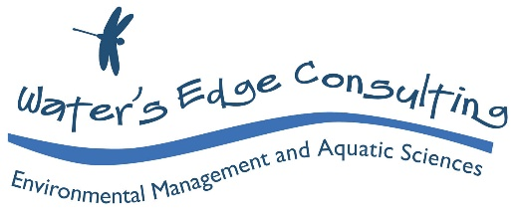

Document history

Original 02

Author/s Rhonda Butcher, Adam Fenton

Checked Sabine Schreiber

Approved Rhonda Butcher

Issue date November 2020

Issued to Commonwealth Environmental Water Office (CEWO)

Description: Briefing Paper: LTIM stakeholder engagement results

**Citation:** Butcher, R and Fenton, A.J. (2020). LTIM stakeholder engagement report: Survey results and sentiment analysis of interview responses. Independent evaluation of the Long-Term Intervention Monitoring (LTIM) project. Water’s Edge Consulting and associates, report to the Commonwealth Environmental Water Office, 102 pp.

**Disclaimer:**

The views and opinions expressed in this publication are those of the authors and do not necessarily reflect those of the Australian Government or the Minster for the Environment. While reasonable efforts have been made to ensure that the contents of this publication are factually correct, the Commonwealth does not accept responsibility for the accuracy or completeness of the contents, and shall not be liable for any loss or damage that may be occasioned directly or indirectly through the use of, or reliance on, the contents of this publication.

**Acknowledgements:**

We acknowledge the traditional owners of the lands and waterways of the Murray-Darling Basin, and pay our respect to Elders past, present and emerging.

This document was produced with the assistance of Peter Cottingham and Sabine Schreiber. Valuable input from Pablo Shopen, Irene Wegener, Nadia Kingham and Paul Marsh (CEWO) is gratefully acknowledged.

Contents

1 Introduction 1

2 Survey demographics 2

4 Survey results 5

4.1 Key evaluation questions 5

4.2 Effectiveness – achieved objectives 6

4.2.1 Familiarity with LTIM objectives 6

4.2.2 Extent to which the LTIM project achieved its objectives 6

4.2.3 Effectiveness of data management processes in aiding evaluation and reporting on outcomes 6

4.2.4 Effectiveness in supporting adaptive management of Commonwealth Environmental Water (CEW) in each Selected Area (including reporting of adaptive management) 6

4.2.5 Effectiveness of monitoring and evaluating the ecological response to CEW at each of the seven Selected Areas 7

4.2.6 How effectively did the CEWO Outcomes Framework align to the Basin Plan Environmental Watering Plan (EWP) and Water Quality and Salinity Plan? 7

4.2.7 Effectiveness in demonstrating the contribution of CEW to achieving Basin Plan objectives 7

4.2.8 Effectiveness in documenting and reporting on the evaluation of the contribution of CEW at the Basin scale 7

4.2.9 Effectiveness of the annual evaluation of CEW on the six specified Basin Matters 7

4.2.10 Effectiveness of inferring ecological outcomes of CEW to areas in the Basin not monitored 8

4.2.11 Effectiveness of data extrapolated from reach to whole of Selected Area and to Basin scale 8

4.3 Effectiveness – communicated findings 8

4.4 Effectiveness – demonstrated outcomes 8

4.5 Appropriateness – Strategic relevance 9

4.6 Appropriateness – Fit for purpose 9

4.7 Impact 10

4.8 Efficiency 10

4.9 Opportunities for Improvement 11

5 Sentiment analysis of LTIM interview responses 13

5.1 Purpose 13

5.1.1 Interview sentiment analysis 13

5.1.2 Method 14

5.1.3 Coding protocol 16

5.1.4 Summary statistics 18

5.1.5 Interview sentiment analysis results 18

Appendix 1: Survey questions and relevent Key evaluation Questions 20

Appendix 2: Results by question 22

Question 6: How familiar are you with the LTIM project objectives? 22

Question 7: To what extent do you think the LTIM project achieved its objectives? 23

Question 8: How effective were the data management processes in aiding evaluation and reporting on outcomes? 24

Question 9: How effectively did the LTIM project support adaptive management of Commonwealth Environmental Water (CEW) in each Selected Area (including reporting of adaptive management)? 25

Question 10: How effective has the LTIM project been in monitoring and evaluating the ecological response to CEW at each of the seven Selected Areas? 27

Question 11: How effectively did the CEWO Outcomes Framework align to the Basin Plan Environmental Watering Plan (EWP) and Water Quality and Salinity Plan? 28

Question 12: How effectively has the LTIM project demonstrated the contribution of CEW to achieving Basin Plan objectives (includes Chapter 8 and 9 objectives)? 29

Question 13: How effectively did the LTIM project document and report on the evaluation of the contribution of CEW at a Basin scale? 31

Question 14: How effectively did the LTIM project undertake annual evaluation of CEW on the six specified Basin Matters? 32

Question 15: To what extent did the LTIM project infer ecological outcomes of CEW to areas in the Basin not monitored? 34

Question 16: How effectively was Selected Area data extrapolated from reach to whole of Selected Area and to Basin scale? 35

Question 17: How effective was the LTIM project at communicating key findings to stakeholders (CEWO, MDBA, other members of the LTIM project, etc.), including to inform adaptive management? 37

Question 18: How effectively has the LTIM project improved capacity to predict outcomes of environmental flow allocations and their management over 1–5 years? 38

Question 19: How effectively has the LTIM project demonstrated that short term, less than 1-year outcomes, contribute to longer term outcomes? 40

Question 20: How well has the LTIM project contributed to the CEWO’s ability to meet their legislative reporting requirements? 42

Question 21: To what extent was the LTIM project design fit for purpose in meeting the CEWO’s strategic requirements? 45

Question 22: To what extent did the cause and effect diagrams include best available knowledge (including scientific, local and cultural knowledge)? 47

Question 23: To what extent were the best practice scientific methods employed in the LTIM project? 48

Question 24: To what extent were the Standard Methods fit for purpose and consistently applied at the Selected Areas? 49

Question 25: How appropriate was the predictive modelling in predicting outcomes of environmental watering in areas not monitoring for each Basin Matter? 51

Question 26: To what extent have data management arrangements supported systematic capture and making available data generated by the LTIM project? 52

Question 27: What level of impact has the LTIM project had on the adaptive management of environmental water? 53

Question 28: How impactful has knowledge gained through the LTIM project been in informing and improving Basin Plan implementation and/or outcomes? 55

Question 29: How impactful has the LTIM project been in fostering improved collaboration? 57

Question 30: What impact has the LTIM project had on partnership mechanisms and initiatives to build stronger coherence and collaboration between participating organisations? 58

Question 31: How efficiently were the funds and time allocated to address the LTIM project objectives? 59

Question 28: How efficient was the collaborative process within the LTIM project? 60

Question 33: To what extent did the LTIM project take up opportunities for joint activities, pooling of resources and mutual learning with other organisations and networks? 61

Question 34: How efficient was the LTIM project in managing data? 62

Question 35: How efficient was the LTIM project in sharing data? 63

Appendix 3: Free-text responses to Q6-35 65

Appendix 4: Free-text responses to Q36 opportunities for improvemet 94

# Introduction

This report presents the results from engagement with three stakeholder groups (client, service providers and end users) as part of an independent scientific program evaluation of the outcomes from the Long-term Intervention Monitoring (LTIM) project. The outcome evaluation of the LTIM project is focused on:

* How well each project achieved their objectives, demonstrated environmental outcomes, and communicated findings to all stakeholders,
* The extent to which each project was fit for purpose in terms of design and meeting legislative requirements, and
* How the CEWO can improve its future monitoring, evaluation, and research activities.

The engagement included an online survey and interviews with stakeholders during July to August 2020. The main purpose of the engagement was to provide lines of evidence specific to key evaluative questions (KEQs), contributing to a mixed method approach to evaluating the effectiveness, appropriateness, efficiency, and impact of the LTIM project (see Butcher and Schreiber 2020 for more details on the evaluation approach). This report summarises the survey responses and provides a sentiment analysis of the interview responses that will complement the main outcome evaluation report. Evaluative judgements are not made in this report, it simply summarises the results of the sentiment analysis (see Hart et al. 2020).

Survey and interview questions were designed in consultation with CEWO (see Appendix 1) and relate to a subset of the full suite of KEQs. In total 36 questions were included across the surveys and interviews. Discussion of the structured survey results mostly describes the responses broken down by the three stakeholder groups, while the sentiment analysis looks to interrogate the free form interview responses to gain additional insights. The purpose and methods used to do this are provided in Section 4.1 and 4.2.

# Survey demographics

The total number of participants to the LTIM survey was 38. Six participants were classified as the client (Group 1), 19 as service providers (Group 2), and 13 classified as end-users (Group 3)(Figure 1). Of the 38 participants, one participant (service provider) completed the survey after the deadline and thus did not contribute to the analysis. The free-text comments from this participant are included in the Appendix 3.

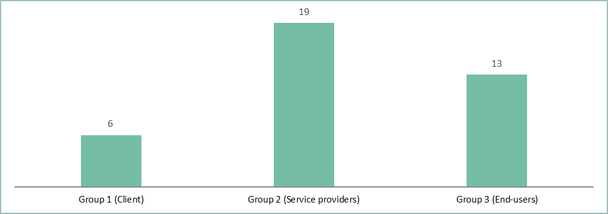

Figure Number of participants for Groups 1, 2 and 3 (n = 38).

The survey participants were asked to indicate their role in environmental water, of which 60% indicated their role is related to water delivery or environmental water monitoring and evaluation. Note, some participants selected both ‘Research’ and ‘Environmental water monitoring and evaluation’. In addition to the answer selections provided, 1 participant indicated that they are in ecological consulting, and another in local relationship management and engagement (Figure 2 and Figure 3).

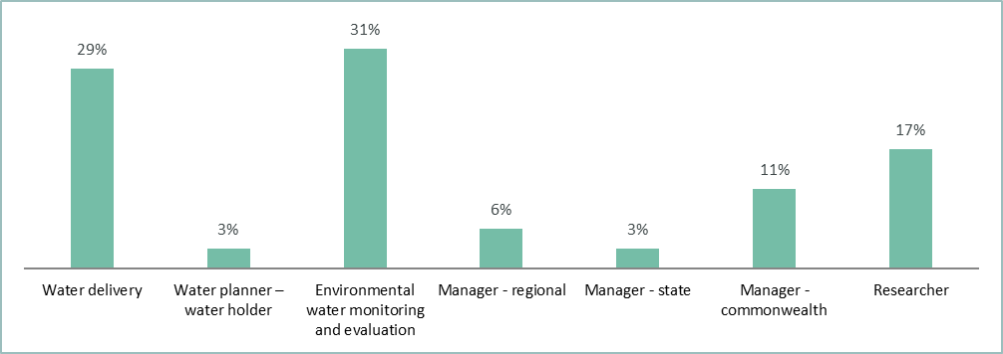

Figure Responses to question 3 of the LTIM survey (Group 1, 2 and 3 | n = 35).

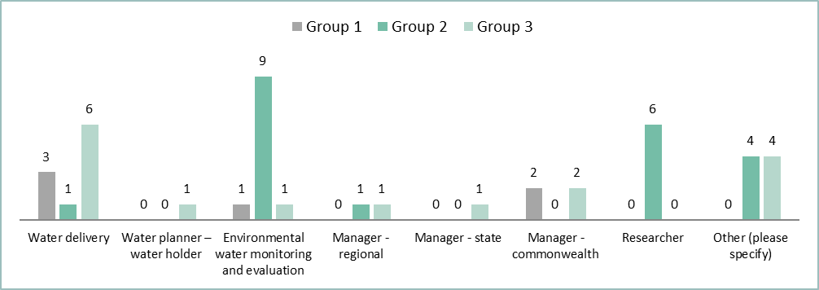

Figure Responses to question 3 of the LTIM survey by group (n = 35).

Participants were asked to indicate the length of time they have been involved in environmental water, with the vast majority indicating greater than 5 years (Figure 4Figure 5).

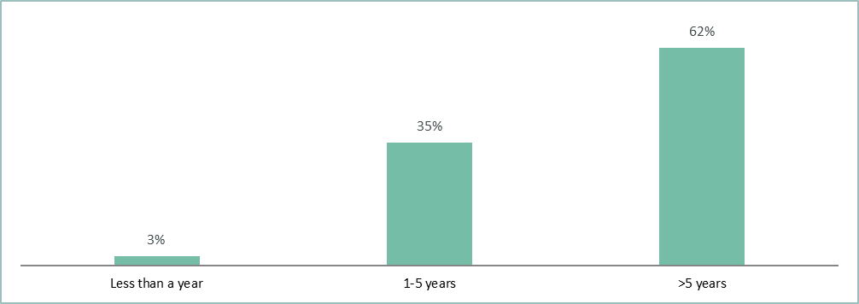

Figure  Response to years of experience in environmental water of participants (Group 1, 2 and 3 | n = 37).

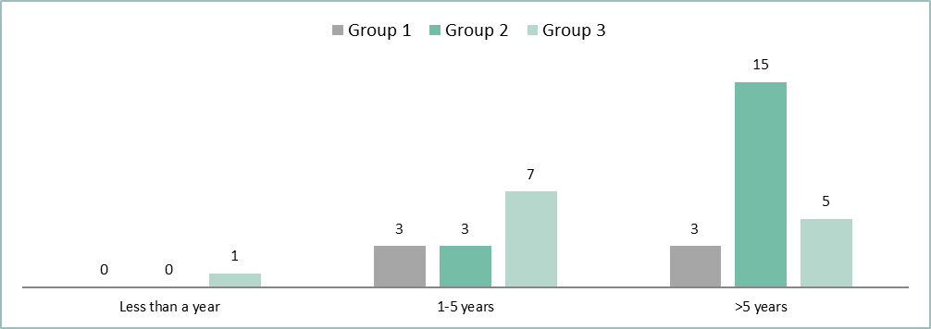

Figure Years of experience in environmental water of participants by group (n = 37).

The survey participants were asked to indicate their role (if any) in the LTIM project. Whilst 38 responses were provided, six participants indicated that they do not wish their personal data to be collected. As such, their role in the LTIM project was not included (Figure 6Figure 7).

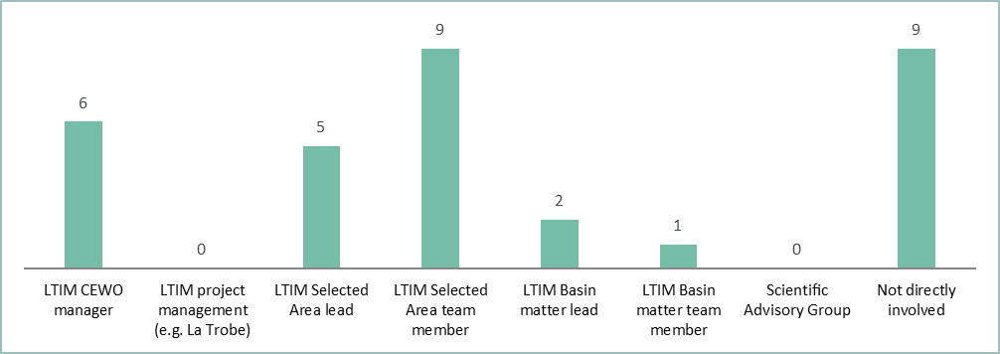

Figure Combined responses to question 5 of the LTIM survey - participants roles within the LTIM project (Group 1, 2 and 3 | n = 32).

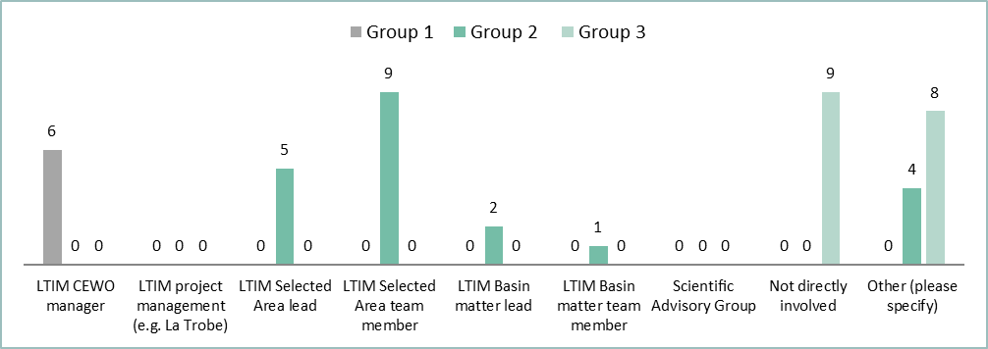

Figure Responses to question 5 of the LTIM survey by Group - participants’ roles within the LTIM project (n = 32).

# Survey results

## Key evaluation questions

The 35 questions included in the survey related to 14 of the 16 high level KEQ (Table 1; see also Appendix 1 to 3 for the survey questions).

Table High level KEQ addressed by the survey and interview questions

|  |  |  |
| --- | --- | --- |
| Evaluative criteria | High level KEQ | |
| Effectiveness | KEQ1 | How effective was the LTIM project in planning, reporting, and collaborating to support adaptive management? |
| KEQ1A | How effective has the LTIM project been in monitoring the ecological response to Commonwealth environmental watering at each of the seven Selected Areas? (objective 5 Gawne et al. 2014[1]) |
| KEQ2 | How effectively did the LTIM project evaluate Basin-scale contribution of CEW to the Basin Plan objectives using the CEWO Outcomes Framework and following the process and methodology outlined in Gawne et al. (2014, Section 2.4)? (from Head contract B2.1 (b)) |
| KEQ3 | How effectively did the LTIM project evaluate the ecological outcomes of Commonwealth environmental water at the seven Selected Areas? (objective 2 Gawne et al. 2013[2]) |
| KEQ4 | To what extent did the LTIM project infer ecological outcomes of Commonwealth environmental water to areas in the Basin not monitored? (objective 3 Gawne et al. 2013) |
| KEQ5 | How effective was the LTIM project at communicating key findings? |
| KEQ6 | How effectively has the LTIM project demonstrated its outcomes? |
| Appropriateness | KEQ7 | How well has the LTIM project contributed to the CEWO’s ability to meet their legislative reporting requirements? |
| KEQ8 | How appropriate was the LTIM project design, in terms of being fit for purpose in meeting the CEWO’s strategic requirements? |
| Impact | KEQ9 | To what extent has the LTIM project had an impact in terms of improving water management practices? |
| KEQ10 | How impactful have the LTIM project been in fostering improved collaboration? |
| Efficiency | KEQ11 | How efficiently has the LTIM project achieved its objectives and outcomes? |
| KEQ12 | How efficient was the collaborative process within the LTIM project? |
| KEQ13 | How efficient was the LTIM project in managing and sharing data? |

## Effectiveness – achieved objectives

See Appendix 2 Questions 6 to 16 for graphic presentation of results.

### Familiarity with LTIM objectives

The survey results indicated that familiarity with the LTIM objectives varied between the client, service providers and end‐users. Overall, there was a high level of familiarity with the LTIM objectives at the Selected Area, whereas familiarity with the LTIM Basin scale objectives was notably lower (Figure 10).

### Extent to which the LTIM project achieved its objectives

Over 80% of survey participants in each survey group indicated that they believe some objectives of the LTIM project have been met (Figure 14) and that more objectives are likely to be met in the future. Overall, 8% of the combined pool of survey participants believed that all the LTIM objectives had been met (Figure 16); this included 17%, 11% and 0% of the client, service provider and end user groups, respectively.

### Effectiveness of data management processes in aiding evaluation and reporting on outcomes

Adequate data management is considered a fundamental aspect for complex monitoring projects such as the LTIM project and there were specific objectives in the head contract relating to data management. The client and end users indicated a high level of unfamiliarity (selected ‘Don’t know’) with the effectiveness of the LTIM data management processes in aiding evaluation and reporting at the Basin‐scale, for each Basin Matter[3], and at Selected Area scale. Others mostly indicated that it was somewhat effective. Combined results indicated that for those who were familiar with the data management processes, the majority considered data management of Basin scale data was somewhat effective, whereas data management for Basin Matters was less so.

### Effectiveness in supporting adaptive management of Commonwealth Environmental Water (CEW) in each Selected Area (including reporting of adaptive management)

A large proportion of the survey participants in each stakeholder group were unable to comment on how effective the LTIM project supported adaptive management at the basin scale or within any Selected Area (Group 1, 33-67%, Group 2, 50-78%, and Group 3, 31-69%) (Figure 22 - Figure 25). This potentially indicates adaptive management messages are not being either captured, and or communicated effectively. Group 1 rated the effectiveness of adaptive management within each Selected Area 33-67% ‘somewhat to very effective’. This was less favourable than group 2 and 3, which had one or two participants indicating some Selected Areas as ‘extremely effective’ in supporting adaptive management of CEW. Overall, the LTIM project was considered to be ‘somewhat effective to very effective’ in supporting the adaptive management of CEW within the Selected Areas.

### Effectiveness of monitoring and evaluating the ecological response to CEW at each of the seven Selected Areas

At the Selected Area scale there was a high proportion of ‘don’t know’ responses across all groups. However, most participants indicated that each individual Selected Area effectively monitored and evaluated the ecological response to CEW. Of note, end users were more certain in the effectiveness of the Gwydir Selected Area in this regard, with double the number of participants indicating it was very effective, and less than half of the ‘don’t knows’ of the other Selected Areas.

### How effectively did the CEWO Outcomes Framework align to the Basin Plan Environmental Watering Plan (EWP) and Water Quality and Salinity Plan?

Whilst the CEWO Outcomes Framework[4] was identified as being central to the design of the LTIM project in the LTIM project foundation documents by providing a direct line of sight to the Basin Plan Chapter 8 and 9 objectives, the majority of responses across all stakeholders was that it was only moderately aligned (65-70%). In part this may reflect the development of the Outcome Framework prior to the release of the Basin‐wide Environmental Watering Strategy in 2014. Approximately one quarter of responses indicating that it was effectively aligned.

### Effectiveness in demonstrating the contribution of CEW to achieving Basin Plan objectives

Another primary objective of the LTIM project was to support the CEWO’s legislative reporting requirements under the Water Act 2007 and Basin Plan. Survey responses generally indicated that the LTIM project was predominantly ‘somewhat effective’ in demonstrating the contribution of CEW to achieving Basin Plan objectives. Basin Matters were rated as effective (83%, somewhat and very effective combined)(Figure 35) by group 1 in contributing to Basin Plan objectives. However, service providers and end users rated the Basin Matters less favourably, at 45-67% and 54-77% effective (covers somewhat effective, very effective and extremely effective). Among the Basin Matters Hydrology was rated the most highly by service providers and end users.

### Effectiveness in documenting and reporting on the evaluation of the contribution of CEW at the Basin scale

A key objective of the LTIM project was to evaluate the annual and cumulative contribution of Commonwealth Environmental Water (CEW) at the Basin scale. Survey results only slightly varied across the stakeholder groups with most participants indicating the LTIM project was mostly ‘somewhat effective’ in reporting on the annual and cumulative contribution of CEW at the Basin scale (Figure 38 to Figure 41).

### Effectiveness of the annual evaluation of CEW on the six specified Basin Matters

Across the six Basin Matters, most survey participants across each stakeholder group viewed the LTIM project as being mostly ‘somewhat effective’ in the annual evaluation of the contribution of CEW, with the exception of Hydrology, where service providers found it to be ‘very effective’ to ‘extremely effective’.

### Effectiveness of inferring ecological outcomes of CEW to areas in the Basin not monitored

The extent to which the LTIM project inferred ecological outcomes of CEW to areas in the Basin not monitored was largely considered to be ineffective (‘A little’ and ‘Not at all effective’ combined).

### Effectiveness of data extrapolated from reach to whole of Selected Area and to Basin scale

A high proportion of participants (>57% for each Selected Area) in each group did not know how effectively the Selected Area data was extrapolated to whole of Selected Area scale and to the Basin scale. Of those participants who did provide a scaled response, the majority indicated it was somewhat effective or not so effective.

## Effectiveness – communicated findings

See Appendix 2, Question 17 for graphic presentation of results.

A significant proportion of survey participants indicated that they did not know how effectively the LTIM project findings were communicated to stakeholders. Those that did provide a scaled response indicated that communication was effective (reflected by responses of ‘very effectively’ and ‘extremely effectively’ combined) from each of the Selected Areas. The Selected Areas in the Northern Basin (i.e. Gwydir and Warrego‐Darling) were viewed more favourably in this regard, with a higher proportion of participants indicating the outcomes from these tow Selected Areas were very effectively communicated. For outcomes from the LTIM project at the Basin scale however, the majority of client and end users indicated communication was ineffective.

## Effectiveness – demonstrated outcomes

See Appendix 2, Questions 18 to 19 for graphic presentation of results.

There were mixed perceptions on the effectiveness with which the LTIM project improved capacity to predict the outcomes of environmental flow allocations and their management over 1‐5 years. For example, 38% of survey participants indicated that they didn’t know if there had been an improved capacity to predict outcomes at the Basin scale and for Basin Matters. Increased capacity to predict outcomes at the Selected Areas was viewed as being more effective in this regard, particularly among the service providers with 50% indicating that it was effective.

The effectiveness with which the LTIM project demonstrated that short-term (less than one year) outcomes contribute to longer-term outcomes varied by both Basin Matter and by Selected Area. A large proportion of survey participants (38-49%) indicated that they did not know if short-term outcomes led to the demonstration of long-term outcomes for each of the Basin Matters, and notably more so in terms of demonstrating outcomes for each of the Selected Areas (49-70%). For those participants who did provide a scaled response, the majority selected ‘somewhat effectively’.

## Appropriateness – Strategic relevance

See Appendix 2, Question 20 for graphic presentation of results.

Overall, the LTIM project was considered to have contributed to the CEWO’s ability to meet their legislative reporting requirements. Both the service provider and end user groups indicated that LTIM project’s contribution to CEWO’s legislative reporting requirements was more appropriate (‘a lot’ and ‘a great deal’ combined) compared to inappropriate (‘not at all’ and ‘a little’ combined); however they also had a high proportion of participants responding ‘don’t know’. The client group, however, felt that the LTIM project was more likely to contribute ‘a moderate amount’ in terms of meeting legislative reporting requirements.

## Appropriateness – Fit for purpose

See Appendix 2, Questions 21 to 26 for graphic presentation of results.

Some 34-54% of survey participants viewed the LTIM project as being fit for purpose (‘a lot’ and ‘a great deal’ combined) in terms of meeting the CEWO’s strategic requirements, while 20-31% considered the LTIM project as moderately appropriate in this regard.

The cause and effect diagrams developed during the early stages of the LTIM project were widely perceived as being appropriate in terms of including best available knowledge. In relation to scientific methods used in the LTIM project, whilst a small portion of participants indicated that they ‘don’t know’, virtually all other participants across each stakeholder group indicated that the best practice scientific methods were employed.

The extent to which participants considered the LTIM standard methods to be fit for purpose and having been consistently applied across the Selected Areas varied considerably between stakeholder group and between each of the Selected Areas. A high proportion of participants (49-69%) indicated that they did not know if standard methods were applied consistently. Of the participants that did provide a scaled response, a higher proportion of responded favourably (‘a lot’ and ‘a great deal’ combined) than unfavourably (‘not at all’ and ‘a little’ combined).

Overall, there was a high proportion of participants (66-77%) from each stakeholder group who did not know how appropriate the predictive modelling was in predicting outcomes of environmental watering in areas not monitored for each of the Basin Matters. In addition, 11-17% of survey participants indicated that the predictive modelling approach(es) were ‘not at all’ or ‘a little’ appropriate. Of note, the hydrology Basin Matter was considered to have been dealt with more appropriately than other Basin Matters. This also reflects the interview responses (pers. observation), where most participants felt the predictive modelling was problematic except for in the hydrology Basin Matter.

Some 28-40% of survey participants felt that data management arrangements supported capture and making available data generated by the LTIM project (for Basin Matter and Selected Areas), while 26% of participants felt data management arrangements moderately appropriate. Service providers tended to have a less favourable view of data management arrangements than the other groups. For example, while end user survey participants had a higher relative proportion of ‘don’t know’ responses, (54% at Basin Matter, 46% at Selected Area), most of those who made a scaled response viewed data management arrangements to be appropriate. This finding is somewhat different to that expressed in the LTIM stakeholder interviews (pers. observation, unpublished data), where many participants indicated significant problems with data management, particularly in the early years of the LTIM project.

## Impact

See Appendix 2, Questions 27 to 30 for graphic presentation of results.

Across each stakeholder group, there were mixed perceptions on the impact that the Basin Matter assessments had on the adaptive management of environmental water. Of note was that the end user survey participants often indicated that outcomes reported for each of the Basin Matters had ‘little impact’ and/or was only ‘somewhat impactful’ in terms of influencing adaptive management of environmental water. Conversely, the level of impact at the Selected Areas was rated as much higher (‘very impactful’ and ‘extremely impactful’ combined) across each stakeholder group, although overall a very high proportion (46-69%) of survey participants selected ‘don’t know’ for each of the Selected Areas.

There were mixed perceptions across the stakeholder groups regarding how impactful the knowledge gained through the LTIM project has been in informing and improving Basin Plan implementation and/or outcomes. Whilst this aspect of the project was considered more favourably than not, overall, most participants indicated that it was only ‘somewhat impactful’ suggesting this could be an area of improvement moving forward.

Service providers indicated that the LTIM project was impactful in fostering collaboration with external agencies and research organisations, whilst end users mostly indicated that this aspect of the project was ‘somewhat impactful’. The client group provided mixed responses. Service providers considered the degree to which LTIM fostered the collaboration between Selected Areas as significantly more impactful than between the Basin Matter team and Selected Areas.

The LTIM project was considered to impactful on partnership mechanisms and initiatives to build stronger coherence and collaboration between participating organisations across all stakeholder groups. The LTIM project was less impactful in establishing partnership mechanisms at the Basin scale and across the Basin Matters. A large proportion of the service providers and end users indicated that they did not know (56% and 54% for Basin scale, respectively; 44% and 54% for Basin Matters, respectively) how impactful the LTIM project had been in this regard.

## Efficiency

See Appendix 2, Questions 31 to 35 for graphic presentation of results.

The allocation of funds and time to address the LTIM project objectives were largely considered to be efficient at the Selected Area scale. A relatively large proportion (57-66%) of survey participants did not know how efficient the LTIM project was in delivering on Basin Matter and Basin scale objectives. For those participants who did provide a scaled response, proportionally more participants considered the project to be efficient (20-23% of responses were ‘very efficient’ and ‘extremely efficient’) than inefficient (15-20% of responses were ‘not so efficient’ and ‘not at all efficient’).

There were mixed views on the efficiency of the collaborative processes between the Selected Areas, between the Basin Matter team and Selected Area teams, and between the Basin Matters team. For example, half of the service provider survey participants indicated that the collaborative processes between Selected Area and Basin Matter were either ‘not so efficient’ or ‘not at all efficient’. Overall, most participants who provided a scaled response indicated that collaborative processes at the Selected Area were ‘somewhat efficient’.

The extent to which the LTIM project took up opportunities for joint activities, pooling of resources and mutual learning with other organisations and networks was much greater at the Selected Area than was the case for the Basin Matters and Basin scale evaluation. There was a high proportion of survey participants who did not know how the project performed in this regard at the Basin scale or for the Basin Matters. However, most participants who provided a scaled response considered the LTIM project to be inefficient (‘not at all efficient’ and ‘a little efficient’ combined) in terms of joint activities and mutual learning about the Basin Matters.

There were mixed views regarding the efficiency with which the LTIM project managed data. The service providers considered data management for Selected Areas more favourably in this regard than that of Basin Matter data management. There were also mixed views regarding the efficiency with which the LTIM project shared data. Overall, participants considered the LTIM to be more efficient at sharing data with other agencies (i.e. MDBA) than between Selected Areas or between Basin Matter and Selected Areas.

## Opportunities for Improvement

The free text responses from the surveys are presented in Appendix 4. Whilst explicitly stated by only two survey participants, the range and number of suggested improvements strongly indicates change is required, and that future monitoring, evaluation and research should not be a ‘business as usual’ or ‘tweaked’ version of the current LTIM/Flow MER projects.

Potential improvements put forward by the survey participants has been summarised as follows:

* Purpose/Objective
  + Resolve the perceived imbalance between Selected Area and Basin scale; there are differing perspectives on which scale future projects should focus
  + Change the role of the Basin scale team to one providing support to Selected Areas teams
  + Focus on adaptive management
  + Reduced focus on CEW as opposed to broader environmental water
* Design
  + Increase spatial coverage of Selected Areas – more sites in the Northern basin
  + Consider representativeness of the Selected Areas in context of basin aquatic ecosystem types – Selected Areas should be representative of the ecosystem types across the basin
  + Revisit and improve Basin scale evaluation; dependent on future projects needing to deliver basin scale outcomes
  + Revisit conceptual underpinning (CED diagrams) – improve accessibility, and improve use as communication tool
  + Improve alignment to BWS/Basin Plan by updating design
  + Review indicators to ensure realistic outcomes are achievable in response to ewater (i.e. fish) and at different spatial scales – less is potentially better
  + A more integrated approach to monitoring and research
  + Improve data management systems
  + Greater inclusion of scientist in design phase (from Selected Areas)
  + Improve flexibility of design, for example allow for ability to monitor natural events, or top up events
* Outputs
  + Improve timeliness of reporting, particularly to support delivery teams – at site scale
  + Streamlining reporting process
  + Continued support of adaptive management at the Selected Area scale
* Communication
  + Increase level of engagement across a broader range of stakeholders
  + Increase range of opportunities for within project communications/gatherings – opportunities to interact with scientists and address management questions (not less as is perceived with Flow-MER by one respondent)
  + Include measurable frameworks for communication
* Collaboration
  + Improve within project collaboration – i.e. Selected Area and Basin Matter teams
  + Increase role of service providers in design
  + Increased participation and broadening of stakeholders engaged
* Governance
  + Continued, expanded funding – including continued investment in coordination and collaboration; improved leadership and a willingness to invest in areas where collaboration is required
  + Stronger links with MDBA
  + Improved cohesion and ownership across all elements of the project – an integrated structure across Selected Areas and Basin Matter team
  + Improve data management processes
  + Steam line monitoring under a single program with greater flexibility to response to emergent conditions (e.g. natural events)

Group 1 (client) suggestions included improvements to the design to the LTIM project, with more emphasis on the use of conceptual models and improvements in evaluation and reporting processes. Other areas of improvement identified included data management, communication of outcomes, broader consultation and engagement with the wider community, First Nations and stakeholder groups at the local level. The latter is to be achieved by stipulating collaboration as a foundational component of any future programs. Better integration between monitoring and research was also supported with several Group 1 survey participants calling for a more flexible approaches to be adopted in the future, and referred to the Flow- MER project’s ability to respond to emerging issues/opportunities.

Group 2 (service providers) responses ranged from covering issues relating to project design and more sites in the Northern Basin, through to improving collaboration and communication, notably between the Selected Area and Basin Matter teams. One survey participant suggested moving to include overbank flows (whilst acknowledging current constraints), while another participant pointed to the need to increase funding to improve collaborative activities. Greater use of project findings and technical experts in informing and designing coordinated environmental flow events across multiple systems was another suggestion. A number of survey participants also highlighted the need to continue integrated monitoring and research, similar to the approach of Flow-MER.

Group 3 (end users) suggested a more integrated approach to environmental water management, and a reduced focus on CEW in isolation from other sources of environmental water. It was also recommended that future programs be designed to focus more directly on adaptive management needs, and that a broader range of scientists and stakeholders (i.e. managers, community, river operators) have input into the purpose of programs. Survey participants identified the use of conceptual models and graphical representation of findings integrated with cultural and social outcomes, improving flexibility and the inclusion of traditional ecological knowledge and monitoring on country as further areas of opportunity for future programs.

A few survey participants raised concern over continuing the project in its current LTIM/Flow-MER form, without considering coverage of effort more evenly across the Basin. To date, local stakeholders and communities have not seen findings being inferred from one as convincing. One other survey participant suggested that the application of standard methods, predictive modelling be reconsidered and the approach of a single Basin scale provider be limited to a short contract to support the CEWO in communicating findings generated by the Selected Areas. Selected Areas were suggested to continue but with improved analysis and communication. Several specific suggestions regarding localities for new Selected Areas were made (see Appendix 4), along with a shift to increased emphasis on significant sites (e.g. Ramsar wetlands) and greater consideration of species of conservation significance and migratory species.

Effort to continuously improve adaptive management was a common theme among end users, as adaptive management was seen to be too reliant on “*personal relationships and more needs to be done to socialise results, discuss their meaning and identify their significance to flow management*”. Integration of programs to inform adaptive management at system scales (e.g. co-designing with researchers and water managers to address large scale adaptive management issues) was also mentioned by survey participants in Group 3.

# Sentiment analysis of LTIM interview responses

## Purpose

### Interview sentiment analysis

Sentiment analysis is the interpretation and classification of attitudes (i.e. positive, neutral, and negative) within textual data using pre-determined classification principles and subjective judgement. Sentiment analysis is often used to analyse structured and semi-structured interview transcripts, where respondents may provide a dichotomous response (i.e. “yes” or “no”), or a subjective scaled response (i.e. “somewhat”, “strongly agree”) in addition to an open-ended response, depending on the question(s) asked. There may also be instances where a definitive indication (e.g. “strongly agree”, “absolutely not”, “yes”) are not provided, rather praise, criticism or general opinions are provided, some of which may be conflicting. Combining these different response data provides a general indication of a group’s attitudes. Sentiment analysis of the LTIM interview transcripts was conducted to provide insight into stakeholder attitudes not captured within the scope of the KEQs.

The approach adopted for the LTIM evaluation was to classify participants’ responses to the questions into positive, neutral or negative sentiment based upon a combination of a) the degree to which that response converged or diverged from the ‘desired’ response to an interview question and b) the general attitude towards that element (basis of an interview question) of the project. These classifications were made in accordance with pre-developed classification principles. Summary statistics provide an overall summary of the relative proportions of stakeholder sentiment between focal areas and between stakeholder groups (i.e. end users, service providers).

### Method

Thirty nine stakeholders were interviewed for the evaluation of the LTIM project guided by the questions and prompts listed in Table 2 Interview questions and follow up prompts for the LTIM stakeholder interviews. Interview recordings were transcribed using software-assisted manual transcription. All transcripts were imported into NVivo and the responses were coded to individual nodes relating to focal areas (e.g. achieved objectives, communicated findings etc). Not all prompts were asked of every participant, these were used by the interviewers to direct the conversations to key points if needed.

Table Interview questions and follow up prompts for the LTIM stakeholder interviews

|  |  |  |
| --- | --- | --- |
|  | Questions and prompts | KEQ |
|  | **Effectiveness – achieved objectives** |  |
| 1 | To what extent do you think the LTIM project achieved its objectives? On what basis? | **KEQ1** |
| * Prompt: can you be specific as to which objectives were achieved and how well? |  |
| * Prompt: do you think others in your organisation would have a different perspective? If so, what different perspective do they have? |  |
| 2 | How effectively did the LTIM project evaluate the contribution of CEW to the Basin Plan objectives, noting that this includes Chapter 8 and 9 objectives? | **KEQ2** |
| 3 | To what extent did the LTIM project infer ecological outcomes of Commonwealth environmental water to areas in the Basin not monitored? | **KEQ4** |
| * Prompt: was this done effectively at Selected Area and Basin scale? |  |
|  | **Effectiveness - demonstrated outcomes** |  |
| 4 | How effectively has the LTIM project demonstrated that short term, less than 1 year outcomes, contribute to longer term outcomes? | **KEQ6.7** |
| * Prompt: was this done effectively at Selected Area and Basin Matters? |  |
| 5 | How effectively the LTIM project improved capacity to predict outcomes of environmental flow allocations and their management over 1–5 years? | **KEQ6.6** |
| * Prompt: How effectively were the outcomes related to the six specified matters incorporated into the environmental water adaptive management process (Selected Area, Basin-scale)? |  |
| * Prompt: How effectively have the predictive tools or processes developed or refined as part of the LTIM project informed environmental watering regimes (Selected Area and Basin-scale)? |  |
|  | **Effectiveness - communicated findings** |  |
| 6 | How well did the LTIM project communicate the key findings to stakeholders? | **KEQ5** |
| * Prompt: to what extent did planned outputs (reports) meet CEWO project reporting requirements (see reporting template) and timelines? |  |
| * Prompt: to what extent were planned outputs targeted at key audiences (both in terms of providing relevant information and in a format useful to the end user)? |  |
| * Prompt: to what extent do you think there could be improvements in targeting of products? If so, how could the products be improved? |  |
| * Prompt: what if anything would you change regarding communication activities? |  |
| 7 | How effective were the cause and effect diagrams (CED) in communicating key relationships between environmental watering and ecological outcomes? | **KEQ5.1.6** |
|  | **Appropriateness – strategic relevance** |  |
| 8 | To what extent do you think the overall LTIM project was aligned to Basin Plan objectives? | **KEQ7** |
| * Prompt: what aspect of the BP objectives – Chapter 8 and or 9? |  |
| * Prompt: to what extent has LTIM contributed to assessing Schedule 7 targets |  |
| * Prompt: in what areas could LTIM be improved to support CEWOs legislative reporting requirements? |  |
| 9 | To what extent did the LTIM project consider other ongoing and planned initiatives/projects related to Basin Plan implementation? How? | **KEQ8.4** |
| * Prompt: can you provide examples of how themes extrapolated their findings to the Basin scale? |  |
| * Prompt: how closely did LTIM integrate/interact with EWKR? |  |
|  | **Appropriateness - design was fit for purpose** |  |
| 10 | To what extent was the LTIM project design fit for purpose in meeting the CEWO’s strategic requirements? | **KEQ8** |
| * Prompt: at the basin scale, Basin Matters or Selected Areas? |  |
| * Prompt: to what extent did the program logic align to Basin Plan objectives (Chapter 8 and 9), BWS and reporting requirements? |  |
| * Prompt: to what extent do you think the project was an appropriate means of improving adaptive management – were there any areas in which this aspect could be improved? |  |
| * Prompt: were data management protocols and management effective in maintaining and making available the data sets generated by LTIM? |  |
| 11 | To what extent were the best practice scientific methods employed in the LTIM project? | **KEQ8.6** |
| * Prompt: to what extent were the Standard methods fit for purpose and consistently applied at the Selected Areas? |  |
| * Prompt: how appropriate were the Cat II and III methods for addressing CEWO’s strategic requirements? |  |
| 12 | To what extent have data management arrangements supported systematic capture and making available data generated by the LTIM project? | **KEQ8.9** |
|  | **Impact – leads to changed management behaviour** |  |
| 13 | What level of impact has the LTIM project had on the adaptive management of environmental water? | **KEQ9.1** |
| 14 | How impactful has knowledge gained through the LTIM project been in informing and improving Basin Plan implementation and/or outcomes? | **KEQ9.2** |
| * Prompt: how impactful has the LTIM data been for the 2020 evaluation? |  |
| * Prompt: what evidence is available to support this? |  |
|  | **Efficiency – value for money** |  |
| 13 | Do you consider the expenditure worthwhile? Question is specifically about value for money. | **KEQ11.1** |
| * Prompt: would you change the allocation to Basin Matters/Selected Areas? Were they equally efficient or did one or more stand out – if yes why? |  |
| * Prompt: could the resources have been more efficiently used? How? |  |
| * Prompt: if there was greater focus on aligning with BP objectives and outcomes, would that have improved value for money? |  |
| * Prompt: how well do you think the allocation of funding was balanced, targeted to needs? |  |
| 14 | To what extent do you think LTIM project processes encouraged participants to collaborate, and share resources and lessons learnt? | **KEQ12.1** |
| * Prompt: what evidence is available to support this? |  |
| * Prompt: how effective was the Annual Forum in improving collaborative process? |  |
| * Prompt: how efficient have the data management processes been, including end user access to data? |  |
| * Prompt: how efficient was the data sharing between Selected Area and Basin Matter teams? |  |
| * Prompt: what if anything would you do differently? |  |
| 15 | How technically efficiently was the LTIM project implemented - were the optimal methods of producing the outputs adopted? | **KEQ11.2** |
| * Prompt: Did this vary at the Basin scale, by Basin Matter or Selected Area? |  |
| * Prompt: To what extent were the intended quality and quantity of deliverables, achieved within the available resources for each Basin Matter? |  |
| * Prompt: To what extent is there evidence that the LTIM project has continued/attempted to improve, by finding better or lower cost ways to deliver outcomes? |  |
|  | **Moving forward – opportunities for improvement** |  |
| 18 | What, if any, improvements could be made to the LTIM project moving forward? |  |
| * Prompt: if you had a do over, what would you do differently and why? |  |
| * Prompt: what would you keep, what needs more work and why? |  |
| * Prompt: what else might be included in future programs? |  |

### Coding protocol

#### Preliminary sentiment Auto-code

The ‘auto-code function’ in NVivo (QSR International) was used as a starting point for classifying the text into positive and negative sentiment. The auto-code function has built-in lexicons for positive, neutral, and negative sentiments, as well as word modifiers like “very”, “more” or “somewhat”, which can change the class of that emotion. These lexicons and modifiers are used to automatically classify data. However, as NVivo cannot recognise the context of the responses, as well as sarcasm, double negatives, slang, dialect variations, idioms, or ambiguity, the results of the auto-coded sentiment analysis of the LTIM interview transcripts required further manual coding.

#### Manual coding

Coding classification principles were developed and then followed as general guidelines for classifying participants responses. As manual sentiment analysis is inherently subjective, the coding classification principles (listed in Table 3) enhanced consistency in coding across the substantive collection of data.

Table Sentiment classification principles.

|  |  |  |
| --- | --- | --- |
| Sentiment | Description | Modifiers (examples) |
| *Positive* | *Positive sentiment:*   * Participant indicates positive agreement/attitude to the basis of the question. * Examples provided by the participant of where the LTIM project resulted in positive outcomes. | *Negative Modifier:*   * “I think the project mostly met it’s objectives, however the objectives were not all relevant and the project did not achieve what we thought it would”. |
| *Neutral* | *Neutral sentiment:*   * Participant indicates mixed agreement/attitude to the basis of the question. * General statements about the components, processes etc. of the LTIM project, if not used to directly support a statement relevant to the evaluation question or the focal area, are coded as neutral. | *Positive Modifier:*   * “The degree to which the project met its objectives varied, although I think the Selected Areas did an amazing job”   *Negative Modifier:*   * “The degree to which the project met its objectives varied, although I think inferring outcomes to areas not monitored was very poorly done” |
| *Negative* | *Negative sentiment:*   * Participant indicates negative response/attitude to the basis of the question. * Examples provided by the participant of where the LTIM project resulted in negative outcomes. | *Positive Modifier:*   * “The project did not meet it’s objectives at all, however, I think overall I think the LTIM project was highly valuable as a vehicle to foster relationships within the industry”. |

The unit of analysis (i.e. blocks of text to be classified as positive, neutral, negative) varied with the complexity of participant responses to a question. The smallest unit of analysis used to classify sentiment was individual statements (sentences), whereas the largest unit of analysis was the full response to a question by a participant. A participant’s complete response to a question (or interview prompt) could be classified as one sentiment, if the sentiment of the response were clear and all statements related to a single opinion. In instances when a direct response to the basis of the question was provided and supplementary statements were also given, the classification of these individual responses were promoted or relegated based on sentiment of the supplementary statements (“Modifiers” - see Table 3).

Further, if the participant responses to a question consisted of a number of conflicting statements that did not necessarily conclude to one overall opinion relative to that question, the complete response was either not included in the analysis, or split into discrete statements which are then subsequently classified as positive, neutral or negative sentiment. However, this was only done provided that the participant’s responses to a question were distinct statements that could be clearly delineated from one another.

### Summary statistics

Sentiment was calculated by addition of all the positive, neutral, and negative coding references across each question, and each focal area, to produce relative proportions of each sentiment. As the unit of analysis varied between transcripts, interviews and questions, the total sample size for each question varied, thus reporting on relative statistics was considered more appropriate than direct counts of positive, neutral and negative statements.

### Interview sentiment analysis results

A total of 610 units of textual data (hereafter “statements”) were coded across all interview questions from the Group 1 (Client), Group 2 (service providers) and Group 3 (end users) interview transcripts. These where classified into positive, neutral or negative sentiment across the focal areas: Effectiveness - Achieved objectives (n=95), Effectiveness - Demonstrated outcomes (n=82), Effectiveness - Communicated findings (n=86), Appropriateness - Strategic relevance (n=70), Appropriateness - Fit for purpose (n=114), Impact (n=43) and Efficiency (n=120).

Overall, 38% of statements were classified as positive, 25% of statements were classified as neutral, and 37% were classified as negative. Four out of the seven focal areas had more positive sentiment than negative sentiment, these included ‘Achieved objectives’, ‘Strategic relevance’, ‘Design was fit for purpose’ and ‘Impact’. Overall, participants responded to ‘Impact’ questions significantly more positively than the other focal areas. The relative proportions of each sentiment across each focal area are illustrated in Figure 8 Relative proportions of positive, neutral, and negative sentiment across the focal areas (Groups 1, 2 and 3)

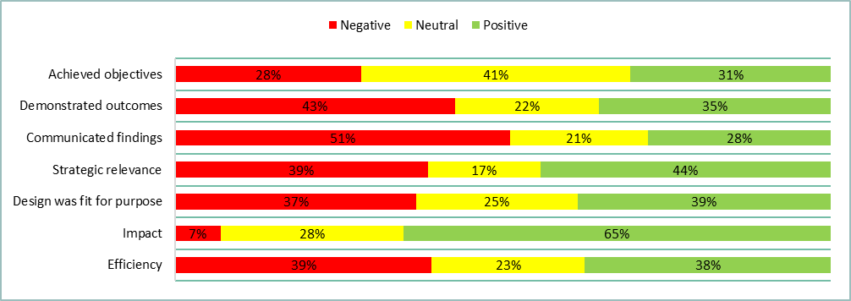

Figure Relative proportions of positive, neutral, and negative sentiment across the focal areas (Groups 1, 2 and 3)

There was considerable variability in sentiment of the questions within each focal area (Figure 9). The questions with a relatively high degree of positive sentiment included the extent to which the LTIM project achieved is objectives (Q1), the extent to which the overall LTIM project was aligned to Basin Plan objectives (Q8), the extent to which the LTIM project design fit for purpose in meeting the CEWO’s strategic requirements (Q10), the level of impact that the LTIM project had on the adaptive management of environmental water (Q13) and how impactful the knowledge gained through the LTIM project been in informing and improving Basin Plan implementation and/or outcomes (Q14).

The questions with a relatively high degree of negative sentiment included the extent to which the LTIM project inferred ecological outcomes of CEW to areas in the Basin not monitored (Q3), the effectiveness with which the LTIM project demonstrated that short term, less than 1 year outcomes, contribute to longer term outcomes (Q4), the effectiveness with which the LTIM project communicated key findings to stakeholder (Q6), the effectiveness of the cause and effect diagrams (CED) in communicating key relationships between environmental watering and ecological outcomes (Q7), the extent to which data management arrangements supported systematic capture and making available data generated by the LTIM project (Q12)

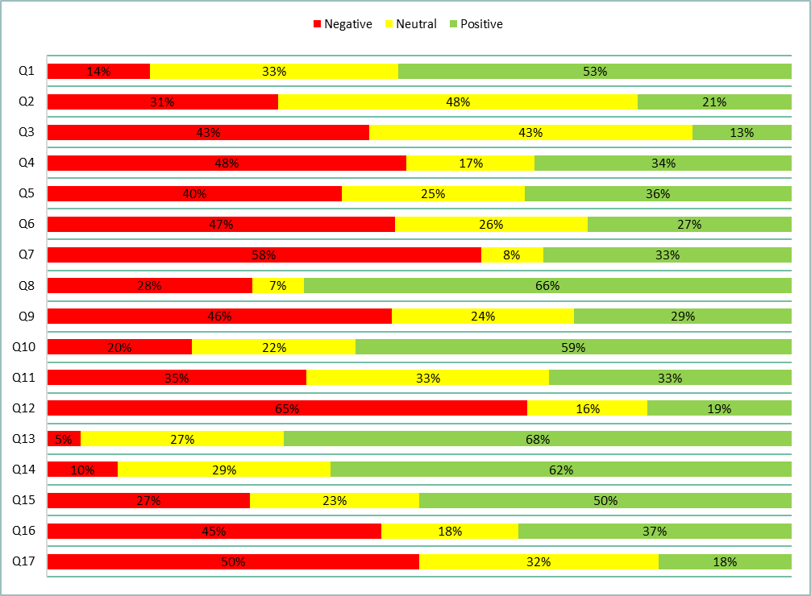

Figure Relative proportions of positive, neutral and negative sentiment (Groups 1, 2 and 3) for each question (Table 2) of the LTIM interviews (note that list of interview questions are not the same as survey ).

A large proportion of the neutral sentiment was derived from participants indicating that different aspects of the project varied in performance in relation to the basis of the question. For example, participants would often comment that the project performed well at the Selected Area but performed poorly at the Basin Matter, or vice versa. Instead of capturing such instances as separate statements, they were considered a combined attitude towards that aspect (basis of the question) of the project as a whole.

Note that 72% of the statements classified in the sentiment analysis overall came from service providers (Group 2). There were multiple reasons for this, the first being that the combined transcript for all service provider interviews was 264 pages, whereas the client (Group 1) and end user (Group 3) combined transcripts were 54 and 62 pages, respectively. The second reason for this, is that a higher proportion of the conversations turned to formative topics (i.e. opportunities for improvement) in the client and end user interviews, which weren’t included in the sentiment analysis as they did not directly reflect a participants attitudes in relation to the interview questions.

# Appendix 1: Survey questions and relevent Key evaluation Questions

Table Questions (n = 36) in the LTIM survey and the relevant Key Evaluation Questions (KEQs)

|  |  |  |
| --- | --- | --- |
|  | Survey and interview Question | Relevant KEQ |
| 1 | Do you consent for your personal data to be collected? |  |
| 2 | Contact details |  |
| 3 | Independent Evaluation of the Long Term Intervention Monitoring (LTIM) project |  |
| 4 | How long have you been in this role? |  |
| 5 | What is your role, if any, in the LTIM project? |  |
| Achieved objectives | | |
| 6 | How familiar are you with the LTIM project objectives? | **KEQ1** |
| 7 | To what extent do you think the LTIM project achieved its objectives? | **KEQ1** |
| 8 | How effective were the data management processes in aiding evaluation and reporting on outcomes? | **KEQ1.7** |
| 9 | How effectively did the LTIM project support adaptive management of Commonwealth Environmental Water (CEW) in each Selected Area (including reporting of adaptive management)? | **KEQ1.8.1** |
| 10 | How effective has the LTIM project been in monitoring and evaluating the ecological response to CEW at each of the seven Selected Areas? | **KEQ1A** |
| 11 | How effectively did the CEWO Outcomes Framework align to the Basin Plan Environmental Watering Plan (EWP) and Water Quality and Salinity Plan? | **KEQ2.1** |
| 12 | How effectively has the LTIM project demonstrated the contribution of CEW to achieving Basin Plan objectives (includes Chapter 8 and 9 objectives)? | **KEQ2.2**  **KEQ6.1** |
| 13 | How effectively did the LTIM project document and report on the evaluation of the contribution of CEW at a Basin scale? | **KEQ2.3 KEQ2.3.2** |
| 14 | How effectively did the LTIM project undertake annual evaluation of CEW on the six specified Basin Matters? | **KEQ2.4** |
| 15 | To what extent did the LTIM project infer ecological outcomes of CEW to areas in the Basin not monitored? | **KEQ4** |
| 16 | How effectively was Selected Area data extrapolated from reach to whole of Selected Area scale Remove basin scale? | **KEQ4. 1** |
| Communicated findings | | |
| 17 | How effective was the LTIM project at communicating key findings to stakeholders (CEWO, MDBA, other members of the LTIM project, etc.), including to inform adaptive management? | **KEQ5** |
| Demonstrated outcomes | | |
| 18 | How effectively has the LTIM project improved capacity to predict outcomes of environmental flow allocations and their management over 1–5 years? | **KEQ6.6** |
| 19 | How effectively has the LTIM project demonstrated that short term, less than 1-year outcomes, contribute to longer term outcomes? | **KEQ6.7** |
| Strategic relevance | | |
| 20 | How well has the LTIM project contributed to the CEWO’s ability to meet their legislative reporting requirements? | **KEQ8** |
| Fit for purpose | | |
| 21 | To what extent was the LTIM project design fit for purpose in meeting the CEWO’s strategic requirements? | **KEQ8** |
| 22 | To what extent did the cause and effect diagrams include best available knowledge (including scientific, local and cultural knowledge)? | **KEQ8.5** |
| 23 | To what extent were the best practice scientific methods employed in the LTIM project? | **KEQ8.6** |
| 24 | To what extent were the Standard Methods fit for purpose and consistently applied at the Selected Areas? | **KEQ8.6.2** |
| 25 | How appropriate was the predictive modelling in predicting outcomes of environmental watering in areas not monitoring for each Basin Matter?' | **KEQ8.6.4** |
| 26 | To what extent have data management arrangements supported systematic capture and making available data generated by the LTIM project? | **KEQ8.9** |
| Impact | | |
| 27 | What level of impact has the LTIM project had on the adaptive management of environmental water? | **KEQ9.1** |
| 28 | How impactful has knowledge gained through the LTIM project been in informing and improving Basin Plan implementation and/or outcomes? | **KEQ9.2** |
| 29 | How impactful has the LTIM project been in fostering improved collaboration? | **KEQ10** |
| 30 | What impact has the LTIM project had on partnership mechanisms and initiatives to build stronger coherence and collaboration between participating organisations? | **KEQ10.1** |
| Efficiency | | |
| 31 | How efficiently were the funds and time allocated to address the LTIM project objectives? | **KEQ11.1** |
| 32 | How efficient was the collaborative process within the LTIM project? | **KEQ12** |
| 33 | To what extent did the LTIM project take up opportunities for joint activities, pooling of resources and mutual learning with other organisations and networks? | **KEQ12.1** |
| 34 | How efficient was the LTIM project in managing data? | **KEQ13** |
| 35 | How efficient was the LTIM project in sharing data? | **KEQ13** |
| Opportunities for improvement | | |
| 36 | What, if any, improvements could be made to the LTIM project moving forward? | **All** |

# Appendix 2: Results by question

### Question 6: How familiar are you with the LTIM project objectives?

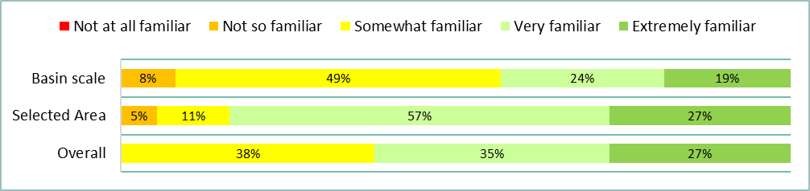

Figure Responses to question 6 of the LTIM survey (Group 1, 2 and 3 | n = 37)

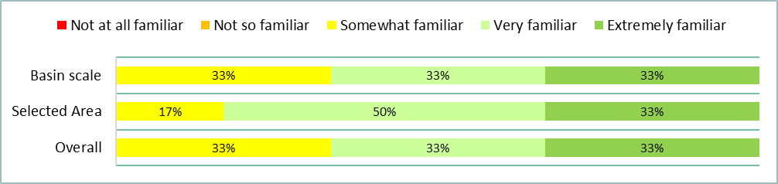

Figure Responses to question 6 of the LTIM survey (Group 1 | n = 6)

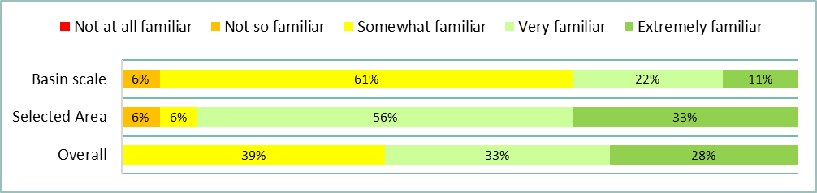

Figure Responses to question 6 of the LTIM survey (Group 2 | n = 18)

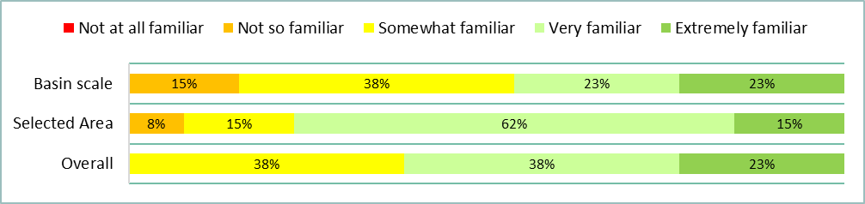

Figure Responses to question 6 of the LTIM survey (Group 3 | n = 13)

### Question 7: To what extent do you think the LTIM project achieved its objectives?

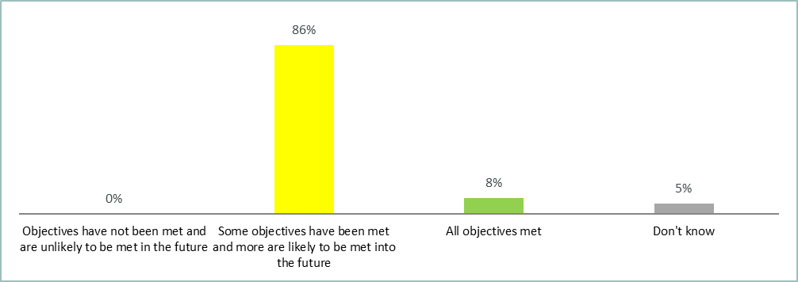

Figure Responses to question 7 of the LTIM survey (Group 1, 2 and 3 | n = 37)

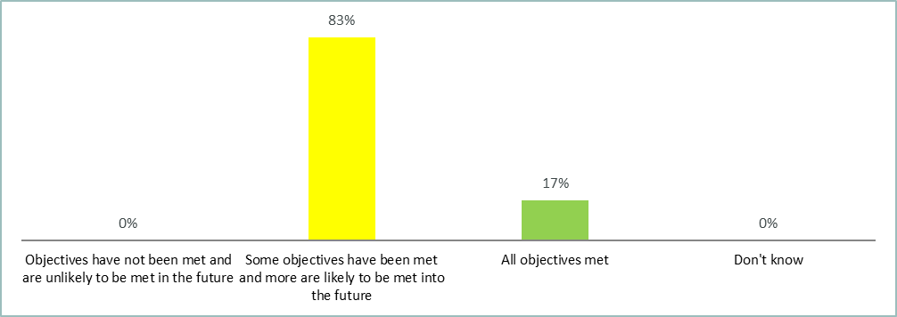

Figure Responses to question 7 of the LTIM survey (Group 1 | n = 6)

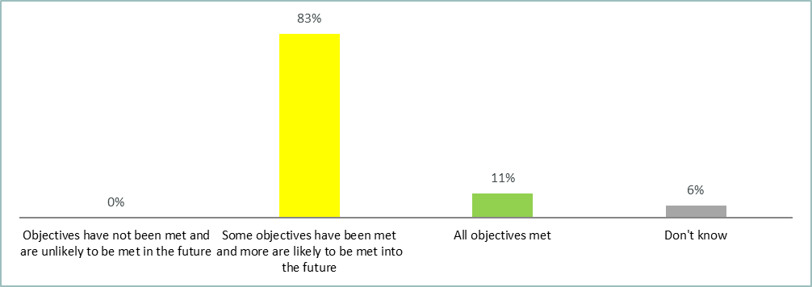

Figure Responses to question 7 of the LTIM survey (Group 2 | n = 18)

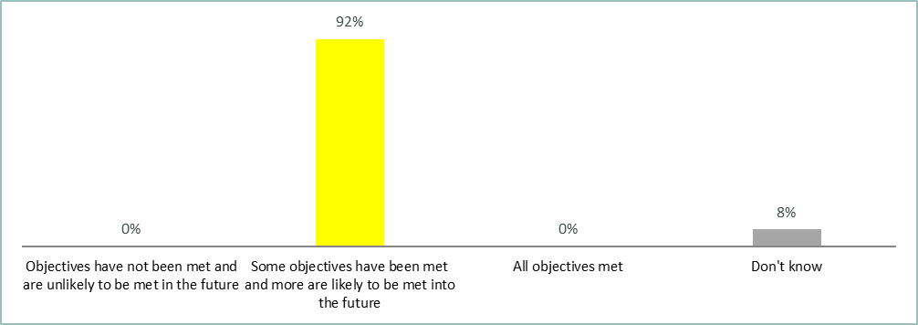

Figure Responses to question 7 of the LTIM survey (Group 3 | n = 13)

### Question 8: How effective were the data management processes in aiding evaluation and reporting on outcomes?

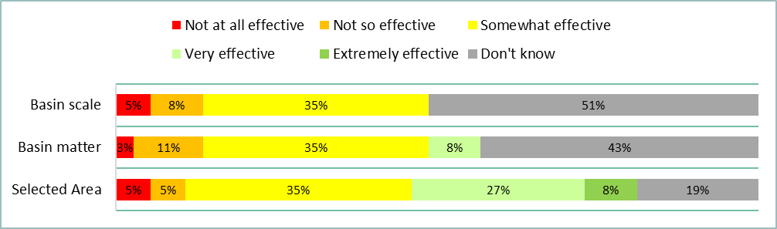

Figure Responses to question 8 of the LTIM survey (Group 1, 2 and 3 | n = 37)

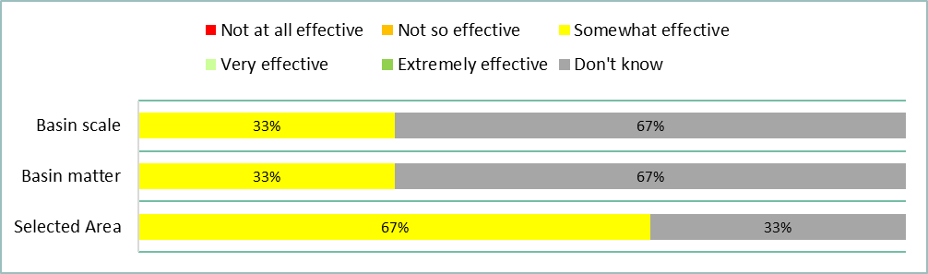

Figure Responses to question 8 of the LTIM survey (Group 1 | n = 6)

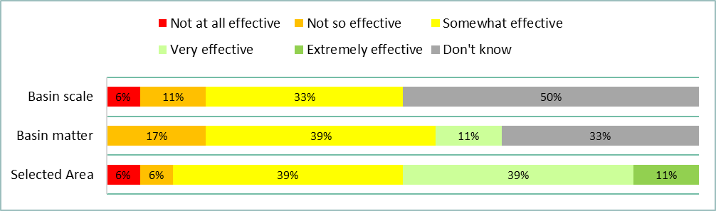

Figure Responses to question 8 of the LTIM survey (Group 2 | n = 18)

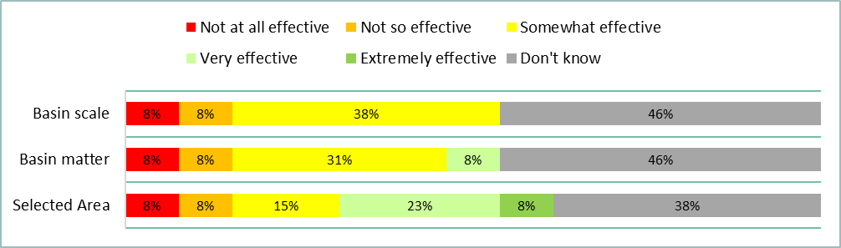

Figure Responses to question 8 of the LTIM survey (Group 3 | n = 13)

### Question 9: How effectively did the LTIM project support adaptive management of Commonwealth Environmental Water (CEW) in each Selected Area (including reporting of adaptive management)?

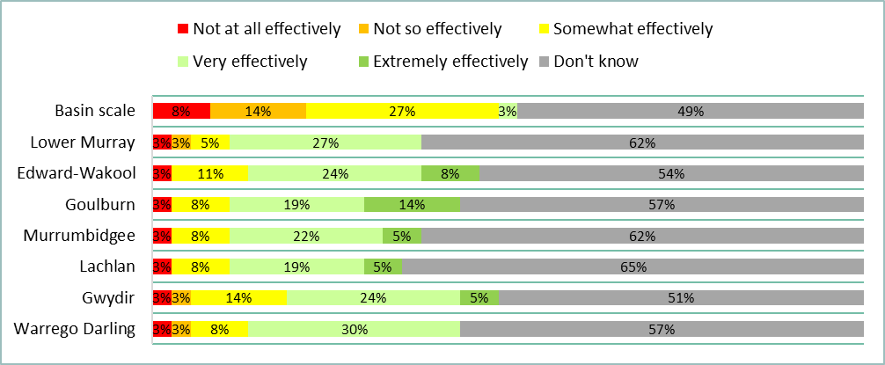

Figure Responses to question 9 of the LTIM survey (Group 1, 2 and 3 | n = 37)

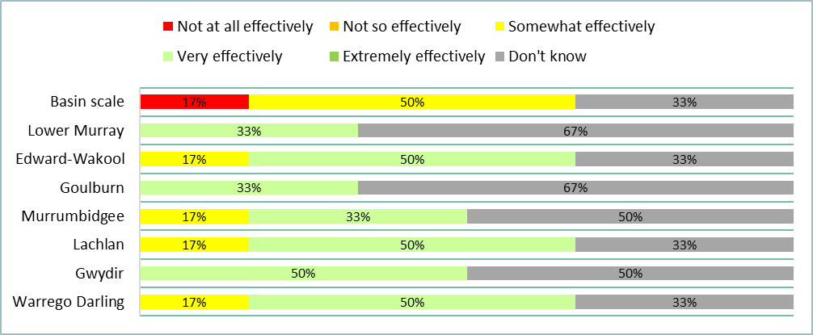

Figure Responses to question 9 of the LTIM survey (Group 1 | n = 6)

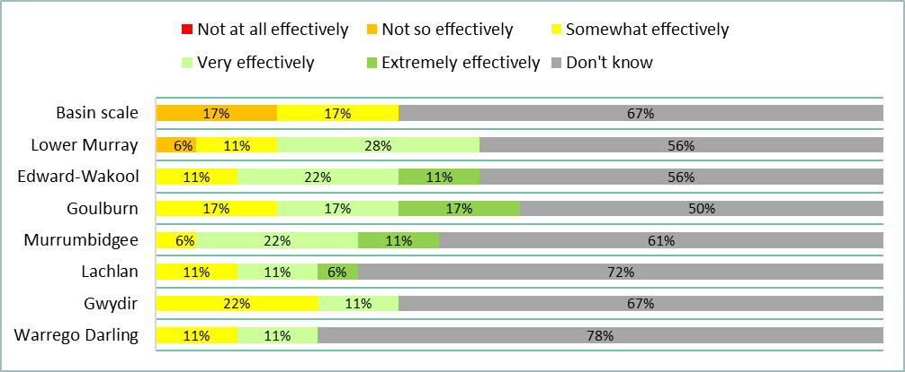

Figure Responses to question 9 of the LTIM survey (Group 2 | n = 18)

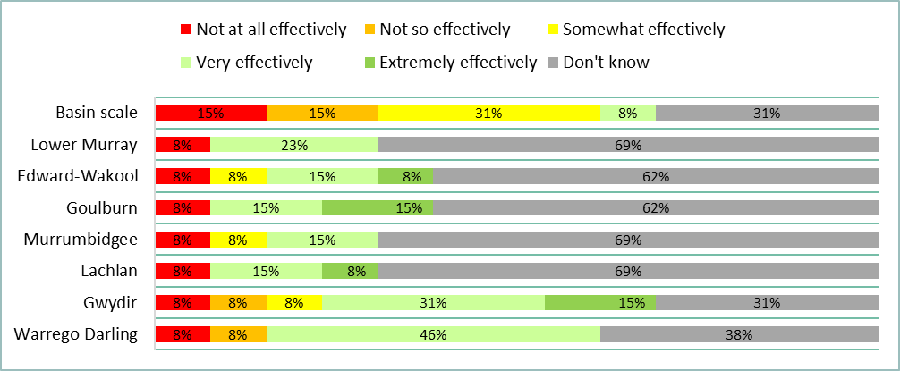

Figure Responses to question 9 of the LTIM survey (Group 3 | n = 13)

### Question 10: How effective has the LTIM project been in monitoring and evaluating the ecological response to CEW at each of the seven Selected Areas?

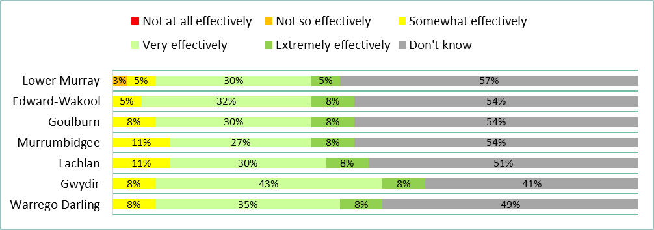

Figure Responses to question 10 of the LTIM survey (Group 1, 2 and 3 | n = 37)

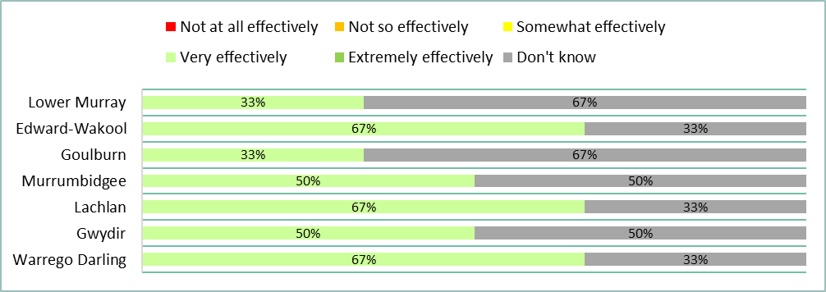

Figure Responses to question 10 of the LTIM survey (Group 1 | n = 6)

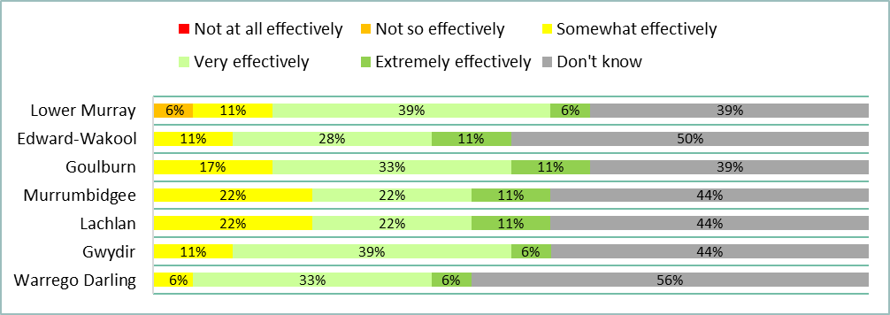

Figure Responses to question 10 of the LTIM survey (Group 2 | n = 18)

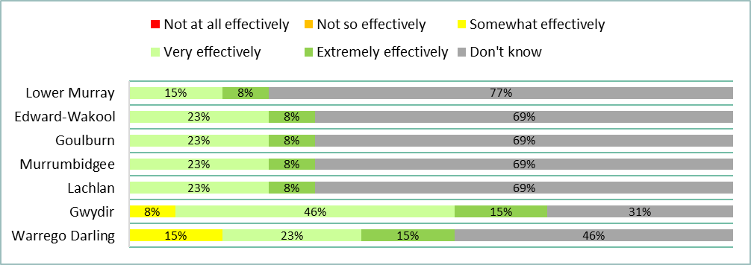

Figure Responses to question 10 of the LTIM survey (Group 3 | n = 13)

### Question 11: How effectively did the CEWO Outcomes Framework align to the Basin Plan Environmental Watering Plan (EWP) and Water Quality and Salinity Plan?

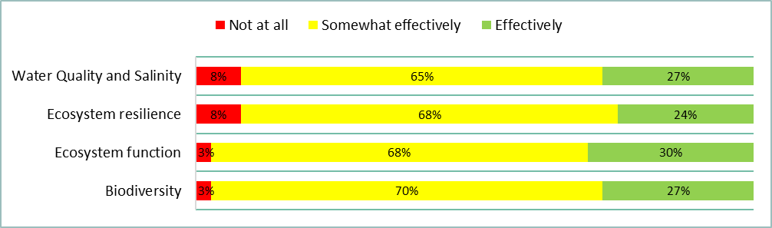

Figure Responses to question 11 of the LTIM survey (Group 1, 2 and 3 | n = 37)

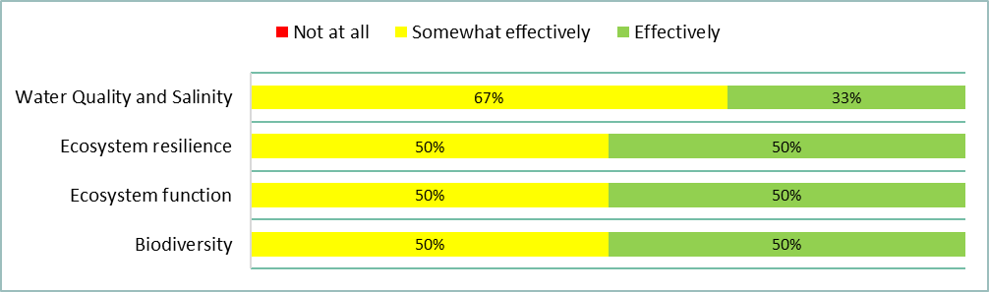

Figure Responses to question 11 of the LTIM survey (Group 1 | n = 6)

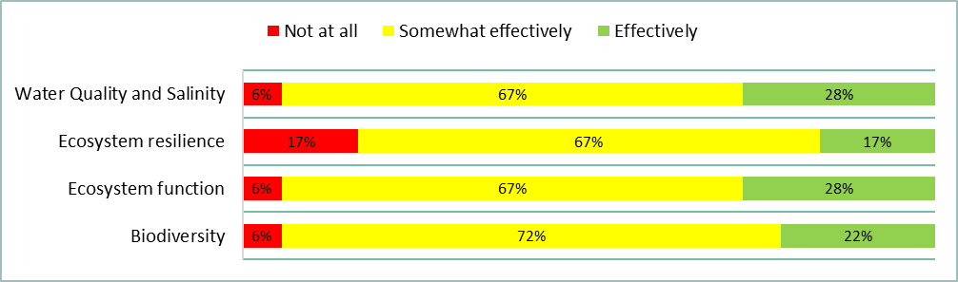

Figure Responses to question 11 of the LTIM survey (Group 2 | n = 18)

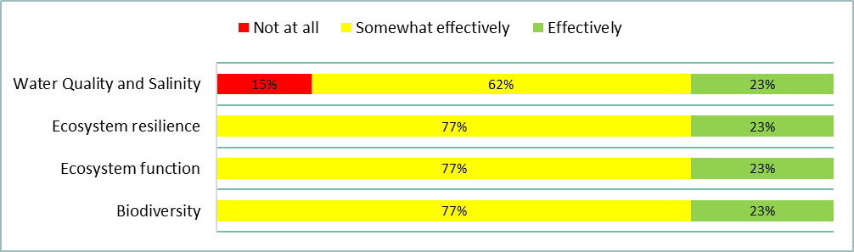

Figure Responses to question 11 of the LTIM survey (Group 3 | n = 13)

### Question 12: How effectively has the LTIM project demonstrated the contribution of CEW to achieving Basin Plan objectives (includes Chapter 8 and 9 objectives)?

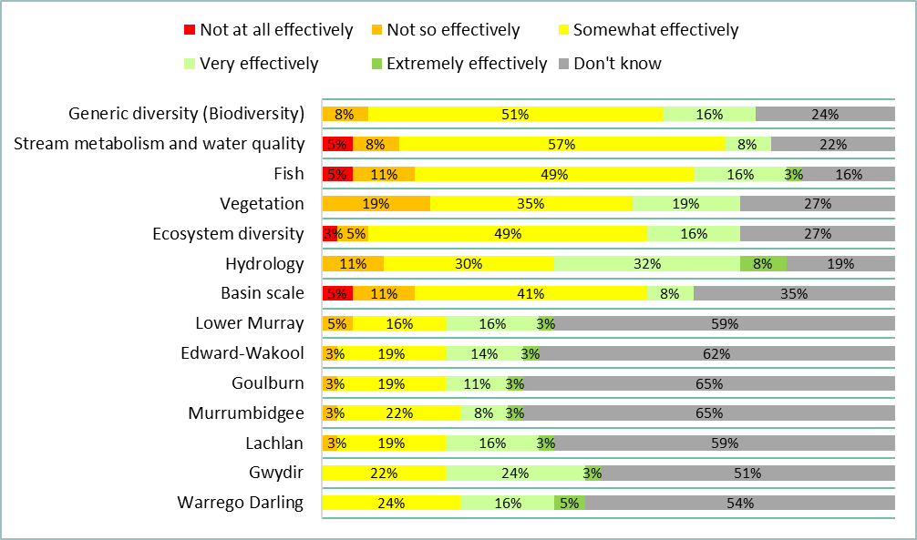

Figure Responses to question 12 of the LTIM survey (Group 1, 2 and 3 | n = 37)

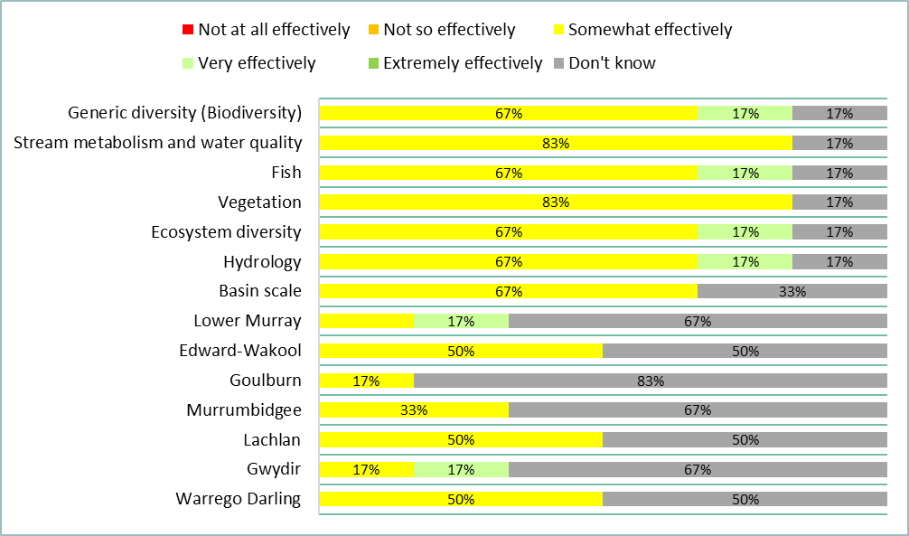

Figure Responses to question 12 of the LTIM survey (Group 1 | n = 6)

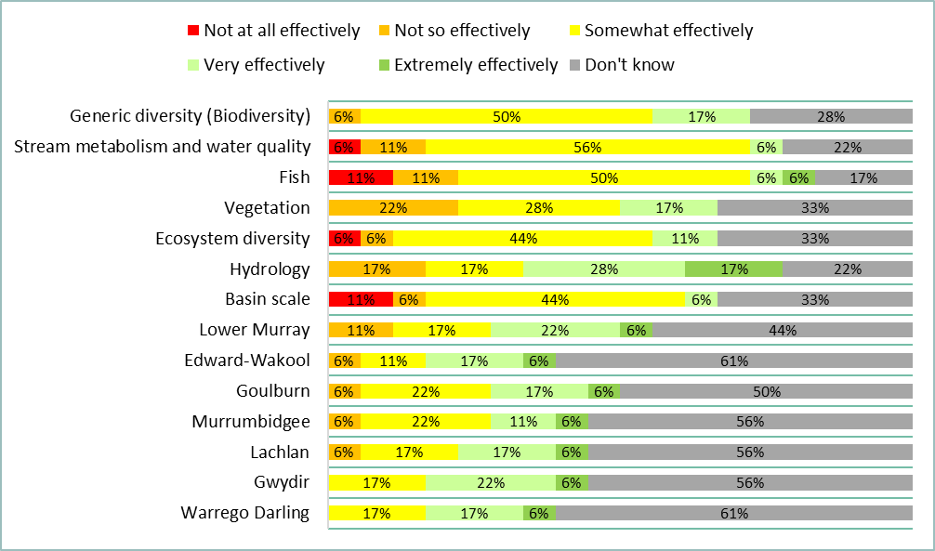

Figure Responses to question 12 of the LTIM survey (Group 2 | n = 18)

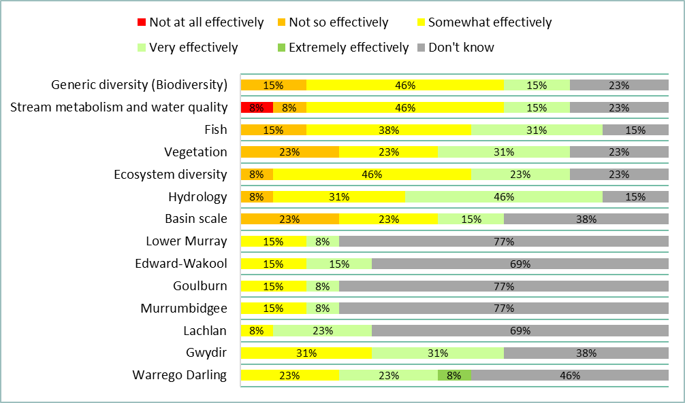

Figure Responses to question 12 of the LTIM survey (Group 3 | n = 13)

### Question 13: How effectively did the LTIM project document and report on the evaluation of the contribution of CEW at a Basin scale?

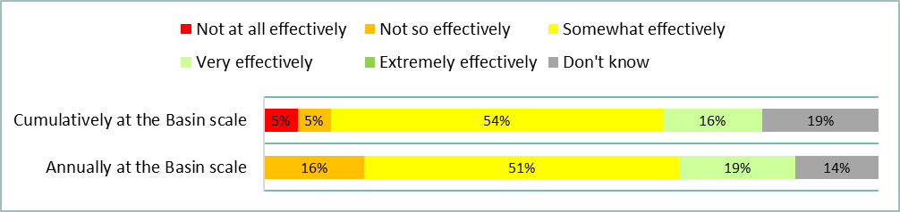

Figure Responses to question 13 of the LTIM survey (Group 1, 2 and 3 | n = 37)

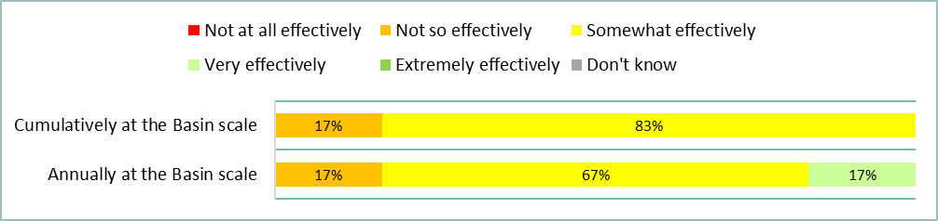

Figure Responses to question 13 of the LTIM survey (Group 1 | n = 6)

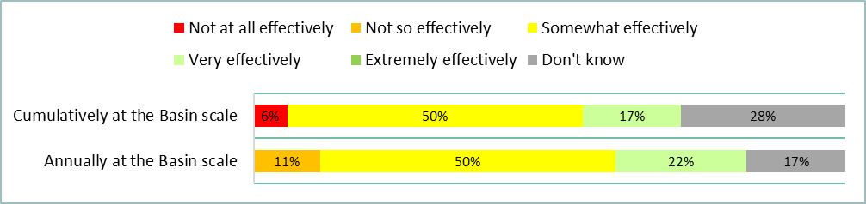

Figure Responses to question 13 of the LTIM survey (Group 2 | n = 18)

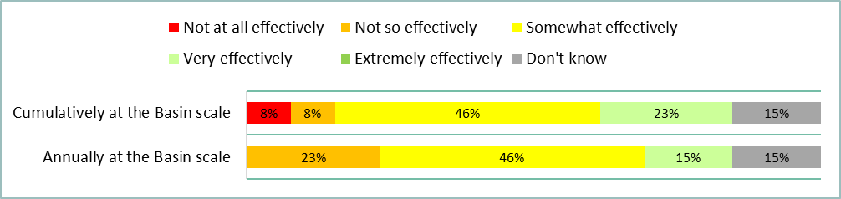

Figure Responses to question 13 of the LTIM survey (Group 3 | n = 13)

### Question 14: How effectively did the LTIM project undertake annual evaluation of CEW on the six specified Basin Matters?

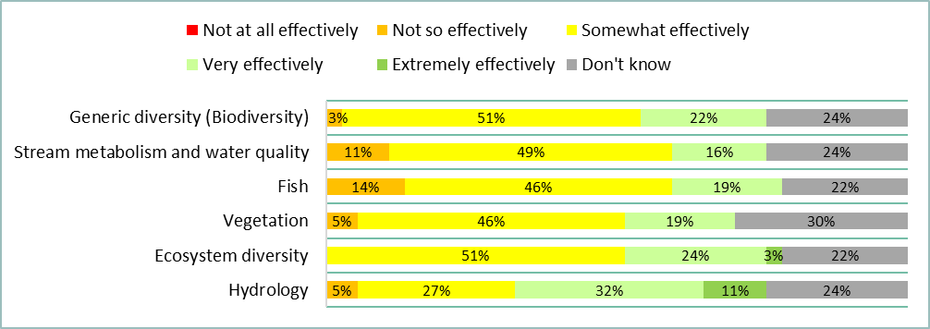

Figure Responses to question 14 of the LTIM survey (Group 1, 2 and 3 | n = 37)

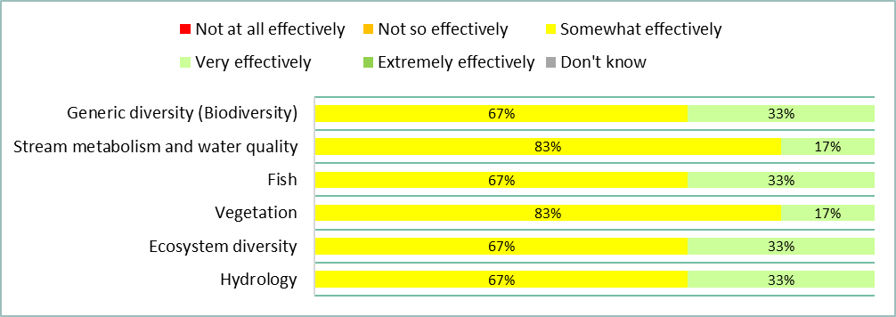

Figure Responses to question 14 of the LTIM survey (Group 1 | n = 6)

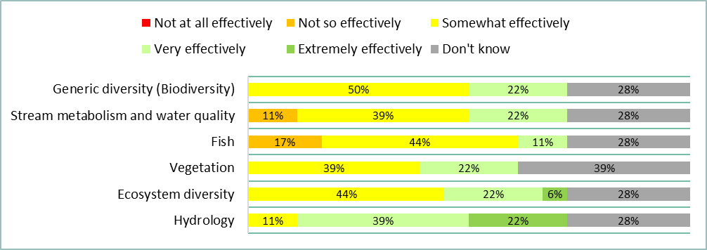

Figure Responses to question 14 of the LTIM survey (Group 2 | n = 18)

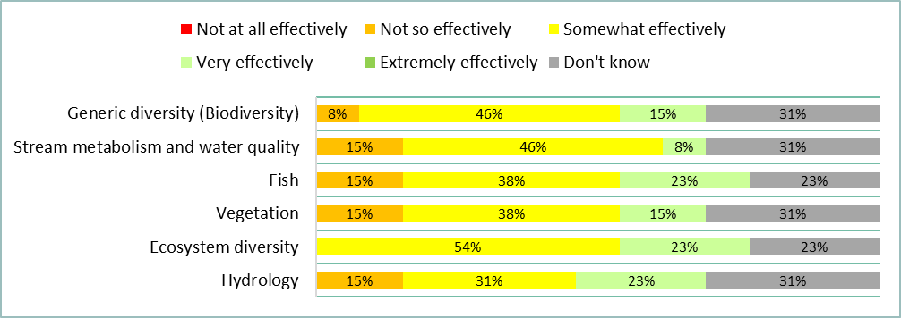

Figure Responses to question 14 of the LTIM survey (Group 3 | n = 13)

### Question 15: To what extent did the LTIM project infer ecological outcomes of CEW to areas in the Basin not monitored?

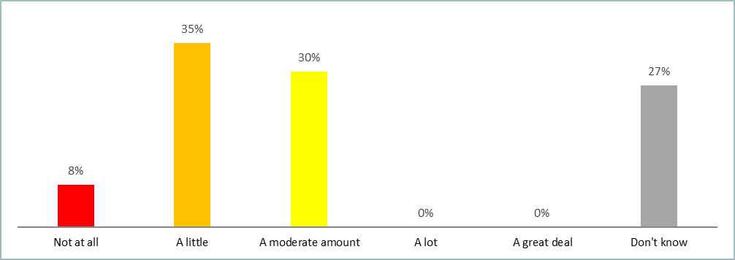

Figure Responses to question 15 of the LTIM survey (Group 1, 2 and 3 | n = 37)

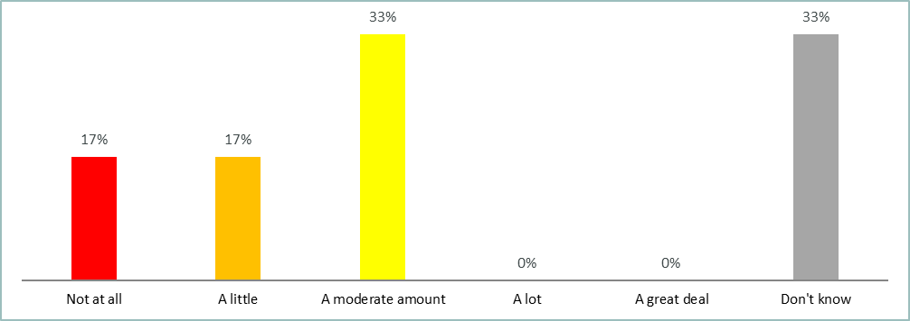

Figure Responses to question 15 of the LTIM survey (Group 1 | n = 6)

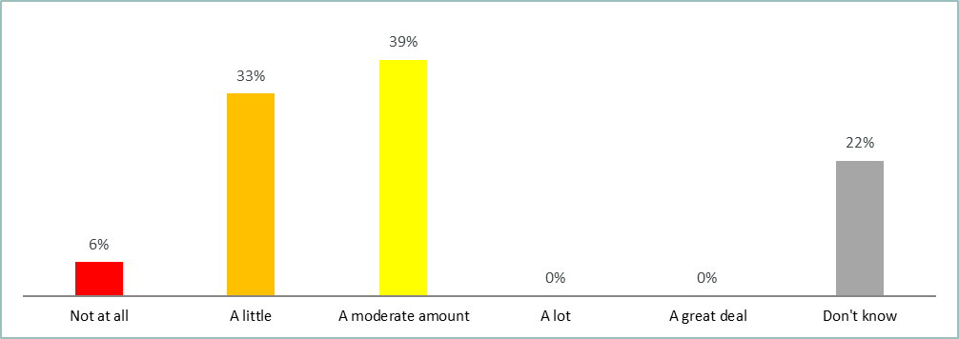

Figure Responses to question 15 of the LTIM survey (Group 2 | n = 18)

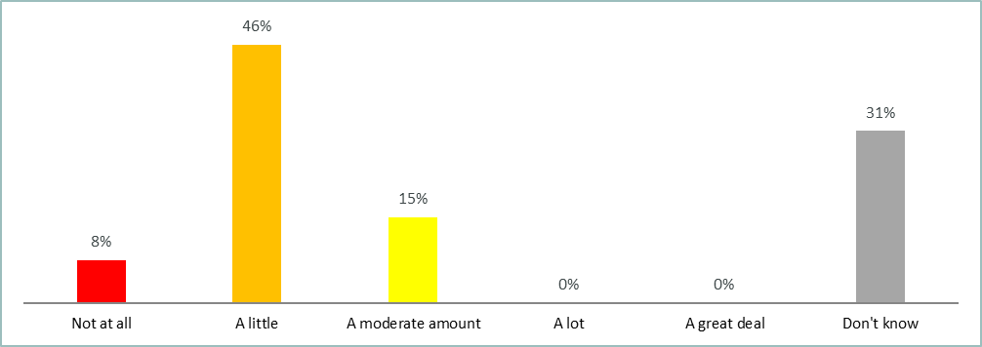

Figure Responses to question 15 of the LTIM survey (Group 3| n = 13)

### Question 16: How effectively was Selected Area data extrapolated from reach to whole of Selected Area and to Basin scale?

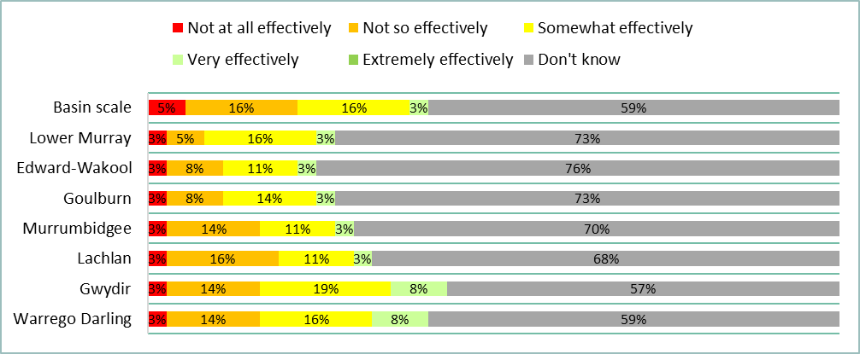

Figure Responses to question 16 of the LTIM survey (Group 1, 2 and 3 | n = 37)

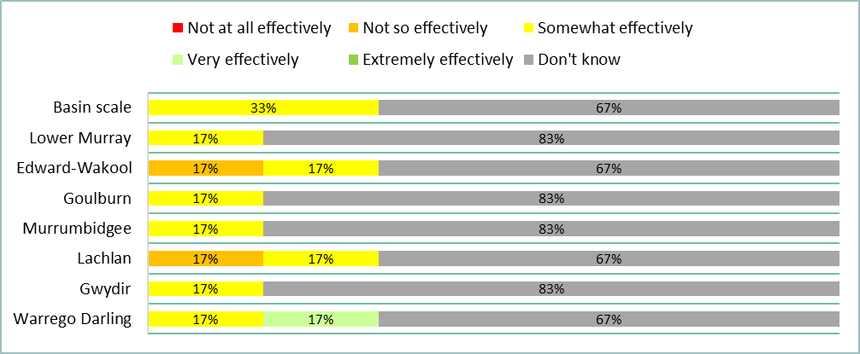

Figure Responses to question 16 of the LTIM survey (Group 1 | n = 6)

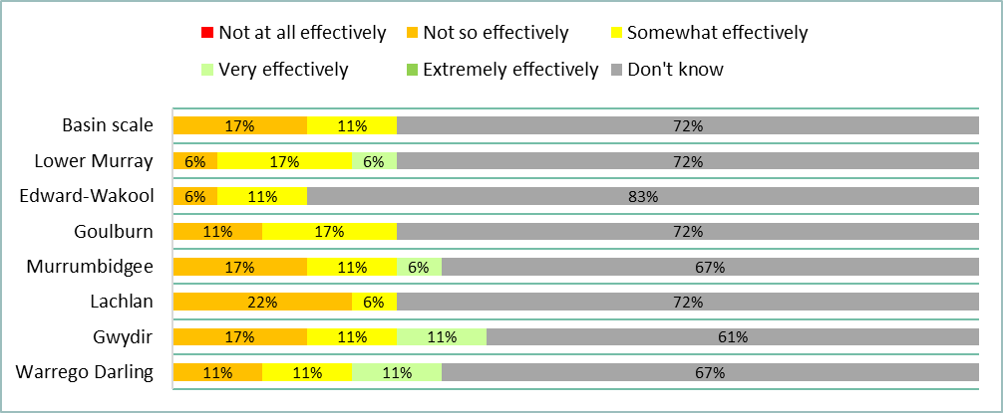

Figure Responses to question 16 of the LTIM survey (Group 2 | n = 18)

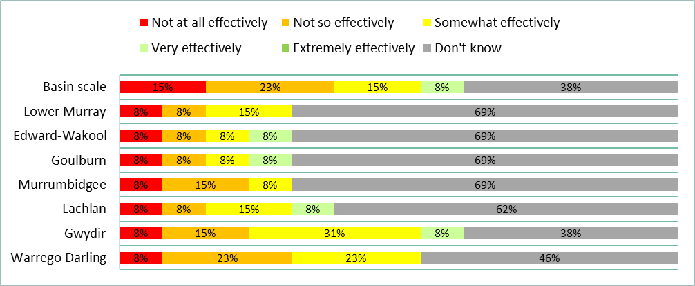

Figure Responses to question 16 of the LTIM survey (Group 3 | n = 13)

### Question 17: How effective was the LTIM project at communicating key findings to stakeholders (CEWO, MDBA, other members of the LTIM project, etc.), including to inform adaptive management?

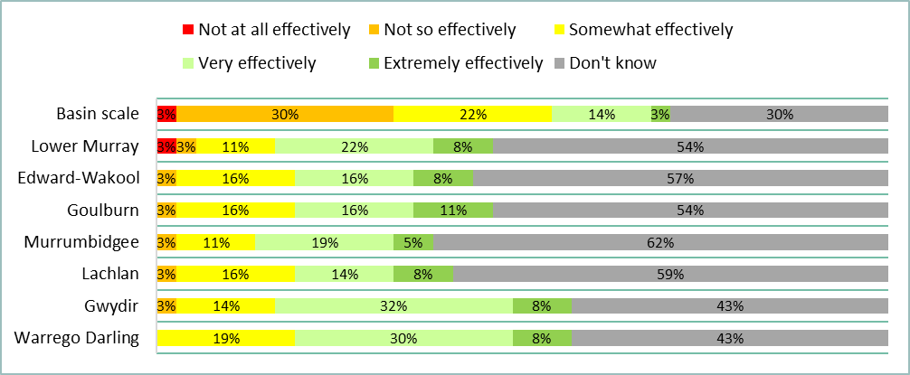

Figure Responses to question 17 of the LTIM survey (Group 1, 2 and 3 | n = 37)

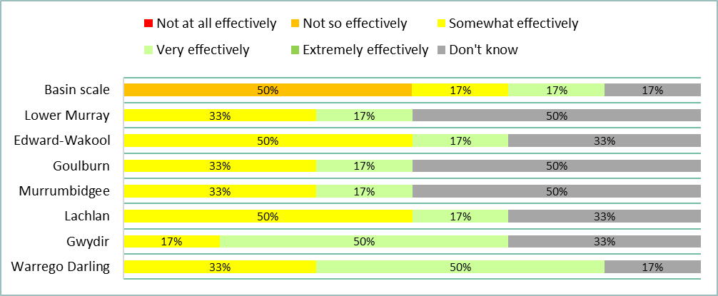

Figure Responses to question 17 of the LTIM survey (Group 1 | n = 6)

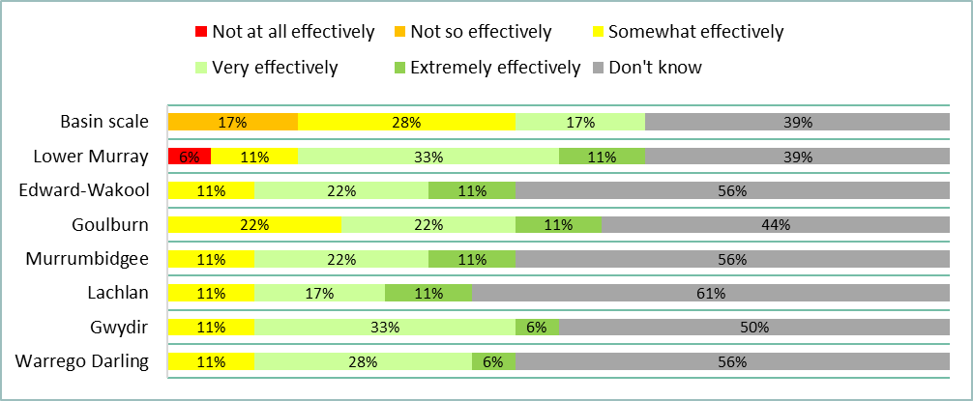

Figure Responses to question 17 of the LTIM survey (Group 2 | n = 18)

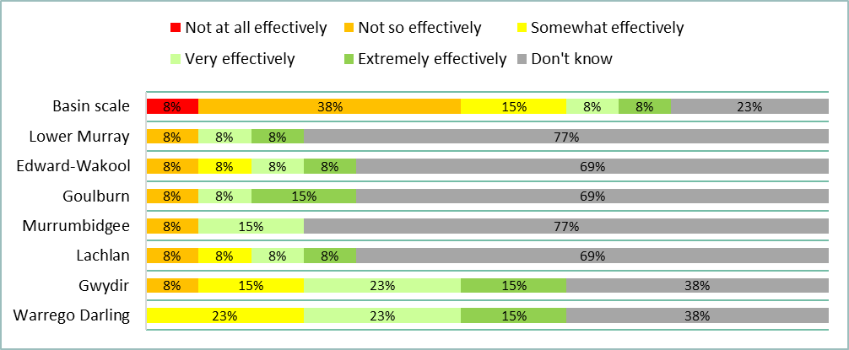

Figure Responses to question 17 of the LTIM survey (Group 3 | n = 13)

### Question 18: How effectively has the LTIM project improved capacity to predict outcomes of environmental flow allocations and their management over 1–5 years?

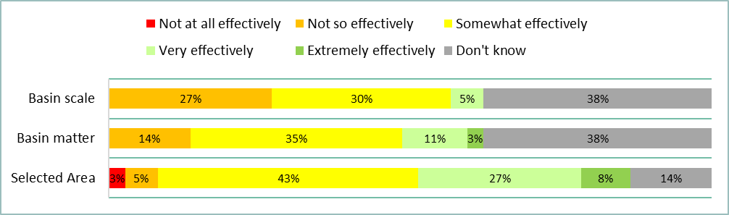

Figure Responses to question 18 of the LTIM survey (Group 1, 2 and 3 | n = 37)

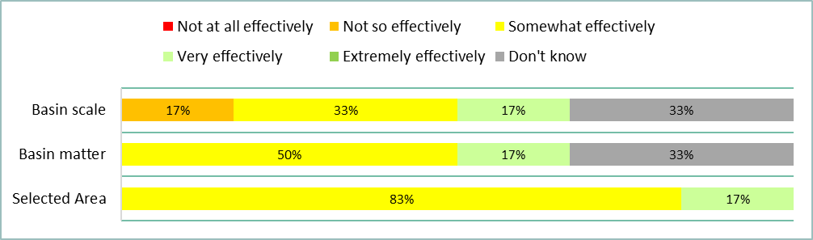

Figure Responses to question 18 of the LTIM survey (Group 1 | n = 6)

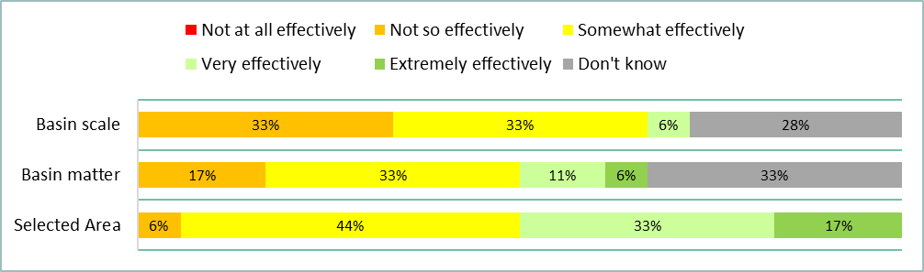

Figure Responses to question 18 of the LTIM survey (Group 2 | n = 18)

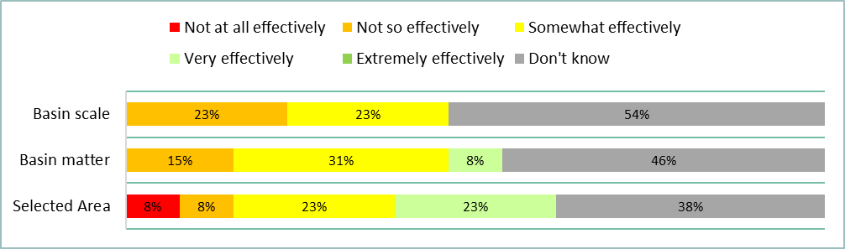

Figure Responses to question 18 of the LTIM survey (Group 3 | n = 13)

### Question 19: How effectively has the LTIM project demonstrated that short term, less than 1-year outcomes, contribute to longer term outcomes?

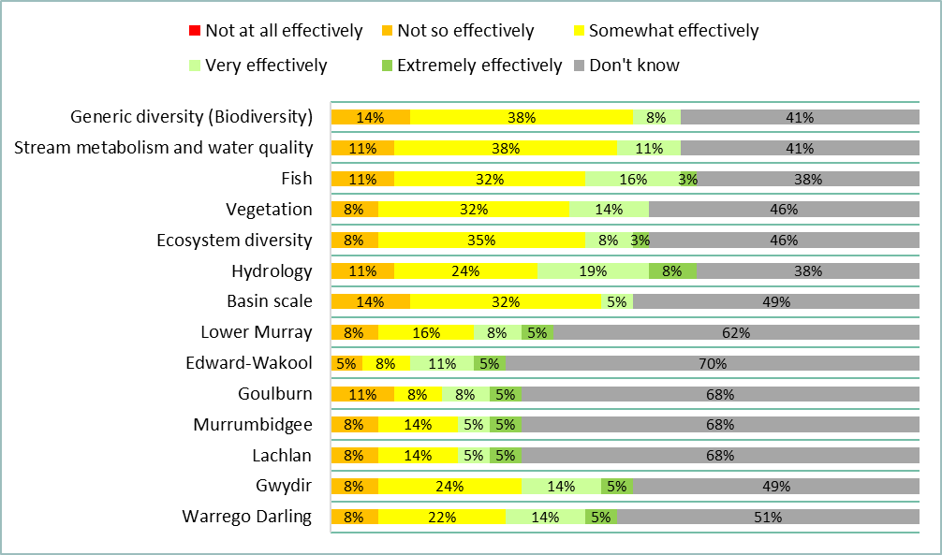

Figure Responses to question 19 of the LTIM survey (Group 1, 2 and 3 | n = 37)

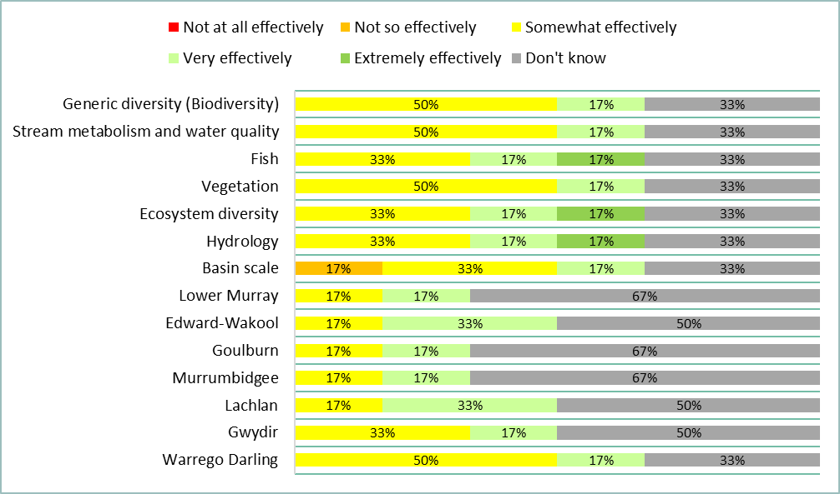

Figure Responses to question 19 of the LTIM survey (Group 1 | n = 6)

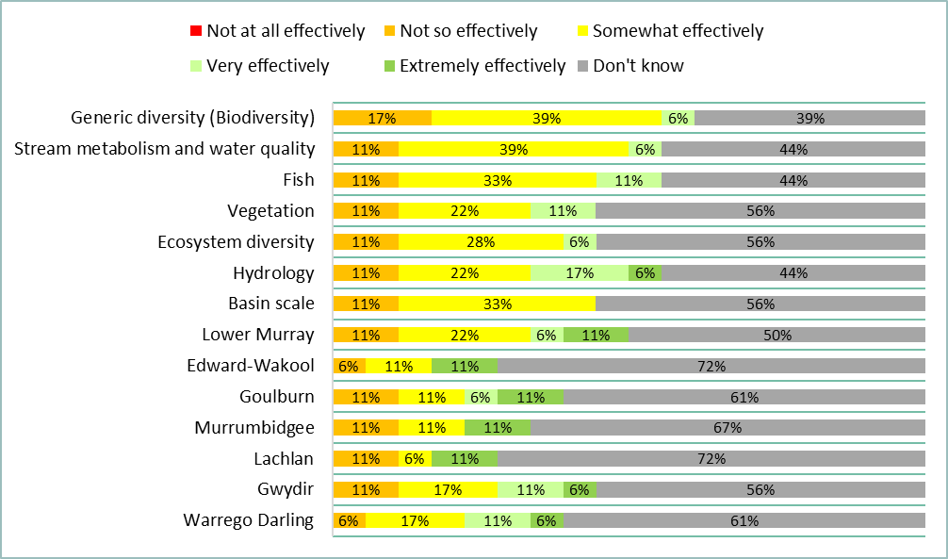

Figure Responses to question 19 of the LTIM survey (Group 2 | n = 18)

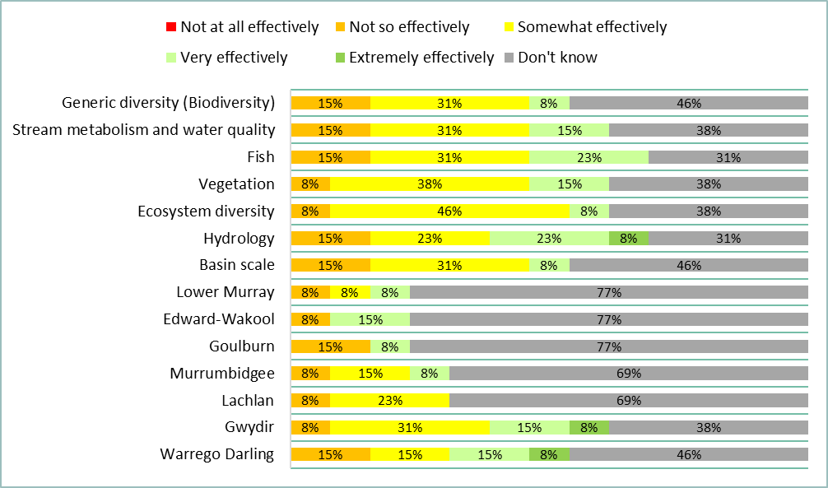

Figure Responses to question 19 of the LTIM survey (Group 3 | n = 13)

### Question 20: How well has the LTIM project contributed to the CEWO’s ability to meet their legislative reporting requirements?

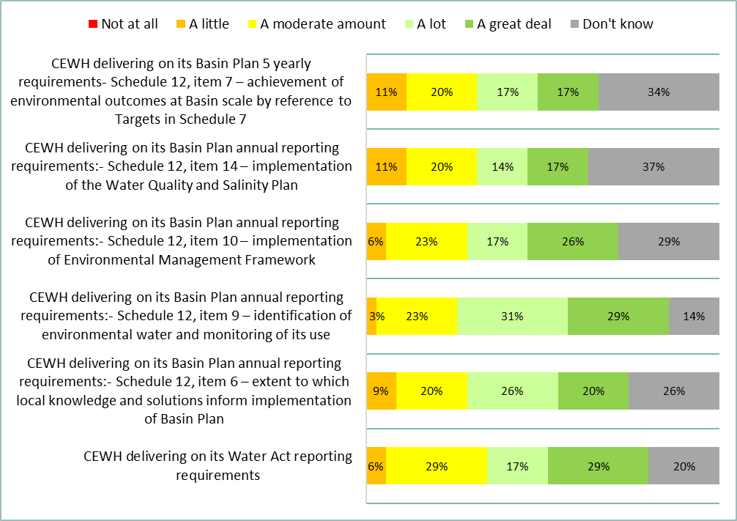

Figure Responses to question 20 of the LTIM survey (Group 1, 2 and 3 | n = 35)

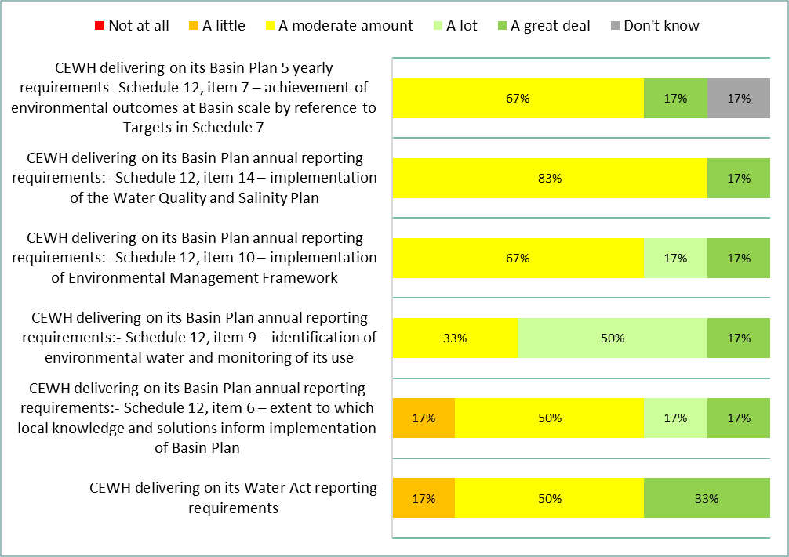

Figure Responses to question 20 of the LTIM survey (Group 1 | n = 6)

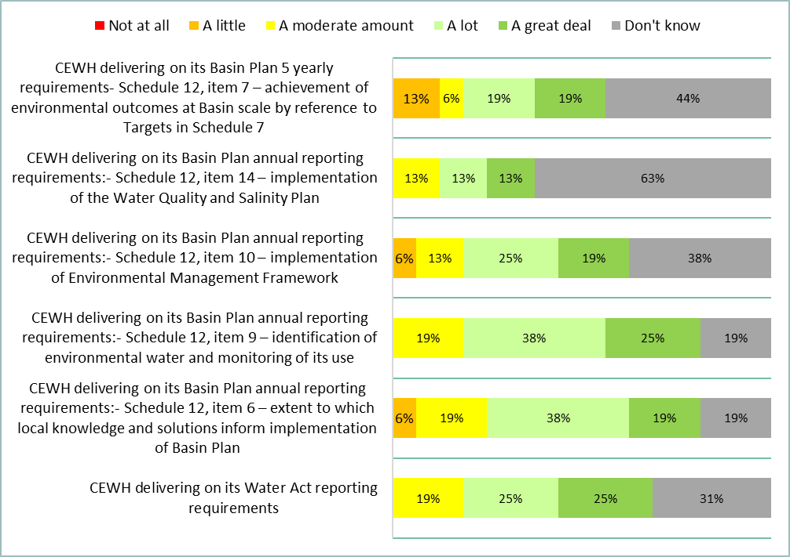

Figure Responses to question 20 of the LTIM survey (Group 2 | n = 16)

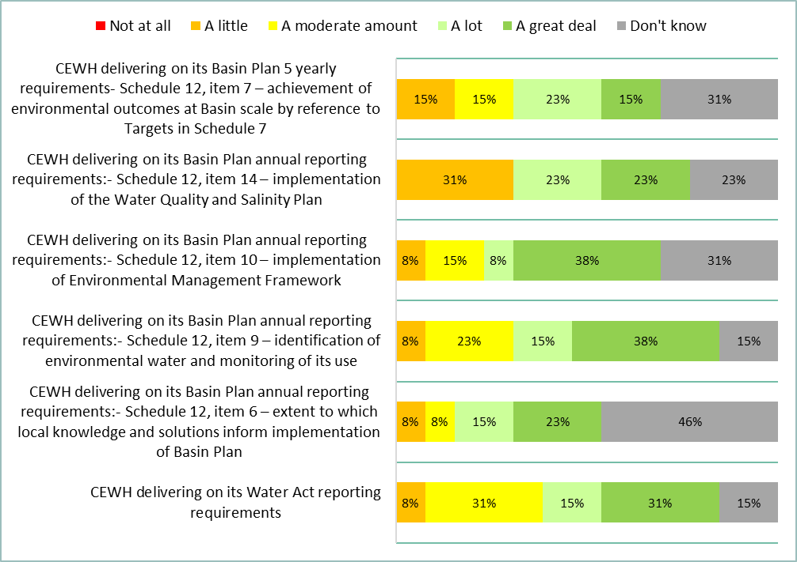

Figure Responses to question 20 of the LTIM survey (Group 3 | n = 13)

### Question 21: To what extent was the LTIM project design fit for purpose in meeting the CEWO’s strategic requirements?

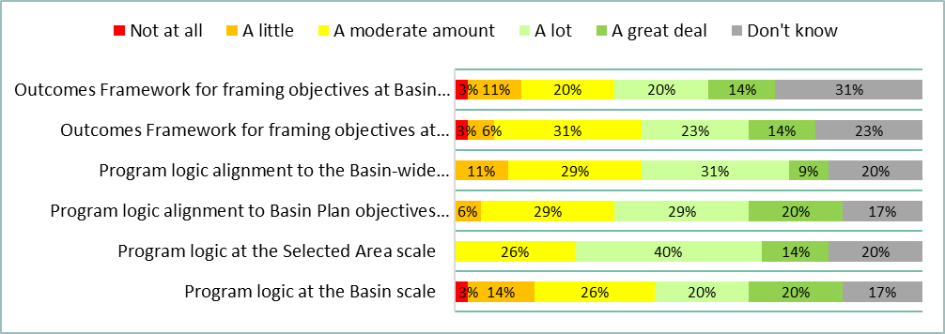

Figure Responses to question 21 of the LTIM survey (Group 1, 2 and 3 | n = 35)

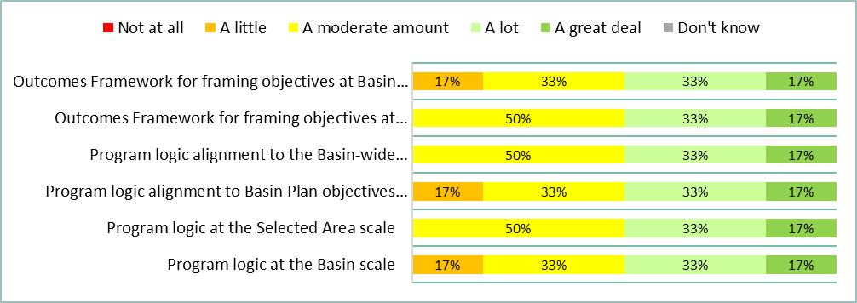

Figure Responses to question 21 of the LTIM survey (Group 1 | n = 6)

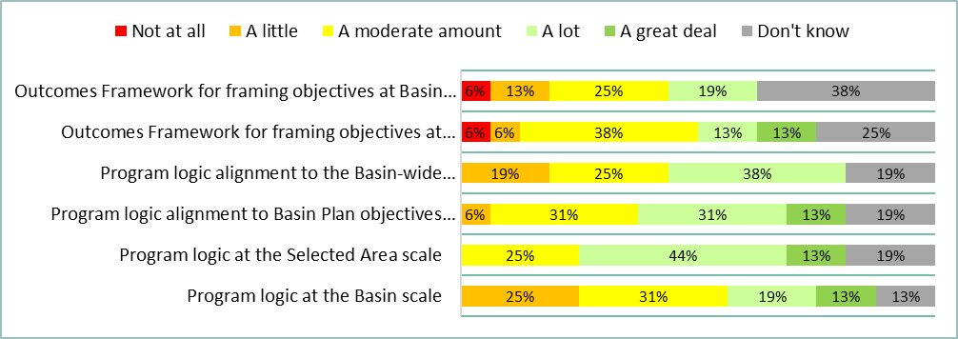

Figure Responses to question 21 of the LTIM survey (Group 2 | n = 16)

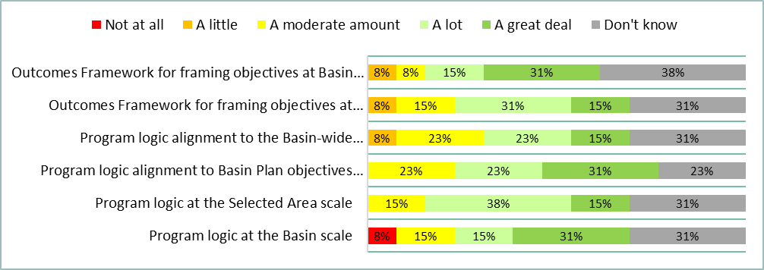

Figure Responses to question 21 of the LTIM survey (Group 3 | n = 13)

### Question 22: To what extent did the cause and effect diagrams include best available knowledge (including scientific, local and cultural knowledge)?

Figure Responses to question 22 of the LTIM survey (Group 1, 2 and 3 | n = 34)

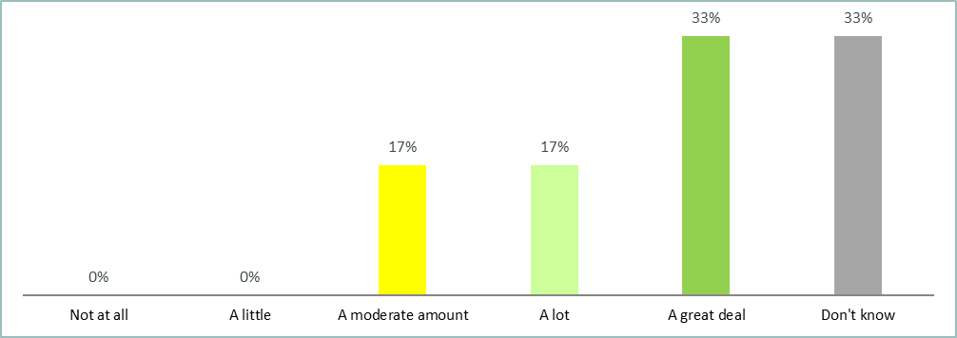

Figure Responses to question 22 of the LTIM survey (Group 1 | n = 6)

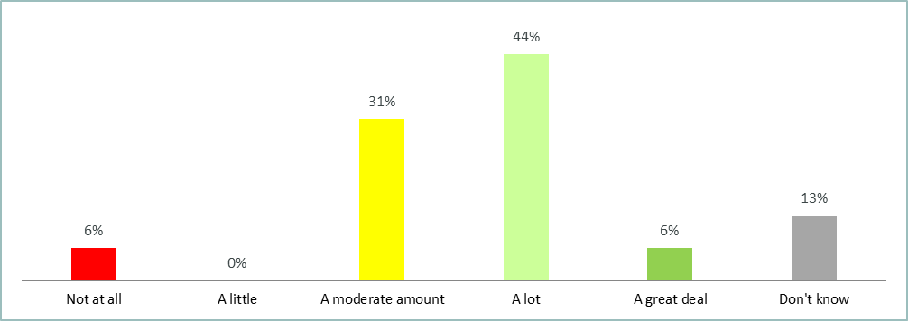

Figure Responses to question 22 of the LTIM survey (Group 2 | n = 16)

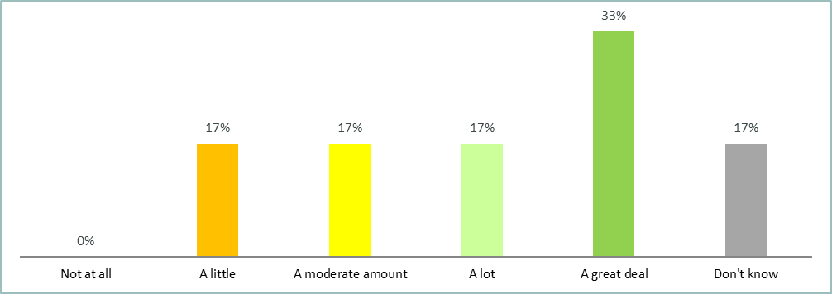

Figure Responses to question 22 of the LTIM survey (Group 3 | n = 12)

### Question 23: To what extent were the best practice scientific methods employed in the LTIM project?

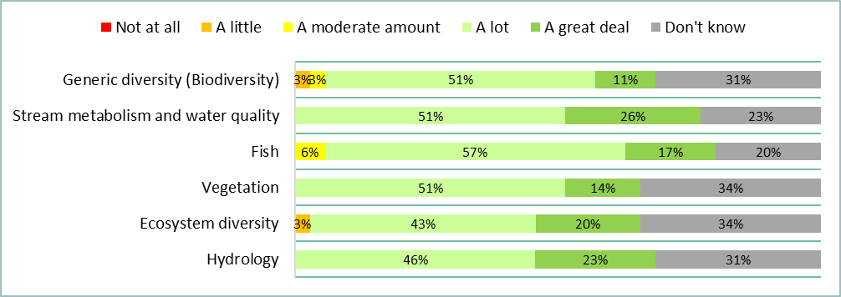

Figure Responses to question 23 of the LTIM survey (Group 1, 2 and 3 | n = 35)

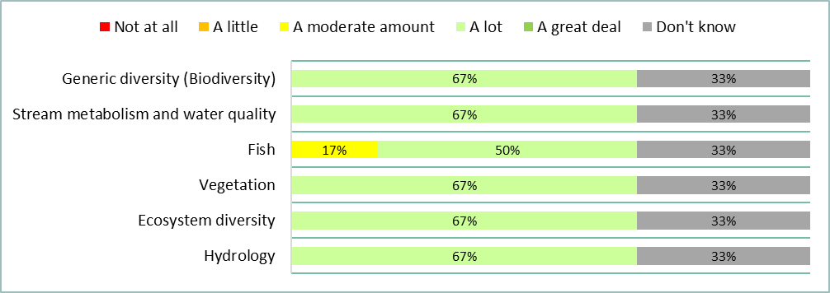

Figure Responses to question 23 of the LTIM survey (Group 1 | n = 6)

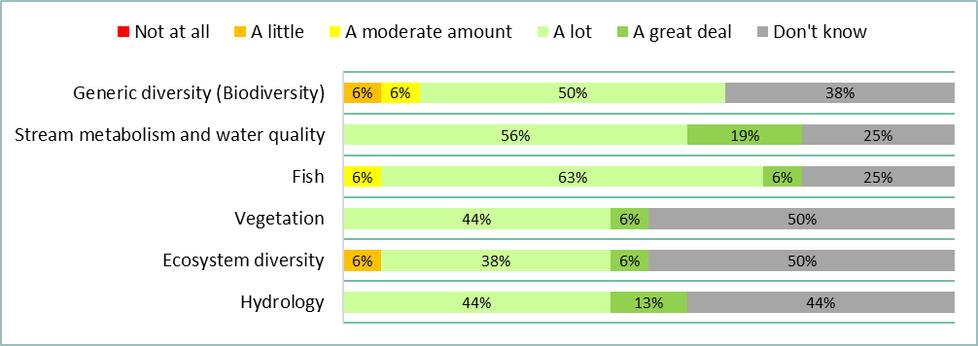

Figure Responses to question 23 of the LTIM survey (Group 2 | n = 16)

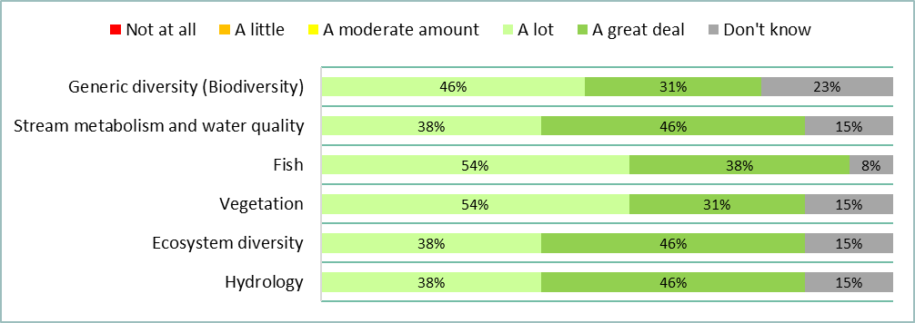

Figure Responses to question 23 of the LTIM survey (Group 3 | n = 13)

### Question 24: To what extent were the Standard Methods fit for purpose and consistently applied at the Selected Areas?

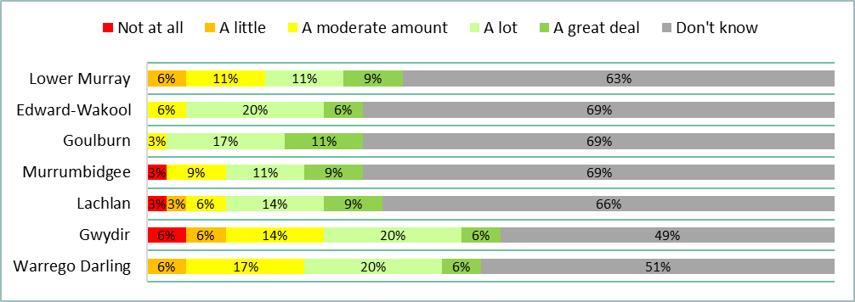

Figure Responses to question 24 of the LTIM survey (Group 1, 2 and 3 | n = 35)

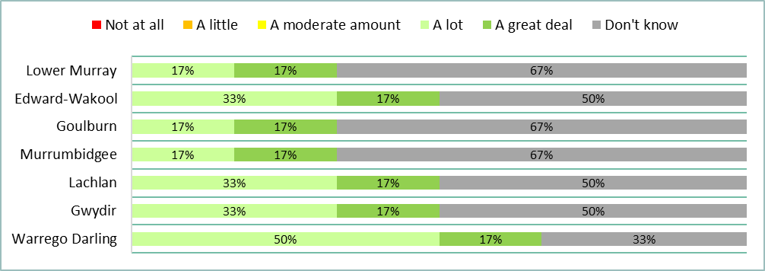

Figure Responses to question 24 of the LTIM survey (Group 1 | n = 6)

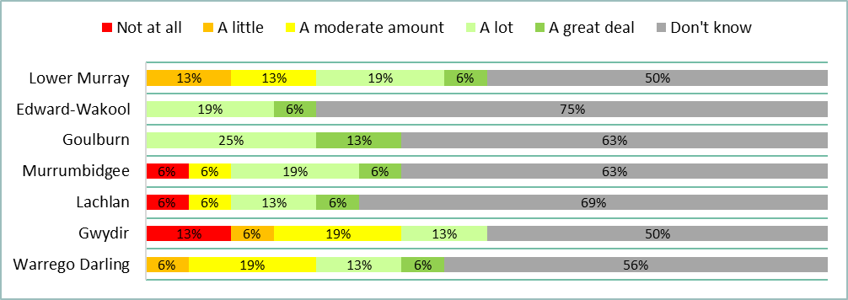

Figure Responses to question 24 of the LTIM survey (Group 2 | n = 16)

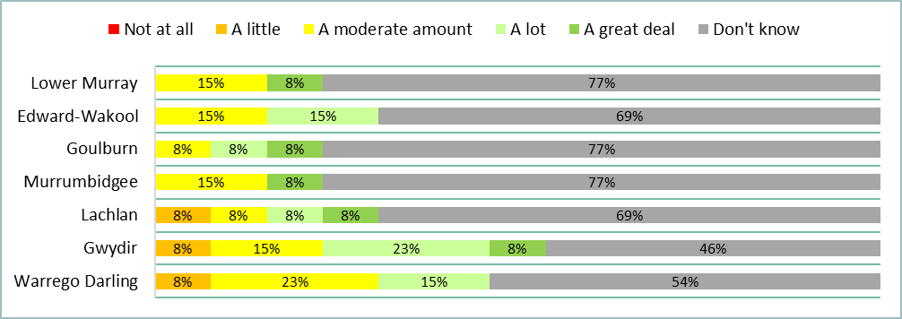

Figure Responses to question 24 of the LTIM survey (Group 3 | n = 13)

### Question 25: How appropriate was the predictive modelling in predicting outcomes of environmental watering in areas not monitoring for each Basin Matter?

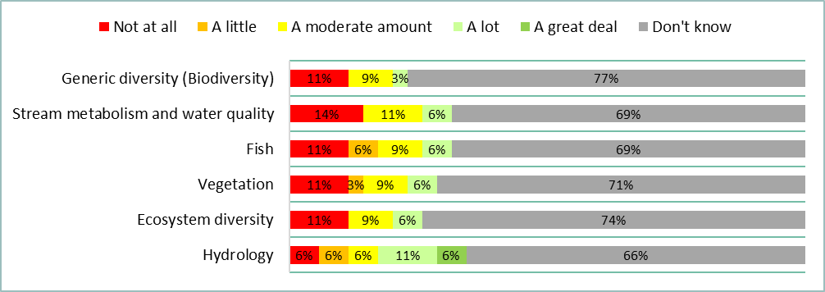

Figure Responses to question 25 of the LTIM survey (Group 1, 2 and 3 | n = 35)

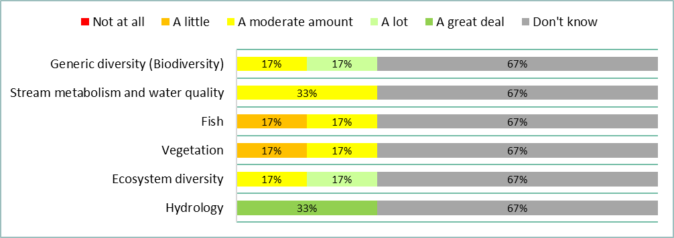

Figure Responses to question 25 of the LTIM survey (Group 1 | n = 6)

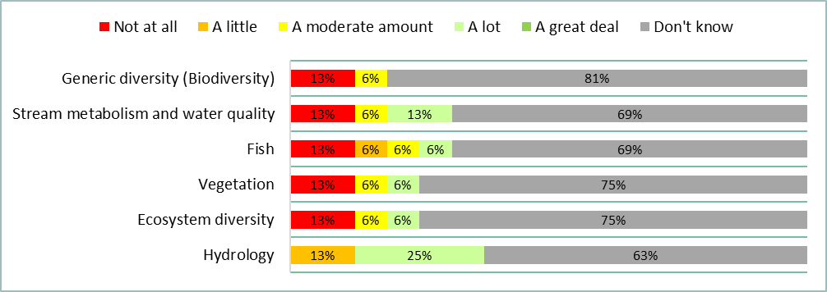

Figure Responses to question 25 of the LTIM survey (Group 2 | n = 16)

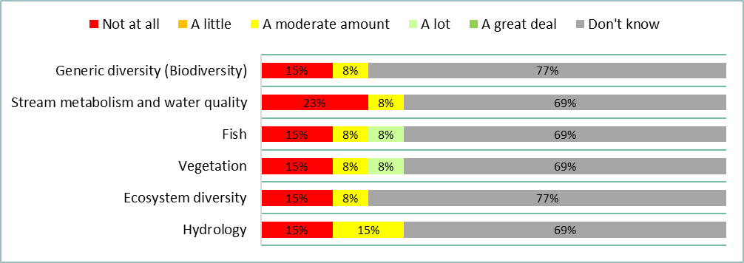

Figure Responses to question 25 of the LTIM survey (Group 3 | n = 13)

### Question 26: To what extent have data management arrangements supported systematic capture and making available data generated by the LTIM project?

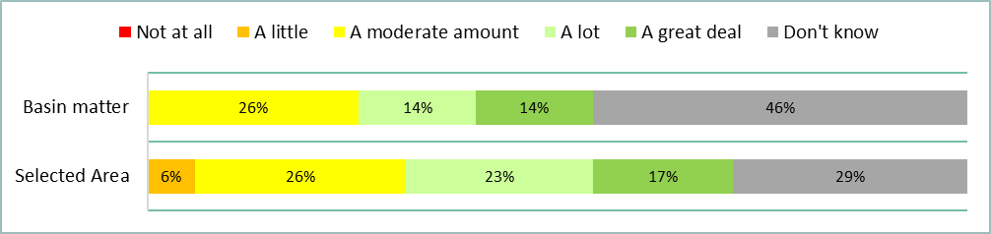

Figure Responses to question 26 of the LTIM survey (Group 1, 2 and 3 | n = 35)

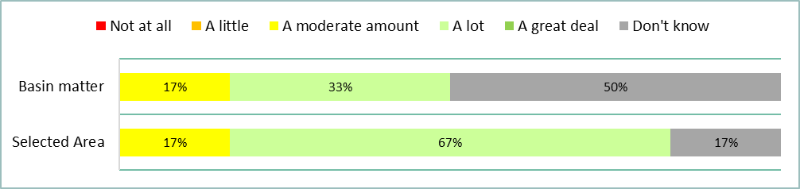

Figure Responses to question 26 of the LTIM survey (Group 1 | n = 6)

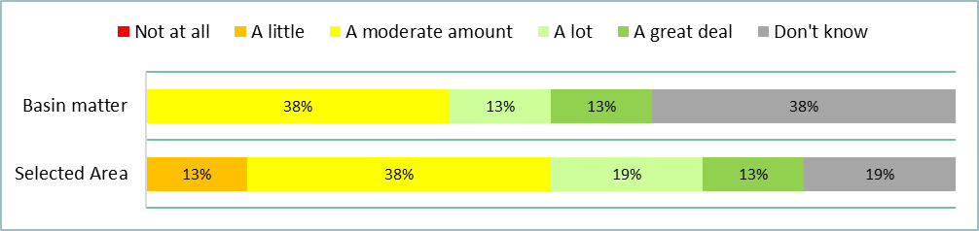

Figure Responses to question 26 of the LTIM survey (Group 2 | n = 16)

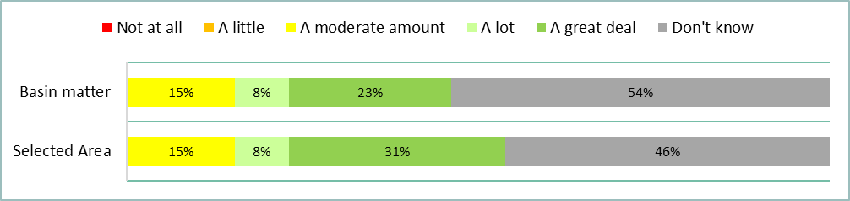

Figure Responses to question 26 of the LTIM survey (Group 3 | n = 13)

### Question 27: What level of impact has the LTIM project had on the adaptive management of environmental water?

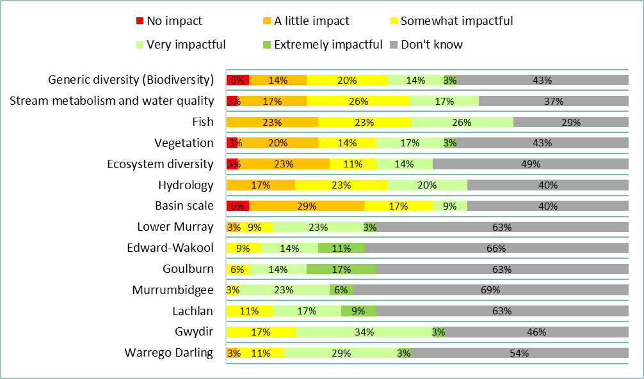

Figure Responses to question 27 of the LTIM survey (Group 1, 2 and 3 | n = 35)

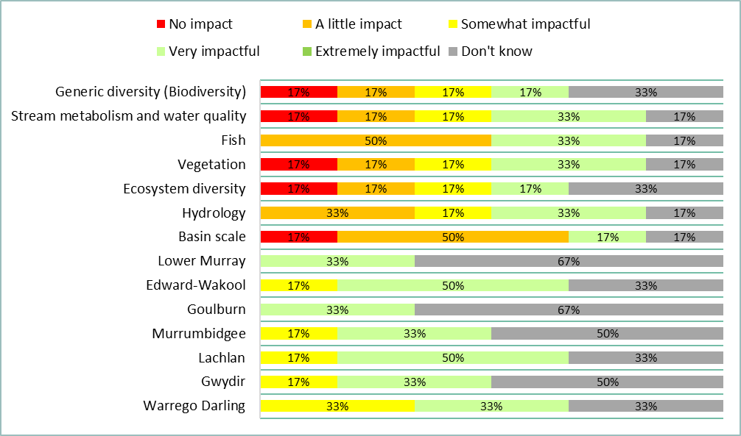

Figure Responses to question 27 of the LTIM survey (Group 1 | n = 6)

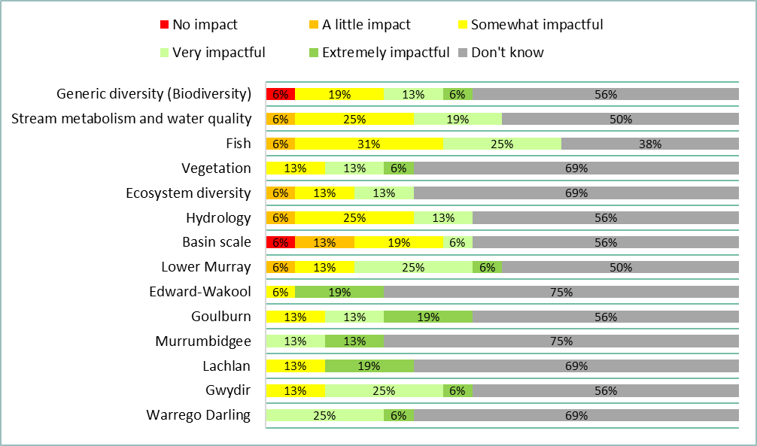

Figure Responses to question 27 of the LTIM survey (Group 2 | n = 16)

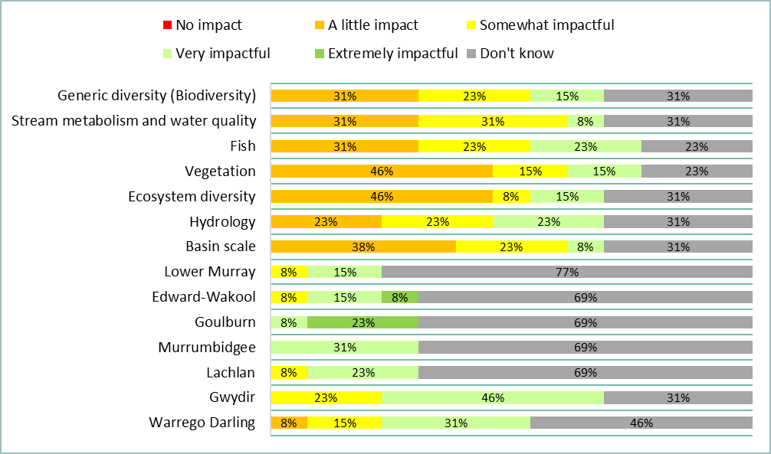

Figure Responses to question 27 of the LTIM survey (Group 3 | n = 13)

### Question 28: How impactful has knowledge gained through the LTIM project been in informing and improving Basin Plan implementation and/or outcomes?

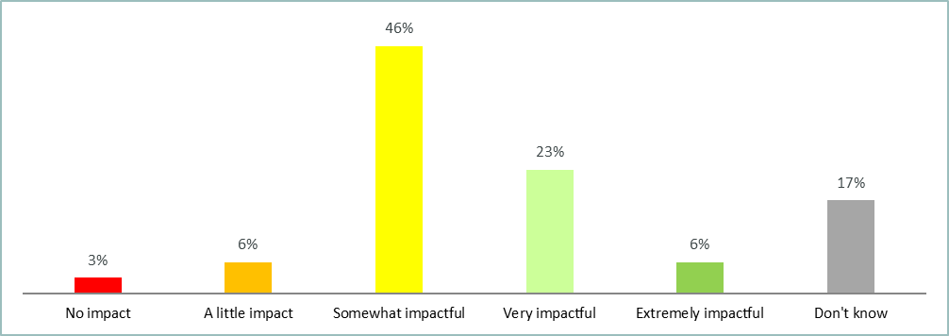

Figure Responses to question 28 of the LTIM survey (Group 1, 2 and 3 | n = 35)

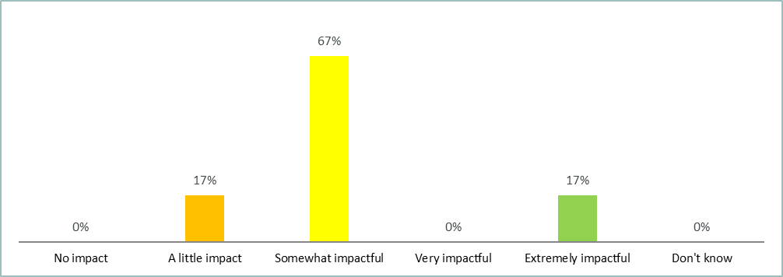

Figure Responses to question 28 of the LTIM survey (Group 1 | n = 6)

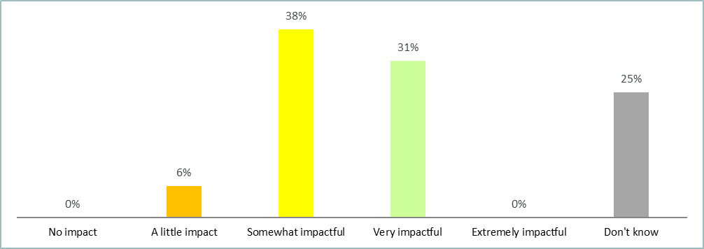

Figure Responses to question 28 of the LTIM survey (Group 2| n = 16)

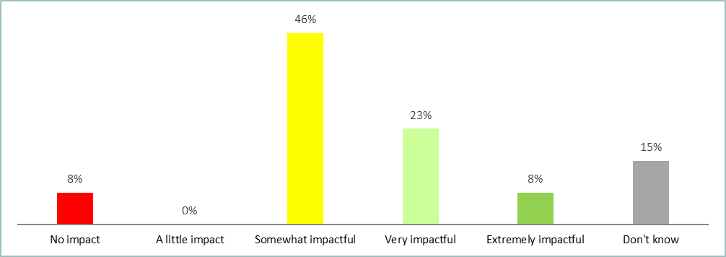

Figure Responses to question 28 of the LTIM survey (Group 3 | n = 13)

### Question 29: How impactful has the LTIM project been in fostering improved collaboration?

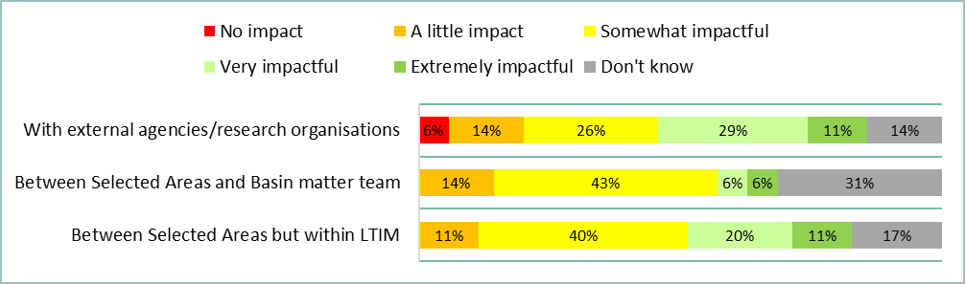

Figure Responses to question 29 of the LTIM survey (Group 1, 2 and 3 | n = 35)

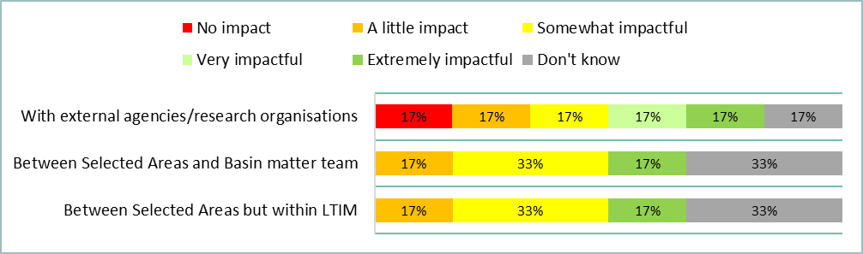

Figure Responses to question 29 of the LTIM survey (Group 1 | n = 6)

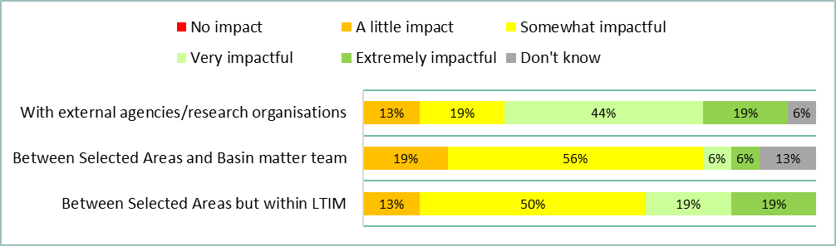

Figure Responses to question 29 of the LTIM survey (Group 2 | n = 16)

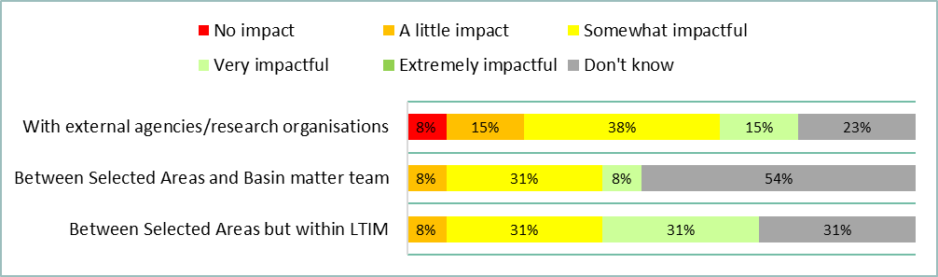

Figure Responses to question 29 of the LTIM survey (Group 3 | n = 13)

### Question 30: What impact has the LTIM project had on partnership mechanisms and initiatives to build stronger coherence and collaboration between participating organisations?

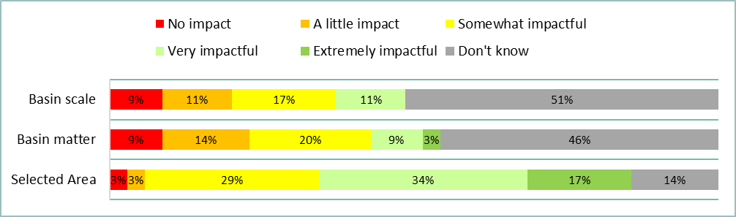

Figure Responses to question 30 of the LTIM survey (Group 1,2 and 3 | n = 35)

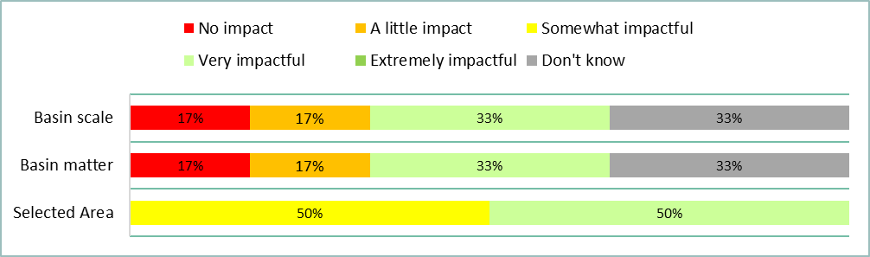

Figure Responses to question 30 of the LTIM survey (Group 1 | n = 6)

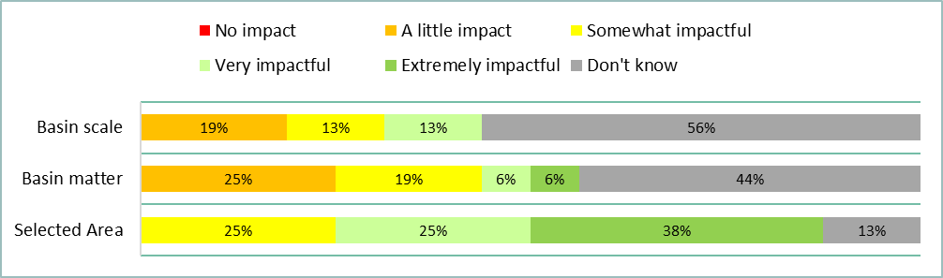

Figure Responses to question 30 of the LTIM survey (Group 2 | n = 16)

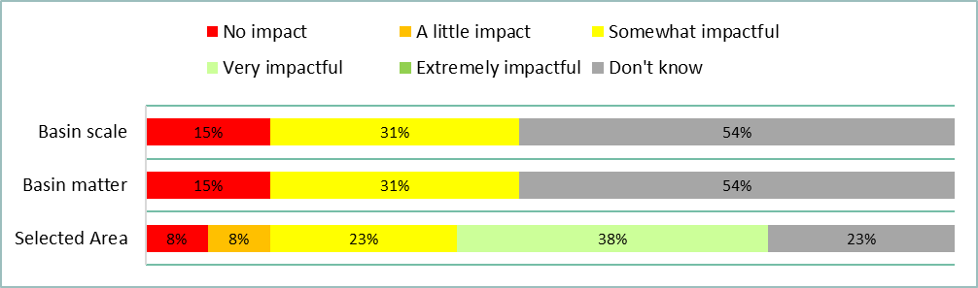

Figure Responses to question 30 of the LTIM survey (Group 3 | n = 16)

### Question 31: How efficiently were the funds and time allocated to address the LTIM project objectives?

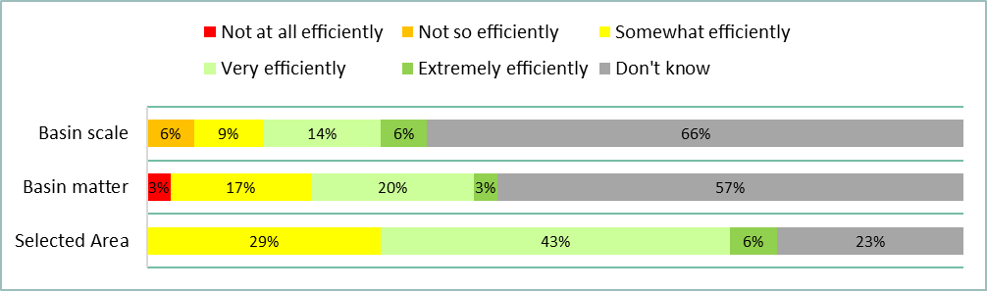

Figure Responses to question 31 of the LTIM survey (Group 1, 2 and 3 | n = 35)

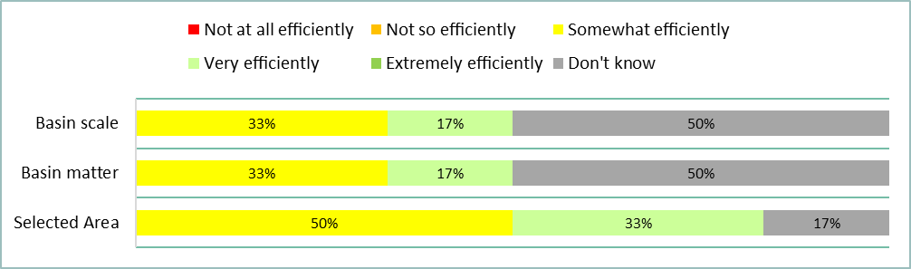

Figure Responses to question 31 of the LTIM survey (Group 1 | n = 6)

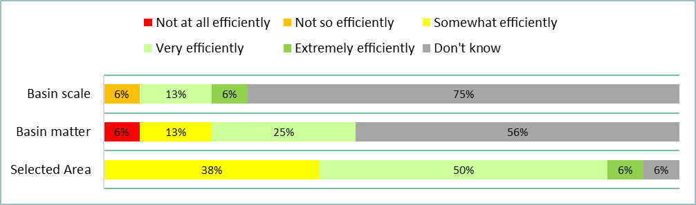

Figure Responses to question 31 of the LTIM survey (Group 2 | n = 16)

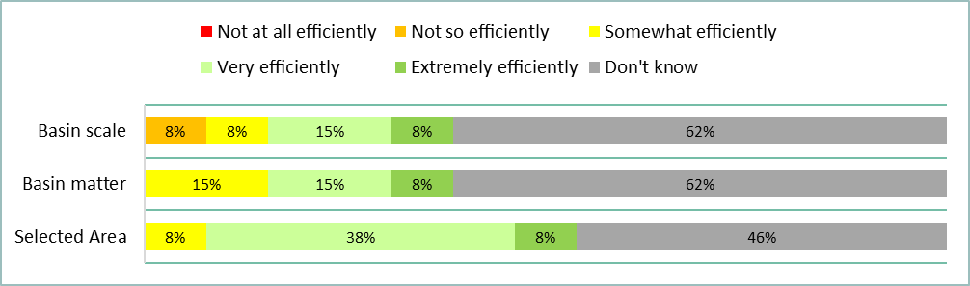

Figure Responses to question 31 of the LTIM survey (Group 3 | n = 13)

### Question 28: How efficient was the collaborative process within the LTIM project?

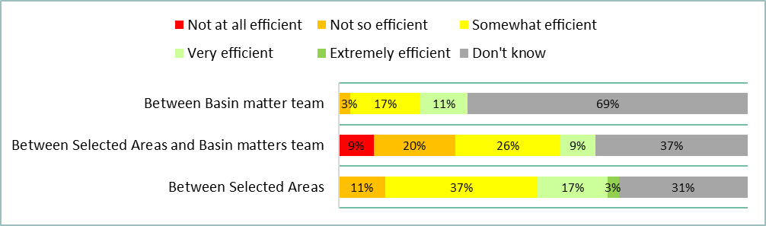

Figure Responses to question 32 of the LTIM survey (Group 1, 2 and 3 | n = 35)

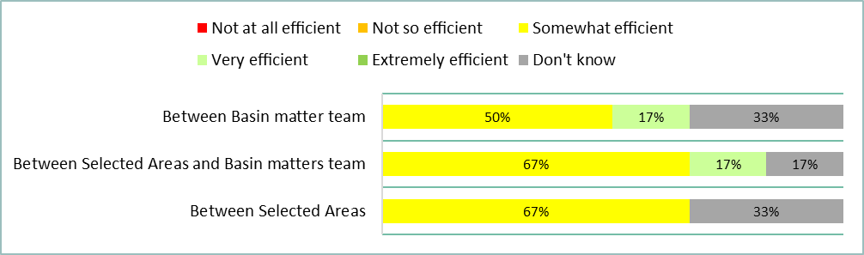

Figure Responses to question 32 of the LTIM survey (Group 1 | n = 6)

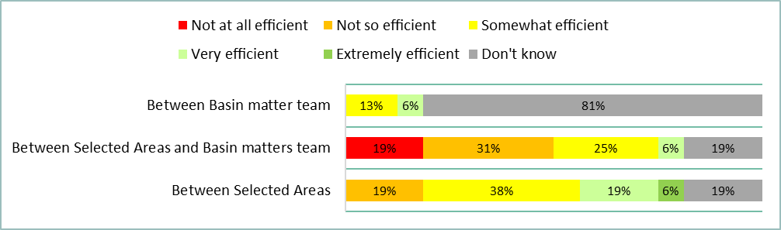

Figure Responses to question 32 of the LTIM survey (Group 2 | n = 16)

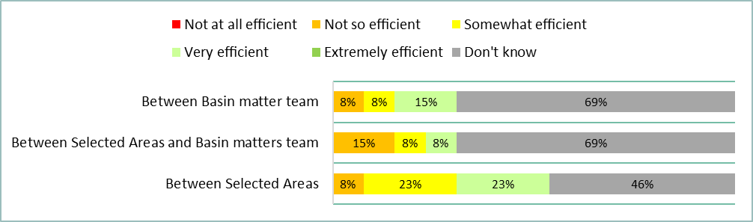

Figure Responses to question 32 of the LTIM survey (Group 3 | n = 13)

### Question 33: To what extent did the LTIM project take up opportunities for joint activities, pooling of resources and mutual learning with other organisations and networks?

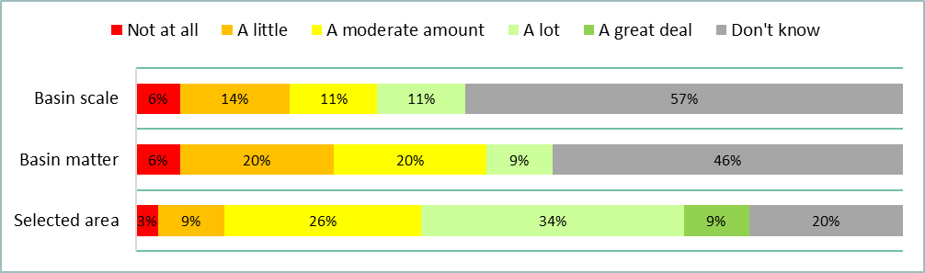

Figure Responses to question 33 of the LTIM survey (Group 1, 2 and 3 | n = 35)

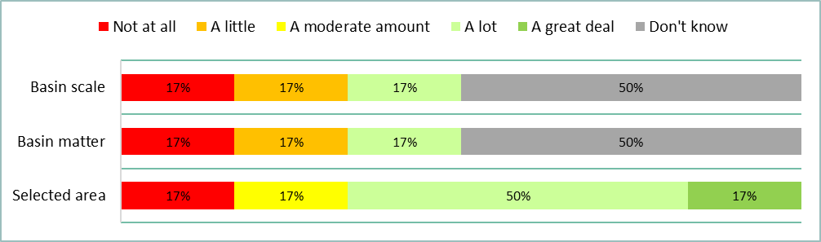

Figure Responses to question 33 of the LTIM survey (Group 1 | n = 6)

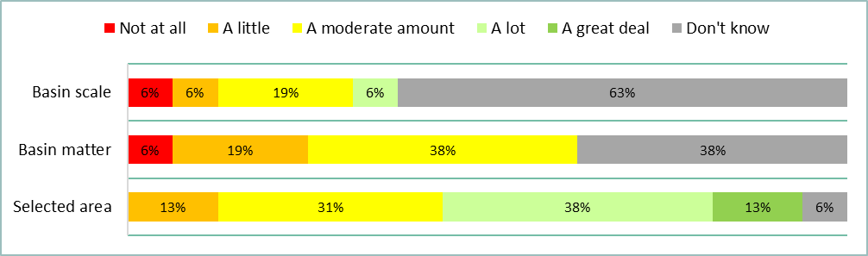

Figure Responses to question 33 of the LTIM survey (Group 2 | n = 16)

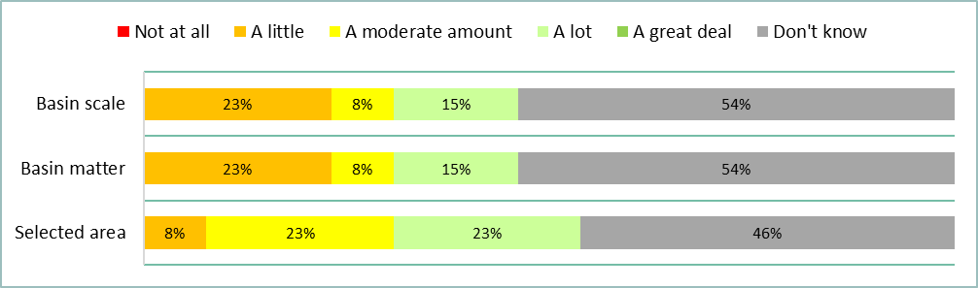

Figure Responses to question 33 of the LTIM survey (Group 3 | n = 13)

### Question 34: How efficient was the LTIM project in managing data?

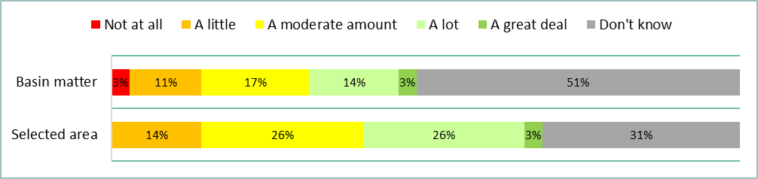

Figure Responses to question 34 of the LTIM survey (Group 1, 2 and 3 | n = 35)

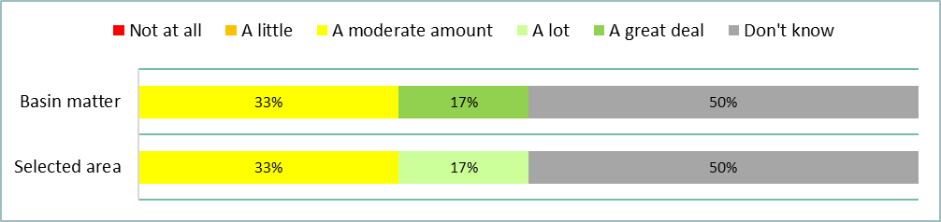

Figure Responses to question 34 of the LTIM survey (Group 1 | n = 6)

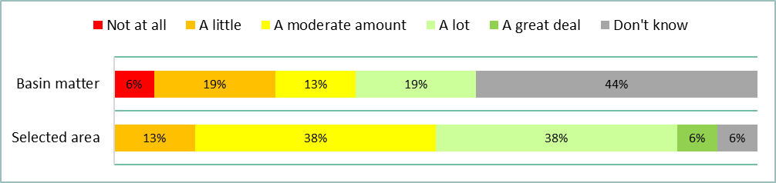

Figure Responses to question 34 of the LTIM survey (Group 2 | n = 16)

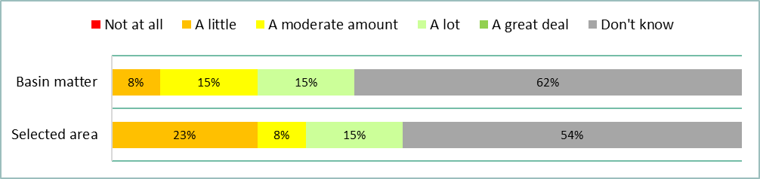

Figure Responses to question 34 of the LTIM survey (Group 3 | n = 13)

### Question 35: How efficient was the LTIM project in sharing data?

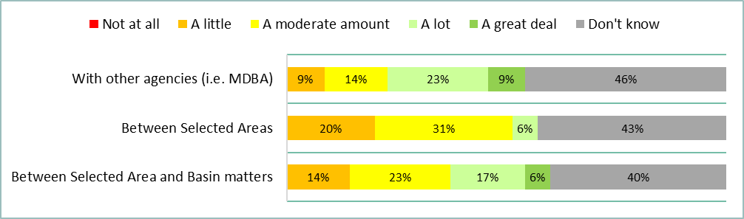

Figure Responses to question 35 of the LTIM survey (Group 1, 2 and 3 | n = 35)

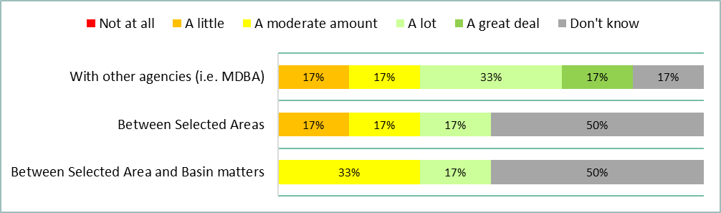

Figure Responses to question 35 of the LTIM survey (Group 1 | n = 6)

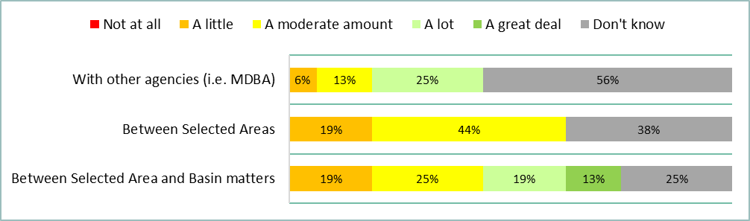

Figure Responses to question 35 of the LTIM survey (Group 2 | n = 16)

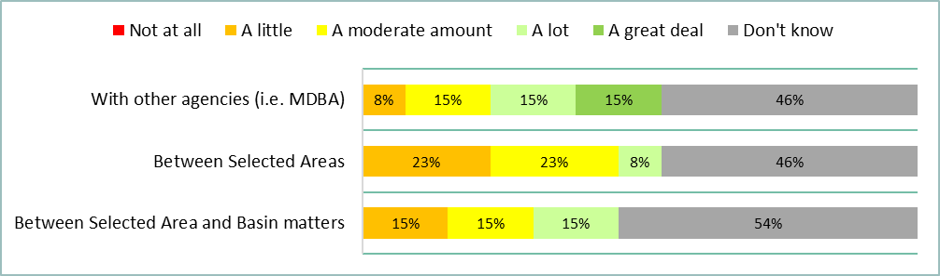

Figure Responses to question 35 of the LTIM survey (Group 3 | n = 13)

# Appendix 3: Free-text responses to Q6-35

Table Free-text responses to survey questions for Groups 1, 2 and 3.

|  |  |
| --- | --- |
| Group | Survey Question and response |
| Q6. How familiar are you with the LTIM project objectives? | |
| Group 1 | No comments provided |
| Group 2 | 1. **2.24:** Have attended all LTIM Annual Meetings which included discussion of Basin Scale objectives. |
| Group 3 | 1. **3.8:** Generally, I am much more aware of work at the Selected Area scale than the Basin scale. I am not aware of general learnings from Basin scale LTIM that have been explicitly brought into the decision making in the northern Basin. Some learnings may have been brought in implicitly that I am not aware of. |
| Q7. To what extent do you think the LTIM project achieved its objectives? | |
| Group 1 | 1. **1.5:** I believe that all the objectives were met, although some more so than others e.g. monitoring of ecological responses to CEW at seven Selected Areas has definitely (in my opinion) been achieved/met, but I feel that for in terms of supporting adaptive management of CEW at the Basin-scale, that's something that has only just really started in at the end of year 5. 2. **1.7:** Some of the short term (1-5yr) outcomes have been e.g. golden perch recruitment in the Warrego. 3. **1.8:** I think all objectives have been met to some degree. A lot of things that were aimed for at the start of the project were ambitious and whilst progress has been made there is likely to be more progress made through the MER project eg fish and veg counterfactual models. |
| Group 2 | 1. **2.1:** Many Selected Area focused objectives and Basin scale objectives have been met. however, others such as evaluating outcomes to other areas outside of SA not being monitored have not been met. Program has supported some elements of adaptive management, but could be improved 2. **2.13:** For the Lower Murray, all objectives have been met. 3. **2.17:** 'infer ecological outcomes of Commonwealth environmental watering in areas of the Murray– Darling Basin (MDB) not monitored' - I’m not close to how well this has been achieved. However, this is a challenging objective that may take more time to achieve than some of the other objectives 4. **2.18:** Challenges in extrapolating to monitored areas due to limited large-scale floodplain inundation mapping - hydrology had a very heavy focus on in-channel outcomes but wetland watering had very patchy coverage 5. **2.19:** Ecological recovery occurs at a longer timescale than the LTIM project. Whilst it showed that there were positive ecological responses to environmental water delivery, complete separation from antecedent conditions and climatic variation is not always possible. The focus of monitoring on discrete environmental watering events rather than overall ecological condition also limited the findings. 6. **2.22:** I am only familiar with outcomes in Gwydir and Barwon/Darling Selected Areas 7. **2.23:** On the basis that ecological responses to flow drivers occur over a range of spatial scales and within different windows of temporal complexity. Therefore, it will be more likely to meet its objectives of understanding the ecological responses to flow regimes even at a Selected Area scale will more likely to be met over a longer time period than 5 years 8. **2.24:** A large data set has been collected over 5 years describing the influences of environmental flows on a range of environmental conditions. This has provided an improved understanding of environmental responses to flow and a stronger basis for identifying environmental flow requirements. However, significant data analyses are required to further develop understanding, not only for the individual indicators, but in particular for cross-indicator interactions. 9. **2.26:** 5 years is a short time in which to learn how to answer the questions the first five years showed that responses were occurring the next job is to quantify responses against expected outcomes 10. **2.27:** A five-year time frame is insufficient period to quantify and assess some of the objectives. That said, this timeframe was ok for some objectives, yet, the final assessment presented fell short of assessing them using appropriate methods / analyses as was promised at the beginning of the program. 11. **2.4:** I believe that the program has demonstrated to the best of its ability (within the constraints of the available budget and the defined methods), the contribution of Commonwealth Environmental Water to achieving environmental outcomes however, some of the contributions are not apparent within the timeframes of the evaluation; some contributions have not been monitored; and some contributions are very difficult (and/or expensive) to detect. With regard to communicating project ﬁndings to all stakeholders, I consider this to be a work in progress. It is obvious from my interactions with the MDBA that they are not making the best use of the LTIM work (whether this is an awareness thing or something else, I don't know). The communication processes within the CEWO have been evolving and are improving. They will meet this objective more comprehensively in the future. 12. **2.5:** Some difficulty in evaluating the contribution of CEW towards particular outcomes (e.g. fish). 13. **2.7:** Only really focused on the objectives at our Selected Areas, Not sure how they went for the whole program or at the Basin Scale, though would assume that objectives would be met or close to met 14. **2.8:** Overbank flows using CEW are highly unlikely |
| Group 3 | 1. **3.1:** Effectiveness of Selected Area monitoring to inform evaluation of e-water use and adaptive management. The Basin scale is ambitious and will take a bit longer, but what has been achieved in 5 years is already proving impressive. 2. **3.11:** Until review is complete, we will not fully understand to what degree the objectives have been fully met 3. **3.12:** Evaluation at Selected Area scale has been working well and has probably been reasonably well shared with those who know about LTIM and Selected Areas. Supporting adaptive management has been improving at Selected Areas. There has been limited inferring to other areas not monitored There has been limited sharing of findings/outcomes more broadly there could be improvements at the basin-scale evaluation and providing meaningful outcomes. 4. **3.13:** Some of the LTIM objectives were met, some were partially met, and some were not met. Some have the potential to more likely met in the future IF program design changes. Some will not be met in the future without an unacceptable level of investment. To understand the degree to which LTIM succeeded / failed in its original objectives, it is important to understand where they came from – i.e. the motivation behind LTIM at the time of its design that led to the CEWO investing in this project. There were a number of needs the CEWO had, or ‘outcomes’ that led to the LTIM objectives. These are document in various ways across LTIM documents and website material but can be summarised below:  1. Demonstrate outcomes. The CEWO had to demonstrate outcomes to the community at a time when the Basin Plan was in negotiation. And it had to do this better than it had done in the past – i.e. in a way that spoke to the ongoing, longer term role of ewater; and in a way that allowed a more joined up, broader view of ewater outcomes – i.e. at the ‘Basin scale’, which was why the CEWO had come into existence.  3. Adaptive management – and better understanding the role of ewater over multiple years. The CEWO had a desire to advance from the 'short-term' annual M&E that had been funded for a number of previous years - this annual 'snapshot' form of M&E that played some role in informing annual ewater planning, but did not allow the CEWO to understand its impact over the longer term.  2. Fulfil legislative reporting obligations. The CEWO had reporting requirements that were only loosely defined at the time by the legislation - to report to the MDBA on its contribution at the Basin and Asset scale. It is of critical importance to note that the CEWO greatly overestimated this requirement, which played a fundamental part in the design of LTIM and its objectives. The CEWO was a new organisation, and we wanted to ensure we were fulfilling our legislative reporting obligations in a way that was robust. In the end, all the MDBA required of us was basic information – but at the time we didn’t know that, the MDBA had not sorted this out – and the LTIM Project was designed on the basis that we would need to report across ALL catchments on the nature of our contribution. This is a critical point – because it meant we had to find a way to report on CEWO contribution in catchments not monitored, noting we only had funds to monitor a ‘select’ few catchments. This led to a LTIM Project that favoured and invested in the developed of predictive models – informed by standard monitoring data across Selected Areas – on the basis that once complete, those models could be used to infer contribution in areas not monitored. As you can, our overestimating of legislative reporting requirements led to a massive investment in the collection of standard monitoring data on the premise that predictive models of the type described above were possible, and indeed presented the only option available for us to understand our contribution across all MDB catchments so as to meet legislative reporting obligations. These predictive models did not succeed in their intention – which didn’t matter for our legislative reporting obligations in the end (MDBA only require VERY basic information on watering volumes and objectives across Catchments) but resulted in the diversion of approximately half of the $30M investment in LTIM away from other more critical CEWO needs, such as 1 and 2 above. This is the single biggest lesson from LTIM that we must learn from for future CEWO MER design.  4. Evaluation, not monitoring results. Those short-term projects were also overly focused on the monitoring, at the expense of an evaluation of water use objectives for the purpose of adaptive management. We wanted to design an ‘evaluation’ project – not a monitoring project (noting the name LTIM failed to capture this). These needs or desired outcomes led to an LTIM Project with the following objectives:  Monitor the ecological response to Commonwealth environmental watering at each (Selected Area (succeed)), evaluate ecological outcomes of Commonwealth environmental watering at each Selected Area (partial succeed), evaluate the contribution of Commonwealth environmental watering to the objectives of the Murray-Darling Basin Plan (partial succeed), infer ecological outcomes of Commonwealth environmental watering in areas of the Murray-Darling Basin not monitored (fail), support the adaptive management of Commonwealth environmental water (partial succeed). What is perhaps more relevant is the degree to which succeeded to achieve the outcomes we needed:   - Demonstrate outcomes – LTIM has not done this in a convincing way and this MUST be the focus of future MER design. We got better at this for Selected Areas, but only in terms of consecutive annual snapshots loosely joined up.  - The Basin scale team were not focused on this critical objective, and thus our increasingly growing need to present outcomes at the Basin level went unmet. It is worth mentioning that while LTIM focused on 7 ‘Selected Areas’ the CEWO continued to invest in M&E across many more catchments  – but outside of LTIM. Nonetheless LTIM never presented a qualitative, summarised view of outcomes across the Basin – something that we desperately need and still need.  - Adaptative Management – we got better at this WITHIN Selected Areas. But again, the focus was on annual planning, and we didn’t capture and transfer learnings well across Catchments including to those not monitored (again, speaking the more desired possible role of a basin scale team).  - Legislative obligations. We now know that these are not onerous and do not depend on M&E investment.   - Evaluation, not monitoring. We continued to struggle to get providers to provide their ‘best guess’, expert opinion for the benefit of informing water use in an uncertain climate. They got better, but it was always a struggle, year in, year out. 5. **3.17:** The irony with the title 'LTIM' is that LTIM (now MER, which includes EWKR) essentially had to re-start after there were pre-existing equivalent flow programs under state government (IMEF, RERP), which they have partly benefited from the experience of, and built on, but they are in many regards having to build a long-term dataset. The quality of science and personnel is very high, but you cant beat long-term data. This is not any fault with the commonwealth, or LTIM. There was no or limited support at the state level to enable this transition, and where it did partly happen it was through the goodwill of state employed officers. 6. **3.18:** Hopefully more objectives will be met into the future when MD Basin Plan processes such as the Constraints Management Program are finalised and implemented, otherwise I believe the ecological outcomes are limited. 7. **3.2:** There remain challenges in determining what would have happened in the absence of environmental flows and while the great progress has been achieved in building relationships between delivery managers and Selected Area providers, this remains reliant on individual relationships and adaptive management at the basin scale has not progressed to the same extent 8. **3.6:** LTIM has contributed to the evaluation on how environmental water and specifically the delivery of CW environmental water has contributed (or not) to achieving the local and basin scale objectives. Some of these require longer time frames to assess and effects of climate variability and different flow conditions and water availability make this challenging. 9. **3.8:** LTIM has done some great work and has some great people involved. LTIM has a small footprint in north. Drought has dominated the sampling period. Not much focus on climate change. I don't know how much we can say from LTIM that influences water management decisions in Namoi, Border, Macquarie, Condamine-Balonne catchments, and much of the Darling. There is a high degree of hydrological and ecological diversity. There is very little sampling in the Barwon-Darling. I don't think we can say that much at all about water quality and salinity. |
| Q8. How effective were the data management processes in aiding evaluation and reporting on outcomes? | |
| Group 1 | 1. **1.2:** I have no direct exposure to these 2. **1.5:** I wasn't involved in evaluation and reporting so it is difficult to comment on the effectiveness of data management processes other than I believe they improved in later years once the CEWH approved the expenditure of additional funds to enable the data wrangler to undertake additional work on the management of the data and database. 3. **1.7:** Some challenges with unreg accounting because we rely on Qld to confirm figures, which would hold things up a bit. 4. **1.8:** This evolved through the project. We had in place an agreed set of data management protocols but there were initially challenges in ensuring that data was entered consistently into the MDMS. This was partly a QA issue and partly because the data standards were not sufficiently specific. In the second half of the project we established a "data wrangler" role in the La Trobe project team which allowed data management to be handled much more smoothly. |
| Group 2 | 1. **2.1:** Data management for fish was very problematic and patchy initially, but was massively improved in recent years. Since 2019 we focused on data quality issues that were impacting ability to undertake Basin scale analysis. This required SA's to re-enter data, which was done. This was not done in a timely manner for some SAs and became very problematic for analysis timeframes. 2. **2.14:** Data management has multiple layers: The requirement to provide data in clearly defined formats is very helpful. The data management system (MDMS) has had a multitude of problems. At an an area scale, we manage our own data very effectively within the requirements of our project and the requirement to report data in a consistent pre-defined format. I invest in a data manager to ensure the integrity of our data and it's careful management - this pays off for us, but I know that other SA's do not do this. We do not use the MDMS for area scale evaluation and reporting. At a Basin scale/Basin Matter scale, the data quality has been problematic and the MDMS difficult to use. From the perspective of being a data provider, there have been numerous instances where we have provided Basin Matter leads with our data outside of the MDMS system. 3. **2.15:** Although somewhat expected, the MDMS experienced a lot of teething issues, which impacted on the accuracy and efficiency of data transfer. Despite standard methods (and data templates) being developed and enforced for the purpose of evaluating outcomes across the Basin, evaluation often involved analysing data from other methods (e.g. Category 3 indicators). This resulted in the development of additional data templates by groups. This was largely a problem with the way the project was incepted, rather than the data processes themselves. 4. **2.17:** Not across data management processes for Basin Matter and Basin Scale reporting 5. **2.18:** data management is in house at Selected Area level - but MDMS was use to store data for use by basin teams- there were some challenges with the MDMS systems 6. **2.24:** The original set up of the LTIM project separated the Selected Area researchers from the Basin Team researchers. Selected Area groups in general ran their own data management systems and used these for analyses. The Basin Teams relied solely on the uploaded information in the database and often carried out analyses without the interaction of those who had collected the data. This is a poor procedure as interpretation of the data requires familiarity with the idiosyncrasies of the Selected Areas, knowledge of modifications to "standard" methods required at the various sites, and an understanding of the limits of the data. Such detail could not be captured in the uploaded data sets. A better approach is to have the Selected Area Matter leads form the Basin Teams with additional leads charged with ensuring that these teams develop comprehensive understanding of flow induced responses across the very different monitoring sites. 7. **2.27:** Having used some of the data coming out of Selected Areas (in collaboration with researchers and with approval from CEWO), Selected Area teams (some themes) and states seemed to have their data processes aligned, however, there was a clear disconnect from the basin scale evaluation team. 8. **2.3:** Data management was not always a formalised process 9. **2.7:** Our internal processes at the Selected Area where pretty good, but the MDMS system was a real pain. Hard to get data in, and from what i understand was very hard to get data out. In the early years we were sending raw data to Basin Matters teams for their reports as it was too hard for them to access data from the MDMS 10. **2.8:** MDMS was a pain in the bum to use |
| Group 3 | 1. **3.1:** Basin Matter and Basin scale data collection through MDMS was a lot of effort and it would be worth seeing if this is worth it. On the one hand, there was thinking that a $30M program can't just have data handled in spreadsheets (and the MDMS provided strict QA measures), on the other hand, spreadsheets are easily moved and corrected if needed, and can circumvent time and effort required to get quick changes across 7 sites. 2. **3.11:** Bias towards Selected Areas 3. **3.13:** Selected Area monitoring raw data needs be captured, under LTIM it was not - only processed data collected via standard methods to inform Basin scale evaluation. In future, all data needs to be captured, noting different data is needed for different purposes. Data MUST be publicly available in the future, and more easily accessed by non data specialists. 4. **3.17:** At the Lachlan level, which I was part of, the data collation and reporting seemed to be at a high level, although I wasn't involved at the number crunching level. I was also on BPIC groups - EWWG and MEWG - as part of Basin Planning and so I could see the LTIM/EWKR data was scaled up. But at that level the information used in evaluation reports was very patchy. I was - and still am to some extent - also involved in the JVSC steering committee whose role it is to fill MER gaps across the basin within what funds it has, and there's still a lot of scope to improve integration of MER across themes (fish, plants, birds, functions) 5. **3.18:** I think reporting in the Edward-Wakool LTIM Selected Area has been good, but seems to only reach a reasonably small audience. Sadly, there are individuals and groups in this area that are trying to obstruct the MD Basin Plan and processes. I have a concern that the intervention monitoring programs are not well designed to inform environmental water managers or water policy or community engagement at system scales. 6. **3.2:** My experience was limited to the first few years during which data management was a major drain on resources with no resources allocated to quality assurance, area providers using their own formats and then laboriously transposing data into the required format. There were also access issues due to limited interoperability between browsers. I am not sure to what extent these issues have been resolved, but it is an area that requires ongoing investment to ensure data integrity 7. **3.6:** Not aware of the details re the data management process |
| Q9. How effectively did the LTIM project support adaptive management of Commonwealth Environmental Water (CEW) in each Selected Area (including reporting of adaptive management)? | |
| Group 1 | 1. **1.2:** In most cases there is a disconnect between the design of discrete watering actions and the M&E which was overwhelmingly static. 2. **1.5:** My responses for the Selected Areas is based on my observations at LTIM forums and from conversations with CEWO Selected Area leads. We didn't really start seeing clear adaptive management messages emerging from Basin-scale reports until year 4, and it wasn't until year 5 that these became a greater focus of the reports. As such, it's not clear if the Basin-scale adaptive management learnings have had an opportunity to be incorporated into water delivery. Reasons as to why Basin-scale adaptive management hasn't been incorporated into watering might include that there is extremely low readership of reports by delivery teams and there hasn't been a high level of communication of the learnings from the Science Section to delivery teams (something we are looking to work on). 3. **1.7:** Feedback loops between reporting results and planning and decision making didn't always align. 4. **1.8:** The relationships built between area-scale providers and CEWO delivery officers are a big success story. These science providers are now integrally involved in the adaptive management of CEW at the various selective areas. The LTIM project has contributed to this through a combination of its findings and the working relationships built. At the Basin scale the adaptive management messages have taken longer to build but progress is being made. |
| Group 2 | 1. **2.1:** I don’t feel confident to judge how effective it was at the SA scale. 2. **2.17:** Annual workshop held to discuss results and implications for environmental water management planning. LTIM researches contacted throughout the year to seek advice on environmental water management decisions and adaptions to seasonal conditions or issues. 3. **2.21:** It was effective to support/communicate the need for adaptive management, particularly when water was available at levels that were needed. 4. **2.23:** Through regular communications via memos, planning meetings and workshop forums the Murrumbidgee SA provided advice (often in real time) to environmental managers so support evidence based decision making 5. **2.24:** Water delivery to the LMR is achieved through planning by SA DEW to meet particular environmental targets and then discussion with MDBA and CEWO. Over time the results of the LTIM monitoring played increasingly important roles in the planning process. In particular, the influence of flows on salt export from the basin, the hydraulic effects of changing hydrology within the river channel and in weir pools, fish movement from estuary up through the rivers system (this was an indicator added to the project as is developed), the effects of flow on food resources within channel, especially as a result of changes in water quality associated with flows provided from different upstream tributaries. This adaptive management approach continues through the strong links between the Selected Area Team and DEW 6. **2.27:** Only familiar with the Goulburn Selected Area, whereby there were some useful adaptive management processes, but i think it fell short in a few areas. 7. **2.4:** I am not familiar with all of the SA's - keeping a close eye on only a few. At the Basin Scale, it is not clear HOW the evaluation is being used in an adaptive management context and I think this is only starting to emerge after 5 years of the program. I would expect the time delay in the basin scale adaptive management processes to be far greater than at the individual SA. 8. **2.5:** Project outcomes from watering events did provide water management advice for the Lower Murray. Delivery constraints and the cross-jurisdictional coordination of water delivery required for the Lower Murray, however, impacted on the way water delivery could be managed. 9. **2.7:** Again, not being that closely associated with the other areas im not sure how effective it was, though i did see a number of examples where the LTIM monitoring did support adaptive management. 10. **2.8:** Within constraints of what could be delivered and when |
| Group 3 | 1. **3.12:** Selected Area providers provided input and thoughts prior to decisions use at the Warrego and supported design of a fish pulse at the Warrego which hadn't been done before. Providers willing to be contacted and discuss options between reports. I believe providers also had input to timing of flows to support native fish etc. 2. **3.13:** I haven't differentiated between Selected Area teams on this. But i would say that across Selected Areas, LTIM played an increasingly important role in informing water use. At the start of LTIM, decisions on water use were not informed strongly by science, or with the aid of scientists. At the end of LTIM, LTIM providers became critical stakeholders in the design, management and evaluation of water in those catchments. CEWO managers will not make decisions without them, and often wait and their analysis, which are directly tied to water use objectives. That is not say there is not improvement needed. LTIM Providers need to continue to improve in the provision of expert opinion, and in the absence of full certainty. This is what the CEWO pays and contracts them to do. Also provider must improve considerably in their capacity to undertake cumulative analysis that better understand the longer term role of ewater int he systems they monitor. the CEWO let LTIM Selected Providers off the hook in this space over the term of LTIM -but it shouldn't have. If you look at the final 5 year Selected Area reports - they are still annual reports. This was one of the primary reasons LTIM came to being - and that outcome has not come to fruition. The Basin scale analysis and reports did not inform adaptive management of CEW in any real way. this is because it was not designed to do so. that component of the project tried to do so in the latter years, but was never set up for that purpose. This is something for the future - the role of a Basin scale provider (if indeed there is a need for one) in capturing lessons across catchments, synthesising and communicating to mangers - across themes such as fish, birds, veg etc perhaps 3. **3.17:** See previous comments. Although LTIM/EWKR is designed for assessing the effectiveness of the Commonwealth's ewater, my view is that at the basin scale 1. all MER across basin governments are, and should be part of a whole., and 2. at the valley scale, whomever is doing the flow monitoring is also informing a range of evaluation processes such as the effectiveness of all environmental water, whether the WSPs/WRPs are meeting their environmental objectives, whether the LTWPs are meeting their planned outcomes under the BWP etc. The question is somewhat naive and restrictive, because CW environmental delivery doesn't even remotely sit in isolation, but is intermixed and affected by the actions of EES deliveries, law, regulations and annual interventions imposed by DPIE Water, the regulation framework and reporting requirements required under the Basin plan and rules under which WaterNSW operate. Adaptive management should be and really is only partly whole-of-government, and probably also should operate under an ICM approach, but that never really worked out in NSW 4. **3.18:** The intervention monitoring programs do not seem to be designed to inform adaptive management or water policy or community engagement at system scales. For instance, there are still fundamental knowledge gaps like relationships between productivity and native fish recruitment that, if answered, could help to design decision support tools for environmental water managers and river operators, and help to educate and inform the public and key stakeholders. 5. **3.2:** I don't think there is any doubt that the relationships developed between CEWO and Selected Areas has improved access to knowledge and associated with this, the experience and expertise of the Selected Area teams. The extent to which this represents adaptive management will vary among the experts and the quality of science they are able to communicate. There is a risk that there will be instances where strongly held opinions or intellectual fancies will inhibit AM or lead managers down dead ends. There has also not been as much sharing of knowledge across Selected Areas and resource limitations constrain the capacity of the Basin evaluation to explore commonalities or differences in responses across Selected Areas in detail. 6. **3.6:** Only have knowledge of LTIM in northern catchment and for these the LTIM was very supportive and useful and at times critical for adaptive management and advice re CEW. It also helped inform CEW actions and management at the northern basin scale. |
| Q10. How effective has the LTIM project been in monitoring and evaluating the ecological response to CEW at each of the seven Selected Areas? | |
| Group 1 | 1. **1.2:** The project design did attempt this but I would argue that there are more efficient approaches. 2. **1.7:** Unfortunately we didn't get a really wet year to measure ecological response to flooding to be able to get the whole picture for a boom bust system. 3. **1.8:** Clear hydrologic and ecologic outcomes have been demonstrated. Challenges have included teasing apart the contribution of CEW to an observed outcome compared to other influences (drought, land use practices, pests, weeds etc). |
| Group 2 | 1. **2.12 :** As you'll understand I don't have an unbiased view on this but from what I could see and hear the 7 teams did a pretty good job, including the 2 I helped to lead 2. **2.17:** It can be challenging to attribute ecological responses to CEW due to other hydrological and ecological influences/interactions. 3. **2.19:** As stated earlier the focus on ewater delivery events meant that other climate and flow factors impacted on results. For example unseasonably high flows over summer and autumn in the Goulburn river due to an increased demand for water (consumptive and environmental) in the lower Murray led to massive ecological damage for bank condition and vegetation. Complementary monitoring was undertaken by the members of the Selected Area team managed and funded by Vic gov agencies. this complementary monitoring was crucial in evaluating the ecological response to CEW. 4. **2.23:** Attributing ecological responses to one source of water holder is inherently difficult across floodplain wetlands. Most effective when CEW water is the only flow source being delivered to a particular wetland which works well for small discrete wetlands but challenging across floodplains with multiple water sources and events occurring at the same time. The value is in the total water available to the environment that helps to re-instate the required flow regimes regardless of who owns the water. A useful thing to know is what the CEW volume of water has contribution to the hydrograph over time and then model what might have been expected without that water. 5. **2.24:** See previous answer. The five year project reported on a set of indicators which were initially selected. Over this time other useful indicators have been identified and in some cases introduced as special sub-projects or planned for introduction to the MER project. This adaptive response has been powerful at the LMR site directly helping with evaluating ecological responses. 6. **2.27:** I think the monitoring itself has been fairly robust, but the evaluation has fallen a bit short. 7. **2.4:** I am only going to provide detailed comment on my own SA here. In the Lachlan, the indicators, methods and design are focussed on collecting data to inform Basin Scale evaluation which means that evaluating the Selected Area outcomes are compromised and we do the best we can with an imperfect evaluation study design to achieve an evaluation of the SA outcomes. We are also confined spatially ($$$$) and many of the watering actions and watering objectives in the Lachlan are in the mid-Lachlan, yet we are confined to monitoring and evaluating in the Lower Lachlan. We have tried to balance scope creep - as we are only paid to focus on the Lower Lachlan, yet for some metrics, we have had to extend our focus....... 8. **2.5:** I think the M&E in the Lower Murray has been done quite well. However, there are some indicators that have not been able to evaluate the contribution of CEW (e.g. microinvertebrates). I believe the main reason for this is the difficulty in trying to distinguish the influences of CEW from others, e.g. weir pool manipulation, other eWater and other flows (e.g. unregulated or entitlement). 9. **2.7:** Same as above, did see some examples from other areas where it was effective, but couldn't comment with certainty overall 10. **2.8:** Can only comment on those two SA's as I'm not aware of details of other indicators in other SA's |
| Group 3 | 1. **2.8:** Can only comment on those two SA's as I'm not aware of details of other indicators in other SA's 2. **3.12 :** LTIM monitoring in Warrego-Darling is more challenging by the unregulated nature of the catchment and responding to inflows and flows which are often a small proportion of CEW rather than having designed deliveries from regulated storage. Also conditions which meant that a number of years were dry during scheduled monitoring. I don't think the Warrego-Darling had the same level of fish and water quality sampling as at other Selected Areas. Having flexibility to monitor to quickly set up and respond to flows in these systems would be beneficial (fish spawning, recruitment, movement, fish floodplain interactions, etc) 3. **3.13:** Monitoring was fine. Evaluation improved over time. Needs to improve for cumulative evaluation over multiple years. Needs to improve in the provision of expert advice in the absence of full certainty. Needs to improve in the communication and presentation of evaluation results - with a focus on informing future water use. 4. **3.17 :** I see the work done in other valleys on and off, and they seem comparable, but I'll just score the valley I know better 5. **3.18 :** The monitoring and evaluation methods may be effective, but the most important question is, do the projects support adaptive management and provide decision support for environmental water managers and site managers? Also, do these projects help environmental water managers engage with key stakeholders and build public support for MD Basin Plan processes such as the Constraints Management programs (CMPs)? The CMPs in the Goulburn, Murray and Murrumbidgee rivers underpin the basin plan. 6. **3.2:** There are a range of issues around timing of sampling in relation to action and the diversity of water actions from short and discrete to extended to multiple actions blended into each other or piggy backed on natural and consumptive flows 7. **3.6:** Effective at the Selected Area scale for the areas covered in the north. Do not have any detailed knowledge of the effectiveness for the other 5 SA | |
| Q11. How effectively did the CEWO Outcomes Framework align to the Basin Plan Environmental Watering Plan (EWP) and Water Quality and Salinity Plan? | | |
| Group 1 | 1. **1.2:** Environmental watering has regard to these but the scale is often far finer. 2. **1.7:** There was a clear line of sight between the EWP objectives and the conceptual diagrams and ecological outcomes. 3. **1.8:** The framework specifically relates the relevant Basin-Plan objectives through a hierarchical framework to the indicators being monitored under LTIM although the Outcomes Framework was finalised before the BWS and its QEOs existed. | |
| Group 2 | 1. **2.17 :** Challenging due to different spatial and temporal scales of the objectives (Basin Plan/Selected Area). Also constrained by the objectives established for waterways/wetlands by state authorities (e.g. CMAs). Often no clear alignment. 2. **2.18 :** Other biodiversity ( frogs, birds etc) were only assessed in some Selected Areas - but this is sensible because the e SA focused solely on riverine outcomes were not expected to produce outcomes for other vertebrates resilience is a very difficult process to evaluate over short time frames water quality was managed very well in SAs where it was a priority 3. **2.24 :** The CEWO framework was drawn from the EWP and they effectively aligned. However, the emphasis given to particular components varied according to those identified as important at each of the different Selected Areas. At the same time effort was made to identify indicators that were important across sites to provide a basin scale understanding of these. As alluded to previously, the schism introduced in the project structure by the separation of the Selected Area and Basin Scale researchers has, in my view, impeded the progress of the Basin Scale component of the work. 4. **2.4:** As an example: At the time the initial LTIM program was established, the Basin Watering Strategy was still under development. The LTIM program thus used the objectives of the Murray-Darling Basin Plan to develop a suite of expected outcomes for vegetation that were nested within objectives for Biodiversity within the Basin Plan (Basin Plan Section 8.05). These focused on the use of environmental water to support vegetation diversity within the Basin and evaluation then focused on groundcover vegetation diversity. The expected outcomes for Basin vegetation in the BWS do not refer to vegetation diversity, focusing instead on maintaining the extent of vegetation, increasing periods of growth. This introduces a disconnect in terms of the evaluation focus and the BWS and should be revisited. 5. **2.5:** I am unfamiliar with the water quality and salinity plan. I believe the project has done reasonably well to align their framework with the EWP. 6. **2.7:** Don't really know to be honest so just selected the middle answer 7. **2.8:** Bit hazy on the details of frameworks etc. My work was on measured effects of CEW water rather than on effectiveness of plans REALLY annoying the system forces me to answer two items where I have no idea of the answer. Should always be a don't know. Listed them as not at all but totally disregard that. | |
| Group 3 | 1. **3.13 :** To be honest - the CEWO outcomes framework played a less important role or central role, than what was originally envisaged. It sort of became an after thought for providers at it related to ticking off on contractual requirements. And this is because the CEWO didn't rely on the reporting against the outcomes framework to fulfil its own reporting obligations. Once the Basin plan came in, we added an extra column to the outcomes framework to demonstrate alignment with Basin Plan objectives and targets. The outcomes framework was always confusing for providers and managers alike, the presentation had issues (gaps everywhere). For future programs, the outcomes framework needs to be replaced by Basin Watering Strategy expected outcomes 2. **3.14:** Sorry - I'm not familiar with the outcomes framework so I had to tick the middle - no option to say don't know 3. **3.18 :** The CEWO Outcomes Framework, EMP and WQ and Salinity Plan should be aligned to Long Term Watering Plans. Do the LTIM projects help to inform, align or integrate, and refine these processes? Can this be improved? 4. **3.2:** I need more categories - I think biodiversity was done best followed by ecosystem function while resilience lagged and water quality even further behind 5. **3.8:** 8.05 of the Basin Plan on objectives relating to the protection and restoration of water-dependent ecosystems mentions all of: Ramsar, migratory bird agreements (e.g. JAMBA), areas of high productivity, threatened species. I think that the design has been more spatially targeted than target on indicators of this protection and restoration against the mentioned things. Over half of the Selected Areas are in the Murray or highly connected tributaries to it (Goulburn, Murrumbidgee) - not capturing that much diversity. I think there has been a low emphasis re the Water Quality and Salinity Plan. | |
| Q12. How effectively has the LTIM project demonstrated the contribution of CEW to achieving Basin Plan objectives (includes Chapter 8 and 9 objectives)? | | |
| Group 1 | 1. **1.2:** Again there is a problem of scale here. 2. **1.5:** Difficult to say as not closely involved in Selected Areas however for Basin-scale, this has been achieved to varying degrees. 3. **1.7:** Basin Plan objectives are long term, some elements of the Basin Plan haven't taken effect yet so difficult to tell but there have been some good results during the five years. 4. **1.8:** The outcomes framework and reporting structure provide this picture. The challenge is teasing apart the contribution of CEW compared to other influencing factors | |
| Group 2 | 1. **2.18:** Hydrology data was patchy and not available for all SAs , Biodiversity relied heavily on data collected outside the LTIM program 2. **2.19:** My responses are based on a high level ewater manager basis rather than analysis of scientific outcomes. The complex nature of water management, long time frames for ecological recovery and the fact that not all basin plan components have been completed are all contributing factors to unknowns. 3. **2.24 :** Analyses at all selected sites required detailed information on hydrology and as a result new tools for describing flows and flow sources across the basin were developed. At some sites the hydraulic responses to changed hydrology have been investigated providing greatly improved understanding of the flow characteristics that directly influence physical conditions and the biota. These will be critical for basin scale analyses. Comparisons have been made of stream metabolism across sites providing new understanding of how flow impact these processes and provided a beginning to accessing their influence on river food resources across the basin. Influences of environmental flows on salinity export from the Basin provides additional tools to the basin salinity plan. However, like hydrologists who require decades of data to understand river flows in a system as variable as the Murray, more data will be required to improve our understanding of all interactions, but particularly of higher trophic groups such as the fish and submerged/emergent macrophytes. 4. **2.27 :** While i think the data is there, some of the analysis, and specifically demonstrating the links to the Basin plan objectives was not clear 5. **2.4:** See comments above. 6. **2.5:** The Lower Murray indicators (e.g. Category 3) were not developed with the intention to answer Basin Plan objectives, although some have helped to do this. The Basin-scale fish indicator has, in my opinion, not been able to demonstrate the contribution of CEW to Basin Plan Fish objectives. 7. **2.7:** From the aspects i was involved in, the project seemed to be effective at linking outcomes to the Basin Plan objectives | |
| Group 3 | 1. **3.11 :** Can only comment on the Warrego-Darling and Gwydir in terms of Indicators 2. **3.13** : LTIM provides lessons in this space, and Basin water reform is reliant on the CEWO learning from them. The Basin scale team tried to report on the thematic contribution of CEW using outcomes framework tables, but these were rarely used for any purpose and their work did not lend it self to reporting on outcomes. Selected Areas did not focus on reporting against the outcomes framework, and thus contribution to Basin Plan objectives. The CEWO did not press the issue, because as i said earlier, we didn't really need this info to fulfil our own reporting obligations. for future CEWO MER programs we need to think about what CEWO needs are - what does it mean to report on outcomes? Is this a strick analysis against Basin Plan objectives and targets (that are condition monitoring targets - not intervention monitoring targets) or do we need to work out a better way to connect with communities? 3. **3.14:** 5 yearly reporting on this will be released later this year - can't really answer this Q until then, without a detailed knowledge of all project components, which I don't have 4. **3.18 :** The Edward-Wakool LTIM project does not include the Edward and Niemur rivers in any significant or meaningful way. Therefore, I believe there are significant shortcomings in this project if these waterways are excluded from long-term monitoring. LTIM should be supporting the CMPs by measuring ecological outcomes at various flow regimes (including overbank events) at much larger scales. For example, there are no system scale long-term monitoring programs for the southern basin. LTIM should also identify works and measures required to remove flow constraints, barriers to fish passage, etc. 5. **3.2:** Just a gut response, there are challenges in demonstrating contribution and it is hard to be definitive 6. **3.6:** For 2 NB SA has demonstrated how CEW has contributed towards achieving some Basin Plan objectives, but some of objectives will take longer term to achieve and some hard to quantify how much CEW has contributed to. For a few of Basin Plan objectives the objectives themselves may have questionable aspects. Also the influence of non-CEW factors on achieving BP objectives can be very significant for some meeting some objectives or not. 7. **3.8:** I wonder if there should be more monitoring of threatened species. The Basin annual environmental watering priorities this year include Barwon-Darling and Macquarie Marshes - there was little monitoring of the former, and none of the latter in LTIM (or current MER). This suggests to me there is a need for rebalancing. | |
| Q13. How effectively did the LTIM project document and report on the evaluation of the contribution of CEW at a Basin scale? | | |
| Group 1 | 1. **1.2:** There would have been greater benefit from persisting with the cause:effect relationships undertaken early in LTIM by MDFRC. These focus the best scientific knowledge on hypothesis that then could be tested adaptively, but always with a view to simplified scaling up to determine an "event count" with/without CEW. This would be more qualitative but in the end I'm unconvinced that an attempt to quantify led to better understanding. 2. **1.8:** The hydrologic contribution has been well demonstrated. Approaches to other themes eg fish and veg continued to develop through the program and will continue to improve through MER. It has been challenging to convert a series of annual outcomes into a cumulative outcome. This is still work in progress. | |
| Group 2 | 1. **2.17:** Haven't reviewed relevant documents. 2. **2.23 :** Some themes were more effective than others but that maybe a reflection on how well established the monitoring is for those themes 3. **2.24 :** Demonstrated by the many reports, plus reviews of the project. 4. **2.27 :** As mentioned above, while the there has been a steady collection of important data at each Selected Area, its collation and interpretation for reporting at a basin scale has fallen short. 5. **2.4:** This is difficult. I think for some indicators, there has been some very good reporting of the contribution of CEW at the basin scale (stream metabolism, hydrology) whereas for others, it has been considerably more difficult (vegetation), in part because there is no 'basin scale' response, but regional responses. 6. **2.5:** Being a Selected Area Team Member, I have not thoroughly reviewed the Basin-scale reports and primarily spend my time reporting for the Selected Area. See my comments above regarding fish Basin-scale reporting. 7. **2.7:** Probably did the best they could with the information they had, but its a very hard thing to do. I'm not convinced that it can or really makes sense to try. 8. **2.8:** Obviously improved over time as we worked out what was happening. Argue that it was very good by the end. | |
| Group 3 | 1. **3.11 :** Have not seen the documentation so cannot comment 2. **3.13:** The Basin scale team was tasked with developing predictive models to infer outcomes at areas not monitored. They tried to change scope a bit along the way and report on outcomes against the outcomes framework - or even summarise outcomes and learnings across Selected Area reports - but this was not useful or presented well and always came a year or more too late - both for adaptive management purposes, and reporting purposes. The role of the Basin scale provider needs to be carefully examined - what role is needed in this space, now knowing what we do. The degree to which cumulative analysis was undertaken was poor - noting the above. I refer to the final hydrology report - which not a cumulative hydrological analysis but yet another annual report, rendering it largely useless and putting question to the value of that component of the project. 3. **3.18:** I do not think these documents are effective engagement resources. Has any of this information helped to inform decisions for water recovery and proposed works and measures in the MD Basin? These documents are generally to high level (academic) and/or too large for a majority of non-scientific stakeholders to read or completely understand unless the information is explained in layman's terms or presented at face to face forums. 4. **3.2:** Confusion reigns over what basin scale means despite my robust and helpful framework and associated publication 5. **3.6:** Some of it is very hard to make sense of in the detailed annual reports but the later summary and reports showed this. Really hard to say is an evaluation at the Basin Scale to include the north when only 2 Selected Areas in north. 6. **3.8:** I think that the LTIM reports can be repetitive and wordy - not really sharp and written for managers or the community. I think there could be a problem in being clear about who the audience is. I know that my Selected Area managers can find going through the annual reports to be quite gruelling. They can be a bit like theses - without all of the hard core technical rigour and stats. There's often an attribution problem - how much of a benefit resulted from Commonwealth environmental water. | |
| Q14. How effectively did the LTIM project undertake annual evaluation of CEW on the six specified Basin Matters? | | |
| Group 1 | 1. **1.2:** Refer comments above 2. **1.5:** Answers based on final two years of evaluation. 3. **1.7:** The area that needs works is the cumulative effect of Cew since the start of LTIM and MER monitoring. 4. **1.8:** This improved through the life of the project but was being done well by year 5 | |
| Group 2 | 1. **2.19:** Within limitations stated earlier I think the annual evaluation worked well 2. **2.12:** While these are all difficult Hydro has the closest link to CEW and probably was easiest to report on in this context 3. **2.17:** Haven't reviewed relevant documents. 4. **2.18 :** Typically all of these metrics were handled very well within the Selected Areas where they were a priority, but note that only fish and metabolism were undertaken within all SAs so its hard to assess overall 5. **2.23:** I can't comment across the entire LTIM project 6. **2.24 :** Annual reports were required from all Selected Areas, and from Basin Matter teams. Also annual meetings were held and attended by both Selected Area teams and basin teams, this was about the only time the two got together. In my view the separation of the Selected Area and basin teams made integration of the reports more difficult as each Selected Area and each Basin Matter group tended to work in isolation. 7. **2.26:** Area scale the most effective 8. **2.27 :** From what i could see, these were descriptive at annual time steps, which i think is fine and appropriate, so long as no significant resources were used to do so, and instead, directed to the 5-year evaluation (that i think fell short). 9. **2.4:** Given the budget constraints, sampling constraints it was done outstandingly well ...... depends on your concept of effective...... In reality, hydrology is easy and the team came up with excellent ways of demonstrating the outcomes. Others are way more difficult. 10. **2.5:** See earlier comments. Unable to demonstrate the influence of CEW on fish populations at the Basin scale. Changes with staff and organisations involved in the Basin-scale analysis and little communication with Selected Area fish leads also affected the outputs. 11. **2.7:** Answers based off the reports that i have read - didn't have anything to do with the fish or steam metabolism reports | |
| Group 3 | 1. **3.1:** I have not seen the most recent results, but suspect some of these could be closer to extremely effectively based on the trajectory of earlier years. 2. **3.11:** Have not read documentation to enable me to comment on effectiveness 3. **3.13:** Again I note that this was not their central role. While i recall the contract requiring some level of summary of selected outcomes against the outcomes framework, this wasn't a focus of their work. Most Basin Matter reports had an attached outcomes framework table that tried to map this - but CEWO staff did not find this useful for any purpose. 4. **3.18 :** There seems to be knowledge gaps for flow-ecological relationships with stream metabolism and aquatic biota, especially native fish. The interactions between the productivity benefits derived from overbank flows and return flows from floodplains to rivers at system scales seems to be poorly understood. There seems to be a lack of coordination or consultation between productivity researchers and fish ecologists. Integrating this research could help to develop or refine decision support tools that could inform event planning and adaptive management and effectively engage with the public. 5. **3.8:** Really - I think it is more up for others to judge, e.g. MDBA. The ratings provided are probably an indictment of me as well as a reflection of LTIM - that I did not go hunting for this information. It seems southern centric and peripherally relevant, and then quite patchy / small footprint in the north. | |
| Q15. To what extent did the LTIM project infer ecological outcomes of CEW to areas in the Basin not monitored? | | |
| Group 1 | 1. **1.2:** Refer comments above. This outcome would certainly benefit from greater reliance on cause:effect relationship hypotheses 2. **1.7:** There was a good effort for hydrology by the Warrego team and Enzo. 3. **1.8:** This was a challenging space for the LTIM scientists and progressive improvement was achieved through the life of the project. It is an area that will benefit from improved counterfactual modelling approaches. | |
| Group 2 | 1. **2.17:** Haven't reviewed relevant documents. 2. **2.19:** Similar responses between Selected Areas, in particular through bank condition and fish and partly to vegetation can be inferred to non monitored systems. an example is the Campaspe system to the Goulburn system where monitoring results and in the campaspe showed very similar responses to processes and hydrology to those found in the Goulburn. 3. **2.27 :** Major shortfall 4. **2.5:** Speaking from fish, the findings have been applied fairly broadly. 5. **2.7:** Again, this is a challenge given the variability in responses across the basin - I think they did as much as they could with the information they had, but it was limited 6. **2.8:** only speaking for metabolism here. Little idea about the other themes | |
| Group 3 | 1. **3.11 :** Some inference can be made between the Warrego Darling and the Lower Balonne (not currently monitored) 2. **3.13 :** LTIM failed in this objective. As I later learned, this was aspirational in the minds of LTIM scientists at the time of LTIM design - though that point was not well communicated to the CEWO. This a founding objective of LTIM and led to the investment in standard monitoring data collection at the role of the Basin scale team in developing predictive models. Future program needs to look hard at the benefit of collecting standard monitoring data and whether those resoruces are better spent elsehwere on objectives that are achievable and fulfill CEWO needs. 3. **3.18:** I don't believe the Edward-Wakool LTIM project inferred this. I guess this is the issue I have with LTIM being constrained to relatively small scales that have somewhat different hydrological regimes to adjacent parts of the system. 4. **3.2:** This is complicated by the fact that there hasnt been a lot of water allocated outside a few key assets 5. **3.8:** I think this is a big issue. I'd be interested in examples where this has happened. I think we might be better to have a few key indicators remaining at most current MER sites, and then to spread the effort more broadly. | |
| Q16. How effectively was Selected Area data extrapolated from reach to whole of Selected Area scale Remove basin scale? | | |
| Group 1 | 1. **1.2:** This isn't really my area of expertise. 2. **1.8:** collation of data was done well. extrapolation of findings to the area and basin-scale and particularly cumulative evaluation of those findings was and still is a difficult challenge. Only a modest amount of progress in developing counterfactual models slowed progress in this regard. | |
| Group 2 | 1. **2.17:** Monitoring was undertaken in multiple reaches along the lower Goulburn River which improved the effectiveness of this. 2. **2.27 :** I think this was a bit of a shortfall from the SA data i was familiar with (having worked on data from an adjacent reach and having asked the question to the SA lead). Not familiar of how this was achieved at other SA's. 3. **2.4:** I presume 'Remove basin scale' means we are not talking about that. i am only going to comment on the Lachlan here and I don't think it was as effective as it could have been because of the reasons I've described in previous comments. The sampling design was implemented to inform Basin Scale evaluation and not area scale evaluation which meant that we did the best we can with the data we have - so as effective as we could within the constraints of the program, but could have been considerably better. 4. **2.5:** The findings within the reaches monitored were assumed to be reflective of what was happening across the entire Selected Area. I'm not entirely sure how relevant this is though for some indicators as some sites (e.g. for Stream Metabolism and Microinvertebrates) differed among each other quite considerably. 5. 2.8: Don't understand the question. What does 'Remove basin scale' mean? | |
| Group 3 | 1. **3.11 :** Have not seen documentation to demonstrate this 2. **3.12 :** Not sure I fully understand the question - How effectively was Selected Area data extrapolated from reach to whole of Selected Area scale Remove basin scale? Answered as if extrapolation to basin scale at end of question. 3. **3.13 :** Selected Area providers struggled in this space. Selected Area reports focus on the areas monitored, and the watering actions studied. Rarely did Selected Area providers extrapolate results to areas not monitored. in the conversations i had with them, they were rarely comfortable with this requirements, and did not think it scientifically feasible. This idea of inferring or extrapolating results to areas not monitored, even using basic cause and effect conceptual models, needs to re examining to determine its benefit and feasibility. 4. **3.17 :** Within the limits of their resources they do/did a very good job, but there's limits to how much you can meaningfully extrapolate 5. **3.18:** I don't think the LTIM work undertaken in the Yallakool-Wakool can be extrapolated to the Niemur or Edward or Murray rivers. 6. **3.2:** In my experience, Selected Areas just didnt think this was their job. As for the Basin scale, there is quite wide variation among themes - hydrology and ecosystem diversity good, generic diversity at the other end. 7. **3.6:** Not sure that data from Selected Area was extrapolated to whole of reach except may be to parts of reach for water quality and salinity. Think difficulties trying to extrapolate to whole of Basin 8. **3.8:** I don't think I understand the question. 'Remove basin scale'? If the question is how much does data from the Warrego-Darling site cover the whole Barwon-Darling, I would say somewhat effectively. | |
| Q17. How effective was the LTIM project at communicating key findings to stakeholders (CEWO, MDBA, other members of the LTIM project, etc.), including to inform adaptive management? | | |
| Group 1 | 1. **1.2:** This question reflects the core problem: a very poor understanding of who stakeholders are. LTIM had very little science communication. Adding that in was piecemeal. MER has addressed this but there is more improvement possible. Stakeholders include local landowners and the community at large. The effort was limited at first, did incorporate some resources to communicate/extend the program to local stakeholders, but included negligible effort to communicate key findings to the community at large. As an Australian Government program, we could not claim that the Australian community at large has any better understanding of outcomes as a result of LTIM. 2. **1.5:** Answers for Selected Area are based on having attended presentations and from discussions with CEWO Selected Area leads. 3. **1.7:** The SAWGs were a good way t communicate information. There has been a big improvement on comms with the implementation of the MER. 4. **1.8:** The design of the project was light on in this regard. We had to include a collaboration funding component into LTIM part way through to encourage more collaboration within the project. External communication of LTIM findings was not emphasised in the project design. This is a learning which has led to increased emphasis on engaging with stakeholders and communicating findings in the MER project. More work needs to be done on this. | |
| Group 2 | 1. **2.17 :** Goulburn Selected Area and Basin Scale annual workshop were useful forums to communicate findings to some stakeholders. Communication of findings to broader community was limited by CEWO. 2. **2.24 :** In the LMR Selected Area the South Australian Working Group that supported the project team was comprised of the key stakeholders and they were kept informed with regular meetings and with input to the annual and final 5y report. This close connection between the Selected Area team and stakeholders was invaluable, not only for communication but also for accessing data from the agencies. 3. **2.27:** I think it was a real shortfall early on in the program, which seemed very insular and purely academic. WI do however think things really started to improve in the last 1-2 years of the program for the SA i was familiar with, and based on the Basin scale communications outputs i was privy too (hence my moderate rating). 4. **2.19:** The higher score for the Goulburn reflects the interactions that i directly had with the Selected Area discipline leads in regard to seeing ecological responses to watering events as they were found and being able to discuss theoretical responses to potential watering actions so that we could maximise ecological outcomes. What didn't work was the timelines for formal reporting which were often 6 -12 months behind results in the field. this meant adaptive management for other systems, i.e adapting Goulburn ewater deliveries to affect downstream outcomes was not effective 5. **2.4:** Difficult to answer on an overall basis. I know that some SA's have extremely effective communication pathways with key stakeholders (state agency staff, CEWO delivery teams). It is less effective with the MDBA (see previous comments) and probably varies between LTIM teams. Without clear objectives at a CEWO level for what effective communication looks like, it is impossible to address this properly. 6. **2.5:** Through Selected Area Working Group meetings, key findings were regularly presented to stakeholders for our Selected Area. See earlier comment about informing adaptive management - this was hard in the Lower Murray. 7. **2.7:** I thought this was one of the strong points of our work in the northern Basin - We worked closely with the ECA committee in the Gwydir and with NPWS/CEWO in the Warrego. We made specific trips to canberra to disseminate our project findings to CEWO/MDBA and other interested people 8. **2.8:** But better to ask key stakeholders! | |
| Group 3 | 1. **3.1:** Warrego-Darling, Gwydir and Edward-Wakool teams coming to Canberra to present; the Lower Murray Selected Area working group including MDBA; and the Goulburn annual adaptive management workshops were all very effective. 2. **3.11 :** I have more knowledge and involvement of the Warrego Darling and Gwydit Seleceted Area. I coinsider that the team has done an excellent job in informing management 3. **3.12 :** Communication within Selected Areas and those involved with them is probably quite good. Not necessarily effective beyond that. 4. **3.13:** The Warrego Darling and Gwydir did the best. the Basin scale teams did the worst. The others were in between. This is area that needs attention - the ability of scientists to communicate scientific complexity. In my experience they simply can't do it, they need help. It is worth remembering that LTIM providers were NOT contracted to do this. They were contracted to summarise their findings in a way that would allow CEWO communications to communicate the findings. For various reasons CEWO comms never took up that baton, and so it fell back to providers, despite not being resourced in this space. So quite possibly an unfair question on these provider teams. In relation to adaptive management - I would have a different set of tick boxes. Goulburn was particularly good at informing water use and evaluating watering objectives to inform AM. Less so Warrego Darling And Gwydir. Selected Areas were much better at this - it suited their skills and their contracts, though there was still a resistance to provide expert opinion in an easy to understand way despite it being written into contracts. 5. **3.18:** I think the community reference groups are effective at communicating key finding to stakeholder representatives. I am not sure if this information is distributed outside these forums though. This largely depends on the individual representative. I think Robyn Watts does a great job at communicating key findings to non-scientists. The discussions at these forums is generally productive and interesting. I don't think the process informs adaptive management to any great extent or scale. There are too many knowledge gaps and the projects are constrained to reach scales and not system scales. MER programs such as Flow MER and TLM should be integrated and expanded. These programs should be reviewed and co-designed by environmental water managers so that management related questions are incorporated into the programs. This will help to inform adaptive management at system scales and help to develop decision support tools that can be used by managers. 6. **3.6:** Only have knowledge of 2 northern basin SA where the LTIM were effective at communicating key findings to stakeholders 7. **3.8:** I am mainly interested in the northern Basin though. There was little info that I was aware of at a broader scale, and I did not go looking for additional info really. | |
| Q18. How effectively has the LTIM project improved capacity to predict outcomes of environmental flow allocations and their management over 1–5 years? | | |
| Group 1 | 1. **1.2:** Stronger hypothesis testing cause:effect overlaid on background condition monitoring (which is lacking presently) would improve this effectiveness 2. **1.7:** Native fish is a good example. | |
| Group 2 | 1. **2.23 :** After 5-6 years of monitoring ecological responses in diversity of river, wetland and floodplain habitats there is a much greater ability to build ecological response models which will improve predictive capacity 2. **2.24 :** Clear progress has been made across these three scales in some areas while in others less has been achieved. However, 5 years is not a very long time in a variable system like the Murray and against this the progress has been solid. For some indicators sufficient understanding has been gained to start developing empirical models assessing the influences of different flow regimes and for helping plan future water deliveries. 3. **2.26:** Still need to quantify response in a meaningful way - apply indeces of expected outcomes to flow to actual outcomes 4. **2.4:** Again - depends on the action and outcome and SA. 5. **2.5:** Within the Lower Murray, we are fairly able to predict expected outcomes for some indicators (e.g. fish) based on the flow scenario for a given year, which includes environmental water. 6. **2.7:** Stronger or better knowledge of responses at the SA scale i believe 7. **2.8:** The Selected Area response is based on Goulburn & Edwak. Not sure about others or effectiveness of other Basin Matters | |
| Group 3 | 1. **3.1:** Been a while since I've been in this space so can't recall an answer with certain confidence. 2. **3.13 :** The Basin scale team's development of predictive models did not come to fruition as expected. The Selected Area teams were not tasked with developing predictive capacity outside of adding to the general scientific understanding 3. **3.17 :** They've written some nice journal papers and book chapters. 4. **3.18 :** Key parts of the flow regimes (eg. overbank flows and winter flows) are not effectively monitored. Can the productivity outcomes of overbank flows be quantified? How does this affect native fish breeding and recruitment? Do winter flow improve native fish recruitment and help to build native fish populations? What are the key restrictions ('bottlenecks') to native fish recruitment and populations (flow regimes? productivity? snag density? carp? large scale disturbance events such as hypoxic blackwater?)? 5. **3.2:** I'm not sure that predicting outcomes at the basin scale is meaningful - in most instances the flows are localised and their meaning is at the Basin scale. 6. **3.8:** By Selected Area I mean the two northern ones. I don't know re the others. The drought has been a confounding factor in this timeframe. What 'outcomes' are referred to(?) Re migratory birds, threatened species, Ramsar sites? | |
| Q19. How effectively has the LTIM project demonstrated that short term, less than 1-year outcomes, contribute to longer term outcomes? | | |
| Group 1 | 1. **1.7:** We still don't have a great understanding on the cumulative impact i.e. 5+ yrs. 2. **1.8:** This is a long journey and we are only at the beginning. With an increasing record of annual observations we are starting to see trends and understanding how to respond. For example we are progressively building a better understanding of the different flow requirements of different fish species, of the watering requirements of different wetland types, of the characteristics of key aquatic vegetation types. This picture is built slowly through repeated annual observations and it is building. | |
| Group 2 | 1. **2.1:** I would argue that it was too early in the program for this to be effective. a baseline of data to compare against is required - mostly we are comparing against nothing! 2. **2.17 :** Difficult to answer 3. **2.23 :** I don't have enough knowledge to comment on all the Don't knows 4. **2.24:** Critical short term influences have been shown to affect longer term outcomes for a number of indicators. Reductions in production due to the introduction of turbid flows reduced annual production, fluctuations in weir pool levels in the LMR altered hydraulic conditions that could influence suitability for fish habitat, impacting populations. Alterations in flow patterns influenced community composition of zooplankton with potential influences on grazers. Short term reductions in flow could impact the passage of fish through fishways influencing river populations. Many such interactions are evident in the data but need further assessment both through the data and with extra targeted measurements. 5. **2.26:** For vegetation different communities respond in different timeframes eg River red gum woodland takes longer to respond than spickrush sedgeland so this is relative to the community being monitored 6. **2.27:** I think that general long-term outcomes have been a bit of an omission of the program. This is to some extent due to the limited time frame / data available to do so, but also due to the evaluation approach used (or not used). 7. **2.4:** Again - probably case studies where it has been effective, but overall????? I can't judge. 8. **2.5:** Across the project, long-term outcomes were not well demonstrated. For some indicators, the effect of short-term outcomes (e.g. lack of golden perch recruitment) was demonstrated later as a long-term outcome (reduced resilience from lack of younger age cohorts and truncation of ages). 9. **2.8:** Apart from one or two shorter wet periods, there is little evidence available about longer term impacts of short term events simply due to the paucity of such events during the 5 year period. | |
| Group 3 | 1. **3.1:** Lachlan had 5 different years making it more challenging to tease out year on year results. Basin scale takes longer, but largely on the right track. Note, I haven't seen the latest results. 2. **3.13:** This wasn't a focus of Selected Areas, or Basin Matter teams. Worth noting we held a workshop with LTIM 'leads' to discuss the issue of 'cumulative' evaluation. We agreed on several ways it could be done - each LTIM Selected Area provider documented how they would do - either via using the LTIM Outcomes framework or to join the dots up to 5 year outcomes, or via their own method ( i can't recall the idea that angus webb had right now). The providers struggled to do this, and the CEWO struggled to get them to do it in. The Basin scale teams were tasked with the development of predictive models - and i have seen those final reports as yet. 3. **3.17:** For what audience ? I'm assuming I'm the audience here, and I think the LTIM program does a good job, but above the baseline of what was and is already known, I think the answer would sit between somewhat and very in most categories. I haven't seen anything new in this space in terms of 'demonstrated', but the LTIM is doing what most programs could in this regard, with integrity, and we definitely need people continuing to do this work. The key thing is not what I think anyway, it's whether the EWAGs and the agency and water user community think its useful, and I think the answer is yes, and again that's a result of many agencies working together 4. **3.18:** I do not believe it has. 5. **3.8:** That's a really hard question - extrapolating across temporal scales. But we manage in real time, need to make judgements based on the best info we have. | |
| Q20. How well has the LTIM project contributed to the CEWO’s ability to meet their legislative reporting requirements? | | |
| Group 1 | 1. **1.7:** LTIM will only ever be able to contribute a moderate amount to things like the EMF requirements. 2. **1.8:** We consider that our reporting outputs meet our legislative obligations | |
| Group 2 | 1. **2.24:** Not involved in considering any of these issues. 2. **2.26 :** See previous comments re quatification of response 3. **2.8:** Presume this was planned correctly but don't know the details of the CEWO requirements under legislation | |
| Group 3 | 1. **3.1:** don't have visibility to this, but would hope that from the way it was structured, it supported their reporting. 2. **3.11 :** Have not had the opportunity to determine effectiveness in achieving Basin Plan outcomes with enough confidence to answer 3. **3.12 :** LTIM would help provide answers for Selected Areas for some of these but not automatically beyond to other areas of Basin 4. **3.13 :** LTIM is not used in any meaningful way to fulfil these reporting obligations. As such the role of the CEWO's future M&E program needs to examine the nature of the CEWO's need in this space. 5. **3.15:** Probably contributed a lot for catchments with a Selected Area. Didn't help in those without. 6. **3.14:** item 7 hasn't been properly reported on yet so I can't judge this. Had to say 'don't know' but this is not strictly true. Due Oct 31 2020 7. **3.17 :** Sch12, item 7 - this (and others, but this in particular) really depends on whether you're an ecologist or a bureaucrat that just wants a box ticked. The data that goes into the BP evaluation reports is a complete hodge podge if you talk to the people who compile these, but it does create an impression of what's happening out there. Different programs, with different designs, and not for all areas contribute to the overall picture of 'health'. Sch 12, item 9, are almost in the narrative space, so hard to get too wrong. I think we (agencies and MER activities) meet these reporting requirements well (and don't over-emphasise the hodge podge nature of the underlying data), and we need to make it look good, but we always do this with the risk of obfuscating the ecological decline that is happening out there 8. **3.18:** I assume LTIM was designed to meet these requirements. | |
| Q21. To what extent was the LTIM project design fit for purpose in meeting the CEWO’s strategic requirements? | | |
| Group 1 | 1. **1.8:** At the time the LTIM project was designed it was considered to meet those requirements. We'll look forward to the outcomes of the review to guide us in meeting those requirements into the future. | |
| Group 2 | 1. **2.17:** Not particularly close to this. Answers above are best guess. 2. **2.19:** This is based on my limited understanding of the CEWO's stratigic planning requirements. The LTIM project was fit for purpose (note the limitations indicated) for helping report against responsibilities. What would benefit is considering how appropriate the basin plan objectives still are based on evidence from the LTIM project. There hasn't been a critical analysis undertaken (to my knowledge) and the Enviro watering strategy review was inadequate in terms of critical review. 3. **2.20:** The wording of the evaluation questions/objectives were problematic in that they did not link clearly to the Basin watering strategy expected outcomes 4. **2.24 :** As indicated previously, the program logic at the Basin Scale that resulted in a distinct separation between the Selected Area and basin teams I consider to be a major flaw which significantly impeded progress. 5. **2.26 :** Outcomes were not quantifiable 6. **2.7:** Not sure what you mean by outcomes framework 7. **2.8:** Presume this was planned correctly but don't know the details of the CEWO strategic requirements under legislation | |
| Group 3 | 1. **2.17:** Not particularly close to this. Answers above are best guess. 2. **3.12 :** The logic is there but challenging moving up from 6 Selected Areas to the basin, only two in the north. Not really representative of all systems and all types of environmental water in the north including systems with large unregulated influence and dry-wet periods that occur in north and variable water availability conditions. Limited inferring to other areas. 3. **3.13:** see previous comments - but as i said earlier, the outcomes framework is now out of date and no longer useful. The BWS was developed after LTIM, so LTIM doesn't align as it should or report on our contribution to those objectives (even if that is possbiel given they are condition targets, of which ewater is a minimal impact). There is alignment to Chapter 8 objectives, less so Chap 9. Since LTIM's design much has changed - the BWS exists, and CEWO needs and requirements are better understood. The Basin scale program logic has not proven to be useful. 4. **3.17 :** I was involved in the early 'providers' meetings for the LTIM, and read a lot of the relevant material then, and it all seemed to fit 5. **3.18:** I assume LTIM was designed to meet these requirements. 6. **3.8:** I think monitoring could be better aligned to 8.05 of the Basin Plan - e.g. migratory birds, threatened species, sampling @ Narran Lakes and Macquarie Marshes Ramsar sites | |
| Q22. To what extent did the cause and effect diagrams include best available knowledge (including scientific, local and cultural knowledge)? | | |
| Group 1 | 1. **1.2:** These were terrific, were a better appreciation of the information used to inform delivery actions, and should have been used more up front. 2. **1.8:** I wasn't involved in their development but I understand they were developed in consulation with key scientists | |
| Group 2 | 1. **2.17:** Was not involved in their development. I imagine local and cultural knowledge may have been limited. 2. **2.19:** Response based on scientific and local knowledge, Cultural knowledge would be a little 3. **2.24 :** Generally were useful discussion and planning tools 4. **2.4:** But they should be revisited and refined - particularly with local and cultural knowledge. They need stronger justification and documentation and need to be living documents that are updated. They probably also need to be unpacked, because they operate at a generic scale which is fine, but not very helpful for setting specific expected outcomes or setting specific objectives. 5. **2.7:** They were OK, but very general 6. **2.8:** Only commenting on scientific knowledge here | |
| Group 3 | 1. **3.11:** More needs to to be done to include cultural and local knowledge in the future 2. **3.12 :** Although less inclusion of cultural and local knowledge Consider whether spawning/connectivity/migration aspects are covered in diagrams- some fish migrating to repopulate catchments rather than spawning and recruiting within catchments Would be good to see if any there are any changes/updates following LTIM/EWKR 3. **3.13 :** I understand they were based on best available knowledge in 2012 (scientific). they were not informed by local and cultural knowledge to any major degree. I should note that the cause and effect models are rarely used, referenced or understood by LTIM providers and teams. Their original purpose did not come to fruition. 4. **3.15:** Suspect less local and cultural knowledge may have been included 5. **3.14:** It is a LONG time since I have looked at these but my recollection is they were focussed on the science, rather than local and cultural knowledge 6. **3.18 :** I assume LTIM was designed to meet these requirements. Whether LTIM can inform adaptive management at a system scale is questionable. 7. **3.6:** Scientific yes, local and Cultural knowledge - only a little 8. **3.8:** I don't know of the cause and effect diagrams. They could be really useful. I think that there is a lot more potential to use conceptual diagrams in comms and engagement. | |
| Q23. To what extent were the best practice scientific methods employed in the LTIM project? | | |
| Group 1 | 1. **1.2:** LTIM standardised methods - a not inconsiderable challenge. But innovation (eg eDNA) was actively discouraged in favour of established methods that had been hard argued. Also the lack of responsiveness to real world outcomes was a MAJOR FLAW. Example - waterbird breeding. Effort was directed (this includes EWKR as well as LTIM) to "favourite" sites (familiarity/ease of access/ease of planning) and when the biggest bird breeding event in 30 years occurred at Booligal the M&E effort was a fight to get even a small amount done. It was left to Delivery team persistence to do this because the science effort behemoth was unable to be adapted. Yes the Office got it done - but it was hard to do what was needed. 2. **1.8:** We took the advice of MDFRC who designed the methods and ensured us they were best practice. Probably a question for science folk to answer. | |
| Group 2 | 1. **2.12:** I never really tried to review these methods against current best practice 2. **2.18 :** Its difficult to answer this question because it is so variable between Selected Area and basin outcomes. for example the hydrology data that we collect for the SA were based on best practice and worked well for us. But the standard method originally proposed for floodplain hydrology was unworkable. 3. **2.20 :** My involvement was limited to the waterbird and frog themes 4. **2.24:** As in all such large projects there was debate over some measurement methods and monitoring approaches, but those finally selected for application were planned to use the best practice scientific approaches. Not all ended up being suitable for the different Selected Areas that varied greatly in their form and so some adjustments were made on the run. Assessing the suitability of the methods, and the indicators should be an ongoing exercise. 5. **2.5:** Whilst appropriate scientific methods were employed for fish, inability of the Basin team to consider constructive advice from the Selected Area fish leads considerably affected the efficiency and outputs of the project. 6. **2.7:** Overall the methods appeared robust, especially at the SA level 7. **2.8:** Stream metabolism was setting world standard. Verified by talks at conferences. Can't comment on the other Basin Matters. | |
| Group 3 | 1. **3.13:** We rely on the scientists to develop best practice methods. Difficult to comment. Different methods were developed and used for different purposes. Basin scale methods have been criticised by Selected Area teams 2. **3.17:** It's also about what's achievable 3. **3.18 :** I assume LTIM was designed using best practice scientific methods. Whether LTIM can inform adaptive management at a system scale is questionable. Demonstrating the linkages between productivity and native fish recruitment and populations should be recognised as a priority, especially at system scales. 4. **3.8:** Hi - I generally don't know, but I think that a lot of great people are involved and there was a lot of work done on methods. So I think best practice methods would be used. My question is more are we monitoring the right things with the right spatial distribution, particularly in the north, where some catch up might be warranted. | |
| Q24. To what extent were the Standard Methods fit for purpose and consistently applied at the Selected Areas? | | |
| Group 1 | 1. **1.2:** "A Great Deal" is not meant to indicate success. When other things could augment, it took disproportionate effort to get them done because of the reliance on standard methods. Also, in the Lachlan in particular, the lack of local data continued to effect knowledge because the suite of parameters was biased to basin scale parameters. 2. **1.8:** There were a lot of teething problems and some push back initially. Over time the standard methods have been more consistently applied and a mechanism developed to agree across thematic groups with the Selected Area and basin scale teams to changes in methods where needed. | |
| Group 2 | 1. **2.17 :** Some modifications made to suit local conditions and objectives. 2. **2.18 :** Only Fish and stream metabolism has a fixed standard method - they other components were cat 2 or 3 so there was flexibility in the design to make it fit for purpose for the SA. The fish and metabolism were Cat 1 and did have some challengers - they were very costly and not necessarily fit for purpose for all SAs. For example while the survey intensity for fish was uniform across the SAs, big differences in detection probability due to differences in stream flow. 3. **2.20 :** Note that my assessment is limited to the Waterbird Diversity and Waterbird Breeding Methods. We used consistent survey methods across NSW Selected Areas but the protocols used were more comprehensive than those outlined in the standard methods (e.g. higher frequency of sampling for waterbird breeding surveys for instance). 4. **2.24 :** See previous 5. **2.26 :** A review of the diffferneces in method used in each community on each valley and their relative effectiveness would be great 6. **2.4:** There are two parts to this question. I am confident they were reasonably consistently applied across all of the Selected Areas. Fit for purpose - I'm less certain of! The methods were most obviously fit for purpose for the Southern Basin, but not necessarily the best of methods for the northern parts of the basin - particularly stream metabolism, the hydrology methods (which no-one used)..... 7. **2.5:** The standard methods were not as fit for purpose for the Lower Murray as what they were the other Selected Areas due to the very different morphology of this Selected Area, e.g. slow-flowing, large, diverse. Also see comment above regarding fish. 8. **2.7:** It was party of the contract so we pretty much had to use them. Worked well for most indicators, though fish were an overkill and the stream metabolism model did not work in out systems 9. **2.8:** Common method for stream metabolism applied across all sites in all 6 SA's where metabolism was a Cat 1 indicator. (Not done in Gwydir) | |
| Group 3 | 1. **3.1:** Noting I haven't seen the latest results. This was a point of contention early on (and perhaps still). 2. **3.11 :** As the Warrego Darling is an unregulated and highly variable in its hydrology and ecological response, more investigation of the appropriate methods is necessary on an ongoing basis. 3. **3.12:** Need improvements in flexibility of monitoring in unregulated systems. Standard methods and timings while applied may not have worked as well in Warrego. Having baseline information but then being able to deploy during and after events rather than scheduled times may have worked better. Perhaps have some monitoring that turns on and off when it makes sense - detailed fish sampling, movement etc but not when dry. 4. **3.13:** There was no auditing, but i understood the methods were not always consistently applied. Were they fit for purpose? I haven't seen the final Basin scale reports, but probably not given the predictive models are unlikely to have been completed as envisaged. A more relevant question is perhaps whether the predictive models was a suitable objective 5. **3.18 :** I believe the standard methods were adapted to help alleviate concerns raised by the community reference group members. 6. **3.8:** I am not involved in that level of detail. But I think that a thorough job would have been done. The standard methods may not apply as well to streams that stop and cease to flow for extended periods, unregulated systems. There may need to be some nuancing for these systems. | |
| Q25. How appropriate was the predictive modelling in predicting outcomes of environmental watering in areas not monitoring for each Basin Matter?' | | |
| Group 1 | 1. **1.3:** I didn't know that there was any predictive modelling in predicting outcomes of environmental watering in areas not monitoring for each Basin Matter? 2. **1.8:** There is a lot of variation in progress in this regard across the different themes | |
| Group 2 | 1. **2.1:** I don’t know that there was any attempt at describing how appropriate the predictive modelling is outside of the SA? how would this be done? - compare to other data? 2. **2.24 :** Have not seen such much Basin Matter information on this. 3. **2.7:** Were any predictive models made at the basin scale? 4. **2.8:** Presume it's good but not monitored so who can tell? For metabolism: Very good for southern MDB but much greater uncertainty in northern MDB | |
| Group 3 | 1. **3.1:** Have not reviewed basin scale results for a couple of years to comment. 2. **3.11:** Have not had the opportunity to see any modelling outcomes 3. **3.12 :** I don't recall predicting outcomes in areas not monitored unless I've forgotten what this refers to 4. **3.13:** I haven't seen the final reports but i would be surprised if predictive models were even developed 5. **3.18** : The fish population model developed by ARI could be developed into very useful decision support tools for managers at system scales and should be supported. Flow and floodplain inundation modelling is improving. I believe the river red gum condition predictive model developed for TLM is quite good. The BRAT is very good. Stream metabolism predictive models are apparently being developed, but their usefulness as a predictive tool is unknown. ARI believes this information could help to inform the fish population model. I do not know how useful the predictive models for biodiversity are. 6. **3.6:** Not familiar with use of the predictive modelling for predicting outcomes of env watering in the areas not monitored. Curious to know where was used. 7. **3.8:** I don't know of predictive modelling being applied in the north. | |
| Q26. To what extent have data management arrangements supported systematic capture and making available data generated by the LTIM project? | | |
| Group 1 | 1. **1.8:** There have been improvements over the life of the project but this has been painful at times. The creation of the "data wrangler" role in the project was instrumental in improving this. | |
| Group 2 | 1. **2.12 :** The MDMS has the data but I am not sure anyone is using it other than to load data in? 2. **2.13:** MDMS got issues at the start and early stage, but it's improving. 3. **2.24 :** The data management system is important in capturing the project outputs, but care is required in its uncritical use by anyone accessing it for across site, basin scale analyses. Use of this data should require that the researchers who carried out the measurements are included in any assessments and analyses as they have the detailed knowledge of sites and sampling conditions that are required to interpret the data correctly. I am sure that all effort has been made to provide reliable data, but such dense data like that for metabolism can easily contain odd responses that require explanation that may not be detailed in the database. 4. **2.27:** When i've required data for collaborative purposes, the individuals contacted (theme leads from Selected Areas and the CEWO) have been forthcoming in providing access to this data and encouraged its use. I haven't attempted this at basin scale. 5. **2.4:** Yes, systematic capture. Available????? 6. **2.5:** Did not understand the question. 7. **2.7:** The MDMS process was really hard for everyone involved. We are still ironing out issues with LTIM data now. 8. **2.8:** Great in theory, implementation was extremely cumbersome (and that was with fantastic assistance - so absolute no criticism of the people involved) | |
| Group 3 | 1. **3.12 :** Assume has supported systematic capture. Not sure about data availability. 2. **3.13:** The LTIM data capture mechanism and process is reasonably robust. However the data is not publicly available, and the MDMS only captures processed data for the purposes of basin scale evaluation. since ltim hired a data specialist to manage the MDMS, things improved - such as QA / QC of annual data uploaded. 3. **3.6:** Don't know re the data management arrangements, only re data collection, and reporting | |
| Q27. What level of impact has the LTIM project had on the adaptive management of environmental water? | | |
| Group 1 | 1. **1.5:** We've only really seen the adaptive management learnings over the last year or two and these don't seem to have really been incorporated into adaptive management of water delivery (to my mind). 2. **1.7:** There i a lot of room for more active input into decision making/prioritisation, particularly now that there are ewrs for the WF, Warrego and Darling. 3. **1.8:** As mentioned previously this is a combination of the LTIM findings themselves and the relationships built between LTIM scientists and CEWO water delivery staff. | |
| Group 2 | 1. **2.24:** This has been discussed in previous questions 2. **2.4:** There have been substantial changes in the management of water in the Lachlan because of this program, starting with the way expected outcomes are described and continuing into reporting/management feedback loops. 3. **2.5:** See earlier comments. There has been little impact on the delivery due to constraints in volumes and coordination. | |
| Group 3 | 1. **3.11:** The last 6 relate to the Gwydir and Warrego-Darling Selected Areas 2. **3.13 :** LTIM has changed the way the CEWO manages its water across particular assets. This has been LTIM's primary benefit. At the start of LTIM, water managers did not interact with scientists, or read their reports. The opposite is true at the end of LTIM (in relation to area providers, anyway). The CEWO's capacity to deliver outcomes, and improve water use has been greatly improved. Note however, there are improvements that could be made to the CEWOs AM processes - particularly around the documentation of learning's over time and their communication more broadly. 3. **3.15:** Maybe greater impact for those involved and with a Selected Area to manage. 4. **3.8:** Have fewer choices at Toorale - unregulated flow events, can't shape them much. Can shape regulated events in the Gwydir. 5. **3.2:** Its hard to gauge because the decision making processes are not transparent and while I have little doubt that the opinions of the Selected Area teams influenced area watering decisions, its something only the delivery teams would know | |
| Q28. How impactful has knowledge gained through the LTIM project been in informing and improving Basin Plan implementation and/or outcomes? | | |
| Group 1 | 1. **1.8:** There's a can of worms here. Basin Plan outcomes are expressed through the QEOs in the BEWS. These are static condition targets which reflect the input of a range of things - drought, climate change, land-use etc.... and e-water. The LTIM data has clearly contributed to the outcomes but how much is an ongoing piece of work. I expect the MDBA 2020 evaluation to address this. The problem here is as much the way the outcomes are defined as it is pinning down the contribution. | |
| Group 2 | 1. **2.19:** In terms of demonstrating the positive outcomes from enviro water use and watering at a local/area scale. only somewhat impactful at a basin scale in relation to the basin plan objectives 2. **2.24:** Information obtained at the LMR Selected Area has been used by SA DEW in identifying and assessing environmental flow requirements in SA, including the lower lakes and estuary. Major adjustments have been made to SA requests for environmental flows in light of the results from the monitoring program. 3. **2.4:** It is hard to work out how this is going to be used within a Basin Wide adaptive management framework. 4. **2.7:** I assume it has, but I haven't been involved at that level 5. **2.8:** But hopefully it has had a significant impact. Anecdotal information suggests this. | |
| Group 3 | 1. **3.13 :** Difficult to quantify. But the capacity for the Commonwealth to defend it use of CEW, and justify CEW, has bee important - and LTIM has played a key role here -for example in providing science to bust myths, justify decisions and demonstrate outcomes. 2. **3.17:** In most valleys its the only provider of this nature so its often critical 3. **3.18 :** I think the Edward-Wakool LTIM project has demonstrated that managed in-stream events provide some localised benefits. The key learnings have been that in-stream managed events have provided limited outcomes for native fish breeding/recruitment/populations and metabolism/productivity. The flows have provided water quality benefits for salinity, but not for large scale hypoxic blackwater mitigation or blue-green algae. The in-stream vegetation responses have been good. The hydrological benefits may be good, but they are constrained to the Selected Area and are limited by the flow constraints in the Yarrawonga to Wakool Junction reach. These flows cannot be coordinated with large-scale Murray River system flows until the CMPs are finalised. Therefore, understanding these limitations has been very useful. 4. **3.15:** Don't feel it has really changed much in non-LTIM catchments 5. **3.2:** But this is an issue of time. The major findings are only now becoming clear and it will take managers and policy makers time to imbed this knowledge in plans and policies | |
| Q29. How impactful has the LTIM project been in fostering improved collaboration? | | |
| Group 1 | 1. **1.8:** The level of collaboration has progressively built over the five years of the program and is now very impressive | |
| Group 2 | 1. **2.24 :** See earlier responses 2. **2.4:** And I think this is improving as the program matures. 3. **2.5:** LTIM has helped improve collaboration, particularly across research organisations. 4. **2.7:** From my experience the LTIM has really helped in working with other agencies | |
| Group 3 | 1. **3.13 :** Across universities it has been impactful - we now see consortium arrangements across universities that didn't exist 5 years ago to my knowledge. Relationships with Basin Matter leads and provider leads improved over time. With other external agencies - also improved - e.g. when LTIM Providers would present to the MDBA or state agencies etc - and the involvement of state agencies on LTIM teams helped foster collaboration with CEWO staff 2. **3.17 :** LTIM/MER has been a boon for universities and selected consultancies, and has definitely had a positive approach to collaboration. The EWAGs have also developed through this process and so they would have leveraged LTIM's capacity for collaboration 3. **3.18:** I think there is a lot of work to do to integrate and/or coordinate MER programs and large scale watering events. The LTIM processes has probably helped to bring environmental water managers, community engagement specialists and researchers together and improve each others understanding of their roles and the opportunities that can be produced if they work collaboratively. 4. **3.8:** I think that the northern LTIM providers feel a bit isolated. | |
| Q30. What impact has the LTIM project had on partnership mechanisms and initiatives to build stronger coherence and collaboration between participating organisations? | | |
| Group 1 | 1. **1.5:** From what I've heard, it's been a good opportunity to achieve more collaboration between participating organisations. 2. **1.8:** There is a lot of collaboration between the CEWO and relevant water management agencies which has come about through the LTIM project. All LTIM science teams contain some state agency personnel. | |
| Group 2 | 1. **2.24:** See earlier responses 2. **2.4:** Again - this is improving. If you look at where it started, we have come a long way. 3. **2.7:** Dont really understand the question 4. **2.8:** SA - speaking of the Goulburn. No idea about others | |
| Group 3 | 1. **3.15:** Has probably helped build relationships in those catchments with an LTIM site. However, those within CEWO who don't manage an LTIM site are often 'out of the loop' in terms of information sharing and collaboration - internally and externally. 2. **3.18:** See comment in previous question. | |
|  | **Q31. How efficiently were the funds and time allocated to address the LTIM project objectives?** | |
| Group 1 | 1. **1.8:** This relates to the implementation of the current LTIM project objectives. I imagine this review will offer advice as to how relevant the objectives are now and whether funding could be redistributed. | |
| Group 2 | 1. **2.1:** I don’t know this detail for the SA scale. Basin scale evaluation was very tight with both timelines and funds 2. **2.18 :** The Cat 1 methods were not very cost effective and took up a big proportion of the SA budgets- more consideration should also have been given to the volumes of watering and the number of indicators that SAs were expected to report on. 3. **2.24:** Most of the researchers I have spoken with have contributed additional time to this project, over and above that planned, so in that sense the project has been efficient with funds, but has required significant additional time making it less efficient time wise for the supporting organisations. 4. **2.4:** There was an awful lot of added value in what has been provided under the LTIM project and a substantial amount of scope creep so the CEWO have received substantially more than paid for. 5. **2.5:** The Selected Area proposed indicators (to evaluate CEW) for CEWO to decide which would be successful, after mandatory Category 1 indicators were chosen. Resources were not necessarily spread evenly across all themes (e.g. no vegetation theme in the Lower Murray). 6. **2.7:** Selected Area allocation seemed about right 7. **2.8:** Money was fine but the time required AND expected to provide the information (inc reporting) required was massively more than was budgeted. | |
| Group 3 | 1. **3.13 :** The CEWO's very large investment in Basin Matter analysis as it is defined under LTIM has not been value for money. The very large resources for the collection of standard monitoring data is a case in point. Also the time given to Basin Matter leads was insufficient - a lot of the funds got sucked up by the MDFRC in expensive but inefficienct project management and administration. Basin scale report received a few days per year of Jenni Hales time - and yet that was the most useful document. Selected Areas usually allocated their resources efficiently and the CEWO continually tested this by questioning priorities and shifting focus. 2. **3.8:** I think that UNE team were on the ground a lot. I don't know re $ per outcome. The question was asked re communication activities. These were not a function in LTIM. They provided outstanding photos. 3. **3.2:** By very efficiently, the project was resource limited and everyone contributed more time than was contracted. Whether this is morally acceptable appears moot in a free market system | |
| Q32. How efficient was the collaborative process within the LTIM project? | | |
| Group 1 | 1. **1.5:** Based on what I've heard. 2. **1.8:** I think at the start of the project it was assumed that collaboration would happen and there was surprise when it didn't. We added a funded collaboration component part way through the project and it is fair to say that collaboration between Selected Area and basin scale providers had improved considerably by the end of the project. This is an important issue to get right in designing future MER programmes and needs to be factored in as a funded component of project design. | |
| Group 2 | 1. **2.1:** I can only comment in recent times on this 2. **2.12:** This wasn't part of the original plan and developed informally as the project went forward 3. **2.24:** Have discussed these issues previously 4. **2.27:** Thematic teams worked well across the Selected Areas, however there were shortfalls between SA teams (and themes therein) and the Basin scale team. 5. **2.4:** This has been variable throughout the program and has had periods where it has been very good and others where it has been very poor. It improved markedly after the first two years. 6. **2.5:** For Selected Area reporting, there wasn't much need or demand to collaborate with other Selected Areas or Basin teams, despite the avenue being available. I feel that the engagement of Selected Areas from Basin teams was poor, but resources (e.g. time allocation) may have limited this. 7. **2.7:** Very authoritarian approach of Basin scale team to SA teams initially - You just provide the data! This made things difficult in the first few years of the project. CEWO worked hard to improve things towards the end. Some useful collaborations between SA's in the end, but took some driving from our team to make it happen 8. **2.8:** One of the problems was the isolation of Selected Area teams and the basin team. Multiple lines of communication and responsibility. Better towards the end of the project. Individual interactions were very positive in stream metabolism between me and the SA metabolism people. | |
| Group 3 | 1. **3.12:** I think collaboration improved over time. Don't have a lot of experience on this to comment 2. **3.2:** Things improved through time. More effort was required at the start and time was spent recovering from a very shaky start 3. **3.13:** this was an area where we made some improvements, largely through the injection of funds to each contract. The Basin Matter team rarely communicated well with each other - that is my understanding. There are many possible causes of this, including resourcing, which i won't go into here. Collaboration between area and basin providers got better after we formalised meetings and paid for them. Selected Area providers tended to operate well as a group on their own, but the Steering Committee function fell down over time (for which i'll take responsibility!) | |
| Q33. To what extent did the LTIM project take up opportunities for joint activities, pooling of resources and mutual learning with other organisations and networks? | | |
| Group 1 | 1. **1.7:** We had a good working relationship with NSW agencies (Warrego) even though they weren't directly involved in LTIM like other Selected Areas. 2. **1.8:** This wasn't a specific requirement of the LTIM project but my observation is that the various LTIM scientists were often prepared and willing to look for opportunities to work with each other and learn from each other. | |
| Group 2 | 1. **2.19:** The Basin scale mutual learning could have been improved along with chances for learning in regard to water delivery agencies 2. **2.24 :** Within the Selected Area teams there was great camaraderie and good interactions with supporting agencies. Interaction at the Basin Matter scale was largely unsatisfactory, because the Basin Matter leads followed the project plan and acted more or less separately from the Selected Area groups. Discussions were infrequent and largely disappointing. I don't know what the Basin scale group were doing. 3. **2.27 :** As per my comment above re: insular nature of the program, I am currently working in this area, whereby I am involved in the collection and collation of large long-term data sets and monitoring programs across the state and basin (in collaboration with other agencies), in particular environmental water response programs. I was never approached by the Basin scale team for joint activities, despite obvious cross overs and relevance for the basin scale evaluation. I have been involved in some collaborations with individuals, however, these were not initiated by the LTIM program at all. 4. **2.4:** It could have been better, but it would have require a different framing/style of investment. Compartmentalised investment makes this hard. 5. **2.5:** There was good emphasis and encouragement by the CEWO to use current monitoring to complement other projects and activities where possible. Within the Lower Murray, a large amount of fieldwork was aligned across indicators to make it as cost-effective as possible. 6. **2.7:** We worked closely with other state agencies in our SA's. In the end i think there were some useful discussions between SA and basin scale guys in some of the Basin Matters, especially vegetation and fish. 7. **2.8:** Annual fora helped with information and experience sharing within the stream metabolism teams. Independently of LTIM, I interacted with other leading metabolism people throughout the world via conferences and invitation to specialized fora. | |
| Group 3 | 1. **3.1:** Almost not at all in early years and then improved over years. 2. **3.11:** A number of forums have been held to enable joint activities and mutual learning either face-to-face or online 3. **3.12:** Saw this with Selected Area providers and uni's, LLS etc in some areas. Not so much across areas 4. **3.13:** This wasn't a focus and the CEWO didn't require it. We did have some alignment with the annual fish survey and the work of ARI re model development. there were some learning and networking opportunities and national conferences and forums etc - LTIM Providers (Area) were usually pretty good at attending these and presenting learnings etc 5. **3.17:** From my experience a lot and in very good will, but as mentioned, much of the state equivalent programs we de-funded about the time that LTIM kicked off, so resources to support LTIM from the state level were limited. Many NSW officers that had been working in this space for decades either left these jobs or were moved onto other things. 6. **3.2:** This is very difficult to achieve given contracts, time lines, limited resources etc | |
| Q34. How efficient was the LTIM project in managing data? | | |
| Group 1 | 1. **1.5:** In the later years. 2. **1.8:** See previous comments and refs to "data wrangler" | |
| Group 2 | 1. **2.1:** by the end for fish it was efficient but this was a considerable effort to get to that point 2. **2.24 :** Our Selected Area did not use the LTIM database and I imagine most other Selected Area groups used their own data systems too, including field note books etc. to assist with data interpretation. The Basin Matter researchers relied largely on the data management system which after some initial teething problems appeared to be reliable. 3. **2.4:** Again - could be improved and it depends. I think I'm very efficient internally - but I also invest considerably in data management. I think the processes (particularly the MDMS) make it very inefficient at times but I'm not sure there is a better system - it requires investment, considerable investment! 4. **2.5:** Issues with MDMS led to a lot of inefficiencies. The Selected Area held and maintained separate databases within each organisation that was used for Selected Area reporting. 5. **2.7:** This was probably the hardest part of the whole project 6. **2.8:** mentioned earlier, mdms was a nice idea but implementation was terrible | |
| Group 3 | 1. **3.11 :** A more efficient and effective data management system need to be developed and deployed to enable greater access and utilisation of statistical analysis tools and to produce reports 2. **3.13 :** Data from standard methods - i think LTIM was pretty good. Less so for raw Selected Area data. 3. **3.2:** Initial under-investment and subsequent recovery with damage to relationships, blurring of roles and responsibilities and loss of good will | |
| Q35. How efficient was the LTIM project in sharing data? | | |
| Group 1 | 1. **1.8:** All reports were published as feasible and unpublished data and reports were provided to the MDBA for evaluation purposes as soon as CEWO had access to them. All MDMS data was available to all LTIM project participants at all times and/or on request. | |
| Group 2 | 1. **2.24:** See earlier comments 2. **2.27 :** As mentioned, my experience was that this efficiency was reliant on other programs requesting data from theme leads and CEWO, not Selected Area leads or the Basin team. 3. **2.5:** Data in the required MDMS format was available to users. I am unaware of if the data was shared. Note: the MDBA did use data from this project, but it was supplied through the Selected Area team to help interpret the data, rather than through the MDMS. 4. **2.7:** As discussed, MDMS was hard work, and sometimes it was circumvented as people struggled to be able to get data out. Any sharing of data between SA's would have been outside of the MDMS. 5. **2.8:** Not aware of who outside LTIM can access LTIM data (apart from MER) | |
| Group 3 | 1. **3.13:** We provided data to anyone who asked for it. But it was difficult for people to access. There is no question any future CEWO MER program needs to ensure all data is publicly available and accessible. 2. **3.8:** I think there was a lot of sharing between the northern Selected Areas, and little between these and the rest of the Basin. That is a perception, I don't know for sure. 3. **3.2:** It improved through time. Judging by the reports Selected Areas didn’t share a lot of data | |

# Appendix 4: Free-text responses to Q36 opportunities for improvemet

|  |  |
| --- | --- |
|  | Q36. What, if any, improvements could be made to the LTIM project moving forward? |
| Group 1 | 1. **1.2:** Greater reliance on Cause:Effect, then testing hypotheses, and adjusting. This would simplify determination of number of "events" (to quantify, but against qualitative criteria rather than to attempt to quantify all responses). Whilst this methodology was developed for LTIM, I don't believe that it formed a routine basis for evaluation. 2. **1.3:** Response provided at interview 3. **1.4:** Better integration between LTIM Selected Areas and the EWKR projects (now achieved under the MER program). During my previous employment in NSW Fisheries there was a perception that the LTIM fish monitoring was operating in competition with state agencies (at least in NSW), there was not a lot of knowledge sharing or collaboration in some areas. The report style for LTIM (only have detailed experience for the five year evaluation report) was overly repetitive and made reviewing it difficult (this has been addressed in the new MER). 4. **1.5:** To be discussed in the interview. 5. **1.7:** I think the way the MER is being implemented is excellent. We have sufficient flexibility to adjust and respond to opportunities. 6. **1.8:** I think we will continue to build on the learnings from the LTIM project itself, the mid-term review and we're looking forward to hearing what this review comes up with. There are some themes that weren't strong at the start of the LTIM project that we need to do better at in the future: - communicating the outcomes - engaging first nations people in the delivery of the science - engaging better with community and stakeholders more generally - particularly at the local level - emphasizing our requirements for collaboration within and between project provider teams at the outset. - continuing to improve data management. |
| Group 2 | 1. **2.1:** At least one more SA in Nthn Basin - greater involvement of Basin scale leads in SA monitoring (this is the data understanding and data quality) - no sense of ownership by any party for basin scale data - appropriateness of questions being asked at the right scale. for eg Basin scale evaluation cannot answer detailed questions about water delivery at a SA and has probably poor predictability outside of SA (at the moment) - timeliness of data completion 2. **2.12 :** Looking forward to the review outcomes :) 3. **2.13:** Improve the design of Basin-wide MER, and collaboration and engagement with Selected Areas. Continue the good work with intervention monitoring at SAs to inform the eWater evaluation and support adaptive management. Foster stronger relationships with stakeholders and engaging community. 4. **2.17:** Commitment to ongoing funding beyond the current 3 years. CEWO could play a more proactive role in communicating project outcomes, partially Basin Scale Outcomes. Has improved with MERP. Project funding process could be streamlined. Current project funding doesn't support many collaborative opportunities (within Selected Area projects and more broadly). Project findings and technical experts involved in the LTIM project could be used to play a bigger role in informing and designing coordinated environmental flow events across multiple systems. 5. **2.19:** A lot have been picked up in the new flow-MER project design. However opportunities for meaningful communications and opportunities to interact with scientific experts is less for me at the GB CMA under MER compared to LTIM 6. **2.20 :** Streamlining of annual reporting requirements for Selected Areas to enable more efficient dissemination of key findings 7. **2.24:** Improved project structure to ensure that there is a coherent structure linking all the way through from data capture to data analysis to ensure reliable and well considered results built on the knowledge and expertise of all the researchers involved with understanding the influence of flows on particular indicators. This integrated structure needs to be further used to enable basin wide, cross-indicator analyses. 8. **2.25 :** More effective integration between Selected Area and basin scale. 9. **2.26:** Quantify outcomes for veg 10. **2.27 :** Biggest improvements to be made relate to basin scale evaluation; improving links between Selected Area teams and basin team; and collaborations with external agencies and monitoring programs. Hopefully this is being addressed in MER. 11. **2.4:** 1. Review the BWS objectives and the LTIM objectives to create stronger more up to date alignment 2. Decide if the evaluation is to support basin scale evaluation or area scale evaluation and be conscious of the trade-off - in an ongoing way. This has been 'lost' into the memory banks for our program in the Lachlan and we are constantly working with a flawed design at the SA scale 3. Resolve the needs of the delivery teams (real time information/rapid reporting at the SITE scale) with the needs of the broader program. 4. Develop stronger communication frameworks and (measurable) objectives for communications - these are now evolving but generally didn't exist for the LTIM program. 5. Make stronger links with the MDBA 6. Continue to invest in coordination and collaboration 7. Revisit the Cause and Effect diagrams and foundation material (after 1) 12. **2.5:** Improve data management. Increased communication from Basin team to Selected Area teams (this is being done in MER). Realistic understanding of the limitations in showing the contribution of eWater to outcomes for certain indicators (e.g. fish) - not promising too much. 13. **2.8:** Get water out of the channels and onto the floodplain - but I understand the constraints ion doing that. More sites in the northern MDB (from a metabolism perspective) |
| Group 3 | 1. **3.1:** Trying to step away from 'CEW' water. More resources for communication of results. Strengthening involvement of first Nations. 2. **3.11:** "More consultation and engagement with community. Monitoring and evaluation should respect principles of participation and involve all programme stakeholders. Greater involvement of broader scientific community (particularly those who have worked in respective Selected Areas) in development of evaluation questions. Eg, include river operators and those who have an understanding of how the systems operate. • Need a clearer definition of the purpose of LTIM/MER …Must clearly state that the program is designed to inform adaptive management. Greater utilisation of conceptual models to better enunciate evaluation questions and demonstration of answers to management and operational questions. The use of graphic and textual conceptual models would add greatly to better understanding of the LTIM / MER process and principles. The use of graphic and textual conceptual models would add greatly to better understanding of the ecological and physical process interactions. This would also apply to social and cultural values and how they also interact. " 3. **3.12:** Improve flexibility of monitoring to respond to watering events including unregulated. Increase monitoring in the northern systems. Improve sharing and inferring of findings, adaptive management and outcomes across basin Review usefulness of existing monitoring to work out which elements at different sites are essential to continue and which aren't so that we can expand monitoring elsewhere. Consider how best to monitor for some themes (e.g. fish) and whether site specific is the most appropriate or whether monitoring could be implemented across a number of sites for a theme (e.g. fish) Improve sharing of outcomes/stories more broadly across the basin Involvement of indigenous groups, traditional ecological knowledge, involvement in monitoring and access to country 4. **3.13 :** Main suggestions – happy to discuss: The basin scale analysis and cost has not been value for money. Role of Basin scale team needs examining against existing CEWO needs. No more standard monitoring and standard methods. No more predictive models. Better understand the reporting needs of CEWO, and significantly downgrade the role of CEWO M&E in fulfilling these. I believe there is still a role for a Basin scale provider. But its role is in summarising in (qualitatively) the results across Selected Area teams, facilitating the collection and communication of AM lessons against key themes, helping the CEWO communicate outcomes at the Basin scale. Their role I see more as a 30 day contract per year. The Selected Area teams to continue – but they need to improve in cumulative analysis, better connect with community and produce better communication products / interaction with community / first nations. CEWO needs to stop having two streams of monitoring – short and long term. All monitoring needs to come under the single program, that needs the flexibility to undertake new monitoring in new areas on an as needed basis. Selected Areas – i.e. constant monitoring – needs to expand to the a new Lower Balonne site in QLD. Funding saved from stopping collection of standard monitoring could fund this new work and also the monitoring of actions across other catchments – Macquarie, lower darling, Murray main channel etc. The CEWO needs to improve in its collation and communicating of outcomes across the Basin – and in a way that more heavily relies on people / community / case studies. It needs an M&E program specifically designed to achieve this. The CEWO needs to continue to AM manage its water - but in a way that speaks to longer term objectives and can speak to an ongoing narrative of ewater. The CEWO needs to lessen the number of indicators it monitors – decide what is important and focus on less, better. All data needs to be collected - in a more simple and less expensive way - and be made publicly available 5. **3.14:** Improved comms is already happening, which is great. Improved engagement between Basin Scale and Basin Matter teams and external stakeholders? 6. **3.15:** I don't feel that the objectives for providing Basin scale information were achieved - it seemed initially that being able to extrapolate knowledge from the LTIM sites to other parts of the Basin was going to be really helpful. But over time this didn't happen - I acknowledge the difficulties in doing this, but it really limited the benefit of the LTIM program for those other catchments that didn't have a Selected Area. It would be good if future monitoring could be more flexible in thinking across catchments (e.g. for things like fish). At the very least, it would be beneficial to bring others from the CEWO who don't manage an LTIM site into the process more, so that there is more information sharing etc. Engagement could definitely be improved, even within the Office. 7. **3.18:** Integration of MER programs to inform adaptive management at system scales; co-designing MER programs with researchers and environmental water managers so that large scale adaptive management can be improved and to develop decision support tools for managers; improved collaboration between researchers, river operators, environmental water managers and community engagement specialists; increased funding for integrated system scale MER programs and for improved community engagement that help to support MD Basin Plan processes such as CMPs. 8. **3.2:** I think MER has made major steps forward in terms of engaging areas in basin scale and moving toward governance of the entire program rather than treating elements as individual projects. There have also been clear lessons around the development of predictive models. These need to be learned and appropriate changes implemented. Finally, there is an emerging opportunity to better define roles and responsibilities for monitoring and ensure that the various monitoring programs complement each other. This will require leadership and a willingness to invest in areas where collaboration is required. Adaptive management is still trapped in personal relationships and more needs to be done to socialise results, discuss their meaning and identify their significance to flow management 9. **3.5:** Greater flexibility could be applied in the design of respective programs to allow for event-based sampling rather than fixed sampling schedules alone. LTIM had a limited focus on communications and engagement. The MER program does have more of a focus on comms & engagement and has enabled knowledge from the LTIM program to be shared more broadly. Greater sharing of findings and outcomes, including transferable findings, across the basin would be help support management and delivery of environmental water in the Basin. 10. **3.6:** More LTIM sites in northern basin. Has been improvements in MER with a component for flexibility in monitoring when needed, addressing some research areas, better communications and engagement including with Aboriginal community 11. **3.8:** 1. Be clear whether LTIM/MER includes water quality and salinity, and if it does, do more. We don't manage e water for WQ outcomes as the primary focus, more incidental. 2. Expand northern footprint. Perhaps compensate for southern skew in LTIM for the next MER program. The original program had a southern bias because the CEWO had not much water in the north 6 years ago. 3. Extend a few long term data sets at most current MER Selected Areas, but do not simply just continue current program. There is a major opportunity cost of not collecting data at other sites - people in northern valleys like the Namoi don't accept that monitoring from the Gwydir or Warrego/Darling are of any relevance whatsoever to them. 4. Review whether the highly connected southern connected Basin warrants nearly 60% of the monitoring effort in Selected Areas. Is there a high degree of commonality between Goulburn, Murrumbidgee and Edward Wakool? 5. Orientate program more to internationally significant sites and endangered / migratory species. For example, consider swapping a lot of the monitoring effort from the Lachlan (non Ramsar) to the Macquarie (Ramsar). 6. Consider expanding the budget - the CEWH can change budget if she chooses. 7. More comms and engagement effort (which is happening in MER, a positive). 8. More flexibility with monitoring and research (contingency provisions are good in MER, a positive). 9. More Basin - north interaction - and comms products written up to demonstrate this. 10. Think about monitoring for climate change - including in ephemeral systems, may be heavily affected by extended dry periods (e.g. Narran Ramsar site) and then bursts. 10. More effort to understand the Darling. Maybe there needs to be a Selected Area from Bourke to Wentworth, with a fish focus. 11. More monitoring in Lower Balonne (including Narran Ramsar site). Three short term intervention monitoring programs have been commissioned, in part to make up for a big gap in MER. Perception - Most water entitlements recovered in Lower Balonne after LTIM was initiated, and so wasn't adequately considered. It is possible that there could be less monitoring at Warrego/Darling in future, with more in Lower Balonne. |

1. Gawne B, Hale J, Butcher R, Roots J, Brooks S, Cottingham P, Stewardson M and Everingham P. (2014) Commonwealth Environmental Water Office Long Term Intervention Monitoring Project: Evaluation Plan. Final Report prepared for the Commonwealth Environmental Water Office by The Murray-Darling Freshwater Research Centre, MDFRC Publication 29/2014, January, 61pp.
2. Gawne, B., Brooks, S., Butcher, R., Cottingham, P., Everingham, P., Hale, J., Neilson, D., Stewardson, M. and Stoffels, R. (2013). Long Term Intervention Monitoring Project: Logic and Rationale Document (Final Report), Publication 01/2013, Murray Darling Freshwater Research Centre, Wodonga, 109 pp
3. Hydrology, ecosystem diversity, vegetation diversity, fish, stream metabolism and water quality, and generic diversity/biodiversity.
4. CEWO. 2013. Commonwealth Environmental Water – The Environmental Water Outcomes Framework, Commonwealth Environmental Water, December 2013 V1.0.