Stage 1 Report: Appendix A

Outcome evalUation strategy for the long term intervention monitoring and murray-darling basin Environmental Water Knowledge and Research projects

May 2020

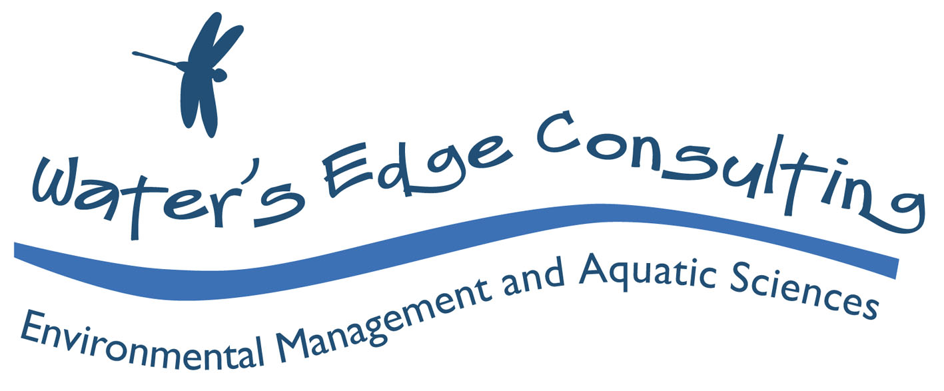

Document history

Original 04

Author/s Rhonda Butcher, Sabine Schreiber

Checked Peter Cottingham

Approved Rhonda Butcher; CEWO

Issue date May 2020

Issued to Commonwealth Environmental Water Office (CEWO)

Description: Final Evaluation Strategy

**Citation:** Butcher, R. and Schreiber, E.S.G. (2020). Evaluation Strategy for the Long Term Intervention Monitoring and Murray-Darling Basin Environmental Water Knowledge and Research projects. Water’s Edge Consulting, report to the Commonwealth Environmental Water Office.

**Disclaimer:**

The views and opinions expressed in this publication are those of the authors and do not necessarily reflect those of the Australian Government or the Minster for the Environment. While reasonable efforts have been made to ensure that the contents of this publication are factually correct, the Commonwealth does not accept responsibility for the accuracy or completeness of the contents, and shall not be liable for any loss or damage that may be occasioned directly or indirectly through the use of, or reliance on, the contents of this publication.

**Acknowledgements:**

We acknowledge the traditional owners of the lands and waterways of the Murray-Darling Basin, and pay our respect to Elders past, present and emerging.

This document was produced with the assistance of Peter Cottingham and Adam Fenton. Valuable input from Pablo Shopen, Nadia Kingham and Paul Marsh (CEWO) is gratefully acknowledged.



**Contents**

Executive Summary v

Background v

Context v

Evaluation purpose vi

Evaluation design vi

Evaluation strategy vi

1 Background 1

1.1 Context 1

1.2 Evaluation purpose 1

1.3 Evaluation design 2

2 Evaluation Strategy 3

2.1 Framing the evaluation 3

2.1.1 The LTIM and EWKR projects’ background and context 3

2.1.2 Contextual factors 3

2.2 Identifying and engaging with stakeholders 4

2.2.1 Participatory approach to identifying stakeholders 4

2.2.2 Stage 1 targeted consultation and engagement 4

2.2.3 Stage 2 broader consultation and engagement 5

2.3 Key evaluation questions (KEQs) 6

2.4 Rubrics, evaluation criteria and performance standards 7

2.4.1 Rubrics 7

2.4.2 Effectiveness rubric 9

2.4.3 Appropriateness rubric 11

2.4.4 Impact rubric 12

2.4.5 Efficiency rubric 13

2.5 Data collation and interpretation 14

2.5.1 Multiple lines of evidence 14

2.5.2 Data collection - Work flow example 16

2.6 Evaluative judgements: Synthesis 17

2.6.1 Summative evaluation 17

2.6.2 Formative evaluation 18

2.7 Reporting 18

2.7.1 Stage 1 reporting 18

3 References 19

4 Glossary 21

Appendix A: Project team and schedule of tasks 24

Appendix B: Framing the evaluation – Project context 26

Appendix C: Overall and Specific Basin Plan Objectives 39

Appendix D: Evaluation criteria and assocated questions from RFQ 42

# Executive Summary

## Background

The Commonwealth Environmental Water Office’s (CEWO) two major science projects, the Long Term Intervention Monitoring (LTIM) and Environmental Water Knowledge and Research (EWKR) projects, ended in June 2019.

The LTIM project aimed to monitor and evaluate the use of Commonwealth environmental water and the EWKR project aimed to improve knowledge about ecological responses to environmental water to better inform adaptive management.

The CEWO has extended the activities of the LTIM and EWKR projects through an integrated Monitoring, Evaluation and Research (Flow-MER) program until June 2022 to:

* complete the LTIM Basin Evaluation (June 2020)
* review the success of the LTIM and EWKR projects to inform the design of the CEWO’s future monitoring, evaluation, and research activities.

## Context

The CEWO’s *Review of the LTIM and EWKR projects* is comprised of three stages as outlined in Figure E 1 and summarised below:

* stage 1: Independent evaluation of the LTIM and EWKR projects (undertaken by Water’s Edge Consulting & Associates’ consulting team)
* stage 2: Consultation with Murray-Darling Basin stakeholders (led by the CEWO, with support from the consulting team)
* stage 3: Design of the CEWO’s future monitoring, evaluation, and research activities (led by the CEWO with no role for the consulting team).

Figure E . Representation of the CEWO’s Review of the LTIM and EWKR projects and design of the CEWO’s future monitoring, evaluation, and research activities. Water’s Edge Consulting is contracted to contribute to Stages 1 and 2.

This Evaluation Strategy is being developed and implemented by Water’s Edge Consulting & Associates as part of the Stage 1 independent evaluation. The evaluation will be staged, commencing with the EWKR project in April 2020, with the LTIM Selected Areas and Basin Matter evaluation being undertaken from May to June 2020. A Stage 1 evaluation report will be delivered by September 2020. Stage 2 Consultation will commence in September and end in December 2020, with the evaluation project (i.e. delivery of the consolidated findings of Stages 1 and 2 of the Review) ending in February 2021. The evaluation is being undertaken by Water’s Edge Consulting and Associates (See Appendix A)

## Evaluation purpose

**The evaluation will address** **six focal areas to determine**:

* the extent to which the projects’ objectives were achieved
* the extent to which the projects supported the CEWO’s legislative reporting requirements
* how well the environmental outcomes were either demonstrated (LTIM) or supported the achievement of environmental outcomes (EWKR)
* how well findings were communicated to all stakeholders
* the extent to which the projects were fit for purpose
* what opportunities there are for improvement to support the CEWO’s future monitoring, evaluation, and research activities.

Each focal area will be assessed by addressing a series of key evaluation questions (KEQs) using relevant evaluation criteria as prescribed in the CEWO’s *Monitoring, Evaluation, Reporting and Improvement* (MERI) Framework (CEWO 2013).

## Evaluation design

**The evaluation design combines a summative outcome evaluation process with a formative evaluation process.** The **summative evaluation** examines the extent to which the LTIM and EWKR projects effectively achieved their objectives, were appropriately designed and produced impactful outcomes that led to improved management of environmental water.

The **formative evaluation** examines what aspects of the LTIM and EWKR projects are appropriate to keep or modify to meet future needs of the CEWO.

**The evaluation has adopted a mixed method design.** A mixed method design is considered best practice for complex evaluations and is suited to the complexity (e.g. multiple themes, spatial and temporal scales) of the LTIM and EWKR projects. Mixed method evaluation designs take into consideration which methods will be connected during the analysis, how they interact throughout the evaluation process, and if any method is weighted in terms of relative importance. The methods adopted in this evaluation include:

* development of a theory of change (for internal project team use only)
* development of three levels of nested key evaluation questions (high, mid and micro levels)
* development of rubrics using simple graded performance standards
* multiple lines of evidence (document review, surveys, interviews)
* judgement aggregation[1] for the summative and formative evaluative findings.

## Evaluation strategy

**This Evaluation Strategy documents eight steps included in the evaluation process:**

1. **framing the evaluation** 
   * presenting context information, such as the EWKR and LTIM projects’ objectives, program logic, expected outcomes, etc.
2. **identifying and engaging with stakeholders**
   * including developing a communication strategy
3. **describing the evaluation types** 
   * participatory, summative, formative and their influence on the evaluation methods
4. **developing key evaluation questions** 
   * that address if an action occurred and how well it was done
5. **developing simple rubrics**
   * based on the evaluative criteria: effectiveness, appropriateness, impact and efficiency
6. **assessing performance against the key evaluation questions** 
   * through collecting, collating and interpreting multiple lines of evidence to assess performance against the key evaluation questions, via document review, surveys and semi-structured interviews (i.e. mixed methods)
7. **making summative and formative evaluative judgements related to the six focal areas**
   * through synthesising outputs from the assessment of the key evaluation questions
8. **reporting the findings** 
   * in an appropriate format for multiple audiences in the Stage 2 consultation.

**Approximately 200 stakeholders have been identified in consultation with the CEWO** and include three broad stakeholder groups:

* client
* service providers/oversight groups
* end users – water managers and planners

Stakeholders will be engaged either by online surveys or semi-structured interviews (via video conferencing). Some interviews will be in groups, as the project only has capacity to undertake approximately 20 interviews per project. All qualitative data will be captured and coded using NVivo software to allow thematic analysis.

**Over 140 key evaluation questions (KEQ) have been developed for each project.** The KEQs are designed to be nested, with two or three levels (high level, mid-level, micro level). Evaluative reasoning will be based on assessing overall outcomes of the evaluation at the high level, which will address the six focal areas.

**The evaluation includes the use of rubrics, one for each of the four criteria to be evaluated: effectiveness, appropriateness, impact and efficiency**. The rubrics allow the expert evaluators to consistently assess the KEQ into three grades (e.g. efficient, moderately efficient, and inefficient).Currently no weighting is applied to any of the criteria.

**Data collection and collation will be undertaken using NVivo software.** All documents being included in the evaluation will be loaded into NVivo, coded and classified. This includes documents such as planning/foundation documents, research plans, annual reports, technical reports and peer reviewed publications. Each is coded and classified for easy cross referencing. The core evaluation team will code key pieces of evidence from each document to each KEQ. In addition, qualitative data collected by surveys and semi structured interviews will be analysed and coded into NVivo.  **Once complete the collated data (NVivo files) will be provided to the expert evaluators to undertake the evaluations.**

**The evaluations will be staged and undertaken by different evaluators, then the results compared and discussed in a team workshop.** The expert evaluators will use evaluative judgement to reach conclusions about specific evaluation questions. They will do this by weighing up the strength of evidence in line with predetermined and agreed-to performance standards (i.e. in the rubrics) and describing the degree of certainty of these conclusions. This will take into consideration any contextual factors (e.g. drought) that may have affected the achievements of each project. Evaluative judgement is used as it is suited to synthesising findings of complicated projects where there are several external factors to consider and/or where there is a mix of evidence and different degrees of certainty.

**In evaluating how well each project performed, the expert evaluators will also identify areas in which future improvements could be made for future monitoring, evaluation and research activities to support the CEWO’s future needs.** A technical workshop with the expert evaluators will be held to jointly consider findings from the Stage 1 evaluation to provide a final, synthesised set of recommendations for future monitoring, evaluation and research activities.

**Reporting on the findings of the Stage 1 evaluation will be targeted to meet the needs of multiple audiences including stakeholders who are the subject of the Stage 2 consultation.**  Water’s Edge Consulting will support the CEWO in undertaking Basin wide consultation through presenting the findings.

# Background

## Context

The Commonwealth Environmental Water Office (CEWO) requires an independent program evaluation of the outcomes of the Long Term Intervention Monitoring (LTIM) (2014-2019) and Murray-Darling Environmental Water Knowledge and Research (EWKR) (2014-2019) projects. Broadly, the evaluation aims to assess the achievement of each project and make recommendations for enhancements and inform future program design.

The LTIM Project aimed to monitor and evaluate the use of Commonwealth environmental water and the EWKR Project aimed to improve knowledge about ecological responses to environmental water to better inform adaptive management.

The evaluation will form part of a larger project the CEWO is undertaking as part of the design of its future monitoring, evaluation and research activities (Figure 1).

Figure . Representation of the CEWO Review undertaking evaluation, consultation and future design of the CEWO’s monitoring, evaluation and research activities. Water’s Edge Consulting is contracted to contribute to Stages 1 and 2.

This document details the approach taken for the evaluation, including evaluation methodology, engagement with stakeholders, evaluation questions and criteria, rubrics and performance standards, the types of evidence used to answer the evaluation questions, and the approach to the synthesis of evaluation findings by the evaluators.

This document will serve as a reference for both the evaluation team for the current evaluation, and for the CEWO for future evaluations of their monitoring, evaluation and research program. This document is a key deliverable of the larger project (see Appendix A).

## Evaluation purpose

Specifically, the purpose of the evaluation is to establish the merit, worth and significance of each project across six focal areas:

* the extent to which the project objectives were achieved
* the extent to which the projects supported the CEWO’s legislative requirements
* how well the environmental outcomes were either demonstrated (LTIM)or supported the achievement of environmental outcomes (EWKR)
* how well findings were communicated to all stakeholders
* the extent to which the projects were fit for purpose
* opportunities for improvement to incorporate within the CEWO’s future monitoring, evaluation, and research activities.

Each focal area will be assessed by addressing a series of key evaluation questions using relevant evaluation criteria from the CEWO’s MERI Framework (CEWO 2013).

## Evaluation design

The evaluation being undertaken is a mixed method outcome evaluation that can be described as:

* **ex-post evaluation** that is being conducted after five years of funding
* **summative** in nature assessing performance to date
* **formative** in that the evaluation will inform future design considerations of the CEWO’s monitoring, evaluation and research activities
* **participatory** in nature, as it will be undertaken in consultation with the CEWO and engage stakeholders.

A mixed method approach is considered best practice for complex evaluations and is suited to the complexity (e.g. multiple themes, spatial and temporal scales) of the two projects being evaluated. Mixed method evaluation designs take into consideration which elements will be connected during the analysis, how they interact throughout the evaluation process and if any method is weighted in terms of relative importance. The methods adopted here include:

* development of theory of change (for internal project purposes only – not detailed here)
* development of three levels of nested key evaluation questions (macro, mid and micro levels)
* four rubrics with three levels of performance standards incorporating effectiveness appropriateness, impact and efficiency criteria (plus sub-criteria)
* multiple lines of evidence (document review, survey, and interviews)
* judgement aggregation for the summative and formative evaluative findings.

Mixed method approaches strengthen the reliability of the data, validity of the findings and recommendations (Bamberger 2012). Interrogating the data using different methods improves the understanding of the processes through which the project outcomes and impacts are achieved, and how contextual factors can affect implementation (Bamberger 2012).

The evaluation will use rubrics (Davidson 2005) to ensure transparent connection between the key evaluation questions, the multiple types/lines of evidence used in addressing each evaluation question and the overall evaluation findings. By adopting rubrics, the evaluation can address the question: ‘How good were the outcomes?’ relative to agreed definitions of quality and value. The use of rubrics also provides a methodology that aligns with the CEWO MERI Framework (CEWO 2013) of addressing effectiveness, appropriateness, impact, and efficiency of the LTIM and EWKR projects. Rubrics include definition and agreement on performance standards *a priori*, hence reducing the potential for bias in an assessment.

Including surveys and semi-structured interviews with stakeholders, to support the project documentation review, will provide a richer understanding of how each project operated, how they changed over time, how obstacles to implementation were dealt with and the areas in which implementation was relatively strong or weak. The formative evaluation step will occur after the summative evaluation is complete and will build on the findings of the previous steps of the evaluation (see Section 2.6.2 for more detail).

The various evaluation methods adopted were agreed on in consultation with the CEWO and at the November 2019 workshop it was decided with the CEWO and the evaluation team that no elements of the evaluation would be weighted.

The evaluation design has been undertaken in close consultation with the CEWO and refined via two workshops with the expert evaluators. The evaluation of the EWKR and LTIM projects will be undertaken in stages; starting with summative evaluation of the EWKR project then the LTIM project work. The evaluation will occur over a 12 month period and is staged to coincide with the availability of final project reports, particularly from the LTIM project.

The mixed method design adopted will use multiple sources of evidence including:

* desktop materials (project management reports, technical reports, published literature)
* interviews
* surveys.

Multiple interview sources such as:

* multiple stakeholder groups represented (see Section 2.2)
* multiple participants within the stakeholder group (see Butcher and Cottingham 2020).

Multiple review processes:

* core team undertake basic evaluation, interviews, and surveys
* expert evaluators review each project
* external review of evaluation report.

Previous reviews and evaluations of the two projects included process evaluation of the planning stage of EWKR (Watts 2017), a mid-term review of LTIM (Hart and Butcher 2018) and a process evaluation of the implementation of EWKR (Hale et al. 2019). This previous work will provide context, as well as some inputs into the outcome evaluation. For example, some questions posed in earlier evaluations will be repeated to ensure key information is captured that reflects potential changes over the life of the projects.

Detail on the schedule of activities are summarised in Appendix A.

# Evaluation Strategy

## Framing the evaluation

### The LTIM and EWKR projects’ background and context

Explanation of the background and context for the LTIM and EWKR projects is presented in Appendix B including reference to:

* requirements under the *Water Act 2007* (Water Act) and the *Basin Plan 2012* (Basin Plan)
* reference to the CEWO MERI Framework
* summary of the LTIM project’s objectives including a subsection of the head contract
* summary of the EWKR project’s objectives and requirements

### Contextual factors

In undertaking the evaluation, it is necessary to take into consideration the contextual factors that may have influenced the implementation of an individual project and, therefore, achievement of stated objectives and outcomes. This includes such things as climatic conditions and infrastructure attributes/operation that may have influenced outcomes, and/or any legislative or policy changes after the projects commenced (among others). Other considerations include such things as the general results of literature reviews for similar projects, and previous evaluations of the LTIM and EWKR projects (e.g. Watts 2017, Hart and Butcher 2018) and their impact on implementation, if any. A full list of contextual factors will be developed in consultation with the CEWO and major stakeholders, such as the Murray-Darling Basin Authority (MDBA). It is expected that most contextual factors would have been captured in the synthesis reports for each project; however, this will also be addressed in interviews with stakeholders.

Where contextual factors may have led to an operating context that affected a project’s ability to achieve a desired outcome, these will be documented and taken into consideration in the evaluation. For example, the performance ratings for effectiveness and/or efficiency may be altered in light of contextual factors.

## Identifying and engaging with stakeholders

Detailed and broad consultation with stakeholders and the wider Murray-Darling Basin community is a major element of the review project being undertaken by the CEWO. The independent evaluation will undertake two processes of stakeholder engagement. During Stage 1 those involved in the development, management, delivery and end users of the two projects will be directly engaged via a series of online surveys and semi-structured interviews (see Butcher and Cottingham 2020). This will provide additional lines of evidence that will be included in the evaluation, contributing to both the summative and formative components of the evaluation.

In Stage 2, further consultation with a wider audience will focus on presenting the findings of the evaluation and elicit suggestions for the future design of the CEWO’s monitoring, evaluation and research activities.

### Participatory approach to identifying stakeholders

The CEWO will be one of the primary users of the findings from the evaluation and, as such, it is important to understand how they intend to use the evaluation findings. In this sense the evaluation is participatory, directly involving the CEWO to establish how they want to be engaged, who is intended to learn from the evaluation and to decide whether there are any specific decision points of importance.

Close consultation has taken place with the CEWO during the design of the Evaluation Strategy and in particular, on the approach to stakeholder engagement. The CEWO have been directly involved in two design workshops.

### Stage 1 targeted consultation and engagement

Stakeholders that have a substantial interest in the outcome of the evaluation and may have important information about each of the projects (e.g. its situation/history/influence) will be engaged during the Stage 1 evaluation phase. This will include a subset of service providers rather than all involved in the projects. Stakeholders to be engaged were identified in consultation with the CEWO. Stage 1 target stakeholders are predominantly:

* CEWO staff
* MDBA staff
* LTIM and EWKR project staff
* water delivery partners
* jurisdiction and Catchment Management Authority and Local Land Services representatives.

Overall, approximately 200 stakeholders have been identified in consultation with the CEWO to be engaged during Stage 1 across three broad stakeholder groups (see Table 1 and Table 2):

* client
* service providers, oversight groups
* end users – water managers and planners.

Stakeholders will be engaged either by online surveys or semi-structured interviews (via video conferencing). Some interviews will be in groups, as the project only has capacity to undertake approximately 20 interviews per project. All qualitative data will be captured and coded using NVivo software to allow thematic analysis.

Table . Stakeholder groups for EWKR project.

|  |  |
| --- | --- |
| Stakeholder group | Stakeholders to be engaged |
| Client for MDB EWKR project | CEWO |
| Service providers for EWKR, Project oversight groups | Murray-Darling Freshwater Research Centre (MDFRC)/La Trobe University project management team  QLD floodplain vegetation project management team |
| Research theme co-ordinators  Research theme team leaders  Research theme members |
| Jurisdictional reference group (JRG) - nominated representatives from NSW, QLD, SA and Vic |
| EWKR Scientific advisory group (SAG) |
| EWKR Project Steering Committee (PSC) |
| End users - managers | Commonwealth (e.g. MDBA, CEWO water delivery teams) |
| Basin States |
| Water planners |
| Water management, river operations |

Table . Stakeholder groups for LTIM project.

| Stakeholder group | Stakeholders to be engaged |
| --- | --- |
| Client for LTIM | CEWO |
| Project service provider for LTIM | MDFRC project management team  Selected Area project management teams |
| Basin matter leaders |
| Data management team |
| Selected Area theme leads |
| End users | Commonwealth (e.g. MDBA, CEWO water delivery teams) |
| Basin States |
| Water planners |
| Water management, river operations |

### Stage 2 broader consultation and engagement

Stage 2 consultation and engagement will capture a wider audience that will include those groups listed for Stage 1 and potentially the following additional groups:

* First Nations representatives
* basin non-government organisation representatives
* research provider representatives
* other groups selected in consultation with CEWO staff.

In Stage 2, broader consultation with stakeholders across the Basin will be undertaken. This is intended to capture input from those not involved in the LTIM and EWKR projects and/or not engaged in Stage 1. This will include consulting with those involved with the CEWO Flow-MER program (Table 3), who are considered a key group of stakeholders with insight to future monitoring, evaluation and research needs. The engagement process in Stage 2 is intended to include online surveys, workshops and meetings across the Basin with final details to be arranged in consultation with the CEWO[2].

Table . Stakeholder groups for the Flow-MER project.

| Stakeholder group | Stakeholders to be engaged |
| --- | --- |
| Client for Flow-MER | CEWO |
| Project service provider for Flow-MER, project oversight | CSIRO project management team |
| Basin matter leaders |
| Data management team |
| Selected Area theme leads and researchers/consultants |
| Flow-MER Science Advisory Group |
| End users | Commonwealth (e.g. MDBA, CEWO water delivery teams) |
| Basin States |
| Water planners |
| Water management, river operations |
| First Nations |
| Researchers |

## Key evaluation questions (KEQs)

Key evaluation questions (KEQs) define the information that the evaluation will generate and consider. They provide both a focus and a frame for an evaluation and are essential for producing robust conclusions (McKegg et al. 2018). In addition to assessing the LTIM and EWKR project outcomes, the KEQs have been designed to address other relevant CEWO’s needs, such as how the two programs contribute to meeting the CEWO’s Basin Plan requirements.

The KEQs will be framed by reference to:

* the planning/foundation documents that describe the objectives and intended outcomes for each of the projects (Section 2.1 and Appendix C)
* address the six focal areas
* the evaluation criteria (Section 2.5).

The KEQs will yield answers that (modified from Wingate and Schroeter 2007):

* provide determinations of merit, worth, and/or significance
* inform decisions about the projects such as how to improve or modify them; whether to continue, discontinue, expand, or reconfigure them.

Three levels of nested KEQ will be developed: high, mid and micro level questions. Mid-level KEQs will be used to aggregate evidence across themes and/or spatial scales (e.g. Selected Area, Basin scale) to answer the high level KEQs. The micro-level KEQs will aggregate evidence to inform the mid-level KEQ and will mostly be focused on theme questions, often relating to specific research or monitoring questions from each project. Where appropriate only two levels, high and mid-level KEQ may be used, but in the majority of cases three levels will be required due to the complexity of the two projects.

An example of the linkages between the different levels of KEQs is illustrated in Figure 2. The data/evidence collected from the document review, surveys and interviews (see Section 2.5) will be used in combination with the rubrics (see Section 2.4) to determine the relative performance of each KEQ. Evaluative reasoning will be based on assessing overall outcomes of the evaluation at the high level, which will address the six focal areas. Over 140 KEQ have been drafted for each project and will be iteratively refined as the evaluation proceeds, with the complete list of KEQs to be presented in the findings report.

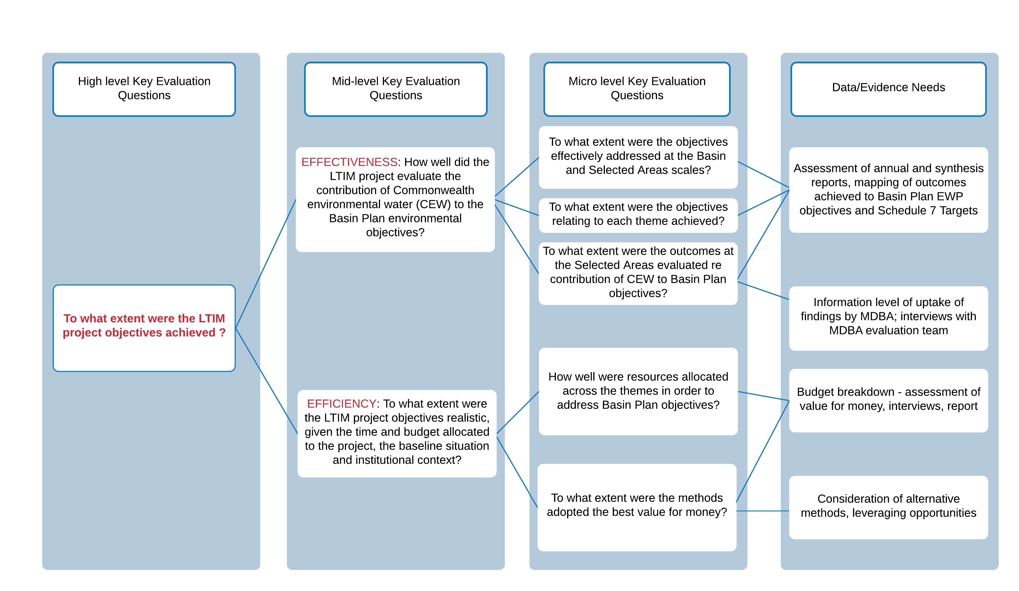

Figure . Illustration of levels of key evaluation questions relating to a single LTIM project high level KEQ and indicating the potential evidence needs (based on Davidson 2014). Note for this question both effectiveness and efficiency KEQ would be relevant.

## Rubrics, evaluation criteria and performance standards

### Rubrics

Evaluative processes include judgements about merit, worth or significance. By adopting an approach that incorporates rubrics, it is possible to make these judgements based on a set of evaluation criteria that help define how good or bad a program is in relation to the quality of its activities and the success of its outcomes (Davidson 2005, Dickinson and Adams 2017).

A rubric is a matrix table with three main components (Figure 3):

1. a set of evaluation criteria or key aspects of performance (as explained below)
2. a set of standards or a qualitative rating system distinguishing levels of performance and descriptions for each criterion
3. the importance of each criteria or key aspect of performance.

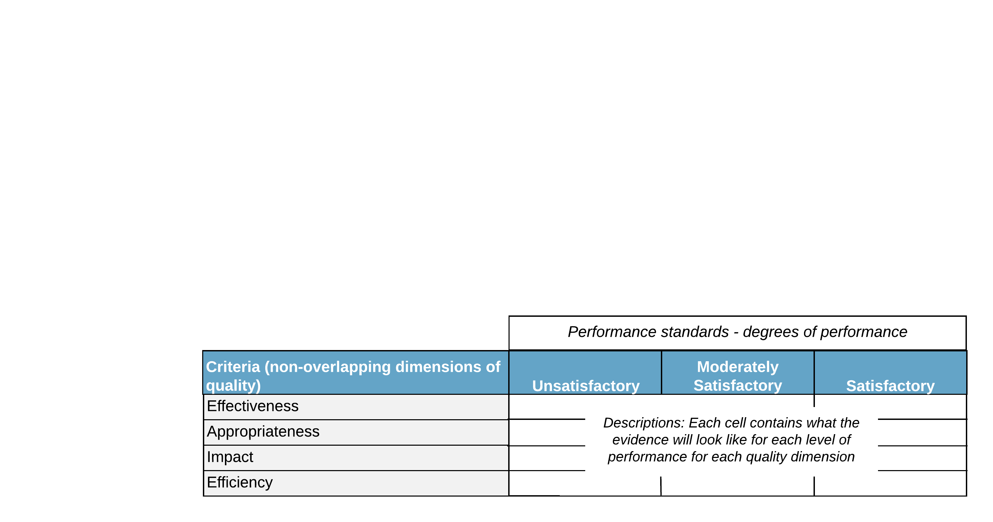

Figure . The components of a rubric reflecting the four evaluative criteria being adopted in this evaluation (modified from Martens 2018).

#### Evaluation criteria and sub-criteria

Four evaluation criteria, two with sub-criteria, were agreed on following discussion at the planning workshop in November 2019 and pilot workshop in February 2020. The evaluation criteria align with the CEWO MERI Framework (CEWO 2013) of addressing effectiveness, appropriateness, impact, and efficiency of the LTIM and EWKR projects.

The evaluation criteria and sub-criteria are:

* Effectiveness
  + Achieved objectives
  + Communicated key findings
  + Demonstrated or supported achieving environmental outcomes
* Appropriateness
  + Strategic relevance
  + Fit for purpose
* Impact
* Efficiency

#### Performance standards

There are several types of rubrics that can be used in evaluations; however, a simple generic grading or ranking style has been adopted due to the complexity of the two projects being evaluated. This type of rubric outlines more generic levels of performance relative to each other, such as poor to excellent, and the evaluator collects and analyses the data and then checks it against the generic grading scale to determine the level of performance later in the evaluation process.

Ranking levels of performance within a rubric evaluation methodology requires clear articulation of the aspects of performance that are to be evaluated. The process provides clarity on the aspect of performance that are important, and allows quicker development of judgement (Stone-Jovicich 2015). A rubric methodology with ranked, generic grading allows integration of complex data through an inductive process that can incorporate emergent understanding during the evaluation process.

The evaluation criteria will be rated on a three-point scale as agreed at the November 2019 workshop, with the wording of the levels of the criteria reflecting the relevant evaluation criteria. No weightings will be applied to the criteria, with each considered of equal importance. The performance levels are:

* Minimally effective, Moderately effective, Effective
* Inappropriate, Moderately appropriate, Appropriate
* Low impact, Moderate impact, High impact
* Inefficient, Moderately efficient, Efficient.

Once the rubrics were drafted they were reviewed and updated in consultation with the CEWO to ensure:

* criteria selected were clear, distinct and predominantly derived from appropriate standards (e.g. CEWO MERI framework and peer reviewed literature)
* each level of the performance standard is distinct and progress in a clear and logical order
* description of the performance standard is understandable to all users of the rubrics, including evaluators, the CEWO and stakeholders; with specific language that aids evaluators in making assessments.

The rubrics are presented for each of the four evaluation criteria in the sections below[3].

### Effectiveness rubric

Effectiveness is the relationship between the project’s objectives, outputs and its outcomes. Effectiveness will be assessed by considering how effectively the projects:

achieved their objectives

communicated their findings

achieved/or supported the desired outcomes.

In order to allow a meaningful comparison of the intended objectives and actual outcomes, a project's objectives should be measurable (i.e. Specific, Measurable, Achievable, Relevant and Time-bound (SMART)). Any formally documented modifications/revisions made to the objectives during project implementation will be considered as part of the project design. Where project objectives have changed from what is presented in foundation documents, these will be captured in the evaluation (e.g. as a table showing where original and reformulated objectives occurred, as recommended in UN Environment 2018).

The communication of key findings will be assessed on both quantity and quality of the communication products; their ownership by, and usefulness to, intended end-users; and the timeliness of their delivery (as recommended in UN Environment 2018).

Sometimes a project will have no control over outcome(s), for example due to unforeseen climatic events. However, a project will strive to achieve an output(s) that has the greatest likelihood of producing the intended outcome(s). Therefore, project effectiveness is driven primarily by two things: its design and its implementation, which equates to its management.

To demonstrate if the intended outcomes were effective it is necessary to show improved management of environmental water, that is, behavioral changes (i.e. changed management practices) occurred. The sub-criterion addressing effectiveness in demonstrating, or supporting, the achievement of environmental outcomes considers the contribution of the outcomes to improved water management and relative contribution Commonwealth environmental water made to Basin Plan environmental objectives.

Evaluation questions will be iteratively developed throughout the evaluation. As a minimum the high level evaluative questions to be addressed using this rubric will include:

* How well have the EWKR and LTIM projects achieved their objectives?
* How well have the EWKR and LTIM projects communicated key findings to stakeholders?
* To what extent has the EWKR project improved understanding of how management or delivery of environmental water influences environmental outcomes achieved over time?
* How well did the LTIM project Basin team evaluate the contribution of Commonwealth environmental water to the Basin Plan Environmental Watering Plan objectives?
* How effectively did the LTIM project evaluate the ecological outcomes of Commonwealth environmental water at the seven Selected Areas?
* To what extent did the LTIM project infer the ecological outcomes of Commonwealth environmental water to areas in the Basin not monitored?

The performance standards for the effectiveness rubrics are presented in Table 4.

Table . Effectiveness sub-criteria and performance standards (based on UN Environment 2019).

| Effectiveness | Performance standards | | |
| --- | --- | --- | --- |
| Sub-criteria | Minimally effective | Moderately effective | Effective |
| Achieving objectives (Rubric 1.1) | Majority of objectives, either as specified in the head contract for LTIM or in the grant guidelines for the E.WKR project and/or foundation documents, at Basin and Selected Area/site scale partially achieved. Some unlikely to be achieved over longer timeframe. | Moderate number of objectives, either as specified in the head contract for LTIM or in the grant guidelines for the EWKR project and/or foundation documents, at Basin and Selected Area/site scale achieved. Some partially achieved, but likely to be achieved over longer timeframe. | Majority of objectives, either as specified in the head contract for LTIM or in the grant guidelines for the EWKR project and/or foundation documents, at both the Basin and Selected Area/site scale achieved. |
| Communicating key findings (Rubric 1.2) | Objectives specific to communicating key findings were minimally effective, with few of the planned/ approved outputs delivered. | Objectives specific to communicating key findings were mostly effective with the majority the planned/approved outputs delivered. | Objectives specific to communicating key findings were highly effective, with the majority of planned/approved outputs delivered. |
| Communication of key findings failed to lead to changed water management practices. | Communication of key findings led to limited/minor changes in water management practices. | Communication of key findings led to substantial changes in water management practices. |
| Evidence suggests that key audiences had low awareness of the project’s main messages. | Evidence suggests that some key audiences were aware of project’s main messages. | Evidence suggests that majority of key audiences were fully aware of the project’s main messages. |
| Communication activities were poorly-targeted, and missed most key audiences. | Communication activities were generally well-targeted, but missed some key audiences. | Communication activities were well-targeted, with all key audiences kept informed over the life of the project. |
| Low end user uptake - intended users of key outputs only peripherally or not aware of outputs. | Moderate levels of end user uptake - intended users of key outputs aware of outputs in general. | High levels of end user uptake – intended end users aware of and utilised outputs. |
| Communication of findings was somewhat late for its intended use and was below average quality. | Communication of findings was available on time for its intended use and was of average to good quality. | Communication of findings was available on time for its intended use and was of excellent quality. |
| A weak communication plan/strategy was prepared but not implemented. | Adequate but limited communication plan/strategy was prepared and was partially implemented. | A strong and comprehensive communication plan/ strategy was prepared and was fully implemented. |
| Demonstrating (LTIM) or supporting (EWKR) achievement of environmental outcomes (Rubric 1.3)[4] | Minority of environmental and managerial outcomes achieved, **or** achievement supported. Some unlikely to be achieved over longer timeframe. | Environmental and managerial outcomes partially achieved, **or** achievement supported. Some partially achieved, but likely to be achieved over longer timeframe. | Majority of environmental and managerial outcomes fully achieved, **or** achievement supported. |
| Outcomes have resulted in minimal improvements to the capacity to predict outcomes of environmental flow allocations and their management over 1–5 years. | Outcomes have resulted in moderate improvements to the capacity to predict outcomes of environmental flow allocations and their management over 1–5 years. Further improvements will be gained with continued monitoring and research. | Outcomes have resulted in significant improvements to the capacity to predict outcomes of environmental flow allocations and their management over 1–5 years. |
| Predictive tools, conceptual models and frameworks to inform environmental watering regimes have not been delivered; or are mostly ineffective in terms of improving the knowledge basis and utility of such tools. | Predictive tools, conceptual models and frameworks to inform environmental watering regimes have mostly been delivered; and are mostly effective in terms of improving the knowledge basis and utility of such tools. | Predictive tools, conceptual models and frameworks to inform environmental watering regimes have been fully delivered; and improve the knowledge basis and utility of such tools. |
| Line of sight from environmental outcomes to the Basin Plan Environmental Watering Plan (EWP) outcomes is limited. Outcomes unlikely to contribute to meeting legislative requirements. | Line of sight from environmental outcomes to the Basin Plan EWP outcomes is clear for most of the outcomes. Most outcomes are likely to contribute to meeting legislative requirements. | Line of sight from all environmental outcomes to the Basin Plan EWP outcomes is clear. Outcomes contribute to meeting legislative requirements. |

### Appropriateness rubric

Appropriateness is the determination made through comparing a project with the needs of the intended beneficiaries using any of the techniques of needs analysis (Commonwealth of Australia 2009). In this evaluation, this criterion relates to the project’s objectives and outcomes being consistent with the CEWOs strategic requirements, including reporting needs to meet Basin Plan and legislative requirements. The need for project design to be fit for purpose underpins the appropriateness of the projects in meeting the CEWOs strategic requirements. Thus there are two sub-criteria, strategic requirement and fit for purpose.

Assessing fit for purpose will include an assessment of how well the project, either at design stage or during the project implementation, took account of other ongoing and planned initiatives (being implemented by other agencies) that address similar needs of the same target groups. The evaluation will also consider if there were efforts made to ensure activities were complementary to other projects/programs, optimised any synergies and avoided duplication of effort during the design phase (modified from UN Environment 2019).

The high level evaluative questions to be addressed using this rubric will include:

* How well have the EWKR and LTIM projects supported/contributed to the CEWO’s ability to meet their legislative reporting requirements?
* To what extent were the EWKR and LTIM project designs fit for purpose in meeting the CEWO’s strategic requirements?

The performance standards for each sub-criterion of the appropriateness rubric are shown in Table 5.

Table . Appropriateness sub-criteria and performance standards.

| Appropriateness | Performance standards | | |
| --- | --- | --- | --- |
| Sub-criteria | Inappropriate | Moderately appropriate | Appropriate |
| Strategic requirement (Rubric 2.1) | The project’s findings show low levels of alignment with:  a) CEWO’s needs in satisfying Basin Plan reporting requirements b) Regional, sub-regional and / or national environmental priorities (e.g. Selected Area watering priorities, Ramsar obligations to maintain ecological character)  c) Target group and beneficiary needs and priorities (e.g. MDBA needs for Basin Plan evaluation) | The project’s findings show moderate levels of alignment with: a) CEWO’s needs in satisfying Basin Plan reporting requirements b) Regional, sub-regional and / or national environmental priorities (e.g. Selected Area watering priorities, Ramsar obligations to maintain ecological character)  c) Target group and beneficiary needs and priorities (e.g. MDBA needs for Basin Plan evaluation) | The project’s findings show high levels of alignment with:  a) CEWO’s needs in satisfying Basin Plan reporting requirements  b) Regional, sub-regional and / or national environmental priorities (e.g. Selected Area watering priorities, Ramsar obligations to maintain ecological character)  c) Target group and beneficiary needs and priorities (e.g. MDBA needs for Basin Plan evaluation) |
| Design fit for purpose (Rubric 2.2) | Project logic and design in foundation documents lacks clarity, key assumptions and or drivers are not articulated, and/or exhibits poor alignment to the Basin Plan objectives and outcomes, reporting requirements not articulated. | Project logic and design in foundation documents is satisfactory with key assumptions and or drivers articulated, reasonable line of sight to Basin Plan objectives and outcomes, reporting requirements mentioned. | Project logic and design in foundation documents is exemplary, with key assumptions and or drivers clearly articulated, direct line of sight of results to Basin Plan reporting requirements with outcomes aligned to those of the BWS and EWP. |
| The project design was not integrated with complementary recent, ongoing or planned projects in the same area or on the same problem/issue resulting in considerable overlap and duplication. | The project design was partially integrated with complementary recent, ongoing or planned projects in the same area or on the same problem/issue resulting in some overlap and duplication. | The project design was fully integrated with complementary recent, ongoing or planned projects in the same area or on the same problem/issue with no overlap or duplication |

### Impact rubric

Impact is a measure of the broader consequences of the project (i.e. economic, social, political, environmental, managerial), which can occur at multiple scales (e.g. Selected Area, Basin scale), on the target group and other directly or indirectly affected parties.

Impact is therefore a measure of the positive and negative, primary and secondary long-term change produced by the projects, directly or indirectly, intended or unintended. Not all projects will have high level or direct impacts. Factors that might influence impact could include (modified from Chelimsky 2019):

* complexity of the project (i.e. requiring highly sophisticated skill levels or unrealistic degrees of cooperation across systems or agencies, thus inhibiting implementation and diffusion)
* absence of local buy-in (i.e. failure to obtain the interest or participation of the people affected by the project)
* isolation of the project activities/outcomes (i.e. inability to achieve integration of the project within other projects/regions)
* over optimistic timeframes (i.e. errors in estimating how long it will take to achieve the desired outcome).

The evaluation will consider the extent to which each project has played a catalytic role in changing water management practices. The relative impact will be assessed across the multiple themes and also at the Basin and Selected Area scale for LTIM.

The high-level evaluative questions to be addressed using this rubric will include:

* To what extent have the environmental outcomes from the EWKR project had an impact on the CEWO's adaptive management of environmental water?
* To what extent has the LTIM project impacted water management practices leading to achievement of Basin Plan objectives and outcomes?
* How impactful have the EWKR and LTIM projects been in supporting adaptive management in the basin?
* How impactful have the EWKR and LTIM projects been in fostering improved collaboration?

The performance standards for the impact rubric are shown in Table 6.

Table . Impact criteria and performance standards.

| Impact (influence) | Performance standards | | |
| --- | --- | --- | --- |
|  | Low impact | Moderate impact | High impact |
| (Rubric 3) | The project did not result in any significant direct or indirect outcomes that have led to changed water management practices at either the Basin or regional scale. | The project resulted in direct or indirect outcomes, resulting in changed water management practices at the regional scale. | The project resulted in direct, improved water management practices at either the Basin and/or regional scale that will be sustained |
| Some direct outcomes partially achieved but do not include those most important to achieve desired impacts of changed water management. | Moderate number of direct outcomes either achieved or on track to being achieved and likely to lead to changed water management practices. | Majority of direct outcomes achieved leading to desired impacts; changed practices in water management. |
| Considerable underestimation of timeframe in which outcomes would be observed. | Minor underestimation of timeframe in which outcomes would be observed, due mainly to unpredictable external factors | Timeframe not an issue – desired impacts achieved. |
| Low to no impact on adaptive management practices or collaborative processes. | Moderate impact on adaptive management practices and collaborative processes. | Clear impact on adaptive management practices and collaborative processes. |

### Efficiency rubric

Efficiency is a measure of how inputs (resources, expertise, time, etc.) are converted into outputs (reports, data, etc.) (Peersman 2015). Assessing efficiency should consider what systems are in place for activities to be implemented, the application of best practice, or allocated expenditure versus actual expenditure. Questions evaluating project efficiencies will identify whether the intended quality and quantity of outputs were produced within the available resources and represented value for money[5].

It is possible that efficiency evaluation questions will be iteratively refined during the evaluation. As a minimum the following high level evaluative questions will be addressed using this rubric:

* How efficiently have the EWKR and LTIM projects achieved their objectives and outcomes?
* How efficient were the EWKR and LTIM projects in managing and sharing data?
* How efficient was the collaborative process within the EWKR and LTIM projects?
* How efficient were the EWKR and LTIM projects in generating the agreed outputs?

The performance standards for the efficiency rubric are shown in Table 7.

Table . Efficiency criteria and performance standards.

| Efficiency | Performance standards | | |
| --- | --- | --- | --- |
|  | Inefficient | Moderately efficient | Efficient |
| (Rubric 4) | Limited improvements over time, with little novel learning for the cost of the activities (i.e. adaptive management outcomes limited). | Moderate improvements over time, with some novel learning for the cost of the activities (i.e. adaptive management outcomes moderate). | Obvious improvements over time, with novel learning across themes/scales for the cost of the activities (i.e. adaptive management outcomes efficient and represent good value for money). |
| Fails to produce the intended quality and quantity of most outputs (including data), within the available resources in a timely fashion. | In most cases, but not all, succeeds in producing the intended quality and quantity of outputs (including data), within the available resources in a timely fashion. | Succeeds in producing the intended quality and quantity of outputs (including data), within the available resources in a timely fashion. |
| No evidence of pooling of resources to take up opportunities for joint activities or mutual learning with other organisations and networks. | Some evidence of pooling of resources to take up opportunities for joint activities or mutual learning with other organisations and networks. | Clear evidence of pooling of resources to take up opportunities for joint activities and mutual learning with other organisations and networks. |
| Evidence of limited effective collaboration and communication with appropriate organisations external to the project. | Evidence of some effective collaboration and communication with appropriate organisations external to the project. | Strong evidence of effective collaboration and communication with appropriate organisations external to the project (i.e. joint publications, conference papers etc.). |

## Data collation and interpretation

### Multiple lines of evidence

We will use multiple lines of evidence to collect evidence for addressing the KEQs. These will include:

* document reviews, including project reports, scientific papers and communication products provided by the CEWO[6]
* on-line surveys using survey monkey
* and semi-structured interviews.

For each KEQ the core evaluation team has mapped the type of evidence to be used, if surveys and/or interviews are required as a line of evidence, and which stakeholder groups are to be engaged. An example of this mapping is presented in Figure 4.

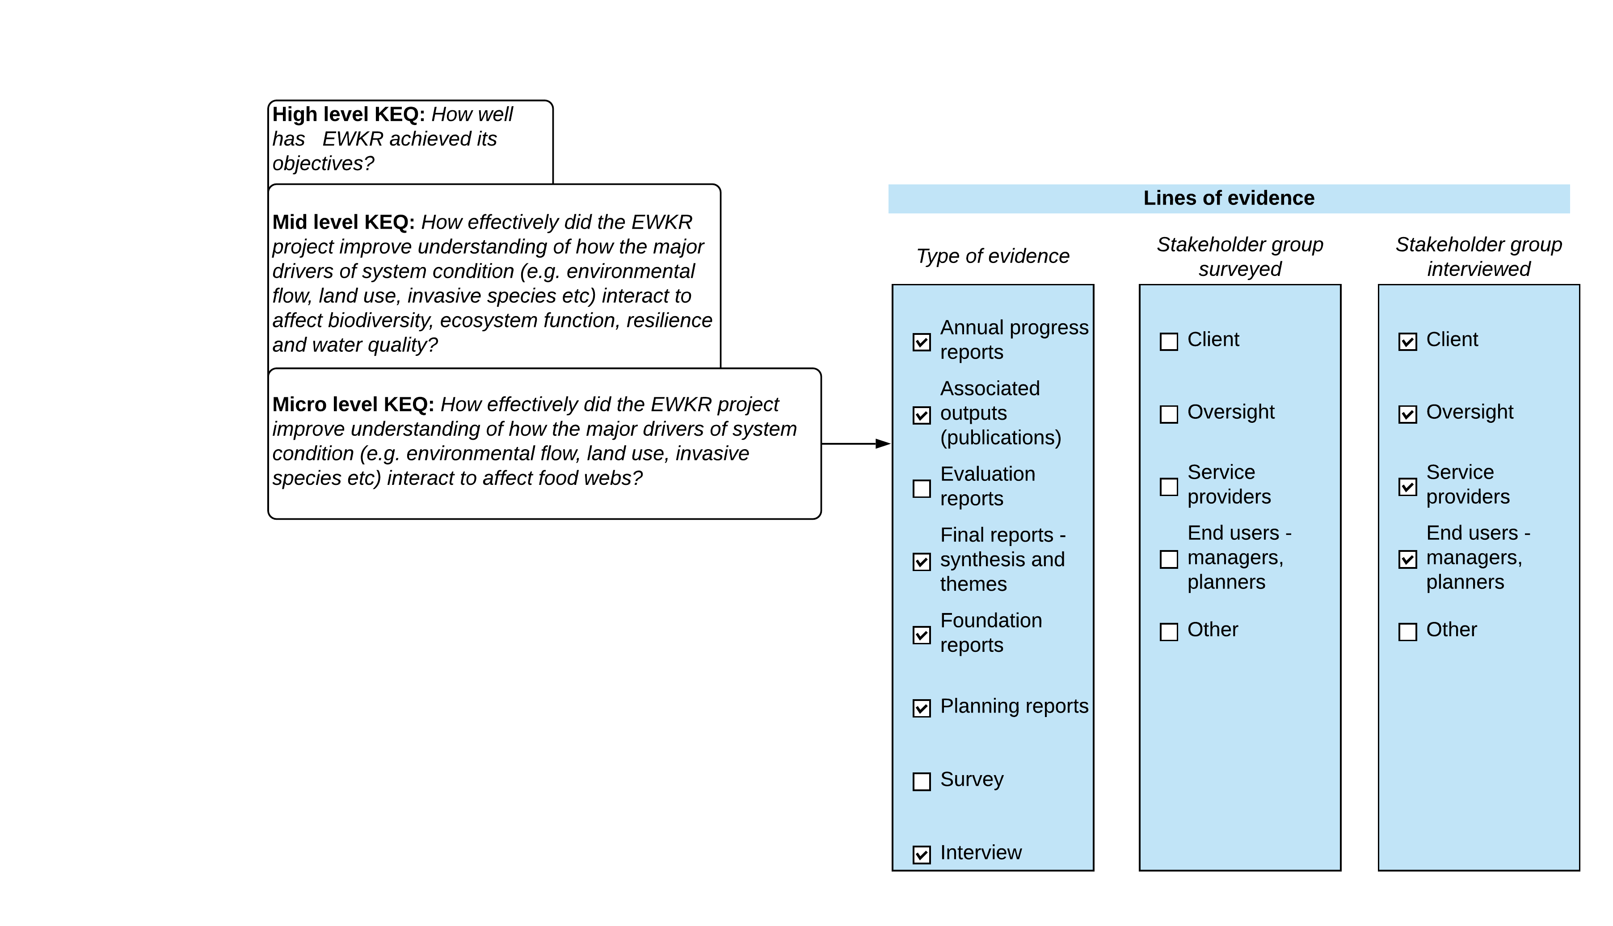

Figure . Example of multiple lines of evidence used for a KEQ set of questions relating to achieving objectives for the EWKR project.

Information will be triangulated, that is verified from different sources, as far as possible, and when verification is not possible, the single source will be cited.

The range of documents that will be included in the evaluation are summarised in Table 8.

Table . Document categories per project included in the document review.

| EWKR documents | LTIM documents |
| --- | --- |
| Foundation reports - Preliminary identification of research questions, Selection of priority research questions research sites, Research report for the Queensland vegetation project | Foundation documents – Logic and Rationale report, Outcomes framework, foundation reports by theme, Generic cause effect diagrams, Standard methods report |
| Planning reports – annual research plans, multi-year research plans, communication plan, data management plans, Operations strategy etc. | Planning reports – Basin evaluation plan, Selected Area Monitoring and Evaluation Plans |
| Annual progress reports | Annual progress reports - Basin scale evaluation of CEW, Basin matter reports, Synthesis report, Selected Area annual evaluation reports |
| Associated outputs – peer reviewed publications | Associated outputs – peer reviewed publications |
| Evaluation reports – Evaluation strategy (process and implementation), Phase 1 and 2 evaluation reports | Evaluation reports – mid-term review and evaluation |
| Final reports - Synthesis, Theme reports | Final reports – theme reports, synthesis and Selected Area evaluation reports |
| Presentations, factsheets | Presentations, factsheets |

Targeted online surveys will be conducted using Survey MonkeyTM, a web-based survey platform that has been used to design the surveys and will serve as the central repository for all survey responses. This platform has been chosen as the most appropriate survey-host as the data can be individually or collectively analysed through the platform securely or directly imported into qualitative analysis software (NVivo) for content and thematic analysis. The survey and interview questions have been designed to elicit targeted responses that are relevant to the evaluation focal areas across both projects.

Interviews will be semi-structured with the overall topic and questions to be answered forwarded to participants prior to interviews. This format is more flexible than structured interviews, allowing evaluators to deviate from the questions as the discussion develops and so gain a more in-depth exploration of a given theme (O’Neil 2020).

The interview transcripts and survey responses will be analysed using the qualitative analysis software package NVivo. NVivo will enhance the ability to capture, explore and cross-reference themes, concepts and ideas within and between interview and survey transcripts using coding and graphical tools. One of the main advantages of this approach is that, as themes emerge within the process of reviewing the interview and survey transcripts, the evaluators will have the utility to link them to those captured during the document review phase of the evaluation.

Using NVivo, we can then express these themes/ideas quantitatively, enabling the evaluation team to explore patterns in the data, such as minority and majority views, as well as report on stakeholder sentiment by analysing the distribution of positive and negative terms within and between questions, stakeholders and stakeholder groups.

### Data collection - Work flow example

The workflow approach to collecting and collating the data for the EWKR evaluation is illustrated in Figure 5. A similar approach is anticipated for LTIM. The core evaluation team will split into two teams; the first will undertake a full document review and use the four rubrics to assess performance against the KEQs. Simultaneously the second team will review all documents and then run the online survey and undertake the interviews. This latter team will also evaluate a sub-set of KEQ relating to two focal areas. A workshop will be held where the core evaluation team makes some preliminary judgement aggregation decisions (i.e. agree on performance for KEQs). The lines of evidence and preliminary judgements (stored in NVivo files) will be supplied to the expert evaluators.

Figure . Workflow for collating and interpreting data for the EWKR project evaluation. A similar approach will be adopted for the LTIM evaluation.

## Evaluative judgements: Synthesis

### Summative evaluation

The penultimate step of the evaluation will involve synthesising the outputs from the evaluation using the KEQ and rubrics relating to each of the six focal areas into an overarching judgement of merit, worth and significance for each project. To do this the expert evaluators will have to undertake judgement aggregation (List 2012) which is explained below and illustrated in Figure 6.

As both projects are complex and there are large amounts of data that will be used to inform evaluative decisions, we expect that the evaluators will arrive at different judgements for some of the questions. In addition, judgements may change iteratively as the evaluator’s progress through the multiple lines of evidence and projects. To make a collective evaluative judgement on the findings and achieve an accepted evaluation result, evaluation information is aggregated from bottom (ratings for micro KEQ) to top (ratings for the high level KEQ and/or focal area) step by step.

It was agreed at the February 2020 workshop that the expert evaluators would document the aggregation rules applied they applied for each project evaluation, noting that they may be different for the two projects.

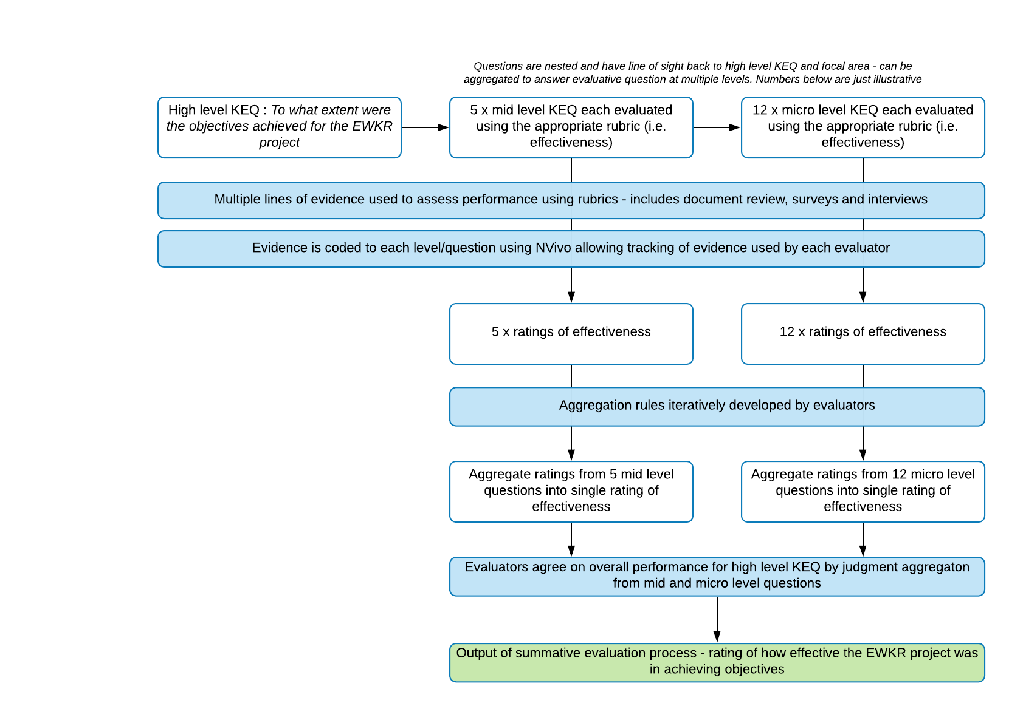

Figure . Example of steps in summative evaluation process of applying rubrics to achieve ratings for one set of KEQ.

### Formative evaluation

This step will produce recommendations for improvements to the CEWO’s future monitoring, evaluation and research program that will begin post 2021. It will take the output from the summative evaluation and combine this with the Stage 1 stakeholder interview transcripts to identify areas in which there can be improvements in existing elements of the projects and areas in which new approaches are needed. Findings from the Stage 2 consultation and an expert workshop in November 2020 will contribute to the recommendations.

In most cases, formative evaluation focuses on achieving better outcomes with fewer resources (Macnamara 2020), which will likely be a consideration for the CEWO, but meeting its legislative requirements and improving adaptive management of Commonwealth environmental water is likely to still underpin the monitoring, evaluation and research activities it undertakes post 2021. As such the emphasis of this stage of the project will be on providing the CEWO with recommendations on the need to address gaps in current monitoring and evaluation, and research needs to enable the CEWO to contribute to meeting the Basin Plan objectives and outcomes by 2026.

## Reporting

### Stage 1 reporting

The main audience for the evaluation will be the CEWO. Two evaluation reports will be produced one each for the LTIM and EWKR projects, providing a summary of the approach taken, and summative evaluative findings. To support Stage 2 consultation, secondary outputs will summarise and present the summative evaluation results in a format suitable for wide dissemination amongst the general public. Info-graphics such as those used in report cards, will be designed to convey key findings in a simple, easy to understand manner.

The summative evaluation reports will include the following (modified from Davidson 2014):

* explicitly evaluative language will be used when presenting findings (rather than value-neutral language that merely describes findings)
* use of clear and simple data visualization to present easy-to-understand ‘snapshots’ of how each project has performed on the various dimensions of merit (i.e. traffic light type graphics)
* structuring of the findings section using focal areas and high KEQs as subheadings
* clarity and transparency about the evaluative reasoning used, with the explanations clearly understandable to both non-evaluators and readers without deep content expertise in the subject matter. These explanations will be broad and brief in the main body of the report, with more detail available in annexes
* evaluative rubrics that are relatively small, will be included in the main body of the report. If they are large, a brief summary of at least one or two should be included in the main body of the report, with all rubrics included in full in an annex.

The Stage 1 summary report present the findings and recommendations for each project and the output of a synthesis workshop on the options for future CEWO monitoring, evaluation and research activities.

The formative evaluation report will provide recommendations in relation to the key elements of program planning, including:

* Governance: project management and requirements for technical advisory groups
* Planning: engagement with water managers and co-design, collaboration models
* Design: program logics, strategic relevance and objective setting
* Annual processes: engagement, reporting and adaptive management processes
* Communication: engagement with stakeholders/end users
* Evaluation: process and outcome evaluation

# References

Bamberger, M. 2012. Introduction to mixed methods in impact evaluation. Impact Evlauation Notes, No. 3 August 2012.

Butcher, R., and Cottingham, P. 2020. LTIM and EWKR review Communication Strategy. Report to the Commonwealth Environmental Water Office.

CEWO. 2013. Commonwealth Environmental Water – The Environmental Water Outcomes Framework, Commonwealth Environmental Water, December 2013 V1.0.

Chelimsky, E. 2019. Improving the Match Between Sustainability Questions and Evaluation Practice: Some Reflections and a Checklist. New Directions for Evaluation **2019**(162): 69–86. doi:10.1002/ev.20363.

Commonwealth of Australia. 2009. NRM MERI Framework. Australian Government Nature Resource Managment Monitoring, Evaluation, Reporting and Improvement Framework.

Commonwealth of Australia. 2012. Murray-Darling Basin Plan, Federal Register of Legislative Instruments, F2012-L02240, Canberra.

Davidson, E.J. 2014. Evaluative Reasoning, Methodological Briefs: Impact Evaluation 4, UNICEF Office of Research, Florence.

Davidson, J.E. 2005. Evaluation Methodology Basics, The Nuts and Bolts of Sound Evaluation. Sage, Thousand Oaks, California.

Dickinson, P., and Adams, J. 2017. Values in evaluation – The use of rubrics. Evaluation and Program Planning **65**: 113–116. doi:10.1016/j.evalprogplan.2017.07.005.

Evaluation Office of UN Environment. 2017. Use of Theory of Change in project evaluations.

Gawne, B., Brooks, S., Butcher, R., Cottingham, P., Everingham, P., Hale, J., Nielsen, D.L., Stewardson, M.J., and Stoffels, R. 2013. Long Term Intervention Monitoring Logic and Rationale Document Final Report prepared for the Commonwealth Environmental Water Office by The Murray-Darling Freshwater Research Centre.

Gawne, B., Roots, J., Hale, J., and Stewardson, M.J. 2014. Commonwealth Environmental Water Office Long–Term Intervention Monitoring Project: Basin Evaluation Plan. MDFRC, Albury, NSW.

Hart, B.T., and Butcher, R. 2018. Commonwealth Long-Term Intervention Monitoring Project: Stage 1 Mid-Term Review and Evaluation, Report by Water Science Pty Ltd and Water’s Edge Consulting for Commonwealth Environmental Water Office, Canberra, 151 pp.

Macnamara, J. 2020. New Developments in Best Practice Evaluation: Approaches, Frameworks, Models, and Methods. *In* Handbook on Public Sector Communication. *Edited by* V. Luoma‐aho and M.J. Canel.

Martens, K.S.R. 2018. How program evaluators use and learn to use rubrics to make evaluative reasoning explicit. Evaluation and Program Planning **69**: 25–32. doi:10.1016/j.evalprogplan.2018.03.006.

McDonald, G. 2018. Checklist of key considerations for development of program logic models. Retrieved from https://wmich.edu/evaluation/checklists.

McKegg, K., Oakden, J., Wehipeihana, N., and King, J. 2018. Evaluation building blocks: A guide. The Kinnect Group. Available from http://kinnect.co.nz/to/wp-content/uploads/EvaluationBuildingBlocks_A-Guide_FINAL_V1.pdf.

MDBA. 2014. Basin-wide environmental watering strategy (draft for public comment).

O’Neil, G. 2020. Measuring and evaluating audience awareness, attitudes, and response. *In* The Handbook of Public Sector Communication. *Edited by* V. Luoma-aho and M.J. Canel. Wiley, Blackwell.

Palinkas, L.A., Mendon, S.J., and Hamilton, A.B. 2019. Innovations in Mixed Methods Evaluations. Annual Review of Public Health **40**(1): 423–442. doi:10.1146/annurev-publhealth-040218-044215.

Peersman, G. 2015. Impact evaluation. BetterEvaluation. Available from http://www.betterevaluation.org/themes/impact_evaluation.

Stone-Jovicich, S. 2015. To rubrics or not to rubrics? An experience using rubrics for monitoring, evaluating and learning in a complex project. Practice Notes Series: Managing for impact. CSIRO.

Wingate, L., and Schroeter, D. 2007. Evaluation questions checklist for program evaluation. Available from http://wmich.edu/evaluation/checklists.

# Glossary

**Adaptive Management** comprises (1) problem definition, (2) planning, (3) management, (4) monitoring and evaluation and (5) sharing lessons learnt. Adaptive changes can occur at any stage of this cycle. In particular, adaptive management includes (MDBA 2017):

1. setting clear objectives
2. linking knowledge (including local knowledge), management, evaluation and feedback over a period of time
3. identifying and testing uncertainties
4. using management as a tool to learn about the relevant system and change its management
5. improving knowledge
6. having regard to the social, economic, and technical aspects of management.

As this is an iterative process during the evaluation the specific rules will be documented in the final reports.

**Evaluation** is the systematic determination of the merit (quality), worth (value), or significance (importance) of something so as to improve performance.

**Evaluation criteria** the values (i.e. principles, attributes or qualities held to be intrinsically good, desirable, important and of general worth) which will be used in an evaluation to judge the merit of a program (Davidson 2014) and identify areas of improvement. Examples include effectiveness, appropriateness, impact, and efficiency (see CEWO 2013).

**Impact (criterion)** is a measure of the positive and negative, primary and secondary long-term effects produced by the projects, directly or indirectly, intended or unintended. In the context of the LTIM and EWKR project evaluation the impact criteria predominantly relates to management practice change as a result of the interventions.

**Ex-post** (meaning after the event)evaluationsassess whether a specific project or program was justified and whether it worked as expected in achieving its objectives and why; therefore they are typically undertaken at the end of a project.

**Judgement aggregation** (in the context of the evaluation) deals with how a group of individuals make consistent collective judgments on a set of propositions on the basis of the group members’ individual judgments on them: in this case how the expert evaluators compare their findings and then agree on a consistent evaluative judgement. **Aggregation rules** (in the context of the evaluation) refer to the rules that the individual expert evaluators will use to aggregate their individual judgements for micro level KEQ to mid and from mid to high level KEQ. Judgements will initially be made separately, and then the evaluators will seek a consensus via the judgement aggregation step. An example of an aggregation rule is ‘*the majority vote wins*’. As this is an iterative process during the evaluation, the specific rules will be documented in the final reports.

**Key evaluation questions (KEQ)** are evaluation questions about overall performance, which the evaluation should aim to answer. KEQs are derived from the purpose of the evaluation (Davidson 2014).

**Mixed methods** designs can be defined as those in which the investigator collects and analyses data, integrates the findings, and draws inferences using both qualitative and quantitative approaches or methods (modified from Palinkas et al. 2019). Mixed method designs are often used in teams where different members have different sets of skills, and or where more than one project is being evaluated but are linked by having similar questions addressed. In this project only qualitative data are used but the design is a mixed method as we are collecting different types of data to validate/confirm assessments using document review, surveys and semi-structured interviews (called convergence or triangulation) (Palinkas et al. 2019).

**Needs analysis/assessments** are systematic processes that identify the information required to make justifiable decisions to address a ‘need’ (which can be some level of satisfaction in terms of goals or aspirations). Needs assessments rely on tools and techniques for collecting information to inform decision-making. SWOT analysis and GAP analysis are example of needs analysis tools or techniques.

**Outcomes** are variably defined, but typically relate to the expected benefits, changes or results of the project (McDonald 2018) which can relate to either changed management practices or changed environmental/ecological conditions.

**Environmental outcomes:** The CEWO MERI Framework defines environmental outcomes as the likely or achieved short-term (<1 year) and intermediate-term (1-5 years) effects of a project or policy’s activities and outputs, such as informing annual water use options. Long term outcomes (>10 years) relate to achieving environmental changes. The overall, long term environmental outcome of the Basin Planis the restoration and protection of water-dependent ecosystems and ecosystem functions in the Murray-Darling Basin with strengthened resilience to a changing climate. The outcome in relation to water quality and salinity is that Basin water resources remain fit for purpose. The LTIM project refers to environmental 1 year and 5 year outcomes.

**Outcome evaluation**[7]provides information about the short and intermediate changes produced by an intervention. It can be undertaken of a program or a policy, or upstream work – such as capacity building, policy advocacy and support for an enabling environment (OECD 2010 cited in Davidson 2014). It goes beyond looking only at goals and objectives to also examine unintended outcomes, and how the outcomes might lead to improvements in a program and changes in behaviour.

**Outputs** are defined here as the direct products of project/program implementation. Outputs include tangible artefacts of activities that are in process or complete (e.g., reports, data).

**Process evaluation** is an evaluation of the internal dynamics (operating procedures) of implementing projects/organisations, their policy instruments, their service delivery mechanisms, their management practices, and the linkages among these (modified from OECD-DAC definition 2010 cited in Davidson 2014).

**Program logic** is “the rationale behind a program—what are understood to be the cause and-effect relationships between program activities, outputs, intermediate outcomes and longer-term desired outcomes. Program logic shows a series of expected consequences, not just a sequence of events.” (Commonwealth of Australia 2009).

**Rubric -** commonly defined as denoting “a type of matrix that provides scaled levels or achievement or understanding for a set of criteria or dimensions of quality for a given type of performance” (Allen and Tanner, 2006, p. 197 cited in Dickinson and Adams 2017).

**Selected Areas** the seven areas within the Murray-Darling Basin in which long-term intensive intervention monitoring were undertaken on behalf of the CEWO.

**Stakeholder** is considered in the broadest sense, encompassing both project partners and target users (such as MDBA) of project products.

**Summative evaluation** occurs after a project has been implemented and focuses on the impact of the project. Most often it focuses on the performance of the project, specifically is the objectives have been achieved.

**Themes** represent specific topics that will be evaluated within each project. EWKR has four themes: fish, food webs, vegetation and waterbirds. LTIM has themes specific to Selected Areas (macroinvertebrate diversity, bank condition etc.), Basin Matters which are assessed in the Selected Areas and basin scale, and also Basin synthesis themes (biodiversity, resilience, and ecosystem function.

**Theory of change** describes the processes of change by outlining the causal pathways from outputs (goods and services delivered by the project) through direct outcomes (changes resulting from the use of outputs by key stakeholders) through other ‘intermediate states’ towards impact. In evaluation it is most commonly used to assess a project’s causal logic, effectiveness and likelihood of impact (Evaluation Office of UN Environment 2017).

# Appendix A: Project team and schedule of tasks

**Evaluation project team and roles**

The project is being undertaken by Water’s Edge Consulting[8] in association with a number of leading national and international professionals including:

* Professor Andrew Boulton, Adjunct Professor in Ecosystem Management, University of New England.
* Peter Cottingham, Principal, Peter Cottingham & Associates.
* Professor Peter Davies (AM), University of Tasmania.
* Adam Fenton, Consultant, Water’s Edge Consulting.
* Professor Barry T Hart (AM), Director, Water Science Pty Ltd, Emeritus Professor Monash University.
* Dr Tony Ladson, Director of Moroka Pty. Ltd., Adjunct Associate Professor at Victorian University, honorary fellow in the Waterway Ecosystem Research Group at the University of Melbourne.
* Dr Gene Likens, University of Connecticut, Special Advisor to the President on Environmental Affairs, Distinguished Research Professor; Cary Institute of Ecosystem Studies, Founding Director and President Emeritus, Distinguished Senior Scientist Emeritus. U.S. National Medal of Science (2001).
* Dr Sabine Schreiber, independent consultant.
* Dr Wayne Robinson, Institute for Land, Water and Society, Charles Sturt University.

The structure of the consultant team includes a core evaluation team and six expert evaluators. The core evaluation team will undertake:

* the design of the Stage 1 evaluation (this document)
* the majority of data collection and collation
* the engagement with stakeholders via surveys and interviews
* preliminary evaluations which are then supplied to the expert evaluators (steps 1 and 2 in Figure 7).

The expert evaluators are roles are illustrated in steps 2-6 in Figure 8. They are responsible for undertaking the evaluation, preparing the evaluation reports and making recommendations for improvements for the future CEWO monitoring, evaluation and research activities to meet the legislated requirements. The core evaluation team will support the CEWO in the Stage 2 Consultation with the broader basin community and provide a Consultation report summarising the stakeholder engagement in Stages 1 and 2.

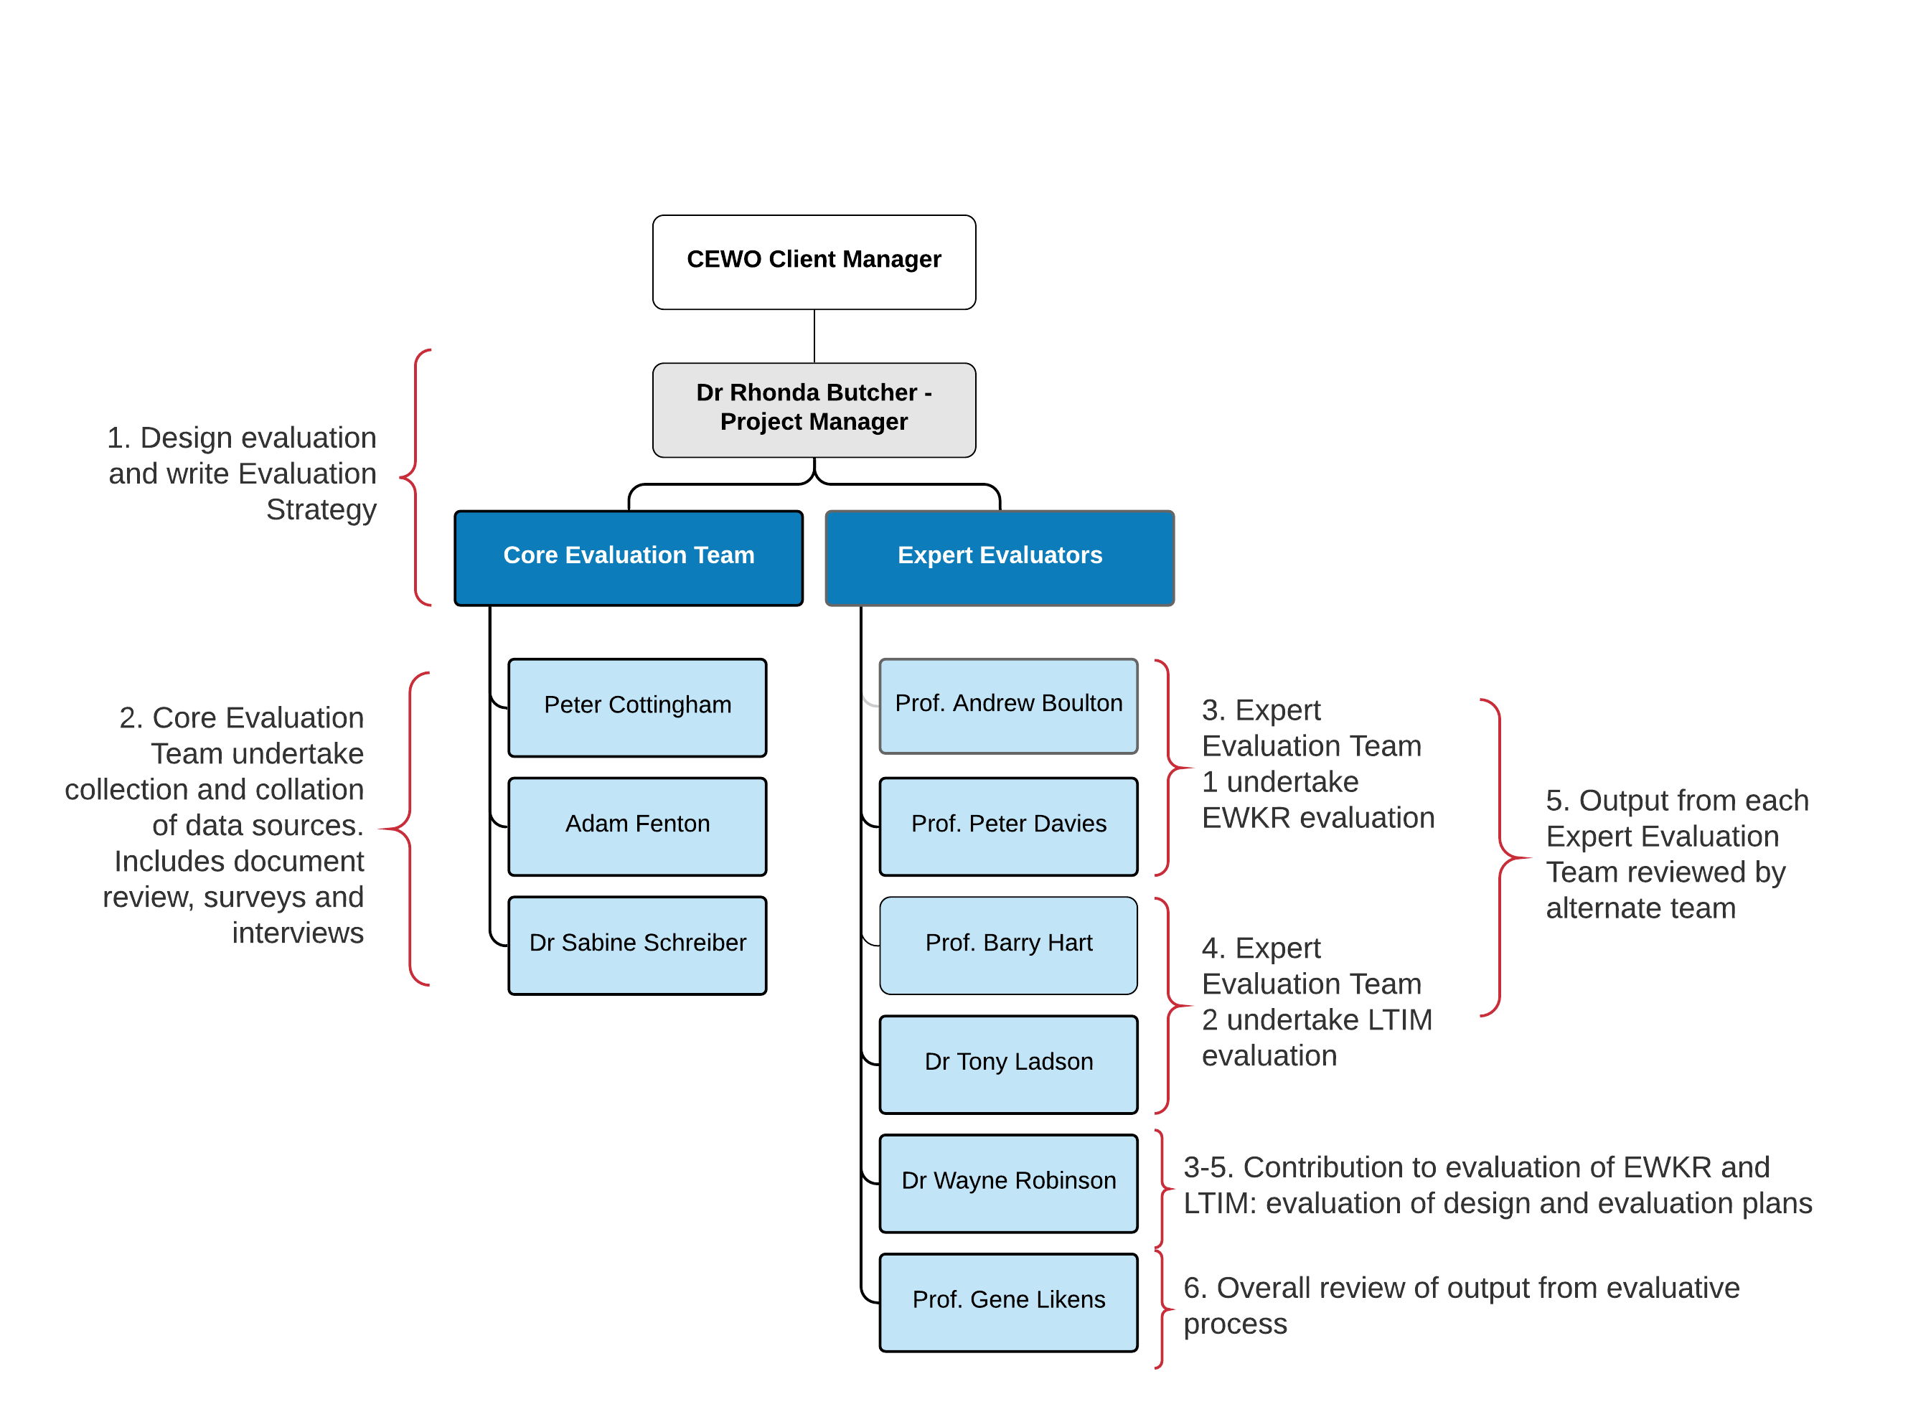

Figure . Roles, responsibilities and broad tasks of the consultant team in relation to the evaluative process.

**Schedule of tasks**

**Stage 1 (September 2019 – December 2020):**

* develop an Evaluation Strategy to be approved by the CEWO
* undertake independent outcome evaluation of the LTIM and EWKR projects.
* undertake consultation with LTIM/EWKR stakeholders to gain insights into processes and projects that have been undertaken
* report on findings from the evaluation and Stage 1 consultation to inform future considerations for the CEWO’s design of future monitoring, evaluation and research activities
* present findings to the CEWO and the Government Agency Contact Group.

**Stage 2 (December 2020-March 2021):**

* in conjunction with, and to support the CEWO, the core project team will participate in a Basin-wide consultation process with relevant organisations and agencies on the findings of the Stage 1 review
* findings from the consultation will help inform the CEWO’s design of future monitoring, evaluation and research activities
* a technical workshop will be held with the project team and additional researchers to contribute to program logic and scope for the CEWO’s design of future monitoring, evaluation and research activities

**Stage 3 (March 2021 – June 2021) – not funded in this contract:**

* findings from Stage 1 and Stage 2 consultation will be used by the CEWO to inform the design of future monitoring, evaluation, and research activities.

# Appendix B: Framing the evaluation – Project context

**Context**

The *Water Act 2007* *(Cwlth)* (Water Act) requires the Commonwealth Environmental Water Holder (CEWH) to perform its functions and exercise its powers consistently with and in a manner that gives effect to the *Basin Plan 2012* (Commonwealth of Australia 2012)(hereafter the Basin Plan). Specifically, the CEWH must ensure that Commonwealth environmental water is managed in accordance with the Basin Plan’s environmental watering plan (EWP; Commonwealth of Australia 2012) and the Basin-wide environmental watering strategy (BEWS; MDBA 2014). The CEWH is also expected to have regard to the Basin annual watering priorities as well. The Water Act (in part via the Basin Plan) places a number of obligations on the CEWH, including principles of monitoring, evaluation and reporting requirements.

In response to the requirements of the Water Act and the Basin Plan, the Commonwealth Environmental Water Office (CEWO) undertakes intervention monitoring, evaluation and research projects in order to understand, quantify and report on the environmental response to Commonwealth environmental water. Initially, the CEWO established the Long Term Intervention Monitoring (LTIM) and Murray-Darling Basin (MDB) Environmental Water Knowledge and Research (EWKR) projects and then integrated these two projects into the current Monitoring, Evaluation and Research (Flow-MER) program.

The LTIM project addresses the CEWO’s requirements under the Water Act and Murray-Darling Basin Plan. The LTIM project commenced monitoring in June 2014, after an initial two year scoping and development phase. The MDB EWKR project was established to improve the science available to support environmental water management and contribute to meeting Basin Plan objectives. The project commenced in 2014 and ended in 2019. The results from these two projects are used by the CEWO to demonstrate outcomes, inform management of Commonwealth water for the environment and meet legislative reporting requirements.

The LTIM project focuses on examining the contribution of Commonwealth environmental water to the environmental objectives of the Basin Plan, while assisting the CEWO to demonstrate environmental outcomes and adaptively manage water holdings. Under the LTIM project, the CEWO engaged consortium monitoring teams, led by research institutions, to develop and implement 5-year monitoring and evaluation plans (MEP) for seven selected areas within the Basin. The focus of each MEP was to determine whether Commonwealth environmental water was achieving the outcomes expected of it at the local and Basin scale. The seven selected areas included in the LTIM project covered areas where Commonwealth environmental watering occurred and each MEP was to complement, rather than duplicate, monitoring activities by other organisations/programs, such as asset scale monitoring by Basin states under Long Term Watering Plans. For example, although being a Matter of National Environmental Significance (Ramsar site), listed under the *Environment Protection and Biodiversity Conservation Act 1999,* the Coorong and Lower Lakes, was not included in the LTIM Project as it was deemed to be adequately monitored as part of other South Australian and Murray Darling basin programs (e.g. The Living Murray Initiative).

The EWKR project was established to improve the ability of Basin water management agencies to assess and understand changes in ecological health over the medium to long-term by:

* improving capacity to predict outcomes of environmental flow allocations over one to five years
* building capacity to set realistic objectives and targets for water management and other complementary activities as the climate changes
* improving monitoring, evaluation and reporting on progress toward the Basin Plan environmental objectives and targets
* building capacity to report progress on Basin Plan environmental objectives and targets.

Investigations undertaken as part of the EWKR project were organised around four themes: vegetation, fish, waterbirds and food webs. Also included were adoption and communication activities that contributed to synthesis of knowledge across disciplinary boundaries.

A key element of both the LTIM and EWKR projects was that they were supported by a five-year funding program: this was instrumental for addressing questions related to ecosystem responses to environmental watering, which would not have been possible with shorter-term funding. LTIM and EWKR have been extended to 2022 under the Flow-MER program.

The CEWO requires an independent, scientific, ‘program level’ review and evaluation of the LTIM and EWKR projects to better understand the effectiveness, efficiency and impact of the current projects and to inform the development of the CEWO’ s monitoring evaluation and research activities into the future following the conclusion of the Flow-MER program in 2022.

This Evaluation Strategy documents the type, purpose and approach to evaluating both the LTIM (2014-2019) and EWKR (2014-2019) projects.

**CEWO MERI Framework for use of environmental water**

The CEWO MERI Framework for the use of environmental water (CEWO 2013) is consistent with the Australian Government use of program logic in planning, as per the best practice Natural Resource Management MERI Framework guidelines (Commonwealth of Australia 2009). Both the LTIM and EWKR projects utilised the CEWO MERI Framework in their development phase.

This Evaluation Strategy aligns to the CEWO MERI framework, where appropriate, particularly in the selection and use of evaluation criteria. Evaluation undertaken as part of the CEWO MERI Framework is to be guided by the reporting requirements set out in Schedule 12 of the Basin Plan (Table 9). The focus of evaluation activity will be:

* demonstrating the outcomes from the use of Commonwealth environmental water, and contributions to the environmental objectives of the Basin Plan
* supporting adaptive management and improvement in the management of Commonwealth environmental water
* identifying information gaps to help build new knowledge.

Table . The alignment of planning and MERI activities with the timeframes set out under the program logic approach. Primary agencies responsible for these activities are also identified (MDBA – Murray-Darling Basin Authority) (modified from CEWO 2013). Areas highlighted in red will be components of the current evaluation.

| Timeframe | Relevant planning document guiding the use of CEW | Monitoring activities | Key issue to be addressed through evaluation and review | Key reporting activities | Key improvement activities |
| --- | --- | --- | --- | --- | --- |
| Long-term  (Greater than 10 years) | **Basin Plan’s environmental watering plan (‘the EWP’)**  **(MDBA)** | Program monitoring of the effectiveness of the EWP (MDBA) | Environmental outcomes and effectiveness of the EWP | Basin Plan Schedule 12 (Item 7) | Refinement of Basin Plan’s EWP |
| Intermediate  (1–5 years) | **Long-term portfolio management strategies** | Long-term **intervention** monitoring of selected areas where Commonwealth environmental water is delivered | Environmental outcomes of Commonwealth environmental watering | Basin Plan Schedule 12 (Item 7) | Refinement of long-term portfolio management strategies |
| Immediate  (Up to 1 year) | **Annual water use options**  **Watering decisions** | Targeted **intervention** monitoring of selected watering actions  **Operational** monitoringto ensure water is delivered as planned and without unintended consequences (delivery partners) | Environmental outcomes of Commonwealth environmental watering  Effectiveness of water delivery | Annual Report to Parliament  Annual Outcomes report  Published results from all monitoring  Basin Plan Schedule 12 (Items 6, 9, 10, 14) | Refinement of annual and future water use options |

**Long Term Intervention Monitoring Project**

The LTIM project aimed to monitor and evaluate Commonwealth environmental water over a period of 5 years following a two year scoping and development phase (Figure 8).

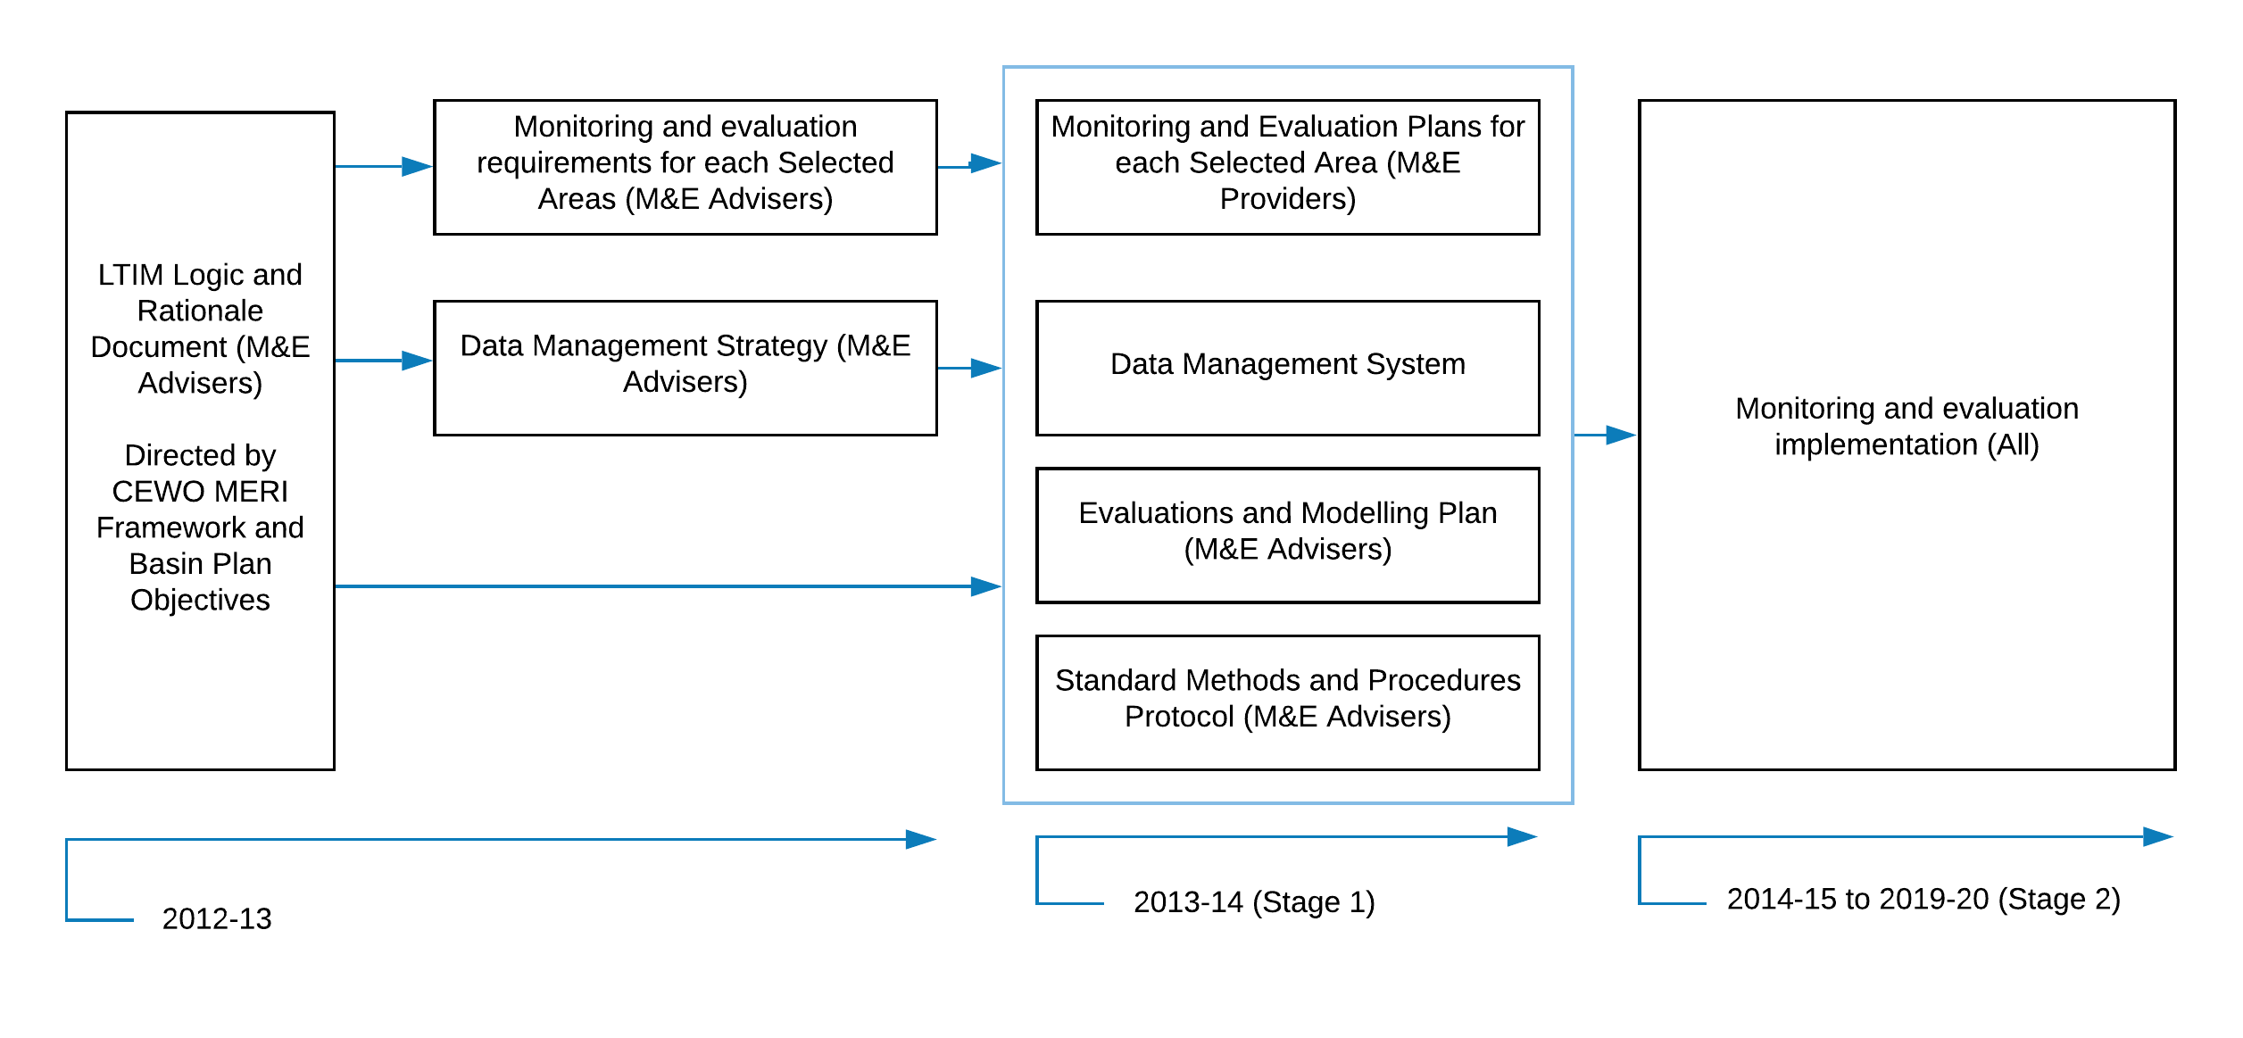

Figure . Timeframes and activities – Long Term Intervention Monitoring Project.

The three main structural components of the LTIM project are (Figure 9): the seven Selected Area teams, the Basin Matters team, and the CEWO Water Delivery teams.

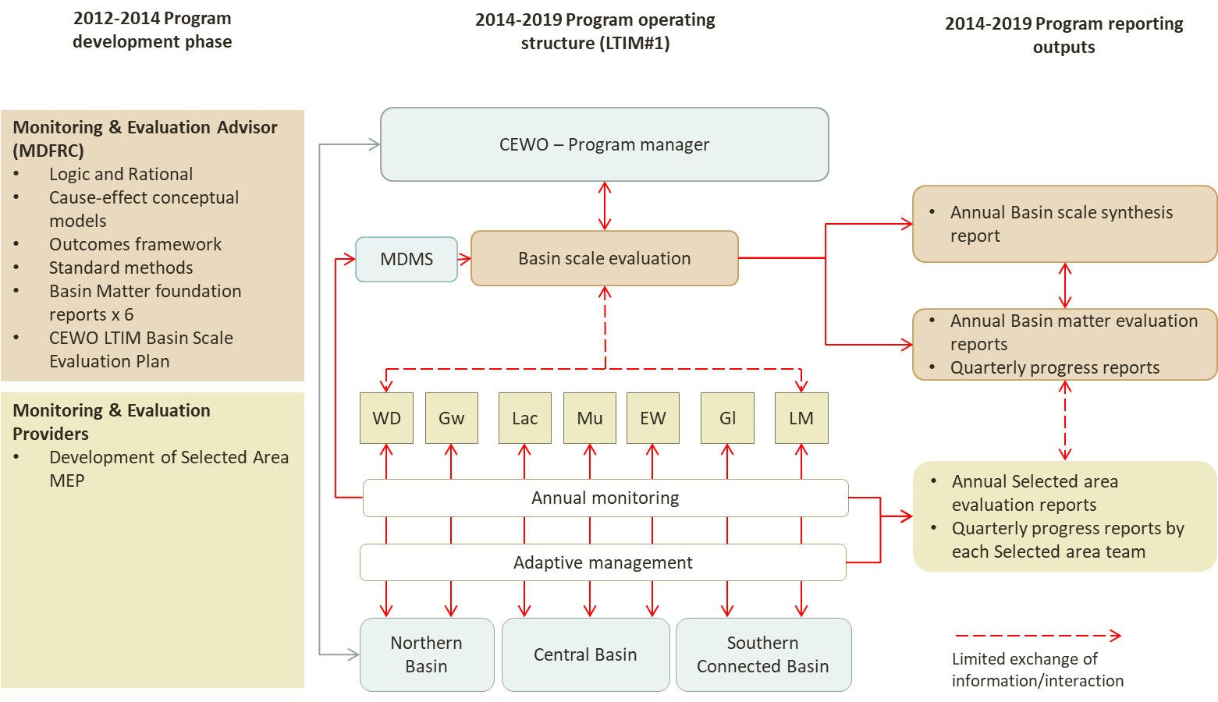

Figure . Schematic of LTIM Project development and output phases and operating structure (from Hart and Butcher 2018). WD= Warrego-Darling, Gw=Gwydir, Lac=Lachlan, Mu=Murrumbidgee, Gl=Goulburn and LM=Lower Murray.

**Objectives and Outcomes Framework**

The overarching objective of the Long Term Intervention and Monitoring Project is:

* to evaluate the contribution of Commonwealth environmental water to Basin Plan environmental objectives.

The LTIM objectives were aimed at two spatial scales:

* basin scale, from head contract and Gawne et al. (2013)
* selected Area objectives are based on those from head contract.

**Basin scale objectives - Head contract objectives**

**B.2 Evaluation of the contribution of Commonwealth environmental water to the environmental objectives of the Murray-Darling Basin Plan**

8.2.1 The Service Provider will:

(a) Undertake and report on the Pilot Basin Evaluation in 2014-15 to test the proposed Basin-scale evaluation process and methodology as described in Attachment A, Part B, Section 5;

(b) Undertake a Basin-scale evaluation of the contribution of Commonwealth environmental water to the environmental objectives of the Murray-Darling Basin Plan using the CEWO Outcomes Framework and following the process and methodology outlined in Attachment A, Part B, Section 2.4;

(c) Document and report annually on the cumulative evaluation of the contribution of Commonwealth environmental water at a Basin-scale as 'described in Attachment A, Part C, Section 6.3;

(d) Undertake an annual and cumulative Basin evaluation and reporting of Commonwealth environmental water on the following specific Basin Matters, as described in Attachment A, Part B, Section 3 and Part C, Section 2.2 of:

* hydrology
* ecosystem diversity
* water quality and stream metabolism
* fish populations
* vegetation diversity
* generic diversity (or aggregation of Selected Area biodiversity outcomes).

(e) Organise, convene and report on the Long Term Intervention Monitoring

Project Annual Forum to be held in July each year of the project as described in Attachment A, Part B, Section 6,1;

(f) Undertake the Technical Review of the Long Term Intervention Monitoring Project at the end of the final year of the project, as described in Attachment A, Part B, Section 6.2; and

(g) Consult with Monitoring and Evaluation Providers prior to the finalisation of the Basin Evaluation Plan and Basin Matter Foundation Reports.

(h) Undertake a Technical Review of Monitoring and Evaluation Providers draft Selected Area Evaluation Reports.

(i) Conduct and/or participate in collaboration activities between Monitoring and Evaluation Providers and other relevant parties.

(j) Undertake the tasks associated with data management as specified in Attachment C, in order to evaluate and report on outcomes as per B.2.1.

**Objectives from LTIM foundation document (Gawne et al. 2013)**

The LTIM Project will give effect to the monitoring and evaluation elements of the Commonwealth Monitoring, Evaluation, Reporting and Improvement (MERI) Framework (Commonwealth of Australia 2009). The five high level objectives of the LTIM Project (in order of priority) are:

1. evaluate the contribution of Commonwealth environmental watering to the objectives of the Murray–Darling Basin Authority’s (MDBA) Environmental Watering Plan
2. evaluate the ecological outcomes of Commonwealth environmental watering at each of the seven Selected Areas
3. infer ecological outcomes of Commonwealth environmental watering in areas of the Murray–Darling Basin (MDB) not monitored
4. support the adaptive management of Commonwealth environmental water
5. monitor the ecological response to Commonwealth environmental watering at each of the seven Selected Areas.

**Outcomes Framework**

The Outcomes Framework developed by MDFRC represents a hierarchy of expected outcomes based around the environmental watering objectives stated in the Murray-Darling Basin Plan (Commonwealth of Australia 2012). Six ecological indicators or ‘matters’ were used for Basin evaluation (Gawne et al. 2014):

* **ecosystem diversity** – the aquatic ecosystem types (e.g. wetlands, rivers, streams) that benefited from Commonwealth environmental water
* **hydrology** – river flow and wetland water regimes modelled with and without Commonwealth environmental water
* **stream metabolism and water quality** – rates of instream primary productivity and decomposition, salinity and pH
* **vegetation diversity** – plant species’ responses with respect to extent, diversity and condition
* **fish** – short- and long-term responses of fish with respect to movement, condition, abundance and diversity
* **biodiversity** – effects on diversity of all biota from monitoring and observations.

Expected environmental outcomes were set for:

* within a one year timeframe (1 year expected outcomes)
* within a one year to five-year timeframe (5 year expected outcomes).

Table . Objectives relevant to Commonwealth environmental water management (CEWO 2013).

|  |  |  |
| --- | --- | --- |
| Basin Plan Reference | Basin Plan Objective | Basin Plan short label |
| Environmental watering plan | “to protect and restore water-dependent ecosystems of the Murray-Darling Basin” (Basin Plan, Chapter 8, Part 2, 8.04(a)) | Biodiversity |
| “to protect and restore the ecosystem functions of water-dependent ecosystems” (Basin Plan, Chapter 8, Part 2, 8.04(b)) | Ecosystem function |
| “to ensure that water-dependent ecosystems are resilient to climate change and other risks and threats” (Basin Plan, Chapter 8, Part 2, 8.04(c)) | Resilience |
| Water quality and salinity management plan | “to ensure water quality is sufficient to achieve the above objectives for water-dependent ecosystems, and, for Ramsar wetlands, sufficient to maintain ecological character” (Basin Plan, Chapter 9, Part 3, 9.04 (1) & (2)) | Water quality |

The seven Selected Area service providers were contracted to collect data in their areas for the purpose of informing the Basin-scale evaluations by the Basin Matters team, and to determine ecological outcomes of Commonwealth environmental watering in the Selected Areas.

Expected Outcomes from environmental watering at the Basin-scale are presented in Table 11 (shaded). Expected Outcomes to be monitored as part of LTIM for Basin and/or Selected Area evaluation and indicated with an * and Expected Outcomes which may be monitored (i.e. are optional) are indicated with ^ (Gawne et al. 2014, Commonwealth of Australia 2017).

Table . Summary of expected outcomes at the Basin-scale.

| Basin Plan objectives (MDBA 2012 – see Appendix E this document) | Basin Outcomes (Commonwealth of Australia 2013) | | Basin-wide Environmental Watering Strategy – Expected Outcomes (Commonwealth of Australia 2017) | Five-year Expected Outcomes (Gawne et al. 2014) | One-year Expected Outcomes (Gawne et al. 2014) |
| --- | --- | --- | --- | --- | --- |
| Biodiversity  (Basin Plan S. 8.05) | **Ecosystem diversity** |  |  | • **Species diversity** |  |
| **Species diversity** | **Vegetation** | * Maintenance of the current extent of river red gum, black box, coolibah forest and woodlands; existing large communities of lignum; and non- woody communities near or in wetlands, streams and on low- lying floodplains * Maintain the current condition of lowland floodplain forests and woodlands of river red gum, black box and coolibah * Improved condition of southern river red gum | • **Vegetation diversity\*** | • Reproduction |
| • **Condition\*** |
| **• Growth and survival\*** | • Germination • Dispersal**\*** |
| Macro-invertebrates |  | • Macro-invertebrate diversity |  |
| **Fish** | * Improved distribution of key short and long-lived fish species across the Basin * Improved breeding success for short-lived species, long-lived species and mulloway * Improved populations of short- lived species, long-lived species, Murray cod and golden perch. | **• Fish diversity\*** | **• Condition\*** |
| **• Larval and juvenile recruitment\*** | **• Larval abundance\***  **• Reproduction\*** |
| Waterbirds | * Maintained current species diversity of all current Basin waterbirds and current migratory shorebirds at the Coorong * Increased abundance with a 20– 25 per cent increase in waterbirds by 2024 * Improved breeding events for colonial nesting waterbird species and an increase in nests and broods for other waterbirds | • Waterbird diversity |  |
| • Waterbird diversity and population condition (abundance and population structure) | • Survival and condition**^**  • Chicks**^**  • Fledglings**^** |
| **Other vertebrate diversity** |  | **• Adult abundance\*** | **• Young\*** |
| Ecosystem Function  (Basin Plan S. 8.06) | **Connectivity** |  | * Maintained base flows - at least 60 per cent of natural levels * Improved overall flow * Maintained connectivity in areas where it is relatively unaffected * Improved connectivity with bank-full and/or low floodplain flows * Maintain the Lower Lakes above sea level |  | **• Hydrological connectivity including end of system flows\*** |
| * Improved movement with more native fish using fish passages |  | **• Biotic dispersal and movement\*** |
|  |  | • Sediment transport**\*** |
| **Process** |  |  |  | **• Primary productivity (of aquatic ecosystems)\*** |
|  |  | **• Decomposition\*** |
|  |  | • Nutrient and carbon cycling**\*** |
| Resilience  (Basin Plan S. 8.07) | **Ecosystem resilience** |  |  | • Population condition (individual refuges)**^** | • Individual survival and condition (individual refuges)**^** |
|  | • Population condition (landscape refuges)**^** |  |
|  |  | • Individual condition (ecosystem resistance) |
|  | • Population condition (ecosystem recovery) |  |
| Water quality  (Basin Plan S. 9.04) | **Chemical** |  |  |  | **• Salinity\*** |
| **• Dissolved oxygen\*** |
| **• pH\*** |
| • Dissolved organic carbon**^** |
| Biological |  |  |  | • Algal blooms |

**Environmental Water Knowledge and Research Project**

Ten million dollars was allocated from 2013-14 to 2018-19 for applied research on environmental water use to ensure the best scientific information is available to support the use of growing environmental water holdings to meet Basin Plan environmental objectives. The EWKR project was established to improve the ability of water agencies to assess and understand changes in ecological health over the medium to long-term by:

* improving capacity to predict outcomes of environmental flow allocations over one to five years
* building capacity to set realistic objectives and targets for water management and other complementary activities as the climate changes
* improving monitoring, evaluation and reporting on progress toward the Basin Plan environmental objectives and targets
* building capacity to report progress on Basin Plan environmental objectives and targets.

The main research focus of EWKR was to address the role of environmental water in medium to long-term changes in the condition of environmental assets in the Basin. A range of contextual factors also influence medium to long-term changes in condition and how well assets respond to environmental watering. In recognition of this the Basin Plan acknowledges that its environmental objectives will be met in part by environmental water, but also via the intervention of other management actions (EWKR Grant Guidelines 2013, unpublished).

Investigations undertaken as part of the EWKR project were organised around four themes: vegetation, fish, waterbirds and food webs. Also included were adoption and communication activities that contributed to synthesis of knowledge across disciplinary boundaries. The MDB EWKR project was collaboration between environmental water managers, scientists and practitioners working in the Murray-Darling Basin.

**Objectives**

The overarching objective of the Environmental Water Knowledge and Research project was to improve understanding of incremental changes in ecological condition in response to multiple management interventions. Specific objectives were to determine:

* how environmental flow management influences ecosystem function and thereby sustains biodiversity
* how the major drivers of system condition (e.g. flow, land use, invasive species etc.) interact to affect biodiversity, ecosystem function, resilience and water quality
* how threats (hydrological, aquatic and terrestrial) may reduce or prevent the ecological improvement expected through the application of environmental water
* how management or delivery of environmental flow influences environmental outcomes achieved over time
* what are the links between ecosystem responses to watering regimes (e.g. natural and/or managed events) and incremental changes in ecological condition?
* how complementary water management and natural resource management enhance the outcomes of environmental water management
* what are the links between ecosystem responses to management interventions (water management and natural resource management) and incremental changes in ecological condition?

**Project description**

(a) The Project will improve the best science available to support the evolving needs of environmental water managers within the framework of adaptive water management in the Murray-Darling Basin. The research will support the Basin Plan 2012 (the Basin Plan) environmental and adaptive management objectives and reporting needs. The major body of the research will focus on:

(i) Improved identification, assessment and understanding of the links between ecological responses to watering regimes (e.g. natural and/or managed events) and incremental changes in ecological condition;

(ii) medium- and long-term changes in ecological condition, including the effects of threats (hydrological, aquatic and terrestrial) which may reduce or prevent the ecological improvement expected; and

(iii) The Queensland floodplain vegetation watering requirements.

(b) The research will support the collaborative role of the Commonwealth in environmental watering in the Basin, in particular:

(i) The Murray-Darling Basin Authority's (MDBA) role in implementing the Basin Plan;

(ii) The Commonwealth Environmental Water Office's (CEWO) role in managing Commonwealth environmental water; and

(iii) The Basin States' role in managing environmental water and aquatic assets.

(c) The research will also promote collaboration among research institutions which will be important in generating new knowledge about the complex responses of aquatic ecosystems to changes in flows across a range of spatial and temporal scales.

**The Project Objectives are to improve understanding of:**

(a) How environmental flow management influences ecosystem function and thereby sustains biodiversity.

(b) How the major drivers of system condition (e.g. flow, land use, invasive species etc.) interact to affect biodiversity, ecosystem function, resilience and water quality.

(c) How threats (hydrological, aquatic and terrestrial) may reduce or prevent the ecological improvement expected through the application of environmental water.

(d) How management or delivery of environmental flow influences environmental outcomes achieved over time.

* What are the links between ecosystem responses to watering regimes (e.g. natural and/or managed events) and incremental changes in ecological condition?

(f) How complementary water management and natural resource management enhance the outcomes of environmental water management.

* What are the links between ecosystem responses to management interventions (water management and natural resource management) and incremental changes in ecological condition?

The research outcomes are expected to make a significant contribution to the ability to assess and understand incremental changes in ecological condition in the medium- to long-term within the context of multiple management interventions, stressors and pressures and will support the following Project Outcomes:

(a) Improved capacity to predict outcomes of environmental flow allocations and their management over 1-5 years.

(b) Developing predictive tools and conceptual models to inform environmental watering regimes.

(c) Improved water management and complementary natural resource management.

(d) Building capacity to set realistic objectives and targets for water management and complimentary natural resource management as the climate changes.

(e) Improved environmental water effectiveness through the application of science to the development and operation of environmental works and measures.

(f) Improved monitoring, evaluation and reporting on progress toward the Basin Plan environmental objectives and targets.

(g) Building capacity to report against Basin Plan environmental objectives and targets.

**Project requirements**

The essential requirements of the Project are to:

(a) Conduct the research at up to four aquatic asset sites/river reaches in key geographical locations in the northern and southern Murray-Darling Basin;

(b) Use the objectives of the Basin Plan 2012 to establish the underlying framework for this body of work. This will ensure that results are ultimately framed in a manner that can be readily implemented in the adaptive management of environmental water. For example, the environmental objectives of the Basin Plan 2012 articulate what the Commonwealth is seeking to achieve through the management of environmental water. They also establish the common objectives for the Murray Darling Basin Authority, the Commonwealth Environmental Water Holder and the Basin states in managing environmental water;

(c) Use the classification of the Basin Plan 2012 objectives that the MDFRC has already completed to support the management of Commonwealth environmental water (Gawne et a12013, Long-Term Intervention Monitoring Logic and Rationale) as the basis on which the Basin Plan 2012 objectives are used and expanded upon in this project to:

i) provide alignment with other Commonwealth projects noted below;

(ii) ensure that the tools and results produced through this Project can be readily applied in the adaptive management of environmental water under the Basin Plan 2012;

(d) conceptually align, complement, and build on the following Commonwealth projects undertaken by the MDFRC in the Basin:

(i) the Long Term Intervention Monitoring of Commonwealth Environmental Water and

(ii) the development of the Integrated Ecological Condition Assessment (IECA) Framework;

(e) align, complement, and build on other Commonwealth projects in the Basin including:

(i) any monitoring undertaken by the MDBA to support reporting under the Basin Plan;

(f) explore the development and utility of an Integrated Assessment Framework within which all monitoring data (e.g. intervention/ecological response, condition, compliance/operational, and monitoring for research) can be linked, to inform research outputs and outcomes. The Integrated Assessment Framework must be designed and implemented in a way that does not interfere with the Commonwealth Environmental Water Holder's needs, timelines or activities;

(g) focus on synthesis and analysis of existing knowledge where relevant, as well as new knowledge.

This will include:

(i) building on existing knowledge, data, and information where possible, and linking with existing monitoring regimes, to minimise duplication and to maximise investment outcomes;

(ii) encouraging all research partners and Basin States to share existing knowledge, data, and information to facilitate constructive progression of priority research within the current constrained budgetary environment;

(h) encourage improved, innovative, and new approaches to research as appropriate;

(i) apply consistent research methods within the project to enable comparison of results within and between research sites, both spatially and temporally, as appropriate, and to ensure tools developed provide consistency and compatibility;

(j) engage with appropriate local community groups, individuals and industry groups on the implementation of particular research projects once locations have been agreed, and brokering knowledge generated from the research as appropriate; and

(k) ensure all non-financial reports have a technical well-founded scientific basis and are written in a way that is useful and meaningful for managers, to enable the research to inform adaptive management and policy as appropriate. The scoping report, implementation plan, research plans, final reports and synthesis report are to be independently peer reviewed.

# Appendix C: Overall and Specific Basin Plan Objectives

|  |  |  |
| --- | --- | --- |
| Overall Basin Plan objectives | Objective specifics | LTIM reference |
| to protect and restore water-dependent ecosystems of the Murray-Darling Basin (Basin Plan, Chapter 8, Part 2, 8.04(a)) | Chpt 8, Part 2, 8.05   1. This section sets out particular objectives relating to the protection and restoration of the water-dependent ecosystems of the Murray-Darling Basin. 2. **An objective is to protect and restore a subset of all water-dependent ecosystems** of the Murray-Darling Basin, including by ensuring that: 3. declared Ramsar wetlands that depend on Basin water resources maintain their ecological character; and   Note: See paragraph 21(3)(c) of the Act.   1. water-dependent ecosystems that depend on Basin water resources and support the life cycles of species listed under the Bonn Convention, CAMBA, JAMBA or ROKAMBA continue to support those species; and 2. water-dependent ecosystems are able to support episodically high ecological productivity and its ecological dispersal. 3. An objective is to protect and restore biodiversity that is dependent on Basin water resources by ensuring that: 4. water-dependent ecosystems that support the life cycles of a listed threatened species or listed threatened ecological community, or species treated as threatened or endangered (however described) in State law, are protected and, if necessary, restored so that they continue to support those life cycles; and 5. **representative populations and communities of native biota are protected and, if necessary, restored**. | Biodiversity |
| to protect and restore the ecosystem functions of water-dependent ecosystems (Basin Plan, Chapter 8, Part 2, 8.04(b)) | Chpt 8, Part 2, 8.06   1. This section sets out particular objectives relating to the protection and restoration of the ecosystem functions of water-dependent ecosystems. 2. An objective is that the water quality of Basin water resources does not adversely affect water-dependent ecosystems and is consistent with the water quality and salinity management plan 3. An objective is to protect and restore connectivity within and between water-dependent ecosystems, including by ensuring that: 4. the diversity and dynamics of geomorphic structures, habitats, species and genes are protected and restored; and 5. ecological processes dependent on hydrologic connectivity:   (i) longitudinally along watercourses; and  laterally between watercourses and their floodplains (and associated wetlands); and  (iii) vertically between the surface and subsurface;  are protected and restored; and   1. the Murray Mouth remains open at frequencies, for durations, and with passing flows, sufficient to enable the conveyance of salt, nutrients and sediment from the Murray-Darling Basin to the ocean; and 2. the Murray Mouth remains open at frequencies, and for durations, sufficient to ensure that the tidal exchanges maintain the Coorong’s water quality (in particular salinity levels) within the tolerance of the Coorong ecosystem’s resilience; and   Note: This is to ensure that water quality is maintained at a level that does not compromise the ecosystem and that hydrologic connectivity is restored and maintained.   1. the levels of the Lower Lakes are managed to ensure sufficient discharge to the Coorong and Murray Mouth and help prevent river bank collapse and acidification of wetlands below Lock 1, and to avoid acidification and allow connection between Lakes Alexandrina and Albert, by:   (i) maintaining levels above 0.4 metres Australian Height Datum for 95% of the time, as far as practicable; and  (ii) maintaining levels above 0.0 metres Australian Height Datum all of the time; and   1. barriers to the passage of biological resources (including biota, carbon, and nutrients) through the Murray-Darling Basin are overcome or mitigated. 2. An objective is that natural in-stream and floodplain processes that shape landforms (for example, the formation and maintenance of soils) are protected and restored. 3. An objective is to support habitat diversity for biota at a range of scales (including, for example, the Murray-Darling Basin, riverine landscape, river reach and asset class). 4. An objective is to protect and restore ecosystem functions of water-dependent ecosystems that maintain populations (for example recruitment, regeneration, dispersal, immigration and emigration) including by ensuring that: 5. flow sequences, and inundation and recession events, meet ecological requirements (for example, cues for migration, germination and breeding); and 6. habitat diversity, extent, condition, and connectivity that supports the life cycles of biota of water-dependent ecosystems (for example, habitats that protect juveniles from predation) is maintained. 7. An objective is to protect and restore ecological community structure, species interactions and food webs that sustain water-dependent ecosystems, including by protecting and restoring energy, carbon and nutrient dynamics, primary production and respiration. | Ecosystem function |
| to ensure that water-dependent ecosystems are resilient to climate change and other risks and threats (Basin Plan, Chapter 8, Part 2, 8.04(c)) | Chpt 8, Part 2, 8.07   1. This section sets out particular objectives relating to ensuring that water-dependent ecosystems are resilient to climate change and other risks and threats. 2. An objective is that water-dependent ecosystems are resilient to climate change, climate variability and disturbances (for example, drought and fire). 3. An objective is to protect refugia in order to support the long-term survival and resilience of water-dependent populations of native flora and fauna, including during drought to allow for subsequent re-colonisation beyond the refugia. 4. An objective is to provide wetting and drying cycles and inundation intervals that do not exceed the tolerance of ecosystem resilience or the threshold of irreversible change. 5. An objective is to mitigate human-induced threats (for example, the impact of alien species, water management activities and degraded water quality). 6. An objective is to minimise habitat fragmentation. | Resilience |
| to ensure water quality is sufficient to achieve the above objectives for water-dependent ecosystems, and for Ramsar wetlands, sufficient to maintain ecological character (Basin Plan, Chapter 9, Part 3, 9.04 (1) & (2)) | Chpt 9, Part 3, 9.04   1. The water quality objective for declared Ramsar wetlands is that the quality of water is sufficient to maintain the ecological character of those wetlands.   Note: See paragraph 21(3)(c) of the Act.   1. The water quality objective for water-dependent ecosystems other than declared Ramsar wetlands is that the quality of water is sufficient: 2. to protect and restore the ecosystems; and 3. to protect and restore the ecosystem functions of the ecosystems; and 4. to ensure that the ecosystems are resilient to climate change and other risks and threats.   Note: See the overall environmental objectives of the environmental watering plan in section 8.04. | Water quality |

# Appendix D: Evaluation criteria and assocated questions from RFQ

A number of evaluation criteria were listed in the RFQ which the CEWO derived from the MERI framework (Table 12). These formed the basis of the final set of evaluation criteria and the focal areas for the project agreed to in consultation with CEWO at a workshop in November 2019.

Table . Suggested evaluation criteria and questions as per RFQ.

| MERI Key evaluation criteria | Questions |
| --- | --- |
| Effectiveness | * **in achieving the LTIM objectives:**   + to evaluate the contribution of Commonwealth environmental water to Basin Plan environmental objectives * **in achieving the EWKR objectives:**   + to improve understanding of incremental changes in ecological condition in response to multiple management interventions * **in communicating the key findings of the scientific review to all stakeholders** such as government, scientists, natural resource managers and communities impacted by environmental water. * **of the foundational design** to determine what features are fit for purpose and determine what other strategies might be more effective in delivering the required outcomes |
| Appropriateness | * in satisfying Basin Plan reporting requirements * of scientific methodologies * in aligning with current best practice scientific processes * in employing people with the right combination of skills and experience. |
| Impact | * on Basin Plan management objectives and outcomes * on CEWO’s research on water dependent ecosystems * on CEWO’s adaptive management of environmental water holdings * on raising awareness of CEWO’s aims and approach across the environmental water sector and relevant communities in the Basin * on supporting collaborative relationships amongst providers. |
| Efficiency | * in extracting the most value out of the total funding provided and if it could be used more productively and efficiently. |
| Legacy | * over time and how will they inform the key aspects of the design of the next phase of the CEWO’s monitoring, evaluation, and research activities from July 2022. |

1. Judgement aggregation deals with how a group of individuals make consistent collective judgments on a set of propositions on the basis of the group members’ individual judgments on them: in this case how the expert evaluators compare their findings and then agree on a consistent evaluative judgement.
2. The approach to Stage 2 consultation will be confirmed in consultation with the CEWO in June-July, and will comply with government advice in relation to COVID-19 restrictions.
3. The rubrics were further refined post the EWKR evaluation after advice from the evaluators that achieving the higher standard was difficult. The changes were not considered substantive and were adopted for the LTIM evaluation.
4. EWKR was not designed to specifically achieve environmental outcomes per se. Outcomes from EWKR could support the achievement of environmental outcomes by improving the knowledge based to inform decision making. LTIM was designed to assess environmental outcomes from environmental watering.
5. A full economic evaluation was not within scope.
6. All documents reviewed will be included in a bibliography in the final reports.
7. Impact evaluation is sometimes confused with outcome evaluation – however impact evaluation focuses on long term changes and tends to be broader in scope.
8. This project is contracted via the Environmental Research and Analysis Panel Deed of Offer with Water’s Edge Consulting