|  |
| --- |
| CSIRO Land and Water Flagship |
| Status and Trends of Australia’s EPBC-Listed Flying-Foxes  A report to the Commonwealth Department of the Environment  David A. Westcott, Daniel K. Heersink, Adam McKeown, Peter Caley  1st April 2015 |

|  |
| --- |
|  |

Citation

Westcott, DA, Heersink, DK, McKeown, A, Caley P (2015) The status and trends of Australia’s EPBC-Listed flying-foxes. CSIRO, Australia.

Copyright and disclaimer

© 2015 CSIRO To the extent permitted by law, all rights are reserved and no part of this publication covered by copyright may be reproduced or copied in any form or by any means except with the written permission of CSIRO.

Important disclaimer

CSIRO advises that the information contained in this publication comprises general statements based on scientific research. The reader is advised and needs to be aware that such information may be incomplete or unable to be used in any specific situation. No reliance or actions must therefore be made on that information without seeking prior expert professional, scientific and technical advice. To the extent permitted by law, CSIRO (including its employees and consultants) excludes all liability to any person for any consequences, including but not limited to all losses, damages, costs, expenses and any other compensation, arising directly or indirectly from using this publication (in part or in whole) and any information or material contained in it.

Contents

Acknowledgments iv

Executive summary v

1 Introduction 2

*2* Spectacled Flying-Fox, *Pteropus conspicillatus* 3

2.1 Monitoring History 4

2.2 Biases in SFF Monitoring 4

2.3 Methods 5

2.4 Results 7

2.5 Discussion 12

2.6 Conclusions 15

3 Grey-Headed Flying-Fox, Pteropus poliocephalus 17

3.1 Monitoring history 17

3.2 Sources of error in the methods 18

3.3 Methods 20

3.4 Results 22

3.5 Discussion 32

3.6 Conservation Status 35

3.7 Conclusions 35

References 36

Figures

Figure 1 Population dynamics of the Wet Tropics spectacled flying-fox population over the period May 2004 to October 2014. Data shown are a line connecting monthly counts (to make the figure interpretable), the regression line of the count against time and the 95% CI interval of the regression. The inverted triangles indicate the timing of Cyclone Larry in 2006 and Cyclone Yasi in 2011, filled circles indicate the population recorded during the November count of each year (i.e. the adult population). The x labels mark the beginning of the indicated year 8

Figure 2 (A) Inferred median trajectory in November counts arising from a state-space model including both observation error and process noise. Solid line is the median and dashed lines 95% credibility intervals. The extremely low count following Cyclone Larry (open circle) is omitted from the analysis as an outlier. (B) Posterior distribution for the exponential rate of increase (*r*) with red line showing demarcation between decline and growth. The posterior probability of negative population growth rate (left of vertical line) is 0.928. 9

Figure 3 Results of the Diffusion-Drift-Jump modelling across the monitoring periods. The top panel shows the diffusion results across the survey period while the lower panel shows the total variance of dx, a combination of the relative contributions of diffusion (short term) and drift (large scale) perturbations. 10

Figure 4 95% posterior predictive intervals for total spectacled flying-fox population (blue) and spectacled flying-fox population found in camps (red) utilising counts through January 2015. The lines indicate the medians. The black points are observed counts of spectacled flying-foxes in camps. The regions with line fill represent predictions for the next 24 months based on 50,000 samples. The x labels mark the beginning of the indicated year. 11

Figure 5 95% posterior predictive intervals for total spectacled flying-fox population (blue) and spectacled flying-fox population found in camps (red) utilising counts through May 2013. The solid lines indicate the medians. The black points are observed counts of spectacled flying-foxes in camps. The regions with line fill represent predictions for the next 24 months based on 50,000 samples. The green points indicate counts from June 2013 – January 2015. The x labels mark the beginning of the indicated year 12

Figure 6 Population estimates from the NFFMP based on the adjustment of raw data using the proportion of animals roosting away from known camps during each monitoring period. Filled circles represent the unadjusted population estimate, bold horizontal bars represent the adjusted estimate and the whiskers indicate the uncertainty represented by the measured precision. 23

Figure 7 Median camp sizes recorded in each of the NFFMP survey periods. Bold line represents the median, the box the quartile range, whiskers 1.5 *quartile range and circles outliers 23

Figure 8 Comparison of the corrected counts from the pre-NFFMP and NFFMP phases of the monitoring. Filled circles indicate raw counts, inverted triangles represent raw counts corrected for accuracy (pre-NFFMP only), bold horizontal lines represent estimated population after correction for accuracy (pre-NFFMP) and roosting away from camps based on telemetry (pre-NFFMP & NFFMP). The whiskers indicate the % range of the precision, being 34% of the raw count in each case 25

Figure 9 Frequency plot of the number of camps surveyed (dark bars) and the number of camps occupied (light bars) in comparable surveys across all years of monitoring. No data was available on the number of camps occupied in 1998 26

Figure 10 Changes in camp size. Top panel, median camp size recorded in April – May surveys across the two phases of the monitoring and for the years for which individual camp data was available. Dark lines represent the median, boxes the quartile range, whiskers 1.5 the quartile range, and circles outliers. Middle panel, frequency distribution of camp sizes across the three years of the pre-NFFMP for which individual camp data was available. Bottom panel, frequency distribution of camps across the two May surveys of the NFFMP monitoring 26

Figure 11 LISA correlation for each camp for a neighbourhood size of 50km. Size of the circle indicates magnitude of correlation. Red circles have a negative correlation, blue are positive 27

Figure 12 Mean correlation of LISA statistics calculated for all camps for varying neighbourhood size. Black indicates GHFF camps, red indicates SFF camps. Lines indicate 95% confidence intervals. 28

Figure 13 Estimated population distribution of GHFF at each survey period based on the kriging approach to spatial smoothing. The circles represent the relative size of the counts at each camp during the surveying period. The colour scheme is presented on a natural logarithm scale to greater highlight highs and lows in abundance. 29

Figure 14 Estimated in population of spectacled flying-foxes. Black lines indicate in camp population confidence intervals from kriging approach. Red and blue lines indicate credibility intervals for in camp and total population estimates from state-space modelling approach. Populations are presented as 1000s of animals. 31

Figure 15 Plot of total estimated GHFF population for all counting periods; red are pre-NFFMP counts (1998–2004), black are NFFMP counts (quarterly from November 2012–November 2014). Squares represent raw counts and circles the estimated true population. The correction and confidence bounds on the pre-NFFMP counts are based on a 34% estimate of precision for fly-out counts. The correction and confidence bounds on NFFMP counts are based on standard error approximation of kriging. 31

Tables

Table 1 Precision estimates for the different methods. Estimates are based on double counts of single camps as i) reported in the NFFMP or ii) in error estimation trials 24

Table 2 Moran’s I correlation coefficients for camp size changes at the scale of the species’ range 27

Table 3 Minimum, maximum, mean, median, and standard deviation of estimated camp population and total estimated population for each of the nine survey periods. Camp population estimates are derived from the kriging approach detailed in Section 3.4.4. 30

Table 4 Table 4 Minimum, maximum, mean, median, and standard deviation and total population of survey counts for all camps for each of the nine survey periods. 30

Acknowledgments

This reports presents the results of work funded from a variety of sources over the last 12 years. These include the Australian Government’s Commonwealth Environmental Research Facilities Program, the National Environmental Research Program, the Rural Industries Research and Development Corporation and the Rainforest Cooperative Research Centre. Additional funding came from CSIRO’s OCE PostDoctoral Scheme and the Sensor and Sensor Networks Program. The State Governments of New South Wales, Queensland, Victoria, South Australia and the Australian Capital Territory contributed crucial in-kind resources to the conduct of the monitoring through the coordination of counter networks and providing staff resources for monitoring. It was their support from the outset that made the work possible.

The monitoring reported on here was possible in large part because of the efforts and knowledge of the community of people who are interested in flying-foxes. These people include researchers, bat carers, conservation managers and those with a deep interest in and knowledge of the natural history of flying-foxes. Their knowledge of camps and of camp history provided a strong starting point for this work and allowed us to achieve far more than would otherwise have been possible. Many of these people, along with a host of other volunteers, contributed valuable time and energy to the monitoring.

Executive summary

This report reviews past and current monitoring of Australia’s two threatened flying-fox species, the spectacled flying-fox (*Pteropus conspicillatus*) and the grey-headed flying-fox (*P. poliocephalus*). On the basis of this review we then consider their current conservation status

Both the spectacled and grey-headed flying-foxes were listed as Vulnerable under the EPBC Act on the basis of Criterion 1 of the Act (decline in numbers). The spectacled flying-fox also met Criterion 5 (probability of extinction in the wild is at least 10% in the medium-term). Listing against these criteria means that in any re-assessment of the status of these species a key consideration must be the issue of their current and predicted population trends.

In this report we draw together data on the species population dynamics from past and current monitoring programs. We consider the results of the programs and describe the errors associated with them. In light of this we then provide an assessment of the species current status and trend.

The spectacled flying-fox has shown a decline from a population of 214,750 in November of 2005 to 92,880 in November of 2014. This decline appears to be associated with three periods of perturbation: two large perturbations, Cyclones Larry (2006) and Yasi (2011), and then a series of smaller perturbations occurring in the cooler months of each year starting in 2011 and occurring each year thereafter. The cause of the smaller perturbations is unknown.

Overall we suggest that the decline exhibited by the spectacled flying-fox (as much as 62%) over a 10 year period, when extrapolated out to three generations, is sufficient warrant its listing as Endangered under the EPBC against Criteria 1 and 5.

The grey-headed flying-fox has been monitored in a number of programs, most recently the National Flying-Fox Monitoring Program. The NFFMP surveys the species across its range every quarter and has done so since November 2012. Based on these surveys we estimate the current population to be 680,000 (±164,500).

Monitoring of grey-headed flying-foxes was also conducted in the period 1998-2005. Comparison of results between the two phases of monitoring is too risky, because the differences in the methods used and uncertainty about the survey coverage of the extent of the population. However, we recognise that, irrespective of these concerns, these comparisons will be made. If this is to happen, then it is important to ensure that appropriate qualifications and corrections are incorporated and so we attempt to do this. Once such considerations are incorporated we estimate that the population has remained relatively stable, but potentially has declined slightly, across the two periods.

Given that the identified threats to the species continue to be threats and that new threats are emerging, e.g. extreme heat events, we suggest that the grey-headed flying-fox’s status should at the very least remain as Vulnerable.

|  |
| --- |
|  |

# Introduction

This report reviews past and current monitoring of Australia’s two threatened flying-fox species, the spectacled flying-fox (*Pteropus conspicillatus*) and the grey-headed flying-fox (*P. poliocephalus*).

Both the spectacled and grey-headed flying-foxes (hereafter SFF and GHFF) were listed on the basis of criterion 1 of the EPBC Act (decline in numbers). The SFF also met criterion 5 (probability of extinction in the wild is at least 10% in the medium-term). As a consequence of the criteria used in their listing, any re-assessment of the status of these species a key consideration must be the issue of whether there is evidence of a “population size reduction over the last 10 years or three generations, whichever is the longer”.

In this report we:

1. review the different monitoring programs that have been in place for these species,
2. consider the results of the most recent monitoring of the two species conducted under the National Flying-Fox Monitoring Program (NFFMP) and CSIRO’s long-term SFF monitoring program,
3. Assess whether the NFFMP monitoring of GHFFs can be compared with previous monitoring of the species,
4. provide our estimate of the population status and trends of the two species,
5. Consider the design elements of an ongoing program that could be used to estimate “population size reduction over the last 10 years or three generations, whichever is the longer”.

While both species are subject to very similar threats, have similar ecologies and are monitored using similar methods, key aspects of the monitoring programs and the population dynamics these programs have described differ substantially. As a consequence we treat the two species in two separate sections. This requires some repetition, however it provides for a clearer discussion of our current understanding of their status.

# Spectacled Flying-Fox, *Pteropus conspicillatus*

The spectacled flying-fox (*Pteropus c.* conspicillatus) is a large (600-1100 gms) Pteropodid bat. The species’ range includes north-eastern Australia and the low-land margins of south-eastern New Guinea and associated islands. The sub-species *P. c. chrysauchen* occurs through northern and western New Guinea (Helgen *et al.* 2008). In Australia, the species is found only in association with tropical rainforest. The majority of its Australian population being found in the Wet Tropics Region of Far North Queensland. A small population, on the order of hundreds of individuals, occurring in the Iron and McIlwraith Ranges of Cape York (Fox 2011; Woinarski *et al.* 2014; Helgen *et al.* 2008).

Like many other Pteropodids, SFFs are primarily nectivorous feeding on the floral resources of a wide range of wet and sclerophyll forest species (Richards 1987; Parsons *et al.* 2006). Rapid increases in the local abundance of SFFs are often associated with mast flowering of schlerophyll species (Westcott and McKeown, unpubl. data) and sclerophyll resources are significant in the diet even of individuals roosting in rainforest areas (Parsons *et al.* 2006). SFFs also feed extensively on fruit, particularly in rainforest areas, and to lesser extents on foliage and occasionally insects. In order to exploit these resources SFFs utilise all habitats in their range, including offshore islands, mangroves, coastal lowland dry forests, rainforests at all but the highest elevations and tropical savannahs (Westcott and McKeown, unpubl. data). Because of the scale and frequency of their movements between these habitats, SFFs play an important role not only in pollination and seed dispersal (Dennis & Westcott 2007; Westcott *et al.* 2008) but also act as mobile links between habitat patches and different vegetation communities (Westcott and McKeown, unpubl. data).

SFFs have had a long history of conflict with Australia’s non-indigenous population. Reports of crop damage begin to appear soon after settlement of the region in the late 1800s and their presence in and around settlements is recorded from this same period. Newspaper reports make it clear that persecution of the species began early, became organised in the early 1900s with the establishment of the Flying-Fox Destruction Boards, and has continued in a wide-spread, if *ad hoc,* fashion since the disbanding of these boards in the 1920s (Westcott 2013). Today SFFs face a range of threats including a massive increase in clearing that occurred in the region over the period of the Newman Government in Qld (Maron *et al.* 2015), vegetation transition, culling in orchards (Queensland Department of Environment and Resource Management 2010), increasing frequency of extreme temperature events (Welbergen *et al.* 2008), cyclones (Shilton *et al.* 2008), paralysis tick attacks (Buettner *et al.* 2013), entanglement on barbwire fences, electrocution on power lines (Westcott *et al.* 2001), possible exposure to agricultural chemicals (DERM 2010), and the disruption and dispersal of camps due to impact on amenity and the fear of disease (Tait *et al.* 2014). While mortality due to any one of these threats at a given time might be small, their combined effect on the population has the potential to be large.

Concern over the long-term effects of these threats has seen the species listed as Vulnerable under the EPBC Act (Threatened Species Scientific Committee 2002) and in Queensland as Of Least Concern under the *Nature Conservation Act 1992*. SFFs are currently listed as Of Least Concern by the IUCN (Helgen *et al.* 2008) however a recent reassessment recommends the species be upgraded to Vulnerable (Roberts & Eby submitted). The Australian Mammal Action Plan lists the species as Near Threatened (Woinarski *et al.* 2014). The species has been identified as embodying the World Heritage Values of the Wet Tropics World Heritage Area (Westcott *et al.* 2001).

Debate around the appropriate management responses to human-SFF conflict can be intense. This debate pits highly emotional advocates from both extremes of the spectrum, from those that want to kill all flying-foxes to those who despair at slights to individual animals and from those who endure real impacts on amenity and livelihood to those with little direct experience of the animals. Given the intensity of feeling it is unsurprising that the subject of flying-fox management plays well in the political arena, a factor that complicates attempts to resolve issues if for no other reason that it results in frequent policy changes. In such a context, having good monitoring data on population status and trend is fundamental to good management decisions. Here we review the history and results of SFF monitoring since 1998 with a focus on the intensive monitoring conducted over the last 11 years in an attempt to provide a sound baseline.

## Monitoring History

Monitoring data for SFFs in the Wet Tropics Region come from regular monitoring programs begun in 1998 and continuing today. In total there have been three distinct programs with each employing slightly, to very different designs. In 1998 and 1999 surveys were conducted in March and November while from 2000 to 2003 surveys were conducted in November only. In both these cases surveys were coordinated by the Queensland Parks and Wildlife Service and involved positioning QPWS staff and volunteer counters around the perimeter of camps to count the animals as they flew out of the camp at dusk, i.e. fly-out counts. Garnett *et al.* (1999) provide a more detailed description of the methods used. From 2004 onwards surveys have been conducted monthly by CSIRO and have employed ground counts, including distance sampling and tree or area estimates as appropriate. The methods used in the CSIRO monitoring are described more fully by (Shilton *et al.* 2008; Westcott *et al.* 2011; Westcott *et al.* 2012). In 2012 the spectacled flying-fox monitoring program was used as a basis for the development of the National Flying-Fox Monitoring Program (NFFMP). From November 2012 the SFF monitoring program has been incorporated into the NFFMP.

## Biases in SFF Monitoring

The original design for the analysis of the NFFMP’s data envisaged a relatively traditional approach to data analysis. This was based on identifying the different error components, assessing these directly in the field and incorporating their magnitude and direction into a correction of the estimated population sizes (Westcott *et al.* 2011; Dobbie *et al.* 2013). To this end the NFFMP design included features such as multiple, independent counts at each camp in order to obtain direct estimates of specific errors and research components to describe others, e.g. telemetry to quantify the proportion of days spent away from camps.

Progress towards describing these errors has, however, been variable. From the outset it was recognised that some errors, e.g. the accuracy of counts, were not assessable in all but the most trivial cases and no description of them was intended. Assessment of others, e.g. count precision, has progressed slowly because, despite being a key part of the implementation plan, double counts were generally not implemented by the partners for a variety of reasons. Despite repeated attempts to remedy this, few counters have cooperated and we have been forced to conduct additional work ourselves to provide assessments of precision within and between methods. Other errors were addressed directly and good data is available to assess them, e.g., the proportion of days spent away from known camps.

The variable progress towards describing errors led us to explore options that allowed the use of the available data on errors but which were able to estimate errors and their influence as part of the analysis when that data was not available. The method we have adopted is Bayesian state-space modelling. State-space models are increasingly being used in ecology for population dynamics and estimation (Jonsen et al., 2003; Buckland et al., 2004; Pedersen et al., 2011) because they integrate error correction, calculation of metrics and the statistical analysis phases of the monitoring. Rather than considering uncertainties in the input data during data processing, as is commonly the case, the explicit inclusion of an observation model means that accounting for uncertainties can occur during statistical inference. Estimation of parameters and uncertainty in both the process and observation models, as well as estimation of state (e.g. predicted population size), can thus be achieved within a single framework. This allows direct assessment of the effect of error estimation on model outputs and assessment of the confidence in error estimates based on the data recorded in the field. Prior knowledge of errors, e.g. from other studies, can be used to facilitate this process.

State-space models are hierarchical modelling frameworks which incorporate various sources of uncertainty into a coherent model of the data, something they achieve by integrating a process and a data model. The process model is used to determine how the state of interest, in our case flying-fox abundance, evolves through time. Any uncertainty in processes determining the state is incorporated into the error component of the process model. Parallel to the process model, a data model is used to determine how the data collected relates to the process. It is used to incorporate any effects of uncertainty associated with the data collection process on the inferred state of the system. Essentially, in the integration, the process model predicts the future state of the system given its current state and the probability of this prediction is then weighed by the observation model using the likelihood of the data. The advantage of such a hierarchical modelling framework is the explicit incorporation of different sources of uncertainty in the model and the data collection process, providing a transparent and defensible estimate of the total abundance.

Our state-space model for the SFF population incorporates observation error, a time-varying proportion of the total population available for counting (i.e. in a known camp), and major weather disturbances. We have chosen to use this approach rather than the modelling approach previously considered (Westcott *et al.* 2011; Dobbie *et al.* 2013) for two reasons. First, the difficulties in estimating important observation error parameters; in particular, the fact that only precision can be estimated directly while accuracy remains unknown. Second, the state-space approach allows us to estimate these parameters in the light of direct assessments of error components, e.g. precision and roosting away from camps, and a broader understanding of the population and observation processes.

## Methods

### Estimating days away from camps - telemetry

In past work the proportion of the population roosting away from known camps was identified as a major source of error in flying-fox monitoring (Westcott *et al.* 2012). In this current research we have used telemetry to identify the location of day-time roost sites in order to describe the magnitude of this error.

We attached 22g GPS transmitters to adult spectacled flying-foxes using leather collars. Concerns about the potential impacts of the collars on pregnancy outcomes and the ability of females to carry young and a transmitter meant that we initially biased our samples towards adult males. Evidence from our own work and that of others (J. Welbergen and J. Martin, pers. comm.), however, indicates little discernible effect of transmitters on females and has subsequently seen us return to collaring females. At this point in time though our sample remains male biased.

Our transmitters were programmed to take day-time fixes with these fixes being downloaded via a VHF download station when the animals returned to camps with download stations. This approach to downloading data can result in a lag between data collection and data download and also means that a proportion of the data will ultimately never be recovered. Once downloaded, daytime fixes were assessed to be either a camp fix, i.e. located <500m of a known camp, or a non-camp fix, i.e. located >500m from a known camp. Non-camp fixes were ground-truthed where possible to ascertain the type of roost involved, specifically whether the location was an unknown camp or an ephemeral roost, i.e. used by one or a few individuals or used only for a few days. In some instances, fixes from multiple individuals or fixes obtained over a long period at an unknown site were also used as indications of an unknown camp when access was limited.

### Monitoring

Since May 2004 monthly, daytime, walk-through surveys of every camp in the study region have been conducted. Just one month (Decmber 2014) has been missed over this period. In small camps (generally <1000 individuals) the surveyor counts all flying-foxes directly. In larger camps a density based estimate is derived. The manner in which density is assessed is determined by whether the interior of the camp can be accessed and whether the flying-foxes tolerate the presence of the observer. When access is possible and the counter tolerated, distance sampling is used. Distance counts involve the counter walking a transect through the camp and conducting a count at 15 or more randomly chosen points. At each point the counter records the size of clusters of flying-foxes (being 1 or greater) and the distance of each cluster from the counter (measured with a rangefinder). The arc through which clusters are counted is also recorded. A density and final count based on this data is then estimated using the Distance software (Thomas *et al.* 2010). When either camp access or tolerance of counters is low, tree counts or area counts are used as appropriate given the conditions at the camp. In tree counts the number of roosting individuals in randomly-selected roost trees are counted and the average of these is extrapolated to give a camp size estimate by counting the number of roost trees (a number raised estimate). In area counts the individuals in plots are counted and the area of each plot estimated (e.g. with a rangefinder or measured on GoogleEarth or aerial photos). Each regional survey is completed within three consecutive days to minimise the effect of inter-camp movements and any resultant recounting of individuals. Since their inception counts have been conducted by just two counters and only one since 2006 (Shilton *et al.* 2008; Westcott *et al.* 2012).

### Timing of perturbations.

We used nonparametric drift-diffusion-jump modelling (Dakos *et al.* 2012) to identify key changes in the time series of SFF population counts. This method is drawn from early warning analysis, a developing research area which seeks to identify clues to imminent changes in the state of a system and, in particular, to identify predictors of regime shifts (Hughes *et al.* 2013; Dakos *et al.* 2015). Drift-diffusion-jump modelling is useful for identifying changes in the structure of time-series data when the underlying processes that generate the changes in the dynamics are unknown. This is achieved by fitting general models that approximates a wide range of non-linear processes at different points in the data and documenting the effect on the fit. Here, we use drift-diffusion-jump modelling to identify points in time where significant perturbations in the SFF population time series data become apparent.

### State-Space Model

We use a simple Ricker population growth model for total abundance for the spectacled flying-fox data for the process model. Process error is incorporated using a log-normal distribution and process error variance $σ_{t}^{2}$. At any given time *t*, the expected size of the SFF population, $X_{t}$ is modelled by

$X_{t} \sim L\left(log\left(X_{t-1}exp\left(r\left(1 - \frac{X_{t-1}}{K}\right)\right)\right), σ_{t}^{2}\right)$,

where $L(θ_{1},θ_{2})$ is the log-normal distribution with mean $θ_{1}$ and variance $θ_{2}$, $r$ is the growth rate parameter, and $K$ is the carrying capacity. Here, *t* is measured in months.

On any given day, some proportion of SFF will not be in a known camp. This could be due to the animals roosting in unknown camps or roosting at a temporary site. The second of these potential absences from camps is seasonal in nature as more spectacled flying-foxes are found in camps during the mating (summer) season. We model this behaviour in a second process termed the in-camp process using a simple cosine function to capture the seasonal behaviour.

Two major cyclones occurred during the data observation period, Cyclone Larry in March 2006 and Cyclone Yasi in February 2011. These cyclones had the effect of delaying and decreasing the summer peak in the counted population (Figure 1). To account for cyclone effects, we introduce an additional parameter, $β∈(0,1)$. We also incorporate an in-camp process error $σ_{C}^{2}$ through the log-normal distribution. The proportion of SFFs in known camps at time *t*, $X_{t}^{C}$, is modelled as

$X_{t}^{C} \sim L\left(log\left({p_{t}X}_{t}\right), σ_{C}^{2}\right)$, and

$p_{t}=\frac{\cos\left({2πt}/{12}\right)+ α_{1}}{α_{2}}\left(1-βc\right)$,

where, $c$ is an indicator function that is one for the year of severe tropical cyclones (starting three months before the cyclone makes landfall in the spectacled flying-fox’s range), and zero otherwise. Here, $α_{1} ∈(1, ∞)$ and $α_{2} ∈(α_{1}+1, ∞)$ are parameters that govern the proportion of spectacled flying-foxes in camps in the summer and winter seasons. In non-cyclone years, the proportion $p_{t}$ is largest in December, $\frac{α_{1}+1}{α_{2}}$, and lowest in June, $\frac{α_{1}-1}{α_{2}}$.

### Data Model

Our interest is in total population, thus we use the sum over all camps of counts at each time *t*. The total observed counts of spectacled flying-foxes at time *t* is $Y_{t}$. For our data model, we assume $Y_{t}$ is log-normally distributed with observation error $σ_{obs}^{2}$. The data model is then defined as

$Y_{t} \sim L\left(log\left(X_{t}^{C}\right), σ_{obs}^{2}\right)$.

#### Particle Markov chain Monte Carlo

A Particle Markov chain Monte Carlo model (pMCMC) (Andrieu et al., 2010), utilizing 256 particles, was used to estimate the unknown state variables $X_{t}$ and $X_{t}^{C}$, as well as the unknown parameters $r$, $K$, $α_{1}$, $α_{2}$, $σ_{obs}^{2}$, $σ_{t}^{2}$, $σ_{C}^{2}$, and $β$. The pMCMC was performed using the software LibBi (Murray, 2013).

#### Prior distributions

Priors used for the parameters are as follows: $r \sim U(-0.1, 0.1)$, $K \sim U(150 000, 250 000)$, $α_{1} \sim U(1, 4)$, $α_{2} \sim U(α_{1}+1, 8)$, $β \sim U(0, 1)$, and $σ_{obs}^{2}$, $σ_{t}^{2}$, and $σ_{C}^{2}$ all have $IΓ(7.3, 14.5)$ priors. Here, $U(θ_{1}, θ_{2})$ is the uniform distribution with endpoints $θ_{1}$ and $θ_{2}$ and $IΓ(θ_{1}, θ_{2})$ is the inverse-gamma distribution with shape parameter $θ_{1}$ and scale parameter $θ_{2}$. The variance parameter priors were chosen to have a mean of 2 and a variance of 1.

#### MCMC initialisation and update distributions

The pMCMC was initialized as $X_{t} \sim N(200 000, {50 000}^{2})$, and $X_{t}^{C} = p_{t}X_{t}$. Here, $N(θ_{1}, θ_{2})$ is the Gaussian distribution with mean $θ_{1}$ and variance $θ_{2}$. For the updates, proposal distributions used were $r \sim N(r, {0.1}^{2})$, $K \sim tN(K, {4000}^{2},150 000, 250 000)$, $α_{1} \sim tN(α_{1}, {0.5}^{2},1.0, ∞)$, $α_{2} \sim tN(α_{2}, {0.5}^{2},α_{1}+1, ∞)$, $σ_{obs}^{2} \sim tN(σ_{obs}^{2}, {0.05}^{2},0, ∞)$, $σ_{t}^{2} \sim tN(σ_{t}^{2}, {0.1}^{2},0, ∞)$, $σ_{C}^{2} \sim tN(σ_{C}^{2}, {0.1}^{2},0, ∞)$, and $β \sim tN(β, {0.03}^{2},0, 1)$, where $tN(θ_{1},θ_{2},θ_{3}, θ_{4})$ is the truncated Gaussian distribution with mean $θ_{1}$, variance $θ_{2}$, lower truncation point $θ_{3}$, and upper truncation point $θ_{4}$.

## Results

### Telemetry

Transmitters were attached to 63 SFFs, 51 males and 12 females, providing 42,227 daytime locations, with 1,260 unique roost locations to date (average 25 per individual). The average SFF spent 36% of their days at non-camp locations. Females spent 67% (±30 SD) of their days at non-camp locations while males spent 22% (±37 SD) of their days roosting at non-camp locations.

During the period November – January the average flying-fox spent 80% (range 0-100%) of days roosting at camps with females spending 100% of their time in camps and males 60% (range 0-100%). With one exception (55%) males either spent >80% or <20% of their time at camps during this period suggesting that they pursue two very distinct strategies; in camp or away. During the months of June – August the average tagged animal recorded just 7% of nights in camps with females averaging 6% (range 0-20%) and males 8% (range 0-33%).

In total 12 new camps were located over the study, representing a 24% increase in the number of known camps. These camps averaged 4,555 (± 5397 S.D.) animals and just two were ever recorded with more than 10,000 animals. These new camps contributed 14% (± 22 S.D.) of the counted population in any month and were recorded as occupied in an average of 76% (±17 S.D.) of months.

### Monitoring

The counted SFF population shows marked fluctuations through the annual cycle with a peak recorded during the late dry to early wet season and a trough in the cooler months. The population counted in the first year of the monitoring was the highest recorded in the study with a maximum estimate in March 2005 of 274,000 animals. In the following year this dropped to 214,750 and the maximum recorded population has remained between 203,722 and 125,000 over the subsequent 10 years (Figure 1). While on face value this suggests a dramatic decline between the first and second years of the monitoring, examination of the data show that during this first year two very large camps (>50,000 individuals) were recorded. Camps of this size have not subsequently been encountered and we currently feel that these two estimates are probably over estimates, possibly a function of our inexperience in the first year. Correction of these large camp sizes to the maximum seen in subsequent years would reduce the peak counted population from 274,000 to 224,000. As a consequence of the uncertainty associated with the early counts, while we plot this first years’ data for completeness in Figure 1, we do not use the first 12 months of data in our subsequent analyses.

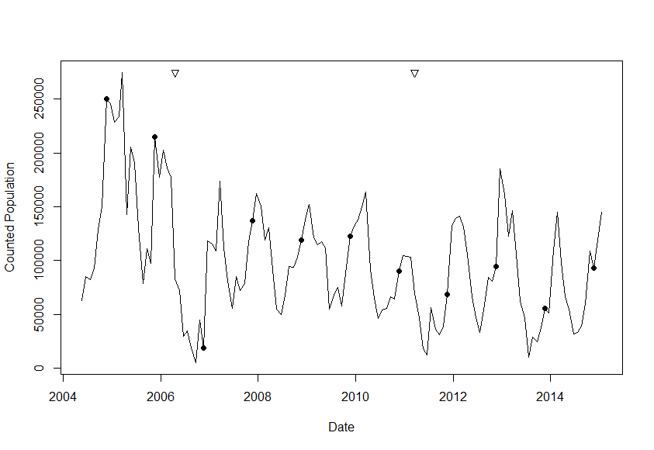

Figure 1 Population dynamics of the Wet Tropics spectacled flying-fox population over the period May 2004 to October 2014. Data shown are a line connecting monthly counts (to make the figure interpretable), the regression line of the count against time and the 95% CI interval of the regression. The inverted triangles indicate the timing of Cyclone Larry in 2006 and Cyclone Yasi in 2011, filled circles indicate the population recorded during the November count of each year (i.e. the adult population). The x labels mark the beginning of the indicated year

An examination of the raw data (Figure 1) suggests a decline over the course of the monitoring when the first (and even the second) year of data is excluded. Downward steps in abundance occur after each of the two major cyclones. We used the November only data in this analysis as it is the month in which the greatest proportion of the adult population is likely to be in camps (Figure 1) but is also the time during the pupping season when young-of-the-year are not yet independent of their mothers and therefore are least likely to be incorporated into the count. Thus, in most years, November is the month when the estimate will most closely approximate a count of the adult population. We didn’t use the simplest approach to estimating the population growth rate of regressing the logarithm of population size on time (Eberhardt & Simmons 1992), as this is well known to overestimate the precision of the resulting rate of increase estimate, and hence has a higher Type I error than assumed. Rather, we fitted a Bayesian implementation of the simple state-space model of Humbert *et al.* (2009), which incorporates both observation error and process noise. The model was fitted using OpenBUGS using the R package R2OpenBugs (Sturtz *et al.* 2010). Prior distributions for observation error and process noise were largely uninformative (uniformly distributed), though bounded by the range of the observations (on the natural logarithmic scale).

The resulting model for all the November data infers no significant trend despite 62% of the population lost over the 10 years from November 2005 until November 2014. The November immediately post Cyclone Larry has a large effect on this model through increasing the estimated process noise (the cyclone effect was not explicitly accounted for here, in contrast to the more complex state-space model described below). Exclusion of this month’s data from the model as an outlier results in a much stronger inference that the population is in decline, with the estimated exponential rate of increase *r* = -0.12 year-1. (Figure 2A). The posterior distribution for *r* reveals considerable belief (92.8%) that *r* is negative, and that the population is in decline (Figure 2B). From a simple linear regression of counts versus time, there is an estimated loss of 39 animals per day resulting in a decrease from 195,623 to 65,318 animals over the 10 year period(*r*2=0.83).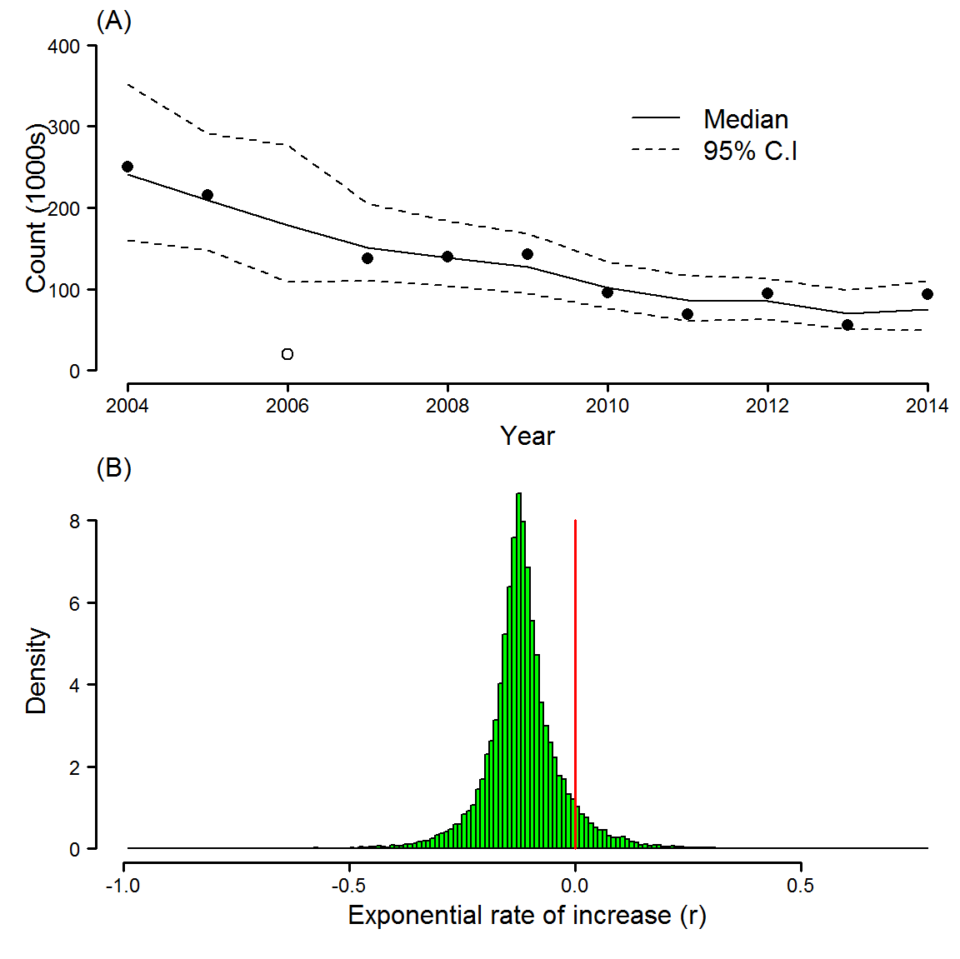

Figure 2 (A) Inferred median trajectory in November counts arising from a state-space model including both observation error and process noise. Solid line is the median and dashed lines 95% credibility intervals. The extremely low count following Cyclone Larry (open circle) is omitted from the analysis as an outlier. (B) Posterior distribution for the exponential rate of increase (*r*) with red line showing demarcation between decline and growth. The posterior probability of negative population growth rate (left of vertical line) is 0.928.

### Identifying critical time periods

The Diffusion-Drift-Jump modelling indicated an annual pattern of fluctuation in the variance with peaks in small perturbations at each time step (diffusion) beginning in early 2006, throughout 2011 and then mid-year in each year subsequent to 2011 (Figure 3 top panel). Large, intermittent perturbations (jumps) were identified in early 2006, early 2011 and then again in July of 2013 (Figure 3 bottom panel). Total variance plotting, which combines the effects of diffusion and jumps, suggests that the dominant effects were the large perturbations in early 2006 and 2011 and mid-2013 (Figure 3 lower panel).

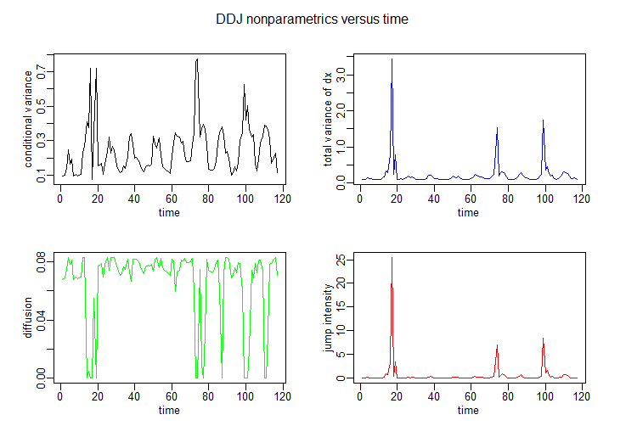

s

Figure 3 Results of the Diffusion-Drift-Jump modelling across the monitoring periods. The top panel shows the diffusion results across the survey period while the lower panel shows the total variance of dx, a combination of the relative contributions of diffusion (short term) and drift (large scale) perturbations.

### State Space Modelling

Figure 4 depicts the posterior median estimate of the total and in camp spectacled flying-fox abundance, with 95% posterior predictive intervals derived from the state-space model. Also depicted are the median and 95% prediction intervals for the 24 months following on from the last available data point (February 2015―January 2017).

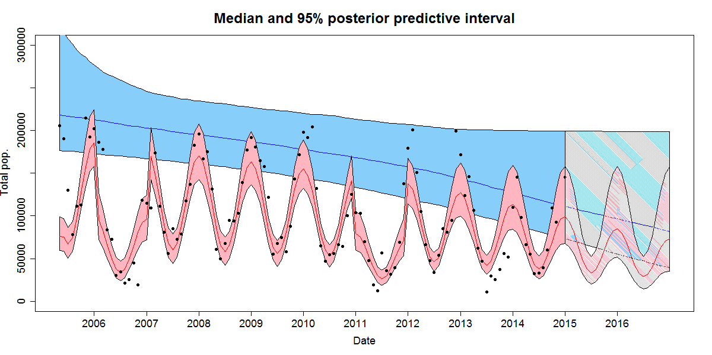

Figure 4 95% posterior predictive intervals for total spectacled flying-fox population (blue) and spectacled flying-fox population found in camps (red) utilising counts through January 2015. The lines indicate the medians. The black points are observed counts of spectacled flying-foxes in camps. The regions with line fill represent predictions for the next 24 months based on 50,000 samples. The x labels mark the beginning of the indicated year.

The median abundance estimate for November 2014 is 113,631 which is slightly higher than the counted population of 92,880 (Figure 1 and Figure 4). Over the period of the monitoring this suggests a decline of 47% from a population of 214,238 in November 2005 through to November 2014. We also analyse the abundance estimates of the final available time point (January 2015) as this provides the current estimate of spectacled flying-fox abundance. The median total population is 111,115 at the final time point. The standard deviation (SD) of total abundance at this time point is 36,375. The observed value of 145,000 falls above the median estimate but well within the 95% posterior predictive interval (PPI) of the estimate.

The $σ_{obs}^{2}$ parameter also gives us an estimate of the coefficient of variation (CV) of the observation process. The CV of a log-normally distributed random variable is related to the variance through CV = $\sqrt{exp(σ^{2}) – 1}$. The median of $σ_{obs}^{2}$ is 0.3710, which corresponds to a CV of 0.6702. This means there is an estimated 67% error rate in flying-fox counts.

The posterior mean for the rate of increase is $r$ = -0.0091 mth-1 – the mean was used in preference to the median as the presence of a birth pulse results in a highly skewed distribution. Posterior medians of the remaining parameters are: $K$ = 224,561, $α_{1}$ = 2.07, $α_{2}$ = 3.56, $σ_{t}^{2}$ = 2.45, $σ_{C}^{2}$ = 1.99 and $β$ = 0.47. Thus, there is an estimated -10.3% growth rate each year, with a carrying capacity of approximately 224,500 – note this estimate doesn’t show good convergence properties. Approximately 86% of spectacled flying-foxes are estimated to be found in camps during the month of December, compared with 80% estimated from the telemetry, and only approximately 30% during the month of June, compared with 7% estimated from the telemetry. The differences between the modelled and measured percentages are in part explicable due to the model estimating an average across all years while the telemetry is estimating from just two years, including years with record low winter numbers (Figure 1). In major tropical cyclone years, there is an estimated 47% drop in spectacled flying-foxes found in camps.

Figure 5 depicts results of the same analysis with the final twenty observations (June 2013–January 2015) excluded from the fitting. Those excluded observations are then depicted in green. Restricting the data used in this manner indicates the impact of the lower numbers observed over the last 20 months on the population trend and suggests that the population had been relatively stable from 2007 through to late 2012.

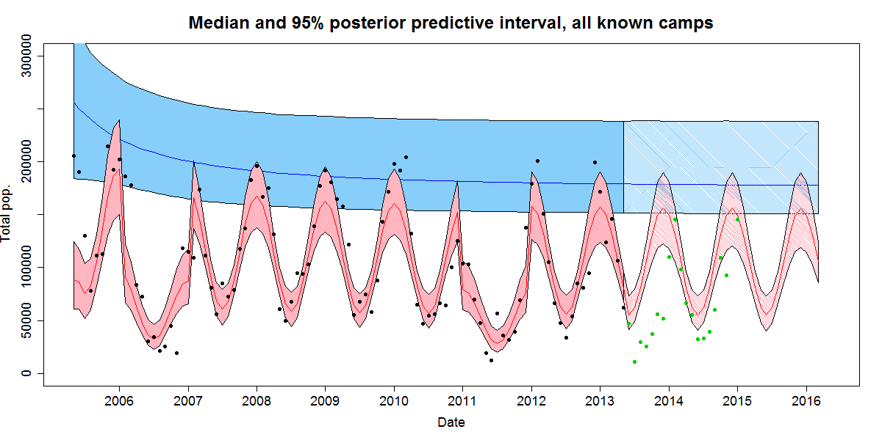

Figure 5 95% posterior predictive intervals for total spectacled flying-fox population (blue) and spectacled flying-fox population found in camps (red) utilising counts through May 2013. The solid lines indicate the medians. The black points are observed counts of spectacled flying-foxes in camps. The regions with line fill represent predictions for the next 24 months based on 50,000 samples. The green points indicate counts from June 2013 – January 2015. The x labels mark the beginning of the indicated year

## Discussion

### Both approaches indicate a decline

Over the period of the monitoring considered in this analysis, April 2005-January 2015, the annual peak in the counted population has declined from 214,750 to 145,000. Over this same period the counted adult population, i.e. the November counts only, has declined from 214,750 to 92,880, a decline of 57%. The regression based on the November data suggests that c. 18 adults have been lost from the population each day over this period equating to a decline of 62% in the counted population. A similar conclusion can be drawn from the state-space modelling. In that analysis we estimate that the total population has declined from 214,238 to 113,631, or 47%, over the period of November 2005 to November 2014. This modelling also suggests that this decline is likely to continue (Figure 4).

### Can we be confident about a decline?

How confident are we about this decline? The state-space modelling gives us an estimate of the observation error of the counts and therefore our confidence in the estimates. The state-space analysis suggests the observation error in the SFF monitoring estimate at the level of the whole population has a CV of 67%. While high, this value is not surprising given the challenges associated with counting flying-foxes, the accumulation of errors across camp counts (Westcott *et al.* 2011; Westcott *et al.* 2012) and the impact of missing camps. As a consequence we think this is both a reasonable estimate of overall precision for a total population estimate and a reminder of the importance of long-term monitoring for describing trends in flying-fox abundance. With low precision, large sample sizes are required if signal is to be salvaged from noise (Westcott *et al.* 2012) and this inevitably means years of data. Just how long a monitoring program is required is a function of the magnitude of the signal with smaller signals requiring longer monitoring.

Given that we have just 10 years of data, have we monitored long enough to be confident given our estimates of error? Our previous work (Westcott *et al.* 2012) suggested that 13 years of monitoring data was required to reach 80% confidence of detecting a decline. At that point we were interested in estimating the effort required to confidently detect the minimum decline that would be required to change the species’ listing under the EPBC Act. Here we are estimating an average annual decline of 6.75% but in reality the decline we have described starts out at c.4.5% in the early years but then between 2010 and 2014 increases to 12%. In short, we are attempting to detect a larger effect than was the case in our previous study and therefore will need a smaller sample size, i.e. a shorter time series, to do so. Our confidence in accepting that the decline is real is further strengthened by the fact that in both the state-space modelling and the regression analyses, the starting population lies outside the 95% CI or PPI limits of the population estimates for the last months of the monitoring and *vice versa*. Combined these observations suggest that we can be confident in concluding a real decline has occurred.

While we may be confident that we have seen a decline in the counted population, it is necessary to ask what has caused it. In particular, we need to discriminate between two potential explanations, one biological and one methodological. The first is that the decline is real and that increased mortality or reduced recruitment has driven a drop in abundance. If this explanation holds then there should be some identifiable driver of that decline. The second, methodological, hypothesis is that the decline is actually due to animals moving out of the counted population and simply roosting in places we don’t count, i.e. a detection or counting error. That this second hypothesis is a contributor to the decline is suggested by the telemetry work which showed that at least some proportion of the annual fluctuation in abundance can be ascribed to animals roosting at locations that were not surveyed.

While the telemetry results clearly identify a potential role for the movement of animals out of the counted population to contribute to the decline, we do not think this role is adequate to explain the decline. There are two main reasons for this. First, the average tagged individual was recorded using 25 distinct roost locations, including known and unknown camps and solitary or ephemeral roosts. Across all individuals this led to a 24% increase in the number of known camps. Given that these new camps were distributed across the species’ range, we think it is reasonable to conclude that these tagged animals were sampling the available and occupied camps generally and, it is reasonable to think that more camps more camps might yet be discovered, the telemetry work to date is not obviously biased against their discovery. Second, despite the number and geographic distribution of new camps found, they contribute only a modest 14% increase to the estimated population in any given month. Even when this increase is incorporated into the analysis of population trend, as it is in our analyses, it is not sufficient to eliminate the decline. Thus while we acknowledge that each new telemetry download has the potential to identify the camps containing the lost portion of the SFF population, the indications to date are that this is unlikely and that any camps discovered in the future will, like the camps discovered to date, contribute numbers that ameliorate rather than negate the decline. This leads us to favour the hypothesis that a real decline in the population explains the greatest proportion of the missing SFF population.

### What is causing the decline?

There are two major events that appear to have perturbed the dynamics of the SFF population and which at this juncture appear to be likely candidates for the drivers of the SFF decline overall. These are Cyclones Larry (landfall, 20 March 2006) and Yasi (landfall, 3 February 2011). Both cyclones were Category 5 storms which caused extensive damage to vegetation in the south and central parts of the Wet Tropics Region. After Larry the SFF population dropped dramatically and there was not a return to camps until the following year. The effect of this was to increase the length of the annual trough and to reduce abundance during the peaks that followed (Shilton *et al.* 2008)(Figure 1). A similar effect is seen with Cyclone Yasi in 2011 (Figure 1).

The effect of cyclones is also apparent in the Early Warning Analysis with Cyclones Larry and Yasi coinciding with strong perturbations in the population variance structure (Figure 3). Smaller perturbations then occur mid-year in each year after Cyclone Yasi (Figure 3 top panel) suggesting either that the population has i) changed its winter behaviour after Yasi, or, ii) that after Yasi it is more sensitive to minor shocks that occur during this lean season.

The exact identity of these minor shocks is unclear. There are a range of natural and anthropogenic drivers of mortality which may become more significant when populations are stressed by major disturbances such as cyclones and these may vary over time. These include factors such as disease, predation, other weather events, hunting and disturbance of camps.

A possible additional impact in 2013 may have been Cyclone Oswald which tracked south along the entire Wet Tropics Region, and therefore the entire SFF range, in January 2013. It is harder to ascribe any direct effect of Oswald as there are annual minor shocks each year after Yasi in 2011 (Figure 3 top panel) and the major perturbation identified in 2013 (Figure 3, lower panel) occurs in the winter, several months after Oswald. Oswald was only a Category 1 cyclone and thus was unlikely to have caused significant direct mortality, however, the winds (65-140 kph) and intense rain associated with the system may have been sufficient to destroy flowers and fruits. If Oswald is the cause of the large perturbation in 2013 it is likely to have been due to the development of a resource trough across the species’ entire range over the months after the cyclone leading to the peak in variance observed during the lean months in the middle of the year.

The impact of tropical cyclones on the population of a species that roosts in the canopy during the day and feeds there at night on resources that are easily damaged by wind is easy to imagine. Cyclones result in direct mortality during the event (Shilton *et al.* 2008), though the magnitude of this is unknown it may well be significant. They also have longer term effects. Both major cyclones resulted in major canopy loss across all vegetation types over large swathes of what is the core distribution of the SFF and this resulted in a loss of both the flower and fruit resources that the population is dependent upon. While most Australian nectarivores/frugivores are generalists and under such conditions switch to a more general diet, SFF are nectar and fruit specialists (Parsons *et al.* 2006) and rely on being able to follow resources across the landscape (Westcott & McKeown. 2014). Cyclones that impact on a large proportion of a species’ range effectively negate such a strategy. They probably forced SFFs to disperse over a much reduced resource base and likely resulted in significant mortality over the subsequent months due to starvation.

Given the available data the most likely hypothesis for the SFF decline is that two major cyclones in rapid succession have had a significant impact on SFF abundance and that, without an adequate interval between these events, and with the additional impact of as yet unidentified ‘minor’ drivers of mortality, the species has not had the opportunity to recover.

### What does this mean For the status of the species?

Under the EPBC Act Regulations a >50% and <70% decline over the longest of either 3 generations or 10 years is required to warrant listing as Endangered while a decline >30% and <50% is required for listing as vulnerable. This decline can be observed, inferred or projected. Here we are describing a 53-62% decline over a 10 year period. Current estimates of the duration of three SFF generations range from 15 years (Fox *et al.* 2008) to 24 years (Woinarski *et al.* 2014) depending on the method used. If the decline we have measured is extrapolated out to three generations using the more restrictive estimate of 15 years (i.e. the period that provides the least time for a decline of a given magnitude) this decline would be on the order of a 90% decline based on the regression analysis and 70% based on the state-space modelling. Either way this level of decline would qualify the species for listing as Endangered. Adopting the more permissive 24 year period only makes the outcome worse if the inferred decline is projected forward.

It must be noted however that while the decline is currently occurring, whether it continues remains to be seen. Cyclones are not new in the Wet Tropics Region and SFFs must have presumably recovered from them in the past. If cyclones are the primary driver of the decline then whether it continues will depend on: i) how long it is until another major cyclone hits the region, and, ii) what impact other threats have on the species over the coming years. Other known or potential causes of excess mortality include increased clearing that occurred in the region during the period 2013-2015 (Maron *et al.* 2015), increasing frequency of extreme temperature events (Welbergen *et al.* 2008), paralysis tick attack (Fox *et al.* 2008; Buettner *et al.* 2013), persecution at orchards (Westcott *et al.* 2001), and the disruption of urban camps (Tait *et al.* 2014). Given that there is little evidence of abatement in any of these threats we think there is good reason to be concerned about the future of the species.

Over the same period that the species has shown this decline there has been a trend towards increased urbanisation of the Wet Tropics population (Tait *et al.* 2014). This has involved an increase in the number of urban camps and of the proportion of the SFF population roosting in these camps. This trend has occurred in the absence of any apparent drivers: there has been no significant loss of habitat, of camps, or of encroachment by urban development in the vicinity of camps (Tait *et al.* 2014). Rather a shift towards urban roosting appears to be occurring and along with that comes conflict and persecution at these camps. While disturbance at a single camp is unlikely to constitute an issue at the population level, persecution at multiple camps may well. Camps are likely to play a significant role in social processes but also in the ability of individuals to gather information and exploit resources. Persecution, including non-lethal disturbance, at too many camps may reduce the ability of a population to share this information. This is of concern for a declining population.

Given the population decline we have described here, the uncertainty about threats into the future, the loss of foraging habitat in drier parts of the range (Maron *et al.* 2015) and the unfortunate timing of increased urbanisation in the SFF population (Tait *et al.* 2014), we suggest that the upgrading of the species to Endangered is warranted and that trends over the coming years be monitored, noting regular review of on-going telemetry work and the incorporation into the monitoring of any new camps found. We recommend that specific research needs should be addressed, including; i) on-going monitoring of the species, ii) on-going telemetry work to identify where any ‘lost’ proportion of the population may be and describe foraging habitat, iii) identification of the drivers of the decline, in particular the causes of the minor shocks over the last three years, iv) determination of why flying-foxes are urbanising, v) determination of how concerns about impacts on amenity and SFF population declines can be balanced in policy and management responses, and vi) description of the social and economic context of SFF management.

Given SFF’s distribution extends beyond Australia’s borders it is worth also noting the species’ status in these areas. Outside Australia the species is found in the lowlands of sections of the northern side of New Guinea and associated islands (Helgen *et al.* 2008). In these areas it appears to face similar threats with population declines inferred from high and increasing rates of hunting, increasing rates of deforestation and forest degradation from expanding forestry operations, the expanding oil palm industry and human settlement (Hansen *et al.* 2013; Stibig *et al.* 2014; Bonaccorso 1998). These threats outside Australia and the situation in Australia have led to the recommendation that the species status under the IUCN Redlist Criteria be upgraded to Vulnerable (Roberts & Eby submitted). While the proportion of the species global population found in Australia is uncertain, the threats faced by the species in Indonesia and Papua New Guinea make it clear that the Australian population is globally significant.

## Conclusions

1. Analysis of long-term monitoring of SFFs suggests that the population is declining with November counts dropping from 214,750 in 2005 to 92,880 in 2014. Up until mid-2013 the dynamics might have been dismissed as fluctuations in abundance, however, the very low numbers recorded since that time suggest that this is not the case.
2. The hypothesis that the decline reflects a change in roosting behaviour is not supported by telemetry work conducted during the decline. While the discovery of new camps and non-camp roosting sites identified by telemetry has had a mitigating effect, it has not reversed the decline seen. This suggests that the decline is real and is the result of external drivers.
3. Modelling identifies Cyclones Larry and Yasi as having had a large impact on the population and suggests that the adult population has not recovered from these events. Post-Yasi the annual mid-year small perturbations leading to a major perturbation some months after Cyclone Oswald cannot be explained and suggest some yet unidentified factor is involved.
4. Given the data currently to hand we can only conclude that the decline in SFF abundance is real and of the order of 50-62% over the last 10 years and between 70 and 90% over three generations.
5. This decline has occurred at the same time as the species has shown a shift towards urban areas increasing conflict with humans.
6. Research needs include;   
   i) on-going monitoring of the species,   
   ii) on-going telemetry work to identify where any ‘lost’ proportion of the population may be and describe foraging habitat,   
   iii) description of basic life-history and behavioural parameters,  
   iv) identification of the drivers of the decline, in particular the causes of the minor shocks over the last three years,   
   v) determination of the drivers of flying-fox urbanisation,   
   vi) determination of how concerns about impacts on amenity and SFF population declines can be balanced in policy and management responses,   
   vii) description of the social and economic context of SFF management.
7. We recommend that the species be listed as Endangered under the EPBC Act.

# Grey-Headed Flying-Fox, Pteropus poliocephalus

The grey-headed flying-fox is a large Pteropodid, with adults weighing in the range of 700-1100gms (Westcott and McKeown, unpubl. data). The species is endemic to eastern and southern Australia with the great bulk of the species’ population being found along the eastern seaboard, from Melbourne through to Mackay (see NFFMP Reports 2013-2015 and Interactive Webviewer (Department of the Environment 2015a)). Recent years have seen apparent range expansions as far west as Adelaide in the south, Innisfail in the north and onto the western slopes of NSW and Qld (see e.g. the NFFMP Interactive Webviewer (Department of the Environment 2015a)). While this appears to represent an expansion of the species’ range west and north, reports of GHFF in SA and western NSW in the late 1800s suggest that the boundaries of the species range may be more dynamic over longer timeframes than previously supposed and that such changes probably occur intermittently (Westcott and McKeown, unpubl. data). Roberts *et al.* (2012)’s analysis of latitudinal shifts in the species distribution led to a similar conclusion in the context of an apparent southerly shift into Melbourne. Time will tell whether these movements represent fluctuations of long-term shifts in the range boundaries.

GHFFs use most habitats in which suitable foraging resources are to be found. They are reported from coastal areas including mangroves and coastal eucalypt forests and wet forests, through to montane forests and the woodlands and drier forests of the western slopes (Woinarski *et al.* 2014). Their primary food sources are species which produce large quantities of floral resources, e.g. Eucalyptus, Banksia, and Melaleucas, and to a lesser extent fruit resources, particularly of rainforests (Eby 1991; Parry-Jones & Augee 1991b, a; Eby 1998; Eby *et al.* 1999; Eby & Law 2008).

Like all Australian *Pteropus spp.*, GHFF roost colonially with camps usually comprising one to a few thousand individuals but occasionally exceeding 100,000 individuals for short periods (NFFMP Interactive Webviewer(Department of the Environment 2015a)). While many camps have a long history of occupation (Parry-Jones & Augee 2001; Roberts *et al.* 2011) new camps are established (or identified) and existing camps abandoned on a regular, if not frequent, basis. Relatively few camps are occupied continuously. Roosting habitat is highly variable and ranges from mangroves and dune forests through to pine plantings, urban parks, rainforest thickets and woodland patches. Vegetation structure can vary from sparse and open to dense and closed vegetation, and their location can vary from large blocks of forest through to individual trees or clusters of trees in urban landscapes (NFFMP, unpubl. data).

Threats to GHFF have been identified as historical and continuing habitat loss (Woinarski *et al.* 2014), persecution in camps and orchards (Roberts *et al.* 2011), extreme heat events (Welbergen *et al.* 2008), barbwire and vehicle strikes (Department of the Environment 2015d).

## Monitoring history

There have been three phases of monitoring of the grey-headed flying-fox (hereafter GHFF). Between July 1998 and May 2005 eight national counts were conducted under the auspices of the Australasian Bat Society (Eby 2002). This monitoring began with an initial aim of describing habitat use during winter months in coastal parts of its range that were under increasing pressure. This work demonstrated that large scale monitoring of GHFF was possible.

Following on from this pioneering work, the Commonwealth funded a continuation of the monitoring for the period 2002-2005. The aim of this phase was to conduct synchronous, range-wide counts to provide estimates of population size and distribution to underpin management of the GHFF following its listing as vulnerable under the NSW *Threatened Species Conservation Act 1995* and the Commonwealth’s *Environment Protection and Biodiversity Conservation Act 1999* (EPBC Act) in May and December, respectively, of 2001. This monitoring continued on an annual basis until 2005. Both these phases of monitoring were based on evening fly-out counts. Where possible these counts were conducted on multiple nights at a camp. In the rest of this report these two phases are referred to collectively as the pre-NFFMP phase.

The third phase of the monitoring was prompted by increased public and agency concern over the status and impacts of the GHFF. This led to the establishment of the National Flying-Fox Monitoring Program (the NFFMP). This phase of monitoring built on the knowledge developed during the pre-NFFMP monitoring, the knowledge and contributions of a large number of individuals, long-term monthly monitoring of spectacled flying-foxes and research on design considerations for monitoring of flying-foxes (Westcott *et al.* 2011; Westcott *et al.* 2012).

The NFFMP phase was a collaboration between State and Commonwealth agencies, including the Department of the Environment, the NSW, Victorian, Queensland, Victorian, South Australian and ACT governments and CSIRO. The program included a monitoring component but also a research and analysis component that sought to describe biases associated with the monitoring, account for those biases in deriving population estimates, and to provide additional management relevant information on the species’ ecology and movement in particular. This program was designed to feed information into management and policy in the areas of conservation management and disease risk assessment but also to make the data available to the public more generally through web-based mapping tools.

The NFFMP was implemented in November 2012 and counts are conducted quarterly. The NFFMP counts differ from the pre-NFFMP counts primarily in that they do not rely on fly-out counts and instead focus on ground-counts. This change was made due to the enormous logistical costs associated with coordinating the large number of volunteers required for a fly-out count (Westcott & McKeown 2004; Westcott *et al.* 2011) and was also a suggestion that came out of the pre-NFFMP monitoring (Eby 2004). In fly-out counts most camps require 4-6 counters to ensure an adequate count and counters are only able to count at dusk and at one camp. With c. 400 known camps of which c. 100 to 150 are occupied during any given census, both the task and the cost of sourcing and deploying so many counters becomes enormous. To reduce these prohibitive costs, in the NFFMP we developed methods that required fewer counters and allowed individual counters to count at multiple camps. Ground counts are conducted using a variety of methods depending on the conditions encountered at the camp. These are area, tree and distance-sampling based density estimates, direct counts, and when another type of count is not otherwise possible, fly-out counts (Westcott *et al.* 2011).

## Sources of error in the methods

Any comparison of data derived from different monitoring methods requires some assessment of the errors associated with each. Below we review the current state of knowledge of errors in flying-fox monitoring. Later we describe precision estimates conducted as part of the NFFMP.

### Fly-out counts

Over the years there have been a number of studies of the errors and biases of fly-out counts of flying-foxes (Westcott & McKeown 2004; Forsyth *et al.* 2006; van der Ree *et al.* 2009) and as a result a range of errors have been described, including:

* Non-departure and return - The method assumes that all animals leave the camp and do not return. However, during fly-outs a variable proportion of individuals leave the camp, return and leave again. Similarly, not all individuals leave the camp during the period of the fly-out count and this has in some instances been estimated to be as much as 20% (Westcott and McKeown, unpubl. data).
* Multiple departures – a varying proportion of individuals depart and return and depart again, sometimes multiple times.
* Stream error – While at very small camps each counter can sometimes count all departing animals, at most camps there are multiple streams as well as individuals leaving outside the streams. This usually requires multiple counters deployed around the camp. Errors enter here when i) streams are missed because of a lack of counters, i.e. there are not enough counters or counters are deployed to the wrong locations, when a new stream is not anticipated, or when ii) counters overlap in the areas they count, resulting in a double count. These errors were common and large in SFF fly-out counts (Westcott and McKeown, pers. obs.).
* Stream characteristics – The width, size and rate of fly-out, and light conditions all contribute to errors in counting (Westcott & McKeown 2004; Forsyth *et al.* 2006; van der Ree *et al.* 2009)
* Multiple species – flying-fox camps are frequently comprised of more than one species, typically c. one third of GHFF camps have other species present. This presents a problem for fly-out counts because different species cannot be reliably recognised during the fly-out. This necessitates determining the proportion of each species in the camp prior to the fly-out.
* Leading – most fly-out counting methods result in clear signals about the rate at which a counter is counting. These primarily include verbalising the count, the use of clickers, and physical gestures. This has the potential to influence the count of nearby counters though any effect has not been quantified. The potential influence on counts led to (Westcott & McKeown 2004) experimentally deafening their counters to minimise any such effects.

### Ground Counts

To date there has been less attention applied to the estimation of errors in ground counts; this does not equate to these methods necessarily having less error associated with them. It is currently not possible to determine a ‘true’ number as is the case when individual fly-out streams are videoed (e.g. Westcott & McKeown 2004; Forsyth *et al.* 2006). Therefore, while it is possible to directly assess precision of counts it is not possible to directly assess their accuracy. Identified errors of ground counts vary across the methods and, include:

* Counting error – all ground count methods require counters to detect and enumerate the animals. The errors associated with these activities are dependent on individual experience and skill but also on the physical structure and accessibility of the camp and the extent to which the animals tolerate the counter.
* Area estimation – three approaches to ground counting rely on estimating a density. This requires an estimate of a camp’s area, either its geographic area, an estimate of the number of trees in which flying-foxes are roosting or the estimation of distance to animals in distance sampling. Each of these estimation techniques are prone to errors. For example, distance sampling requires a reliable estimate of observer-cluster distance and requires that counters are in the camp, or at least on the edge of the camp, and estimating area and counting trees can be challenging for some counters even when using hi-resolution imagery or with reasonable access to the camp.
* Disturbance – where counters approach or enter a camp their presence can cause disturbance resulting in the movement of animals away from the counter. In severe cases this will make a count impossible and require adoption of a different approach. This effect of disturbance varies depending on the tolerance exhibited by the animals and this can vary from camp to camp and even day to day at the same camp.

### Errors common to the methods

There are several important errors associated with all monitoring methods:

* Missed camps – all methods of enumeration suffer from the problem of missed camps. This can happen because of the last minute withdrawal of counters or because counters could not be sourced for a camp. This is a particular problem for fly-out counts because they require multiple individuals for each camp, e.g. a well conducted fly-out count in the NFFMP uses 8-12 counters. These sorts of numbers mean that difficulties in sourcing and coordinating sufficient counters are more likely to result in camps being missed.
* Unknown camps – all methods of flying-fox enumeration will suffer from error introduced by the fact that a varying proportion of individuals are known to roost either solitarily or in camps that we are not aware of. That this occurs to a varying extent through the year is illustrated by the fluctuations seen in the populations of both GHFF and SFF that cannot be completely explained by patterns of breeding. (Westcott *et al.* 2012) found that this was the major contributor to uncertainty in estimating confidence about trends in SFF population dynamics. The solution being implemented is to use telemetry to document the patterns of camp use throughout the year, recording days spent roosting in and out of camps.

##### Objectives of this work

The goal of the NFFMP has been to implement an ongoing monitoring program with the aim of establishing baseline data against which long-term monitoring can establish trends. Here we present data from the first two years of the NFFMP monitoring of the GHFF population across its range. We present raw count data and then apply corrections to that data based on our understanding of the errors associated with the methods to arrive at an estimated population size.

We recognised from the outset that it was inevitable that comparisons would be made between the results presented in pre-NFFMP reports and the results of the NFFMP program. Such comparisons are fraught due to the differences in methods and errors, and uncertainties about relative coverage of the programs. Simplistic comparisons that make no consideration of these differences are likely to result in erroneous conclusions. As a consequence in what follows we review past and current monitoring results, we later derive and apply error corrections and confidence estimates to the results of the monitoring from both the pre-NFFMP and the NFFMP phases of the monitoring. The corrections we explore include i) accuracy, ii) precision, iii) proportion of days spent away from known camps. We then use a modelling approach to estimate the effect of missing known camps. In the light of these corrections, we explore the potential for comparing the two monitoring phases.

## Methods

### Monitoring

#### Pre-NFFMP counts

In the pre-NFFMP monitoring (Eby 2002, 2003, 2004; Birt 2005) the count was a staged process where i) as many counters as possible were trained in the weeks leading up to the count, ii) camps were assessed for presence of flying-foxes prior to the count, iii) species composition was estimated as a percentage of the camp prior to the count, iv) the count performed, and subsequently, v) analysis completed providing a camp population estimate. These counts were almost invariably fly-out counts and they were performed once or twice a year (in the first years).

#### NFFMP

In the NFFMP, counts have been conducted quarterly since November 2012 and use a similarly staged program. Counters are identified prior to counts. There is effort invested in training counters and in retaining them in the program through feedback in the form of reports, data visualisation and newsletters (see http://www.environment.gov.au/biodiversity/threatened/species/flying-fox-monitoring). Training occurs in the weeks leading up to a count and most counters have received training at least once during the program. Before the surveys are conducted we use historical data and local knowledge to determine which camps are likely to be occupied and which are likely to be large. Camps are checked opportunistically in the weeks leading up to the survey to determine occupancy and size. During the three day monitoring window all camps are visited and a count is conducted at any camp where animals are detected. In areas where availability of counters is limited we survey camps according to their assessed priority, based on occupancy and size, e.g. larger and more likely to be occupied camps are given higher priority. The intention is that if a camp must be omitted because of a lack of counters on the day then it should be a camp that is expected, or known, to be small or unoccupied. While every effort is made to visit all camps inevitably a small proportion are missed for some reason.

The method employed to count GHFFs at a camp depends on the conditions encountered at the camp. When numbers permit, generally in camps of <1000 individuals, a direct count is conducted. When the camp is too large some form of density estimation is combined with an estimate of camp size. The methods include i) tree counts, ii) area counts and iii) distance sampling. These methods are outlined in detail in (Westcott *et al.* 2011).

### Telemetry

In our past analyses we identified the proportion of the population roosting away from known camps as a major source of error in flying-fox monitoring (Westcott *et al.* 2012). We have used telemetry to describe the magnitude of this error. To do this we attached 22g GPS transmitters to adult GHFFs. As was the case for SFFs, concern about the constraints of pregnancy and carrying young meant that we biased our samples towards adult males. Transmitters were programmed to take day-time fixes and these fixes were downloaded when the animals returned to camps with a download station. This approach can result in a long lag between data collection and download and also means that a proportion of the data will not be recovered during the project. Once downloaded, daytime fixes were assessed to either be in a camp, i.e. within 500m of a known camp, or not in a camp, i.e. greater than 500m from a known camp. Non-camp fixes were ground-truthed where possible to ascertain whether the location was an unknown camp or an ephemeral roost, i.e. used by one or a few individuals or used only for a few days. In some instances it was not possible to access a site but fixes from multiple individuals or fixes obtained over a long period indicated that the site was not a solitary or temporary roost.

### Imputation of missing counts

While unknown camps are inevitably missed, invariably a proportion of known camps are also missed, usually due to last minute lack of availability of counters. This has occurred for reasons as good as flooding and bushfires and for reasons as prosaic as a counter simply didn’t get around to doing the count and didn’t inform us. While we maintain a ‘flying-team’ to try and fill these gaps, e.g. we covered the entire state of Victoria during fires there in February 2013, the vast area and the delays in reporting gaps means that we are never completely successful in this.

One means of characterising the error associated with missing camps is to make the assumption that the dynamics in individual camps are spatially correlated. This might be expected at a small to intermediate scale if flying-foxes move into local areas to exploit local resources, a process that we believe characterises the spatiotemporal dynamics of flying-fox populations. If this is the case then we would expect to see a correlation between camps at small to some intermediate scale and we would predict that this would disappear at larger scales. If this assumption holds then it may be possible to extrapolate at smaller scales to ‘recover’ missed, known camps.

To account for the effect of missing known camps during surveys we use a spatial smoothing technique call kriging. Kriging is an optimal prediction method from spatial statistics that assumes a smooth structure to the data (Cressie 1993). Specifically, the data is assumed to follow the model

$Y= P\left(x\right)+Z\left(x\right)+ ε$,

where $P\left(x\right)$ is a low order polynomial trend and $Z\left(x\right)$ is a zero-mean Gaussian process with an exponential covariance function with, in this case, a range of 10 kilometres (based on the LISA analysis described below and the mean foraging distance), $ε$ is noise and $x$ is the spatial location. Kriging and standard error estimation was done using the fields package in R (Fields Development Team 2006; R Development Core Team 2008). This analysis works essentially by extrapolating from the counts at known locations to create a smooth surface over the entire range of the species. The value of this surface at all known GHFF camp locations is then computed. This estimate serves as the imputed value for uncounted camps and an estimate of the true population in counted camps. Standard errors of these estimates are also computed to create 95% confidence intervals of the total population.

This method makes the assumption that the size of a counted camp tells you something about the size of a nearby uncounted camp. In other words, it assumes that at a local scale there is a positive correlation between camp sizes. We might expect such a correlation if flying-foxes move into an area from distant locations because of an abundance of resources and then distribute themselves across the camps in that local area.

#### Tests for spatial correlation in camp size

We tested for spatial autocorrelation in camp size in two ways. First, we used Moran’s I to give a global measure of spatial autocorrelation in each year of the monitoring. Moran’s I is generally scaled between -1 and 1 and values near zero indicate data that exhibit close to complete spatial randomness, i.e. no spatial autocorrelation (Banerjee *et al.* 2004). However, because Moran’s I calculates the global spatial correlation (in this case c. 3200km), it potentially masks any correlations occurring at smaller spatial scales, such as those that are of interest to us. Such correlations can be assessed using Local Indicators of Spatial Association (LISA) (Anselin 2010). The (non-centred) LISA for each camp was calculated using neighbourhoods ranging from 1 to 3162 km at equal intervals on the log10 scale. This results in measurement intervals ranging from 528m to 1092km.

#### Trend estimation

The kriged surface for each of the eight NFFMP survey periods was computed, along with the associated standard error estimates. These then provide the basis for constructing 95% confidence intervals of the total population and, subsequently, an estimate of the trend in total abundance. This approach to trend estimation ignores any temporal correlation in the counts, meaning that each survey period is treated independently of the others. The seasonal pattern of camp – non-camp use is also ignored in this analysis. Incorporating temporal correlations could lead to a potentially smoother rate of growth (or decline) as these correlations serve to link successive surveys, thereby limiting the variation between them.

## Results

### Monitoring

GHFF population dynamics showed an annual cycle that reflects movement out camps in the first half of the year and into camps in the second half (Figure 6). Over the course of the monitoring the total counted population fluctuated from as high as 694,825 to as low as 327,516. In the first count some extremely high numbers were recorded from remote camps in south east Queensland and while we report those high numbers here and in Figure 6, we believe that these are over-estimates and that a total figure on the order of 600,000 is more likely for those counts. We attribute this over-estimate to a lack accessibility and possibly the presence of a large group of little-red flying-foxes.

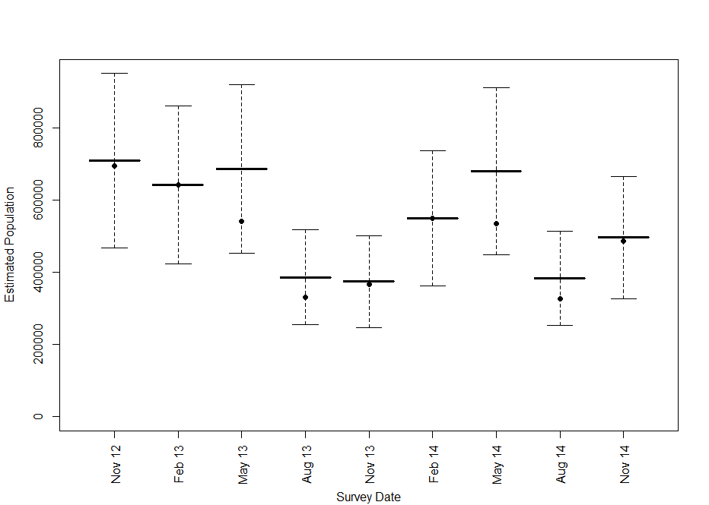

Figure 6 Population estimates from the NFFMP based on the adjustment of raw data using the proportion of animals roosting away from known camps during each monitoring period. Filled circles represent the unadjusted population estimate, bold horizontal bars represent the adjusted estimate and the whiskers indicate the uncertainty represented by the measured precision.

The number of camps occupied by GHFF remained relatively constant throughout the survey period, varying between 94 and 144 (median =124). The size of camps varied over the annual cycle with camps being slightly larger in February and smaller in August (ANOVA, F1, 3=3.026, p=0.03; Figure 7).

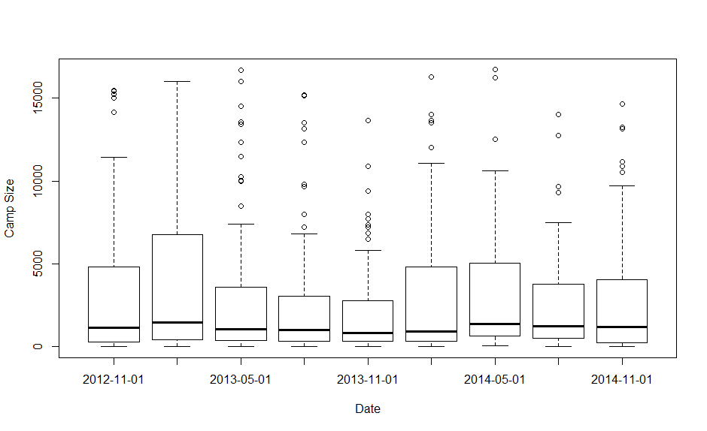

Figure 7 Median camp sizes recorded in each of the NFFMP survey periods. Bold line represents the median, the box the quartile range, whiskers 1.5 *quartile range and circles outliers

### Error Estimation

#### Proportion of time spent in unknown camps

Transmitters were attached to 68 GHFFs, 42 males and 26 females, providing 52,835 daytime locations at 704 unique roost locations to date. On average GHFFs spent 11% of their days at non-camp locations but this varied seasonally: February 0%, May 17%, August 27% and November 2%. The sexes did not differ in the proportion of time they spent away from camps (females=11%, males=10%). The population estimates derived from the raw counts can be corrected by these percentages and the effect of this is shown in Figure 6.

#### Precision of counts

In the NFFMP monitoring precision for counts at a single camp was moderate but similar for each of the various methods employed (Table 1). Repeat counts at individual camps were compared and the absolute difference between the counts expressed as an % of the mean. Direct counts and Distance sampling had the best precision and Estimation and Tree counts the worst. Precision estimates based on comparisons between the different methods yielded values ranging from 15% (Estimate versus Distance, n=10) to 40% Area versus Distance, n=32) with a mean across all comparisons between methods of 30% (± 23 S.D., n=249). Average precision within methods (34%) is plotted against the corrected estimates for each of the NFFMP surveys in Figure 6 & Figure 7.

|  |  |  |  |
| --- | --- | --- | --- |
| Method | Mean Precision, % | SD | N |
| Estimate | 39 | 20 | 15 |
| Area | 37 | 20 | 10 |
| Tree | 39 | 21 | 17 |
| Distance | 31 | 21 | 14 |
| Direct | 28 | 21 | 20 |
| Fly-out | 34 | 24 | 19 |
| All Methods | 34 | 21 | 95 |

Table 1 Precision estimates for the different methods. Estimates are based on double counts of single camps as i) reported in the NFFMP or ii) in error estimation trials

### Comparison of the Pre-NFFMP and NFFMP monitoring

The mean counted population in April-May surveys was similar across the two monitoring phases (t-test=-1.99 p=0.10) and becomes more similar when the counts are corrected for accuracy and the proportion of animals not in camps (W=2.0, p=0.24)(Figure 8). It should be remembered in making this comparason that we have no estimate of the magnitude or direction of the accuracy error of the NFFMP surveys and making such a correction could move the estimate up or down.

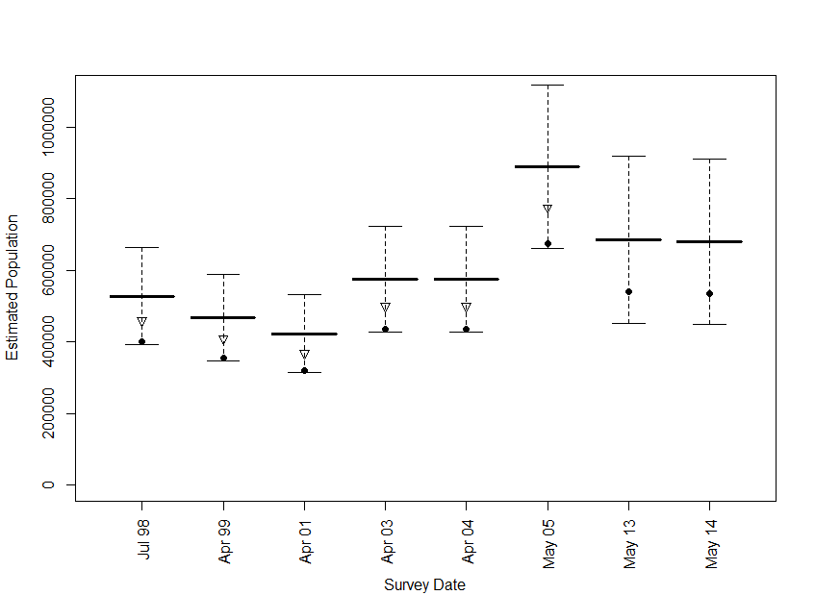

Figure 8 Comparison of the corrected counts from the pre-NFFMP and NFFMP phases of the monitoring. Filled circles indicate raw counts, inverted triangles represent raw counts corrected for accuracy (pre-NFFMP only), bold horizontal lines represent estimated population after correction for accuracy (pre-NFFMP) and roosting away from camps based on telemetry (pre-NFFMP & NFFMP). The whiskers indicate the % range of the precision, being 34% of the raw count in each case

More camps were surveyed in the NFFMP phase than the pre-NFFMP phase of monitoring (t=-7.89, d.f.=5.53,P<0.001). In addition, there was a trend towards a greater number of camps being occupied in the NFFMP phase, but it was not significant (W=0, p=0.09) (Figure 9). Overall, the percentage of surveyed camps that were occupied in the pre-NFFMP and the NFFMP phases was the same (t=-.0.62, d.f.=4.93, p=0.56).

There was a significant difference in the camp sizes reported from the two phases of monitoring, with a median camp size in the pre-NFFMP phase of 2500 individuals and in the NFFMP phase of 1230 individuals (Wilcoxon’s W=29581, p<0.01). This was reflected in a pre-NFFMP camp size frequency distribution that had a lower peak and a fatter tail than observed in the NFFMP (Figure 10).

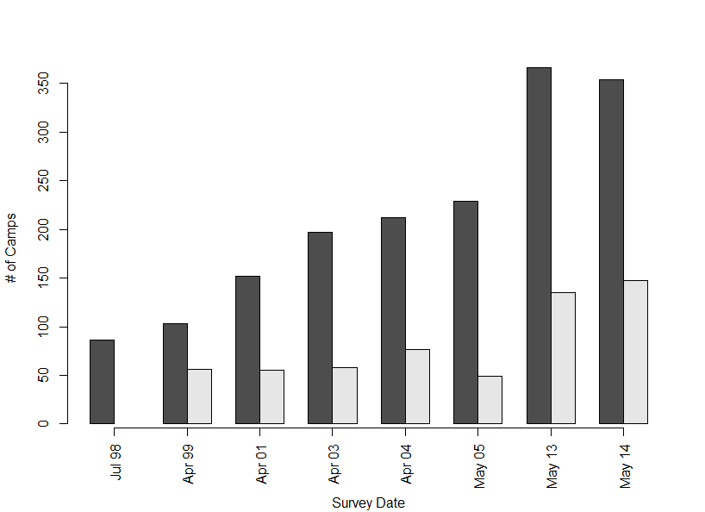

Figure 9 Frequency plot of the number of camps surveyed (dark bars) and the number of camps occupied (light bars) in comparable surveys across all years of monitoring. No data was available on the number of camps occupied in 1998

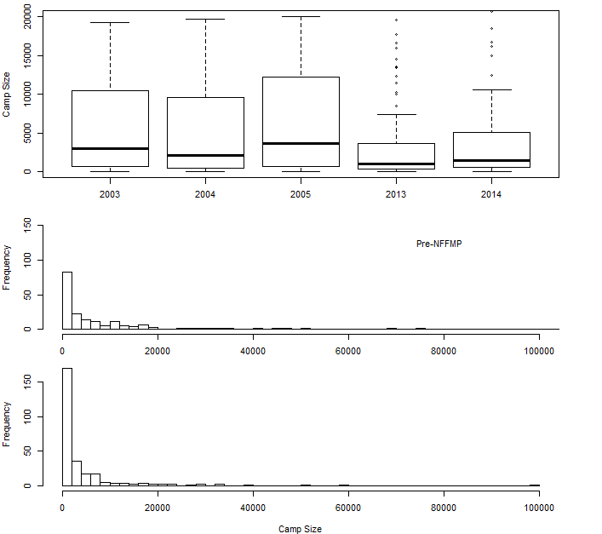

Figure 10 Changes in camp size. Top panel, median camp size recorded in April – May surveys across the two phases of the monitoring and for the years for which individual camp data was available. Dark lines represent the median, boxes the quartile range, whiskers 1.5 the quartile range, and circles outliers. Middle panel, frequency distribution of camp sizes across the three years of the pre-NFFMP for which individual camp data was available. Bottom panel, frequency distribution of camps across the two May surveys of the NFFMP monitoring

### Correcting the NFFMP population estimate for missed camps.

#### Spatial autocorrelation

For the NFFMP counts from November 2012 to August 2014, Moran’s I indicates there is little to no spatial autocorrelation detectable at the global scale. See Table 2 for the calculated values.

|  |  |  |  |  |  |  |  |  |
| --- | --- | --- | --- | --- | --- | --- | --- | --- |
| Nov. 2012 | Feb. 2013 | May 2013 | Aug. 2013 | Nov. 2013 | Feb. 2014 | May 2014 | Aug. 2014 | Nov. 2014 |
| 0.0324 | 0.0535 | 0.0342 | 0.0084 | 0.0172 | 0.1037 | 0.0367 | 0.0093 | 0.0246 |

Table 2 Moran’s I correlation coefficients for camp size changes at the scale of the species’ range

The LISA analysis identifies a positive correlation between camps at a radius of <50km across most of the species range (Figure 11). Across all camp comparisons there is a marginally negative correlation between camps that are extremely close to each other (< 10km, <1% of the comparisons) and a slight, positive correlation from c. 10km up to c. 100km (Figure 12). Beyond this there is little correlation – this makes intuitive sense.

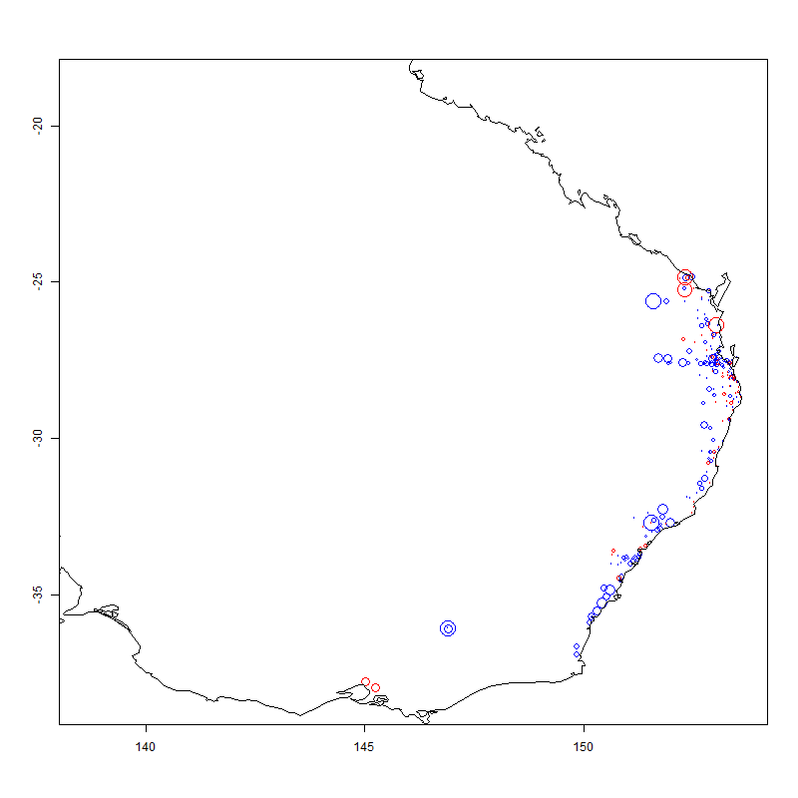

Figure 11 LISA correlation for each camp for a neighbourhood size of 50km. Size of the circle indicates magnitude of correlation. Red circles have a negative correlation, blue are positive

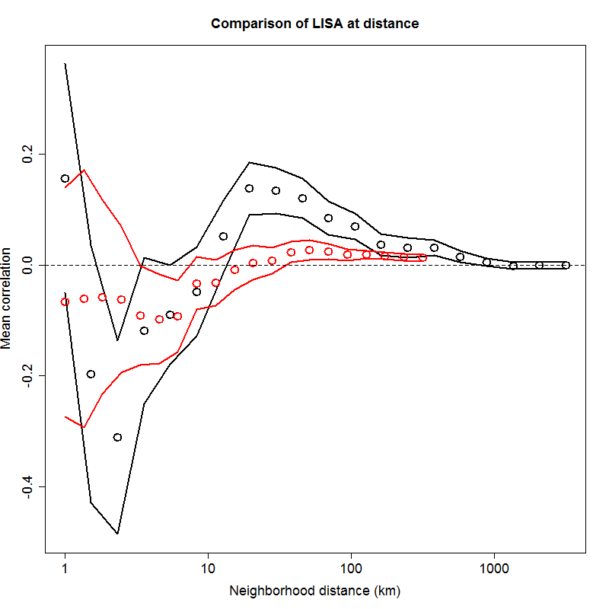

Figure 12 Mean correlation of LISA statistics calculated for all camps for varying neighbourhood size. Black indicates GHFF camps, red indicates SFF camps. Lines indicate 95% confidence intervals.

#### Estimation of the proportion of the known camps and therefore population is missed

The results of the kriging analysis for each of the surveys conducted in the pre-NFFMP and the NFFMP are shown in Figure 13. Overall, 26.9% of known camps were missed in each survey and correcting for this resulted in an average increase of 32.7% in the total population estimate. A simple linear regression of the raw count data suggests a decline in abundance of 169,124 animals over the NFFMP survey, or 84,562 per year over the two years of the NFFMP. Using the estimated true population yields a declining abundance of 209,716 animals over the NFFMP survey, or 104,858 per year. Even if we use the lower confidence bounds of the estimated total population, the linear trend estimate of decline is 180,255 over the NFFMP survey, or 90,127 per year. When counting periods from successive years are analysed, the average year-on-year decrease in counts is 104,348 for the raw data and 102,012 for the estimated true population. The raw counts see a decrease in successive years for two survey periods, with the February, August, and November 2014 counts indicating a year on year increase. For the estimated true population, the August and November 2014 counting periods show the only increase in population.

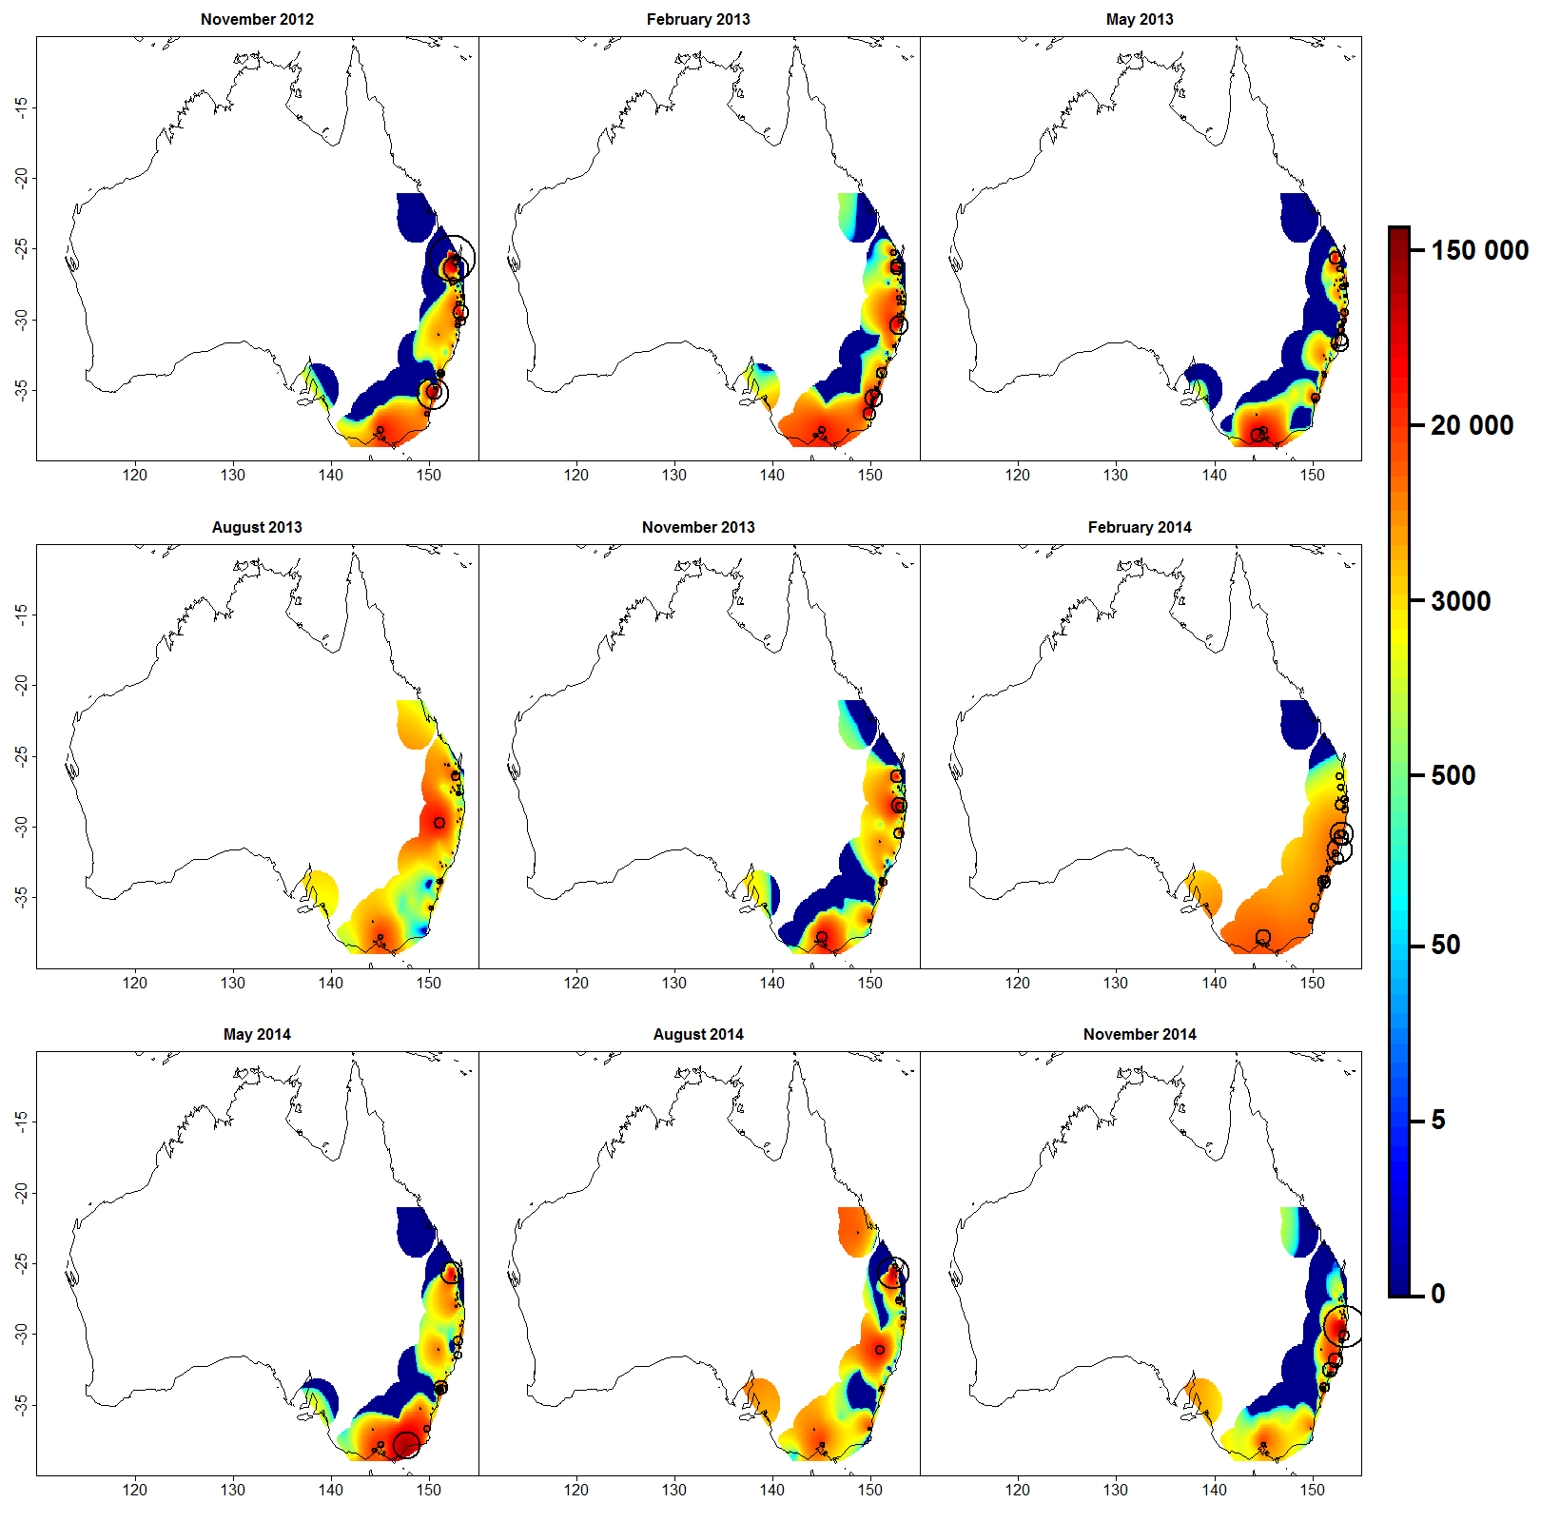

Figure 13 Estimated population distribution of GHFF at each survey period based on the kriging approach to spatial smoothing. The circles represent the relative size of the counts at each camp during the surveying period. The colour scheme is presented on a natural logarithm scale to greater highlight highs and lows in abundance.

#### Kriging validation

At the level of individual camps, the kriging approach does not perform particularly well. This is largely due to the fact that no restriction on the positivity of camp population was made (i.e. negative estimates are permitted). The minimum, maximum, mean, median, and standard deviation of the camp population estimates for each survey period are presented in Table 3 (c.f. Figure 7).

At the level of the species range, however, kriging’s performance was much better and it appears to smooth out unwanted variation arising from missed surveys. The mean estimated number of animals in a camp over the nine survey periods is 2,496 with a standard deviation of 5,741. The median number of animals is 846. These estimates correspond well with the raw data (Table 4). Confidence in the results is strengthened by the fact that the 95% CI of the correlation between camps at small spatial scales for the most part overlaps 0.00 (Figure 12) and that the proportion of camp comparisons at distances of <10km from each other is very small.

|  |  |  |  |  |  |  |  |  |  |
| --- | --- | --- | --- | --- | --- | --- | --- | --- | --- |
| Camp statistic | Survey period | | | | | | | | |
|  | Nov. 2012 | Feb. 2013 | May 2013 | Aug. 2013 | Nov. 2013 | Feb. 2014 | May 2014 | Aug. 2014 | Nov. 2014 |
| Minimum | -5,421 | -1,488 | -1,795 | -95 | -516 | -4,164 | -1,949 | -2,315 | -799 |
| Maximum | 98,039 | 40,456 | 36,377 | 22,388 | 35,126 | 8,145 | 55,582 | 69,255 | 85,767 |
| Mean | 3,286 | 3,150 | 2,515 | 1,563 | 2,153 | 3,111 | 2,376 | 1,783 | 2,528 |
| Median | 772 | 536 | 756 | 863 | 447 | 2049 | 924 | 492 | 438 |
| St. Dev. | 9,126 | 6,370 | 5,159 | 2,230 | 4,840 | 2,353 | 4,893 | 4,977 | 7,843 |
| Total Pop. | 883,975 | 847,375 | 676,603 | 420,413 | 579,248 | 836,981 | 639,061 | 479,565 | 679,951 |
| 95% CI | 242,254 | 123,217 | 102,986 | 55,869 | 108,485 | 56,894 | 124,197 | 138,650 | 164,580 |

Table 3 Minimum, maximum, mean, median, and standard deviation of estimated camp population and total estimated population for each of the nine survey periods. Camp population estimates are derived from the kriging approach detailed in Section 3.4.4.

|  |  |  |  |  |  |  |  |  |  |
| --- | --- | --- | --- | --- | --- | --- | --- | --- | --- |
| Camp statistic | Survey period | | | | | | | | |
|  | Nov. 2012 | Feb. 2013 | May 2013 | Aug. 2013 | Nov. 2013 | Feb. 2014 | May 2014 | Aug. 2014 | Nov. 2014 |
| Minimum | 0 | 0 | 0 | 0 | 0 | 0 | 0 | 0 | 0 |
| Maximum | 100,000 | 42,832 | 39,721 | 26,757 | 37,264 | 56,782 | 60,000 | 70,000 | 92,083 |
| Mean | 3,776 | 2,851 | 2,512 | 1,565 | 1,956 | 3,485 | 2,889 | 1,930 | 2,493 |
| Median | 285 | 155 | 355 | 150 | 238 | 285 | 400 | 182 | 100 |
| St. Dev. | 11,034 | 6,506 | 5,804 | 3,496 | 5,110 | 8,434 | 7,323 | 5,988 | 8,133 |
| Total Pop. | 694,825 | 601,468 | 542,496 | 335,000 | 375,550 | 665,619 | 534,485 | 351,236 | 486,130 |

Table 4 Table 4 Minimum, maximum, mean, median, and standard deviation and total population of survey counts for all camps for each of the nine survey periods.

#### Kriging validation with spectacled flying-fox data

To further validate the spatial smoothing approach, the counts from the spectacled flying-fox survey data were analysed in the same manner. The in-camp population of spectacled flying-foxes estimated using the kriging approach detailed here is presented in Figure 14. A comparison to the state-space modelling approach is overlayed on the figure. The simple kriging approach provides generally commensurate estimates to that of the more sophisticated state-space modelling, albeit with wider confidence bands. This is more evidence that the kriging approach for population estimates produces valid estimates of in camp population of flying-foxes.

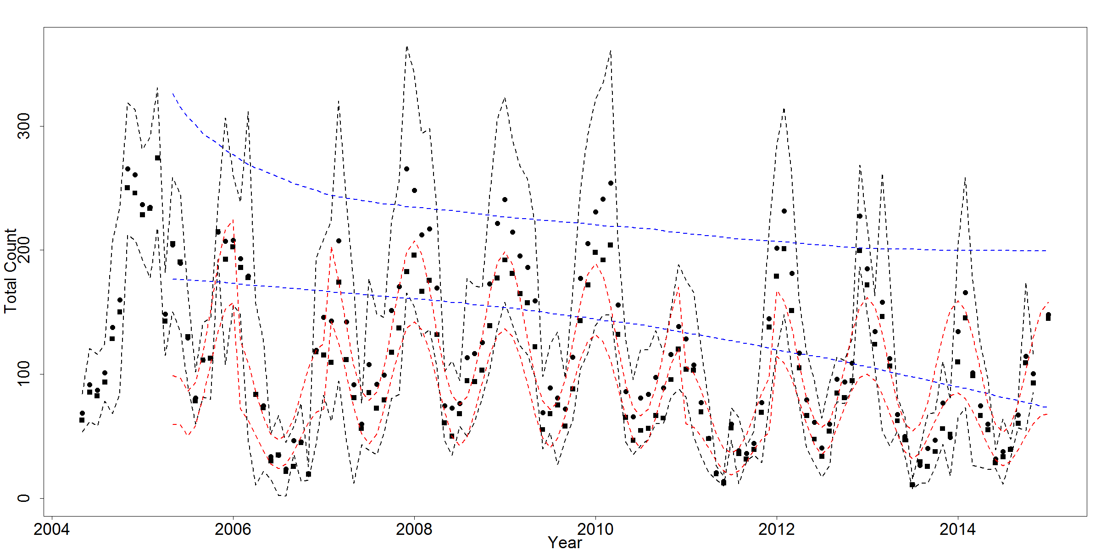

Figure 14 Estimated in population of spectacled flying-foxes. Black lines indicate in camp population confidence intervals from kriging approach. Red and blue lines indicate credibility intervals for in camp and total population estimates from state-space modelling approach. Populations are presented as 1000s of animals.

Despite the uncertainties of the kriging results at the individual camp scale, the validation performed using the SFF data (Figure 14) and the close correspondence of summary statistics to those of the raw GHFF data suggest that at the scale of the species population we can be confident in the results.

#### Comparison to historical national counts

Total abundance estimates and associated confidence bounds for the NFFMP survey periods were constructed using the kriging approach. The population estimates and estimated confidence bounds for all national counts are depicted in Figure 15. The uncertainty about how comprehensive the pre-NFFMP surveys were, i.e. it is unclear whether the pre-NFFMP – NFFMP difference in camps counted was due to camps being missed or to those camps not existing in the pre-NFFMP, means that no kriging correction has been applied to those estimates. Any correction would, however, result in an increase in the pre-NFFMP estimates, potentially by as much as 32% (the overall figure estimated for the NFFMP surveys).

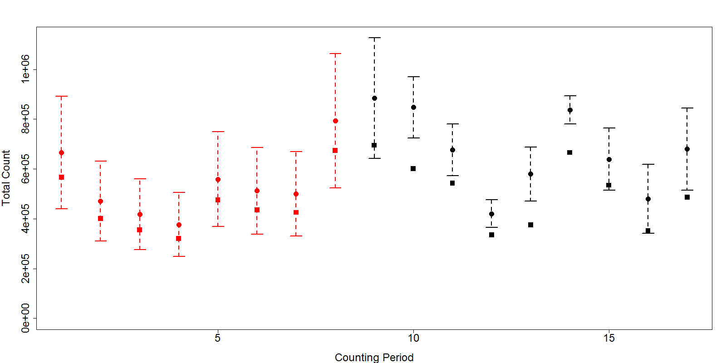

Figure 15 Plot of total estimated GHFF population for all counting periods; red are pre-NFFMP counts (1998–2004), black are NFFMP counts (quarterly from November 2012–November 2014). Squares represent raw counts and circles the estimated true population. The correction and confidence bounds on the pre-NFFMP counts are based on a 34% estimate of precision for fly-out counts. The correction and confidence bounds on NFFMP counts are based on standard error approximation of kriging.

## Discussion

The data indicates a counted population that shows annual variation in size and differences between the two years for which data is presented. The counted population in November of 2014 was 486,130 and once corrected for nights spent away from counted camps and precision the estimated population is 495,852 (±168,590). The kriging analysis suggests a population of 680,000 (±158,500 95%CI) individuals as of November 2014 once missed camps are accounted for. Over the period of the NFFMP monitoring there is an apparent decline in numbers, however, given the confidence intervals associated with the estimate a much longer period of monitoring is required before any such conclusion can be made.

### Comparison of the errors of the Pre-NFFMP and NFFMP Monitoring

As we noted earlier, comparisons between the pre-NFFMP and the NFFMP data are fraught due to uncertainties around the relative impact of the methodological errors between the two survey methods, differences in the geographic scope of the projects, and uncertainty about how comprehensive the two bouts of surveys were relative to each other. The result of these uncertainties is to make any conclusions about the population trend from the pre-NFFMP to the NFFMP surveys very tenuous. Because of this our recommendation at the outset of the NFFMP was that the uncertainties were too great for there be any confidence and that the aim of the NFFMP should be to establish a current baseline and on-going monitoring to allow for future trends to be established.

While this is still our position we acknowledge that it is inevitable that the comparisons will be made and that conclusions will be drawn based on the available data, i.e. that available in the pre-NFFMP reports and this report. Given this, it is important that any such comparisons are not based on a simple and direct comparison of the numbers presented in this report and in the pre-NFFMP reports. As a consequence we have invested in trying to make such comparisons more realistic and provide our understanding of how any such comparisons should be interpreted.

#### Accuracy

Ideally, in an attempt to estimate confidence in an estimate, we are interested in the accuracy of the measurements that led to it, i.e. how close to the true number our measurement is, and the precision of that measurement, i.e. how much variation there is between repeated measurements. In assessing the accuracy of flying-fox monitoring we are severely limited because, except in exceptional circumstances, it is impossible to ascertain the true size of a camp once numbers get beyond a few hundreds of individuals, and often even less than this. This is a function of issues to do with detection of all individuals in a complex habitat, the tolerance of flying-foxes to counters in the camp, the sheer number of animals often present, accessibility, and in some cases, the structure of the camp, with clusters often well separated from the main group.

Several studies to date have examined accuracy in the context of fly-out counts (Westcott & McKeown 2004; Forsyth *et al.* 2006) but in each case have only estimated accuracy for individual fly-out streams, leaving additional errors, e.g. those introduced by counting multiple streams at a camp and aggregating those counts across the camp and population, largely unaddressed (Westcott & McKeown 2004). Based on individual streams, these studies estimate an accuracy of -15% on average, a result supported by comparisons between very meticulous direct counts and fly-outs at Yarra Bend (van der Ree *et al.* 2009).

As a consequence, in this analysis we have used an accuracy of -15% based on assessments of fly-outs to correct the pre-NFFMP fly-out counts but made no accuracy adjustment for the NFFMP counts for which we have no equivalent accuracy correction. This has the effect of making the counts from the two phases more similar than might be the case if the accuracy of the NFFMP counts were also negative, if NFFMP counts are under-counts then correction would push those estimates higher. For reasons outlined below we think that this is a reasonable and cautious option as it has the effect of making our conclusions more conservative.

#### Precision

In the first phase of the monitoring, error was estimated in cases where two counts were reported from a single camp. These counts were usually performed on subsequent nights. In these instances a measure of precision was derived as the percentage deviation of the two counts from the mean count (Eby 2004; Birt 2005). Birt (2005) reported the differences between paired fly-out counts in different surveys as: Vic 17.5%, n=6, 2005; Vic 45%, n=3, 2004; NSW, 15%, n=60, 2005; NSW, 6.75%,n=61, 2004). This gives an average error (precision) of c. 12% across the surveys.

In the NFFMP phase of the counting we have also used instances of multiple counts to estimate error, though in our case the counts were generally done simultaneously. In the NFFMP we estimate precision as the absolute difference between paired counts expressed as a percentage of the mean of the counts. The precision of fly-out counts in the NFFMP fly-out counts, calculated using absolute values, was 34% but when calculated as a percentage deviation from the mean was 16%. . Similarly, while the average precision estimated using absolute values of all methods in the NFFMP is 34% (S.D.=28, n=95) it was 14% (S.D.=42, n=91) when estimated simply as the percentage deviation from the mean. This suggests that the precision of the two phases is comparable though slightly higher in the NFFMP. In view of this, in our subsequent analyses we have used a fly-out precision derived from fly-outs conducted during the NFFMP for both phases.

In summary, both phases of the monitoring had moderate levels of absolute counting precision, which in the case of the NFFMP was 34%. From a monitoring perspective, less precise estimates require a greater sample size to achieve any given level of statistical confidence even when they are very accurate, and thus the monitoring must be continued for longer to achieve that confidence.

### Changes in the scope of the monitoring

There were significant changes in the geographic scope of the monitoring in the two phases with the NFFMP phase covering camps well beyond the pre-NFFMP range, e.g. in Canberra, Tumut, Adelaide, Finch Hatton (central Qld) and Ingham (FNQ), and the western plains. Though these are dramatic increases in range, the camps at these sites generally contribute relatively little to the number of camps or the total population estimate. Interestingly, though it is tempting to think of these as dramatic changes in the distribution and behaviour of GHFFs, reports of flying-foxes, potentially GHFF, from such places are in fact not new, e.g. there are reports from Goulbourn in 1873, Wellington in 1920, Gawler near Adelaide in 1920. This suggests that they have either recently recolonised these areas after a long absence, or, that the range boundaries are more dynamic over the longer-term than we have previously realised (Roberts *et al.* 2012).

With the greatly increased number of camps checked in the NFFMP (Figure 9) it seems reasonable to conclude that this phase covered a greater proportion of camps than did the pre-NFFMP surveys, a reflection of accumulated additional knowledge over the intervening period and the resources available in the NFFMP. This conclusion is support by confirmation that a number of significant camps were not covered in the pre-NFFMP phase for a variety of reasons, e.g. no available counters, not known to coordinators, and that while these issues remained in the NFFMP they appear to be less severe (J. Wellbergen, pers. comm.).

### Correction for animals roosting away from camps

Telemetry indicates that animals roosting away from known camps results in an average underestimate of 11%, though this varies seasonally. As predicted based on an understanding of the social and resource dynamics, we found a greater tendency for individuals to spend time away from the known camps during the winter months (17% May, 27% August), a period when reproductive and resource drivers would provide reduced cause for aggregating in camps. In contrast just 2% and 0% of tagged animals’ days were spent roosting away from known camps during November and February quarters. We suggest that these estimates are likely to be an underestimate as our sample is biased towards males due to animal ethics considerations and animals were trapped in camps and likely had a preference for camps. Our on-going work seeks to rectify these biases.

### Population trend from Pre-NFFMP to NFFMP

The results presented here suggest that, based on the raw numbers and our estimates corrected using field data and kriging, that the population size has remained relatively constant from the pre-NFFMP and the NFFMP monitoring (Figure 8, Figure 15). In each case however it needs to be remembered that we could not apply all the same corrections to both the pre-NFFMP and the NFFMP estimates and that this makes direct comparisons unreliable.

In the case of the estimates that use the field data corrections, the NFFMP has not been adjusted for accuracy while the pre-NFFMP has. Considered as is, the error bars of the NFFMP counts overlap most of the range of the error bars of the pre-NFFMP counts and all the estimates from this period indicating little difference between the phases (Figure 8). If we are willing to assume that the pre-NFFMP phase missed camps then this difference would be reduced by any correction applied as this would increase the estimates for this period. We think this is a reasonable assumption but have not applied a correction here due to the lack of any means of assessing the proportion of camps missed and the magnitude of the correction. The magnitude of any such correction is also uncertain. While Figure 9 might suggest that c. nearly half the camps were missed whether this should result in a doubling of the estimate or much less would depend on whether the camps missed were a random selection of all camps or were more likely to be the smaller and therefore less detectable camps. If differences in average camp size across the two periods (Figure 10) can be ascribed to the latter then the correction might be relatively small. However, a change in camp use, resulting in more and smaller camps during the NFFMP, cannot be ruled out.

There is evidence to suggest that all factors may be at play. A shift to more and smaller camps has been reported for certain parts of the GHFF range and attributed to loss of habitat, fragmentation and urbanisation of the population (P. Eby, pers. comm., Parry-Jones, pers. comm.). At the same time, and all other things being equal, it is larger camps that are most likely to be found first and therefore it is reasonable to expect that the pre-NFFMP monitoring, starting with a smaller knowledge base and fewer resources, would inevitably have missed camps and may have been more biased towards larger camps. If only a shift towards more and smaller camps is involved then we would expect little effect on population estimates because it suggests few camps were missed. If only sampling bias is involved then we would expect a larger effect. If both processes are operating then we would expect some intermediate impact, dependent on the relative magnitude of the effects. We think that it is most likely that both processes are operating and therefore that the effect is an intermediate underestimate of the true number in the pre-NFFMP phase relative to the NFFMP phase. We suggest that correction for this effect would result in a stable to declining population trend if comparisons were made across the two phases.

In the case of the kriging correction we run into similar difficulties. Here while we can correct the pre-NFFMP for accuracy and precision from published work, we cannot confidently use the Kriging approach to correct for missed camps because we cannot distinguish between camps that were not surveyed because they did not exist and those that were simply missed. Without this correction the estimates for the two periods fall in roughly the same range. If we could assume that there was a similar effect to that estimated for the NFFMP monitoring then we could expect the population estimates to increase possibly by as much as 33%. Thus, depending on the assumptions one is willing to make, this analysis suggests that GHFF populations have at best remained stable but are more likely to have declined slightly over the two periods. Given that recent analyses of population structure and population trend modelling based on this suggest a declining population (Divljan *et al.* 2006) we think it is reasonable to assume that the population is in decline. This issue can only now be confidently resolved with long term monitoring data; the two years of data we have in hand is insufficient. Further data would eventually permit imputation of missing survey data using more standard methods, negating the need for the kriging approach.

## Conservation Status

We suggest that the GHFF population is on the order of 680,000 (±164,500) individuals and has at best been stable but more likely has declined by some amount over the pre-NFFMP to NFFMP period. Given this and the fact that the threats that originally led to the listing of the species remain while new threats such as extreme weather events (Welbergen *et al.* 2008) are emerging, there seems to be little justification for downgrading the species status.

## Conclusions

* The NFFMP monitoring and the corrections applied to its data suggest a GHFF population of 680,000 (±164,500). Longer-term monitoring will provide greater confidence in this estimate.
* Comparison between the pre-NFFMP and NFFMP phase is difficult because of differences in the methods and in their errors, differences in the number of camps monitored and uncertainty as to the proportion of the camps actually monitored. It would be unwise to place confidence in simplistic and direct comparisons of the results of the two phases of monitoring.
* Because comparisons will inevitably be made, we present comparisons here which attempt to take into account the effects of the errors involved. The results of our empirical and analytical corrections suggest that the GHFF population has remained relatively stable but may have declined over the intervening period between two monitoring periods.
* The goal of the NFFMP was to establish a monitoring program and provided a baseline for GHFF population sizes against which on-going monitoring could establish trends. This is a long term goal and we must continue to make the necessary investments to achieve it, particularly in the context of the on-going issues of conflict associated with the species. In short, determination of population trends should be an outcome of future monitoring under this program not from the fuzzy comparisons with previous programs that are currently possible.
* We suggest that there is no justification based on the monitoring data and current threats for a downgrading of the species at this point in time.

References

Banerjee S., Carlin B.P. & Gelfand A.E. (2004). *Hierarchical Modeling and Analysis for Spatial Data*. Chapman and Hall/CRC Press, Boca Raton, FL.

Birt P. (2005). National Population Assessment- Grey-headed Flying-foxes Pteropus poliocephalus. A report to: Department of Environment and Heritage, Queensland Parks and Wildlife Service, New South Wales Department Environment and Conservation, Victorian Department Sustainability and Environment. p

Bonaccorso F. ( 1998). *Bats of Papua New Guinea*. Conservation International, Washington, DC, USA.

Buettner P.G., Westcott D.A., Maclean J., Brown L., McKeown A., Johnson A., Wilson K., Blair D., Luly J., Skerratt L., Muller R. & Speare R. (2013). Tick Paralysis in Spectacled Flying-Foxes (*Pteropus conspicillatus*) in North Queensland, Australia: Impact of a Ground-Dwelling Ectoparasite Finding an Arboreal Host. *PLoS One*, 8, e73078.

Cressie N. (1993). *Statistics for spatial data*. J. Wiley.

Dakos V., Carpenter S.R., Brock W.A., Ellison A.M., Guttal V., Ives A.R., Kefi S., Livina V., Seekell D.A., van Nes E.H. & Scheffer M. (2012). Methods for Detecting Early Warnings of Critical Transitions in Time Series Illustrated Using Simulated Ecological Data. *PLoS One*, 7, 20.

Dakos V., Carpenter S.R., van Nes E.H. & Scheffer M. (2015). Resilience indicators: prospects and limitations for early warnings of regime shifts. *Philos. Trans. R. Soc. B-Biol. Sci.*, 370, 10.

Dennis A. & Westcott D. (2007). Estimating dispersal kernels produced by a diverse community of vertebrates. In: *Frugivory and Seed Dispersal: theory and its application in a changing world* (eds. Dennis A, Green R, Schupp E & Westcott D). CAB International Publishing Wallingford, pp. 201-228.

Department of the Environment (2015a). Monitoring Flying-Fox Populations. URL <http://www.environment.gov.au/biodiversity/threatened/species/flying-fox-monitoring>. Accessed 21st April 2015

Department of the Environment (2015d). Pteropus poliocephalus in Species Profile and Threats Database. URL <http://www.environment.gov.au/sprat>. Accessed 24 Apr 2015 12:06:50 +1000.

Divljan A., Parry-Jones K. & Wardle G.M. (2006). Age determination in the grey-headed flying fox. *J. Wildl. Manage.*, 70, 607-611.

Dobbie M., Westcott D.A. & Caley P. (2013). Method for estimation of population abundance and error from flying-fox monitoring. CSIRO. p 18.

Eberhardt L.L. & Simmons M.A. (1992). Assessing rates of increase from trend data. *Journal of Wildlife Management*, 56, 603-610.

Eby P. (1991). Seasonal movements of gray-headed flying-foxes, *Pteropus poliocephalus* (Chiroptera, Pteropodidae), from 2 maternity camps in northern New South Wales. *Wildl. Res.*, 18, 547-559.

Eby P. (1998). An analysis of diet specialization in frugivorous Pteropus poliocephalus (Megachiroptera) in Australian subtropical rainforest. *Aust. J. Ecol.*, 23, 443-456.

Eby P. (2002). National Count of Grey-headed Flying foxes July 27 & 28, 2002. A report to: Environment Australia Queensland Parks and Wildlife Service NSW National Parks and Wildlife Service and Victorian Dept Natural Resources and Environment. p 19.

Eby P. (2003). National Count of Grey-headed Flying foxes April 12 & 13, 2003. A report to: Dept. Environment and Heritage Queensland Parks and Wildlife Service, NSW Dept. Environment and Conservation Victoria Dept. Sustainability and Environment. p 21.

Eby P. (2004). National Count of Grey-headed Flying-foxes April 3 & 4, 2004. A report to: Dept. Environment and Heritage Queensland Parks and Wildlife Service NSW Dept. Environment and Conservation, Victoria Dept. Sustainability and Environment. p 22.

Eby P. & Law B. ( 2008). Ranking the feeding habitat of Grey-headed flying foxes for conservation management. Department of Environment, Heritage, Water and the Arts, Canberra.

Eby P., Richards G., Collins L. & Parry-Jones K. (1999). The distribution, abundance and vulnerability to population reduction of a nomadic nectarivore, the grey-headed flying-fox *Pteropus poliocephalus* in New South Wales, during a resource concentration. *Australian Zoologist*, 31, 240-253.

Fields Development Team (2006). fields: Tools for Spatial Data. In. National Center for Atmospheric Research Boulder, CO.

Forsyth D.M., Scroggie M.P. & McDonald-Maddena E. (2006). Accuracy and precision of grey-headed flying-fox (Pteropus poliocephalus) flyout counts. *Wildl. Res.*, 33, 57-65.

Fox S. (2011). *The Spectacled Flying-fox - a review of past and present knowledge*.

Fox S., Luly J., Mitchell C., Maclean J. & Westcott D.A. (2008). Demographic indications of decline in the spectacled flying fox (Pteropus conspicillatus) on the Atherton Tablelands of northern Queensland. *Wildl. Res.*, 35, 417-424.

Garnett S., Whybird O. & Spencer H.J. (1999). The Conservation status of the Spectacled Flying-fox Pteropus conspicillatus in Australia. *Australian Zoologist*, 31, 38-54.

Hansen M.C., Potapov P.V., Moore R., Hancher M., Turubanova S.A., Tyukavina A., Thau D., Stehman S.V., Goetz S.J., Loveland T.R., Kommareddy A., Egorov A., Chini L., Justice C.O. & Townshend J.R.G. (2013). High-Resolution Global Maps of 21st-Century Forest Cover Change. *Science*, 342, 850-853.

Helgen K., Salas L. & Bonaccorso F. ( 2008). Pteropus conspicillatus. The IUCN Red List of Threatened Species. Version 2014.3. URL [www.iucnredlist.org](http://www.iucnredlist.org). Accessed 21 April 2015

Hughes T.P., Linares C., Dakos V., van de Leemput I.A. & van Nes E.H. (2013). Living dangerously on borrowed time during slow, unrecognized regime shifts. *Trends Ecol. Evol.*, 28, 149-155.

Humbert J.-Y., Mills L.S., Horne J.S. & Dennis B. (2009). A better way to estimate population trends. *Oikos*, 118, 1940-1946.

Maron M., Laurance W.F., Pressey B., Catterall C.P., Watson J. & Rhodes J. (2015). Land clearing in Queensland triples after policy ping pong URL <https://theconversation.com/land-clearing-in-queensland-triples-after-policy-ping-pong-38279>. Accessed 18 March 2015

Parry-Jones K. & Augee M.L. (1991a). The diet of flying-foxes in Sydney and Gosford areas of New South Wales, based on sighting reports 1986-1990. *Australian Zoologist*, 27, 49-54.

Parry-Jones K. & Augee M.L. (1991b). Food selection by grey-headed flying-foxes (*Pteropus poliocephalus*) occupying a summer colony site near Gosford, New South Wales. *Wildl. Res.*, 18, 111-124.

Parry-Jones K.A. & Augee M.L. (2001). Factors affecting the occupation of a colony site in Sydney, New South Wales by the Grey-headed Flying-fox Pteropus poliocephalus (Pteropodidae). *Austral Ecology*, 26, 47-55.

Parsons J.G., Cairns A., Johnson C.N., Robson S.K.A., Shilton L.A. & Westcott D.A. (2006). Dietary variation in spectacled flying foxes (Pteropus conspicillatus) of the Australian Wet Tropics. *Aust. J. Zool.*, 54, 417-428.

Queensland Department of Environment and Resource Management D. (2010). National recovery plan for the spectacled flying fox Pteropus conspicillatus. Report to the Department of Sustainability, Environment, Water, Population and Communities, Canberra. p

R Development Core Team (2008). R: A language and environment for statistical computing. In. R Foundation for Statistical Computing Vienna, Austria.

Richards G.C. (1987). Aspects of the Ecology of Spectacled Flying-foxes, Pteropus conspicillatus (Chiroptera: Pteropodidae) in Tropical Queensland. *Australian Mammalogy*, 10, 87-88.

Roberts B.J., Catterall C.P., Eby P. & Kanowski J. (2012). Latitudinal range shifts in Australian flying-foxes: A re-evaluation. *Austral Ecology*, 37, 12-22.

Roberts B.J. & Eby P. (submitted). Pteropus conspicllatus, Gould 1850. Assessment submitted for the IUCN Redlist Assessments. p

Roberts B.J., Eby P., Catterall C.P., Kanowski J. & Bennett G. (2011). The outcomes and costs of relocating flying-fox camps: insights from the case of Maclean, Australia. In: *The Biology and Conservation of Australasian Bats* (eds. Law B, Eby P, Lunney D & Lumsden L). Royal Zoological Society of NSW Mosman, NSW, Australia, pp. 277–287.

Shilton L.A., Latch P.J., McKeown A., Pert P. & Westcott D.A. (2008). Landscape-scale redistribution of a highly mobile threatened species, Pteropus conspicillatus (Chiroptera, Pteropodidae), in response to Tropical Cyclone Larry. *Austral Ecology*, 33, 549-561.

Stibig H.J., Achard F., Carboni S., Raši R. & Miettinen J. (2014). Change in tropical forest cover of Southeast Asia from 1990 to 2010. *Biogeosciences*, 11, 247–258.

Sturtz S., Ligges U. & Gelman A. (2010). R2OpenBUGS: A Package for Running OpenBUGS from R. In.

Tait J., Perotto-Baldivieso H.L., McKeown A. & Westcott D.A. (2014). Are Flying-Foxes Coming to Town? Urbanisation of the Spectacled Flying-Fox (*Pteropus conspicillatus*) in Australia. *PLoS One*, 9, e109810.

Thomas L., Buckland S.T., Rexstad E.A., Laake J.L., Strindberg S., Hedley S.L., Bishop J.R.B., Marques T.A. & Burnham K.P. (2010). Distance software: design and analysis of distance sampling surveys for estimating population size. *J. Appl. Ecol.*, 47, 5-14.

Threatened Species Scientific Committee (2002). Commonwealth Listing Advice on Pteropus conspicullatus (Spectacled Flying-fox). URL <http://www.environment.gov.au/biodiversity/threatened/species/p-conspicillatus.html>. Accessed 16 Mar 2010

van der Ree R., Wilson C. & Yazgin V. (2009). Yarra Bend Park Flying-fox campsite: review of the scientific research. Victorian Government Department of Sustainability and Environment. p 24.

Welbergen J.A., Klose S.M., Markus N. & Eby P. (2008). Climate change and the effects of temperature extremes on Australian flying-foxes. *Proc. R. Soc. B-Biol. Sci.*, 275, 419-425.

Westcott D., Dennis A., Bradford M., McKeown A. & Harrington G. (2008). Seed dispersal processes in Australia’s Wet Tropics rainforests. In: *Living in a dynamic tropical forest landscape* (eds. Stork N & Turton S). Blackwell Publishing Malden., pp. 210-223.

Westcott D.A. (2013). Flying-foxes and settlements in FNQ: evidence from the early Cairns newspapers. *Ecotone*, 32, 4-5.

Westcott D.A., Dennis A.J., McKeown A., Bradford M. & Margules C. (2001). The Spectacled Flying fox, Pteropus conspicillatus, in the context of the world heritage values of the Wet Tropics World Heritage Area. p 75.

Westcott D.A., Fletcher C.S., McKeown A. & Murphy H.T. (2012). Assessment of monitoring power for highly mobile vertebrates. *Ecol. Appl.*, 22, 374-383.

Westcott D.A. & McKeown A. (2004). Observer error in exit counts of flying-foxes (Pteropus spp.). *Wildl. Res.*, 31, 551-558.

Westcott D.A., McKeown A., Murphy H.T. & Fletcher C.S. (2011). A monitoring method for the greyheaded flying-fox, Pteropus poliocephalus. A report to the Commonwealth Department of Sustainability, Environment, Water, Population and Communities. p 58.

Westcott D.A. & McKeown. A. (2014). Flying foxes and drifting continents Invasion Biology and Ecological Theory. In. Cambridge University Press, pp. 138-158.

Woinarski J.C.Z., Burbidge A.A. & Harrison P. (2014). *The Action Plan for Australian Mammals 2012*. CSIRO Publishing, Collingwood, Victoria, Australia.

|  |  |  |
| --- | --- | --- |
|  | | |
| CONTACT US  t 1300 363 400  +61 3 9545 2176  e enquiries@csiro.au  w www.csiro.au  Your CSIRO  Australia is founding its future on science and innovation. Its national science agency, CSIRO, is a powerhouse of ideas, technologies and skills for building prosperity, growth, health and sustainability. It serves governments, industries, business and communities across the nation. |  | For further information  Land and Water Flagship  David Westcott  t +61 7 4091 8827  e david.westcott@csiro.au  w [www.csiro.au/Land](http://www.csiro.au/Land) and Water |