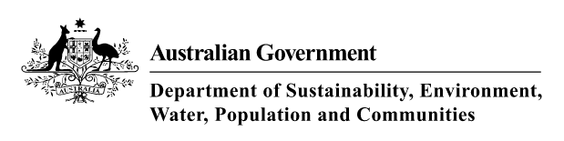

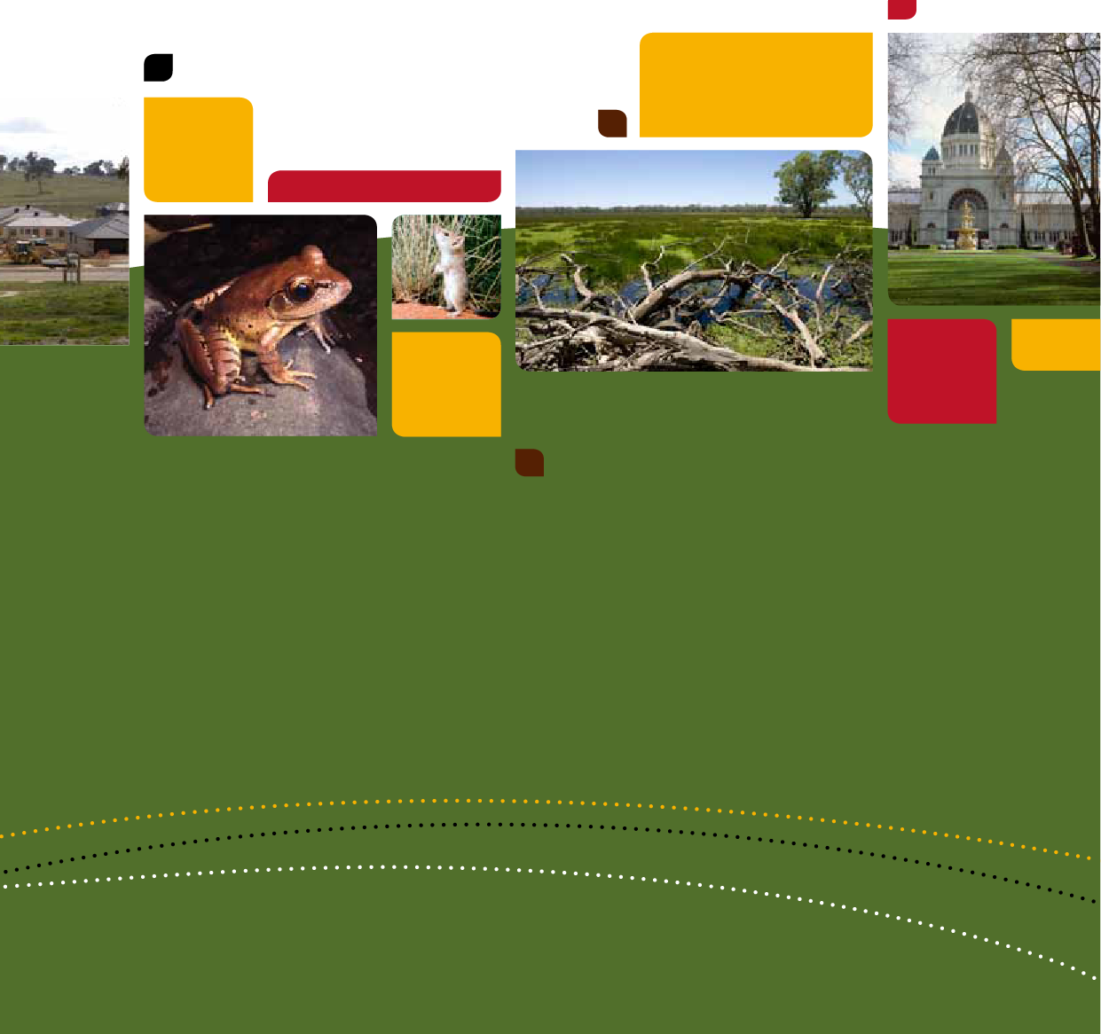A GUIDE to undertaking Strategic Assessments

*Environment Protection and Biodiversity Conservation Act 1999*

**First published 2011. Reprinted (minor amendments) March 2012, November 2012 and June 2013.**

Photo Credits: Front Cover (L – R): Housing construction (Steve Wray), Fleay’s frog (Steve Wilson), Mulgara (Ken Johnson), Yanga National Park (Mark Mohell), Royal Exhibition Building and Carlton Gardens (National Trust of Australia).

Back Cover (L-R): Green Turtle swimming with fish over coral (GBRMPA), Box gum grassy woodland (Andrew Tatnell), Chudich

(Todd R Soderquist), Redgum trees on the McIntyre River floodplain (Arthur Mostead), Housing construction (Steve Wray).

**Disclaimer**

Prepared by Open Lines Environmental Consulting for the department.

This document may only be used for the purpose for which it was commissioned and in accordance with the contract between Open

Lines Environmental Consulting and the Department of Sustainability, Environment, Water, Population and Communities.

Open Lines Environmental Consulting accepts no liability or responsibility whatsoever for or in respect of any use of or reliance upon this report and its supporting material by any third party. Information provided is not intended to be a substitute for legal advice in relation to any matter. Unauthorised use of this report in any form is prohibited.

The views and opinions expressed in this publication are those of the authors and do not necessarily reflect those of the Australian Government or the Minister for Sustainability, Environment, Water, Population and Communities.

While reasonable efforts have been made to ensure that the contents of this publication are factually correct, the Commonwealth does not accept responsibility for the accuracy or completeness of the contents, and shall not be liable for any loss or damage that may be occasioned directly or indirectly through the use of, or reliance on, the contents of this publication.

**© Commonwealth of Australia 2013**

This work is copyright. Apart from any use as permitted under the Copyright Act 1968, no part may be reproduced by any process without prior written permission from the Commonwealth. Requests and enquiries concerning reproduction and rights should be addressed to Department of Sustainability, Environment, Water, Populations and Communities, Public Affairs, GPO Box 787 Canberra ACT 2601 or email [public.affairs@environment.gov.au](mailto:public.affairs@environment.gov.au)

Further information about the EPBC Act is available on the Department of Sustainability, Environment, Water, Population and Communities website [www.environment.gov.au/epbc](http://www.environment.gov.au/epbc) or by contacting the department’s Community Information Unit [ciu@environment.gov.au](mailto:ciu@environment.gov.au) or freecall 1800 803 772.

# Contents

Introduction 4

Environment Protection and Biodiversity Conservation Act 4

Assessment and approval pathways 5

Outcomes 7

Outcomes for matters of national environmental significance 7

Ecologically sustainable development outcomes 12

Planning outcomes 13

Process 14

Timing of the assessment process 16

Scoping of the assessment 16

Strategic assessment agreement 17

Preparation of the draft Program 19

Draft strategic assessment report 20

Public consultation 20

Submission of the final documents 21

Program endorsement 22

Approval of actions 22

Implementation of the Program 23

Compliance with the Program 23

Ingredients for success 25

Fundamentals 26

Data 26

Funding and resources for the assessment process 27

Governance arrangements 27

Appendix A — Program document structure 28

Appendix B — Strategic assessment report structure 29

# Introduction

The purpose of this guide is to explain the strategic assessment process under the Australian Government’s national environment law—the Environment Protection and Biodiversity Conservation Act 1999 (EPBC Act).

Strategic assessments are a landscape scale assessment and unlike project-by-project assessments, which look at individual actions (such as a port or a mine), they can consider a much broader set of issues. For example, a large urban growth area that will be developed over many years or a fire management policy across a broad landscape.

This guide:

* provides an introduction to national environment law and strategic assessments
* outlines the environmental and planning outcomes that can be achieved
* walks through the assessment process
* discusses the necessary ingredients for a successful strategic assessment
* outlines the fundamentals that need to be in place to conduct the assessment.

## Environment Protection and Biodiversity Conservation Act

The Environment Protection and Biodiversity Conservation Act 1999 (EPBC Act) is the Australian Government’s central environmental legislation. It provides a legal framework to protect and manage nationally and internationally important flora, fauna, ecological communities and heritage places - defined in the EPBC Act as matters of national environmental significance.

The eight matters of national environmental significance (MNES) are:

* world heritage properties
* national heritage places
* wetlands of international importance (often called ‘Ramsar’ wetlands after the international treaty under which such wetlands are listed)
* nationally threatened species and ecological communities
* migratory species
* Commonwealth marine areas
* the Great Barrier Reef Marine Park
* nuclear actions (including uranium mining)
* a water resource, in relation to coal seam gas development and large coal mining development.

The EPBC Act also regulates the behaviour of Commonwealth agencies and actions that occur on Commonwealth land where there may be a significant impact on the environment (even if that significant impact is not on one of the eight MNES).

The federal environment department administers the EPBC Act. This is currently the Australian Government Department of Sustainability, Environment, Water, Population and Communities (the department or SEWPAC).

The federal environment minister (the minister) is the decision maker in relation to strategic assessments.

Any new proposal or development that is likely to have a significant impact on MNES must be approved by the minister.

The EPBC Act refers to a new proposal or development as an ‘action’.

Unless stated otherwise the definitions and terms in the EPBC Act apply to this guide.

## Assessment and approval pathways

The EPBC Act offers two pathways to achieve approval for actions that are likely to have a significant impact on MNES. The first of those is the referral, assessment and approval process (known as project-by-project assessments). The second is the strategic assessment process. Both processes have their benefits and are appropriate for different situations.

### Project-by-project assessments

Project-by-project assessments (Parts 7, 8 and 9 of the EPBC Act) consider the potential impacts of individual actions on MNES. They relate to the actions of a single proponent or developer, and provide an assessment process for one action at a time. This guide does not address project-by- project assessments any further, but information about this process is available at: [www.environment.gov.au/epbc/assessments/strategic.html.](http://www.environment.gov.au/epbc/assessments/strategic.html)

### Strategic assessments

Strategic assessments (Part 10 of the EPBC Act) offer the opportunity to look at, and potentially approve, a series of new proposals or developments (actions) over a much larger scale and timeframe (even if the developer is currently not known).

At a broad level, the process occurs in two steps:

1. assessment and endorsement of a ‘policy, plan or program’ (referred to from this point as ‘Program’)
2. approval of actions (or classes of actions) that are associated with the Program. It is this second step that potentially allows development to proceed across a large area without further need for EPBC Act approval of individual developments (project-by-project assessments).

Strategic assessments are undertaken by the organisation responsible for implementing the Program (for example, state or territory government, local council, industry group or organisation) in partnership with the Australian Government. They are designed to be a collaborative process that delivers positive outcomes for both parties.

Examples of Programs that could be strategically assessed include:

* regional-scale urban development plans and policies
* large-scale industrial development and associated infrastructure
* fire, vegetation/resource or pest management policies, plans or programs
* water extraction/use policies
* infrastructure plans and policies
* industry sector policies.

More information on the strategic assessment process is provided in the ’Strategic assessments process’ section of this document. Examples of recent and current strategic assessments are available at: [www.environment.gov.au/epbc/assessments/strategic.html.](http://www.environment.gov.au/epbc/assessments/strategic.html)

# Outcomes

Entering into a strategic assessment offers the potential to deal with cumulative impacts on matters of national environmental significance (MNES) and look for both conservation and planning outcomes at a much larger scale than can be achieved through project-by-project assessments. The process is designed to be flexible and provide the opportunity to reach

a negotiated outcome for the benefit of both parties.

Advantages of doing a strategic assessment include:

* clear ‘goal posts’ or requirements for protection of MNES are set upfront, at the planning stage
* greater certainty to local communities and developers over future development
* reduced administrative burden for strategic assessment partners and government through:
  + a substantial reduction in the number of environmental assessments required for an area
  + the avoidance of potentially duplicative and separate environmental assessments by different types of government (such as Australian, state, territory or local governments)
* capacity to achieve better environmental outcomes and address cumulative impacts at the landscape level
* coordinated establishment and management of offsets
* flexible timeframes to better meet planning processes.

## Outcomes for matters of national environmental significance

In entering into a strategic assessment, the Australian Government seeks to maximise conservation of MNES values that occur within the strategic assessment area, in the most practical and achievable way. To do this the assessment takes a landscape approach to environmental assessment rather than undertaking assessments at a site level.

To achieve this outcome, the Australian Government expects that during the strategic assessment process, all parties will consider how the Program can use the four mechanisms illustrated in Figure 1 to maximise beneficial outcomes for MNES. It is important to note that to successfully do this, strategic assessment partners need to engage early and often with the department to ensure the process is a collaborative one.1. Avoidance of impacts:
  * As a first priority every effort should be made to avoid impacts to MNES
   * Development that is designed to avoid MNES values should be prioritised
2. Mitigation of potential impacts
  * Mitigation measures to protect MNES values from potential impacts (for example construction activities) should be developed
3. Offsets 
  * Environmental offsets should be applied to compensate for impacts to MNES that can't be avoided or mitigated 
4. Ongoing adaptive management
 * Ongoing adaptive management is critical to provide positive long-term outcomes for MNES


Figure : Key steps for achieving positive outcomes for matters of national environmental significance (MNES)

### Understanding adverse impacts to matters of national environmental significance (MNES)

In doing a strategic assessment, it is important to gain a good understanding of both potential ‘direct’ and ‘indirect’ impacts to MNES as a result of implementing the Program.

‘Direct’ impacts relate to the loss of MNES values as a direct result of the Program. For example, clearing of a threatened ecological community or loss of habitat for a threatened species. Direct impacts generally arise due to the on-site activities within a Program area (such as construction of roads or urban development).

Indirect impacts include:

* ‘downstream’ or ‘downwind’ impacts, such as impacts on wetlands or ocean reefs from sediment, fertilisers or chemicals that are washed or discharged into river systems
* ‘upstream impacts’ such as impacts associated with the extraction of raw materials and other inputs used to undertake the Program
* ‘facilitated impacts’ resulting from further actions (including actions by third parties) that are made possible or facilitated by the Program. For example, the construction of a dam for irrigation water facilitates the use of that water by irrigators with associated impacts. Likewise, construction of basic infrastructure in a previously undeveloped area may, in certain circumstances, facilitate urban or commercial development of that area.

‘Indirect’ impacts are relevant when they can be linked to activities within the Program, and are thus considered a consequence of that Program, and they can reasonably be assumed to be within the scope of the considerations the organisation responsible for the Program should take into account.

### Avoidance of impacts

Avoiding impacts to MNES is the highest priority. Every effort should be made in designing the Program to protect existing values of these matters through upfront consideration and planning. In working through the strategic assessment process, the Australian Government will look for the best options to avoid impacts within the context of the objectives of the Program.

Avoidance of impacts can be achieved through:

* understanding the location, type and significance of protected matters in the area
* developing a set of options to deliver the program objectives that can be discussed with the department during the strategic assessment process (rather than presenting a single option with no flexibility)
* designing the Program in a way that incorporates the conservation of MNES values in the planning process. It is particularly important to identify and avoid impacts to areas of high- value MNES that may be irreplaceable
* determining conservation areas to maximise protection of MNES and ensure connectivity in the landscape.

### Mitigation of potential impacts

‘Mitigation’ refers to the various measures that can be put in place to reduce the level of impact from the Program during its implementation. This can be achieved by:

* avoiding unnecessary impacts before and during construction activities
* putting measures in place to minimise the long-term potential direct and indirect impacts of the Program.

The mitigation measures that can be applied depend on the nature of the Program and the nature of the surrounding environment. However, examples of mitigation measures that can be applied include:

* the development and implementation of construction environmental management plans that will avoid and minimise potential impacts from construction, such as those due to movement of machinery, spread of weeds, or uncontrolled run off into sensitive areas
* water sensitive urban design measures to ensure that run-off from development areas does not have an impact on downstream MNES values
* ongoing monitoring measures to ensure that MNES values are being protected
* fire prevention measures that are designed to take into account the ecological thresholds of MNES values.

It is important that the effectiveness of mitigation measures built into the Program are well established. There should be a high degree of certainty that mitigation measures will avoid and minimise potential impacts.

### Offsets

Environmental offsets are conservation activities intended to compensate for the harm to the environment caused by actions that cannot be avoided or mitigated. They can be divided into:

* direct offsets—land acquired or retained for conservation purposes, together with enduring management actions to enhance the condition of the land for MNES.
* indirect offsets—any other measure that improves the overall conservation outcome for MNES such as: research programs; breeding programs or public education.

Where feasible, all the adverse environmental impacts of a Program should be avoided or mitigated. If this is not possible, or if this outcome can only be achieved in part, the Program might still be acceptable if the residual impacts can be offset.

Offsets must produce an overall conservation outcome that improves or maintains the viability of the relevant MNES. In a strategic assessment, the conservation gain through activities including retention, protection and management of an ecological community or habitat for threatened species can be considered at the broader landscape scale. Offsets that contribute to relevant priorities identified in recovery plans, conservation advice or other government policies, programs or plans are encouraged. Offsets must be readily able to be measured, monitored, audited and enforced.

To minimise the risk that an offset will not fulfill the aim for which it was designed, it should present the lowest possible risk. Risks may be minimised through obtaining a direct offset, located near the affected site that contain ‘like for like’ MNES or supporting habitat. The proposed tenure and management regimes to maintain or enhance MNES values are also important considerations.

Offsets that present a higher risk can be considered, but the scale of offset may need to be larger to increase certainty that the conservation outcome for the MNES can be fulfilled. Offset size is directly linked to the risk of an offset not fulfilling its purpose. Risk increases the further the offset deviates from being direct, like for like and near the affected site.

Further information on offsets, and offset approaches, is in the *Environment Protection and Biodiversity Conservation Act Offsets Policy* (October 2012) available on the department’s web site. This publication describes key principles that must be met in considering offsets including in strategic assessments. An offsets assessment guide, which accompanies the policy, has also been developed to help quantify impacts and offsets.

The department will work with other jurisdictions, such as state and territory agencies, to reduce duplication in considering offset approaches, particularly when the same environmental values are involved. Cooperation between agencies and developers working in the same geographical area in proposing consolidated offsets to achieve strategic aims is encouraged.

### Ongoing adaptive management

Ongoing adaptive management is critical to ensuring that MNES values can be maintained and enhanced over time. This can apply to all activities and areas of land that aim to provide conservation outcomes for MNES, such as nature reserves, offset areas, or other land that is managed for its conservation value.

Adaptive management is a systematic process for continually improving management practices through learning from the outcomes of previous management. The general process for adaptive management is shown in Figure 2. The Australian Government expects that this process be incorporated into the management of all conservation lands protected under a Program.

Some of the key characteristics of adaptive management are:

* acknowledgment of uncertainty about what management practices are ‘best’ for a particular issue
* thoughtful selection and design of the management practices to be applied
* careful implementation of a management plan designed to reveal the critical knowledge that is currently lacking
* monitoring of key response indicators
* analysis of the management outcomes against the original objectives for maintaining and improving MNES values
* incorporation of the results into future management plans.

Adaptive management process flow diagram
1. Understand MNES values and priorities
2. Develop management plan
3. Implement management plan
4. Monitor outcomes of management
5. Evaluate success of management
6. Adjust management measures
Return to step 1 and repeat

Figure : Adaptive Management Process

## Ecologically sustainable development outcomes

The EPBC Act also emphasises the importance of promotion of ecologically sustainable development more broadly. Programs that are subject to a strategic assessment need to demonstrate how they incorporate and achieve the principles of ecologically sustainable development, which are as follows:

1. Decision making processes should effectively integrate both long-term and short-term economic, environmental, social and equitable considerations.
2. If there are threats of serious or irreversible environmental damage, lack of full scientific certainty should not be used as a reason for postponing measures to prevent environmental degradation.
3. The principle of inter-generational equity—that the present generation should ensure that the health, diversity and productivity of the environment is maintained or enhanced for the benefit of future generations.
4. The conservation of biological diversity and ecological integrity should be a fundamental consideration in decision making.
5. Improved valuation, pricing and incentive mechanisms should be promoted.

## Planning outcomes

In addition to providing opportunities to achieve positive outcomes for the environment, strategic assessments also offers benefits from a planning perspective. These include the ability to:

* work through a single assessment process rather than potentially hundreds of project-by- project processes, which can lead to enormous time and cost savings
* achieve positive planning outcomes, such as well-planned and funded infrastructure (as opposed to a haphazard response to development pressure)
* join up federal and state/territory approval processes, providing greater certainty for developers
* avoid delays and inconsistency with state planning processes because of last minute referrals and decisions under national environment law.

From a development perspective, one of the key advantages of strategic assessments is the potential for the Australian Government to approve ‘actions’ or ‘classes of actions’ that are associated with an endorsed Program. Approval of these actions can provide certainty and reduce the future regulatory burden within the strategic assessment area, because proposals that follow the endorsed plan and fit within the approved classes of action are no longer required to undergo a full federal environmental assessment.

# Process

The strategic assessment process is a flexible one that is designed to be a collaboration between the Australian Government and the strategic assessment partner. However, a set of legislative and non-legislative steps must be followed. These are illustrated in Figure 3 and discussed below.

Examples of the different elements of the strategic assessment process are available at: [www.environment.gov.au/epbc/assessments/strategic.html](http://www.environment.gov.au/epbc/assessments/strategic.html).

The strategic assessment parties work together to develop the Program and strategic assessment report in relation to EPBC Act requirements. The federal environment department assesses the Program and strategic assessment report throughout the process, from scoping to submission of the final documents to the minister.

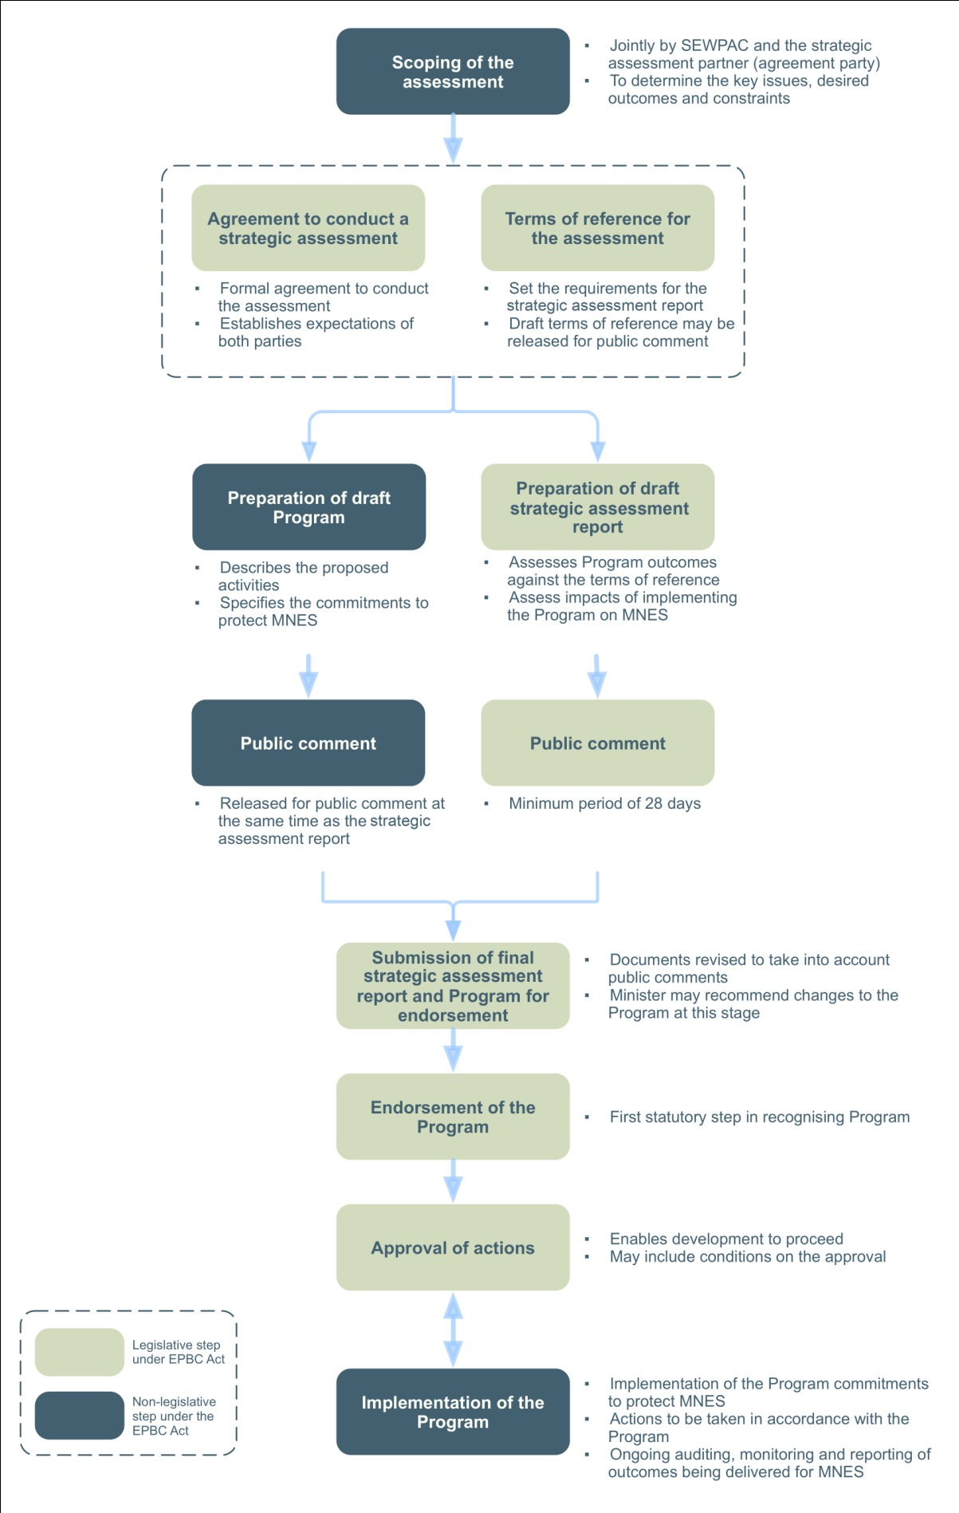

Figure : Strategic assessment process

## Timing of the assessment process

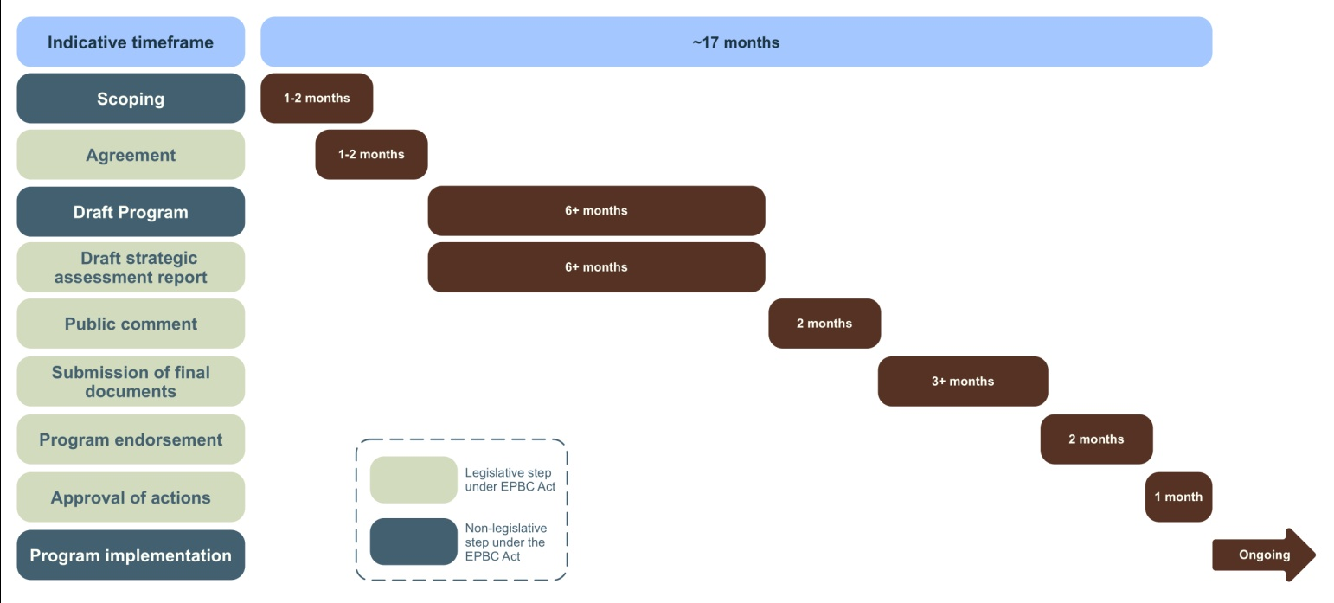The indicative timing of the strategic assessment process is shown in Figure 4. It is important to note that this is provided as an indication only, and the nature of the specific strategic assessment will determine the exact timing of each step.

Figure : Indicative strategic assessment timing

## Scoping of the assessment

Before a strategic assessment begins, it is recommended that a scoping exercise be done by the department and the strategic assessment partner (assessment partner). This scoping would lead to a common understanding on:

* expectations about the outcomes of the assessment
* key issues for both parties including areas where compromise is not possible
* key matters of national environmental significance (MNES)
* availability of information and data requirements
* resourcing requirements
* timing
* governance arrangements.

The main purpose of doing this is to ensure that both parties are very clear about expectations and legal requirements. The scoping exercise would provide the basis for preparing the agreement and a workplan detailing milestones, responsibilities and other arrangements.

|  |  |
| --- | --- |
| Assessment partner responsibilities | * Engage collaboratively with the federal environment department. * Identify desired outcomes in developing the program. * Identify key issues for consideration by the federal environment department. * Identify available data for MNES. * Understand resource requirements |
| Department responsibilities | * Engage collaboratively with the assessment partner. * Identify key issues with regards to MNES. * Identify desired outcomes in entering into the strategic assessment. * Provide clarity around process, including timing, governance, and commitments from the department to the process. |
| Required output | * Scoping report |
| Suggested timing | * 1–2 months |

## Strategic assessment agreement

The strategic assessment agreement is the formal agreement between the minister and the assessment partner to conduct the assessment. It is a mandatory requirement under national environment law, and formally establishes the expectations of both parties. Examples are available at: www.environment.gov.au/epbc/assessments/strategic.html.

A typical strategic assessment agreement includes:

* background to the assessment
* the process for preparing the draft Program and the draft strategic assessment report
* the terms of reference for the strategic assessment report
* public consultation requirements
* the process to finalise the Program and the strategic assessment report
* the process by which the minister considers the Program for endorsement (including the endorsement criteria)
* the process by which the Minister would approve actions associated with the Program
* governance arrangements
* processes to vary, resolve disputes or terminate the agreement.

Terms of reference (ToR) are negotiated between parties and may be put out for public comment before finalisation.

### Indicative strategic assessment endorsement criteria

The endorsement criteria describe the high-level objectives for the strategic assessment, and are read in conjunction with the terms of reference for the strategic assessment report. An indicative set of endorsement criteria are provided below:

In determining whether to endorse a Program, the minister will have regard to the extent to which the Program is consistent with the objectives of the EPBC Act in that it:

* protects the environment, especially matters of national environmental significance
* promotes ecologically sustainable development
* promotes the conservation of biodiversity
* demonstrates adaptation to reasonable climate change scenarios
* provides for the protection and conservation of heritage.

Without limiting the matters the minister may consider when making the decision to endorse a Program, the minister will consider the manner in which the Program:

* avoids impacts on matters of national environmental significance or areas of high biodiversity or heritage value
* mitigates impacts on matters of national environmental significance
* offsets impacts on matters of national environmental significance
* contributes to the enhancement of the existing environment and management of existing threats
* provides a comprehensive framework of adaptive management, monitoring, auditing and public reporting.

|  |  |
| --- | --- |
| Assessment partner responsibilities | * Ensure high-level sign off for the agreement. * Commit necessary resources to the process. * Establish appropriate governance arrangements. |
| Department responsibilities | * Draft the agreement in consultation with the assessment partner. * Ensure sign off by the minister or his/her delegate. * Commit necessary resources to the process. * Establish appropriate governance arrangements. |
| Required output | * Strategic assessment agreement including terms of reference and endorsement criteria. |
| Suggested timing | * 1–2 months (noting that there can be overlap with the scoping stage). |

## Preparation of the draft Program

The Program is the actual document that is the subject of a strategic assessment. As outlined previously, examples of Programs that could be strategically assessed include:

* regional-scale development plans and policies
* large-scale industrial development and associated infrastructure
* fire, vegetation/resource or pest management policies, plans or programs
* water extraction/use policies
* infrastructure plans and policies
* industry sector policies.

From an Australian Government perspective, the ideal situation is where the Program is developed as part of the strategic assessment process (rather than being finalised before the start of a strategic assessment). This provides the opportunity to tailor the Program to meet the objectives of both the assessment partner and the EPBC Act.

There may be circumstances where a ‘policy, plan or program’ addresses a broad variety of environmental issues to meet state or territory requirements. For the minister to understand how a ‘policy, plan or program’ will specifically avoid and mitigate impacts on matters of national environmental significance (MNES) values (rather than all environmental values), a separate document is required that includes:

* a description of the activities within the plan, policy or program (for example, urban development)
* the outcomes that will be achieved for MNES
* the commitments that will be implemented to achieve these outcomes.

This separate document is prepared as part of the strategic assessment process, and provides the details of the Program from an EPBC Act perspective. In a legal sense, this document becomes the Program that is the subject of the strategic assessment.

More guidance on a possible structure of a Program document is provided at Appendix A, and examples of previous Program documents are available at: [www.environment.gov.au/epbc/assessments/strategic.html](http://www.environment.gov.au/epbc/assessments/strategic.html).

|  |  |
| --- | --- |
| Assessment partner responsibilities | * Prepare the Program document in close consultation with the department. * Organise whole-of-government sign off for Program commitments (if necessary). |
| Department responsibilities | * Provide clear advice about options including to mitigate impacts to MNES. * Be responsive to requests for information or feedback from the assessment partner. |
| Required output | * Draft Program document for public comment. |
| Suggested timing | * 6+ months (noting that there is overlap with preparation of the draft strategic assessment report). |

## Draft strategic assessment report

The draft strategic assessment report analyses the potential impacts and outcomes of the Program on MNES. It is prepared for public consultation, and helps the minister in making the decision on whether to endorse the Program.

The draft strategic assessment report must be prepared against the terms of reference that are included in the strategic assessment agreement. The assessment partner is responsible for developing the report, and often engages suitably qualified consultants to do the task.

The draft strategic assessment report is comparable with an environmental impact statement or similar environmental strategic assessment report. It can be prepared using a similar skill set and resources. A key difference is that the draft strategic assessment report only deals with MNES (and ecologically sustainable development principles as required by the endorsement criteria) rather than the whole of the environment.

The strategic assessment report typically includes:

* a description of the Program
* a description of the relevant matters of national environmental significance
* an assessment of the likely impacts
* an analysis of the proposed avoidance, mitigation, offset and adaptive management measures.

More guidance on a possible structure of a strategic assessment report is provided at Appendix B.

|  |  |
| --- | --- |
| Assessment partner responsibilities | * Prepare the draft strategic assessment report against the terms of reference in close consultation with the department. |
| Department responsibilities | * Provide clear advice about the requirements for the draft * strategic assessment report. * Be responsive to requests for information or feedback from the assessment partner. |
| Required output | * Draft strategic assessment report for public comment. |
| Suggested timing | * 6+ months (noting that there is overlap with preparation of the draft Program). |

## Public consultation

The EPBC Act requires a minimum 28 day public comment period for the draft strategic assessment report. The minister may require a longer period where the issues under assessment are complex. In addition to the release of the draft strategic assessment report, the draft Program is released for comment at the same time.

The public consultation phase may involve public meetings or forums to enable the public to be more involved in the process. A report summarising the public comments received and how they were addressed in the final documents (Program and strategic assessment report) is required to be submitted with the final documents (see the next step).

|  |  |
| --- | --- |
| Assessment partner responsibilities | * Publish the strategic assessment documents for public comment. * Manage the public consultation process. * Analyse and respond to the public comments. |
| Department responsibilities | * Support the assessment partner in the public consultation process as required. * Public consultation report. |
| Required output | * Successfully run public consultation process. * Public consultation report. |
| Suggested timing | * 2 months. |

## Submission of the final documents

Following completion of public consultation, the Program document and the strategic assessment report must be finalised. This process must take into account the comments from the public and any advice from the federal environment department.

In finalising the strategic assessment report there are two options:

1. Revise the draft strategic assessment report to make it a final.
2. Prepare a supplementary strategic assessment report to go along with the draft.

It is critical that this stage is done collaboratively with the department. Working through the issues in a collaborative way is the best process for successful resolution of issues. The aim is to ensure that the final Program will provide for adequate protection and management of MNES, and to minimise potential requirements for modifications by the minister or further conditions at the approval stage.

Once finalised to the satisfaction of the department, the Program document and the strategic assessment report are submitted to the minister to consider whether to endorse the Program. It is at this point that the minister is able to formally request modifications to the Program if they are considered necessary.

|  |  |
| --- | --- |
| Assessment partner responsibilities | * Finalise the Program document and strategic assessment report based on public comments and any advice from the department. * Ensure that there is whole-of-government sign off for the commitments in the Program (if necessary). * Address modifications (if any) to the submitted final Program if required by the minister. |
| Department responsibilities | * Provide clear advice about the requirements for the Program and strategic assessment report. * Provide advice to the minister on whether any modifications to the submitted final Program are needed. |
| Required output | * Final Program document. * Final strategic assessment report or supplementary strategic assessment report to go along with the draft. |
| Suggested timing | * 3+ months. |

## Program endorsement

Endorsement of a Program by the minister does not equate to the approval of actions under the EPBC Act. However, it is a necessary step towards approval.

Endorsement occurs when the minister is satisfied that the Program and the associated strategic assessment report:

* adequately identifies and addresses impacts on matters of national environmental significance
* meet the terms of reference, endorsement criteria, and any other requirements set out in the strategic assessment agreement
* provide for any modifications recommended by the minister.

|  |  |
| --- | --- |
| Assessment partner responsibilities | * None |
| Department responsibilities | * Submit the final documents to the minister for endorsement |
| Required output | * Formal endorsement of the Program by the minister |
| Suggested timing | * 2 months |

## Approval of actions

Following endorsement of a Program, the minister may approve the taking of an ‘action’ or ‘class of actions’ in accordance with the endorsed Program. This approval is the legal step that allows activities under the Program to proceed without need for further federal approval of individual proposals or developments.

Approval may occur concurrently with endorsement or any time after that, and conditions may be attached to an approval if the minister considers them necessary. Approvals may be staged, whereby classes of actions are approved at different times.

In considering an approval decision, the minister must invite comments from other Australian Government ministers with administrative responsibilities relating to the relevant actions or class of actions before making his or her decision. There is a 10-day statutory timeframe for this consultation.

Following approval, any action that does not comply with the endorsed Program is still subject to the project-by-project assessment and approval requirements (Parts 7, 8 and 9) of the EPBC Act.

|  |  |
| --- | --- |
| Assessment partner responsibilities | * Formal request for approval of actions or classes of actions |
| Department responsibilities | * Manage the administrative process relating to the approval of actions or classes of actions |
| Required output | * Formal approval of actions or classes of actions by the minister |
| Suggested timing | * 1 month |

## Implementation of the Program

Following endorsement and approval, the Program can then be implemented. The assessment partner is responsible for ensuring that commitments in the Program to protect MNES are met. It is critical as part of this process that necessary resources are provided to meet these commitments (for example, funds for the ongoing management of conservation areas).

Key processes during the implementation phase typically include:

* ongoing adaptive management of conservation areas
* monitoring of the Program outcomes
* independent auditing of the Program outcomes
* regular public reporting of the Program outcomes.

|  |  |
| --- | --- |
| Assessment partner responsibilities | * Implementation of the Program commitments |
| Department responsibilities | * Compliance role in relation to implementation of Program commitments |
| Required output | * Relevant reporting requirements |
| Suggested timing | * Ongoing |

## Compliance with the Program

Proposals and developments done in accordance with approvals under an endorsed Program are legally considered to be approved under the EPBC Act, and do not need any further consideration by the Australian Government under the EPBC Act.

The approval will typically apply to ‘actions’ within the Program area irrespective of who the proponent is or when the action is taken within the period for which the approval has effect.

Proposals not done in accordance with the endorsed Program, or any conditions set by the minister, do not enjoy the benefit of the strategic assessment approval, and must be referred separately under the project-by-project assessment requirements.

Typically, a Program prepared by a state or territory government agency will include higher-level requirements and objectives for the protection and management of matters of national environmental significance (MNES) will be met. These may be beyond the control of an individual developer to implement, although they will contribute to the outcomes (for example, if the Program includes a specific methodology or scheme to manage offsets).

The Program must include adequate monitoring, reporting and enforcement provision to demonstrate that the Program commitments to protect and manage matters of national significance will be met. The Australian Government is seeking the following implementation outcomes:

* A sound process administered by the state, or other agency, that clearly recognises and protects MNES through avoidance, mitigation and offset principles.
* An improvement for matters of national significance at the ecosystem or landscape scale compared with the baseline of business-as-usual individual project assessments.
* Checks and balances as part of the Program commitments to ensure that outcomes for MNES are delivered on the ground and are endurable.

# Ingredients for success

While strategic assessments offer many potential benefits, experience to date suggests that there are a set of ingredients that need to be in place for the process to be successful (see Table 1). When considering a strategic assessment, it is recommended that assessment partners consider this list and how well it applies to their project.

| Ingredient | Comment |
| --- | --- |
| 1. Timing | The timing has to be right to start a strategic assessment. For example, there needs to be a clear link with a state or territory process to ensure that integration of the outcomes can be achieved.  It is critical that a Program is not so advanced in its development that changes cannot be made to it to protect matters of national environmental significance. |
| 1. Imperative | There needs to be a clear imperative from the assessment partner to enter into and complete the assessment. Lack of imperative may result in the process drifting. |
| 1. Leadership | Leadership from both the assessment partner and the Australian Government is critical. Management of the process at an ‘inadequate’ level has major risks as the process unfolds.  Governance arrangements involving senior engagement from both parties should be established early in the process. |
| 1. Collaboration at all levels | Strategic assessments are a collaborative process. Collaboration at all levels between the assessment partner and the Australian Government is necessary to move the process forward and deal with the difficult issues. |
| 1. Honesty | Developing and maintaining an honest approach to the assessment is critical. This is the approach that is most likely to generate trust and provide opportunities to achieve the best outcomes. |
| 1. Expectation management | Both parties need to set and then meet clear expectations. Clear communication around the ability to meet expectations is critical throughout the process. |
| 1. Outcome focus | An ongoing focus on the outcomes to be achieved is vital. Outcomes need to be developed early in the project by both parties and referred to throughout. |
| 1. Agreed timelines and project management | Having clearly agreed timelines and proactively managing the project throughout the process are vital for both parties. |

Table : Ingredients for a successful strategic assessment

# Strategic assessment fundamentals

There are a set of fundamentals that are required to do a strategic assessment. These include:

* appropriate data in relation to matters of national environmental significance (MNES)
* adequate funding and resources for the assessment process
* appropriate governance arrangements.

## Data

Good quality data on the MNES values within the strategic assessment area is critical. An overall objective is to ensure the data is appropriate for understanding and quantifying expected impacts on MNES, identifying areas requiring protection because of their quality or conservation values, and identifying critical habitat areas at a broader landscape level that are high priorities for conservation gain or as consolidated offsets for the Program.

While the data requirements for each assessment will need to be defined on a case-by-case basis, a set of criteria are helpful to consider. These are as follows:

* Data must be focused on MNES and not on other matters (such as threatened ecological communities that are listed under state or territory legislation under a different definition).
* Data should be at a landscape scale to reflect the size and nature of the strategic assessment area, and the level of risk posed by the Program to nationally protected matters.
* Data should be current (that is, collected within the past few years) and reliable (that is, collected at the appropriate times of year using well recognised methods).
* Remotely sensed data should be field tested to ensure their reliability.
* Data requirements should be agreed between the assessment partner and the department at the beginning of the assessment process.

In addition to ensuring appropriate data is available, consideration should also be given to the use of species models to better understand species presence across the landscape. Modelling can contribute to the assessment process where the strategic assessment area is too large for the cost-effective collection of site level data. Where modelling is to be done, it is critical that the data used to inform the models are fit for purpose.

To help the Australian Government understand the issues relating to the assessment, access to the raw data used in the assessment process is critical. The department will seek to establish a data sharing Memorandum of Understanding (or similar) at the beginning of the assessment process to provide for this.

## Funding and resources for the assessment process

Doing a strategic assessment requires a serious commitment of resources to the project. The process can take upwards of 12 months, and providing the necessary funding and resources is essential. As a guide, timing and resourcing will be similar to that required for a typical environmental strategic assessment at the level of an environmental impact statement.

Funding can be required for employing specialists to:

* conduct flora and fauna surveys
* prepare mapping throughout the project
* conduct species modelling
* help with the upfront scoping of the assessment
* help prepare the strategic assessment agreement
* help prepare the Program document
* prepare the strategic assessment report (usually a considerable investment), including a public consultation supplementary report
* help with stakeholder management and the public consultation process
* help with negotiations between the assessment partner and the department.

Allocation of dedicated staff resources to the assessment by the assessment partner is also essential. At a minimum, it is recommended that there is a dedicated officer who has responsibility for the strategic assessment, with senior support provided as necessary.

## Governance arrangements

As outlined in the ‘Ingredients to a successful strategic assessment’ section of this document, leadership from both the assessment partner and the Australian Government is critical. Management of the process at an ‘inadequate’ level has major risks of leading to problems as the process unfolds.

Governance arrangements for the assessment that involve senior engagement from both parties (for example, through regular meetings) should be established early in the process.

# Appendix A —

## Program document structure

Each Program document must be developed based on the nature of the particular Program. However, the following structure is provided as a starting point for developing a Program document.

### Suggested Program document structure

1. CONTEXT FOR THE PROGRAM

* Background to the Program
* Overview of the strategic assessment process

1. PROGRAM DESCRIPTION

* Overview of the development activities within the Program
* Overview of the conservation activities within the Program

1. PROGRAM IMPLEMENTATION

* Legal framework for implementing the Program
* Planning processes and tools for implementing the Program
* Conservation processes and tools for implementing the Program

1. OUTCOMES AND COMMITMENTS FOR NATIONALLY PROTECTED MATTERS

* Outcomes and commitments to protect each relevant matter of national environmental significance
* Outcomes must be clearly measurable and auditable
* Commitments must specify: actions to achieve the outcomes, who is responsible, timing

1. PROGRAM EVALUATION, REPORTING AND MONITORING

* Mechanisms to monitor the outcomes of the Program
* Commitment to regular public reporting about the Program commitments
* Mechanism to independently audit the Program

# Appendix B —

## Strategic assessment report structure

Each strategic assessment report must be developed based on the nature of the particular Program and nationally protected matters issues. However, the following structure is provided as a starting point for developing a strategic assessment report.

### Suggested strategic assessment report structure

1. EXECUTIVE SUMMARY

* Outline of the key issues in the strategic assessment report

1. INTRODUCTION

* Background to the Program and the strategic assessment process (including rationale and alternatives
* Purpose and structure of the strategic assessment report

1. PROGRAM DESCRIPTION

* Summary of the Program, including the development and conservation activities

1. ENVIRONMENT AFFECTED BY THE PROGRAM

* Description of the environment within and around the strategic assessment area
* Broad description that includes:
  + regional context
  + natural environmental values
  + heritage values
  + overview of the relevant matters of national environmental significance

1. IMPACTS TO MATTERS OF NATIONAL ENVIRONMENTAL SIGNIFICANCE

* Analysis of the direct and indirect impacts to MNES
* Discuss impacts for each ‘relevant’ MNES against the following issues:
  + description of the MNES
  + description of the MNES within the strategic assessment area
  + description of potential impacts
  + analysis of measures to avoid, mitigate and offset impacts
  + analysis of adaptive management measures

analysis of the overall conservation outcome for the MNES.

1. ECOLOGICALLY SUSTAINABLE DEVELOPMENT

* Analysis of how the Program meets the principles of ecologically sustainable development

1. ADDRESSING UNCERTAINTY

* Analysis of how the Program addresses uncertainty

1. INFORMATION SOURCES

* Analysis of the information sources used to develop the strategic assessment report. This should include the currency and reliability of the various information sources.

1. TERMS OF REFERENCE AND ENDORSEMENT CRITERIA

* Outline of how the strategic assessment report meets the terms of reference
* Outline of how the Program meets the endorsement criteria

1. REFERENCES

* List of the references used to inform the strategic assessment report

