# Great Artesian Basin Strategic Management Plan

The Strategic Management Plan has been prepared by the Australian, New South Wales, Queensland, South Australian and Northern Territory governments in consultation with the Great Artesian Basin Coordinating Committee.

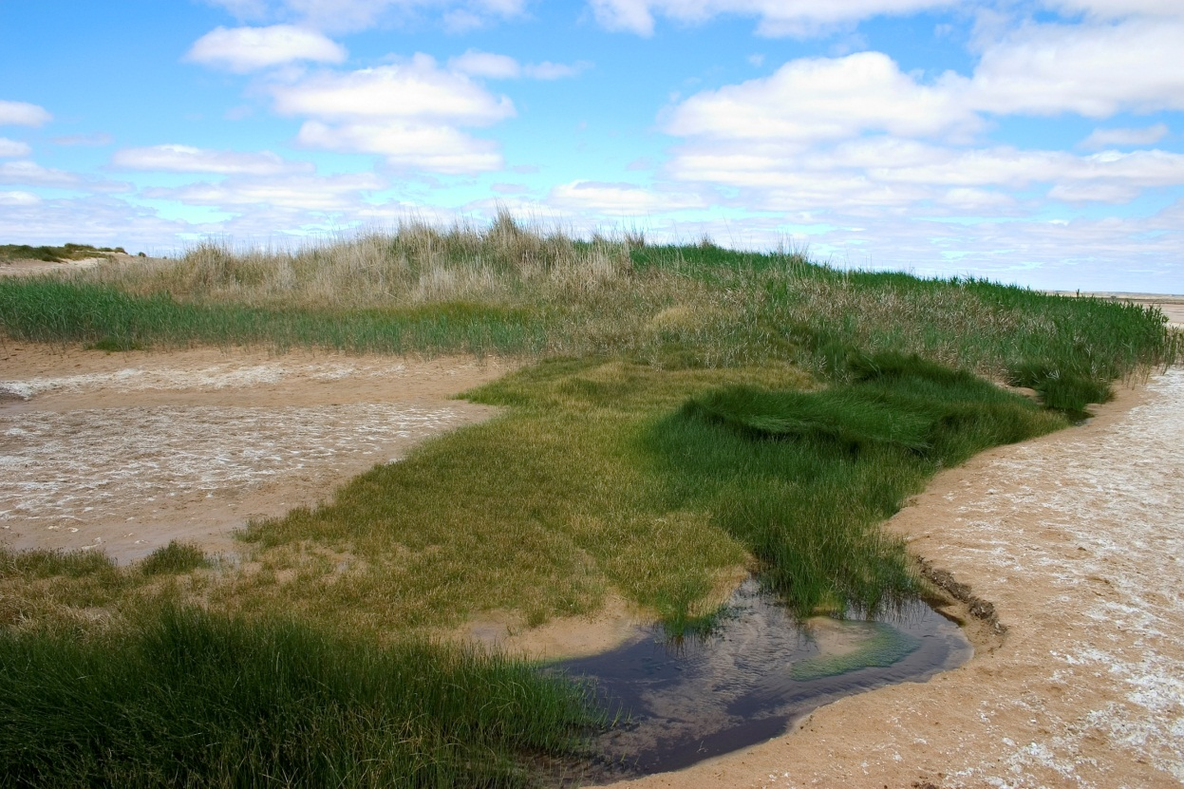

Sandsilt Mound at McLachlan Springs, Kati Thanda-Lake Eyre, South Australia. Photo: T Gotch

Contents

Acronyms 5

Foreword 6

Vision 6

Purpose 6

Scope 7

Context 7

Previous Basin-wide achievements 7

Issues, challenges and opportunities 9

Issues noted in the Review of the Strategic Management Plan 2015 10

Emerging challenges 10

Opportunities 11

Principles 13

1. Coordinated governance 15

2. A healthy resource 18

3. Aboriginal and Torres Strait Islander values, cultural heritage and other community values 21

4. Secure and managed access 23

5. Judicious use 25

6. Information, knowledge and understanding for management 27

7. Communicate and educate 30

Implementation of the Plan 32

Appendix A – Why is the Great Artesian Basin important? 34

Dimensions – space and time 34

Water use and value in the Basin 34

Appendix B – Past achievements through collaborative partnerships 37

Coordinated governance 37

A healthy resource 37

Aboriginal and Torres Strait Islander values, cultural heritage and other community values 38

Secure and managed access 39

Judicious use 40

Information, knowledge and understanding for management 41

Communicate and educate 42

Appendix C – Statistics from the Great Artesian Basin Sustainability Initiative 44

Appendix D – Pressure Trends across the Basin linked to GABSI 47

Queensland 47

New South Wales 48

South Australia 49

Appendix E - References 51

Geographic extent of the great artesian basin and selected overlying surface water drainage divisions. Smerdon et al. 2012.

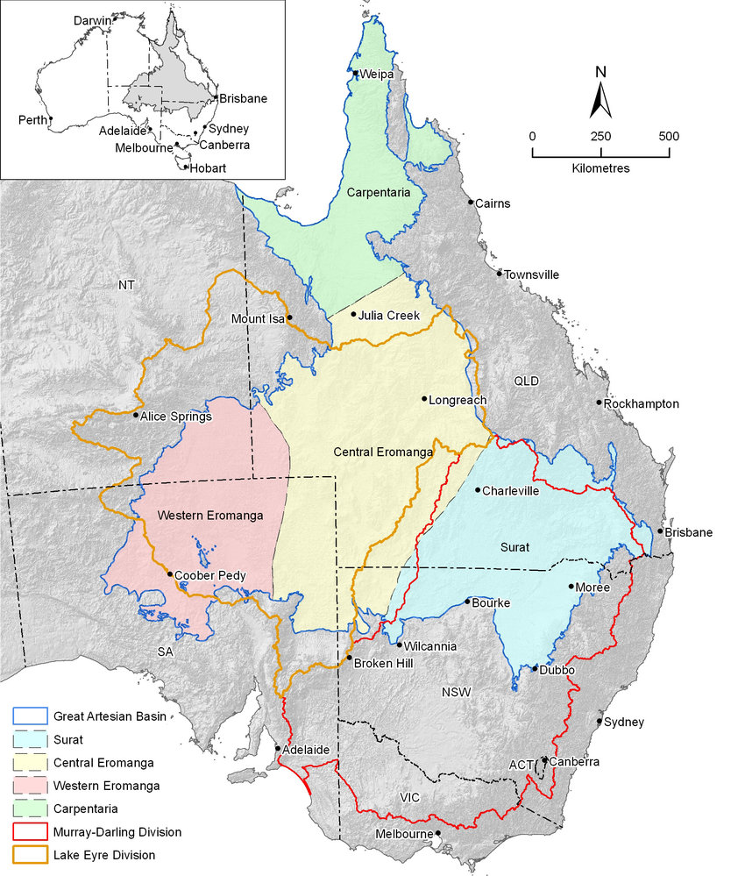

## Acronyms

| Term | Definition |
| --- | --- |
| The Plan | The Great Artesian Basin Strategic Management Plan |
| The Basin | The Great Artesian Basin |
| GABSI | Great Artesian Basin Sustainability Initiative |
| GABCC | Great Artesian Basin Coordinating Committee |
| ML | Megalitre |
| NRM | Natural Resource Management |
| SMP | The Great Artesian Basin Strategic Management Plan 2000-2015 |
| WAP | Water Allocation Plan |
| PWA | Prescribed Wells Area |
| EPBC Act | Environment Protection and Biodiversity Conservation Act 1999 |

## Foreword

The Great Artesian Basin (the Basin) is one of the largest underground freshwater resources in the world. It underlies approximately 22% of Australia – an area of over 1.7 million square kilometres beneath arid and semi-arid parts of Queensland, New South Wales, South Australia and the Northern Territory. Approximately 70% of the Basin lies within Queensland.

The Basin is a highly valued water resource which provides diverse benefits and opportunities. Basin springs have enabled Aboriginal and Torres Strait Islander people to occupy dry inland areas of Australia for more than 40,000 years, and communities maintain cultural, social and spiritual connections with Basin springs and their associated ecological communities and landscapes.

The provision of drinking water through domestic bores and town water supply has been essential to the development of regions within the Basin and is used in more than 120 towns and settlements.

The estimated consumptive use of Basin water supports at least $12.8 billion of production each year. The consumptive water uses by stock (pastoral and intensive), irrigation, mining, electricity and gas industries are all of high economic value. The use of Basin water adds economic value to regional resources (land and minerals) and underpins economic activity and employment across the region.

Significant public and private funds have been spent on developing and protecting the Basin water resource to support its economic, social and environmental values. On-farm investment has been significant with a total of 50,475 bores in the Basin. Although the vast majority of these bores are less than 200 metres deep, more than a thousand bores are deeper than 1200 metres.

In some areas, artesian water is used in mineral spas and tourists are attracted by the cultural and natural history of springs that are developed as visitor sites. Tourist developments across the Basin rely on artesian water pressure being maintained.

The wellbeing of present and future generations of Australia depends on the sound management of our natural resources. Sustainable groundwater management is critical to the long-term productivity and profitability of the Basin’s economy, the viability of rural communities and the protection of associated biodiversity, cultural and heritage values.

This Strategic Management Plan builds on the outcomes and actions of the first Strategic Management Plan agreed in 2000, and takes a principles-based approach to guiding governments, industry and the community in managing this important resource together.

## Vision

The Great Artesian Basin is managed judiciously through the optimal use of the water for present and future generations in a manner that upholds the values of the Basin and maintains water-dependent ecosystems by governments, communities and industries working together.

## Purpose

This Strategic Management Plan (the Plan) provides a framework to guide the actions of governments, Aboriginal and Torres Strait Islanders, water users and other interests in their endeavour to achieve economic, environmental, cultural and social outcomes for the Great Artesian Basin and its users. Implementation of the Plan will assist all parties to identify and respond to the risks, issues, challenges and opportunities associated with use of Basin water.

## Scope

The Plan is not a statutory document; instead it fosters collaborative management between users to achieve agreed objectives and outcomes. The Plan is built on management principles and contains values, objectives and desired outcomes that will help achieve continued improvement in the management of the Basin.

The Plan has a life of 15 years to 2034 and will be reviewed every five years to check progress.

While the Plan applies specifically to the Basin and its water resources, there are overlapping natural resource planning and management processes to be considered. Areas of overlap are identified in this document.

## Context

The Plan has been developed within agreed national water policy frameworks.

The groundwater resources of the Basin are managed by the governments of New South Wales, Queensland, South Australia, and the Northern Territory (Basin governments), with national policy and water resources information support provided by the Australian Government. Basin governments authorise the taking of groundwater under specified conditions.

The Plan seeks to deliver outcomes for the Basin through an adaptive, evidence-based risk management approach. This means accurate and timely information will be used to guide decisions of regulators, investors, water users and other interests. Governments will use the Plan to assist in the development of policies, management and investment plans that meet objectives for the Basin. Investors, water users and other interests can use the Plan to guide decisions concerning their use and management of the Basin resources.

In implementing the Plan, water users and other interests will play important roles in providing input and evidence to help ensure compatible Basin-wide responses to risks and development opportunities. The Plan provides for a coordinated governance structure drawing on the knowledge and expertise of all interested parties to develop robust Basin-wide perspectives that strengthen understanding and confidence in decisions about use of Basin water.

## Previous Basin-wide achievements

Basin governments have been working with water users and others to manage the Basin since early last century due to its importance to inland Australia (Appendix A). Only a decade into the water use expansion of the late 19th century, falling water pressures and reduced flows dashed hopes for an inexhaustible water supply from the Basin. Basin governments first met in 1912 to discuss the implications of water lost through uncontrolled bores and open bore drains. Over subsequent decades the limitations of water delivery technology and poor understanding of the Basin and its values restricted responses to addressing these problems. In the second half of the 20th century, improvements in water infrastructure technologies and understanding of the Basin enabled governments to work with landholders to control uncapped bores and replace open bore drains with pipes.

The Plan builds on the progress of the previous 15-year plan, and seeks to address outstanding Basin-wide management issues and guide decisions that respond to emerging issues and challenges. A summary of the achievements during the first Strategic Management Plan are at Appendix B.

A major focus of the first Basin-wide plan, which was released in 2000, was to assist Basin governments and landholders in negotiating strategies and timings for bore rehabilitation and to coordinate efforts to rehabilitate hundreds of uncontrolled bores and remove more than 30,000 km of open bore drains (SKM 2014). The plan’s achievements were underpinned by the Great Artesian Basin Sustainability Initiative (GABSI program), a funding initiative negotiated between Commonwealth and state governments and water users to cap (control artesian flow) and pipe (pipe water to troughs) pastoral bores across the Basin.

Key achievements of the previous plan include:

* From 1999 to 2017, Commonwealth and state governments invested $248 million into the Basin through the GABSI program for improving water infrastructure (Appendix C)
* 750 bores have been capped, rehabilitated or decommissioned
* 21,390km of open bore drains have been piped
* 250GL of water is being saved each year.
* Water pressure in parts of the Basin has been restored (see Appendix D).
* Health of naturally occurring springs has been maintained or improved.
* The profile of the Basin and understanding of its structure and dynamics has been raised among its users and community members.
* With this knowledge, respect of the Basin and the importance of its sustainable management has grown.
* Substantial improvements in policy, planning and management have also been achieved, including the development of state water management plans and policy support, changed community attitudes concerning the need for judicious use of Basin resources (see Appendix B).

The previous plan was reviewed in 2015 by the Australian Government in consultation with the Great Artesian Basin Coordinating Committee (GABCC) and the Basin governments. The outcomes of the review are published in Future Directions for the Management of the Great Artesian Basin (Commonwealth of Australia 2015). The review noted the following major achievements since 2000:

* Finding 1: ‘There has been continual improvement in the awareness of Basin water management issues by landholders, communities and other water users as a result of the GABSI program, the GABCC and implementation of the Strategic Management Plan.’
* Finding 6: ‘Monitoring of artesian pressure and flow where bores have been capped and piped in the last 20 years shows that previously declining artesian pressure appears to be stabilising and/or improving in those areas’ (see also Appendix D).
* Finding 10: ‘The removal and reduction of bore drains (such as through the GABSI program) has been an effective management tool to address water wastage, seepage and evaporation and reduce the adverse environmental impacts associated with bore drains such as weed and pest incursions.’
* Finding 29: ‘The current Basin governance arrangements have facilitated consultation and communication with jurisdictions and stakeholders. The GABCC in particular has contributed to the proactive identification and discussion of whole-of-basin water management issues for water managers and governments.’
* Finding 32: ‘Over the life of the Strategic Management Plan, the GABCC has held productive and constructive discussions that have provided considered advice to ministers. As the Strategic Management Plan has progressed, the relationship of stakeholders with government representatives has created a culture of trust and respect. The level of understanding of Basin water management issues among non-government members has strengthened over time from these relationships.’

## Issues, challenges and opportunities

A range of issues, challenges and opportunities framed the development of the new Plan and supported the case for continued cooperative management in the Basin. Some of these are unresolved matters identified in the review of the previous plan and some are new or emerging.

**Consultation Themes**

An emerging concern in the Great Artesian Basin, reflected in comments made during public consultation on the draft Plan, relates to equity between water users and transparency relating to water use. As composition of water users and patterns of use in the Basin continues to change, there are particular concerns relating to the quantity of water taken by extractive industries and their potential impact on water quality, including on stock and domestic water supplies. There is concern that water take for different industries is managed under different legislation within the same state and that not all take in the Basin is fully accounted for in a consistent manner. There is a desire for all water users to be accountable in order to contribute to maintaining the long-term sustainability of the Basin.

The Plan addresses these concerns in a number of ways. Basin governments agree to implement measures aimed at minimising impacts from extractive industries on groundwater recharge and groundwater dependent ecosystems. Facilitating full accounting of water taken by all water users including the resource extraction industry is an objective of the Plan. Water entitlements should have nationally compatible characteristics, with conditions complied with by industries operating in multiple jurisdictions. There is a focus in the Plan on aligning Basin management more closely with nationally agreed strategies and frameworks, including the National Water Initiative. The Plan envisages that scientifically defensible limits relating to both quantity of water take and water quality will be established and adhered to. Specifically, measures are to be implemented so that features important to natural groundwater recharge are not unduly impacted.

### Issues noted in the Review of the Strategic Management Plan 2015

The 2015 review noted a number of ongoing issues that need to be addressed to ensure the social, economic and environmental benefits and integrity of the Basin are maintained. These include the need for:

* effective governance arrangements to improve coordination of water management policies and practices across the Basin and management actions
* a clear definition and understanding of the rights and responsibilities of water users across the whole Basin, and working to close the gaps in compliance where appropriate
* a coordinated approach to engage all stakeholders
* a supply of timely, robust and appropriately presented information to assist in Basin-wide decision-making
* strategies to address persistent wasteful behaviour and practices of some water users and associated environmental degradation
* strategies to address continued declining artesian pressure and increasing rates of extraction across some areas of the Basin
* identifying funding sources that reflect public and private user benefits, to ensure a financially sustainable approach to minimising water wastage and the recovery of artesian pressure
* installing, maintaining and decommissioning water delivery infrastructure in accordance with best practice
* maintaining continued recognition of the Basin as one of the world’s largest and most significant groundwater resources.

The review also documented emerging issues including risks to groundwater that may arise from mining and unconventional gas development. It noted (3.1).

‘It is crucial that water extractions for mining and unconventional gas related activities is transparent and accountable, does not compromise the long-term sustainability of the resource, does not erode the water rights of other users and minimises any potential third party impacts.’

### Emerging challenges

As the demand for Basin resources increases and patterns of use change, there will be increasing competition between water users and changes to the nature, magnitude and significance of impacts caused by water extraction. Emerging challenges may include:

* injection of gases
* injection of water (for future use or to maintain aquifer pressures)
* large resource developments
* unconventional gas extraction
* geothermal power.

These new and emerging issues may impact both water quantity and quality. To meet increasing demand, the use of new technologies to maximise the efficiency of Basin water use is encouraged to meet user demands in terms of quantity and quality.

Blackall Bore, Queensland



Extractions from the Basin are estimated at 451,000 megalitres per year (ML/yr) (Frontier Economics 2016). The pastoral industry is the largest water user in the Basin, licensed to use an estimated 187,000 ML/yr or 41% of Basin water extraction. The industry generates more than $4 billion annually in the Basin and uses water delivery infrastructure worth more than $5 billion. The second largest water user is the irrigated agriculture sector, which uses an estimated 109,000 ML/yr (25%) and generates $58 million.

A mix of mining, intensive stock and other industries consumes 57,000 ML/yr (12%) and the gas/petroleum industry, which is a growing water user and using mostly co-produced water, consumes 87,000 ML/yr (19%). The mining and petroleum industries generate annual economic value of $6.3 billion in mining and almost $2 billion in gas.

Additionally, more than 120 towns rely on the Basin for water supply, consuming more than 40,000 ML/yr or 9% of Basin water (Frontier Economics 2016).

Each user group undertakes water management practices to meet their specific water needs. Each sector’s water extraction creates impacts that may generate unacceptable risks and offer opportunities to develop efficiencies that reduce the amount of water required.

Accurate assessments of water use and entitlement arrangements are essential to ensure long-term water access for water users.

### Opportunities

These opportunities for Basin improvements are aimed at delivering outcomes that promote the principles identified in the Strategic Management Plan.

* Increase stakeholder awareness that the Basin is a declining and finite resource (Smerdon et al. 2012). The Basin’s water resources require judicious use and stewardship of the remaining water pressure, temperature and water quality to ensure that its benefits continue to be available for as long as possible. New demand should not affect the improvements coming from the previous plan.
* Develop frameworks to manage third party impacts consistently across industries and geographic locations.
* Develop adaptive management approaches to accommodate changes in artesian pressures. For example, increasing water pressures in some areas are resulting in artesian flow management now being required at bores not previously required during the current landholder tenure. Conversely, continuing decline in artesian pressures in other areas may require installation of pumping infrastructure if artesian conditions cease.
* Review maintenance and decommissioning practices for water delivery infrastructure to enable a long term approach to be implemented within the Basin which reduces the risk of structural failure, water loss and loss of artesian pressure.
* Improve cross-border management of groundwater resources through coordination of water management and related policies and practices across the Basin.
* Examine impacts of emerging and new Basin water users on water consumption, quality and pressure.
* Develop the monitoring and accounting required to enable tracking of water use and resource condition to drive decision making, particularly on climate change and new, emerging or expanding uses.
* Develop mechanisms to address non-adopters and ensure water use practices across the Basin are of a best practice minimum standard, including identification of mechanisms to address the persistence of wasteful practices.
* Recognising and conserving non-use values in biodiversity resources and cultural heritage values that rely on Basin water, including listed springs and threatened species.
* Clearly define rights and responsibilities of water users, in order to minimise gaps in compliance and inadequate water use reporting.
* Promote the timely and robust collection of information for use as the basis for decision-making.
* The need to better understand and account for the effects of changing land use and other activities on recharge areas.
* Account for extraction-induced impacts between aquifers of the Basin, both artesian and non-artesian aquifers.
* Assess, and respond to the effects of climate change on long-term management of the Basin, both on recharge rates and water usage patterns.
* Support the development of skills and knowledge in the community to potentially assist in the provision of bore construction and maintenance, water delivery infrastructure design, and asset condition monitoring activities.
* Assessment of the changing populations and related economies in parts of the Basin.
* Recognising the need to maintain ongoing urban water infrastructure within the Basin as it is a core water supply source for many towns.
* Establish a proactive Basin-wide governance structure and process to maintain the profile of the Basin and ensure effectiveness of the evidence-based risk management approach.
* Implement compatible policy approaches to strengthen protection of springs, as spring discharges and non-spring groundwater dependent ecosystems continue to be threatened by human activities.
* Develop and implement innovative water use efficiencies in all sectors through improved technologies and better water management practices.
* Enable and encourage the beneficial use of co-produced water. Improve information systems and increase the accessibility of information.
* Investigate a long-term funding arrangement for Basin-wide replacement of bores, based on lessons learnt from previous funding programs.

## Principles

Basin governments and community and industry representatives have agreed to seven guiding principles for managing the Great Artesian Basin to achieve economic, environmental, cultural and social outcomes.

These principles cover:

1. coordinated governance
2. a healthy resource
3. Aboriginal and Torres Strait Islander values, cultural heritage and other community values
4. secure and managed access
5. judicious use of groundwater
6. information, knowledge and understanding for management
7. communicate and educate

The agreed principles capture the collective values and objectives for future Basin management and have guided the development of the Plan’s desired outcomes.

Mud Springs, Queensland

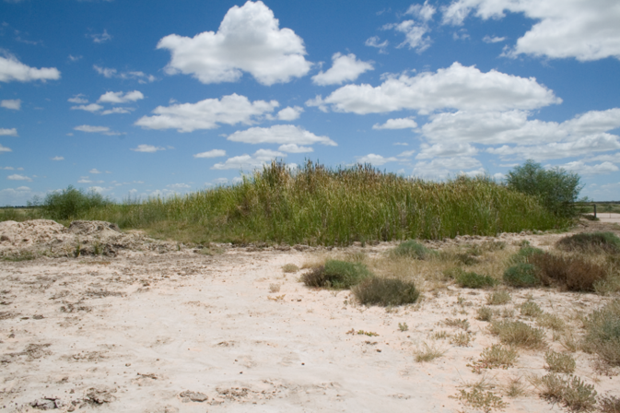

### 1. Coordinated governance

Coordinated governance means the Great Artesian Basin jurisdictions of New South Wales, Queensland, South Australia, Northern Territory and the Australian Government working together to manage the resource on a whole of Basin approach in partnership with communities and industry partners. This partnership provides advice to the governments on the productive, environmental and other public benefit outcomes to be achieved in a mutually beneficial way within the Basin.

The Australian and Basin governments and other stakeholders, including water users, have key roles in reforming current management practices. Basin governments have a constitutional responsibility to protect natural and cultural heritage values and to ensure water is used judiciously to support community values and benefits and to minimise third party impacts on all water users. Governments may also become involved when market or regulatory frameworks fail and where a public good or benefit can be shown.

The Great Artesian Basin consists of groundwater management sub-units that the individual Basin governments are responsible for managing. These sub-units are hydraulically connected to varying degrees, both vertically and horizontally, to form a large multi-jurisdictional and nationally significant water resource system which spans the three states and a territory. It is desirable for this connected water system to be managed under a whole of Basin approach consistent with the National Water Initiative whereby the Australian and Basin governments work together to achieve whole of Basin outcomes.

Each government has its own policy and regulatory framework under which it undertakes the management of Basin matters, and each directly engages with community and industry in developing and implementing that framework.

Achievement of some outcomes in the Plan rely on the actions undertaken by community and industry partners as water users. It will be important that these stakeholders can provide advice to the joint governments on whole of Basin approaches to the management of the Basin. The coordinated governance system will aim to strengthen and enhance investment and planning initiatives of governments and water users, supporting implementation of the Plan with strategy and accountability.

This system will enable the development of Basin-wide perspectives that contribute to more effective generation, collection, evaluation and use of information.

Robust Basin-wide perspectives are important because:

* Jurisdictional boundaries have no effect on the function of the Basin or on intrinsic values, including biodiversity and cultural heritage connections.
* Artesian pressure is shared, and solutions to water pressure change problems need to be shared.
* Management across jurisdictions needs to be compatible in intent and direction, towards shared outcomes and targets.
* All jurisdictions and stakeholders have a shared obligation to enable the Basin to provide benefits for as long as possible.
* Actions by one jurisdiction cannot be allowed to produce skewed outcomes detrimental to current or improved water use in other jurisdictions.
* Monitoring, reporting and data sharing need to be consistent across jurisdictions to enable coordinated evaluation of impacts and responses.
* Information sharing and understanding across the Basin builds the levels of understanding, confidence and trust required for effective coordinated responses.
* Entitlements and approvals need to have nationally compatible characteristics to enable streamlined management between jurisdictions and include enforceable conditions to be complied with by industries and other water users who operate in multiple jurisdictions.

A coordinated Basin-wide governance system will be established through a set of agreed arrangements that enables Basin governments to work together to develop Basin-wide policies and management frameworks and to engage and seek advice from communities and industry when considering whole of Basin water management. *These arrangements will be established in an agreement between the respective governments.*

Table 1: Strategic outcomes for coordinated governance

| Objective | Outcomes |
| --- | --- |
| Basin governments working together to manage the Basin groundwater system in consultation with community and industry to achieve consistent outcomes | Basin-wide coordinated governance engages Basin governments, community and industry in implementation of the Strategic Management Plan, to:   * collectively consider long term management of the Basin * actively engage with community and industry on matters of importance and provide community and industry advice to Basin Ministers * enable transparent public reporting * enable evaluation of, and public reporting on, implementation of the Strategic Management Plan. |

Peery Springs, New South Wales

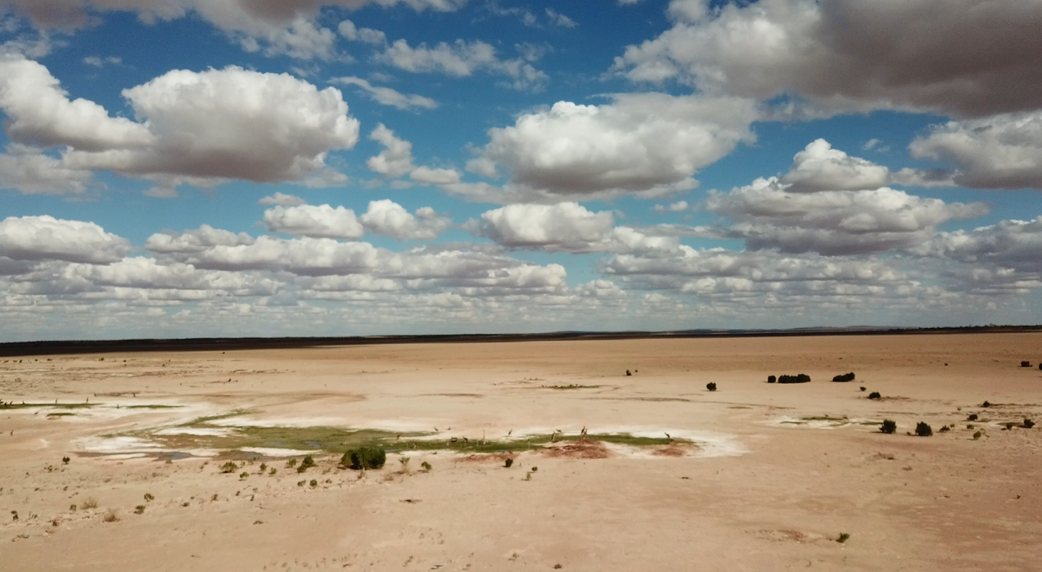

Photo provided by NSW Department of Industry - Water

### 2. A healthy resource

A healthy resource means the Great Artesian Basin groundwater system is under artesian pressure, with water flows and quality that continue to support natural ecosystems and supply water for a wide range of human activities, including economic, social and cultural uses.

The health of the Basin can be described in multiple ways. These include water pressure both locally and across the Basin, important hydrogeological processes including recharge and discharge, the quality of water, and the ecological health of both spring and non-spring groundwater-dependent ecosystems.

Groundwater in the Basin, although substantial, is finite. In most parts of the Basin recharge rates have declined over geological time, so the resource is in natural decline (Smerdon et al. 2012). This means that, even if humans were not extracting water, the volume of water and water pressure in the Basin would continue falling. As the extraction of water has significantly increased the speed of this decline, the Plan seeks to encourage actions which ensure judicious use of water by all water users.

The health of the Basin will be impacted by current and emerging demand for water. This demand includes the potential expansion of existing industries such as large-scale irrigation and resource industries, as well as new users such as geothermal power production and new resource industries. Decisions regarding new developments within the Basin are managed under state and territory legislation which includes environmental assessment processes.

Although the volume of water stored in the Basin is enormous, estimated to be 64,900 million ML (GABCC 2014), the annual extraction and free-flowing discharge from the Basin is relatively small. For example, less than 0.02% of the estimated storage in New South Wales (Department of Water and Energy 2009) is extracted annually. However, take has had a significant and relatively rapid impact on groundwater heads (water pressure) and flow rates of bores and springs in certain areas.

The main task over the life of this Plan, relating to the health of the resource, is to ensure current and new extraction is managed within agreed limits to stabilise or possibly increase water pressure. In addition, activities occurring in the Basin should minimise their impact on the quality of water.

Recent surveys by Basin governments show that bore rehabilitation and piping has led to the stabilisation of water pressure in various aquifers and increases of water pressure in some areas of the Basin in recent decades. See Appendix D.

Groundwater moves slowly through the system. This results in a delay, or lag, in system responses to both stress and recharge events. Response time could be hundreds to thousands of years – well beyond planning horizons. Due to the inherent hydrodynamic characteristics of the groundwater system, it is neither possible nor practical to achieve a balance between recharge and discharge at a system scale. Therefore it is far more practical to manage in terms of acceptable groundwater water pressure/levels on a local to sub-regional scale.

#### Basin recharge and natural discharge

The Basin can be affected by disruption or modification of recharge and natural discharge areas. Recharge occurs on the eastern margins of the Carpentaria, Eromanga and Surat Basins in Queensland and New South Wales, as well as the western margin of the Eromanga Basin in South Australia, the Northern Territory and Queensland. On average, less than 3% of the rain that falls on recharge areas filters into Basin aquifers. In north Queensland recharge rates are much higher, 985,000 ML/yr in the Carpentaria Basin compared to 336,000 ML/yr in the Eromanga Basin; this recharge has little effect on parts of the Basin south of this region, due to the Euroka Arch acting as a natural groundwater flow divide (KCB 2016a).

Recent research indicates that surface channels and water storage areas may be of critical importance to Basin aquifer recharge, especially during heavy rain events. Land use changes can mechanically disturb channels and water storage areas and cause silting of river beds that are important to sustaining recharge. Changes in vegetation cover, either native or invasive species, may affect recharge processes. Recharge may be affected by climate change impacts on both rainfall intensity and duration.

Basin waters discharge into at least 80 waterways, augmenting base flows that help to sustain them during times of low rainfall, while other springs discharge through the seabed in the Gulf of Carpentaria.

More than 460 Basin spring groups support unique isolated wetland ecosystems, home to species of animals and plants found nowhere else (Fensham et al. 2010). Many of these discharge springs have been significantly impacted by declines in flow from water pressure losses. Springs have also suffered from land use impacts, including mechanical disturbance to modify outlets to improve water access, and others are affected by grazing and weeds (EPA 2005). Basin springs are internationally important cultural, spiritual and ecological assets.

Additional biodiversity and broader environmental values are affected by uncontrolled flows from the Basin. For example, bore drains direct water into parts of the landscape where water was not previously stored on a permanent basis within natural channels and these channels now support pest plant and animal species (GABCC 2011).

Climate change effects may drive water users to increase their extraction of Basin water as other water sources such as surface water or shallow groundwater become less reliable.

#### Water extraction

Extraction rates from the Basin are changing, reflecting improvements in management practices, the increased value being placed on Basin water, and resulting in increased benefits to the community. For example, in Queensland the annual take of water in 2016 was estimated at approximately 315,000 ML/yr (NRM 2017), reduced from extraction that peaked at approximately 750,000 ML/yr in the 1910s. Stock and domestic water extraction for the pastoral industry is estimated to comprise almost 50% of Basin water use (156,000 ML/yr.) within Queensland. Approximately half of this water still flows uncontrolled from bores, while the rest is delivered through piped systems which is a major improvement over the past two decades. Other uses, including industrial, town and intensive agricultural purposes, consume approximately 91,000 ML/yr. The petroleum and coal seam gas industry extracts approximately 64,000 ML/yr (20% of Queensland Basin water use), a substantial increase from 6,300 ML/yr a decade ago, when it was mostly from conventional oil and gas production (Office of Groundwater Impact Assessment 2016). (Note: the above figures are different to those within the Frontier Economics 2016 report since this is a specific case study within Queensland).

There is community concern that new users will affect the security of existing entitlements or environmental assets. If take is from areas of current stress, any opportunities to avoid additional take and maximise savings through improved efficiency or innovation need to be explored.

See **Consultation Themes** for a summary of feedback on water extraction received during the consultation period.

Table 2: Strategic outcomes for a healthy resource

| Objectives | Outcomes |
| --- | --- |
| A groundwater system in which water flows, artesian pressure and water quality support groundwater-dependent ecosystems and provide a supply of water that meets the needs of communities and industries  Improved management of Basin groundwater recharge and discharge processes and the ecosystems/springs that are dependent on them | Basin state and territory water resource plans:   * are evidence-based with all evidence transparent and publicly available * identify access and extraction risks to Basin water resources * set out scientifically defensible extraction limits and management measures that sustain the use of the resource, by 2033 * set out scientifically defensible water quality limits and extraction impact management measures that minimise impacts on the Basin resources, its users and dependent ecosystems.   Authorised water users extract groundwater in accordance with limits specified in Basin governments’ water resource management plans and under their licence or approval conditions, to minimise third party impacts.  Basin governments implement the following outcomes:   * water resource matters are considered as part of land use planning, linked to regional natural resource management plans and activities * land use impacts are considered when undertaking water resource management and planning for the Basin groundwater system, especially around Basin springs and recharge areas * risk-based, cost-effective measures are used to manage impacts on groundwater flows, artesian pressure and the quality of groundwater * industry measures are put in place to minimise impacts from mining and other resource extraction on groundwater recharge and Basin groundwater dependent ecosystems, including springs * water resource management identifies and manages risks to Basin springs and other groundwater-dependent ecosystems, and on biodiversity and their environmental values * where Basin aquifers are identified as having potential for mining and other resource extraction, Basin governments may put in place management plans for their long-term sustainable management.   Landholders are encouraged and supported to adopt best management practice for managing important physical landscape features that support natural recharge and Basin springs. |

### 3. Aboriginal and Torres Strait Islander values, cultural heritage and other community values

Those Aboriginal and Torres Strait Islander values, cultural heritage and other community values supported by Basin water and deemed to be important by Aboriginal and Torres Strait Islander people and other stakeholders are identified and considered as an integral part of the water planning and management process.

Water from the Basin is crucial to the maintenance of numerous natural and cultural resources and assets that are considered by the community to have high value. Basin water sustains natural biodiversity and ecosystems as well as settings and assets that are recognised as having important local, national and international values.

#### Aboriginal and Torres Strait Islander values

Basin water naturally discharged from springs has enabled Aboriginal and Torres Strait Islander people to occupy a range of Basin environments, from coastal wetlands to the dry inland, for more than 40,000 years. As a result, Aboriginal and Torres Strait Islander communities have enduring cultural, social and spiritual connections with Basin springs and their associated ecological communities and landscapes (Commonwealth of Australia 2014). Springs and other cultural sites must be protected as an integral, intricate component of Aboriginal and Torres Strait Islander culture and society and as an essential part of Australia’s cultural heritage.

Aboriginal and Torres Strait Islander stakeholders of the Basin accept responsibility as traditional custodians for ensuring that the management of cultural assets continues to provide cultural, social and economic benefits for current and future generations reliant on the resources of the Basin. Aboriginal and Torres Strait Islander people need to have a key role in decision-making concerning information about cultural sites and need access to Basin water to sustain heritage values.

#### Cultural heritage and other community values

Much of the recorded history in central Australia has been built around access to Basin water. Sites that help to tell the story of exploration, settlement and development of the Basin are an essential part of Australia’s national heritage, and require protection (Commonwealth of Australia 2014).

The role of the Basin in the history and development of inland Australia remains one of the key messages for anyone interested in learning about the Australian story (See Appendix A). Much of the interpretative and educational material on historical and contemporary culture in outback visitor centres and school curriculum materials focuses on sites supported by Basin springs and bores.

The cultural heritage of the Basin has important social, cultural and environmental value and is also an important part of local economies. The story of the Basin and local histories built around its uses are an important tourist attraction. The structure, function and natural diversity of springs are of great interest to visitors to northern South Australia and western Queensland. ‘Mineral baths’ using Basin water attract visitors to a number of centres. Aboriginal and Torres Strait Islander engagement in resource management and tourism is important to a number of communities.

Wetlands fed by Basin water may also have a range of social amenity and recreational values that are very important to regional communities, visitors and tourists. They may provide important educational and leisure settings, a focus for experiencing natural and cultural features and biodiversity, and important refuges for both wildlife and people during periods of drought.

Table 3: Strategic outcomes for Aboriginal and Torres Strait Islander values, cultural heritage and other community values

| Objective | Outcomes |
| --- | --- |
| Water is available to sustain Aboriginal and Torres Strait Islander values, cultural heritage and other identified community values that are dependent on the Basin groundwater system | Basin governments include provisions in water resource management plans to enable access to the groundwater required for sustaining:   * Aboriginal and Torres Strait Islander values and interests, which includes Basin springs * cultural heritage values * other identified community values.   Governments ensure that cultural knowledge is integral to governance, planning and implementation of Basin management.  Aboriginal and Torres Strait Islander people have an effective voice in coordinated governance arrangements including through representation on stakeholder advisory committees within the Basin.  Basin governments set out strategies to achieve Aboriginal and Torres Strait Islander values, cultural heritage and other community objectives that are dependent on Basin water resources. |

Tego Springs, Queensland

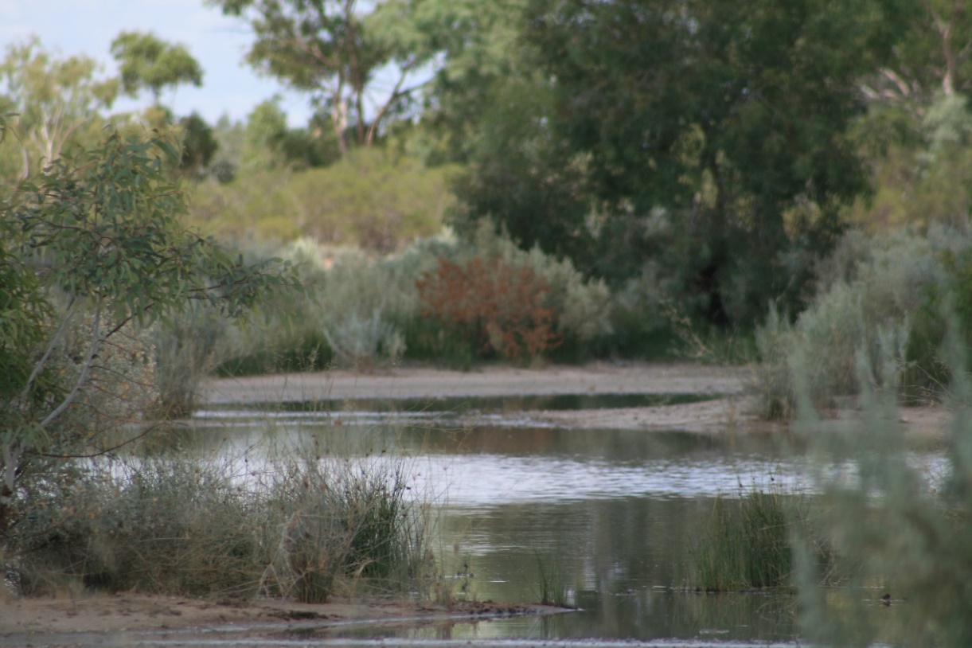

### 4. Secure and managed access

Secure and managed access is provided for the environment and authorised water users to have secure entitlements to access, extract and use groundwater in accordance with rights and responsibilities.

The rights of all authorised users must have a clear, secure statutory basis, and responsibilities must be clearly defined and understood by all water users regardless of access arrangements. Secure and managed access increases the certainty of water supply over the long term, an outcome beneficial to all Basin water users.

Safe and reliable water supplies are critical to people who live and operate businesses in the Basin. Governments, industries, water users and others need to protect and maintain the resource, preserve cultural values and ensure environmental water requirements are understood and met. This means that impacts resulting from water extraction need to be clearly identified, accounted for and adequately managed to maintain the health of the resource and the greatest long-term benefits to the community.

Both governments and users have important roles to play in delivering secure and managed access. Governments have the responsibility to ensure that legislation and relevant state and territory plans clearly define water access rights and specify the on-ground activities required of individual water users in order to lawfully exercise those rights. Water users have the responsibility of carrying out their business in accordance with legislation and the relevant plans.

Over the period of this Plan, governments and stakeholders will work cooperatively to create a culture whereby the rules established in legislation and plans in Basin jurisdictions to manage the resource are understood and adopted, including water use measurement and reporting.

Engagement between water users and regulators regarding water access entitlements needs to be open and evidence-based, focusing on identifying the productive, environmental and other public benefits that accrue from the proposed water extraction, and the capacity and needs of water users. Conditions on licences or approvals need to be stated clearly. These engagement activities would help water users understand their water access rights and responsibilities.

To protect security of access and water quality for water users, it is important to maintain compliance and education, with communities, industries and governments playing a critical role. The coordinated governance system will help to ensure that entitlements have nationally compatible characteristics and streamlined between jurisdictions and are complied with by industries and other water users who operate in multiple jurisdictions.

Compliance programs need to encourage judicious water use through education, knowledge and information, with penalties imposed in accordance with compliance frameworks. Partnerships between government and industry sectors are encouraged, to provide compliance incentives and industry support. Trust and respect in working relationships between users and governments will help to ensure that outcomes are accepted and adopted.

Changing risks to the resource arise from new industries, changing community priorities and additional knowledge about water use and Basin hydrogeology. These changes require periodic review and adjustment of policies, incentives and compliance programs. This is managed through state and territory water planning processes, and is made more efficient, effective and understandable through consideration of Basin-wide perspectives.

Table 4: Strategic outcomes for secure and managed access

| Objectives | Outcomes |
| --- | --- |
| Secure and managed access to groundwater for authorised water users and the environment  Public confidence that the management of groundwater access and extraction is in accordance with agreed statutory requirements  Regulatory frameworks facilitating innovative solutions and productive developments to ensure the Basin groundwater system is used in a way that optimises economic, social and environmental outcomes  Full accounting of water taken or injected by all water users | Basin state and territory water resource management plans specify:   * the process in which access to ground water is granted and how third party impacts are managed * the characteristics of the groundwater resource, the water available for extraction and the conditions under which extractions can occur * strategies to assess risks that could affect those characteristics and the allocation and extraction of groundwater.   Rights and responsibilities associated with Basin state and territory authorisations to access and extract groundwater are clearly specified, understandable and enforceable.  Government decisions that affect the extraction of groundwater are made in accordance with a transparent process and in consideration of Basin-wide perspectives.  Coordinated governance arrangements enable Basin governments to work together to implement complementary authorisation/management frameworks, regulations and requirements across jurisdictional boundaries which achieves Basin wide outcomes, including pressure.  Extraction and management of groundwater, including water or gas storage, disposal and aquifer reinjection, is in accordance with rights and responsibilities specified in relevant authorisations.  Basin governments recognise and foster access to water for Aboriginal and Torres Strait Islander people to achieve social and economic outcomes.  Basin governments implement risk-based compliance and education programs.  Basin governments identify, attribute and publicly report costs associated with Basin water resource planning and management.  All authorised groundwater extraction and injection is accounted for through applicable tracking and monitoring processes. |

### 5. Judicious use

Judicious use is responsible, productive and efficient use of Basin water that minimises the impacts of extraction on groundwater flows and water pressures while meeting requirements for existing users, water-dependent ecosystems, and for development where appropriate.

Judicious use involves authorised users extracting sufficient water to meet their needs and implementing practices that improve water use efficiency and reduce wastage.

Judicious use:

* is the productive use of water in a way that minimises water wastage
* is not an end point but a continuous approach to manage the extraction of water
* requires users and governments to ensure that no more water is extracted than statutory requirements allow, and that acceptable benefits accrue from the water extracted
* commits regulators and users to continue to improve practices to encourage water-use efficiencies and increase benefits
* requires evidence-based risk approach to be implemented for managing water.

A major outcome of the previous Strategic Management Plan was the removal of a significant number of bore drains and uncontrolled bores (through the GABSI program). Noting that several states now have water plan objectives setting out a timeline for making the Basin watertight. This Plan seeks to complete this work and ensure all other Basin infrastructure is managed to address water wastage, seepage and evaporation.

Government policy and legislation regulates the quantity and rate of water extraction and sets out conditions under which authorised users may access water. Coordinated governance processes play an important role in promoting judicious use and willing compliance by identifying and enabling practices that help to change cultures in industries and other water users. Willing compliance driven by knowledge of statutory requirements and the costs and benefits of latest infrastructure technologies and management practices is a cost-effective way to achieve water management objectives.

Excessive extraction of Basin water resulted in the decline of artesian pressures across parts of the Basin. Declining artesian pressures impede access to artesian water and reduce natural discharge. This negatively affects groundwater-dependent ecosystems and associated biodiversity values, as well as industries that have traditionally relied on flowing artesian water (Commonwealth of Australia 2014).

Judicious use involves regulators, industries and water users ensuring that all water extractions operate within specified conditions and create ways to use water more efficiently as new science, risk information, changing conditions and technological developments emerge. This includes overcoming trade barriers and encouraging, where appropriate, the trading of water to users who will value it the most. Water trade should be encouraged both within and between jurisdictions, in a manner which recognises and protects the needs of the environment and addresses third party impacts on existing users.

All sectors need to share information about the costs and benefits of water-saving strategies, in particular new and emerging technologies, and to work cooperatively to develop ways to eliminate waste and use water more judiciously.

Table 5: Strategic outcomes for judicious use

| Objective | Outcomes |
| --- | --- |
| Basin water wastage minimised and social, economic and environmental values in the Basin enhanced in accordance with extraction limits | Through planning, education, information, incentive measures and regulatory tools, Basin governments and water users will manage Basin water resource extractions, in line with social, economic and environmental values, so that:   * water wastage is minimised * authorised water users are encouraged to implement water use practices that minimise the amount of groundwater extracted * the economic value of Basin water resources increases as a result of increased productivity from using Basin water resources within agreed extraction limits * water resource planning and regulatory frameworks provide for effective, efficient and innovative management of groundwater access, extraction, injection and use that is responsive to future development opportunities * water infrastructure owners and operators upgrade and maintain groundwater infrastructure to meet Basin state and territory standards and minimise water loss, including the capping and piping of bores and removal of bore drains consistent with the requirements of individual state and territory water resource plans * new and emerging risks to the Basin’s water resources are assessed and managed under state and territory legislative tools.   Coordinated governance arrangements assist in identifying and promoting practices and culture for judicious use and willing compliance among water users across the Basin.  Basin governments develop mechanisms to allow transfer of water access rights within and between jurisdictions, where water systems are physically connected and water supply considerations will permit trading.  Basin governments grant new authorisations to extract groundwater through processes that maximise the efficiency and productivity of water use. |

### 6. Information, knowledge and understanding for management

Information and knowledge generation ensures that accurate, timely and readily accessible information supports good management of the Great Artesian Basin.

The Plan proposes a framework that defines principles, objectives and desired outcomes, and suggests that the outcomes be achieved through an adaptive, evidence-based risk management approach. In order to succeed, such an approach must be driven by accurate and timely information. Readily accessible, relevant, high-quality information can ensure risks are identified and inform the development of effective policy.

The management and use of information is critical to achieving the desired outcomes for each of the Plan’s principles. Achieving these outcomes depends not only on building and maintaining a robust comprehensive knowledge base but also on ensuring that policy, planning and management decisions are based on critical thinking, focused on risk management and supported by a clear understanding of the best information available.

Information has always been a key aspect of making decisions and forming policy in the Basin. Hindsight demonstrates that previous policies and water management practices based on inadequate information have contributed to unacceptable impacts, including declining water pressure and loss of flows to ecosystems. These changes occurred, and were allowed to continue, because the resource was not adequately understood or because evidence was not available and/or used by decision makers and water users.

There is an extensive amount and variety of credible information on the Great Artesian Basin. New published research and agreements on standardised collection and reporting of monitoring and accounting data will ensure that the knowledge base continues to grow. Current and emerging technologies may present new opportunities to collect and share information.

There are still knowledge gaps that affect our ability to understand and manage the Basin. Because this water resource is not visible, in the sense that it is not a surface catchment with visible flow events and water levels, understanding its nature requires scientific knowledge of the structures, processes and dynamics of the groundwater systems that make up the Basin. Also, to ensure the best outcomes from use of Basin water resources, it is important that decisions be based on understanding the risks posed by cultural practices or economic drivers that may impact on other users. Areas that may require new knowledge include climate change impacts, possible water quality impacts or impacts on ground dependent ecosystems from new industries or accumulative impacts of water extraction.

Each Basin government will implement ongoing monitoring programs for Basin resources.

It is also vitally important to understand the distribution, ecology and health of the surface ecosystems supported by natural discharge, as they are one of the few surface indicators of the health of the whole system (Silcock et al. 2013, Fensham et al. 2016). Understanding the changes caused by human activity on both the water stored and the ecosystems affected requires data about the nature of the Basin. This must be supported by monitoring of information about the activities that cause the changes, leading to changes in policy regarding on-ground activity to improve the health of the resource.

The remote nature of the Basin, diverse management practices and the private ownership of most Basin infrastructure has meant that little consistent or aggregated information about economic and social benefits from water use has been available. This lack of knowledge has impacted on investment decisions by both water users and governments.

Information must be derived from meaningful and consistent monitoring of agreed resource variables that indicate the condition of the Basin, as well as monitoring of the condition of the infrastructure used to access the resource and the ecological systems dependent on it. This information must be collected in a transparent and compatible manner and made available to all stakeholders. An understanding of how the Basin operates can then be developed and shared over time by governments and scientific organisations.

Kyneton Trough, Queensland

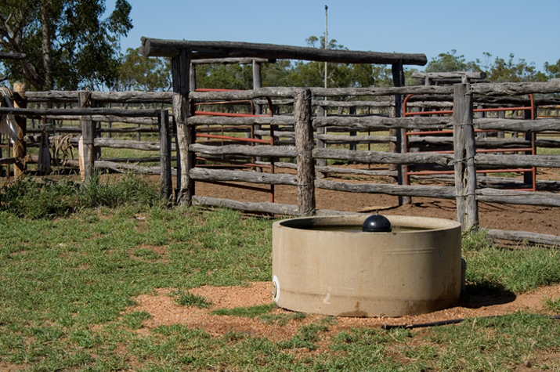

Table 6: Strategic outcomes for information, knowledge and understanding for management

| Objectives | Outcomes |
| --- | --- |
| Baseline information that identifies how the hydrology, hydrogeology and environment interact in Basin water resources is sufficiently accurate and robust to support decision-making processes  Understanding of changes that result from extraction of Basin water resources, developed in a timely manner that enables management intervention  The benefits that accrue from use of Basin water resources understood by water users and the general public | The coordinated governance system enables collaborative working relationships between researchers, industry, water users and governments to improve the Basin-wide information and knowledge base by:   * seeking out, evaluating and using the best available information to make evidence-based decisions * enabling collection and consolidation of information held by governments, researchers, and industry and community interests * facilitating improved data quality and consistency * investing in the acquisition of: * baseline information on the hydrogeological function of the Basin groundwater system, including natural recharge and discharge processes, water flows, water balances and risks to those processes * information on biodiversity and ecology of groundwater-fed systems, and risks to biota for all parts of the Basin * identifying knowledge gaps and priorities for research and for development of models and management tools * undertaking risk-based monitoring of the Basin groundwater system, including: * groundwater extraction * groundwater resource condition (artesian pressure, water quality, environmental values) * water infrastructure condition, including inter-aquifer leakage * compiling social, economic and cultural heritage values information related to the use of groundwater * understanding future patterns of development and projected water demand within the Basin * All of the above supports the preparation of a Basin-wide resource condition report every five years. |

### 7. Communicate and educate

Communicate and educate means that water resource management information, including information on social, cultural, economic and environmental values, will be publicly available, accessible and clearly understandable.

The challenge is to enable decision makers at all levels to access, understand and use the best information available as an integral part of their decision-making process.

Making the most effective use of the Basin knowledge base in policy development, planning, implementation and community education depends on having the capacity to understand, anticipate and respond to the information needs of particular audiences. This requires access to robust, timely information, followed by preparation of content with appropriate format and timing. A national monitoring strategy will be an important tool for reporting the status of the Basin resources across all jurisdictions.

The Plan promotes a culture of judicious water use and improved productivity in each sector. This needs to be based on a clear understanding of the conditions under which Basin water resources are used, as well as evidence of the impacts and benefits that accrue as a result of the use of these resources.

Using information and dialogue appropriately during policy development, planning and implementation helps to build trust, transparency, accountability and acceptance between managers, industry and water users. Such relationships are a key to establishing the willing adoption of management measures and minimising the need for costly compliance enforcement and confrontation.

Although some aspects of communication, education and dialogue are best handled within Basin jurisdictions, there is also a critically important role for Basin-wide information management and communication:

* Perspectives that result from Basin-wide dialogue and critical analysis are often the most efficient and effective way to add value, achieve consensus, and generate support for decision-making processes.
* The shared understanding generated in Basin-wide perspectives assists governments to strengthen the case for changes that meet management objectives and ensure that outcomes are compatible across the Basin.
* Authoritative Basin-wide perspectives are effective in responding to misinformation which may appear in popular and social media.

Establishing a clear understanding of the national significance of the Basin and the issues concerning its use and management in the minds of decision makers, industry and water resource managers and members of the wider community helps to ensure that Basin management is allocated a share of resources relative to its national importance. The Basin is the largest groundwater resource in Australia and is estimated to support close to $13 billion in economic production as well as a wide range of social and environmental values (Frontier Economics 2016). Raising the profile of the Basin also encourages industry investment and influences the decisions that industries make about operations and water management practices negotiated with governments.

Communication, dialogue and discussion between various interests based on factual information have a wide range of applications that benefit Basin management. No government, regulatory agency, industry or interest group involved in the management and use of the Basin will ever reach a point where information, education and communication are no longer required.

Table 7: Strategic outcomes for communicate and educate

| Objective | Outcomes |
| --- | --- |
| Basin-wide water resource management information, including information on social, cultural, economic and environmental values is publicly available, easily accessible and understandable | A centralised hub for Basin-wide information is established as part of the coordinated governance system to:   * draw on expertise from governments, water users and other interests * share information openly * assist in identifying and remedying strategic information gaps * ensure that Basin information is accessible, understandable, reliable, and usable for all levels of decision-making and enquiry, and appropriate to target audiences * provide a community gateway to authoritative information products about Basin groundwater systems, and their values, health, management and use.   Basin governments publicly report information on management of Basin groundwater systems.  A Basin-wide resource condition report is established based on an agreed monitoring strategy. It is communicated and updated 12 months prior to each five-year review of the Plan, to include ‘dashboard’ indicators of the current state of Basin resources and management, and identification of emerging trends, risks, challenges and opportunities. The Basin-wide condition report will provide a source of information for reviewing state and territory basin monitoring programs. |

Trochidrobia Minuta on Stromatolites at The Blanche Cup Natural Artesian Springs, South Australia



Photo: T Gotch

## Implementation of the Plan

Basin governments, water users and other interests have a joint responsibility to continue to improve management of the Basin to sustain important community values, continue to meet the needs of water users, and grow the benefits that accrue from Basin water use. The implementation of this Plan will assist governments with policy development and management, and support industries in their decision making to achieve more judicious use of water.

Basin governments have statutory responsibilities to provide adequate resources for Basin management, with national policy and water resources information support provided by the Australian Government.

Achieving the objectives and desired outcomes of the Plan will require targeted investment by Basin governments and the Australian Government commensurate with the risks and threats facing future Basin management. Industry and other interest groups should also be encouraged to consider the Plan when making investment decisions within the Basin. This will support active engagement of water users and other interests to enable implementation of the Plan through a whole of Basin-wide approach.

Local government and regional natural resource management groups provide an important source of local knowledge on social, economic and environmental matters and will be integral to implementing the Plan.

A rolling five-year implementation plan will be developed, be publically available and jointly managed by Basin governments in consultation with water users and other stakeholders, to:

* meet national water management agreements and their respective legislative requirements
* emphasise the critical role of whole of Basin management
* continue to enable stakeholders to participate in Basin-wide policy and decision making
* assist industries and other interests in making management and investment decisions
* provide information that assists meeting the Plan objectives and raising the profile of the Basin
* apply the coordinated governance principle of the Plan to strengthen and complement state/territory and whole-of-Basin policy and management initiatives.

Implementation plans will be guided by the principles, objectives and desired outcomes in the Strategic Management Plan and will include:

* actions to be taken by governments through water planning processes
* joint actions to be delivered by multiple governments in partnership
* activities to be delivered by governments working closely with industry, community groups and other stakeholders timeframes within which those actions and activities will occur
* the commitments required by water users, Basin governments, Australian government, industries and other interests to make the implementation plans operational.

## Appendix A – Why is the Great Artesian Basin important?

### Dimensions – space and time

The Great Artesian Basin is one of Australia’s great natural resources, with water up to 2 million years old. It is also one of the largest underground artesian water reservoir systems in the world. It covers an area greater than 1.7 million square kilometres, more than one-fifth of the Australian continent, and underlies most of Queensland and parts of New South Wales, South Australia and the Northern Territory.

The Great Artesian Basin is defined as a groundwater basin, encompassing several geological basins: the Eromanga, Surat and Carpentaria basins. It also incorporates parts of the Bowen and Galilee basins in Central Queensland, the Laura Basin in North Queensland, the Mulgildie Basin in central Queensland, and the western part of the Clarence–Moreton Basin in southern Queensland, all of which are hydraulically connected. Of the major geological basins, the Eromanga Basin is the largest at 1,000,000 km2 and extends across a large part of Queensland, New South Wales, South Australia and the Northern Territory. The Surat Basin covers 300,000 km2 in south‑eastern Queensland and north-eastern New South Wales. The Carpentaria Basin underlies an onshore area of 560,000 km2 in northern Queensland, though the sediments of the Carpentaria Basin also extend underneath the Gulf of Carpentaria (Smerdon et al. 2012).

Total water storage capacity is estimated at approximately 64,900 million ML. The depth of the sandstone aquifers is up to 3,000 metres in the deepest central parts. Temperatures of water coming to the surface are, on average, around 30.5°C, but range upwards to 100°C at some bore heads (Commonwealth of Australia 2011).

The Basin’s significance as a water resource is largely due to its location—it underlies arid and semi-arid landscapes to the west of the Great Dividing Range. Basin groundwater provides a climate-independent water supply in areas which often receive low or intermittent supply of rainfall. Under pressure in many Basin aquifers, water rises in bores and flows freely to the surface and so can be distributed without additional pumping to dams and other stock watering points. The water is often good enough quality for most uses, but in some aquifers high sodium levels may make it unsuitable for irrigation or human consumption.

More than 460 spring groups (Miles et al*.* 2012) support unique isolated wetland ecosystems, home to species of animals and plants found nowhere else. Communities of native species which depend on the natural discharge of groundwater from the Basin have been declared as endangered ecological communities under the *Commonwealth Environment Protection and Biodiversity Conservation Act 1999*. Due to the extent of the Basin its springs support ecosystems in a wide range of habitats, from mound springs on the arid margins in the south and west in South Australia and Queensland to springs in the Cape York Peninsula where high flows support lush rainforest.

Basin waters also flow into at least 80 other waterways, augmenting base flows which help to sustain them during times of low rainfall, while other springs discharge through the seabed in the Gulf of Carpentaria (Commonwealth 2011).

### Water use and value in the Basin

For Aboriginal and Torres Strait Islanders, the springs across the vast arid interior were often the only assured source of water, critical for survival, and were prime sites for hunting. Trade and travel routes evolved around these oases in the desert. They remain precious cultural and sacred sites imbued with power – integral to ceremonies and stories, and permeated with the histories of ancestors (Commonwealth of Australia 2011).

Much of the exploration, history and commerce of non-Aboriginal and Torres Strait Islander settlement in central Australia is built around access to Basin springs and bores. Early exploration and trade from the coast to central Australia depended on Basin springs. The story of the Camel and the ‘Afghan’ cameleers centres on access to springs and bores. The overland telegraph followed the ‘string of springs’ north through the outback of South Australia. The first bore was drilled in the Basin near Bourke in 1878. Within the next few decades access to artesian bores changed much of the arid and semi-arid part of Australia forever. The settlement of many towns and the evolution of the pastoral industry, stock routes, and the mining and petroleum industries is all part of Australian heritage supported by the Basin. The construction and operation of the Ghan railway relied on Basin springs and bores. Much of the local culture in towns and industries across the Basin is built around and continues to be sustained by access to the Basin. Sites which preserve the exploration, settlement and development story of the Basin are an essential part of Australia’s national heritage.

More than 180,000 people live in the area underlain by the Basin and 7,600 domestic, industrial and commercial enterprises depend on it as the sole reliable water resource for settlement, development and economic activity. Basin water is used in households in more than 120 towns and settlements and on hundreds of properties. Many communities avoid water heating systems by using naturally hot artesian supplies, while at Birdsville in Queensland hot artesian water is used to generate power to supplement the town’s off-grid electricity generation system (Commonwealth of Australia 2011).

The consumptive use of Basin water is estimated to be integral to at least $12.8 billion of production annually, including $4 billion in stock, $6 billion in mining and $2 billion in gas. (Frontier Economics 2016). The Basin’s waters offer considerable potential for increased levels and greater diversity of uses, as well as ways of facing future challenges such as climate change and low carbon energy sources. However, this diversity of opportunities will lead also to challenges.

The pastoral industry has long been the largest user of Basin water to water stock. The discovery and use of water held underground in the Basin opened up thousands of square miles of country away from rivers in inland New South Wales, Queensland, South Australia and the Northern Territory which had previously been unavailable for pastoral activities. The pastoral industry generates more than $4 billion annually in the Basin and utilises water delivery infrastructure worth more than $3 billion (Frontier Economics 2016). In some parts of the Basin intensive lot feeding of stock, as well as piggeries and poultry production has become an important use of Basin water in recent years.

The mining and petroleum industries are also major water users, either as co-produced water or water extracted to support in industry processes. Mining for copper, uranium, bauxite and opals depend on a reliable supply of Basin water. Mining industries also use Basin water for both mining and processing of lead, silver, zinc, bismuth, gold, and kaolin (Frontier Economics 2016). The extraction of conventional oil and gas, and (increasingly) coal seam gas results in extraction of substantial amounts of artesian water as a by-product throughout the life of those projects.

Basin water is used in a range of tourism enterprises, both in mineral spas and as part of the cultural and natural history of outback Australia. The tourism industry includes the outback experience, thermal baths, springs, camel treks, Aboriginal and Torres Strait Islander heritage sites, and the Ghan railway (GABCC 2016).

There are an estimated 50,000 bores across the Basin. The vast majority of these bores are less than 200 metres deep and draw water from sub-artesian aquifers. However, there are more than 9,000 artesian bores in the Basin, and more than a thousand of these are deeper than 1,200 metres (GABCC 2017).

Most early bores were not constructed with headworks, and water was allowed to flow freely, running into open drains over long distances to water stock with more than 95% of flows lost to evaporation and seepage into the soil. The rate of extraction of water led to reduced water pressure and flow across the Basin. In turn this reduced both access to artesian water and natural discharge, impacting on springs and associated biodiversity values.

## Appendix B – Past achievements through collaborative partnerships

The first Strategic Management Plan (SMP) was released in September 2000, developed collaboratively as a voluntary non-statutory planning document by the then Great Artesian Basin Consultative Council. This document was the first ‘whole of-Basin’ management plan to be adopted by all governments responsible for the management of the Basin, to address the critical issues and limitations in management identified by Basin stakeholders. The first SMP had a 15 year timeframe and detailed a staged process for implementing the strategies and objectives, as well as reviewing and reporting progress (GABCC 2009, Commonwealth of Australia 2015).

In parallel with this SMP, in 1999 the Great Artesian Basin Sustainability Initiative (GABSI) was introduced as a joint program between the Australian government and the New South Wales, Queensland, South Australia and Northern Territory governments. The program financially supported capping of uncontrolled bores and piping of open bore drains, to control water use and minimise wastage to improve the health of Basin springs. (See Appendix C).

Through a coordinated Basin-wide program that included investment in on-ground works, research, and the development and dissemination of an improved understanding of the resource, significant advances have been made in the management of the Basin under the previous SMP.

### Coordinated governance

Cooperative management of the Basin has included the co-funding of the Great Artesian Basin Consultative Committee by Basin governments and the Commonwealth. The Basin governments and the Commonwealth have also co-funded the GABSI to assist landholders cap and pipe. Relationships amongst all Basin stakeholders both within and outside government have proven robust over this time, and has been assisted by Great Artesian Basin advisory bodies being set up in South Australia, Queensland and New South Wales. These bodies have provided a community voice in regard to management activities. Recognising the linkages between other cross-state water Basins, meetings have occurred with Lake Eyre Basin and Murray-Darling Basin Community Advisory Committees to develop joint approaches for coordinated management.

### A healthy resource

All four Basin governments have expanded their planning frameworks and developed water management plans for Basin water resources: Queensland [Great Artesian Basin Water Resource Plan (2006) to be superseded by the Great Artesian Basin and other regional aquifers water plan in 2017], New South Wales [Water Supply Plan for the NSW Basin Groundwater Sources 2008], South Australia [Water Allocation Plan for the Far North Wells Prescribed Area 2009] and Northern Territory [draft Great Artesian Basin (NT) Water Allocation Plan]. The water management plans set limits on the amount of water that can be taken, balancing new development with needs of existing water users and the environments (Commonwealth of Australia 2015).

Over the period of the last SMP significant public and private investment has been made in the rehabilitation and maintenance of water bore and water distribution infrastructure in order to address historical impacts on artesian pressure and reduce the waste of water. This investment has improved the ‘health’ of the Basin.

Springs and related flows to watercourses, lakes and wetlands have been recognised as having significant and unique cultural and ecological values. The community of native species dependent on natural discharge of groundwater from the Basin was listed as a threatened ecological community under the *Environment Protection and Biodiversity Conservation Act* 1999 (Cwth) in 2001. These communities are also managed under state laws through the *Threatened Species Conservation Act* 1995 (NSW) and both the *Vegetation Management Act* 1999 and the *Environmental Protection Act* 1992 (Qld).

### Aboriginal and Torres Strait Islander values, cultural heritage and other community values

This SMP recognised the need to incorporate Aboriginal and Torres Strait Islander values and knowledge into management plans, recognising that cultural values may require a different water management approach, and that Aboriginal and Torres Strait Islander enterprises may have water requirements similar to other enterprises.

National water reforms led to all states agreeing to address Aboriginal and Torres Strait Islander access to and management of water through legislation and water planning. New South Wales water sharing plans provide for access licences for Aboriginal cultural and community development. In South Australia the Water Allocation Plan for the Far North Prescribed Wells Area 2009 recognises the cultural significance of Aboriginal and Torres Strait Islander water sites. The Northern Territory has adopted the Strategic Aboriginal Water Reserve Policy Framework which enables a volume of water from the consumptive pool within a Water Allocation Plan area to be exclusively accessible to Aboriginal landowners to use or trade for economic and social development outcomes.

Education packages have been produced for primary and secondary teachers and students. These focus on the importance of the Basin to the Aboriginal and Torres Strait Islander people and broader cultural heritage of inland Australia.

The cultural heritage of the Basin not only has important social, cultural and environmental values, but is an important part of local economies as well. The story and natural diversity of springs is of great interest to visitors in Northern South Australia. The story of the Basin and local history built around its uses are important attractions for tourism across the Basin. ‘Mineral baths’ using Basin water attract visitors to a number of centres. Aboriginal and Torres Strait Islander engagement in resource management and tourism is important to a number of communities.

Much of the available interpretive and educational material on Aboriginal and Torres Strait Islander historical and contemporary culture and local European history and contemporary culture in outback Australia centres on access to and reliance on water from springs and Basin bores.

Further community recognition of the importance of the Basin springs is reflected in special conservation areas protected by State legislation. A number of important spring complexes are protected in conservation reserves in South Australia including the Bubbler and Blanche Cup along the Oodnadatta Track and Dalhousie Springs near the Northern Territory border. Other important springs are protected under heritage and other agreements with private landholders. Edgbaston Reserve in Queensland was purchased in 2008 with assistance from the Australian Government and through private funding directed to the conservation organisation, Bush Heritage Australia. This reserve protects two nationally threatened fish: red-finned blue-eye and Edgbaston goby in the Basin spring-fed pools (Bush Heritage Australia 2016).

### Secure and managed access

Improved policy and the development of water plans with consultative planning strategies in all jurisdictions have resulted in good progress to support improved understanding of the rights and responsibilities of groundwater users and the licensing of extraction for most sectors of water use.

Each Basin government manages water extraction from the Basin in line with their own legislation, policy and regulatory frameworks. Such arrangements have progressed groundwater management, particularly where management rules have been developed in consultation with communities, however more progress is required.

The following achievements have occurred since the first SMP:

* In South Australia, the Water Allocation Plan (WAP) for the Far North Prescribed Wells Area was adopted by the South Australian Government in 2009 and is currently under review with a revised plan to be considered by government in 2019. The WAP establishes a framework to manage Basin water in South Australia. Almost all Basin water extraction in South Australia requires a water entitlement and allocations through a licensing regime (Department for Environment and Water 2018) and will align and support the desired outcomes of the Plan.
* In New South Wales the Water Sharing Plan for the New South Wales Great Artesian Basin Groundwater Sources 2008 commenced on 1 July 2008 and is in force until 30 June 2020. This Plan sets limits on extraction and establishes rules for sharing water between the different types of water users and the environment. It identifies the volume available to landholders under their basic right to access domestic and stock supplies and the volume available to licensed entitlement holders. It also sets rules for the location of bores to protect access for other users and impacts on the environment (Department of Primary Industries and Water 2017).
* In Queensland a new Water Plan (Great Artesian Basin and Other Regional Aquifers) 2017 commenced on 2 September 2017. The Plan provides the framework for the management of Queensland’s Basin groundwater, including providing security of supply for current and future water users and the protection of groundwater flows to springs and watercourses. The plans also broadly defined the areas and circumstances in which water may be taken or made available, as well as requirements for ongoing monitoring and reporting. It recognises the changed situation in relation to water demand in Queensland and contemporary planning policies. New elements in the plan include: improved water efficiency by mandating all uncontrolled bore and drains be made watertight by 2027, providing unallocated water reserves for the economic aspirations of Aboriginal people and Torres Straight Islanders, and simplified water trading in the Basin (Department of Natural Resources, Mines and Energy 2018).
* In the Northern Territory the Great Artesian Basin (NT) Water Allocation Plan is currently in draft form. The plan is being prepared in accordance with the NT Water Act and NT Water Allocation Planning Framework, and will align with and support the desired outcomes of the Plan. The volume of water currently extracted from the NT Great Artesian Basin is very small in volume relative to estimated storage and is used primarily for remote community water supply and stock watering. The draft Plan contains measures for the management of any future large scale extraction (e.g. potential petroleum/gas developments in the Pedirka Basin), particularly in the artesian zone, to mitigate potential impacts on water dependent spring systems in neighbouring South Australia and Queensland.

### Judicious use

There have been a wide range of successful strategies implemented across the Basin to eliminate wasteful practices over most of the last century to encourage judicious use. At the beginning of this SMP implementation phase, the use of flowing bores and bore drains to water stock had been the accepted practice sustaining the pastoral industry for a century. Eliminating wasteful water delivery practices was not as simple as just asking landholders to accept government subsidies to control their bores and replace bore drains. Many landholders had successfully relied on open bore drains for generations and were very reluctant to change. They presented a wide range of perceptions that suggested that a piped water delivery system would not work effectively in the Basin. Many did not have a good understanding of the water infrastructure technologies available and the water and land management advantages of installing those technologies. Those who had accessed information about piped systems were rightly concerned about the cost of installation and maintenance, the reliability of piped systems, and the changes in their business and lifestyle that would be required to operate the system sustainably.

As part of the implementation of this SMP, a number of programs were developed and implemented to engage water users and decision makers to more greatly value the Basin resources. These programs included education through farm, mining, energy and town water supply extension support which helped to embed a more positive approach towards adopting best practices for water use that avoids wastage. This information was supported by funding opportunities to support the changes needed at ground level. Examples include:

* The development of the Great Artesian Basin Sustainability Initiative (GABSI) provided financial support to pastoral landholders to increase their ability to use water judiciously. To date, 759 bores have been rehabilitated and 21,390 kilometres of bore drain have been replaced with piping, saving an estimated 253,640 mega litres of water every year. (See Appendix C).
* Dedicated groups within the managing agency in each jurisdiction to assist landholders with assessment of bore condition, understanding the water infrastructure technologies available, the standards for drilling and installation that are required, and water system planning to help them obtain the best outcomes from the investment.
* The use of bore trusts or cost sharing arrangements between neighbours where appropriate to share the cost of bore maintenance and rehabilitation and make the installation of distribution systems more efficient.
* Technical workshops and field days sponsored by governments, CSIRO and suppliers on water infrastructure installation and maintenance were held on pastoral properties in each jurisdiction.
* Packages of learning materials designed in collaboration with universities and school educators were developed for primary and secondary teachers and students on the natural and cultural history of the Basin. The packages also included information on the need to stop wasteful practices and rehabilitate flowing bores. Materials were offered free of charge to primary and secondary schools and sent to the schools of the air and mailed to schools where children of pastoralists were likely to attend.
* South Australia included statutory conditions on pastoral water licences, tying water allocation to stocking rates on the property and requiring landholders to deliver water to stock through a well maintained closed water delivery system. A compliance program was implemented in consultation with landholders. Groups other than government and landholders also contributed to Basin health. In South Australia Western Mining Corporation, and subsequently BHP, contributed to the GABSI program in that state and in Queensland several bore rehabilitation projects were sponsored by mining companies.

The need to eliminate wasteful practices and install and maintain closed water delivery systems has now become the accepted practice for delivering stock water in the Basin. Within the life of this SMP, the practice of using bore drains to water stock changed, and landholders agreed to invest in new stock watering systems, reorganise their land and business management practices and change their lifestyle to accommodate piped watering systems. Many landholders have improved their productivity and businesses by installing closed stock water systems. They have become advocates and encourage peers to operate such systems as the opportunities to strengthen their businesses through having greater flexibility in stock management were realised (GABCC 2006). Nevertheless, a small percentage of mostly sheep producers still see bore drains as a better water delivery system than piping.

### Information, knowledge and understanding for management

Knowledge of the Basin has been improving with significant investments through the National Groundwater Action Plan, and Commonwealth and state-led knowledge initiatives. Scientific knowledge of the Basin resource and its connectivity to other surface and groundwater systems has significantly increased, and the most important connections are in the recharge zones of the Basin (Smerdon et al. 2012). New knowledge on the structure, hydrogeology and water chemistry in the Basin, culminating in the Great Artesian Basin Water Resource Assessment and the subsequent new information generated for the Hydrogeological Atlas of the Great Artesian Basin (Welsh 2006, Smerdon et al. 2012, and Ransley et al. 2015). This knowledge along with associated monitoring information can be used to understand the water balance in the Basin.

Important research on the ecology and natural values supported by Basin Springs has been published and reported on as a component of understanding the resource. This has seen the community of native species dependent on natural discharge of groundwater from the Basin listed as a threatened ecological community under the *Environment Protection and Biodiversity Conservation Act* 1999 (Cwth) in 2001. These communities are also managed under state laws.

Substantial evidence on the cultural importance of springs to Aboriginal and Torres Strait Islander people and to other stakeholders has also been collected and reported (Silcock et al. 2013; Fensham et al. 2016).

Research on human impacts in the Basin has been less studied. The study on Economic Output of Groundwater Dependent Sectors (Frontier Economics 2016) provides a recent snapshot of the important economic value of this asset and a starting point for developing a process to continue to monitor outputs.

Work has also been done on landscape changes which have occurred as a result of the improved distribution of bore water. A series of national workshops was held in the past decade looking at various elements of grazing best practice, technological developments such as remote monitoring systems and improved water delivery systems and other industrial water uses that has resulted in more efficient water usage. This has also led to the development of policies concerning the spreading of water in the pastoral industry and the surface impact of water delivery in the mining and petroleum industries.

The Great Artesian Basin Coordinating Committee (GABCC) established three-year PhD top-up scholarships to support research that improved knowledge of the Basin. These have added to knowledge and understanding of links between springs and aquifers, and of fish and endemic invertebrates in springs and desert waterholes.

### Communicate and educate

A major focus of this SMP was investigating and compiling an up-to-date knowledge base about the Basin and its uses. Much of the work focused on water use by the pastoral industry and the effect of uncontrolled bores on water pressure in the Basin. A Basin Resource Study was compiled and published along with the SMP in 2000. The Study has subsequently been updated twice to include more information about springs, better science on the hydrology of the Basin, and changes in policy and management practices. The Resource Study was used as a basis for the development of the SMP and helped to identify knowledge gaps which may be limiting the effectiveness of Basin management.

Efforts were made continuously over the life of the Plan to encourage research, investigations and reporting to fill strategic gaps in understanding and then to identify opportunities to inform decisions and communicate knowledge about the Basin. Copies of these documents can be found on the GABCC website.

Scientific, technical, policy and management presentations on topical subjects and areas of limited understanding were programmed at each GABCC meeting. Special Basin conferences, forums and workshops were also cooperatively organised by regulatory agencies and the GABCC. Members were sponsored to attend and to present at conferences and meetings. Outcomes from these presentations and forums were utilised in discussion, advice and information products.

The GABCC acted as a catalyst to identify relevant expertise and presentations and then provide a forum for information sharing. The Committee worked cooperatively with management agencies, research groups, and the media to prepare and deliver communication products which informed ministers, regulators, water users and other interests. Examples of the range of products that were targeted at particular audiences to meet help achieve particular outcomes are:

* Basin Resource Study (GABCC 2014)
* Advice and briefings for Basin ministers
* Basin website containing a variety of credible information
* Researchers forums and conferences
* Field days and technical workshops at various locations in the Basin
* Presentations and displays at conferences
* Special Basin stalls and presentations at community events around the Basin
* Media programs and briefings
* Student and teacher education packages (DSEWPC 2012)
* Special information packages targeted at particular sectors of water users
* Booklets, posters and DVDs on the Basin
* Research prospectus
* Public meetings and consultation with water users and industry groups
* Website fact sheets on a variety of subjects and issues.

## Appendix C – Statistics from the Great Artesian Basin Sustainability Initiative

The Great Artesian Basin Sustainability Initiative (GABSI) was a joint program between the Australian, New South Wales, Queensland, South Australian and Northern Territory governments and Basin landholders. It has operated for 17 years over four phases of activity.

Table C.1: Australian Government and State Funding Contributions up to and including 30 June 2018

| Jurisdiction | GABSI 1: 1999-00 to 2003-04 ($mil) | GABSI 2: 2004-05 to 2008-09 ($mil) | GABSI 3: 2009-10 to 2013-14 ($mil) | GABSI 4: 2015-16 to 2016-17 $mil) | Total |
| --- | --- | --- | --- | --- | --- |
| Australian Government | 28.386 | 38.531 | 44.644 | 13.401 | 124.962 |
| QLD | 14.304 | 22.736 | 23.706 | 3.996 | 64.742 |
| NSW | 12.335 | 15.595 | 18.011 | 2.78 | 48.721 |
| SA | 1.747 | 0.200 | 2.927 | 6.625 | 11.499 |
| Total | 56.772 | 77.062* | 89.288 | 26.802 | 249.924 |

* This total does not include $1.357 million which was provided to WA under GABSI 2

Table C.2: Estimated* GABSI Phase 3 Landholder Contributions

| State | Contributions by Year ($mil) 09-10 | Contributions by Year ($mil) 10-11 | Contributions by Year ($mil) 11-12 | Contributions by Year ($mil) 12-13 | Contributions by Year ($mil) 13-14 | Total |
| --- | --- | --- | --- | --- | --- | --- |
| New South Wales | 5.399 | 3.841 | 5.527 | 5.832 | 7.653 | 28.252 |
| South Australia** | - | - | - | - | - | - |
| Queensland | 3.293 | 2.597 | 2.662 | 2.467 | 6.465 | 17.484 |
| Total | 8.022 | 7.461 | 8.337 | 8.503 | 13.838 | 46.161 |

* The figures in this table are the estimated land holder contributions shown in the Implementation Plans against each year. In some years, severe and unexpected natural events may have caused the landholder contributions to be significantly different to those shown. This is likely to have occurred in New South Wales in 2009-2010 and 2010-2011 and in Queensland in 2010-2011 due to extensive flooding.

** South Australia has not required landholder contributions in the same manner as New South Wales or Queensland.

Table C.3: Water Savings (mega litres per annum) up to 30 June 2018

| State | Water Saved ML/annum |
| --- | --- |
| New South Wales | 68,830 |
| South Australia | 48,961 |
| Queensland | 139,081 |
| Total | 256,872 |

Table C.4: Bores Controlled up to 30 June 2018

| State | Number of Bores |
| --- | --- |
| New South Wales | 311 |
| South Australia | 51 |
| Queensland | 397 |
| Total | 759 |

Table C.5: Open Bore Drains deleted (km) up to 30 June 2018

| State | Bore drains deleted (km) |
| --- | --- |
| New South Wales | 8,558 |
| South Australia | 342 |
| Queensland | 12,491 |
| Total | 21,391 |

Table C.6: Piping Installed (km) up to 30 June 2018

| State | Piping installed (km) |
| --- | --- |
| New South Wales | 15,063 |
| South Australia | 344 |
| Queensland | 16,140 |
| Total | 31,547 |

Table C.7: Estimated Remaining Basin Bore capping and piping

| State | New South Wales | Queensland3 | South Australia | Total |
| --- | --- | --- | --- | --- |
| Bores to be controlled1 | 229 | 179 | 23 | 431 |
| Bore drains to be deleted (km)2 | 1,150 | 3,986 | 0 | 5,136 |
| Estimated water saving (ML/annum)2 | 26,600 | 89,296 | 365 | 116,261 |
| Total estimated cost, ($ mil )2 | 114 | 135 | 1.25 | 250.25 |

1 GABCC – Summary of past drilling activity within the Great Artesian Basin – November 2017 – updated to reflect projects completed since November 2017

2 Great Artesian Basin Sustainability Initiative Value for Money Review – January 2014 – these figures are estimates based on state data

3 Census of Uncontrolled Artesian Bores and Artesian-Fed Bore Drains in Queensland: Bore Summary Report – GHD 2019

## Appendix D – Pressure Trends across the Basin linked to GABSI

Data collected to date shows that water pressure levels have responded to improved Basin water management with differing results ranging from increased water pressure or stabilization through to ongoing trends of decline.

### Queensland

In Queensland data collected for the review of the Great Artesian Basin Water Resource Plan 2006 showed that based on long term monitoring, groundwater levels across the Eromanga and Carpentaria basins have been stabilising and recovering in recent decades. The observed trends coincide with the Great Artesian Basin Sustainability Initiative (GABSI) program, as well as longer term trends of reducing groundwater extraction. The historical water use assessment suggests that extractions peaked in the Eromanga basin, for example, between 1915 and 1928 with an average use of over 600 GL/year during this period (Figure D1). After this, until 1990, there is a gradual decline due to a combination of declining artesian pressure and declining number of uncontrolled bores. From 1990 onwards, there is a significant decline in use to approximately 150 GL/year, due to bore rehabilitation and drain replacement programs (KCB 2016b).

In the Gilbert River Formation of the southern Carpentaria basin, average groundwater level stabilised around the 1990s (KCB 2016a). In the Cadna-owie–Hooray Aquifer in the northern Eromanga basin, significant declines in average groundwater levels prior to 1940 started stabilising after 1940 and began rising after 1990 (Figure D2). A similar pattern is observed in the southern Eromanga basin, but with average water levels rising after 2000 (KCB 2016b).

While in the Gubbermunda Aquifer of the Surat basin, average groundwater levels have been declining since the early 1900s, but started approaching stability after 1970. Average water levels continue to decline in the Surat Basin as a whole, however, with significant declines occurring in some deeper aquifers such as the Hutton Sandstone (KCB 2016c).

Figure D.1: Trend in water use in the Eromanga Basin (1900 – 2015) in Queensland. (KCB 2016b)

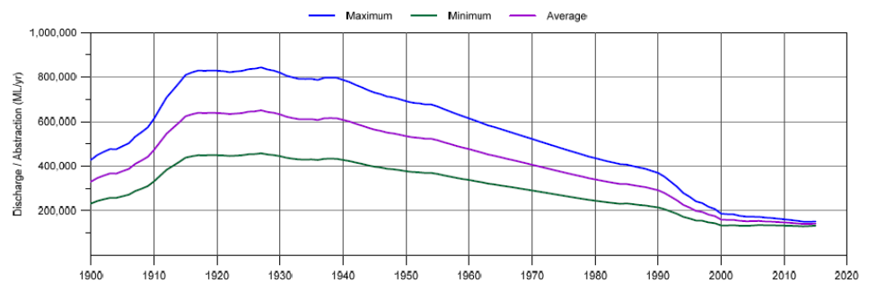

Figure D.2: Change in average water levels in the Cadna-owie–Hooray aquifer group in the northern Eromanga sub-basin in Queensland. (KCB 2016b)

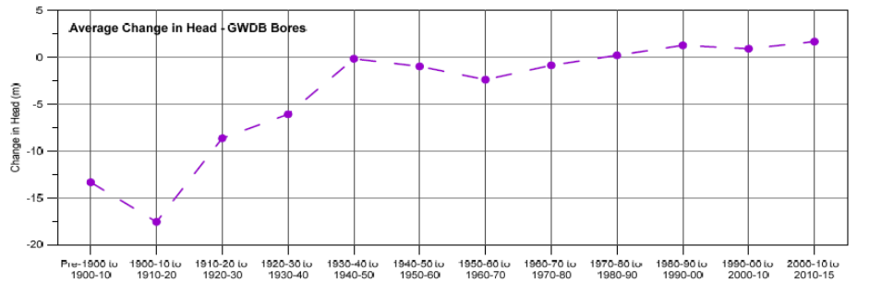

### New South Wales

Groundwater levels, artesian pressure, artesian flow and temperature are regularly monitored at 123 sites throughout the Great Artesian Basin within New South Wales. The monitoring network includes 29 bores that are equipped with loggers that record data continuously which is telemetered so that real time data is available via the internet at http://realtimedata.water.nsw.gov.au/water.stm.

Increases in artesian bore pressure are being observed (Figure D3) across large areas of the New South Wales Basin as a result of the capping and piping programs. Over 70% of the bores controlled to date are located in the Surat Groundwater Source where the artesian heads and associated uncontrolled artesian flows were the largest prior to the implementation of the capping program. This area has also seen the greatest recovery of artesian pressure with over 100 kPa (~10 m head) in the last decade observed in areas north of Coonamble.

Signs of pressure recovery and reversal of declining pressure have also been monitored further west in the Warrego and Central Groundwater Sources. Although the area of pressure recovery is smaller in comparison to the Surat Groundwater Source, there has been significant head recovery monitored at individual bores.

The monitoring has also shown that the rate of pressure recovery appears to be higher in the Surat Groundwater Source than in the Warrego and Central Groundwater Sources.

Figure D.3: Area of artesian pressure recovery in NSW

Shows areas of artesian pressure recovery in the Eastern Recharge, Southern Recharge, Surat, Warrego and Central Groundwater Sources.
The Eastern Recharge, Southern Recharge and Surat Groundwater Sources have significantly more bores and sections of work completed by the ‘Cap and Pipe the Bores’ project than in the Werrego and Central Groundwater Sources.

### South Australia

Over the past 20 years in the South Australian Far North Prescribed Wells Area (PWA), the groundwater pressure levels of the Basin (J-K) aquifer have remained generally stable.

In the five years to 2015, and from a total of 19 wells, nine monitoring wells (47%) show a trend of rising groundwater pressure levels and three wells (15%) show stable water pressure levels. Rises in water pressure levels ranged between 0.04–0.9 m/y, with a median of 0.19 m/y. These wells are located around the Oodnadatta region (Figure D.4). The remaining seven monitoring wells (38%) show a trend of declining groundwater pressure levels; and these wells are mainly located in the William Creek and Howard Springs region (Figure D.4). It should be noted that 10% of all available monitoring wells display their lowest level on record in 2015 (Department of Environment, Water and Natural Resources 2016).

The Basin (J-K) aquifer in the Far North PWA has been assigned a green status for 2015 (meaning that Positive trends have been observed over the past five years).

The 2015 status for the Basin (J-K) aquifer is based on:

* most monitoring wells (63%) showing a five-year trend of rising or stable groundwater pressure levels
* all monitoring wells showing a five-year trend of stable groundwater salinity.

It should be noted that the majority of these available monitoring wells are concentrated in the south-western part of the PWA, and are related to J-K aquifer of the Basin. Therefore, the assigned status to the PWA cannot be extended to the whole of the Great Artesian Basin.

Although a green status has been assigned to the J-K aquifer of the Basin, steady declines in groundwater pressure levels, registered within the BHP Billiton’s Olympic Dam (Wellfield B) monitoring network, and salinities increases shown by the Heathgate Resources monitoring network, are acknowledged.

Figure D.4: 2015 status of the groundwater levels in the Basin (J-K) aquifer of the Far North Prescribed Wells Area, based on five-year trends from 2011 to 2015

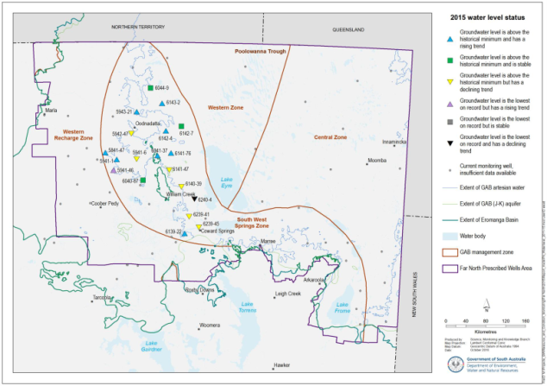

## Appendix E - References

Bush Heritage Australia (2016) Edgbaston. Accessed at: https://www.bushheritage.org.au/places-we-protect/queensland/edgbaston

Commonwealth of Australia (2011) Water Down Under. Understanding and Managing Australia’s Greatest Artesian Basin. Accessed at: http://www.gabcc.gov.au/publications/water-down-under-booklet

Commonwealth of Australia (2014) Ecological and hydrogeological survey of the Great Artesian Basin springs - Springsure, Eulo, Bourke and Bogan River supergroups. Volume 1: history, ecology and hydrogeology, Knowledge report, prepared by UniQuest for the Department of the Environment, Commonwealth of Australia’. Accessed at: http://www.environment.gov.au/water/publications/great-artesian-basin-springs-survey-vol-1

Commonwealth of Australia (2015) Future Directions for the Management of the Great Artesian Basin. Accessed at: http://www.gabcc.gov.au/publications/gab-future-directions

Department of Agriculture and Water Resources (2017) Great Artesian Basin Sustainability Initiative. Accessed at: http://agriculture.gov.au/water/national/great-artesian-basin/great-artesian-basin-sustainability-initiative

Department of Environment, Water and Natural Resources (2016) Far North PWA GAB (J-K) aquifer 2015 Groundwater level and salinity status report, Government of South Australia, through the Department of Environment, Water and Natural Resources, Adelaide. Accessed at:  
https://www.waterconnect.sa.gov.au/Content/Publications/DEWNR/Far_North_PWA_GAB_J-K_2015.pdf

Department of Environment, Water and Natural Resources (2017) Ground water. Accessed at: http://www.naturalresources.sa.gov.au/aridlands/water/managing-water-resources/ground-water

Department of Natural Resources, Mines and Energy (2018) Great Artesian Basin and Other Regional Aquifers. Accessed at https://www.business.qld.gov.au/industries/mining-energy-water/water/catchments-planning/water-plan-areas/great-artesian-basin

Department of Primary Industries and Water (2017) NSW Great Artesian Basin Groundwater. Accessed at: http://www.water.nsw.gov.au/water-management/water-sharing/plans-commenced/water-source/gab

Department of Sustainability, Environment, Water, Population and Communities (2012) The Great Artesian Basin: Water in the dry interior teacher guide and lesson plans—lower secondary. Accessed at: http://agriculture.gov.au/water/national/great-artesian-basin/great-artesian-basinwater-dry-interior

Department of Water and Energy (2009) Water Sharing Plan: NSW Great Artesian Basin Groundwater Sources – Background document. Accessed at: http://www.water.nsw.gov.au/__data/assets/pdf_file/0007/547927/wsp_nsw_gab_background.pdf

EPA (2005) Great Artesian Basin Spring Wetlands. Queensland Wetlands Programme. Accessed at: https://wetlandinfo.ehp.qld.gov.au/resources/static/pdf/resources/fact-sheets/profiles/p01718aa.pdf

Fensham R., Ponder W., Fairfax R. (2010) Recovery Plan for the community of native species dependent on natural discharge of groundwater from the Great Artesian Basin. Accessed at: http://www.environment.gov.au/system/files/resources/0cefc83a-3854-4cff-9128-abc719d9f9b3/files/great-artesian-basin-ec.pdf

Fensham R.J., Silcock J.L., Laffineur B., MacDermott H.J. (2016). Hydrogeology, cultural history and biological values of springs in the Barcaldine, Springvale and Flinders River supergroups, Galilee Basin and Tertiary springs of western Queensland. Accessed at: https://publications.qld.gov.au/dataset/lake-eyre

Frontier Economics (2016) Economic output of groundwater dependent sectors in the Great Artesian Basin. Accessed at: http://www.gabcc.gov.au/basin-management/Basin-economic-report

GABCC (2006) Champions of the Great Artesian Basin. Accessed at: http://www.gabcc.gov.au/publications/champions-of-the-gab-booklet

GABCC (2009) Strategic Management Plan: Progress and Achievements to 2008. Accessed at: http://www.gabcc.gov.au/publications/strategic-management-plan-progress-and-achievements-2008

GABCC (2011) Water in remote areas: when wetter isn't better Fact sheet. Accessed at: http://www.gabcc.gov.au/publications/water-remote-areas-fact-sheet

GABCC (2014) Great Artesian Basin Resource Study 2014. Accessed at: http://www.gabcc.gov.au/publications/gab-resource-study-update-2016

GABCC (2016) Fact sheet 1: Cultural values of the Great Artesian Basin. Accessed at: http://www.gabcc.gov.au/sitecollectionimages/resources/ff1601dd-f42a-4bfb-9308-ab241e60b40d/files/cultural-values-gab-factsheet.pdf

GABCC (2017) ‘Summary of past drilling activity within the Great Artesian Basin (Prepared for the GABCC jurisdictional members)’ Accessed at: http://www.gabcc.gov.au/publications

KCB [Klohn Crippen Berger] (2016a) Hydrological Assessment of the Great Artesian Basin – Characterisation of Aquifer Groups Carpentaria Basin. Accessed at: http://www.gabcc.gov.au/SiteCollectionDocuments/gab-hydrogeological-carpentaria.pdf

KCB [Klohn Crippen Berger] (2016b) Hydrological Assessment of the Great Artesian Basin – Characterisation of Aquifer Groups Eromanga Basin. Accessed at: http://www.gabcc.gov.au/SiteCollectionDocuments/gab-hydrogeological-eromanga.pdf

KCB [Klohn Crippen Berger] (2016c) Hydrological Assessment of the Great Artesian Basin – Characterisation of Aquifer Groups Surat Basin. Accessed at: http://www.gabcc.gov.au/SiteCollectionDocuments/gab-hydrogeological-surat.pdf

Miles C, White M Scholz G (2012) Assessment of the impacts of future climate and groundwater development on Great Artesian Basin springs. A technical report to the Australian Government from the CSIRO Great Artesian Basin Water Resource Assessment. CSIRO Water for a Healthy Country Flagship.

Office of Groundwater Impact Assessment (2016) Surat Underground Water Impact Report. Office of Groundwater Impact Assessment, Queensland government. Accessed at: http://www.business.qld.gov.au/industries/mining-energy-water/resources/land-environment/surat-cma/uwir.

Ransley T.R., Radke B.M., Feitz A.J., Kellett J.R., Owens R., Bell J., Stewart G. and Carey H. (2015) Hydrological Atlas of the Great Artesian Basin. Commonwealth of Australia (Geoscience Australia).  
Accessed at: http://www.ga.gov.au/metadata-gateway/metadata/record/gcat_79790

Silcock, J., Powell, O., Drimer, J. & Fensham, R. (2013) Ecological and hydrogeological survey of the Great Artesian Basin Springs - Springsure, Eulo, Bourke and Bogan River supergroups - Volume 1: history, ecology and hydrogeology. Report commissioned by the Department of the Environment on the advice of the Interim Independent Expert Scientific Committee on Coal Seam Gas and Coal Mining.  
Accessed at: https://www.environment.gov.au/water/publications/great-artesian-basin-springs-survey-vol-1

SKM (2014) Great Artesian Basin Sustainability Initiative Value for Money Review. Accessed at: http://webarchive.nla.gov.au/gov/20160111084809/http://www.environment.gov.au/water/publications/environmental/groundwater/gabsi-value-money-review

Smerdon BD, Ransley TR, Radke BM and Kellett JR (2012) Water resource assessment for the Great Artesian Basin. A report to the Australian Government from the CSIRO Great Artesian Basin Water Resource Assessment.  
Accessed at: https://publications.csiro.au/rpr/download?pid=csiro:EP132686&dsid=DS5

Welsh WD (2006) Great Artesian Basin transient groundwater model. Bureau of Rural Sciences, Canberra.  
Accessed at: http://www.southwestnrm.org.au/sites/default/files/uploads/ihub/welsh-wd-2006-great-artesian-basin-transient-groundwater-model.pdf

**Further Information**

Department of Agriculture

agriculture.gov.au/water/national/great-artesian-basin

**Contact Information**

Email: gabsecretariat@agriculture.gov.au

Great Artesian Basin Secretariat  
Water Division  
GPO Box 858  
CANBERRA ACT 2601

Enquiries: 1800 900 090