# Sulfur Dioxide (SO2) Carbon Dioxide (CO2) fumigation methodology

Version 1.0



© Commonwealth of Australia 2019

**Ownership of intellectual property rights**

Unless otherwise noted, copyright (and any other intellectual property rights, if any) in this publication is owned by the Commonwealth of Australia (referred to as the Commonwealth).

**Creative Commons licence**

All material in this publication is licensed under a Creative Commons Attribution 3.0 Australia Licence, save for content supplied by third parties, logos and the Commonwealth Coat of Arms.

C:\Documents and Settings\west merryn\Local Settings\Temporary Internet Files\Content.Word\by.png

Creative Commons Attribution 3.0 Australia Licence is a standard form licence agreement that allows you to copy, distribute, transmit and adapt this publication provided you attribute the work. A summary of the licence terms is available from [creativecommons.org/licenses/by/3.0/au/deed.en](http://creativecommons.org/licenses/by/3.0/au/deed.en). The full licence terms are available from [creativecommons.org/licenses/by/3.0/au/legalcode](http://creativecommons.org/licenses/by/3.0/au/legalcode).

Inquiries about the licence and any use of this document should be sent to [copyright@agriculture.gov.au](mailto:copyright@agriculture.gov.au).

**Cataloguing data**

This publication (and any material sourced from it) should be attributed as: Department of Agriculture, 2019, *Sulfur dioxide carbon dioxide fumigation methodology*, Canberra, November. CC BY 3.0.

This publication is available at [agriculture.gov.au/publications](http://agriculture.gov.au/publications).

Department of Agriculture

Postal address GPO Box 858 Canberra ACT 2601

Telephone 1800 900 090

Web [agriculture.gov.au](http://agriculture.gov.au/)

The Australian Government acting through the Department of Agriculture has exercised due care and skill in preparing and compiling the information and data in this publication. Notwithstanding, the Department of Agriculture, its employees and advisers disclaim all liability, including liability for negligence and for any loss, damage, injury, expense or cost incurred by any person as a result of accessing, using or relying upon any of the information or data in this publication to the maximum extent permitted by law.

## Purpose

This methodology sets out the minimum requirements for treatment providers performing combined Sulfur Dioxide (SO2) and Carbon Dioxide (CO2) fumigations as a phytosanitary measure for regulated pests on plant products. Specifically, this methodology is for the treatment of redback spiders in Australian table grapes to New Zealand.

Fumigation treatment providers registering to perform treatments in accordance with these requirements must have the equipment, facilities, suitably qualified fumigators and management and administrative procedures necessary to ensure that all relevant treatments comply with these requirements.

Treatment certification through this system is a declaration that the treatment has been undertaken in accordance with this methodology. Responsible certifying authorities must ensure, through audit or verification, that treatment facilities can demonstrate that they meet all the requirements to effectively deliver SO2/CO2 treatments. This may include registration, or approval arrangements by third parties.

## Scope

This methodology provides the requirements for the effective application of SO2/CO2 fumigation as a phytosanitary measure for regulated pests on plant products for human consumption. It is the baseline for the application of SO2/CO2 fumigation in trade with and within Australia. Additional requirements may apply to trade with some countries.

The following is out of scope:

* specific import requirements
* target temperatures and durations for specific pests
* operational instructions including requirements for premises registration, certification, approval of arrangements, etc.

The import requirements for trade with Australia can be found on the department’s website at [www.agriculture.gov.au](http://www.agriculture.gov.au/). The Biosecurity Import Conditions (BICON) database contains the requirements for imports to Australia and the Manual of Importing Country Requirements (MICoR) lists known conditions for exports from Australia. The specific State and Territory department of agriculture websites for domestic trade can be found on the relevant state websites.

Contents

Purpose iii

Scope iii

1 Prior to fumigation 6

1.1 Fumigation personnel 6

1.2 Fumigation equipment 6

1.3 Treatment rate 6

1.4 Treatment temperature 6

1.5 Load configuration 7

2 Fumigation chamber 7

2.1 Fumigation chamber requirements 7

3 Applying the dose 8

3.1 Dose calculation 8

3.2 Releasing the gas into the chamber 8

3.3 Start time of the fumigation 8

3.4 End of the exposure period 8

4 Ventilating the chamber 9

4.1 Removing the fumigant from the chamber 9

4.2 Threshold limit value - time weighted average (TLV-TWA) 9

4.3 Releasing the consignment from the fumigator’s control 9

5 Safety 10

5.1 Risk assessment 10

5.2 Managing the risk 10

5.3 Personal protective equipment (PPE) 10

6 Phytosanitary security 11

6.1 Phytosanitary security 11

7 Documentation 11

7.1 Record of Fumigation 11

7.2 Fumigation treatment certificate 12

Appendix 1: Example record of fumigation 13

Completing the record of fumigation 14

Appendix 2: Performing a pressure test 16

Procedure for performing a pressure test 16

Instruments for measuring the pressure decay time 16

Appendix 3: Example treatment certificate 17

Glossary 18

## Prior to fumigation

### Fumigation personnel

#### 1.1.1 The fumigator must have the relevant regulatory approval and training to conduct fumigations with SO2/CO2, for example state fumigation licence.

#### 1.1.2 The fumigator must apply the correct treatment schedule for the pest/commodity/destination combination.

### Fumigation equipment

#### 1.2.1 The fumigator must have the appropriate equipment and other resources needed to undertake the fumigation in compliance with this methodology. The equipment must be fit-for-purpose and in good working order.

#### 1.2.2 Instruments used to monitor temperature or detect the presence of fumigant must be in calibration at the time of use and serviced in accordance with the manufacturer’s instructions.

#### 1.2.3 A copy of the user’s manual for each type of instrument must be available and the equipment must be used in accordance with the operating instructions.

### Treatment rate

#### 1.3.1 A fumigant mixture of 1% sulfur dioxide with 6% carbon dioxide at an ambient temperature of at or above 18° C.

#### 1.3.2 The duration of the treatment must be no less than 30 minutes from the time the entire amount of both gases have been added to the chamber.

### Treatment temperature

#### 1.4.1 The ambient temperature in the chamber must be at or above 18° C before any fumigant can be applied and maintained at or above 18° C for the duration of the exposure period.

#### 1.4.2 If the product is being treated straight from the field use the ambient temperature in the chamber once the product has been loaded.

#### 1.4.3 If the product is being treated from cold storage or the ambient temperature is 18° C or below, the product must be warmed to at or above 18° C and the temperature must be measured in at least three representative locations in the enclosure, with at least two of the thermometers placed in the middle of a grape bunch situated in the centre of a carton, at the centre of the treatment lot, at mid height.

1.4.4 Temperature is to be measured for the duration of the treatment.

### Load configuration

#### 1.5.1 The volume of the load to be treated must not be more than 50% of the volume of the chamber.

#### 1.5.2 The boxes must be positioned so that air can freely circulate on all sides

#### 1.5.3 The boxes and any liners must be opened so that the fumigant can penetrate into all bunches.

## Fumigation chamber

### Fumigation chamber requirements

#### 2.1.1 The fumigation must be performed in a gas-tight fumigation chamber.

#### 2.1.2 Fumigation chambers must:

* be clean and pest free
* have a system in place to prevent pest infestation or reinfestation of consignments, which may include pest proof materials covering all openings
* be permanent structures designed specifically for fumigation
* be constructed from rigid materials on all sides, including the door and floor
* have any wood or porous masonry used as an inner surface in the chamber they are to be painted with a non-water based paint
* be permanently sealed along all joins between the walls, roof and floor
* be gas–tight once the door is closed without the need to use tape, sealant, sand snakes or any other means.
* not have anything, such as sampling tubes, supply pipes or electrical leads, enter the chamber through the door or walls that will interfere with the seal
* have an in-built circulation system that will distribute the fumigant evenly throughout the chamber
* have an in-built extraction system that actively and safely removes the fumigant from the chamber.

#### 2.1.3 A fumigation chamber is considered to be sufficiently gas-tight if it is able to pass a pressure test as described in Appendix 2 Performing a pressure test. Instruments for measuring the gas concentrations at the fumigation levels specified are not available, therefore, maintaining adequate gas concentrations is inferred by meeting the pressure testing requirements.

#### 2.1.4 The fumigation chamber must pass a pressure test no more than a week before the first fumigation at start of the season and, thereafter, every four weeks until the season ends.

## Applying the dose

### Dose calculation

#### 3.1.1 The doses must be calculated by multiplying the dose rates by the volume of the chamber. The rates are:

1 per cent sulfur dioxide equals 27.174 grams of sulfur dioxide per cubic metre.  
6 per cent carbon dioxide equals 109.69 grams carbon dioxide per cubic metre.

**SO2 dose (g) = Chamber Volume (m3) x 27.174**

**CO2 dose (g) = Chamber Volume (m3) x 109.69**

#### 3.1.2 Calculations must be rounded up to the next increment that can be accurately measured by the equipment used to dispense the dose.

### Releasing the gas into the chamber

#### 3.2.1 The circulation system must be operating during the injection of the gases into the chamber and for the entire exposure period.

#### 3.2.2 If the chamber has a separate gas supply line for each gas they can be released simultaneously.

#### 3.2.3 If the chamber only has one gas supply line, the CO2 line must be released first followed by the SO2.

#### 3.2.4 Record the start and end weight of each gas cylinder used to supply the dose.

#### 3.2.5 If the chamber has previously been used for other fumigants such as methyl bromide or sulfuryl fluoride the supply line/s must be purged with fresh air or an inert gas such as nitrogen, before the next SO2/CO2 fumigation.

### Start time of the fumigation

#### 3.3.1 The fumigation exposure period starts when the required amounts of SO2 and CO2 have been released into the chamber.

### End of the exposure period

#### 3.4.1 The elapsed time between the start time and the end time of the fumigation must not be less than 30 minutes.

## Ventilating the chamber

### Removing the fumigant from the chamber

#### 4.1.1 At the end of the exposure period the fumigant must be fully ventilated from the chamber in a controlled and safe manner.

#### 4.1.2 An assessment of the risks must be done to manage the ventilation process so that unprotected personnel in the vicinity are not exposed to unsafe levels of fumigant. The assessment must take into account:

* prevailing wind direction
* location and proximity of unprotected personnel
* establishment of a temporary buffer zone around the chamber that is sufficient to prevent unprotected personnel in the vicinity from being exposed to unsafe levels of SO2
* prevention of unprotected personnel entering the buffer zone during ventilation.

#### 4.1.3 Unprotected personnel are not permitted to enter the risk area until the fumigator verifies that the concentration in the area and throughout the chamber is at or below the threshold limit value – time weighted average (TLV–TWA).

### Threshold limit value - time weighted average (TLV-TWA)

#### 4.2.1 The chamber must be ventilated until the concentration of SO2 in the chamber, including within the boxes, is the equal to or below the TLV–TWA of 2 ppm.

#### 4.2.2 The equipment used for measuring TLV–TWA must be fit-for-purpose and capable of accurately measuring the actual concentration, not just the presence, of SO2 in the range of 0 to 20 ppm.

#### 4.2.3 If stain tubes are used, they must be used in conjunction with the sampling pump specified by the manufacturer.

### Releasing the consignment from the fumigator’s control

#### 4.3.1 The consignment can only be released from the fumigators control once the following conditions have been met:

* the fumigation has been performed in accordance with this methodology and any other importing country authority’s requirements, and
* the fumigant concentrations have been verified to the TLV–TWA or below.

#### 4.3.2 The TLV–TWA readings and the time they were taken must be recorded.

## Safety

### Risk assessment

#### 5.1.1 Before commencing any fumigation a risk assessment must be carried out to determine if any hazards are present and evaluate the potential consequences to:

* fumigation personnel
* unprotected people in the vicinity

#### 5.1.2 Appropriate control measures must be in place to address the hazards identified.

#### 5.1.3 The designated fumigator–in–charge is responsible for the safe conduct of the fumigation.

### Managing the risk

#### 5.2.1 A minimum three metre exclusion zone must be enforced while the fumigant doses are being released into the chamber.

#### 5.2.2 Anyone inside the exclusion zone while it is in force must be wearing appropriate Personal Protective Equipment (PPE) at all times.

#### 5.2.3 The chamber must be secured from access from the time gas injection starts until ventilation is complete.

### Personal protective equipment (PPE)

#### 5.3.1 Respiratory protection must be worn at all times when inside the buffer zone during ventilation.

#### 5.3.2 A full–face respirator must be:

* operated in accordance with the manufacturer’s instructions
* fitted with the correct gas filter canister (Type E for SO2) and replaced in accordance with the manufacturer’s instructions
* maintained in good condition with all valves clean and intact
* able to form an air–tight seal against the face of the fumigator.

5.3.3 Self–contained breathing apparatus must be:

* operated in accordance with the manufacturer’s instructions
* used only by properly trained personnel
* maintained in good working order
* refilled from a safe source.

## Phytosanitary security

### 6.1 Phytosanitary security

6.1.1 Phytosanitary security must be maintained for all goods that are intended for export from the time the goods attain a phytosanitary status.

6.1.2 Goods that have a phytosanitary status must be kept secure and identifiable at all times, that is, they must be adequately protected to prevent infestation or contamination and labelled to prevent substitution.

6.1.3 Registered establishments must meet the phytosanitary security requirements in the Guideline: [*Maintenance of phytosanitary security for horticulture exports*](https://www.agriculture.gov.au/export/controlled-goods/plants-plant-products/plantexportsmanual#phytosanitary-security).

## Documentation

### Record of Fumigation

#### 7.1.1 The fumigator must record sufficient information to demonstrate that the fumigation complied with this methodology.

#### 7.1.2 At a minimum the records must include the following:

* job identification – sufficient to allow trace back to individual fumigation treatments
* client or customer name
* grower name and address where product was grown, packer, and exporter
* date of the fumigation
* location
* description of consignment
* chamber volume
* lot size and volume, including number of packages
* quantity of product
* pressure testing (date of last test; decay time; performed by)
* chamber load factor – expressed as % of chamber volume
* calculated dose
* the actual weighed amount of each gas – the start and end weight of each cylinder used must be recorded individually for each gas
* the time the injection of the dose into the chamber was completed
* the start and finish times of treatment
* the time ventilation commenced
* the TLV–TWA reading for SO2 and the time it was taken
* the name and signature of the fumigator–in–charge
* any observed deviation from the treatment schedule and, where appropriate, subsequent actions taken.

**Note:** See Appendix 1: Example record of fumigation for an example SO2/CO 2 Record of Fumigation.

#### 7.1.3 The Record of Fumigation must be completed at the fumigation site as the tasks are performed and copies must be maintained for audit purposes for a minimum of two years.

#### 7.1.4 Recording of false or misleading information is not permitted under any circumstances.

### Fumigation treatment certificate

7.2.1 A treatment certificate can be issued by the fumigator once they are satisfied that the fumigation has been performed in accordance with the requirements.

7.2.2 An example certificate is provided at Appendix 3: Example fumigation certificate.

#### Appendix 1: Example record of fumigation

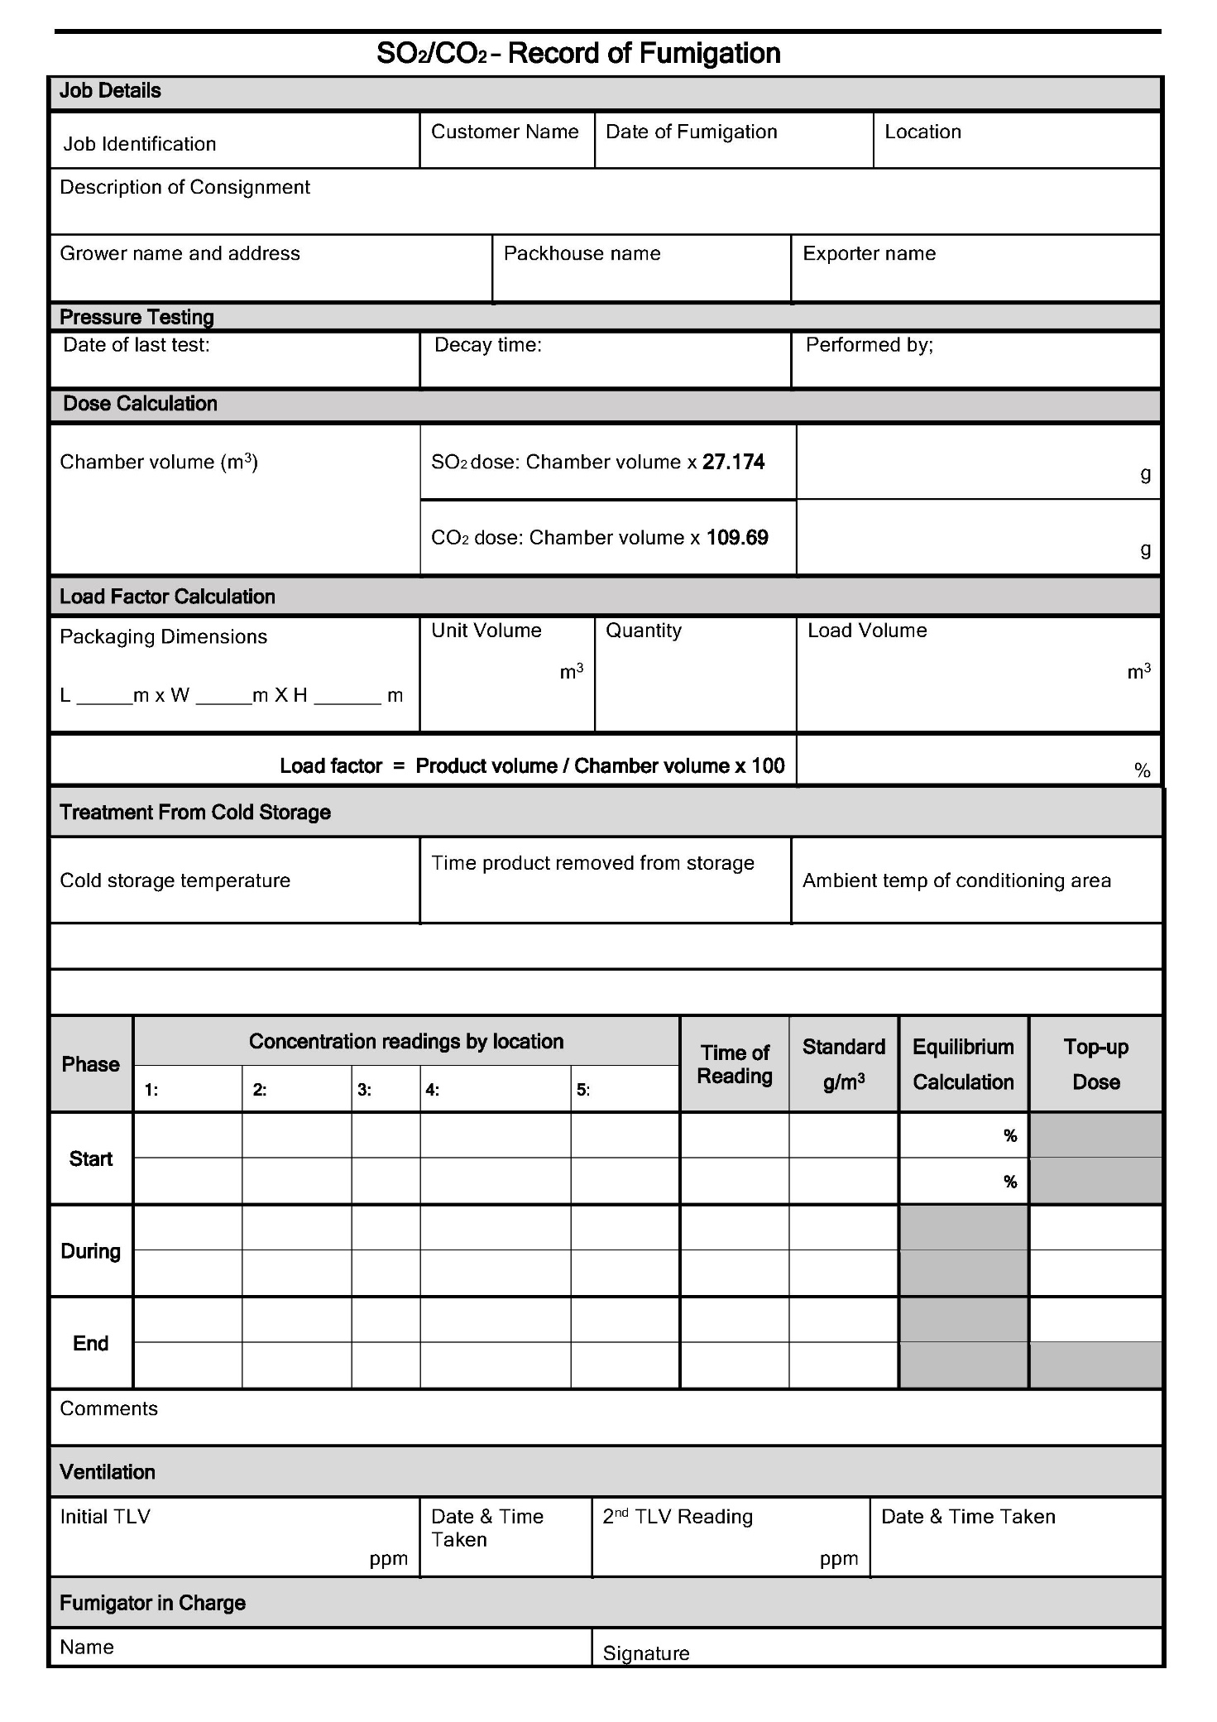

### Completing the record of fumigation

**Job details**

* **Job identification** – identifies the fumigation and links it to other related documentation
* **Customer name** – name of the entity requesting the fumigation
* **Grower name, address where product was grown, name of packhouse, exporter** – to identify where the product was grown and packed and who is responsible for the export
* **Date of fumigation** – the date the fumigation was performed
* **Location** – the site at which the fumigation chamber is located
* **Description of consignment** – describe the commodity and the type of packaging used

**Pressure testing**

* **Date of last test** – when was the most recent pressure test performed
* **Decay time** – what was the pressure decay time from 200 to 100 Pascals, must be 10 seconds or more
* **Performed by** – who performed the most recent test. There must be supporting documentation detailing the conduct and result of each pressure test.

**Dose calculation**

* **Chamber volume** – the volume of the chamber must include all the space that the gases can occupy including any external ducting used for circulation.
* **SO2/CO2 dose** – the total weight in grams of each gas to be applied for the chamber

**Load factor calculation**

* **Packaging dimensions** – record and use the packaging (boxes, cartons, crates or other types) to calculate the volume of each type of packaging
* **Unit volume** – the volume displaced by each/an individual packaging unit
* **Quantity** – how many units are there in the treatment lot
* **Load volume** – multiply the unit volume by the quantity to get the total volume displaced by the product
* **Load factor** – use the chamber volume and load volume to determine the load factor – it must be 50% or less.

**Treatment from cold storage**

* **Cold storage temperature** – only applicable if the product is being taken from cold storage before treatment
* **Time product removed from storage** – record the time all the product was removed from cold storage
* **Ambient temperature of conditioning area** – record the ambient temperature of the space where the product is being allowed to come up to fumigation temperature

**Treatment temperature**

* **Ambient chamber temperature** – the ambient temperature of the chamber must be measured and recorded once all the product in the treatment lot has been loaded into the chamber. The ambient temperature must be at or above 18° C.
* **Centre of packages** – if the product temperature was below 18° C prior to the treatment, the temperature in the centre of at least two packages from different locations within the chamber must be measured and recorded to ensure the product temperature is at or above 18° C before the fumigation can start.
* **Time of readings** – record the time the temperature readings were taken.

**Applying the dose – the information is the same for both gases**

* **Start time and dose required** – Round up the weight of gas needed from the calculated dose to an amount appropriate for the accuracy of the method used to measure the dose. Record the time you started releasing the dose into the chamber for each gas.
* **Cylinder, start weight, end weight and amount used** – identify each cylinder of gas used and record the start and end weight. The difference will be the amount of gas released into the chamber from that cylinder. Record the details for each cylinder or part cylinder used.
* **End time and actual dose used** – record the time that the entire dose amount for each gas was released into the chamber. Total the amount of gas used from each cylinder, the total amount must be equal to or more than initial dose amount.

**Ventilation**

* **Time ventilation started** – record the time that the chamber ventilation commenced. This time cannot be any less than 30 minutes after the last of the gases were released into the chamber.
* **TLV readings** – a suitable instrument capable of measuring SO2 concentration under 2 ppm must be used to verify that the chamber is safe for unprotected personnel. Product cannot be moved from the chamber until TLV has been verified under 2 ppm in the ambient space and within the packaging.
* **Time taken** – record the time any TLV readings are taken. Readings may need to be taken several times to confirm the chamber is safe to enter.

**Fumigator in charge**

* Record the name and signature of the fumigator responsible for ensuring the fumigation is conducted in accordance with the requirements of this methodology.

## Appendix 2: Performing a pressure test

### Procedure for performing a pressure test

Check the monitoring tubes, supply pipes and exhaust system valves are closed.

The pressure inside the closed chamber must be raised to 250 Pa. This can be done using high-pressure compressed air supplied from a portable compressor or gas cylinders attached to the supply pipe or, in some designs, by reversing the flow of the extraction fans.

Attach a suitable pressure measuring instrument to one of the sampling tubes.

1. when the pressure inside the chamber reaches 250 Pa, turn off the compressed air supply
2. allow the pressure to decay to 200 Pa
3. start measuring the time (in seconds) when it reaches 200 Pa
4. stop measuring the time (in seconds) when it reaches 100 Pa
5. record the pressure decay time (must be 10 seconds or above to pass the pressure test).

### Instruments for measuring the pressure decay time

The pressure inside the chamber can be measured using a variety of instruments. These include:

* A simple U tube manometer or an inclined manometer, using a manually operated stop watch
* any sensitive pressure gauge, using a manually operated stop watch
* a purpose made instrument, the CONTESTOR, which combines a pressure sensor with a timer that cuts in when the required pressures have been achieved.

## Appendix 3: Example treatment certificate

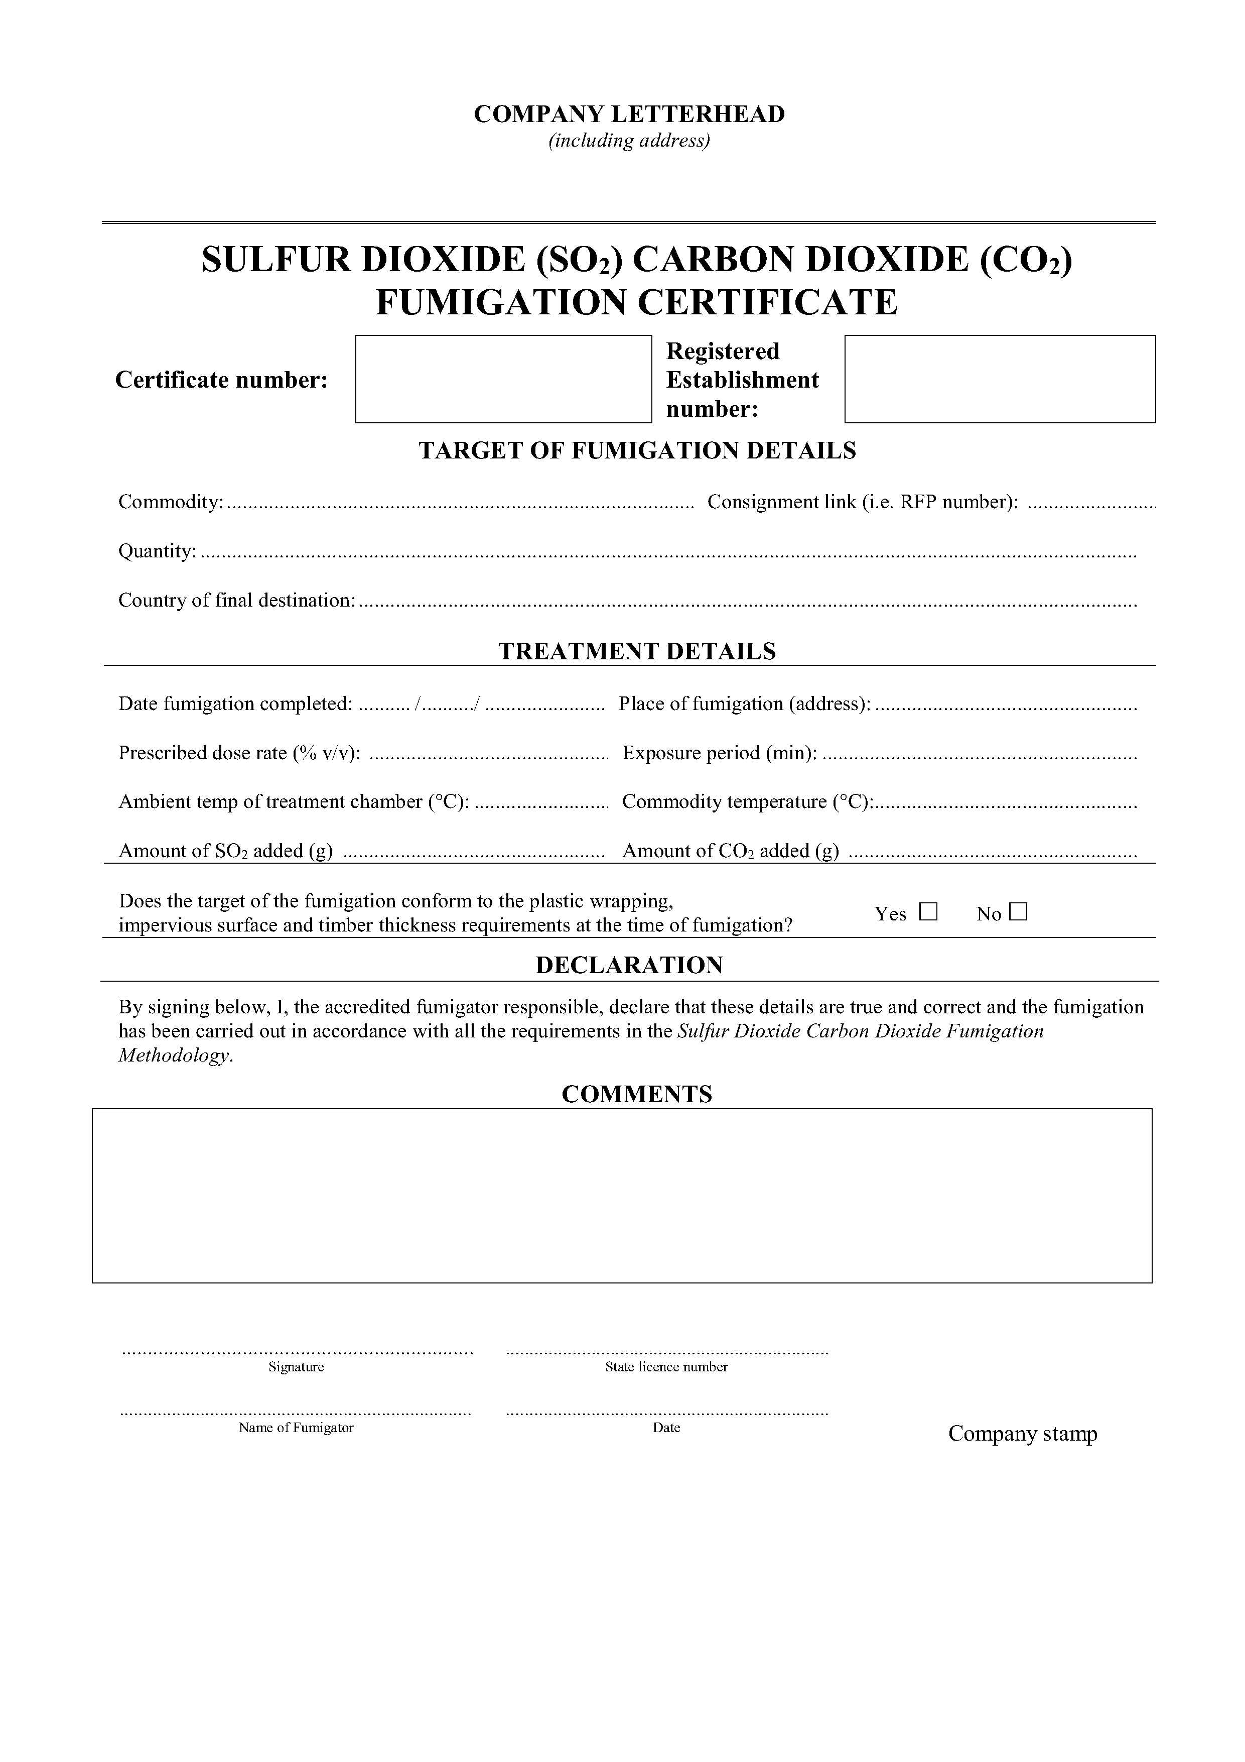

## Glossary

|  |  |
| --- | --- |
| Ambient temperature | The air temperature of the surrounding area where the fumigation will be conducted. |
| Buffer zone | The area around the chamber, outside of which, the concentration levels of sulfur dioxide should not exceed the TLV–TWA during ventilation. |
| Commodity | The item or goods that are being exported or imported. |
| Concentration | The amount of fumigant present at a certain point in the fumigation chamber, usually expressed as grams per cubic metre (g/m³), parts per million (ppm) or % v/v. |
| Consignment | Refers collectively to the commodity, any packing materials used and the mode of transport such as a shipping container. |
| Dose | The amount of fumigant applied to a fumigation chamber. |
| Exclusion zone | An area around fumigation chamber restricted to those wearing appropriate PPE to mitigate the risk of a leak in the gas supply lines during the introduction of the gas into the chamber. |
| Exposure period | The amount of time, in one continuous block, that the consignment must be exposed to sufficient concentration levels of fumigant to be lethal to the targeted pests. |
| Free air space | Empty space in the chamber between, above or around a commodity. |
| Fumigant | A chemical, which at a particular temperature and pressure can exist in a gaseous state in sufficient concentration and for sufficient time to be lethal to insects and other pests |
| Minimum treatment temperature | The treatment schedule will specify the minimum temperature allowed for the fumigation. The temperature of the commodity and enclosure must not fall below this minimum temperature at any time during the exposure period. |
| Pascal (Pa) | The standard international unit for pressure. Standard atmospheric pressure is 101.325 kPa. |
| Pest | Any animal, plant or other organism that may pose a threat to the community or the natural environment. |
| Quarantine pest | A pest of potential economic and/or environmental importance to an area where it is not yet present, or is present but not widely distributed and is being officially controlled. |
| Record of fumigation | A document that records the relevant information to demonstrate the fumigation complied with requirements. |
| Treatment | Application of a set of specified requirements intended to kill pests and diseases that may be associated with a consignment. |
| Treatment schedule | The specified treatment requirements (initial dose, minimum exposure period, minimum temperature, minimum end point concentration %). |
| Threshold Limit Value – Time Weighted Average (TLV–TWA) | TLV–TWA is the maximum concentration of fumigant that a person can be repeatedly exposed to in the workplace without harmful effects. This figure is based on an 8 hour day, 40 hour working week. |