**Agricultural export summary: Summer 2021**–**22 - May 2022**

Bumper crops and high prices led to a record $16.8 billion in Australian agricultural and seafood exports in summer 2021–22. The value of exports to major markets increased. Fruit export results were mixed, with Vietnam the stand-out market.

## Australian summer 2021-22 export overview

* Australia exported over $16.8 billion in agricultural and seafood products from Dec–Feb 2021–22. This was a 35% increase on the 2018–19 to 2020–21 average.
* Increased exports were predominately caused by record crop production and [record high global food prices](https://www.awe.gov.au/sites/default/files/documents/march_2022_-_record_high_global_food_prices_snapshot.pdf).
  + [ABARES estimate](https://www.awe.gov.au/abares/research-topics/agricultural-outlook/agriculture-overview) that Australian grain, oilseed and pulse production will reach 67 million tonnes in 2021–22, more than double the drought affected 2019–20 crop.
* Exports to all Australia’s major markets, apart from China, were above the three-year summer average.
  + Exports to ASEAN, the EU and the Middle East grew substantially. Exports to Japan, Korea and the USA also rose.

Figure 1 - Australian agricultural and seafood exports during summer (Dec–Feb)

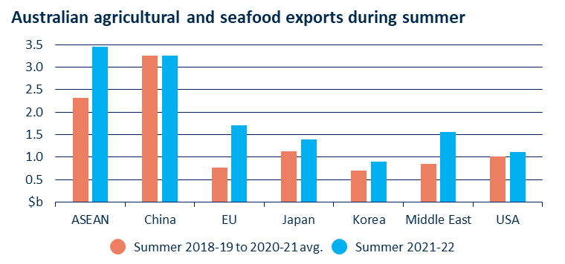

Source: ABS Catalogue 9920.0

## Mixed results for fruit exports

* It was a challenging summer for fruit producers. Elevated costs and reduced labour and freight availability created issues for producers. Some crops were also impacted by untimely rain.
* Despite these challenges, 2021–22 mango export volumes were 10% higher than the previous record set in 2020–21.
* The value of summer stonefruit (cherry, peach and nectarine) exports fell by 14%.
  + Vietnam (+56%) and Taiwan (+55%) were the stand-out export markets for summer stonefruit in 2021-22.
  + Australia’s first substantial consignment of peaches and nectarines since 2014 arrived in Vietnam on 19 March 2022. There is potential for further growth in Australian fruit exports to Vietnam.

Figure 2 - Australian stone fruit exports during summer 2016–17 to 2021–22

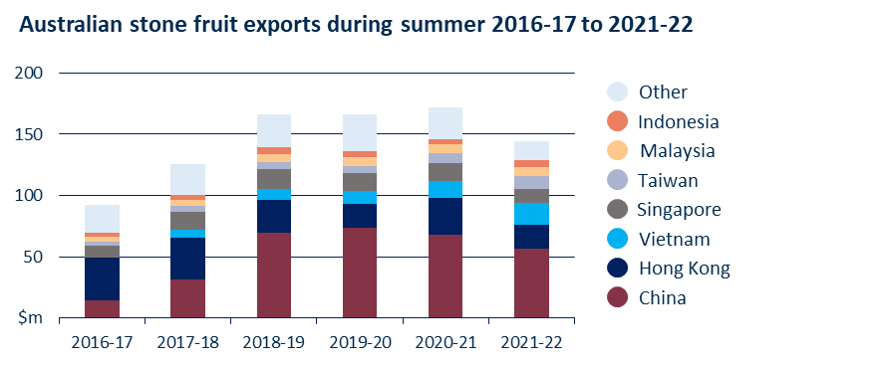

Source: ABS Catalogue 9920.0