NATIONAL RECOVERY PLAN
FOR THE NOWRA HEATH MYRTLE
Triplarina nowraensis

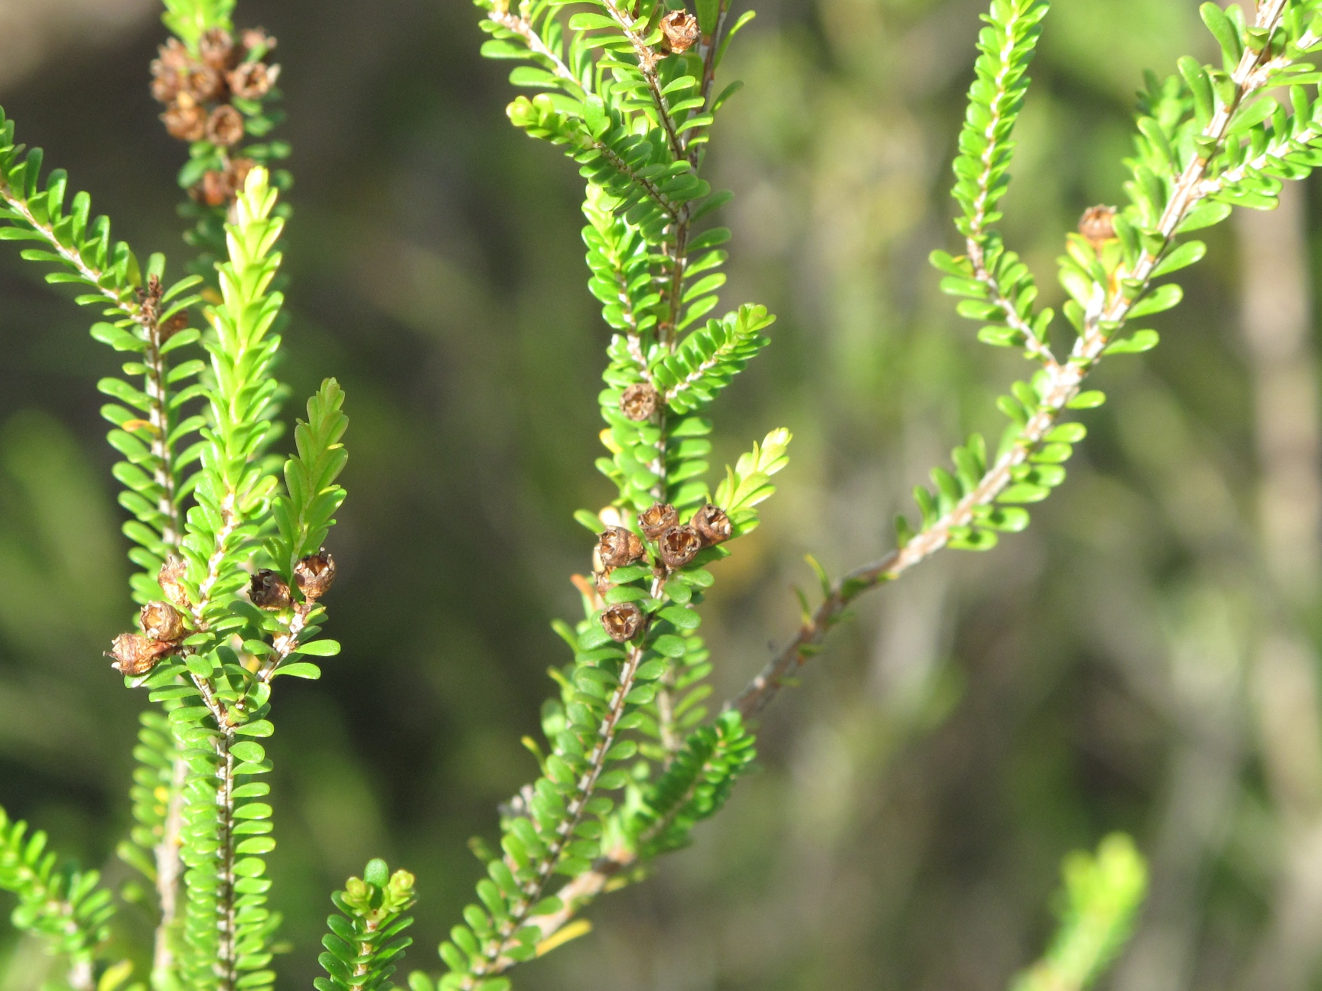


© Office of Environment and Heritage (NSW), 2011.
This work is copyright. However, material presented in this plan may be copied for personal use or published for educational purposes, providing that any extracts are fully acknowledged. Apart from this and any other use as permitted under the Copyright Act 1968, no part may be reproduced without prior written permission from the Office of Environment and Heritage (NSW).

Prepared by:
Biodiversity Conservation Section
Environment Protection and Regulation Group
Office of Environment and Heritage (NSW)
PO Box 2115
Queanbeyan NSW 2620
Tel: 02 6298 9700
Prepared in accordance with the Commonwealth Environment Protection and Biodiversity Conservation Act 1999 and the New South Wales Threatened Species Conservation Act, 1995 in consultation with Environment ACT.
This plan should be cited as follows:
Office of Environment and Heritage (NSW) 2011, National Recovery Plan for Triplarina nowraensis, Office of Environment and Heritage, Hurstville, (NSW).

ISBN: 978 1 74232 842 3 OEH 2010/571

Cover Photo: © Geoff Robertson

DISCLAIMER
The attainment of objectives and the provision of funds may be subject to budgetary and other constraints affecting the parties involved, and may also be constrained by the need to address other conservation priorities. Approved recovery actions may be subject to modifications due to changes in knowledge and changes in conservation status.

Summary
This document constitutes the formal National and New South Wales State Recovery Plan for the Nowra Heath-myrtle (Triplarina nowraensis). It considers the conservation requirements of the species across its known range, identifies the future actions to be taken to ensure the long-term viability of the Nowra Heath-myrtle in nature and the parties who will carry these out.
The Nowra Heath-myrtle is listed as Endangered under the Commonwealth Environment Protection and Biodiversity Conservation Act 1999 and as Endangered (Schedule 1, Part 1) on the NSW Threatened Species Conservation Act 1995.
There are five known populations, three of which form a cluster to the immediate west of Nowra. The fourth occurs in the Boolijong Creek catchment 18 km to the southwest of these and the fifth is located about 12 km west of Nowra on the plateau north of the Shoalhaven River.
The future Recovery Actions detailed in this Recovery Plan include:

- Determine the impact of Myrtle Rust on the Nowra Heath-myrtle
- Protect populations from road and track maintenance
- Liaise to ensure that fire regimes are appropriate
- Development impacts are minimised
- Survey of potential habitat
- Map critical habitat
- Monitor known populations
- Weed control
- Research the fire ecology
- Conservation agreements

Abbreviations used in this Plan
DSEWPaC – Australian Government Department of Sustainability, Environment, Water, Population and Communities
EP&A Act – NSW Environmental Planning and Assessment Act 1979
EPBC Act – Commonwealth Environment Protection and Biodiversity Conservation Act 1999
ESD – Ecologically Sustainable Development
LEP – Local Environment Plan
NPW Act – NSW National Parks and Wildlife Act 1974
OEH – NSW Office of Environment and Heritage
SCC – Shoalhaven City Council

Species information and general requirements
Description
The genus Triplarina was reinstated from the closely related Baeckea by Bean in 1995. The seven species of Triplarina are endemic to Australia, with most found within 80 km of the coast (Bean 1995). In the Nowra district there are a number of Baeckea sens. lat. that grow in association with the Nowra Heath-myrtle: B. ramosissima, B. virgata, B. imbricata, B. diosmifolia, B. brevifolia and B. linifolia. These species can be easily distinguished from Triplarina nowraensis on the basis of leaf size and shape.
The Nowra Heath-myrtle is a small erect shrub which can attain a maximum height of 5 m in areas which remain fire free for long periods. Bark grey and scaly on the branchlets. Leaves are wider towards the tips of the leaves, 3.4-5.0 mm long and 1.2-1.7 mm wide. There are two parallel rows of large oil glands on either side of the midrib. The cross shaped arrangement of the leaves when viewed end on gives the shrub a distinctive appearance. The leaves are highly aromatic, with a scent like camphor when crushed. Flowers are borne in pairs in the leaf axils and are about 4.5 mm across. The creamy-white flowers are produced in the spring. Fruits are hemispherical, wrinkled (2.0-2.9 x 2.1-2.8 mm) and the seeds are brown (0.6-0.8 long) (from Bean 1995).
The Nowra Heath-myrtle is closely related to Triplarina imbricata, which occurs in north-eastern New South Wales.

Distribution
There are currently five known populations of the Nowra Heath-myrtle (Fig. 1). Three of these occur near the Sandy, Cabbage Tree and Flat Rock Creeks west of Nowra, in an area approximately 6 km by 2.5 km. These populations total about 50 000 plants. A fourth population in the Boolijong Creek valley occurs approximately 20 km to the southwest of Nowra, with the population numbering several hundred individuals. The remaining population is located on the plateau north of the Shoalhaven River about 12 km west of Nowra near Illaroo. Numbers are estimated at 22 000. All five populations are limited in extent; ranging from less than 1 ha to approximately 15 ha.
A population of unknown size first recorded by Rodway in 1925 and more recently by Mills in 1988 appears to have disappeared. Recent visits have not been able to reconfirm these earlier records.
Populations of the Nowra Heath-myrtle have only been found between the elevations of 10 and 220 m. All populations occur on sedimentary substrates, ranging from conglomerates to siltstones. Rainfall averages in the area range from 1038 mm at Nowra to 920 mm at Yalwal, near the Boolijong Creek population.
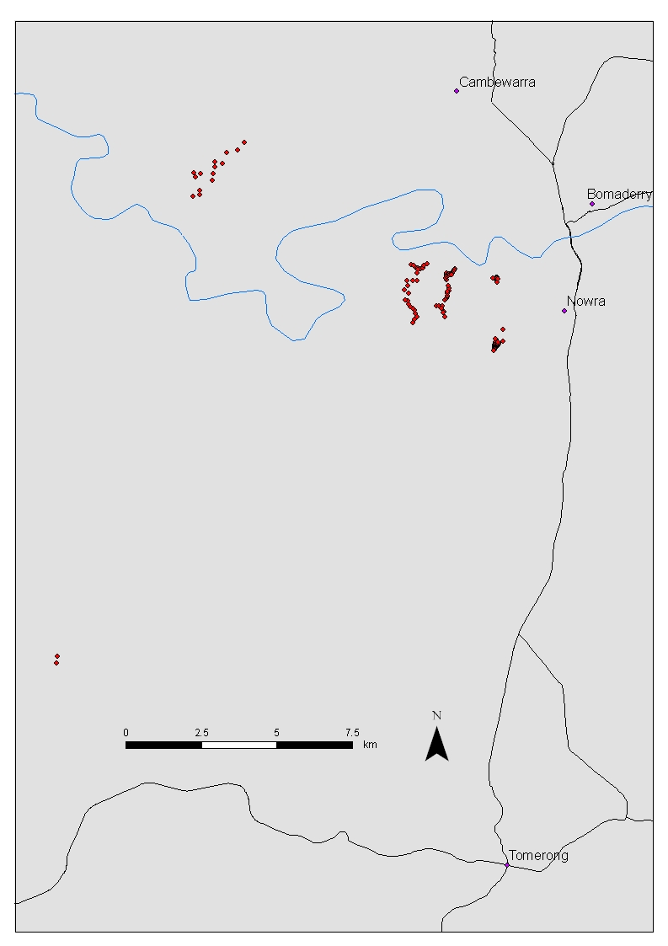

Figure 1. Map showing the five populations of the Nowra Heath Myrtle
Habitat
Populations of the Nowra Heath-myrtle are found on moist soils or poorly drained sites such as water courses and bedrock surfaces with impeded drainage, although two populations are known to occur in drier sites. Populations occur in forest and woodland communities that are dominated by Scribbly Gum (Eucalyptus racemosa), Grey Gum (E. punctata) and Red Bloodwood (Corymbia gummifera). Other tree species occasionally occurring include: Blackbutt (E. pilularis), Spotted Gum (C. maculata), Peppermint (E. piperita), White Stringybark (E. globoidea) and Grey Ironbark (E. paniculata) with Yertchuk (E. consideniana) north of the Shoalhaven River. The species is often found in patches that are treeless or with a very open canopy due to the preference for wetter sites. Sometimes the species may also be found in sandstone sedgeland or shrubland dominated by Kunzea ambigua.
The associated shrub species are typical of moist, sandy soils such as Slender Wattle (Acacia elongata), Tall Baeckea (Sannantha pluriflora), Yellow Tea-tree (Leptospermum polygalifolium) and Thyme Honey-myrtle (Melaleuca thymifolia).
Biology and ecology
A study was carried out by Hogbin (2000) which provides important preliminary information on the reproductive ecology of the Nowra Heath-myrtle. A number of life-history stages from pollination through to seed germination were investigated, including; flower morphology (as an indication of the likely mating system), pollen viability, pollination biology, fruit initiation, seed production, and seed germinability.
The flower morphology suggests that the species releases pollen prior to the stigma becoming receptive, thereby limiting or reducing self-pollination within flowers and increasing the efficiency of outbreeding. The pollen of the Nowra Heath-myrtle was found to have high viability. Abundant potential pollinator activity was observed, with a diverse range of insects visiting Nowra Heath-myrtle flowers. A pollinator exclusion experiment revealed that the species appears to have a predominantly outcrossing mating system, but is also capable of selfing in the absence of pollinator activity. The ability to self pollinate in low frequencies may be a “fail safe” method of ensuring seed set when pollinator activity is low.
The Nowra Heath-myrtle produces abundant seed, however not all ovules form seed. This excess ovule production is a common characteristic of many plant species. The seed are capable of germination ex-situ and appear not to possess a dormancy mechanism. The absence of seed dormancy suggests that the species may possess a short-lived soil stored seed bank. No seedlings were observed in-situ, however the seedling survey was conducted up to only 3 months after seed release. In-situ seed germination and survival needs to be investigated further.
The species has been observed to resprout from lignotubers after fire and on older plants a number of stems may originate from a single large lignotuber (Mills 1998). Sites where the species occurs have been burnt at various times in the past with known major fire events having taken place 18 months, ten years and more than twenty years ago. Increased knowledge of the detailed fire response is desirable from the perspective of making management actions more effective.
The Nowra Heath-myrtle tends to dominate or co-dominate the sites in which it occurs. Whether this is attributable entirely to the difficulty other species have in adapting to the predominantly wet or moist conditions or is to some extent an effect of competition between the Nowra Heath-myrtle and other species is not known. The result is that relatively large populations of the species may be concentrated in favourable locations, particularly along creeklines.
Land Tenure and Zoning
The southern part of the population in Flat Rock Creek occurs in Triplarina Nature Reserve. The northern parts of the population occur on land that in the proposed LEP is zoned E3 – Environmental Management. The objectives of this zone are: “To protect, manage and restore areas with special ecological, scientific, cultural or aesthetic values. To provide for a limited range of development that does not have an adverse effect on those values”. Dwellings are permitted with consent, but impacts on environmental values such as the presence of threatened species are presumably to be minimised.
The southern parts of the population in Cabbage Tree Creek occur on land owned by Wollongong University, and are zoned SP2 to provide for expansion of the facilities. The SCC has conducted extensive surveys, so that impacts on threatened flora of any developments are minimised. The northern parts of the population occur on freehold land zoned E3.
The majority of the population in Sandy Creek occurs in Bamarang Nature Reserve (11 600 out of an estimated total population of 13 000). The northern parts occur on freehold land zoned E3.
The sub-populations in the Boolijong Creek area occur on vacant Crown land, that is zoned E3.
The extensive population north of the Shoalhaven River is confined to a large area of vacant Crown land, much of which is under a land claim by the Nowra Aboriginal Land Council. Most of the area in which the population occurs is proposed to be zoned RU2 – a rural zoning. The area where Triplarina nowraensis occurs is overlaid with an Environmentally Sensitive Lands layer, which requires that developments avoid features of environmental significance. The remainder of the population occurs on land proposed to be E2 – Environmental Conservation.
Legal Status
The Nowra Heath-myrtle is listed as Endangered under the Threatened Species Conservation Act 1995 (TSC Act), the Commonwealth Environment Protection and Biodiversity Conservation Act 1999 (EPBC Act) and the ACT Nature Conservation Act 1980 (NC Act).
International obligations
The species is not listed under International agreements. However, this plan is consistent with the aims and recommendations of the Convention on Biological Diversity, which has been ratified by Australia, and will assist in meeting Australia’s responsibilities under that convention.
Role and interests of indigenous people
In NSW, local Aboriginal Land Councils and traditional owners organisations were consulted in the preparation of this plan. At the time of publication indigenous information or interest of indigenous people had been identified for this species. The interests of these communities will be considered in the implementation of recovery actions where a role is identified.
Habitat critical to the survival of the species
Given the small number of extant populations and the low population size at most sites, all populations and the habitat they occupy are critical to the survival of Triplarina nowraensis. The exact area of habitat critical to the survival of the species has not been mapped. It may include more locations in the vicinity of Nowra than are currently known to be occupied by the species.
Biodiversity Benefits
The preparation and long term implementation of Recovery Plans for threatened species, populations and ecological communities, contributes to, and highlights the importance of, conserving biodiversity. The conservation of biodiversity has a number of wider community benefits. These include providing and maintaining a range of ecosystem processes and contributing to increased ecological knowledge of species, habitats and broader ecosystems.
The protection of the Nowra Heath-myrtle will lead to some protection of the bushland in which it is found. Rare and threatened flora and fauna that will be protected by conservation of Nowra Heath-myrtle habitat include:

Common Name | Scientific name | Status
Albatross Mallee | Eucalyptus langleyi | TSC and EPBC Vulnerable
Nowra Tea-tree | Leptospermum sejunctum
Many Veined Wattle | Acacia subtilinervis
Broad-leaved Hop Bush | Dodonaea rhombifolia
Yellow-bellied Glider | Petaurus australis | TSC Vunerable
Large Pied Bat | Chalinolobus dwyeri | TSC & EPBC Vulnerable
Common Name | Scientific name | Status
Large-footed Fishing Bat | Myotis macropus | TSC Vulnerable)
White Footed Dunnart | Sminthopsis leucopus | TSC Vulnerable
Southern Brown Bandicoot | Isoodon obesulus obesulus | TSC Endangered
Giant Burrowing Frog | Heleioporus australiacus | TSC and EPBC Vulnerable
Glossy Black Cockatoo | Calyptorhynchus lathami | TSC Vulnerable

Social and economic impacts
The main social benefit of conserving the remnant bushland habitat in which the Nowra Heath-myrtle survives is the prevention of further loss of this and other co-occurring threatened species, as well as the ecological communities in which they occur. There is a significant level of recognition in the community that such loss should be avoided if at all possible. The Nature Reserves encompassing the Nowra Heath-myrtle and a range of other species and ecosystems provide an educational resource for the University of Wollongong extension located on Yalwal Road and a focus for a variety of research projects. There are negligible immediate economic and social costs relating to the Recovery Plan, although the presence of a threatened species could potentially constrain some activities that might otherwise occur.

Affected Interests
Stakeholders and those involved in implementing the plan include:
- NSW OEH;
- Shoalhaven City Council.
Threats
Myrtle Rust
Myrtle Rust (Puccinia psidii sens. lat.) was discovered on the Central Coast of NSW in April 2010. By March 2011 the disease had been found from Nowra in NSW to Cairns in north Qld. Infection may cause a range of symptoms such as distortion of new growth, buckling of leaves, defoliation and diseased flowers and fruits. In South America repeated infection cycles have been known to result in plant death in Eucalypt plantations (ANPC 2011). The susceptibility of Triplarina nowraensis to Myrtle Rust is not known.
Vehicles, tracks and track maintenance.
Several vehicle tracks occur in close proximity to Nowra Heath-myrtle populations. Track use and maintenance have the potential to result in the loss of individuals from these populations.
Inappropriate fire regimes
The Nowra Heath-myrtle occurs in a fire prone environment and has acquired adaptations to periodic burning. Available evidence from recent fires in the Flat Rock Creek catchment suggests that the survival rate of the species from a single fire event is very high. However it is possible that too frequent burning could exhaust the reserves of the plants, or that infrequent fire might result in the plants becoming senescent.
Urban development
Nowra is expected to increase from a population of around 32,000 in 2006 to about 41,000 in 2026. Triplarina nowraensis occurs so close to Nowra that pressures from this increase in population are inevitable. Several populations occur on land where residential development is permitted. Careful assessment of development applications and a consistent approach to determinations will be needed to ensure that adverse affects on Triplarina are minimised.
Weeds
There is also the possibility of increased competition from weed species such as Hydrocotyle bonariensis, Persicaria spp., Anredera cordifolia, Lonicera japonica, Ipomoea cairica adversely affecting reproduction and survival of the Nowra Heath-myrtle.
Guidance for Environmental Management
To avoid significant impacts on the species, any of the following management practices or on ground works in the immediate vicinity of T. nowraensis require assessment.
- Clearing
- Herbicide and pesticide spraying
- Burning
- Removal of vegetation in and around the populations
- Removal or destruction of T. nowraensis plants; and
- Damage to T. nowraensis plants.
- Residential development

Recovery Objectives and criteria

Objectives
Over the life of this Recovery Plan:
- to ensure that all natural populations of Triplarina nowraensis are stable or increasing in size
- to reduce or manage threats

Performance Criteria
Over the life of this Recovery Plan:
- self-sustaining natural populations are maintained at all sites over the next five years
- all populations have remained stable or have increased in size over a five year period

The estimated cost of the implementation of recovery actions over five years is $26 000.
Plan review and evaluation
OEH will evaluate the performance of the recovery plan against the criteria identified. The Plan will be formally reviewed within five years from the date of its adoption under the EPBC Act. The plan will be revised if necessary.

recovery actions

Previous Recovery Actions
- A recovery team was established by the OEH and met for the first time on 22 July 1998.
- Members of the Recovery Team and other volunteers conducted detailed surveys during 1998-99 to determine the full extent of the species in the Nowra area. This work in the catchments of Sandy, Cabbage Tree and Flat Rock Creek as well as on plateau north of the Shoalhaven River near the property Bundanon significantly extended our understanding of the distribution and abundance of the species.
- An initial trial of a water quality monitoring program has been carried out on Sandy/Mundamia and Cabbage Tree Creeks. This has incorporated event sampling to determine whether during rainfall events nutrient levels are significantly elevated above normal background levels. In parallel with this program, studies on the tolerance of the species to elevated nutrient levels have also been carried out. The results of these investigations (Hogbin 2002) suggest that, while storm events do increase levels of some nutrients, these are still well within the tolerance limits of adult Nowra Heath-myrtle plants. In-situ studies demonstrated that adult individuals are able to tolerate extremely high nutrient levels without any significant effect on growth or survival. Seedling survival was, however, adversely affected but only at levels well above those measured in soils associated with field populations.
- Baseline water quality monitoring will need to continue, however, because proposed developments in the catchments of Sandy and Cabbage Tree Creeks such as expansion of the landfill, construction of a Nowra bypass road and residential development have the potential to alter soil and water quality over time. This could impact directly on the species (particularly seedlings) through toxicity effects or indirectly through increased weed infestation.
- An agreement has been reached with Transgrid regarding modification of maintenance procedures where the Nowra Heath-myrtle is growing in the powerline easement north of the Shoalhaven River near Bundanon. Signs have been erected at this site to alert maintenance workers to the presence of a threatened species and the need to avoid slashing unless the vegetation encroaches on the statutory safety clearance.
- A pipeline corridor was constructed through the Cabbage Tree Creek population. This resulted in the removal of several hundred individuals of the Nowra Heath-myrtle which were held under glasshouse conditions and then replanted as part of the rehabilitation program. In 2010 most appeared to have survived and are up to 1 metre high. Several small plants were found that are potentially seedlings. An agreement is in place that the pipeline corridor where the plants occur should not be slashed.
- Two Nature Reserves containing significant parts of two of the populations of the Nowra Heath-myrtle were created as a part of the Comprehensive Regional Assessment (CRA) process completed in 2001. These are Bamarang Nature Reserve containing 89% of the population in Sandy Creek, and Triplarina Nature Reserve containing 66% of the population in Flat Rock Creek. About 20% of the total known population of around 70 000 is protected in these two Reserves.
- The proposed Local Environment Plan for Shoalhaven City Council incorporates most of the populations outside National Parks into an “Environmental Living” zone. Dwellings are permitted in this zone, but conservation is a high priority, so that direct impacts are unlikely. Most of the population north of the Shoalhaven is in a rural zone, but with an “Ecologically Sensitive Land” overlay, offering a similar level of protection.
- The Nowra Area of OEH established a series of fire monitoring plots across park estate that measure changes in structure and abundance of all species, and record fire response information such as the primary juvenile period. Two of these plots are in populations of Nowra Heath-myrtle in Triplarina and Bamarang Nature Reserves and are monitored after all fires and in the absence of fire every ten years. The site in Bamarang NR did not burn during the survey period, but may have declined marginally in abundance from <5% cover and common to <5% cover and uncommon. This may be attributable to observer error. No recruits were found. The site in Triplarina NR burned in the summer of 2001/2002. The Nowra Heath-myrtle plants resprouted, and did not decline in abundance (<5% and common). A “few” seedlings were found after the fire.

Proposed recovery actions
1.Determine the effect of Myrtle Rust on the Nowra Heath-myrtle.
Preferably six monthly monitoring is required until the impact of the disease is known. If the Nowra Heath-myrtle is susceptible to Myrtle Rust a specific management strategy may need to be developed, depending on the severity of symptoms.
Responsibility: OEH
Cost: $5000
2. Protect Nowra Heath-myrtle populations from the impacts of road and track maintenance.
Road and track maintenance is carried out by authorities such as SCC, the Rural Fire Service, the Land and Property Management Authority, Jemena P/L (operator of the Eastern gas Pipeline), the Nowra Aboriginal Land Council and the OEH in areas where the Nowra Heath-myrtle occurs. Information on the locations where the species is found will be provided to these authorities and assurances of their cooperation in avoiding direct or indirect disturbances sought. Signs may also be considered for some areas if appropriate.
Responsibility: OEH
Cost: In kind
3. Liaise with fire management authorities to ensure that fire regimes are appropriate.
The Recovery Team will provide information to the Shoalhaven Bush Fire Management Committee on all known occurrences of the Nowra Heath-myrtle. While a better understanding of the fire ecology of the species needs to be obtained in order to develop site-specific guidelines, any increase in fire frequency would be cause for concern. Therefore, discussions will take place between OEH and the Shoalhaven Bush Fire Management Committee on any areas where the Nowra Heath-myrtle occurs that are identified in the Bush Fire Risk Management Plan as Asset Protection or Strategic Management Zones. Some sites, at least, should remain unburnt indefinitely.
Responsibility: OEH
Cost: In kind

4. Development impacts on Nowra heath-myrtle are minimised

Parts of several populations occur on land that could potentially be subdivided in the future. Sub-divisions should be configured in ways that minimise the number of lots on which the Nowra Heath-myrtle occurs. Given that Nowra-Heath-myrtle occurs in drainage lines and on land potentially flood prone, it may be possible to include populations in a lot held by common title where development is prohibited, or in a single large lot that may include residential development on higher ground. Developments near the Triplarina nowraensis populations in the Sandy, Cabbage Tree and Flat Rock Creeks west of Nowra and near the Illaroo population that:

remove a significant proportion of a population or

isolate a proportion of a population from the remainder of that population or

occur higher in the catchment and are likely to increase nutrient loads and weeds downstream

should not be approved unless it can be demonstrated that the impact on the populations is not significant.

Responsibility: SCC, OEH, DSEWPaC
Cost: In kind

5. Survey of potential habitat
Survey has so far concentrated on the creeklines west of Nowra, and on the plateau north of the Shoalhaven. It is still possible that other populations may exist elsewhere. In particular, the Boolijong Creek and Nowra Creek areas should be investigated. If sites are found, they will be surveyed in order to determine the size and extent of the populations
Responsibility: OEH
Cost: $5000 in year 1.
6. Map critical habitat
Once surveys of potential habitat are complete a map of habitat critical to the survival of the species could be can be prepared.
Responsibility: DEHWA
Cost: $2000 in year 2

7. Monitoring of populations.
A program of monitoring will be implemented to follow any trends in health and numbers. Monitoring of all sites should take place every four years. The program will be modified as required to examine the impacts of disturbances such as fires. All monitoring should include collection of data on the incidence of weed species.
Responsibility: OEH
Cost: $8000 in years 1 & 5.
8. Weed control
Manage any weed invasions found during the population monitoring. Weeds of concern are those that have the potential to adversely affect recruitment or provide strong competition, such as climbers like Anredera cordifolia (Madeira vine)
Responsibility: OEH
Cost: $4 000 over 5 years.

9. Research the fire ecology.
An understanding of the response of the Nowra Heath-myrtle to fire will be of value in making future management decisions for the species. This research should include the documentation of the fire history of all known Nowra Heath-myrtle sites and investigations of the response of the species to different fire regimes (frequency, timing and intensity of fire) including in situ recruitment, survival and growth of seedlings at appropriate intervals. The research will also investigate the time it takes for seedlings to form lignotubers large enough to survive fire.
Responsibility: OEH
Cost: $10 000 over 5 years.

10. Conservation agreements
Parts of several populations occur on private land, land owned by the Nowra Aboriginal Land Council, or are subject to a land claim on behalf of the Local Aboriginal Land Council. There are a variety of protection mechanisms such as Voluntary Conservation Agreements, or Incentive Property Vegetation Plans that OEH will seek to implement to secure the long term protection of sites. Elsewhere on private land protective fencing of areas in which the Nowra Heath-myrtle occurs may be appropriate now or in the future. In particular, an area at the southern end of the population in Cabbage Tree Creek should be considered.
Responsibility: OEH
Cost: In kind
Summary of costs and actions identified in the Recovery Plan
Action No. | Action Title | Cost Estimate ($1000s/year) |  |  |  |  | Total Cost ($) | Responsible Party | Priority
Action No. | Action Title | Year 1 | Year 2 | Year 3 | Year 4 | Year 5 | Total Cost ($) | Responsible Party | Priority
1 | Determine the impact of Myrtle Rust | 1 | 1 | 1 | 1 | 1 | 5 | OEH | 1
2 | Protect populations from road & track maintenance |  |  |  |  |  | In kind | OEH | 1
3 | Liaise to ensure that fire regimes are appropriate |  |  |  |  |  | In kind | OEH | 2
4 | Development impacts are minimised |  |  |  |  |  | In kind | SCC  OEH  DEHWA | 2
5 | Survey of potential habitat | 5 |  |  |  |  | 5 | OEH | 2
6 | Map critical habitat |  | 2 |  |  |  | 2 | DEHWA | 3
7 | Monitor known populations | 4 |  |  |  | 4 | 8 | OEH | 1
8 | Weed control |  | 1 | 1 | 1 | 1 | 4 | Land Managers | 2
9 | Research the fire ecology | 2 | 2 | 2 | 2 | 2 | 10 | OEH | 3
10 | Conservation agreements |  |  |  |  |  | In kind | OEH | 3
Total |  | 12 | 6 | 4 | 4 | 8 | 34

References
Australian Network for Plant Conservation (2011). Myrtle Rust – a new threat to Australia’s biodiversity. Australian Network for Plant Conservation in association with the Royal Botanic Gardens and Domain Trust.
Bean, A. R. (1995). Reinstatement and revision of Triplarina Raf. (Myrtaceae). Austrobaileya 4: 353-367.

Hogbin, P. (2000). The reproductive ecology of Triplarina nowraensis (Myrtaceae). Unpubl. Report. NSW NPWS.

Hogbin, P. (2002). The impact of elevated nutrient levels on the growth and survival of the Endangered plant Triplarina nowraensis. Unpubl. Report. NSW NPWS.

Mills, K. (1998). Vegetation Survey Methods and Natural Vegetation Types in the Coastal Parts of the City of Shoalhaven, New South Wales. Illawarra Vegetation Studies (7), Coachwood Publishing, Jamberoo, NSW.

Acknowledgments
OEH would like to thank the following people and their respective agencies/organisations for their assistance with the preparation of this Recovery Plan and with the implementation of recovery actions to date for this species.
Les Mitchell (NSW OEH)
Elizabeth Dixon (Shoalhaven City Council)
John Briggs (NSW OEH)
Funding for the preparation of this plan was provided by the Australian Government.



