**A report to address the “Terms of Reference” for an application to include *Glossolepis pseudoincisus* onto the allowable live imports list under the provisions of Section 303 EB, Environment Protection Biodiversity Conservation Act, 1999.**

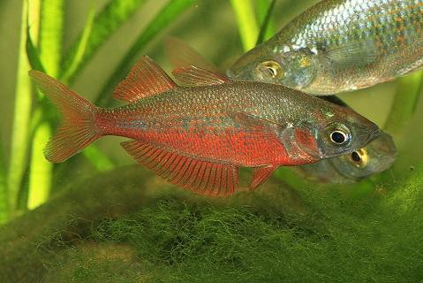

*Glossolepis pseudoincisus* © Johannes Graf

## Introduction

The keeping of tropical fish species in aquaria is growing in popularity and has been booming during the lock down period attributed to the Covid19 Pandemic. Studies into mental health have proven that an aquarium can produce a soothing effect on the human mind that tends toward anxiety. This trend to worry about the future seems to be increasing in recent times. Studies have demonstrated stress reduction from viewing aquatic life in an aquarium, lower heart rates and decrease in blood pressure. (Clements 2019 and Cracknell 2016)

The ornamental aquatic life, fish, invertebrates and aquatic plants industry is not like industries that produce food and shelter it is more like the Fashion Industry that relies on new products to excite customers to buy the latest trend. The rise of social media and other instant news forums has produced an intense interest in owning possessing the latest trend. This has happened recently with the smuggling of the small Mexican red crayfish and the Indonesian Assassin Snail. Neither of those are on the allowable import list. There is also a large Australia wide trade in red cherry shrimps and other small colourful crustaceans, all of which are smuggled except the native species from tropical NT and Qld.

The Authors of this report will determine that the Tami River Rainbowfish, *Glossolepis pseudoincisus* does not possess any of the aspects of an organism that will cause problems should it escape effective human control. These aspects are reproduced from a statement prepared for a Court Case in the NT when an aquarium shop bought unassessed imported aquatic life to a Darwin Aquarium Shop. The statement was to be presented for the prosecutor in the witness box by the author of this report, however the accused offender pleaded guilty.

## Disease

Introduced unassessed aquatic life entering Australia without appropriate quarantine or a risk assessment of the exporting country can carry exotic parasites and disease that may negatively impact on native species and aquaculture enterprises.

## Competition with native species

Introduced unassessed aquatic life that escapes human control may breed into very large numbers out competing native species for food and space possibly causing local extinctions of native species.

## Destruction of aquatic habitat

Introduced unassessed aquatic life that escapes human control may damage waterways by digging and moving substrate causing water to be clouded with silt, smothering plants and contributing to erosion.

## Dangerous species

Introduced unassessed aquatic life that escapes human control may have features that are a danger to humans, large venomous spines, very sharp teeth, even high voltage electrical discharge and could pose a danger to recreational and commercial activities in natural waterways.

## Impacts associated with Genetic Changes

Introduced unassessed aquatic life that escapes human control may be closely related to native aquatic life and be able to hybridise causing the loss of genetic diversity.

## References:

**Clements, Valentin, Rankin, Baker, Gee, Snellgrove, Sloman** (2019) “*The effects of interacting with fish in aquariums on human health and well-being: A systematic review*” published by Institute of Biomedical and Environmental Health Research, School of Health and Life Sciences, University of the West of Scotland, Paisley, United Kingdom.

**Cracknell, White, Pahl, Nichols & Depledge**. 2016 “*Marine Biota and Psychological Well- Being: A Preliminary Examination of Dose–Response Effects in an Aquarium Setting*” published by Environment and Behavior2016, Vol. 48(10) 1242 –1269© 2015 SAGE Publications

**Allen, G.R. and Cross, N.J.** 1980. Descriptions of five new rainbowfishes (Melanotaeniidae) from New Guinea. *Records of the Western Australian Museum* 8(3): 377-396.

**Froese, R. and D. Pauly**. Editors. 2020. FishBase. [www.fishbase.org,](http://www.fishbase.org/) version (12/2020). https://[www.fishbase.se/summary/Glossolepis-pseudoincisus.html](http://www.fishbase.se/summary/Glossolepis-pseudoincisus.html)

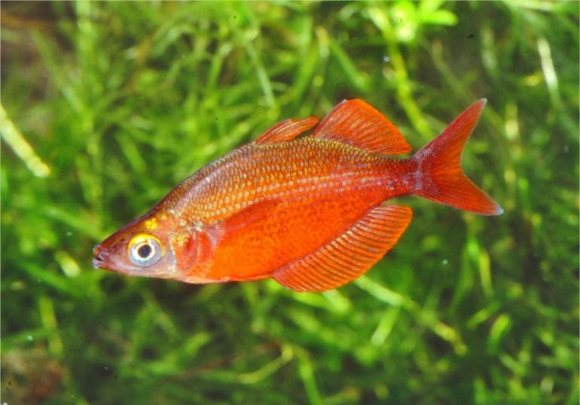

Glossolepis pseudoincisus (Lake Emfote) © Gunther Schmida

## Terms of Reference

1. **Provide information on the taxonomy of the species.**

**Overview:** The rainbowfish genus *Glossolepis* consists of nine species occurring

only in the northern half of New Guinea. The name *Glossolepis* consists of two words from the Greek language: “glossa” = tongue “lepis” = scale and refers to the tongue-shaped scale margins.

Characteristic differences to the closely related Rainbowfish genera *Melanotaenia* and

*Chilatherina* are:

* tongue-shaped scales,
* increased number of gill rakers,
* first spine of the second dorsal fin stronger than the first spine of the first dorsal fin and
* relatively elongated pectoral fins and enlarged teeth in the lateral wing of the remaxillary.

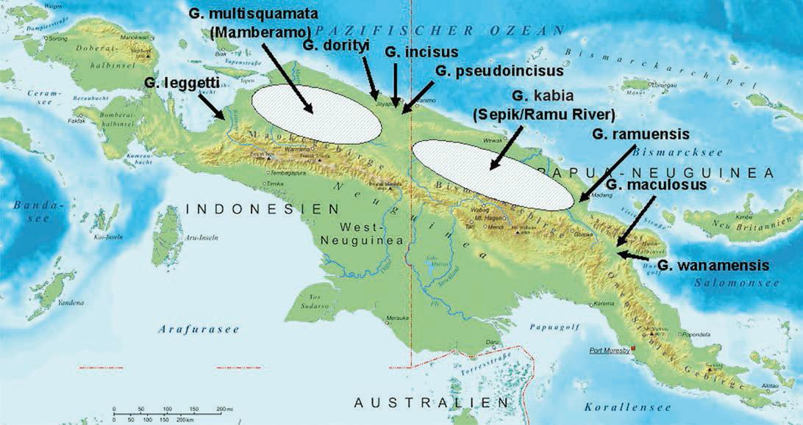

Distribution of the genus *Glossolepis*. Map: Creative commons, modified.

## Information on the taxonomy of the species.

**Kingdom:** Animalia

**Phylum:** Chordata

**Class:** Actinopterygii (ray-finned Fishes)

**Order:** Atheriniformes (Silversides)

**Family:** Melanotaeniidae (Rainbowfishes)

**Genus:** *Glossolepis* (origin - *Glossolepis*: Greek, "glossa"

= tongue, and "lepis" = scale which refers to the tongue shaped scale margins

**Species:** *Glossolepis pseudoincisus* (Allen & Cross 1980), Tami River Rainbowfish

**Etymology:** *Glossolepis:* Greek, glossa = tongue + Greek, lepis = scale,

pseudo, false, i.e., although this species may resemble G. incisus, and lives in close proximity to it, such an appearance is false.*

## Reference:

**Allen, G.R. and Cross, N.J.** 1980. Descriptions of five new rainbowfishes (Melanotaeniidae) from New Guinea. *Records of the Western Australian Museum* 8(3): 377-396.

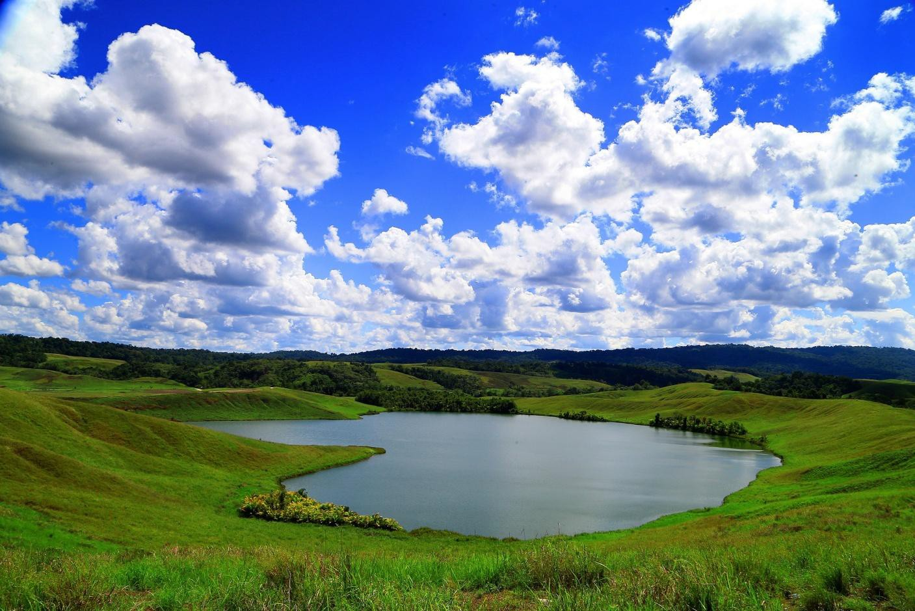

Glossolepis pseudoincisus habitat, (Lake Emfote) Jayapura, PNG

1. **Provide information on the status of the species under the *Convention on International Trade in Endangered Species of Wild Fauna and Flora* (CITES). For example, is the species listed on CITES Appendix I, II or III, and if so, are there any specific restrictions on the movement of this species? Include information on the conservation value of the species.**

A search of Convention for International Trade in Endangered Species (CITES) checklist with the search terms “Rainbowfish” and “Glossolepis” revealed no results for those entities. (accessed 21 April 2021).

A search of the International Union for the Conservation Red List web site indicated the Tami River Rainbowfish, *Glossolepis pseudoincisus* is assessed as Vulnerable. It has an extent of occurrence (EOO) of 1,250 km2. It occurs in seven locations, based on four settlements along the Tami River, and three small lakes that are affected separately by threats. There is also continuing decline in habitat. Threats to this species include settlements, oil palm plantations and invasive species. Any specimens imported if the application is improved will be from aquaculture in the USA or Germany. No wild collections will be made.

A search of the International Union for the Conservation of Nature (IUCN) Red List indicated there are 9 species of Glossolepis listed.

*Glossolepis dorityi* listed as critically endangered https://[www.iucnredlist.org/species/161080437/161080455](http://www.iucnredlist.org/species/161080437/161080455)

*Glossolepis incisus* listed as endangered https://[www.iucnredlist.org/species/9268/147681075](http://www.iucnredlist.org/species/9268/147681075)

*Glossolepis leggetti* listed as least concern https://[www.iucnredlist.org/species/161080708/161080713](http://www.iucnredlist.org/species/161080708/161080713)

*Glossolepis kabia* listed as least concern https://[www.iucnredlist.org/species/161080469/161080528](http://www.iucnredlist.org/species/161080469/161080528)

*Glossolepis maculosus* listed as endangered https://[www.iucnredlist.org/species/9269/147681182](http://www.iucnredlist.org/species/9269/147681182)

*Glossolepis multisquamata* listed as least concern https://[www.iucnredlist.org/species/169502/147681206](http://www.iucnredlist.org/species/169502/147681206)

*Glossolepis ramuensis* listed as vulnerable https://[www.iucnredlist.org/species/9271/147681464](http://www.iucnredlist.org/species/9271/147681464)

*Glossolepis pseudoincisus* listed as vulnerable https://[www.iucnredlist.org/species/9270/147681435](http://www.iucnredlist.org/species/9270/147681435)

*Glossolepis wanamensis* listed as critically endangered https://[www.iucnredlist.org/species/9272/147681490](http://www.iucnredlist.org/species/9272/147681490)

## References:

The **Cites** Species website with lists and search facility URL <http://www.cites.org/eng/disc/species.php>

The **IUCN** Red List search facility locate at URL [http://www.iucnredlist.org/search](http://www.iucnredlist.org/details/4630/0)

## Provide information about the ecology of the species. Include, but do not restrict your response to:

* 1. **Lifespan of the species.**

Rainbowfishes, *Melanotaenia, Glossolepis* and *Chilatherina* are treated as one entity in regard to lifespan by Allen and Cross, they are said to live approximately 4 years in the natural location but can live up to 8 years when in captivity. (Allen and Cross 1982). Tappin 2011 suggested rainbowfishes from temperate waters have a longer life span than rainbowfishes from warm tropical areas.

## References:

**Allen, G.R. & Cross, N.J.** (1982) “*Rainbowfishes of Australia and Papua New Guinea”*. Published by Angus and Robertson

**Tappin, A.R.,** (2011) “*Rainbowfishes, their care and keeping in captivity*” available at: <http://www.mediafire.com/download/g7qzn85uqde8v8o/Rainbowfishes.2011.pdf>

## Size and weight range.

Allen (1980) records the holotype as male, 75.7 mm SL, collected from ox-bow lake next to Tami River, 23 km SE of Jayapura, Irian Jaya, Indonesia (approximately 20 42'S, 1400 55'E) by M. Boeseman on 19-21 November 1954. Paratypes 54 specimens, 33.1- 78.5 mm SL.

## References:

**Allen, G.R. and Cross, N.J.** 1980. Descriptions of five new rainbowfishes (Melanotaeniidae) from New Guinea. *Records of the Western Australian Museum* 8(3): 377-396.

**Tappin, A.R.,** (2011) “*Rainbowfishes, their care and keeping in captivity*” available at: <http://www.mediafire.com/download/g7qzn85uqde8v8o/Rainbowfishes.2011.pdf>

## The natural geographic range.

*Glossolepis pseudoincisus* has been recorded from the Tami River system of northern Papua Province near the Indonesia-Papua New Guinea border. It is also known from Lake Ifaten/Emfote, a tiny lake situated at about 110 m elevation near the southern shore of Lake Sentani or about 25 km north-west of the Tami River. It is also known from Lakes Iwom and Yaniruk.

## References:

**Allen, G.R. and Cross, N.J.** 1980. Descriptions of five new rainbowfishes (Melanotaeniidae) from New Guinea. *Records of the Western Australian Museum* 8(3): 377-396.

**Graf, Johannes.** (2010) The genus *Glossolepis* International Rainbowfish Association (IRG) Special Edition no 1. of the "Rainbowfish" ISBN 978-3-936616-64-4

## Habitat.

Specimens of *G. pseudoincisus* were collected by Boeseman in November, 1954 in an ox-bow lake of the Tami River, about 30 kilometres to the east of Lake Sentani. They are also known from Lake Emfote, Lake Iwom and Lake Yaniruk. This species occurs in ox-bow lakes of the Tami River floodplain and tiny lakes perched above the southern shore of Lake Sentani. It congregates in areas of dense aquatic vegetation and can grow to a maximum size of about 8

cm SL This species occurs in ox-bow lakes of the Tami River floodplain and tiny lakes perched above the southern shore of Lake Sentani. It congregates in areas of dense aquatic vegetation and can grow to a maximum size of about 8 cm SL. The species was named ‘pseudoincisus’ with references to its similar appearance and geographic proximity to G. incisus.

## References:

**Allen, G.R. and Cross, N.J.** 1980. Descriptions of five new rainbowfishes (Melanotaeniidae) from New Guinea. *Records of the Western Australian Museum* 8(3): 377-396.

**Graf, Johannes.** (2010) The genus *Glossolepis* International Rainbowfish Association (IRG) Special Edition no 1. of the "Rainbowfish" ISBN 978-3-936616-64-4

**Tappin, A.R.,** (2011) “*Rainbowfishes, their care and keeping in captivity*” available at: <http://www.mediafire.com/download/g7qzn85uqde8v8o/Rainbowfishes.2011.pdf>

## Diet, including potential to feed on agricultural plants

Allen (1980) records *Glossolepis pseudoincisus* gut contents of the types indicate a diet consisting mainly of small insects (such as ants) with lesser amounts of tiny crustaceans and algae. The gonads were poorly preserved and it was therefore difficult to determine the minimum size at maturation. The smallest ripe female examined was 47 mm SL. The species is named pseudoincisus with reference to its similar appearance and geographic proximity to

G. incisus. This is similar to the diet of other members of the *Glossolepis* genus. All rainbowfishes of the family Melanotaeniidae are reasonably similar in their dietary preferences. They are omnivores, eating a variety of small aquatic and terrestrial creatures and plant matter. Rainbowfishes have villiform teeth that extend outside their mouth around their lips to enable them to scrape algae from submerged hard surfaces. The diet includes algae, ants, aquatic insect larvae and small crustaceans. (Allen 1991)

## References:

**Allen, G.R. and Cross, N.J.** 1980. Descriptions of five new rainbowfishes (Melanotaeniidae) from New Guinea. *Records of the Western Australian Museum* 8(3): 377-396.

**Graf, Johannes.** (2010) The genus *Glossolepis* International Rainbowfish Association (IRG) Special Edition no 1. of the "Rainbowfish" ISBN 978-3-936616-64-4

**Tappin, A.R.,** (2011) “*Rainbowfishes, their care and keeping in captivity*” available at: <http://www.mediafire.com/download/g7qzn85uqde8v8o/Rainbowfishes.2011.pdf>

## Social behaviour and groupings

Allen (1991) describes the general behaviour of rainbowfishes as small schooling fishes generally less than 12 cm in length and common in most habitats below 1500m elevation. The habits of other members of *Glossolepis* genus in captivity are well documented. Behavioural observations for *Glossolepis* are typical for most rainbowfishes and may be considered indicative of the behaviour of *Glossolepis Pseudoincisus*. Tappin (2005) gives the following general descriptions of rainbowfish behaviour in the aquarium ; “Rainbowfishes have very similar breeding habits, their food requirements are similar, and water that suits one particular species will suit all. All are of good-natured temperament and will live harmoniously, more or less, with one another. Rainbowfishes are a schooling fish, living in the midwater to the surface zone, often adjacent aquatic and emergent vegetation or snags in deeper water and in the quieter parts of streams at the head and bottom of riffles and rapids. From first light to mid morning dominant males will intensify in colour, select a feature such as a prominent piece of aquatic vegetation or small snag then attempt to lure and chase females into the area at the

same time displaying erect fins to other nearby males trying to attract the same females. Males with close areas will sometime circle each other flaring their fins. This rarely causes any damage and as it is mostly stylized display to establish male dominance. Females generally select the male they mate with and the pair quiver side by side for a few seconds near the chosen feature before a simultaneous release of eggs and sperm. The pair split apart in a rapid burst, scattering the fertilized eggs into the vegetation. The eggs have sticky filaments and are generally caught in the vegetation where they remain for 5 to 11 days before hatching into well formed larvae with very small yolk sac.”

## References:

**Allen, G.R. & Cross, N.J.** (1982) “*Rainbowfishes of Australia and Papua New Guinea”*. Published by Angus and Robertson

**Graf, Johannes.** (2010) The genus *Glossolepis* International Rainbowfish Association (IRG) Special Edition no 1. of the "Rainbowfish" ISBN 978-3-936616-64-4

**Tappin, A.R.,** (2011) “*Rainbowfishes, their care and keeping in captivity*” available at: <http://www.mediafire.com/download/g7qzn85uqde8v8o/Rainbowfishes.2011.pdf>

## territorial and aggressive behaviours

Males with close areas will sometime circle each other flaring their fins. This rarely causes any damage and as it is mostly stylized display to establish male dominance. Rainbowfishes are peaceful towards each other and other species except for the male displays mentioned earlier. Keepers of aggressive species such as some cichlids use rainbowfishes as “dither fish” to diffuse aggressive behaviour because they are able to keep out of the way and distract the aggressive species from hurting each other.

## References:

**Allen, G.R. & Cross, N.J.** (1982) “*Rainbowfishes of Australia and Papua New Guinea”*. Published by Angus and Robertson

**Graf, Johannes.** (2010) The genus *Glossolepis* International Rainbowfish Association (IRG) Special Edition no 1. of the "Rainbowfish" ISBN 978-3-936616-64-4

**Tappin, A.R.,** (2011) “*Rainbowfishes, their care and keeping in captivity*” available at: <http://www.mediafire.com/download/g7qzn85uqde8v8o/Rainbowfishes.2011.pdf>

## natural predators

Rainbowfishes will form the diet of many predatory species of fish, water birds, aquatic reptiles and humans. The fish markets in Jayapura have dried Glossolepis for sale and they are eaten like biscuits. Some of the predatory fish families that eat rainbowfishes that occur in Australia and West Papua are; Ambassidae, Anguillidae, Apogonidae, Ariidae, Belonidae, Butidae, Carcharhinidae, Dasyatidae, Eleotridae, Gobiidae, Kuhliidae, Latidae, Lutjanidae, Megalopidae, Muraenidae, Osteoglossidae, Plotosidae, Sciaenidae, Synbranchidae, Terapontidae and Toxotidae. List compiled from Fishbase April 2021.

https://[www.fishbase.se/country/CountryChecklist.php?resultPage=8&what=list&trpp=50&c_co](http://www.fishbase.se/country/CountryChecklist.php?resultPage=8&what=list&trpp=50&c_co) de=598&cpresence=Reported&sortby=alpha&ext_CL=on&ext_pic=on&vhabitat=fresh

## characteristics that may cause harm to humans and other species.

There are no really sharp spines or any toxins or venom in any member of the Melanotaeniidae family.

## References:

**Fishbase:** https://[www.fishbase.de/summary/Glossolepis-pseudoincisa.html](http://www.fishbase.de/summary/Glossolepis-pseudoincisa.html)

**Tappin, A.R.,** (2011) “*Rainbowfishes, their care and keeping in captivity*” available as a (PDF) at: <http://www.mediafire.com/download/g7qzn85uqde8v8o/Rainbowfishes.2011.pdf>

## Provide information on the reproductive biology of the species, including

There are no scientific records of any work done on the reproductive biology of *Glossolepis pseudoincisus* but the description of the *Glossolepis pseudoincisus* by Allan G.R (1980) *Glossolepis pseudoincisus* is most closely allied to *G. incisus.* They differ from the other members of the genus by possessing more gill rakers on the first arch (26-32 us. 19-23) and by having more pronounced crenulations on the scale margins. *Gl. incisus* is a species that is well known in the aquarium trade and has been kept and bred by the authors since 1983 from stock obtained from Melbourne. Six other *Glossolepis* species are well known in Australia; *G. incisus, G. kabia, G. maculosus, G. multisquamata, G. ramuensis* and *G. wanamensis*. The members of this genus were imported by various individuals from wild New Guinea populations up until 1986 when further import controls were placed on live ornamental fish importations.

## References:

**Graf, Johannes.** (2010) The genus *Glossolepis* International Rainbowfish Association (IRG) Special Edition no 1. of the "Rainbowfish" ISBN 978-3-936616-64-4

**Tappin, A.R.,** (2011) “*Rainbowfishes, their care and keeping in captivity*” available at: <http://www.mediafire.com/download/g7qzn85uqde8v8o/Rainbowfishes.2011.pdf>

## The age at maturity (first breeding)

The authors could find no record of this information for *Glossolepis pseudoincisus* but generally Rainbowfishes start to breed about 6 months of age and are reported to live for about 4 years in their natural habitat and up to 8 years in captivity.

## References:

**Allen, G.R. and Cross, Norbert J.(**1982) Rainbowfishes of Australia and New Guinea. Angus and Robertson Publishers. ISBN 0-207-14604-7 (pp9-16)

**Tappin, A.R.,** (2011) “*Rainbowfishes, their care and keeping in captivity*” available at: <http://www.mediafire.com/download/g7qzn85uqde8v8o/Rainbowfishes.2011.pdf>

## how frequently breeding occurs

The authors could find no record or observation for *Glossolepis pseudoincisus* but closely related *Glossolepis* species will produce about 40 to 100 viable eggs a day for several consecutive days in a two week period. This amount of egg production will continue during

times of good water quality and abundant foods which would occur for several months before, during and shortly after the wet season.

## References:

**Allen, G.R. and Cross, Norbert J.(**1982) Rainbowfishes of Australia and New Guinea. Angus and Robertson Publishers. ISBN 0-207-14604-7 (pp9-16)

**Tappin, A.R.,** (2011) “*Rainbowfishes, their care and keeping in captivity*” available at: <http://www.mediafire.com/download/g7qzn85uqde8v8o/Rainbowfishes.2011.pdf>

## if the female can store sperm

The authors could find no record in any Rainbowfish books or papers examined of this family being able to store sperm. Rainbow fish are egg scatterers with eggs and sperm ejected simultaneously requiring both sexes for a successful fertile egg laying.

## References:

**Allen, G.R. and Cross, Norbert J.(**1982) Rainbowfishes of Australia and New Guinea. Angus and Robertson Publishers. ISBN 0-207-14604-7 (pp9-16)

**Tappin, A.R.,** (2011) “*Rainbowfishes, their care and keeping in captivity*” available at: <http://www.mediafire.com/download/g7qzn85uqde8v8o/Rainbowfishes.2011.pdf>

## how many eggs or live-born young are produced at each breeding event

The authors could find no record or observation for *Glossolepis pseudoincisus* but closely related *Glossolepis* species will produce about 40 to 100 viable eggs a day for several consecutive days in a two week period. This amount of egg production will continue during times of good water quality and abundant foods which would occur for several months before, during and shortly after the wet season.

## References:

**Allen, G.R. and Cross, Norbert J.(**1982) Rainbowfishes of Australia and New Guinea. Angus and Robertson Publishers. ISBN 0-207-14604-7 (pp9-16)

**Graf, Johannes.** (2010) The genus *Glossolepis* International Rainbowfish Association (IRG) Special Edition no 1. of the "Rainbowfish" ISBN 978-3-936616-64-4

**Tappin, A.R.,** (2011) “*Rainbowfishes, their care and keeping in captivity*” available at: <http://www.mediafire.com/download/g7qzn85uqde8v8o/Rainbowfishes.2011.pdf>

## if the species has hybridised with other species (both in the wild and in captivity) or has the potential to hybridise with any other species

Reports of naturally occurring rainbowfish hybrids in the wild are extremely rare. A report of naturally occurring hybrids between the genera *Melanotaenia* and *Chilatherina* can be found in Allen & Cross (1992) but there are no known naturally occurring hybrids between *Glossolepis* sp. and *Melanotaenia* sp.. There are no naturally occurring *Glossoplepis* species in Australia. Despite the fact that some species of *Glossolepis* have been kept as aquarium fish in Australia for several decades this genus has never established feral populations in Australia.

Based on Allen (1989) and other works, the species in this genus have evolved in isolation from each other and almost certainly differences in courtship and spawning behaviour would have evolved at the same time (indeed, such isolating mechanisms must be available in this one habitat for two or more taxa to have evolved to the level of genus!). Distinct species as we know them have evolved as separate breeding units because of physicochemical, behavioural and recognition cues. These are complex and species-specific and effectively restrict hybridization. That many species of rainbowfish are being raised in ponds adjacent to each other by breeders in Asia and elsewhere (and it is so unlikely that the tanks would always be uncontaminated), negates the likelihood of easy hybridisation between this and other rainbowfish taxa. There are reports, both published and anecdotal, of hybridisation between the various species of *Melanotaenia, Glossolepis, Chilatherina* and *Rhadinocentrus* as well

as between genera. Virtually all of these have taken place either accidentally or on purpose under the artificial conditions within captivity.

There was no record or mention from Dr Allen of any hybrids of this species in its natural location. Hybridisation in rainbowfishes, although rarely occurring in nature, can be forced in the aquarium by providing only one sex of two different species. A closely related species, *G. incisus* was hybridized with a *Melanotaenia praecox* by an Australian fish importer in an attempt to create appealing aquarium subject for commercial purposes. The resulting offspring were infertile. Overseas ( Europe and USA) some attempts have been made to establish “aquarium” strains of hybrids between various *Melanotaenia* species and none of these have become established in the trade, mainly because of hobby , club and market resistance to such crosses . The hobby groups overseas such as the RSG (Rainbowfish Study Group, in the USA) and the IRG (in Europe) and ANGFA here in Australia regularly advise hobbyists against buying or perpetuating such hybrids even when they are disguised under “pseudo-scientific” names such as *Melanotaenia marcii* etc. Hobbyists engage in continuous dialogue on various aspects of husbandry and conservation of rainbowfishes (as well as other species) on the Internet, social media and various discussion forums in several languages. The members of the Australia and New Guinea Rainbowfishes Association have a “Code of Conduct” that encourages enthusiasts to stay away from hybrid fish.

There are wild places that have many species of Rainbowfish living together, if hybridisation was common or easy there would only be one species with the features of the original 4 or 5 species at that location. The Mary River NT, at the southern end entry to Kakadu National Park has 4 species of Rainbowfish, *Melanotaenia trifasciata, M.exquisita, M.nigrans and M.splendida inornata*. No hybrids have been found there during many collections by the author.

## References:

**Allen, G.R. and Cross, Norbert J.(**1982) Rainbowfishes of Australia and New Guinea. Angus and Robertson Publishers. ISBN 0-207-14604-7 (pp9-16)

**ANGFA** “Code of Conduct”

https://[www.angfa.org.au/about-constitution/206-angfa-code-of-conduct.html](http://www.angfa.org.au/about-constitution/206-angfa-code-of-conduct.html)

**PIAA** (2008) Pet Industry Association of Australia (PIAA) National Code of Practice, (Accessed 17 April 2021) at: [http://piaa.net.au/wp-content/uploads/2015/03/PIAA-](https://www.piaa.net.au/) [CodeofPractice.pdf](https://www.piaa.net.au/)

**Tappin, A.R.,** (2011) “*Rainbowfishes, their care and keeping in captivity*” available on the world wide web as a portable document format (PDF) at universal resource locator <http://www.mediafire.com/download/g7qzn85uqde8v8o/Rainbowfishes.2011.pdf>

## Fertility of Hybrid Progeny

There is no record of *Glossolepis pseudoincisus* being hybridized in captivity nor any observations of hybrids in their natural habitat. Hybrids of other *Glossolepis* with *Melanotaenia* produce infertile offspring. Recent Scientific Genetic studies are inconclusive regarding the possible fertility of hybrid offspring. An Australian fish importer tried to make a more colourful hybrid between *Melanotaenia praecox* and *G. incisus*, they produced an hybrids but were unable to breed further fish from the hybrid, concluding it was infertile.

Majtánová and all, 2020, concluded that their DNA in the family Melanotaeniidae was sufficiently close for them all to hybridise. Author 1 called an expert in the field of rainbowfish for clarification and was reminded that Rainbowfishes have been imported into Australia for many decades and none have caused any trouble from introductions to natural waterways, However there has been an hybridisation event in Running River a tributary of Barnett River Qld where a different Rainbowfish *Melanotaenia splendida splendida* has been introduced to a different Rainbowfish *Melanotaenia splendida* known as Running River Rainbowfish. Researchers for Australian National University have taken steps to preserve that over run species. However these are both in the *Melanotaenia splendida* group, very closely related.

## References:

**Majtánová, Unmack, Prasongmaneerut, Shams, Srikulnath, Ráb and Ezaz** (2020) “*Evidence of Interspecific Chromosomal Diversification in Rainbowfishes(Melanotaeniidae, Teleostei)*” published Genes2020,11, 818; doi:10.3390/genes11070818

## Provide information on whether this species has established feral populations, and if so, where those populations are. Include information on whether this species has been introduced to other countries, even if it has not established feral populations.

There are no records of this fish being translocated to another place. Despite the fact that some species of *Glossolepis* have been kept as aquarium fish in Australia for several decades this genus has never established feral populations here. *Glossolepis pseudoincisus* has been introduced to Europe and North America and has not established feral populations.

## References:

<http://www.agriculture.gov.au/SiteCollectionDocuments/biosecurity/new-> legislation/submission/terrestrial-ecosystems.pdf

**Francis, Robert A.** (2012) A Handbook of Global Freshwater Invasive Species ISBN 978-1- 84971-228-6

**Froese, R. and D. Pauly**. Editors. 2020. FishBase. [www.fishbase.org,](http://www.fishbase.org/) version (12/2020). Accessed 04 Apr 2021 https://[www.fishbase.de/summary/Glossolepis-pseudoincisa.html](http://www.fishbase.de/summary/Glossolepis-pseudoincisa.html)

## Provide information on, and the results of any other environmental risk assessments undertaken on the species both in Australia and overseas, including any Import Risk Analyses undertaken by Biosecurity Australia.

*G. incisus,* has been assessed on behalf of the Pet Industry Association of Australia. *G. leggetti* has been assessed by author 1 and was advised by email on 8th October 2020 that the fish has been approved and has been added to the allowable import list as created by S.303EB of the Environment Protection Biodiversity Conservation Act of 1999.

Panaquatic Health Solutions Pty Ltd conducted a review of the health risks associated with the importation of Rainbowfish for ornamental purposes.

## References:

Amendment - List of Specimens Taken to be Suitable for Live Import (11/04/2005)

## https://[www.legislation.gov.au/Details/F2005L00922/Explanatory%20Statement/Text](http://www.legislation.gov.au/Details/F2005L00922/Explanatory%20Statement/Text)

**Panaquatic® Health Solutions Pty Ltd, 2009**, “*Scientific review of the Biosecurity risks associated with the importation of rainbowfish for ornamental purposes*”, available as an electronic publication on World Wide Web Universal Resource Locator; <https://www.baphiq.gov.tw/public/Data/910614193571.pdf>

, or [http://www.agriculture.gov.au/SiteCollectionDocuments/ba/animal/horsesubmissions/2009-](http://www.agriculture.gov.au/SiteCollectionDocuments/ba/animal/horsesubmissions/2009-24a-1_red_rainbowfish_attachment.pdf) [24a-1_red_rainbowfish_attachment.pdf](http://www.agriculture.gov.au/SiteCollectionDocuments/ba/animal/horsesubmissions/2009-24a-1_red_rainbowfish_attachment.pdf)

## Assess the likelihood that the species could establish a breeding population in the Australian environment should it ever be released from effective human control. Include at least the following factors:

The 2006 refined model for risk assessment has been used to assess the possibility of establishment of *Glossolepis pseudoincisus* into the Australian environment should it be released or escape effective human control. Author 1 contacted Mary Bomford after publication of the risk assessment calculator in 2004. A spreadsheet for scoring was produced and is reproduced and is attached with *Glossolepis pseudoincisus* data below as Appendix B. Using Climatch v2.0 for PC (Australian Bureau of Agriculture and Resource Economics and Sciences - ABARES) November 2020

## Reference:

**ABARES 2020, Climatch v2.0 (Australian Bureau of Agriculture and Resource Economics and Sciences)** November 2020

**7a. ability to find food sources**

*Glossolepis pseudoincisus* is a small forage species that lives at the margins of its natural habitat, from near the surface to the bottom in 1 to 1.5 meters of clear water. It will have a similar diet to all other Melanotaeniidae that is an omnivorous consisting of small terrestrial insects fallen in the water, aquatic insects, small aquatic crustaceans and algae. The whole family has small villiform teeth designed to scrape periphyton form hard submerged surfaces. The species will be ok in any environment with suitable water quality along with other small forage fishes with a similar diet.

## References:

**Allen, G.R. and Cross, Norbert J.(**1982) Rainbowfishes of Australia and New Guinea. Angus and Robertson Publishers. ISBN 0-207-14604-7 (pp9-16)

**Graf, Johannes.** (2010) The genus *Glossolepis* International Rainbowfish Association (IRG) Special Edition no 1. of the "Rainbowfish" ISBN 978-3-936616-64-4

**Tappin, A.R.,** (2011) “*Rainbowfishes, their care and keeping in captivity*” available at: <http://www.mediafire.com/download/g7qzn85uqde8v8o/Rainbowfishes.2011.pdf>

## 7b. ability to survive and adapt to different climatic conditions (e.g. temperatures, rainfall patterns)

There is very little climate match between West Irian and the Australian continent. See Bomford risk assessment. There are few places where a large population is near a suitable aquatic environment for this species. Perhaps near Townville, Cairns and Darwin there maybe waters that will enable this fish to survive. There are people in these places putting tropical exotic species in ponds that are in flood prone areas. 72 species of exotic aquarium fish were released into the Katherine River in the 1999 floods that put nearly 4 meters of water through the main street emptying the aquariums in the local pet shop.There have been no reports of ferals establishing in that river.

## References:

**ABARES 2020, Climatch v2.0 (Australian Bureau of Agriculture and Resource Economics and Sciences)** November 2020'

**Herbert, B. and J. Peters** (1995). Freshwater Fishes of Far North Queensland

# Department of Primary Industries, Queensland.

**Larson, H.K. and K.C. Martin** (1990). Freshwater Fishes of the Northern Territory. Northern Territory Museum, Darwin.

**Morgan, David L., Allen, Gerald R., Pusey, Bradley J., and Burrows, Damien W.** (2011) [*A*](https://researchonline.jcu.edu.au/20974/)[*review of the freshwater fishes of the Kimberley region of Western Australia.*](https://researchonline.jcu.edu.au/20974/) Zootaxa, 2816. pp. 1-64.

## 7c. ability to find shelter

Allen (1979), describes the fish as swimming in loose groups near the edge not at the surface nor near the bottom but all levels of mid water in 1 to 1.5 meters depth. This to me indicates that its habits are similar to all other members of the Melanotaeniidae family. They are relaxed, spread out and swim in loose groups during a normal day, form schools if attacked by predators or when travelling. A personal observation from Author 1, at night most rainbowfishes are hard against the bank in very shallow water away from nocturnal hunters in the deep water. This makes them an easy meal for Night Heron.

## References:

**Allen, G.R. and Cross, Norbert J.(**1982) Rainbowfishes of Australia and New Guinea. Angus and Robertson Publishers. ISBN 0-207-14604-7 (pp9-16)

**Graf, J. 2010**. The genus Glossolepis: Special Edition no. 1 of the “Rainbowfish” International Rainbowfish Association (IRG) © 2010 Internationale Gesellschaft für Regenbogenfische, Dompfaffweg 53, D-42659 Solingen ISBN 978-3-936616-64-4

**Tappin, A.R.,** (2011) “*Rainbowfishes, their care and keeping in captivity*” available at: <http://www.mediafire.com/download/g7qzn85uqde8v8o/Rainbowfishes.2011.pdf>

## 7d. rate of reproducing

*Glossolepis pseudoincisus* is similar to other members of that genus, producing between 40 and 200 eggs several days in a row during a two week period in a time of good conditions. Fry survival would depend on the availability of small natural foods such as plankton, both zooplankton and phytoplankton.

## References:

**Allen, G.R. and Cross, Norbert J.(**1982) Rainbowfishes of Australia and New Guinea. Angus and Robertson Publishers. ISBN 0-207-14604-7 (pp9-16)

**Graf, J. 2010**. The genus Glossolepis: Special Edition no. 1 of the “Rainbowfish” International Rainbowfish Association (IRG) © 2010 Internationale Gesellschaft für Regenbogenfische, Dompfaffweg 53, D-42659 Solingen ISBN 978-3-936616-64-4

**Tappin, A.R.,** (2011) “*Rainbowfishes, their care and keeping in captivity*” available at: <http://www.mediafire.com/download/g7qzn85uqde8v8o/Rainbowfishes.2011.pdf>

## 7e. any characteristics that the species has which could increase its chance of survival in the Australian environment.

Arthington et al. (1999) considered that there is a low or residual probability that New Guinea rainbowfishes would establish feral populations in Australia. Indeed, *G. incisus* has been here, and popular, for more than 35 years (and other New Guinea rainbowfishes are cultivated here also).

The risk assessment process for estimating the ability of a fish species establishing within the Australian environment was prepared by Mary Bomford in 2004 Using the provisions in “Risk assessment for the establishment of exotic vertebrates in Australia: recalibration and refinement of models” A report produced for the Department of the Environment and Heritage, Commonwealth of Australia 2004. Using Climatch software, results in a score of 3for *Glossolepis pseudoincisusa, indicating the species has* a very low chance of survival in Australian water ways.

The natural spread of this species would occur similar to other rainbowfishes. Some of the spread mechanisms for rainbowfishes are upstream and downstream migrations especially in times of greater flow during wet season floods. Barriers such as waterfalls will prevent upstream migrations of rainbowfishes and the marine environment is devoid of rainbowfishes so the estuaries of rivers prevent rainbowfishes from moving to new rivers via the sea (Allen 1995).

If *Glossolepis pseudoincisus* were to escape, effective control is where the likelihood of accidental or intentional release is greatest. Since the most likely scenario for release into the wild will be by aquarium escape into the disturbed habitats surrounding major centres of population the survival of this species is extremely unlikely.

Potential control measures include listing as a noxious species; eradication or containment programs (including movement controls) or broader education/awareness building campaigns such as labelling aquarium fish bags with messaging

Even if somebody was prepared to transport expensive broodstock (plastic bags, oxygen, styrofoam boxes etc) to one of the possible suitable natural habitats (e.g. Lake Argyle in W.A. or Lawn Hill Gorge National Park in Queensland) and these conspicuous were to avoid the formidable spectrum of natural predators (an array of waterbirds, an even larger array of predatory fish such as barramundi, grunters etc, file snakes, and so on) and the species became established it is most likely that it would peacefully co-exist with the other small forage species, just as several species of native rainbowfishes, glassfishes, hardyheads and small gudgeons peacefully co-exist in many other habitats in Northern Australia. The naturally small restricted habitat of *Glossolepis pseudoincisus* tends to suggest its behaviour is that of low invasiveness because it is not already widespread despite suitable habitat surrounding its natural distribution.

It is also possible that locally predators in that area are efficient in controlling its numbers and reducing its spread into adjacent habitats. *Glossolepis* have no demonstrated salt tolerance therefore no tendency to invade other drainages via estuary migration (Allen and Cross 1982, Allen 1989, Allen 1991, Allen 1995, Allen et al 2002, Herbert and Peeters 1995, Lake 1978, Larson and Martin 1990, Leggett and Merrick 1987, Lever 1996, Merrick and Schmida 1984). .

## References:

**ABARES 2020, Climatch v2.0 (Australian Bureau of Agriculture and Resource Economics and Sciences)** November 2020'

**Herbert, B. and J. Peters** (1995). Freshwater Fishes of Far North Queensland

# Department of Primary Industries, Queensland.

**Larson, H.K. and K.C. Martin** (1990). Freshwater Fishes of the Northern Territory. Northern Territory Museum, Darwin.

**Morgan, David L., Allen, Gerald R., Pusey, Bradley J., and Burrows, Damien W.** (2011) [*A*](https://researchonline.jcu.edu.au/20974/)[*review of the freshwater fishes of the Kimberley region of Western Australia.*](https://researchonline.jcu.edu.au/20974/) Zootaxa, 2816. pp. 1-64.

## Provide a comprehensive assessment of the potential impact of the species should it establish feral population/s in Australia. Include, but do not restrict your assessment to the impact of this species

Glossolepis pseudoincisus has been recorded from the Tami River system of northern Papua Province near the Indonesia-Papua New Guinea border. It is also known from Lake Ifaten/Emfote, a tiny lake situated at about 110 m elevation near the southern shore of Lake Sentani or about 25 km north-west of the Tami River. It is also known from Lakes Iwom and Yaniruk. The IUCN list it as vulnerable. It has an extent of occurrence (EOO) of 1,250 km2. It occurs in seven locations, based on four settlements along the Tami River, and three small lakes that are affected separately by threats. There is also continuing decline in habitat.

Threats to this species include settlements, oil palm plantations and invasive species. Allen mentions a local practise of using crushed root compounds to poison fish. In the NT local use roots of *Derris trifoliata* and Freshwater Mangrove, *Barrintonia acutangular*, both these plants occur in New Guinea and through SE Asia, many of these species that have bark and roots that are used to kill fish are common in North Australia and New Guinea.

## References;

**Brock ( 1998 )** “*Top End Native Plants*” published by John Brock.

**Cowie, Short, Osterkamp-Madsen (2000)** “*Floodplain Flora*” published by Environment Australia and NT Parks and Wildlife

**IUCN red list of Threatened Species** URL - https://[www.iucnredlist.org/](http://www.iucnredlist.org/)

## similar niche species (ie. competition with other species for food, shelter etc.)

If *Glossolepis pseudoincisus* were to establish in natural waterways, it would mix with the similar forage fishes and most likely school with local rainbowfishes, glassfishes, hardyheads, gudgeons and other similar species. It would be competing with the other small omnivores that eat small crustaceans, aquatic insects, terrestrial insects and algae. In some river systems in Australia, up to four species of rainbowfish coexist without either obvious competition or inter- breeding (e.g. Mary River, N.T., Jardine River, Qld.). It can be assumed that because

*Glossolepis pseudoincisus* is similar other members of the *Glossolepis* genus the behaviour will be similar. Aquarium observations worldwide of *Glossolepis pseudoincisus* have been recorded to be similar to other related fish from this genera are mid to surface dwellers, exhibiting little aggression toward other fish except from breeding males and this aggression is stylized display that is harmless and generally ignored by fishes of other species and mostly ignored by their own species except other males trying to attract available females.

## Reference:

**Aqua-fish.net – since 2005** - [https://en.aqua-fish.net/fish/tami-rainbowfish](https://en.aqua-fish.net/fish/doritys-rainbowfish)

**Herbert, B. and J. Peters** (1995). Freshwater Fishes of Far North Queensland

# Department of Primary Industries, Queensland.

**Larson, H.K. and K.C. Martin** (1990). Freshwater Fishes of the Northern Territory. Northern Territory Museum, Darwin.

**Morgan, David L., Allen, Gerald R., Pusey, Bradley J., and Burrows, Damien W.** (2011) [*A*](https://researchonline.jcu.edu.au/20974/)[*review of the freshwater fishes of the Kimberley region of Western Australia.*](https://researchonline.jcu.edu.au/20974/) Zootaxa, 2816. pp. 1-64.

## probable prey/food sources

Generally rainbowfishes are omnivorous eating mainly algae which they scrape from harder surfaces with their villiform teeth that extend to the outside of the jaws. They will also take advantage of small crustaceans, aquatic and terrestrial insects when available. *Glossolepis pseudoincisus* is a small omnivore, a second order consumer that itself would form part of the diet of larger predatory fishes. It is a species with a maximum recorded length of 79mm SL (Allen 1980)

## References:

**Allen, G.R. and Cross, N.J.** 1980. Descriptions of five new rainbowfishes (Melanotaeniidae) from New Guinea. *Records of the Western Australian Museum* 8(3): 377-396.

**Allen, G.R. and Cross, Norbert J.(**1982) Rainbowfishes of Australia and New Guinea. Angus and Robertson Publishers. ISBN 0-207-14604-7 (pp9-16)

**Graf, J. 2010**. The genus Glossolepis: Special Edition no. 1 of the “Rainbowfish” International Rainbowfish Association (IRG) © 2010 Internationale Gesellschaft für Regenbogenfische, Dompfaffweg 53, D-42659 Solingen ISBN 978-3-936616-64-4

**Herbert, B. and J. Peters** (1995). Freshwater Fishes of Far North Queensland Department of Primary Industries, Queensland.

## habitat and local environmental conditions

*Glossolepis pseudoincisus* are mid water swimmer and thus cause no disturbance to the substrate or cause water turbidity. Their dietary components (algae and aquatic organisms) are abundant in any healthy ecosystem. This species breeds by laying eggs on aquatic vegetation or debris and does not damage the habitat doing so. They exhibit no parental care so have no extra biological advantage over other rainbowfish or other egg laying species.

The introduction of disease from the introduction of a *Glossolepis* sp. into the natural environment is unlikely to pose any further risk than other endemic freshwater fish species as there are no known fish diseases or strains specific to *Melanotaeniids*. Any diseases that are

carried into native waters by escaped *Glossolepis pseudoincisus* (Fishbase records diseases in other *Glossolepis* species such as fin rot, flukes and general bacterial infections) are unlikely to be more lethal to Australian rainbowfishes than would diseases they may already by carrying. In particular, with Mycobacteriosis, a common captive disease of rainbowfish worldwide, there is no *Mycobacterium* species specific to melanotaeniids (ANGFA, 2002).

Kahn et al. (1999) stated that mycobacteriosis equally affects a wide range of freshwater and marine aquarium fish in Australia.

## Reference:

**Walstad, Diana** (2017) Mycobacteriosis in Aquarium Fish. located at: [http://dianawalstad.com](http://dianawalstad.com/)

There is no firm evidence, from all of the areas where other *Glossolepis,* are raised, that it has formed or will form feral populations. In the unlikely event that it would in northern Australia, those populations would be more likely to be under pressure from native Australian aquatic predators than would populations of other small exotic fishes (such as those of guppies and swordtails which are a permitted import to Australia and have formed feral populations) because their habits would be more 'familiar' to predators. There is no information that describes any control or eradication of this genus.

A disease import risk assessment report was prepared by Panaquatic Health Solutions for Biosecurity Australia concluded there were 4 diseases of concern but revealed that all these diseases also occur in Australian waters.

## References :

**Allen, G.R. and Cross, Norbert J.(**1982) Rainbowfishes of Australia and New Guinea. Angus and Robertson Publishers. ISBN 0-207-14604-7 (pp9-16)

**Graf, J. 2010**. The genus Glossolepis: Special Edition no. 1 of the “Rainbowfish” International Rainbowfish Association (IRG) © 2010 Internationale Gesellschaft für Regenbogenfische, Dompfaffweg 53, D-42659 Solingen ISBN 978-3-936616-64-4

**Hardy-Smith P., Jones R. and Kailola P**. (2007) “Scientific review of the biosecurity risks associated with the importation of rainbowfish for ornamental purposes” - Prepared for Biosecurity Australia by Panaquatic® Health Solutions Pty Ltd

**IUCN red list of Threatened Species** URL - https://[www.iucnredlist.org/](http://www.iucnredlist.org/)

**Kahn, S.A., Wilson, P.W., Pereira, R.P., Hayder, H. and Gerrity, S.E. 1999**. *Import Risk analysis on live ornamental finfish*. Canberra: Australian Quarantine and Inspection Service. 172 p.

## What conditions or restrictions, if any, could be applied to the import of the species to reduce any potential for negative environmental impacts (e.g. single sex imports).

Arthington et al. (1999) considered that there is a low or residual probability that New Guinea rainbowfishes would establish feral populations in Australia. Indeed, *G. incisus, G. kabia*, *G. maculosus*, *G. multisquamata, G. ramuensis* and *G. wanamensis* have been here, and popular, for more than 35 years (and other New Guinea rainbowfishes are cultivated here also). Permitting *Glossolepis pseudoincisus* into Australia would not create undue pressure on the populations in their native habitat as all stocks would come initially from European and North American breeders and then from commercial facilities to which these captive bred stocks are distributed.

*Glossolepis pseudoincisus* poses no greater threat to Australian aquatic biodiversity than does the *Glossolepis* sp*. (G. incisus,* and *G. leggetti)* currently permitted for import. The distinctive colouration of this species, likely popularity of this species among hobbyists, and expectant relatively high price should together mitigate against any likelihood of accidental establishment of feral populations. It is unknown whether this species has any distinctive features that would make it readily identifiable at a small size, rainbowfish fry at 10 millimetres are relatively difficult to differentiate to a species level. It is therefore recommended that any importation of these fish should be a minimum length of 4 centimetres for ease of identification.

Retailers/traders should be encouraged to engage in "best practice" and to provide relevant information brochures to buyers of this species. At present, there are numerous *Melanotaeniidae* species being kept in Australia that have been derived from very small numbers of fish, imported pre-1986 and surviving despite very narrow genetic variability. The genetic basis of this species will be considerably wider and thus the need for “fresh” wild stock imports at a later date will be unlikely. Importation of single sex or reproductively altered individuals would not be of any value to the recipient aquaculture business.

## References:

**Arthington, A. H.; Kailola, P. J.; Woodland, D. J.; Zaluki, J. M.** (1999) Baseline environmental data relevant to an evaluation of quarantine risk potentially associated with the importation to Australia of ornamental finfish. Report to the Australian Quarantine and Inspection Service. Canberra, ACT, Department of Agriculture, Fisheries and Forestry

**PIAA** (2008) Pet Industry Association of Australia (PIAA) National Code of Practice, (Accessed 17 April 2021) at: [http://piaa.net.au/wp-content/uploads/2015/03/PIAA-](https://www.piaa.net.au/) [CodeofPractice.pdf](https://www.piaa.net.au/)

## Provide a summary of the proposed activity, including the intended use of the species (e.g. pet, commercial, scientific).

If accepted for import, *Glossolepis pseudoincisus* will be used in the live fish ornamental aquarium display trade. *Glossolepis pseudoincisusa* are to be added to the live import list to legitimise the use of the species within Australia as an ornamental aquarium fish. Six of the nine species of *Glossolepis, G. incisus, G. kabia, Gl. maculosus, G. multisquamata, G. ramuensis and G. wanamensis* have been kept, bred here, and popular in Australia, for more than 35 years (and other New Guinea rainbowfishes are cultivated here also). Two of the species, *Glossolepis incisus* and Glossolepis *leggetti* appear on the 'List of Specimens Suitable for Live Import' under the Environment Protection and Biodiversity Conservation Act 1999 (EPBC Act. Rainbowfish of the genus *Glossolepis* have been used as an ornamental species within the aquarium hobby and aquarium trade in Australia ever since their introduction in the 1960’s.

If *Glossolepis pseudoincisus is* added to the allowable import list it is logical that aquarium fish importers will most likely import this species as part of the normal numbers of species imported from the usual foreign sources of ornamental aquarium fishes that are acceptable to the conditions imposed by the Biosecurity Act 1915.

## Provide detailed guidelines on the way in which the species should be kept, transported and disposed of in accordance with the types of activity that the species may be used for if imported into Australia. You must include:

The fish will be transported as per the conditions set down by the International Air Transport Association (IATA) guidelines and the provisions of AQIS policy document 99/2750a (AQIS 1999). The importation of the species will adhere to provisions of Biosecurity Australia advice 2009/24 issued 02 October 2009. Keeping in captivity, husbandry information is well documented by Tappin 2005.

## References:

**Biosecurity Australia.** (2009) “ **BIOSECURITY AUSTRALIA ADVICE 2009/30 EXTENSION OF POLICY TO INCLUDE THE IMPORTATION OF RED RAINBOWFISH FOR**

**ORNAMENTAL PURPOSES”.** Published by the Australian Government, available at: <http://www.daff.gov.au/SiteCollectionDocuments/ba/memos/2009/2009-30.pdf> Downloaded 17 Jul 2015.

**Tappin, Adrian. (2005)** “*Rainbowfishes ~ Their Care & Keeping in Captivity Second Edition - 2011”* available at: <http://www.mediafire.com/file/g7qzn85uqde8v8o/Rainbowfishes.2011.pdf>

## the containment (e.g. cage, enclosure) and management standards for this species to prevent escape or release. This should also talk about the security standards for this specimen

The specimens if approved for import will be imported under the same provisions and disease protocols as used for other ornamental fishes imported by Aquarium Importers and the current quarantine practices as outlined by Biosecurity Australia Advice 2009/24 of 2 October 2009.

They will be kept in aquariums with lids inside buildings.

## Reference:

**Biosecurity Act 2015** as in force 25 march 2020, available on Federal Register of Legislation at Universal Resource Locator <https://www.legislation.gov.au/Details/C2020C00127> Accessed 24 march 2021

## the disposal options for surplus specimens

The species will be kept under the same conditions as any other members of the same genus would be kept in Aquaria. The Aquarium trade will treat this fish in a similar to other members of the genus *Glossolepis* which have been bred and traded in Australia since the 1970’s when they were first imported legally by Barry Crockford of Melbourne, and continuously imported until 1986 when the importation of New Guinea rainbowfishes ceased. The importers of this fish will comply with provisions under conditions as outlined in advice 2009/24 issued by Biosecurity Australia 02 October 2009. *Glossolepis pseudoincisus* will be kept under conditions that mimic the water quality and diet that are as close as possible to the limited knowledge of its natural habitat.

There is a process in place under the provisions of the new Biosecurity Act 2015 for importing Ornamental Fishes and the disease protocols to prevent fish carrying disease into Australia. The proponents do not intend to import any *Glossolepis pseudoincisus* into Australia but realise that other importers may do so. Any importer will have to follow the quarantine protocols put in place by the Department of Agriculture, Water and the Environment. Australian Department of Agriculture, Water and the Environment, conditions for importing live ornamental fish into Australia available at - [http://www.agriculture.gov.au/import/goods/live-](http://www.agriculture.gov.au/import/goods/live-animals/importing-live-fish-aus) [animals/importing-live-fish-aus](http://www.agriculture.gov.au/import/goods/live-animals/importing-live-fish-aus)

If application is successful and Author 1 is able to farm this species any surplus production will be handled as any other excess fish. Unwanted fish are euthanised by overdose of anaesthetic and used as aquatic plant fertiliser.

## References:

**ANGFA** “Code of Conduct”

https://[www.angfa.org.au/about-constitution/206-angfa-code-of-conduct.html](http://www.angfa.org.au/about-constitution/206-angfa-code-of-conduct.html)

**Aquagreen,** Aquarium and Pond Keepers Code of Conduct – available at URL - https://[www.aquagreen.com.au/files/Code_of_Conduct_V5.pdf](http://www.aquagreen.com.au/files/Code_of_Conduct_V5.pdf)

**Caughey, A. and Armstrong, N.** (1993). A code of ethics for ANGFA fishkeepers. *Fishes of Sahul* **7(4),** 332–334.

**PIAA** (2008) Pet Industry Association of Australia (PIAA) National Code of Practice, (Accessed 17 April 2021) at: [http://piaa.net.au/wp-content/uploads/2015/03/PIAA-](https://www.piaa.net.au/) [CodeofPractice.pdf](https://www.piaa.net.au/)

**Tappin, A.R.,** (2011) “*Rainbowfishes, their care and keeping in captivity*” at: <http://www.mediafire.com/download/g7qzn85uqde8v8o/Rainbowfishes.2011.pdf>

## Provide information on all other Commonwealth, state and territory legislative controls on the species, including:

**the species’ current quarantine status, or pest or noxious status, or**

**whether it is prohibited or controlled by permit or licence in any state or territory.**

In the book by Robert Francis (2012) A Handbook of Global Freshwater Invasive Species , there are no references or instances of *Glossolepis* being an invasive or noxious species, anywhere in the world.

## The Commonwealth Government

Regulation of fish imports is in two parts, biosecurity and possible risk to the environment. Environmental risk is controlled and assessed under provisions the Environment Protection and Biodiversity Conservation Act 1999 (EPBC Act). The list of allowable species of fishes for importation into Australia and *Glossolepis pseudoincisus* is not included on the current list.

The current list of fishes allowed for importation occurs in section 303 EB of the Environment Protection and Biodiversity Conservation Act 1999 Information about importation of fishes is available on Department of The Environment and Energy web site accessed on 21/04/2021 at <https://www.legislation.gov.au/Series/F2006B01053>

The disease risk assessment used to be controlled by the provisions of the Quarantine Act 1908. The current legislation is the Biosecurity Act 2015 as in force 9th April 2020 available at <https://www.legislation.gov.au/Details/C2020C00127>and accessed 21/04/2021. The Federal Department that changes its name regularly and is responsible for the administration of these acts this week is The Department of Agriculture, Water and the Environment which was established on 1 February 2020.

## The Northern Territory Government

The Northern Territory Fisheries Division Department of Industry, Tourism and Trade

will not allow *Glossolepis pseudoincisus* across its border unless it has passed the Commonwealth guidelines for acceptance into Australia. The list of species of fishes allowed into the Northern Territory for ornamental fishes is the same as Commonwealth list under the provisions of the EPBC Act 1999 or native to Australia but with the possibility of having the species rejected if it is deemed unsuitable by the NT. Minister for Fisheries as outlined in section 26 of the Northern Territory Fisheries Regulations 2017.

The most current version of the Northern Territory Fisheries Regulations accessed on 21/04/2021 shows *Glossolepis pseudoincisus* is not listed on this schedule as noxious fish [https://nt.gov.au/marine/for-all-harbour-and-boat-users/aquatic-pests-marine-and-](https://nt.gov.au/marine/for-all-harbour-and-boat-users/aquatic-pests-marine-and-freshwater/list-of-noxious-fish) [freshwater/list-of-noxious-fish](https://nt.gov.au/marine/for-all-harbour-and-boat-users/aquatic-pests-marine-and-freshwater/list-of-noxious-fish), and shows no *Glossolepis* on that list

## The Queensland Government

The Queensland legislation to control possession of noxious fish called “Restricted Matter” comes under the provisions of the Biosecurity Act 2014, Schedule 2 lists Noxious Fish in the Restricted matter schedule . Part 6 of the Act lists further Noxious Fish. *Glossolepis pseudoincisus* is not listed on this schedule as noxious fish or listed in the restricted matter schedule.

The most current version of Queensland Biosecurity Act 2014 accessed on 21/04/2021 and can be accessed at:

https://[www.daf.qld.gov.au/](http://www.daf.qld.gov.au/) data/assets/pdf_file/0008/1398842/prohibited-restricted-invasive- fish.pdf , and there are no *Glossolepis* on the list.

## The Western Australian Government

Under Regulation 176 of the Fish Resources Management Regulations 1995, a person must not bring into the State a species of fish not endemic to the State without the written approval, or written authority, of the Executive Director of the Department of Fisheries. Species listed as noxious under Schedule 5 of the Fish Resources Management Regulations 1995 and prohibited to be imported into the State. *Glossolepis pseudoincisus* is not listed as noxious or restricted in Western Australia.

West Australian Government Fish Resources Management Regulations 1995 current at April 2021, and accessed 21/04/2021 at, <http://www.fish.wa.gov.au/Documents/biosecurity/noxious_fish_list.pdf>, and shows no *Glossolepis* on that list.

## The South Australian Government

Section 49 of the Fisheries Act 1982 makes it an offence to import or sell exotic fish. The South Australian Fisheries regulations relating to exotic aquarium fish are the Fisheries (Exotic Fish, Fish Farming and Fish Diseases) Regulations 2000, Regulations under The Fisheries Act 1982. Part 6 of the regulations creates schedule 3 that lists the fishes exempt from Section 49 of the fisheries Act.

The South Australian Government of noxious fish list accessed 21/04/2021, is available at <http://pir.sa.gov.au/biosecurity/aquatics/aquatic_pests/noxious_fish_list#toc1> and shows no *Glossolepis* on that list.

## The New South Wales Government

New South Wales Fisheries Management Act 1994 No 38 sections 209, 210 and 211 declare certain fish and plants to be noxious and it is an offence to possess or sell noxious fish.

Section 217 controls the importation of live fishes into the state. Section 340 of the New South Wales Fisheries Management (General) Regulations 2002 declares certain fish, aquatic invertebrates and plants to be noxious. *Glossolepis pseudoincisus* is not listed as noxious in this Regulation.

The New South Wales noxious fish list accessed on 21/04/2021, is available at https://[www.dpi.nsw.gov.au/fishing/aquatic-biosecurity/pests-diseases/freshwater-](http://www.dpi.nsw.gov.au/fishing/aquatic-biosecurity/pests-diseases/freshwater-) pests/freshwater-finfish, and shows no *Glossolepis* on that list

## The Victorian Government

Section 75 of the Victorian Fisheries Act 1995, allows the declaration of certain species as "Noxious Aquatic Species". The Victorian Government publishes the Noxious Aquatic Species List on their web site. *Glossolepis pseudoincisus* does not appear on this list. The list of Victorian Government declared noxious species is available.

The Victorian Fisheries Act accessed 21/04/2021 is available at https://vfa.vic.gov.au/operational-policy/pests-and-diseases/noxious-aquatic-species-in-victoria and shows no *Glossolepis* on that list.

## Tasmania

To import freshwater aquarium or pond fish into Tasmania the Inland Fisheries Service requires registration as a Fish Dealer. Certain species may be imported under permit with written consent of the Director of the Inland Fisheries Service. Species listed as Controlled under the *Inland Fisheries Act 1995* cannot be imported into Tasmania. These species include European carp **(*Cyprinus carpio*)** mosquito fish **(*Gambusia* spp.)** Didymo a freshwater algae **(*Didymosphenia geminata*)** and freshwater turtles.

The Tasmanian noxious list accessed on 21/04/2021 can be found at: <http://dpipwe.tas.gov.au/invasive-species/invasive-animals/invasive-freshwater-species> there are no *Glossolepis* listed on the page.

## Australian Capital Territory

Under s. 155 of the Nature Conservation Act 2014, held under a nature conservation licence, or listed on Part 1 of the Live Import List, established under the Commonwealth Environment Protection and Biodiversity Conservation Act 1999. Part 1 of the Live Import List identifies non- native animals that can be brought into Australia without a permit.

Under s. 22 of the Act, it is an offence for a person to keep a prohibited pest animal if the person is ‘reckless’ about whether the animal is a prohibited animal and is also ‘reckless’ about whether keeping the animal would result, or would be likely to result, in the spread of prohibited animals of that kind. For example, a person who keeps a fish that is declared as a prohibited pest animal is unlikely to be committing an offence if they keep that fish isolated in a tank and do not allow it to spread into public waters. However, if the species is also declared as notifiable, that person will now be required to notify the ACT Government that the species is being kept.

Proposed Amendments to the Pest Plants and Animals (Pest Animals) declaration discussion paper (May 2019) was to be published in 2020. It was accessed on 21/04/2021. It can be found at

https://s3.ap-southeast-2.amazonaws.com/hdp.au.prod.app.act- yoursay.files/3115/5807/4536/Proposed-Amendments-to-the-Pest-Plants-and-Animals- Declaration-ACCESS-3.pdf . There are no *Glossolepis* species listed.

**Bibliography & Relevant Reading:**

**ABARES 2020, Climatch v2.0 (Australian Bureau of Agriculture and Resource Economics and Sciences)** November 2020

**Agriculture Department** <http://www.agriculture.gov.au/SiteCollectionDocuments/biosecurity/new-> legislation/submission/terrestrial-ecosystems.pdf

**ALLEN, G.R.** (1980). A generic classification of the rainbowfishes (Melanotaeniidae). Rec. West. Aust. Mus. 8 (3): 449-490.

**Allen, G. R.** (1981a). A new species of Glossolepis (Pisces: Melanotaeniidae) from fresh waters of Papua New Guinea. Records of the Western Australian Museum 9(3): 301-306

**Allen, G.R.** (1981): Sepik magic. Tropical Fish Hobbyist 39 (8), 19-33.

**Allen, G.R. 1985**. Three new rainbowfishes (Melanotaeniidae) from Irian Jaya and Papua New Guinea. *Revue fr. aquariol.* 12 (2): 53-62.

**Allen, G.R.** (1989). “*Freshwater Fishes of Australia*”, TFH Publications, New Jersey.

**Allen, G.R.** (1991): Ramu diary. Tropical Fish Hobbyist 38 (2), 104-118.

**Allen, G.R.** (1991) Field Guide to the Freshwater Fishes of New Guinea. Publication No. 9 of the Christensen Research Institute. ISBN 9980-85-304-2

**Allen, G.R.,** (1995) Rainbowfishes In Nature and in the Aquarium, Their identification, care and breeding. Tetra-Verlag Germany. ISBN 1-56465-149-5

**Allen, G. R.** (2001a). A new species of rainbowfish (Glossolepis: Melanotaeniidae) from West Papua, Indonesia, Indonesia. Journal of the Australia and New Guinea Fishes Association 15(3): 766-775.

**Allen, G.R., and Coates, D.** (1990) An Ichthyological survey of the Sepik River, Papua New Guinea. Records of the Western Australian Museum Supplement No. 34 (1990) Studies on Freshwater Fishes of New Guinea and Northern Australia. Western Australian Museum

**Allen, G.R. and Cross, N.J**. (1980). Descriptions of five new rainbowfishes (Melanotaeniidae) from New Guinea. Rec. West. Aust. Mus. 8 (3): 377-396.

**Allen, G.R. and Cross, Norbert J.(**1982) Rainbowfishes of Australia and New Guinea. Angus and Robertson Publishers. ISBN 0-207-14604-7

**Allen, G.R., Hortle, Kent G., and Renyaan, Samuel J.** (2000), Freshwater Fishes of the Timika Region New Guinea. PT Freeport Indonesian Company, and Tropical Reef Research. ISBN 0-646-40480-6

**Allen, G.R. and Kailola, P.J.** (1979). Glossolepis wanamensis, a new species of freshwater rainbowfish (Melanotaeniidae) from New Guinea. Rev. fr. Aquariol. 6 (2): 39-44

**Allen, G.R., S.H. Midgley and M. Allen** (2002). Field Guide to the Freshwater Fishes of Australia, Western Australian Museum.

**Allen, G. R., Parenti, L. R. & Coates, D.** (1992): Fishes of the Ramu River, Papua New Guinea. Ichthyological Exploration of Freshwaters 3 (4), 289-304.

**Allen, G.R. & Renyaan, S.** (1998): Three new species of rainbowfishes (Melanotaeniidae)

from Irian Jaya (Indonesia). aqua 3 (2), 69-80.

**Allen, G.R., Storey, A.W., and Yarrao, M** (2008). Freshwater Fishes of the Fly River Papua New Guinea. PT Freeport Indonesian Company, and Tropical Reef Research. ISBN 978-0- 646-49605-4

## Amendment - List of Specimens Taken to be Suitable for Live Import (11/04/2005)

https://[www.legislation.gov.au/Details/F2005L00922/Explanatory%20Statement/Text](http://www.legislation.gov.au/Details/F2005L00922/Explanatory%20Statement/Text)

**ANGFA**, Australia New Guinea Fishes Association https://angfa.org.au/

## ANGFA “Code of Conduct”

https://[www.angfa.org.au/about-constitution/206-angfa-code-of-conduct.html](http://www.angfa.org.au/about-constitution/206-angfa-code-of-conduct.html)

**ANGFA**, Australia New Guinea Fishes Association, (05/1990), Submission to 1990 IBM Conservation award review committee - Taronga Zoo. "Project Eachamensis" .. the saving of a species from extinction.

**ANGFA,** Australia New Guinea Fishes Association, (1993), The best of ANGFA Queensland Newsletters..the early years (1985-1992)

**ANGFA**. 2002. *Response to the Thorogood report on Glossolepis incisus*. Australia New Guinea Fishes Association. 15 p.

**ANGFA** Database available on the world wide web at URL [http://db.angfa.org.au](http://db.angfa.org.au/)

If reviewers require further information contact Author 1 for password access.

**Aquagreen,** Aquarium and Pond Keepers Code of Conduct – available at URL - https://[www.aquagreen.com.au/files/Code_of_Conduct_V5.pdf](http://www.aquagreen.com.au/files/Code_of_Conduct_V5.pdf)

**Armstrong, N** (1998), The Mamberamo River's mighty multisquamatus (The Tiger Rainbowfish) *Fishes of Sahul* 12(2) (563-565).

**Arnold, K.E.** (2000). Kin recognition in rainbowfish (*Melanotaenia eachamensis*): sex, sibs and shoaling. PHD thesis, University of QLD.

**Arthington, A.H., Milton, D.A. and McKay, R.J.** (1983) “*Effects of urban development And habitat alterations on the distribution and abundance of native exotic freshwater fish in the Brisbane region, Queensland*”. Australian Journal of Ecology, 8: 87-101.

**Arthington, A. H.; Kailola, P. J.; Woodland, D. J.; Zaluki, J. M.** (1999) Baseline environmental data relevant to an evaluation of quarantine risk potentially associated with the importation to Australia of ornamental finfish. Report to the Australian Quarantine and Inspection Service. Canberra, ACT, Department of Agriculture, Fisheries and Forestry

**Australian Government, Department of Agriculture**, Importing-Live-fish-Aus, Information and advice for importing live fish to Australia, published on the World Wide Web at Uniform Resource Locator <http://www.agriculture.gov.au/import/live-animals/importing-live-fish-aus>

**Australian Government, Quarantine Act 1908**, available at <http://www.austlii.edu.au/au/legis/cth/consol_act/qa1908131/>Downloaded 17 July 2015

**Australian Quarantine Inspection Service (AQIS) (**July 1999) “Import Risk Analysis on Live Ornamental Finfish”, available at: [http://www.agriculture.gov.au/SiteCollectionDocuments/ba/animal/horsesubmissions/finalorna](http://www.agriculture.gov.au/SiteCollectionDocuments/ba/animal/horsesubmissions/finalornamental.pdf) [mental.pdf](http://www.agriculture.gov.au/SiteCollectionDocuments/ba/animal/horsesubmissions/finalornamental.pdf) downloaded 17 July 2015**Aqua-fish.net** – since 2005 - [https://en.aqua-](https://en.aqua-fish.net/fish/doritys-rainbowfish) [fish.net/fish/doritys-rainbowfish](https://en.aqua-fish.net/fish/doritys-rainbowfish)

**Axelrod, H.R., Burgess, W.E., Pronek, N., and Walls, J.G**. (1985) Dr. Axelrod's Atlas of Freshwater Aquarium Fishes. T.F.H. Publications, Inc. Ltd. ISBN 0-86622-052-6

**Beauforti (1960)** A series of miscellaneous publications zoological museum - Amsterdam No. 87 Volume 7 January 15, 1960 A list of type specimens of fishes in the Zoological Museum, University of Amsterdam. 1. Order Mugiliformes by J.J. Hoedeman (Zoological Museum, Amsterdam)

## Biosecurity Australia. (2009) “ BIOSECURITY AUSTRALIA ADVICE 2009/30 EXTENSION OF POLICY TO INCLUDE THE IMPORTATION OF RED RAINBOWFISH FOR

**ORNAMENTAL PURPOSES”.** Published by the Australian Government, available at: <http://www.daff.gov.au/SiteCollectionDocuments/ba/memos/2009/2009-30.pdf> Downloaded 17 Jul 2015.

**Biosecurity Act 2015** as in force 25 march 2020, available on Federal Register of Legislation at Universal Resource Locator <https://www.legislation.gov.au/Details/C2020C00127> Accessed 24 march 2021

**Bleher, H.** (1994): Mamberamo. aqua geographia 7, 6-35.

**Bleher, H.** (1998): Wanam. aqua geographia 16, 88-95.

**Bleher, H.** (2002): The millennium fish: collecting the blood-red rainbowfish in Irian Jaya. Tropical Fish Hobbyist 51 (2), 34-49.

**Bleher, H.** (2002): Discovery of the Red Zigzag Rainbowfish. Tropical Fish Hobbyist 51 (3), 12-22.

**Bleher. H.**, Bleher's Rainbowfishes I (o.J.): Melanotaeniidae – Irian Jaya – Indonesia – 29 colour photos. Poster, Aquapress-Verlag, Miradolo Terme.

**Bleher, H.** (2015). Reportage Etna Bay: A Primordial Paradise. AMAZONAS, Aquatic Media Press LLC, Rochester, U.S.A. May/Jun 2015

**Boeseman, M. (1963)** Notes on the fishes of western New Guinea 1. Zool. Mededelingen, 38(14); 221-242.

**Bomford, Mary and Glover, Julie** (June 2004) “*Risk assessment model for the import and keeping of exotic freshwater and estuarine finfish*”, A report produced by the Bureau of Rural Sciences for The Department of Environment and Heritage.

**Bomford, Mary** (2006) “Risk assessment for the establishment of exotic vertebrates in Australia: recalibration and refinement of models” A report produced for the Department of the Environment and Heritage, Commonwealth of Australia

**Briggs, G.** (2001). The spotted rainbow. *Fishes of Sahul* **15(4),** 798–802

**Briggs, Glen.** (2021) Personal communication in his capacity as part time international fish buyer for Aquarium Industries, Melbourne, Australia. Telephone: 03 9409 930

**Brock ( 1998 )** “*Top End Native Plants*” published by John Brock.

**Caughey, A. and Armstrong, N.** (1993). A code of ethics for ANGFA fishkeepers. *Fishes of Sahul* **7(4),** 332–334.

**CITES** Species website with lists and search facility accessed on 17 April 2021. URL <http://www.cites.org/eng/disc/species.php>

**Clements, Valentin, Rankin, Baker, Gee, Snellgrove, Sloman** (2019) “*The effects of interacting with fish in aquariums on human health and well-being: A systematic review*” published by Institute of Biomedical and Environmental Health Research, School of Health and Life Sciences, University of the West of Scotland, Paisley, United Kingdom.

**Coates, D.** (1990) Biology of the rainbowfish, Glossolepis multisquamatus (Melanotaeniidae), from the Sepik River floodplains, Papua New Guinea. Environmental Biology of Fishes 29: 119-126.

**Corfield J, Diggles B, Jubb C, McDowall RM, Moore A, Richards A and Rowe DK** (2008). Review of the impacts of introduced ornamental fish species that have established wild populations in Australia’. Prepared for the Australian Government Department of the Environment, Water, Heritage and the Arts. Available at: [https://www.environment.gov.au/system/files/resources/fb1584f5-1d57-4b3c-9a0f-](https://www.environment.gov.au/system/files/resources/fb1584f5-1d57-4b3c-9a0f-b1d5beff76a4/files/ornamental-fish.pdf) [b1d5beff76a4/files/ornamental-fish.pdf](https://www.environment.gov.au/system/files/resources/fb1584f5-1d57-4b3c-9a0f-b1d5beff76a4/files/ornamental-fish.pdf) [Downloaded 17 April 2021]

**Cowie, Short, Osterkamp-Madsen (2000)** “*Floodplain Flora*” published by Environment Australia and NT Parks and Wildlife

**Cracknell, White, Pahl, Nichols & Depledge**. 2016 “*Marine Biota and Psychological Well- Being: A Preliminary Examination of Dose–Response Effects in an Aquarium Setting*” published by Environment and Behavior2016, Vol. 48(10) 1242 –1269© 2015 SAGE Publications

**Crockford, B.** (1985). *Glossolepis maculosus*. *Fishes of Sahul* **3(1),** 102–104.

**Crockford, B.** (1985). *Glossolepis wanamensis*. *Fishes of Sahul* **3(2),** 113–116.

**Crockford, B.** (1987). The genus *Glossolepis*. *Fishes of Sahul* **4(2),** 164–165.

**Crockford, B. (**1998), *Glossolepis multisquamatus Fishes of Sahul* 3(3) (126-127).

**Crockford, B.** (1999). Lake Wanam revisited – a habitat under threat. Lake Wanam survey. *Fishes of Sahul* **13(3),** 621–629.

**Crockford, B., Littlejohn, P. and Vincent, M.** (1999). The Lake Wanam rainbowfish, Papua New Guinea field expedition. *Fishes of Sahul* **13(3),** 629–638.

**Davis, MA, Grime, P and K Thompson** (2000) Fluctuating resources in plant communities: a general theory of invisibility. Journal of Ecology, 88: 528-534.

**DAWE** (2020b) “Import conditions for freshwater aquarium fish: Effective 18 July 2020. Department of Agriculture, Water and the Environment” [online] Available at: [https://bicon.agriculture.gov.au/BiconWeb4.0/ImportConditions/Conditions?Evaluatabl](https://bicon.agriculture.gov.au/BiconWeb4.0/ImportConditions/Conditions?EvaluatableElementId=482052&Path=UNDEFINED&UserContext=External&EvaluationStateId=7f1ea5c5-8bef-4b34-a789-2987549620ff&CaseElementPk=1354044&EvaluationPhase=ImportDefinition&HasAlerts=False&HasChangeNotices=False&IsAEP=False) [eElementId=482052&Path=UNDEFINED&UserContext=External&EvaluationStateId=7](https://bicon.agriculture.gov.au/BiconWeb4.0/ImportConditions/Conditions?EvaluatableElementId=482052&Path=UNDEFINED&UserContext=External&EvaluationStateId=7f1ea5c5-8bef-4b34-a789-2987549620ff&CaseElementPk=1354044&EvaluationPhase=ImportDefinition&HasAlerts=False&HasChangeNotices=False&IsAEP=False) [f1ea5c5-8bef-4b34-a789-](https://bicon.agriculture.gov.au/BiconWeb4.0/ImportConditions/Conditions?EvaluatableElementId=482052&Path=UNDEFINED&UserContext=External&EvaluationStateId=7f1ea5c5-8bef-4b34-a789-2987549620ff&CaseElementPk=1354044&EvaluationPhase=ImportDefinition&HasAlerts=False&HasChangeNotices=False&IsAEP=False) [987549620ff&CaseElementPk=1354044&EvaluationPhase=ImportDefinition&HasAlert](https://bicon.agriculture.gov.au/BiconWeb4.0/ImportConditions/Conditions?EvaluatableElementId=482052&Path=UNDEFINED&UserContext=External&EvaluationStateId=7f1ea5c5-8bef-4b34-a789-2987549620ff&CaseElementPk=1354044&EvaluationPhase=ImportDefinition&HasAlerts=False&HasChangeNotices=False&IsAEP=False) [s=False&HasChangeNotices=False&IsAEP=False](https://bicon.agriculture.gov.au/BiconWeb4.0/ImportConditions/Conditions?EvaluatableElementId=482052&Path=UNDEFINED&UserContext=External&EvaluationStateId=7f1ea5c5-8bef-4b34-a789-2987549620ff&CaseElementPk=1354044&EvaluationPhase=ImportDefinition&HasAlerts=False&HasChangeNotices=False&IsAEP=False) [Accessed 12 October 2020]

**Department of Agriculture and Water Resources** 2016, Biosecurity Import Risk Analysis Guidelines 2016: managing biosecurity risks for imports into Australia, Department of Agriculture and Water Resources, Canberra. ISBN 978-1-7600-3118-3 (online) This publication is available at agriculture.gov.au.

**DOA** (2014) Importation of freshwater ornamental fish: review of biosecurity risks associated with gourami iridovirus and related viruses—Final import risk analysis report, Department of

Agriculture, Canberra. Available online: [https://www.agriculture.gov.au/sites/default/files/style%20library/images/daff/ data/assets/pdf](https://www.agriculture.gov.au/sites/default/files/style%20library/images/daff/__data/assets/pdffile/0004/2404309/gourami-ira.pdf) [file/0004/2404309/gourami-ira.pdf](https://www.agriculture.gov.au/sites/default/files/style%20library/images/daff/__data/assets/pdffile/0004/2404309/gourami-ira.pdf)

**EASystems** 2006 – Import Risk Assessment- Analysis of 10 species of fish. Report number 21397.9724. Department of the Environment and Heritage

**Environment Protection Biodiversity Conservation Act 1999** Australian Commonwealth Legislation available as an electronic publication from the world wide

web at universal resource locator <https://www.legislation.gov.au/Details/C2021C00081>

as in force 16 December 2020, accessed 24 march 2021

**Evers, Hans-Georg** (2018) Kasonaweja, Ho!, AMAZONAS, Aquatic Media Press LLC, Rochester, U.S.A. May/Jun 2018

**Fishbase**, April 2021. https://[www.fishbase.se/country/CountryChecklist.php?resultPage=8&what=list&trpp=50&c_co](http://www.fishbase.se/country/CountryChecklist.php?resultPage=8&what=list&trpp=50&c_co) de=598&cpresence=Reported&sortby=alpha&ext_CL=on&ext_pic=on&vhabitat=fresh

**Flannery, Tim** (1994) “*The Future Eaters: An Ecological History of the Australasian Lands and People”*, ISBN 0-8021-3943-4 ISBN 0-7301-0422-2

**Francis, Robert A.** (2012) A Handbook of Global Freshwater Invasive Species ISBN 978-1- 84971-228-6 https://[www.fishbase.de/summary/Chilatherina-lorentzi.html](http://www.fishbase.de/summary/Chilatherina-lorentzi.html)

**Fricke, R., Eschmeyer, W.N. and Van der Laan, R.** (eds). 2019. Eschmeyer's Catalog of Fishes: genera, species, references. Updated 07 October 2019. Available at: <http://researcharchive.calacademy.org/research/ichthyology/catalog/fishcatmain.asp>.

**Froese, R. and D. Pauly**. Editors. 2021.FishBase.

[www.fishbase.org,](http://www.fishbase.org/) ( 02/2021 ) https://[www.fishbase.se/summary/Chilatherina-lorentzi.html](http://www.fishbase.se/summary/Chilatherina-lorentzi.html)

**Froese, R. and D. Pauly**. Editors. 2021.FishBase. [www.fishbase.org,](http://www.fishbase.org/) (02/2021)

**Graf, J. 2010**. The genus Glossolepis: Special Edition no. 1 of the “Rainbowfish” International Rainbowfish Association (IRG) © 2010 Internationale Gesellschaft für Regenbogenfische, Dompfaffweg 53, D-42659 Solingen ISBN 978-3-936616-64-4

**Graf, Johannes** (2018) Reportage, Searching West Papua for new Rainbowfishes , AMAZONAS, Aquatic Media Press LLC, Rochester, U.S.A. May/Jun 2018 Nov/Dec 2018

**Graf, J. & Ohee, H.L.** (2009): The *Glossolepis* from Mamberamo, Sepik and Ramu Rivers: Possible recognition of an additional species of Rainbowfish: *Glossolepis kabia* (Herre). Fishes of Sahul 23 (2), .

**Groombridge, B.** (ed.). 1994. *1994 IUCN Red List of Threatened Animals*. IUCN, Gland, Switzerland and Cambridge, UK.

**Hammer, MP et al** (2018). Revision of the Australian Wet Tropics endemic rainbowfish genus Cairnsichthys (Atheriniformes: Melanotaeniidae), with description of a new species. Zootaxa, 4413 (2): 271–294.

**Hardy-Smith P., Jones R. and Kailola P.** (2007) “Scientific review of the biosecurity risks associated with the importation of rainbowfish for ornamental purposes” - Prepared for Biosecurity Australia by Panaquatic® Health Solutions Pty Ltd

**Herbert, B. and J. Peters** (1995). Freshwater Fishes of Far North Queensland Department of Primary Industries, Queensland.

**Herre, A.W.C.T.** (1935): New fishes obtained by the Crane Pacific expedition. Field Museum of Natural History, Publications, Zoological Series 18 (12), 383-438.

**Herre, A.W.C.T.** (1936): Fishes of the Crane Pacific Expedition. Field Museum of Natural History, Publications, Zoological Series 21 (1) 353-472.

**Hieronimus, Harro**. Aqualog (2002), Regenbogenfische und verwandte familien, all Rainbows and related families. ISBN 3-931702-80-4

**Hieronimus, Harro**. Aqualog Special (1999), Breathtaking Rainbows. ISBN 3-931702-51-0

**Hoedeman, J.J.** (1960): A list of type specimens of fishes in the Zoological Museum, University of Amsterdam. Beaufortia 87 (7) 211-217.

**Howeth, J.G, Gantz, CA, Angermeier, PL, Frimpong, EA, Hoff, MH, Keller, RP, Mandrak, NE, Marchetti, MP, Olden, JD, Romagosa, CM and DM Lodge** (2016). Predicting invasiveness of species in trade: Climate match, trophic guild and fecundity influence establishment and impact of non- native freshwater fishes. Diversity and Distributions, 22: 148–160.

**Hunter, R.** 1997. *Glossolepis ramuensis* the Ramu rainbowfish. *Fishes of Sahul* **11(3),** 525–526.

**IUCN** . **Soorae, Pritpal S.,** Editor. IUCN SSC Conservation Translocation Specialist Group (CTSG) . Global conservation translocation perspectives: 2021 Case studies from around the globe. Available at: [Global conservation translocation perspectives: 2021 | IUCN SSC](https://iucn-ctsg.org/project/global-conservation-translocation-perspectives-2021/) [Conservation Translocation Specialist Group (iucn-ctsg.org)](https://iucn-ctsg.org/project/global-conservation-translocation-perspectives-2021/)

**IUCN Red List** search facility locate accessed on 17 April 2021. URL <http://www.iucnredlist.org/details/4630/0>

**Kadarusman, H.N, Hadiaty RK, Sudarto, P.E, Paradis, E and L Pouyand** (2012) Cryptic Diversity in Indo-Australian Rainbowfishes Revealed by DNA Barcoding: Implications for Conservation in a Biodiversity Hotspot Candidate. PLoS ONE 7(7): e40627. doi:10.1371/journal.pone.0040627

**Kahn, S.A., Wilson, P.W., Pereira, R.P., Hayder, H. and Gerrity, S.E. 1999**. *Import Risk analysis on live ornamental finfish*. Canberra: Australian Quarantine and Inspection Service. 172 p.

**Kailola, P.J.** (2004) Risk assessment of ten species of ornamental fish under the Environment Protection and Biodiversity Conservation Act 1999. DEH consultancy report, Australia.

**Lake J.S.,** (1978). Australian Freshwater Fishes – an Illustrated Field Guide. Nelson, Australia.

**Lange, Gary** (2014) Raise and Shine. AMAZONAS, Aquatic Media Press LLC, Rochester,

U.S.A. Nov/Dec 2014

**Larson, H.K. and K.C. Martin** (1990). Freshwater Fishes of the Northern Territory. Northern Territory Museum, Darwin.

**Lawson, David** (1997) The Northern Territory Government policy “Strategy for Conservation through Sustainable Use of Wildlife”

<http://www.nretas.nt.gov.au/> data/assets/pdf_file/0018/11187/sustainable_utilisat ion_wildlife.pdf

**Leggett, R. and J.R. Merrick** (1987). Australian Native Fishes for Aquariums, Griffin

Press.

**Lever, C.** (1996). Naturalised Fishes of the World Academic Press. ISBN 0-12- 444745-725

**Mailliet, C. 2004. “**Those little red fish” *Melanotaenia parva* and *Glossolepis pseudoincisus*. *Fishes of Sahul* **18(3),** 58–67

**Majtánová, Unmack, Prasongmaneerut, Shams, Srikulnath, Ráb and Ezaz** (2020) “*Evidence of Interspecific Chromosomal Diversification in Rainbowfishes(Melanotaeniidae, Teleostei)*” published Genes2020,11, 818; doi:10.3390/genes11070818

**McCosker, J.** (1998). Mate choice and sexual selection in two species of Australian rainbowfish (*M. duboulayi and M. splendida splendida*): implication for speciation.

Honours thesis, University of Queensland.

**McNee, Alex** ( no date on publication ) “A national approach to the management of exotic fish species in the aquarium trade: An inventory of exotic freshwater species” Published by Bureau of Rural Sciences, Canberra

**Merrick, J.R. and G.E. Schmida** (1984). Australian Freshwater Fishes, Biology and Management. Griffin Press.

**Munro, Ian. S.R.**, The Fishes of New Guinea (1967)Victor C.N. Blight, Government printer, Sydney N.S.W.

Northern Territory of Australia Fisheries Act 1988 as in force 20 June 2018 and Northern Territory of Australia Fisheries Regulations 1992 as in force from 31 July 2020. Northern Territory Government Legislation, accessed 24 March 2021 available at: <http://www.nt.gov.au/dcm/legislation/current.html>

**O'Leary, Rachel** (2018) A basement full of Rainbows, AMAZONAS, Aquatic Media Press LLC, Rochester, U.S.A. Nov/Dec 2014

**Panaquatic® Health Solutions Pty Ltd, 2009**, “Scientific review of the Biosecurity risks associated with the importation of rainbowfish for ornamental purposes”, available at <https://www.baphiq.gov.tw/public/Data/910614193571.pdf>, or [http://www.agriculture.gov.au/SiteCollectionDocuments/ba/animal/horsesubmissions/2009-](http://www.agriculture.gov.au/SiteCollectionDocuments/ba/animal/horsesubmissions/2009-24a-1_red_rainbowfish_attachment.pdf) [24a-1_red_rainbowfish_attachment.pdf](http://www.agriculture.gov.au/SiteCollectionDocuments/ba/animal/horsesubmissions/2009-24a-1_red_rainbowfish_attachment.pdf)

**PIAA** (2008) Pet Industry Association of Australia (PIAA) National Code of Practice, (Accessed 17 April 2021) at: [http://piaa.net.au/wp-content/uploads/2015/03/PIAA-](https://www.piaa.net.au/) [CodeofPractice.pdf](https://www.piaa.net.au/)

**Phelong, P.C.** (1996) “Climex: a system to predict the distribution of an organism based on climate preferences”. Available as a download from West Australian Government universal resource locator [http://www.agric.wa.gov.au](http://www.agric.wa.gov.au/)

**Queensland Fisheries Act 1994**. Available at:

<http://www.legislation.qld.gov.au/LEGISLTN/CURRENT/F/FisherA94>

**Queensland Fisheries Regulation 1995**. Available at:

# [www.legislation.qld.gov.au/LEGISLTN/CURRENT/F/FisherR95](http://www.legislation.qld.gov.au/LEGISLTN/CURRENT/F/FisherR95)

**RSG**, Rainbowfish Study Group of North America, (1992), The Best of the RSG.

**Renyaan, S.J.** (1993). The Freshwater Fishes of Lake Sentani, Jayapura, Irian

Jaya. Proceedings of the Biological Society of New Guinea, R. Hoeft, Ed., Wau Ecology Institute.

**Schmida, G.E.** (2000) “*Rainbowfish, A Complete Pet Owners Manual*”

**Tappin, Adrian.** (2005) “Rainbowfishes ~ Their Care & Keeping in Captivity Second Edition - 2011” at: https://rainbowfish.angfaqld.org.au.htm

**Tappin, Adrian** (2005) “Rainbowfishes ~ Their Care & Keeping in Captivity Second Edition - 2011” at: <http://www.mediafire.com/download/g7qzn85uqde8v8o/Rainbowfishes.2011.pdf>

**University of Queensland** (1998). Rainbowfish Workshop. Proceedings of workshop discussing various student projects – UQ and Griffith Universities.

**Unmack, P.R, Allen, G.R, and J.B Johnson** (2013). Phylogeny and biogeography of rainbowfishes (Melanotaeniidae) from Australia and New Guinea. Molecular Phylogenetics and Evolution 67:15– 27

**Wagner, Michael** (2015) Husbandry & Breeding: Charmed by Chilatherina, AMAZONAS, Aquatic Media Press LLC, Rochester, U.S.A. Jul/Aug 2015

**Wagner, Michael** (2015b) Husbandry & Breeding Part Two, The Chilatherina Eleven, AMAZONAS, Aquatic Media Press LLC, Rochester, U.S.A. Nov/Dec 2015

**Walstad, Diana** (2017) Mycobacteriosis in Aquarium Fish. located at: [http://dianawalstad.com](http://dianawalstad.com/)

**Weber, M. 1907.** Süsswasserfische von Neu-Guinea. Ein Beitrag zur Frage nach dem früheren Zusammenhang von Neu-Guinea und Australien. In: Wichmann, A. (ed.), *Nova Guinea. Résultats de l'expédition scientifique Néerlandaise à la Nouvelle-Guinée en 1903*, pp. 201-267, plates 11-13. E. J. Brill, Leiden, Netherlands.

**Weber, M.** Professor at the University of Amsterdam, and **De Beaufort, L. F**. (1911)

The fishes of the Indo-Australian Archipelago index of the Ichthyological papers of P. Bleeker Leiden —. E.J. Brill Ltd

**Weber, M. 1913**. Süsswasserfische aus Niederländisch Süd- und Nord-Neu-Guinea. *Nova Guinea. Résultats de l'expédition scientifique Néerlandaise à la Nouvelle-Guinée. Zoologie. Leiden* 9(4): 513-613.

**Weber, M.** Professor at the University of Amsterdam, and **De Beaufort, L. F**. (1922) The fishes of the Indo-Australian Archipelago. iv heteromi, solenichthyes, synentognathi, percesoces, labyrinthici, microcvprini - Leiden E. J. Brill Ltd.

**Whitley G.P.** (1938) Descriptions of some New Guinea fishes. Records of the Australian Museum

**Whitley, G.P.** (1957). Fishes from inland New Guinea. *Records of the Australian Museum*

**Wilson, D.N. & Biggs**, C (2004) “Aquarium and Pond Keepers Code of Conduct” available as a download from World Wide Web electronic publication at URL <http://www.aquagreen.com.au/files/Code_of_Conduct_V5.pdf>

**APPENDIX A** – calculation of climate from *Glossolepis pseudoincisus* distribution climate to Australian Climate.

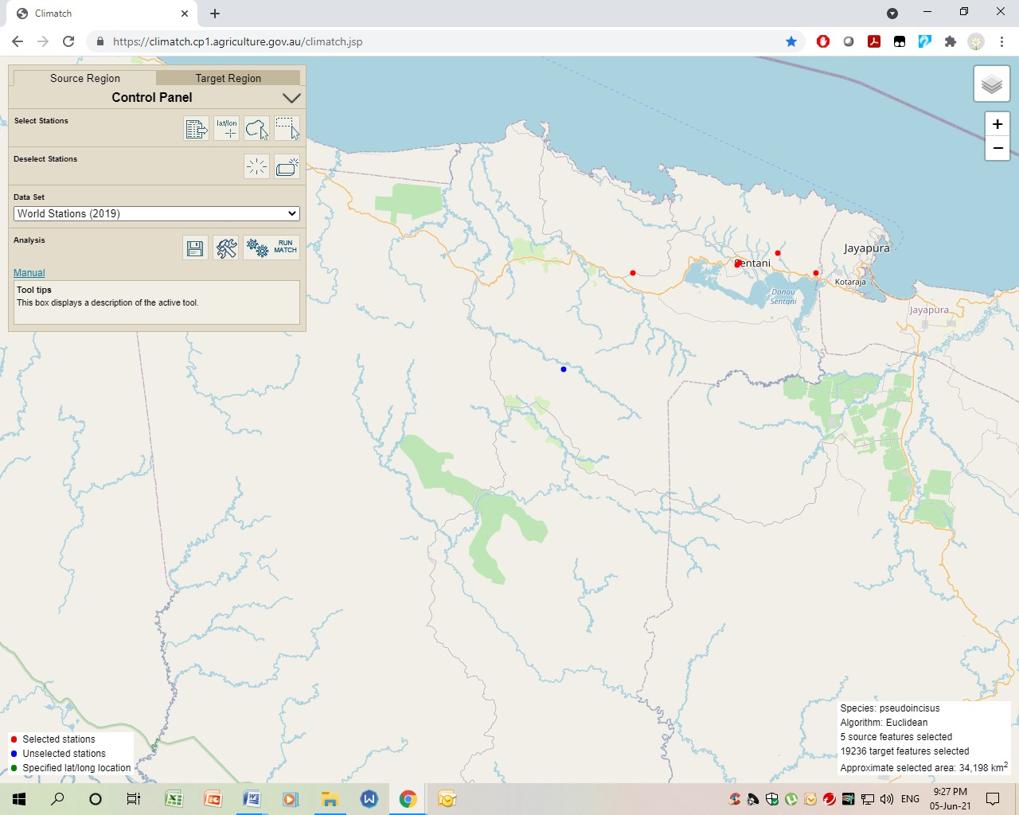

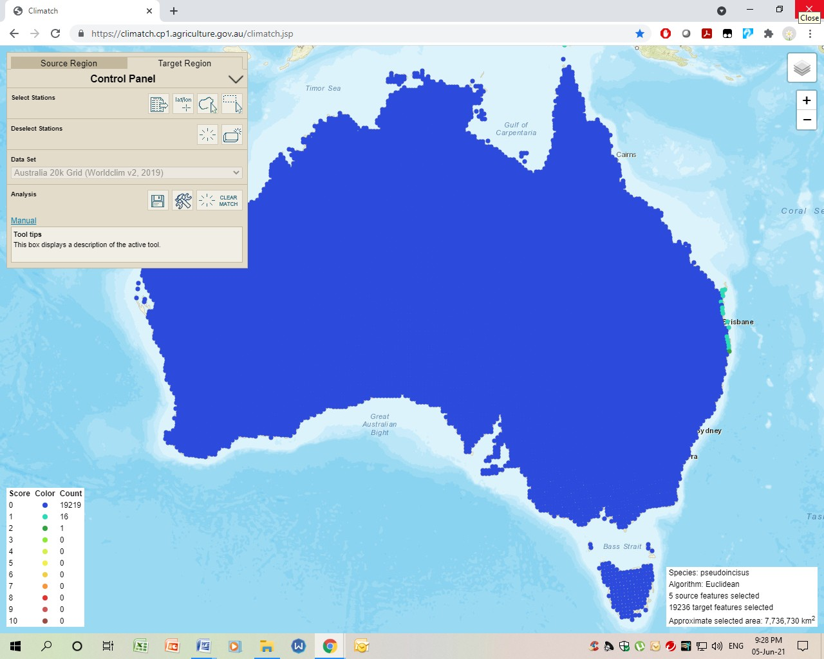

## Attachment B

**BOMFORD ASSESSMENT**

**SPECIES:** Glossolepis pseudoincisus

**Score A. Climate Match (0-8)**

Number of squares within 60% of the mean: (No. 5) 0

Number of squares within 50% of the mean: (No. 6) 0

Number of squares within 40% of the mean: (No. 7) 0

Number of squares within 30% of the mean: (No. 8) 0

Number of squares within 20% of the mean: (No. 9) 0

Number of squares within 10% of the mean: (No. 10) 0

Total = <3

**Score: 1** (Ref: fishbase.org, PC CLIMATE)

**Score B, Overseas Range**

Number of 1° x 1° grids in which species occurs overseas. No. of squares : <3

**Score: 0** (Ref: fishbase.org, googleearth.com)

**Score C, Establishment**

Locations of establishment incidence: nil - never introduced

**Score: 1** (Ref: fishbase.org)

**Score D, Introduction Success**

Percentage of Introduction events that have been successful Introductions nil

Successful: nil

**Score: 1** (Ref: fishbase.org)

**Score E, Taxa risk**

**Genus:** Glossolepis

Introductions: 0

Successful: 0

Score: 0 (Ref: fishbase.org / M. Bomford)

**Family:** Melanotaeniidae (Rainbowfishes)

Introductions: 5

Successful: 0 unknown

**Score: 0** (Ref: fishbase.org / M. Bomford)

**Total: 3 (VERY LOW)**

The score of 3 according to the assessment model gives the fish a very low chance of establishment.

## Establishment Risk Rank Establishment Risk Score

|  |  |
| --- | --- |
| **Extreme** | **13** |
| **Very High** | **11–12** |
| **High** | **9–10** |
| **Moderate** | **6–8** |
| **Low** | **4–5** |
| **Very Low**  **References:** | **≤ 3** |

**ABARES 2020, Climatch v2.0 (Australian Bureau of Agriculture and Resource Economics and Sciences)** November 2020

**Bomford, Mary** (2006) “Risk assessment for the establishment of exotic vertebrates in Australia: recalibration and refinement of models” A report produced for the Department of the Environment and Heritage, Commonwealth of Australia

**Bomford, Mary and Glover, Julie** (June 2004) “*Risk assessment model for the import and keeping of exotic freshwater and estuarine finfish*”, A report produced by the Bureau of Rural Sciences for The Department of Environment and Heritage.

**Phelong, P.C.** (1996b) “Climex: a system to predict the distribution of an organism based on climate preferences”. Available at: [http://www.agric.wa.gov.au](http://www.agric.wa.gov.au/)