

Threat Abatement Plan

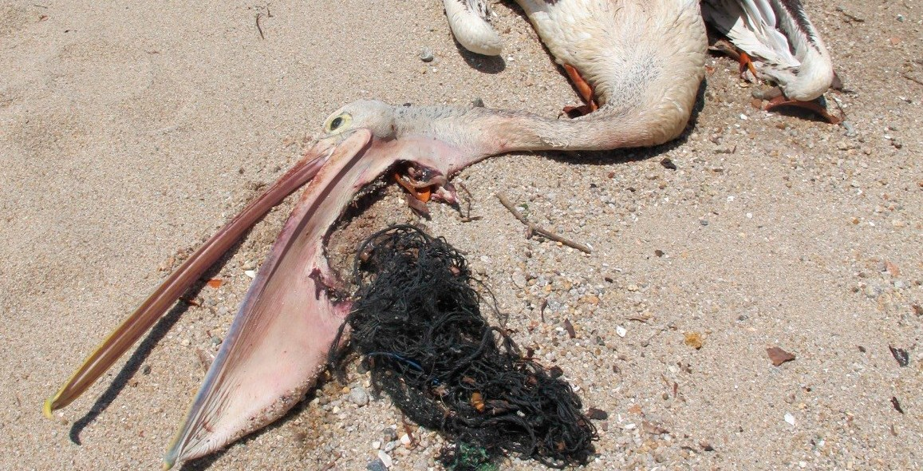for the impacts of marine debris on the vertebrate wildlife of Australia’s coasts and oceans (2018)

2 / Threat Abatement Plan

**© Commonwealth of Australia, 2018.**

*Threat Abatement Plan for the impacts of marine debris on the vertebrate wildlife of Australia’s coasts and oceans (2018)* is licensed by the Commonwealth of Australia for use under a Creative Commons Attribution 4.0 International licence with the exception of the Coat of Arms of the Commonwealth of Australia, the logo of the agency responsible for publishing the report, content supplied by third parties, and any images depicting people. For licence conditions see: <http://creativecommons.org/licenses/by/4.0/au/>

This report should be attributed as ‘*Threat Abatement Plan for the impacts of marine debris on the vertebrate wildlife of Australia’s coasts and oceans*, Commonwealth of Australia 2018’.

The Commonwealth of Australia has made all reasonable efforts to identify content supplied by third parties using the following format ‘© Copyright, [name of third party] ’.

**Disclaimer**

The views and opinions expressed in this publication are those of the authors and do not necessarily reflect those of the Australian Government or the Minister for the Environment and Energy.

**Front Cover photo:** A pelican killed by marine debris at Cardwell, Queensland. Image: P. Campbell, Tangaroa Blue Foundation

**Back Cover photo:** Removing net from an entangled Australian fur seal (Arctocephalus pusillus). Image: Phillip Island Nature Parks

Contents

## Background 4

1. Objectives and actions 8

Objective 1: Contribute to long-term prevention of marine debris 8

Objective 2: Understand the scale of impacts from marine plastic and microplastic on key species, ecological communities and locations 20

Objective 3: Remove existing marine debris 26

Objective 4: Monitor the quantities, origins and hazardous chemical contaminants of marine debris and assess the effectiveness of management arrangements for reducing

marine debris 30

Objective 5: Increase public understanding of the causes and impacts of marine debris, including microplastic and hazardous chemical contaminants, to bring about

behaviour change 33

## Duration, investment, implementation and evaluation

of the plan 37

* 1. Duration 37
  2. Investment in the plan 37 Table 1: Estimated costs of implementation for selected actions

(note that these are not funded actions) 38 Table 2: Estimated average cost of beach clean-ups per kilometre (Tangaroa Blue) 39

* 1. Links to legislation and to Australian Government plans and programs 39
  2. Evaluating implementation of the plan 40 Appendix A 41 Appendix B 45 Appendix C 46 References 47

3

# Background

## Threat abatement plans

Threat abatement plans address key threatening processes listed under section 183 of the *Environment Protection and Biodiversity Conservation Act 1999* (EPBC Act). A key threatening process is ‘a process that threatens or may threaten the survival, abundance or evolutionary development of a native species or ecological community’. If the environment minister decides, with advice, that a feasible, effective and efficient way of addressing a listed key threatening process is the development of a threat abatement plan, the Australian Government works with stakeholders to develop a plan under section 270A of the EPBC Act. The EPBC Act describes the process, content and consultation required when making a threat abatement plan.

The Australian Government implements actions under threat abatement plans that are its direct responsibility. It also guides the implementation of actions where other groups (e.g. state or territory governments, industry or community groups) lead the implementation of a threat abatement plan.

The Australian Government undertakes the threat abatement planning process with assistance from stakeholders including other governments, scientific experts, industry, non-government agencies and the community. To progress actions under the *Threat abatement plan for the impacts of marine debris on the vertebrate wildlife of Australia’s coasts and oceans*, the Australian Government will rely on engagement from all stakeholders involved in this complex problem.

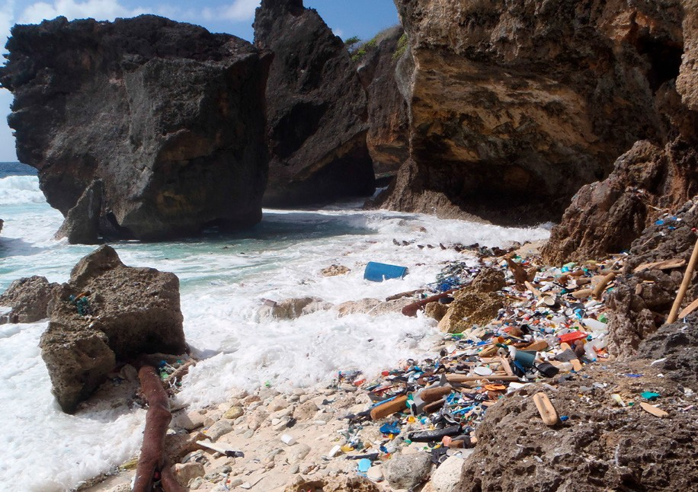

Plastic debris on Christmas Island Image: © CSIRO

4 / Threat Abatement Plan

# Background to this threat abatement plan

Injury and fatality to vertebrate marine life caused by ingestion of, or entanglement in, harmful marine debris was listed as a key threatening process under the EPBC Act in August 2003.

Harmful marine debris includes land-sourced garbage, fishing gear from recreational and commercial fishing abandoned or lost to the sea, and vessel-sourced, solid, non-biodegradable floating materials disposed of or lost at sea. Most of these items are made of synthetic plastics. Harmful marine debris is recognised as a ubiquitous, global problem.

Many industry, government and non-government stakeholders are working to address marine debris and related issues (e.g. through beach clean-up and management of litter and illegal dumping).

In 2009, a threat abatement plan (TAP) to address the key threatening process was prepared and approved in accordance with the EPBC Act. The primary focus of the TAP was the impact of entanglement and ingestion of marine debris on vertebrate marine life.

A review of action under the 2009 TAP was completed in 2015. The review concluded that, despite progress, particularly in beach clean-up efforts, the key threatening process had not been abated and the objectives of the 2009 TAP had not been met. Community and non-government stakeholders were noted as key partners in effective action. The review also noted that understanding had increased over the life of the 2009 plan, particularly regarding the global nature of the marine debris problem and the potential sublethal and other impacts of microplastic and associated chemical contamination.

The Department of the Environment and Energy held an expert workshop in August 2015, involving research, industry, non-government and government organisations, to understand priorities for revising and updating the TAP. This workshop led to the development of this plan, which replaces the 2009 plan.

With increasing public interest in this issue, in June 2015 the Australian Senate referred the threat of marine plastic pollution in Australia for inquiry and reporting. The Senate Inquiry report, *Toxic tide: the threat of marine plastic*, was tabled on 20 April 2016, and highlighted the need for improved action on many issues relevant to the TAP (Senate Environment and Communications References Committee, 2016).

This plan incorporates new actions needed to abate the listed key threatening process, particularly actions to develop understanding about microplastic impacts and the potential role of new technologies in waste management. The actions are intended to be feasible, effective and efficient, as required by the EPBC Act. The plan binds the Commonwealth and its agencies to respond to the impact of marine debris on vertebrate marine life, and identifies the research, management and other actions needed to reduce the impacts of marine debris on affected species. The plan is subject to review at intervals of no more than five years.

Since 2009, marine wildlife researchers have documented additional EPBC Act-listed species that are being impacted by marine debris. **Appendix A** has been updated to include these species.

5

# Why is plastic debris a problem in the marine environment?

Anthropogenic debris entering and accumulating in the world’s oceans is comprised of many types of materials. However, a recent systematic review of the demonstrated ecological impacts of these materials (Rochman et al., 2016), found that the majority (82 per cent) were plastic. The review suggested that there is sufficient evidence now for decision makers to begin to mitigate problematic plastic debris to avoid risk of irreversible ecological harm. Other researchers (e.g. Browne et al., 2015) suggest that policies on anthropogenic debris should focus on replacing problematic products with safer alternatives by tasking ecologists and engineers to identify and remove features of products that might cause ecological impacts.

Plastics are an obvious, problematic target for action. Experts say fishing gear (ropes and nets made from synthetic fibres), balloons and plastic bags are the biggest entanglement threat to marine fauna, and plastic bags and utensils are the biggest ingestion risk for seabirds, turtles and marine mammals (Wilcox et al., 2016). Plastics may also be chemically harmful in some contexts, either because of their potential toxicity or because they absorb other pollutants (Rochman et al., 2013).

As plastic debris accumulates in the environment, exposure to physical, chemical and biological processes results in its fragmentation into smaller pieces, and the potential for ingestion by animals increases (Browne et al., 2008). Potential routes for entry of microplastics (including beads and fibres) into the environment include fragmentation of larger items, introduction of small particles that are used as abrasives in cleaning products, and spills of plastic powders and pellets in sewage waste.

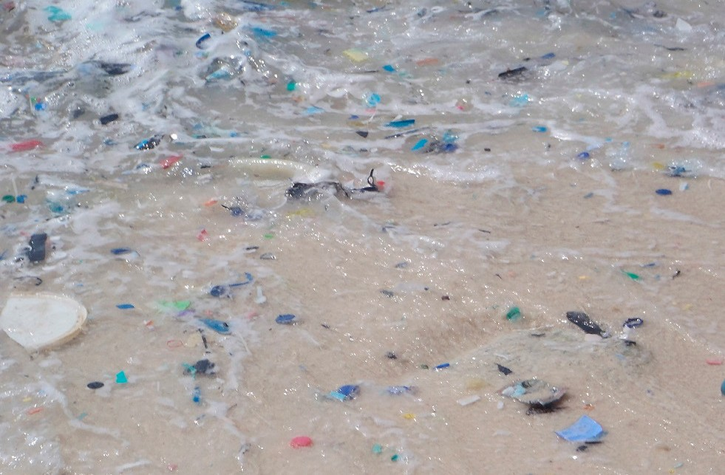

Fragments of plastic on the shoreline. Image: © CSIRO

Seabirds often eat floating plastic. Wilcox et al. (2015b) suggested that nearly all species of seabirds will eventually be found ingesting plastic, based on the discoveries reported so far. For example, 21 per cent of surveyed wedge-tailed shearwater (*Ardenna pacifica*)chicks on Heron Island in the southern Great Barrier Reef were fed plastic fragments by their parents, ingesting 3.2 fragments on average (Verlis et al., 2013). In addition, plastic-derived polybrominated diphenyl ethers (a very common class of flame retardants) are found in the abdominal fat tissues of short-tailed shearwaters (*Ardenna tenuirostris*) in the north Pacific Ocean, presumably transferred from ingested plastics (Tanaka et al., 2013).

6 / Threat Abatement Plan

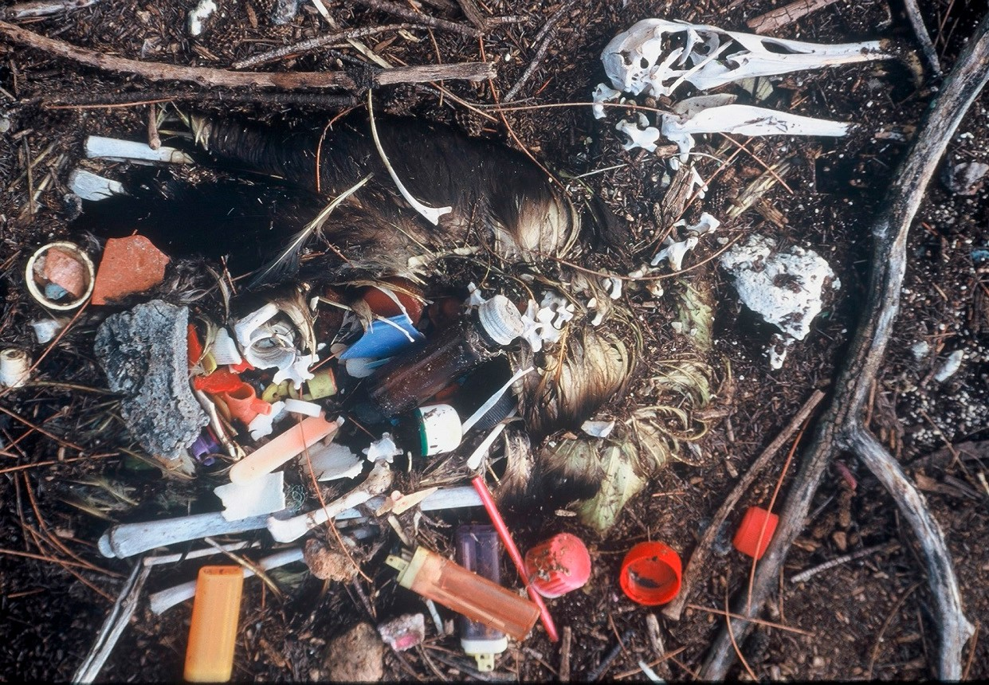

An extreme example of plastic ingestion — an albatross chick from Midway Island, USA, killed by the plastic it was fed by parent birds. Image: © Britta Denise Hardesty

Studies published between 1985 and 2012 identified general plastic as the main debris ingested by marine turtles, followed by soft plastic, rope and styrofoam (Schuyler et al. 2014). Up to 52 per cent of sea turtles may have ingested debris (Schuyler et al. 2016). Other research suggests that turtle nesting activity (and therefore recruitment of new generations) may also be impacted by marine debris. Fujisaki and Lamont (2016), found a substantial increase in loggerhead turtle nesting activity after the removal of large debris from nest beaches in Florida, USA.

Plastic ingestion studies on fish are still in their infancy, especially in the southern hemisphere (Cannon et al., 2016). There is, however, experimental evidence that ingested microbeads can transfer sorbed pollutants (specifically polybrominated diphenyl ethers) to Murray River rainbow fish (*Melanotaenia fuviatilis*) (Wardrop et al., 2016).

The size range of microplastics overlaps with the preferred particle size ingested by animals at the base of the marine food web; detritus-, suspension- and filter-feeders are readily able to ingest the fragments. This leads to uptake and trophic transfer of the plastics themselves and any chemicals they contain or have absorbed from seawater (Galloway and Lewis, 2016). Ingestion of polystyrene microparticles has been shown to interfere with energy uptake and allocation, reproduction, and offspring performance in oysters (Sussarellu et al., 2016).

There is no information available on uptake or biological effects of microplastics originating from marine or terrestrial debris and subsequently ingested by humans through the food chain (Galloway, 2015). Microplastic and chemical contaminant transfers, and the possible accumulation of such contaminants in marine food webs, requires further investigation.

7

Plastic debris increases the susceptibility of reef-building corals to disease, with subsequent habitat implications for marine wildlife. The likelihood of disease increased from 4 per cent to 89 per cent when corals were in contact with plastic (Lamb et al., 2018). Structurally complex corals were eight times more likely to be affected by plastic, suggesting that microhabitats for reef-associated organisms and valuable fisheries may be disproportionately affected.

As an example of the extent of plastic pollution and the concern this issue generates, the first coordinated joint survey of floating macroplastics in remote seas around east and west Antarctica in 2007–2008 found that the seabeds immediately surrounding continental Antarctica are probably the last environments on the planet yet to be reached by plastics (Barnes et al. 2010). However, with pieces of plastic floating into the surface of the Amundsen Sea, this seems likely to change. Australian scientists are planning to investigate the impact of microplastics on the Southern Ocean food web in Antarctica during the life of this plan.

# Objectives and actions

This plan provides national guidance on action to prevent and mitigate the impacts of harmful marine debris on vertebrate marine life through five major objectives:

1. Contribute to long-term prevention of the incidence of marine debris
2. Understand the scale of impacts from marine plastic and microplastic on key species, ecological communities and locations
3. Remove existing marine debris
4. Monitor the quantities, origins, types and hazardous chemical contaminants of marine debris, and assess the effectiveness of management arrangements for reducing marine debris
5. Increase public understanding of the causes and impacts of harmful marine debris, including microplastic and hazardous chemical contaminants, to bring about behaviour change.

The criteria for success remain consistent with those in the previous TAP and with national indicators for estuarine, coastal and marine ecosystems:

* a general decline in the presence and extent of harmful marine debris in Australia’s marine environment
* a general decline in the number of marine vertebrates dying and being injured from ingestion of and/or entanglement in harmful marine debris.

Context and specific actions for each objective are outlined below.

# Objective 1: Contribute to long-term prevention of marine debris

Globally, the loss of plastic to the environment is increasing at an exponential rate. The World Economic Forum estimates that 95 per cent of plastic packaging material value (or over $80 trillion annually) is lost to the economy after a short first use (World Economic Forum, Ellen MacArthur Foundation and McKinsey & Company, 2016).

It is widely cited that 80 per cent of marine debris originates from land (rather than ship- or marine-based sources), but this figure is not well substantiated (Jambeck et al., 2015). During 2010, 275 million metric tonnes of plastic waste was generated in 192 coastal countries, with 4.8 to 12.7 million tonnes entering the ocean (Jambeck et al., 2015). In 2014, 15 to 51 trillion microplastic particles (items above 0.33 mm), weighing between 93 and 236 thousand tonnes were present in global oceans (van Sebille et al., 2015). The ocean may contain upward of 150 million tonnes of plastic (Ocean Conservancy, 2015). In a business-as-usual scenario, the sea is expected to contain 1 tonne of plastic for every 3 tonnes of fish by 2025, and by 2050, more plastics than fish (by weight) (World Economic Forum, Ellen MacArthur Foundation and McKinsey & Company, 2016).

8 / Threat Abatement Plan

Reisser et al. (2013) characterised and estimated the concentration of marine plastics in waters around Australia and inferred their potential pathways. The marine plastics recorded were predominantly microplastics resulting from the break-up of larger objects made of polyethylene and polypropylene (e.g. packaging and fishing items). Mean sea surface plastic concentration was over 4000 pieces per square kilometre, and after incorporating the effect of vertical wind mixing, this value increased to nearly 9000 pieces per square kilometre. These microplastics appear to be associated with ocean currents that connect sampled sites to their international and domestic sources, including populated areas of Australia’s east coast.

Australian action can contribute to reducing the effects of plastic marine debris on marine wildlife globally, particularly through development of innovative concepts and technologies that help prevent plastic debris entering the marine environment. Domestic policies on materials, supply chains, product stewardship, waste management and resource recovery can all assist in minimising the volumes of debris entering the ocean. For example, the Australian Packaging Covenant is an agreement between the state and Australian Government environment ministers and the Australian Packaging Covenant Organisation, (APCO) a non-government organisation that focuses on sustainable packaging. The covenant seeks to minimise the impacts of packaging on the environment and the strategic plan (Australian Packaging Covenant, 2016), advocates for resource use, reuse and recycling innovation to minimise packaging going to landfill. APCO is working to instil a ‘circular economy’ culture in Australian businesses, focusing on keeping product packaging within an active economy by recovering it for further use after its initial use.

Australia is also working regionally and internationally to address the issue of marine debris, particularly through the United Nations General Assembly, the International Maritime Organization (IMO), the Convention on the Conservation of Migratory Species of Wild Animals, the International Whaling Commission and the Secretariat of the Pacific Regional Environment Programme.

Australia is a member of the International Whaling Commission’s entanglement response network, which includes an entanglement response capacity building program incorporating threat mitigation relating to large marine debris. Australian scientists have also been involved in the International Whaling Commission Scientific Committee’s program ‘Pollution 2020,’ which is studying the origin, fate and distribution of microplastics. As chair of the Commission’s Standing Working Group on Conservation Management Plans, Australia is working to incorporate consideration of marine debris into existing and new conservation management plans, which are a practical tool for improving the conservation status of at-risk cetaceans.

Most plastic enters the ocean from a small geographic area, with over half coming from five rapidly growing economies—China, Indonesia, the Philippines, Thailand and Vietnam (Ocean Conservancy, 2015). Recent, significant economic gains, reduced poverty, and improved quality of life in these countries have generated demand for consumer products that has not yet been met with a commensurate waste management infrastructure.

As well as improving waste, litter and stormwater management domestically, improving marine debris management in regional developing countries will improve outcomes for Australia’s marine wildlife, particularly for migratory species that use areas affected by these international sources. This will require immense resources and effort, beyond the scope of this plan. However, while marine debris is the result of outflow of waste from global economic activity, much can be done by Australia domestically to provide leadership and coordination in limiting further contributions of marine debris to the ocean.

9

# Land-based sources of marine debris

Marine debris comes from many different land-based sources. Kroon et al. (2015) identify that chronic exposure to plastic pollution is likely near sewage, stormwater, aquaculture and industrial discharges. A study of plastic waste on coastal beaches in the greater Sydney region in New South Wales found high correlation between plastic debris and both the frequency of storm-water drains and local population sizes. This suggests that storm-water drains may be responsible for delivering plastic waste to coastal ecosystems, with the amount of plastic debris proportional to the size of the surrounding population (Duckett and Repaci, 2015).

Pre-production resin plastic pellets (or nurdles) are produced and shipped around the world in significant volumes. These pellets can be lost to the environment in many ways, but spills around factories and transport over land are major factors. Pellets spilled on land may eventually find their way into drainage systems and out to sea, contributing to marine microplastic debris levels. The non-government organisation Tangaroa Blue has introduced Operation Clean Sweep to Victoria (funded through the Victorian Government’s Litter Hotspots Program) with the aim of ensuring that resin pellets are contained, reclaimed and/or disposed of properly, and with a goal of zero pellet loss.

Plastics along Australia’s east coast mostly come from domestic uses (Reisser et al., 2013). A study on hotspots of coastal debris across Australia found relatively high loads in Western Australia due to prevailing onshore transport from wind and wave action, along with potential transport from currents in the Indian Ocean (Hardesty et al., 2016). On the east coast of the mainland, the debris loads increase from Queensland south to New South Wales, and further increase on the Victorian coastline, likely due to transport of materials southward along the coast in the East Australian Current. Debris from Brisbane appears to be exported southward, and transported onshore by wind and waves. This plume is steadily joined by additional debris from sources down the populated eastern coast, with deposition along the way, leading to the highest levels on the Victorian coastline. Tasmania, South Australia and the Northern Territory have relatively low debris loads compared with the other states.

# Marine-based sources of debris

Marine sources of debris include commercial shipping, offshore installations such as oil rigs (Reisser et al., 2013), and recreational and commercial fishing.

Chronic exposure to marine debris on the Great Barrier Reef was found to be most likely in areas frequented by ships, primarily in ports and marinas, at anchorage areas, at moorings and to a lesser extent along shipping lanes (Kroon et al., 2015). This situation is likely to be reflected in such facilities around the Australian coastline.

Coastal clean-ups in Australia show that recreational fishing appears to provide a source of very high-impact material (C. Wilcox, pers. comm., 2016). Seabirds may be particularly vulnerable to injury from recreational fishing material given their scavenging and fishing activities in areas that are also used by humans (Carapetis et al., 2010). Globally, an estimated 640 000 tonnes of commercial fishing gear is lost in the oceans each year (UNEP, 2016). This gear (referred to as ghost gear or ghost nets) is predominantly comprised of plastic material and, whether accidently or deliberately discarded, threatens marine wildlife through indiscriminate entanglement

10 / Threat Abatement Plan

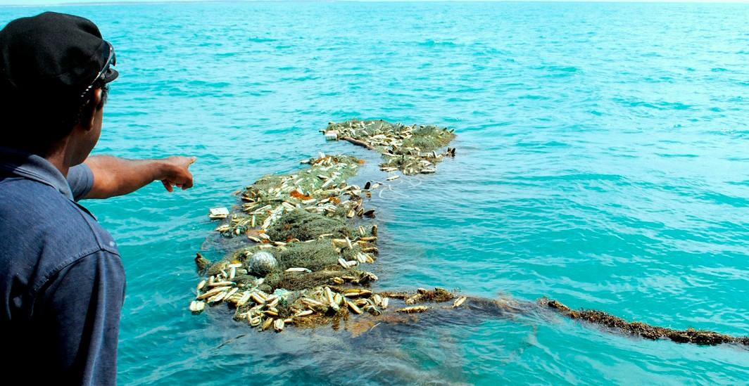

A large ghost net in Australian waters. Image: © GhostNets Australia

.

Illegal, unreported and unregulated (IUU) fishing is fishing that does not comply with national, regional or global fisheries conservation and management obligations. Such fishing contributes to the impact of abandoned, lost or otherwise discarded fishing gear on marine wildlife. Australia has been actively involved in working to strengthen existing regional and international fisheries management and conservation arrangements. Australia also takes a role in pursuing the development and adoption of new measures (where appropriate) to combat IUU fishing and to fully implement key international instruments to ensure that vessels do not act in contravention of their international obligations.

Australia is party to Annex V of the International Convention for the Prevention of Pollution from Ships (MARPOL), which regulates garbage pollution from ships (including fishing vessels). The discharge of plastic into the sea has been prohibited under MARPOL Annex V since 1988; the discharge of all types of garbage into the sea, with very limited exceptions (not related to plastics), has been prohibited since 2013. MARPOL also obliges parties to ensure that adequate waste reception facilities that fully meet the needs of ships normally using them are available in all ports and terminals. Adequate waste reception facilities assist and encourage crews to dispose of plastic wastes appropriately. The potential biosecurity risks posed by ships’ waste delivered to port waste reception facilities is an important consideration.

Effective implementation of MARPOL Annex V can be difficult. Fishing, for example, represents a significant challenge. Compliance and enforcement activities for this industry sector are difficult, given that most the world’s fishing vessels are less than 100 tonnes gross tonnage and are therefore not required under MARPOL to maintain a garbage management plan or garbage record book on board. Fisheries observer data for 2003–2015 from purse seine and longline vessels operating in the western and central Pacific Ocean noted more than 10,000 pollution incidents within the exclusive economic zones of 25 Pacific countries and territories and in international waters. Most of the purse seine pollution was from dumping plastics waste (Richardson et al., 2016).

Discarded, lost and abandoned fishing nets are a significant transboundary issue in the Arafura and Timor seas. Fisheries in the region support livelihoods in the littoral nations of Indonesia, Timor Leste, Papua New Guinea and Australia (Butler et al., 2013). Since the early 2000s there have been reports of very high levels of foreign, fishing-related marine debris on Australia’s sparsely populated, remote northern shores. There is limited information on the temporal and spatial patterns of this fishing debris or its origin (Edyvane and Penny, 2017). Gillnets and other passive fishing gears are thought to be the most problematic of ghost nets (Gilman, 2016; Wilcox et al., 2015a). Northern Australia has some of the highest densities of ghost nets in the world, with up to three tonnes per kilometre washing ashore at some shorelines annually.

11

In 2016, the Food and Agriculture Organization of the United Nations (FAO) produced a technical paper entitled *Abandoned, lost or otherwise discarded gillnets and trammel nets: methods to estimate ghost fishing mortality, and the status of regional monitoring and management* (Gilman et al., 2016). The paper suggests preventive methods to avoid and minimise fishing gear becoming abandoned, lost or discarded, as well as ways to reduce its longevity at sea. Ghost fishing mortality is of particular concern for marine megafauna, particularly long-lived and slowly reproducing seabirds, sea turtles, marine mammals, sharks and their relatives and some bony fishes (Gilman et al., 2016; Wilcox et al., 2015a).

In the open ocean many species, particularly fish, associate with objects drifting on the surface, which provide shelter and may also protect juvenile fish from predators. This behaviour is advantageous to fishing operations, as fishing around floating objects is associated with more successful catches (Davies et al., 2014). However, the use internationally of drifting fish aggregating devices (FADs), which are often comprised of synthetic ropes and netting, is a further potential source of marine debris if the FAD is abandoned, lost or discarded. The Pew Environment Group estimated that the number of drifting FADs deployed in the world’s oceans each year ranges from 47,000 to 105,000, demonstrating the scale of FADs use globally, as well as their potential contribution to marine debris if discarded, abandoned or lost. However, awareness of the impacts caused by uncontrolled FADs is increasing and their use in tuna fisheries in Indonesia and western and central Pacific fisheries has been reduced.

Under current MARPOL Annex V requirements a FAD is considered an illegal discharge if the Master or skipper of the vessel that released the device decided not to retrieve it (unless the loss was accidental and all reasonable precautions have been taken to prevent such loss; or the discharge was for the protection of the marine environment or for the safety of the ship or its crew). In Australian waters, Commonwealth legislation applicable to the management of these devices includes the *Sea Installations Act 1987* and the *Environment Protection (Sea Dumping) Act 1981*.

In 2015, the Australian Senate Environment and Communications References Committee held an inquiry into regulation of the finfish aquaculture industry in Tasmania*.* The committee’s report encourages continued exploration of new ways to decrease marine debris attributable to aquaculture. In particular, the committee suggested colour tagging of each company’s ropes and nets to identify the source of marine debris to aid debris reduction efforts (Senate Environment and Communications References Committee, 2015).

New technologies such as shipboard gasification waste-to-energy systems and accessible and affordable waste reception facilities at ports are likely to play important roles in addressing the challenges of ship waste in the future. The IMO is developing standards for shipboard gasification waste-to-energy systems and associated amendments to regulation 16 of MARPOL Annex VI to allow use of these systems on ships.

Community action can also lead to significant reductions in marine debris from ship-based sources. For example, in 2005, after the initial Cape to Cape Beach Clean Up, community members of the Tangaroa Blue Foundation at Margaret River, Western Australia analysed which items came from local sources, and what plans could be created to prevent their loss to the environment. This process (known as source reduction planning) led to the Western Australia Government, in consultation with the commercial and recreational fishing bodies, introducing regulations to prohibit at-sea possession (in state waters) of plastic bait bands used to secure cartons of bulk bait on fishing vessels. Plastic bands pose a significant risk to a range of marine life; sea lions, seals and sharks are particularly susceptible to injury or death through entanglement in uncut plastic straps. Similarly, the South Australia Government has banned the use of rubber bands in the oyster industry to prevent entanglements with dolphins and seals and has worked with the oyster industry to find other ways of securing baskets to the infrastructure.

12 / Threat Abatement Plan

13 / Threat Abatement Plan

## Actions for Objective 1: Contribute to long-term prevention of marine debris

|  |  |  |  |  |
| --- | --- | --- | --- | --- |
| **Action Priority/timeframe Output** **Outcome Responsibility** | | | | |
| 1.01 Establish a threat abatement plan (TAP) team to coordinate actions for the life of the TAP | High priority—within 6 months of the TAP being in place; meetings to occur on a 6-monthly schedule | Agenda- and action-based meetings/ teleconferences involving representatives of relevant agencies and organisations (for example the Department of the Environment and Energy, state and Northern Territory agencies, the Australian Fisheries Management Authority [AFMA], Australian Maritime Safety Authority [AMSA], Australian Border Force, Australian Antarctic Division, CSIRO, non-government, research and industry groups) so that key stakeholders can contribute to the timely coordination of actions under the TAP. Outcomes of TAP team meetings made publicly available | Better coordinated action on marine debris | Australian Government Department of the Environment and Energy |
| Over time more targeted teams established under this group to address specific issues (for example in regard to Action 1.05 on ghost nets); status reports supplied to the broader TAP team |
| A continuously updated list of stakeholders with marine debris interest (detailing the marine debris resources, expertise and frameworks they bring to the issue in the Australian context) |
| 1.02 Limit the amount of single-use plastic material lost to the environment in Australia | High priority — ongoing for the life of the plan | Industry-led voluntary agreement to phase out microbeads in personal care, cosmetic and cleaning products by mid-2018 | Fewer single-use plastic waste items in the marine environment | Australian Government, Australian states and territories, local governments, industry and retailers |
| Materials and products are selected for use based on robust, scientific understanding of their whole-of-life cycle |

14

|  |  |  |  |  |
| --- | --- | --- | --- | --- |
| **Action Priority/timeframe** | | **Output** | **Outcome Responsibility** | |
|  |  | Government purchasers consider marine debris impacts in procurement, consistent with Commonwealth Procurement Rule 4.5: *When conducting a procurement, an official must consider ….:*  *e. environmental sustainability of the proposed goods and services (such as energy efficiency and environmental impact); and f. whole-of-life costs* |  |  |
| Event guidelines developed for limiting waste and potential debris generated at Australian, state, territory and local government events (guidelines include for example, bans on balloon release and other problem litter items and provision of water refills) |
| Town planning standards are put in place limiting the potential for marine debris inputs resulting from  coastal developments |
| Sites of high litter loads are identified  and infrastructure such as gross pollutant traps, litter booms and bins are installed and maintained at these sites |
| Plastic production and transport infrastructure are designed to lower risk of industrially sourced marine debris (e.g. “operation clean sweep”) |
| 1.03 Encourage development of a circular economy in Australia | High priority — ongoing for the life of the plan | Systems are designed and put in place to prevent waste and encourage recovery of valuable materials (for example bans on single-use lightweight plastic bags, development of container deposits schemes and more efficiently recyclable products) | Materials prevented from entering the environment as waste  Improved recycling and reuse of valuable resources | All levels of government, with industry involvement |

15 / Threat Abatement Plan

|  |  |  |  |  |
| --- | --- | --- | --- | --- |
| **Action Priority/timeframe** | | **Output** | **Outcome** | **Responsibility** |
|  |  | Site-specific logistical support is put in place involving remote communities in state-based container deposit schemes (where such schemes are in place). For example, improved trucking/barge backload of recyclables for remote communities | The use of available technology to reuse plastic is increased | State, Northern Territory and local government, with community support |
| Updated standards, improved information and labelling related to the development, use and appropriate disposal of degradable and compostable plastics. Consistent definitions apply for plastic types, across industry and jurisdictions | Assurance on the environmental suitability of degradable and compostable plastics available  in Australia | Australian Government Industry (e.g. Chemistry Australia) |
| Research to understand the full life cycle of any newly developed plastic |
| 1.04 Encourage innovation in recovery and waste treatment technologies | High priority — within 3 years of the plan entering into effect | An assessment of the environmental impact and cost effectiveness of the use of waste-to-energy systems in remote coastal communities and at ports, informed by technologies and innovation programs being undertaken internationally and noting that IMO standards for gasification systems are being prepared for shipboard systems in the maritime sector | Informed decisions on the practicalities of waste-to-energy technologies (especially at a scale and cost practical for remote Australian conditions) to enable waste material such as recovered ghost nets to be used to generate energy | Australian, state and local governments |
| High priority — ongoing for the life of the plan | Innovation grants relating to improved recovery and waste treatment technologies | Better understanding of microplastic outflows and the potential for capture of this material before it enters the environment | State and territory governments, Australian Government, with industry and community involvement |

16

|  |  |  |  |  |
| --- | --- | --- | --- | --- |
| **Action** | **Priority/timeframe** | **Output** | **Outcome** | **Responsibility** |
| 1.05 Improve management of abandoned, lost and discarded fishing gear | High priority — review prepared within 2 years of the TAP being in place | A review of Australia’s engagement on abandoned, lost or otherwise discarded fishing gear in the Asia Pacific region, with a determination on the appropriateness of current actions  Considerations:   * the cost effectiveness and environmental impacts of current and potential disposal techniques for discarded, lost and abandoned fishing gear (for example, burning in situ on beaches, transfer to land fill, recycling or potential waste-to- energy treatment) * assessment of the potential for cost- effective alternative materials for nets (ensuring that catches of target species are not reduced) * an agreed management process for net incursions into the Australian Exclusive Economic Zone – for example, a permit process (at cost) for entry to retrieve damaged nets * implementation of use of ghost net toolkits developed by the former GhostNets Australia to assess the relative contributions of international and Australian commercial and recreational fishery to the total amount of abandoned, lost and discarded fishing gear present in the Gulf of Carpentaria, with a view to implementing source reduction planning where possible | Improved management of abandoned, lost or otherwise discarded fishing gear  Australia plays a role in building international solutions on abandoned, lost or otherwise discarded fishing gear | Australian Government Department of the Environment and Energy Industry, CSIRO, Universities  TAP team |

17 / Threat Abatement Plan

|  |  |  |  |  |
| --- | --- | --- | --- | --- |
| **Action Priority/timeframe** | | **Output** | **Outcome Responsibility** | |
|  |  | * engagement with countries in the Asia Pacific (particularly the Arafura and Timor Sea region, noting the Regional Plan of Action to Promote Responsible Fishing Practices including Combating Illegal, Unreported and Unregulated Fishing in the Region) and the potential for incentive schemes for return of end-of-life fishing nets and fishing net leasing arrangements * IUU fishing * business plans for micro interest loans arrangements for fishing nets (with nets returned at end of life) in regional developing economies * marking of fishing gear (for example through the use of rogue yarn) to enable identification of owners * the extent to which current Australian fishing practices comply with FAO preventive methods to avoid and minimise fishing gear becoming abandoned, lost and discarded * the potential benefits from Australian Government vessels carrying transponders for attachment to discarded, lost and abandoned fishing gear for tracking and potential retrieval * reporting mechanisms |  |  |

18

|  |  |  |  |  |
| --- | --- | --- | --- | --- |
| **Action Priority/timeframe Output Outcome Responsibility** | | | | |
|  | High priority over the life of the plan | Engagement with best practice international forums on abandoned, lost or otherwise discarded fishing gear, e.g. Committee on Fisheries, a subsidiary body of the FAO Council | Less impact globally on marine wildlife resulting from lost or otherwise discarded fishing gear | Australian Government Department of Agriculture and Water Resources,  AFMA |
| Low priority, but progressed by 2022 | Encourage an international forum with fishing gear and materials/plastics industry experts to determine long-term solutions on lost and discarded fishing gear | Less impact globally on marine wildlife resulting from lost or otherwise discarded fishing gear | Department of the Environment and Energy  CSIRO  International agencies and governments |
| Medium priority, within the life of the plan | An examination of species entanglement risk for the types of fishing gear found abandoned, lost and discarded in Australian waters (for example, the risks posed to marine turtles by lost crab pots) | Prioritisation of management effort to prevent impacts from abandoned, lost and discarded fishing gear in Australian waters | Department of the Environment and Energy |
| High priority from 2018 for the life of the plan | Implementation of the national code of practice for recreational fishing in relation to lost and discarded recreational fishing gear and litter | Less impact on wildlife in domestic waters from recreational fishing | Department of Agriculture and Water Resources  State and territory governments |
| 1.06 Improve shipping waste management | High priority — ongoing for the life of the plan | Ongoing changes to MARPOL are incorporated in state and NT legislation  Enactment of state and NT legislation to mandate provision of waste reception facilities at ports/boating hubs (where this legislation exists). Where this legislation is not in place, consider how this can be encompassed in state/NT legislation and policies  Communication of facilities/services available and waste management options available | States / Northern Territory have legislation relevant to MARPOL in place | All state and NT governments  AMSA |

19 / Threat Abatement Plan

|  |  |  |  |  |
| --- | --- | --- | --- | --- |
| **Action Priority/timeframe** | | **Output** | **Outcome** | **Responsibility** |
|  |  | Support for work being undertaken in the region, including work by the Secretariat of the Pacific Regional Environment Programme on the management of ships’ waste through the Regional Reception Facilities Plan for the Small Island Developing States in the Pacific Region  Australian participation on the IMO’s Sub-Committee on Pollution Prevention and Response to support and contribute to, as appropriate, the development and implementation of new technologies for the management of waste on board ships, for example gasification waste-to-energy technology | Less waste discarded from vessels  Improved management of biosecurity waste  Shipping ports generally have better waste management in place | Australian Government (particularly AMSA and the Department of the Environment and Energy) |
|  |  | Provision of waste reception facilities is incorporated at the planning stage for new port developments/port expansions  Environmental standards or management plans detailing port waste management requirements are in place and implemented  A review of the biosecurity risk of ships’ waste, with a view to maximising recycling/reuse or energy capture and minimising costly biosecurity control options, such as deep burial.  Implementation of container deposit scheme hubs at ports | Improved availability and adequacy of waste reception facilities at Australian ports and boating hubs  Removal of disincentives for vessels to use waste reception facilities | All state/NT government planning/ environment agencies  Ports Australia  Department of Agriculture and Water Resources |

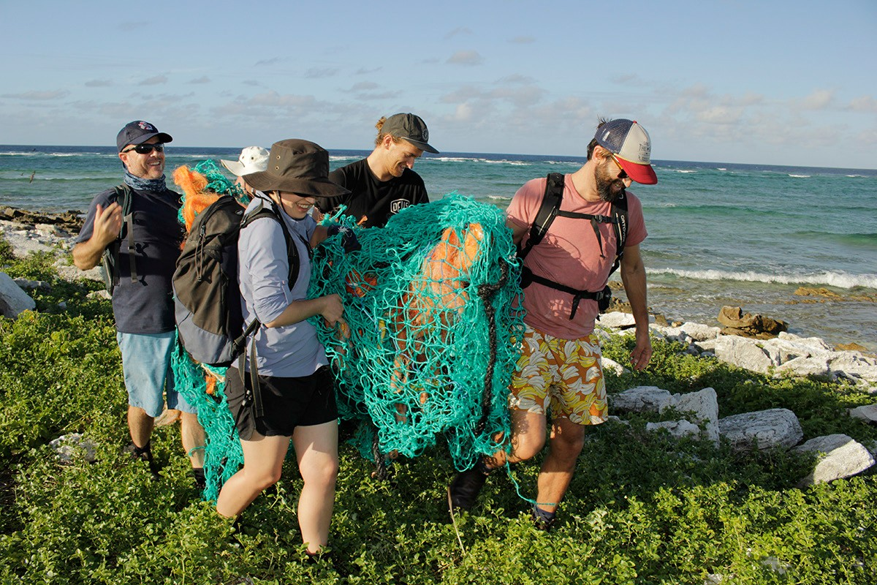

Coral Sea clean-up. Image: Andy Warmbrunn, Parks Australia

## Objective 2: Understand the scale of impacts from marine plastic and microplastic on key species, ecological communities and locations

Marine debris research in the 1980s found that accumulating debris posed increasingly significant threats to marine mammals, seabirds, turtles, fish, and crustaceans (Laist, 1987). At that time, threats were assumed to be straightforward and primarily mechanical (through entanglement or ingestion of small plastic pieces). More recently, ingestion of microplastics has been demonstrated in a range of marine organisms (Cole et al., 2011) and this may be leading to more complex and as-yet poorly understood impacts.

For the purpose of this TAP, plastic debris and its impacts are categorised as:

* large debris, such as lost or discarded fishing gear, plastic drums and containers, etc. that may trap and entangle wildlife
* small plastic pieces (>5 mm) that may be ingested by biota, causing ecotoxicological effects, physical blockage and internal injuries
* microplastics particles (<5 mm) that pose an ecotoxicological risk through ingestion. These particles can be transferred to higher levels in the marine food chain and may serve as a transport mechanism for contaminants such as persistent organic pollutants.

As plastic debris accumulates in the environment, exposure to physical, chemical and biological processes results in its fragmentation into smaller pieces and the potential for ingestion by animals increases (Browne et al., 2008). An improved understanding of the ways in which plastic and microplastic impact and interact with the marine environment is needed, given that worst-case trophic transfer could lead to a much broader level of impact than is currently understood.

20 / Threat Abatement Plan

**Appendix A** identifies EPBC Act-listed species for which there are scientifically documented adverse impacts resulting from marine debris. For example, 90 per cent of flesh-footed shearwater fledglings on Lord Howe Island were affected by ingestion of plastic debris in 2011 (Lavers et al., 2014). Ingestion of plastic significantly reduced flesh-footed shearwater fledgling body mass and wing length, lowering juvenile survival by at least 11 per cent (Lavers, 2014). Ingestion of plastic has also been implicated in the decline of the Lord Howe Island population of this species (Hutton et al., 2008; Lavers and Bond, 2016; Lavers et al., 2014; Priddel et al., 2006).

As understanding on species impact grows (through understanding of microplastic impact for example), the number of species on the list at Appendix A is likely to increase. For example, in two whale shark (*Rhincodon typus)* stranding cases in the Philippines, necropsies revealed plastic materials in the animal’s stomachs (Marine Wildlife Watch of the Philippines, 2014). Whale sharks are listed as vulnerable and migratory under the EPBC Act; confirmation of lethal or sublethal impact resulting from plastic ingestion will lead to addition of whale sharks to the **Appendix A** impacted species list.

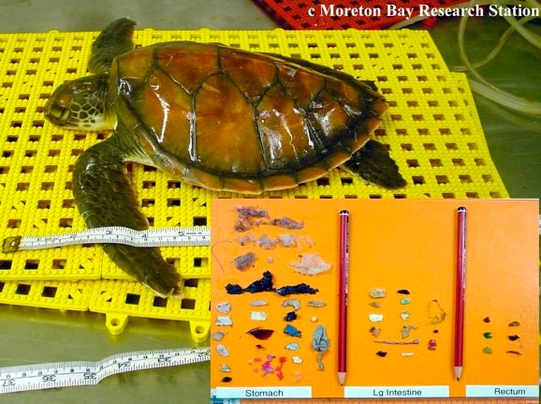

Researchers found over forty pieces of rubbish including the remains of balloons, plastic bags, hard plastic, fishing line, thong and plastic bottle top in this young green turtle. Image: Dr Kathy Townsend, Moreton Bay Research Station, University of Queensland.

**Appendix B** identifies the two EPBC Act-listed ecological communities (*Posidonia australis* seagrass meadows of the Manning–Hawkesbury ecoregion, and subtropical and temperate coastal saltmarsh) for which marine debris (litter) is identified as a threat. As understanding of marine debris impact develops, further ecological communities may also be identified as impacted. For example, climate change is identified as the major threat to the endangered giant kelp marine forests of south-east Australia, but land-based pollution is a recognised secondary threat that may become increasingly relevant.

As discussed under Objective 1, abandoned, lost and discarded fishing gear is predominantly comprised of synthetic material and threatens wildlife through interactions that lead to entanglement. Investigation of spatial and temporal links to species entanglement in derelict fishing gear and other forms of plastic debris is a research priority (Vegter et al., 2014).

21

Ocean circulation patterns can concentrate marine debris at certain locations along the coast and within Australian waters. To prioritise protection of species, it is important to understand where these accumulations occur, and their overlap with threatened species distributions and other marine priorities, such as World Heritage Areas, Commonwealth Marine Reserves, Marine Key Ecological Features and Biologically Important Areas. For example, debris along the northern Australian coastline is driven by oceanic currents that circulate in a clockwise gyre, with materials (for example ghost nets) transported into the Gulf of Carpentaria by south-easterly trade winds. This is cause for concern because the waters of the Gulf support important foraging, breeding, and nesting grounds for six of the world’s seven marine turtle species (Wilcox et al., 2015a). Similarly, more than 50 per cent of post-hatchling loggerhead and green turtles captured while drifting in the East Australian Current through waters off south Queensland and New South Wales carried ingested microplastic fragments in their digestive tracts (Boyle and Limpus, 2008).

22 / Threat Abatement Plan

23 / Threat Abatement Plan

## Actions for Objective 2: Understand the scale of marine plastic and microplastic impact on key species, ecological communities and locations

|  |  |  |  |  |
| --- | --- | --- | --- | --- |
| Action | Priority/timeframe | Output | Outcome | Responsibility |
| 2.01 Update the list of marine debris impacted EPBC Act-listed vertebrate species as scientific evidence is published | Medium priority—ongoing for the life of the plan | An annual review of relevant published literature, as well as data from state- or Northern Territory- based stranding, ingestion and entanglement datasets, to maintain an up-to-date list of EPBC Act-listed threatened species for which the impact of marine debris is clearly demonstrated | Better understanding of the EPBC Act-listed threatened species most in need of action and protection in relation to marine debris | TAP team, Department of the Environment and Energy |
| 2.02 Monitor relevant ecological research to determine if further EPBC Act-listed ecological communities are threatened by marine debris | High priority—ongoing for the life of the plan | An annual literature review to maintain an up-to-date list of EPBC Act-listed threatened ecological communities for which the impact of marine debris is clearly demonstrated | Better understanding of the EPBC Act threatened ecological communities most in need of action and protection in relation to marine debris | TAP team, Department of the Environment and Energy |
| 2.03 Identify locations where aggregations of debris intersect with the temporal and spatial distribution of EPBC Act-listed species, especially during vulnerable life stages (e.g. whale and turtle migrations) | High priority—ongoing for the life of the plan | Identified locations within Australian waters where major circulation patterns cause aggregations of marine debris  A review of the impact of ingestion of marine debris on the population dynamics of the southwestern Pacific stock of loggerhead turtles and of the southern Great Barrier Reef stock of green turtles at five-year intervals  An investigation into the sources of materials causing entanglements of humpback whales during their north/ south migrations during breeding and calving seasons  Publicly available maps identifying marine debris accumulation sites and where possible, characterisation of the type of debris occurring at these sites. | Prioritisation of source reduction efforts to mitigate marine debris threats to EPBC Act-listed species at these locations/times  Better understanding of the locations at which EPBC Act-listed threatened species and ecological communities are most at risk  Correlation of these locations with other priority marine sites (e.g. Commonwealth marine reserves, key ecological features) | National Environmental Science Programme (NESP), Department of the Environment and Energy, Great Barrier Reef Marine Park Authority, state government agencies |

24

|  |  |  |  |  |
| --- | --- | --- | --- | --- |
| Action | Priority/timeframe | Output | Outcome | Responsibility |
| 2.04 Build understanding related to plastic and microplastic pollution | High priority—over the life of the TAP | An appropriate suite of indicator species (invertebrate and vertebrate) identified for long-term monitoring to measure the impact of marine microplastic and plastic debris  Research on bioaccumulation and biomagnification of ingested microplastic contaminants in marine organisms at multiple biological scales  An understanding of the qualities of plastics and plastic items (e.g. toxicity, colour, ability to fragment, density, format, composition, size) that increase the likelihood of negative impacts on marine vertebrates when ingested or entangled  Ranking of impact risk for microplastic types (potentially informed by the developing understanding of human health impacts of microplastic, e.g. through use of plastic implants in medicine) | Predictions on microplastic risk / threat for EPBC Act-listed species | NESP Marine Biodiversity Hub University-based researchers Industry (e.g. Chemicals Australia) |

25 / Threat Abatement Plan

|  |  |  |  |  |
| --- | --- | --- | --- | --- |
| Action | Priority/timeframe | Output | Outcome | Responsibility |
|  |  | An assessment of the morbidity and the differential toxicity of plastic types for indicator species  Research on the morbidity threshold (especially for impacted EPBC Act- listed vertebrates) from ingestion of plastic and microplastic, including generational impacts such as reproductive effectiveness  Research on the physical pathways leading to marine debris, including microplastic. For example, understanding of the microplastic content in land-based sewerage outputs.  Long-term monitoring of the ecological communities at Appendix B to measure the impact of plastic debris |  |  |
| 2.05 Survey marine plastic pollution in the Southern Ocean, sub-Antarctic islands and other high-value offshore island environments | High priority—over first 2 years of the life of the TAP | A baseline assessment of plastic marine debris and its potential wildlife impacts the Southern Ocean, sub-Antarctic islands and offshore islands of high ecological value | Improved understanding of the plastic pollution risk/threat to EPBC Act-listed impacted species in the Southern Ocean, sub-Antarctic islands and other high-value offshore island environments  Source reduction operations undertaken where feasible | States and territories Department of Environment and Energy  Parks Australia  Australian Antarctic Division |
| 2.06 Determine the relevance of microplastics to the Australian Government’s Science and Research Priorities and corresponding Practical Research Challenges | Medium priority | A determination on whether microplastic pollution should be considered under the Australian Government’s Science and Research Priorities (which are reviewed every two years) | Potentially strengthened research focus on microplastic | Department of Industry, Innovation and Science  Department of the Environment and Energy |

## Objective 3: Remove existing marine debris

Australia has an established network removing marine debris from beaches through the efforts of Indigenous ranger groups in coastal Australia, Australian Government agencies and non-government organisations such as the Australian Marine Debris Initiative, Tangaroa Blue, Eco Barge Clean Seas Inc., the Surfrider Foundation and the South West Marine Debris Cleanup (Tasmania). These activities prevent significant quantities of debris returning to the ocean and continuing to interact with marine biodiversity.

Approximately 85 Indigenous ranger groups in coastal areas remove marine debris (including ghost nets) as part of their work on country. For example, the Dhimurru Rangers of north-east Arnhem Land conduct regular beach clean-ups which remove tonnes of marine debris each year. Rangers have found between 800 and 1000 kg of marine debris washed ashore per kilometre of coastline in Dhimurru Indigenous Protected Area each year.

Lost and discarded fishing gear (ghost nets) is a major component of identified debris. The scale and location of many ghost nets can prevent their removal and appropriate disposal. The Northern Territory Government, Indigenous ranger groups and the non-government organisations Worldwide Fund for Nature (WWF), Conservation Volunteers Australia and GhostNets Australia have all been involved in coordinating the removal of nets across northern Australia. GhostNets Australia has developed a ghost net identification kit (Gunn, 2015) to aid in identifying sources, building on a previous version developed by WWF.

State and Northern Territory agencies make significant efforts to remove ghost nets from the marine environment.

For example, the Northern Territory Department of Primary Industries and Resources provides nearly one million dollars per annum to selected Northern Territory coastal Indigenous ranger groups for tasks including ghost net removal.

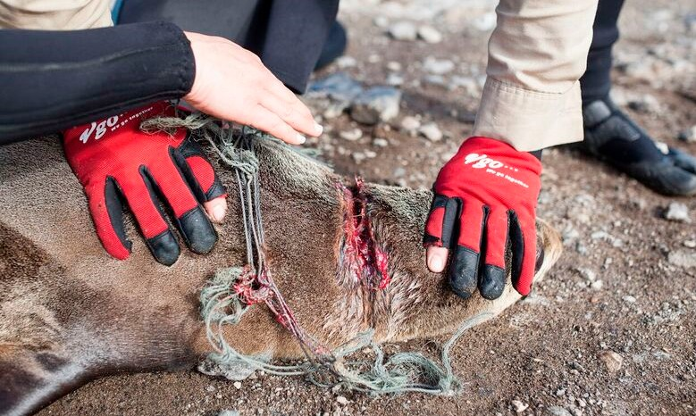

Removing net from an entangled [Australian fur seal (*Arctocephalus pusillus*](https://www.penguins.org.au/conservation/environment/wildlife-clinic/wildlife-protection/new-news-page-2/)). Image: Phillip Island Nature Parks

26 / Threat Abatement Plan

The AFMA, working in partnership with the Australian Border Force and Parks Australia, has successfully recovered and disposed of abandoned foreign gillnets sighted inside the Australian Exclusive Economic Zone and Torres Strait Protected Zone. Nets have also been located and opportunistically recovered by the Australian Defence Force.

Debris along the northern Australian coastline is driven by oceanic currents that circulate in a clockwise gyre, with ghost nets transported into the Gulf of Carpentaria by south-easterly trade winds, where they accumulate in high densities (Wilcox et al. 2015a). The Global Ghost Gear Initiative, established by World Animal Protection, operates with the Northern Prawn Fishery to address this problem in the Gulf of Carpentaria. The initiative works with fishing industry stakeholders around the world to remove ghost nets from the ocean.

Beach-based clean-up activities provide an opportunity to record valuable data on the types of objects found, allowing identification of frequently found items and potentially their source. In South Australia, a number of beach clean-up programs along the coastline of the Eyre Peninsula are led by the aquaculture industry (Adopt-a-Beach, Oyster Industry Coastal Debris recovery program). Debris is collected and categorised to aid in identifying and addressing sources. The Australian Marine Debris Initiative has built a system of source reduction planning into its work and has achieved significant gains, including bringing about legislative change in Western Australia.

A potentially innovative approach to removing plastic involves using strains of [microorganisms](http://www.omicsonline.org/searchresult.php?keyword=%20microorganisms) with the capacity to degrade plastics. These microorganisms use synthetic polymers as their sole source of carbon. Some types of plastics are highly biodegradable, while others, such as polystyrene, have low biodegradability. Polymer biodegradation in natural ecosystems is affected by environmental and microbiological factors and further advances in biochemistry and biotechnological fields could offer new perspectives on the bioremediation of [plastic contamination](http://www.omicsonline.org/searchresult.php?keyword=%20plastic-contamination) (Caruso, 2015). Plastic has a longer half-life than most natural floating marine substrates, and a hydrophobic surface that promotes microbial colonisation and biofilm formation (Zettler et al., 2013). Anthropogenic, millimetre-sized plastic polymers have created a new pelagic habitat for microorganisms and invertebrates; this ‘epiplastic’ community appears to influence the fate of marine plastic pollution by affecting the degradation rate, buoyancy and toxicity of plastics (Reisser et al., 2014). Diatoms appear to be the most diverse group of plastic colonisers; bryozoans and barnacles have also been recorded, as have rounded, elongated and spiral cells considered to be bacteria, cyanobacteria and fungi. Researchers speculate that, apart from providing long-lasting buoyant substrata that allow many organisms to disperse widely, marine plastics may also supply energy for microbiota capable of biodegrading polymers and/or associated compounds, and perhaps for invertebrates capable of grazing on plastic inhabitants (Reisser et al., 2014). Strategic, contained use of such organisms for biological breakdown of plastic could provide an innovative solution for some aspects of marine debris (for example in addressing microplastic in sewage treatment).

27

28 / Threat Abatement Plan

## Actions for Objective 3: Remove existing marine debris

|  |  |  |  |  |
| --- | --- | --- | --- | --- |
| Action | Priority/timeframe | Output | Outcome | Responsibility |
| 3.01 Support beach-based clean-up efforts | High priority—ongoing for the life of the TAP | National coordination of beach clean-up effort via the TAP team established under Action 1.01  Removal of marine debris from Australia’s coastal environment and from upstream sources  Collected materials reused, recycled or appropriately land-filled  Data on the types of marine debris collected in beach-based  clean-up efforts | Funding for ongoing beach clean-up efforts by community groups and Indigenous ranger groups in coastal regions across Australia, preventing marine debris returning to the sea  Evidence to aid source reduction planning (from beach clean-up data) continues to build | Australian, state, territory and local governments.  Community groups |
| 3.02 Improve the effectiveness of Australian Government grants in relation to marine debris outcomes | Medium priority—ongoing for the life of the TAP | Australian Government grant recipients required to consider litter/ marine debris consequences in their projects  Australian Government environment grant recipients required to collect data and report on the types and amounts of marine debris removed or observed | Australian Government grant recipients have increased consideration of marine debris and its impacts  Additional data available on marine debris | Australian Government / Department of the Environment and Energy |

29

|  |  |  |  |  |
| --- | --- | --- | --- | --- |
| Action | Priority/timeframe | Output | Outcome | Responsibility |
| 3.03 Remove derelict fishing gear from Australia’s oceans and coasts | High priority  Ongoing for the life of the TAP | National coordination and an identified single point of contact in relation to survey, intercept and recovery of ghost nets, following advice from Action 1.05 (review of Australia’s engagement)  Identified ghost net aggregation sites are targeted for net removal operations (see 2.03)  A review of options for fishing gear marking and tracking  Identify ports as cost-effective hubs for ghost net disposal and management, particularly in the Gulf of Carpentaria  Removal of nets circulating and accumulating in the Gulf of Carpentaria near to a strategic port e.g. Weipa | Mechanisms for public reporting of ghost nets are improved  Existing data and models contribute to safe, cost efficient removal of ghost nets in the Gulf of Carpentaria  Continued collaboration between Australian Border Force, the AFMA, AMSA and Parks Australia in net identification, tagging and removal from Commonwealth waters across Northern Australia  Appropriate ghost net disposal options are available | Through the TAP team |
| 3.04 Develop understanding of the potential for biological breakdown of plastic to prevent it entering the marine environment, or aid its removal | Low priority, long term | Strategic use of organisms able to biologically breakdown plastic (for example in sewage treatment) | A determination on whether organisms present in the marine environment could be manipulated to address accumulations of plastic | NESP Marine Biodiversity Hub |

## Objective 4: Monitor the quantities, origins and hazardous chemical contaminants of marine debris and assess the effectiveness of management arrangements for reducing marine debris

Data collection, management and access are crucial in improving marine debris outcomes. Rigorous data from clean-up efforts can reveal patterns in debris items and sources, enabling the implementation of source reduction plans (such as those developed under the Australian Marine Debris Initiative) and aiding in the identification of cost-effective actions. This is especially the case when clean-up data is combined with other relevant data sources (e.g. oceanographic information).

The Atlas of Living Australia provides free online access to a repository of information about Australia’s biodiversity. This infrastructure can potentially support organisations in aggregating data from other domains and could be a means of bringing together and maintaining existing marine debris datasets, should they be made available.

International Pellet Watch is a volunteer-based global monitoring program for persistent organic pollutants found on plastic resin pellets. These resin pellets are industrial feedstock of plastic products and can be spilled into the environment during production, packaging and transportation. They are ubiquitous in the marine environment and on beaches. Resin pellets are persistent in the environment and hydrophobic, which allows sorption of hydrophobic organic pollutants, including persistent organic pollutants, from the surrounding environment. Continuous monitoring of persistent organic pollutants is important for understanding of pollution status, pollutant fates, and the effectiveness of regulation and remediation (Yeo et al., 2015).

Understanding of the potential impacts of microplastic chemical contamination is developing. For example, laboratory experiments have found that a form of flame retardant with potential to persist in the environment (polybrominated diphenyl ethers) accumulated in tissue after fish ate contaminated microbeads sourced from facial soaps (Wardrop et al., 2016).

30 / Threat Abatement Plan

31 / Threat Abatement Plan

## Actions for Objective 4: Monitor the quantities, origins and hazardous chemical contaminants of marine debris and assess the effectiveness of management arrangements to reduce debris

|  |  |  |  |  |
| --- | --- | --- | --- | --- |
| Action | Priority/timeframe | Output | Outcome | Responsibility |
| 4.01 Continue collection of data in long-term beach surveys | Ongoing for the life of the plan | Long-term datasets of beach survey sites | Long-term monitoring of the state of the threat (relevant to this TAP, State of the Environment reporting and for efforts such as the Australian Packaging Covenant)  Improved ability to conduct source reduction planning | CSIRO, non-government organisations, volunteers |
| 4.02 Develop a nationally consistent monitoring system for land-based plastic pollution | High priority—within 2 years of the TAP entering into effect | Standardised and cost-effective methods for sampling land-based plastic pollution  Standardised data structure and entry capacity (for example via the Atlas of Living Australia [ALA])  A baseline data set | Nationally consistent long-term monitoring of land-based plastic pollution responses to waste management programs | NESP Marine Biodiversity Hub TAP team |
| 4.03 Maintain a national database for long-term marine debris beach survey data and promote standard methods for collecting and ongoing monitoring of beach clean-up debris | High priority—within 1 year of the TAP entering into effect | The ALA to act as a repository for central data reporting for all agencies or groups that would like to provide input. Data would remain in the source formats provided by agencies, but be publicly available | An accessible information repository for marine debris data | Department of the Environment and Energy / NESP working with the ALA |

32

|  |  |  |  |  |
| --- | --- | --- | --- | --- |
| Action | Priority/timeframe | Output | Outcome | Responsibility |
| 4.04 Assess the effectiveness of Australia’s product stewardship and waste management in reducing the levels of plastics entering the marine environment | High priority—within 2 years of the TAP entering into eff | An investigation of the effectiveness of different government investments in reducing the impacts of plastic packaging and reducing litter moving into the marine environment  Identified littering hotspots.  Identified pathways (e.g. stormwater) for litter and other refuse to reach the  marine environment | Identified issues and trends in littering, with associated opportunities for reducing litter at source points  Improved ability for making cost-effective decisions based on high-quality data  Pinpoint key approaches and sites to enhance recycling of packaging away from sources and households  Flow-on effects include reduced litter and other solid waste impacts on terrestrial and marine ecosystems | CSIRO, NESP Marine Biodiversity Hub  State and territory governments |
| 4.05 Continue to monitor persistent organic pollutant contamination using plastic resin pellets from Australian beaches | High priority—ongoing for the life of the TAP | Comprehensive Australian data included in International Pellet Watch dataset (www.pelletwatch.org) | Publicly available, long-term data indicates trends in persistent organic pollutant levels in plastic resin pellets from Australian beaches | Community, Australian, state and territory governments  Plastics industry |
| 4.06 Regularly assess mean surface plastic loads and associated hazardous chemical contaminants across Australian jurisdictions and territories | Ongoing for the life of the TAP | Regular assessment of mean surface plastic loads and associated hazardous chemical contaminants in Australian waters | Understanding of the amounts, sources and potential impacts of the most abundant forms of plastic, microplastic and associated hazardous chemical contaminants in Australian waters | CSIRO, Australian, state and NT governments, other research providers |
| 4.07 Enhance collection of data related to ghost net retrievals from Commonwealth waters across northern Australia | Ongoing for the life of the plan | Long-term datasets on ghost net retrievals from Australian Commonwealth waters, including data on the presence of entangled threatened species | Improved ability to conduct source reduction planning in relation to ghost nets  Assistance with identification of accumulation zones for ghost nets | Department of Environment and Energy working with Australian Government and charter vessel operators |
| 4.08 Improve understanding of the impact and origins of ghost nets | Medium priority—within 6 months of TAP being in place | Promotion of the use of ghost net identification kits in coastal northern Australia through TAP team members to all Australian, state, NT and local governments, ranger and community groups that are involved in ghost net management | Improved ghost net data collection using identification kits (with a view to aiding source reduction planning) | TAP team |

## Objective 5: Increase public understanding of the causes and impacts of marine debris, including microplastic and hazardous chemical contaminants, to bring about behaviour change

Changes in the way people buy, use and dispose of consumer products will play a major role in limiting the impact of marine debris. To achieve this change, consumers need to understand both short- and long-term implications of continuing to use and dispose of plastic and other materials in their current form and at the current rate. Increasing understanding of potential marine food chain and human health impacts from microplastic and contaminants could be a major driver of change in consumer behaviour.

Plastic Free July is an example of effective community-based action aimed at raising awareness of the issues associated with single-use disposable plastic. This initiative, developed in 2011 by Western Metropolitan Regional Council in Perth, Western Australia and now attracting national and international interest, encourages the public to refuse single-use plastic every July, focusing on plastic bags, bottles, takeaway coffee cups and straws. An estimated 84,000 Western Australians participated in 2016, and around one million people from 130 other countries joined in. A recent survey showed that eight out of ten Western Australians are concerned about the amount of rubbish that goes into landfill and the plastics that are polluting the ocean and have indicated they are willing to change their habits.

In the Great Barrier Reef catchment, the Reef Guardian schools program provides an excellent example of a

school-based initiative that improves understanding of environmental risks and solutions. The program sees students team up with others in their community to actively participate in activities aimed at improving catchments, water quality, sustainability and Great Barrier Reef health. This includes environmental and sustainability projects such as cleaning up local beaches and recycling waste and litter. Similarly, 17 councils between Bundaberg and Cooktown in the Reef Guardian Councils program undertake a range of projects along the Great Barrier Reef catchment that engage the community on waste management, illegal dumping and marine debris clean-ups.

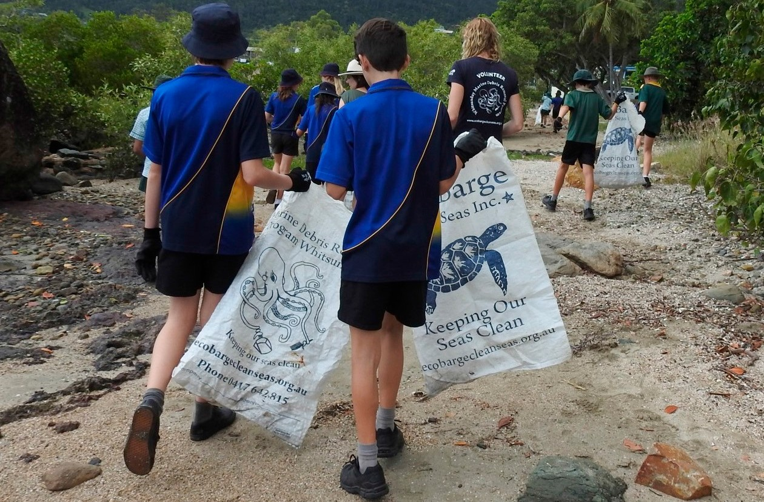

Reef Guardians in action. Image: Kate Finch

33 / Threat Abatement Plan

Community action in the form of ghost net art has proven to be an effective means of alerting the public to the damage that discarded, lost and abandoned fishing gear causes in the marine environment. The former non-government organisation GhostNets Australia sponsored ghost net art workshops in Indigenous communities between 2009 and 2013. As a result, Indigenous ghost net art now appears regularly in galleries and art exhibitions around Australia and internationally.

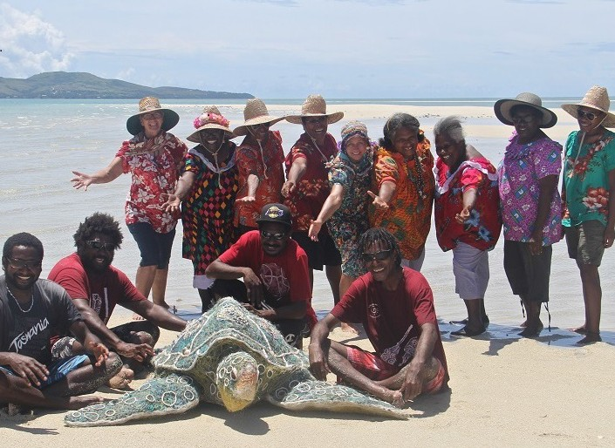

The Erub Arts Ghost Net Gang at Seu Cay (eastern Torres Strait) with Emarr Totol, made from ghost net material. Image: Erub Arts, photographer Lynnette Griffiths

34

35 / Threat Abatement Plan

## Actions for Objective 5: Increase public understanding of the causes and impacts of marine debris, including microplastic and hazardous chemical contaminants, to bring about behaviour change

|  |  |  |  |  |
| --- | --- | --- | --- | --- |
| Action | Priority/timeframe | Output | Outcome | Responsibility |
| 5.01 Raise the profile of marine debris impacts on marine vertebrate species, especially EPBC Act-listed threatened species | High priority — throughout the life of the TAP | Engagement with the public on marine debris impact and  pollution issues through Australian Government social media channels (Threatened Species Commissioner, Commonwealth marine reserves, Department of the Environment and Energy, NESP, AMSA) through promotion of:   * marine debris problems identified through source reduction planning, such as helium balloons and wildlife impacts resulting from ships’ waste discarded at sea * outcomes of research into impacts of marine debris on marine species, including any potential human health impacts arising from research into marine microplastic and associated chemical contamination * wildlife rescue and rehabilitation efforts for marine species impacted by marine debris | Community better engaged on the wildlife impacts of consumer products to drive choices that limit marine debris impacts  Greater levels of personal responsibility in relation to consumption and  waste management | Department of the Environment and Energy  NESP NGOs  Education agencies/schools  State, territory and local government agencies |

36

|  |  |  |  |  |
| --- | --- | --- | --- | --- |
| Action | Priority/timeframe | Output | Outcome | Responsibility |
|  |  | Continued production of ghost net art, especially in coastal  Indigenous communities  Engagement with community on marine debris, litter and waste management issues through school programs, local government and NGOs |  |  |
| 5.02 Improve public communication about consumer waste and litter | Ongoing for the life of the TAP | Reinvigorated, nationally consistent communication aimed at preventing litter and improved recycling effort (based around psychological insights into littering behaviour, e.g. Spehr and Curnow, 2015)  Existing litter campaigns are refocused on:   * microplastic (including microfibers) emphasising that this material cannot be removed from the ocean * the everyday sources of marine debris e.g. helium balloons released into the environment at celebrations and ceremonies * improved information and labelling on appropriate disposal of degradable and   compostable plastics   * public education through promotion of major public events such as no-waste days | Better awareness of consumer impacts on the marine environment |  |

# Duration, investment, implementation and evaluation of the plan

## Duration

This threat abatement plan is subject to review within five years. Given the global nature of the marine debris flows and the durability of the materials involved, many of the objectives and actions in this plan will continue to be valid well beyond the five-year review period.

## Investment in the plan

This TAP is not linked directly to any Australian Government funding programs. However, the plan helps direct the focus of government funding programs to activities that will help to meet identified actions. While the Australian Government is unable to provide funding to cover all actions in this plan, it is committed to implement the plan to the extent to which it applies in Commonwealth areas, for example, in Commonwealth marine reserves. Investment in marine debris TAP actions will be determined by the level of resources that industry, government and community stakeholders commit to management of the problem. The cost estimates shown in Table 1 are provided for guidance and do not represent funding commitments.

The successful implementation of the actions under this TAP will rely on support from stakeholders. The Australian Government engages with all states and territories on matters relating to the reduction of plastics in the environment through the Meeting of Environment Ministers. There has been recent progress on implementation of container deposit schemes, as well as plastic bag and microbead bans. Partnerships involving industry, government and non-government organisations, universities, community groups, Indigenous groups and the community will be key to successfully delivering significant reductions in the threats posed by marine debris.

Estimated costs of implementation for selected actions within the plan are outlined in Table 1.

37 / Threat Abatement Plan

## Table 1: Estimated costs of implementation for selected actions (note that these are not funded actions)

|  |  |  |
| --- | --- | --- |
| **Action** | **Costs anticipated at the time of TAP development** | **Estimated total cost over the life of the TAP (generally 10 years)** |
| 1.01 Agenda- and action-based meetings of representatives of relevant agencies and organisations (establish a TAP team to coordinate TAP actions for the life of the plan) | $50,000 (staff time for coordination / attendance at meetings) | $500,000 (coordination of effort and several teleconferences or meetings per year) |
| 1.04 Encourage innovation in recovery and waste  treatment technologies | $200,000 (consultancy to assess the environmental impact and cost effectiveness of the use of waste-to- energy systems in remote coastal communities and at ports) | $200,000 |
| 1.05 Improve management of abandoned, lost and discarded fishing gear | $150,000 (consultancy / staff time to review Australia’s engagement on abandoned, lost or otherwise discarded fishing gear in the Asia Pacific region and to determine the appropriateness of current actions) | $150,000 |
| 3.01. Build understanding related to microplastic pollution (research projects) | $1,000,000 (identification of an appropriate suite of indicator species (invertebrate and vertebrate) for long-term monitoring to measure the impact of marine microplastic plastic debris) | $10,000,000 (long-term monitoring of impact on indicator species) |
| 4.01 Support beach-based clean-up efforts | $500,000 per year | $5,000,000 |
| 4.03 Maintain a national database for long-term marine debris beach survey data (the ALA) and promote standard methods for collecting and ongoing monitoring of beach clean-up debris | $100,000 (staff time/ resources for 6 months) | $200,000 (annual data maintenance approx. $10,000 per year) |

Note that substantial volunteer effort on marine debris removal, monitoring and communication has resulted in valuable outcomes for minimal investment. Tangaroa Blue Foundation estimated the real average cost per kilometre of its volunteer-based beach clean-up activities in New South Wales and Queensland (Table 2; note variability in costs due to relative volumes of debris and accessibility of sites). These figures assume an hourly rate of $30 per hour per person rather than volunteer labour. They indicate the high cost of even the most fundamental action to address marine debris and the obvious value in preventing debris entering the ocean.

38

## Table 2: Estimated average cost of beach clean-ups per kilometre (Tangaroa Blue)

|  |  |  |
| --- | --- | --- |
| **Type of site** | **NSW ($)** | **QLD ($)** |
| Within populated areas | 1,109.53 | 842.96 |
| Away from populated areas | 559.85 | 2,080.47 |
| Inland waterways | 1,878.57 | 1,140.25 |
| State average | 1,182.65 | 1,354.56 |
| Remote sites (e.g. Cape York Peninsula) |  | 7,687.32 |

Due to the entrenched and pervasive nature of the problem, investments in marine debris threat abatement actions are likely to be long term and costly. Economic returns on such investment are possible through retrieval of resources or energy from debris material, but are likely to remain small, at least for the life of this plan. However, opportunities for investment and new jobs may result from establishment of a circular economy and development of waste-to-energy industry.

Waste-to-energy systems involve high infrastructure costs but allow for waste (potentially including retrieved marine debris) to be valued as a commodity. This waste management option is being pursued in Western Australia, with the planned development of two waste-to-energy facilities at the City of Kwinana, south of Perth and Boodarie in the Pilbara. Costs for development of these facilities are $400 million and $200 million respectively:

## Links to legislation and to Australian Government plans and programs

This TAP sits within the context of national legislation, policy and programs directed to the long-term preservation of Australia’s biodiversity. The TAP is a legislative instrument under the EPBC Act, Australia’s central piece of environmental legislation. EPBC Act-listed threatened species that have been documented as impacted by marine debris are shown at **Appendix A**, and the threatened ecological communities identified as impacted by marine debris (litter) are shown at **Appendix B**. Relevant recovery plans that have been prepared to guide the recovery of EPBC Act-listed threatened species are shown at **Appendix C**.

The Reef 2050 Plan is the overarching framework for protecting and managing the Great Barrier Reef

from 2015 to 2050. The Reef Trust is one of the key mechanisms assisting in the delivery of the Reef 2050 Plan, investing in the mitigation of known key threats to the reef. The Reef Trust has a strong focus on evaluation and adaptive management, aimed at ensuring the long-term sustainable management of the Great Barrier Reef.

Australian Government funding for scientific research or management actions in line with the objectives and actions of this TAP may be possible. The National Environmental Science Programme provides a long-term commitment to environment and climate research through six research hubs, including the Marine Biodiversity Hub and Tropical Water Quality Hub.

The Australian Government’s Threatened Species Strategy provides a broad framework for science, action and partnership to achieve Australia’s long-term goal of reversing species declines and supporting species recovery.

Commonwealth and state/Northern Territory legislation is in place to implement MARPOL Annex V. The Commonwealth legislation giving effect to MARPOL Annex V is the *Protection of the Sea (Prevention of Pollution from Ships) Act 1983,* which applies in areas of Commonwealth jurisdiction and in state waters where a state or the NT has not implemented complementary legislation to implement MARPOL Annex V. All states except Western Australia, and the NT have enacted complementary legislation to implement MARPOL Annex V in state waters.

39 / Threat Abatement Plan

## Evaluating implementation of the plan

Section 279 of the EPBC Act provides for the review of action under this TAP at any time and requires that the TAP be reviewed at intervals no greater than fi e years. The review will examine action under the TAP and assess whether the TAP’s objectives have been met, i.e. has Australia:

* contributed to long-term prevention of the incidence of marine debris
* understood the scale of impacts from marine plastic and microplastic on key species, ecological communities and locations
* removed existing marine debris
* monitored the quantities, origins, types and hazardous chemical contaminants of marine debris, and assess the effectiveness of management arrangements for reducing marine debris
* increased public understanding of the causes and impacts of harmful marine debris, including microplastic and hazardous chemical contaminants, to bring about behaviour change.

The review will also make a statement on the TAP’s criteria for success, i.e. has activity under the TAP resulted in:

* a general decline in the presence and extent of harmful marine debris in Australia’s marine environment
* a general decline in the number of marine vertebrates dying and being injured from ingestion of and/or entanglement in harmful marine debris.

The TAP review’s recommendations will form the basis of a revised plan, if required.

Regular six-monthly meetings of the newly established TAP team and its working group will help ensure that progress is monitored and implementation of the plan is progressed.

40

# Appendix A

## EPBC Act-listed vertebrate species adversely impacted by marine debris

|  |  |  |  |  |
| --- | --- | --- | --- | --- |
| **Type** | **Common name** | **Scientific name** | **EPBC Act status** | **Reference** |
| **Turtles** | Flatback turtle | *Natator depressus* | Vulnerable Marine Migratory | Identified in key threatening process (KTP) listing |
| Green turtle | *Chelonia mydas* | Vulnerable Marine Migratory | Identified in KTP listing |
| Hawksbill turtle | *Eretmochelys imbricata* | Vulnerable Marine Migratory | Identified in KTP listing |
| Leatherback turtle | *Dermochelys coriacea* | Endangered Marine Migratory | Identified in KTP listing |
| Loggerhead turtle | *Caretta caretta* | Endangered Marine Migratory | Identified in KTP listing |
| Olive ridley turtle | *Lepidochelys olivacea* | Endangered Marine Migratory | Schuyler et al. 2016 Jensen et al. 2013 |
| **Seasnake** | Elegant seasnake | *Hydrophis elegans* | Marine | Udyawer, et al. 2013 |
| **Cetaceans Baleen whales** | Blue whale | *Balaenoptera musculus* | Endangered Cetacean Migratory | Identified in KTP listing |
| Bryde’s whale | *Balaenoptera edeni* | Cetacean Migratory | Department of Environment and Energy 2018 |
| Fin whale | *Balaenoptera physalus* | Vulnerable Cetacean Migratory | Bannister et al. 1996 |
| Humpback whale | Megaptera *novaeangliae* | Vulnerable Cetacean Migratory | Identified in KTP listing  Besseling et al. 2015 |
| Pygmy right whale | *Caperea marginata* | Cetacean Migratory | Kemper et al. 2013 |
| Sei whale | *Balaenoptera borealis* | Vulnerable Cetacean Migratory | Bannister et al. 1996 |
| Southern right whale | *Eubalaena australis* | Endangered Cetacean Migratory | Identified in KTP listing |

41 / Threat Abatement Plan

|  |  |  |  |  |
| --- | --- | --- | --- | --- |
| **Type** | **Common name** | **Scientific name** | **EPBC Act status** | **Reference** |
| **Cetaceans Toothed whales** | Antarctic minke whale | *Balaenoptera bonaerensis* | Cetacean Migratory | García-Godos et al. 2013 |
| Blainville’s beaked whale | *Mesoplodon densirostris* | Cetacean | Secchi and Zarzur 1999 |
| Cuvier’s beaked whale | *Ziphius cavirostris* | Cetacean | MacLeod et al. 2003 |
| Killer whale | *Orcinus orca* | Cetacean Migratory | Morrice 2004 |
| Longman’s beaked whale | *Indopacetus pacificus* | Cetacean | Kaladharan et.al. 2014 |
| Indian Ocean bottlenose dolphin | *Tursiops aduncus* | Cetacean | Steiner and Bossley 2008 |
| Rough-toothed dolphin | Steno bredanensis | Cetacean | de Meirelles and do Rego Barros 2007 |
| **Pinnipeds** | Australian sea lion | *Neophoca cinerea* | Vulnerable Marine | Page et al. 2004 Threatened Species Scientific Committee 2010 |
| Sub-Antarctic fur seal | *Arctocephalus tropicalis* | Endangered Marine | Threatened Species Scientific Committee 2016a |
| Southern elephant seal | *Mirounga leonina* | Vulnerable Marine | Threatened Species Scientific Committee 2016b |
| Long-nosed fur seal | *Arctocephalus forsteri* | Marine | Page et al. 2004 |
| Antarctic fur seal | *Arctocephalus gazella* | Marine | Rebolledo and van Franeker 2015 |
| Australian fur seal | *Arctocephalus pusillus* | Marine | Lawson et al. 2015 |
| **Dugong** | Dugong | *Dugong dugon* | Marine Migratory | Ceccarelli 2009 |
| **Sharks** | Grey nurse shark (west coast population) | *Carcharias taurus* | Vulnerable | Identified in KTP listing |
|  | Grey nurse shark (east coast population) | *Carcharias taurus* | Critically endangered | Identified in KTP listing |
|  | Silky shark | *Carcharhinus falciformis* | Migratory | Filmalter et al. 2013 |

42

|  |  |  |  |  |
| --- | --- | --- | --- | --- |
| **Type** | **Common name** | **Scientific name** | **EPBC Act status** | **Reference** |
| **Birds Albatross** | Antarctic Prion | *Pachyptila desolata* | Marine | Roman et al. 2016 |
| Antipodean albatross | *Diomedea antipodensis* | Vulnerable Marine Migratory | Identified in KTP listing |
| Black-browed albatross | [*Thalassarche*](http://www.environment.gov.au/cgi-bin/sprat/public/publicspecies.pl?taxon_id=66472)[*melanophris*](http://www.environment.gov.au/cgi-bin/sprat/public/publicspecies.pl?taxon_id=66472) | Vulnerable Marine Migratory | Jiménez et al. 2015 |
| Brown booby | *Sula leucogaster* | Listed marine Listed migratory | Lavers et al. 2013 |
| Buller’s albatross | *Thalassarche bulleri* | Vulnerable Marine Migratory | Roman et al. 2016 |
| Chatham Albatross | *Thalassarche eremita* | Endangered Marine Migratory | Roman et al. 2016 |
| Gibson’s albatross | *Diomedea exulans gibsoni* | Vulnerable Marine Migratory | Identified in KTP listing |
| Grey-headed albatross | *Thalassarche chrysostoma* | Endangered Marine Migratory | Identified in KTP listing |
| Indian yellow-nosed albatross | *Thalassarche carteri* | Vulnerable Marine Migratory | Identified in KTP listing |
| Northern royal albatross | *Diomedea sanfordi* | Endangered Marine Migratory | Identified in KTP listing |
| Salvin’s Albatross | *Thalassarche salvini* | Vulnerable Marine Migratory | Roman et al. 2016 |
| Shy albatross | *Thalassarche cauta cauta* | Vulnerable Marine Migratory | Roman et al. 2016 |
| Southern royal albatross | *Diomedea epomophora* | Vulnerable Marine Migratory | Identified in KTP listing |
| Tristan albatross | *Diomedea dabbenena* | Endangered Marine Migratory | Identified in KTP listing |
| Wandering albatross | *Diomedea exulans* | Vulnerable Marine Migratory | Identified in KTP listing |
| White-capped Albatross | *Thalassarche cauta steadi* | Vulnerable Marine Migratory | Roman et al. 2016 |

43 / Threat Abatement Plan

|  |  |  |  |  |
| --- | --- | --- | --- | --- |
| **Type** | **Common name** | **Scientific name** | **EPBC Act status** | **Reference** |
| **Petrel** | Blue petrel | *Halobaena caerulea* | Vulnerable Marine | Identified in KTP listing |
| Gould’s petrel | *Pterodroma leucoptera leucoptera* | Endangered Marine | Identified in KTP listing  Roman et al. 2016 |
| Northern giant petrel | *Macronectes halli* | Vulnerable Marine Migratory | Identified in KTP listing |
| Southern giant petrel | [*Macronectes giganteus*](http://www.environment.gov.au/cgi-bin/sprat/public/publicspecies.pl?taxon_id=1060) | Endangered Marine Migratory | Roman et al. 2016 Tourinho et al. 2010 |
| Westland petrel | *Procellaria westlandica* | Marine Migratory | Roman et al. 2016 |
| **Storm petrel** | Wilson’s storm petrel | *Oceanites oceanicus* | Marine Migratory | van Franeker and Bell 1988 |
| **Prion** | Fairy prion (southern) | [*Pachyptila turtur*](http://www.environment.gov.au/cgi-bin/sprat/public/publicspecies.pl?taxon_id=64445)[*subantarctica*](http://www.environment.gov.au/cgi-bin/sprat/public/publicspecies.pl?taxon_id=64445) | Vulnerable Marine | Gregory 2009 Roman et al. 2016 |
| Salvin’s prion | *Pachyptila salvini* | Marine | Roman et al. 2016 |
| Slender-billed prion | *Pachyptila belcheri* | Marine | Roman et al. 2016 |
| **Shearwater** | Little shearwater | *Puffinus assimilis* | Marine | Roman et al. 2016 |
| Flesh-footed shearwater | *Puffinus carneipes / Ardenna carneipes* | Marine Migratory | Lavers et al. 2014 |
| Fluttering shearwater | *Puffinus gavia* | Marine | Roman et al. 2016 |
| Short-tailed shearwater | *Ardenna tenuirostris* | Marine Migratory | Carey 2011 Roman et al. 2016 |
| Wedge-tailed shearwater | *Ardenna pacifica* | Marine Migratory | Roman et al. 2016 |
| Pelican | *Pelecanus conspicillatus* | Marine | Roman et al. 2016 |
| **Gull** | Kelp gull | *Larus dominicanus* | Marine | Yorio et al. 2014 |
| Silver gull | *Chroicocephalus novaehollandiae* | Marine | Roman et al. 2016 |

44

# Appendix B

## EPBC Act-listed threatened ecological communities adversely impacted by marine debris

|  |  |  |  |
| --- | --- | --- | --- |
| **Community name** | **Current status** | **EPBC Act listing advice** | **Recovery plan decision** |
| *Posidonia australis* seagrass meadows of the Manning–Hawkesbury ecoregion  (effective 07 May 2015) | Listed as endangered | Catchment disturbance and pollution. The ecological community is impacted by increased inputs from a range of pollutants associated with catchment disturbance including sediment, nutrients, metals, hydrocarbons, industrial compounds and litter to the associated estuary (Department of the Environment 2015). | Recovery plan not required. While there is no state recovery plan across the full distribution of the ecological community there are existing catchment and estuary management plans and other planning documents relating to  the recovery of ecological community. Taking into account the protection from EPBC Act listing, recovery and threat abatement priorities and actions specified in the conservation advice and the existing management and other plans, a recovery plan for the ecological community is not recommended at this time (Department of the Environment 2015) |
| Subtropical and temperate coastal saltmarsh  (Effective 10 August 2013) | Listed as vulnerable | Pollution and litter from stormwater or dumping of waste can smother coastal saltmarsh plants and introduce contaminants such as heavy metals or organic chemicals (Department of Sustainability, Environment, Water, Population and Communities, 2013). | There is not a recovery plan for this ecological community |

45 / Threat Abatement Plan

# Appendix C

## Relevant EPBC Act recovery plans

Conservation management plan for the blue whale (2015–2025): a recovery plan under the Environment Protection and Biodiversity Conservation Act 1999. (Commonwealth of Australia, 2015)

Conservation management plan for the southern right whale (2011–2021): a recovery plan under the Environment Protection and Biodiversity Conservation Act 1999. (Commonwealth of Australia, 2012)

Recovery plan for marine turtles in Australia. (Commonwealth of Australia, 2017)

Lord Howe Island biodiversity management plan. (Department of Environment and Climate Change (NSW), 2007)

National recovery plan for threatened albatrosses and petrels: 2011–2016. (Department of Sustainability, Environment, Water, Population and Communities, 2011)

Recovery plan for the Australian sea lion (*Neophoca cinerea*). Commonwealth of Australia, 2013 Recovery plan for the grey nurse shark (*Carcharias taurus*). Commonwealth of Australia, 2014

Sawfish and river sharks multispecies recovery plan (*Pristis pristis, Pristis zijsron, Pristis clavata, Glyphis glyphis* and *Glyphis garricki*). Commonwealth of Australia, 2015

46

# References

Australian Packaging Covenant (2016). *Covenant strategic plan 2017–2022*. Available at [http://www.](http://www/) packagingcovenant.org.au/data/Publications/Covenant_Strategic_Plan_December_2016.pdf.

Bannister, J.L., Kemper, C.M. and Warneke, R.M. (1996). *The action plan for Australian cetaceans* (pp. 1-242).

Canberra: Australian Nature Conservation Agency.

Barnes, D.K., Walters, A. and Gonçalves, L. (2010). Macroplastics at sea around Antarctica. *Marine Environmental Research*, 70(2), pp. 250–252.

Besseling, E., Foekema, E.M., Van Franeker, J.A., Leopold, M.F., Kühn, S., Rebolledo, E.B., Heße, E., Mielke, L., IJzer, J., Kamminga, P. and Koelmans, A.A. (2015). Microplastic in a macro filter feeder: humpback whale *Megaptera novaeangliae*. *Marine Pollution Bulletin*, 95(1), pp. 248–252.

Boyle, M.C. and Limpus, C.J. (2008). The stomach contents of post-hatchling green and loggerhead sea turtles in the southwest Pacific: an insight into habitat association. *Marine Biology*, 155(2), pp. 233–241.

Browne, M.A., Dissanayake, A., Galloway, T.S., Lowe, D.M. and Thompson, R.C. (2008). Ingested microscopic plastic translocates to the circulatory system of the mussel, *Mytilus edulis* (L.). *Environmental science & technology*, 42(13), pp. 5026–5031.

Browne, M.A., Underwood, A.J., Chapman, M.G., Williams, R., Thompson, R.C. and van Franeker, J.A. (2015). Linking effects of anthropogenic debris to ecological impacts. *Proceedings of the Royal Society B: Biological Sciences*, 282(1807), p. 20142929.

Browne, M.A., Crump, P., Niven, S.J., Teuten, E., Tonkin, A., Galloway, T. and Thompson, R, (2011).

Accumulation of microplastic on shorelines woldwide: sources and sinks. *Environmental science & technology*, 45(21), pp. 9175–9179.

Butler, J.R.A., Gunn, R., Berry, H.L., Wagey, G.A., Hardesty, B.D. and Wilcox, C., (2013). A value chain analysis of ghost nets in the Arafura Sea: identifying trans-boundary stakeholders, intervention points and livelihood trade-offs. *Journal of Environmental Management*, 123, pp. 14-25.

Cannon, S.M., Lavers, J.L. and Figueiredo, B. (2016). Plastic ingestion by fish in the southern hemisphere: a baseline study and review of methods. *Marine pollution bulletin*, 107(1), pp. 286–291.

Carapetis, E., Machado, A.J. and Byard, R.W. (2010). Lethal consequences of ingested foreign material in seabirds. *Forensic Science, Medicine, and Pathology*, 6(3), pp. 242–243.

Carey, M.J. (2011). Intergenerational transfer of plastic debris by short-tailed shearwaters (*Ardenna tenuirostris*).

*Emu*, 111(3), pp. 229–234.

Caruso, G. (2015). Plastic-degrading microorganisms as a tool for bioremediation of plastic contamination in aquatic environments. *Journal of Pollution Effects and Control*, 3, e112.

Ceccarelli, D. M. (2009). Impacts of plastic debris on Australian marine wildlife. Unpublished report by C&R Consulting for the Department of the Environment, Water, Heritage and the Arts. Available at [http://155.187.2.69/biodiversity/threatened/publications/pubs/marine-debris-cr-consulting.doc.](http://155.187.2.69/biodiversity/threatened/publications/pubs/marine-debris-cr-consulting.doc)

Cole, M., Lindeque, P., Halsband, C. and Galloway, T.S. (2011). Microplastics as contaminants in the marine environment: a review. *Marine Pollution Bulletin*, 62(12), pp. 2588–2597.

Commonwealth of Australia (2012). *Conservation management plan for the southern right whale (2011–2021): a recovery plan under the Environment Protection and Biodiversity Conservation Act 1999*. Available at: <http://www.environment.gov.au/system/files/resources/4b8c7f35-e132-401c-85be-6a34c61471dc/> files/e-australis-2011-2021.pdf.

Commonwealth of Australia (2014). *Recovery plan for the grey nurse shark.* Available at: [http://www.environment.](http://www.environment.gov.au/resource/recovery-plan-grey-nurse-shark-carcharias-taurus) [gov.au/resource/recovery-plan-grey-nurse-shark-carcharias-taurus](http://www.environment.gov.au/resource/recovery-plan-grey-nurse-shark-carcharias-taurus).

47 / Threat Abatement Plan

Commonwealth of Australia (2015). *Conservation management plan for the blue whale—a recovery plan under the Environment Protection and Biodiversity Conservation Act 1999.* Available at: [http://www.environment.](http://www.environment.gov.au/system/files/resources/9c058c02-afd1-4e5d-abff-11cac2ebc486/files/blue-whale-conservation-management-plan.pdf) [gov.au/system/files/resources/9c058c02-afd1-4e5d-abff-11cac2ebc486/files/blue-whale-conservation-](http://www.environment.gov.au/system/files/resources/9c058c02-afd1-4e5d-abff-11cac2ebc486/files/blue-whale-conservation-management-plan.pdf) [management-plan.pdf](http://www.environment.gov.au/system/files/resources/9c058c02-afd1-4e5d-abff-11cac2ebc486/files/blue-whale-conservation-management-plan.pdf).

Commonwealth of Australia (2015). *Sawfish and river sharks multispecies recovery plan*. Available at: [http://www.](http://www.environment.gov.au/biodiversity/threatened/publications/recovery/sawfish-river-sharks-multispecies-recovery-plan) [environment.gov.au/biodiversity/threatened/publications/recovery/sawfish-river-sharks-multispecies-](http://www.environment.gov.au/biodiversity/threatened/publications/recovery/sawfish-river-sharks-multispecies-recovery-plan) [recovery-plan](http://www.environment.gov.au/biodiversity/threatened/publications/recovery/sawfish-river-sharks-multispecies-recovery-plan).

Commonwealth of Australia (2013) *Recovery plan for the Australian sea lion (Neophoca cinerea)*. Available at: <http://www.environment.gov.au/resource/recovery-plan-australian-sea-lion-neophoca-cinerea>.

Commonwealth of Australia (2017). *Recovery plan for marine turtles in Australia*. Available at: [http://www.](http://www.environment.gov.au/system/files/resources/46eedcfc-204b-43de-99c5-4d6f6e72704f/files/recovery-plan-marine-turtles-2017.pdf) [environment.gov.au/system/files/resources/46eedcfc-204b-43de-99c5-4d6f6e72704f/files/recovery-plan-](http://www.environment.gov.au/system/files/resources/46eedcfc-204b-43de-99c5-4d6f6e72704f/files/recovery-plan-marine-turtles-2017.pdf) [marine-turtles-2017.pdf](http://www.environment.gov.au/system/files/resources/46eedcfc-204b-43de-99c5-4d6f6e72704f/files/recovery-plan-marine-turtles-2017.pdf).

Davies, T.K., Mees, C.C. and Milner-Gulland, E.J. (2014). The past, present and future use of drifting fish aggregating devices (FADs) in the Indian Ocean. *Marine Policy*, 45, pp. 163–170.

de Meirelles, A.C.O. and do Rego Barros, H.M.D. (2007). Plastic debris ingested by a rough-toothed dolphin,

*Steno bredanensis*, stranded alive in northeastern Brazil. *Biotemas*, 20(1), pp.127–131.

Department of the Environment (2015). Approved conservation advice for *Posidonia australis* seagrass meadows of the Manning–Hawkesbury ecoregion ecological community. Available at: [http://www.environment.](http://www.environment.gov.au/biodiversity/threatened/communities/pubs/127-conservation-advice.pdf) [gov.au/biodiversity/threatened/communities/pubs/127-conservation-advice.pdf](http://www.environment.gov.au/biodiversity/threatened/communities/pubs/127-conservation-advice.pdf).

Department of the Environment and Energy (2018). *Balaenoptera edeni*. Species profile and threats database.

Canberra: Department of the Environment. Available at: [http://www.environment.gov.au/cgi-bin/sprat/](http://www.environment.gov.au/cgi-bin/sprat/public/publicspecies.pl?taxon_id=35) [public/publicspecies.pl?taxon_id=35](http://www.environment.gov.au/cgi-bin/sprat/public/publicspecies.pl?taxon_id=35).

Department of Environment and Climate Change (NSW) (2007). *Lord Howe Island biodiversity management plan*. Sydney: Department of Environment and Climate Change. Available at: [http://www.environment.](http://www.environment.gov.au/system/files/resources/e30dcdd3-e6d5-43e2-bc33-7fdb6dd9061e/files/lord-howe-island.pdf) [gov.au/system/files/resources/e30dcdd3-e6d5-43e2-bc33-7fdb6dd9061e/files/lord-howe-island.pdf](http://www.environment.gov.au/system/files/resources/e30dcdd3-e6d5-43e2-bc33-7fdb6dd9061e/files/lord-howe-island.pdf).

Department of Sustainability, Environment, Water, Population and Communities (2011), *National recovery plan for threatened albatrosses and giant petrels 2011-2016*, Hobart: Commonwealth of Australia. Available at: [http://www.environment.gov.au/biodiversity/threatened/recovery-plans/national-recovery-plan-](http://www.environment.gov.au/biodiversity/threatened/recovery-plans/national-recovery-plan-threatened-albatrosses-and-giant-petrels-2011-2016) [threatened-albatrosses-and-giant-petrels-2011-2016](http://www.environment.gov.au/biodiversity/threatened/recovery-plans/national-recovery-plan-threatened-albatrosses-and-giant-petrels-2011-2016).

Department of Sustainability, Environment, Water, Population and Communities (2013). Conservation advice for subtropical and temperate coastal saltmarsh. Canberra: Department of Sustainability, Environment, Water, Population and Communities. Available at: [http://www.environment.gov.au/biodiversity/](http://www.environment.gov.au/biodiversity/threatened/communities/pubs/118-conservation-advice.pdf.%20In%20effect%20under%20the%20EPBC%20Act%20from%2010-Aug-2013) [threatened/communities/pubs/118-conservation-advice.pdf. In effect under the EPBC Act from 10-](http://www.environment.gov.au/biodiversity/threatened/communities/pubs/118-conservation-advice.pdf.%20In%20effect%20under%20the%20EPBC%20Act%20from%2010-Aug-2013) [Aug-2013](http://www.environment.gov.au/biodiversity/threatened/communities/pubs/118-conservation-advice.pdf.%20In%20effect%20under%20the%20EPBC%20Act%20from%2010-Aug-2013).

Duckett, P.E. and Repaci, V. (2015). Marine plastic pollution: using community science to address a global problem. *Marine and Freshwater Research*, 66(8), pp. 665–673.

Edyvane, K.S. and Penny, S.S. (2017). Trends in derelict fishing nets and fishing activity in northern Australia: Implications for trans-boundary fisheries management in the shared Arafura and Timor Seas. *Fisheries Research*, 188, pp. 23–37.

Filmalter, J.D., Capello, M., Deneubourg, J.L., Cowley, P.D. and Dagorn, L. (2013). Looking behind the curtain: quantifying massive shark mortality in fish aggregating devices. *Frontiers in Ecology and the Environment*, 11(6), pp. 291–296.

Fujisaki, I. and Lamont, M.M. (2016). The effects of large beach debris on nesting sea turtles. *Journal of Experimental Marine Biology and Ecology*, 482, pp. 33–37.

Galloway, T.S. (2015). Micro- and nano-plastics and human health. In: Bergmann M., Gutow L. and Klages M., eds, *Marine Anthropogenic Litter*, Cham: Springer International, pp. 343–366.

48

Galloway, T.S. and Lewis, C.N. (2016). Marine microplastics spell big problems for future generations.

*Proceedings of the National Academy of Sciences*, 113(9), pp. 2331–2333.

García-Godos, I., Waerebeek, K.V., Alfaro-Shigueto, J. and Mangel, J.C. (2013). Entanglements of large cetaceans in Peru: few records but high risk. *Pacific Science*, 67(4), pp. 523–532.

Gilman, E. (2016). Biodegradable fishing gear: part of the solution to ghost fishing and marine pollution. *Animal Conservation*, 19(4), pp. 320–321.

Gilman, E., Chopin, F., Suuronen, P. and Kuemlangan, B. (2016). *Abandoned, lost or otherwise discarded gillnets and trammel nets: methods to estimate ghost fishing mortality, and the status of regional monitoring and management*. FAO Fisheries and Aquaculture Technical Paper No. 600. Rome: Food and Agriculture Organization.

Gregory, M.R. (2009). Environmental implications of plastic debris in marine settings—entanglement, ingestion, smothering, hangers-on, hitch-hiking and alien invasions. *Philosophical Transactions of the Royal Society of London B: Biological Sciences*, 364(1526), pp. 2013–2025.

Gunn, R. (2015). Ghost net ID guide, GhostNets Australia. Available at [https://www.ghostnets.com.au/process/](https://www.ghostnets.com.au/process/download/docs/19/) [download/docs/19/](https://www.ghostnets.com.au/process/download/docs/19/).

Hardesty, B.D., Schuyler, Q., Lawson, T.J., Opie, K. and Wilcox, C. (2016). *Understanding debris sources and transport from the coastal margin to the ocean*. Final Report to the Australian Packaging Covenant Organisation Ltd. Hobart: Commonwealth Scientific and Industrial Research Organisation.

Hutton, I., Carlile, N. and Priddel, D. (2008). Plastic ingestion by flesh-footed shearwaters, *Puffinus carneipes*, and wedge-tailed shearwaters, *Puffinus pacificus*. *Papers and Proceedings of the Royal Society of Tasmania,* 142(1), pp. 67–72.

Jambeck, J.R., Geyer, R., Wilcox, C., Siegler, T.R., Perryman, M., Andrady, A., Narayan, R. and Law, K.L. (2015). Plastic waste inputs from land into the ocean. *Science*, 347(6223), pp. 768–771.

Jensen, M.P., Limpus, C.J., Whiting, S.D., Guinea, M., Prince, R.I., Dethmers, K.E., Adnyana, I.B.W., Kennett,

R. and FitzSimmons, N.N. (2013). Defining olive ridley turtle *Lepidochelys olivacea* management units in Australia and assessing the potential impact of mortality in ghost nets. *Endangered Species Research*, 21(3), pp. 241–253.

Jiménez, S., Domingo, A., Brazeiro, A., Defeo, O. and Phillips, R.A. (2015). Marine debris ingestion by albatrosses in the southwest Atlantic Ocean. *Marine Pollution Bulletin*, 96(1), pp. 149–154.

Kaladharan, P., Asokan, P.K., Koya, M. and Bhint, H.M. (2014). Plastic debris in the stomach of a Longman’s beaked whale, *Indopacetus pacificus* (Longman, 1926) stranded off Sutrapada, Veraval, Saurashtra coast, India. *Journal of the Marine Biological Association of India*, 56(2), pp. 92–94.

Kemper, C.M., Middleton, J.F. and van Ruth, P.D. (2013). Association between pygmy right whales (*Caperea marginata*) and areas of high marine productivity off Australia and New Zealand. *New Zealand Journal of Zoology*, 40(2), pp. 102–128.

Kroon, F.J., Berry, K.L.E., Brinkman, D.L., Davis, A., King, O., Kookana, R., Lewis, S., Leusch, F., Makarynskyy, O., Melvin, S., Muller, J., Neale, P., Negri, A., O’Brien, D., Puotinen, M., Smith, R., Tsang, J., van de Merwe, J., Warne, M. and Williams, M. (2015). *Identification, impacts, and prioritisation of emerging contaminants present in the GBR and Torres Strait marine environments*. Report to the National Environmental Science Programme. Cairns: Reef and Rainforest Research Centre Limited.

Laist, D.W. (1987). Overview of the biological effects of lost and discarded plastic debris in the marine environment. *Marine Pollution Bulletin*, 18(6), pp. 319–326.

Lamb, J.B., Willis, B.L., Fiorenza, E.A., Couch, C.S., Howard, R., Rader, D.N., True, J.D., Kelly, L.A., Ahmad, A., Jompa, J. and Harvell, C.D. (2018). Plastic waste associated with disease on coral reefs. *Science*, *359*(6374), pp.460-462.

49 / Threat Abatement Plan

Lavers, J.L. (2014). Population status and threats to flesh-footed shearwaters (*Puffinus carneipes*) in South and Western Australia. *ICES Journal of Marine Science*, 72(2), pp. 316–327.

Lavers, J.L. and Bond, A.L. (2016). Selectivity of flesh-footed shearwaters for plastic colour: evidence for differential provisioning in adults and fledglings. *Marine Environmental Research*, 113, pp. 1–6.

Lavers, J.L., Bond, A.L. and Hutton, I. (2014). Plastic ingestion by flesh-footed shearwaters (*Puffinus carneipes*): implications for fledgling body condition and the accumulation of plastic-derived chemicals.

*Environmental Pollution*, 187, pp. 124–129.

Lavers, J.L., Hodgson, J.C. and Clarke, R.H. (2013). Prevalence and composition of marine debris in brown booby (*Sula leucogaster*) nests at Ashmore Reef. *Marine Pollution Bulletin*, 77(1), pp. 320–324.

Lawson, T.J., Wilcox, C., Johns, K., Dann, P. and Hardesty, B.D. (2015). Characteristics of marine debris that entangle Australian fur seals (*Arctocephalus pusillus doriferus*) in southern Australia. *Marine Pollution Bulletin*, 98(1), pp. 354–357.

MacLeod, C.D., Santos, M.B. and Pierce, G.J. (2003). Review of data on diets of beaked whales: evidence of niche separation and geographic segregation. *Journal of the Marine Biological Association of the United Kingdom*, 83, pp. 651–665.

Marine Wildlife Watch of the Philippines (2014). Philippine aquatic wildlife rescue and response manual series: sharks and rays. Taguig City: Marine Wild Fauna Watch of the Philippines, Inc. Available at [http://www.](http://www/) mwwphilippines.org/downloads/rm-sharksrays.pdf

Morrice, M.G. (2004). *Killer whales (Orcinus orca) in Australian territorial waters*. Report for the Whale and Dolphin Conservation Society. Warnambool: Deakin University.

Ocean Conservancy (2015). *Stemming the tide: land-based strategies for a plastic-free ocean.* Washington DC: Ocean Conservancy and McKinsey Center for Business and Environment, 48 pp.

Page, B., McKenzie, J., McIntosh, R., Baylis, A., Morrissey, A., Calvert, N., Haase, T., Berris, M., Dowie, D., Shaughnessy, P. and Goldsworthy, S. (2004). Entanglement of Australian sea lions and New Zealand fur seals in lost fishing gear and other marine debris before and after government and industry attempts to reduce the problem. *Marine Pollution Bulletin,* 49, pp. 33–42.

Priddel, D., Carlile, N., Fullagar, P., Hutton, I. and O’Neill, L. (2006). Decline in the distribution and abundance of flesh-footed shearwaters (*Puffinus carneipes*) on Lord Howe Island, Australia. *Biological Conservation*, 128(3), pp. 412–424.

Rebolledo, E.B. and van Franeker, J.A. (2015). *Impact of marine debris on Antarctic fur seals Arctocephalus gazella at Cape Shirreff: diet dependent ingestion and entanglement*. Den Helder, Netherlands: Institute of Marine Resources and Ecosystem Studies.

Reisser, J., Shaw, J., Wilcox, C., Hardesty, B.D., Proietti, M., Thums, M. and Pattiaratchi, C. (2013). Marine plastic pollution in waters around Australia: characteristics, concentrations, and pathways. *PLoS One*, 8(11), e80466.

Reisser, J., Shaw, J., Hallegraeff, G., Proietti, M., Barnes, D.K., Thums, M., Wilcox, C., Hardesty, B.D. and Pattiaratchi, C. (2014). Millimeter-sized marine plastics: a new pelagic habitat for microorganisms and invertebrates. *PLoS One*, 9(6), e100289.

Richardson, K., Haynes, D., Talouli, A. and Donoghue, M. (2016). Marine pollution originating from purse seine and longline fishing vessel operations in the Western and Central Pacific Ocean, 2003–2015. *Ambio*, 46(2), pp. 190–200.

Rochman, C.M., Browne, M.A., Halpern, B.S., Hentschel, B.T., Hoh, E., Karapanagioti, H.K., Rios-Mendoza, L.M., Takada, H., Teh, S. and Thompson, R.C. (2013). Policy: classify plastic waste as hazardous.

*Nature*, 494(7436), pp. 169–171.

Rochman, C.M., Browne, M.A., Underwood, A.J., Franeker, J.A., Thompson, R.C. and Amaral‐Zettler, L.A. (2016). The ecological impacts of marine debris: unravelling the demonstrated evidence from what is perceived. *Ecology*, 97(2), pp. 302–312.

50

Roman, L., Schuyler, Q.A., Hardesty, B.D. and Townsend, K.A. (2016). Anthropogenic debris ingestion by avifauna in eastern Australia. *PLoS One*, 11(8), e0158343.

Schuyler, Q., Hardesty, B.D., Wilcox, C. and Townsend, K. (2014). Global analysis of anthropogenic debris ingestion by sea turtles. *Conservation Biology*, 28(1), pp. 129–139.

Schuyler, Q.A., Wilcox, C., Townsend, K.A., Wedemeyer‐Strombel, K.R., Balazs, G., Sebille, E. and Hardesty,

B.D. (2016). Risk analysis reveals global hotspots for marine debris ingestion by sea turtles. *Global Change Biology*, 22(2), pp. 567–576.

Secchi, E.R. and Zarzur, S. (1999). Plastic debris ingested by a Blainville’s beaked whale, *Mesoplodon densirostris*, washed ashore in Brazil. *Aquatic Mammals*, 25(1), pp. 21–24.

Senate Environment and Communications References Committee (2015). *Regulation of the fin-fish aquaculture industry in Tasmania.* Canberra: Parliament of Australia.

Senate Environment and Communications References Committee (2016). *Toxic tide: the threat of marine plastic pollution in Australia*. Canberra: Parliament of Australia.

[Spehr](https://www.smashwords.com/profile/view/Litterology), K. and [Curnow](https://www.smashwords.com/profile/view/oldozsurfer) R. (2015). *Litter-ology: understanding littering and the secrets to clean public places*.

Frankston: Environment Books

Steiner, A. and Bossley, M. (2008). Some reproductive parameters of an estuarine population of Indo-Pacific bottlenose dolphins (*Tursiops aduncus*). *Aquatic Mammals*, 34(1), pp. 84–92.

Sussarellu, R., Suquet, M., Thomas, Y., Lambert, C., Fabioux, C., Pernet, M.E.J., Le Goïc, N., Quillien, V., Mingant, C., Epelboin, Y. and Corporeau, C. (2016). Oyster reproduction is affected by exposure to polystyrene microplastics. *Proceedings of the National Academy of Sciences*, 113(9), pp. 2430–2435.

Tanaka, K., Takada, H., Yamashita, R., Mizukawa, K., Fukuwaka, M.A. and Watanuki, Y. (2013). Accumulation of plastic-derived chemicals in tissues of seabirds ingesting marine plastics. *Marine Pollution Bulletin*, 69(1), pp. 219–222.

Threatened Species Scientific Committee (2010). *Commonwealth listing advice on Neophoca cinerea (Australian sea lion)*. Canberra: Department of Sustainability, Environment, Water, Population and Communities. Available at http://www.environment.gov.au/biodiversity/threatened/species/pubs/22-listing-advice.pdf.

Threatened Species Scientific Committee (2016a). *Approved conservation advice for Arctocephalus tropicalis (sub- Antarctic fur seal)*. Canberra: Department of the Environment and Energy. Available at [http://www.](http://www.environment.gov.au/biodiversity/threatened/species/pubs/25909-conservation-advice-07122016.pdf) [environment.gov.au/biodiversity/threatened/species/pubs/25909-conservation-advice-07122016.pdf](http://www.environment.gov.au/biodiversity/threatened/species/pubs/25909-conservation-advice-07122016.pdf).

Threatened Species Scientific Committee (2016b). *Approved conservation advice for Mirounga leonina (southern elephant seal)*. Canberra: Department of the Environment and Energy. Available at: [http://www.](http://www.environment.gov.au/biodiversity/threatened/species/pubs/26-conservation-advice-07122016.pdf) [environment.gov.au/biodiversity/threatened/species/pubs/26-conservation-advice-07122016.pdf](http://www.environment.gov.au/biodiversity/threatened/species/pubs/26-conservation-advice-07122016.pdf).

Tourinho, P.S., do Sul, J.A.I. and Fillmann, G. (2010). Is marine debris ingestion still a problem for the coastal marine biota of southern Brazil? *Marine Pollution Bulletin*, 60(3), pp. 396–401.

Udyawer, V., Read, M.A., Hamann, M., Simpfendorfer, C.A. and Heupel, M.R. (2013). First record of sea snake (*Hydrophis elegans*, Hydrophiinae) entrapped in marine debris. *Marine Pollution Bulletin*, 73(1), pp.

336–338.

UNEP (2016). *Marine plastic debris and microplastics – Global lessons and research to inspire action and guide policy change.* United Nations Environment Programme, Nairobi.

van Franeker, J.A. and Bell, P.J. (1988). Plastic ingestion by petrels breeding in Antarctica. *Marine Pollution Bulletin*, 19(12), pp. 672–674.

van Sebille, E., Wilcox, C., Lebreton, L., Maximenko, N., Hardesty, B.D., van Franeker, J.A., Eriksen, M., Siegel, D., Galgani, F. and Law, K.L. (2015). A global inventory of small floating plastic debris. *Environmental Research Letters*, 10(12), 124006.

51 / Threat Abatement Plan

Verlis, K.M., Campbell, M.L. and Wilson, S.P. (2013). Ingestion of marine debris plastic by the wedge-tailed shearwater *Ardenna pacifica* in the Great Barrier Reef, Australia. *Marine Pollution Bulletin*, 72(1), pp. 244–249.

Vegter, A.C., Barletta, M., Beck, C., Borrero, J., Burton, H., Campbell, M.L., Costa, M.F., Eriksen, M., Eriksson, C., Estrades, A. and Gilardi, K.V. (2014). Global research priorities to mitigate plastic pollution impacts on marine wildlife. *Endangered Species Research*, 25(3), pp. 225–247.

Wardrop, P., Shimeta, J., Nugegoda, D., Morrison, P.D., Miranda, A., Tang, M. and Clarke, B.O. (2016).

Chemical pollutants sorbed to ingested microbeads from personal care products accumulate in fish.

*Environmental Science & Technology*, 50(7), pp. 4037–4044.

Wilcox, C., Heathcote, G., Goldberg, J., Gunn, R., Peel, D. and Hardesty, B.D. (2015a). Understanding the sources and effects of abandoned, lost, and discarded fishing gear on marine turtles in northern Australia. *Conservation Biology*, 29(1), pp. 198–206.

Wilcox, C., Van Sebille, E. and Hardesty, B.D., (2015b). Threat of plastic pollution to seabirds is global, pervasive, and increasing. *Proceedings of the National Academy of Sciences*, 112(38), pp. 11899–11904.

Wilcox, C., Mallos, N.J., Leonard, G.H., Rodriguez, A. and Hardesty, B.D. (2016). Using expert elicitation to estimate the impacts of plastic pollution on marine wildlife. *Marine Policy*, 65, pp. 107–114.

World Economic Forum, Ellen MacArthur Foundation and McKinsey & Company (2016). *The new plastics economy — rethinking the future of plastics*, Cowes: Ellen McArthur Foundation. Available at: [http://](http://www.ellenmacarthurfoundation.org/publications) [www.ellenmacarthurfoundation.org/publications](http://www.ellenmacarthurfoundation.org/publications).

Yeo, B.G., Takada, H., Taylor, H., Ito, M., Hosoda, J., Allinson, M., Connell, S., Greaves, L. and McGrath, J. (2015). POPs monitoring in Australia and New Zealand using plastic resin pellets, and International Pellet Watch as a tool for education and raising public awareness on plastic debris and POPs. *Marine Pollution Bulletin*, 101(1), pp. 137–145.

Yorio, P., Marinao, C. and Suárez, N. (2014). Kelp gulls (*Larus dominicanus*) killed and injured by discarded monofilament lines at a marine recreational fishery in northern Patagonia. *Marine Pollution Bulletin*, 85(1), pp. 186–189.

Zettler, E.R., Mincer, T.J. and Amaral-Zettler, L.A. (2013). Life in the “plastisphere”: microbial communities on plastic marine debris. *Environmental Science & Technology*, 47(13), pp. 7137–7146.

52

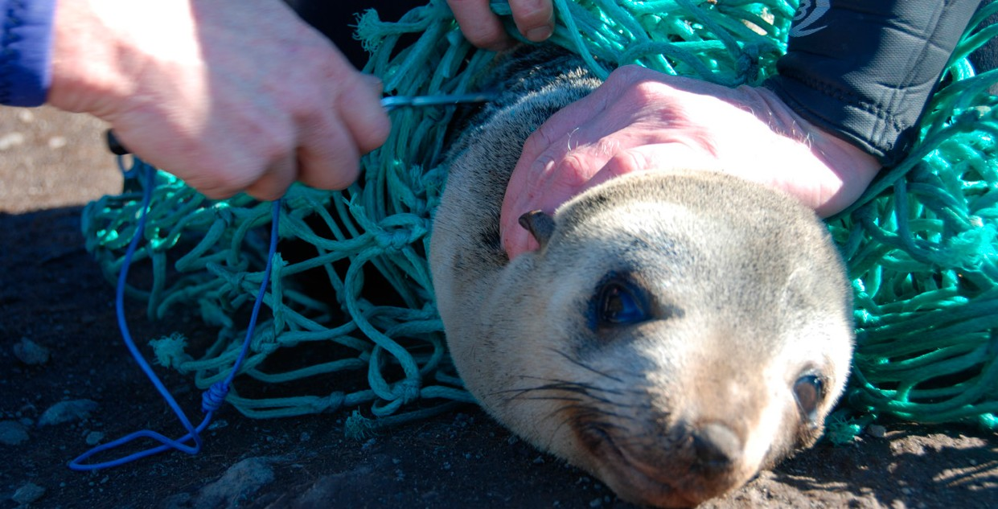

MAR363.0218

**environment**.gov.au