**Appendix 1**

**Brushtail Possum Management Regions and Survey Routes**

The brushtail possum management regions reflect the areas covered by the existing population-monitoring program and correlate closely with IBRA bioregions. These regions are presented in Figure 1.

**Southwest Region (20,490 km2)**

The southwest region is the largest of the regions, extending from Sandy Cape on the west coast to New River Lagoon on the south coast. The area consists predominantly of the World Heritage Area and other conservation reserves, with very little agricultural activity taking place in most of the region. The harvesting of possums is not permitted in the protected areas and presently very few possums are culled in the region nor is there likely to be a need to cull significant numbers in the future. Possum densities within this region are very low and no commercial possum harvest is currently undertaken.

**Southeast Region (12,610 km2)**

The Southeast Region extends from New River Lagoon on the south coast to Long Point on the east coast. It adjoins the southwest, central and northeast regions. This region includes the D’Entrecasteaux Channel area, the Tasman Peninsula, and much of the Derwent River Valley and the east coast. This region is highly developed for agriculture, including a number of high-value crops, and therefore there is a large demand for crop protection permits. Possum densities in this region are high.

**Central Region (9,041 km2)**

The Central region is bounded by all other regions and encompasses much of the Central Plateau and the Midlands. The Midlands area has been highly modified since European settlement and is now dominated by agricultural land use. In particular, the loss of natural habitat through the clearing of areas of native vegetation and the growing of crops has seen the encroachment of possums onto farming properties and they have particularly flourished in this region. Possum densities in this region are very high.

**Northeast Region (11,300 km2)**

The Northeast region extends from Long Point on the east coast to the mouth of the Rubicon River on the north coast. It encompasses the hinterland south of Launceston to Longford and westward to Westbury, as well as the Tamar Valley and the Fingal Valley in the south. This region has several important agricultural areas, particularly in the vicinities of Longford and Scottsdale as well as the northeast coast. Possum densities in this region range from moderate to high.

**Northwest Region (9,949 km2)**

The Northwest region extends from Liffey at the boundary of the Central region through Westbury to the north coast and to Sandy Cape on the west coast. It includes the far northwest as well as the Smithton, Somerset, Burnie, Devonport and Deloraine areas. Impacts to farming activities on high value agricultural lands are felt in the region although to a lesser extent than the central region due to the larger area of natural habitat available to possums. Possum densities in this region are low.

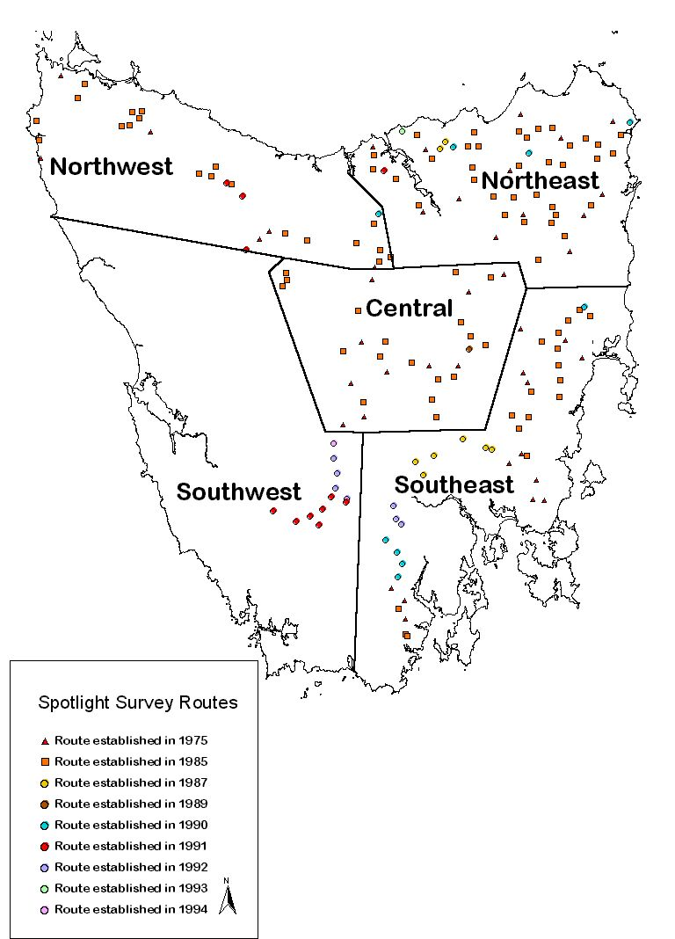

**Figure 1: Brushtail possum management regions and survey routes for population monitoring, mainland Tasmania.**