Appendix 2: Examples of advanced DFTD compared to non-DFTD

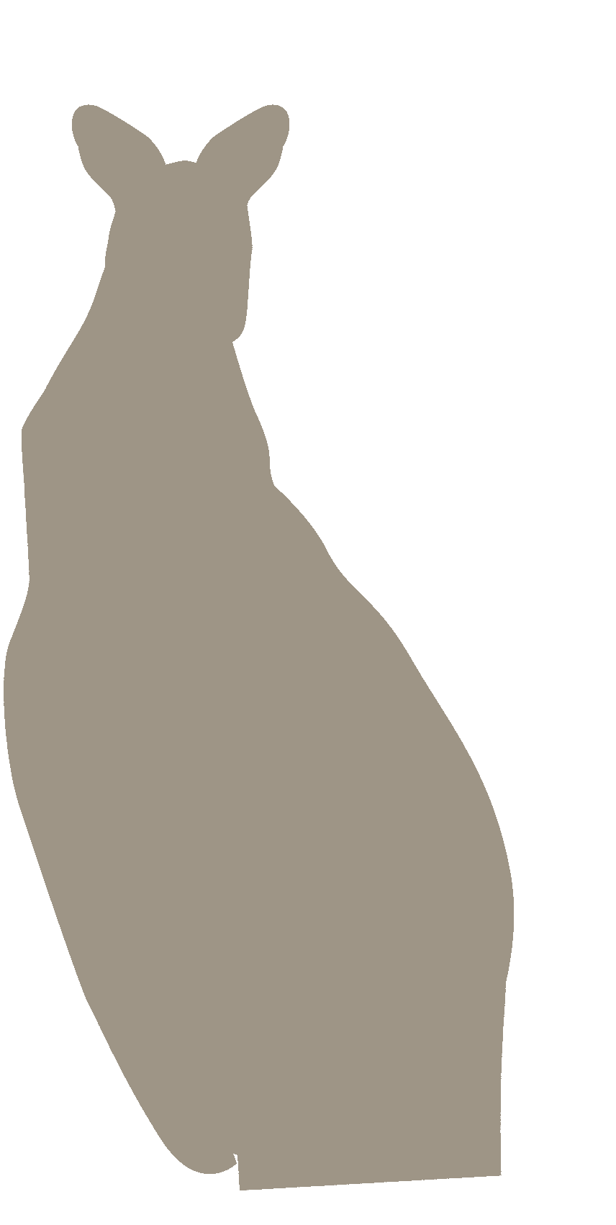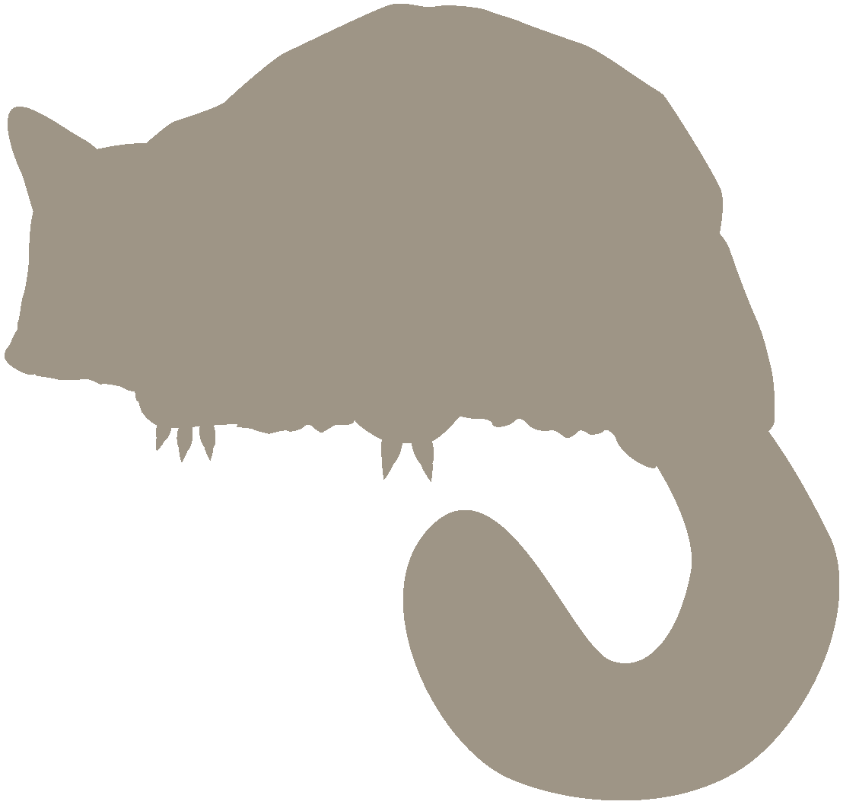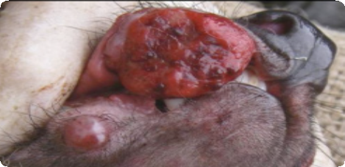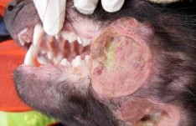

**Typical advanced-stage DFTD** showing large tumours on the jaw area with a ‘lobulated’ appearance, thick pus. Tumours are often hollowed-out.

**CODE OF PRACTICE**

for the trapping and destruction of wallabies and brushtail possums in Tasmania

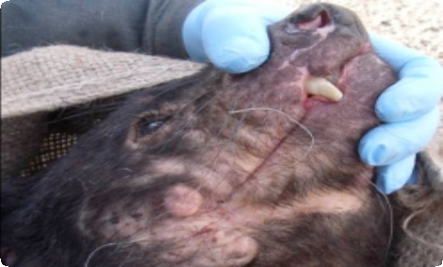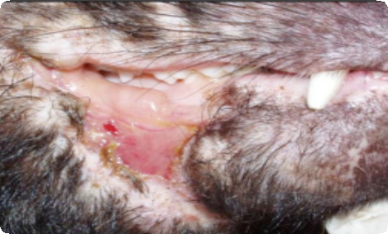

November 2009

FOR CROP-PROTECTION AND COMMERCIAL PURPOSES

**Non-DFTD** - Lumpy appearance due to build-up of soft scar tissue.

**Non-DFTD** - Open fight wound,

not sticking out from body.

Contact and Enquiries:



Wildlife Management Branch

Department of Primary Industries, Parks, Water and Environment

GPO Box 44 HOBART, TAS 7001

Ph: (03) 6233 6556

Web: [www.dpipwe.tas.gov.au](http://www.dpipwe.tas.gov.au/)

Email: [wildlife.enq@dpipwe.tas.gov.au](mailto:wildlife.enq@dpipwe.tas.gov.au)

Wildlife Management Branch

Department of Primary Industries Parks Water and Environment

*November 2009*

1. Introduction

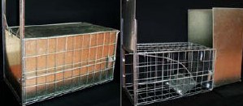

This Code of Practice applies to persons responsible for the live trapping and destruction by shooting of Tasmanian pademelons (*Thylogale billardierii*) and Bennett’s wallabies, (*Macropus rufogriseus*), hereafter collectively referred to as “wallabies”, and/or brushtail possums (*Trichosurus vulpecula*), hereafter referred to as “possums”.

This Code is based on knowledge and experience of the live trapping for the purpose of destruction of wallabies and possums and the technology available at the time of publication. The Code will be revised as required, to take into account advances in technology and understanding of physiology and behaviour, as well as expectations of land managers and the general community.

Tasmanian pademelons, or rufous wallabies, Bennett’s wallabies and brushtail possums are abundant across much of Tasmania, due in large part to land-use changes and the planting of crops and pasture.

In some areas the animals damage crops and tree seedlings and may compete for food with domestic stock. Localised population reduction by trapping and destruction is seen as one management tool to reduce damage to crops.

Due to their rapid flight response into undergrowth when approached, wallabies are not easily taken by shooting. Equally, such behaviour makes them prone to injuries if captured in conventional cage traps that have not been designed to account for their behaviour. Conversely, possums are recognised as adaptable animals, not as easily stressed by trapping as many other native species, and the use of cage traps (see photos and description page 6) is acceptable when trapping this species.

2. Regulatory Requirements

Wallabies and possums are protected in Tasmania under the *Wildlife Regulations 1999* of the *Nature Conservation Act 2002*. The hunting or trapping of these species cannot be undertaken without a licence or permit from the Department of Primary Industries, Parks, Water and Environment (DPIPWE) and approval from the landholder. Permits can be obtained by phoning the Wildlife Management Branch (contact details at end of this document). Trapping activities may only be conducted on land used for primary production.

Under the *Animal Welfare Act 1993*, a person with control or custody of an animal has a legal duty of care for the welfare of that animal. This document specifies the requirements to be followed by persons involved in live trapping and destruction of wallabies and possums for crop protection and commercial purposes.

a.

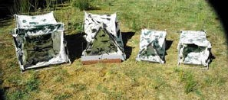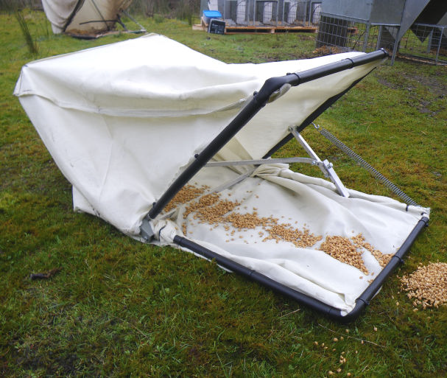

b. c.

**Above**: **a**. Mersey Box Trap in closed and open position. **b.** Ivo Edwards tent traps in various designs and sizes. **c**. Tent trap: ‘Stubby 2’ design.

**Possums:**

(The above traps, approved for wallabies, are also suitable for possums).

**Traditional Cage Traps**: Cage traps must be no smaller than 60 cm long by 30 cm wide by 30 cm high. Cage traps should be constructed using weld mesh or other material which is capable of securely confining possums and minimising the risk of injury. The mesh size must be no greater than 25x50 mm, to prevent facial and other injuries in possums and non-target species such as bettongs and potoroos. The door may be sliding or swing type.

Due to the open mesh structure of the cage trap, users must make every reasonable effort to ensure that the possums have protection from the elements - particularly direct sunlight, injury, pain or stress and protection from domestic dogs and native predators. Traps should be sheltered by a hessian, nylon or plastic cover.

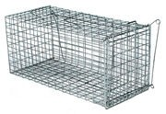

**Above:** Example of typical cage trap used for the capture of brushtail possums.

The trapped animal must be prompted into the holding device in a quick and humane manner. Trappers may not use an electric prod or electronic device or any sharpened implement for the purpose of removing any animal from a trap. Death of the wallaby or possum (see section 4) must occur as soon as practical after the animal moves into the holding cage. Live animals are not to be transported off the capture site unless a special permit has been issued from DPIPWE.

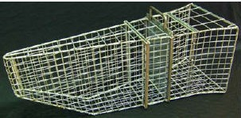

**Above:** Example of typical holding device used for shooting wallabies and possums.

4. Humane Destruction of Trapped Wallabies and Possums

Wallabies and possums, including young-at foot or back-young, should be killed as early as possible on the morning following capture.

It is important that handling of live wallabies and possums, other than for prompting into a holding device (see section 3), is avoided. If handling is unavoidable then the animal must be handled minimally and quietly before shooting to ensure they are not distressed or alarmed.

The method of killing captured animals must be effective in causing a sudden and painless death. The preferred method is a single shot to the brain with a .22 calibre firearm, whilst the animal is in a holding device (wallabies/possums) or cage trap (possums). Low-velocity ammunition may be used. If one shot fails to cause immediate loss of consciousness, then a second shot must be applied as soon as possible after the first shot. Following collapse, animals should be immediately bled- out to ensure a rapid death. Shooting of wallabies or possums in holding devices should take place away from the trap so as not to contaminate the trap with blood.

**Pouch- and back-young**: Female wallabies and possums must be examined for pouch-young as soon as possible after shooting, with any pouch-young being humanely killed. In the case of naked young, killing by decapitation with a sharp instrument is recommended. In larger pouch- or back-young, a heavy blow or a single shot to the brain (as described above) must be used, followed by bleeding-out. Possum back-young must not be released and must be shot, even if off the back in a trap, as survival of these animals is very unlikely without the mother.

5. Non-Target Animals

Non-target animals caught in traps must be examined before immediate release at the site of capture. Animals should be released in an area of cover at or near the trapping site. Trappers should note that some animals, such as bettongs, are easily stressed, causing females to abandon their young. Handling of these animals should therefore be kept to an absolute minimum. Should any animal be seriously injured and deemed to be suffering in the extreme, it is permissible to euthanase that animal on welfare grounds (as for Tasmanian devils, see below).

**Tasmanian Devils (*Sarcophillus harrisii*) with visible signs of DFTD**: Should a Tasmanian devil with obvious Devil Facial Tumour Disease (DFTD; large suppurating, hollowed-out lumps on face or jaw, vital to distinguish from common soft scar tissue; see Appendix 2) be caught in a trap, the trap must be thoroughly cleaned to remove all faecal material and disinfected (e.g. with bleach) before it is returned to use on the trap line.

Should a trapped Tasmanian devil with very severe advanced-stage DFTD be suffering in the extreme, it is permissible to euthanase that animal. Generally, only devils with very large tumours that restrict feeding may require euthanasia. A judgement on whether to euthanase must be made on whether the distress a devil is suffering is well beyond the norm and must be made in good faith: the decision to euthanase must be made on animal welfare reasons alone. Before euthanasing a female devil, every effort must be made to check for the presence and growth-stage of any pouch- young or for lactating teats. If a female devil has large lactating teats (young are likely denned), or fully-furred pouch-young, euthanasia must not be carried out as the young may yet be weaned. It is possible that female devils may be supporting young at any time of the year. Occupational health and safety considerations are simply the same as appropriate when handling any animal species.

Whenever practical, euthanasia of trapped devils should be undertaken by a veterinarian, however it is permissible to euthanase *in situ*. Euthanasia *in situ* should be sudden and painless using a single shot to the brain with a .22 calibre firearm. If one shot fails to cause sudden death, then a second shot must be applied as soon as possible after the first shot. Any unfurred pouch-young are to be killed as for wallabies and possums (see section 4).

Any euthanasia of Tasmanian devils (including pouch-young) must be immediately reported to the Wildlife Management Branch (see contact details at the end of this document) and the carcass must not be disposed of until after consultation.

Appendix 1: Description of Approved Trap Types

Wallabies:

**The Mersey Box Trap**: The Mersey box trap is a wire cage 60 cm long and open at one end with a width of 32 cm and a height of 31 cm. It has a metal mesh floor, ceiling and side walls and solid metal back wall. The door is a metal sheet with a rubberised base that falls vertically along rails in order to cover the entrance. When the trigger mechanism is activated and the door closes, a solid metal cover falls in place to protect the animal from coming into contact with the wire mesh walls, minimising the risk of abrasions and providing protection from predators and the elements. The dark, enclosed space assists in keeping the trapped animal calm.

Due to its size, the Mersey box trap is not recommended where the larger Bennett’s wallaby is the primary target species.

All existing traps are required to have a new wire added to the side between the bottom and second wires to prevent animals from getting their head caught under the lid. All future traps need either a new wire or a smaller mesh size on the sides. A mesh size of 7.5x5 cm is permitted, except for the bottom 2 rows where the mesh size should be 3.5x5 cm.

**The Ivo Edwards Tent Trap**: Ivo Edwards tent traps are available in several different designs and sizes, and models are regularly updated and refined. Their common features are a collapsible lightweight metal frame covered with a strong flexible fabric such as nylon. They contain no conventional door but rather a spring- loaded opening provided by a hinged frame that collapses to contain the animal when it treads on a trip plate beneath the fabric or a trigger at the rear of the trap.

In an Edwards trap, physical damage to trapped animals is avoided because wallabies jumping against the sides and roof of the trap, can only impact soft fabric. Possible tail damage from door closure is avoided by a rubber covering of the door frame. Their relatively large size provides room for trapped animals to turn, move about and stand upright, and the water-repellant fabric provides protection from the elements and predators. The sensitivity of the traps can be adjusted to avoid catching small non-target species such as bettongs and potoroos. Ivo Edwards tent traps are available in sizes suitable for both Tasmanian pademelons and Bennett’s wallabies.

**Modifications**: New designs or significant modification to approved trap designs, including size, materials, trigger mechanism, etc. must be brought to DPIPWE for attention and review before they may be used. Evidence such as video footage, photos and trap records must be provided to clearly demonstrate that a new trap design meets animal welfare requirements before approval for use is granted.

2. Approved Trap Types for Capture of Wallabies and Possums

**Bennett’s wallabies and Tasmanian pademelons**: Conventional wire mesh cage traps used for trapping possums are not acceptable for the capture of wallabies. Wallabies captured and held in such traps are likely to suffer severe facial abrasions due to their behaviour. Descriptions of approved trap types are given in Appendix 1.

**Brushtail possums**: Cage traps may be used when specifically trapping possums, however approved wallaby traps are also suitable for possums. Snares and jawed traps are not permitted to be used. Approved cage trap designs are described in Appendix 1.

**General:** All traps must be regularly cleaned, maintained and checked for broken wires, sharp edges and protrusions that may cause injury or trap malfunction.

Wherever possible, traps must be set in sheltered locations that reduce exposure to direct sunlight, extreme weather, domestic dogs and native predators. Traps must not be set on or close to European wasp nests, or aggressive, stinging ant nests (e.g. ‘Bull-ants’ or ‘jack-jumpers’). Trap positions must be inspected when setting to ensure rocks, sticks or other debris won’t prevent traps from closing correctly. Traps must not be set in low-lying areas subject to flooding. When using cage traps in areas subject to extreme frost, ice and snow, or areas populated by bettongs, the traps should be elevated and set on stumps or logs etc.

The *Wildlife Regulations 1999* require that set traps must be inspected and cleared at intervals not exceeding 24 hours. Traps should be inspected and cleared as early as practical each morning.

3. Holding Device

The use of a holding device, such as a cage or hand net, is mandatory for shooting wallabies captured in traps, however possums may be shot in either a cage trap or holding device.

The purpose of the holding device is to briefly, firmly, but gently, physically restrain the animal in order to deliver a lethal shot in such a way as to minimise stress or the risk of a non-lethal shot. The holding device must be of a design appropriate for use with the trap for the capture of the target species.

The holding device must be regularly cleaned and maintained and checked for broken wires or webbing, sharp edges and protrusions that may cause injuries.