 Logo for Tasmanian Government

**State Specific Guideline For**

***Tasmania***

This guideline has been prepared by the Australian Government and the Tasmanian Government. It is intended to assist businesses who process raw logs grown in Tasmania to better understand the regulatory frameworks covering the harvest of such logs in that jurisdiction. This information can be used to help the businesses satisfy their due diligence obligations, as set out in the *Illegal Logging Prohibition Act 2012* and associated *Illegal Logging Prohibition Regulation 2012*.

This guideline was co-endorsed by the Australian Government and the Tasmanian Government on 7 April 2021.

Contents

1. What is required under Australia’s Illegal Logging Laws? 3

1.1 Who is a processor? 3

2. How to use the State Specific Guideline (SSG) 4

3. Scope of the SSG for Tasmania 4

4. Overview of Forest Management in Tasmania 5

5. Laws and regulations governing forestry in Tasmania 6

5.1 Other relevant laws that relate to legal timber 7

5.2 Additional information 8

6. Identifying legal raw logs from Tasmania 9

7. Who should I contact for further information? 10

Attachment A: Example Forest Practices Plan Cover Page 11

Attachment B: Example Delivery Arrangement – Sustainable Timber Tasmania sales procedure 12

# What is required under Australia’s Illegal Logging Laws?

The *Illegal Logging Prohibition Act 2012* (the Act) seeks to ‘reduce the harmful environmental, social, and economic impacts of illegal logging by restricting the importation and sale of illegally logged timber products in Australia’.

The Act makes it a criminal offence to process domestically grown raw logs that have been illegally logged. For the Act’s purposes, ‘illegally logged timber’ is defined as timber ‘harvested in contravention of laws in force in the place (whether or not in Australia) where the timber was harvested’.

The Act also requires ‘processors’ to actively assess and manage the risk that the raw logs may have been illegally harvested before processing them. This is known as undertaking ‘due diligence’, the specifics of which are set out in the *Illegal Logging Prohibition Regulation 2012* (the Regulation).

The due diligence requirements for processors includes the following key steps:

**Step 1:** Establish and maintain a due diligence system.

**Step 2:** Gather information about the raw log that is being processed

**Step 3:** Assess the risk (using one of the three methods outlined in the Regulation)

**Step 4:** Risk mitigation (if required)

**Step 5:** Keep records

Further information about the Regulation and the due diligence requirements is available at the Australian Government Department of Agriculture, Water and the Environment’s website (www.[agriculture.gov.au/illegallogging)](http://agriculture.gov.au/illegallogging)).

## 1.1 Who is a processor?

For the purposes of the Act, a processor is a person who processes Australian grown raw logs into something other than a raw log. This includes activities such as the processing of Australian grown raw logs into woodchips, sawlogs, pulp, or other timber products.

The Act also specifies that a processor also needs to be a constitutional corporation, or a person processing the raw logs:

* on behalf of a constitutional corporation, the Commonwealth, or a Commonwealth authority
* for trade with other countries or between Australian states or territories; or in a territory.

Entities which are not constitutional corporations include:

* state authorities not established as a body corporate
* partnerships
* un-incorporated associations or individuals.

# How to use the State Specific Guideline (SSG)

This SSG is intended to assist a processor of raw logs grown in Tasmania to comply with the Regulation’s due diligence requirements.

In accordance with section 19 of the Regulation, a processor must gather information about the raw logs they are seeking to process, this includes gathering the information or evidence outlined in this SSG.

The information listed in this SSG is not meant to be an exhaustive list of the evidence or documentation required to satisfy the Regulation’s due diligence requirements.

The information gathered by applying this SSG, along with any other information gathered in accordance with the Regulation, needs to be assessed in accordance with the processes outlined in section 21 of the Regulation. This includes considering any other information that the processor knows, or ought reasonably to know, but is not contained in the SSG.

All data included in this document is the most current as available at the time of publishing.

# Scope of the SSG for Tasmania

This SSG provides detailed information on the control of pathways for raw logs grown within Tasmania and is intended to inform Australian processors of what is considered legal timber within that jurisdiction. It is only applicable for logs that were harvested within Tasmania.

# Overview of Forest Management in Tasmania

Tasmania’s total land area is approximately 6.81 million hectares, of which 3.35 million hectares is forested (roughly 49.2%). Approximately 1.78 million hectares of forested land in Tasmania is situated within reserves, which includes more than 80% of Tasmania’s old growth forests.

Tasmania has a long history of timber harvesting for the production of sawn timber, wood chips for domestic use and export sales, round wood and rough sawn wood for post poles, and a range of timbers for what are classified as ‘speciality purposes’, including boat building, furniture, artistic and decorative functions.

The forest resource is usually described as falling into three broad categories:

* native forest
* softwood plantation
* hardwood plantation.

These forest resources are held by a diverse group of owners.

Sustainable Timber Tasmania (STT) (formerly Forestry Tasmania), manages public resources of native forest and plantations. STT harvests timber, through private contractors, from the Permanent Timber Production Zone (PTPZ). PTPZ land is managed by STT under the [*Forest Management Act 2013*](https://www.legislation.tas.gov.au/view/whole/html/inforce/current/act-2013-049).

There are currently 812,000 hectares of PTPZ land in Tasmania. Of this, around 46% contains native forest available for wood production, around 15% is land specifically managed for reservation, and the remainder is a combination of plantations on rotation and land that is unavailable for harvesting due to operational constraints. In total, there are approximately 300,000 hectares of plantations on public and private land in Tasmania (approximately 75% hardwood and 25% softwood plantations).

Tasmania also has significant forest resources held privately by individuals or businesses engaged in and/or vertically integrated in the forest industry. Other individuals may hold forests as part of a larger agricultural enterprise or as a small plot or holding. Consequentially, a processor may find that wood may be for sale from a wide range of legal sources. The unreserved native forest estate on private land comprises approximately 744,000 hectares.

Private timber growers can apply to have a Private Timber Reserve (PTR) registered on the applicable land title to have their land dedicated for long-term forest management. A PTR provides that forestry activities on the land are subject to a single, consistent, state-wide system of planning and regulation through the *Forest Practices Act 1985*, rather than to variable systems that may be applied under different planning schemes through the [*Land Use Planning and Approvals Act 1993*](https://www.legislation.tas.gov.au/view/whole/html/inforce/current/act-1993-070).

The Department of State Growth provides information on forests and forestry activities in Tasmania on their website (www.stategrowth.tas.gov.au/energy_and_resources/forestry).

# Laws and regulations governing forestry in Tasmania

Processors need to be aware that there are a variety of circumstances that may impact on the legality of timber purchases. However, in most cases, this is relatively straightforward because the approvals to meet legislative requirements for timber harvesting have been centralised under the Tasmanian [Forest Practices System](https://www.stategrowth.tas.gov.au/__data/assets/pdf_file/0018/154620/5_Overview_Tasmania_Forest_Management_System_2017.pdf). [*Tasmania’s Forest Management System: An Overview*](https://www.stategrowth.tas.gov.au/__data/assets/pdf_file/0018/154620/5_Overview_Tasmania_Forest_Management_System_2017.pdf) details the State’s suite of forest legislation, policies, plans and management practices, as amended from time to time.

The [Forest Practices Authority](https://www.fpa.tas.gov.au/) administers the Forest Practices System, established under the [*Forest Practices Act 1985*](https://www.legislation.tas.gov.au/view/whole/html/inforce/current/act-1985-048). The Forest Practices System is tenure blind and operates equally on private and public land. Most forest practices require a **Forest Practices Plan** (FPP)—a document that provides details of the forestry operation, including physical location and the details of any protection measures for natural and cultural heritage values within the proposed operational area. The FPP must be prepared in accordance with the [*Forest Practices Code*](https://www.fpa.tas.gov.au/FPA_publications/forest_practices_code), which prescribes measures to be incorporated into FPPs to protect certain values or manage risks associated with proposed forestry operations. FPP compliance reports are required to be lodged with the Forest Practices Authority within 30 days of the completion of each operational phase authorised by the FPP. There are some exemptions from requiring an FPP, largely for small scale operations, which are specified in the [*Forest Practices Regulations 2017*](https://www.legislation.tas.gov.au/view/whole/html/inforce/current/sr-2017-021). It must be stressed that these exemptions are limited in their application.

Forest Practices Officers are appointed under the *Forest Practices Act 1985* and have powers to enforce compliance with FPPs and the Forest Practices Code. They are certified, trained, authorised, directed and monitored by the Forest Practices Authority. Forest Practices Officers can be employed directly by the forest industry, or engaged as consultants by industry, or by private land owners to prepare, certify and supervise FPPs. Further information on Forest Practices Officers and the regulatory and administrative functions of the Forest Practices Authority can be found in the Forest Practices Authority’s [Annual Reports](https://www.fpa.tas.gov.au/FPA_publications/annual_reports).

It is a requirement under the [*Forest Practices Act 1985*](https://aus01.safelinks.protection.outlook.com/?url=https%3A%2F%2Fwww.legislation.tas.gov.au%2Fview%2Fwhole%2Fhtml%2Finforce%2Fcurrent%2Fact-1985-048&data=04%7C01%7COlivia.Richardson%40stategrowth.tas.gov.au%7C2f2bd43a62554cfbc0e608d875571e7c%7C64ebab8accf44b5ca2d32b4e972d96b2%7C0%7C0%7C637388364314190435%7CUnknown%7CTWFpbGZsb3d8eyJWIjoiMC4wLjAwMDAiLCJQIjoiV2luMzIiLCJBTiI6Ik1haWwiLCJXVCI6Mn0%3D%7C1000&sdata=87Xg%2B36FQwyf8999wERGjxQhz64vmaj0yPchm5BRv04%3D&reserved=0) that a Tasmanian based timber processor can only purchase or acquire timber that was certified by a FPP at the time of harvest (in instances where a FPP is required). Typically, the relevant FPP identification number will be noted on the tax invoice or Delivery Arrangement provided at the point of sale. Processors can confirm the FPP identification number and location using the Forest Practices Authority’s [FPP location map](https://www.fpa.tas.gov.au/fpa_services/fpp_location_map). Processors can also request the FPP identification number, or the FPP, from the timber supplier if this has not been provided at the point of sale. An example FPP cover page is included at Attachment A.

In addition to a certified FPP, local government planning schemes may apply and a **Land Use Permit** (or equivalent documentation) from the local government authority may be required to meet compliance with these laws. For further information on local government planning schemes, including Land Use Permit applications, see the Tasmanian Planning Commission website at [www.planning.tas.gov.au](http://www.planning.tas.gov.au/).

## 5.1 Other relevant laws that relate to legal timber

**Collection of firewood**

Firewood is a major source of home heating in Tasmania, with approximately 25% of homes using wood as a primary heat source. Tasmanians are the greatest consumers, per person, of firewood in Australia.

It is illegal to cut or take wood from public land without a permit. Under existing legislation, a permit is required to take any native plant species from public lands managed by the Tasmanian Government. This includes National Parks, State Reserves, Game Reserves, Nature Recreation Areas, Conservation Areas, Regional Reserves, Historic Sites and Public Reserves under the [*Crown Lands Act 1976*](https://www.legislation.tas.gov.au/view/whole/html/inforce/current/act-1976-028), Permanent Timber Production Zone land under the [*Forest Management Act 2013*](https://www.legislation.tas.gov.au/view/whole/html/inforce/current/act-2013-049), Future Potential Production Forest land under the [*Forestry (Rebuilding the Forest Industry) Act 2014*](https://www.legislation.tas.gov.au/view/whole/html/inforce/current/act-2014-012), and all other Crown land that does not currently have reserve status under the [*National Parks and Reserves Management Act 2002*](https://www.legislation.tas.gov.au/view/whole/html/inforce/current/act-2002-062).

Wood cut or taken from private land must have the permission of the land owner, who is responsible for all forest operations on their land. There are limited exemptions from requiring an FPP if standing or fallen timber is to be removed, as detailed in the [*Forest Practices Regulations 2017*](https://www.legislation.tas.gov.au/view/whole/html/inforce/current/sr-2017-021). In most instances, provided the land is not vulnerable land, less than one hectare of trees or less than 100 tonnes of timber (whichever is less) may be harvested from each area of applicable private land per year.

If in doubt, the Forest Practices Authority can provide advice as to whether a FPP will be required to collect firewood. Some local councils also require permits prior to removal of trees on private land. You will need to check this with your local council.

## 5.2 Additional information

This Guideline outlines the regulatory framework in Tasmania in order to assist timber processors in identifying compliance with Australia’s illegal logging laws. Processors should refer to the [Illegal Logging Prohibition Regulation 2012](https://www.legislation.gov.au/Details/F2018C00885) and the Australian Government Department of Agriculture, Water and the Environment’s website ([www.agriculture.gov.au/illegallogging](http://www.agriculture.gov.au/illegallogging)) for further information on their due diligence obligations.

It is not within the scope of this Guideline to explain or accredit every relevant system in Tasmania. It is ultimately the processor’s responsibility to make well documented decisions, based on their particular circumstances and their timber legality risk assessments.

Other systems may also be of assistance in carrying out due diligence checks, an example of such a system is the documentation provided under STT’s sales system. This system is utilised to ensure that the timber products provenance can be traced and includes:

* That all log deliveries and their invoices are supported by a **Delivery Arrangement** (see Attachment B), issued to all processors prior to deliveries being made. This operates as a tax invoice equivalent and provides a level of detail in relation to the provenance and certification status of the wood product;
* Documentation received by a processor may provide relevant advice, such as regulatory information (e.g. FPP number) and information on compliance with forest management certification(s) held by STT.

# Identifying legal raw logs from Tasmania

To assist in identifying legal product from Tasmania, the following flowchart is provided explaining the key regulatory mechanisms. Supporting example materials are located at Attachments A and B.

**Diagram 1: Due Diligence Decision Pathway**

*Note: This flowchart is intended as a guide only. Refer to the relevant legislation for further information.*

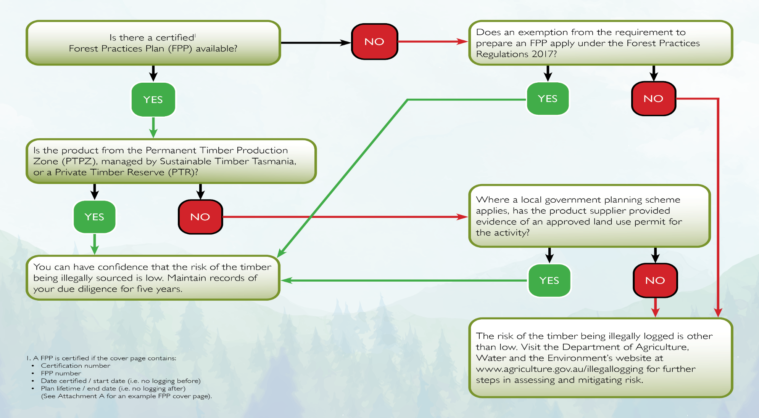

# Who should I contact for further information?

|  |  |  |
| --- | --- | --- |
| **Australian Government**  Department of Agriculture, Water and the Environment  GPO Box 858  Canberra ACT 2601 Phone: +61 (0) 2 6272 3933  Email: [illegallogging@awe.gov.au](mailto:illegallogging@awe.gov.au)  Web: [www.agriculture.gov.au/illegallogging](http://www.agriculture.gov.au/illegallogging) |  | **C:\Users\o-richardson\Desktop\fpa.jpg**  **Tasmanian Government**  Forest Practices Authority  30 Patrick Street  Hobart Tasmania 7000  Phone: 03 6165 4090  Email: [info@fpa.tas.gov.au](mailto:info@fpa.tas.gov.au)  Web: [www.fpa.tas.gov.au](http://www.fpa.tas.gov.au) |

**Disclaimer**

While reasonable efforts have been made to ensure that the contents of this guideline and the associated quick reference guide are factually correct, the Commonwealth of Australia does not accept responsibility for the accuracy or completeness of the contents and expressly disclaims liability for any loss or damage, however caused, that may be occasioned directly or indirectly through the use of, or reliance on, the contents of this guideline or associated quick reference guide.

This guideline and its associated quick reference guide is made available on the understanding that the Commonwealth of Australia is not providing professional advice. Before relying on this guideline or its associated quick reference guide, readers should obtain appropriate professional advice suitable to their particular circumstances.

Readers should also confirm that this is the most up-to-date available guideline by referring to the Department of Agriculture, Water and the Environment’s website.

# Attachment A: Example Forest Practices Plan Cover Page

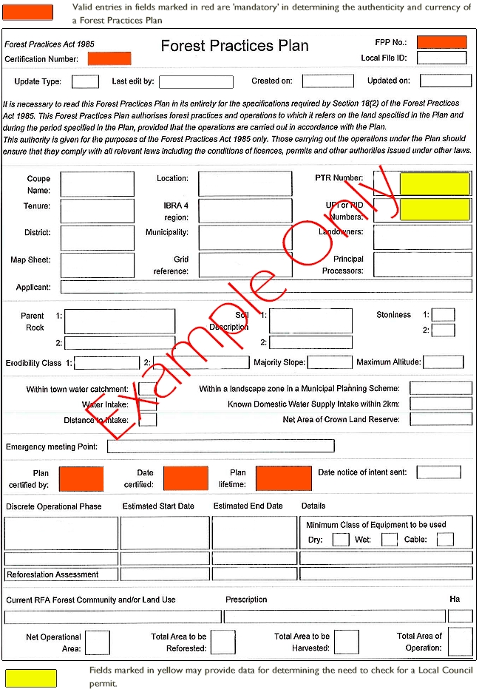

# Attachment B: Example Delivery Arrangement – Sustainable Timber Tasmania sales procedure

