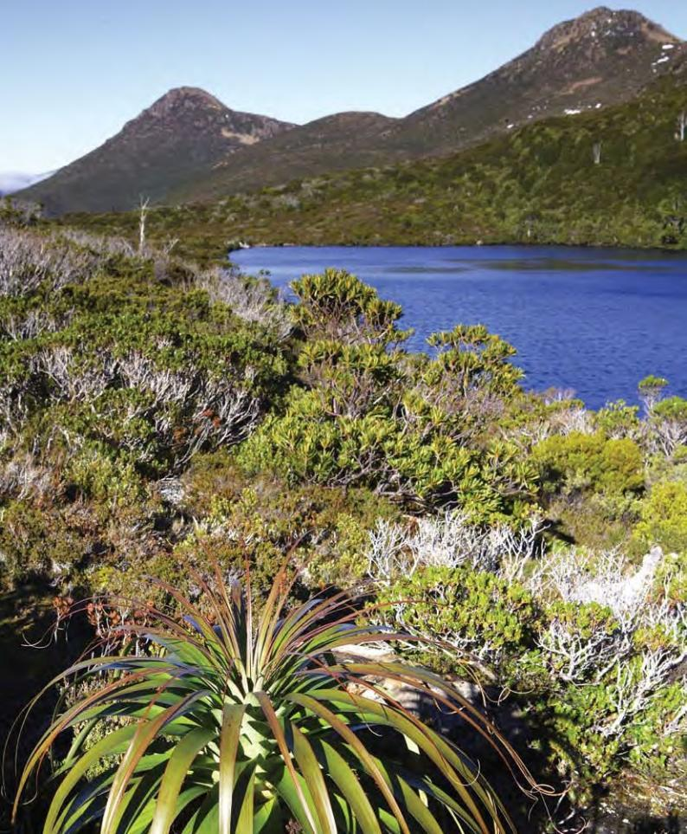



|  |  |  |
| --- | --- | --- |
|  | The Tasmanian Wilderness World Heritage Area |  |
|  | | |
| *World Heritage Committee Decision WHC-06/30.COM/7B State Party Report* | | |







*The Tasmanian Wilderness World Heritage Area World Heritage Committee Decision*

*WHC-06/30.COM/7B State Party Report*

*© Commonwealth of Australia*

*Front Cover:*

*Pandani & glacial lake at Hartz Mountains National Park.*

*© Department of Tourism, Arts and the Environment, JoeShemesh/StormfrontProductions*

*Printed on Monza Satin recycled paper. Monza Satin contains 30% pre-consumer and 25% post-consumer stock and is Elemental Chlorine Free (ECF).*

The Tasmanian Wilderness World Heritage Area

## World Heritage Committee Decision WHC-06/30.COM/7B State Party Report

ISBN 0642 55333 5

Published by the Australian Government Department of the Environment and Heritage

Printed January 2007

This work is copyright. Apart from any use as permitted under the Copyright Act 1968, no part may be reproduced by any process without prior written permission from the Commonwealth, available from the Department of the Environment and Heritage. Requests and enquiries concerning reproduction and rights should be addressed to:

Assistant Secretary

Heritage Management Branch

Department of the Environment and Heritage

GPO Box 787

CANBERRA ACT 2601

# Table of Contents

#### EXECUTIVE SUMMARY 5

1. INTRODUCTION 7
   1. Vilnius Decision & Impetus for Report 7
   2. Preparation of Report 7
   3. Background
      1. Map of the TWWHA and Adjacent Land Use 7
      2. World Heritage Nominations & IUCN Evaluation 9
      3. Regional Forest Agreements 11
   4. Commonwealth Legislation 15
      1. *Environment Protection and Biodiversity* 15

*Conservation Act 1999*

* + 1. *Regional Forest Agreement Act 2002* 15
  1. Structure of Response 15

#### REPORT ON PROGRESS 17

* 1. Integrity of the TWWHA 17
     1. WWF-Australia Scorecard 17
     2. Land Use 17
     3. Fire 18
     4. Wilderness 18
  2. Management of the TWWHA 18
     1. TWWHA Management Plan 1999 18
  3. Management of Adjacent Lands 21
     1. Forestry in the Landscape 24
     2. Forestry Rotation and Regeneration Techniques 26
     3. Threat Management Planning 33
  4. Monitoring 34
     1. Monitoring the TWWHA 34
     2. Joint Research & Monitoring 35
     3. Monitoring the Tasmanian RFA 37
  5. Reporting 38
     1. TWWHA Reporting 38
     2. State of the Forests & RFA Reporting 40

#### REFERENCES AND FURTHER READING 43

APPENDICES

|  |  |  |
| --- | --- | --- |
| **A** | **NGO Aspirations – response** | 45 |
| **B** | **Forestry Tasmania’s ‘Forestry in the Landscape’ Approach** | 52 |

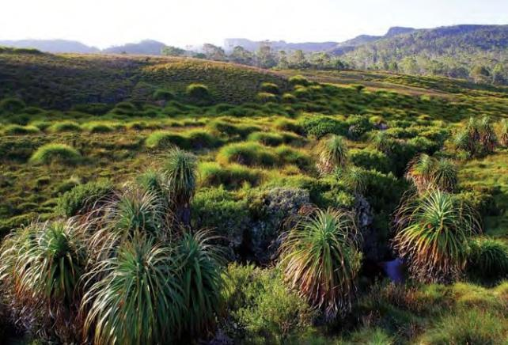

Pandani and buttongrass in the Cradle Mountain area.

© Department of Tourism, Arts and the Environment, Joe Shemesh / Stormfront Productions

# Executive Summary

This State Party Report has been prepared in response to World Heritage Committee Decision WHC-06/30.COM/7B.

The report addresses concerns raised with the World Heritage Committee by Non Government Organisations (NGOs) at its July 2006 meeting in Vilnius, Lithuania. The concerns relate to forestry operations in the vicinity of the Tasmanian Wilderness World Heritage Area (TWWHA) and in Tasmania generally.

The focus of the report is to address concerns about the integrity of the TWWHA. As the report demonstrates, there are several tools used to conserve and manage various values, both inside the TWWHA and in adjacent lands. These tools include:

* The *TWWHA Management Plan 1999* for all areas inside the TWWHA and some additional reserves outside it.
* The Reserve Management Code of Practice, developed collaboratively by various State agencies.
* The Inter-Agency Fire Management Protocol which operates seamlessly across land tenures and provides a best practice model for such activity in Australia.
* State of the TWWHA Reporting.
* State of the Forests and Regional Forest Agreement Reporting in accordance with Montreal Process.
* The Forest Practices Code (Tasmania) used for planning and operations in all forestry areas.
* Forestry Tasmania’s ‘Forestry in the Landscape’ Approach and Giant Trees Policy which guide forestry operations planning.
* The Warra Long Term Ecological Research site, a collaborative research and monitoring program crossing the TWWHA boundary.

In addition, the *Environment Protection and Biodiversity Conservation Act 1999* (Cth) provides for the protection of the World Heritage Values of Australian World Heritage properties.

The 2004 State of the Tasmanian Wilderness World Heritage Area Report concluded that management under the 1992 management plan delivered major achievements and that sound progress was made against all the management objectives.

Tasmania rated highly in the 2006 WWF-Australia Review of Australia’s Terrestrial Protected Area System; as shown in the table below.

In conclusion, the Australian Government is confident that the Tasmanian Wilderness World Heritage Area is well protected and managed, and that there is no threat to its integrity.

An updated map of the TWWHA and surrounding land use is included, as requested.

### Table 1 Scorecard of Tasmania’s Protected Area System

**Rating Explanation of Rating**

|  |  |  |
| --- | --- | --- |
| Comprehensiveness (proportion of broad regional ecosystems sampled in the protected area system for each bioregion). | A | Median value 85% and up |
| Extent (Proportion of total land area in protected areas) | A | Combined protected area extent above 15% |
| Management Standard (by bioregion) | B | (Good) Major biodiversity issues were effectively managed |

**STATE OF TASMANIA**

*BASS STRAIT*

*SOUTHERN*

*OCEAN*

## TASMAN SEA

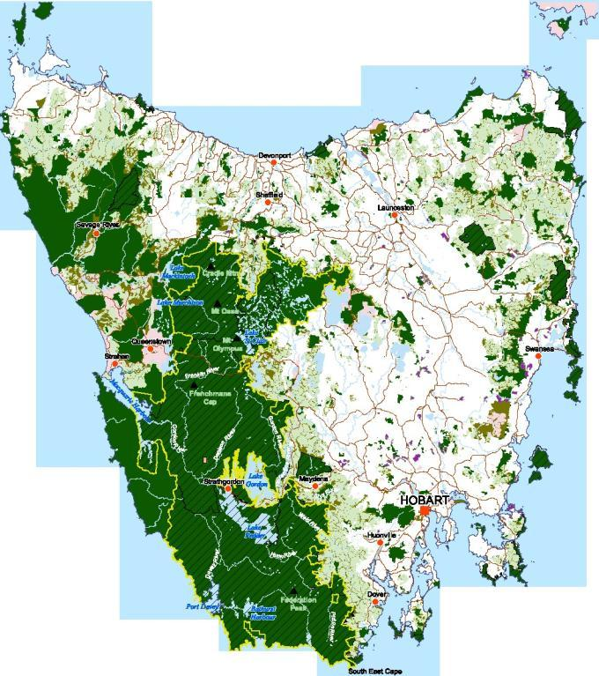

## 

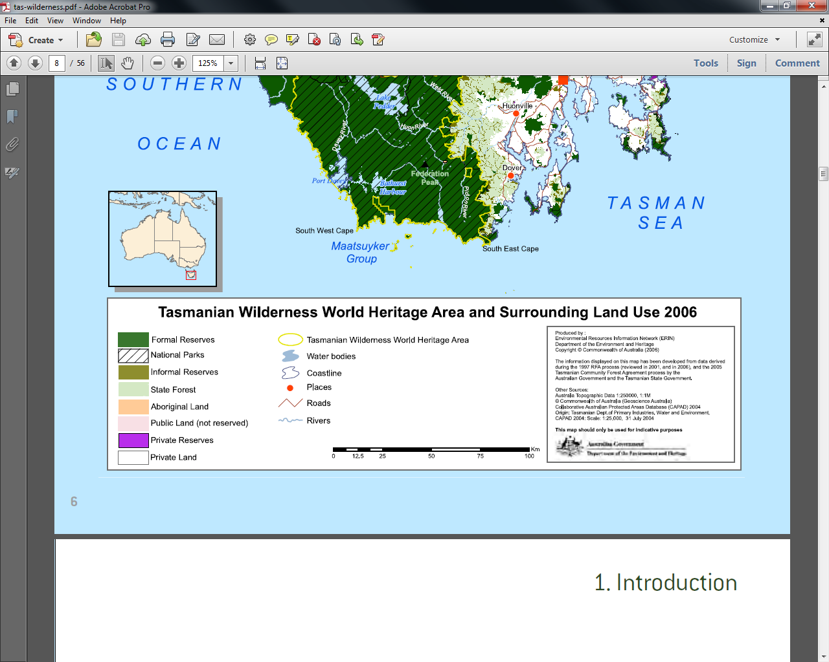

# Introduction

### VILNIUS DECISION & IMPETUS FOR REPORT

At its meeting in July 2006, the World Heritage Committee requested Australia to provide a report on progress in responding to NGO concerns about forestry operations in the vicinity of the Tasmanian Wilderness World Heritage Area (TWWHA) (see below).

#### The World Heritage Committee,

* + 1. Having examined Document WHC-06/30.COM/7B,
    2. Commends the State Party for the implementation of a Supplementary Tasmanian Regional Forest Agreement, and recent efforts to increase the protection of old growth forests adjacent to the World Heritage property, thus increasing the buffer zone in certain areas;
    3. Notes the concerns expressed by NGOs in relation to the impacts of logging adjacent to the World Heritage property and the potential for this activity to compromise options for future extensions to the World Heritage property;
    4. Requests the State Party to submit a revised map of the World Heritage property, showing the areas of extended buffer zone and identifying other use zones directly adjacent to the boundary;
    5. Notes that the World Heritage Centre has written to the State Party seeking comments on outstanding NGO concerns and that the State Party has indicated its willingness to provide a full response;
    6. Requests the State Party to submit to the World Heritage Centre by 1 February 2007 a report on progress on the issues identified.

### PREPARATION OF REPORT

The Australian Government has prepared this report for the World Heritage Committee with the assistance of the Tasmanian Government.

In late December 2006, the Federal Court of Australia handed down a judgement relating to forestry operations on the east coast of Tasmania and the protection of nationally endangered species. The area in question is not in the vicinity of the TWWHA. The decision is being appealed. The World Heritage Centre will be advised of the outcome of the appeal

A copy of the judgement can be found at:

<http://www.austlii.edu.au/au/cases/cth/federal_ct/2006/1729.html>

### BACKGROUND

* + 1. **Map of the TWWHA and Adjacent Land Use**

The map (see opposite page) shows the Tasmanian Wilderness World Heritage Area (TWWHA) in context with the rest of Tasmania. The map has been updated to reflect the addition of various reserves as a result of the Tasmanian Regional Forest Agreement (1997) and Tasmanian Community Forest Agreement (2005).

The size of the TWWHA is now 1,383,865 ha – approximately 20 per cent of Tasmania’s total area.

### Key to map

**Term Definition Legislation Tenure classifications Land manager Forestry**

**permitted?**

|  |  |  |  |  |  |
| --- | --- | --- | --- | --- | --- |
| Formal | A secure reserve requiring | Nature | National Park | Department | No |
| Reserve | action by the Tasmanian | Conservation Act | State Reserve | of Tourism, |
| Parliament to revoke | 2002 | Historic Site | Arts and the |
| National Parks and Reserves Management Act 2002  Forestry Act | Game Reserve  Conservation Area  Nature Recreation Area  Nature Reserve  Regional Reserve  Forest Reserve | Environment  – Parks and  Wildlife Service  Forestry Tasmania |
| 1920 |
| Informal | An administrative reserve | Forestry Act | State Forest – Protection Zone | Forestry | No |
| Reserve | on State Forest or public  land formally defined and  managed for protection of  natural or cultural values | 1920  Crown Lands Act 1976 | Public Reserve | Tasmania  Department of Primary Industries and |
| Water |
| National Park | A Formal Reserve  National Parks are usually large areas of high conservation value with no extractive resource uses permitted | Nature Conservation Act 2002  National Parks and Reserves Management Act 2002 | National Park | Department of Tourism, Arts and the Environment  – Parks and Wildlife Service | No |
| State Forest | Land set aside under the Forestry Act 1920 to be managed for multiple uses with a focus on sustainable commercial wood production | Forestry Act 1920 | State Forest | Forestry Tasmania | Yes |
| Aboriginal Land | Land with significant Aboriginal heritage value that has been transferred to the ownership of the Aboriginal Land Council of Tasmania by Act of Parliament | Aboriginal Lands Act 1995 | Private Land | Aboriginal Land Council of Tasmania | With owner’s agreement |
| Public Land (not reserved) | Crown land that has not been allocated by Parliament for any specific purpose | Crown Lands Act 1976 | Crown Land | Department of Primary Industries and Water | Not generally |
| Private Reserves | Privately owned land that is subject to a formal agreement with the owners to be managed  to protect conservation values | Nature Conservation Act 2002 | Private Land | Private land owners | No |
| Private Land | Privately owned land |  | Private Land | Private land owners | With owners agreement |

* + 1. **World Heritage Nominations & IUCN Evaluation**

In 1982, the then Cradle Mountain–Lake St Clair National Park, Franklin-Lower Gordon Wild Rivers National Park and Southwest National Park were inscribed on the World Heritage List as the Western Tasmania Wilderness National Parks World Heritage Area

— an area of 769,355 hectares.

In 1989, an enlarged area, known as the Tasmanian Wilderness World Heritage Area (TWWHA), was accepted for inclusion on the World Heritage List. This listing incorporated the 1982 property and further expanded the area to its current size. It is important to note that there were two nominations for the Tasmanian Wilderness in 1989. The first, considered by the World Heritage Committee in June of that year, was not as extensive as the subsequent September nomination.

The September 1989 nomination of the TWWHA to the WHC included a statement indicating that the issues of protection of areas outside the nominated boundary had been considered by the Australian and Tasmanian Governments and no additional areas were considered essential to protect the values of the nominated area:

*p1, 1(d) “If an area surrounding nominated property is considered essential for the protection of the property, eg a buffer zone, indications should also be provided on the boundaries of this area.*

*The boundaries of the nominated area have been selected to ensure adequate protection of the integrity of the area.”*

The September 1989 nomination document also clearly stated in the section on management plans [refer 4(e)] that forestry operations are permitted in areas adjacent to the boundary.

Most importantly in the context of this report, the World Conservation Union (IUCN) made the following recommendation in its October 1989 evaluation of the September nomination:

*“The consequence of the Australian Government’s latest initiative (agreed with the Tasmanian Government) is that the boundaries of the property inscribed in 1982 as the “Western Tasmania Wilderness National Parks” have been substantially modified, consolidated and greatly enhanced in the latest (September) revision*

*of the area nominated as the ‘Tasmanian Wilderness’. The September revision fully meets the reservations indicated earlier by IUCN and expressed in the Bureau’s recommendation. The site as set out in the September 1989 revision should therefore be inscribed on the World Heritage list on the basis of satisfying all four criteria for natural properties.” (emphasis added).*

As shown in Table 2 on page 10, the area covered by the TWWHA Management Plan 1999 also includes twenty one small areas of National Park and one area of State Reserve that are not within the TWWHA but are contiguous with it.

The twenty one areas include two small areas added to the Southwest National Park (south of Hartz Mountains [the ‘Hartz hole’] and south-east of Cockle Creek) in June 1991. Another two small areas were included in the Franklin–Gordon Wild Rivers National Park, one in the vicinity of the Navarre Plains, the other in the Beech Creek area. Two further small areas at Lees Paddocks in the Mersey Valley were added in 1991 (see map 2, page 215 of the TWWHA Management Plan for their location).

The plan prescribed that these areas, once they were formally reserved, became part of the plan area and subject to the relevant prescriptions of the management plan.

### TABLE 2: TWWHA Management Plan reserves outside the TWWHA

**NATIONAL PARK ADDITIONS Hectares**

**Cradle Mountain–Lake St Clair National Park**

|  |  |
| --- | --- |
| Dove River RFA | 320 |
| Mersey Valley (two discrete blocks) | 108 |

**Franklin–Gordon Wild Rivers National Park**

|  |  |
| --- | --- |
| Beech Creek and Navarre Plains | 841 |
| Counsel River RFA | 141 |
| Beech Creek - Counsel River RFA | 3,927 |
| Tiger Range RFA | 1,140 |
| Nelson Falls RFA | 325 |

**Southwest National Park**

|  |  |
| --- | --- |
| Hartz ‘hole’ and southeast of Cockle Creek | 3,298 |
| Little Florentine River RFA | 821 |
| Styx River RFA | 1,008 |
| Blakes Opening RFA | 3,715 |
| Cook Rivulet RFA | 335 |
| Farmhouse Creek RFA | 334 |
| East Picton RFA | 405 |
| Hastings Caves RFA | 1,254 |
| D’Entrecasteaux River RFA | 1,446 |
| Catamaran River RFA | 394 |

**STATE RESERVE ADDITIONS**

|  |  |
| --- | --- |
| Devils Gullet RFA | 302 |
| Total Additional Areas | 20,114 |

The above have become reserves as a result of the *Regional Forest Agreement (Land Classification) Act 1998*. (p.15)

### Regional Forest Agreements

Australia's National Forest Policy Statement sets out broad conservation and industry goals for the management of Australia's forests agreed between Commonwealth, State and Territory Governments. A component of this Statement included implementation of Regional Forest Agreements (RFAs). To implement this component of national policy, governments agreed to negotiate 20-year RFAs between the Commonwealth and State Governments on the long-term management and use of forests in a particular region.

RFAs provide a balance between the conservation of Australia’s native forest estate and its sustainable use for economic production, tourism, recreation, cultural, spiritual and other community purposes. They were underpinned by a process

of assessment of all forest values, both economic, social and conservation, that was unprecedented in its comprehensiveness. The process also featured extensive consultation with a wide range of forest users.

The RFAs have three key objectives:

* + - * To establish a Comprehensive, Adequate and Representative (CAR) reserve system based on nationally agreed criteria;
      * To facilitate an innovative, internationally competitive wood and wood products industry; and
      * To ensure the ecologically sustainable management of the native forest estate.

Each RFA is based on a scientific Comprehensive Regional Assessment (CRA) of the economic, social, environmental and heritage values of forest regions. The assessments provided more information than ever before about native forests. Up to fifty projects were completed for each region.

RFAs address the Australian Government’s statutory requirements relating to environmental impact, World Heritage, the national estate and endangered species. RFAs allow for Australian Government accreditation of state management systems and processes for ecologically sustainable forest management. Accreditation was based on independent assessments by expert scientific panels that incorporated a “best practice” approach to forest management, based on a set of principles and assessment criteria. Principles of sustainability, risk management and continuous improvement in forest management performance and practice were incorporated into the assessment process.

Assessments of Ecologically Sustainable Forest Management (ESFM) took into account the agreed framework on ecologically sustainable forest management to be contained in each RFA including Australia’s international responsibilities and obligations. This was done to ensure that the Australian Government’s

international responsibilities and obligations linked to sustainable forest use, management and forest conservation were met.

Each RFA incorporates a commitment to continuously improve sustainable forest management and to take into account advances in knowledge and improved standards of forest management and practice. All RFAs have commitments to improve forest management systems, processes and practice.

State governments put into place comprehensive forest management systems and processes to ensure that environmental values are adequately protected and forests are harvested on a sustainable basis. Within the State forest management systems, there are monitoring and auditing processes to ensure compliance with approved policies and practices and enforcement and penalties for breaches. Under

Australian Government accredited ESFM systems, all States have in place the necessary process to identify and remedy deficient or illegal forest operations. Provided the States comply with the accredited ESFM systems and processes and implement any improvements they have committed to under the RFA, then they cannot be held in breach of the RFA.

Under RFAs, all forest harvesting must be conducted in accordance with legislation, Forest Management Plans (FMPs) and codes of practice. The principles of ecologically sustainable forest management are incorporated into the systems and processes governing forest harvesting. This means that

the whole range of forest management values is taken into consideration, including harvesting at sustainable rates, conserving biodiversity across the forest landscape, conserving wildlife habitats, protecting watercourses, and preventing soil erosion and land degradation. As part of ESFM, governments review and update their forest management systems and forestry practices to continue to maintain a high level of environmental protection and biodiversity conservation across the forest estate.

Forestry operations undertaken in accordance with an RFA covering the relevant region are excluded from the operation of certain Commonwealth legislation including, in most cases, environment and heritage legislation.

These assessments take into account the agreed framework on ecologically sustainable forest management contained

in each RFA, and the degree to which they ensure that the Australian Government's responsibilities linked to ecologically sustainable forest management are met. Each RFA incorporates a commitment to continuously improve forest practices codes and take into account advances in knowledge and accepted standards of forest management.

Through the National Forest Policy Statement, Governments agreed that the national CAR reserve system should safeguard biodiversity, old growth, wilderness and other natural and cultural values of the forests. Forests outside reserves are available for

wood production and other uses, subject to codes of practice that ensure long-term sustainability and contribute to the conservation of these natural and cultural values.

Comprehensive, Adequate and Representative (CAR) is defined as:

* + - * + Comprehensive: includes the full range of forest communities recognised by an agreed national scientific classification at appropriate hierarchical levels;
        + Adequate: the maintenance of the ecological viability and integrity of populations, species and communities; and
        + Representative: those sample areas of the forest that are selected for inclusion in reserves should reasonably reflect the biotic diversity of the communities.

#### The Tasmanian Regional Forest Agreement 1997

In 1997, agreement was reached on the first national criteria for a reserve system that aimed to protect at least:

* + - * + 15% of the pre-1750 distribution of each forest ecosystem;
        + 60% or more of existing old growth forest, if rare or depleted;
        + 60% or more of the current distribution of old growth forests;
        + all remaining occurrences of rare and endangered forest ecosystems including old growth, and;
        + 90% or more of high quality forested wilderness areas.

The criteria significantly exceed accepted international forest conservation standards and have been flexibly applied to ensure acceptable environmental, social and economic outcomes.

The Tasmanian RFA was signed on 8 November 1997 and achieved each of the key objectives in establishing a world class CAR forest reserve system of more than 2.7 million hectares, representing forty per cent of Tasmania’s total land and forest area, in providing resource certainty for forest industries, and in providing for continuous improvement in ecologically sustainable management of the entire forest estate on public and private lands.

As a result of the Tasmanian RFA, a total of 442,000 hectares of forests were added to the reserve system, bringing the total area of reserves to more than 2.7 million hectares. In addition,

the national criteria for forest management have been met in all forests that are available for wood production. These forests are managed under codes of practice designed to ensure long-term sustainability and contribute to the conservation of their natural and cultural values.

The RFA added 166,700 hectares of old growth forests to reserves bringing the overall level of protection to more than 68 per cent of Tasmanian’s old growth forest protected under the RFA.

The RFAs also strengthen the protection for hundreds of endangered forest-dependent flora and fauna species. RFAs do this in a range of ways: by ensuring that habitat is included in reserves; by providing a further commitment to actions and recovery plans; and through off-reserve management prescriptions and informal reserves.

#### Heritage

An inherent process in the development of RFAs is to examine each region’s World Heritage and national estate values. These examinations add greatly to our understanding and knowledge of forest values. During this process, World Heritage themes and possible places for further assessment of World Heritage values

are also identified. Each RFA includes a commitment to undertake further assessment of the relevant Australia-wide World Heritage themes, and has recommendations for the protection and management of national estate values.

As part of the CRA for the Tasmanian RFA 1997, an expert panel identified places in Tasmania that warrant further investigation to assess their potential World Heritage values. Many of these potential areas were or are now in the CAR reserve system. Under the Tasmanian RFA 1997, the Australian and Tasmanian Governments agreed that any further nominations of forested areas in Tasmania would only occur through the agreement of

both governments and would only come from certain elements of the existing CAR reserve system.

#### Australian Government accreditation of Tasmania’s Forest Management System

An Independent Expert Advisory Group (1996, 1997) undertook an assessment of Tasmania’s Forest Management System and processes. Their assessment was based on seven specific principles, two general principles and six management system criteria (Table 3). Their qualitative assessment used an environment management system framework; that is, (i) commitment and policy framework (including legislation), (ii) planning, (iii) implementation, (iv) monitoring and compliance, and (v) review and improvement. Public submission and consultation formed a component of their assessment methodology. The Group investigated the status of forest management systems and processes and

made recommendations for their modification and/or continual improvement.

Important elements of the Tasmanian Forest Management System include the legislative basis, policies, planning and management systems, and the codes and management practices applying to forest reserves (including the TWWHA), production forest and

forest on public and private land. Systems and processes of monitoring, compliance and regulation, reporting, management planning and decision making, audit, public engagement and consultation, and research are also important elements. The Independent Expert Advisory Group (1997) made findings and recommendations to improve Tasmania’s forest management systems and processes. Their recommendations and findings were considered by the Australian and Tasmania Governments and were incorporated into the Tasmanian RFA as commitments. These commitments and amendments to the Tasmanian Forest Management System formed the basis of Australian Government accreditation of Tasmania’s Forest Management System.

Australian Government accreditation of Tasmania’s Forest Management System was based on the findings of the Independent Expert Advisory Group and the commitments Tasmania made in the RFA to continually improve and amend their Forest Management System. Amendments to the System included strengthening the Tasmanian Forest Practices System (including the Code), increasing public transparency and participation in forest decision making, adoption of a permanent forest estate policy, improving the information systems for managing heritage values and threatened forest communities and species, research into flexible silvicultural systems, improvement of monitoring, auditing and reporting of forests and forest practices, and development and implementation of environmental management systems.

Further improvements to Tasmania’s Forest Management System resulted from the five year review of the Tasmanian RFA. The improvements were incorporated into the Supplementary Tasmanian Regional Forest Agreement (2005) as commitments.

### Table 3 Ecologically sustainable forest management principles and assessment criteria for Tasmania’s Forest Management System (from Independent Expert Advisory Group 1997)

**Principles**

Planning and management of forests should maintain the suite of forest values for present and future generations and

1. maintain and enhance long-term socio-economic benefits
2. protect and maintain biodiversity
3. maintain the productive capacity and sustainability of forest ecosystems
4. maintain forest ecosystem health and vitality
5. protect soil and water resources
6. maintain forests’ contribution to global carbon cycles
7. maintain natural and cultural heritage values.

Planning and management of forests should use the precautionary principle for prevention of environmental degradation.

### Assessment criteria Description

|  |  |
| --- | --- |
| Public transparency | Type and level of scrutiny—parliamentary, administrative Consultation—opportunity for public comment and advisory group involvement Access to information—process for access to supporting information  Public involvement—opportunity for individual stakeholder or community groups to be involved in the decision-making process  Reporting—mechanism for reporting of processes and outcomes for all system criteria |
| Scientific and technical  basis | Mechanism for assessing adequacy of information (scientific/peer review)  Process for incorporation of information in decision-making process |
| Indicators, standards  and monitoring | Trend measurements—process for assessment of change  Monitoring regimes—process for regular monitoring of indicators  Standards—process for designation of quantifiable measures against which the quality or performance of a characteristic or attribute is assessed  Performance targets—process for designation of specified goals  Performance verification—process for ensuring achievement of standards and targets |
| Review/implementation  of change | Mechanisms for review, feedback and continual improvement, internal/external, periodicity  Actions—process for implementing and operationalising outcomes of review |
| Education and training | Identification—of education and training needs  Implementation—delivery of education and training programs |
| Compliance | Audit arrangements, penalties, incentives—processes that ensure compliance with stated goals or  objectives |

Notes:

The principles should be interpreted and applied in the context of the National Forest Policy Statement and other policy documents. Definitions contained in the National Forest Policy Statement apply to the principles.

Planning and management of plantations should be consistent with the Ministerial Council for Forests, Fisheries and Aquaculture document, *Forest Practices Related to Wood Production in Plantations: national principles.*

The principles need to be applied at the appropriate ecological scales.

#### Supplementary Tasmanian Regional Forest Agreement (2005)

The Supplementary Tasmanian Regional Forest Agreement (known as the Tasmanian Community Forest Agreement or TCFA) was signed by the Prime Minister and Premier of Tasmania on

13 May 2005. The TCFA further added to the already extensive reserve system created under the RFA. An additional 139,500 hectares of forest was added to the CAR reserve system including an additional 6,460 hectares of predominantly wet eucalypt forest, in proximity to the eastern boundary of the TWWHA, in

the Styx and Florentine Valleys. As a result, about 45 per cent of Tasmania’s native forests, 1 million hectares of the 1.2 million hectares of old growth forest in Tasmania, 87 per cent of the Tarkine and 53 per cent of the Styx Valley, is now protected in reserves.

Other commitments contained within the TCFA included a cap on the conversion of native forest to plantations, the banning of

the use of the toxin monosodium fluoroacetate (1080) on public land by the end of 2005, and utilising non-clearfell harvesting techniques for at least 80 per cent of the small amount of old growth forest available for harvesting on State forest.

### COMMONWEALTH LEGISLATION

* + 1. **Environment Protection and Biodiversity Conservation Act 1999**

The *Environment Protection and Biodiversity Conservation Act 1999* (EPBC Act) (Cth) recognises an appropriate role for the Commonwealth in relation to the environment by focussing Commonwealth involvement on matters of national environmental significance and on Commonwealth actions and Commonwealth areas. The EPBC Act aims to strengthen intergovernmental

co-operation, and minimises duplication, through bilateral agreements.

The EPBC Act empowers the Commonwealth to protect matters of national environmental significance. These matters include nationally threatened species and ecological communities, World Heritage properties and National Heritage places. The TWWHA is inscribed on the World Heritage List and therefore has protection under the EPBC Act.

World Heritage is a matter of national environmental significance under the EPBC Act. Under Part 3 of the EPBC Act it is an offence to take an action that has, will have or is likely to have a significant impact on the World Heritage values of a declared World Heritage property, without approval under the EPBC Act.

The provisions of Part 3 of the EPBC Act do not apply to "RFA forestry operations undertaken in accordance with an RFA" [subsection 38(1) EPBC Act; subsection 6(4) of the Regional Forests Agreement Act 2002 (RFA Act)]. The above RFA exemption from Part 3 of the EPBC Act does not apply when an RFA forestry

action is taken on a World Heritage property (section 42 of the EPBC Act).

The definition of 'forestry operations' in the EPBC Act includes planting of trees; managing of trees before they are harvested; the harvesting of forest products for commercial purposes; and includes any related land clearing, land preparation and burning off and transport operations. The definition of 'action' in the EPBC Act includes a project, development, undertaking, an activity or series of activities, and an alteration of any of these things.

### Regional Forest Agreement Act 2002

The *Regional Forest Agreements Act 2002* (the RFA Act) (Cth) gives legislative effect to the commitments entered into by the Australian Government in RFAs and seeks to underpin the agreements by:

* + - * precluding the application of controls under the *Export Control Act 1982*, and other Commonwealth laws which have the effect of prohibiting or restricting exports of wood from a region where an RFA is in force (supporting the current Export Control Regulations which have removed export controls where RFAs are in place);
      * exempting forestry operations undertaken in accordance with an RFA from the application of Commonwealth environmental and heritage legislation (adding to provisions already in the EPBC Act);
      * ensuring that the Commonwealth is bound to the termination and compensation provisions in RFAs and cannot effectively change these provisions in the future without legislative action; and
      * binding future executive governments to consider advice from the Forest and Wood Products Council on the implementation of the Forest and Wood Products Action Agenda.

### STRUCTURE OF RESPONSE

NGOs have expressed a range of concerns to the World Heritage Centre regarding forestry management in Tasmania. Some

of these concerns relate to the listed TWWHA, while others do not impact on the integrity of the TWWHA and Australia’s

responsibilities as a State Party to the World Heritage Convention. This report is structured to reflect this distinction.

The main focus of the report is to address NGO concerns about the integrity of the TWWHA. To demonstrate transparency, those issues relating to aspirational areas are addressed in **Appendix A** of this report.

# 2. Report on Progress

### INTEGRITY OF THE TWWHA

* + 1. **WWF-Australia Scorecard**

In a WWF-Australia review of Australia’s Terrestrial Protected Area System (Sattler & Glanznig, 2006), Tasmania was ranked second in Australian States and Territories overall.

One of the key findings of the review was that 10.5% of Australia’s land area was in a protected area at last complete count in 2004, ranking Australia 16th out of the thirty most developed countries. According to the review, the extent of the protected area estate in Tasmania as at 2004 totalled 37.87% of the State, consisting of 25.20% in IUCN protected area Categories I-IV and 12.67% in IUCN

Categories V-VI. This figure has increased as a result of the TCFA in 2005.

As shown in the table below drawn from the review, Tasmania scored highly on comprehensiveness and extent of protected areas, as well as on the standard of management.

### Scorecard of Tasmania’s Protected Area System

### Rating Explanation of Rating

Comprehensiveness (proportion of broad regional ecosystems sampled in the protected area system for each bioregion).

A

Median value 85% and up

|  |  |  |
| --- | --- | --- |
| Comprehensiveness (proportion of broad regional ecosystems sampled in the protected area system for each bioregion). | A | Median value 85% and up |
| Extent (Proportion of total land area in protected areas) | A | Combined protected area extent above 15% |
| Management Standard (by bioregion) | B | (Good) Major biodiversity issues were effectively managed. |

The full report is available on the WWF-Australia website at:

Management Standard (by bioregion)

B

(Good) Major biodiversity issues were effectively managed.

Extent (Proportion of total land area in protected areas)

A

Combined protected area extent above 15%

<http://wwf.org.au/publications/building-natures-safety-net/>

##### Land Use

The Tasmanian Government has taken active steps to continuously improve the integrity of the TWWHA, as is comprehensively outlined in the TWWHA Management Plan.

The TWWHA is surrounded predominantly by conservation reserves and State forest. Conservation reserves adjoin the vast majority of the boundaries of the WHA. The extent of such reserves has been significantly increased as a result of both the Regional Forest Agreement 1997 and the TCFA 2005. Such

reserves encompass a considerable length of the boundary along the Great Western Tiers and the Upper Mersey which have been identified by the NGO concerns (see Map 1).

The remainder of the boundary mainly adjoins State forest that is being managed on a long-term sustainable basis as natural wood production forest. In many places (eg the Mersey, Wedge, Florentine, Snowy Range, Weld, Picton), the boundary of the TWWHA was located in the 1989 extension nomination at the then extent of forest harvesting and logging access roads. As

a consequence forestry operations and World Heritage Area management co-exist.

As outlined in 2.3 below, the forest manager, Forestry Tasmania, has adopted a Forestry in the Landscape approach which maintains a relatively less intensive, longer rotation approach to the management of forests immediately adjacent to the TWWHA.

### Fire

Fire is an integral part of the Australian landscape, and in fact fire is actively applied as a management tool in the maintenance of certain vegetation types within the TWWHA. In this context, even intense fire occurrences, within the range of natural occurrence, do not necessarily represent a threat to integrity. Areas of vegetation of particular fire sensitivity within the TWWHA are known and taken into account of fire management and protection plans. Fire is managed co-operatively by Tasmanian agencies, including the Parks and Wildlife Service, Forestry Tasmania

and the Tasmanian Fire Service, under the Inter-Agency Fire Management Protocol. This operates seamlessly across land tenures and provides a best practice model for such activity in Australia.

A web-based map provides up-to-date information on bushfires and permit fires in Tasmania. This map can be viewed at: [www.fire.tas.gov.au/mysite/Show?pageId=colCurrentBushfires](http://www.fire.tas.gov.au/mysite/Show?pageId=colCurrentBushfires)

Fire is actively used as a forest management tool on State forests as part of the process to sustainably reforest eucalypt forest areas after harvesting, and hence there is a risk that fire may spread from State forest into the TWWHA. This risk is lowered

by the prevailing fire weather being from the north west (ie more likely to blow fires from the TWWHA into State forest), the increasingly systematic and scientific approach being applied in fire management, and the fire response capability (within the context of the Inter-Agency Fire Management Protocol). The

actuality is that there has been only one minor instance of a fire encroaching from forest management activities on State forest into the TWWHA from a fuel reduction burn. Forestry Tasmania actively manages its activities, and applies resources as necessary to maintain such risks to these low levels.

Within this context, adjoining lands are managed for wood production that involves harvesting and road construction as encompassed within the TWWHA nomination documents. These activities do not threaten the integrity of the TWWHA, and no evidence as yet has been produced to this effect.

### Wilderness

Ninety seven per cent of the high quality wilderness areas in Tasmania that were mapped as part of the RFA process in 1996 are now within the reserve system and unavailable for production forestry. Most of this wilderness is within the TWWHA. The small area of unreserved wilderness is managed as production forestry and some of this now has reduced wilderness values due to

road construction and logging since 1996. Most of the roading adjacent to the TWWHA is already in place and any additional impacts on wilderness will be minimal.

### MANAGEMENT OF THE TWWHA

* + 1. **The TWWHA Management Plan 1999**

The Management Plan for the TWWHA was developed in 1999 and was praised by the World Heritage Committee upon its presentation. The plan was subsequently awarded the 2003 Planning Institute of Australia’s state and national Award

of Excellence in the category for Environmental Planning/ Conservation. It also received the Planning Ministers’ Award as overall winner across all categories of the 2003 national awards for planning excellence.

The Tasmanian Parks and Wildlife Service (PWS) are responsible for implementing the 1999 Management Plan (the Plan). The Plan is legally enforceable for lands managed under the *National Parks and Reserves Management Act 2002* (Tas).

Chapter 10 of the Plan provides general policy advice on the management of adjacent land use.

In relation to activities adjacent to or outside the TWWHA, relevant points of the Plan are as follows:

* + - * Adjacent landholders will be encouraged by PWS to manage areas adjacent to the WHA in a manner

sympathetic to maintaining the values and presentation of the WHA (Chapter 10).

* + - * PWS are to “liaise with all agencies with management responsibility to seek to ensure that any plans, policies or operations in adjacent areas are, as far as possible, sympathetic to the values and presentation of the WHA.” (p.203)
      * PWS are to “encourage and provide guidance regarding complementary management of areas and activities outside the WHA to protect the WHA’s natural and cultural values.” (p.203)
* PWS is required to monitor the extent to which developments or activities in areas adjacent to the WHA have enhanced or detracted from the heritage values of the WHA and/or the presentation of those values (Chapter 10).

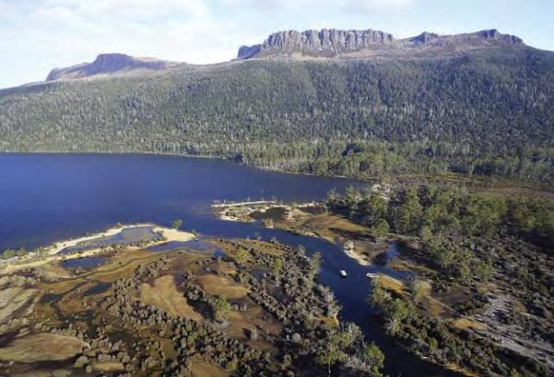

Northern end of Lake St Clair, the usual completion point for the world-famous Overland Track.

© Department of Tourism, Arts and the Environment, Joe

Shemesh / Stormfront Productions

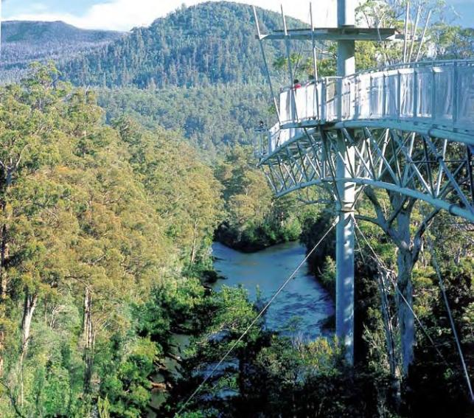

Tahune Forest AirWalk, Southern Forests, Tasmania. The Tahune AirWalk is a commercial tourism venture developed by Forestry Tasmania at the confluence of the Huon and Picton Rivers. It attracts over 100,000 visitors each year into this production forest landscape, against the backdrop of the TWWHA.

Forestry Tasmania.

### MANAGEMENT OF ADJACENT LANDS

A significant part of the TWWHA boundary is adjacent to State forest managed by Forestry Tasmania, a Government-owned business enterprise. Forestry Tasmania is constituted under the *Forestry Act 1920* (Tas), and has a charter to manage State forest lands in a commercial and sustainable manner, in conformity with a Ministerial Charter, and a Corporate Plan agreed with responsible Ministers on an annual basis.

As outlined at 1.3.3 above, the classification, boundaries and management of State forest land has been largely influenced by the outcomes of joint Australian-Tasmanian Government assessment and agreement processes in the RFA 1997 and the TCFA 2005 which have sought to determine an appropriate

balance of interests between conservation and socio-economic development within Tasmania's forests. High conservation forests have been identified and protected to levels achieved in very few comparable jurisdictions, while provision has been made for the sustainable management of remaining forests to provide for the support of regional Tasmanian communities.

Forestry Tasmania operates within the regulatory control of the *Forest Practices Act 1985* (Tas), which enforces compliance with a strong Forest Practice Code (FPC) that operates across all forest operations within Tasmania. An independent regulator, the Forest Practices Authority (FPA), administers the FPC and the *Forest Practices Act 1985.*

Forestry Tasmania is independently certified under both ISO 14001 (environmental management systems) and Australian Standard AS 4708 (Australian Forestry Standard) and annually publishes a sustainability report of its performance against sustainable forest management objectives and targets. It consistently achieves high levels of performance under independent audits conducted by the FPA against the FPC.

State forest adjacent to the TWWHA is managed as productive working forest. This was acknowledged in the nomination for inclusion of the TWWHA on the World Heritage List (see 1.3.2 above). These adjacent areas are actively managed as timber production landscapes, with harvest and regeneration of the forests on a sustainable, systematic basis.

These forests are also actively managed for recreation and tourism, with Forestry Tasmania providing active leadership in the development of unique commercial tourism facilities. These developments both augment those available in the TWWHA and assist in reducing visitor pressures on it.

The TWWHA boundary interface with forestry activities is also well managed.

For the past fifty years, logging has occurred in areas around the periphery of the TWWHA. This included down-slope and up-wind activity from sensitive and scenic alpine and sub-alpine areas. These areas included the Mersey, the Great Western Tiers, the Styx and the Florentine. However, forest management practice today is vastly improved, particularly the management of forestry in areas adjacent to the TWWHA.

Current practice now takes into account the proximity of the TWWHA and implements the necessary measures to protect its values. Significantly, extensive areas adjacent to the TWWHA are either not available for logging (Reserves – see Map at 1.3), not suitable for forestry, or set aside from harvesting by Forestry Tasmania through the forest planning process. Timber harvesting in areas adjacent to the TWWHA are also planned to minimise visual impacts. This includes partial and selective harvesting of special timbers in suitable forests, and non-clearfell harvesting of eucalypt forests.

Where clearfell harvesting is planned, boundaries are chosen to minimise the risk of subsequent regeneration burns escaping. If a burn does escape, there are strategies in place to prevent its encroachment on the TWWHA. There have been no regeneration burn escapes from State forest that have entered the TWWHA since its inception in 1983. There has been one minor escape from a fuel reduction burn that has entered the TWWHA. The fire was at Wedge Inlet in 2000 and burnt 157 hectares.

As explained in 2.1.3. fire management within the TWWHA is a complex and highly refined process. Fire is managed to protect fire sensitive communities, to regenerate pyrogenic communities and to protect people and park assets. Fire is part of the natural environment.

Ninety seven per cent of high quality wilderness areas in Tasmania (identified in 1996) are within reserves, most of which are within the TWWHA. Whilst the “middle Huon” karst and Aboriginal heritage areas are not within the TWWHA, they are adjacent to it. Thus concerns about karst and Aboriginal heritage are about aspirations to extend these areas, rather than

maintaining the integrity of the values within the existing TWWHA. However, identification and management of karst and Aboriginal heritage values remain an integral component of the Tasmanian Forest Practices System. A salient example of how this system protects TWWHA values in these areas is the “middle Huon” which was successfully identified and protected under this process.

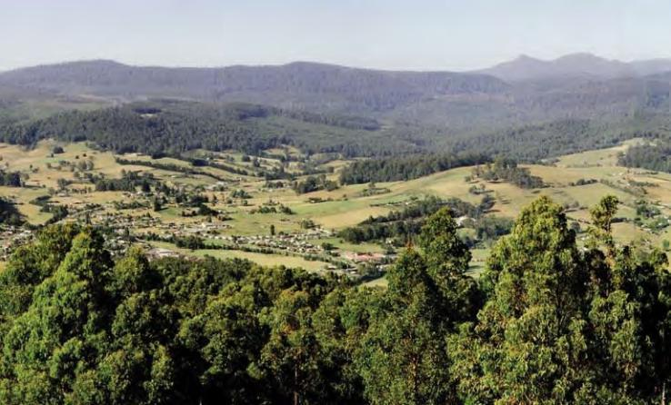

Town of Geeveston Regeneration 1989 Hartz Peak

### Southern Forests

Looking west over the town of Geeveston, with harvested and regrowth forest behind, and mountains in the TWWHA.

Richard Bennett

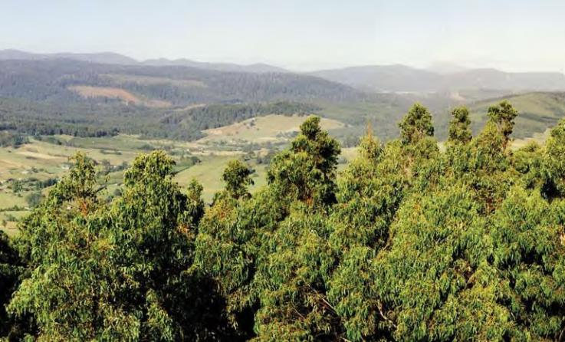

Harvested 2006 Regeneration 2004 Mount Picton

### Forestry in the Landscape

As illustrated on the preceding and following pages, Forestry Tasmania adopts a ‘Forestry in the Landscape’ approach to zone forest activities such that the most intensive activities are furthest from remote areas/wilderness.

This approach has been specifically adopted by Forestry Tasmania to provide an appropriate transition for activities adjacent to the TWWHA that assists in maintaining natural and cultural values of the TWWHA.

State forest areas with rainforest or mixed forest bordering the TWWHA are commonly zoned as Special Timber Management Units for the production of high value, low volume special species timbers on cycles of around 200 years using selective or small group partial harvest regimes.

Adjoining these areas are native eucalypt forests managed for multiple-uses on 80-100 year management cycles. Regrowth eucalypt forests are sometimes thinned at around age 30 years to shorten rotation times to about 60 years.

Plantations of *Eucalyptus nitens* and *E. globulus* are mainly located closer to the agricultural landscape, some distance from the TWWHA, and managed on 25 year rotations.

The diagram in Appendix B further illustrates this concept. It is an extract from Sustainable Forest Management, a Forestry Tasmania publication available in full on the following website: [www.forestrytas.com.au/forestrytas/pdf_files/sfm_brochure.pdf](http://www.forestrytas.com.au/forestrytas/pdf_files/sfm_brochure.pdf)

Partial Harvesting of 1998

Close-up of partial harvesting on a shelf on the side of Mother Cummings Peak, with Great Western Tiers panorama

shown below.

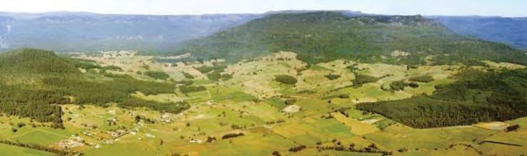

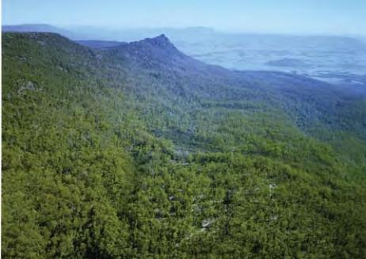

Archers Sugarloaf

Town of Meander

Smoko Creek

Mother Cummings Peak

A 15-kilometre length of the Great Western Tiers, seen from the north. There are many elements in this varied landscape. Paddocks on private property dominate the foreground, with the township of Meander being evident. In the background is part

of the Tasmanian Wilderness World Heritage Area. The middle ground is mostly forest; some is reserved, some is on public land available for wood production, and some is privately owned. In the forest there is a mix of areas that have never been logged, and logged at various times, beginning over 100 years ago. Areas harvested and regenerated in the last decade on Warners Sugarloaf at the entrance to Jackeys Marsh, and on the slopes of Mother Cummings Peak are indicated. More recent harvesting can be seen, for example on Archers Sugarloaf, together with

patches of plantation.

Forestry Tasmania

### Forestry Rotation and Regeneration Techniques

As outlined above, Forestry Tasmania uses a range of silvicultural systems for different native forest types in Tasmania. The commercial native forest types which abut the TWWHA are primarily rainforest, mixed forest (eucalypts over rainforest), wet sclerophyll forest (eucalypts with a broad-leaved shrub understorey) and high altitude eucalypt forests dominated by

*Eucalyptus delegatensis* over a narrow-leaved shrub understorey.

Commercial rainforest areas are mostly assigned to Special Timbers Management Units and harvested using single tree/small group selection methods and managed on very long rotations of 200 years or longer.

The mixed forests have traditionally been managed by clearfell, burn and sow silviculture on 80-100 year rotations but this is being largely replaced, under the TCFA, with variable retention silviculture. Under variable retention, about 20 per cent of the coupe is retained as old forest, usually in patches from 0.5 to

5 ha, to maintain late successional species and structures. The majority of the felled area is within a tree’s length of standing trees that will be kept for at least one rotation.

The wet sclerophyll forests, which have a natural fire frequency of 20-100 years, will continue to be managed by clearfell, burn and sow silviculture on 80-100 year rotations which are well matched to the natural disturbance regime.

Partial harvesting techniques, developed in the 1980’s, are now routinely used for *E. delegatensis* forests with low, narrow-leaved understoreys. These techniques include shelterwoods, advance growth retention and potential sawlog retention. Typically about a third of the canopy remains after harvesting and the forest

regenerates naturally, assisted by low intensity burning to reduce fuel hazards and create seedbed.

The following images (see overleaf) demonstrate various stages in the regeneration process following clearfall harvest.

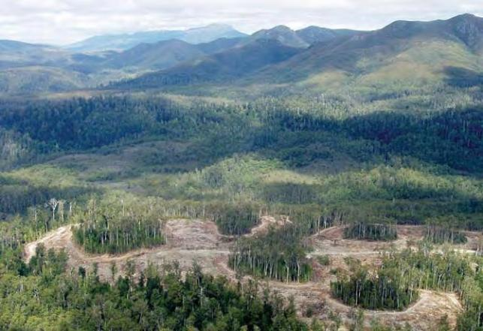

Variable Retention harvest in the Styx Valley. The TWWHA is in the background. Forestry Tasmania is introducing Variable Retention as an alternative harvest regime following pioneering research in the Warra Long Term Ecological Research site, to enhance landscape and biodiversity outcomes in the management of wet eucalypt forest.

Rod Hill, Forestry Tasmania.

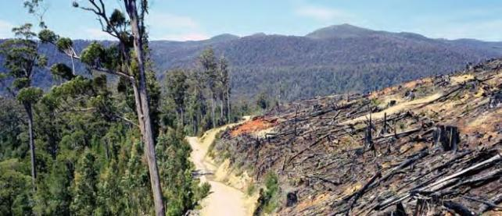

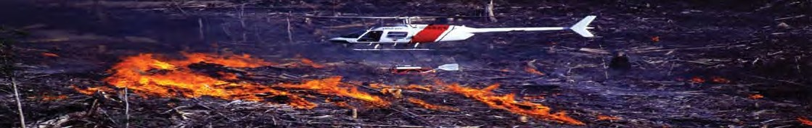

### Various stages in the regeneration process following clearfall harvest

1. A regeneration establishment burn being lit in the Weld forest to prepare an ash bed for seed, and to remove fire hazard, following clearfall harvest. This system has evolved out of pioneering research into eucalypt ecology which has established the necessary conditions for healthy and successful regeneration in these particular forest types. Weld Forest 2006.

Richard Bennett.

1. Forest area Picton 39a was harvested for veneer, sawlog and pulpwood in 1988. Logging debris was burnt in March 1989. The area was then aerially sown with eucalypt seeds collected locally.

Geoffrey Lea, Forestry Tasmania.

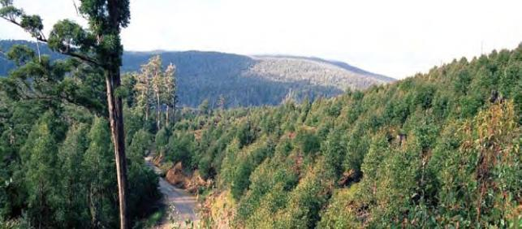

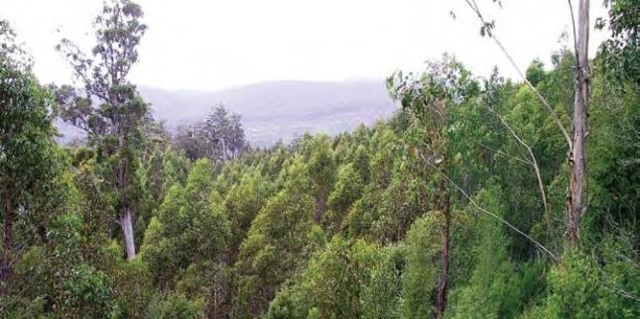

Forest area Picton 39a showing a young eucalypt forest 5 years after being regenerated. 3

Geoffrey Lea, Forestry Tasmania.

In 1997 measurements in Picton 39a show that the young trees have reached a height of 15 metres and the full complement of forest and scrub species has 4

returned to this new forest, including Blackwood, Celerytop Pine, Leatherwood and Myrtle.

John Sulikowski, Forestry Tasmania.

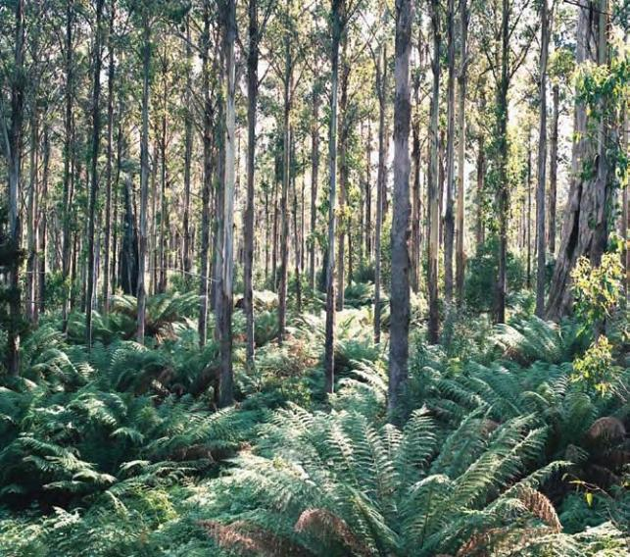

25 year old regenerated eucalypt forest, Arve Road, Southern Forests, following harvest and burn and sow, resulting from the same processes illustrated in the previous images.

Geoffrey Lea, Forestry Tasmania.

Smoko Creek Mother Cummings

Rivulet

Mother Cummings

Peak

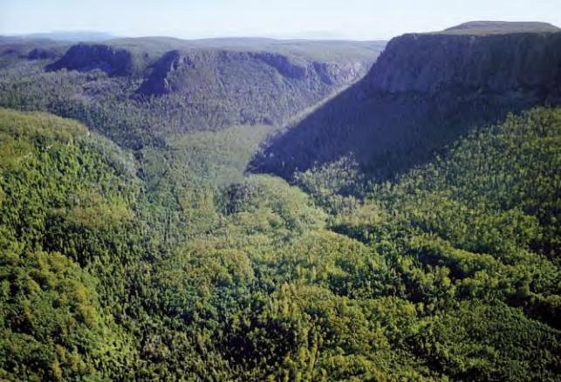

Regenerated forest 30 years after harvest (outlined area) at Smoko Creek, in State forest along the Great Western Tiers. The lower half of the photograph shows a mosaic of logged and regenerated and unlogged

forest. The TWWHA is in the background.

Richard Bennett.

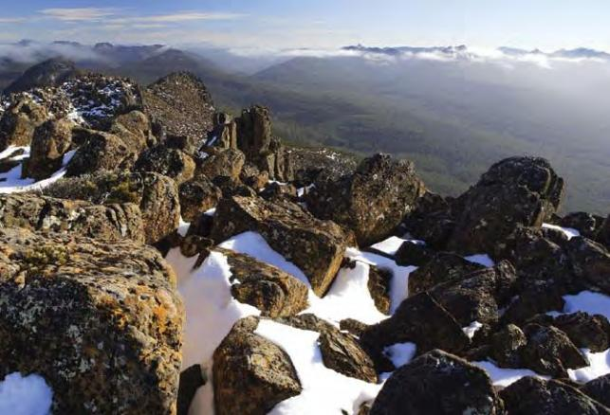

Dolerite Mountains, Lake St Clair area.

© Department of Tourism, Arts and the Environment, Joe Shemesh / Stormfront Productions.

### Threat Management Planning

The TWWHA Management Plan 1999 requires the Parks and Wildlife Service (PWS) to:

*“Maintain the co-operative arrangements for fire management developed with Forestry Tasmania and the Tasmania Fire Service as set out in the Inter-Agency Fire Management Protocol. Make arrangements with neighbouring landowners for joint fire management planning across boundaries.” (p.108)*

Fire protection for lands adjacent to, and inside the TWWHA, is coordinated in accordance with a Tasmanian Fire Management Protocol which underpins strong cooperation and sharing of resources between the three primary fire management agencies: the Tasmania Fire Service, PWS and Forestry Tasmania. This co- operative approach has proven very successful, and has afforded a good level of protection to the adjoining TWWHA.

The TCFA includes several important initiatives that affect Forestry Tasmania’s management of State forests, including those adjacent to the TWWHA. Under the TCFA, variable retention is being progressively introduced as an alternative to clearfelling for harvesting old growth eucalypt forests. By 2010, at least 80 per cent of the annual old growth harvest will be by non-clearfell methods. This will further reduce any perceived effects of adjoining State forest management on the TWWHA. The TCFA also heralded an end to the use of 1080 poison for browsing mammal control in State forests and a rapid phasing out of plantation establishment on natural forest land.

The management of adjacent State forest land is considered to represent the most benign form of productive land use available for land adjoining the TWWHA. It maintains a large area of natural vegetation on a sustainable basis as a reservoir of biodiversity, protecting soil and water values and maintaining landscape values over the long term.

Fire is the major external threat that could affect substantial parts of the TWWHA. Whilst the risk of this is slim, it is nonetheless present. However, this risk is reduced by the preparedness

of all the fire management agencies in Tasmania to fight fires wherever they occur and regardless of tenure with an integrated, systematic approach under the Inter-Agency Fire Management Protocol.

### MONITORING

* + 1. **Monitoring the TWWHA**

The PWS has developed a management evaluation system for the TWWHA that has been acclaimed internationally for supporting informed, effective, and transparent management.

The first *State of the Tasmanian Wilderness World Heritage Report* (Parks & Wildlife Service, 2004) provides a structured, evidence- based account of how management is performing against both its own management objectives and the obligations of the

World Heritage Convention. These objectives include *‘to identify, protect, conserve, present, transmit to future generations and, if appropriate, rehabilitate the World Heritage values of the property’.*

The report presents detailed information, including data, maps and photos about management outcomes including the condition of vegetation communities. The report is available on the PWS website at: [www.parks.tas.gov.au/publications/tech/state_of_WHA/summary.html](http://www.parks.tas.gov.au/publications/tech/state_of_WHA/summary.html)

The report was acclaimed by the World Heritage Centre, which demonstrates that management of the TWWHA is exemplary. Pages 6 and 7 of the report include the following significant approbations:

* + - * Dr. Natarajan Ishwaran, Chief, Natural Heritage Section, UNESCO World Heritage Centre stated that *“The development of the first management plan for the Tasmanian Wilderness World Heritage Area in 1992 and the completion of an evaluation of the effectiveness*

*of that plan has immense value and significance for World Heritage management practice globally. The application of the World Heritage identity as an integrator of management practices across the multiple protected areas that make up the Tasmanian Wilderness World Heritage Area has significant lessons for countries that are grappling with how the World Heritage Convention can be used to conserve thematic or geographical protected area clusters. I am impressed with the work that has gone into this detailed and comprehensive report. Congratulations and well done!”*

* Adrian Phillips, Chair, World Commission on Protected Areas (1994-2000), IUCN stated that *“The work on the assessment of management effectiveness pioneered in the Tasmanian Wilderness World Heritage Area represents a thorough professional view. Its significance lies not only in its relevance to the future management of the area itself, but also in its potential to offer lessons that other site managers could learn from. It is indeed an excellent piece of work that tries honestly to assess the quality of management and to identify what needs to be done to improve it. Congratulations to all concerned.”*

The Report was awarded the 2005 Australasian Evaluation Society’s Caulley Tulloch Prize for best publication in evaluation. The Report was also selected as a finalist in the Australian 2006 Banksia Awards for environmental excellence (Category 4: Land & Biodiversity).

The State of the TWWHA Report 2004 found that sound progress was made against all management objectives. While the report covers the period from 1992-1999, it does address emerging issues with implications for the future. A further updated report is scheduled for inclusion in the next full management plan review.

The report identifies the proposed elements of a core long-term monitoring program for the TWWHA developed as part of this mid-term review process. This will assist in guiding monitoring priorities to support sound adaptive management of the TWWHA.

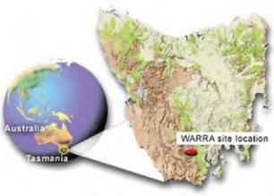

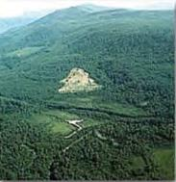

### Joint Research & Monitoring

The Warra Long Term Ecological Research (the Warra) site has been established to facilitate the understanding of ecological processes of Tasmania's wet (*Eucalyptus obliqua*) forests. These forests are part of the southern cool temperate wet forest biome. The programs foster multi-disciplinary research within a long-term framework. The site contains both working forests and conservation reserves. Appropriate management prescriptions and practices prevail in different parts of the site.

Covering an area of 15,900 hectares, the Warra is located near the junction of the Huon and Weld Rivers in southern Tasmania, Australia. It encompasses an elevation range of 37 m to 1260 m. The main communities it contains are temperate broadleaf forest (mainly *Eucalyptus obliqua* wet forest) with some areas of moorland, temperate rainforest, riparian and montane conifer forest and scrubs.

The Warra site location and from the air.

Images from Warra website.

The Warra research site is managed jointly by Forestry Tasmania, the Tasmanian Parks and Wildlife Service (Department of Tourism, Arts and the Environment), the Tasmanian Department of Primary Industries and Water, the Forests and Forest Industry Council,

the Forest Practices Authority, the Bureau of Rural Sciences, the University of Tasmania, the CSIRO and the Cooperative Research Centre for Forestry.

The main aims of the Warra are as follows:

* + - * To understand fundamental ecological processes in

*E. obliqua* wet forests.

* + - * To assess and monitor biodiversity and geodiversity.
      * To determine the long term effects of different forest management regimes on natural diversity and ecological processes and thus assess their sustainability.
      * Where necessary, to develop alternative management regimes.
      * To provide an integrated multi-disciplinary focus which complements research programs elsewhere in Tasmania.
      * To link Tasmanian forest research with national and international programs having a long term ecological focus.

The site is partly within the TWWHA, which is managed for conservation, and partly within State forest, which is managed for multiple purposes including wood production. There has been a history of data collection for forestry purposes since the late 1960s. Parts of the area were first harvested in the early 1970s. The complete logging history, recent fire histories and vegetation survey data are available. Further information on the Warra is available on a dedicated website: [www.warra.com/warra/docs/about.html](http://www.warra.com/warra/docs/about.html)

### Monitoring the Tasmanian RFA The Forest Practices System

One of the intentions behind the RFAs is to reduce duplication

in forest management decision making as far as possible by removing the Commonwealth from any detailed involvement in this process. The Commonwealth was able to remove itself from this level of involvement through a process of accreditation of state forest management systems. Direct interaction between the Australian and Tasmanian Governments over the RFA relates primarily to formal monitoring and review processes, collaborative RFA-based programs, projects or implementation initiatives,

and dealing with implementation or interpretation issues raised through public representations to Ministers.

Pursuant to Clause 44 of the RFA, the Parties prepared annual reports on progress with implementation of the milestones and obligations set out in Attachment 3 to the RFA. These continued to the year 2001 and have been tabled in the Australian Parliament, as required by the RFA Act.

The Tasmanian forest practices system was established to ensure that forest practices on all tenures provide reasonable protection for the natural and cultural values of the forest. In addition to the forest practices system, local government regulates forestry on private land which is not a Private Timber Reserve (PTR).

The Tasmanian forest practices system is based on a co- regulatory approach, involving responsible self-management by the industry, with independent monitoring and enforcement by the FPA. Self-management is delivered by Forest Practices Officers (FPOs), who are employed within the industry to plan, supervise and monitor forest practices. The FPA trains and

authorises the FPOs to carry out these functions. The specialists also provide advice and monitor forest practices to ensure

that standards are being met. Corrective action is taken where required and penalties are imposed for serious breaches.

The emphasis of the forest practices system is on developing and nurturing a partnership between the government and the forest industry through training and education.

The FPA administers the forest practices system, set up under the *Forest Practices Act 1985*. Most forest practices require a Forest Practices Plan (FPP) which must be prepared in accordance

with the Forest Practices Code (FPC). Specialists within the FPA carry out research to improve the FPC and advise on FPPs being prepared for forests with special cultural and natural values.

Forest Practices Officers (FPOs), trained and accredited by the FPA and employed by forest owners or the forest industry,

prepare FPPs and supervise their implementation. They submit certificates detailing the compliance of operations with the plan to the FPA at the end of each stage of the FPP.

The FPA annually audits a representative sample of FPPs. The FPA has powers to issue notices, impose fines or take legal action to ensure compliance with the FPC. The forest practices system fosters a co-regulatory approach, based on self-management

by forest owners and the forest industry, who are responsible for ensuring that their forest practices comply with the FPC, and government regulation through the FPA. Some of the benefits of this system are that it encourages forest owners and the forest industry to be responsible and that it is a cost-efficient system.

A key feature of the forest practices system is a Forest Practices Code (FPC) which provides practical standards for forest management, timber harvesting and other forest operations. The system also includes independent auditing, reporting and enforcement of the Act and Code by the FPA.

The FPC provides a set of guidelines and standards to ensure protection of the natural and cultural values of the forest. The guidelines and standards in the FPC cover:

* + - * building access into the forest: (roads, bridges, quarries etc);
      * harvesting timber;
      * conservation of natural and cultural values (soil and water, geomorphology, visual landscape, flora, fauna and cultural heritage); and
      * establishing and maintaining forests.

The FPA developed the FPC through extensive consultation and public comment. It is reviewed periodically, incorporating

suggestions from scientists, government, the forestry industry and the public. As part of this process it has been refined and expanded twice, most recently in 2000. The FPC is legally enforceable under the *Forest Practices Act 1985* for both public and private forests. There are also other legislation and policy requirements that need to be considered when preparing a FPP, such as the Tasmanian *Threatened Species Protection Act 1995* and the Permanent Native Forest Estate Policy.

The Forest Practices Code can be downloaded from the FPA website:

[www.fpa.tas.gov.au/index.php?id=7#249](http://www.fpa.tas.gov.au/index.php?id=7&amp;249)

### REPORTING

* + 1. **TWWHA Reporting**

The Tasmanian PWS management evaluation system for the TWWHA provides the main mechanism for monitoring and reporting on management performance. The adaptive

management cycle for the TWWHA is illustrated in Figure 1 below.

periodically review overall management

program

report findings and

recommendations r

of evaluation

T

Determine management objectives

Determine define key deired outcomes

Identify performance indicators

Develop management strategies and actions

Establish monitoring programs for selected performance indicators

evaluate management effectiveness

implement strategies and actions to achieve objectives

##### Figure 1. The Adaptive Management Cycle

The integration of effectiveness monitoring, evaluation and reporting into the cycle of management for the TWWHA generates informed feedback that enables managers to learn from and improve on past management approaches and so continuously improve management. The adaptive management cycle for the TWWHA is supported by two key documents – the *Management Plan*, and the *State of the TWWHA Report*, which evaluates the effectiveness of management under the plan.

As noted in 2.4.1, the *State of the TWWHA Report* was first produced in 2004 to wide acclaim, including from the World Heritage Centre. The report is available online at: [www.parks.tas.gov.au/publications/tech/state_of_WHA/summary.html).](http://www.parks.tas.gov.au/publications/tech/state_of_WHA/summary.html))

The PWS also contributes monitoring information to Periodic Reporting for World Heritage for the Department of the Environment and Heritage (DEH) and information to State of the Environment reporting, State of the Forests and RFA reporting.

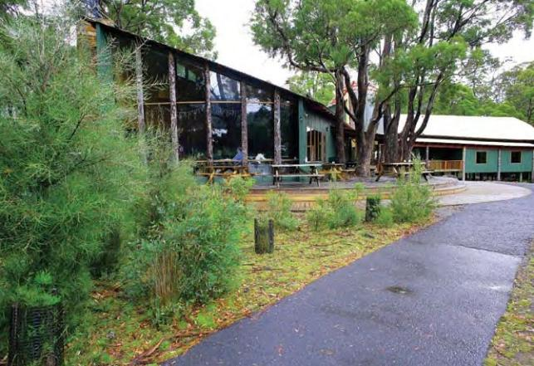

Lake St Clair Visitor Centre.

© Department of Tourism, Arts and the Environment, Joe Shemesh / Stormfront Productions.

### State of the Forests & RFA Reporting

Under Tasmanian legislation, there is a requirement for the Tasmanian Government, through the FPA, to submit to State Parliament a State of the Forests Report every five years that covers all forests in Tasmania, not just those managed for wood production. Such reports have been published in 1993, 1998 and 2002.

The 2002 report was based on a series of indicators of sustainable forest management based on the Montreal Process Indicators. The next State of the Forests report, currently in preparation, will also follow this format. The Montreal Process is an international agreement between twelve nations with temperate or boreal forest cover. It is a way of evaluating forest management against a prescribed framework using criteria and indicators and it provides mechanisms for describing and monitoring progress towards sustainability.

As noted above, Australia’s criteria and indicators are based on the Montreal Process criteria and indicators. The criteria represent the broad forest values that Australians want enhanced or preserved. The seven criteria for sustainable forest management are:

* + - * Conservation of biological diversity;
      * Maintenance of productive capacity of forest ecosystem;
      * Maintenance of ecosystem health and vitality;
      * Conservation and maintenance of soil and water resources;
      * Maintenance of forest contribution to the global carbon cycle;
      * Maintenance and enhancement of long term multiple benefits to meet the needs of society; and
      * An effective legal, institutional and economic framework for forest conservation and sustainable management.

The twelve countries now involved have stewardship of at least 90 per cent of these forests worldwide. Member countries are Australia, Argentina, Canada, Chile, China, Japan, the Republic of Korea, Mexico, New Zealand, the Russian Federation, the United States of America and Uruguay.

Each RFA contains commitments and milestones for implementation by the Commonwealth and State governments. Much of the task of putting the RFAs into practice lies with State governments, although the Australian Government has a number of commitments under the agreements.

The RFAs provide for annual reporting by both governments against their RFA commitments and obligations for each of the first four years of the agreements. RFAs also require the

governments to review their performances every five years in consultation with the community.

The TCFA 2005 includes a variety of monitoring requirements:

### Tasmanian RFA annual reviews (years 1-4)

Under Clause 44 of the Tasmanian RFA “the parties agree to provide annually for the first five years ... written reports detailing achievement of milestones”. The milestones to be reported against are listed within the RFA.

### Tasmanian RFA five year review (2002)

Clause 45 of the RFA defines the process for the conduct of five- yearly reviews of performance in meeting the RFA commitments and milestones. This includes using and taking account of a set of sustainability indicators developed in accordance with Clause 91 of the RFA. Pursuant to this process, the two governments

agreed to a set of forty one indicators from the Montreal Process Framework of Criteria and Indicators.

In February 2002, the then Tasmanian Minister for Primary Industries, Water and Environment issued a reference to the Tasmanian Resource Planning and Development Commission (RPDC) to conduct an enquiry into and report on progress with the implementation of the RFA.

In May 2002, RPDC released for public comment a background report whose major components included:

* + - * + Reports by the Governments on progress against each of the ninety milestones and commitments included in the scoping agreement; and
        + Detailed analyses and assessment against each of the forty one sustainability indicators.

Public submissions were invited by July 2002, with the Review Panel also conducting public hearings. In September 2002, the RPDC released a draft recommendations report for further public comment, due by 31 October 2002. The final recommendations report was released in December 2002. The report contained thirty recommendations. Review documentation can be found at: <http://www.rpdc.tas.gov.au/public_land_use/plu_docs/plu_reg_forest_> agree.htm

In all, there were five separate opportunities for public involvement in the review.

The principal conclusion of the report was:

*“The Commission considers the parties have made substantial progress on implementing the RFA. Ninety specific milestones and commitments were identified in the Terms of Reference for this review. Seventy-eight milestones have been completed, or had substantial progress made, eight other milestones have had some progress made, four milestones have had no progress made, although for three of these, this was with the knowledge and consent of the Parties. Clearly, the Parties have devoted considerable resources toward implementation of the RFA. The Commission has made some specific Recommendations to cover issues where further progress needs to be made in a timely manner.”*

### Tasmanian RFA 10 year review (2007)

The Tasmanian RFA is due for its 10 year review in 2007. The review will encompass both the milestones and further commitments contained within the RFA, recommendations from the 2002 review and those commitments contained in the TCFA.

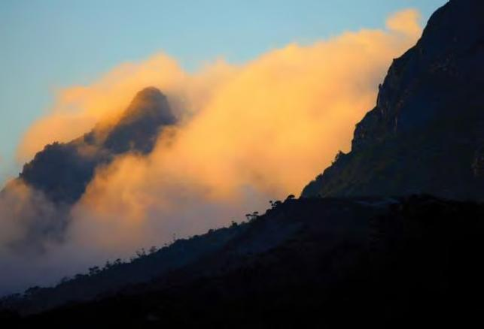

Cradle Mountain and clouds

© Department of Tourism, Arts and the Environment, Joe Shemesh /

Stormfront productions.

# REFERENCES & FURTHER READING

**Australian Government, 2006**. *Australia’s World Heritage: Australia’s places of outstanding universal value.* Australian Government Department of the Environment and Heritage, Canberra.

**Forest Practices Board, 2000**. *Forest Practices Code*, Forest Practices Board, Hobart, Tasmania.

**Independent Expert Advisory Group, 1996**. *Assessment of Ecologically Sustainable Forest Management Systems and Processes: Independent Expert Advisory Group Preliminary Report.* Tasmania-Commonwealth Regional Forest Agreement, Background Report Part E. Tasmanian Public Land Use Commission, Hobart, November 1996.

**Independent Expert Advisory Group, 1997**. *Assessment of Ecologically Sustainable Forest Management Systems and Processes: Independent Expert Advisory Group Final Report.* Tasmania-Commonwealth Regional Forest Agreement, Background Report Part G. Tasmanian Public Land Use Commission, Hobart, February 1997.

**Parks and Wildlife Service, 2004**. *State of the Tasmanian Wilderness World Heritage Area – an evaluation of management effectiveness*, Report No.1, Department of Tourism Parks Heritage and the Arts, Hobart, Tasmania.

**Parks and Wildlife Service, 1999**. Tasmanian Wilderness World Heritage Area Management Plan 1999. Department of Primary Industries, Water and Environment.

**Parks and Wildlife Service, Forestry Tasmania and Department of Primary Industries, Water and Environment, 2003**. *Tasmanian Reserve Management Code of Practice.*

**Sattler, P.S. and Glanznig, A. 2006**. *Building Nature’s Safety Net: A Review of Australia’s Protected Area System 1991-2004,* WWF- Australia Report, WWF-Australia, Sydney.

**World Heritage Expert Panel, 1997**. *World Heritage Report: Record of the Tasmanian World Heritage Expert Panel Meeting and a Preliminary Analysis of the Forest and Mineral Resources in Areas Identified by the Panel.* Tasmania-Commonwealth Regional Forest Agreement, Background Report Part I. Tasmanian Public Land Use Commission, Hobart, June 1997.

### Websites:

Australian Government Department of Agriculture, Fisheries and Forestry – The Montreal Process [www.daffa.gov.au/forestry/international/fora/montreal](http://www.daffa.gov.au/forestry/international/fora/montreal)

Forest Practices Authority - The Forest Practices Code

[www.fpa.tas.gov.au/index.php?id=7#249](http://www.fpa.tas.gov.au/index.php?id=7&amp;249)

Forestry Tasmania – Giant Trees Policy

[www.forestrytas.com.au/forestrytas/pdf_files/giant_trees_policy.pdf](http://www.forestrytas.com.au/forestrytas/pdf_files/giant_trees_policy.pdf)

Parks & Wildlife Service – Fire Management

[www.parks.tas.gov.au/manage/fire/index.html](http://www.parks.tas.gov.au/manage/fire/index.html)

Parks & Wildlife Service – State of the TWWHA Report No.1

[www.parks.tas.gov.au/publications/tech/state_of_WHA/summary.html](http://www.parks.tas.gov.au/publications/tech/state_of_WHA/summary.html)

Resource Planning and Development Commission – Tasmanian RFA five year review <http://www.rpdc.tas.gov.au/public_land_use/plu_docs/plu_reg_forest_> agree.htm

Tasmania Fire Service – Current Fire Map

[www.fire.tas.gov.au/mysite/Show?pageId=colCurrentBushfires](http://www.fire.tas.gov.au/mysite/Show?pageId=colCurrentBushfires)

Warra Long Term Ecological Research Site

[www.warra.com/warra/docs/about.html](http://www.warra.com/warra/docs/about.html)

### World Heritage Documentation:

**Commonwealth Department of the Arts, Sport, the Environment, Tourism and Territories and the Government of the State of Tasmania, 1989**. *Nomination of the Tasmanian Wilderness by the Government of Australia for Inclusion in the World Heritage List,* September 1989.

**Tasmanian Government & Australian Heritage Commission, 1981**. *Nomination of Western Tasmania Wilderness National Parks by the Commonwealth of Australia for Inclusion in the World Heritage List.*

**UNESCO, 1972**. *Convention Concerning the Protection of the World Cultural and Natural Heritage.* Adopted by the General Conference at its seventeenth session, Paris, 16 November 1972.

**World Conservation Union (IUCN), 1989**. *World Heritage Nomination – IUCN Summary 507: Tasmanian Wilderness (AUSTRALIA)*. Dated October 1989.

**World Heritage Centre, 2005**. *Operational Guidelines for the Implementation of the World Heritage Convention.* WHC. 05/2.

### Agreements:

*Tasmanian Community Forest Agreement between the Commonwealth of Australia & the State of Tasmania*, 13 May 2005.

*Tasmanian Regional Forest Agreement between the Commonwealth of Australia & the State of Tasmania*, 8 November 1997.

### Legislation:

*Environment Protection & Biodiversity Conservation Act 1999*

(Cth)

*Nature Conservation Act 2002* (Tas)

*Regional Forest Agreement Act 2002* (Cth)

*Regional Forest Agreement (Land Classification) Act 1998* (Tas)

### APPENDIX A

**NGO ASPIRATIONS**

It is noted that the World Heritage Committee (WHC 06/30.COM/ 7B) commends the State Party on the implementation of both the 1997 Tasmanian Regional Forest Agreement and the 2005 Tasmanian Community Forest Agreement.

### NGO CLAIM COMMENTS

The correspondence from the NGOs to the World Heritage Centre that was forwarded to the Australian Government identifies a range of broad areas that, it is claimed, are worthy of inclusion in the TWWHA.

Most of the reports mentioned by the NGOs have identified areas that may have World Heritage values requiring further assessment or are alleged to have World Heritage values by NGOs.

The World Heritage Expert Panel (1997) convened during the RFA process identified themes of values and areas that may have these values that should be further investigated. None of these areas had specific boundaries and many of the locations were within existing reserves, including the existing TWWHA.

The values of the areas identified in the 1990 Appropriate Boundaries report were considered in the RFA process.

The boundaries of what the NGOs claim constitutes these areas are arguable and seem to derive from an aspirational report produced by the Wilderness Society in the early 1980s.

All of these areas have been subject to many reviews and inquiries since then, notably the 1988 Helsham Inquiry, the 1990 Tasmanian Forests and Forest Industry Strategy, the 1996-97 RFA process

and the 2005 Tasmanian Community Forest Agreement. All of these processes have defined the area to be reserved and the area available for forestry operations outside of reserves.

The RFA (clauses 39-41) included an agreed process for the joint consideration of further assessment of WH values and any

nominations in Tasmanian forest areas. The RFA did not identify any areas for inclusion in the TWWHA.

Views expressed by NGOs on the ‘outcomes’ and ‘current situation’ of these reports are inaccurate. The areas referred to are relatively minor areas peripheral to the TWWHA and contain no values not contained in the existing TWWHA or essential to the integrity of the TWWHA.

The views of IUCN and WHB were considered and dealt with previously. Other government reports were part of a process to look at conservation values as part of a broader assessment process of all values from which a balanced decision was made about allocation of land to protection of productive uses.

### NGO CLAIM COMMENTS

|  |  |
| --- | --- |
| Identifies areas as having conservation / World Heritage value including: Beech/Counsel River area, the Wylds Craig/Lower Florentine area, the Gordon and Tiger Ranges, the Upper Florentine, the upper Styx, the middle Weld, the middle Huon, the Picton Valley, Southeast Cape, the Navarre Plains / Mt Rufus area, part of the Great Western Tiers, upper Mersey. | All of these areas are outside the agreed TWWHA boundaries.  Many of these areas are fully protected in reserves eg South East Cape, Middle Weld, parts of Great Western Tiers, Navarre Plains/Mt Rufus, Middle Huon, and Beech Counsel  Forestry operations do and have occurred on State forests outside of these reserved areas. |
| Only a small part of “additional 6460 hectares of reserves along the eastern boundary of the TWWHA” are adjacent to the TWWHA.  Unprotected areas with conservation values are subject to intensified logging and building of new logging roads.  Conservation gains in the Styx are diminished by logging between new reserves and the TWWHA and ‘informal reserves’ adjacent to the TWWHA.  The Tarkine’s new reserves are separated from the TWWHA. | There is no “intensification” of logging in areas adjacent to the TWWHA. In most areas there is a history of logging over many decades. The rate of harvesting of older forests has not increased in recent times and is decreasing if anything. The type of logging is less intensive as clearfell harvesting has decreased.  Most of the remaining tall old growth forest in the Styx is now reserved. The non- reserved areas in between are largely young regrowth forests from previous clearfall and burn operations.  As a result of the TCFA there is now a contiguous reserve system connecting the TWWHA with the Tarkine through to the West Coast. |
| Proposed extensions to the TWWHA are ‘all part of one of the world’s greatest temperate wilderness areas’ and should be treated as a unified whole with the TWWHA. Details individual values for various areas and references. | Ninety seven per cent of the high quality wilderness identified in the Tasmanian RFA is within the reserve system. |

**NGO CLAIM COMMENTS**

|  |  |
| --- | --- |
| Claims ongoing and potential intensification of forestry operations in many of the aspirational areas  Past and present fire management - examples of fire escapes Informal and formal reserve size and design - adequacy and  connectivity with the TWWHA  Road construction for forestry operations in informal reserves Adequacy of impact assessment for threatened species and  for the pulp mill  Areas identified as having conservation value include: Beech/ Counsel River area, the Wylds Craig/Lower Florentine area, the Gordon and Tiger Ranges, the Upper Florentine, the upper Styx, the middle Weld, the middle Huon, the Picton Valley, Southeast Cape, the Navarre Plains / Mt Rufus area, part of the Great Western Tiers, upper Mersey. Claims that large tracts of these forests remain under threat from logging, despite 1997 and 2005 RFAs | All of these areas are outside the agreed TWWHA boundaries.  Many of these areas are fully protected in reserves eg South East Cape, Middle Weld, parts of Great Western Tiers, Navarre Plains/Mt Rufus, Middle Huon, and Beech Counsel.  Forestry operations do and have occurred on State forests outside of these reserved areas. |
| Provides detail on 'crisis areas' where it is claimed Government did not protect the amount it promised and where logging may occur: The Florentine and the Styx, The Weld Valley, Counsel River, Mt Wedge, Mt Rufus, Great Western Tiers and Upper Mersey. | As above  Counsel River area (7000ha) – establishment of a network of new logging roads and coupes is underway.  As above. Roads have been constructed and there has been selective harvesting of forest in the Butlers East State Forests outside of the TWWHA in accordance with the RFA and Tasmanian legislation. |
| Claims logging coupes on the lower slopes of Mt Wedge are ‘eating away’ tall-eucalypt forest and leatherwood trees on steep slopes. | As above. There has been forest harvesting of State Forest on the lower slopes of Mt Wedge since the 1960s. The upper slopes (outside of the TWWHA) are reserved. |

**NGO CLAIM COMMENTS**

|  |  |
| --- | --- |
| New coupes within 2-3km of Lake St Clair have been scheduled in the Mt Rufus area. Lake St Clair is one of the three biggest tourism gateways of the TWWHA. | As above. There has been harvesting in and around Lake St Clair for over 50 years. All of the forest harvesting in this area is low impact, selective. There will be no impact on the gateway to the TWWHA. |
| Claims that in the middle Huon an important karst system and unique rock art and other Aboriginal heritage have been discovered within the past 6 years. These sites occur within  2-3 km of the TWWHA and/or Southwest National Park. Logging is temporarily on hold, but claims Forestry Tasmania could resume logging within these areas at any time. | The karst areas and associated Aboriginal heritage are protected by Forestry Tasmania in close consultation with the Aboriginal community. |
| Claims that there has been forest harvesting of State Forest on the lower slopes of Mt Wedge. In 2002-03 in the lower Florentine, Forestry Tasmania burnt and killed the largest known living tree in Australia – El Grande. | Forestry Tasmania acknowledges the natural and cultural value of the Giant Trees in Tasmania and seeks to enhance their protection on State forest and to encourage their appreciation through a Giant Trees Policy. This policy states that Forestry Tasmania will seek to identify, manage and protect giant trees on State forest in Tasmania. Giant Trees are defined as trees that are at least 85 metres tall or at least 280 cubic metres estimated stem volume. Based on current  known examples, trees of this volume are generally at least 5 metres in diameter at chest height.  To achieve this policy the objective is to:   * Protect currently known Giant Trees; * Periodically remeasure known Giant Trees; * Undertake surveys to identify any Giant Trees within coupes in the Three Year Plan that have the potential to contain these trees; * Maintain registers of the 10 tallest and 10 largest volume extant trees known on all lands in Tasmania and of the 10 tallest trees ever recorded in Tasmania; * Promote with other forest managers a statewide tourism strategy for Giant Tree appreciation on all tenures and participate in its implementation. |

### NGO CLAIM COMMENTS

|  |  |
| --- | --- |
| Proposed Pulp Mill in northern Tasmania – claims it is likely that impacts on the State’s native forests will not be assessed during the formal approval process of either Tasmanian or Australian Governments. | The proposed pulp mill is being assessed through a rigorous independent assessment process to meet State and national environmental requirements. The mill’s proponents have stated that they will not be using any wood from old growth forests in the mill. |
| Claims of deficiencies in endangered species laws. Claims fundamental antagonism by Australian Government to protect endangered species where there is a perceived conflict with the logging industry. | The State and Commonwealth have rigorous legislation and procedures for protection of endangered species. |
| Claims that under the TCFA, the Government protected about 25% (4,730h) of what was promised in 2004 (18,700 ha) in the Styx and Florentine. | These areas were in a policy document for a federal election, not a binding agreement with the State. Following a consultative process with the State, the TCFA resulted in a greater area of forest being protected than that outlined in the Coalition policy for the 2005 federal election, including many areas adjacent to the TWWHA in southern, northern and western Tasmania. |

### NGO CLAIM COMMENTS

Informal reserves – claims many new reserves are small, scattered, convoluted ‘informal reserves’ that were never threatened by logging.

Claims roads can be built in informal reserves.

Informal reserves are an important but relatively small component of the total reserve system. They provide important protection of local values including threatened species locations, heritage sites, landscape, soil and water protection, and recreation sites.

Informal reserves within the wood production zones provide complementary protection to that provided by the larger extensive Formal Reserves. These informal reserves include "linear" reserves providing protected habitat connectivity to larger reserved areas and protection along linear features such as water courses and public roads. As such these linear Informal Reserves often cross existing roads and new roads constructed for access to timber harvest areas or any other purpose may have to cross Informal Reserves. This is specifically recognised and permitted in the RFA. Where this occurs the values of these reserves are considered in the Forest Practices Plans to minimise impacts but do not materially detract from the purpose of the reserve. Where road construction is incompatible with the site specific values for which the reserve was created (eg cultural value site, rare species location) then road construction in these reserves is avoided where possible.

Most of the new reserves created under the TCFA provided guaranteed protection of State forest areas that were previously unprotected

and available for forest harvesting. As is the case for all State forest, some areas available for logging are not ever harvested.

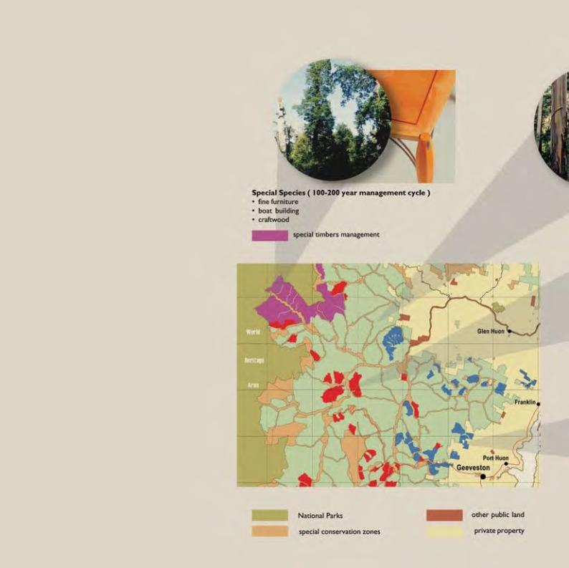

### APPENDIX B

**FORESTRY TASMANIA’S LANDSCAPE APPROACH**

Extract from "Sustainable Forest Management" (Forestry Tasmania)

[www.forestrytas.com.au/forestrytas/pdf_files/sfm_brochure.pdf](http://www.forestrytas.com.au/forestrytas/pdf_files/sfm_brochure.pdf)

# How we manage forests

* in the landscape

The Tasmanian Parliament determines which areas of the State’s public lands are set aside for wood production and which areas should be National Parks and Conservation Reserves. Forestry Tasmania then broadly zones the lands it manages (State forest) for a range of wood production, protection and recreational uses.

Eucalypts (80-100 year management cycle)

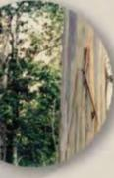

* + solid wood produces
* furniture
* pulpwood products

Multiple use

Production forest

In areas bordering World Heritage Area or National Parks, we generally plan longer management periods for special species timber production. Adjoining these areas, eucalypt forests are managed for multiple uses on an 80 to 100 year management cycle, producing eucalypt logs that are used for solid wood products, furniture, pulp and paper:

Closer to the agricultural landscape, we thin the forests to produce a

premium range of structural products – framing and furniture timbers.

Adjoining the agricultural landscape, we set up our main plantation zones.

These areas will produce products suitable for reconstituted wood, pulp and paper.

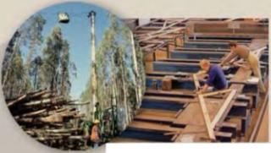

Thinned eucalypts and Blackwood ( 60 year management cycle )

* structural products
* framing and furniture
* pulpwood products

thinned native forest



Planted and thinned eucalypt plantation (25-40 year management cycle)

* structural products
* reconstituted wood
* pulpwood products

 Eucalypt plantation

The Tasmanian Wilderness Wor ld Heritage Area World Heritage Committee Oec1s 1on WHC -06/30.COM/78 State Party Report