6. Annexure 1. Factual position of each signatory group as put by them

6.1. The Construction, Forestry, Mining and Energy Union (CFMEU)

Representatives of timber workers, employers, communities and the environment movement embarked on a consensus building process in 2010. We did this assumedly due to the fact that we believed that a concurrence reached with each other on the specific nature of a Tasmanian forest and forest products industry restructure would potentially deliver superior results to all of our constituents than the results that we could be expected to deliver in the absence of an agreement. To the CFMEU’s knowledge, all signatories remain committed to the process so we must assume that all signatories still believe that prospects for a better outcome for their respective constituents reside in the ‘Statement of Principles’ process.
- In the face of an industry crisis brought on by erratic markets, uncertain wood supply and persistent inability to attract capital investment; a crisis resulting in significant and continuing job losses, CFMEU members supported the union to take a proactive and pragmatic approach. This led the CFMEU to explore possible solutions resulting in coming to an agreement with the environment movement and employers. Generally, we do not believe that locking up forests from timber production makes social, economical or environmental sense. However, we know that consensus does not mean everyone achieves every wish, but rather that it could result in an enduring agreement which resolves everyone’s major concerns, mitigating disquiet and leading to mutually acceptable outcomes.
We remain committed to attempting to achieve this through the process.
Any agreement reached as an outcome of the process will be taken back to CFMEU members in Tasmania for a vote by secret ballot and will also be put to the CFMEU National Executive and the ACTU for endorsement.
- We believe the following facts need to be acknowledged by the signatories, non-signatories, governments and the broader community:
- The quality and quantity of the Tasmanian native forest resource is in decline.

- The quality of the native forest resource supplied to all remaining processors is decreasing as the yield is not sustainable.
- By approximately 2021, 50% of the 300K m3 pa of high quality saw log the state has generally been required to provide the sawmilling and veneer industry is projected to suddenly come from plantations (majority eucalyptus niten species managed under a certain pruning regime), which key enterprises have argued are unsuitable for their purposes given their current operations.
- Gunns’ proposal to exit from native forests and not sell their wood supply agreement to the highest bidder presents a once in a life time opportunity to somewhat mitigate the upcoming on stream resource crisis.

- Tasmanian native forest logging and processing has become economically unviable.
- The collapse in the value of the native forest residue chip market (especially when containing a percentage of residue of what ENGO’s have branded come from ‘High Conservation Value’ forests) is not temporary but a permanent and structural shift, particularly in the absence of an agreement.
- State Government agency Forestry Tasmania made an $8 million operating loss in 2010.
- The shortfall in residue chip prices for country saw millers is at least up to $31 per GMT (Green Metric Tonne) for some enterprises, meaning millions of dollars in un-projected and un-budgeted losses per annum for the sector.
- Crown saw millers face a similar predicament to country saw millers in terms of consequences of the permanent collapse of the Japanese export chip market for native forest processing residues.
- Much of the harvest and haulage sector is financially exposed and the banks are refusing to refinance.
- All sectors of the industry are operationally and economically interdependent.

- Further job losses in the Tasmanian timber industry are inevitable and will occur regardless of if an enduring agreement is reached or not.
- Fewer jobs will be lost as the consequence of an agreement that would have otherwise occurred under a ‘business as usual’ scenario.
- The current high risk of job losses at some key community enterprises are fundamentally reduced by the very nature of an agreement.

- There is capacity in the ‘Statement of Principles’ for an enduring agreement to be reached which provides the opportunity for inevitable job losses to be mitigated through job creation in a sustainable timber industry and a diversified regional economy.
- If the CFMEU agrees for Gunns’ supply licenses not be re-allocated this will fundamentally reduce the opportunity for reemployment for CFMEU members who have lost their jobs in the native forest harvest and haulage, sawmilling and veneer manufacturing sectors. Alternative economic activity and subsequent employment opportunities in sustainable, safe and well paid union jobs need to be created for these workers and others in the community.
- The development of strong and sustainable downstream processing and value adding timber industry underpinned by a Pulp Mill can partly provide this outcome.
- Up to 2000 construction jobs will be created in the construction phase of Gunns’ Bell Bay Pulp mill.
- Up to 1500 direct and non-direct permanent jobs will be created through the operation of the Pulp Mill.
- The Pulp Mill will underpin the development of a sustainable plantation processing industry by providing a secure market for plantation harvesting and processing revenues.
- The development of diversified regional economies complimenting the development of a sustainable timber industry can also provide safe and well paid union jobs in a variety of sectors as part of a community by community region by region plan for regional Australia
- Skills & retraining assistance, re-employment support and relocation assistance for CFMEU members made redundant will likely be necessary to ensure that they can capitalise on the economic development and new job opportunities created.

We believe that a better outcome can be achieved for our members compared to what they otherwise face through the implementation of the Principles and the achieving our Log of Claims. For this we believe that commitments by the signatories, government and community need to result in:
- Comprehensive support for any union members who are made redundant including a coordinated package with adequate levels of redundancy pay, compensation, financial planning services, skills & retraining assistance, re-employment support and relocation assistance.
- A Pulp Mill at Bell Bay.
- An ongoing supply of suitable timber for current businesses that stay in the industry, with a priority of supply for enterprises which have union agreements for their workers and have shown commitments to safer workplaces.
- Signatory support for investment in the industry.
- Appropriate economic development and diversification in adversely affected communities.
- Fair compensation for voluntary business exits.
- A timely moratorium on the logging of forests which ENGOs submit warrant imminent protection due to them having ‘High Conservation Values’.
- Transition, over time of the remaining industry out of native forests into suitable and socially acceptable plantation forests.
- The State and Federal Governments implementing agreed outcomes from the Principles through legislation where necessary.

Workers are confronting an industry crisis and an economy in transition through no fault of their own. We are mandated by our members to explore all possible means of reaching a consensus agreement. From our perspective, any enduring agreement must result in an industry restructure which delivers a better outcome for workers, families and communities than they otherwise face.

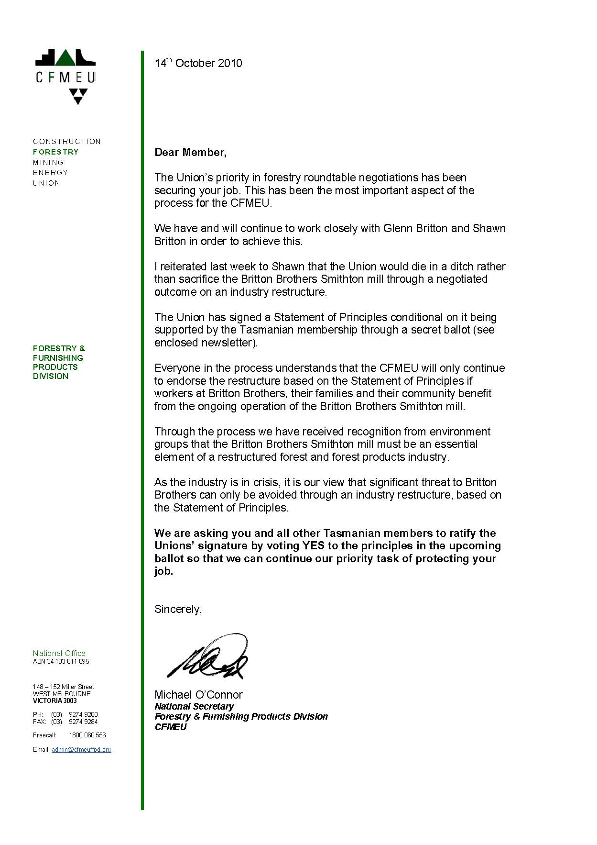

6.2. Tasmanian Country Sawmiller’s Federation (TCSF)

This factual position is prepared against some historical data.
- Since 1990 country sawmills have declined in numbers from 85 to 26.
- Most country sawmills measure investment in the millions of dollars with the majority of investment occurring during the past 12 years, and in particular, the last five years.
- Most country sawmills are green mills.
- As private log resource has decreased country sawmills have increasingly relied on Forestry Tasmania (FT) for log supply. Such log supplies tend to be lower grade logs.
- Some mills receive logs from surplus log harvesting production – the classic Malthusian trap.
- Log consumption varies from 3,000 to 70,000 M3 p.a. with an estimated medium of 10,000 M3 p.a.
- All country sawmills sell solids into the Australian domestic market and residues to chip exporters.

Factual Position
- The exchange rate of the Australian dollar coupled with a lowering of the international woodchip price for native forest sourced woodchips has generally lowered sawmill woodchip prices from $67.00 to $42.00 per tonne. This has had a debilitating effect on sawmill viability, particularly green mills.
- There is now strong competition in international markets for the supply of eucalypt woodchips e.g. Vietnam is increasing output from 0.5 million tonnes to 4.5 tonnes at reported price of AUD 55.00 per tonne.
- There are strong alternatives to Tasmanian suppliers of chips within Australia e.g. the green triangle.
- Log size (age) and grade is declining while log prices continue to rise.
- Most country sawmills have unfulfilled order books but at prices 20 to 30 per cent below value. This is a combination of spot market sales and the price at which imported timber is sold.
- Most country sawmills are weary of the forest wars and the uncertainty as to their future which accompanies every enquiry into the industry. The majority of country sawmills would accept a fair compensated exit package if it were offered. G2.
- Mills continue to receive adequate volumes of logs but with a sense of ‘what will happen tomorrow?’. There is a pervasive sense of uncertainty.
- The overall factual position of country sawmills is twofold:
    - Adequate resource and economic disposal of mill residues or
    - Compensable exit of the industry
- Several country sawmills are confident of their ability to convert plantation logs into boards for kilning but show no enthusiasm to carry out the kilning process.

6.3. Australian Conservation Foundation (ACF), The Wilderness Society (TWS) and Environment Tasmania Inc (ET)

Overall Comments:
- The 3 ENGO signatories are fully committed to the implementation of the Statement of Principles in full
- This is a once in a generation opportunity to deliver a lasting solution to the conflict over forests in Tasmania, if delivered, it will be historic and nationally & internationally significant
- The delivery of this solution is critical to the future of Tasmania’s economy, regional communities, community cohesion and natural environment
- The success of the process will require very clear commitment now from both governments to strongly back the implementation of the Statement of principles and start delivering interim outcomes – clear commitments from both governments to the delivery of the principles in full will need to be seen within a short period after the delivery of the interim report.

- Conduct of the process:
The process by which signatories meet and make decisions is fair and prejudices no one. There are significant areas of agreement and areas where agreement still needs to be reached.
- Implementation of the principles:
ENGO’s believe that Governments needs to demonstrate more willingness to quickly respond to decisions of the signatories.
- Urgent issues that relate directly to the principles that must be addressed:
- The implementation of a moratorium on logging in the ENGO identified HCV reserve proposal areas.
- The identification of secure wood supplies outside of the HCV areas to meet the needs of industry while the process is underway
- The identification of a compensable exit mechanism and associated packages to reduce the volume of sawlog production in Tasmania
- Legislative change to reduce to agreed sawlog volumes that reflect exited sawlog volumes and mechanisms for transition over time
- Legislatively Securing areas of forest for reservation by the Tasmanian Government
- The commencement of a series of studies to underpin the work of the signatories

These sets of issues are inextricably linked. Progress has been made in that a verified boundary of ENGO areas proposed for reservation as per the Statement of Principles has now been agreed. Various resource scenarios can be determined but these and the underlying assumptions used to model these scenarios need to be independently assessed. This will require funding.
Financial resources to undertake rescheduling work to progressively implement a moratorium will be needed. This money will need to be provided by either the Federal or State Government. The Tasmanian Government has agreed that a moratorium must be implemented. This implementation of a moratorium is critical for ENGO’s to be able to demonstrate to their constituencies that negotiations are proceeding in good faith.
Forestry Tasmania has not acted in good faith in respect of the implementation of a moratorium and interim wood supply arrangements. The failure of State Government to direct FT over implementation of the moratorium, and that it took two and a half months to finally have an admission to the signatories that this was so, points either to failed processes or deliberate obfuscation. Clearly this needs to be addressed for this process to have a reasonable chance to succeed. This situation reflects the institutionalised power of the agency. In the near term the Tasmanian Government must be able to deliver and expect to have implemented clear instructions to Forestry Tasmania. In the medium term the restructuring of this agency will be critical to the success or failure of any final agreement.

Work by the federal government should proceed in parallel to identify a mechanism / mechanisms for compensable exit and the assistance packages for mills, workers, industry participants without contractual rights and contractors still wishing to exit. This work should be undertaken in consultation with the signatories and begin immediately.

ENGO’s have provided for information a table that looks at the possible financial scale of assistance (Appendix 1).

The Tasmanian Government needs to agree, at least in principle to the gazettal of new reserves. ENGO’s believe that the simplest mechanism is to move these areas from multiple use forests to conservation areas (the most basic reservation class under Tasmanian legislation) with a transparent process for determining final reservation tenure to follow. However ideally these forests should become IUCN protected areas categories I – IV.

Similarly the Tasmanian Government will need to make legislative changes to the Forestry Act to reduce its legal obligations to supply Category1 and 3 sawlogs. The quantum of this reduction will need to be agreed between signatories following the resource analysis and the quantum of resource that is identified for exit through the compensable exit mechanism. The Tasmanian Governments needs to agree in principle to undertake this reform.

A clear time-table needs to be set-up and started for the legislative protection of the areas for gazettal and legislative mechanisms to enable the reduction of the HQSL quota and a transition.

A budget needs to be identified to undertake a range of consultancies to underpin the work of the signatories.

Governments currently setting budgets need to identify provisions to resource this process and the implementation of agreements.

- Investment in downstream processing of plantations
It is recognised by the three environment groups participating in the process that the development of a diverse downstream processing sector including a range of plantation processing options is a critical component of a long-term solution to the conflict over forests in Tasmania.
Significant work needs to be done in assessing the opportunities for improved management regimes and diversifying the plantation processing and investment options and opportunities for Tasmania, particularly for the creation of a range of solid-wood products, and particularly in the interests of providing for regional processing jobs in the timber sector.
The three ENGO organisations have met Gunns to discuss their respective policy positions and concerns in relation to the environmental issues associated with any pulp mill proposal in Tasmania, including their concerns and grievances in relation to the current proposal. Gunns has voluntarily sought to impose tougher restrictions on the pulp mill permits for the current proposal. This was welcomed by the ENGO’s though we must reserve our judgment until we see any changes made, and it is stressed that this does not imply support or endorsement from the ENGO’s for the current proposal. Environment Tasmania’s members will be separately meeting with Gunns in two weeks’ time.
It is the view of the ENGO’s that the abandonment of the initial independent assessment process and the fast tracking of the new assessment process in 2007 has resulted in a critical loss of trust and confidence of the Tasmanian community in both the company and the Tasmanian Government in relation to the current proposal. The ENGO’s remain convinced that a proper public process that has the confidence of the Tasmanian community is essential for the success any pulp mill proposal in Tasmania, and / or any downstream plantation processing investment in Tasmania for that matter. There remains very significant opposition to the current Gunns Tamar proposal in the Tasmanian community.
It is understood by ENGO’s that investment in downstream processing of plantations in Tasmania, and the Tasmanian forest Industry as a whole, is critically dependant on the resolution of the Tasmania Forestry conflict and the implementation of a durable lasting Agreement.
- Transition out of native forest and related other principles.
The work to determine the length of time and resource requirements required to implement a transition will take time and will require that the urgent issues addressed above are dealt with expeditiously. Related to this is the identification of a permanent area of forest to be set aside for the production of specialty timbers for use by the Tasmanian craft and high value furniture industry.
ENGO’s have discussed with other signatories the need to examine alternative silvicultural models to provide suitable plantation wood for a range of purposes to ensure that a transition can be effectively implemented. Possible investment models should be explored as part of any consultancy work undertaken.
- Financing regional transition strategies and non extractive uses of the forest
It is very clear that significant investment will be required to restructure the forest industry and regional economies. ENGO’s welcome the engagement of Professor Jonathan West to undertake some of this work.
We have identified a number of possible sources of finance. These include but are not limited to: facilitated investments in new agro-forestry models; avoided forest degradation (carbon) payment; carbon farming initiatives; regional infrastructure and national infrastructure grants and a comprehensive regional economic transition package.
- Commitment and Support for the development of a National FSC Standard.
Critical in delivering market access for a sustainable forest industry is the need for robust standards. The work of FSC Australia would be rapidly enhanced if the Federal Government could provide some funding support for the National Standard setting process as soon as possible.
- Public participation, engagement & communication about the process
There is a widespread public desire and need for more information about the Forests principles process, and there will be a need for State & Commonwealth governments to set-up public engagement and consultation mechanisms for relevant parts of the statement of principles to ensure for community wide buy-in and engagement in the solution.
- Concluding comments
Whilst the process with Bill Kelty, and indeed the ENGO focus to date, has been on some of the critical and time bound issues, it is the view of the ENGO’s that the Statement of Principles will need to be delivered in full for the process to deliver a solution that is lasting and wholistic. Mechanisms will need to be developed and agreed upon for the delivery of all of the Principles encapsulated in the Agreement.
Appendix 1 - ENGO’s recommendations on compensation payments for reduction of crown log quota

The compensation cost of an immediate reduction in crown native forest licenses has been assessed under a 50% reduction scenario and a 67% reduction scenario.
Compensation has been calculated for the loss of Category I, Category III and veneer sawlogs at the rate of $300 per cubic metre. This rate has been assessed against rates used in native forest license buy backs during the last decade in Australia and appears reasonable.

Compensation costs have also been estimated for employee retraining and relocation and for loss of income to harvesting and haulage contractors.
These numbers are, by definition, broad estimates however they give a reasonable feel to the levels of compensation likely to be required.

 | 50% Buy back | 67% Buy back
Compensation to mills for loss of crown quota | $45.0m | $60.0m
Retraining and relocation assistance to employees | $14.5m | $19.5m
Compensation to harvesting and haulage contractors | $19.2m | $25.6m
TOTAL COST OF BUY BACK | $78.7m | $105.1m

The cost of implementing an immediate buy back is estimated at between $79 million and $105 million depending on the level of reduction between 50% and 67%.
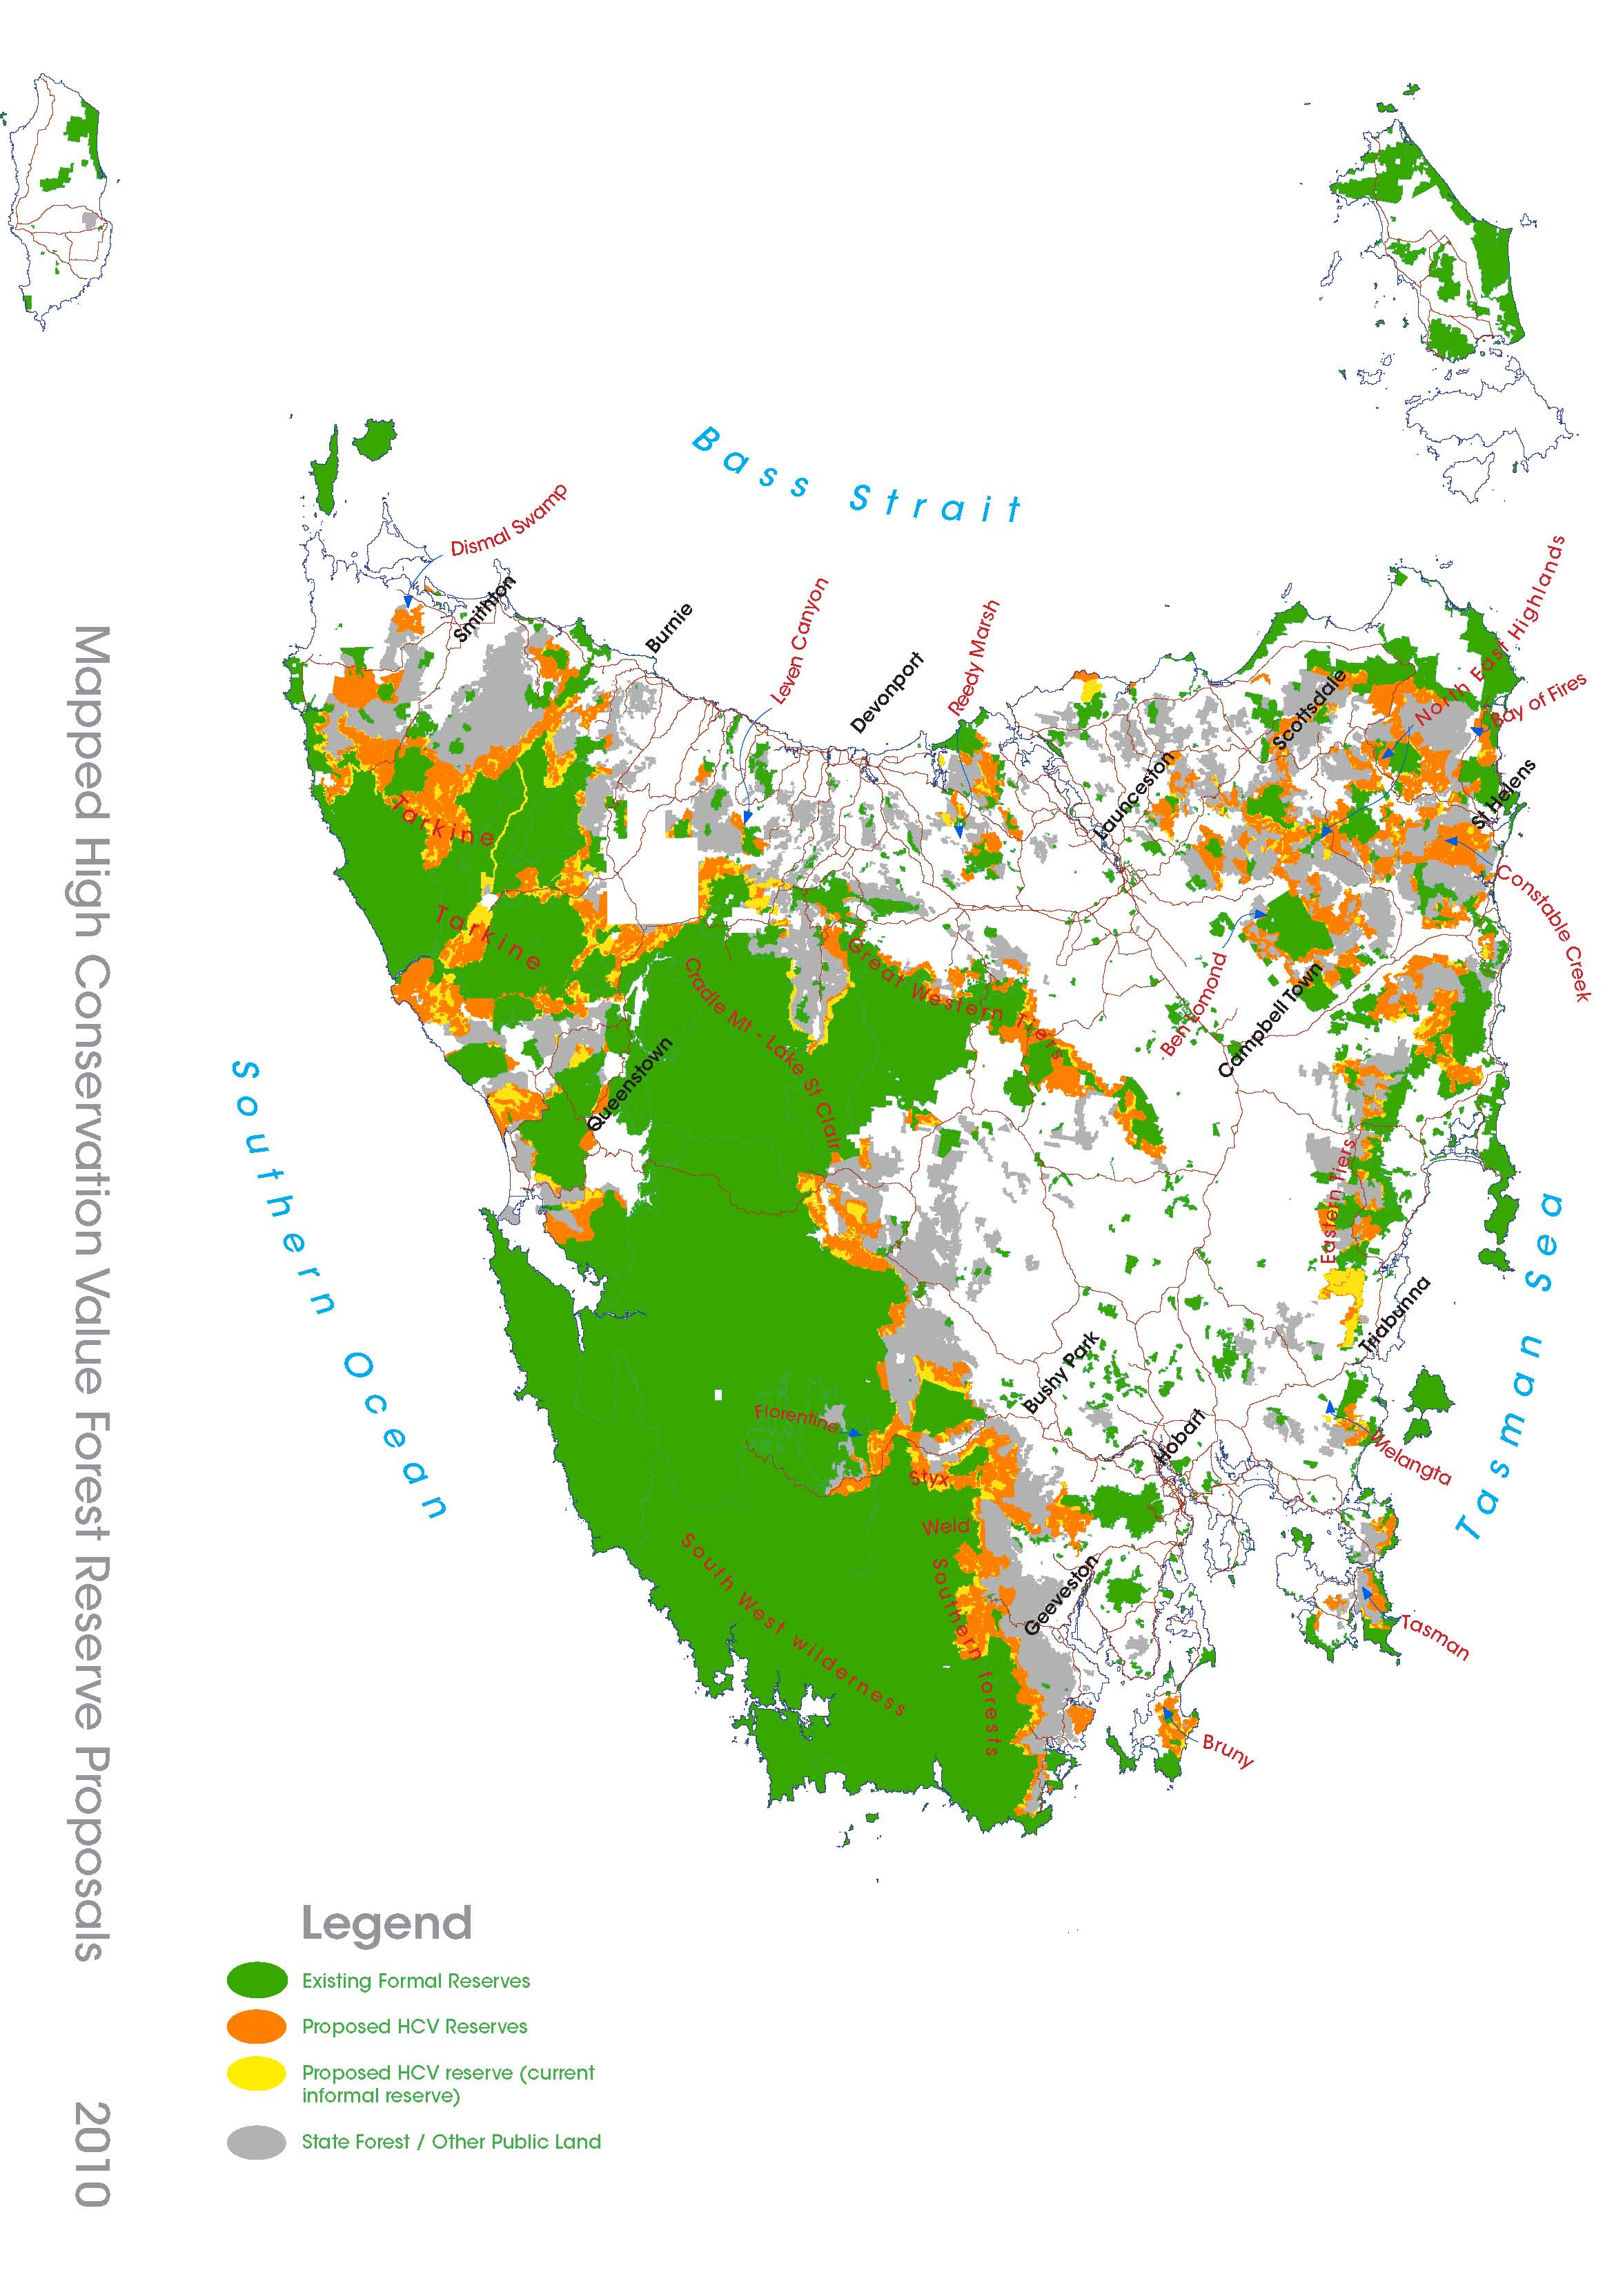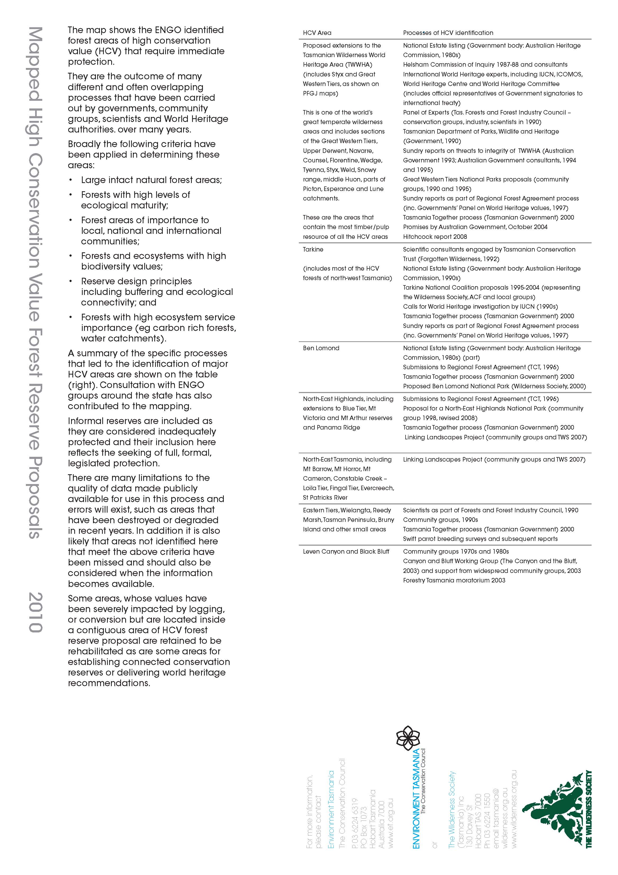

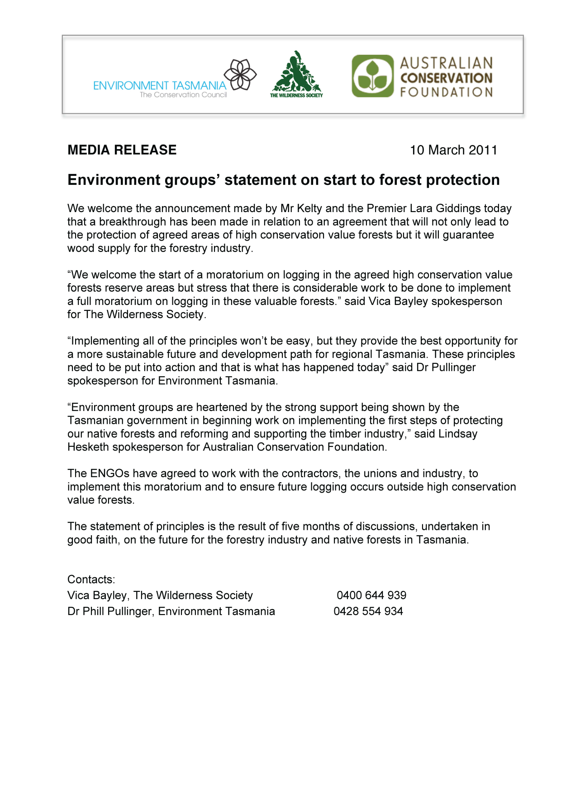

6.4. Timber Communities Australia (TCA)

TCA supports the following intentions of the negotiations; (our commitments);

- To ensure that long term compensate-able contracts for the supply of adequate volumes and grades of logs to all remaining current participants in the native forests processing sector are delivered.
- To achieve the construction of a pulp mill at Bell Bay.
- To ensure that forests containing independently determined High Conservation Values are appropriately managed.
- That to the extent that it is driven by the determination of HCVF, any further transition from native forests to plantations occurs only when the substitute resource in the required volumes and quality and at the required locations is available.

TCA’s positions in respect of the talks (our conditions) remain as outlined in TCA Board letter to the Premier dated 8th Oct 2010 and include;

- Any decision to put additional forest areas into reserves must be supported by verification of the conservation values within those areas. This requirement is consistent with the intentions of the “verification” document attached to the Principles as negotiated by TCA. No area should be permanently reserved until such verification has been independently determined.
- There must be a comprehensive and sophisticated assessment of the regional social and economic impacts of any outcome of the negotiations.
- There must be comprehensive and sophisticated packages designed, funded and implemented to manage and mitigate the impacts of any adverse outcome of the negotiations.
- The durability of any outcome to the negotiations must be ensured through;
- No party having their outcomes “front-ended”, that is all agreements are to be implemented only when full agreement is reached, no early implementation.
- All parties having “structured” incentives to see the whole process through in order to achieve their outcomes.
- A comprehensive package of complementary State and Federal legislation to secure the outcomes, including formal review mechanisms, resource security and meaningful penalties for breaches of either.

Notes; (our suggestions);

TCA considers that negotiations around areas and volumes should include;
- consideration of a wide range of options including alternate silvicultural management systems,
- certification impacts,
- appropriate productive management options in areas of lesser conservation value within existing and new reserves,
- options for improving access to areas of marginal management viability, for the duration of any transition period
- The use of improved optimisation options in available areas.
- maintenance of economically viable options for utilisation of harvesting and processing residues, including wood biomass

6.5. The Forest Industries Association of Tasmania (FIAT) and The National Association of Forest Industries (NAFI)

Executive Summary
Following the public announcement by Gunns Ltd of their intent to exit the native forest industry of its own volition and the ‘Statement of Principles to lead to an agreement on Tasmania’s forests’ (Statement of Principles), there is a real opportunity for the remaining native forest industry in Tasmania to consolidate and plan for a growing, sustainable future. This future should be based on a continuing reliance on sustainably managed native forests but with a growing proportion of wood supply being sourced from suitable plantations over time.
Key issues
Resource security
- Immediate resource security for the growing processing and the harvest and haulage sectors, their workers and reliant communities is essential in any future discussions on the future of Tasmania’s forests and forest industry.
- The industry requires a reconfirmation of the Tasmanian Premier’s commitment of 8 October 2010 for the guaranteed extension of wood supply contracts to at least 2027.
- Tasmania’s specialty timbers are world renowned for their quality and characteristics for a range of high value purposes, including furniture, boat building, cabinet making and craft purposes. Supplies of these highly valued timbers must also be guaranteed at equitable & commercially viable levels.
Transition
- The Forest industry is prepared to explore the potential of a transition toward a greater reliance on suitable plantations. The level and timing of transition should be determined only after a thorough investigation of the technical and commercial aspects of growing and processing logs of suitable quality and characteristics to meet the needs of the remaining native forest industry.
- Any transition toward a greater reliance on plantation wood should be developed through a negotiated plan, with progress subject to achievement of tangible milestones, for example: any reductions in availability of native forest wood will only be considered once plantations of the right quality and quantity, in the right location and price are available.
Moratorium
- Subject to a guaranteed sustainable and compensable quantity and quality of wood supply from FT to all remaining processors in the industry, the industry is supportive of a progressive moratorium on old growth and other high conservation value forests as identified by ENGO’s.
- The suspension of logging of these coupes should continue until these forests have been independently, scientifically assessed and verified for their high conservation values. An appropriate plan for the future management of verified high conservation value forests will be determined through an appropriate management plan and based on a comprehensive community stakeholder process. Noting that verification of HCV forests does not necessarily mean that forest management and harvesting activities are excluded from the future management of HCV forests.
Industry Growth
- The Gunns Ltd commercial decision to exit from native forest activities in Tasmania of their own volition has already resulted in the loss of around 700 direct jobs in processing and harvest and haulage. There has also been a resulting cost to the remaining industry in terms of investment and market uncertainty. These losses are expected to escalate as Gunns finalizes their exit strategy and divests itself of native forest processing assets and stocks.
- Though the development of the Tamar pulp mill will hopefully assist in addressing this loss, there is still some uncertainty surrounding the finalization of commercial arrangements for the mill and associated timing of construction of the mill.
- However, the job losses and costs associated with the exit of Gunns from the industry can be largely offset through increased investment in the remaining industry – but this will require immediate – long term resource security and a long term plan to grow the industry.
- The future of the industry needs to be assessed recognizing the essential integrated linkage between the sawmilling, veneer processing and the management of harvest and processing residues from these activities.
Requirements from the ENGOs
- ENGO support for the Tamar pulpmill;
- ENGO’s to cease targeting of the forest industry in the forests, markets and Boardrooms;
- ENGO signatories to publicly distance themselves from un-condoned activities;
- Development of alternative conflict resolution approaches between ENGO’s and Industry;
- Joint promotion activities for forest products; and
- ENGO support for the development of key policies, including mechanisms to facilitate investment in plantations and facilitation of bioenergy from sustainably managed forests.
- Pathway for each processing facility to be endorsed by ENGO’s.
- Positive approaches in relevant markets to support the sustainable nature of Tasmania’s forest products.

6.6. Tasmanian Forest Contractors Association (TFCA)

TFCA’s involvement in the Statement of Principles is as a result of the long held belief of the Association that there was, and is a need for fundamental restructure of the Tasmanian forest industries: i.e. That the industry in its current format was not sustainable either economically, socially or environmentally and especially not for contractors.

The economic basis for this position is clear cut:
- Forest contractors currently represent the largest capital investment, by sector (arguably after landowners/forest growers) with in excess of $600 million in the harvest and haul sub-sectors alone. (TFCA Surveys 2006, 2007, 2009, 2010), carry the largest risk and have accumulated losses of $145 million between July 2005 and June 2010 (AFCA Report – Col Shipard - 2010).
- This sub-sector has the largest recurrent investment in all forest industry sectors, at an average of over $90 million per annum. (TFCA Surveys 2006, 2007 2009 2010)
- The real return for native forest woodchips has declined at an average of 3.9% PA since 1992-93 (Australian Commodities Vol 10 No.1, March Quarter 2003)
- While “global import demand for woodchips is increasing”, the “export supply of woodchips will increase even more” leading to a continuing decline in real prices for woodchips. (ANU Forestry Market Report – March 2004)

There has been an expansion of the eucalypt plantation estate in lower production cost countries. For example, Vietnam is now an exporter of plantation eucalypt chips.
That the rest of the industry, and governments both state and federal, have not been prepared to accept or act on this information does them no credit.

The facts as understood by TFCA are:
- That the industry needs restructure to cope with the changes, both market, social and environmental.
- There will be a moratorium of so-called high conservation value crown forests, combined with exit assistance for affected businesses, workers and communities.
- There will be an adequate volume of viable hardwood sawlogs provided to that of the processing sector that choose to remain, for these businesses to continue.

TFCA are committed to achieving a number of outcomes through this process including:
- Programs to enable a dignified exit from the industry for forest contractors, their workers and communities.
- Amendment of the state Fair Contracts Legislation and/or the federal Trade Practices Act, to give contractors the right to be represented either individually or collectively, to minimise the current market power imbalance in the industry.
- Licensing of site foremen and contract holders to ensure at least a minimum standard of understanding of the environmental, OHS and other risks that impact on forest contractors
- An improved model for silvicultural contractor engagement
- An environment that encourages “bankable” contracts.

A major issue over the next two years will be the retention of critical skills within the sector to enable survival of the industry into the future.

Gunns Bell Bay Pulp Mill and their decision to exit the native forest is, to some extent separate, while providing the opportunity for an agreement to be forged.

However, it is beyond rational dispute that, regardless of Gunns actions the native forest industry in Tasmania is in deep trouble. The notion that it is “a Gunns problem, not an industry problem” is a denial of a significant number of underlying facts combined with a, possibly deliberate, refusal to accept the interconnectedness of all the sectors of the industry.

The consequences of not achieving an agreement through the current process would be catastrophic for the Tasmanian hardwood forest industry, the communities which rely on it and the state as a whole. This is not an acceptable option.

6.7. The Forest Industries Association of Tasmania (FIAT), The National Association of Forest Industries (NAFI) and Tasmanian Country Sawmiller’s Federation (AFCA)

