7. Annexure 2. Non Signatories

7.1. Nick McKim MP - Greens Leader, Member for Franklin, Tasmanian Greens

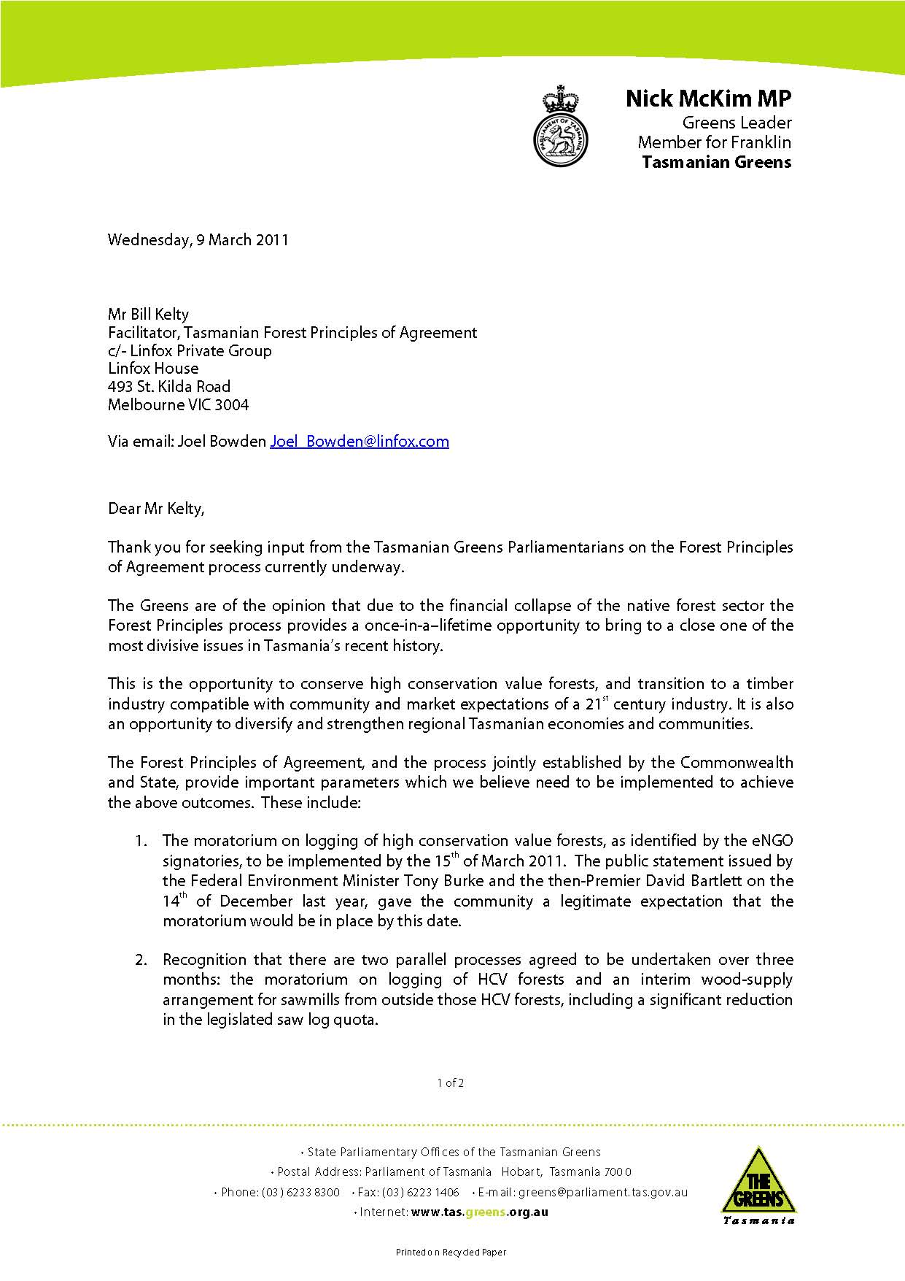
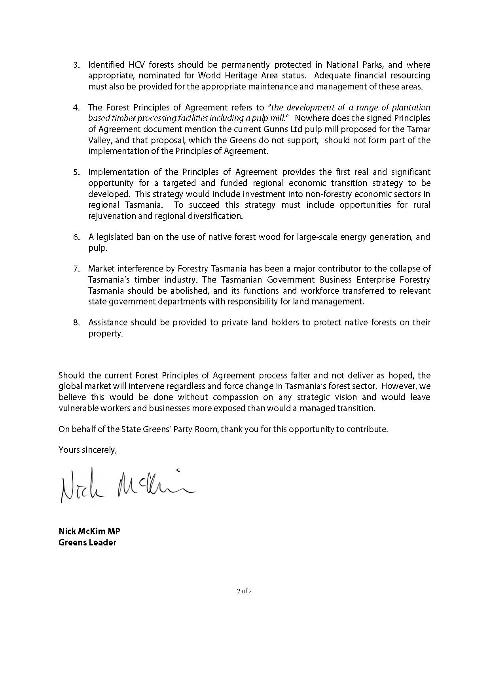

7.2. Native Forest Industry

Background
Following the public announcement by Gunns Ltd of their intent to exit the native forest industry of its own volition and the ‘Statement of Principles to lead to an agreement on Tasmania’s forests’ (Statement of Principles), there is a real opportunity for the remaining native forest industry in Tasmania to consolidate and plan for a growing, sustainable future. This future should be based on a continuing reliance on native forests but with a growing proportion of wood supply being sourced from suitable plantations over time as sufficient quality and quantity of plantation grown resource becomes available.

There is also a real opportunity to explore whether there is a justifiable scientific or community need to reserve additional areas of native forest to supplement Tasmania’s existing and world leading national park and forest reserve system.

In considering its response to the events of the last six months and in preparation for any future process that may arise, the industry thought it important to outline its Vision for the future. The foundation of the Industry’s Vision is achieving a balanced triple bottom line outcome –social, economic, and environmental, free of the social conflict of the past. Our vision is as follows:

TASMANIAN FOREST INDUSTRY – VISION

A Vision for Tasmania’s forest sector
A sustainable and profitable forest and forest products industry which:
- compliments the maintenance and enhancement of social and ecological values;
- makes a significant contribution to Tasmanian society by value adding timber produced from forests identified for timber production and managed sustainably;
- produces high quality sawn products, veneers, and special timbers; engineered products, solid wood products, commodity grade timbers as well as fiber based products;
- can respond to changing markets and provide renewable and carbon friendly products and services;
- enjoys broad support from the Tasmanian community including the media and political process, recognizing the industry's valued contributions to the economy, social outcomes and forest management for a wide range of our communities legitimate forest values; and
- A forest estate that is managed for balanced triple bottom line outcomes – social, economic and environmental, free of the social conflict of the past.

Environmental outcomes:
To achieve the following based on the best science available:
- Maintain and enhance the biological diversity in our forests;
- Contribute to maximizing the sequestration of carbon;
- Aim to ensure that Tasmanian forests are carbon negative i.e. sequester more carbon than they emit;
- Protect identified values that demonstrably need to be protected;
- Promote management activities in high conservation value forests to maintain or enhance the attributes which define such forests;
- Ensure management activities reduce the likelihood of catastrophic wildfire;
- Promote sustainable forest management and certification of public and private forests; and
- Combat introduced species.

Social outcomes:
To achieve the following:
- Retain the decentralized population demographic of Tasmania (i.e. avoiding the drift of population to the bigger cities);
- Provide worthwhile career paths for Tasmanians who are interested in working in the industry, working outside, working with their hands, contributing to the management of the Tasmanian landscape, maintaining Tasmania’s biodiversity, seeing whether Tasmania can become a carbon negative jurisdiction;
- Provide proper packages for adversely effected businesses and their workers including exit assistance, redevelopment pathways, financial assistance and employee retraining for those who are not able to remain in the industry;
- Provide fair, secure and compensable contracts for those who remain in the industry backed by legislation;
- Ensure the forest industry is valued and supported by the wider community; and
- Ensure the forest industry engages effectively with the community.

Economic outcomes:
To achieve the following:
- Ensure continuing industries remain viable;
- Recognize one of Tasmania’s most sustainable competitive advantages is the growing of forests;
- Develop a highly skilled and valued workforce operating in a safe environment;
- Establish new age sustainable industries based on sustainable forest production;
- Use the solar energy captured in our forests as a contributor to a carbon neutral economy; and
- Maintain the forest industry as a key driver of Tasmania’s economy.

Implementation of the Vision
This paper outlines the Tasmanian forest industry’s position on key issues arising from the Gunns exit and Statement of Principles and the requirements for achieving a long term, sustainable and socially durable outcome for Tasmania’s forests, the forest industry, its workers and the communities that rely on it. These requirements are also essential for the industry to achieve its Vision.

Key Issues
Resource security
Immediate resource security for the growing processing and the harvest and haul sectors, their workers and reliant communities is essential if any future discussions on the future of Tasmania’s forests and forest industry are to proceed. The Tasmanian Premier has recognized this requirement and has guaranteed the extension of wood supply contracts to at least 2027. The industry welcomes this commitment and would also like to explore extensions past 2027 to align wood supply agreements with the renewal and extension of the Tasmanian Regional Forest Agreement (RFA).

Tasmania’s specialty timbers are world renowned for their quality and characteristics for a range of high value purposes, including furniture, boat building, cabinet making and craft purposes. Supplies of these highly valued timbers must also be guaranteed at equitable & commercially viable levels.

Requirements:
- Forestry Tasmania (FT) will enter into immediate negotiations with all remaining native forest wood processors (includes crown and country sawmillers) that hold native forest wood supply contracts to extend these contracts to 2027. The contracts must be compensable, will guarantee volume and quality and will have a mechanism to set price and other core contract provisions. Discussions will also explore options for extension past 2027 to further facilitate long term investment plans by the industry and to align contracts with the renewal of the Tasmanian RFA;
- As part of the establishment of long term wood supply to 2027 and beyond, ongoing specialty timber supply including eucalypt should be guaranteed for high value furniture, boat building, cabinet making and craft industries.;
- Sustainable regionally based resource supply profiles outlining minimum quantity and quality requirements will be underpinned by legislation. Our assessment of the minimum resource requirement for the remaining processing industry is at Annexure A, noting that this is a minimum resource requirement and does not include additional resource required for ‘growth’ of the industry;
- Resource supply pathways for each processing facility must be prepared and signed off by ENGO; and
- Harvest and haul associations will start immediate discussions with the processing associations and FT to develop ‘fair go’ contracts between processors and the harvest and haul sector that recognise the long term certainty required by the harvest and haul sector. These contracts will be implemented once long term wood supply contracts between FT and wood processors are settled.

Transition
The Forest industry is prepared to explore the idea of a transition toward a greater reliance on suitable plantations. However, the level and timing of transition should be determined only after a thorough investigation of the technical and commercial aspects of growing and processing logs of suitable quality and characteristics to meet the needs of the remaining native forest industry and the potential requirements for emerging industries. Any transition toward a greater reliance on plantation wood should be developed through a negotiated plan, with progress subject to achievement of tangible milestones, for example: any reductions in availability of native forest wood will only be considered once plantations of the right quality and quantity, in the right location and price are available.

Requirements:
- A comprehensive assessment of:
- Quality and quantity of public and private native forests;
- Quality and quantity and utility of existing plantation resources- particularly the E nitens resource; and
- A mapped resource profile for each processing facility to demonstrate supply capacity to 2027 and beyond.
- As assessment of the technical and commercial feasibility of establishing suitable plantations. The following questions need answers:
- what species;
- where – public – private land and location;
- how – public or private funding mechanisms; and
- why – long term economic, social and environmental costs and benefits.

Moratorium and HCV forests – Management of Reserved areas
Subject to a guaranteed sustainable quantity and quality of wood supply from FT to all remaining processors in the industry, the industry is supportive of a progressive moratorium on old growth and other high conservation value forests as identified by ENGO’s. The suspension of logging of these coupes should continue until these forests have been independently, scientifically assessed and verified for their high conservation values. An appropriate plan for the future management of verified high conservation value forests will be determined through an appropriate management plan and based on a comprehensive community stakeholder process. Noting that verification of HCV forests does not necessarily mean that forest management and harvesting activities are excluded from the future management of HCV forests.

Requirements:
- An accepted definition of HCV;
- An assessment and recognition of existing HCV and other forests already in reservation in Tasmania; and
- A transparent scientific and community stakeholder based process to inform the future management plans for forests that are verified as HCV.

Industry Growth
The Gunns Ltd commercial decision to exit from native forest activities in Tasmania of their own volition has to date resulted in the loss of around 700 direct jobs in processing and harvest and haulage. It has also resulted in cost to the remaining industry in terms of investment and market uncertainty. These losses are expected to escalate as Gunns finalizes their exit strategy and divests itself of native forest processing assets and stocks.

Though the development of the Tamar pulp mill will hopefully assist in addressing this loss, there is still considerable uncertainty surrounding the finalization of commercial arrangements for the mill and associated timing of construction of the mill. However, the job losses and costs associated with the exit of Gunns from the industry can be largely offset through increased investment in the remaining industry – but this will require immediate – long term resource security and a long term plan to grow the industry.

The decision by Gunns Ltd to exit the native forests industry provides an opportunity for the remaining industry to consolidate and plan for future growth in the industry. The Tasmanian native forest industry is already world renowned for high quality eucalypt and specialty timbers for high value uses. The harvesting activities for the sawmilling and rotary peeled veneer industry also creates significant volumes of lower grade pulp logs that are largely processed into woodchips and exported. These two activities are commercially integrated to maximize efficiency, utilization and commercial return. The export wood chips from Tasmania assist in addressing Australia’s trade deficit in wood products. The future of the industry needs to be assessed recognizing the essential integrated linkage between the sawmilling, veneer processing and the management of harvest and processing residues from these activities.

The native forest industry in Tasmania has in recent years invested millions of dollars into value added processing in the State. There are significant opportunities for the industry in traditional processing activities (including pulp and paper and engineered wood products) as well as emerging ‘climate change’ activities such as bio energy. These activities can provide new investment and employment opportunities for timber based communities in Tasmania and can assist in offsetting some of the employment loss and human cost as a result of the Gunns decision to exit native forest industry. However, these opportunities can only be identified and realized when the future availability of wood supply is known and secured.

Requirements:
- A full assessment of the native forest and plantation resources in the State and the potential to expand the plantation resource; and
- The identification of processing opportunities for the industry in the short – medium and longer term, including traditional processing opportunities and emerging opportunities; such as bioenergy.

A sustainable native forest resource
The Vision for Tasmania’s forest industry can only be realized if the industry has certainty that it is using a sustainably managed native forest resource. The community and many commodity markets are now demanding that our native forests are managed in a ‘proven’ sustainable way. The responsibility for the sustainable management of Tasmania’s native forest is with FT and the Forest Practices Authority. It should be noted that Tasmania’s forests that are used for wood production also provide a range of other community based products and services, such as recreation, biodiversity management and bushfire protection. Though these community service costs are borne by FT and passed on to their customers, there is an argument that they should be covered by the broader Tasmanian community. The full range of community values from our native forests can only be sustainably delivered if we have an efficient and viable public forest manager and forest regulation organization.

Requirements:
- Encourage and assist forest growers in Tasmania to obtain independent third party audited certification to international standards;
- Ensure FT remains a viable forest manager of Tasmania’s public native forests;
- Conduct a review of the Forest Practices Authority & the impact of the Forest Practices Code on wood supply; and
- Fund FT’s community service obligations from Government funds.

Legislation
The development and implementation of a durable long term plan for the future management of Tasmania’s forests and the growth of the forest industry will require appropriate changes to existing State and Federal legislation. The industry supports the bipartisan view of the Tasmanian Government and Opposition for the renewal and extension of the Tasmanian RFA and its conversion to a durable evergreen 20 year agreement. It is the Industry’s view that any agreed plan for the future management of Tasmania’s forests and the growth of the forest industry should be implemented under the RFA framework to provide long term resource security to encourage investment and innovation.

Outcomes sought from the ENGO’s
As a result of the numerous processes to address the forest debate, the forest industry, its workers and communities have undergone considerable human and economic costs. This has been in the hope that there will finally be an enduring agreement between the industry, ENGO groups and the Government on the management of Tasmania’s native forests that will bring an end to the conflict in the forests, markets and Boardrooms.
The spirit of the Statement of Principles is to achieve an enduring agreement. However, in contrast to previous processes, just as the forest industry, its workers and communities will deliver outcomes toward an enduring agreement it is also expected that the ENGO groups will do likewise.

Requirements:
- ENGO support for the Tamar pulpmill;
- ENGO’s to cease targeting the forest industry in the forests, markets and Boardrooms;
- ENGO signatories to publicly distance themselves from un-condoned activities;
- Development of alternative conflict resolution approaches between ENGO’s and Industry;
- Joint promotion activities for forest products;
- ENGO support for the development of key policies, including mechanisms to facilitate; investment in plantations and facilitation of bioenergy from sustainably managed forests;
- Pathway for each processing facility to be endorsed and supported by ENGO’s; and
- Positive approaches in relevant markets to support the sustainable nature of Tasmania’s forest products.

Carbon Sequestration & Pricing
The Australian government has publicly committed to the establishment of a price on carbon as part of its response to the climate change debate.

Forestry can play an important even critical role in climate integration and adaption through carbon storage and substitution benefits from renewable forest products. The forest industry can significantly assist in the transition to a low emissions future through:
- Carbon stored in sustainably managed forests;
- Carbon stored in durable wood products & substitution for more emissions intensive building materials such as concrete, steel, aluminum and masonry; and
- Green energy produced from forest & processing residues offsetting emissions from fossil fuels based energy.
There is a need to clearly determine and agree the role that the Tasmanian forests and forest industry can play within the carbon debate.

Requirements:
An immediate review of the opportunities for the forest industry relating to carbon storage and substitution benefits, including:
- An assessment of carbon stored in Tasmania’s sustainably managed forests and plantations;
- An assessment of carbon stored in wood products and the benefits of substituting these products for more carbon intensive building materials;
- An assessment of the opportunities for green energy produced from forest and processing residues to offset fossil fuels; and
- This review should provide an input to shaping a future plan for the Tasmanian forest industry.

Research & Development
The changes proposed within the industry in Tasmania are significant and will require an extensive, highly focused program of research and development to permit the maximization of benefits to be derived from the outcome on a triple bottom line basis.

The significant reduction in the size of the industry proposed in the current process will lead to reduced capacity of industry to undertake the research and development activities required to underpin a successful implementation program.

The requirements to produce a successful transition from native forest resources to plantation grown resources are not well understood in an Australian and more specifically a Tasmanian context and will require careful scientific work to be undertaken.

The contribution of the Tasmanian forests and forest industry to a carbon mitigation program likewise are not well understood particularly the valuable contribution of different forest types and different age classes of forests; these are issues that need to be understood through rigorous scientific research.

The potential to utilize the existing plantation estate especially the pruned and thinned E nitens resource that is not suited to traditional sawmilling uses for high quality appearance grade products requires extensive evaluation and assessment along with market research. This will be beyond the capacity of the restructured industry in Tasmania to achieve.

Requirements:
- Retain the CRC for forestry centered within the University of Tasmania;
- Funding for targeted research , development and extension activities associated with the growing, processing and seasoning properties of plantation grown wood for high value market sought products;
- Funding to research the capacity of the Tasmanian growing environment to sustain a plantation resource suitable to replace the high quality native forest resource; and
- Creation of an innovation fund that will allow access for potential investors in the industry to develop new processing technologies with an emphasis on a plantation resource.

Industry Lobby Security
The decision by Gunns Limited to voluntarily exit all native forest based activity in Tasmania and the consequent potential significant reduction in the size of the Tasmanian forest and forest products industry creates a significant concern over the viability of existing industry representative bodies.

It is considered to be vital that a capacity for a centralised leadership during the extensive changes envisioned by the implementation of the Statement of Principles is retained and fostered. Industry require a properly resourced representative structure to advise on strategic direction and to liaise with all levels of government over the complex issues associated with a fundamental restructure and repositioning of the Tasmanian industry.

The absence of this centralized leadership will lead to significant fragmentation of direction as individual economic units seek out their own, often competing strategic outcomes within a restructured industry. This will lead inevitably to sub optimal outcomes from the restructure.

Requirements:
- Government assistance in the development of strategic analysis of existing representational structures with a view to ensuring a strong, viable and sustainable industry lobby capacity; and
- Interim assistance to existing representative organizations to ensure an effective role in the negotiation process leading to an implementation agreement.

Marketing and Communication
The current drivers for fundamental change of the Tasmanian forest industry are largely based on perceptions that have led to a reduction in community confidence in the industry. The industry has been the subject of an immense array of enquiries, reviews, analysis and regulation all of which cast the industry in a highly positive light in respect to its environmental, social and economic credentials, yet the community continues to refuse to accept these credentials.

The RFA processes were intended to produce an environment within which the rancor and divisiveness over forestry activities would dissipate. This has not been the result as the parties to the RFA in concert with the industry have not properly communicated the positive advances achieved within the community and just as importantly within our national and international markets.

Failure to produce a comprehensive enduring communication strategy that assures the community and our market of the economic, social and environmental credentials of forestry will ensure that any outcome from the implementation of the Statement of Principles will likewise not lead to the elimination of the divisive debate all parties have committed to.

In particular, international markets look to government assurances at the highest level when confronted with environmental campaigns to be assured of the credentials of an industry placing products into their markets.

It is imperative that any agreement arising from the Statement of Principles be accompanied by a comprehensive and sustained communication and marketing strategy to ensure its long term success.

Requirements:
- The development of a comprehensive long term communication and marketing campaign to provide assurance to the community and markets; and
- Committed funding to the implementation and maintenance of such a campaign including regular market research and testing.

Annexure A - Minimum Industry wood supply requirements
- Reduction from a legislated supply of 300,000 m3 to a minimum of 150,000m3 per annum of high quality eucalypt saw logs for at least four commercial scale saw mills, in the three regional wood catchment areas (South, North and North West) progressing to at least 300,000m3 by the end of the transition period.
- A minimum of 265,000 m3 per annum of appropriate peeler quality billets for the existing two commercial scale rotary veneer mills (115,000m3 at Smithton and 150,000 m3 at Southwood), progressing to 365,000 m3 per annum by the end of the transition period
- Maintain the current level of supply and quality of current grade sawlogs to country sawmills
- A minimum of 12,500 m3 per annum of Category 4 sawlog speciality timbers for Tasmania’s furniture, craft and boat building industries. This volume to include 10,000 m3 of Blackwood from the Blackwood Working Circle and fenced regenerated Blackwood resource and 2,500 m3 of special species from Special Species Timber Management Zones (STZs) including an area of 20,000 ha of Eucalypt forest identified in the Forestry Tasmania Special Species strategy to be harvested and regenerated on a minimum 200 year rotation.
- continued sales of woodchips to international markets from pulp wood arising from these harvesting and processing operations
- Where plantation material is unavailable or untenable, for saw mills or veneer mills, contractors or the grower on a case by case, site by site basis; wood is to be supplied from regrowth forests to ensure continued viability of the enterprise to provide local community outcomes; which is acknowledged by all parties and respected.

7.3. Forestry Tasmania

Summary of Current Position
Forestry Tasmania (FT) is working co-operatively with all Parties to facilitate the Statement of Principles (SoPs).

FT voluntarily agreed to withdraw from 39 coupes specified as priorities by ENGOs as a sign of good faith when the SoPs were released. This withdrawal, which was concentrated in the Huon district, has impacted negatively on current supply of peeler logs to Ta Ann Huon, while rescheduling to new coupes has been organised.

FT has not been presented with any position agreed by the Parties on which any progressive moratorium can be implemented, and there are no currently ‘agreed’ HCVF areas. As any moratorium is likely to have impacts on the sourcing of supplies to contracted customers (whether volume, location, cost and/or quality) FT can only progress this issue in the context of agreement from all Parties, and agreement from governments as to the broader community impacts and formal acceptance of the financial consequences for FT.
ENGO parties have only today finalised (we trust) their map of claimed HCVF areas, following advice of further amendments over the last week.

There has been no agreement by the Australia and Tasmanian governments that a moratorium must be implemented by March 15, and no direction has been to Forestry Tasmania to implement a moratorium.

The early implementation of a moratorium across the full extent of claimed HCVF areas is likely to lead to an immediate inability to maintain contracted supplies of sawlogs, peeler logs and pulpwood. The costs of rescheduling (roading and harvest planning) will be significant, and the reduction in revenues from reduced supply capacity would severely impact on FTs financial capacity to maintain operations. At a minimum FT would require formal underwriting of these financial impacts.

Gunns continue to require sawlog supplies under their contracts. Even if Gunns relinquish their contract rights, the above position remains, particularly for peeler log supply.

There are opportunities to implement a progressive moratorium as envisaged by the SoPs. This must be based on a stable, agreed map of area claims, and progressive confirmation of rescheduled coupes capable of maintaining contracted supplies, and provision of funding to FT to meet rescheduling costs.

It is unlikely that any progressive moratorium can achieve the full HCVF claim in the short-medium term, including in a three month period, without significant impact on supply levels. However this can only be confirmed by detailed planning and progressive implementation.

FT has been asked and has agreed to model various scenarios for both ENGOs and for the processing sector. This modelling is progressing but not completed. It is apparent however that it will not be possible to meet industry expectations (ex-Gunns) for ongoing sawlog and peeler supply while withdrawing from production all the areas apparently claimed for protection by ENGOs.

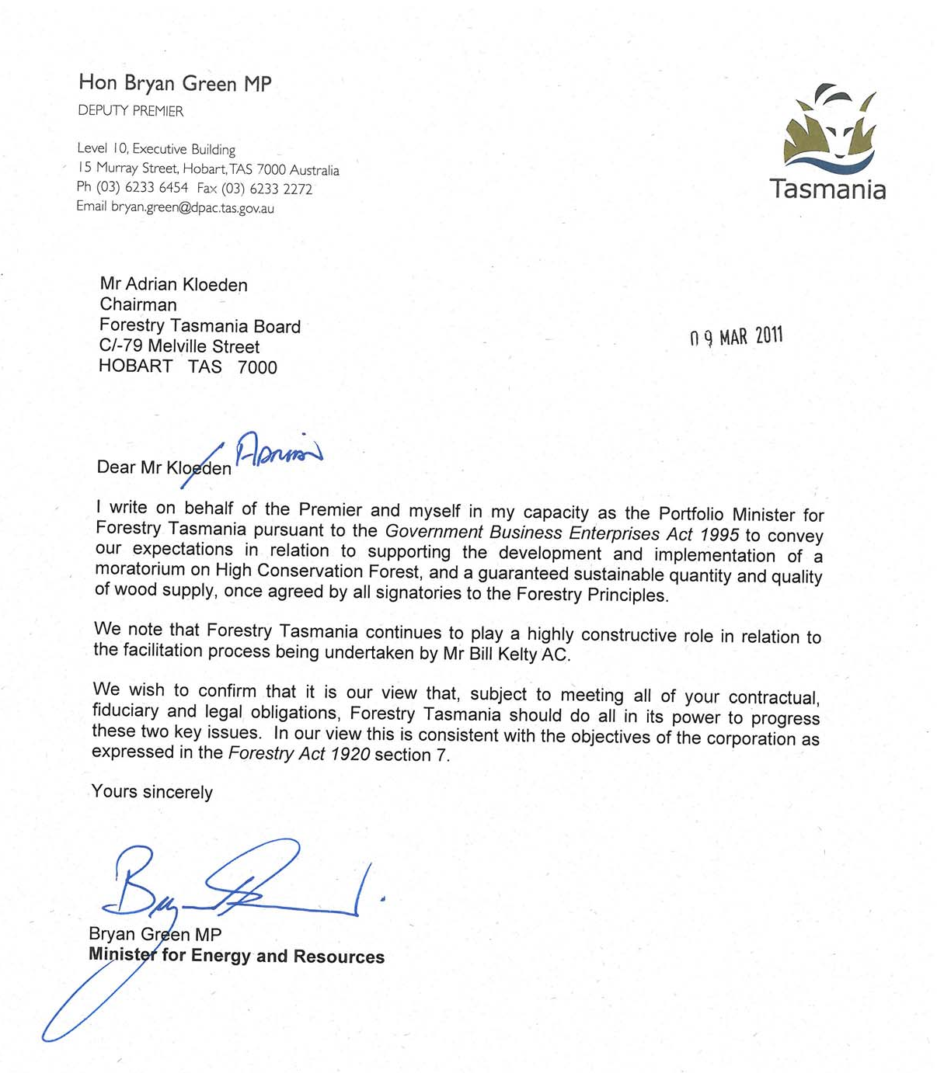

7.4. Furniture Makers

The furnishing industry is a major manufacturing sector employing over 103,000 people across the whole industry Australia wide (FurnitureTrend 2010). Victoria and Tasmania represent around 30% of that total. The domestic freestanding area of the industry represents almost half the total. This part of the industry is under severe pressure, with over 50 business closures (Vic/Tas alone) in the past five years. Profit margins as a percentage of sales are around 5% (FurnitureTrend 2010), which is very low by manufacturing benchmarks.

The hardwood sector is probably close to 50% in number of employees. Timber is around 25-35% of their manufactured cost (including labour). A survey of members taken in the past week shows a very high sensitivity to timber costs increases, due to the inability to pass on cost increases. The threat of import substitution is the obvious issue. Simple arithmetic will show that an increase of 10% wipes out most of their profit, and 20% threatens their existence. This is consistent with the responses given by members in the survey.

We contend that the proposed cut of 50% of Tasmania’s native logging will have a substantial effect on the price of quality hardwood, of the order of 20%. This will be a natural reaction to the combined effects of a sharp reduction of supply, and a significant sawlog cost increase from Forestry Tasmania (we believe this may be as high as 30-50% due to a need to cover fixed costs). Tasmanian hardwood is heavily used by our members, with an average around 50%, but higher amongst the larger hardwood manufacturers. The Timber Merchants Association (Victoria) support our belief that quality native hardwood prices will rise sharply in Victoria as a result. This is due to the volume of quality Tasmanian hardwood sold here.

Given our members sensitivity to timber price increases, Furniture Australia Vic/Tas believes the net effect of the proposed agreement will be devastating for a number of our members and very harmful to many. It is difficult to quantify as there has been no similar event in the current context, but we think the jobs losses may number in the thousands.

Views have been expressed that plantation hardwood could start to replace native hardwood from ten years’ time. This is simply not the case. We believe there is abundant evidence that this is only true for the lower grades of timber. Even the experts say a very specific silviculture regime is required and this has not been properly applied yet. That would leave a minimum 25 year gap. This is also untested in Tasmania to time of harvest. As it stands all of the product that is better quality and higher value add downstream, requires hardwood of at least sixty years regrowth.

Furniture Australia Vic/Tas is resolved to fight this flawed attempt to resolve a complex issue. We need a “green” and sustainable forestry industry from which to source Australia’s unique and beautiful timbers, they are a key point of difference to imported product. We also need that industry to be of an economic scale and able to get full recovery of the logs harvested.

The “Statement of Principles” gives veto power to groups that have not shown a grasp of the science and economics that underpin a competitive industry. We believe the government needs to ditch these negotiations and restart on a rational basis, a process that will produce the best solution for Tasmania and Australia – not one that best serves a single corporation.

Furniture Australia Vic/Tas formally requests a seat at the negotiating table, as an industry that will be impacted by the results of the negotiations

7.5. Tasmanian Private Native Forests

Introduction
The “Statement of Principles” (SOP), signed on 14 October 2010, states that the document and its implications do not apply to the State’s privately owned and managed native forest.
Private forest owners in Tasmania acknowledge and agree that change needs to occur in the management of the State’s native forest estate and that a number of parties have to date put in a considerable amount of work to this end.

Private forest owners, along with a number of other groups, will be affected if changes such as those contemplated in the SOP were to be implemented. To date, these groups have not had the opportunity to have an input to the discussion.

These groups, including private forest owners, are keen to contribute to explain matters such as:
- How they believe changes such as those contemplated in the SOP would affect them (and the State); and
- That they believe there are better options for the State.

Importantly, private forest owners acknowledge that it is time to update our forestry industry operating model. The historical model is outdated and needs updating and rejuvenating. Private forest owners are excited about potential opportunities that exist for their native forests to contribute to a revitalised industry with expanded market opportunities and social engagement. They regard their forests as real, tangible assets for their families and future generations, their local communities and the Tasmanian community at large.

Private native forests
There are an estimated 1,600 private owners who collectively manage over 850,000 hectares of native forest, a little over 27% of Tasmania’s native forest estate. Taking into account discounts resulting from forest practices controls, voluntary reservation and other owner intent matters, it is estimated that up to 60% of this estate is potentially available for timber production and has contributed significant resource to the conventional forest products industry in the past, with potential to continue to do so, while contributing significant positive environmental and social outcomes. This does not take into account the potential that is now developing to expand the product-range from these forests to contribute to new industries around carbon and sustainable energy production, to name just two, along with increased social and environmental outcomes.

Many private forest owners view an integrated approach to forest management as a matter of course, where commercial utilisation is balanced with providing other non commercial values. Importantly, through their ability to actively manage their native forests for commercial outcomes they, and the community in general, have benefited from the following positive outcomes:
- a diversified and expanded source of income to farming enterprises, providing financial stability in times of down turns in traditional agricultural markets;
- additional income that has underpinned the expansion of farming enterprises such that they still exist, are now more viable and employ more people;
- real and tangible assets that haves been used for security for farm development loans;
- resources for existing industries to assist them remain viable;
- worthwhile, real employment opportunities for Tasmanians who are interested in working outside while contributing to the management of the Tasmanian landscape;
- real employment opportunities in rural communities, assisting the retention of the decentralised population demographic of Tasmania;
- a significant reduction in Tasmania’s carbon footprint;
- the maintenance, and in many cases enhancement, of biodiversity values;
- the control of forest fuel load build up that in turn has assisted in protecting people, property and the environment from catastrophic wildfires;
- the control of pest and weed species ; and
- a large proportion of our forest landscape, so important to Tasmania, is managed essentially at no cost to the State as a consequence of having (in the order of) 1,600 on site managers.

And this doesn’t take into account the impact of the potential opportunities that are emerging to engage in new industries around carbon and sustainable energy, among others.
It is obvious that private native forests contribute significantly to the stability of rural Tasmania, and by default to the State as a whole, and have the potential to contribute even more in the future. But this is because these forests are a valuable asset. If something was to happen that had a negative impact on the commercial value of these forests (which in a worst case scenario could mean they actually became a liability rather than an asset for their owners) the impact would be wide spread. All of the positive benefits that they provide would be under threat as would their potential to contribute even more in the future.

The risk and the impact
The stated intention of the signatories to the SOP is that private forest owners will not be impacted by the outcomes of the initiative. This clearly implies that the asset value of private native forests will not be impaired. However, it is impossible to quarantine the private estate from the outcomes of this initiative because the impact cannot be restricted by land tenure boundaries.
Any implementation of the SOP will have inevitable and significant impacts on private native forest owners and managers in the following ways:

- Short term – possible intensification of forestry operations
The loss of the State forest resource will place pressure on private forests to provide additional resources necessary to maintain the productivity and competitiveness of the forest products processing sector. In the short term, assuming no decline in market demand or processing capacity, it is likely that many private forest owners will respond to this opportunity and justifiably view the transitional period as an opportunity to release capital value and reduce their exposure to further sovereign risk, by harvesting their native forests. The forest clearing activity associated with introduction of the Permanent Native Forest Estate (PNFE) policy highlights this reaction. The existence of the PNFE controls will reduce this impact but the risk is real nevertheless and government may come under considerable pressure to relax the controls.

An intensification of activity in response to increased sawlog demand from private native forests will undoubtedly generate additional pulpwood over and above that generated by harvesting operations in the more sawlog-rich State forests which will require either a market (currently limited export), or have to be burnt (creating additional smoke hazards). Failure to secure a market for pulpwood may result in an increase in the application of selective harvesting regimes in forests where this type of silviculture is not appropriate, in order to maximise the yield of higher value products and restrict the yield of pulpwood. This will result in a degradation of the forest quality and associated reduction in their ability to adequately regenerate, along with a reduction in the environmental value of such forests.
Restricted access to State forest and associated post harvesting residue may also increase pressure on private native forests as a source of firewood. This may provide a nominal, potentially unregulated and unsupervised market for low quality, dry and dead wood – often considered a high value conservation/habitat resources. Increased pressure to supply firewood is likely to target individual stags, paddock trees and other readily accessible timber with associated reductions in property biodiversity values.

However, ultimately the private native forest estate simply will not have the capacity to replace the forest production from State forests from either a volume, product mix or product quality perspective. An attempt to do so, even in the short term, will result in degradation of the quality of the private estate and severely put at risk the values and benefits these forests provide.

- Mid to longer term – restriction of forest operations, loss of forest asset value
The reduction in State forest resources is likely to result in processing and manufacturing rationalisation, amalgamations and ultimately closures, not to mention an almost certain cessation of investment in new processing facilities.

A reduction in access to markets, combined with the generally lower quality mix of forest products available from private native forests, will result in reduced operational activity and reduced prices. A complete cessation is unlikely as demand for firewood, special (low volume) timbers and on-farm material will drive some level of production, albeit insignificant.

Under this scenario, the capital value of such forests will diminish – these once valuable assets will potentially become liabilities for their owners. As a consequence, all of those values and positive outcomes that have accrued in the past to the forest owner, and the community in general, not to mention the new and emerging opportunities and positive outcomes, will be put at risk and almost certainly lost.

A loss in asset value is likely over time to reduce the viability of many farming enterprises and their future will be at risk. In addition there will be increased pressure to find alternative land uses for the forested land.

Alternative uses, perhaps with the exception of a carbon market, will become more difficult to achieve because of the restrictive regulations that are in place. This scenario could see private native forest owners in a situation of having to manage and maintain a forest estate with no commercial value in order to meet community expectations about landscape and amenity values. Ultimately, this would be untenable and the forests will, one way or another, degrade, lose their environmental value and gradually disappear.

The opportunity
But none of this needs to happen; the asset value of our private native forests can easily be maintained and as a consequence these forests can continue to assist underpinning the viability of our rural communities and contributing significantly to the State from an economic, social and environmental perspective.

We simply need to:
- Recognise that in Tasmania we have a distinct natural advantage – we can grow trees very well – and native forest management and utilisation is the most environmentally benign method of growing trees that can produce a wide range of truly sustainable products for our community while providing employment opportunities and sound environmental outcomes.
- Recognise that, considering Tasmania’s demographics, we do not have the capacity to fund the management and maintenance of large areas of our landscape from the public purse and recognise that 27% of our important forest landscape is managed “free of charge” by 1,600 on-site managers.
- Recognise that the private forest estate does not have the capacity to replace the production from State owned forests from a volume, product mix or product quality perspective and that the ongoing existence of a viable, private native forest estate is dependent upon a continuation of active management of State owned native forests.
- Recognise that active forest management provides opportunities to maintain, and on occasions enhance, the ecological diversity and regeneration capacity of native forests.
- Recognise that Tasmanian farmers are committed to sequestering more carbon through their agricultural and forest management activities and understand that should their native forests become worthless, and hence a liability, that the inevitable progressive demise of these forests will potentially expose government to considerable deforestation linked carbon imposts.
- Recognise that through the imposition of the Permanent Native Forest Estate Policy private forests owners have been locked into the ongoing commercial management of their native forests with severe restrictions on their capacity to convert these forests to plantations and that any reduction in their capacity to commercially manage these forests could expose government to considerable claims for compensation.
- Realise that the active management of all our native forests, private and State owned, has contributed significantly to the well-being of all Tasmanians in the past in ways that many in the community don’t appreciate (forest products – wood, honey, water; recreation – drives in the forest, bush walking and other active recreation pursuits; employment; wealth generation; environmental protection – control of weeds, pests, wild fire) because these forests have a commercial value.
- Understand that if we destroy or even impair the commercial value of our native forest estate all the benefits we have derived in the past will be lost and, importantly, significant additional benefits that will accrue from new and emerging industries will never be realised.
- Accept that there is a need to update our forestry industry operating model and acknowledge that the old model is out of date and needs updating and rejuvenating but that this must be done without destroying the opportunities that the sustainable, commercial management of our native forest estate can continue to realise for Tasmania.

7.6. Bob Brown – Greens Leader National

In a letter Mr Brown wrote to Greg L’Estrange of Gunns on February 8th 2011 Mr Brown writes that the Australian Greens,

“oppose the Gunns site and configuration at Bell Bay as well as the improper manner in which it was adopted. So I hope the new, more environmentally friendly will you outline is also able to be sited outside the Tamar Valley in a region where it will gain community acceptance. That would be a winner.”

The following letter was sent on the 6th of March 2011.

6 March 2011

Mr Bill Kelty
c/- Linfox Private Group
Linfox House
493 St Kilda Road
Melbourne VIC 3004

Forestry principles process – March 2011

Dear Mr Kelty

Thank you for seeking our comments on the forest principles process. We are keen to assist in the outcome of this process and following is our position on the implementation of some of the immediate agreement parameters.

- A moratorium should begin on 15 March as the signed agreement between all the parties made clear.
- All forests identified as High Conservation Value should be reserved in national parks and nominated for World Heritage status to complete the current World Heritage Area.
- A rapid phase-out of logging in other native forests be implemented, except for agreed areas to be set aside for sustainable selective logging of high-quality, specialty timbers.
- Private land-holders with native forest should be assisted to protect it.
- Any pulp mill built in Tasmania should be closed-loop chlorine free, use plantation feed, have a social licence, and be subject to the same planning and company laws that other businesses in Tasmania are subject to.
- Forestry Tasmania should immediately make publicly available its data.
- Forestry Tasmania should be wound up as a government business enterprise and its functions and workforce transferred to relevant government departments with responsibility for land management.

Yours sincerely

Senator Bob Brown, Australian Greens Leader, Senator for Tasmania
Senator Christine Milne, Australian Greens Deputy Leader, Senator for Tasmania


A comprehensive economic
assessment for the Tasmanian
economy of the direct benefits of the
proposed Gunns pulp mill

A report for the
The Wilderness Society (Tasmania) Inc.

Prepared by the
National Institute of Economic and Industry Research
ABN: 72 006 234 626
416 Queens Parade, Clifton Hill, Victoria, 3068
Telephone: (03) 9488 8444; Facsimile: (03) 9482 3262
Email: Julie.barker@nieir.com.au

JANUARY 2008


While the National Institute endeavours to provide reliable forecasts and believes the material is
accurate it will not be liable for any claim by any party acting on such information.

Contents

Page no.

Executive summary 1

1. Background 3

2. Inconsistencies in the AC study 5

2.1 What is the direct impact on the Tasmanian economy from the
pulp mill? 5
2.2 The MMRF Model does not produce a lower impact on the
Tasmanian economy than the unconstrained NIEIR model 6
2.3 The consumption response for the MMRF-Green Model is far
too high for a credible model 7
2.4 The import inflows into the Tasmanian economy for the MMRF-Green
Model are too low to be credible 7
2.5 There are a number of possible explanations for the MMRF-Green
Model results 8

3. The impact of the pulp mill on the Tasmanian economy -
methodology 9

4. The drivers of the gross benefits of the pulp mill - mill scenario
outcomes 12

4.1 4.2
4.3 4.4
4.5
4.6 4.7
4.8
4.9
4.10 4.11

The US$ pulp price
The Australian/United States dollar exchange rate
The capital cost
Other direct costs
Subsidy from Tasmanian Government
Tourism
Other pulp and paper mills
Fisheries and agriculture
Health
Risk of change of Gunns ownership
Water supply constraints

12 13
14 15
15
16 18
19
20 21 21

5. The alternative uses of the wood - scenario 2 22

5.1 Hardwood exports 22 5.2 Woodchip exports 22 5.3 Alternative export volumes 22
5.4 An alternative case 23

6. The proposed mill: Net direct benefit to the Tasmanian economy 24

6.1 The discount rate 24 6.2 Case 1: The direct economic benefit on the Tasmanian economy 24 6.3 Case 2: The direct economic benefit to the Tasmanian economy 26

7. Conclusion 27

Appendix 1: NIEIR models versus Monash models 28

1

Executive summary

This study has two objectives, namely:

(i) to review the Allens Consulting Group (AC) findings commissioned by Gunns Ltd. in
relation to the impact of the proposed pulp mill; and

(ii) to re-estimate the economic impact on the Tasmanian economy taking into account
additional information that has become available since the Allens Consulting study.

The findings

In relation to the Allens Consulting findings, this study concludes that they are not credible in terms of what would be expected from the MMRF-Green Model that was claimed to be used
for the study. Specifically:

• the gain in Tasmanian gross state product is too high for the increases in employment
which is caused by:
• private consumption expenditure being at least double the level that could
possibly be justified; and
• the impact inflows into Tasmania being at least half of what could be expected
given that Tasmania is a small open economy with limited capacity to satisfy
domestic demand.
This study concludes that, in the absence of a credible defence by Allens Consulting of their
findings, the results can only be explained by:

(i) errors made in using the MMRF-Green model for analysis; and

(ii) unjustified adjustment of the model results that make the case for the pulp mill more
favourable.

This reduces the assessed consumption benefit to 2030 in terms of the MMRF-Green modelling framework by at least half, to the order of $1.4 billion, excluding the construction benefit.

The next adjustment to the Allens Consulting results is that they have under-estimated the opportunity cost of the logs consumed in the pulp mill from existing forestry resources. In part this is probably due to only valuing the opportunity cost at woodchip value added and
ignoring the use of the logs for high value added timber exports. Secondly, they do not
consider the logs from the new plantations (fully employed after 2020) to have an opportunity cost in terms of forestry products, or the agricultural land that will be used to support the
plantation development. Allowing for this reduces the consumption benefit by up to at least
$1 billion, to around $0.4 billion.

This report reduces the consumption benefit at the mean of expectations by another $0.7 to - $0.3 billion. The difference between the $0.4 billion and the -$0.3 billion is due to this study
taking into account the economic costs of:

• lost tourism;
• risk of chemical spillage;
• risk of Gunns change of ownership from undertaking a high risk investment;
2

• blow-out in capital costs;
• deaths and sickness from environmental damage; and
• risk of closure of existing pulp and paper mills.
The -$0.3 billion loss is at the mean of expectations. At the 25 per cent probability
benchmark the net consumption loss is estimated at -$0.6 billion, with only a 25 per cent
probability that the consumption benefits of the operating phase will be greater than $0.2 billion. If anything goes wrong with the mill the maximum cumulative Tasmanian
consumption loss is estimated at -$3 billion, and if everything goes right the gain is assessed
at $1.3 billion. That is, there is no chance that the AC estimate of consumption gains from the operational phase of $2.8 billion will be reached.

If the gain from construction is factored in, at the mean, the conclusion is still that the consumption gains to existing Tasmanian residents will not be positive.

3

1. Background

The proposed Pulp Mill at Bell Bay in Tasmania's North East (or the mill) has been one of the most controversial industry projects since the proposed damming of the Franklin River in
Tasmania's South West in the 1980s. Gunns Limited (Gunns) is proposing to develop a
bleached kraft pulp mill in the Bell Bay Major Industrial Zone, south of George Town at a cost of $1.7 billion1. The proposed pulp mill will, in the initial stages, produce about 820,000 air dried tonnes (ADT) of pulp and will have the capacity to produce up to 1.1m ADT of pulp for
domestic and international markets. Gunns estimates that production of this quantity of pulp
will require between 3.2 and 4.0 million green metric tonnes of pulpwood per annum (plus wood required for energy production).

Proponents of the mill, including the Tasmanian Government, the Federal Government and Opposition, have stated that the mill will create jobs and economic benefit for Tasmania. To date, the only substantive economic evaluation of the project has been undertaken by Allen
Consulting Group (AC) for the proponent Gunns as part of the company's Integrated Impact
Statement.2 ITS Global was commissioned by the Tasmanian Government to undertake a review of the social and economic benefits of the Gunns proposal3. This study was to fulfil the requirements of the Pulp Mill Assessment Act 2007 - legislation that was drafted and
passed after Gunns withdrew from the Resource Planning and Development Commission
process in 2006, "ITS Global did not and was not required to perform any new economic modelling or social impact analysis"4 ITS Global largely repeated the economic claims of the
original AC report and summarised public submissions received by the RPDC process prior
to its inquiry being halted.

The RPDC received more than 790 submissions. ITS Global found5 that of the non-pro forma
submissions, 523 were generally negative, 94 were neutral and 81 were positive. Almost
half, 255, of the submissions related to economic issues. Of these 255 submissions 158 were negative, 28 were neutral and 69 were positive. The consultants listed as 'high concern' submissions to the RPDC stating that the AC evaluation did not assess, did not adequately
assess or ignored:

• potential negative impacts or externalities
• risks associated with the project
• impacts on tourism
• constraints in the labour supply
• environmental impacts
• the value of intangibles (such as the Tasmanian brand).

1

2

3

4

5

Gunns Limited News Release 17 October 2007

The Allen Consulting Group: The Bell Bay Pulp Mill Economic Impact Assessment Report May 2006 Report to Gunns Limited.

ITS Global: Review of the Social and Economic Benefits of the Gunns Limited Pulp Mill Project June 2007.

Ibid pg 9.

Ibid Appendix II pg 110 - 112.


4

They also listed as 'high concern' submissions relating to the potential negative impact of the
project on:

• other business sectors such as marine industries, aquaculture industries, tourism and
agriculture
• intangible assets such as the Tasmanian brand
• Tasmania's dependence on forests and forest industries
• vulnerability of the Tasmanian economy to fluctuations in world pulp markets.
Other studies have attempted to assess all or some of these issues. For instance the
submission of Naomi Edwards to the RPDC6 and a report prepared for the Tasmanian Round Table for Sustainable Industries Project to which two economic consultants contributed.7
These reports point to a number of indicators that underline concerns expressed in the
submissions summarised above.

This study

This report should be seen as by necessity preliminary. New field work has not been undertaken for this study. Instead, it re-evaluates material already on the public record in
reports prepared for the RPDC process, for the Tasmanian Government and released
publicly in recent months. The main contribution of this study is to comprehensively model all data in a comparable probability framework, so as to provide a more complete picture of the
direct economic impact of the Gunns project on the Tasmanian economy. NIEIR has used its
econometric model of the Tasmanian economy to highlight the inconsistencies between the AC study and important aspects of the material available for policy makers. This study represents the first modelling assessment to include material that has become available
more recently, or was not evaluated by the AC report, or is the result of changes in the
broader economic environment since the AC report was prepared.

Since 2006, the Australian economy has continued to grow strongly with the major concern today being inflation, tight labour market conditions and skills shortages. The net benefit of
the mill to the Tasmanian economy will be the difference between the mill scenario and the scenario without the mill, which describes the alternative uses of the logs not consumed by
the mill.

This study, therefore, examines two scenarios: a business as usual base case (excluding the pulp mill), a mill scenario and an alternative scenario. The mill scenario will endeavour to include a number economic impacts not considered as part of the AC evaluation such as the
impacts of tourism; the impacts on other forestry enterprises; impacts on aquaculture; and
impacts on agriculture. It will also critically re-evaluate the distribution of benefits from the proposed mill in the form of profits, wages and salaries, taxes and purchases of goods and
services, and will consider the government contribution to the mill. In the alternative scenario
the same level of government subsidies will be used to develop alternative value-added businesses in Tasmania that are consistent with the Tasmanian Government's economic development agenda, maximise long-term investment in the Tasmanian economy, are
consistent with the Tasmanian brand and minimise impact on other industries. The net direct
impact on the Tasmanian economy is the difference between the mill scenario and this alternative scenario.

6

7

Edwards, Naomi Too much risk for the reward - an analysis of the pulp mill returns to the people of Tasmania, Submission to the Resource Planning and Development Commission, September 2006.

Tasmanian Round Table for Sustainable Industries Project (TRTSIP): Sustainable development in Tasmania is the proposed pulp mill sustainable? Launceston Environment Centre August 2007.


5

2. Inconsistencies in the AC study

The AC results are internally inconsistent because they imply implausible values for productivity and consumption.

In order to demonstrate this NIEIR ran its inter-regional Local Government Area (LGA) based model of Tasmania without capacity constraints. The model is an input-output model for each LGA (some of the smaller LGAs have been aggregated) linked by an inter-regional trade flow matrix for each industry, and subject to broad economic constraints, notably those governing
trade and financial relationships between Tasmania and the rest of the world, but for the
purposes of this run devoid of labour or capital capacity constraints. A ten household-type consumption model generates total household consumption expenditure. The industry
structure is based on the two digit ANZSIC classifications with the benchmark data year
based on 2006. The data has been adjusted for trends to 2005. This run was for purposes of comparison, and yields a much higher benefit from the investment than NIEIR deems
plausible taking all factors into account; it will be referred to as the NIEIR unconstrained run.
A more plausible, constrained assessment is given in Chapters 3-6.

The AC report uses the Monash University's Centre of Policy Studies MMRF-Green Model, which is stated to be the "most comprehensive economic model available in Australia and is
highly regarded in terms of robustness of its assumptions and the overall credibility of its
results".8

The "comprehensive" and "robustness" claim is based on the fact that the model is a computable general equilibrium (CGE) model which, in addition to input-output relationships,
takes account of capacity constraints operating in the economy at the national level (though not at the Tasmanian level). The proponents of the CGE class of models argue that NIEIR's
models are inadequately constrained and therefore always over-estimate the impact on the
economy compared to CGE models. In Appendix 1 of this report NIEIR gives a summary of its rebuttal of this claim in terms of analysing the impact of the Australian Formula One Grand Prix on the Australian and Victorian economies. This rebuttal involves challenging both
claims: first, the claim CGE models are realistically constrained and second, the claim that
NIEIR's models are unrealistically unconstrained.

However, what concerns us here is not the credibility of the MMRF-Green Model as a model class, but the credibility of the results in terms of the MMRF-Green Model itself. To do this it
is useful to compare the results with the NIEIR unconstrained results.

2.1 What is the direct impact on the Tasmanian economy from the
pulp mill?

The first step in examining the credibility of the MMRF-Green Model results is to calculate the direct shock to the Tasmanian economy. This simple estimate is not reported in the AC
report. However, it can be estimated from what information is available.

In 2005 prices, a pulp mill of 0.82 million ADT would generate $500 million in gross output at the factory gate, that is, excluding shipping costs.

8

ACG Report P.1.


6

The AC report states that in 2015, as a result of the new pulp mill, the existing Tasmanian wood and paper industry (i.e. excluding the new mill) would generate $92 million less in national real value added and $56 million less in real Tasmanian value added (AC Report Table C4). From the Australian Bureau of Statistics' (ABS) Australian Input-Output Tables,
2001-02, the pulp and paper industry's value added to output ratio is 0.28, or 0.33 to allow for
the higher ratio for wood products. Hence, the decline in output from the existing wood and paper industry nationally is $279 million and $170 million for Tasmania. Therefore, the net
expansion in Tasmanian wood and paper products is (500 - 170) or $330 million.

2.2 The MMRF Model does not produce a lower impact on the
Tasmanian economy than the unconstrained NIEIR model

To test the MMRF-Green modellers' claim that the model is credible because it produces a conservatively low impact on the economy, NIEIR ran its inter-regional input-output model of Tasmania without labour or capital capacity constraints. The results in comparison with the
MMRF-Green Model are shown in Table 2.1.

The most striking aspect of the comparison is the impact on Tasmania's gross state product (GSP), which is similar at around $460 million. However, the AC employment impact is less
than half the NIEIR result, while the consumption impact in the AC study is 52 per cent more
than the NIEIR results. The divergence is obvious.

As can be seen from the Appendix analysis, the expectation would have been that the more heavily constrained MMRF-Green Model should have produced a lower GSP impact, along
with the lower employment impact. This produces inconsistencies that render the results
unbelievable. The most obvious inconsistency is that the marginal gross state product per person employed for the MMRF-Green Model is $0.36 million in 2005 prices per person
employed. For Tasmania the average GSP per person employed is $0.07 million in 2005
prices, or a differential of 5 to 1. A differential of 2 or 3 to 1 may be plausible but not 5 to 1.
Closer inspection indicates that this unbelievable result is caused by:

(i) the consumption response being far too high

(ii) the import response by the Tasmanian economy being far too low.

Table 2.1 The Tasmanian pulp mill - a comparison of two models
MMRF-Green Unconstrained
Model Model (NIEIR)

Direct impact on wood and paper
Tasmanian gross state product
(market prices)
Tasmanian private household
consumption
Total Tasmanian employment
2005 $ m
2005 $ m

2005 $ m

Number
330
467

215

1,300
330
460

141

3,203

Note: The MMRF-Green Model results are for the 2015 year.

7

2.3 The consumption response for the MMRF-Green Model is far
too high for a credible model

NIEIR agrees with the statement in the AC report that 'consumption... is essentially determined by total household income.' However, it is not possible to check this derivation in
the AC report since no estimates are given for the changes in household income, and it is therefore necessary to supply the connection. The obvious route is via the increase in
employment. In the MMRF-Green Model results the increase in consumption expenditure is
$165,000 per additional person employed. This is unbelievable. Even for the 300 direct pulp mill employees the total estimated labour cost is $130,000 per employee. After on-costs and
income taxes this would allow a consumption increase at best of around $70,000 per
employee. This is for the highly productive mill which would have to be reduced by at least one third to capture the contraction in wood and pulp products in the AC findings directly stemming from the Mill. The consumption increase for downstream employment would be
significantly less than this, at around the Tasmanian average. The NIEIR model estimate of
$44,000 per employed person is close to the Tasmanian average of $31000 of consumption generated per person employed and hence much more realistic.

The only other major source of income from the pulp mill would be from its gross operating surplus. However, it is expected that this will be fully accounted for by interest payments at around $130 million, by income taxes and by payment of dividends to non-Tasmanian residents. Very little of the gross operating surplus would be available for consumption
expenditure in Tasmania.

The AC results include a substantial figure for induced investment in Tasmania - over $100 million a year. This helps to explain the unexpectedly large increase in GSP although the
import content of this should be high largely offsetting the impact in a credible model. In any
case employment from this investment appears to be included in the reported increase in employment, and the induced investment therefore does not generate employment incomes
to explain the large increase in consumption.

On a credible distribution of income, the consumption increase, given the 1,300 employment increase, should have been around $57 million, not $215 million. (This is derived using the NIEIR estimate of consumption per employed person.) Even if an allowance of $30 million is
made for possible other unexplained stimulus, this would mean that the MMRF-Green model
has over-estimated consumption expenditure by at least $125 million.

2.4 The import inflows into the Tasmanian economy for the
MMRF-Green Model are too low to be credible

The total import flows into the Tasmanian economy induced by the pulp mill are not reported in the AC study but they can be estimated. For 2015 the increase in consumption is reported
at $215 million, the increase in investment at $106 million, and the increase in Tasmanian
GST at $467 million. International export flows are reported at $213 million, but interstate exports should be added to this. If the total product of the mill is exported from Tasmania,
total exports both international and interstate will come to $330 million - the gross value of
production, calculated above. Using the national accounts identities, total exports can then be calculated as consumption plus investment plus exports less gross state product equals
$184 million. Given that international import inflows are reported at $91.0 million this implies
that interstate imports are $93 million. Interstate exports would be the difference between the $330 million and the reported international exports of $213 million, or $117 million. The import to GSP ratio is thus estimated at 0.39. The only rationale given for this low ratio is the
claim that many of the inputs to the mill will be locally sourced (AC report page 33). However,
this is unlikely to apply to the increase in reported consumption or investment.
8

For 2005 NIEIR estimates the Tasmanian total import to GSP ratio to be of the order of 0.8, or double the implied MMRF-Green estimate. Given the incorporation of "capacity constraints" in the MMRF-Green Model, one would have expected it to deliver an outcome well above the average 0.8, say at least unity. An import to GSP ratio of unity would have
reduced the Tasmanian GSP impact for the MMRF-Green Model to $191 million, with a
further reduction to around $130 to $140 million if the consumption impact is adjusted downwards by $125 million. This would make the results "consistent" with the unconstrained
NIEIR model results. That is if the employment increase in the MMRF-Green model was a
third of the NIEIR models result then it would also be expected that the GSP increase in the former would also be a third of the latter. This is also what was obtained in the comparison of
the unconstrained NIEIR model with the MMRF model, which is similar to the MMRF-Green
Model, for the Formula One Grand Prix study.

In brief, the MMRF-Green Model results are unbelievable in terms of the results obtained for more or less the same model when used for another study.

2.5 There are a number of possible explanations for the MMRF-
Green Model results

There are a number of possible explanations for the unbelievable MMRF-Green results.
These include:

(i)
(ii)

(iii)

(iv)

simple error in inputting data into the model
serious specification errors in the model (e.g. allocating gross operating surplus from
the pulp mill to the Tasmanian household sector)
unexplained adjustment of the results to bring them more in line with client
expectations based on simple multiplier models
some other credible explanation which AC may provide.

However, there is a clue in the write-up which favours the unjustified adjustment possibility. Knowing the consumption results were not credible, but perhaps hoping to deflect any future
criticism, the following statement is in the AC report.

"The increase in expected disposable income would be expected to support an increase in consumer confidence. This is further reflected in higher rates of private
consumption." (AC, page 24)

Unfortunately there is no justification for this. The doubling of consumption expenditure from what a credible model would produce can only be financed by a fall in the savings ratio. The recent Tasmanian net savings ratio has been at most zero and generally negative. This
means that the fall in the savings ratio could only be financed by additional borrowings. After
20 years this sustained increase in borrowings would result in net additional Tasmanian household debt of $2 billion and debt service payments of $0.26 million per year. This would eventually have the effect of driving consumption expenditure levels below the levels that
would have prevailed in the absence of the pulp mill.

In short, if a convincing explanation from Allens Consulting is not forthcoming, it will have to be assumed the overall MMRF-Green Model results were adjusted by adding $125 million to
consumption and GSP with further adjustments to GSP from reductions in the import
propensity of the Tasmanian economy.


9

3. The impact of the pulp mill on the Tasmanian
economy - methodology

Dismissing the MMRF-Green Model results out of hand does not, however, lead to a rejection of the case that the pulp mill could make a significant contribution to Tasmania's
economic activity. There are many factors which will determine this, from the opportunity cost of wood to the special costs of risks associated with the project (including the effect of labour
capacity constraints on construction costs - see 4.3 below).

Figure 3.1 lists the factors which together determine the net economic benefit of the pulp mill. The pulp mill will create demands for factors of production, such as logs, labour, materials and services. The mill surplus will be the difference between revenue and costs of factors of
production. Revenue will be determined by mill output, the US$ price of pulp and the
Australian/United States exchange rate. However, only part of the surplus will directly impact on Tasmania. That part of the surplus which will directly impact on Tasmania will be what is
left over after payments for interest, taxes and dividend payments to out-of-state
shareholders.

The direct risks of the project are well documented in the debate over the mill and are listed in Figure 3.1.

The gross impact of the mill must then be adjusted for the alternative uses of the logs consumed by the mill and for alternative uses for the plantations created to support the mill. These alternative uses include woodchip exports, dressed hardwood exports or agricultural
production.

A great deal of uncertainty surrounds many of the factors that will determine whether or not the mill will be an economic positive for the Tasmanian economy. Hence, the approach taken
in this study is to formally include this uncertainty in the analysis. This is done by specifying
an appropriate probability distribution for each factor that is subject to uncertainty. The system is then simulated to find the joint probability distributions of the key variables of interest and in particular the sum of the discounted sum of the direct impact on the
Tasmanian economy. Unless the direct benefit is positive there is no way a positive indirect
benefit can be obtained from any credible model.

In any one year there will be a range of possibilities. Except for the case where a discrete probability distribution is justified, as would be the case for risks just as chemical spills into
the sea, this study adopts the trigen distribution as the preferred representation of possibilities. The trigen is a triangular distribution which has the advantage that its
parameters can be expressed by five easily interpreted parameters. These five parameters
are:

(i)

(ii)

(iii)

(iv)

(v)

lower bound

mode

upper bound

probability that values will fall below the lower bound

probability that values will exceed the upper bound.

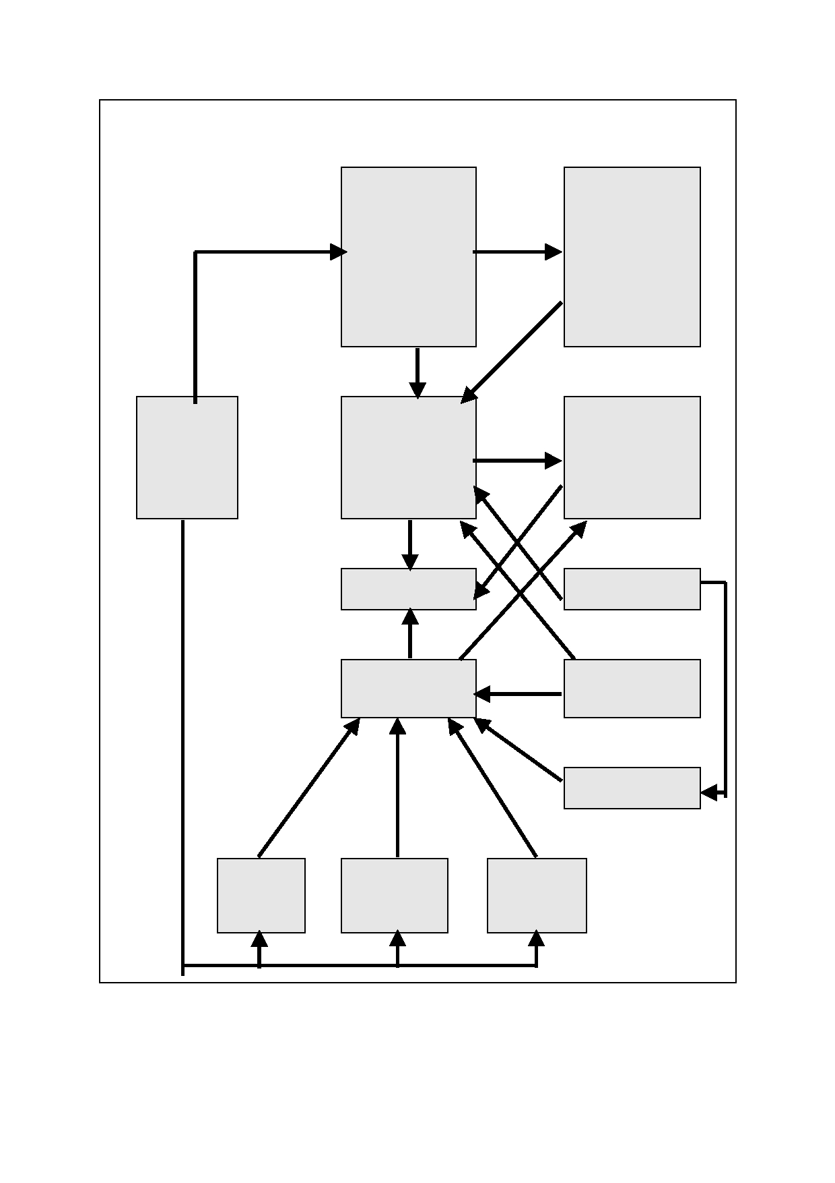
10

Figure 3.1: Factors determining the net direct impact of the pulp mill in
Tasmania

Risk of economic
loss from:
1. Tourism

Direct factors of
production,
labour, services, materials, capital
2. Deaths
3. Water supply
constraints 4. Chemical
spillages.
5. Gunns change
of ownership

Logs
consumed

Gross direct
impact of pulp
mill

Direct outflows from Tasmania's
taxes to Federal
Government,
interest
payments, dividends

Net direct impact Pulp price $US
of pulp mill

Cost of logs Australian/United alternative uses States exchange
ra t e

Prices of wood
exports

Use of Use of logs Use of
logs as as hardwood plantation
woodchip timber land for
exports exports agriculture

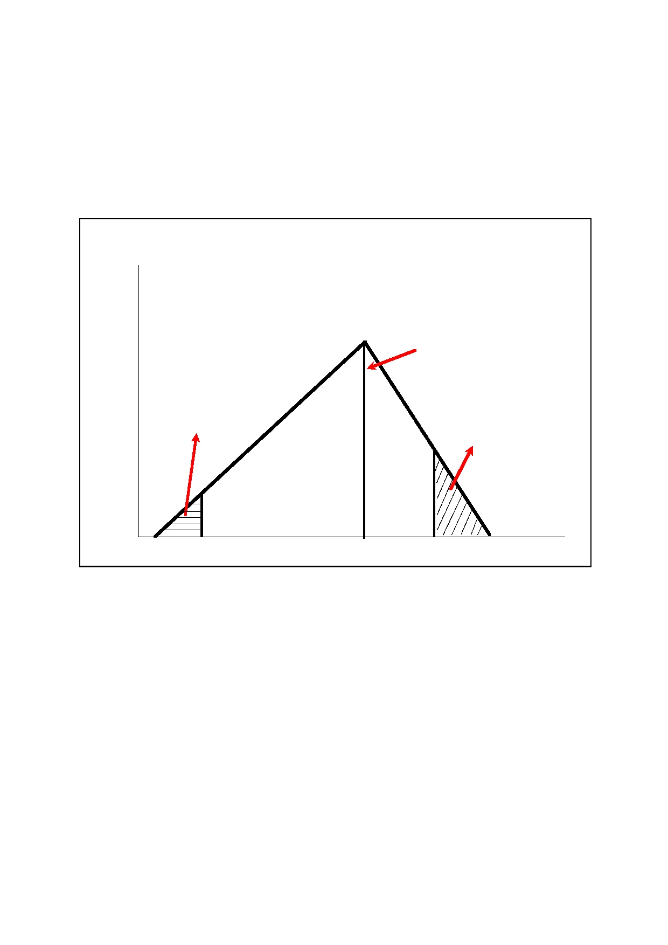
11

The trigen distribution is used to describe the uncertainty around the pulp mill price, the exchange rate, the scale of alternative uses of the logs, the discount rate applied, etc.

For some risks a trigen distribution is not suitable and a discrete distribution is employed. For example, for chemical spills the parameters which describe the distribution for a given year
are the probability that the one-off event will occur and the cost (in million dollars) of the
event.

Figure 3.2: The trigen probability distribution

Frequency
of factor
value

Highest frequency
factor value

Probability that lower bound will
be below set

bound
Probability that
upper value will
be above set
bound

Factor value
Lower Mode Upper
bound bound

12

4. The drivers of the gross benefits of the pulp mill -
mill scenario outcomes

This section discusses the issues surrounding the drivers of the gross benefits of the mill
and, if appropriate, the parameters of the probability distribution employed for each driver.

4.1 The US$ pulp price

The CommSec study in October 2006 assumed that pulp prices would fall to US$520 in late 2009. However, this was before the commencement of the long run devaluation of the US$.
For this study the trigen parameters are:

Lower bound
Mode
Upper bound
Lower bound probability
Upper bound probability

$510 $600 $650
5 per cent
85 per cent

The higher upper bound probability (that is, a 15 per cent chance that the upper bound outcome will be exceeded) is to allow for more upside risk than downside risk around the
bounds. In addition, the prices are in 2005 prices which, in effect, further adjust prices up by 15 per cent compared to the CommSec study.

For each year to 2030 a trigen distribution is specified for the pulp price. The CommSec study, following historical trends, assumes that the real price falls by 1.5 per cent per annum
from 2010 onwards. For the lower bound the assumption is for a fall of 2 per cent per annum. However, for the mode the assumption is less severe than the CommSec study with a
specified fall of 1 per cent per annum. For the upper bound the assumption is a constant real
pulp mill price of US$650 per ADT from 2010 to 2030. The bound probability settings are held constant at the initial year levels.

The outcomes of these settings for the expected value of the US$ pulp price are given in Figure 4.1. The expected pulp price falls from US$595 in 2009 to US$551 by 2020, or a real
fall of just under 8 per cent over the decade. By 2030 the pulp price reaches a level of US$519. The average annual fall in the real pulp price is 0.7 per cent per annum, or half the
CommSec assumption.

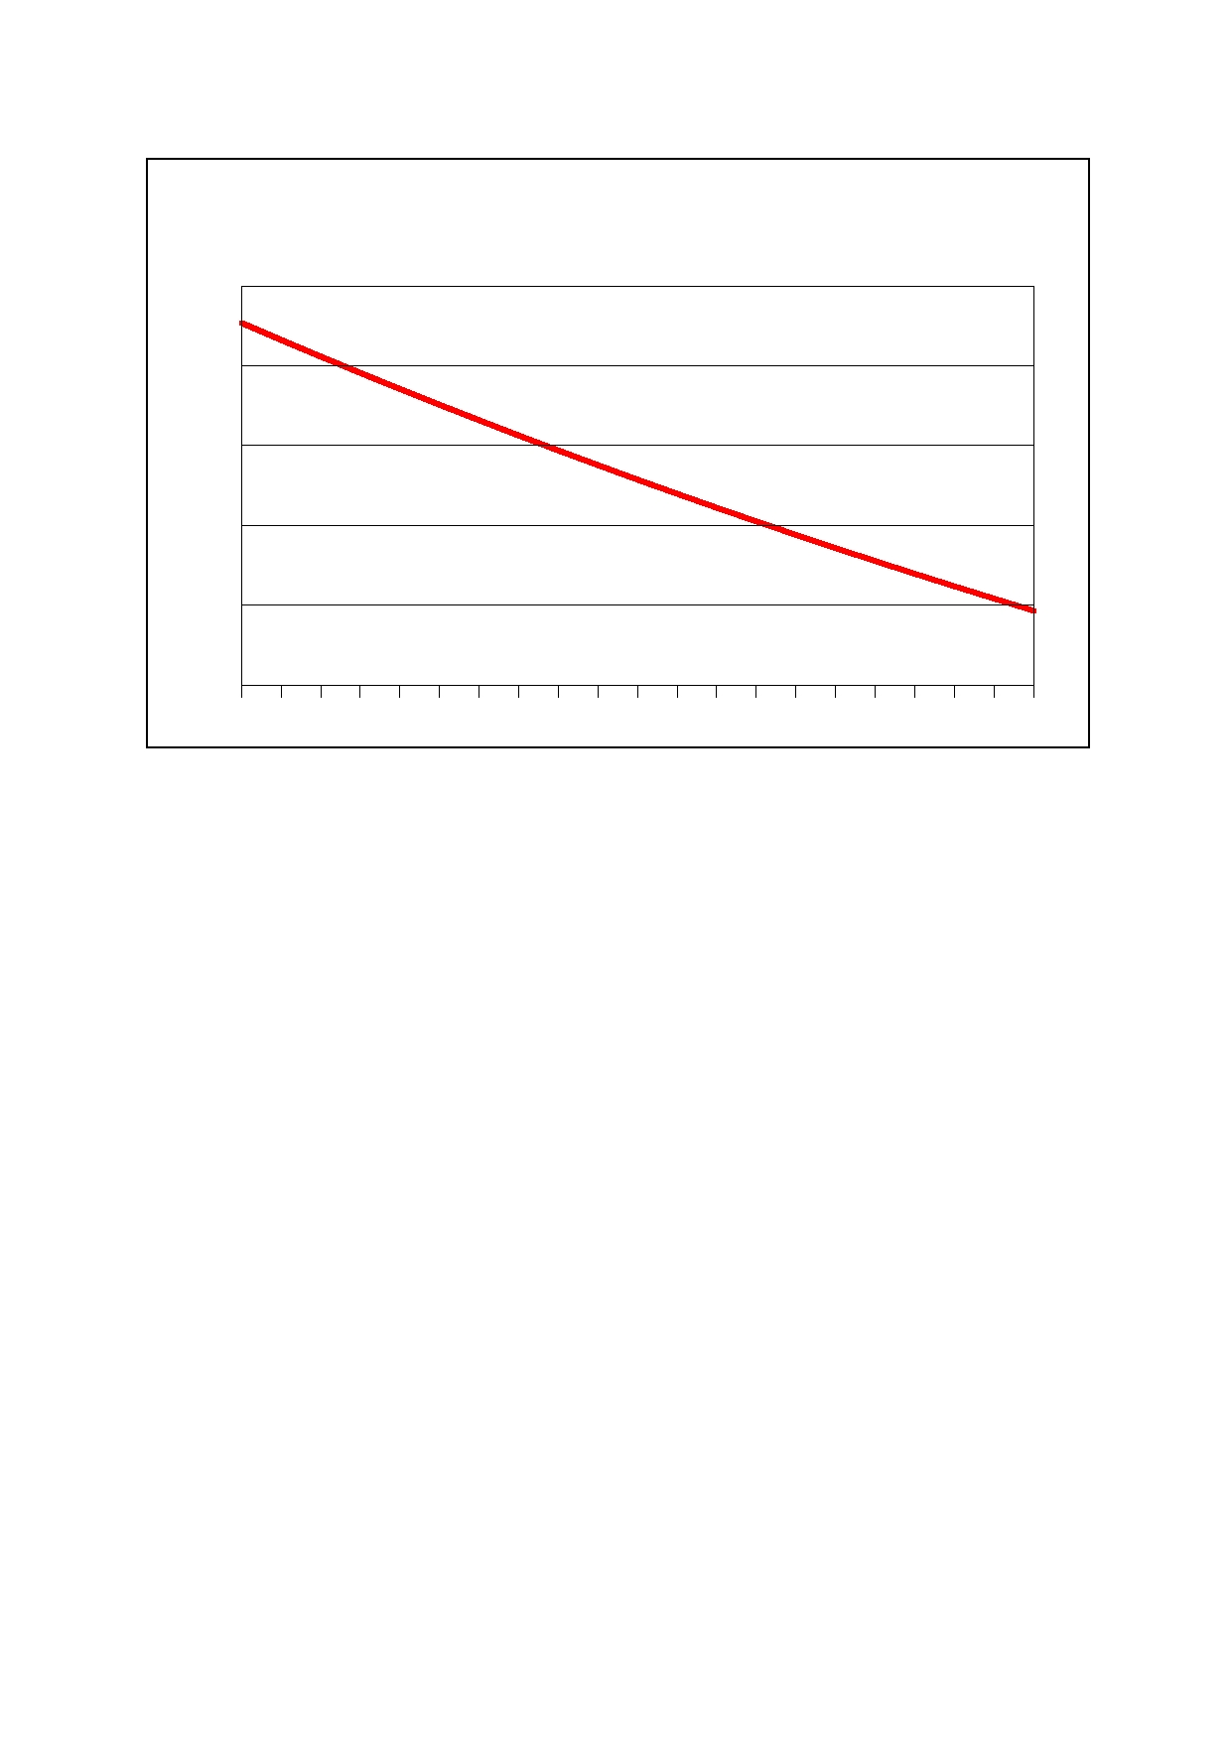
13

Figure 4.1: Real pulp price $US

600

580

560

540

520

500

2005 $

2010
2011
2012
2013
2014
2015
2016
2017
2018
2019
2020
2022
2021
2023
2024
2025
2026
2027
2028
2029
2030

4.2 The Australian/United States dollar exchange rate

The CommSec study assumed a long run $A/$US exchange rate of 0.72. However, there are risks that the exchange rate could be both lower and higher than this assumption. In any
case, by 2009 or 2010 current trends indicate that the Australian dollar will be considerably higher than 0.72 cents.

For 2010 the trigen parameters are:

Lower bound
Mode
Upper bound
Lower bound probability Upper bound probability

0.81 0.85
0.93
15 per cent 85 per cent

By the 2017 to 2020 period the lower bound falls to approximately 0.67, reflecting the
vulnerability of the Australian economy for a low long term exchange rate due to its:

(i) high current account deficit

(ii) high net international debt

(iii) exposure to a high carbon price.

By 2030 the lower bound falls to 0.62.

Between 2010 and 2017 the mode exchange rate falls steadily to 0.71, where it remains until 2030. By 2015 the upper bound falls to 0.80, near which it remains for the remainder of the
horizon to 2030.

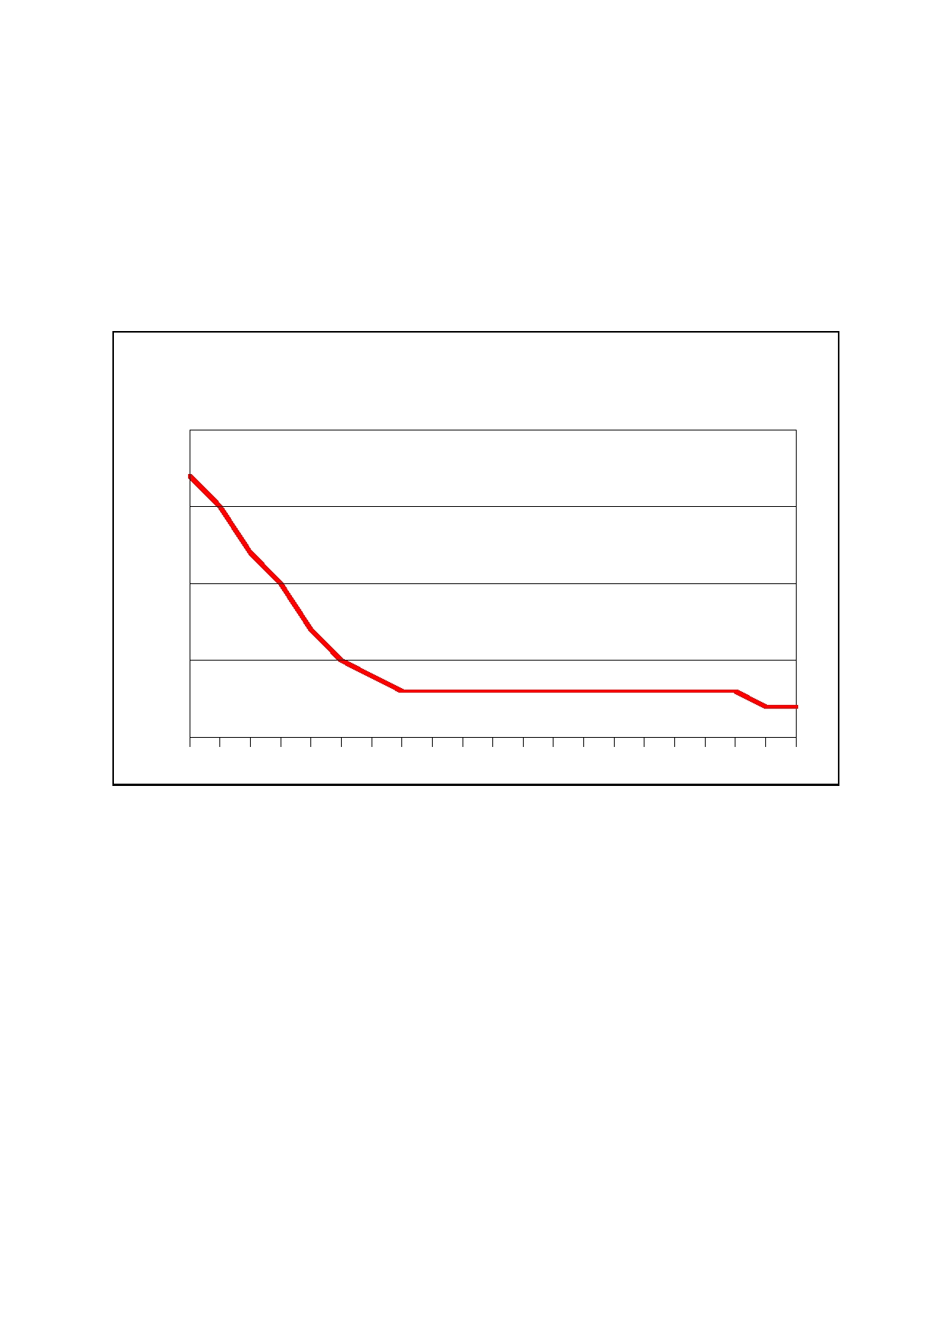
14

As Figure 4.2 indicates, by 2016 the expected exchange rate is 0.73. The expected exchange rate remains near this level until 2030.

The combination of the expected US$ pulp price and exchange rate outcomes considerably increase the profitability of the mill, compared to the CommSec study. Moreover, the
distributions for the pulp price and exchange rate are jointly modelled with a correlation
coefficient of one linking them. That is, when the exchange rate is high so will be the pulp price and visa versa.

Figure 4.2: $A/$US exchange rate

Dollars
0.9

0.85

0.8

0.75

0.7
2010
2011
2012
2013
2014
2015
2016
2017
2018
2019
2020
2021
2022
2023
2024
2025
2026
2027
2028
2029
2030

4.3 The capital cost

The current capital cost is estimated at $1.7 billion. However, construction activity is at historically high levels and real costs are rising significantly. Hence, the trigen distribution
parameters for the capital costs are:

Lower bound
Mode
Upper bound
Lower bound probability
Upper bound probability

1,750 1,900 2,200
5 per cent
90 per cent

The expected cost is $1,985 million. Interest costs are set at 7 per cent of the capital cost, reflecting the higher risk margin that is likely to prevail in 2008-09 because of the sub-prime
crisis in the United States compared to what was expected to be the case when the
CommSec study was done.


15

4.4 Other direct costs

The structure of direct costs (that is, wood, labour, services, etc.) follows the CommSec study, including the dynamics of expansions to 1.05 ADT as the plantation input reaches 80 per cent and the decline in unit wood costs and chemical costs also result as the plantation input reaches 80 per cent.

At start-up the log impact will be 20 per cent plantation and 80 per cent native forest. The plan is that this will be reversed by 2018 with 80 per cent of the logs from plantation and 20 per cent from native forest. This has been challenged in that the rate of plantation expansion
is unlikely to enable this target to be reached.9 Hence, for 2018 the trigen distribution for the
share of plantation log into the mill is:

Lower bound
Mode
Upper bound
Lower bound probability Upper bound probability

0.4 0.7
0.8
2 per cent
98 per cent

This gives an expected impact of 62 per cent plantation logs in 2018. Whatever the 2018 outcome is, the time profile of plantation log input approaches the 2018 linearly from the 20 per cent in 2010. At the latest the mill is expected to reach the 80 per cent benchmark by
2024. Again, this is approached linearly from the 2018 outcome.

No probability bounds are placed around the individual direct cost components. However, an aggregate for direct unit operating costs or contingency bound is applied. The factor value for this distribution is the rate of growth of real unit operational costs per annum above the
expected value. The trigen probability distribution parameters are:

Lower bound value
Mode
Upper bound
Lower bound probability Upper bound probability

0.0 per cent per annum 0.4 per cent per annum
0.9 per cent per annum
2 per cent
98 per cent

The cost contingency only influences the level of subsidy from the Tasmanian Government, not the mill's direct profitability.

That part of depreciation or replacement investment that is directly spent in Tasmania is set at $79 million.

4.5 Subsidy from Tasmanian Government

The current planned subsidies for the mill are ignored because they are assumed to be applied in equal measure in the alternative scenario. The application will be to develop alternative uses of the logs that would have otherwise been consumed by the mill. Subsidies from the Tasmanian Government are triggered in the current analysis if the cash flow from
the mill after interest payments, direct operating costs and replacement investment falls
below zero.

9

C. Beadle, "Chasing an Elusive Harvest", 2007.

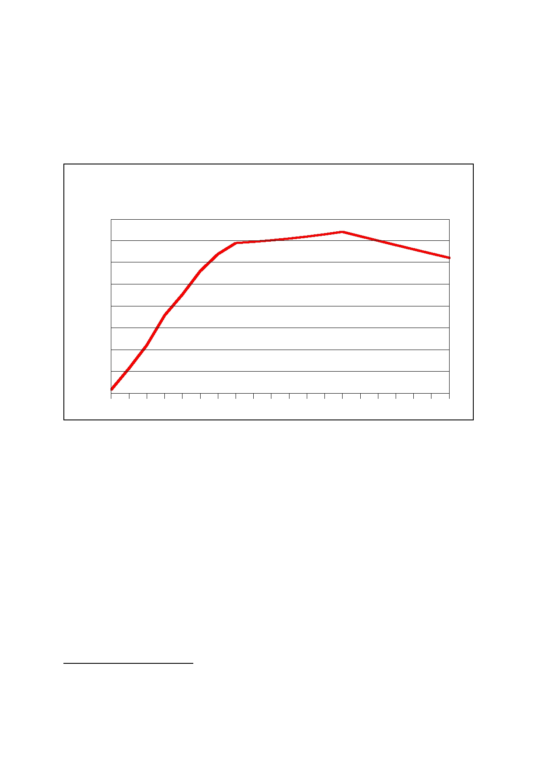
16

Figure 4.3 indicates that this does not happen for the mill case as the surplus available for distribution after direct costs, interest costs, energy savings and replacement investment is between $100 and $150 million until late 2016.

If dividends are payable, 20 per cent of the dividends are assumed to flow directly to Tasmanian households.

Figure 4.3: Pulp mill surplus available for distribution after interest
payments and capital expenditure but before taxes

2005 $ million

140.7

120.7

100.7

80.7

60.7

40.7

20.7

0.7
2029
2028
2027
2026
2025
2024
2023
2022
2021
2020
2019
2018
2017
2016
2015
2014
2013
2012
2011
2010

4.6 Tourism

A survey of 700 tourism operators in Tasmania revealed that 34 per cent believed the mill would directly affect their businesses in a negative way while 58 per cent believed it would
affect Tasmania's 'clean, green' brand.10 TRTSIP says that Tasmania finds it difficult to attract first time visitors but is 'incredibly good' at attracting repeat visitors. It quotes a visitor
survey showing that of nearly 200 000 additional visits between March 2003 and March
2007, more than 165 000 were repeat visitors. ITS Global points out that tourism contributed 6 per cent of Tasmania's Gross State Product in 2004; that in 2006 Tasmania attracted
approximately 870 000 international and interstate visitors who generated 1.07 overnight
trips and 4.8 million day trips and; spent $1.8 billion supporting direct employment of 23 000 and indirect employment of 15 500 Tasmanians11. Tourism 21 - Strategic Plan for Tasmanian Tourism Industry, June 2004 sets a goal of developing the industry into a
contributor to the Tasmanian economy of even greater significance. A key component of this
strategy is the Tasmanian tourism brand 'the unforgettable natural experience' that provides 'a range of visitor experiences based on the core appeals of nature, cultural heritage and
food and wine'. The delivery of the strategy has led to cluster and touring route strategies to

10

11

TRTSIP 2007 p15.

ITS Global 2007 p79 attributed to Tourism Tasmania.

17

focus on traveller interest on nature, cultural heritage and food and wine. The Tamar Valley is part of the touring route strategy and contains a number of designated routes. Approximately half of the interstate and international visitor trips to Tasmania in 2006 (448,000 persons) visited the Tamar Valley.

The most significant impact on tourism during the construction phase of the mill will be a 'crowding out' effect resulting from demand generated by the influx of construction workers. This influx is also likely to change the character of the accommodation, restaurant and
entertainment industry due to the prevalence of single males in the construction workforce. It
is also expected (and anecdotal evidence suggests this has already started to happen) that many people who moved to the area for the amenity and lifestyle will move out in anticipation
of the mill adding to the change in character. ITS Global acknowledges that; (1) additional
heavy vehicle movements between Georgetown and Bell Bay could disrupt the tourism experience of visitors using the East Tamar highway, (2) that a number of businesses marketing lifestyle, food and wine experiences immediately west of the construction site on
the Rowella peninsula will be impacted by loss of visual amenity and noise, (3) the
experiences of visitors could be lessened by loss of visual amenity associated with construction of water pipelines (Trevallyn dam to Bell Bay) and effluent pipe (Bell Bay to Four
Mile beach). During the construction phase, these losses are likely to be offset by demand
generated by the influx of construction workers. However, as noted above, this demand will affect the character of the industry and the area.

Once the project moves to its operational phase, the benefit of the additional demand created by 2 900 construction workers will disappear. The industry would need to refocus and attract back the lifestyle tourists that were 'crowded out' during the construction phase. However, it will have to do so after the character of the hospitality industry had been changed
by the substantial influx of single male construction workers during the construction phase. It
will also have to regenerate this momentum after the expected loss of 'social capital' - people who had been attracted by the amenity of the area but decided to move out because
they expect (rightly or wrongly) that this will be lost as a result of the mill. Most operators are
concerned that the 'brand' of the region will be damaged. It will need to rebuild this 'unforgettable natural experience' brand quite possibly, according to ITS Global, in the face of direct and indirect impacts of emissions, odour and effluent on the image of the regional
area. A further issue the area would need to deal with in attracting tourists back after
construction would be a 36 per cent increase in heavy vehicle traffic on the East Tamar Highway. It is acknowledged that this traffic 'is likely to be associated with a corresponding
increase in accidents involving log trucks in the region as well as the number of associated
fatalities."12 In terms of State impact of these developments, the issue is whether tourists would still travel to Tasmania in the same numbers or shift their travel plans to other 'lifestyle'
experiences such as New Zealand which compete with a similar brand.

We note that the AC report is positive on tourism on the ground that tourists will be attracted to see a 'state-of-the-art pulp mill'. This may provide a partial offset to the negative effects listed above.

The trigen distribution parameters for the tourism and cost are:

Lower bound
Mode
Upper bound
Lower bound probability Upper bound probability

$4.7 million annually $20 million annually
$47 million annually
2 per cent
95 per cent

12

ITS Global 2007 p 38.


18

4.7 Other pulp and paper mills

The AC study identified Wood and Paper Products (excluding the new pulp mill) as having the largest negative deviation from the base case in modelling commissioned for the Gunns IIS. Results of that modelling show a negative impact peaking at $91.6 million in 2015 for Australia and $55.5 million for Tasmania. This is the largest absolute deviation in dollar terms
of any industry. AC says that "because of the constraints on the availability of logs for
woodchips in Tasmania, increased pulp production by the mill would result in a reduction in
other forms of secondary log13production. Thus the project was assumed to result in the
reduction of woodchip output." The assumption is that export of pulp would be generated at
the expense of woodchip exports from Tasmania although which woodchips plants would close had not been identified in the AC report. However, given the Tamar Valley chip plant is the least likely to be affected, the locations most likely to see the loss of plant would be
Burnie and Triabunna both in the north of Tasmania.

While the impact on woodchip processing is significant, this is essentially a reallocation of production from one part of the industry and state to another and has been taken into
account in the Gunns modelling. However the AC modelling did not take account of the likely
impact on existing pulp and paper capacity in Tasmania. Two mills that are the most likely to be impacted are operated by Australian Paper at Burnie and Wesley Vale. These mills
employ approximately 660 people directly and are responsible for a further 650 jobs
indirectly. The two plants are operated as related economic units and together generate approximately $240 million in economic activity of which $105 million is directly attributable to Tasmania ($40 million labour, $45 million supplies, $20 million other)14. Australian Paper has
faced a difficult couple of years with these plants and is currently generating returns well
short of targets, and short of the level of returns which been have seen in previous years. Low customer demand (driven by a high Australian dollar) resulted in shutdowns early in
2007 and 40 people being laid off in late 2007. The company is said to be refocusing efforts
on key brands and narrowing down their brand portfolio. It recently sought to gain Forest Stewardship Council certification for the plants but was rejected because it was unable to
access certified input from Tasmania and has recently attempted to highlight 'carbon neutral'
product which is possible through the plant's reliance on hydro electricity. In fact, these plants are responsible for approximately 10 per cent of Tasmania's electric power consumption.

NIEIR believes the proposed Gunns mill could be the last straw for these plants due to constraints on wood supply and the risk of loosing key technical staff. It is understood Gunns will be unable to supply the Wesley Vale pulp mill with 30 thousand tonnes of pine woodchips
from August 2008 due to the pine plantations being logged out and converted to eucalypt
plantation (suitable for the new mill). Australian Paper will find it difficult to replace this supply in Tasmania with softwood pulpwood supplies expected to decline by more than 20 per cent as pine plantations are converted to eucalypt plantations. Forestry Tasmania, supplier of 70
thousand tonnes of hardwood chips, will come under pressure from 2010 to meet
commitments to the Gunns mill. Forestry Tasmania's pulpwood production has been above its sustainable harvest level for three out of the last four years15 and it has recently agreed
with Gunns to supply more than half of this production to the new mill (1.5 million tonnes from
"sustainable" pulpwood supply of less than 2.8 million tonnes). Forestry Tasmania says the remaining 1.3 million tonnes will supply existing contracts with other customers including the

13

14

15

The Allen Consulting Group 2006.

Australian Paper company presentation.

Forestry Tasmania; Sustainable Forest Management Report 2005 - 2006 July 2007 p18.


19

Australian Paper mills16. However, it is expected that Forestry Tasmania will come under
pressure to meet a greater proportion of the 3.2 to 4.0 million tonnes required by the Gunns mill (plus 500 thousand tonnes of bio-fuel). Robert de Fegely in his commentary on pulp wood supply for the proposed mill analysed Gunns export woodchip records for the past 10
years and found that the average volume of woodchips exported was 4.00 mGT and for the
past five years this figure was 4.6 mGT17. He said that average pulpwood supply in Tasmania over the five years to 2004 - 05 was 5.3 mGT per annum and at the end of this period was
just over 6.0 mGT. In other words the requirement for the Gunns Mill was between 57 per
cent and 72 per cent of total pulpwood supply in Tasmania. The mill is highly dependent on growth in hardwood pulpwood supplies from plantations that will start to become available
from 2010. However, total hardwood pulpwood supply from plantations in Tasmania is not
expected to exceed 4.0 million cubic meters until after 2020.18 Forecasts of forest yields can be unreliable and subject to environmental factors including climate change.

NIEIR expect that in the absence of a significant change in the competitiveness of the two mills there is a probability that a combination of sourcing difficulties and loss of key personnel
will contribute to the Australian Paper mills in North Tasmania closing from 2010.

A discrete probability distribution is specified for the risks of the two existing mills closing. The discrete probability function incorporates a 20 per cent probability that the two mills will
close at a direct cost to the Tasmanian economy of $120 million, at some date after 2012 because of the activity of the Gunns mill.

4.8 Fisheries and agriculture

A number of implications from the mill development relating to fisheries and agriculture have
been identified by critical studies19. These include:

• Loss of exports from the Tasmanian fishing industry should there be a spill or other
significant pollution event associated with the mill. It is estimated20 the industry
contributes $472 million to the Tasmanian economy and generates 7000 jobs. A major
spill could reduce this income considerably. Given the nature of material being released into the ocean the likelihood of this occurring during the life of the mill is high.
TRTSIP estimates the value of this risk to be 10 per cent of production over the life of
the project. NIEIR believes that the loss would be 25 per cent in the year of the event, 10 per cent in the subsequent year and 5 per cent in the third year after an event. The likelihood of one major event over the life of the project would be very high and as a
result has included such a scenario. The likelihood of a second event is moderate and
hence has included 50 per cent of a second event.

• Loss of brand image for both agricultural production and fisheries. As with the tourism
industry, a proportion of operators in both industries see the 'clean, green' image of

16

17

18

19

20

Forestry Tasmania; Pulp Mill Wood Supply Agreement Fact Sheet October 2007.

Robert de Fegely; Export Witness Statement 2006.

Bureau of Rural Sciences; Australia's plantation log supply 2005 - 2049, 2007.

TRTSIP 2007 and Naomi Edwards 2006.

TRTSIP 2007 p 17.

20

Tasmanian produce as being an important attribute. These operators expect to see some loss of brand value as a result of both the mill and the publicity that would surround its construction. TRTSIP believes the loss of brand value could amount to 2.5 per cent of production for aquaculture and viticulture.
• Commentators have also pointed to the loss of productive agricultural land as a result
of conversion to plantation forestry. NIEIR believes this is only relevant where the
change of production has a direct impact on the value of production from that land.
Assuming land is priced appropriately so that alternatives are available to different
actors wishing to use the land for either agriculture and tree plantations, it is assumed that the loss of production from the land is the same as the value of the subsidy
available to those establishing tree plantations. TRTSIP21 estimates the NPV of this
subsidy to be $204 million.
• As noted in the discussion on tourism, anecdotal evidence would suggest that there is
already an outflow of people from the region. Locals comment on the large number of
boutique agricultural establishments (particularly wine) for sale as people, fearing the
mill will impact their lifestyle or their product, seek to relocate to other areas. There is a fear this will cause a loss of social capital making the region less productive due to loss
of experience and expertise.
The discrete probability distribution for the annual risk of a channel spill is 1 per cent for a
once-off annual cost of $40 million. This is conservative in that two spills over the life of the
plant would have substantial compounding effects.

4.9 Health

ITS Global identifies at least two health impacts from the mill; air quality and road accidents from log trucks. TRTSIP has attempted to estimate a financial impact from these issues. It
estimates that the cost (both health and lost work time) of respiratory ailments as a result of
the mill would be $350 million over a 24 year period and the cost of log truck accidents over the same period would be $39 million.

The trigen distribution for annual health costs for the study is:

Lower bound
Mode
Upper bound
Lower bound probability
Upper bound probability

$2 million annually
$12 million annually $24 million annually
15 per cent
90 per cent

The undiscounted cumulative expected cost over 20 years is $220 million. The cost profile is conservative with the TRTSIP cost estimates occurring at a relative low probability rating.
The main reason for this is a downward adjustment in the cost of a death.

21

TRTSIP 2007 p 47.

21

4.10 Risk of change of Gunns ownership

The cost of the mill seems to be creeping up having been given as $1.5 billion at the time of the RPDC IIS and now being given as $1.7 billion in company literature. Some suggest this difference results from costs imposed on Gunns as a result of delays in gaining approvals. Current reports suggest the mill could be 100 per cent debt funded through loans raised on
international markets thereby generating an interest bill of more than $180 million per annum
for the new plant. Some reports suggest as much as a third of the cost could be raised by Gunns issuing equity. While the cost of equity is likely to be cheaper than debt there would
still be a cost through returns to equity holders. The vast majority of Gunns shareholders
would be on the mainland or overseas. Although not canvassed through the media, a third option would be for Gunns to link with a larger global partner in order to spread the debt burden across a larger organisation. It is believed that a large Asian producer may be
interested although that is purely speculation. Nevertheless, whatever option eventuates, it is
likely that the mill will have a significant expense as a result of capital raising and that almost all of this service expense will flow overseas. The cost is expected to be spread over the first
three years with a peak in Year 2.

The mill represents a high risk to Gunns. If the exchange rate moves the wrong way, compared to the pulp price and construction costs blow out considerably, given the likely
high international gearing, Gunns may well be forced to merge. This transfer of ownership
may be to a pulp competitor or a wood supply competitor. If a wood supply competitor, the source of the logs may well come from plantations outside Tasmania. Certainly a new owner may not have the same interest in developing the forestry products industry in Tasmania as
Gunns.

Hence, the risk of change of Gunns ownership is set at 10 per cent, with an annual direct cost of $200 million to the Tasmanian economy. The risk of change of ownership applies at
all times between 2010 and 2030.

4.11 Water supply constraints

The mill will use a significant share of Tasmania's available water resources. Climate change may result in a contraction in supplies for agricultural uses. Accordingly, the trigen
distribution for lost agricultural production from constrained water supplies is:

Lower bound
Mode
Upper bound
Lower bound probability
Upper bound probability

$2 million
$15 million $25 million
10 per cent
65 per cent

22

5. The alternative uses of the wood - scenario 2

The alternative uses of the logs for the mill are:

(i) woodchips

(ii) hardwood exports

(iii) remaining unutilised.

The new plantations that will be created to support the mill have the same alternative uses or opportunity costs.

5.1 Hardwood exports

At least 25 per cent of logs recovered from regrowth forests or plantations are suitable for timber exports, ranging from rough sawn logs to plywood/veneer. The 25 per cent benchmark is adopted here. Compared to the pulp price, prices per tonne range from 30 to
40 per cent higher for low value added logs to around 80 per cent for high value added
timber. Accordingly, for the analysis of this study, the hardwood export price of the alternative use of the mill logs is set at 40 per cent of the pulp price in 2010, after which it steadily increases to 80 per cent of the pulp price by 2030 as the value adding capacity of the
Tasmanian forestry product industry expands, in part driven by subsidies that would
otherwise have been employed by the mill. This also captures likely real falls in pulp prices relative to hardwood timber export prices.

5.2 Woodchip exports

The residual after hardwood exports could be exported as woodchips at a price equal to 23 per cent of the pulp price. Note two gross tonnes of logs equals one tonne of woodchips. It should be noted that the outflow of the gross surplus from Tasmania for hardwood or
woodchip exports is assumed to have a similar ratio to that of the pulp mill surplus.

5.3 Alternative export volumes

Securing markets for alternative uses of the logs that would have otherwise been utilised by the mill will take time. Hence, the assumption is that from start-up 40 per cent of the logs will be able to be used for hardwood or woodchip exports. Uncertainty surrounds the future build-
up in the share of the cumulative log stock that otherwise would have been utilised by the
mill. Accordingly, for 2030 the following trigen distribution is specified to cover the range of possibilities for that share of the cumulative log stock that otherwise would have been utilised by the mill that is commercially utilised.

The parameters of this trigen distribution are:

Lower bound
Mode
Upper bound
Lower bound probability Upper bound probability

40 per cent 50 per cent
100 per cent
10 per cent
100 per cent

23

The mean expectation from this distribution is that 60 per cent of the cumulative stock of logs that would have been consumed by the mill by 2030 are found alternative commercial uses.

5.4 An alternative case

One criticism of the above approach is that it considers that logs from the new plantations that Gunns are installing to support the mill have an alternative use or opportunity cost. This
is because, in the absence of the mill, construction of new plantations to at least 150,000
hectares may cease.

To allow for this a no plantations case was designed with the logs available for alternative uses constrained to exclude supply from new plantations. By 2021 at the latest, the log
supply to the mill is planned to be from the new plantations, giving a ceiling green log tonnage available for alternative commercial uses of 54 million tonnes. For this case the trigen probability distribution parameters are modified to change the percentage of the total
that is commercially utilised by 2030 for forest products. That is:

Lower bound
Mode
Upper bound
Lower bound probability Upper bound probability

70 per cent 90 per cent
100 per cent
10 per cent
100 per cent

For case 2 the alternative use of the logs consumed from new plantations will be the opportunity cost of lost agricultural production. The area involved is at least 150 000 hectares.

Again, from the responses to the mill there is uncertainty surrounding the likely losses in agricultural production per hectare. The cost estimates in the literature are in terms of value
added per hectare, when the appropriate comparable estimate is revenue per hectare.

The trigen distribution parameters for the lost revenue per hectare from the new plantations
are:

Lower bound
Mode
Upper bound
Lower bound probability Upper bound probability

$500 per hectare
$1,000 per hectare
$1,400 per hectare
15 per cent 99 per cent

The mean export loss is $845 per hectare per year. The total opportunity cost from lost agricultural production will build up as the new plantations expand at a rate of 17,000
hectares per year. The opportunity cost of lost agricultural production also applies for case 1 until the logs are harvested for the mill or for alternative wood product uses.

Using the negative value added data in AC Table C.4 for Tasmanian agriculture and wood/pulp and interpolating between benchmark years the total discounted opportunity cost for the logs used in the proposed mill from the AC study is around $1.5b in 2005 prices. The opportunity cost from this study from the above assumptions at the mean of the distributions
is at least 2.8 times the AC study results. This is because the AC study has not considered
the opportunity cost of high value added wood exports and after 2020 considers the opportunity cost from the new plantations to be zero including any lost agricultural production
from the land used to support the new plantations.

24

6. The proposed mill: Net direct benefit to the Tasmanian
economy

The output variable of interest is the discounted cumulative net direct benefit of the mill to the Tasmanian economy. The output will be in the form of a probability distribution that is the
product of the joint simulation of all the individual probability distributions specified above.

6.1 The discount rate

A variety of discount rates have been used to assess the mill. One argument is for a low discount rate to reflect the fact that decisions made today cannot be easily reversed,
resulting in the locking in of long run costs. Another argument is that because of the
uncertainty surrounding the project a relatively high discount rate should apply. However, this would result in minimising any long run costs.

Accordingly, a trigen distribution is also specified for the discount rate. The parameters are:

Lower bound
Mode
Upper bound
Lower bound probability Upper bound probability

3 per cent 5 per cent
7 per cent
5 per cent
90 per cent

6.2 Case 1: The direct economic benefit on the Tasmanian
economy

Figure 6.1 gives the cumulative ascending simulated distribution for the net impact. The range is from a minimum of -$6.6 billion, in 2005 prices, to $3.2 billion. The maximum
negative outcome would be when there is a chemical spillage every year, negative factors simultaneously take values at the upper end of their individual distributions, while positive factors are all at the lower end of their distributions. The mean is -$0.6 billion. The 25/75 per
cent probability bounds are -$1.4 to $0.5 billion. The 25/75 per cent bounds are fairly tight,
reflecting:

(i) the strong correlation between the US$ pulp price and the exchange rate

(ii) the fact that a large proportion of the surplus will flow outside Tasmania.

Figure 6.2 shows the relative importance of each factor to the outcome. By design the exchange rate and pulp price offset one another. The next most important driver is the per
cent of the mill log cumulative impact that is harvested for commercial use. The greater the
percentage, the less the benefit from the project.

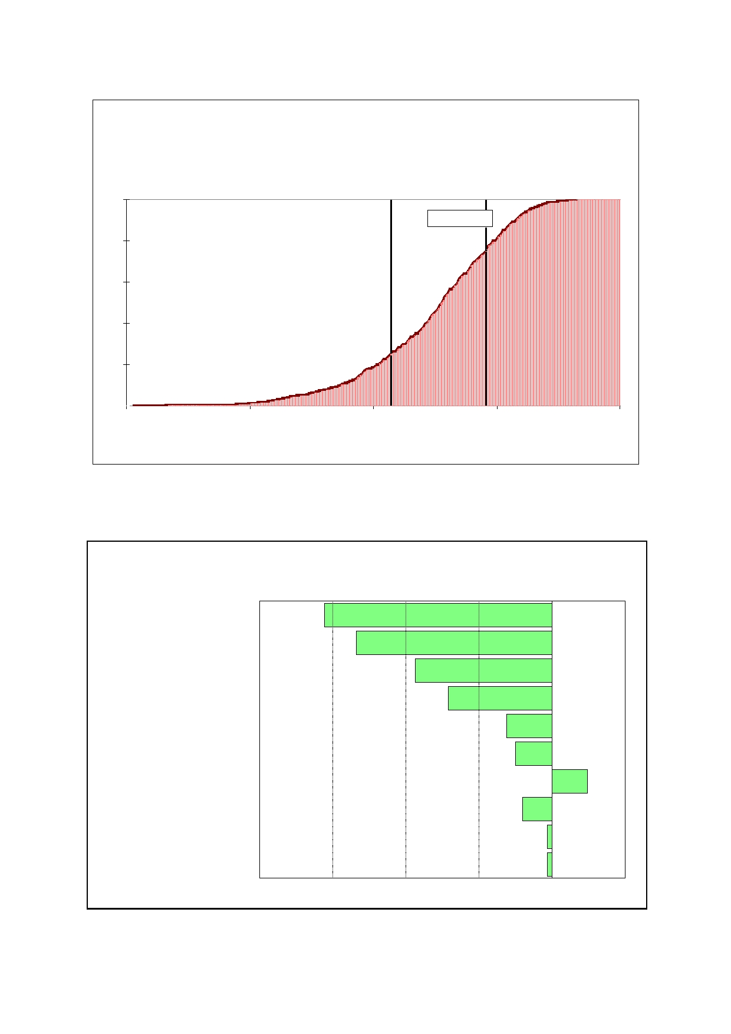
25

Figure 6.1: Case 1 - Distribution for cumulative
discounted - direct economic impact on Tasmanian
economy - 2005 $ billion

1

0.8

0.6

0.4

0.2

0

X <=-1.428
25%

X <=0.493
75%

Mean = -0.5630

-6.8 -4.3 -1.8 0.7 3.2
Value in $ billion

Figure 6.2: Standard deviation change in cumulative discounted
net direct benefits for one standard deviation change in drive factors

% of consumed used for commercial purposes -0.623

Risk of GUNNS bankruptancy -0.536

Paper mill closure -0.374

Agriculture production per hectare -0.284

Lost agriculture production -0.124

Tourism loss -0.1

Discount rate 0.098

Deaths and sickness -0.081

Capital costs -0.013

Chemical spillage -0.012

-0.8 -0.6 -0.4 -0.2 0 0.2
Standard B coefficients

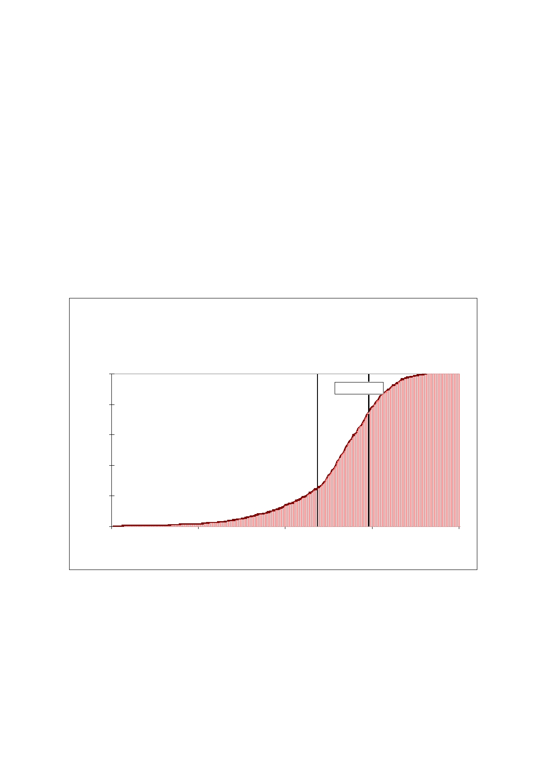
26

6.3 Case 2: The direct economic benefit to the Tasmanian
economy

Case 2 is for the case where, on harvesting, the opportunity cost of the logs is not wood exports but lost agricultural production.

From Figure 6.3 the expected net benefit is -$0.7 billion, with a 25/75 per cent probability range from -$1.2 to $0.1 billion. This is less favourable than case 1, though not significantly
different. The reason for this is that the lower stock of logs for alternative wood uses under
case 2 is offset by the fact that a greater percentage of logs will be harvested for commercial uses by 2030. In other words, it does not make any material difference whether or not the
new plantation logs are treated as having wood product alternative uses or agricultural
product opportunity costs.

Note the probability distribution for case 1 and case 2 are drawn from joint probability simulations of 100 iterations.

Figure 6.3: Case 2: Distribution for cumlative discounted
direct economic impact on Tasmanian economy -
2005 $billion

1

X <=-1.228
25%

X <=0.057
75%

0.8

0.6

0.4

0.2

0

Mean = -0.7336

-6.4 -4.225 -2.05 0.125 2.3
Value in $ billion

27

7. Conclusion

This study has ignored the construction impact and focussed on the operational benefit of the proposed mill. Using the results form the NIEIR model of Tasmania, the direct and indirect
consumption benefit will be of the order of (141/330) or 43 per cent of the direct benefit.
However, the cumulative discounted consumption benefit from the operation of the mill for the Tasmanian economy will be of the order of -$0.3 billion to 2030. This stands in contrast to the $3.3 billion of consumption benefits assessed by the AC study or $2.8 billion if the
estimated $0.5 billion construction benefit in the AC Report is deducted.

It should be noted that the ranges of consumption benefit discussed in the Executive Summary are obtained by applying the 0.43 ratio to the data in Figure 6.1 as well as applying
the 0.43 to the difference between the AC estimate of opportunity cost of the logs and the
estimate made by this study. That is the at least $1 billion estimate given in the executive Summary.

If the AC construction consumption benefit is added to this study's operational benefit estimate, the total consumption benefit is of the order of $0.2 billion. However if half the construction benefit is captured by temporary imported labour to Tasmania and if most of the operational benefit is captured by existing Tasmanian households (NIEIR's view) then there
would be no gain to existing Tasmanian residents in terms of consumption from the totality of
the project.
28

Appendix 1: NIEIR models versus Monash models

Below is the summary of the critique NIEIR made of the MMRF model which is published in the Victorian Auditor General's Report into Government Support for Major Events, published
in May 2007.

The basic NIEIR critique is that the MMRF models are far too constrained to be credible. This is a minor issue in this study because the MMRF-Green Model employment aside is far too expansionary to be credible in terms of its own constraints. Thus, a reading of the
supplement below will give the reader what would have been expected from the Monash
model for the pulp mill study if it was to be consistent with previous studies.

It should be pointed out that the MMRF-Green Model does allow some increase in Tasmanian employment from existing Tasmanian residents compared to the MMRF model
results below, which allowed for no increase. However, this only represents 15 per cent of the total employment increase for Tasmania and, therefore, does not fundamentally alter the
comparison of the two Monash models. The zero increase at the national level is retained.

Supplement to the NIEIR response to the Auditor General's report

NIEIR's response to the second last draft of the Auditor General's report is published in the final report. This attachment complements this response.

The core charge of NIEIR against the report is that it is a polemical document, long on argument but short on facts to support the arguments. Where facts or estimates are used,
more likely than not, they are used misleading. In short, the report is unprofessional, the Auditor General has failed in his core responsibility to provide factual and unbiased advice to
the public free of vested interest influence.

1. There is not a shred of evidence to support the report's assumption of
revenue constraints

The foundation stone of the report is the assertion that because CGE models assume full employed resources nationally, they are somehow more plausible. Yes, Australia is currently experiencing capacity pressures in the construction sector in at least two States. Yet despite
this the industry continues to grow rapidly in Queensland and Western Australia.

A plausible model, like the NIEIR IMP model, would be one which allows the influence of skill shortage capacity constraints to operate individually at the industry level depending on the
severity and not assume just because one or two industries are capacity constrained then
the whole economy must be.

As pointed out in the NIEIR response, the assumption of full employment implies that there is not one hour of additional work available to support the AFOGP or other major events
anywhere in Australia. That is, there is not one hour of work available anywhere in Australia
from:

• more overtime from the full time employed;
• more hours of work from the part time employed;
• the unemployed;
• those of working age outside the workforce who would work.

29

Table A.1 shows that based on available statistics, there was 2.6 million available workers nationally, or 0.7 million in Victoria, who would be willing to undertake and, in most cases adequately provide, the generally low and semi-skilled services required to support the AFOGP.

Nationally, employment opportunities NIEIR estimates to be created by the AFOGP represents 0.1 per cent of the available labour.

As NIEIR pointed out in its response, Australia's low workforce participation rate compared to some other countries is consistent with Australia's inability to provide adequate employment
to the working age population compared to other countries. That is, the estimates in Table A.1 of unutilised labour are also validated by benchmarking Australia to other countries.

Finally, putting aside the macro issue of available labour and simply looking at the seasonal pattern since the level of activity in the December quarter for the tourism related industries is higher than the March quarter, then the inference is that if the Victorian economy can support Christmas it can then also support the March event.

Table A.1 Labour resources available and allocation - 2005 and 2006
Additional
overtime Part-time NIEIR
available who would Victorian
(expressed prefer more employment in terms of hours who Persons not from AFOGP
full time have been in the labour as percent
equivalent) looking for force who Unemployed of available
NIEIR persons work wanted work (NIEIR) Total labour
Victoria 66.1 123 303.7 204 666.2 0.5
Australia 268.6 495 1165.3 782 2593.2 0.1

Interstate un- outside the
migration employment workforce Total
Sources of Victorian labour to support AFOGP
(per cent of total) 5.9 48 46.1 100

Additional
overtime Part-time available who would
(expressed prefer more
in terms of hours who Persons not
full time have been in the labour
equivalent) looking for force who Unemployed
MMRF persons work wanted work (NIEIR) Total
Victoria 0.0 0.0 0.0 0.0 0.0
Australia 0.0 0.0 0.0 0.0 0.0

Interstate un- outside the
migration employment workforce Total
Sources of Victorian labour to support AFOGP
(per cent of total) 100 0 0 100
30

Notes to Table A.1

The Data in the table is taken from Australian Bureau of Statistics Catalogue No. 6220.0, 6265.0 and 6291.0. The unemployment rates are derived from social security data and
explained in NIEIR's "State of the Regions" report. The additional overtime is derived from
the peak average hours worked for full time employed before March quarter 2005 less the actual hours worked by full time employed in the March quarter 2005. The components do
not add to the sum because an allowance has been made between the overlap between the
ABS estimates of those outside the workforce who want a job and the NIEIR unemployment level.

The NIEIR reports on the AFOGP do not report the sources of the additional employment. However NIEIR, in other similar events, does do this, e.g. the evaluation of the Australian
Tennis Open.

2. The implication of the Auditor General report is that much of
government policy is pointless

The Auditor General's report model based evaluations is not specific to the AFOGP. What has been evaluated is the benefits of tourism expenditures generally, whether for the AFOGP
or safari tours of North Queensland. The results also apply to any other source of exports that generate less $ per employed person than the mining industry.

Education services exports would perform particularly poorly. The implications of the report reflect the views of extreme right wing political economists.

3. There are no capacity constraints in the Victorian tourism industry

The Auditor General's report assumes throughout the report that the AFOGP must impose capacity constraints and price pressure on the Victorian tourism sector that will result in crowding out of activity.

When checked against the facts, there is no evidence for these assumptions whatsoever.
The facts which the Auditor General's assertions can be checked against are the:

• rate of growth;
• productivity; and
• price behaviour,
of the Victorian tourism industry which is taken to be represented by ANZSIC industry H, or
accommodation, cafes and restaurants.

Figure A.1 shows these series. The first is the cumulative four quarter output growth rate for the Victorian tourist industry. Over the period since 1996, the average annual rate of growth has been 4.7 per cent per annum, well in excess of the average gross state product growth rate of 3.6 per cent per annum over the same period.

The second series is the rate of growth of the real price of Victorian tourist sector. It is the implicit deflator of the Victorian consumption of accommodation, cafes and restaurants, divided by the overall Victorian implicit consumption deflator. The series was adjusted for the
differential impact for the GST over 2001 and 2002.
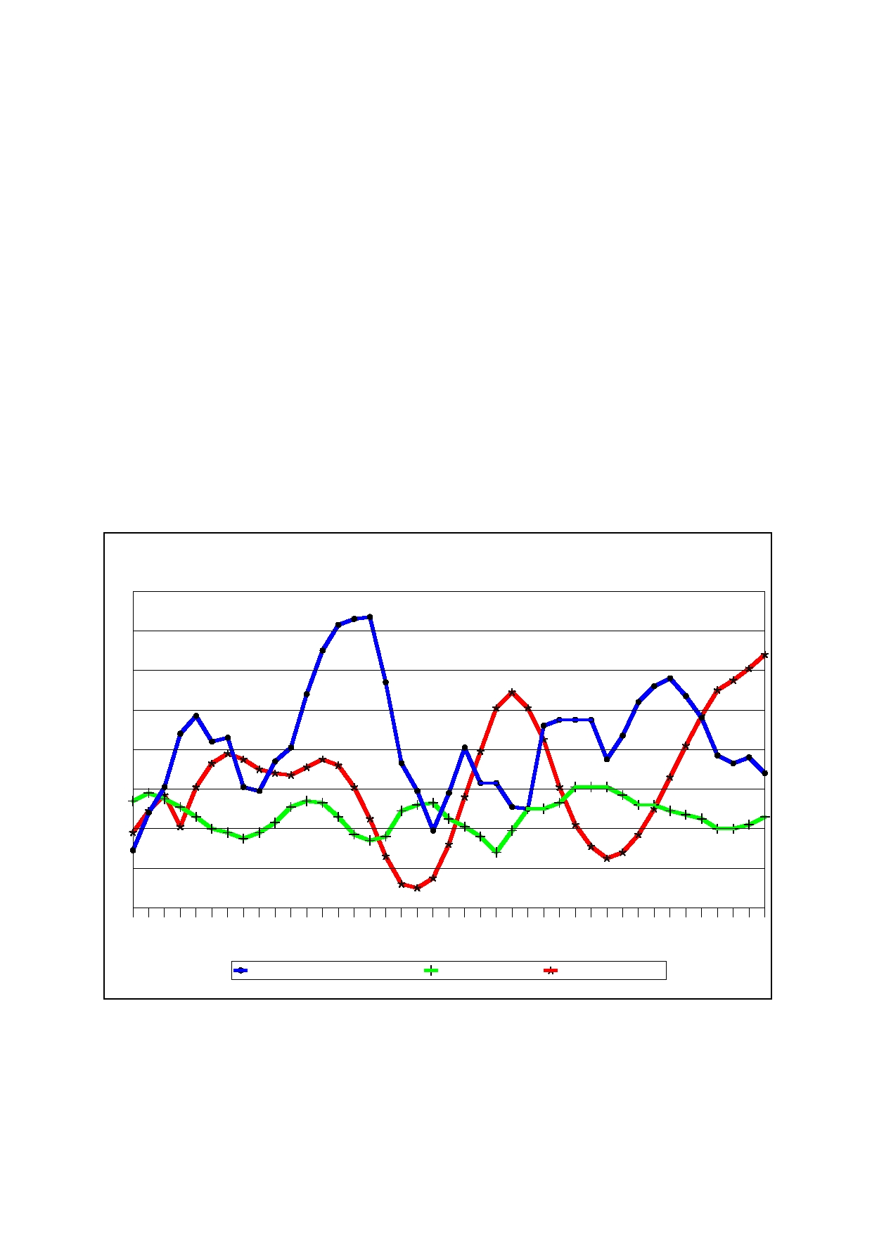
31
n-0
6
J u r-06
Mac-05
Dep-05
Se n - 0 5
J u r-05
Mac-04
Dep-04
Se n - 0 4
J u r-04
Mac-03
Dep-03
Se n - 0 3
J u r-03
Mac-02
Dep-02
Se n - 0 2
J u r-02
Mac-01
Dep-01
Se n - 0 1
J u r-01
Mac-00
Dep-00
Se n - 0 0
J u r-00
Mac-99
Dep-99
Se n - 9 9
J u r-99
Mac-98
Dep-98
Se n - 9 8
J u r-98
Mac-97
Dep-97
Se n - 9 7
J u r-97
Mac-96
Dep-96
Se n - 9 6
Ju

Now the expectation would be since the overall Victorian implicit consumption deflator is
biased downwards from:

• the high labour productivity growth of goods industries;
• the China effect on goods prices; and
• the hedonic price adjusted for electronic equipment,
that the rate of growth of the real tourism price index would be significantly greater than the
overall deflator. In fact, the average rate of growth of real tourism sector prices in Victoria is
only 0.7 per cent per annum.

More importantly, real price growth tends to decline (below the 0.7 per cent trend) when output growth is relatively low and vice versa. Thus, in the late 1990s when output growth
was high, in excess of 10 per cent per annum, the real tourism industry price fall.

The reason for this is because productivity growth in the Victorian tourism sector is positively related to output growth. That is, the sector is subject to increasing returns of scale. For every 1 per cent increase in output growth, productivity growth (output per member)
increases by around 0.6 per cent. Of special importance is that the data shows no capacity
constraints for the Victorian tourism industry around March 2005.

Figure A.1: Culumative four quarter span growth rates (per cent)

Per cent
12

10

8

6

4

2

0

-2

-4

Victorian tourist industry output Real output prices Labour productivity

Source: Derived from ABS Catalogue No. 5220.0, 5206.0 and 6291.0.

The Auditor General's report assumes decreasing returns to scale in much of the analysis. As pointed out in NIEIR's reply, this fact alone invalidates all of the Auditor General's conclusions.

Prima facie, a significant amount of the credit for good recent outcomes for the Victorian tourism industry must go to tourism policy in general, and the activities associated with organising major events in Victoria.

A competent Auditor General's report into the value of major events would have investigated these statistical series thoroughly, not ignored them or assume industry conduct which is a myth.



SCHOOL OF ECONOMICS AND FINANCE

Discussion Paper 2010-01

Economic Assessment of the Gunns Pulp Mill
2004 - 2008

Graeme Wells

ISSN 1443-8593
ISBN 978-1-8629-577-6
Economic Assessment of the Gunns Pulp Mill 2004-2008

Graeme Wells
School of Economics and Finance
University of Tasmania

Abstract

This paper outlines the process for evaluating the economic effects of Gunns proposed pulp
mill in northern Tasmania. Removal of the project from the Resource planning and
Development Commission had two important effects. First, assumptions underlying the
proponent's impact statement could not be tested in public hearings. Second, important parts
of the RPDC economic assessment criteria were never addressed. In the end, the review process was structured so that only one outcome, favourable to the proponents, was ever possible.

Introduction

Speaking in support of the Pulp Mill Permit on 30 August 2007, Legislative Councillor Mr Jim Wilkinson concluded that 'I am satisfied that the pulp mill proposal has been assessed
against the guidelines established by the RPDC and against the conditions that were imposed
by various regulators according to the law'. Some seven weeks earlier the economic
consulting firm ITS Global had completed its review of the social and economic benefits of
the mill. It is clear from the Hansard record of the debate that many Councillors relied on the conclusions of this review in supporting the granting of a permit for the mill, but it is a matter
of speculation as to whether Councillors other than Mr Wilkinson believed that the RPDC
guidelines had been met. The review by ITS Global, however, leaves no doubt as to its
position - it noted that since Gunns had withdrawn from the RPDC assessment process, the guidelines for the draft IIS were 'defunct'1.

For the Lennon government it was self-evident that the large investment associated with the
mill would benefit Tasmanians. In 2004, well before any formal assessment process had
begun, Economic Development Minister Lara Giddings said that

'There are clear benefits for Tasmania in developing a pulp mill. The benefits can be
measured in terms of jobs and economic growth through the downstream processing of our timber resource and we are determined to do 2all we can to see a modern pulp mill
facility using world's best practice in Tasmania.'

The government was true to its word. Significant funds from Commonwealth and State governments were spent to facilitate development of the mill proposal and to persuade
Tasmanians of its merits. The Tasmanian government lobbied for continuation of tax
concessions under managed investment schemes so as to ensure the financial viability of the
mill and, after the mill permit was legislated by the Tasmanian parliament, for
Commonwealth infrastructure funding for transportation of pulpwood around the state.

The effect of withdrawing the mill from the RPDC assessment process was that these and other expenditures or tax concessions, together with possible externality costs, were never quantified by either the proponents or reviewers of the IIS. This made it inevitable that the assessment process would find 'clear economic and social benefits' from building the mill.

The focus of this paper is on the adequacy of the economic assessment of the pulp mill project - both through the RPDC process and the subsequent ITS Global review commissioned by the
Department of Premier and Cabinet. The story begins with an outline of the RPDC
assessment criteria, followed by a section illustrating the pro-mill environment of political
spin in which the assessment took place. I then analyse the assessment process in two stages.
The first stage comprises three sections which examine the economic modelling strategy
underpinning Gunns' IIS, the welfare measures derived from it, and whether the IIS met the RPDC guidelines. The second stage deals with events after submission of the IIS - the peer
review reports of the IIS, the ITS Global review, and the modelling conducted by the National Institute of Economic and Social Research.

It is just possible that, had a more critical assessment been completed, a broad consensus
might have been reached in which a formal benefit-cost analysis showed the mill to be of net
benefit to the residents of Tasmania. This is not what happened. The last section of the
chapter concludes that, at the time Mr Wilkinson spoke, the economic assessment of the pulp
mill was incomplete in a number of important respects - consideration of subsidies for the

1
2

ITS Global (2007), p.8.
Press release by Minister Lara Giddings announcing the establishment of the Pulp Mill Task Force,

18 August 2004.


mill had been sidelined; important modelling assumptions had not been scrutinised; the possible cost of environmental externalities had been excluded; and benefits accruing to Tasmanian households had been misrepresented.

RPDC Assessment Criteria

The role of economic assessment in approving major developments appears to be
straightforward - evaluate social benefits and social costs and, if the latter exceeds the former,
approve the project. Practical implementation of this assessment is, however, always contentious and no more so than in evaluation of Gunns' pulp mill proposal.

A number of issues make assessment problematic. Which costs and benefits are relevant?
How should they be measured? Who bears the costs and who enjoys the benefits? Who
scrutinises claims made by proponents and opponents?

Final Scope Guidelines produced by the RPDC in December 2005, address the first two of
these questions. Section 2.1 specifies that the introductory section of the IIS

'... should describe the pulp mill in the context of international pulp import and export markets and the predicted benefits and costs of the pulp mill with respect to Tasmania and Australia. Provide a descriptive and quantitative analysis of the benefits and costs
of the pulp mill, including but not necessarily limited to, an assessment of the pulp mill
impacts on the Australian balance of trade and associated services and markets. This

should include a summary of overall conclusions of the net pulp mill3impacts based on
environmental, social, economic and community costs and benefits.'

while Section 8.4 requires the proponent to detail

'… any government supplied benefits that have or will be supplied to the proponent to
make the project viable or reduce its risk exposure (including direct government
financial or infrastructure contributions, or tax concessions). The proponent should take account of the timing of payments and costs, including the costs of additional monitoring to all levels of government over the life of the project and anticipated
contributions. Any anticipated forms of public subsidy, both direct and indirect, shall
be identified and described. Any costs to be borne by public expenditure for the

management of social, environm4ental and economic impacts of the pulp mill project
should be individually detailed'.

The third question on distributional issues is sidestepped by implicit use of the so-called
Kaldor-Hicks criterion in welfare economics, whereby a project is approved if the aggregate benefits exceed the aggregate costs. This amounts to the requirement that the benefits should be large enough that those that benefit could, in theory, compensate those that bear the costs.
Precisely how this is to be achieved is left unspecified but the political process has a role to
play. Private remedies may also be available if the losers to access the legal system to enforce
compensation for damages should they occur, although there is some uncertainty as to whether this course is ruled out by s.11 of the PMAA .

Procedures for projects of State Significance address the fourth question. Under these
procedures, there are four opportunities for review of the proponents' draft IIS against the

3

RPDC Final Scope Guidelines, December 2005, p.8. This section is unclear as to the relevant

constituency - is it Tasmanians, or Australians? This is important because, as is detailed subsequently,
most of the economic impacts modelled in Gunns IIS derive from a diversion of resources from mainland Australia to Tasmania.
4 RPDC Final Scope Guidelines, December 2005, p.64-65.
2


RPDC guidelines - peer review reports on the IIS initiated by the RPDC; submissions and hearings on the IIS; submissions and hearings on the RPDC's draft assessment report; and
approval of both the Tasmanian Premier and the Australian Government Minister for Environment and Heritage.

Spin

Assessment of the mill was accompanied by a drumbeat of overblown claims as to the importance of forestry in the Tasmanian economy. Lobbyists such as the Construction, Manufacturing, Forestry and Engineering Union (CMFEU) and Timber Communities
Tasmania, a lobby group largely funded by the forestry industry, lost no opportunity to argue that forestry underpinned growth in the Tasmanian economy while simultaneously stressing the need for government handouts to sustain further growth.

Given their constituency, such behaviour is understandable and appears to have been
successful. In 2007, for example, 24% of survey respondents thought that forestry had 'made

the greatest contribution to the5growth of Tasmania's economy in the last few years' - second
only in importance to tourism. It is hard to reconcile this response with the reality that
Tasmanian woodchip exports had declined since 2000, and forest contractors6had, in 2007,
asked the Commonwealth for a $93m package to help them exit the industry.

While it might be difficult for the general public to discount repeated but erroneous claims,
more is expected from the responsible ministers. But Bryan Green, then Minister for
Infrastructure, Energy and Resources, was infected by the lobbyists' enthusiasm for forestry and wood products industry. For example, in his submission to the Australian Government's
review of taxation treatment of plantation forestry, he claimed that 'these industries contribute
... 23 % of Gross State Product ... and directly employ around 10,700 people (1 in 13
workforce participants)'.7

These claims, which appear to have been sourced from a CFMEU website, were wildly
inflated. Schirmer (2008) estimated employment in the forestry and wood products industry to
have been 6300 in 2005-06 which, given the Tasmanian workforce of 222,000 persons, is
2.9% of the total. That is, the industry employed one in 35 workers, not one in 13 as claimed
by Minister Green. Data on value added in the forestry and wood products industry are not
compiled by the Australian Bureau of Statistics, but even in the unlikely event that workers in
the industry were twice as productive as the Tasmanian average, their contribution to Gross State Product would have been 5.8%, not 23% as claimed by Minister Green.

The same attitude prevailed in characterising the results of the IIS. Consider three examples, one from Gunns' advertising, and two from responsible ministers.

The Gunns example is taken from a series of advertisements during the 2007 federal election

campaign, one of which made the claim that the mill 'will provide government8with an extra
$1 billion in revenue to fund health, education and other community services'. This claim is
worth analysing at some length, as it is misleading in several important respects.

5
6

Enterprise Marketing & Research Services Pty Ltd (2007). Department of Agriculture, Fisheries and Forestry (2007).

7 Department of Infrastructure, Energy and Resources (2005), p.2.
8 Gunns Limited (2007), 'Inconvenient facts the Greens will not discuss', The Mercury, p.10, 7 November.
3


The CoPS model results are that the mill generates an increase in tax revenues for all levels of
government with a discounted present value of $834m9. Perhaps it was just a rhetorical
flourish by Gunns to 'round up' to the nearest billion dollars, but there are other difficulties.

The first is that while IIS tabulates revenues (other than income taxes) generated in Tasmania
as State government revenue most of these revenues accrue, in the first instance, to the
Commonwealth government; only $170m are State and local government taxes. The CoPS
modelling logic, however, is based on marginal rather than average effects. This means that treating GST revenues generated in Tasmania, as a State tax overstates the allocation of GST
revenues that Tasmania would receive consequent on the construction of the mill. The
Commonwealth Grants Commission allocates Australian GST revenues to the states in a complicated way, but the essential point is that the process generates a proportion - in its
most recent allocation, Tasmania received around 3.6% of the total - which is used to
calculate GST revenue shares. Applying the marginal logic of CoPS modelling, therefore, Tasmania could expect to receive 3.6% of the total change in Australian GST revenues.

Using year-2030 figures from the IIS as an example, GST collected in Tasmania is estimated
to rise by $28.7m, while for Australia as a whole, the increase is $19.7m. Assuming
unchanged Grants Commission proportions, therefore, the increase in GST revenue which
Tasmania could expect to receive in year 2030 would be 3.6% of $19.7m, or less than $1m, not the $28.7m figure tabulated in the IIS. Although the same Grants Commission formula
does not apply to Commonwealth income taxes, the same general argument applies. So a more realistic interpretation of the CoPS results is that the present value of tax revenues
accruing to local and State governments in Tasmania is of the order of $200m, not $1000m, as claimed by Gunns.

Unfortunately, the confusion does not end there. Both the IIS (and the subsequent ITS Global
review) overlook one of the modelling assumptions of the CoPS model, which is that
government expenditures are held fixed and the budget balance is unchanged. This
assumption is implemented by the modelling requirement that all tax revenues are given back to households as a lump-sum transfer who, in turn, spend the transfer in the same way as other
components of household disposable income. So, in the IIS, there are no tax revenues available to be spent on 'health, education and other community services'.

Having considered the Gunns example of spin at some length, turn now to two other examples, from Treasure Aird and Premier Lennon.

Answering a question from the Legislative Council member for Rumney on 19 April 2007, Treasurer Michael Aird heralded an era of supercharged growth for Tasmania, claiming that

'…. if the pulp mill is developed, it will give a lift to the economy of 2.5 % growth
every year. When you consider we have around 3.5 % growth now, the 2.5 %
growth that can be achieved by building the pulp mill will give a huge lift to the general wellbeing of the State. … It is not quite a doubling but it is still quite an
impressive figure and it would be a sustainable figure right through.'10

This answer is highly misleading as it suggests that the mill would lead to a sustained annual
growth rate of around 6 %. As will be described in more detail in the next section, IIS
modelling does not report annual growth rates of Gross State Product (GSP). What it does is

9

In the IIS discounted present values apply to the relevant annual flows from 2007 to 2030, expressed

in constant prices; a discount rate of 5% is used. 10 Legislative Council Hansard, 19 April 2007.
http://www.parliament.tas.gov.au/HansardCouncil/isysquery/a034df15-27d1-4cf0-9669-
0336f97a8104/10/doc/
4


to calculate the difference in the level of GSP with and without the mill. The pitfalls of Mr
Aird's analysis are easily demonstrated over the three-year construction period by taking his
assumption of 3.5% annual growth without the mill, together with the IIS results for the effect
of the mill on the level of GSP. Combining these two sets of numbers and expressing the resulting aggregate as a year-on-year percentage change gives the following sequence of growth rates: 2007: 4.86%, 2008: 4.91%, 2009: 2.90%11. In terms of year-on-year growth
rates, the 6 % figure is never reached and in 2009 the year-on-year growth rate is, inconveniently, lower than the 'without-the-mill' growth rate of 3.5 %.

Premier Lennon tried a different approach to spruiking the benefits of the mill. In April 2007
he wrote to the Tasmanian public with the claim that the mill would mean 'an extra $870
each year for every Tasmanian household.'12 The derivation of this figure was never
revealed but the public required no coaching to recognise the implication of the Premier's
claim - that all Tasmanian households would get an equal share of the spoils - was nonsense.

Did the IIS address the RPDC Guidelines?

The RPDC guidelines did not require Gunns to undertake a formal cost-benefit analysis. Rather, section 8.4 requires that any past, present or anticipated public-supplied benefits, together with costs of environmental monitoring and management, should be enumerated.

Readers of section 8.4 of the RPDC guidelines might reasonably have concluded, for
example, that tax benefits such as those provided by managed investment schemes (MIS) fall within the ambit of the IIS in the sense that they provided 'benefits to make the project viable or reduce its risk exposure'.13 It also appears that governments and industry implicitly agreed
with this position. Consider the following:

• In 2005 the Tasmanian Government argued for continuation of MIS schemes because

'The Tasmanian government is concerned that a policy change by the Australian
Government could undermine investment decisions and jeopardise crucial investments.
For example, if a policy change resulted in a significant reduction in plantation
development in Tasmania, the outcome could place at risk the proposed Gunns pulp
mill …'14

• Recording the favourable outcome of the inquiry into MIS schemes, the Commonwealth
Department of Agriculture, Fisheries and Forests noted that

'A number of planned key project proposals, valued at several billion dollars, depend
directly on further expansion of the MIS plantation sector. They include the Gunns
pulp mill in Tasmania, the Protavia pulp mill at Penola in the Green Triangle,

11

If the level of GSP is given a base-period value of 100 in 2006, a 3.5% growth rate for the following

three years gives values of 103.5, 107.12 and 110.87. The IIS reports (Table C1, p.56) that these three
values will be higher by 1.32%, 2.71%, and 2.12% respectively, giving a 'with the mill' sequence of
GSP levels over the three years of 104.86, 110.03 and 113.22. Year-on-year percentage changes based on this sequence give the numbers cited in the text. 12 Lennon (2007).
13 Although the following discussion is focussed on managed investment schemes, Round Table for
Sustainable Industry (2007) identified a number of other areas involving significant government subsidy.
14 Department of Infrastructure, Energy and Resources (2005), p.2.
5


expansion of the Visy pulp mill at Tumut in NSW and the PaperlinX pulp mill upgrade
at Maryvale in Victoria.'15

• This outcome was enthusiastically endorsed by Gunns who noted that

'The industry has lobbied tirelessly to ensure that the government fully understands the significant benefits of the expanding forest industry to regional and rural Australia.
Over $4 billion worth of value-adding processing plants are being planned or
developed in regional areas around Australia on the back of MIS funded plantations
including Gunns Ltd's $1.4 billion pulp mill at Bell Bay.'16

The IIS response to the RPDC requirement in section 8.4 was, however, brief. While
acknowledging that 'Gunns has also benefited from Commonwealth Government R&D
support with respect17 the project, and the Commonwealth Government's Managed to
Investment Scheme' , and that the company had 'been in discussions with Governments with respect to support for common user, public benefit infrastructure aspects of the project' these
benefits were not quantified or included in formal modelling because 'nothing had been contracted with the Tasmanian or Commonwealth Governments'18.

Were it to rely on contracts with individual taxpayers the Australian tax system, of which the tax rules for MIS schemes are a part, would be unique. In any event, the IIS apparently had no
difficulty in modelling tax payments generated by the project, so is difficult to see why the same exactitude could not have been applied to benefits received from the government.

Perhaps the IIS omission of subsidy calculations relied, instead, on the argument that MIS and
TCFA benefits were available to Gunns Ltd and the forestry industry, but not contingent on
construction of the pulp mill. But again it is difficult to see how Section 8.4 restricts attention to contingent forms of assistance.

Treasury (2007) was also keen to avoid any quantitative estimates of subsidies to Gunns, and
hence19 pulp mill. To achieve this outcome, its advice to Minister Turnbull had it both the
ways. On one hand it argued that only costs and subsidies contingent on construction of the
pulp mill should be counted - or in other words the 'avoidable cost' logic of cost-benefit
analysis, rather than the approach outlined in the section 8.4 of the RPDC guidelines - should apply. On the other hand, the same document argues that it was not possible to conduct a cost
benefit analysis of the mill and that attention should focus on the viability of the mill - with the implication that section 8.4 should apply.

The CoPS model and Gunns IIS

Now turn to a description of the model used for the economic impact study included in Gunns
IIS.20 Known as the Monash Multi Regional Forecasting (MMRF) model, it is one of a
number of models developed over the last 25 years by the Centre of Policy Studies (CoPS) at Monash University. During that time, CoPS has earned a strong international reputation in the area of computable general equilibrium modelling.

15

Taken from 'Forestlinks', Department of Agriculture, Fisheries and Forests, August 2007 (emphasis

added).
16 Gunns Annual Report, 2006-07 and Gunns Plantations Limited, Newsletter, Spring 2006. 17 IIS, p.33. 18 IIS, p.33
19 Department of Treasury and Finance (2007).
20 In this chapter, 'IIS' refers to the MMRF model-based report prepared for Gunns by the Allen Consulting Group (2006).
6


Tools of the CoPS kind comprise a large set of computer-coded algebraic equations which
represents demands and supplies of both goods and services and labour for industries,
households and the government, and the way in which these evolve over time. These models
have undoubted strengths because they attempt to calculate impacts of major projects or
policy changes in a consistent way - for example, the enforcement of budget and resource
constraints ensures there is no double counting of costs and benefits. They offer a
considerable advance over older input-output models because they incorporate the adjustment of firms and households to changes in relative prices, rates of return and incomes21.
Nevertheless, it is important to ask whether the structure of the model, and the way in which
the specific project was modelled, captured all the important economic aspects of the mill, and whether the model outputs met the RPDC guidelines.

The CoPS model describes22

• the output, demand for intermediate inputs, employment, and capital investment decisions
of competitive firms. Firms are differentiated by industry (54 in CoPS-Green) and produce differentiated products (58). Each industry is disaggregated by State (8) and sub-
State region (56);
• the spending and saving decisions of households. There is a single 'representative'
household in each State, so the model is not intended to analyse income-distribution
issues;
• the spending, taxation and budget balances of State and Federal governments; • the response of real wages to deviations from the long run equilibrium rate of
unemployment, and the determination of rates of return in the 54 industries in each State.
Changes to these prices induce movements of labour between industries and/or States,
and induce changes in the rate of investment in the State-specific industries. While
productive capital equipment and agricultural land are assumed to be industry-specific,
the model does not differentiate between different skill or occupational classifications of labour.
• international exports and imports of the 58 products (differentiated by State), together
with the income flows consequent on changes in borrowing from abroad.
• the evolution over time of output, the stock of productive capital, and employment in each
industry.

Modelling of this kind is computing- and data-intensive, and for users not familiar with the
underlying specification it tends to be something of a 'black box' with heavy reliance placed on the good reputation of the CoPS modelling program. Basing an impact assessment on the
CoPS model however, does not immunise users against the 'garbage in, garbage out' problem, or ensure that model outputs are interpreted in a useful way.

The starting point for the IIS is to transform the business plan for the mill into a time profile
of industry and State-specific demands for additional capital investment, employment and for
the outputs of other industries23. In turn, these changes to the input variables lead to changes in the output variables - model outputs represent the induced changes to the 'no pulp mill' or
baseline case, which is typically a neutral scenario in which all industries and regions are growing at their long-run equilibrium rates.

21

It is now generally recognised that the older input-output approach to impact assessment tends to

overstate the impact of new projects because it ignores the relevant resource and budget constraints, and so ignores the response to consequent changes in relative prices and rates of return.
22 Parmenter et. al. (2001) and IIS, Appendix B provide more detailed descriptions of the MMRF model.
23 See IIS, p.18. The business plan was not a public document. It does not appear to have been scrutinised in the peer review or the ITS Global report.
7


Now consider the changes that take place in the pulp mill case. In the first instance, increased
demand for capital and labour needed to construct and operate the pulp mill is met by
increased labour supply (in response to a higher real wage); increased supply of goods with
which to produce the required capital equipment; and increased borrowing from abroad (which appreciates the real exchange rate).

These changes have knock-on effects to households, government, and to other industries. For
example, appreciation of the exchange rate reduces profitability in industries exposed to
international competition. Similarly, the rise in the real wage reduces profitability in labour-
intensive industries. These 'crowding out' effects mean that, over time, a significant impact of the pulp mill is to attract resources away from other industries and/or States.

In the long run, this reallocation effect is almost the whole of the story as far as labour is concerned, because the long run equilibrium of the model is one in which total Australian employment reverts towards its baseline level. Employment in Tasmania rises, largely as a
result of migration from the mainland - in the long run, the IIS model solution i24 plies that 84 m
% of the increase in Tasmanian employment is satisfied by interstate migration . Australian
GDP is higher, however, because there is more installed capital in the long run. But the
reallocation story is important here too. The entire rise in production occurs in Tasmania - by
2030 real Tasmanian Gross State Product is $675.8m higher than in the baseline, but in the rest of Australia, real GDP is $351.6m lower.

The Welfare Measure derived from the CoPS model

While the CoPS model provides a wealth of detail regarding the induced effects on various
industries and regions, the bottom line in the impact assessment is 'are Tasmanian households better off'? The IIS welfare measure is based on the change in aggregate private consumption expenditure, and the IIS results indicate that in the long run this aggregate is 2.49 % higher in
the 'with the mill' simulation than in the baseline case. However, many economists would
argue that

• Government consumption expenditures yield private consumption benefits. In other
words, publicly-provided consumption goods are a close substitute for some categories of
private consumption expenditure. For example private health expenditures are a close
substitute for publicly-provided health services; public and private expenditures on schools
are close substitutes, and so on. So if an aggregate consumption measure is to be used to
gauge welfare effects, it should be based on a measure which includes both welfare-enhancing components of consumption, rather than just private consumption expenditure by households.
• Per capita measures are a more relevant basis for welfare measurement than state-wide
aggregates.

To calculate the impact of these two points, it is necessary to estimate the change in welfare- enhancing consumption and population from their baseline levels.

Consider the change in welfare-enhancing consumption first. Conservatively, assume half of
general government consumption expenditure yields private consumption benefits. Then,
based on national account data for 2005/06, private final consumption expenditure in is 85% of welfare-enhancing consumption.

The IIS assumes that there is no change to real government consumption expenditure, and IIS (Table C.1) indicates that in 2030 real private consumption expenditure is 2.49% higher than
it otherwise would be, so the increase in welfare-enhancing consumption is 85% of this figure.

24

IIS, Table C2, p.56.

8

Now consider the change in population, which is related to the number of persons migrating
from the mainland to Tasmania. In the CoPS model, the basic measure of the quantity of
labour demanded is total hours worked. Other important quantities such as household
disposable income (which determines the demand for housing, for example), are based on a measure of wage income which is, in turn, calculated by multiplying 'hours worked' by the
hourly wage. While this might be regarded as a deficiency of the model, employment in terms of persons is essentially a memo item, albeit one which turns out to be important in discussing
per capita measures of welfare. The average employment impact in the operating phase
(2007-2030) is an increase in the number of hours of 2.0% over what it otherwise would be.
The IIS assumes that of this increase in total hours worked, 0.7% is satisfied by an increase in
the number of persons employed, and the remainder by an increase in the numbers of hours per worker.

This assumption is contentious. There may well be an increase in working hours during a
period of intensive construction activity, but it is highly unlikely that this would be sustained
in the long run, at least at a significant state-wide level. So a reasonable alternative
assumption is that in the long run employment increases by the same proportion as the increase in hours.

Although the change in State population is not reported in the IIS it is reasonable to assume
that by 2030 the State population will increase by roughly the same proportion as the increase
in employment satisfied by interstate migration which, from the IIS, Table C.2, can be calculated as 84% of the total increase in Tasmanian employment in 2030.

Although both assumptions - the change in State population and the extent to which
government consumption expenditure yield private consumption benefits - seem reasonable,
they could be challenged. Using the CoPS model assumption as to the increase in
employment numbers, the long-run change in per capita consumption is 1.5%; on a more
reasonable long-run assumption, the per capita consumption benefit is just 0.43% higher than it would have been without the mill.

Peer Review

The peer review of the economic component of the IIS was undertaken by ACIL Tasman as a
sub-contractor to Beca AMEC Limited. The ACIL Tasman report endorses the CoPS model as being appropriate for an impact assessment of this kind and, while it appears not to have
scrutinised the underlying commercial-in-confidence project parameters, is generally
supportive of the modelling assumptions. However, it notes that, while not likely to be
sufficiently important to change to overall positive impact assessment provided by the IIS,

'The model could have been extended to include at least one alternative discount rate
and alternative assumptions about renewable energy credits. These would have
reduced the size of the estimated impacts but in ACIL Tasman's judgement they still
would have been positive. The analysis could also have been extended to cover
evaluations of environmental externalities (after allowing for their mitigation).'25

The first of the three issues noted above - the choice of discount rate - is often a
contentious part of cost-benefit evaluation. The discount rate does not alter the actual
stream of costs and benefits generated by the model - rather, it is important because
any welfare evaluation needs to calculate the net present value, or the difference
between the present value of the stream of benefits and costs. If costs are incurred early

25

Beca AMEC Limited (2006), p222.

9

in the life of the project, and benefits accrue later, it is possible for changes in the discount rate to change net present value from being positive to negative. Such a change would change the decision whether to accept or reject the project.

The discount rate is less important in an assessment of the kind included in the IIS, however, because it is not a cost-benefit study. All that is involved in the IIS is the
present value of a sequence of positive numbers such as the model's solution for the
annual increases in consumption expenditures. So, while different discount rates yield different present values, the present value will remain positive regardless of the choice of discount rate, and this is essentially the conclusion of the ITS Global review.

The second two points are not so easily dismissed. An important component of the mill is the
plant generating electricity from biomass which, under the Mandatory Renewable Energy Target (MRET) scheme, is assumed to attract revenue from the sale of renewable energy

certificates. The IIS estimates 26 impact of these sales on Gunns profits to be more than the
$33m per annum in real terms . However as in the case of MIS schemes (which both the IIS
and ITS Global excluded from consideration), MRET revenues are not subject to a contractual
agreement with government. So the peer-review suggestion that the IIS results be evaluated
against alternative assumptions for renewable energy certificates is important. It is not, however, even mentioned in the ITS Global review.

The third point is concerned with the economic evaluation of environmental externalities.
This issue has been central to the public debate. For various reasons it has never been allowed
to intrude into economic assessment process for the mill. In his expert witness statement to
the RPDC Mr Jon Stanford, the Allen Consulting economist for the IIS, wrote

'We did not model the economic impact of any significant adverse environm27 tal en
impacts because we were not advised that there would be any such impacts.'

For the Tasmanian Treasury, the rationale for exclusion was different. Their argument,
provided in a letter to Malcolm Turnbull, then Commonwealth Minister for the Environment
and Water Resources, was that

'A formal cost:benefit analysis cannot be done for a major industrial project; that is, a
quantification of all the externality costs and benefits to obtain a net present value of the
project. Rather, assessment processes identify the major economic, environmental and social impacts of the project and if, the overall assessment is that the project is viable, the regulatory
regime is then prepared to address potential risk and externality costs'.28

This position is at odds with best practice elsewhere, as various applied studies attest. A
decision to allow private-sector construction of a nuclear power plant is a familiar classroom
example. In that case environmental externalities are a central part of the economic impact
assessment, and must be included in a formal cost-benefit study. Kennedy (2007) provides a recent example of this type of analysis in the UK. A second example is provided by the cost-
benefit analysis of the Gordon-below-Franklin dam which, far from being too difficult, is
used as a case study in the Commonwealth's Handbook of Cost-Benefit Analysis.29

26

This is a significant component of profits from the mill. The IIS assumes the $1.45b mill is debt-

financed. The real interest rate assumed in the IIS is not reported, but assuming it is, say, 5%, the
modelled real interest cost is $72.5m per annum. In other words, the assumed receipts from the sale of energy certificates cover around half the estimated interest cost. 27 Stanford (2006), p.14.
28 Department of Treasury and Finance (2007), p.6.
29 Department of Finance and Administration (2006), ch.8.
10

A major problem with the Treasury position is that 'viability' (whether from the perspective
of the private-sector proponent or society as a whole) is not independent of the costs of the
regulatory regime. At the time of writing, for example, construction can proceed but
operation of the mill is subject to Commonwealth approval for effluent disposal. If the
Commonwealth minister assesses environmental externalities to be sufficiently large the
regulatory regime may, in the end, require installation of a tertiary treatment plant costing
several hundred million dollars. In that event, the Treasury position is silent as to who should
bear this cost - is it the regulator or the proponent? If it is the latter, is the project still
privately viable?

The ITS Global report

Following its withdrawal from the RPDC process, Premier Lennon decided that the
assessment of the economic and social benefits of the mill pulp mill could be outsourced to a
consultant. Whatever the merits of the argument regarding cost-benefit analysis, the brief prepared by the Department of Premier and Cabinet foreclosed the issue by omitting any
reference to environmental issues. ITS Global, a firm specialising in international trade
strategy, were awarded the $270,980 contract and in line with the brief, note that30 their report
is not a cost-benefit analysis and that it does not assess any environmental issues .

The ITS Global consulting brief required it to review the project and to report on whether it would result in a net social and economic benefit for Tasmania. It was required to take into account materials provided to the RPDC by Gunns, the public and government agencies, as
well as a CoPS study of an earlier mill proposal. It was left open to ITS Global to propose and
conduct any additional research for the review. In the event, the review did not incorporate
any additional research. As noted earlier, issues raised in the ACIL Tasman peer review were left to one side31.

Issues raised in public submissions were similarly glossed over. One of these concerned risk.
Edwards (2007), for example, argued that volatility in the world price for pulp exposed the Tasmanian economy to a degree of volatility (through Forestry wood supply contracts and
other interactions between the mill and the wider economy) that should be considered in the
assessment. Others argued that the assumptions in the Jaakko Pöyry business plan for the mill should be subject to a sensitivity analysis.

On the latter point, it is difficult to overstate the extent to which assumptions made by
consultants, using essentially the same model, can lead to radically different outcomes. A
graphic illustration is provided by comparing two assessments of Gunns pulp mill - the
Centre of Policy Studies (CoPS) report prepared for the Tasmanian Treasury in 2004, and the
Gunns IIS report, also based on the CoPS model, but prepared 18 months later. Both these
reports analyse the impact of a pulp mill on the Bell Bay site, with construction spread over a three year period (2005 to 2007 in the first case, and 2007 to 2009 in the second). The three-
year sequences of construction costs are given in the first row of Table 1, and model-
generated outcomes for the change in Tasmanian consumption, investment and employment are given in the next three rows.

30
31

ITS Global (2007), p.8.
Although not available to ITS Global at the time, the review prepared for the Commonwealth

Minister for the Environment and Water Resources also raised 'a number of areas of potential concern
regarding robustness of the results', some of which had been highlighted in public submissions. See Department of the Environment and Water Resources (2007).

11


Table 1 Construction-period impacts from two studies based on the CoPS model.
Treasury report Gunns IIS report
2005 2006 2007 2007 2008 2009
Construction Investment ($m) 100 500 400 435 870 145
Real Consumption ($m) 202 1052.3 468.4 105.9 231.5 162.1 Real Investment ($m) 254.4 1198.1 697.6 509.5 1066.9 285.7
Employment (thousand persons) 1.7 8.4 2.1 1.7 3.4 1.4
Source: Centre of Policy Studies (2004), Table 2; IIS (2006), Table C2
Note: Data for the CoPS study are expressed in 2001 prices; data for the IIS study are expressed in 2005 prices.

The construction-cost profiles differ slightly in the two reports, and so some differences in
model outcomes can be expected. The model-generated outcomes are, however, significantly
different32. Compare these results over the three-year construction period:

• In the first report, a cumulative investment of $1b generates a cumulative increase in
consumption of more than $1.7b; in the second report, a cumulative investment of $1.45b
generates a cumulative increase in consumption of just $0.5b. In other words the 'consumption multiplier' in the first report is five times as large as in the second.
• In the first report, the $1b investment generates a peak-period increase of 8.4 thousand
jobs; in the second report, with a larger investment, the peak-period increase in employment is 3.4 thousand jobs. The employment multiplier is three and half times as large in the first report as in the second.
• In the first report the induced increases in consumption and investment are roughly the
same; in the second report the investment response is up to five times as large as for consumption.

Clearly, these differences are large, and one might have expected the assessment process to
provide an explanation as to how the CoPS model could generate such markedly different results. ITS Global took both studies into account, as required by the consulting brief. In a
116-page report, its comparative analysis of the two studies is recorded in a single sentence,
noting that

'Although the two assessments used somewhat different assumptions - notably for the
timing and length of the assessment period as well as the33 construction and operating
costs of the mill - they obtained broadly similar results.'

A common tactic adopted by the government boosters of the mill was to dismiss the
arguments of the sceptics, on the grounds that they were based on uncertain or speculative
data. No doubt claims made by the sceptics were subject to uncertainty, but the boosters' tactic glossed over the uncomfortable reality that the same applies to CoPS results. This
uncertainty, or risk, is of two types - what I will describe as 'model' uncertainty and 'assumption' uncertainty.

Consider model uncertainty first. The CoPS model is credible, well-documented, and is
widely used in impact assessment. However it is based on estimates of a very large number of
parameters, each of which is subject to its own uncertainty. It is standard practice in
econometrics, and recommended practice in cost-benefit studies and business planning, to

32

Table 1 provides comparative results over the three-year construction period. However, the long-run

results are also markedly different. For example in the 2004 study the long-run percentage increase in consumption is twice as large as the long run increase in Gross State Product; in the 2006 study, these two variables increase by virtually the same percentage. 33 ITS Global (2007), p23, emphasis added.
12


recognise this uncertainty by presenting results as lying within upper and lower confidence
limits34. In realistic applications these calculations can be complex but are nevertheless
essential if users are to judge the degree of uncertainty around model outputs, and to judge
how uncertainty about particular parameters, which may be important in specific applications,
affects the overall result.35 It is not yet standard practice in CoPS modelling, but the
methodology for applying this approach analytically was developed twenty years ago; with the development of more powerful computers similar results can be obtained using Monte
Carlo techniques.36 In the absence of this information the IIS must be regarded as providing
'best estimate' outputs from the CoPS model, but users are given no guidance as to the width of the confidence bands surrounding these estimates.

Now turn to 'assumption uncertainty'. This relates to the assumptions which must, of
necessity, be made about inputs into the model. In preparing the IIS, analysts will have made
a number of these, including assumptions

• required to translate the business plan for the mill, prepared by Jaakko Pöyry, into a form
which can be represented in terms of variables in the model,
• about external conditions such as the world real interest rate, world prices and demand for
paper pulp and woodchips, and the distribution of profits from the mill,
• about the proportion of the construction workforce initially located in Tasmania, and the
proportion satisfied by migration,
• as to how much of the labour input is satisfied by an increase in hours, and how much is
satisfied by an increase in the number of people employed.

Many of these assumptions involve uncertainty. The job of the analyst is to make judgements about the most likely outcomes, and to present them in a transparent way. The point is not to criticise the fact that one has to make assumptions in order to generate solutions from CoPS-
type models - that is an inevitable part of the analysis. The issue is, rather, that a review of the
IIS might reasonably have been expected to provide some assessment of whether the
assumptions were reasonable and the sensitivity of model results to changes in assumptions.

I have discussed the ITS Global review at some length because it was, in a sense, a substitute for the public hearings which would have taken place had the RPDC process been adhered to.
Although the reviewer was able to enquire into the underlying modelling assumptions, or to
propose that additional research be carried out, it did not do so. Instead, the review amounted to little more than a summary of public submissions to the RPDC and a lengthy restatement of the conclusions drawn by the IIS. Inevitably, given that the IIS is not a cost-benefit analysis, it came to the conclusion that the net benefits of the project were positive.

National Institute Review

Legislation for the pulp mill permit had passed the Tasmanian parliament by August 2007,
and Commonwealth minister Turnbull had given conditional approval for the mill in the last
weeks of the 2007 federal election campaign. So the report of the National Institute of

34

See for example, ch.9 of Campbell and Brown (2003), which is a standard reference on cost-benefit

analysis.
35 An everyday example might help to illustrate the point. Suppose I go to the hardware store to buy
paint, but I am uncertain both as to the dimensions of the area to be painted and the porosity of the
surface, which determines the required number of coats of paint. Although the calculation is straightforward the number of tins to buy is uncertain. If I am sure I need only two coats, it is
uncertainty as to the area that matters; but if I measured the area exactly the purchase is only sensitive to the assumed number of coats.
36 See Pagan and Shannon (1985, 1987).
13

Economic and Social Research, which appeared in January 2008, was too late to have much impact on the debate.

The model on which this report is based is not as well documented (at least in the public
domain) as the CoPS model on which the IIS and ITS Global reports are based. So it is difficult to make an assessment as to the reliability of the results, which showed no net
benefits from the pulp mill. However, the model is notable for its attempt to include, in a
probabilistic way, costs of adverse external outcomes identified by Edwards (2007) and the Round Table for Sustainable Industry (2007) that were not included in these earlier studies.

Conclusion

From the time of Lara Giddings' launch of the pulp mill task force in August 2004 the IIS, the peer reviews and the ITS Global report all failed to quantify any costs or subsidies associated with the viability of the mill, monitoring of outcomes, or consequential infrastructure costs.
Similarly, these reports were unable to quantify a single dollar of prospective externality costs.

By fast-tracking the process and excluding considerations detailed in section 8.4 of the RPDC
assessment guidelines, the government promoted an assessment methodology which could
produce only one result - that the mill would increase household consumption spending and gross state product. The only question of interest was the size of these effects. But even with
this blinkered approach, which puts the economic outcomes in the best possible light, the
benefits were meagre. Drawing on the analysis of this paper, results reported in the IIS suggest that welfare-enhancing per capita consumption was likely to be less than half a percentage point higher than it would have been without the mill.

14

References

Adams, P.D., J.M. Horridge and B.P.Parmenter (2000), CoPS-Green: A Dynamic, Multi-
Sectoral, Multi-Regional Model of Australia, Centre of Policy Studies and IMPACT project, Monash University, October.

Allen Consulting Group (2006), The Bell Bay Pulp Mill Economic Impact Assessment Report, (Report to Gunns Limited), May.

Beca AMEC Limited (2006), Gunns IIS Peer Review IU01 of Gunns Limited Bell Bay Pulp
Mill Draft Integrated Impact Statement. Prepared for Resource Planning and Development Commission Tasmania, October.
http://www.rpdc.tas.gov.au/__data/assets/pdf_file/0015/70701/Beca_AMEC_Peer_Review_R ev_1dated13Oct06.pdf .

Campbell, H.F. and R.P.C. Brown (2003), Benefit-Cost Analysis (Cambridge University Press).

Centre of Policy Studies (2004), Economic Impacts of a New Pulp Mill in Tasmania, Report prepared for Department of Treasury and Finance, 13 October.

Department of Agriculture, Fisheries and Forestry (Commonwealth) (2007), Review of 'Structural Assistance Programme for Tasmanian Forest Contractors' as proposed by
Tasmanian Forest Contractors Association', Report prepared by Pöyry Forest Industry, 19 December.

Department of Finance and Administration (Commonwealth) (2007), Handbook of Cost Benefit Analysis, January.

Department of the Environment and Water Resources (Commonwealth) (2007), Environmental Economics Unit, Minute 22 June.
http://www.environment.gov.au/epbc/notices/assessments/2007/3385/pubs/att-b9.pdf.

Department of the Environment and Water Resources (Commonwealth) (2007), Environmental Economics Unit, Minute 22 June.
http://www.environment.gov.au/epbc/notices/assessments/2007/3385/pubs/att-b9.pdf.

Department of Infrastructure, Energy and Resources (Tas) (2005), 'Submission to the Australian government review of taxation of plantation forestry', 23 August.

Department of Treasury and Finance (Tas) (2007), Letter to the Minister for Environment and Water Resources entitled 'Comments by the Launceston Environment Centre on Assessments of the Economic and Social Impacts of the Gunns Pulp Mill', 21 September.

Edwards, N. (2006), 'Too much risk for the reward - an analysis of the pulp mill returns to
the people of Tasmania', Submission to the Resource Planning and Development Commission, September.
http://www.rpdc.tas.gov.au/__data/assets/pdf_file/0004/69214/114_Naomi_Edwards.pdf

Enterprise Marketing and Research Services Pty Ltd (2007), 'Tourisms contribution to the Tasmanian economy', Report prepared for the Tourism Council Tasmania, February.
Hicks, J. (1939), 'The Foundations of Welfare Economics', Economic Journal, 49, 696-712.

Kaldor, N. (1939), 'Welfare Propositions in Economics and Interpersonal Comparisons of Utility', Economic Journal, 49, 549-552.

15

Kennedy, D. (2007), 'New Power Generation in the UK: Cost Benefit Analysis', Energy
Policy, 35, 3701-3716.

ITS Global (2007), Review of the Social and Economic Benefits of the Gunns Limited Pulp Mill Project, 26 June.

Tasmanian Round Table for Sustainable Industries Project (2007), 'Sustainable development
in Tasmania: is the proposed pulp mill sustainable?', Launceston Environment Centre,
August. http://www.lec.org.au/pdfs/TRSIPreport2(Aug07).pdf

Lennon, P. (2007), 'Open Letter to all Tasmanians', The Mercury March 17.

National Institute of Economic and Industry Research (2008), A comprehensive Economic
Assessment for the Tasmanian economy of the direct benefits of the proposed Gunns pulp mill
(Report to the Wilderness Society), Melbourne, January.

Pagan, A.R. and J.H. Shannon (1987), 'How Reliable are ORANI Conclusions?' Economic Record, 63, 33-45.

Pagan, A.R. and J.H.Shannon (1985), 'Sensitivity Analysis for Linearized Computable
General Equilibrium Models', in J. R. Piggott and J. Whalley (eds.), New Developments in Applied General Equilibrium (Cambridge University Press).

Schirmer,J. (2008), Forestry, Jobs and Spending: Forest industry employment and
expenditure in Tasmania, 2005-2006, Technical Report 194, Cooperative Research Centre for Forestry (Hobart), June.

Stanford, J. G. (2006), Expert Witness Statement to RPDC (Engaged by Gunns Limited), 30 November. http://www.gunnspulpmill.com.au/iis/supp/jon_stanford_ews.pdf .

Wells Economic Analysis (2006), Report to the Wilderness Society on Economic Impact Assessment Report, Gunns Limited Pulp Mill, 20 September.
http://www.wilderness.org.au/pdf/Graeme%20Wells%20Pulpmill%20IIS%20Report%2C%2 0Oct%202006.pdf .

Copies of the above mentioned papers and a list of previous years' papers are available from our home
site at http://www.utas.edu.au/ecofin

16

