7.7. Australian Forest Growers (AFG)

Is concerned that recent developments associated with the forest industry could have the potential to unravel the many positive outcomes that have been achieved over the last 30 years, particularly within the private native forest sector.

It is important that the recent evolution in thinking and activity in relation to private native forests be understood in the light of past achievements. To this end, the following provides a brief outline of the change in attitude over the last three decades – quite a recent history given the life cycle of plantations and managed native forests.

Analysis of the history of private forestry within Tasmania shows that prior to the development of substantial markets for non-sawlog material in the early 1970’s, landowners largely regarded native forests as an impediment to maximising their full agricultural income potential. Generally, markets for sawlog could be accessed when such material was available. However, the inability to market the residues generated by this activity, together with an increased proportion of remaining standing trees less suitable for sawlog production, led to a progressive degradation of the private forest estate overall, an historic pattern which was also widespread in forests elsewhere in Australia.

Following the commencement of the export woodchip industry in Tasmania in the early 1970’s, a market for residue material did develop and, consequently, many landowners took the opportunity to clear their land of degraded forest to expand other agricultural activities. Fortunately, within the first decade of this expanded forest utilisation, both the government and the industry recognised the importance of private native forestry’s contribution to the overall resource requirements of the Tasmanian forest industry. Various actions were subsequently introduced to encourage private forest owners to embrace sustainable forest management as part of their overall long term property planning strategy. This encouragement also included seeking to expand the resource base by having landowners add plantation establishment and management to activities they might consider when developing property management outcomes.

Industry addressed this objective by ensuring field staff were available to encourage landowners to view sustainable native forestry and plantation development as part of the ongoing management planning for their properties. The state government created a Private Forestry Division within the Forestry Commission, together with a specially selected council of appropriate representatives, to advise the Minister for Forests on issues relating to the achievement of sustainable private forest management and growth in resource availability from this sector. Upon the Forestry Commission being transformed into a government business enterprise, the private forestry division became a separate identity, Private Forests Tasmania (PFT), with the advisory council becoming a Board of Directors. Throughout this period of change, strong support and encouragement of enhanced private forest management has also been provided by AFG.

Forest Growers is the national association representing and promoting private forestry in Australia representative organisations such as Tasmanian Farmers and Graziers Association (TFGA) and Australian Forest Growers (AFG), the latter both nationally and in Tasmania.
These activities have achieved a very positive outcome for Tasmania with the majority of private forest owners strongly committed to managing their forest estates on a fully sustainable, intergenerational basis, thereby actively providing a positive mix of economic, environmental and social benefits to the community.

AFG is therefore particularly concerned with some of the current developments associated with plans outlined in the recent “Tasmanian Forests Statement of Principles to lead to an Agreement”.

We note that this document has been developed over recent months and signed by representatives of a number of industry related organisations, none of whom represents private non-industrial forest owners. Also, at least in the case of AFG, their peak representative body, no invitation to participate was offered.

The opening comment of the document states that the aim of the process was to resolve the conflict over forests in Tasmania, protect native forests and develop a strong, sustainable timber industry. AFG is intrigued by the reference to resolving conflict, as this industry has participated in recent times in a number of enquiries and assessments, all of which have analysed the science of various claims and considerations, and have resulted in outcomes embraced by industry to improve its sustainability. Whilst the Principles outlined in the document are intended to apply further restrictions on access to public (as opposed to private) native forests in Tasmania, AFG believes that if implemented there will be significant impacts on the future of private forestry in Tasmania.

Firstly, if the decision to reduce access to public native forests is to be determined by ENGO’s, what assurance do we have that such decisions will be based on relevant science? Overall, the publicity relating to this process has implied that a large proportion of public native forests will be removed from access for wood production. Primarily it is AFG’s strong view that the right of access to the private native forest estate must be in no way further encumbered, whether by reduction of access to the resource or by limitations on alternatives for use of the resource. Even if private native forest access does not change, there is risk that market access for wood products of private native forests could diminish significantly. This may occur as a result of either a marked reduction in current processing capacity (whether by perceived insufficiency of resource or by corporate determination to exit the current native hardwood milling sector) or by denial of access to resource utilisation options (including the export of wood chip and/or providing biomass feedstock to the developing renewable energy market).

One possible negative implication for private native forestry concerns the principle relating to forest biomass for energy production. The Principles Agreement states that only plantation forest processing and harvest residues will be permitted for use as biomass stock. However, positive sustainable management of native forests will also generate residues during harvesting and for the foreseeable future, these will only be suitable for woodchip or biomass utilisation. As markets for biomass energy products such as electricity and ethanol develop, it could be both economically and environmentally preferable to direct residues to such markets rather than be totally dependent on the woodchip sector - which will always be subject to changes in demand and availability. AFG rejects any attempt to limit the market options of any forest resource, especially by seeking to determine what the best market use for a resource is via regulation. Once a forest resource is legally and sustainably harvested, it must be entirely up the owner to choose their preferred market options. Restrictions as proposed in relation to limiting utilisation of forest biomass from native forests for renewable energy production are no more than political.

Australian Forest Growers is the national association representing and promoting private forestry in Australia wedges against the legitimate use of legally and sustainably sourced product. It is also inconsistent with recent developments within renewable energy markets of Europe and North America. AFG also wishes to reinforce its support for the role Private Forests Tasmania (PFT) has played in helping to achieve the positive outcomes delivered by the private forestry sector to Tasmanian economic, environmental and social wellbeing in recent years. AFG strongly believes that the need for such an entity continues, particularly in view of the changes which are occurring and are predicted to occur within the forestry sector. The Tasmanian and Australian economies stand to benefit from an increase in sustainable forest resource availability and product manufacturing growth made possible directly through the support of government and private partnerships which are most evident in agencies such as PFT.

The focus on forest certification outlined in the list of principles also reinforces the need for such an entity to be available to assist the private sector in achieving this goal. While AFG supports the option of certification being made available to the sector, it must be recognised that the cost burden of certification is substantial on small private growers. As there is currently no market premium available, and none foreseeable, small growers cannot be expected to bear such a cost alone. Further it is AFG’s view that there is already sufficient regulation in the forest industry, especially in Tasmania, such that added certification is not necessary to demonstrate either legality or sustainability and thus it becomes a marketing tool only. Finally in this context there should be no differentiation in the Principles between currently recognised certification schemes.
AFG also notes that if changes occurring within the forest industry in Tasmania result in private landowners being unable to access appropriate markets for the full range of products, their interest and incentive in sustainable management of these forest estates will diminish, thus leading rapidly to the further loss of environmental, economic and social contributions. Should this occur we run the risk of returning to a time when private forestry was of a minor or a negative value to property owners and to Tasmania. Equally should the resolution of the Principles in any way result in the erosion of access to native forest on private land then growers will require substantial compensation for such losses, including the value of the standing timber resource and perpetual management fees.

In summary, AFG is vitally concerned that any changes enshrined in the Tasmanian Principles of Agreement process, or following from it, do not impact on private forest growers’ access to their private native forest resource; that utilisation of the resource must not be restricted by purpose (e.g. by precluding the utilisation of biomass for renewable energy uses); that forest certification does not become a requirement additional to the existing Code of Practice; and that it be understood that any reduction of processing capacity is highly likely to have a deleterious impact on market options for privately owned resource.

AFG would be pleased to provide a further understanding of our concerns at your convenience.

Warwick Ragg Chief Executive

7.8. Pulp the Mill – Tamar group

The following is a brief overview of Pulp the Mill’s position regarding the Forest Principles Agreement.

PULP MILL
In regards to the wording “a pulp mill” in the Forest Principles Agreement, there is a common serious misunderstanding among many people that this means the Tamar Valley pulp mill, and that the success of the Agreement depends on the construction and operation of this pulp mill.

What needs to be understood is that the overwhelming majority of people in Tasmania are opposed to the Tamar Valley pulp mill. The main reasons for this opposition can be summed up as follows:
- The design and efficiency of the mill has never been scientifically examined by independent experts. Nor has the effect it will have on the surrounding environment. This was because the proponents withdrew from the assessment (RPDC) when they were told that the design of the mill was ‘critically non-compliant’ with environmental protection and other regulations.
- There has been no cost benefit analysis of this pulp mill proposal. Harm to other businesses has not been assessed.
- The legislation for the mill was corruptly fast-tracked through Parliament. In fact the essence of this legislation was designed and drawn up by lawyers outside Parliament who were acting for and being paid by Gunn’s. During the passage of this legislation the members of the Government party and the Opposition party were told they could not vote against or amend the legislation, but must vote for it.
- Our basic objection to the design and siting of the mill is because of the effect it will have on the environment – particularly the Tamar Valley. The type of pulp mill being planned is based on a modified Kraft bleaching system. This produces a foul smell that can be detected for many kilometers from the processing plant. This will adversely affect most parts of the Tamar Valley and the city of Launceston (total population around 100,000 people). It will cause massive destruction to the tourism industry, vineyards, farms and the health of residents. Launceston and the Tamar Valley’s air shed already has one of the worst air qualities of anywhere in Australia.
- There will be a massive increase in the number of log-carrying trucks on all the roads leading to the mill which will have a huge disrupting effect on normal traffic flow, seriously jeopardizing our road safety.
- The water for the proposed mill has to be fresh, clean and filtered. It will be taken from the main water supply lake (Trevallyn Lake) which is the source of all drinking and other water used by the residents of the West Tamar and parts of Launceston. The average capacity of the lake is about 8 gigalitres. However the mill will use 26 gigalitres of clean, filtered water every year – that is 26 million tonnes. Gunn’s will receive this water at massively-reduced rates, far less than most householders. This water will be contaminated after being using by the mill by becoming too toxic to use for any other purpose. It will be pumped into the sea at the rate of 64 thousand tonnes every day of the year. This will cause havoc to all forms of marine life – in the same way that other, similar Kraft-based pulp mills have destroyed all life forms in rivers and the sea in other countries.
- Most of the plantation forests to supply this mill are now situated on Australia’s most fertile soils in North-western Tasmania – otherwise perfect for food production - in districts with a consistent, reliable rainfall. The trees – Eucalyptus nitens – are grown specifically for paper pulp. The wood can be used for other purposes but being from a fast-growing species is inferior to other timbers.
- The number of employees in this highly-mechanized, computer-controlled mill will be relatively small. They will need to have special skills that are not available locally, so most employees will come from elsewhere and will be sending much of their wages out of the State. We believe few locals will be able to find skilled work at the pulp mill – apart from the construction phase.
- There should be no more corporate welfare for Gunns. Other Tasmanian private companies get zero compensation when they fail, why should Gunns and forest industry contractors be compensated? Other businesses have to bear the costs of their own mistakes. The industry has obviously been heading for disaster for at least 30 years and depended on public subsidies for much of that time.
- Gunns’ revised mill process requires a new mill assessment.
- Marine Impacts - some issues appear to have been ignored although final reports have not been made public - again excluding public participation / information.
- There is widespread and massive mistrust towards Gunns and Tasmanian Government because of the fact that we have been repeatedly lied to about the pulp mill process. This mill will be stopped. Be assured, if construction begins, the pulp mill campaign will escalate into a situation bigger than the Franklin campaign. The Labor government in Tasmania will undoubtedly fall as a result of this.

FORESTRY ISSUES
- There should be no more tax dollars wasted on the Tasmanian forestry industry which is in crisis because of its own malpractice. Why support forestry jobs when there is no concern shown for jobs in other industries (such as in ACL Bearing which closed, with the loss of over 200 jobs with NO compensation)? No compensation is being offered to businesses which would be destroyed by the pulp mill.
- Gunns has stated publicly that they do not consider non-plantation timber to be of economic use - they should not be compensated to stop logging such forests if they have already made a business decision to stop anyway.
- The forestry industry has proven to be financially nonviable despite long term Government Subsidies. No more public money should be spent on this failed industry.
- The Forest Principles Statement did not represent the wider environmental movement.

7.9. The Institute of Foresters of Australia (IFA)

Tasmanian Division, has considered the signed “Tasmanian Forests Statement of Principles to Lead to an Agreement”. The IFA understand the principles are seen as a starting point for negotiations, and as such provide a basis for final agreement. As Australia’s only representative professional forest management organisation, the IFA is committed to working with all parties to achieve an outcome that strengthens the communities support for forestry, builds a lasting resolution to differences, and supports ongoing forest based industries and communities in Tasmania.

As a preliminary position statement we have considered the Principles that we believe we can provide comment on.

To access IFA Policy Statements visit: http://www.forestry.org.au/ifa/g/g0-ifa.asp

IFA COMMENT ON RELEVANT PRINCIPLES

General Wood Supply
Native Forest Wood Supply

The IFA has developed robust native forest wood supply policies and support their use as a basis for negotiation. Native forest wood supply should not be mandated by legislation. The public forest manager must have flexibility to respond to changing technology, environmental requirements, social attitudes and market conditions. Wood supply agreements should be the mechanism through which industry has security of supply.

High Conservation Value (HCV) Forests

Immediately protect, maintain and enhance High Conservation Value Forests identified by ENGO’s on public land.

The IFA believes that the scientific value of forests must be assessed by people with professional qualifications in forest management. Any determination must be by an independent process and meet an international definition which is agreed to at the national level. The IFA supports the establishment of a panel of international forest management and conservation experts (including professional foresters) to make recommendations on what is HCV. This process should also consider how well forest communities deemed HCVF outside reserve, are already well represented and protected in current reserves, and how these values are equally assessed against community and economic values. A process for determination of HCV should be overseen by the federal government as the implications of such approach have national application.

Transition

Transition the commodity (non specialty) forest industry out of public native forests into suitable plantations through a negotiated plan and timeline.

It is not clear what the meaning of commodity (non specialty) forest industry means. On a global scale the eucalypt timber industry in Australia produces highly specialised, unique forest products. It can be demonstrated that plantations can only replace some timber products from native forests in a very restricted set of circumstances. Experience from a similar strategy adopted in Queensland has not been successful in substituting plantation timber for native forest sources. Tasmanian native timbers are unique and provide specialist products which are unable to be replicated under plantation management regimes. Commodity bi-products are a consequence of management and manufacture, and as such should be determined by market drivers. There is no need to include this in the framework – other than to allow the market to determine this direction.

Industry

Create a strong sustainable timber industry including the development of a range of plantation based timber processing facilities including a pulp mill. There will need to be stakeholder consultation and engagement with the proponent, ENGO’s and the community.

This should be market driven and as such Governments and ENGO’s should not be determinants of outcomes.

Specialty Timbers

Provide for ongoing specialty timber supply including eucalypt for our Tasmanian high value furniture and craft industries through a negotiated plan and timeline.

Supply of Specialty Timbers at a volume and price that supports existing and new businesses and craft industries is very important and needs to be integrated into any future forest supply plans.

Plantations

Support sustainable and socially acceptable plantations including agreed reforms and new agro-forestry outcomes, including pursuing certification.

The development of integrated farm and agricultural based plantation developments must provide financial returns for land managers based on diverse markets and certainty. Need to consider the structural and social issues. Eg: Plantations on 10% of farms- how to fund and ownership of trees. The true cost of sawlog from plantation sources must be considered.

Private Forests

Encourage and support, but not mandate, private forest owners to: seek assistance for certification; and protect, maintain and enhance high conservation value forests on their properties.

The IFA note that the agreement is focused on public native forest management and as such private forests should be excluded from any principles or negotiations. Where the community determines that private land requires reservation to meet conservation, landscape or other community service benefits, the State should be required to either purchase the land in question at fair market rates or compensate the landowner for loss of asset value. Such land should not be subject to local government rates.

Communities Impacted

Support impacted rural and regional communities, workers, contractors and businesses, through a range of economic development, financial assistance, compensation and retraining measures.

The IFA consider that the Tasmanian social fabric incorporates forestry, forest based businesses, employees and the forest dependent communities. Consequently, a full socioeconomic study is required to fully assess the impacts associated with implementing the agreement, and these impacts must be mitigated so as to minimise adverse outcomes. This would not be necessary if there had been a well structured national and complimentary State forest policy. In addition, the ongoing political interference in forest management, especially resource allocation and pricing has been shown to be a constraint on sensible decision making. Subsidies and compensation packages may be necessary to fix short term problems, but the long term consequences need to be taken into account. We are part of the community!

Community Engagement

Engage and involve the broad Tasmanian community in the development and implementation of a durable solution to the Tasmanian forest conflict.

A well enunciated forest policy is the only solution. There is only a conflict in the eyes of a vocal minority. Successive inquiries, independent reports have generally supported current forest practices and regulatory structures. The Tasmanian community must be fully engaged, provided with transparent, accurate, factual information, and then given the opportunity to determine what level of the agreement is acceptable and to be implemented.
All parties must abide by this outcome.

Planning

Develop a fully-funded, independent, scientifically-led landscape conservation, restoration and integrated-catchments management program, and associated governance and regulatory improvements.

The IFA recognise the benefits of an integrated catchment management approach can only be achieved where controls over all urban, industrial, agricultural and natural land use practices are regulated within a level field, and as such support an independent review to ensure best practice are being implemented across all tenures. There should be acceptance that some public land tenure may need to change.

Government

Reform and support government agencies, policies and legislation as necessary for the implementation of an agreement associated with these Principles.

In terms of implementation of forest science, Tasmania is well served. The structures to support this must be maintained.

Climate Change

Seek funding for improving carbon outcomes as a result of delivering these Principles.

Support the principles of the IPCC and the Garnaut Report, and reputable, science based international climate mitigation initiatives, which recognise the benefits of integrating active forest management and forest products in mitigating climate change. If market mechanisms are in place at national and international level there is no need for public funding.
Sustainability needs to be considered in terms of “global accountability”, and not just from a local viewpoint. Locking up forests in Tasmania for perceived carbon credits, and importing products from overseas, does not fit well with global sustainability of our resources. In addition, many of these countries we are importing from, have poor forest management practices, and we are, by default, condoning those.

Biomass

In Tasmania, only permit plantation forest processing and plantation harvesting residues to be used as biomass for RECs.

Recognise international initiatives in the use of biomass from sustainable resources.

Certification

Encourage Forestry Tasmania to firstly obtain Controlled Wood accreditation on delivery of the moratorium, secondly, obtain full FSC certification on resolution of an
FSC National Standard and once an agreement based on these Principles has been finalised.

The IFA has a robust policy on voluntary certification and consider such initiatives should remain market driven and not mandated by government.
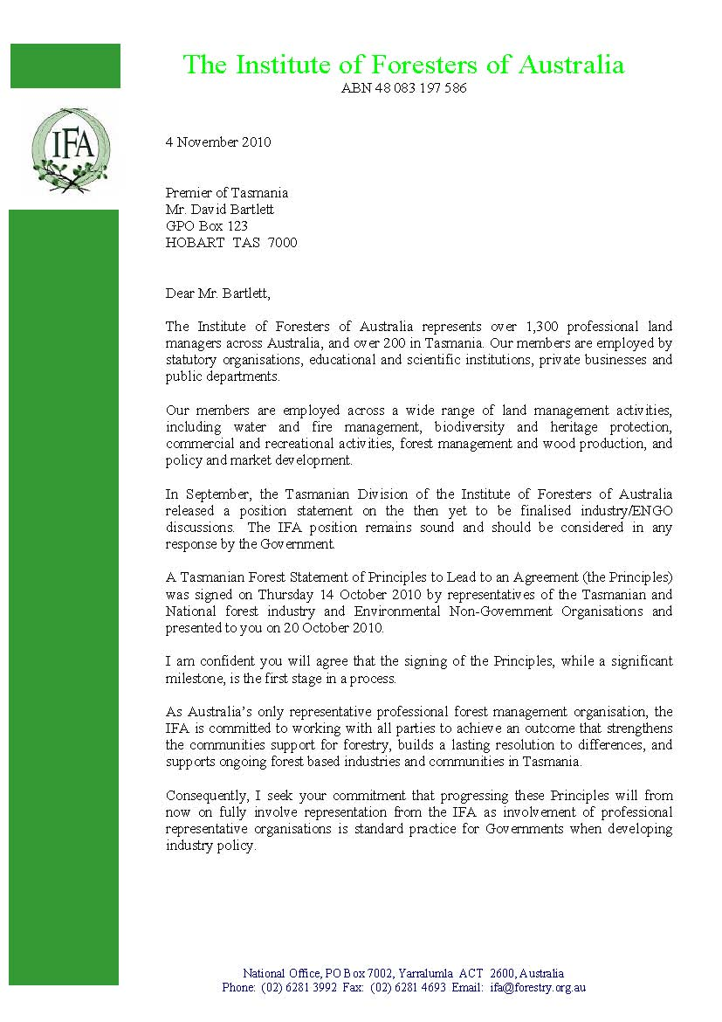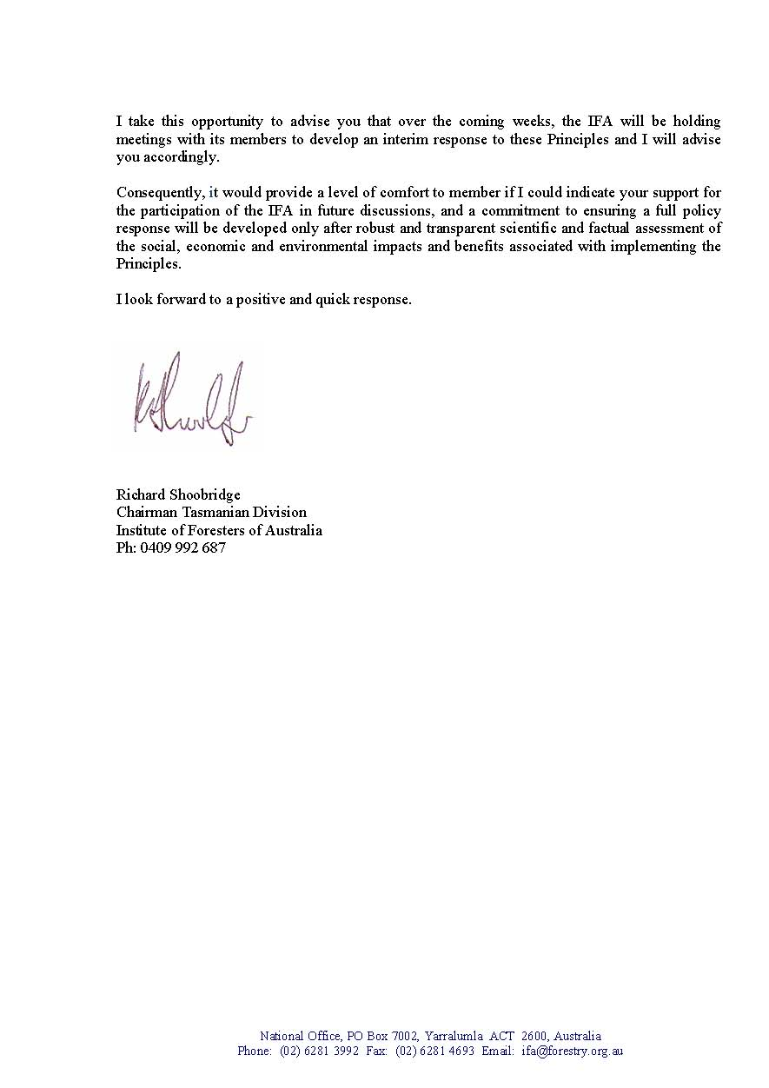

7.10. Fine Timber Tasmania Inc.

Fine Timber Tasmania is a not-for-profit association, with membership reflecting all components of the special timber supply chain; growers, processors, makers and retailers.
It is the owner of a Chain of Custody certificate, certified to AS4707 and recognised under the Australian Forest Certification Scheme. This provides an assurance of the legal and sustainable origin of logs, being a key selling point for high value timber products.

The FTT Chain of Custody is managed on behalf of Fine Timber Tasmania Inc by Tasmanian Quality Assured and independently audited by Global Mark, an assurance of quality and integrity. The system is growing in acceptance and now has the main special timber processors either as licencees accredited to use the system or applicants. It is present in high profile sites such as the Salamanca Market where a majority of woodcraft stalls have applied to become licencees. It is becoming a requirement of entry into discerning markets within Australia and internationally.

Furniture manufacturers, designer makers and other commercial users are joining as the system grows in acceptance as an assurance that wood purchased or within product is legally sourced from sustainably managed forest certified to the Australian Forest Certification Scheme.

Statement of Principles: Concern
The views and opinions of Fine Timber Tasmania, reflect those of many users of Tasmanian Special Timber.

There has been significant recognition of Tasmania internationally through our unique special timber. Tasmania’s forests are home to some of the worlds most precious and beautiful timber species which have an iconic association with the State. They are part of Tasmania’s unique brand and are highly regarded both within Australia and throughout the world for their decorative and other specialised applications.

They are part of Tasmania’s history and its future, having social and economic significance for Tasmanians that is much greater than the relatively modest volume harvested each year. The Tasmania Wood Design Collection has gained international recognition and is a show case of excellence in design and use of our special timber.

Any further reduction in the area of all native forest for wood production is a concern for special timber users. The majority of the “iconic” special timber: myrtle, sassafras, leatherwood, celery top, come from rain forest or the understorey of tall wet eucalypt forest. Blackwood comes from many forest types including the Blackwood rich swamp forest types of the far NW. Huon Pine is a special case and is only available from a very restricted source of historically logged forests, Teepookana Plateau, dam and flood salvage material.

The TCFA increased the reservation of HCV Old Growth (tall eucalypt) to approximately 80%, 973,000 ha leaving 20% to be managed for multiple values including wood production.
Non clear falling silviculture, variable retention, has been developed to manage the majority of the tall eucalypt. Minimal area harvesting has been designed by a community based design group to harvest in the Special Timber Management units.

Reduction in native forest harvesting will as a minimum decrease the volume of special timber available and increase its cost to the user. Contraction to a special timber only native forest harvest will make special timber uneconomic for all, the managers, harvesters, processors and users.

It is vital that special timber is available around the state in concert with the regional location of special timber users.

The Statement of Principles
There are many elements of the SOP that cause concern for the ongoing sustainable supply of commercial volumes of quality affordable special timber.
- General Wood Supply: any reduction will impact
- HCV Forests: any further reduction will significantly impact
- Transition: transitioning out of native forest will have disastrous impacts
- Industry: Special Timbers provide a signature for the forest industry.
- Specialty Timbers: Must be sustainable, quality, affordable, available
- Communities Impacted: High cultural, social and economic impact across the State
- Tourism: direct impact, as special timber strongly associated with Tasmania, The Brand.
- Certification: Fine Timber Tasmania Chain of Custody

The Sector
Given the already limited availability of special timber rich native forests any further reductions will put at risk the significant gains made in developing Tasmania as an Island of excellence, a design lead island.

Current special timber wood supply supports
- 2,000 people employed in Tasmania’s woodcraft sector,
- 8,500 people using special timber as a hobby or semi-commercially.
Milling and processing: $17.25 mill.
- 31 enterprises,
- 160 people
Designing and production: $39 mill.
- 250 enterprises
- 1,750 people
Retail, galleries, tourist attractions, accommodation and market stalls: $14 mill.
- 140 people
(Farley et al 2009, A Review of the Tasmanian Woodcraft Sector)
The review demonstrates clearly that Tasmanian special timber is:
- culturally very significant with 2.6% of Tasmanians involved, 37% higher participation than the national average.
- socially and economically very important from a relatively small volume of wood.
- value added though design, making, manufacturing and marketing excellence.
- Chain of Custody support for wood sourced from legal and sustainably managed certified forests.

Special Timber Management
Forestry Tasmania’s Special Timber Strategy has provided for a strong, robust and sustainable Special Timber supply supporting a special timber using industry including processors, timber merchants, furniture manufacturers, designer makers, craft makers/manufacturers, hobbyists and retail.

The Special Timber Strategy is a comprehensive plan aimed at producing a long term supply of special timber applying appropriate silviculture, trained and accredited contractors improving utilisation, recovery, processing and marketing. The development of Fine Timber Tasmania’s Chain of Custody is an integral component of the success of the strategy.

Tasmanian Community Forest Agreement, TCFA has resulted in special timbers production (sawlog and craftwood) declining from 22,390 cubic metres in 1999/2000 (Brueckner Leech 1999) to approximately 12,500 cubic metres in 2008/09.

The reduced area of native forest containing special timber has increased the cost of access, harvest and added to the cost of material supplied. Further reductions will make the limited volumes uneconomic to harvest and process.

Any further reductions in the limited area available for special timber production will jeopardise the strategy and the ready availability of quality material around the State.

Huon Pine: A Special Case
The area of Huon Pine available for harvest is so minimal that any further reduction will threaten the viability of this iconic wood. Huon Pine was neglected in the RFA and there is potential to enhance the area available rather than reduce it. Addition of cutover forests between Queenstown and Strahan to the cutover production area of Teepookana Plateau would add considerably to its commercial sustainability. Biological sustainability has been established with all areas “salvaged” (i.e. old logs on the ground) regenerated by planting and natural regen.

More than 85 per cent of Tasmania’s Huon pine is already contained within the Statewide reserve system. The main area for production is the Teepookana Plateau, south of Strahan, an area heavily cut over during the first half of the 20th century. The objective is to maximise the recovery of useable timber and restore harvested areas so that they remain as Huon pine forest.

Summary
Tasmania’s Special Timbers provide a unique palette of colour, texture and wood properties within a relatively small island, available in small volumes to the wood using sector and population.

Our Special Timbers and design excellence are internationally recognised.
The relatively small volume of special timber available is socially, culturally and economically significant.

Tasmania leads the world with its Forest Practices System, Special Timber Management Strategy, Fine Timber Chain of Custody , Tasmanian Wood Design Collection and education in design and making.

Any reduction in native forest harvesting will affect special timber availability.
Reduction in rainforest and HCV Old Growth, tall wet eucalypt forest will have disastrous consequences.

Reduction in the already small area available for Huon Pine salvage, the Teepookana Plateau, will severely impact the availability of Huon Pine.
Fine Timber Tasmania Inc is committed to a sustainable supply of available, affordable, legally sourced special timber from certified sustainably managed native forests.

7.11. Friends of the Tamar Valley Inc


Friends of the Tamar Valley Inc

Outline of facts and impacts relating to
the proposed Pulp Mill in
the Tamar Valley, Tasmania

Friends of the Tamar Valley Inc is comprised of members of the Tamar Valley community and generally has as its purposes promotion, encouragement and education relating to the protection and enhancement of the natural environment, economic and social issues in the Tamar Valley, Tasmania. The public officer can be contacted on friendsofthetamarvalley@gmail.com.

November 2010
(2nd edition)

- INTRODUCTION
This document succinctly outlines facts and impacts relating to the proposed pulp mill in the Tamar Valley, Tasmania. It does so by reference to many of the economic, social and environmental issues, and is designed to allow the reader to quickly understand or be reminded of those issues.

- ECONOMIC ISSUES
- Impact on local economy
The Tamar Valley is a picturesque valley and a popular tourism destination, with more than 20 vineyards lining the shores of the Tamar River. Tourism is worth about AUD$465million annually to Launceston and the Tamar Valley.

The pulp mill will cause the loss of well over 1000 jobs, with 1044 jobs lost from the tourism industry and at least 175 jobs from local fishing businesses. Conversely, the pulp mill would create just 280 jobs.

The economic report prepared for Gunns by Allens Consulting Group has failed to meet Australian Treasury guidelines for economic appraisal. It only addresses potential economic benefits of the proposed pulp mill. It ignores the economic costs of the proposed pulp mill. As a result, the report fails to identify whether the pulp mill will actually generate a net economic benefit for Tasmania.

Since the pulp mill proposal was first mooted, there has been a massive reduction in promised employment numbers at the mill.

- Lack of economic benefits
The pulp mill would likely cost the Tasmanian economy AUD$300million over its life or, at worst case scenario, AUD$3billion.

The pulp mill would not be able to match the costs of new low-cost producers in South America that can produce pulp at almost half the price it would cost the proposed pulp mill owner.

The government has already directed significant taxpayer subsidies to the proposed pulp mill. The government has not disclosed all subsidies. Currently known subsidies already outweigh any government income from the project. Based on, among other things, the long tradition of government subsidies to the Tasmanian logging industry, the regard in which the project is held in government and industry circles and the size of the investment, subsidies are likely to be ongoing.

- SOCIAL ISSUES
The Tamar Valley is home to about 100,000 people.

The pulp mill would be in the Tamar Valley air shed with its inherent meteorological inversion layer. An inversion layer is a layer within which an atmospheric property is inverted and leads to pollution being trapped close to the ground.
- Odour
Pulp mills are associated with odour problems and are a cause of significant community concern internationally. Odour is not only a nuisance factor. It can also adversely affect health. Odour through fugitive emissions from hundreds of sources within the pulp mill’s complex would drift to homes, businesses, farms and wineries in the vicinity of the mill. The fugitive odours will be detected in the air up to 55kms away. Bad smells and noxious odours from pulp mills cause nausea, headaches and difficulty with breathing. In high concentrations they are likely to result in eye and respiratory tract irritation that become more severe as the exposure time increases.
Human senses can detect pulp mill odours when the odour-causing substances are at extremely low levels. The inversion layer in the Tamar Valley would exacerbate the impact of odour.
- Pollutants
The pulp mill will release pollutants into the air including small particles, sulphur dioxide and oxides of nitrogen. The Tamar Valley already has a significant problem with air quality and a pulp mill will only aggravate the issue particularly given the Tamar Valley inversion layer. Tasmania has the highest rate of asthma in Australia which has been linked to poor air quality. Air containing particulate matter can trigger asthma attacks and chronic obstructive pulmonary disease lung attacks. There are already an estimated 8 additional deaths per year in the Launceston area as a result of air pollution. The pulp mill could cause an increase in the already existing morbidity and mortality from atmospheric pollutants.
- Water vapour and road traffic
The issue of white-out fog has not been assessed in respect of the proposed pulp mill. The proposed pulp mill’s high output of water vapour at ground level could produce a whiteout fog on the East Tamar Highway, as was produced by the Bowater paper mill in Tennessee, which led to 12 people being killed and dozens more being seriously injured in a multi-car pileup on a neighbouring freeway. With the massive increase in log trucks forecast for all the major Tamar Valley carriageways including the East Tamar Highway which leads directly to the proposed pulp mill site, school buses and other local traffic will face a lethal hazard.
- Log truck traffic
If the pulp mill were to proceed, there would be a significant increase in log truck traffic. An increase in road traffic is likely to cause an increase in road fatalities, air emissions and noise.
- Assessment
The proposed pulp mill was initially subjected to a proper assessment process by Tasmania’s Resource Planning and Development Committee (RPDC).
Shortly after the RPDC said that the information Gunns had submitted was “critically noncompliant”, Gunns announced that it was withdrawing its pulp mill proposal from the RPDC. Shortly thereafter, then-Premier of Tasmania, Paul Lennon, introduced a Bill in the Tasmanian Parliament which would fast track approval of the proposed pulp mill. As a result, the Pulp Mill Assessment Act 2007 was enacted and the project approved. This process resulted in a lack of proper assessment of the proposed pulp mill.

- ENVIRONMENT & HERITAGE
The proposal is to build a chlorine dioxide bleaching pulp mill in Tasmania’s beautiful Tamar Valley.
- Marine Environment
The pulp mill will dump 64,000 tonnes of effluent into Bass Strait every day. The effluent will contain dioxins and furans, which are the most toxic chemicals known to science. The dioxins and furans build up in the food chain contaminating marine life which will have a flow on effect to Tasmania’s fishing industry. The impact of the effluent is exacerbated by the slow flushing Bass Strait, meaning much of the dioxin may settle in a small area surrounding the outfall and build to dangerous levels in a short period of time. The dioxin level that would trigger closure of the mill equals the amount of dioxins emitted in a year by the entire Swedish bleached pulp and paper industry, which produces about seven times more bleached pulp than the proposed pulp mill will produce. Effluent from a pulp mill would wash up on Tasmania’s northern beaches within hours of being discharged, in the same manner that faecal matter washed up on Sydney’s northern beaches. Easterly winds would be able to move an effluent plume into the mouth of the Tamar River in
less than a day.
- Threatened Species
The proposed pulp mill will have a significant impact on threatened species. For example, any pollutants carried by the Australian Grayling (such as dioxins from the pulp mill consumed by the fish) would be ingested by its predators, such as the White-bellied Sea Eagle and the Tasmanian Wedge-tailed Eagle, which are listed threatened species. No work has been done or is intended to be done on the food chain issue.
- Forests
The pulp mill’s surplus electricity will be sourced from biomass, which means that native forest may be burnt to power the pulp mill.
Research from leading scientists at the Australian National University has found that Australia has some of the most carbon-dense forests in the world, with the potential to sequester carbon equivalent to 25% of our current annual emissions over a 100 year time frame. When burned, forest biomass emits more greenhouse gases per unit of energy than fossil fuels.
- Water
The pulp mill will consume 26 to 40 billion litres of fresh water each year. This is almost as much as the combined use of all water users in Northern Tasmania. Research shows that plantations can reduce stream flow by over 50%. Meanwhile, north-east Tasmania can expect a forecast reduction in rainfall of 8% over 30 years due to climate change. This means that public water supply will be put under enormous pressure by the proposed pulp mill.
- Culture and heritage
The Tasmanian Aboriginal Land and Sea Council officially opposes the proposed pulp mill because of its impacts on Aboriginal culture and heritage. These impacts to important heritage sites will occur at both the proposed pulp mill site and in the forests that will be logged to feedor power the mill.

7.12. Treeroots

This was a meeting of invited grass roots members of the Tasmanian forest sector. People from all regions of Tasmania , from local government, communities, land owners, forest growers and managers, scientists, craft and furniture makers and designers. They include sawmillers, workers, harvest, haulage, and silviculture contractors. Professional scientists, ecologists, foresters and engineers also contributed to the grassroots meeting.
They came to Campbell Town to express their support for continued sustainable native forestry and to state their concern over the secret process to develop a Statement of Principles to lead to a new agreement to replace the Regional Forest Agreement created by the National Forest Policy Statement.
They called for greater community input on the issue and published a communiqué that was widely reported in Tasmania’s media.

Campbell Town Communiqué 4 February 2011
We eighty six people from all parts of the Tasmanian forest sector, unanimously agree that:
- Tasmanian native forestry is perfectly sustainable in the short and long term.
- Tasmanian native forestry is backed by science and ideally suits the State’s conditions,
- Tasmanian native forestry supports many thousands of people and is a substantial part of the State’s economy.
- We are extremely concerned that the future of native forest management could be considered without effective community engagement.
- We will continue to promote these arguments until the broader community can have their say on the economic, social and environmental values of native forest management.

7.13. Timber Workers For Forests Inc.
7.14. Tap into a Better Tasmania

TAP is a broad based community organization that for five years has resolutely opposed the establishment of a world scale pulp industry for Tasmania. The grounds for opposition are social, economic and environmental. Perhaps the most compelling argument revolves around the financial risk of a high cost producer like Tasmania, competing against much cheaper producers in Asia and Latin America and what that might mean for the people of Tasmania who will be locked into subsidising an industry ‘too big to fail’.
TAP has over the years organized rallies on water and land involving flotillas of boats and up to 12,000 people. TAP has organized numerous public meetings, petitions (the largest ever presented to the Tasmanian parliament), demonstrations, has done much futile lobbying of politicians, developed a Voter’s’ Block and has established a strong media presence.
Many members of TAP have sacrificed years of their lives to ensure the community has a voice.

OPEN LETTER TO MR BILL KELTY from TAP INTO A BETTER TASMANIA
February 27th 2011
SUBJECT: FOREST PRINCIPLES
Dear Mr. Kelty,
We note that you have volunteered your services as a ‘facilitator’ – or ‘honest broker’ in the words of the PM - of the forest principles negotiations in Tasmania, which for brevity I shall call the ‘roundtable’. TAP Into A Better Tasmania understands that you are prepared to meet with members of the public and community groups.
TAP Into A Better Tasmania has not received an invitation to meet with you nor will we be seeking a meeting.
You should not regard this as a reflection on you as an individual, but a judgment we have made regarding the legitimacy of the ‘roundtable’ negotiation process in which you are now a major participant. We do not intend in any way to recognize or endorse a deeply flawed and illegitimate process.
The ‘roundtable’ process, from its inception, did not include community representation. Instead community representation was deliberately excluded because those who established the process realized that community representation would raise issues that were required to be excluded from discussion, even though those issues were of paramount importance to the future economic, social and environmental health of Tasmania and all Tasmanians.
In this essential element of community representation, the ‘roundtable’ process ignored the broader ramifications of Tasmania’s holistic future. The ‘roundtable’ process is not only illegitimate because it is secret, elitist and un-representative, but because it fails to take into consideration the costs of adopting a policy program such as this without adequate analysis of its impacts on the overall future of Tasmania and of ordinary Tasmanians.
This must not be allowed to happen. You would know that secrecy is corrosive and breeds suspicion, but the ‘elitist’ self-selection and anointing of ‘roundtable’ negotiators behind the scenes, has no public credibility, and must be rejected by an open democracy such as ours aspires to be.
Representation
Some conservation groups either walked out of the negotiations or refused to sign up to the ‘principles’ because the agenda of the three dominant environment groups, TWS, ACF and ET was perceived to be too narrow and exclusive.
It needs to be emphasised in the strongest possible way that while various parties, in attempting to promote their own agenda, claim that the forest negotiation are community driven, this is far from the truth. As with the fast track pulp mill approval process engineered through the Tasmanian parliament in 2007, destined to be recognized as one of the worst abrogations of parliamentary process in Australia since 1856, if not the worst, the community was deliberately excluded from the ‘roundtable’ negotiations.
There are forest workers and former forest workers who do not believe their best interests are represented by either the ‘astroturf’ organizations of FIAT and TCA, or the CFMEU which has for years blatantly toed the Gunns line, rather than fight for the rights of its members. “What is good for Gunns is good for our members”, has not served union members very well at all. Gunns has been very forthright in its willingness to shed hundreds of workers over the last few years, while continuing to suck subsidies from the taxpayers’ coffers, which should have been directed to the interests of public health, housing and education.
Who could ever forget that notorious betrayal of Labor history and principles when, in 2004, the leadership of the CFMEU, on stage in the Albert Hall in Launceston, committed the union to support the re-election of John Howard?
Meanwhile the Gunns business model has failed, the industry has collapsed and the jobs are gone.
Any resolution to the turmoil in Tasmanian forestry requires, as a first principle, the input of a range of technical expertise and scientific knowledge. Were there any hydrologists, foresters versed in alternatives to the way forestry has operated in Tasmania, ecologists, botanists, economists, complex systems analysts, medical experts, forensic accountants etc. informing the ‘roundtable’ negotiations?
No.
In fact, efforts by some experts to provide informed input were scorned or ignored.
The way the ‘roundtable’ forest negotiations have been set up and run goes to the heart of integrity in public affairs. TAP is deeply dismayed that the ALP and the Greens enthusiastically endorse such an unethical process.
It would appear that Tasmanians are addicted to shoddy process and seem incapable of learning the lesson from previous scandals and failures.
FSC
It is our contention that the ‘roundtable’ negotiations undermine the FSC (Forest Stewardship Council) process.
TAP Into A Better Tasmania is a member of the Social Chamber of FSC. As you are aware, FSC has three chambers: social, commercial and environment. Representation of the first chamber is absent from the ‘roundtable’ and of the remaining two chambers we have argued, above, that representation is limited and partial.
Timber Communities Australia (TCA) – formerly Forest Protection Society – was represented at the ‘roundtable’. The representation of TCA in FSC Australia Social Chamber was constructively criticized and formally disputed. TCA is far from a true community group. It is an industry construct, industry funded front group. In other words it is an ‘astroturf’ organization.
The CFMEU’s role in FSC speaks volumes for how this organization behaves. Michael O’Connor, then head of the forestry division of the union, now head of the whole union, wanted the CFMEU to control the Social Chamber of the FSC rather than being one equal voice of three. When that move failed he took the union out of any involvement with FSC.
While FSC is not perfect and has its critics, FSC is a standard that world markets are insisting on for forest products. It is also a point worth making that the FSC process is as good as the stakeholders make it.
It is a mistake to consider the TWS/ET ‘roundtable’ solution to Tasmania’s forest mining mentality as lying in a switch to monoculture tree plantations, essentially for fibre, represents community views. By no stretch of the imagination can it be accepted that the TWS/ET advertising campaign, said to be $600,000 through a front group Our Common Ground, promoting the agenda of the plantation industry, has the support of the public.
Furthermore, TWS/ET must know that monoculture plantation establishment by forest conversion after 1994, which is the bulk of Tasmania’s hardwood plantations, cannot be eligible for FSC certification.
It would require a complete paradigm shift in management, planning and practice, such as restoration management, to be at all likely to be considered for the FSC process.
This narrow and all too simple ENGO ‘solution’ will imprison Tasmania on the wrong side of history. Regardless of the social and environmental consequences of committing Tasmania to a future as Plantation Isle, the economic consequences will be extremely damaging.
TAP does not regard monoculture tree plantations as the solution to anything. Rather, they are the problem.
The ‘roundtable and the pulp mill
It cannot be ignored that the catalyst for the establishment of the ‘roundtable’ was the sequence of events following the collapse of Gunns shares in the early months of 2010, the replacement of John Gay and the resulting dramatic policy shifts by Gunns, signaling their exit from native forest to monoculture plantations as the basis for a complete focus on building the Tamar valley pulp mill.
This was the context within which the ‘roundtable’ was set up and its membership determined. The ‘roundtable’ was the vehicle, where Gunns imperatives and decisions sat front and centre throughout the whole process, driving the agenda and the outcomes of the ‘roundtable’.
There will be no peace in Tasmania about forestry issues while these imperatives remain, driving forest industry policy into an economically unsustainable focus on pulp.
There is a general apprehension in Tasmania is that the ‘roundtable’, from the industry point of view, is about ensuring the delivery of public money from the Federal Government coffers into the pockets of the industry.
The twenty odd million dollars of exit packages so far delivered is but a drop in the ocean compared to the hundreds of millions of public money that the industry has already swallowed up in order to be ‘more sustainable’ or to ‘retool’ or to ‘exit with dignity’.
An industry grown flabby on subsidies thinks the solution to its woes is more public money.
From the industry point of view, while the ‘roundtable’ is centered on the delivery of the Gunns pulp mill, Gunns is a heavily indebted company that has sold off most of its cash flow assets to reduce debt, and is in survival mode. Yet the Prime Minister, egged on by a chorus of Labor politicians, is considering funding the pulp mill with money that belongs to the citizens of Australia.
As you are the ‘honest broker’ and will, I presume, be reporting back to the Prime Minister, please pass on this message. If any more public money is gifted to Gunns the hostile reaction in Tasmania will be tremendously exacerbated. Divisions within Tasmania will deepen further, in much the same way as has occurred, and continues now, at the site of the Botnia mill on the Argentine-Uruguay border.
There will never be peace if the corrupted pulp mill policy proceeds.
For governments, picking winners invariably means picking losers.
Conclusion
The road to peace in Tasmania does not rest with a narrowly constituted ‘fixit’ group secretly seeking a balance of self-interests, while behind the scenes political manipulation is rampant, despite denials to the contrary. Only a properly constituted, broadly represented, fully informed, open and public process has a hope of coming to any resolution.
TAP Into A Better Tasmania would only consider participating if these conditions were met.
What is needed is a fundamental overhaul of resource allocation principles including forest management systems, which see forests as a durable long-term resource requiring the best possible care. Only such an approach will provide the social and economic balance leading to peace in the forest, the population, the workforce and the involved businesses.
As the ‘honest broker’ you are ideally placed to put the third option of a multiple bottom line of a forest and business management approach on the table as a realistic way out of the tunnel vision of EITHER old growth clear felling OR fibre monoculture plantations. The third option models are increasingly cutting edge world- wide
Finally, here is a quote from Tasmanian resident Peter Brenner, who was formerly Head of Information of the Swiss Timber Information Council (Lignum).
“It has been and is impossible to this day to represent the strong desire in many of the general community to move towards forest management methods that answer to multiple bottom lines, are truly sustainable over centuries, provide quality jobs throughout the State, increase biodiversity, enhance quality and quantity of scarce water, avoid the use of dangerous chemicals and fertilisers, retain the viability of rural communities and offer an aesthetically pleasing environment for residents and visitors.”
Yours Sincerely,
Robert McMahon
http://www.tapvision.info

7.15. Department of Economic Development, Tourism and the Arts – Tourism Australia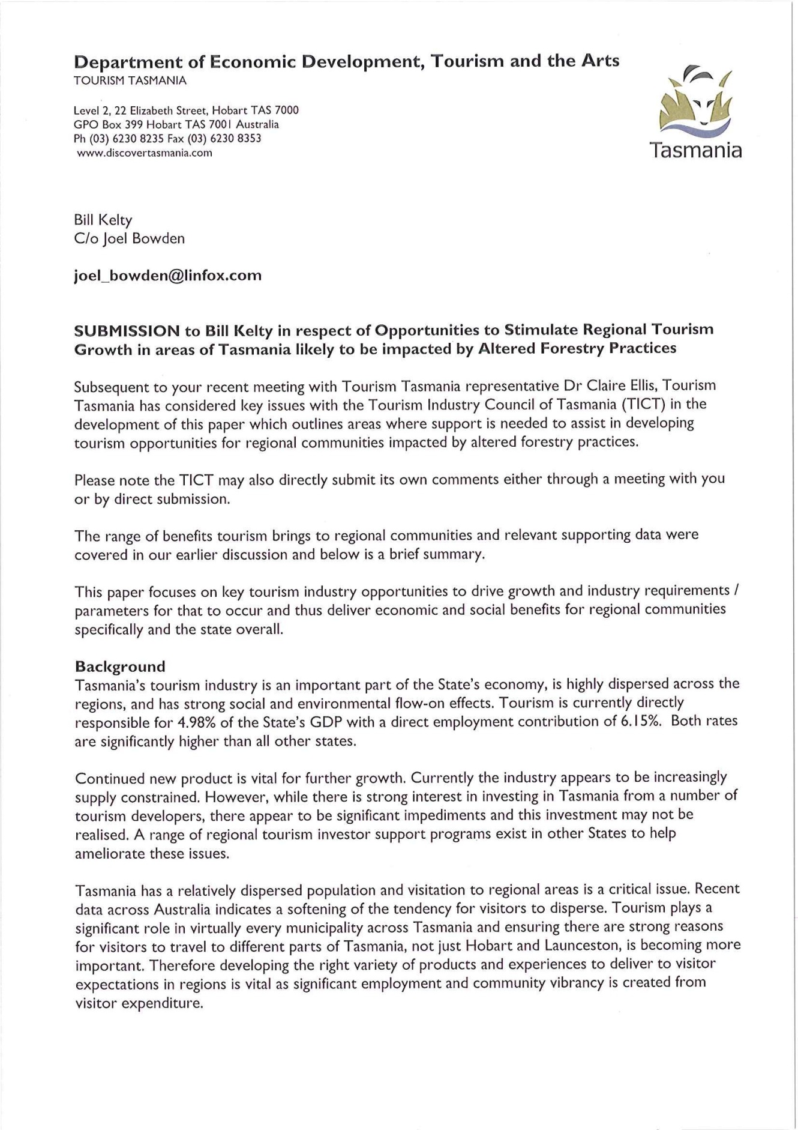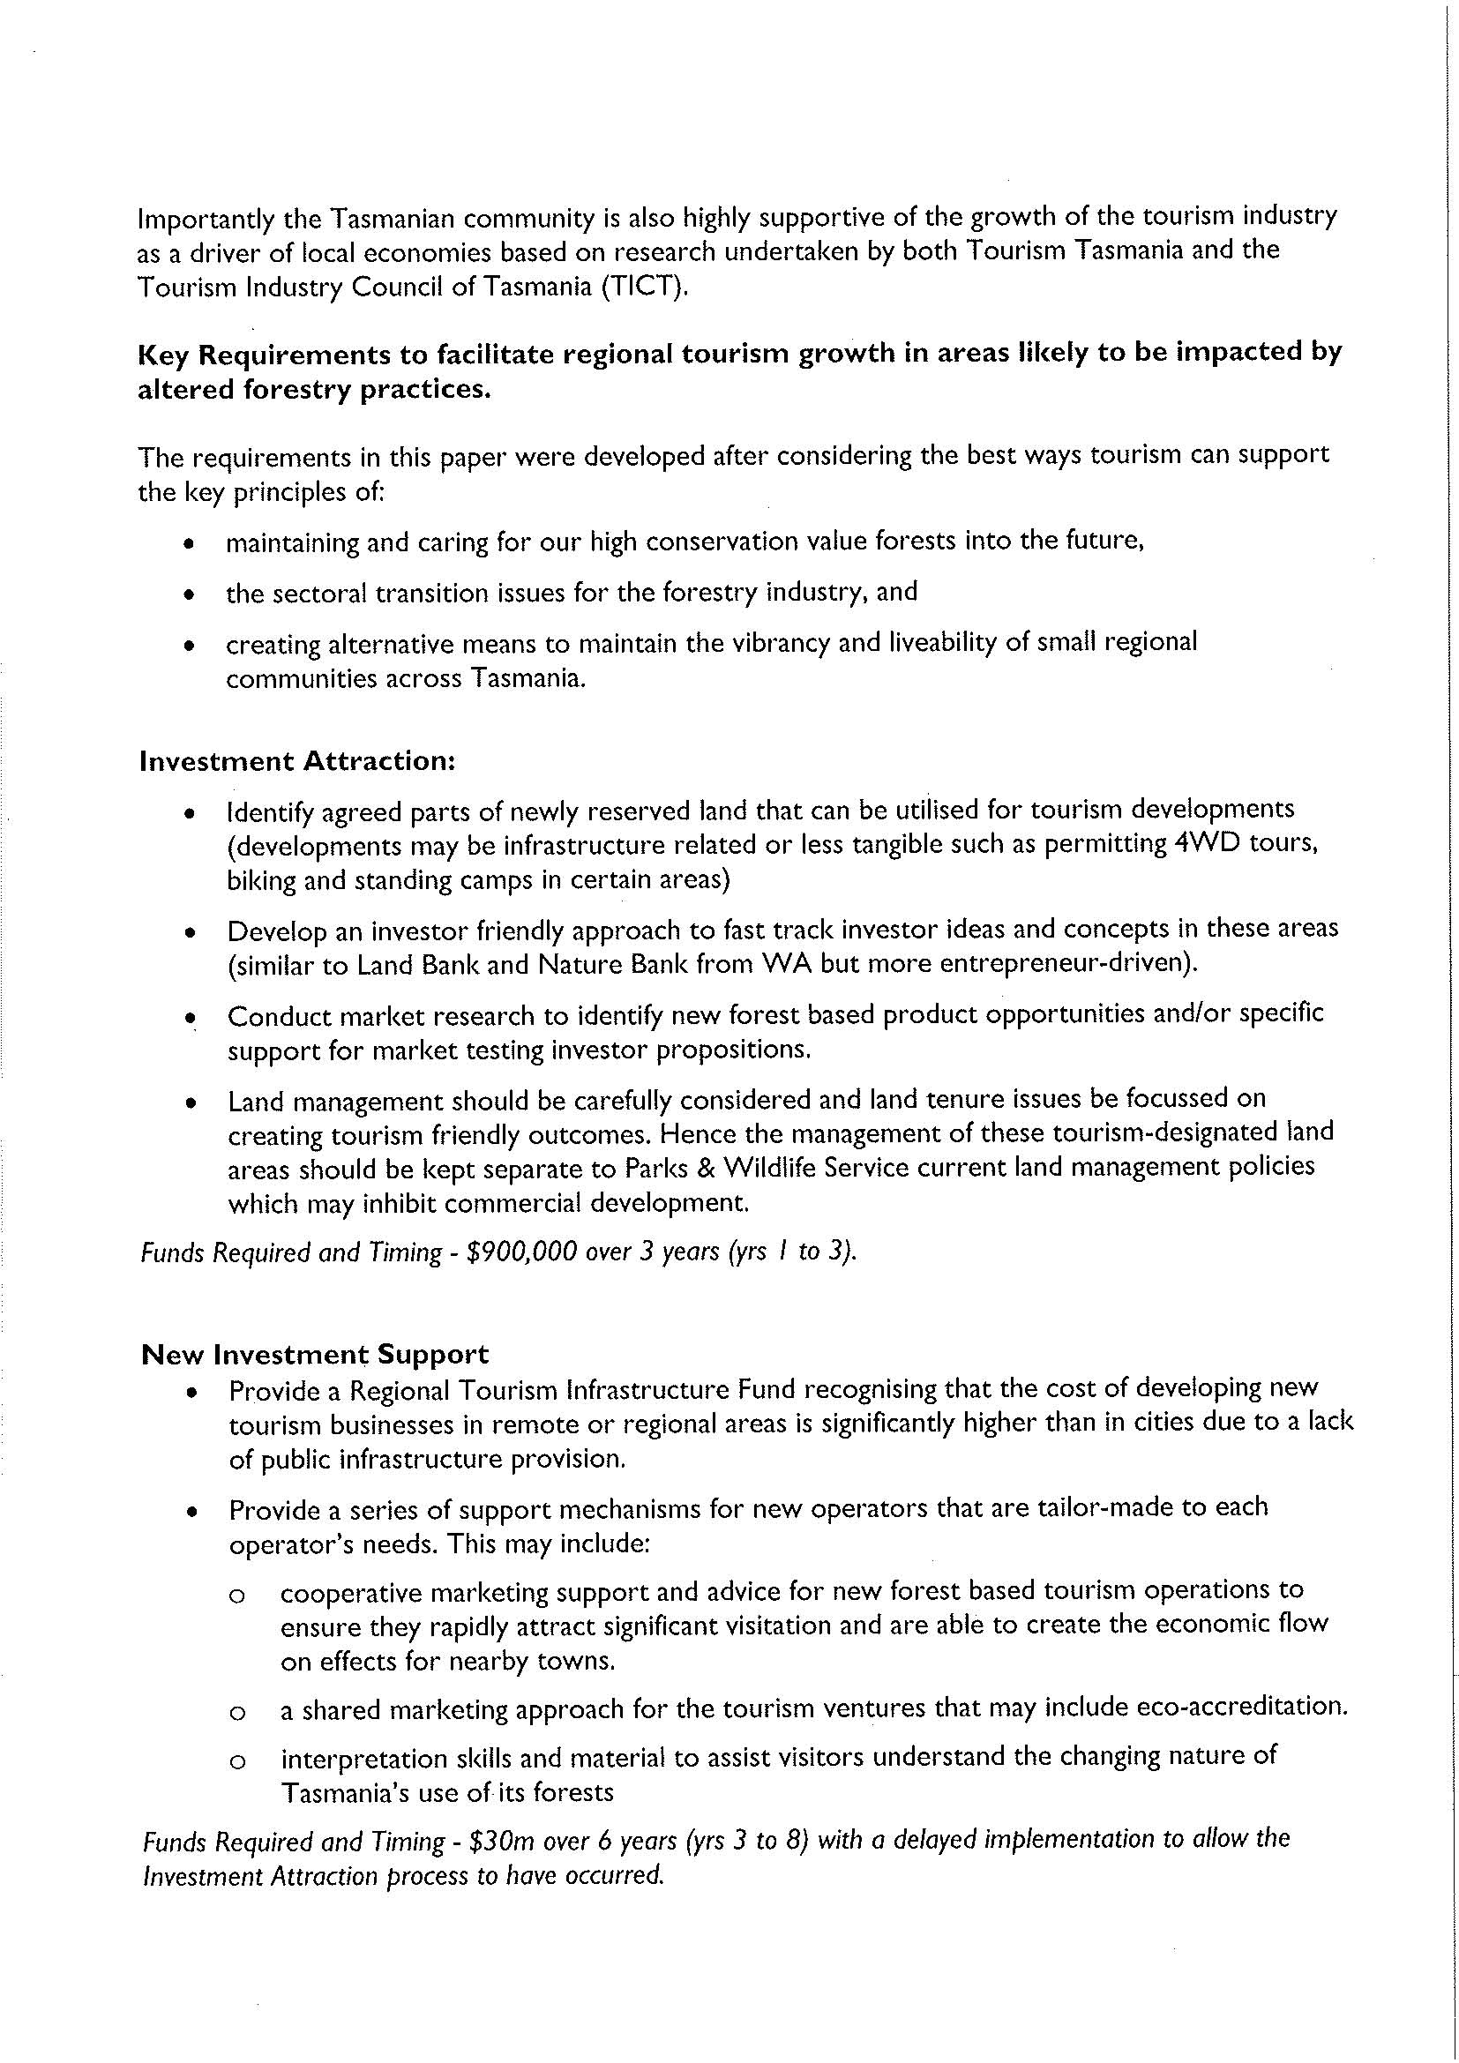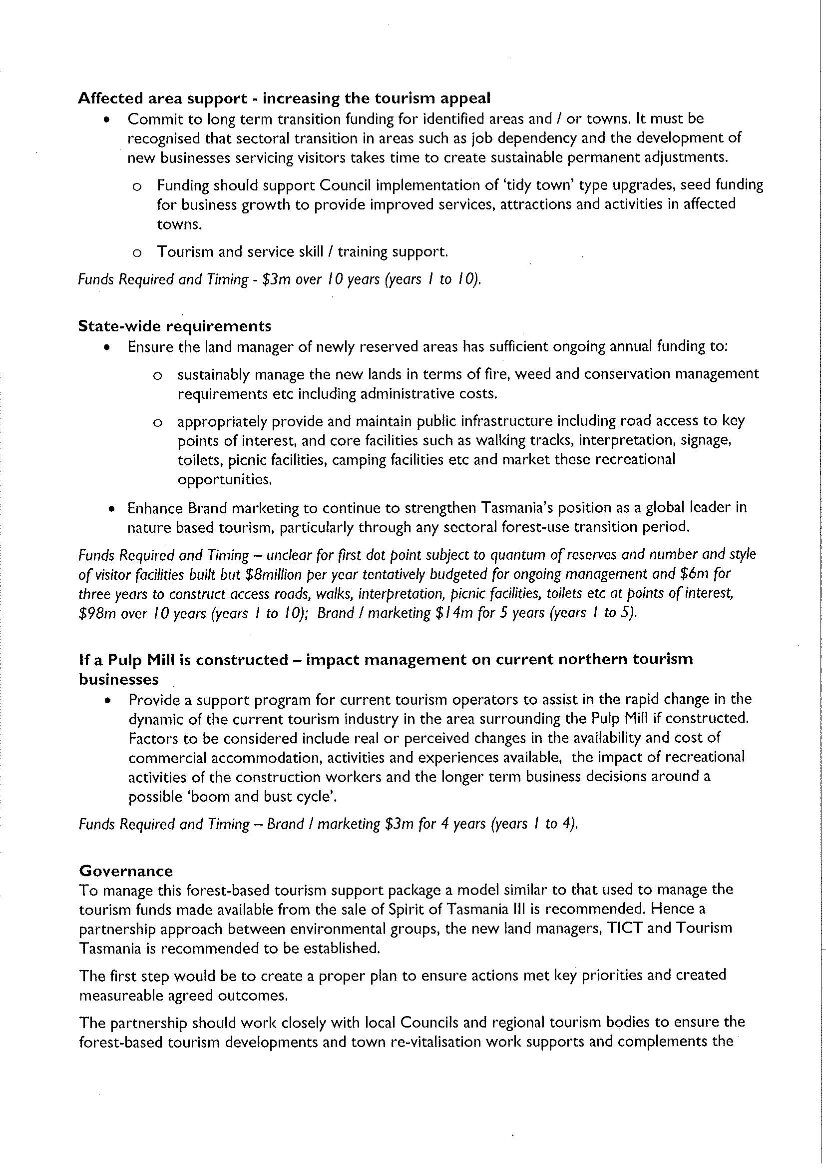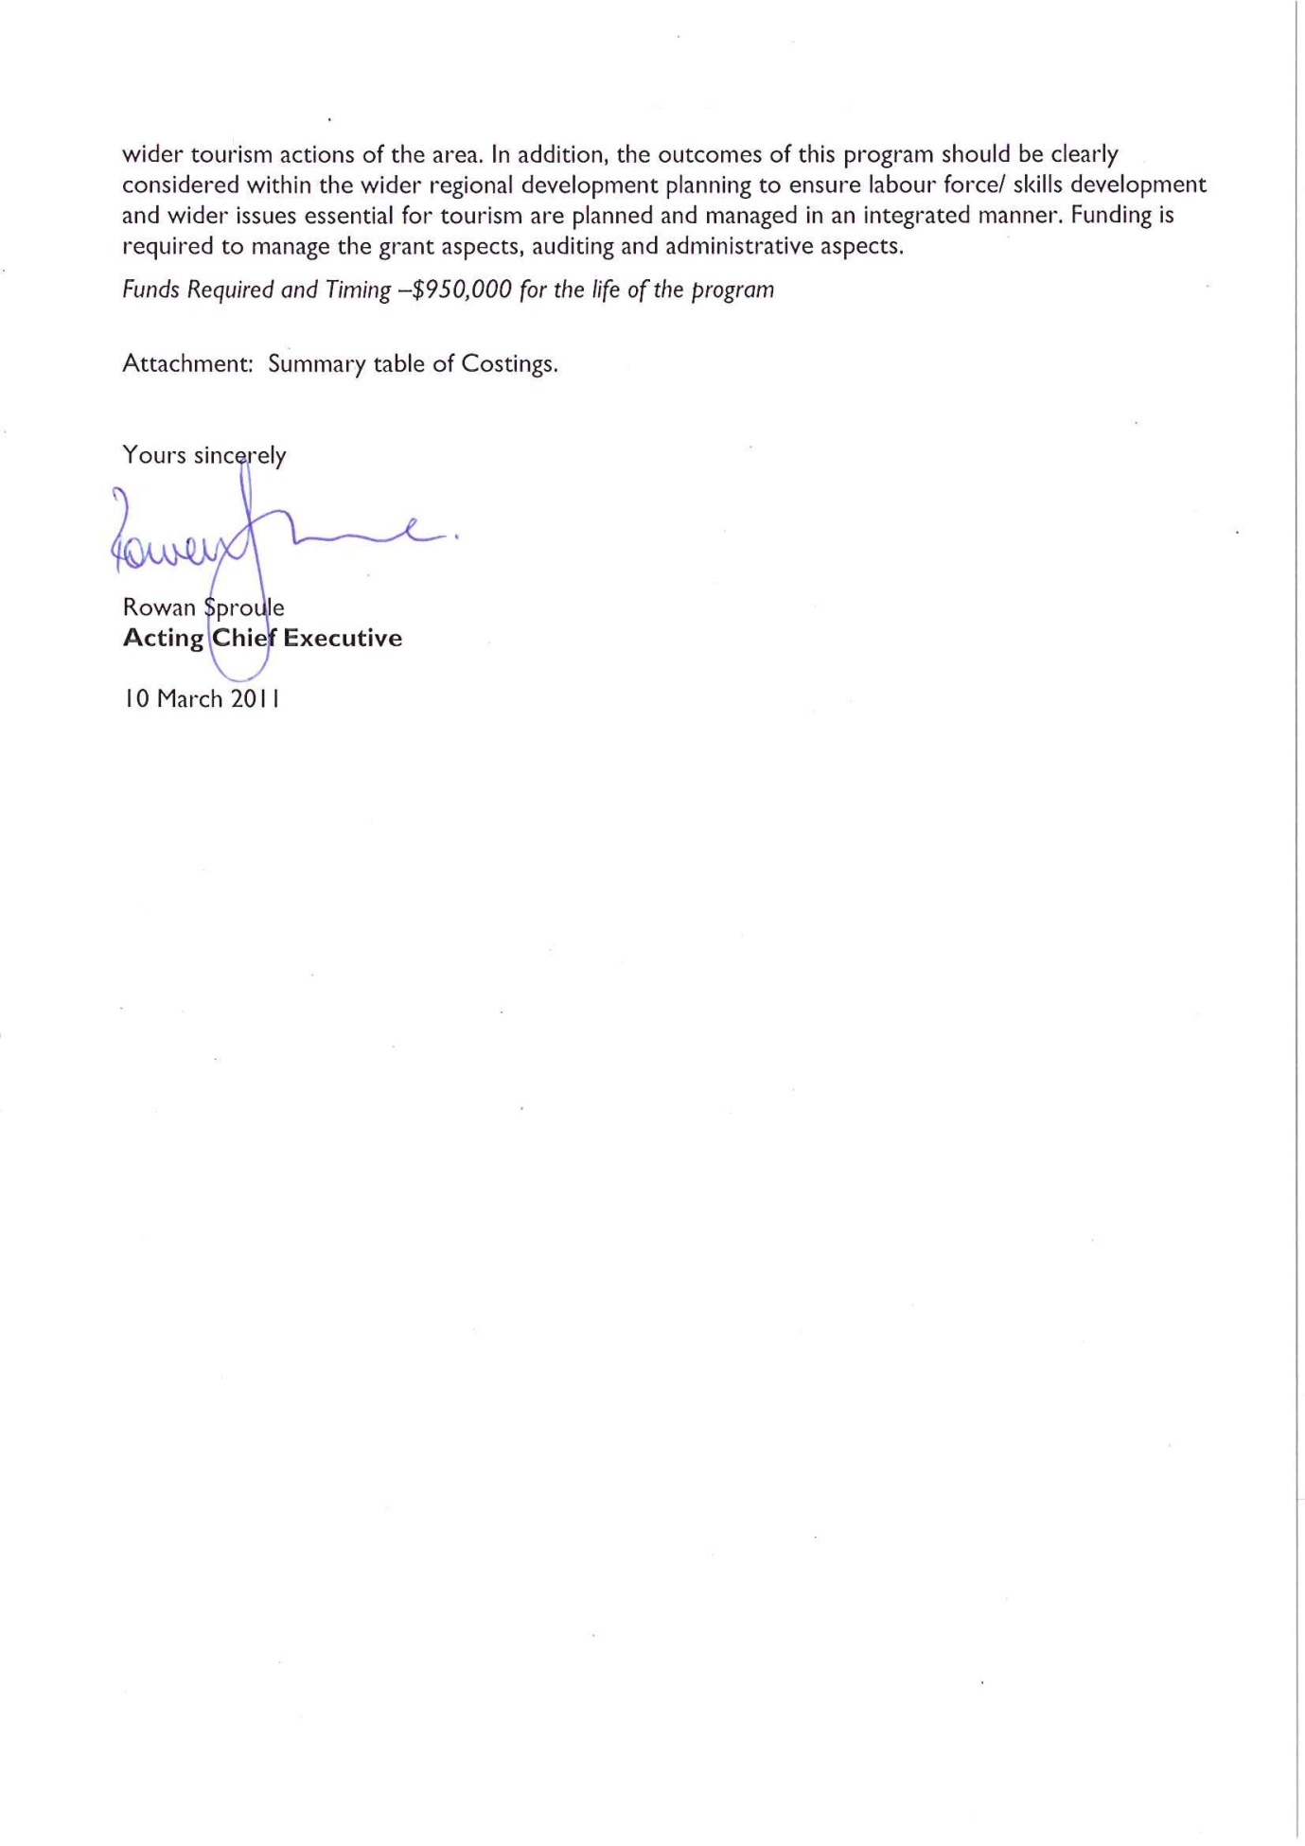

7.16. George Chandler

7.17. Florentine Protection Society

http://maps.google.com.au/maps/ms?hl=en&ie=UTF8&t=h&msa=0&msid=103455232846024107012.0004659d63be3d5b1 818a&z=9
Australian Government, Department of Resources, Energy and Tourism, Tourism Research Australia, Regional Tourism Profiles 2008/09, Tasmania, Launceston and Tamar Valley Region (can be found at http://www.ret.gov.au/tourism/Documents/tra/Regional%20tourism%20profiles/TAS/Tas%20-%20Launceston%20- %20FINAL2.pdf)
Launceston Environment Centre, Tasmanian Round Table for Sustainable Industries Project, August 2007 (can be found at http://www.lec.org.au/pdfs/TRSIPreport2(Aug07).pdf)
ITS Global, Review of the Social and Economic Benefits of the Gunns Limited Pulp Mill Project, 26 June 2007 (can be found at http://www.justice.tas.gov.au/__data/assets/pdf_file/0004/82282/Final_ITS_Global_Report.pdf)
Op cit n3
ABC news, Lack of training stymies local pulp mill jobs: analyst, 20 march 2008 (can be found at http://www.abc.net.au/news/stories/2008/03/20/2195328.htm) and ABC News, No surprises in downsized pulp mill work force, 20 March 2008 (can be found at http://www.abc.net.au/news/stories/2008/03/20/2194968.htm)
National Institute for Economic and Industry Research, A comprehensive economic assessment for the Tasmanian economy of the direct benefits of the proposed Gunns Pulp mill, January 2008 (can be found at http://www.wilderness.org.au/files/nieir-jan-08.pdf)
CommSec http://www.abc.net.au/news/stories/2007/09/21/2040325.htm
Naomi Edwards, BSc (Hons) FIA FNZSA FIAA MAICD, Too much risk for the reward - an analysis of the pulp mill returns to the people of Tasmania, September 2006 (can be found at http://www.twff.com.au/documents/research/nerpdc2006.pdf)
Launceston City Council website, home page, accessed on 18 October 2010 (can be found at http://www.launceston.tas.gov.au/lcc/index.php?c=283)
Launceston City Council, Submission to the Resource Planning and Development Commission, 25 September 2006 (document available by email request to friendsofthetamarvalley@gmail.com)
The Australian Branch of the Australian Medical Association, Position Statement, Proposed Tamar Valley Pulp Mill, 25 September 2006 (can be found at http://www.onlineopinion.com.au/documents/articles/473_Australian_Medical_Association-Tasmania.pdf)
Encyclopaedia Britannica, definition of inversion layer (can be found at http://www.britannica.com/EBchecked/topic/586707/temperature-inversion)
Ministry of Agriculture and Finance, New Zealand, Managing and measuring pulp mill odour emissions (can be found at http://www.maf.govt.nz/mafnet/publications/rmupdate/rm7/rm0703.htm)
Op cit n12
Jaakkola JJ et al, The South Karelia Air Pollution Study: changes in respiratory health in relation to emission reduction of malodorous sulphur compounds from pulp mills. Arch Environ Health. 1999 July-Aug;54(4):254-63
Dr Warwick Raverty (can be found at http://tapvision.info/node/117) 18 Dr Warwick Raverty (can be found at http://tapvision.info/node/573)
S R Young, Georgia-Pacific Consumer Products (Camas) LLC, Cams, Washington, Questions and answers about kraft pulp mill odour, June 2008 (can be found at http://www.gp.com/camas/enviro/MANUAL75.pdf) 20 Op cit n12
Op cit n12
Op cit n11
Sweco Pic,Assessment of the Gunns Limited Bell Bay pulp mill against the environmental emission limit guidelines, 25 June 2007 (can be found at http://www.justice.tas.gov.au/__data/assets/pdf_file/0003/82281/Final_SWECO_Report.pdf)
Op cit n 21
News Limited, Tassie's asthma rate alarm, 30 July 2008 (can be found at http://search.news.com.au/related/id%3Astory%7C24105655/0/Tassies-asthma-rate- alarm/?us=ndmnews&sid=5012672&as=news&ac=travel&r=related)
Op cit n19 and American Lung Association, Particulate matter, April 2000 (can be found at http://www.lbamspray.com/00_Health/Particulate%20Matter%20-%20American%20Lung%20Association%20site.htm
Tasmanian Air Quality Strategy, June 2006, p80
Australian Medical Association Tasmania, position statements (can be found at http://www.amatas.com.au/issues/)
ABC interactive business network, Bowater's Calhourn mill at centre of fog-related highway pileup dispute (can be found at http://findarticles.com/p/articles/mi_qa3636/is_199408/ai_n8710570/)
Dr Warwick Raverty, Mill disaster: the uncanny similarities (white out fogs), 1 December 2008, (can be found at www.tasmaniantimes.com)
GHD, Northern Tasmania pulp mill transport and traffic impact assessment report, March 2006 (can be found at http://www.gunnspulpmill.com.au/iis/V15/V15_A43.pdf)
Op cit n12
http://www.wilderness.org.au/campaigns/gunns-pulp-mill/pulp-mill-fast-track
Hansard, Tasmanian Parliament, March 2007 (can be found at http://www.parliament.tas.gov.au/HansardHouse/isysquery/bf05192c-87c5-4f17-ac9d-c477f388598b/3/doc/)
The Australian, PM's pal dams pulp mill proposal, 15 August 2007 (can be found at http://www.theaustralian.com.au/news/pms-pal-damns-pulp-mill-proposal/story-e6frg6ox-1111114186180)
Gunns' referral under the EPBC Act (April 2007) (can be found at http://www.environment.gov.au/cgi- bin/epbc/epbc_ap.pl?name=referral_detail&proposal_id=3385)
Environment Australia, Air toxics and indoor air quality in Australia, 2001 (can be found at http://www.environment.gov.au/atmosphere/airquality/publications/sok/chapter1.html)
Dr Stuart Godfrey, Inadequacies in the hydrodynamic modelling performed for Gunns IIS, 2007 (can be found at http://www.environment.gov.au/epbc/notices/assessments/2007/3385/pubs/att-b7-3.pdf)
The Age, Swedes cast doubt on mill standards, 15 October 2007 (can be found at http://www.theage.com.au/news/climate-watch/swedes-cast-doubt-on-mill-standards/2007/10/14/1192300601241.html)
Op cit n37
Report of Dr Charles Meredith filed in Federal Court proceeding Lawyers for Forests Inc v Minister for Environment & Gunns Limit
Gunns Limited, The facts, undated (can be found at http://www.gunnspulpmill.com.au/factsheets/The_Facts.pdf)
Brendan G Mackey, Heather Keith, Sandra L Berry and David B Lindenmayer, Green Carbon: the role of natural forests in carbon storage, 2008 (can be found at http://www.wilderness.org.au/files/GreenCarbonReport-synopsis.pdf) 43 Cnet news, Study finds biomass power not carbon neutral, 11 June 2010 (can be found at http://news.cnet.com/8301- 11128_3-20007484-54.html)
Cnet news, Study finds biomass power not carbon neutral, 11 June 2010 (can be found at http://news.cnet.com/8301- 11128_3-20007484-54.html)
Gunns Ltd, Bell Bay Pulp Mill Draft Integrated Impact Statement (can be found at http://www.gunnspulpmill.com.au).
Annual Reports, Esk Water and Cradle Coast Water
Jackson et al, Trading water for carbon with biological carbon sequestration, 23 December 2005 Vol 310 Science
Tasmanian Government, Draft Climate Change Strategy, October 2006 (can be found at http://www.dpiw.tas.gov.au/inter.nsf/Attachments/PMAS-6UF3SU/$FILE/TasClimateChangeStrategy-DraftOct06.pdf)
Tasmanian Aboriginal Land and Sea Council submission to the RPDC

