Tasmanian Forests
Interim Report
For Consideration

by Independent Facilitator Bill Kelty
[Pick the date]

Table of Contents
1. Principles Agreement 4
2. Terms of Reference for an Independent Facilitator 8
3. Process Undertaken by the Facilitator 9
3.1. Key issues and questions identified during the process 9
3.2. Media Releases 11
4. Capacity to Reach Agreement 14
5. Proposals for Advancing the Capacity to Establish a Workable Solution 15
5.1. Forest Resource Issues 15
5.1.1. Moratorium and Wood Supply 15
5.2. Future Forest Industries 21
5.2.1. Plantation Processing 21
5.2.2. The Bell Bay Pulp Mill 21
5.3. The Regional Impact 22
5.4. Contribution to Climate Change 22
5.5. Discussion on Restructuring 22
5.6. Views of the Non Signatories 23
5.7. Political Process 23
5.8. Is there an alternative to the agreement 24

1. Principles Agreement

2. Terms of Reference for an Independent Facilitator

3. Process Undertaken by the Facilitator
Since appointment in December 2010 as an ‘independent facilitator’ by the Tasmanian and Australian governments it has been my intention to act as an honest broker to facilitate the signatories in their attempt to reach agreement.

During the initial stages I met with the signatories and other non signatories/stakeholders such as Forestry Tasmania and Gunns Ltd.

These first few meetings included Michael O’Connor (CFMEU), Greg LeStrange (Gunns), Tom Aldred (DAFF), Charlie Zammit (SEWPaC), Bob Rutherford, Andrew Blakesley and Martin Blake (DIER). I met with Tasmania’s Premier at the time David Barlett in the Cabinet subcommittee which included Bartlett and now Premier Giddings, Bryan Green and Greens leader Nick McKim.

These meetings showed clearly that the industry was struggling and the issue was emotive and divisive with general cynicism around the central issues being the pulp mill most likely the proposal in northern Tasmania, the High Conservation Value Forest (HCVF) claim, industry transition including guaranteed wood supply and regional strategy for the economy in transition.

Initial discussions and meetings with Industry groups, Forestry Tasmania, Private Sawmillers, Specialty Timbers and ENGO’s (Environmental Non Government Organisations) were productive and informative with a crash course in timber mills, forestry and many other facets of Tasmania’s forestry industry.

We travelled by helicopter across the southern region of Tasmania with Bob Gordon from Forestry Tasmania as chaperone and through the north west with the Wilderness Society showing us the north western Tasmania region including two tourism ventures (Tarkine Wilderness Lodge and Wilderness Walks Lodge). However the central issue that has been raised in all meetings is that of the current Gunns Ltd pulp mill proposal and how the industry and the State can handle such a divisive and emotive issue. The principles states that ‘a pulp mill’ is acceptable but the general feeling we got as we meet with ENGO groups and industry is that the real question is not ‘a pulp mill’ but ‘The Pulp Mill’ at Bell Bay.

3.1. Key issues and questions identified during the process
Fundamental issues are whether the Bell Bay pulp mill is supported, whether native forest harvesting continues and whether there is flexibility in the area of high-conservation values areas to be reserved.
- Is continuation of native forest harvesting part of a future industry under the Principles?
  - If so, what timeframes – in perpetuity (i.e. continual production from regrowth forests), transition out of all native harvesting over 5, 10, 20 years?
- What is the expected long-term industry structure under the Statement?
  - for native and plantation forests
  - export woodchip, sawmilling, veneers, specialty timbers?
- Is there agreement on a pulp mill in the industry structure?
  - if so, is there agreement that it is the Bell Bay pulp mill?
  - if not at Bell Bay – then where in Tasmania or the mainland?
- What areas are considered as high conservation value forests?
  - are the boundaries mapped and agreed by all Signatories?
  - are they open to discussion and modification?
- Is there confidence that remaining sawlog resources will be adequate in terms of volume, quality and price for sawn timber and veneer producers?
  - if export woodchips are not supported then how will harvesting be commercial?
- What restructuring will be needed to reach the future envisaged under the Principles?
  - what options exist for economic diversification and workforce re-skilling?
  - what investment is required?
- What are the implications for Climate change and the ability for a national Carbon initiative from both a State and Federal government perspective.
- How does Tasmania position itself as an economy in transition and therefore what is the regional strategy that may foster this strategy.

Including but not withstanding we have met with the following parties since being appointed:
- CFMEU – Michael O’Connor, Jane Calvert, Travis Wacey;
- All signatories including - TCA, TFCA, FIAT, NAFI.
- DIER – Bob Rutherford, Martin Blake, Andrew Blakesley;
- Tasmania Premier Bartlett and Forestry Cabinet Sub Committee;
- Tasmania Premier Giddings and Forestry Cabinet Sub Committee;
- Premier Giddings and Deputy Premier Green separately and together;
- Greens Party Room - Green MP’s;
- Nick Mckim Greens leader;
- Jonathan West - The Innovation Centre;
- ENGO’s – Sean Cadman, Paul Oosting, Phil Pullinger, Russell Warman, Vica Bailey, Lindsay Hesketch, Don Henry;
- Conservation Trust – Alistair Graham, Peg Putt;
- Specialty Timbers – George Harris;
- Forestry Tasmania – Bob Gordon, Simon Grove, Hans Drieslma;
- Country Sawmillers – Fred Ralph, Stuart Ralph:
- Tourism Tasmania – Dr Claire Ellis;
- Institute of Forester of Australia;
- Private Foresters – Ian Dickenson;
- Britton’s and McKay’s Timber – Bernard McKay and Glenn Britton;
- ACF- Don Henry; Lindsay Hesketh.
- TWS – Lyndon Schneiders, Vica Bailey, Paul Oosting;
- Greens National – Bob Brown;
- Dick Adams Labor MP;
- Gunns Ltd –Greg Le Strange;
- Regional Development Australia (RDA);
- Jacki Schirmer – Fenner School;
- Liberal Tasmanian Senator Richard Colbreck;
- Furniture Australia – Rohan Wright;
- Tamar Valley Groups –Friends of the Valley, Pulp the Mill;
- TFGA, Private Foresters – Ian Dickenson, Jan Davies, Tom Fisk, John Ford; and
- TAP and The Tasmanian Liberal Party declined a meeting, however the Liberal Party forwarded their 13 point plan that has been included in annexure 1.

3.2. Media Releases

18th February 2011
Bill Kelty, Independent Facilitator

The signatories to the Forest Principles met on Tuesday and Wednesday this week and reaffirmed commitment to the Principles.

They identified the key issues which needed to be considered and established processes to deal with those issues.

These include discussions with Gunns, the state and federal governments, Forestry Tasmania, and the need for independent assessment of regional impacts.

The meeting confirmed that there was substantial goodwill, but a number of keys issues needed to be resolved.

It was also agreed to deal with the range of matters expeditiously because of potential developments.

It was also recognised that the discussion could not be limited to the signatories, and that ongoing discussions would continue with non-signatories.

Statement from Mr Bill Kelty, independent Facilitator, March 11 2011.

A meeting was held yesterday in Hobart convened by Mr Bill Kelty and all parties reaffirmed their commitment to the delivery of the statement of principles.
Following the meeting of signatories it was decided and absolutely committed to by all parties to continue the process with the issue of security of wood supply/ moratorium as priority.
The signatories have formed a reference group sub committee who then meet with Forestry Tasmania and have been able to confirm the following.
Moratorium/ Security of Supply
This is to confirm our understanding regarding the above matter:
1. The ENGOs have identified the boundaries of the ENGO claimed High Conservation Value (HCV) areas.
2. It is agreed that logging will not occur in that area, unless
- It is necessary to meet existing contracts and
-for the assurance of wood supply for existing industry
(subject to the approval of the reference group)
3. The reference group consisting of Jane Calvert, Sean Cadman, Phil Pullinger, Ed Vincent, Allan Hansard and Terry Edwards and or nominees shall be established to oversee any adjustments or transition within this period. It is understood that the group shall be assisted, if necessary, by Joel Bowden.
4. There is recognition that the group shall have resource to Professor Jerry Vanclay or other available and suitable person/s if independent analysis is required.
5. It is further recognised that there will be additional costs which need Federal Governments to recognise and contribute.
6. It is recognised that there will be a transition period whilst the arrangements for the moratorium are finalised between the subcommittee and Forestry Tasmania
7. The agreement is for a six month period beginning from today’s date the 11th March.
If there is no ultimate agreement by the signatories it is understood that this agreement does not prejudice the position of any party.

Let me place on record our appreciation of Bob Gordon and Forestry Tasmania for your support in this difficult process.
I would also like to acknowledge the support of Premier Giddings who has demonstrated a willingness to engage and help secure an outcome at this point.
Bill Kelty

Bill Kelty – Independant Facilitator, Tasmanian Forest Talks.

STATEMENT

Mr Bill Kelty

As stated at Press Conference in Launceston yesterday, March 22nd 2011.

It would be easy to conclude that there is insufficient agreement to establish a workable solution due to many factors including the difficulty of process, the packaged approach, the number of parties involved, and the divergence of views.

However the easy option is not always the right one.

There is a wonderful opportunity at hand but it is a very big task not made easier by procrastination.

There are a number of areas for consideration and these will be outlined in my interim report which will be handed to government by weeks end.

One area specifically would be an independent review of the current Pulp Mill assessment. This would attempt to clarify the main areas of concern within the current assessment of the proposal from Gunns Ltd.

Bill Kelty

End statement.

4. Capacity to Reach Agreement
It would be easy to conclude that there is insufficient agreement to establish a workable solution. This is evidenced by:
- The difficulty of the task itself. The parties are seeking to overcome generations of mistrust and divergent views. The non signatories’ views reflect that generational view;
- The agreement requires all aspects to be encompassed as a packaged approach. No one principle can be seen in isolation;
- There remains a strong divergence of opinion on the pulp mill at Bell Bay;
- There are a number of interested parties/stakeholders who are not signatories;
- There is a need for Government at both State and Federal level to provide support in an economy under fiscal pressure;
- There is uncertainty surrounding the economic position of Gunns Ltd, reflected in the volatile and relatively low share price; and
- There is uncertainty surrounding the timing and specific intent of Gunns Ltd’s voluntary withdrawal from native forest processing.

However, the signatories remain committed at this point to the process and believe that the chance to establish a workable understanding given the announced intention of Gunns Ltd to withdraw from native forest processing this will be enhanced if:
- There is a clearer understanding of the Forest Resource issues, including the capacity to establish a moratorium, time frame for that and its impacts on wood supply;
- The capacity to deliver the minimum resource requirements to industry to sustain their viability;
- An independent person be appointed to review the current pulp mill assessment. This would attempt to clarify the main areas of concern within the current assessment of the proposal from Gunns Ltd;
- A firm commitment by governments to facilitate regional/community based transition plans arising from the implementation of an agreement;
- A clearer understanding of the restructuring support that would be available to parties by governments;
- The future intentions of Gunns Ltd is better appreciated and understood;
- Understanding the impact an agreement would have on climate change;
- An understanding by signatories and non signatories of what would occur should an agreement not be reached and the ramifications of this;
- Funding support or compensation from the Federal Government to the parties to facilitate their member/constituent engagement in the process and to undertake appropriate analysis; and
- A commitment by governments to deliver formal legislative protection to ENGO HCV forest reserve proposal areas.

It is noted that all parties anticipate that mechanisms will need to be developed and agreed upon for the delivery of all of the principles encapsulated in the Agreement.

5. Proposals for Advancing the Capacity to Establish a Workable Solution

5.1. Forest Resource Issues

5.1.1. Moratorium and Wood Supply
There was a strongly held view by ENGO’s and Industry that the moratorium should be in place by March 15th which includes a commitment to wood supply to meet all existing wood supply obligations and protection of ENGO HCV forests as part of the interim outcome.

On March 10th 2011 the signatories agreed to the placement of a six (6) month moratorium date that will now end September 11th 2011. The moratorium; a guaranteed wood supply, an end to logging and roading within ENGO HCV forests, an agreed process for re scheduling operations. Forestry Tasmania at this stage have been able to achieve 98% of the ENGO HCV claim. However, if there is no ultimate agreement by the signatories it is understood that this agreement does not prejudice the position of any party.

The following letter to Bob Gordon, Forestry Tasmania outlines this;
11th March 2011

Bob Gordon
Forestry Tasmania
79 Melville St, Hobart.Tasmania

Dear Bob,
Re: Moratorium/ Security of Supply
This is to confirm our understanding regarding the above matter:
1. The ENGOs have identified the boundaries of the ENGO claimed High Conservation Value (HCV) areas.
2. It is agreed that logging will not occur in that area, unless
- It is necessary to meet existing contracts and
-for the assurance of wood supply for existing industry
(subject to the approval of the reference group)
3. The reference group consisting of Jane Calvert, Sean Cadman, Phil Pullinger, Ed Vincent, Allan Hansard and Terry Edwards and or nominees, shall be established to oversee any adjustments or transition within this period. It is understood that the group shall be assisted, if necessary, by Joel Bowden.
4. There is recognition that the group shall have resource to Professor Jerry Vanclay or other available and suitable person/s if independent analysis is required.
5. It is further recognised that there will be additional costs which need Federal Governments to recognise and contribute.
6. It is recognised that there will be a transition period whilst the arrangements for the moratorium are finalised between the subcommittee and Forestry Tasmania
7. The agreement is for a six month period beginning from today’s date the 11th March.
If there is no ultimate agreement by the signatories it is understood that this agreement does not prejudice the position of any party.
Let me place on record our appreciation of Bob Gordon and Forestry Tasmania for your support in this difficult process.

Yours Sincerely,

Bill Kelty
Forestry Tasmania is undertaking work on behalf of the signatories on the capacity to establish the Moratorium, the likelihood of meeting the key outcomes over the course of the next generation and the required transitional arrangements to achieve those objectives.

The signatories have established a small group to work with Forestry Tasmania on this. This includes representatives from all groups including ENGO’s, TCA, Industry and Union. The signatories seek to use the expertise of Jerry Vanclay of Southern Cross University.

It is proposed that legislative change(s) to reduce saw-log volumes that reflect exited saw-log volumes and mechanisms for transition over time are identified and progressed by the State government.

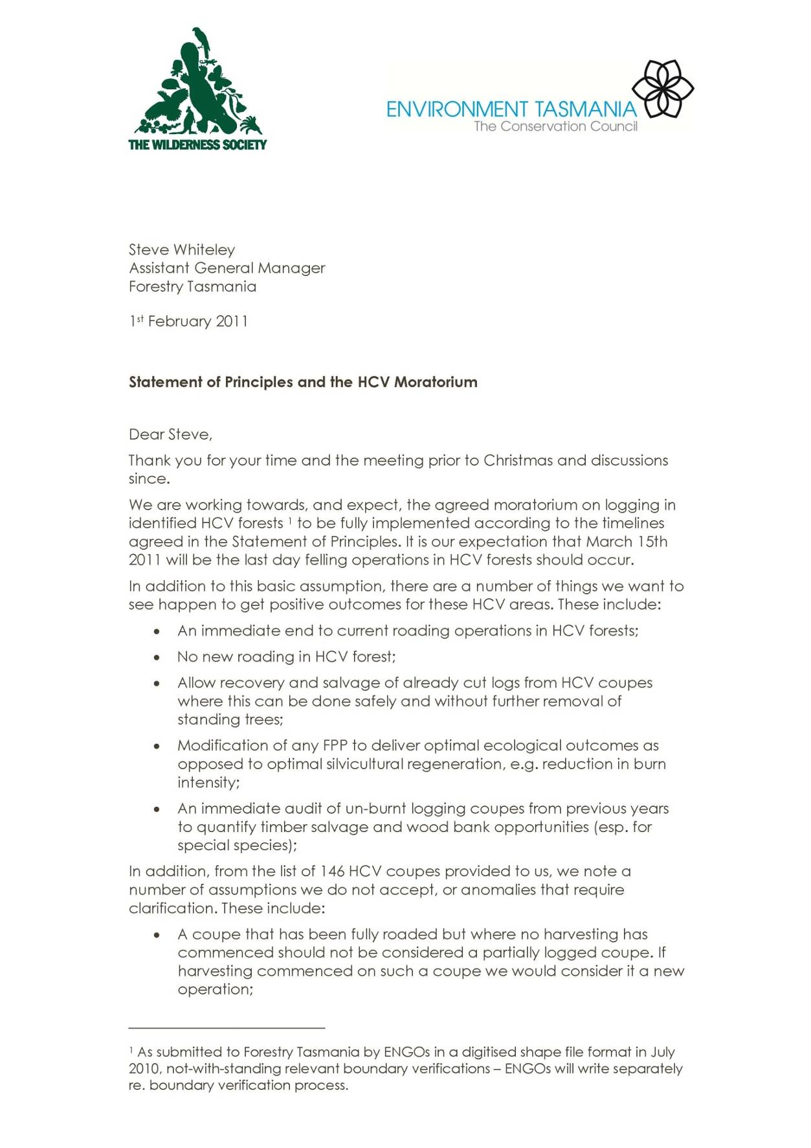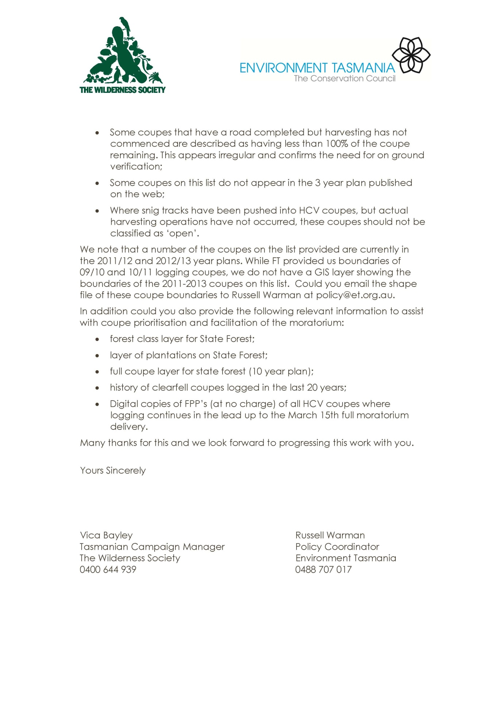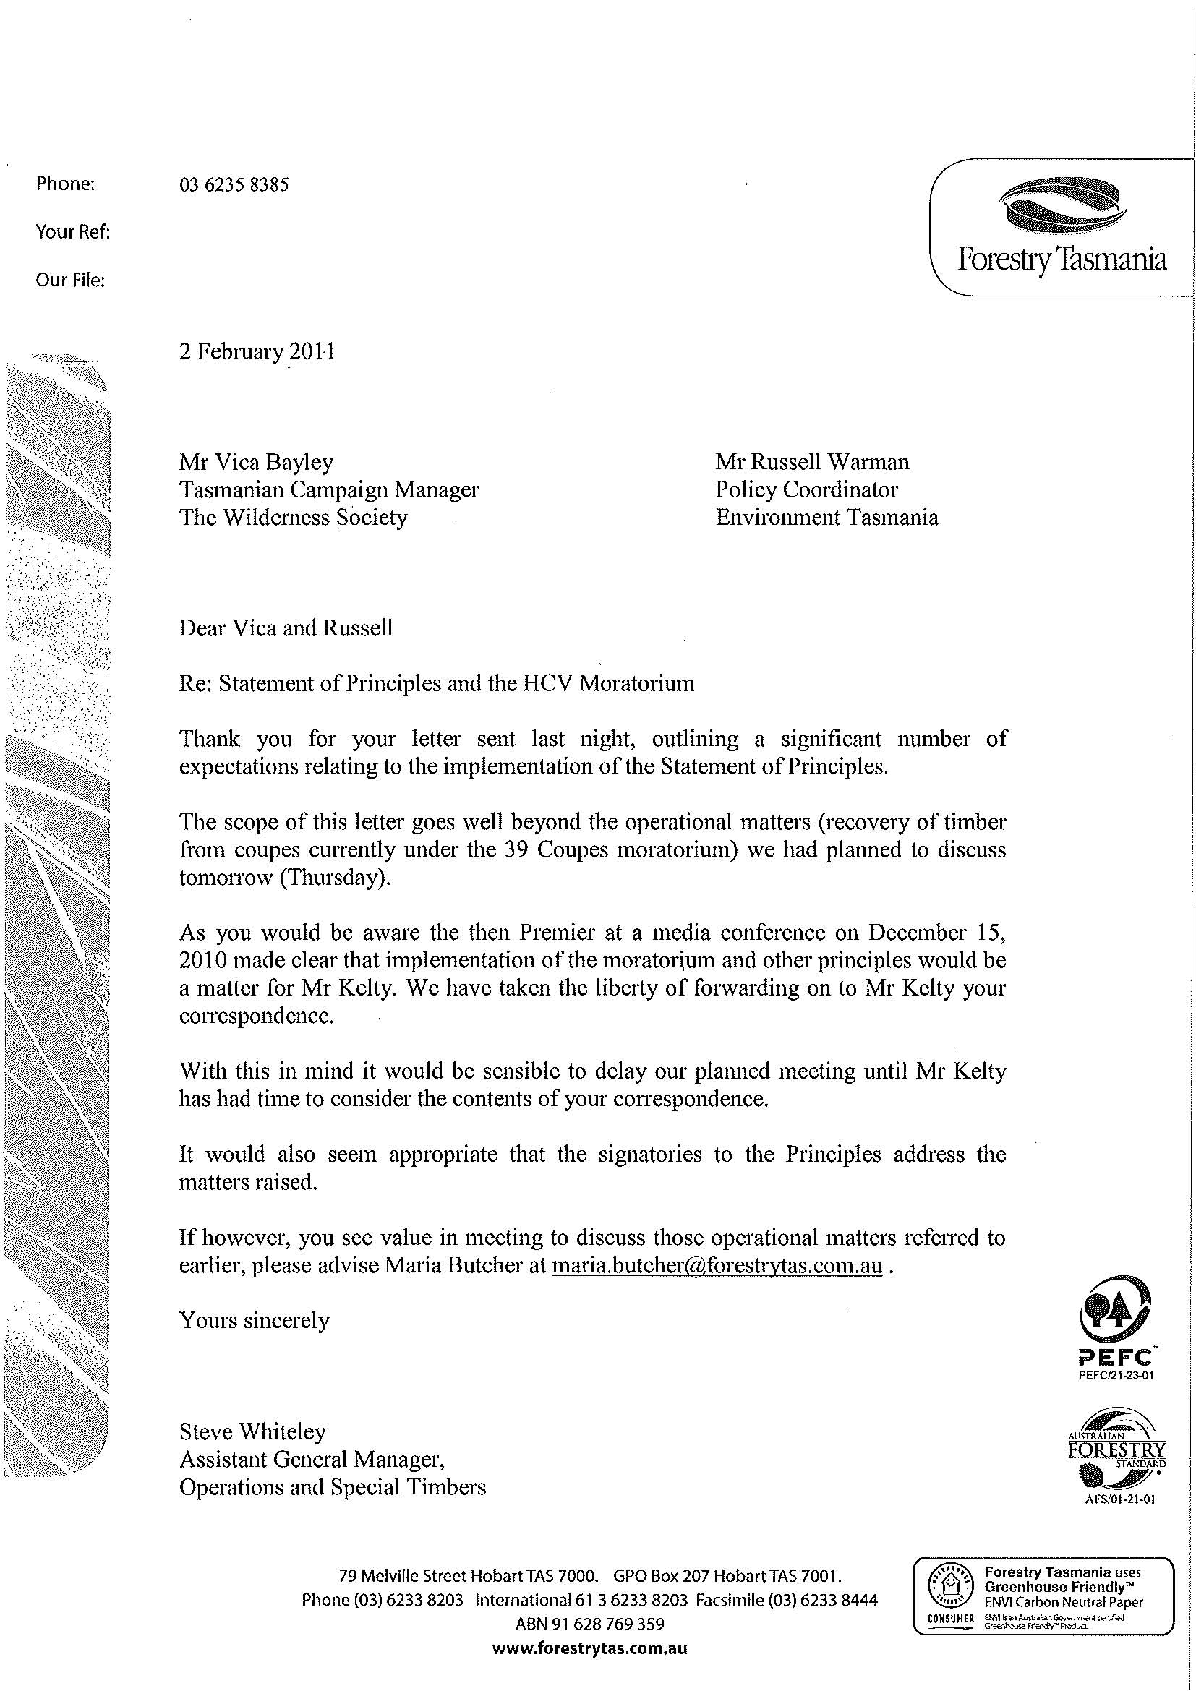

5.2. Future Forest Industries
The agreement is based on recognition that there is a capacity for increased value adding of the downstream processing for the timber industry. This involves the need for a diverse range of plantation processing developments and approaches.

5.2.1. Plantation Processing
It is proposed that options for a diverse range of plantation processing developments and investments for Tasmania be investigated and assessed.

5.2.2. The Bell Bay Pulp Mill
One of these options for plantation processing is a pulp mill and whilst there is a divergence of opinion on an appropriate pulp mill for Tasmania, there is currently a specific proposition involving the Gunns Ltd proposal at Bell Bay.

Gunns Ltd has made it clear to the signatories that:
- there has been a change in their approach to working through the issues;
- they do not intend to use native forests as a resource stock and will rely on plantation stock in Tasmania and mainland Australia;
- they are seeking a joint venture (JV) partner with world’s best environmental standards and plan to build one of the top three pulp mills world wide;
- Gunns are confident that a significant outcome can be achieved in achieving environmental standards for the mill;
- they recognise community concerns and will seek to more realistically address those claims;
- Hampshire as an alternative site does not represent a viable economic alternative;
- the mill is a vital consideration in improving the financial position of the company;
- Gunns will represent the shareholders in the most effective manner if the mill is not capable of support;
- they understand, as does the preferred JV partner that some dissension is inevitable in a democracy; and
- they recognise genuine community concerns about the Bell Bay Pulp Mill to this day.

However, it must be appreciated that there is considerable concern from some parts of the community about the process used to promote the proposed Gunns Ltd Mill at Bell Bay. Whilst it is recognised that there have been changes in approach there remains a reservoir of cynicism and bitterness which needs to be addressed.

There are many issues which impact on the community and it cannot be assumed that there will not be strong opposition from a variety of sources.

Given the position of Gunns and recognising the degree of community concern it is proposed:
- The parties, other stakeholders, and the community be given the opportunity to assess the assertions of the company and JV partners. To this end it is proposed that;
- An independent person be appointed to review the current pulp mill assessment. This would attempt to clarify the main areas of concern within the current assessment of the proposal from Gunns Ltd;
- Further work is undertaken on the economic and socio -economic impacts of the pulp mill in Bell Bay; and
- That all stakeholders be given the time to consider, time to participate and time to respond;
- The views of the community should be appreciated and forums established to present the evidence once the work is completed;
- Any outcomes would need to be protected by State legislation if there was sufficient agreement to protect the respective position of all the parties;
- A permanent independent body would need to be established. This should include representatives of the community; and
- Compensation models be examined for residents and business owners in The Tamar Valley. These must be fair compensation arrangements available for people seriously impacted by the mill.

5.3. The Regional Impact
For any agreement to be stable and durable it must be based on the need for appropriate regional/community based transition plans to be adopted and implemented. To this end the group proposed that Professor Jonathan West, and Dr. Jacki Schirmer (ANU – Fenner School) be used to study and develop these plans with the assistance of Regional Development Australia (RDA) and a group of stakeholders.

5.4. Contribution to Climate Change
The group propose to develop a specific submission of the impact of the agreement and the alternatives to in relation to climate change and carbon tax considerations.

5.5. Discussion on Restructuring
Preliminary discussions should be had to discuss what existing resources are available to facilitate any resultant restructuring.

If it emerges that a workable solution is possible the Parties shall establish a negotiating group under the auspices of the existing group.

It is noted that progress has been made in that a verified boundary of proposed ENGO HCV Forest areas has been undertaken and nearing completion.

It is further noted that various resource scenarios can now be determined working co operatively with Forestry Tasmania.

During the restructuring process any redundancies and job layoffs should be assisted by the use of retraining and re skilling packages. Worker’s Assistance Packages recommended to be coordinated by Forest Works.

Associated mechanisms to support the voluntary exit of logging, harvest and haulage contractors from the native forests sector will also need to be made available. There is an expectation that government resources will be required to establish the mechanism/s, to support the implementation of the moratorium and assist with industry transition/restructuring.

5.6. Views of the Non Signatories
For a workable solution to be developed with the maximum chance of working it would be assisted by understanding the views of non signatories.

In particular, the views of the:
- residents and community groups in the Tamar Valley (Friends of the Tamar, Pulp the Mill, TAP);
- the Private Forestry sector;
- The Institute of Foresters of Australia;
- the downstream impacts on the furnishing trades group;
- other employing bodies; and
- other community groups.

If the process is to continue we are prepared to continue to discuss concerns with these groups and other stakeholders on an ongoing basis. Ensuring that there are mechanisms for broader public participation, engagement and communication about the process will also be critical.

5.7. Political Process
Australia is a pluralist democracy with a well established Parliamentary system. This means that there will be different ideas and different weights given to issues.

If the process is to continue, we would intend to ensure that all the parties should be kept advised of the outcomes so that they can properly frame their responses having regard to their responsibility of representation.

5.8. Is there an alternative to the agreement
There is a higher chance that there will be insufficient support for a workable agreement to be achieved and therefore the lack of a development on an implementation plan by the Facilitator.

The consequences of a failure could be significant for industry, the environment, the community and Tasmania.

If there are two clear conclusions that can be drawn they are:
- Firstly, there has been a tremendous degree of goodwill invested by the parties; and
- Secondly, the industry, community, employees, employers and the State of Tasmania suffer from the continued uncertainty which exists.

If there is no agreement or workable solution possible then the two conclusions should not be overlooked.

Bill Kelty – Facilitator
30 March 2011

