Tasmanian lowland Euphrasia species
Flora Recovery Plan

 | 
DISCLAIMER
This Plan has been prepared under the provisions of both the Tasmanian Threatened Species Protection Act 1995 (TSP Act) and the Commonwealth Environment Protection and Biodiversity Conservation Act 1999 (EPBC Act). While non-listed taxa are referred to in this document for the sake of context, the Recovery Plan only legally covers the ten taxa listed under the TSP Act, and adoption as a national Recovery Plan under the EPBC Act refers only to the six taxa listed under the EPBC Act. The six taxa listed under the EPBC Act are all endemic to Tasmania and are also listed under the TSP Act.
Should a taxon covered by this plan be split into two or more taxa, all subpopulations will remain covered by this plan under the original listing. It is expected that some currently recognised or new taxa will be listed in future years and while not covered by this Plan, the content and actions of this Plan will also be relevant to those taxa. However, the Plan will then require revision to formally include the new species.
ACKNOWLEDGMENTS
This Plan was prepared by personnel with the Threatened Species Section, Resource Management and Conservation Division, Department of Primary Industries, Parks, Water and Environment, Hobart. The Plan draws upon a preceding Recovery Plan (Potts 2000) and various Listing Statements prepared under provisions of the TSP Act (TSU 2001 a-e, 2002, TSS 2008) and drafts held by the Threatened Species Section in 2009. The preparation of this Plan was funded by the Australian Government Department of Environment, Sustainability, Water, Population and Communities and the Tasmanian Department of Primary Industries, Parks, Water and Environment.
Cover photos by Wendy Potts. Euphrasia scabra in centre and clockwise from top left Euphrasia amphisysepala, Euphrasia collina subsp. deflexifolia, Euphrasia fragosa, and Euphrasia gibbsiae subsp. psilantherea.
Citation: Threatened Species Section (2011). Tasmanian lowland Euphrasia species Flora Recovery Plan. Department of Primary Industries, Parks, Water and Environment, Hobart.
© Threatened Species Section
This work is copyright. It may be produced for study, research or training purposes subject to an acknowledgment of the sources and no commercial usage or sale. Requests and enquires concerning reproduction and rights should be addressed to the Section Head, Threatened Species Section, Biodiversity Conservation Branch, Department of Primary Industries, Parks, Water and Environment, Hobart.
ISBN: 978-0-7246-6596-9 (web) 978-0-7246-6600-3 (book)
Abbreviations
DPIPWE Department of Primary Industries, Parks, Water and Environment (Tasmania)
DSEWPaC Department of Environment, Sustainability, Water, Population and Communities (Australian Government)
EPBC Act Commonwealth Environment Protection and Biodiversity Conservation Act 1999
NC Act Tasmanian Nature Conservation Act 2002
NRM Natural Resource Management
PWS Parks and Wildlife Service (DPIPWE)
RTBG Royal Tasmanian Botanical Gardens (DPIPWE)
TSP Act Tasmanian Threatened Species Protection Act 1995
TSS Threatened Species Section, Biodiversity Conservation Branch (DPIPWE)
Taxonomy generally follows Buchanan (2009). Page 2 details authorities for the Euphrasia taxa, and full phrase names for the informally described taxa. Common names are consistent with Wapstra et al. (2005).

CONTENTS

SPECIES INFORMATION 1
Description and taxonomy 2
Life history and ecology 6
Distribution and habitat 7
Population estimate 8
Reservation status 9
Threats, limiting factors and management issues 9
Conservation status 10
Habitat critical to the survival of the species 10
RECOVERY 11
Existing conservation measures 11
Strategy for recovery and progress evaluation 11
Recovery objectives, performance criteria and actions needed 12
Recovery actions 13
1. Protect habitat 13
2. Identify potential habitat and survey 13
3. Manage habitat 14
4. Translocate seed 15
5. Monitor taxa and habitat 15
6. Conserve seed 16
7. Long term management 16
Duration and costs 17
Management practices 18
International obligations 18
Affected interests and social and economic impacts 18
Roles and interests of indigenous people 19
Biodiversity benefits 19
BIBLIOGRAPHY 20
Appendix 1. Tasmanian population summary for lowland Euphrasia species considered to be at risk. Presumed extinct sites are in italics. 22

SPECIES INFORMATION
Tasmanian Euphrasia subpopulations have been found to occupy two different types of habitats, namely, habitats kept open by exposure to extreme environmental factors such as wind and cold temperatures, and habitats kept open by disturbance such as fire, grazing or trampling. Subpopulations occupying the different habitats face different probabilities of extinction. Most Tasmanian lowland Euphrasia taxa are considered to be at risk either because of low numbers, restricted distributions, inappropriate disturbance regimes or threats to their lowland habitats. In general, sub-alpine and alpine Euphrasia subpopulations tend to occupy habitats that are kept open by exposure. Recruitment tends to be continuous in such subpopulations leading to smaller fluctuations in numbers and the area occupied. Generally, subpopulations tend to be relatively large. The likelihood of a detrimental change in land use is low for exposed sites and most of these sites are reserved. Sub-alpine and alpine Euphrasia taxa are less threatened and little can be done to improve their conservation status by management. Therefore, only lowland taxa have been included in this Recovery Plan. Lowland taxa that occupy exposed habitats have not been excluded from the Plan as some taxa are known to occupy both types of habitats and their inclusion facilitates an understanding of taxonomic relationships, which can be complex due to the influence of hybridisation.
Table 1. Lowland Euphrasia taxa in Tasmania and current status
Taxon | Common name¹ | TSP Act | EPBC Act | NRM region
Section Australes
Euphrasia collina subsp. tetragona (incorporating *Euphrasia collina subsp. Northwest Tasmania)² | northcoast eyebright | endangered | Not Listed | Cradle Coast
*Euphrasia collina subsp. deflexifolia (incorporating *Euphrasia collina subsp. gunnii and *Euphrasia collina subsp. tasmanica)³ | eastern eyebright | rare  (Euphrasia collina subsp. gunnii listed separately as rare) | Not Listed | North, South
Euphrasia collina subsp. collina | tall eyebright | not listed | Not Listed | North, South
*Euphrasia collina subsp.  Dukes Marshes⁴ | middle eyebright | not listed | Not Listed | North, South
*Euphrasia collina subsp. diemenica⁵ | plain tufted-eyebright | not listed | Not Listed | North, South  Cradle Coast
*Section Phragmostomae
*Euphrasia phragmostoma | hairy cliff-eyebright,  Buftons eyebright | vulnerable | Vulnerable | South
*Euphrasia amphisysepala | shiny cliff-eyebright | rare | Vulnerable | South
* Euphrasia sp. Bivouac Bay  (prev. Euphrasia sp. fabula)⁶ | masked cliff-eyebright,  masked eyebright | endangered | Endangered | South
Section Scabrae
Euphrasia scabra | yellow eyebright | endangered | Not Listed | North, South  Cradle Coast
Section Striatae
*Euphrasia fragosa | shy eyebright | endangered | Critically Endangered | South
*Euphrasia semipicta | peninsula eyebright | endangered | Endangered | South
*Euphrasia gibbsiae subsp. psilantherea | swamp eyebright | endangered | Critically Endangered | South
*Euphrasia gibbsiae subsp. kingii | kings eyebright | not listed | Not Listed | South, Cradle Coast
*endemic to Tasmania,
¹ Wasptra et al. 2005 with alternate name as per EPBC Act,
² Euphrasia collina subsp. Northwest Tasmania is treated as a variant of Euphrasia collina subsp. tetragona pending further taxonomic studies,
³ Euphrasia collina subsp. gunnii and Euphrasia collina subsp. tasmanica are included in Euphrasia collina subsp. deflexifolia pending further taxonomic treatment (see also Barker 1987),
⁴ a lowland taxon showing characteristics of both Euphrasia collina subsp. diemenica and Euphrasia collina subsp. collina known previously as Euphrasia collina aff. diemenica (see also Barker 1987),
⁵ While Euphrasia collina subsp. diemenica is generally found in highland habitats, at least one lowland occurrence is known,
⁶ see Potts (1997).
The status and occurrence of Tasmanian lowland taxa in the NRM regions are summarised in Table 1. They include 10 taxa listed under the TSP Act and 6 taxa listed under the EPBC Act. Authorities for Tasmanian lowland Euphrasia taxa are shown below:
Euphrasia amphisysepala W.R.Barker, J. Adelaide Bot. Gard. 10(2): 204 (1987)
Euphrasia collina R.Br., Prodr. 436 (1810)
subsp. collina
subsp. deflexifolia (Gand.) W.R.Barker in Stones & Curtis, End. Fl. Tasm. 6: 477 (1978)
subsp. diemenica (Spreng.) W.R.Barker in Stones & Curtis, End. Fl. Tasm. 6: 477 (1978)
subsp. gunnii (Du Rietz) W.R.Barker, J. Adelaide Bot. Gard. 5: 199 (1982)
subsp. tasmanica (Gand.) W.R.Barker, J. Adelaide Bot. Gard. 21: 93 (2007)
subsp. tetragona (R.Br.) W.R.Barker, J. Adelaide Bot. Gard. 5: 189 (1982)
subsp. Northwest Tasmania (M.Visoiu 216) Tas Herbarium [see Barker 1982]
subsp. Dukes Marshes (A.Moscal 861) Tas Herbarium [see Barker 1987]
Euphrasia fragosa W.R.Barker, J. Adelaide Bot. Gard. 17: 217 (1996)
Euphrasia gibbsiae Du Rietz, Sv. Bot. Tidskr. 42: 104 (1948)
subsp. kingii (W.M.Curtis) W.R.Barker in Stones & Curtis, End. Fl. Tasm. 6: 477 (1978)
subsp. psilantherea (F.Muell.) W.R.Barker, J. Adelaide Bot. Gard. 5: 119 (1982)
Euphrasia phragmostoma W.R.Barker, J. Adelaide Bot. Gard. 5: 103 (1982)
Euphrasia scabra R.Br., Prodr. 437 (1810)
Euphrasia semipicta W.R.Barker, J. Adelaide Bot. Gard. 5: 139 (1982)
Euphrasia sp. Bivouac Bay (W.R.Barker 7626 et al.) W.R.Barker [see Euphrasia sp. fabula in Potts (1997)]

Description and taxonomy
Euphrasia, commonly known as eyebright, is a genus of semi-parasitic annual or perennial terrestrial herbs or undershrubs. They are characterised by decussate leaves which are generally fleshy, usually with patches of sessile glands and veins prominent on the undersurface of the leaves and with impressions from veins on the upper leaf surface. The leaf margins are somewhat revolute and the blade is usually shallowly to deeply incised. The corolla is bilabiate, with a tube, a hooded upper lip which usually encloses the anthers, and a three lobed spreading lower lip. They have 4 stamens, and the anthers, with awned lobes, can be fused to form a ‘U’ shape. The fruit is a capsule, and the small seeds are covered with a multifolded testa with fine transverse ridges connecting the folds (Barker 1982).
Euphrasia, in the family Scrophulariaceae, is widespread in temperate areas of both hemispheres. It is characterised by a large degree of variation. Fourteen sections have been recognised, five of which are endemic to Australia and one section is shared with New Zealand. Tasmania has representatives of four sections, one of which is endemic to the State (Section Phragmostomae). Twenty two species are recognised in Australia, all endemic, with 10 species in Tasmania, 7 of which are endemic to the State. Some of the species are polymorphic to the extent that several have been split into numerous subspecies. In all, nearly 50 species and subspecies are recognised in Australia, 19 of which are endemic to Tasmania and a further four are shared with the mainland. Of the 23 Tasmanian taxa, 13 are considered to be lowland types. With a large degree of variation evident between subpopulations of many taxa, further study is likely to result in the recognition of more taxonomic groupings. For example, morphometric analysis of the variation within Euphrasia semipicta supports subspecies status for the three discernable forms (Potts 1997). Hybridisation is thought to play a role in the large degree of variation encountered.
Five Tasmanian lowland taxa are recognised from Section Australes. All are subspecies of Euphrasia collina. Euphrasia collina is distinguished from other Tasmanian Euphrasia species by its non-striated flowers and hairy anther backs. Euphrasia collina subsp. collina branches above ground level and has an elongated apical bud cluster above the first open flowers whereas Euphrasia collina subsp. diemenica branches at ground level only and the apical bud cluster above open flowers is not elongated and open flowers are generally in one plane. A continuum between these two subspecies occurs with increasing altitude on Mt Wellington, near Hobart. However, the intermediate form, with branching at ground level and an elongated apical bud cluster above the first open flowers, is known to occur in isolation from the other two subspecies (Barker 1987). This form is currently recognised as Euphrasia collina subsp. Dukes Marshes (data held in DPIPWE’s Natural Values Atlas). A field study is required to determine whether the coastal variant of Euphrasia collina subsp. diemenica in the far northeast of Tasmania can be attributed to this taxon though plants have not been located recently.
Euphrasia collina subsp. tetragona is most similar to Euphrasia collina subsp. collina though the key distinguishing feature is a lack of hairs on the external surface of the lower corolla lobe of Euphrasia collina subsp. tetragona. While the form of Euphrasia collina subsp. tetragona that is found on the mainland is presumed extinct in Tasmania, a variant informally described as Euphrasia collina subsp. Northwest Tasmania occurs in the northern section of the West Coast (Barker 1982, TSS 2008, Tng 2009). This variant can be distinguished by its smaller flowers and shorter capsules. It is currently recognised and protected under Tasmanian legislation as a form of Euphrasia collina subsp. tetragona, pending further taxonomic studies (TSS 2008). While inconsistent with the formal description of Euphrasia collina subsp. tetragona in that it can have eglandular hairs on the external surface of the lower corolla lobe, its habitat is more similar to that of mainland Euphrasia collina subsp. tetragona than that of Euphrasia collina subsp. collina. However, a re-examination (Tng 2009) of the specimen of the presumed extinct large flowered Euphrasia collina from dunes in the Circular Head area, which has been attributed to Euphrasia collina subsp. tetragona (Barker 1982), has revealed the presence of eglandular hairs on the external surface of the lower corolla lobes on some flowers. Tng (2009) has recommended that the Circular Head taxon be considered for listing as presumed extinct on the TSP Act in its own right (under the name Euphrasia collina subsp. tetragona, as insufficient material is available to determine whether it is a different taxon to that on the mainland) as well as maintaining the listing of the small flowered variant though under the name Euphrasia collina subsp. Northwest Tasmania. It should be noted that Tng (2009) showed a related breakdown in the combination of key characters in specimens in this complex from Tasmanian montane areas (e.g. Middlesex Plains, Vale of Belvoir, Central Plateau). The plants are now being attributed to the polymorphic Euphrasia collina subsp. diemenica even though some specimens show some aerial branching and/or glabrous lower corolla lobes more reminiscent of Euphrasia collina subsp. tetragona. A common feature of mainland Euphrasia collina subsp. tetragona is its usually coastal sandy dune or dune swale habitat or cliff tops with underlying limestone (Barker 1982), quite unlike the habitat of the Tasmanian montane areas.
Three taxa, similar in appearance to Euphrasia collina subsp. collina, but with the presence of glandular hairs on upper leaves and bracts (leaves within the inflorescence) have been described (Euphrasia collina subsp. deflexifolia, Euphrasia collina subsp. gunnii and Euphrasia collina subsp. tasmanica) (Barker 1982, 2007). However, specimens examined since the descriptions were made do not support the existence of different taxa (Barker 1987, 2007, TSS unpublished data) and plants attributed to the 3 taxa are currently recognised and protected under Tasmanian legislation as Euphrasia collina subsp. deflexifolia pending taxonomic clarification. Note that Euphrasia collina subsp. gunnii remains listed under the TSP Act. Occurrences on the Tasman Peninsula are further characterised by squatter flowers and a distinct yellow spot in the throat of the corolla on the lower lobe beneath the anthers (see cover photo). This may prove to be a distinct taxon.
Section Phragmostomae is endemic to Tasmania and can be distinguished from other Tasmanian Euphrasia taxa by larger flowers and relatively long anther awns that protrude well into the mouth of the flower. Three species are recognized (Barker 1982, 1987, Potts 1997). Euphrasia phragmostoma can be distinguished from Euphrasia amphisysepala by the presence of glandular hairs on leaves and bracts, generally larger and relatively wider leaves and a shorter, squatter leaf apex. An intermediate but distinct form, Euphrasia sp. Bivouac Bay (formerly Euphrasia sp. fabula, Potts 1997), has glabrous foliage in the vegetative state but glandular hairs develop on upper leaves and bracts as the plant begins to develop flowers. Leaf shape is intermediate. The Cape Hauy subpopulation of Euphrasia amphisysepala has heavily striated flowers (see cover photo).
Four Tasmanian lowland taxa are known from Section Striatae (Barker 1982, 1984, 1996). Species from this section can be distinguished by striated flowers and glabrous anther backs. Euphrasia gibbsiae can be distinguished from other species in the section by the presence of glandular hairs on bracts and outer surfaces of the calyx.The 2 lowland taxa, Euphrasia gibbsiae subsp. psilantherea and Euphrasia gibbsiae subsp. kingie, are distinguished from other subspecies of Euphrasia gibbsiae by an above ground branching pattern. While Euphrasia gibbsiae subsp. psilantherea has glandular hairs on leaves and inflorescence parts, glandular hairs are generally restricted to the inflorescence in Euphrasia gibbsiae subsp. kingii.
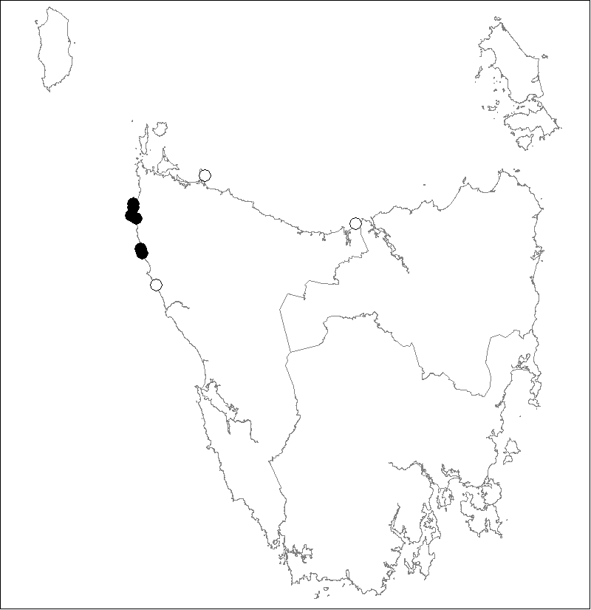 | 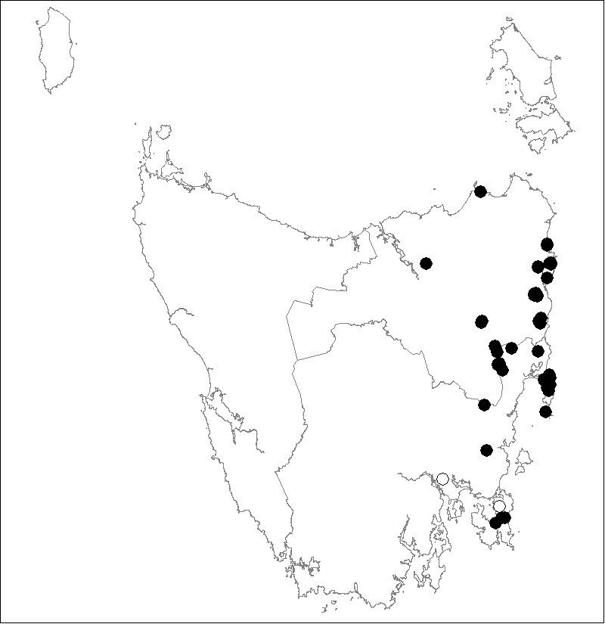
Euphrasia collina subsp. tetragona (incorporating *Euphrasia collina subsp. Northwest Tasmania) | *Euphrasia collina subsp. deflexifolia (incorporating Euphrasia collina subsp. gunnii and Euphrasia collina subsp. tasmanica)
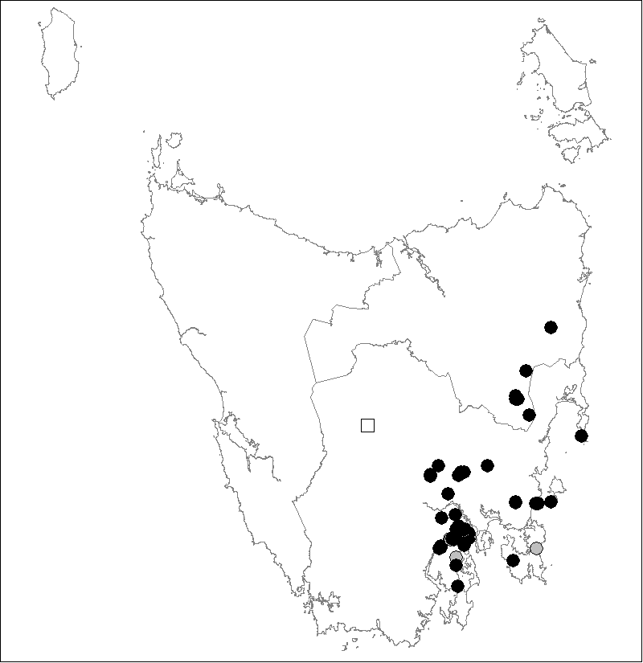 | 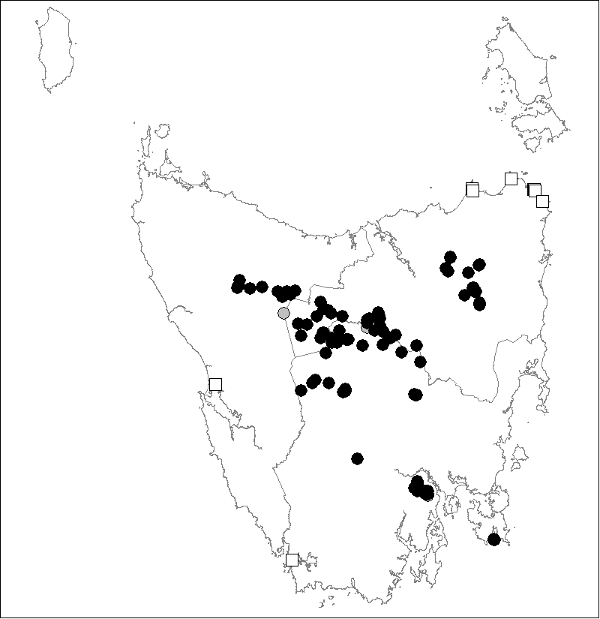
Euphrasia collina subsp. collina | *Euphrasia collina subsp. diemenica
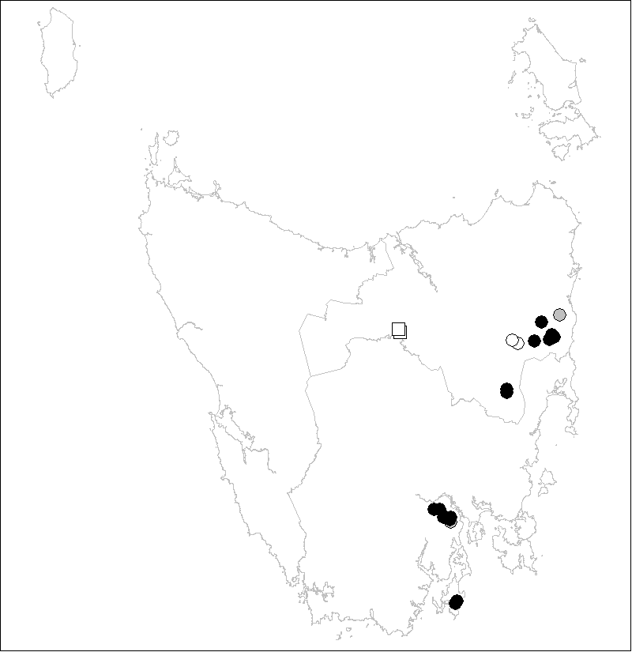 | 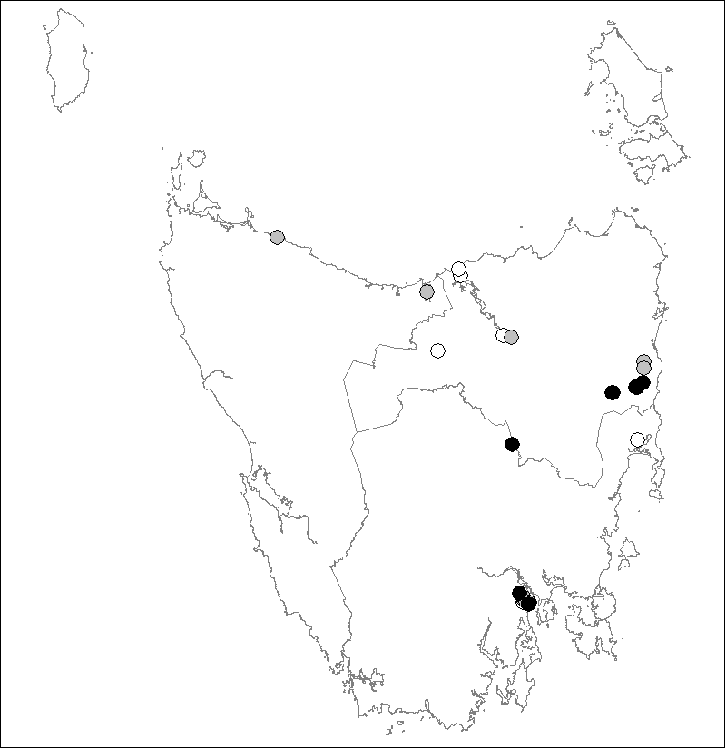
*Euphrasia collina subsp. Dukes Marshes | Euphrasia scabra
Figure 1. Tasmanian distribution of Euphrasia taxa that are found in lowland areas
(* endemic to Tasmania; Status: • = extant, • = pre-1960 record, o = extinct, ◻ = identity uncertain)
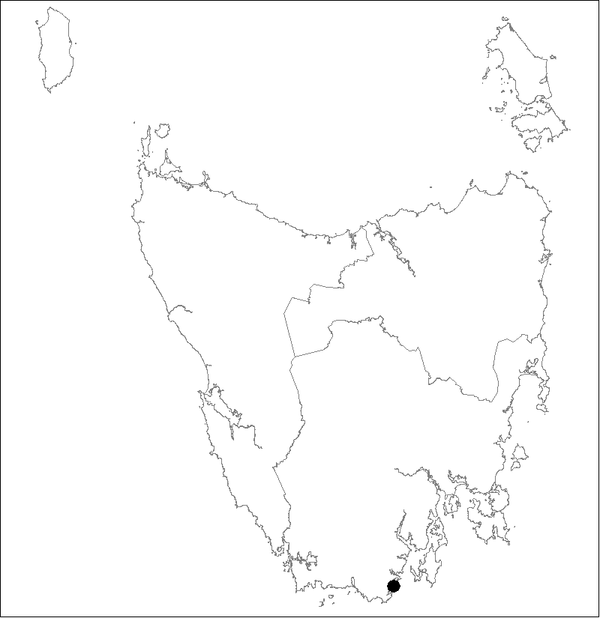 | 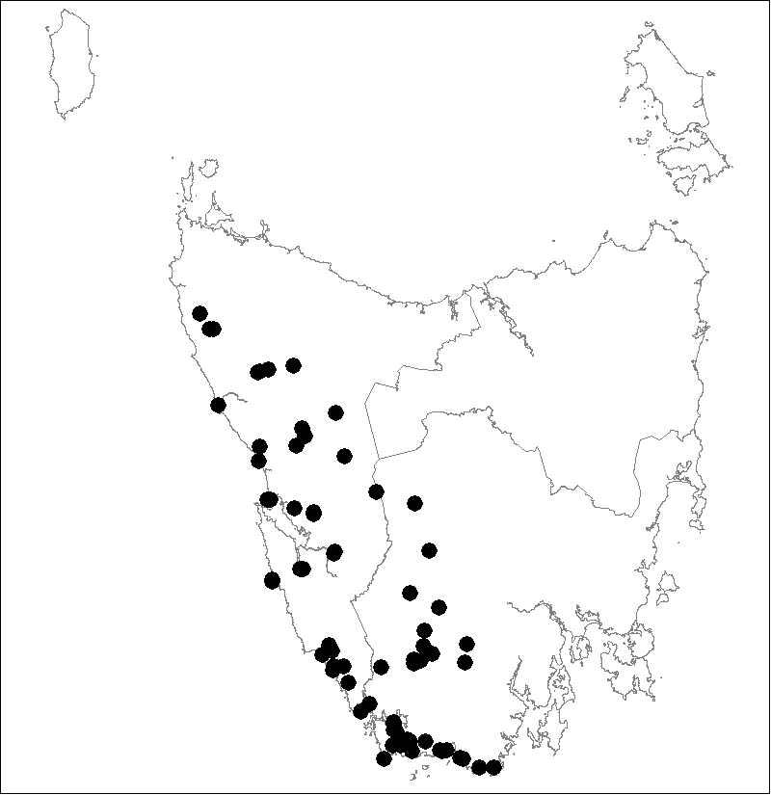
*Euphrasia gibbsiae subsp. psilantherea | *Euphrasia gibbsiae subsp. kingii
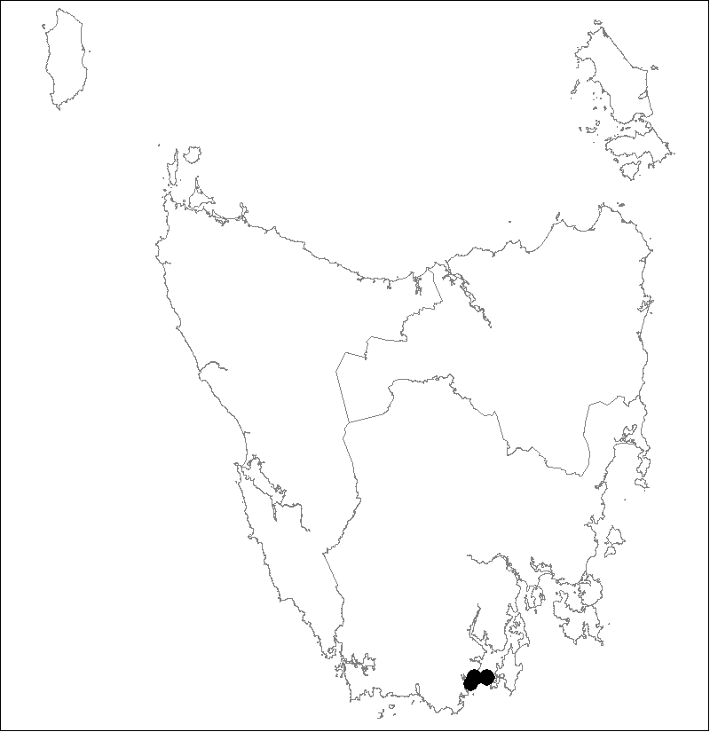 | 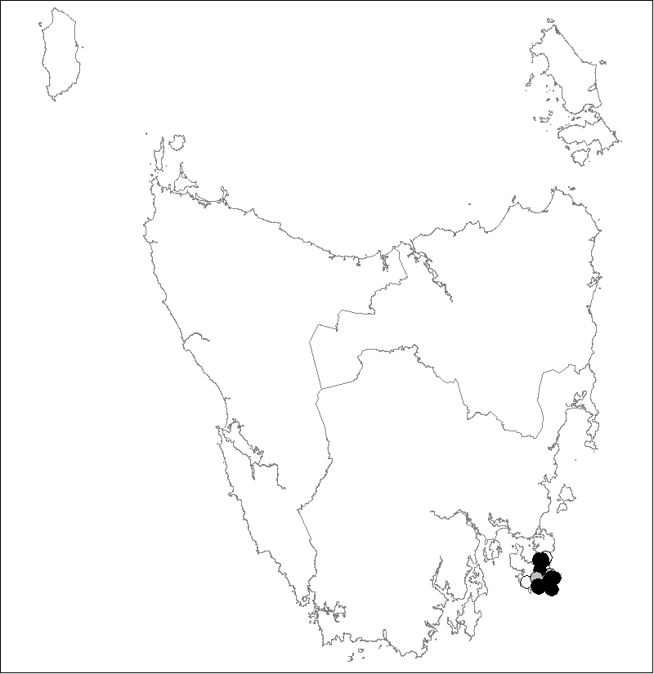
*Euphrasia fragosa | *Euphrasia semipicta
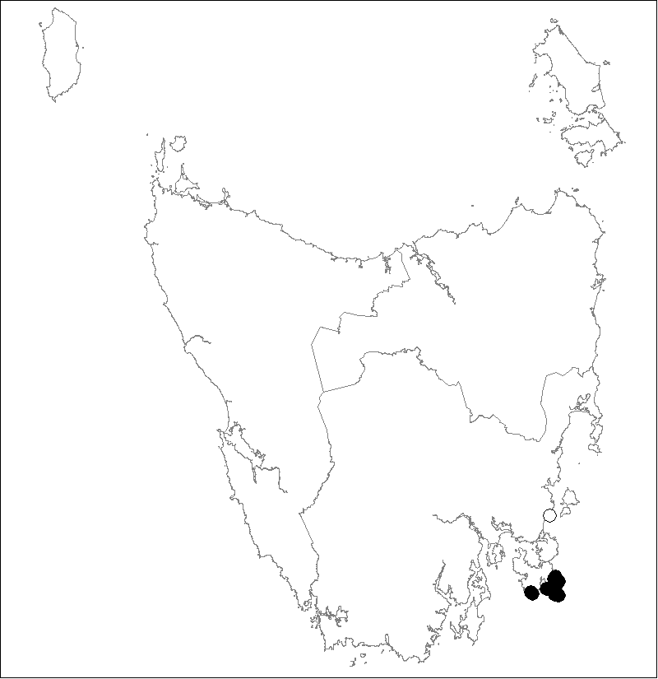 | 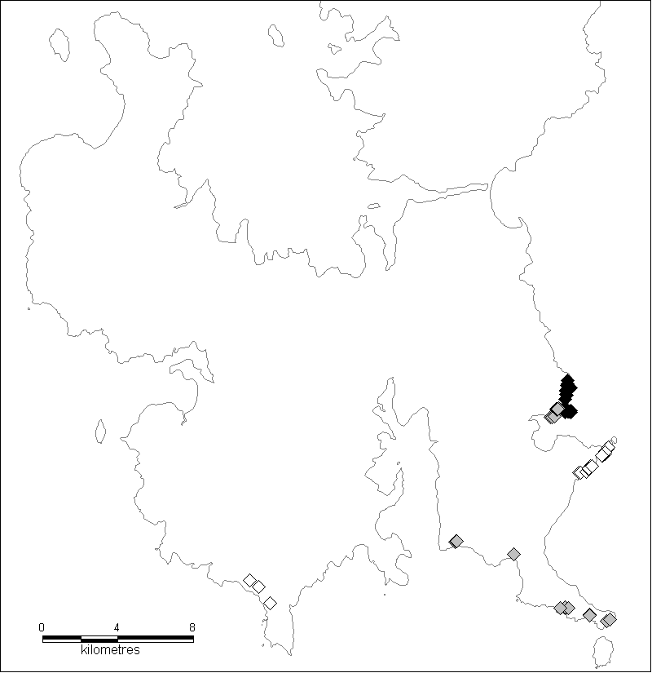
*Section Phragmostomae species | ◊*E. amphisysepala, ♦*E. sp. Bivouac Bay, ♦*E. phragmostoma

Figure 1. Tasmanian distribution of Euphrasia taxa that are found in lowland areas (continued)
(* endemic to Tasmania; Status: • = extant, • = pre-1960 record, o = extinct, ◻ = identity uncertain)
While Euphrasia fragosa (formerly Euphrasia sp. Southport) and Euphrasia semipicta have been placed in Section Striatae, they show some affinities to Section Australes in that corolla striations are not as marked (they are sometimes absent in some individuals of Euphrasia semipicta) and the anther backs of some individuals may not be fully glabrous. These species differ from others in Section Striatae by a lack of glandular hairs on leaves and bracts and an above ground branching pattern. Euphrasia fragosa can be distinguished from Euphrasia semipicta by its smaller flowers and a shorter cleft between the upper corolla lobes. Three different types of Euphrasia semipicta are evident (Potts 1997). Type 1 tends to be more robust with mauve flowers and yellow green leaves. Type 3 tends to be more slender with white flowers and reddish dark green leaves that are more triangular in shape. Type 2 is intermediate in appearance and can have white or mauve flowers, sometimes in the same patch.
Euphrasia scabra (Barker 1982) from Section Scabrae is the only annual Tasmanian Euphrasia species and is characterised by its small pale yellow flowers (see cover photo).

Life history and ecology
Tasmanian lowland Euphrasia are annual or relatively short-lived perennials (up to 5 years) (Potts 1997). Branches generally terminate in an inflorescence. Mortality rates can be high, particularly after fruiting, as new growth from axillary buds is not easily stimulated following reproductive activity and adventitious shoots are uncommon for lowland taxa. They therefore rely on the successful recruitment of seedlings for persistence. The main flowering period is in spring, though the annual species, Euphrasia scabra, flowers in summer (in December for the southern subpopulations and from late February for the northern subpopulations. Some taxa, such as Euphrasia gibbsiae subsp. psilantherea, have a regular pronounced flush of flowering in autumn, a handy adaptation should the seed crop from one season be depleted through browsing or other factors. Most seed is released from late summer to autumn and germinates in late autumn to winter. Seed production is copious. The vast majority of seed is shed within 30 cm of the plants, contributing to the usually restricted distribution of taxa. Flooding events can disperse seed more widely e.g. Euphrasia scabra at Dukes Marshes.
Euphrasia seed has a requirement for light for germination and thus requires patches of open ground for germination. Most taxa that have been tested (with the exception of members of Section Australes) have an additional germination requirement for a period of low temperatures (stratification) (Potts 1997). This allows seed to germinate at a time of low moisture stress, favourable for the survival of germinants. A proportion of freshly shed seed of most of the taxa that have been tested does not germinate within the first year, even with adequate light and cold treatment. This appears to be an adaptation to allow this fraction of seed and seed that does not fall onto open ground, to form a soil seed bank in which seed probably survives for decades. Euphrasia scabra is a notable exception and lack of a dormant fraction of seed on release may help to explain the decline in its range as this species would presumably only add to a soil seed bank if seed is buried through some disturbance event prior to sufficient moisture becoming available to initiate germination. The existence of a relatively long lived soil seed bank is supported by the fact that seed of several taxa, retrieved after being buried for two years, retained its ability to germinate (TSS, unpublished data).
Germination cues for recruitment from dormant soil stored seed are not well understood. Germination can sometimes be profuse after fire indicating that this response may be due to cues additional to allowing exposure of seed to light. However, germination studies on several taxa have not demonstrated a direct link between fire related germination cues (heat and smoke) and recruitment from the soil seed bank (TSS, unpublished data), though fire appears to have an indirect effect by opening up the habitat. Observations of emergence of soil stored seed following unusually wet seasons suggest a role for leaching, though the influence of seed age or successive wet/dry cycles remains to be tested. This may be an adaptation to enhance seedling survival, as the survival of germinants is dependent on relatively high moisture levels. The survival of germinants of several taxa has been observed to increase dramatically following unusually wet spring to summer periods (Potts 1997).
The number of plants in lowland Euphrasia subpopulations can fluctuate greatly from year to year depending on winter and spring moisture levels, which, if sufficient, can greatly enhance the survival of germinants. Plant numbers are also dependent on the degree of habitat openness. Large fluctuations in the number of individuals can be expected in habitats in which openness is dependent on disturbance events such as fire. Fluctuations tend not to be as extreme in habitats kept open by exposure (cliff faces and exposed rocky plateaux and low exposed wet heaths). Fluctuations in numbers increase the extinction risk, particularly of small subpopulations. This helps to explain the relative rarity of lowland Euphrasia taxa, compared to subalpine and alpine taxa. Fluctuations in numbers of individuals of subalpine and alpine taxa is comparatively low as these habitats have reduced moisture stress and reduced fluctuations in habitat openness, which is generally maintained by exposed conditions.
Euphrasia are semi-parasitic, and while some will survive in the absence of hosts, their growth rate and reproductive output is dramatically reduced (Potts 1997). The parasitic relationships that are established during the seedling establishment phase might help plants survive summers and harsh conditions such as those on cliff faces. They are not host specific and prefer the presence of low or sparse vegetation, explaining their relative abundance in rocky places or on edges of tracks. Euphrasia species tend to grow in well ventilated areas. In cultivation they die within days if kept in still dull conditions, possibly as relatively high transpiration rates are needed to maintain the parasitic root connections.
The specific habitat requirements and low seed dispersal potential contribute to a generally small population size, at least in terms of area occupied. This, in part, explains why the Euphrasia genus is characterised by a large number of threatened taxa.
The breeding system of several groups of Tasmanian Euphrasia has been studied. There are different patterns of pollination evident, ranging from largely selfed (e.g. Euphrasia fragosa) to self-incompatible taxa (e.g. Euphrasia collina subsp. diemenica and Euphrasia collina subsp. collina), dependent on insect pollination. Native bees and wasps are the main insect pollinators. Naturally occurring hybrids have been reported and interspecific and even intersectional hybrid seed has been produced using manipulated crosses (Potts 1997).
Much of the variation encountered in Tasmanian Euphrasia in some regions (e.g. the Tasman Peninsula) can be attributed to the occasional hybridisation event following insect pollination, with subsequent introgression aided by rapid generation turnover. This has resulted in a relatively large number of species and subspecies. The probability of hybridisation would be increased following fire, which, with above average rainfall in the growing season, can allow a transient expansion of disturbance dependent subpopulations into the range of other Euphrasia taxa. There is also a relatively large degree of variation evident between subpopulations of the same taxa despite geographical proximity and similar habitat (Potts 1997). In most cases this can be attributed to the hybrid origin (i.e. founder effect) and poor seed dispersal potential. Genetic drift and different selection pressures also contribute to the relatively large degree of speciation in the genus, particularly with increasing geographical distance and different habitat. These factors of origin, as well as allowing rapid speciation, also contribute to the high degree of rarity and endemism in the genus.

Distribution and habitat
Tasmanian threatened lowland Euphrasia taxa tend to be concentrated near coastal areas, particularly on the Tasman Peninsula and on the East Coast, though there are inland occurrences of some taxa. Figure 1 shows the recorded distribution of lowland Euphrasia taxa.
Tasmanian Euphrasia habitats are characterised by the availability of patches of open ground, proximity of low vegetation and relatively moist soils. Such habitats can occur in naturally exposed areas and are often associated with rockiness. For lowland Euphrasia species, exposed habitat consists of cliff faces, windswept rocky plateaux or outcrops and low wet heathland in exposed coastal areas. In non-exposed areas, habitat openness is associated with disturbance such as fire, grazing or that associated with tracks (animal or man made). For lowland Euphrasia species, such habitat can be found in heathland, sedgeland/moorland, grassland, open woodland or forest margins. A description of the habitat and brief notes on the distribution in Tasmania are provided below for each of the lowland taxa (taxa endemic to Tasmania are marked with an asterisk):
Euphrasia collina subsp. tetragona is found in dune swale vegetation, open heath, grasslands and sandy pockets within rocky outcrops near the coast. Its habitat is associated with open patches maintained by disturbance. It occurs on the West Coast and was once known from the North Coast. The taxon is also known from Victoria, South Australia and Western Australia.
*Euphrasia collina subsp. deflexifolia occurs in open woodland or heath, often associated with road edges, tracks and depressions near the headwaters of creeks. Its habitat is associated with the availability of open patches of ground maintained by fire or other disturbance, the proximity of low vegetation and relatively high soil moisture in spring. It occurs in eastern Tasmania, though mainly in the northern section.
Euphrasia collina subsp. collina occurs in open woodland, often associated with road edges and tracks in lowland areas. Its habitat is associated with the availability of open patches of ground maintained by fire or other disturbance, the proximity of low vegetation and relatively high soil moisture in spring. It is also known from coastal cliff edges. It occurs in eastern Tasmania, though mainly in the southern section. The identity of a specimen from an outlying location on the Central Highlands requires field confirmation. The taxon is also known from NSW, Victoria and South Australia.
*Euphrasia collina subsp. Dukes Marshes occurs in open woodland, heath or grassy leads on the edges of marshes in the northeast, and on Bruny Island, it occurs on the edge of a dirt road through rainforest/wet sclerophyll forest. It is often associated with road edges and tracks. Its habitat is associated with the availability of open patches of ground maintained by fire, grazing or other disturbance, the proximity of low vegetation and relatively high soil moisture in spring. The intermediate clinal form on Mt Wellington occurs in open woodland/shrubland and road edge. The identity of specimens from a high altitude outlying location on Drys Bluff requires field confirmation.
*Euphrasia collina subsp. diemenica is a polymorphic taxon generally found in montane to higher altitude sites and sometimes at lower altitude grassland sites associated with cold air drainage. One lowland subpopulation is known from an extremely windswept rocky coastal plateau on Mount Brown on the Tasman Peninsula (Barker 1996). Barker (1982) considers the lowland coastal occurrences in the southwest and far northeast of Tasmania to be variants of Euphrasia collina subsp. diemenica.
*Euphrasia phragmostoma, *Euphrasia amphisysepala and *Euphrasia sp. Bivouac Bay occur on coastal dolerite cliff faces and moist and shady ledges, rock crevices and on patches of bare ground extending from the base to the tops of cliffs where the vegetation is not too dense. The taxa are restricted to the Tasman Peninsula.
Euphrasia scabra is found in moist herb/sedge communities in grassy leads in marshes or in drier open grassy areas on hills at the headwaters of creeks. Its habitat is associated with gaps created by grazing, flooding or other disturbance. The taxon is also known from NSW, Victoria, South Australia and Western Australia.
*Euphrasia gibbsiae subsp. psilantherea is found amongst low sedges in open wet coastal sedgeland/heathland that is frequently waterlogged in winter. Its habitat is associated with gaps created by fire, seasonal inundation and/or disturbance.
*Euphrasia fragosa is found in coastal areas in heathy, grassy or sedgy open woodland or at the forest edge, particularly along animal, walking or vehicular tracks. Its habitat is associated with the availability of open patches of ground maintained by fire or other disturbance, the proximity of low vegetation and relatively high soil moisture in spring.
*Euphrasia gibbsiae subsp. kingii occurs in button-grass and heathy and swampy areas. It occurs in the West and Southwest of the State.
*Euphrasia semipicta occurs in coastal heathy woodland and heath, particularly along animal, walking and vehicular tracks. Habitat is associated with the availability of open patches of ground maintained by fire or other disturbance, the proximity of low vegetation and relatively high soil moisture in spring. It is restricted to the Tasman Peninsula.

Population estimate
Known subpopulations of lowland taxa considered to be at risk are detailed in Appendix 1. All subpopulations of each threatened taxon are considered important for survival of the taxon. Where the habitat is inaccessible, such as with some cliff faces, the number of mature plants seen is given, rather than an estimate of plant numbers.
Several factors complicate the estimate of the size of Euphrasia subpopulations. Plants are difficult to see when not in flower and, as Euphrasia species are short lived and recruitment is from seed, numbers can fluctuate greatly from year to year depending on winter and spring moisture levels, which, if sufficient, can greatly enhance the survival of germinants. Fluctuations in the number of individuals tend not to be as extreme in habitats kept open by exposure (cliff faces and exposed rocky plateaux and low exposed wet heaths). Some subpopulations exhibit a meta-population structure with patches appearing and disappearing over a wider area. As conditions change, plants will often become restricted to track edges where openness is persistent and moisture stress low. An indication of fluctuations in numbers is given in Appendix 1 where possible.
An indication of whether subpopulations are presumed to be extinct is also shown in the Appendix 1. The vast majority of subpopulations detailed have been searched for since 1995, particularly those on the Tasman and Freycinet peninsulas. A date last seen prior to 1995 may indicate that these subpopulations may now be extinct, particularly if they were last seen in the early 1970s or earlier.
The probability of finding new subpopulations of many threatened lowland Euphrasia taxa is considered to be high due to fluctuations and the often transient nature of subpopulations, as well as accessibility issues. Much of the readily accessible potential habitat in reserves has been examined, particularly in coastal areas, though potential habitat on private land has not been well surveyed. However, given the rapidity of speciation and relatively poor seed dispersal mechanisms, the probability that any new findings will significantly increase the known range would appear to be low for most threatened lowland taxa.

Reservation status
Lowland Euphrasia species are generally well reserved. Notable exceptions include Euphrasia scabra near Hobart, Euphrasia fragosa at Southport and Euphrasia semipicta on the northern part of the Tasman Peninsula, which occur on private land, and Euphrasia scabra, Euphrasia semipicta, Euphrasia collina subsp. Dukes Marshes and Euphrasia collina subsp. deflexifolia, which occur in State Forest.

Threats, limiting factors and management issues
Issues and specific threats known for subpopulations of lowland Euphrasia taxa considered at risk are detailed in Appendix 1. As explained above, for reasons of life history, habitat requirements and origin, lowland Euphrasia taxa tend to be characterised by restricted distributions, a low number of subpopulations and small population sizes. This makes the taxa susceptible to stochastic risk that is often enhanced by extreme fluctuations in the number of individuals, particularly for occurrences that tend to be ephemeral because of their dependence on disturbance for openness.
Keeping track of the distribution of lowland Euphrasia taxa and protection of subpopulations is hampered by difficulty of identification due to insufficient knowledge of taxonomic relationships, as well as their tendency to be ephemeral and being difficult to find when not in flower (they have relatively short flowering seasons). Funds to clarify taxonomic relationships are difficult to attain but without taxonomic clarification, it is often not possible for listing under State and Commonwealth legislation in order to afford legislative protection and to attract recovery funding. Given the state-wide distribution of lowland Euphrasia taxa in Tasmania, the trend to fund regional activities without state-wide co-ordination may hamper recovery by reducing efficiencies and the ability to adequately keep track of subpopulations. On the other hand, lowland Euphrasia taxa tend to co-occur with many threatened orchid species in Tasmania offering the possibility of increasing efficiencies by combining recovery efforts for the two groups of taxa.
Translocation of Euphrasia plants is not practical as they are semi-parasitic and mortality rates are high. Translocation of seed is less disruptive of the habitat and if a subpopulation can be established at a site from seed, the chances of that subpopulation self-perpetuating at that site are high.
Many subpopulations are dependent on disturbance for habitat openness to promote regeneration. These are detailed in Appendix 1. However, disturbance that is too frequent can result in a depletion of soil stored seed thereby reducing regeneration potential. On the other hand, should the habitat become overgrown, lack of fire for long periods may be detrimental with the decline of the viability of soil stored seed over time. Over past decades, some parts of the State have experienced long intervals between fires due to the cost and difficulties associated with implementing ecological burns (e.g. narrow burning windows, safety concerns, fire crew unavailability when fighting wildfires). However, recent planning for strategic fuel production burns to reduce the impact of wildfire on populated areas is seeing more lowland Euphrasia habitat burnt, likely benefiting the species. The fire regime in production forests is likely to be beneficial to disturbance dependent occurrences of lowland Euphrasia species provided that weeds and disease are not spread or introduced and that the species are considered with respect to access roads and landings. Some species that show relatively little or no seed dormancy (e.g. Euphrasia scabra) may also be dependent on disturbance such as animal diggings or flooding to bury freshly shed seed to replenish the soil seed store, conferring a higher extinction risk on occurrences of these taxa. Euphrasia scabra is particularly susceptible as it is an annual.
Critical small subpopulations in overgrown areas are best recovered by regular small-scale disturbance (such as slashing around standing plants to enhance germination niches for freshly shed seed), and caging to prevent browsing. This will reduce fluctuations in numbers and eventually increase the number of individuals and representation in the soil seed bank in preparation for ecological burning. Success may only become apparent after several years as an increase in the number of plants will be dependent on adequate rainfall in the growing season. The extent of small subpopulations can be increased by slashing additional patches and translocating seed into the patches. Slashing is also an option for increasing habitat openness when this is difficult to achieve by fire due to proximity to property or assets which are at risk of being destroyed by fire escapes, or logistics such as appropriate environmental conditions and fire crew availability and costs. An increase in browsing pressure may result from applied small scale disturbance, necessitating caging of small occurrences to prevent flower and seed heads from being eaten.
Threats to lowland Euphrasia subpopulations include changes or intensification of land use which result in habitat loss or inappropriate changes in disturbance patterns. Examples include subdivision (Southport, St Helens), tourist developments (Coles Bay), inundation (Coles Bay and Dukes Marshes), sand mining (St Helens Point) and expanding sand blows many of which are initiated by cattle grazing and/or off road vehicle activity (Arthur Pieman Conservation Area). Excessive track braiding by off road vehicles is no longer an issue for Euphrasia gibbsiae subsp. psilantherea in the Southport Lagoon Conservation Area (see below).
While there are obvious benefits in a semi-parasitic relationship, it has the disadvantage of making plants susceptible to factors that limit hosts. Of particular significance, subpopulations of lowland Euphrasia species that co-occur with a high proportion of plants of susceptible species would be impacted by Phytophthora cinnamomi. Increased use or the development of new tracks risks the introduction and spread of Phytophthora cinnamomi, particularly in coastal areas. This is potentially an issue for the Three Capes Walk proposed for the Tasman Peninsula (potentially impacting Euphrasia semipicta and Euphrasia sp. Bivouac Bay). The pathogen has been introduced to the edge of the only subpopulation of Euphrasia gibbsiae subsp. psilantherea through illegal off road vehicle access to a logging road through the Southport Lagoon Conservation Area. The road has now been rehabilitated and vehicular traffic has been banned from the southern part of the reserve. A semi-parasitic relationship also has implications for weed control e.g. all plants of Euphrasia subsp. Dukes Marshes within a 60 cm radius of a Spanish heath plant treated with herbicide were also killed.
The life history attributes of lowland Euphrasia species makes them particularly susceptible to the impacts of climate change. Direct effects include reduced survival of germinants as a result of decreased rainfall or a change in rainfall patterns due to their dependence on high moisture levels. Climate change is implicated in declines perceived for Euphrasia scabra, and Euphrasia collina subsp. deflexifolia and the coastal variant of Euphrasia collina subsp. diemenica in the far north east in particular. Indirect impacts may result from changed disturbance patterns or changes in competition e.g. from a proliferation of weeds.

Conservation status
Most Tasmanian lowland Euphrasia taxa are considered to be at risk. Most qualify for listing because of restricted distributions, low numbers of subpopulations, low numbers of individuals, extreme fluctuations in the number of mature individuals and continuing declines due to risk of an adverse change in land use, inappropriate disturbance regimes, weeds, climate change and vulnerability due to susceptibility of hosts to Phytophthora cinnamomi and other factors.

Habitat critical to the survival of the species
Habitat critical to survival of each threatened lowland Euphrasia taxon comprises:
- the area of occupancy of subpopulations;
- areas of similar habitat adjacent to these subpopulations to allow for expansion;
- areas of similar habitat which is suitable for the species and could contain subpopulations;
- the local catchment for the surface and/or groundwater that maintains the habitat of the species.

RECOVERY

Existing conservation measures
This document is an update of a Recovery Plan for Tasmanian lowland Euphrasia species that was adopted by Tasmania and the Commonwealth in 2000 (Potts 2000) which incorporated information from Collier 1990, Thompson 1992, Ball 1994 and Gilfedder & Kirkpatrick 1997). Implementation of the 2000 Recovery Plan is ongoing, though progress has been limited by funding. Some recovery actions were progressed as part of a threatened Tasmanian orchid and Euphrasia NRM cross regional project funded from March 2007 to March 2009. Actions undertaken since 2000 include:
- a census of subpopulations of threatened taxa on the Tasman Peninsula and on the West Coast;
- morphometric study of the glandular forms of Euphrasia collina on the East Coast and West Coast to clarify taxonomy;
- the creation of Special Management Zones (Orr & Gerrand 1998) that include 7 subpopulations on State forest;
- slashing around standing plants to enhance germination niches for freshly shed seed, coupled with caging to prevent browsing, to increase the number of individuals and representation in the soil seed bank for Euphrasia gibbsiae subsp. psilantherea near Blackswan Lagoon and Euphrasia fragosa on the Labillardiere Peninsula;
- fencing to prevent excessive damage to Euphrasia gibbsiae subsp. psilantherea from track braiding by off road vehicles in the Southport Lagoon Conservation Area and eventual blocking of vehicular access to the area;
- fuel reduction burn for Euphrasia collina subsp. deflexifolia at Stieglitz;
- planning completed for ecological burns for Euphrasia gibbsiae subsp. psilantherea near Blackswan Lagoon, Euphrasia fragosa on the Labillardiere Peninsula, and Euphrasia scabra at Black Marsh;
- consideration of the needs of Euphrasia collina subsp. deflexifolia in production forests and for strategic fuel reduction burns;
- opportunistic monitoring;
- preparation of Listing Statements or drafts for all lowland Euphrasia taxa listed on schedules of the TSP Act;
- a Threatened Plants Tasmania Euphrasia field day on the Tasman Peninsula in 2009;
- collection of seed from at least one subpopulation of each threatened Tasmanian lowland Euphrasia taxon barring Euphrasia fragosa for long term conservation storage at the Tasmanian Seed Conservation Centre.

Strategy for recovery and progress evaluation
The lowland Euphrasia Recovery Plan will run for 5 years and is based on strategies to maintain or increase the number of subpopulations, identify and keep track of lowland Euphrasia subpopulations, recover declining subpopulations and to manage species in the long term. This will be achieved by improving security against adverse changes in land use and disturbance patterns, survey, identification, monitoring, translocation, of seed, habitat management and provision for long term management. Given the large number of taxa, identification issues, their tendency to be ephemeral and their state-wide distribution, the success of this Plan will be contingent on attracting funds for project coordination for the duration of the Plan.
This Plan has been prepared in consultation with representatives of the Biodiversity Conservation Branch (DPIPWE) and various experts. It incorporates management issues and strategies outlined in earlier documents (Potts 2000, TSU 2001 a-e, 2002, TSS 2008) and takes existing conservation measures into account.
TSS will guide implementation, monitoring and review of this Plan or parts thereof if funding is secured. Evaluation of the success or failure of the Recovery Plan can be measured against the performance criteria. A formal review within 5 years of adoption is required under the EPBC Act. Significant developments will be communicated to the general public through Listing Statement updates, websites, newsletters and reports.
This Plan is consistent with the aims of the Threatened Species Strategy for Tasmania (PWS 2000) and Tasmania’s Nature Conservation Strategy (NCB 2002).

Recovery objectives, performance criteria and actions needed
The overall objective of the Recovery Plan is to ensure the persistence of threatened lowland Euphrasia taxa and where possible, to reduce threats.
Specific objectives are to:
- secure the protection of existing subpopulations from potentially detrimental changes in land use or disturbance patterns;
- increase the number of subpopulations of threatened taxa by survey, verification of new records and identification;
- recover declining subpopulations by management of habitat and seed translocation.
The criteria for achieving the objectives constitute a quantifiable decrease in the risk of extinction over 5 years of Recovery Plan implementation. They are:
- no decline in the number of subpopulations for each threatened taxon;
- the total number of mature individuals of each threatened taxon does not fall below 50 over the next 5 years;
- the number of mature individuals is greater than 100 for at least 2 subpopulations of each threatened taxon (for taxa with more than 1 known subpopulation) at least once over the next 5 years;
- an improvement in the tenure or management zoning of 5 subpopulations of threatened taxa by year 5;
- the quality of habitat and potential habitat maintained or improved over 5 years (as measured by Action 5);
- seed of at least 2 subpopulations of each threatened taxon held in long term conservation storage (for taxa with more than 1 known subpopulation);
- taxonomy clarified and formally published.
The actions required for achieving the objectives are:
- protect habitat;
- identify potential habitat and survey;
- manage habitat;
- translocate seed;
- monitor taxa and habitat;
- conserve seed;
- long term management.

Recovery actions

1. Protect habitat
Whilst most lowland Euphrasia subpopulations are reserved, a number of subpopulations critical to the survival of threatened taxa are on private land or unreserved public land (e.g. State forest) and are at risk of inadvertent destruction by land clearance or an adverse change in the disturbance regime. This action is to pursue options with landowners/managers to protect subpopulations against possible changes that would be detrimental to the species. This action includes:
- raising awareness of current owners of private land of legislative responsibilities in year 1 for Euphrasia fragosa, Euphrasia scabra, and Euphrasia semipicta;
- negotiating conservation covenants or management agreements with owners of private land, or appropriate zoning with managers of public land, in years 1 to 5;
- raising awareness of regulators (especially relevant councils), Mineral Resources Tasmania and the Irrigation Development Board of potential impacts to threatened taxa in year 1;
- upgrading the status of Dukes Marshes to a Forest Reserve, and the unallocated Crown land behind Stieglitz to a Conservation Area (or preferably a Nature Reserve) respectively by year 5.
- including all known occurrences of threatened taxa in State forest in Special Management Zones by year 2.
The needs of threatened species in areas subject to forestry activities are considered through the Forest Practices Planning System in Tasmania. For subpopulations in State forest, inclusion of subpopulations critical to the survival of threatened taxa into Special Management Zones (Orr & Gerrand 1998) will ensure that an appropriate firing and disturbance regime is maintained, that roadside maintenance will not damage occurrences (some subpopulations occur on the edge of forestry roads or tracks) and that weed and disease issues are better managed. This is pertinent to Euphrasia semipicta, Euphrasia scabra, Euphrasia collina subsp. deflexifolia and is recommended for Euphrasia collina subsp. Dukes Marshes.
Given that potential habitat is often on land suitable for subdivision, to avoid past problems a process is required to ensure that surveys for the species are requested by relevant councils prior to subdivision applications being made or permits given. Dealing with the presence of the species prior to plans being drawn up would be beneficial to developers as well as other parties. This is pertinent to Euphrasia fragosa, Euphrasia semipicta, Euphrasia scabra and Euphrasia collina subsp. deflexifolia.
Some coastal occurrences of Euphrasia collina subsp. deflexifolia are on land suitable for sand mining. Liaison will need to be maintained with relevant bodies (Mineral Resources Tasmania and relevant councils) to ensure that areas of potential habitat are surveyed before mining leases are renewed or new leases are granted. In 2002, part of a mining lease on land with this species has been revoked and efforts are in progress to increase the status of the unallocated Crown land housing this subpopulation (and a number of other threatened flora species) to that of a Nature Reserve or Conservation Area.
An early proposal to dam Dukes Marshes to supply irrigation needs was not progressed though the needs of the threatened lowland Euphrasia taxa will need to be considered with further irrigation schemes proposals.

2. Identify potential habitat and survey
This action includes:
- identifying (year 1), mapping (year 2) and surveying (years 3 to 5) potential habitat (survey effort should be recorded along with disturbance levels and time since last fire as a negative search may not preclude the species’ presence in the soil seed bank and some areas may need to be searched again following fire and adequate rainfall);
- identifying suitable areas for seed translocation efforts (Action 4);
- clarifying taxonomy and formal publication to facilitate identification (pertinent to the glandular subspecies of Euphrasia collina, Euphrasia collina subsp. Northwest Tasmania, Euphrasia collina subsp. Dukes Marshes, the 3 types of Euphrasia semipicta and Euphrasia sp. Bivouac Bay in particular);
- identifying and verifying any unverified or new occurrences including those identified in Figure 1 as having uncertain identity and unverified reports of plants of Euphrasia on Bruny Island.
In order to progress towards downlisting, the number of known subpopulations of threatened Euphrasia taxa needs to be increased. The probability of finding new occurrences can be demonstrated by the fact that many new subpopulations and new patches have been discovered since the implementation of Recovery Plans for lowland Euphrasia taxa (Ball 1994, Potts 2000) commenced in 1995. The probability of finding new subpopulations is considered to be high (particularly for areas that have been opened up by fire followed by appropriate rainfall) as many subpopulations may only persist in the soil seed bank until recruitment niches are created and dormancy is broken. Surveys will need to be conducted in seasons following good winter/spring rainfall that will allow increased survival of germinants and at a time when plants are likely to be in flower. If not flowering, plants are difficult to find, and to identify as reproductive material is generally required for identification. Pertinent areas that have been burnt recently or are planned for burning in 2010 include parts of the Southport Lagoon Conservation Area, Mt Bleak on the Labillardiere Peninsula, Black Marsh, private land at St Helens Point and Ferrars Tier.
Due to the large number of Euphrasia taxa in Tasmania and a perceived difficulty in their identification or lack of reproductive material, many observations have not been reported and many records have either been misidentified or have only been identified to genus or species level. If a specimen has been lodged for these records, examination may allow identification. Otherwise, records from lowland areas will require field verification in non-drought years. As subpopulations can exist for many years in the soil seedbank, sites may need to be visited several times over the years, particularly following fire, other disturbance and/or unusually cool and wet springs/summers due to the increased likelihood of finding plants. As most subpopulations are small and localised, field verification can be hampered by imprecise locality details provided by recorders. The publication of formal taxonomic descriptions will aid identification.
Reports of any new lowland Euphrasia occurrences will also require identification and/or verification, possibly requiring field study. Increased awareness of the Recovery Program (Action 7) will encourage reporting of occurrences of lowland Euphrasia taxa discovered through vegetation surveys for other programs or for development impact assessments or by interested individuals looking out for plants.

3. Manage habitat
This action includes:
- ecological burns, priorities being Euphrasia fragosa (Labillardiere Peninsula), Euphrasia gibbsiae subsp. psilantherea (Blackswan Lagoon) and Euphrasia scabra (Black Marsh);
- slashing of small recruitment niches and caging to increase numbers and representation in the soil seed bank, priorities as determined in Action 5;
- diversion of the walking track through the subpopulation to maintain openness following fire for Euphrasia fragosa on the Labillardiere Peninsula;
- controlling or preventing the introduction of weeds and Phytophthora cinnamomi;
- fencing and other measures to exclude or deter grazing and off road vehicles from Possum Banks and Ingram Bay for Euphrasia collina subsp. tetragona.
Habitat intervention should be undertaken in an attempt to maintain the total population size of any taxon at more than 50 mature individuals in any year as even though the taxon may persist in the soil seed bank in the absence of standing plants, the risk of failed recruitment or deterioration of the soil seed store (if conditions to break seed dormancy are not experienced) is high. The presence of standing plants and a continual seed rain increase the chance of continual recruitment and population persistence. As such, it is considered critical to increase numbers of mature individuals to more than 100 in at least 2 subpopulations (if more than 1 known is known) at least once during every 5 year interval. However, given difficulties in manipulating the cliff face habitat of species from Section Phragmostomae, this action does not apply to Euphrasia phragmostoma, Euphrasia amphisysepala and Euphrasia sp. Bivouac Bay.

Possible intervention includes firing, slashing, caging to prevent native browsing, alteration of stock grazing regimes, diversion of tracks to increase openness, weed control to reduce competition and fencing or construction of barriers to control access by vehicles, walkers or stock. In some cases, measures will also need to be taken to reduce the risk of spreading the root rot pathogen, Phytophthora cinnamomi. As mentioned earlier, weed control in the vicinity of Euphrasia plants may result in their death. As such, weed removal from occurrences will need to be staged. Weeds in the vicinity of occurrences will need to be managed to prevent their introduction.
To gradually increase recruitment, critical, small subpopulations in overgrown areas are best recovered by regular small-scale disturbance (such as slashing around standing plants to enhance germination niches for freshly shed seed), and caging to prevent browsing. This will reduce fluctuations in numbers and eventually increase the number of individuals and representation in the soil seed bank. Success may only become apparent after several years as recruitment will be dependent on adequate rainfall in the growing season.
For small subpopulations, increasing seed in the soil seed bank will be important preparation for fire in order to reduce competition on a larger scale. For the only known subpopulation of Euphrasia gibbsiae subsp. psilantherea, prescribed burning will start from an edge of the occurrence to maintain standing plants to facilitate expansion into the burnt area. Controlled burning of the current area occupied by the taxon will only occur if and when the species becomes established in the adjacent burnt area.
Control of cattle grazing is required at the Possum Banks and Ingram Bay subpopulations (in Arthur-Pieman Conservation Area) of Euphrasia collina subsp. tetragona (Northwest Tasmania form). If grazing is excluded from these sites, control of openness by firing or slashing may be necessary to prevent encroachment by shrubs. This will be determined by Action 5.
While not a listed taxon subject to this Recovery Plan, it is recommended that the subpopulation of Euphrasia collina subsp. Dukes Marshes at the edge of a forestry road on Bruny Island is maintained by slashing after seeding, and careful control of Spanish heath at the site. Each year, patches will need to be weeded by hand without the use of herbicides (it is likely that this will kill any Euphrasia plants that parasitise plants of spanish heath that are removed) and Euphrasia seed reintroduced from adjacent plants to gradually eliminate the weed from the subpopulation. Slashing in early winter prior to flowering will minimise seed output of the spanish heath.

4. Translocate seed
This action includes:
- translocation of seed to establish at least one new subpopulation of Euphrasia gibbsiae subsp. psilantherea;
- translocation of seed to extend the area occupied or create new patches of Euphrasia gibbsiae subsp. psilantherea, the southern subpopulations of Euphrasia scabra, the subpopulation of Euphrasia fragosa north of Southport and any other critically small disjunct subpopulation of threatened taxa that may be identified or re-emerge (e.g. subpopulations of Euphrasia collina subsp. deflexifolia on the Tasman Peninsula).
The small area of occupancy and extent of some subpopulations makes them susceptible to stochastic events. For critical subpopulations of some taxa, the risk of extinction can be reduced by translocation of seed into new areas. Careful selection of sites for translocation will be necessary to ensure survival of germinants (Action 2). Translocation of seed is best staggered over the seed production season and over several years to counter the effects of any dry period on the survival of germinants before parasitic connections are established. This is the stage when germinants appear to be the most susceptible to drought stress. Translocation of seed is also a practical way of extending the area of occupancy of important small subpopulations, particularly following measures to improve habitat openness (Action 3). Caging may be necessary to enhance the survival of germinants.

5. Monitor taxa and habitat
This action includes:
- monitoring to determine population size and trend;
- mapping the area occupied by subpopulations;
- monitoring to determine the condition of habitat;
- monitoring to determine response to disturbance and environmental conditions and need for management intervention (Action 3) or translocation efforts (Action 4).
Monitoring of known subpopulations of threatened taxa is required to determine the status of subpopulations and the taxa, determine size and trend of subpopulations, map the area of occupancy, and to determine management requirements. The monitoring of the condition of actual and potential habitat needs to consider threats (e.g. from weeds, disease and activities), evidence of disturbance and drought stress and the level of openness. If plant numbers or the area occupied are low or declining to undesirable levels, intervention through habitat management options (Action 3) or translocation (Action 4) may be required to address the deficiency. Most subpopulations of lowland Euphrasia taxa exhibit extreme fluctuations in numbers due to a short life span, sensitivity to dry spells and changes in the amounts of open recruitment niches. Such subpopulations need to be monitored regularly to determine their true status. Monitoring will need to determine possible causes of population changes as well as to determine the effects of habitat management (Action 3) and to track the success of translocation efforts (Action 4).

6. Conserve seed
This action includes collecting seed for long term conservation storage at the Tasmanian Seed Conservation Centre to establish holdings for each subpopulation of threatened taxa with 3 or fewer known subpopulations, small disjunct subpopulations of threatened taxa and subpopulations of threatened taxa that exhibit extreme morphological features.
The life history attributes of lowland Euphrasia species make them particularly susceptible to extinction given trends for a short lifespan, large fluctuation in numbers from year to year, reliance on health of hosts, poor seed dispersal and reliance on an appropriate level of disturbance to maintain habitat openness. Given anticipated increased extinction rates in the face of climate change with trends to warming and drying of habitats particularly in the eastern half of Tasmania, long term conservation storage of seed of priority subpopulations will be required to preserve taxa or variation within taxa. Seed collection requirements for known subpopulations are indicated in Appendix 1. The early requirement of Euphrasia germinants for high moisture levels is of particular concern given predictions of a change in the rainfall pattern as well as reduced rainfall in areas where they are found. It is unlikely that many species will be sufficiently adaptable or move through the landscape quickly enough to survive the rapid changes that are predicted. Fragmentation of the landscape will hinder adaptation and movement and is further complicated by an apparent reliance on hybridisation and introgression for adaptation and longer distance dispersal via pollen. Stored seed may be used to reintroduce species into suitable habitat if and when the rate of change slows sufficiently to allow establishment and persistence.

7. Long term management
This action involves:
- the collation and interpretation of data pertaining to lowland Euphrasia taxa;
- dissemination of this information to stakeholders and other interest groups;
- implementing mechanisms to facilitate community participation in, and ownership of, the recovery program.
The availability of the up to date information is a necessary base for formulating management advice, as well as informing the allocation of resources and the assessment of the impact of development proposals.
Ongoing data and data interpretation requirements as new information becomes available are:
- entry of spatial, population, disturbance and threat information into the Natural Values Atlas (DPIPWE);
- regular reassessment and documentation of the extinction risk of lowland Euphrasia taxa, and preparation of nominations for a change in the conservation status under State and Commonwealth legislation as required;
- regular interpretation of data, including research data, to inform, adapt and prioritise on-ground management;
- analysis of monitoring data and determining thresholds for management intervention;
- lodgement of specimens of any new subpopulation of threatened taxa with the Tasmanian Herbarium in case of future taxonomic treatments.
Requirements for the dissemination of information are:
- finalise Listing Statements that are in draft form, update Listing Statements as new information becomes available, and include on the DPIPWE website to allow access to the wider botanical community and the general public;
- review the Recovery Plan every five years, and update if required, circulate to libraries and the wider botanical community, and include on the DPIPWE and DSEWPaC websites to allow access to the general public;
- prepare written management advice for any new subpopulations of threatened taxa and update existing advice for known sites as necessary and provide to landowners/managers;
- update keys for the identification of lowland Euphrasia taxa and circulate as necessary;
- circulate spatial information to relevant users including NRM South, NRM North, NRM Cradle Coast, PWS, Forestry Tasmania, Department of Infrastructure, Energy and Resources, Mineral Resources Tasmania and regulators including relevant Councils, the Forest Practices Authority, the Development and Conservation Assessment Branch and Water Resources Division of DPIPWE, the Environment Division (DPIPWE), the Tasmanian Planning Commission and DSEWPaC;
- investigate additional processes to alert potential landowners as to possible occurrences of threatened flora species and associated responsibilities
Mechanisms to facilitate community participation and ownership are:
- involve NRM South, NRM North and NRM Cradle Coast in the recovery process;
- make requests to volunteer networks to participate in specific recovery actions (groups might include Wildcare’s Threatened Plants Tasmania, Green Corps, Conservation Volunteers Australia and the Australian Plant Society);
- request participation in recovery actions by the wider botanical community through the Tasmanian Flora Network;
- provide advice to community groups on possible funding and assist with funding applications;
- when necessary, organise (1) permission from landowners/managers to access sites, and (2) permits from TSS for the collection of seed and/or herbarium specimens.

Duration and costs
The Plan will run for five years with the estimated cost being $370,000 (Table 2).
The Tasmanian lowland Euphrasia Recovery Plan may be supported, and may benefit from other projects supported, by DPIPWE, NRM South, NRM North, NRM Cradle Coast, PWS, Forestry Tasmania, Tasman Council, RTBG, Tasmanian Seed Safe Centre, Millennium Seedbank, Wildcare’s Threatened Plants Tasmania, Private Land Conservation Program (DPIPWE), Department of Infrastructure, Energy and Resources, National Reserve System Land Acquisition Program, voluntary reserve programs, and the Tasmanian Land Conservancy.
Table 2. Estimated cost of recovery
Actions | Cost estimate | Timeframe | NRM region
1. Protect habitat | $50,000 | Years 1–5 | South, Cradle Coast, North
2. Identify potential habitat and survey | $70,000 | Years 1–5 | South, Cradle Coast, North
3. Manage habitat | $70,000 | Years 1–5 | South, Cradle Coast, North
4. Translocate seed | $20,000 | Years 1–5 | South, Cradle Coast, North
5. Monitor species and habitat | $60,000 | Years 1–5 | South, Cradle Coast, North
6. Conserve seed | $30,000 | Years 1–5 | South, Cradle Coast, North
7. Long term management | $70,000 | Years 1–5 | State
Total | $370,000

Management practices
Management strategies necessary to avoid a significant impact on threatened lowland Euphrasia include:
- preparation and implementation of management plans for National Parks and Conservation Areas listed in Appendix 1, other formal reserves and on Crown land;
- management of State forest as per the Forest Practices Code including management of Special Management Zones and ecological burns to maintain openness;
- ongoing weed and disease control and prevention by all land managers;
- continuation of private land conservation schemes;
- compliance with existing clearing, and development restrictions and regulations;
- maintenance of seed storage facilities of Tasmanian Seed Conservation Centre.
Actions which result in any of the following within habitat critical to survival of threatened lowland Euphrasia may result in a significant impact:
- adverse increases in grazing and/or browsing by stock, or feral or native herbivores;
- removal of native vegetation;
- introducing or spreading disease or pests;
- increase in competition from other plants;
- dam construction;
- mining;
- removal of, or damage to, Euphrasia plants.

International obligations
The taxa considered in this plan are all endemic to Australia and as such there are no international obligations associated with this species.

Affected interests and social and economic impacts
Listed threatened lowland Euphrasia species have legal protection as a listed threatened species. This places an obligation on landowners and managers for their protection. Affected interests include: DPIPWE (in particular PWS, RTBG, Tasmanian Seed Conservation Centre), Forestry Tasmania, local government, Department of Infrastructure, Energy and Resources (including Mineral Resources Tasmania), the 3 Tasmanian NRM regions, Tasmanian Herbarium, Royal Tasmanian Botanical Gardens, Wildcare’s Threatened Plants Tasmania, Australian Plant Society, Tasmanian Flora Network, mining bodies, Irrigation Development Board, Tasmanian Conservation Seed Centre and private land owners.
Recovery actions for Tasmanian lowland Euphrasia species are unlikely to have any adverse social and economic impacts. As the protection of the plant’s habitat is, or should be, factored into new development approvals, there should be notification to potential developers that restrictions to development will apply. The implementation of recovery actions with potential economic implications for private landholders (eg. fencing and reduced grazing), will be done in consultation with landholders, with advice and assistance provided where appropriate. The economic impact of restrictions on sand mining will be minimised by surveying habitat before mining leases are granted or extended. Conversion of State forest to Forest Reserves or application of Special Management Zones to State forest are unlikely to result in significant social or economic impacts.

Roles and interests of indigenous people
In the preparation of this plan the important role Tasmanian Aboriginal people have played in land management was recognised, and the impact of European settlement on this role acknowledged. The following Aboriginal organisations have been consulted on the significance of lowland Euphrasia species in aboriginal cultural tradition, and on their knowledge, role and interest in the management of the species: Aboriginal Land Council of Tasmania, Tasmanian Aboriginal Centre, and Tasmanian Aboriginal Land and Sea Council.
Implementation of this plan will involve:
- knowledge sharing;
- participation in education and training relevant to threatened species management;
- engagement in recovery actions where relevant to aboriginal land management and communities.
The potential for some recovery actions to adversely impact on aboriginal heritage has been recognised. For example:
- fencing and other measures to exclude or deter grazing and off road vehicles from Possum Banks and Ingram Bay for Euphrasia collina subsp. tetragona.
To mitigate the risk of these impacts, Aboriginal Heritage Tasmania will be consulted prior to the design of recovery actions that may have potential to impact on Aboriginal heritage. Aboriginal Heritage Tasmania will advise if an Aboriginal heritage investigation or mitigation measures are needed to protect Aboriginal heritage. If, during any recovery activity, suspected evidence of Aboriginal heritage significance is found, this will be reported to Aboriginal Heritage Tasmania, and, if the evidence is to be disturbed, the activity will be suspended pending appropriate follow-up.

Biodiversity benefits
Euphrasia is a genus with a large proportion of rare and threatened taxa. It shows a high degree of endemism and has a global distribution. Studies on genetic variation within the genus have important biogeographical inferences and demonstrate the importance of hybridisation in the speciation process. The Recovery Plan will promote the conservation of the 13 lowland taxa of Euphrasia currently recognised in Tasmania, all but three of which are endemic to Tasmania. Euphrasia taxa generally occur in species-rich habitats, which are of special interest and which often house a number of other rare and threatened species, particularly orchids. The exposed habitats of many of the Euphrasia taxa have created a refuge in lowland areas for relictual species. The disturbance dependent habitats of other Euphrasia taxa provide for a succession of species between disturbance events. The management of the disturbance dependent habitats of Euphrasia will contribute to the management of successional vegetation types, particularly the heathy or sedgey/heathy and grassland ecosystems and contribute to the conservation of other threatened species, particularly orchids with which they frequently co-occur. Given that Euphrasia species are relatively susceptible to extinction given the additional risks posed to their hosts, persistence of subpopulations will benefit less vulnerable species where they occur. Changes in the distribution of formerly more widespread Euphrasia taxa such as Euphrasia scabra have been suggested as possible indicators of global climate change due to their sensitivity to hydrology changes. The taxa covered by this plan have potential medicinal uses. The Euphrasia genus is in the family Scrophulariaceae, of which members such as Digitalis are well known for their medicinal properties. Euphrasia extracts are used for treating eye ailments and for homeopathic remedies.

BIBLIOGRAPHY
Ball, P.S. (1994). Four threatened Euphrasia species (E. amphisysepala, E. phragmostoma, E. semipicta and E. sp. ‘Southport’) Research Plan. Wildlife Report 94/6. Parks and Wildlife Service, Tasmania.
Barker, W.R. (1982). Taxonomic studies in Euphrasia L. (Scrophulariaceae). A revised infrageneric classification, and a revision of the genus in Australia Journal of the Adelaide Botanic Gardens 5: 1–304.
Barker, W.R. (1984). Euphrasia. The Australian eyebrights. Australian Plants 12: 335–347
Barker, W.R. (1987). Taxonomic studies in Euphrasia L. (Scrophulariaceae). V. New and rediscovered taxa, typifications, and other notes on the genus in Australia. Journal of the Adelaide Botanic Gardens 10: 201–221.
Barker, W.R. (1996). Taxonomic studies in Euphrasia L. (Scrophulariaceae). VII. A new species and a widely disjunct population from south-eastern Tasmania Journal of the Adelaide Botanic Gardens 17: 217–221.
Barker, W.R. (2007). Euphrasia tasmanica Gand. Formally reduced to a subspecies in E. collina R.Br. Journal of the Adelaide Botanic Gardens 21: 93.
Buchanan, A.M. (2009). A Census of the Vascular Plants of Tasmania & Index to the Student’s Flora of Tasmania. Tasmanian Museum and Art Gallery, Hobart.
(Web edition for 2009: http://tmag.tas.gov.au/file.aspx?id=4439)
Collier, P.A. (1990). Rare taxa in the genus Euphrasia L. from lowland south-eastern Tasmania. The Tasmanian Naturalist. 103: 1–5.
Gilfedder, L. & Kirkpatrick, J.B. (1997). Observations on the ecology and conservation of yellow eyebright Euphrasia scabra Scrophulariaceae, in Tasmania. The Victorian Naturalist 114: 67–73.
NCB (Nature Conservation Branch) (2002). Tasmania’s Nature Conservation Strategy 2002-2006. Department of Primary Industries, Water and Environment, Tasmania.
Orr, S. & Gerrand, A.M. (1998). Management Decision Classification: A system for zoning land managed by Forestry Tasmania. Tasforests 10: 1–14.
Potts, W.C. (1997). The Conservation Biology of Threatened Lowland Euphrasia Taxa in South-eastern Tasmania. Report to Environment Australia for Endangered Species Unit Project number 428. Parks and Wildlife Service, Department of Environment and Land Management, Hobart.
Potts, W.C. (2000). Recovery Plan for Threatened Tasmanian Lowland Euphrasia Species. Department of Primary Industries, Water and Environment, Tasmania.
PWS (Parks and Wildlife Service) (2000). Threatened Species Strategy for Tasmania Parks and Wildlife Service, Tasmania.
Thompson, B. (1992). Rough eyebright Euphrasia scabra. Action Statement No. 10. Flora and Fauna Guarantee Unit, Department of Conservation and Environment, Victoria.
Tng, D. (2009) Threatened Subspecies of Euphrasia collina in Northwest Tasmania. Internal report, Threatened Species Section, Department of Primary Industries and Water, Hobart.
TSS (Threatened Species Section) (2008). Listing Statement for Euphrasia collina subsp. tetragona (Northcoast Eyebright). Department of Primary Industries & Water, Tasmania.
TSS (Threatened Species Section) (2009a). Listing Statement for Euphrasia collina subsp. deflexifolia (Eastern Eyebright). Department of Primary Industries & Water, Tasmania, unpublished draft.
TSS (Threatened Species Section) (2009b). Listing Statement for Euphrasia semipicta (Peninsula Eyebright). Department of Primary Industries & Water, Tasmania, unpublished draft.
TSU (Threatened Species Unit) (2001a). Listing Statement Hairy Cliff Eyebright Euphrasia phragmostoma. Department of Primary Industries, Water and Environment, Tasmania.
TSU (Threatened Species Unit) (2001b). Listing Statement Masked Cliff Eyebright Euphrasia sp. ‘fabula’. Department of Primary Industries, Water and Environment, Tasmania.
TSU (Threatened Species Unit) (2001c). Listing Statement Shiny Cliff Eyebright Euphrasia amphisysepala. Department of Primary Industries, Water and Environment, Tasmania.
TSU (Threatened Species Unit) (2001d). Listing Statement Shy Eyebright Euphrasia fragosa. Department of Primary Industries, Water and Environment, Tasmania.
TSU (Threatened Species Unit) (2001e). Listing Statement Swamp Eyebright Euphrasia gibbsiae subsp. psilantherea. Department of Primary Industries, Water and Environment, Tasmania.
TSU (Threatened Species Unit) (2002). Listing Statement Yellow Eyebright Euphrasia scabra. Department of Primary Industries, Water and Environment, Tasmania.
Wapstra, H., Wapstra, A., Wapstra, M. & Gilfedder, L. (2005). The Little Book of Common Names for Tasmanian Plants. Department of Primary Industries, Water and Environment, Tasmania.

Appendix 1. Tasmanian population summary for lowland Euphrasia species considered to be at risk. Presumed extinct sites are in italics.
 | Locality  Tenure ¹ | NRM  region |  |  | 1:25 000  mapsheet | Year (first) last seen | Area  occupied (ha) | Number  of mature plants | Specific threats/needs/issues where known
SECTION PHRAGMOSTOMAE
Euphrasia phragmostoma |  |  |  |  |  | Total² | 0.7 | 700
1 | Dolomieu Point  Tasman National Park | South |  |  | Hippolyte | (1892)  1996  2008 | 0.7  8.3  (potential) | 700  568 (100s of seedlings) | cliff top activities (occurs along 1.6 km of cliff tops
2 | Marion Bay, on mountain top | South |  |  |  | 1893 |  |  | imprecise locality details, presumed extinct
Euphrasia amphisysepala |  |  |  |  |  | Total² | 1.3 | 2060
1 | Near Mt Raoul  Tasman National Park | South |  |  | Raoul | 1995 | 1.28 | 500 seen  (estimate 2000) | cliff top activities
2 | Cape Hauy -2 sites  Tasman National Park | South |  |  | Hippolyte | (1979)  1986  2000  2008 | 0.02  18.2  (potential) | 20 seen (1 site)  60 seen  8 seen (0 seedlings) | cliff top activities, probably more plants but cliff faces inaccessible though the same areas were searched in 2000 and 2008, flower deformities noted at several sites
Euphrasia sp. Bivouac Bay |  |  |  |  |  | Total² | 0.56 | 159
1 | Fortescue Bay (between Canoe Bay and Bivouac Bay)  Tasman National Park | South |  |  | Hippolyte | (1995)1996  2008 | 0.5  1.65 (potential) | 100  134 (34 seedlings) | cliff top activities, small area, low numbers, susceptible to storm damage
2 | Cape Pillar (at Perdition Ponds, the Oasis & the Chasm)  Tasman National Park | South |  |  | Tasman | (1979)1997  2008 | 0.03  38 (potential) | 30 seen  3 seen (0 seedlings) | cliff top activities, probably more plants but cliff faces inaccessible though the same areas were searched in 1997 and 2008
3 | Tornado Ridge  Tasman National Park | South |  |  | Tasman | 1997 | 0.0003 | 3 seen | cliff top activities, small area, probably more plants but cliff faces inaccessible
4 | Arthurs Peak near Budget Head  Tasman National Park | South |  |  | Tasman | (1995)  2008 | 0.03  10.2 (potential) | 8 seen  26 seen (0 seedlings) | cliff top activities, small area, probably more plants but cliff faces inaccessible though the same areas were searched in 1995 and 2008, plants extend across 100 m
 | Port Arthur, on coast | South |  |  |  | 1892 |  |  | imprecise locality details, presumed extinct

 | Locality  Tenure ¹ | NRM  region | 1:25 000  mapsheet | Year (first) last seen | Area  occupied (ha) | Number  of mature plants | Specific threats/needs/issues where known
Euphrasia collina subsp. deflexifolia  (incorporating Euphrasia collina subsp. gunnii and Euphrasia collina subsp. tasmanica) |  |  |  | Total² | 11.38 | 5120
1 | Ransons Beach  Waterhouse Conservation Area | North | Waterhouse | 1983 | localised | occasional | imprecise locality details, drought, area needs searching
2 | Prossers Forest Road | North | Dilston | 1970 |  |  | imprecise locality details, not relocated despite some searching, may not have persisted, inappropriate disturbance
3 | Taylors Beach–2 sites  Bay of Fires Conservation Area | North | Binalong | (2000)  2001  2003-5  2008 | 0.1 | 30-50 seen  10 seen  500 | sites 1.2 km apart, small area, low numbers, fluctuations, drought, Phytophthora
4 | Constable Creek  State forest | North | Pyengana | (1988)  1998 | 0.0002 | 3 (5 seedlings) | small area, very low numbers, insufficient disturbance, in an informal reserve
5.1 | St Helens Point -Stieglitz–3 sites  unallocated Crown land | North | St Helens | (1988)  1998  1999  2008 | localised  1.84 | frequent  100  300-500 | possible change in land use (originally intended for subdivision, has been recommended for inclusion into the adjacent St Helens Conservation Area), sand mining (lease now expired), low numbers, fluctuations, inappropriate disturbance, drought, Phytophthora widespread at site
5.2 | St Helens Point –Windmill Lagoon  Council land (Break O Day) | North | St Helens | 2000 | 0.0003 | 6 | sewage pond works, small area, low numbers (requires assessment of numbers when in flower), inappropriate disturbance, drought, Phytophthora widespread at site
5.3 | Parnella  private land | North | St Helens | (1990s)  2006 2008 |  | 1 seen  0 | small area, low numbers, residential activities, was threatened by subdivision (revolving fund property that will have a conservation covenant before resale), drought
6 | Beaumaris  private land | North | Beaumaris | 1994 |  |  | imprecise locality details, not relocated despite some searching, may not have persisted, subdivision, drought, inappropriate disturbance
7 | South Sister, North Sister and Cheeseberry Hill  State forest (majority) just extending to Crown land and private land | North | Dublin Town | (1976)  1998  2005 |  | 700-1000  525 (South Sister) | sites scattered mainly along tracks over 180 ha area, inappropriate firing, road maintenance
8 | Thompsons Marshes, Douglas River  Douglas-Apsley National Park | North | Piccaninny | 1980 |  |  | imprecise locality details, not relocated despite some searching
9 | Thompsons Marshes  Douglas-Apsley National Park | North | Piccaninny | 1984 |  | rare | imprecise locality details, not relocated despite some searching
Euphrasia collina subsp. deflexifolia cont.
 | Locality  Tenure ¹ | NRM  region | 1:25 000  mapsheet | Year (first) last seen | Area  occupied (ha) | Number  of mature plants | Specific threats/needs/issues where known
10 | North ridge of Lookout Hills  Douglas-Apsley National Park | North | Seymour | 1985 |  | frequent | imprecise locality details, remote location, searching required
11 | Eastern slopes of McGinties Tier–2 sites  Castle Cary Regional Reserve | North | Stanhope | (1982)  1998 | 3 | 100 seen | 2 sites 1.5 km apart, more searching in area required
12 | Fog Hill  State forest | North | Roys | 1999 | 3 | 500 -600 | in area designated as an informal reserve, insufficient disturbance
13 | Snow Hill  Snow Hill Forest Reserve | North | Snow | (1988)  1998 | 0.75 | 250-500 | low numbers, insufficient disturbance
14 | West Swan River | South |  | 1980 |  |  | imprecise locality details, not relocated despite some searching, may not have persisted
15 | Buster Ridge  State forest or Apslawn Forest Reserve | South | Apslawn | 1980 | 0.25 |  | imprecise locality details, not relocated despite some searching, may not have persisted
16.1 | Ferrars Tier–northern site  State forest | South | Leake (Snow) | (1999)  2009 | 2 | 1200-2500  100-300 | small area, fluctuations, inappropriate firing
16.2 | Ferrars Tier–southern site  State forest | South | Leake (Snow) | (1999)  2002 | 0.2 | 100 | small area, low numbers, inappropriate firing, may be location of 1967 observation 14 miles west of Swansea
17 | Lost Falls  Lost Falls Forest Reserve | South | Leake | (1991)  2007 | 0.0015 | rare  39 (91 seedlings) | small area, low numbers, inappropriate firing
18 | South of Friendly Point  Freycinet National Park | South | Friendly | (1985)  1998  2002 | 0.001  0.0001 | 30 (10 seedlings)  4 (15 seedlings) | small area, low numbers, drought, Phytophthora
19 | The Tin Mines, Middleton Creek  Freycinet National Park | South | Coles Bay | (1995)  2000  2002 | 0.01 | 0  10 | fluctuations, drought, Phytophthora, inundation for town water supply dam
20.1 | Coles Bay, northern end of Muirs Beach  Coles Bay Conservation Area  (extending onto private land) | South | Coles Bay | (2003)  2003-5  2008 |  | 200  12 | scattered in 1.2 ha area with outlying observations 0.7 km and 1.3 km away, low numbers, fluctuations, inappropriate firing, inappropriate disturbance, drought, Phytophthora
20.2 | Coles Bay, southern end of Muirs Beach  Public reserve | South | Coles Bay | (1948)  1999  2003-5  2008 | 0.1636 | 64  10 | scattered in 500 x 100 m area, low numbers, fluctuations, change in land use (caravan park and camping area proposed), sand buggy use, inappropriate firing, drought, Phytophthora
21 | Sleepy Bay  Freycinet National Park | South | Coles Bay | (1959)  1985 |  |  | imprecise locality details, not relocated despite searching, may not have persisted, drought, Phytophthora
22 | The Hazards  Freycinet National Park | South | Coles Bay | (1970)  1981 | 200m extent |  | inappropriate fire regime, not seen in recent years despite searching, drought, Phytophthora
Euphrasia collina subsp. deflexifolia cont.
 | Locality  Tenure ¹ | NRM  region | 1:25 000  mapsheet | Year (first) last seen | Area  occupied (ha) | Number  of mature plants | Specific threats/needs/issues where known
23 | Swamp edge behind Wineglass Bay  Freycinet National Park | South | Coles Bay  or Graham | (1968)  1970 |  |  | imprecise locality details, inappropriate fire regime, not seen in recent years despite searching, drought, Phytophthora
24 | Chinese Creek, Schouten Island  Freycinet National Park | South | Schouten | (1978)  2005 | 0.04 | 10 | inappropriate fire regime, low numbers, small area, drought, Phytophthora
25 | Top of Deep Falls, Green Tier Creek  private land | South | Royalty | 1989 |  |  | requires field assessment
26 | Prosser River | South |  | 1971 |  |  | imprecise locality details, not relocated despite some searching, may not have persisted
27 | Near Murdunna | South | Murdunna | 1970 |  |  | imprecise locality details, not relocated despite some searching, unlikely to have persisted due to agricultural development in area
28 | Base of Cashs Lookout  private land | South | Taranna | 1999 | 0.0003 | 2 (1 seedling) | small area, low numbers, inappropriate firing, possible change in land use, sites over 200m of track
29 | Newmans Road  private land | South | Taranna | (1980)  1998  1999  2002 | 0.004 | 18  18 (4 seedlings) | not seen since 2002, small area, low numbers, fluctuations, possible change in land use, inappropriate disturbance, roadside rubbish dumping
 | Launceston and near Launceston –several sites | North |  | 1942 (1800s) |  |  | imprecise locality details, presumed extinct (last seen at Penquite, other observations in 1800s)
 | Dianas Basin | North | Beaumaris | 1880 |  |  | imprecise locality details, presumed extinct
 | Coast road near Scamander River | North |  | 1876 |  |  | imprecise locality details, presumed extinct
 | Falmouth | North | Falmouth | 1875 |  |  | imprecise locality details, presumed extinct
 | Grass Tree Hill | South |  | 1840 |  |  | imprecise locality details, presumed extinct
 | Old Eaglehawk Neck Tip  Private land | South |  | 1985  (1974) |  |  | extinct, destroyed by housing

 | Locality  Tenure ¹ | NRM  region |  | 1:25 000  mapsheet | Year (first) last seen | Area  occupied (ha) | Number  of mature plants | Specific threats/needs/issues where known
Euphrasia collina subsp. tetragona  (* NW Tasmania form denoted by asterisk) |  |  |  |  | Total² | 0.34 | 616
1 | * West Point Road  Arthur-Pieman Conservation Area | Cradle Coast |  | Marrawah | (2006)  2007 | –  0.04 | 80–90  136 | small area, low numbers, fluctuations, Phytophthora cinnamomi
2 | * Eagle Rock  Private land | Cradle Coast |  | Marrawah | (2001)  2002 | 0.005  0.1 | 10  50–60 | small area, low numbers, fluctuations. Phytophthora cinnamomi
3 | * West of Bluff Hill  Arthur-Pieman Conservation Area | Cradle Coast |  | Bluff | 2008 |  | 5 | small area, low numbers, fluctuations, Phytophthora cinnamomi
4 | * Marrawah Road (c. 1km from Arthur River) | Cradle Coast |  | Bluff | 1970 |  |  | imprecise locality details, not relocated despite some searching, may not have persisted
5 | * Possum Banks  Arthur-Pieman Conservation Area | Cradle Coast |  | Temma | (1999)  2000  2001  2002  2004  2006  2007  2008 | –  0.17  –  0.17  0.05  –  0.04  - | ‘100s’  c. 400  0  400  130–150  105  18  2 | small area, low numbers, off-road vehicles, fluctuations, inappropriate disturbance regime (firing, cattle grazing), shrub invasion, Phytophthora cinnamomi
6 | * Ingram Bay  Arthur-Pieman Conservation Area | Cradle Coast |  | Ordnance | (2001)  2002  2004 | –  0.03  0.5 m apart | 0  15–20  2 | small area, low numbers, fluctuations, inappropriate disturbance regime (firing, cattle grazing), shrub invasion, Phytophthora cinnamomi
7 | * Mouth of Lagoon River  Arthur-Pieman Conservation Area | Cradle Coast |  | Johnsons Bay | 1954 |  |  | imprecise locality details, presumed extinct
8 | * Near Badger Head | Cradle Coast |  |  | 1850 |  |  | imprecise locality details, presumed extinct
9 | Circular Head (& possibly Woolnorth) | Cradle Coast |  |  | (1836)1837 |  |  | imprecise locality details, area developed, presumed extinct
10 | * Sand hills on Northwest Coast | Cradle Coast |  |  | 1800s |  |  | imprecise locality details, presumed extinct

 | Locality  Tenure ¹ |  | NRM  region |  |  | 1:25 000  mapsheet | Year (first) last seen | Area  occupied (ha) | Number  of mature plants | Specific threats/needs/issues where known
Euphrasia collina subsp. Dukes Marshes |  |  |  |  |  |  | Total² | 0.0575 | 420
1 | Dukes Marshes–2 sites  State forest |  | North |  |  | Fingal | (1997)  1999  2005 | 0.02+0.02 | 100-300 + 45 | insecure tenure (was proposed as a potential dam site), inappropriate disturbance (roadside maintenance at 1 site)
2 | Saunders Marsh  State forest |  | North |  |  | St John | (1998)  1999  2000 | 0.0025 | 10-20  24  30-40 | small area, low numbers, fluctuations, inappropriate firing, not seen since despite searches in 2002, 2007 and 2008
3 | Dukes River, north of Mt Puzzler  Mt Puzzler Forest reserve or State forest |  | North |  |  | St John | 1981 |  |  | imprecise locality details, area needs searching
4 | Mount Morriston/Old Flagstaff Marsh-2 sites  State forest |  | North |  |  | Leake | (1984)  1991 |  |  | requires confirmation
5 | Lockleys Road, Bruny Island  State forest |  | South |  |  | Fluted Cape | (1987)1999  2002 | 0.015 | 80 (8 seedlings) | inappropriate roadside management, weed invasion (spanish heath and gorse)
6 | St Marys |  | North |  |  |  | 1929 |  |  | imprecise locality details, presumed extinct.
7 | West of St Pauls Dome/South Esk |  | North |  |  |  | 1800s |  |  | imprecise locality details, presumed extinct.
 | Mt Wellington –clinal form, 7 sites  Wellington Park/private land |  | South |  |  | Collinsvale,Hobart, Taroona | 2002 |  |  | part of cline between Euphrasia collina subsp. collina and Euphrasia collina subsp. diemenica
Unconfirmed sites
 | Waterhouse – 2 sites |  | North |  |  | Waterhouse | (1975)  1979 |  |  | imprecise locality details, lowland sites, not relocated despite searching, may not have persisted, currently assigned to Euphrasia collina subsp. diemenica
 | Cape Portland |  | North |  |  | Lyme Regis | 1979 |  |  | imprecise locality details, lowland sites, not relocated despite searching, may not have persisted, currently assigned to Euphrasia collina subsp. diemenica
 | Musselroe Bay to Cod Bay -3 sites  Mt William National Park |  | North |  |  | Naturaliste, Eddystone | 1979 |  |  | imprecise locality details, lowland sites, not relocated despite searching, may not have persisted, currently assigned to Euphrasia collina subsp. diemenica
 | Prossers Forest Road |  | North |  |  | Nunamara | 1970 |  |  | imprecise locality details, lowland site, not relocated despite some searching, may not have persisted, inappropriate disturbance, currently assigned to Euphrasia collina subsp. diemenica
 | West of Lutregala Creek, Bruny Island  State forest |  | South |  |  | Adventure Bay | 1996 |  |  | unverified and unvouchered reports, currently assigned to Euphrasia sp.
 | Drys Bluff-2 sites  Drys Bluff Forest Reserve/private land |  | North |  |  | Liffey | (1984)  1986 |  |  | high altitude sites

 | Locality  Tenure ¹ |  | NRM  region |  |  | 1:25 000  mapsheet | Year (first) last seen | Area  occupied (ha) | Number  of mature plants | Specific threats/needs/issues where known
Euphrasia gibbsiae subsp. psilantherea |  |  |  |  |  |  | Total² | 0.25 | 55 | first collected at ‘Recherche Bay’ in early 1790s
1 | Near Blackswan Lagoon  Southport Lagoon Conservation Area |  | South |  |  | Leprena | 1985  1987  1997  1998  1999  2000  2001  2002  2005  2007 | 0.25 | 1  25  6  30  39 (20 seedlings)  30 (35 seedlings)  23 (64 seedlings)  47 (40 seedlings)  55 (few seedlings)  25 (12 seedlings) | small area, low numbers, fluctuations in numbers without intervention (slashing and caging), 4WD activity, Phytophthora cinnamomi, browsing, drought, inappropriate firing
 | Locality  Tenure ¹ |  | NRM  region |  |  | 1:25 000  mapsheet | Year (first) last seen | Area  occupied (ha) | Number  of mature plants | Specific threats/needs/issues where known
Euphrasia fragosa |  |  |  |  |  |  | Total² | 0.114 | 434 | first seen at ‘South Port’ in 1855
1 | Lady Bay Road to Rossel Point –3 sites  private land near Southport |  | South |  |  | Partridge | 1995  1996  1999 | 0.08 | 140 (10 seedlings)  200 (200 seedlings)  ? | small area, low numbers, fluctuations, inappropriate disturbance (cattle grazing, firing), subdivision, Phytophthora, not emergence at 1 site since l995
2 | Mt Bleak, Labillardiere Peninsula–3 sites  South Bruny National Park |  | South |  |  | Partridge | (1986)  1988  1995  1996  2000  2006  2007 | 0.034 | 10  35 (15 seedligs)  220 (50 seedlings)  78 (25 seedlings)  2  2 | small area, low numbers, fluctuations, inappropriate disturbance (track use, firing), absent from 2 small outlying sites since 2000, main site now overgrown, Phytophthora
3 | Southport Lagoon  Southport Lagoon Conservation Area |  | South |  |  | Leprena | 1996  1997  1998  1999 | 0.0004 | 14 (2 seedlings)  2  0  1 | small area, low numbers, fluctuations, inappropriate firing, Phytophthora, no emergence since 1999
Unconfirmed sites
 | Cape Bruny |  | South |  |  | Cloudy | early  1990s |  |  | unverified and unvouchered reports with imprecise locality details

 | Locality  Tenure ¹ | NRM  region |  |  | 1:25 000  mapsheet | Year (first) last seen | Area  occupied (ha) | Number  of mature plants | Specific threats/needs/issues where known
Euphrasia scabra |  |  |  |  |  | Total² | 4.1 | 2660
1 | Dukes Marshes  State forest | North |  |  | Fingal | (1990)  1997  1999  2002  2007  2008 | 4 | 2200  1500  low 1000s  250-500  100 | insecure tenure (was proposed as a potential dam site), inappropriate disturbance, fluctuations depending on rainfall
2 | Hockeys Marsh -2 sites  State forest | North |  |  | St Pauls Dome | (1979)1997  1999  2000  2002  2005  2008 | 0.006 | 81  70  24  57  5  0 | inappropriate firing, drought, 1979 recorded as very limited numbers from different site but not seen since at this site
3 | Black Marsh  Douglas-Apsley National Park | North |  |  | Fingal | (1994)  1995  1996 |  | 25  7  1 | not seen since 1996 despite searching, needs to be burnt to re-establish subpopulation but difficult to do due to timing and possibility of escapes
4 | North of Lake Sorell  State forest | South/North |  |  | Penny | 1981 |  | locally abundant | small area, not relocated despite searching
5 | Lenah Valley, above New Town Rivulet  private land | South |  |  | Hobart | (1996)  1998  2009 | 0.12  0.09  0.01 | 200  198  24 | small area, low numbers, inappropriate firing, possible change in land use
6 | Albion Heights  private land | South |  |  | Taroona | (2002)  2004  2008  2010 | 0.006 | 150  <20  63  39 | small area, low numbers, inappropriate firing, possible change in land use
Euphrasia scabra cont.
 | Locality  Tenure ¹ | NRM  region | 1:25 000  mapsheet | Year (first) last seen | Area  occupied (ha) | Number  of mature plants | Specific threats/needs/issues where known
 | Other sites near Hobart  Hill opposite Shot Tower  Mt Nelson, near Signal Station lookout  Mt Nelson, Proctors Road  Mt Wellington, near Ridgeway  Waterworks | South | Taroona  Taroona  Taroona  Taroona  Taroona | 1940s  1960  1946  1973  1937 |  |  | imprecise locality details, probably extinct, not seen recent years  imprecise locality details, probably extinct, not seen recent years  imprecise locality details, probably extinct, not seen recent years  extinct, destroyed by housing  imprecise locality details, probably extinct, not seen recent years
 | Moulting Lagoon | South | Cranbrook | 1921 |  |  | imprecise locality details, probably extinct, not seen recent years
 | St Marys | North | St Marys | 1933 |  |  | imprecise locality details, presumed extinct, area now pasture
 | Near Launceston | North | Launceston | 1887 |  |  | imprecise locality details, presumed extinct
 | Near Deloraine | North | Deloraine | 1849 |  |  | imprecise locality details, presumed extinct
 | Near George Town | North | Bell Bay, Low Head | 1804 |  |  | imprecise locality details, presumed extinct
 | Port Sorell | Cradle Coast | Harford | 1932 |  |  | imprecise locality details, probably extinct, not seen recent years
 | Valley west of Rocky Cape | Cradle Coast | Rocky Cape | 1842 |  |  | imprecise locality details, probably extinct, not seen recent years

 | Locality  Tenure ¹ | NRM  region |  |  | 1:25 000  mapsheet | Year (first) last seen | Area  occupied (ha) | Number  of mature plants | Specific threats/needs/issues where known
Euphrasia semipicta |  |  |  |  |  | Total² | 33.31 | 2520 | subpopulations often displaying a metapopulation structure (i.e. patches often transient)
1 | Norfolk Creek to Masons Point -4 sites (type 1)  Behind Taranna –4 patches  private land (owned by Tasman Council)  Off Pirates Road (Taranna end)–4 patches  State forest  Off Pirates Road (Eaglehawk Neck end)–3 patches  State forest/private land  Masons Point  private land/road reserve | South |  |  | Taranna | (1974)  1995  1997  1999  2008  2009  1995  2008  2009  1996  1998  1999  2001  2002  2008  1998  2007  2008 | 0.0124  0.01  0.007  0.0015  0.0015 | 80 (32 seedlings)  20  1  0  c. 20  35 (35 seedlings)  5  c. 40  10 (10 seedlings)  6 (7seedlings)  4 (4 seedlings)  12 (5 seedlings)  8  0  5  8  18 (12 seedlings) | small area, low numbers, 1 patch destroyed by cable laying, fluctuations, inappropriate firing, slashing & track use, drought, possible change in land use  small area, low numbers, fluctuations, inappropriate disturbance (firing, track use)  small area, low numbers, fluctuations, inappropriate  disturbance (firing, track use, fence maintenance), 1 patch where previously ‘common’ (old tip site) lost to housing  small area, low numbers, fluctuations, inappropriate firing & disturbance (fence & telegraph pole maintenance), possible change in land use
2 | East of McManus Hill (type 1?)  State forest | South |  |  | Port Arthur | 2001 |  |  | requires field verification of type
3 | Fortescue Bay to Cape Hauy (type2) – 6 sites  Tasman National Park | South |  |  | Hippolyte | (1979)  1995  1996  2000  2008 | 0.2 | 296  400  15  1 | small area, low numbers, fluctuations, inappropriate firing, track braiding, shrub invasion, Phytophthora.
4 | Safety Cove (type 2)  Tasman National Park | South |  |  | Port Arthur | (1970)  1983  1986 | 14 | occasional  2 | small area, low numbers, fluctuations, inappropriate firing, grazing & track use, possible change in land use, imprecise locality details, drought, not relocated despite searching
Euphrasia semipicta cont.
 | Locality  Tenure ¹ | NRM  region | 1:25 000  mapsheet | Year (first) last seen | Area  occupied (ha) | Number  of mature plants | Specific threats/needs/issues where known
5 | Brown Mountain, Tasman Peninsula (type 2)  Tasman National Park | South | Port Arthur | (1974)  2000 |  | 5 (1seedling) | small area, low numbers, fluctuations, inappropriate firing, imprecise locality details, not relocated despite searching
6 | Arthurs Peak to ridge of Crescent Mountain (type 2)  -2 sites  Arthurs Moor -2 patches  Tasman National Park  Ridge of Crescent Mountain  Tasman National Park | South | Tasman | 2008  2007 | 7  0.02 | 168 (20 seedlings)  20 | track and infrastructure works, inappropriate firing, potential track and infrastructure works, disturbance by campers, likely fluctuations, Phytophthora
7 | Hurricane Heath, Cape Pillar (type 2)  Tasman National Park | South | Tasman | (1972)  1996  2008 | 12 | 1000 (1500 seedlings)  0 | fluctuations, potential track and infrastructure works, inappropriate firing, disturbance by campers, Phytophthora, drought, not found in 2008 despite extensive searching
8 | Plateau Road (type3)  State forest | South | Taranna | (1995)  1998  2008 | 0.15  0.1 | 800 (500 seedlings)  520  43 (+seedlings) | fluctuations, inappropriate disturbance (road and roadside maintenance, firing)
9 | Track to Dolomieu Point  Tasman National Park | South | Hippolyte | 1974 |  |  | imprecise locality details, not relocated despite searching, inappropriate firing, Phytophthora
 | Near Port Arthur | South | Port Arthur | 1951 |  |  | imprecise locality details, not relocated despite some searching
 | Eaglehawk Neck | South | Taranna | 1949 |  |  | presumed extinct, imprecise locality details, not relocated despite some searching, habitat probably lost to agriculture or housing
 | Road to Stormlea | South | Port Arthur | 1962 |  |  | imprecise locality details, not relocated despite some searching, habitat probably lost to agriculture, presumed extinct
¹ PWS is the management authority for Conservation Areas and National Parks; Forestry Tasmania is the management authority for State forest and Forest Reserves; The Wellington Park Management Trust is the management Authority for Wellington Park; Crown land is managed by DPIPWE or the Department of Infrastructure Energy and Resources for roadside sites
² The total area occupied and number of mature individuals given for each taxon is the sum of the maximum values recorded for each subpopulation. As the data are incomplete, these totals are only of use as a rough guide.

