# U**sing automatic entry processing for commodities during brown marmorated stink bug season**

This task card provides a guide on lodging import declarations containing goods subject to [Seasonal measures for Brown marmorated stink bug (BMSB)](http://www.agriculture.gov.au/import/before/brown-marmorated-stink-bugs) under the Automatic entry processing for commodities (AEPCOMM) approved arrangement (AA).

1. Summary

Commodities available under AEPCOMM may also be subject to BMSB seasonal measures. These commodities are still able to be processed through AEP during the BMSB season. Assessing documentation for these commodities needs to address standard biosecurity risk as well as BMSB risk.

The BMSB hitchhiker pests BICON case has been updated to include in-scope AEPCOMM pathways and codes. The BICON case replaces the Assessment guide for class 19.2 accredited persons that was used to assess goods during the 2018-19 BMSB season.

1. How to assess goods subject to BMSB seasonal measures when using AEPCOMM

The following table outlines the process to assess in-scope goods that are also subject to BMSB seasonal measures through AEPCOMM.

|  |  |
| --- | --- |
| **Step** | **Action** |
|  | Determine if the goods may be subject to seasonal BMSB measures by referring to the [Seasonal measures for Brown marmorated stink bug](http://www.agriculture.gov.au/import/before/brown-marmorated-stink-bugs) webpage   |  |  | | --- | --- | | **If** | **Then** | | Goods are subject to target high risk BMSB measures | **Go to step 2** | | Goods are not subject to BMSB measures | 1. Refer to standard BICON case 2. Verify import conditions do not indicate BMSB seasonal measures 3. Apply the AEPCOMM code from the standard BICON case (if appropriate)   **End of process** | |
| **Step** | **Action** |
|  | Log into your BICON AEPCOMM user access account  **Note**: Detailed AEPCOMM information will only be displayed through your **BICON AEPCOMM user access account** |
|  | Refer to the (standard) relevant BICON case to determine:   * If goods are in-scope for AEPCOMM * Applicable import conditions (including if goods are subject BMSB measures) |
|  | Refer to the Brown marmorated stink bug (BMSB) hitchhiker pests BICON case to determine if an alternate BMSB code is required   |  |  | | --- | --- | | **If** | **Then** | | The onshore outcome section refers back to the standard BICON case | Apply AEPCOMM code from the standard BICON case (if appropriate)  **End of process** | | The onshore outcomes section displays an BMSB code | Apply this code in place of standard AEPCOMM code (e.g. BMSBINS instead of INS)  **End of process** | | The onshore outcomes section does not display AEPCOMM information or provides link to standard BICON cases | Apply AEPCOMM code from the standard BICON case (if appropriate)  **End of process** | |

1. Case studies

**Case study 1**

**Rob is an accredited AEPCOMM Customs Broker. His client is importing used agricultural machinery (chapter 84 target high risk) from France as an FCL shipment. Additionally the container has not been treated for BMSB and requires onshore treatment.**

Rob determines if the goods are subject to BMSB by checking the information on the [Seasonal measures for Brown marmorated stink bug](http://www.agriculture.gov.au/import/before/brown-marmorated-stink-bugs) webpage. Then he logs onto his BICON AEPCOMM user access account and refers to the standard BICON case for machinery and equipment. The import conditions indicate the goods are subject to BMSB measures:

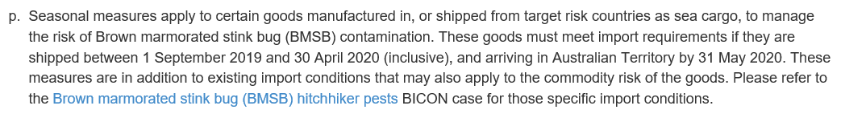

The onshore outcomes section of this BICON case indicate that an inspection is required for the used machinery and provides the AEPCOMM code INS:

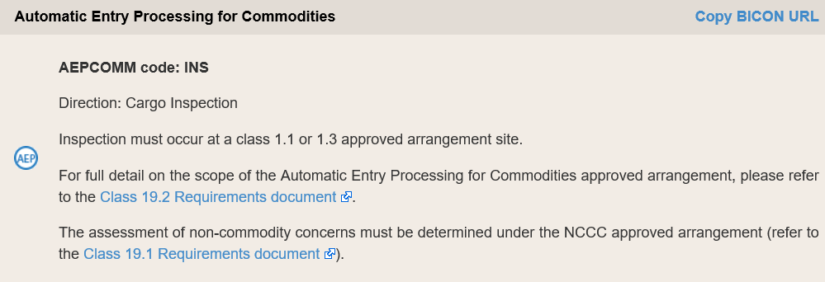

Now Rob refers to the BMSB hitchhiker pests BICON case and enters all the relevant information. The onshore outcomes section displays the following:

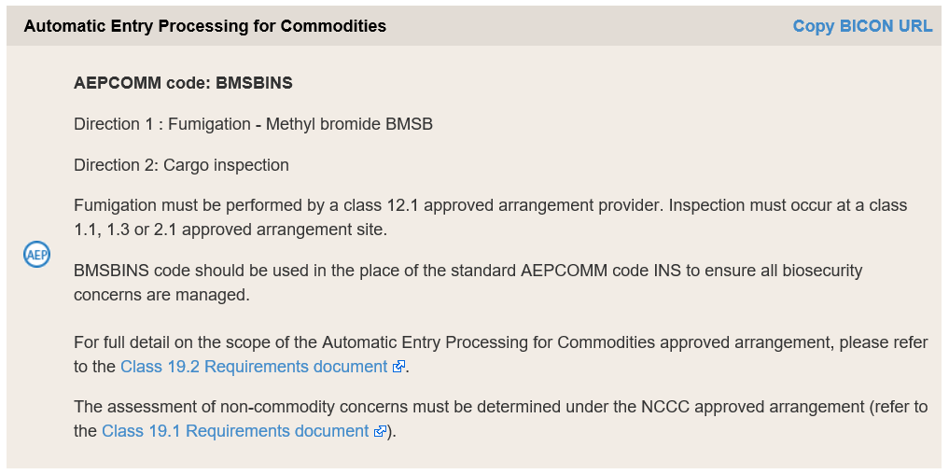

Since the onshore outcomes section of the BMSB BICON case displays a BMSB code, Rob applies the code BMSBINS to the line. Rob is then issued with 2 system generated directions: a fumigation and an inspection (as stated on the AEPCOMM notice).

**Case study 2**

Sally is an accredited AEPCOMM Customs Broker. Her client is importing a used vehicle (chapter 87, target high risk) from Italy during BMSB season as an LCL shipment.

**Sally has been in contact with the Master Consolidator for the container and knows the treatment will be performed onshore at the container level. Sally verifies this is an acceptable procedure when she refers to** the [Seasonal measures for Brown marmorated stink bug](http://www.agriculture.gov.au/import/before/brown-marmorated-stink-bugs) webpage, therefore Sally only needs to consider standard biosecurity risk for AEPCOMM.

Sally then logs onto her BICON AEPCOMM user access account and refers to the standard BICON case for new or used vehicles, aircraft and parts. The onshore outcomes state that an inspection is required for the used goods:

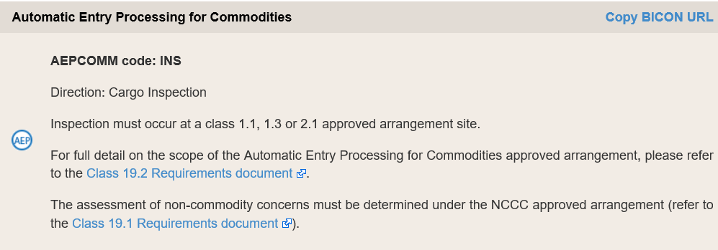

Sally then applies the AEPCOMM code INS to the line and she is then issued with a cargo direction inspection.

**Case study 3**

**Mark is an accredited AEPCOMM Customs Broker. His client is importing untreated sawn timber (chapter 44 target high risk) from Spain as an FCL shipment. Additionally, t**he container has not been treated for BMSB.

Mark determines if the goods are subject to BMSB by checking the information on the [Seasonal measures for Brown marmorated stink bug](http://www.agriculture.gov.au/import/before/brown-marmorated-stink-bugs) webpage. Then he logs onto his BICON AEPCOMM user access account and refers to the standard BICON case for timber and timber products. The import conditions indicate the goods are subject to BMSB measures. The onshore outcomes section of this BICON case indicates that a fumigation is required and provides the AEPCOMM FUM:

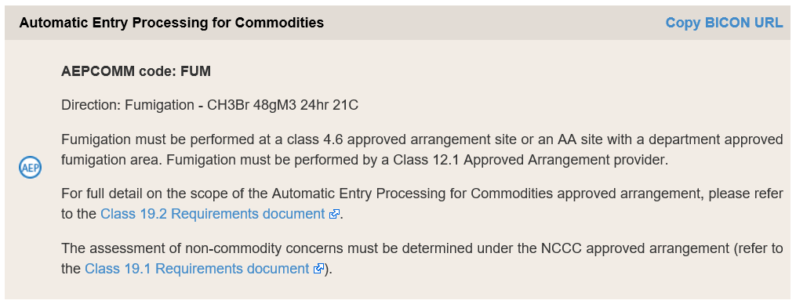

Now Mark refers to the BMSB hitchhiker pests BICON case and follows the untreated timber pathway. The onshore outcomes section displays the exact same information as for the standard BICON case, indicating the AEPCOMM code FUM. Mark then applies FUM to the line and he is then issued with a system-generated Methyl bromide fumigation direction at the rate of 48gM3 24hr 21C. This higher rate would cover both: BMSB and other biosecurity concerns for untreated timber.

**Case study 4**

**Chloe is an accredited AEPCOMM Customs Broker. Her client is importing manufactured wooden articles (chapter 44 target high risk) from Austria as an FCL shipment. The container was treated overseas with Methyl bromide by a company on the** [Offshore BMSB treatment provider scheme](http://www.agriculture.gov.au/import/before/brown-marmorated-stink-bugs/offshore-bmsb-treatment-providers-scheme) **at the rate of 48g for 24hr at 21C or above. Chloe is aware the higher fumigation rate addresses both commodity and BMSB risks as outlined below:**

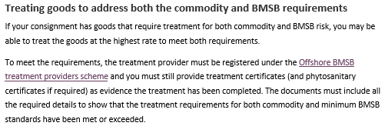

Chloe now logs onto her BICON account and refers to the standard BICON case for timber and timber products to ensure the consignment meets all requirements. The onshore outcomes section indicates that goods can be released however, it also indicates that if the goods are subject to BMSB measures Chloe needs to refer to the BMSB hitchhiker BICON case to obtain the AEPCOMM code.

Chloe refers to the BMSB hitchhiker pests BICON case and enters all the relevant information. The onshore outcomes section indicates the appropriate AEPCOMM code is BMSBREL:

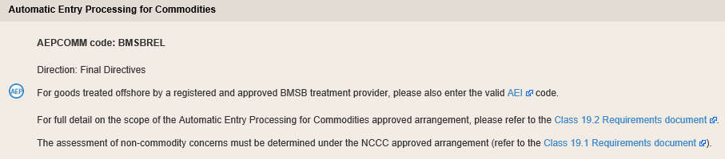

Chloe then applies BMSBREL to the line and she is then issued with a system generated Finalised and released direction.