National assessment of chemicals associated with coal seam gas extraction in Australia

*Technical report number 1*

Literature review: Summary report

This report was prepared by the National Industrial Chemicals Notification and Assessment Scheme (NICNAS)

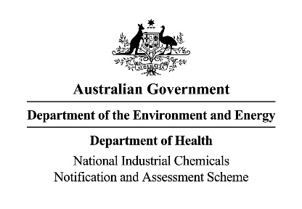**Copyright**

The national assessment of chemicals associated with coal seam gas extraction in Australia was commissioned by the Department of the Environment and Energy and prepared in collaboration with NICNAS and CSIRO

© Copyright Commonwealth of Australia, 2017.



This report is licensed by the Commonwealth of Australia for use under a Creative Commons Attribution 4.0 International licence, with the exception of the Coat of Arms of the Commonwealth of Australia, the logo of the agencies involved in producing and publishing the report, content supplied by third parties, and any images depicting people. For licence conditions see: <https://creativecommons.org/licenses/by/4.0/>

For written permission to use the information or material from this report, please contact the Department of the Environment and Energy at e-mail <http://www.environment.gov.au/webform/website-feedback> or by phone on 1800 803 772. Alternatively, you can write requesting copyright information to:

Office of Water Science  
Department of the Environment and Energy  
GPO Box 787  
CANBERRA ACT 2601  
Australia

Citation

This report should be cited as:

NICNAS 2017, *Literature review: Summary report*,Project report prepared by the National Industrial Chemicals Notification and Assessment Scheme (NICNAS) as part of the National Assessment of Chemicals Associated with Coal Seam Gas Extraction in Australia, Commonwealth of Australia, Canberra.

Acknowledgements

This literature review report is one in a series prepared under the National Assessment of Chemicals Associated with Coal Seam Gas Extraction in Australia. It was prepared by the National Industrial Chemicals Notification and Assessment Scheme (NICNAS) of the Department of Health. The literature review covered information available to the end of 2013. The literature review was completed in 2013, with minor updates to the report made between 2013 and 2016.

The report’s authors gratefully acknowledge input from the Project Steering Committee, which comprised representatives from the National Industrial Chemicals Notification and Assessment Scheme (NICNAS), the Department of the Environment and Energy, the Commonwealth Scientific and Industrial Research Organisation (CSIRO), Geoscience Australia (GA), and an independent scientific member, Dr David Jones of DR Jones Environmental Excellence.

This report was subject to internal review during its development.

Disclaimer

The information contained in this publication comprises general statements based on scientific and other research. Reasonable efforts have been made to ensure the quality of the information in this report. However, before relying on the information for a specific purpose, users should obtain appropriate advice relevant to their particular circumstances. This report has been prepared using a range of sources, including information from databases maintained by third parties, voluntary surveys, and data supplied by industry. The Commonwealth has not verified and cannot guarantee the correctness or completeness of the information obtained from these sources. The Commonwealth cannot guarantee and assumes no legal liability or responsibility for the accuracy, currency, completeness or interpretation of the information in this report, or for any loss or damage that may be occasioned directly or indirectly through the use of, or reliance on, the contents of this publication.

The material in this report may include the views or recommendations of third parties and does not necessarily reflect the views and opinions of the Australian Government, the Minister for the Environment and Energy, the Minister for Health and Aged Care, or the IESC; nor does it indicate a commitment to a particular course of action.

Accessibility

The Commonwealth of Australia is committed to providing web accessible content wherever possible. If you are having difficulties with accessing this document please call the Department of the Environment and Energy on 1800 803 772 (free call).

Reports in this series

The full set of technical reports in this series and the partner agency responsible for each is listed below.

| Technical report number | Title | | Authoring agency | |
| --- | --- | --- | --- | --- |
| Reviewing existing literature | | | | |
| 1 | | Literature review: Summary report | | NICNAS |
| 2 | | Literature review: Human health implications | | NICNAS |
| 3 | | Literature review: Environmental risks posed by chemicals used coal seam gas operations | | Department of the Environment and Energy |
| 4 | | Literature review: Hydraulic fracture growth and well integrity | | CSIRO |
| 5 | | Literature review: Geogenic contaminants associated with coal seam gas operations | | CSIRO |
| 6 | | Literature review: Identification of potential pathways to shallow groundwater of fluids associated with hydraulic fracturing | | CSIRO |
| Identifying chemicals used in coal seam gas extraction | | | | |
| 7 | | Identification of chemicals associated with coal seam gas extraction in Australia | | NICNAS |
| Modelling how people and the environment could come into contact with chemicals during coal seam gas extraction | | | | |
| 8 | | Human and environmental exposure conceptualisation: Soil to shallow groundwater pathways | | CSIRO |
| 9 | | Environmental exposure conceptualisation: Surface to surface water pathways | | Department of the Environment and Energy |
| 10 | | Human and environmental exposure assessment: Soil to shallow groundwater pathways – A study of predicted environmental concentrations | | CSIRO |
| Assessing risks to workers and the public | | | | |
| 11 | | Chemicals of low concern for human health based on an initial assessment of hazards | | NICNAS |
| 12 | | Human health hazards of chemicals associated with coal seam gas extraction in Australia | | NICNAS |
| 13 | | Human health risks associated with surface handling of chemicals used in coal seam gas extraction in Australia | | NICNAS |
| Assessing risks to the environment | | | | |
| 14 | | Environmental risks associated with surface handling of chemicals used in coal seam gas extraction in Australia | | Department of the Environment and Energy |

Foreword

## Purpose of the Assessment

This report is one in a series of technical reports that make up the *National Assessment of Chemicals Associated with Coal Seam Gas Extraction in Australia* (theAssessment).

Many chemicals used in the extraction of coal seam gas are also used in other industries. The Assessment was commissioned by the Australian Government in June 2012 in recognition of increased scientific and community interest in understanding the risks of chemical use in this industry. The Assessment aimed to develop an improved understanding of the occupational, public health and environmental risks associated with chemicals used in drilling and hydraulic fracturing for coal seam gas in an Australian context.

This research assessed and characterised the risks to human health and the environment from surface handling of chemicals used in coal seam gas extraction during the period 2010 to 2012. This included the transport, storage and mixing of chemicals, and the storage and handling of water pumped out of coal seam gas wells (flowback or produced water) that can contain chemicals. International evidence[1] showed the risks of chemical use were likely to be greatest during surface handling because the chemicals were undiluted and in the largest volumes. The Assessment did not consider the effects of chemical mixtures that are used in coal seam gas extraction, geogenic chemicals, or potential risks to deeper groundwater.

The Assessment findings significantly strengthen the evidence base and increase the level of knowledge about chemicals used in coal seam gas extraction in Australia. This information directly informs our understanding of which chemicals can continue to be used safely, and which chemicals are likely to require extra monitoring, industry management and regulatory consideration.

## Australia’s regulatory framework

Australia has a strong framework of regulations and industrial practices which protects people and the environment from adverse effects of industrial chemical use. For coal seam gas extraction, there is existing legislation, regulations, standards and industry codes of practice that cover chemical use, including workplace and public health and safety, environmental protection, and the transport, handling, storage and disposal of chemicals. Coal seam gas projects must be assessed and approved under relevant Commonwealth, state and territory environmental laws, and are subject to conditions including how the companies manage chemical risk.

## Approach

Technical experts from the National Industrial Chemicals Notification and Assessment Scheme (NICNAS), the Commonwealth Scientific and Industrial Research Organisation (CSIRO), and the Department of the Environment and Energy conducted the Assessment. The Assessment drew on technical expertise in chemistry, hydrogeology, hydrology, geology, toxicology, ecotoxicology, natural resource management and risk assessment. The Independent Expert Scientific Committee on Coal Seam Gas and Large Coal Mining Development (IESC) provided advice on the Assessment. Experts from the United States Environmental Protection Authority, Health Canada and Australia reviewed the Assessment and found the Assessment and its methods to be robust and fit-for-purpose.

The Assessment was a very large and complex scientific undertaking. No comparable studies had been done in Australia or overseas, and new models and methodologies were developed and tested in order to complete the Assessment. The Assessment was conducted in a number of iterative steps and inter-related processes, many of which needed to be done in sequence (Figure F.1). There were two separate streams of analysis - one for human health and one for the environment. The steps included for each were: literature reviews; identifying chemicals used in drilling and hydraulic fracturing for coal seam gas extraction; developing conceptual models of exposure pathways; models to predict soil, surface and shallow groundwater concentrations of identified chemicals; reviewing information on human health hazards; and identifying existing Australian work practices, to assess risks to human health and the environment.

The risk assessments did not take into account the full range of safety and handling precautions that are designed to protect people and the environment from the use of chemicals in coal seam gas extraction. This approach is standard practice for this type of assessment. In practice, safety and handling precautions are required, which means the likelihood of a risk occurring would actually be reduced for those chemicals that were identified as a potential risk to humans or the environment.

Steps involved in the National assessment of chemicals associated with coal seam gas extraction
1. Identifying chemicals used in coal seam gas extraction
2. Reviewing existing literature
3. Modelling how people and the environment could come into contact with chemicals during coal seam gas extraction
4. Assessing risks to workers and the public
5. Assessing risks to the environment

Figure F.1 Steps in the assessment

## Collaborators

The Australian Government Department of the Environment and Energy designs and implements policies and programs, and administers national laws, to protect and conserve the environment and heritage, promote action on climate change, advance Australia's interests in the Antarctic, and improve our water use efficiency and the health of Australia's river systems.

Within the Department, the Office of Water Science is leading the Australian Government’s efforts to improve understanding of the water-related impacts of coal seam gas and large coal mining. This includes managing the Australian Government’s program of bioregional assessments and other priority research, and providing support to the Independent Expert Scientific Committee on Coal Seam Gas and Large Coal Mining Development (IESC). The IESC provides independent, expert scientific advice on coal seam gas and large coal mining proposals as requested by the Australian Government and state government regulators, and advice to the Australian Government on bioregional assessments and research priorities and projects.

The National Industrial Chemicals Notification and Assessment Scheme (NICNAS) is a statutory scheme administered by the Australian Government Department of Health. NICNAS aids in the protection of the Australian people and the environment by assessing the risks of industrial chemicals and providing information to promote their safe use.

CSIRO, the Commonwealth Scientific and Industrial Research Organisation, is Australia’s national science agency and one of the largest and most diverse research agencies in the world. The agency’s research is focused on building prosperity, growth, health and sustainability for Australia and the world. CSIRO delivers solutions for agribusiness, energy and transport, environment and natural resources, health, information technology, telecommunications, manufacturing and mineral resources.

## This report: Literature review: summary report

This report summarises the content and key findings of literature reviews undertaken as part of the *National Assessment of Chemicals Associated with Coal Seam Gas Extraction in Australia*.

The literature reviews included national and international literature, and material from industry and government sources to define the main aspects of drilling, hydraulic fracturing, chemical use and handling, the mobilisation of geogenic contaminants, and potential transport pathways between sources of chemicals and the environment. Additionally, the potential pathways by which workers and the public can be exposed to coal seam gas chemicals via surface handling were reviewed.

The literature reviews covered information available to the end of 2013. The literature reviews were completed in 2013, with minor updates made to the review reports between 2013 and 2016.

The literature reviews resulted in five reports:

*Literature review: human health implications* (NICNAS 2017a)

*Literature review: environmental risks from coal seam gas operations* (DoEE 2017a)

*Literature review: leakage to shallow groundwater of fluids associated with hydraulic fracturing* (Mallants et al. 2017a)

*Literature review: geogenic contaminants associated with the hydraulic fracturing of coal seams: a review* (Apte et al. 2017)

*Literature review: hydraulic fracture growth and well integrity* (Jeffrey et al. 2017).

Abbreviations

| General abbreviations | Description |
| --- | --- |
| BTEX | Benzene, toluene, ethylbenzene, xylenes |
| CBL | Cement bond log |
| CBM | Coal bed methane |
| CSIRO | Commonwealth Scientific and Industrial Research Organisation |
| EA | Environmental authority |
| EIS | Environmental Impact Statement |
| EMP | Environmental Management Plan |
| EPA | Environmental Protection Authority |
| EU | European Union |
| GA | Geoscience Australia |
| IESC | Independent Expert Scientific Committee on Coal Seam Gas and Large Coal Mining Development |
| LNG | Liquefied natural gas |
| ML | Megalitre |
| MNES | Matters of national environmental significance |
| NICNAS | National Industrial Chemicals Notification and Assessment Scheme |
| NSW | New South Wales |
| PAH | Polycyclic aromatic hydrocarbon |
| SCP | Sustained casing pressure |
| TPH | Total petroleum hydrocarbons |
| US | United States of America |
| US EPA | US Environmental Protection Agency |
| VDL | Variable density log |
| WA | Western Australia |

Glossary

| Term | Description |
| --- | --- |
| Aquifer | Rock or sediment in a formation, group of formations, or part of a formation, which is saturated and sufficiently permeable to transmit quantities of water to wells and springs |
| Aquitard | A saturated geological unit that is less permeable than an aquifer and incapable of transmitting useful quantities of water. Aquitards often form a confining layer over an artesian aquifer |
| Bounding estimate | A bounding estimate captures the highest possible exposure, or theoretical upper bound, for a given exposure pathway |
| Casing | Steel or fibreglass pipe used to line a well and support the rock. Casing extends to the surface and is sealed by a cement sheath between it and the rock. |
| Coal seam | Coal seams or coal deposits are layers containing coal (sedimentary rock). Coal seams store both water and gas. Coal seams generally contain more salty groundwater than aquifers that are used for drinking water or agriculture |
| Coal seam gas | A form of natural gas (generally 95 to 97% pure methane, CH4) typically extracted from permeable coal seams at depths of 300 to 1 000 m. Also called coal seam methane (CSM) or coalbed methane (CBM) |
| Conservative approach / assessment | An assessment aimed at deliberately overestimating the potential risks to humans and the environment (after US EPA 1992) |
| Drilling fluids | Fluids that are pumped down the wellbore to lubricate the drill bit, carry rock cuttings back up to the surface, control pressure and for other specific purposes. Also known as drilling muds |
| Flowback water | The initial flow of water returned to a well after fracture stimulation and prior to production |
| Formation water | Naturally occurring water that is within or surrounding the coal, rock or other formations underground |
| Geogenic chemical | A naturally-occurring chemical originating, for example, from geological formations |
| Groundwater | Water occurring naturally below ground level (whether in an aquifer or other low permeability material), or water occurring at a place below ground that has been pumped, diverted or released to that place for storage. This does not include water held in underground tanks, pipes or other works |
| High-end estimate | Estimates at the high end of a normal distribution i.e. between 90th and 99.9th percentiles |
| Hydraulic fracturing | Also known as ‘fracking’, ‘fraccing’ or ‘fracture stimulation’, is one process by which hydrocarbon (oil and gas) bearing geological formations are ‘stimulated’ to enhance the flow of hydrocarbons and other fluids towards the well. In most cases is only undertaken where the permeability of the formation is initially insufficient to support sustained flow of gas. The hydraulic fracturing process involves the injection of fluids, gas, proppant and other additives under high pressure into a geological formation to create a conductive fracture. The fracture extends from the well into the coal reservoir, creating a large surface area through which gas and water are produced and then transported to the well via the conductive propped fracture channel |
| Hydraulic fracturing fluid | A fluid injected into a well under pressure to create or expand fractures in a target geological formation (to enhance production of natural gas and / or oil). It consists of a primary carrier fluid (usually water or gel based), a proppant and one or more additional chemicals to modify the fluid properties |
| pH | A measure of the acidity/alkalinity of a solution - a logarithmic scale from 1(most acidic) to 14 (most alkaline); 7 is neutral |
| Produced water | Water that is pumped out of the coal seams to release the natural gas during the production phase. Some of this water is returned fracturing fluid and some is natural ‘formation water’ (often salty water that is naturally present in the coal seam). This produced water moves through the coal formation to the well along with the gas, and is pumped out via the wellhead |
| Proppant | A component of the hydraulic fracturing fluid system comprised of sand, ceramics or other granular material that 'prop' open fractures to prevent them from closing when the injection is stopped |
| Shale gas | A form of natural gas generally extracted from a clay-rich sedimentary rock which has naturally low permeability |
| Surface impoundment | A natural topographic depression, artificial excavation, or dyke arrangement for storing clean water, pure fracturing fluids, or waste water. A surface impoundment may be constructed above the ground, below the ground, or partly above the ground and partly below the ground. A surface impoundment's length or width is greater than its depth (e.g. it is not an injection well) |
| Surfactant | Used during the hydraulic fracturing process to decrease the surface tension of a liquid and improve fluid movements |
| Sustained casing pressure | An indication that cement seals are compromised and there is uncontrolled movement of pressurised gas from an underground formation into the spaces between casings or between the casing and the rock |
| Tight gas | A form of natural gas trapped in ultra-compact reservoirs characterised by very low porosity and permeability |
| Well | A completed wellbore, typically including casing and tubing strings and possibly a pump. A well is intended for injection or production of fluids |
| Wellbore | The hole produced by drilling, with the final intended purpose being for production of oil, gas or water. The wellbore is the actual hole in the earth that is part of the completed well |

Contents

Foreword v

Purpose of the Assessment v

Australia’s regulatory framework v

Approach v

Collaborators vi

This report: Literature review: summary report vii

Abbreviations viii

Glossary ix

1 Introduction 1

1.1 Literature reviews 1

1.2 Relationship between the literature reviews and other components of the National Assessment of Chemicals Associated with Coal Seam Gas Extraction in Australia 2

2 Coal seam gas 3

2.1 What is coal seam gas? 3

2.2 Coal seam gas in Australia 3

2.3 Coal seam gas extraction 5

2.4 Chemicals associated with coal seam gas extraction 10

3 Impacts of coal seam gas chemicals on water resources 16

3.1 Potential impacts on surface waters 16

3.2 Leakage of coal seam gas fluids to groundwater 18

4 Human health impacts from coal seam gas chemicals 21

5 References 22

Tables

Table 1.1 Technical reports arising from the literature survey 1

Table 2.1 A typical listing of chemicals used in drilling and hydraulic fracturing for coal seam gas recovery 11

Figures

Figure F.1 Steps in the assessment vi

Figure 2.1 Basins with coal seam gas potential in Australia 4

Figure 2.2 Schematic occurrence of gas resources; unconventional gas includes coal seam, shale gas, and tight gas. Note: Coal bed methane is another term for coal seam gas. 5

Figure 2.3 Gas production well in Origin’s Spring Gully Field 6

Figure 2.4 Origin lease site showing a drilling rig and temporary water storage in an excavated ground pit 15

Figure 3.2 Possible contaminant sources at the coal seam gas site (1 to 5) and pathways for solute transport during the de-pressurisation phase (6 to 10) 19

# Introduction

## Literature reviews

The literature review stage of the Assessment (completed in 2013, with minor updates since) was an important initial component of the National Assessment of Chemicals Associated with Coal Seam Gas Extraction in Australia. The information obtained from the reviews informed the subsequent stages of the project – the conceptual models and risk assessments.

Five individual literature review reports (summarised in Table 1.1) were produced by the collaborating agencies, with the topics in each report reflecting the specific expertise and responsibilities of each agency. The reports provide a comprehensive synthesis of publicly available information relating to key aspects of drilling, hydraulic fracturing, chemical use and handling, the mobilisation of geogenic contaminants, and potential transport pathways between sources of chemicals and the environment current at the time they were produced. The literature reviews were completed in 2013, with minor updates made to the review reports between 2013 and 2016.

A key objective of each review was to provide a sound foundation for the methods, scenarios and assumptions used in the assessment.

This overview report summarises the content and key findings of the five literature reviews.

Table 1.1 Technical reports arising from the literature survey

| Report title | Agency | Main topics covered |
| --- | --- | --- |
| Literature review: human health implications | NICNAS  (NICNAS 2017a) | * Human exposure pathway for chemicals. * Current approaches to assessing human health risks from chemicals. |
| Literature review: environmental risks from coal seam gas operations | Chemicals and Biotechnology Assessment Section, Department of the Environment  (DoEE 2017a) | * Surface environmental exposure pathways for chemical contaminants. * Characterisation of receiving environments including ecological receptors (entities) potentially adversely affected by environmental contaminants. * Modelling of contaminant transport via the surface. |
| Literature review: leakage to shallow groundwater of fluids associated with hydraulic fracturing | CSIRO  (Mallants et al. 2017a) | * Characteristics of surface contaminant sources. * Potential pathways for contaminant transport through soil and groundwater to receiving environments. * Reported occurrence of contamination from different surface sources. * Approaches to numerically modelling contaminant transport via soil and shallow groundwater. |
| Literature review: geogenic contaminants associated with the hydraulic fracturing of coal seams | CSIRO  (Apte et al. 2017) | * Classes of chemicals that occur naturally in coal. * Mechanisms by which chemicals may be mobilised by hydraulic fracturing and transported to the surface. |
| Literature review: hydraulic fracture growth and well integrity | CSIRO  (Jeffrey et al. 2017) | * Properties of fracturing fluid and geology which affect fracture growth in coal. * Well integrity and areas of concern for well construction, well plugging and abandonment. * Methods to monitor fracture growth during hydraulic fracturing and to assess well integrity during construction and operational life. |

## Relationship between the literature reviews and other components of the National Assessment of Chemicals Associated with Coal Seam Gas Extraction in Australia

The literature reviews provided the starting context for the Assessment and also provided important specific background material for other components of the risk assessment process. For example, the various literature reviews (see Table 1.1) provided information on the coal seam gas industry and its practices, which in turn helped to frame an industry survey (NICNAS 2017b) used to identify the chemicals involved in coal seam gas extraction in Australia. The literature reviews also informed the conceptualisations (DoEE 2017b; Mallants et al. 2017b) of activities and pathways by which humans and the environment may be exposed to chemicals from selected coal seam gas activities.

# Coal seam gas

## What is coal seam gas?

Natural gas is formed from the degradation of organic material over millions of years. Coal seam gas [also known as coal bed methane (CBM)] is methane-rich natural gas trapped within coal seams. Coal seam gas is a form of 'unconventional' gas, meaning that it is sourced from unconventional reservoirs, such as coal seams or measures where the porosity, permeability (i.e. ability to transmit fluids), or other hydrogeological characteristics differ from 'conventional' reservoirs. Economically productive gas flows from unconventional resources frequently require specialised well stimulation techniques.

In addition to coal seam gas, other types of unconventional gas are shale gas and tight gas. Shale gas is natural gas contained in shales or fine-grained carbonates. Tight gas is a more poorly defined category but is best thought of as natural gas occurring in rock reservoirs of the lowest permeabilities (Geoscience Australia 2010a, 2010b). Currently, coal seam gas is the main form of unconventional gas being produced in Australia.

Conventional gas (colloquially termed 'natural gas') is found in distinct underground reservoirs typically in highly porous sedimentary rocks under an impermeable layer. Coal seam gas is another form of 'natural gas' which remains adsorbed onto the coal surfaces mainly within the micropores of coal. Pressure of the overburden and of groundwater within the coal seam keeps the gas in place within these pores.

The coal seams for coal seam gas production are generally located at shallower depths than other types of unconventional gas such as shale gas (Figure 2.2). Coal seams in Australia are generally between 300 and 1 000 m depth below ground (Williams et al. 2012).

## Coal seam gas in Australia

The first large-scale commercial coal seam gas production in Australia commenced in the Bowen Basin in Queensland in 1996. Subsequently, the coal seam gas industry in Queensland has grown, and will support a substantial liquefied natural gas (LNG) export industry. This will involve extensive development in Queensland’s Surat and Bowen Basins (Figure 2.1) which together currently make up most of the coal seam gas production in Australia.

The major producing fields in the Bowen Basin are Moranbah, Fairview, Spring Gully, Peat, Scotia and the Dawson Valley near Moura. The major producing fields in the Surat Basin are Berwyndale South, Argyle-Kenya, Kogan North, Daandine, Tipton West, Strathenden, Talinga and Roma (Day 2009; Freij-Ayoub 2012; QWC 2012). Australia Pacific LNG (a joint venture between Origin Energy and ConocoPhillips) is the leading producer, with plans to export some of its coal seam gas production via a proposed liquefied natural gas (LNG) plant at Gladstone (Roarty 2011). Over the next 30 years, this company plans to construct 10 000 gas wells in the Bowen and Surat Basins and a gas transmission pipeline of about 530 km (APLNG 2012).

In New South Wales, coal seam gas exploration and production was an emerging industry when this report was produced. Exploration, pre-development, or pilot testing has occurred in the Hunter region, Gloucester Basin, Gunnedah Basin, Southern Coalfield Sydney Basin (near Camden) and Clarence-Moreton Basin in north-eastern New South Wales. The Camden Gas Project in the Sydney Basin is New South Wales’ only operating coal seam gas production project at present.

In South Australia, coal seams in the Cooper Basin have been confirmed to contain significant quantities of gas (Yeo 2012).

In the Northern Territory, there are currently no known coal seam gas prospects, although the Pedirka Basin in the Northern Territory and South Australia is known to contain coal (Figure 2.1). Hydraulic fracturing has been performed (reportedly) on a large number of wells in the Northern Territory for around 20 years (DME 2012).

In Tasmania, the gas content of various coal deposits has been deemed insufficient for pilot production (Day 2009).

There is currently no coal seam gas production in Victoria and there are no applications to begin production. Although the location of Victoria’s coal resources is well known, the amount of associated gas and the feasibility of extraction are currently uncertain. A number of companies have been granted exploration licences for coal seam gas in Victoria’s brown coal basins (DPI 2012), but no production has been noted (Baker and Slater 2008).

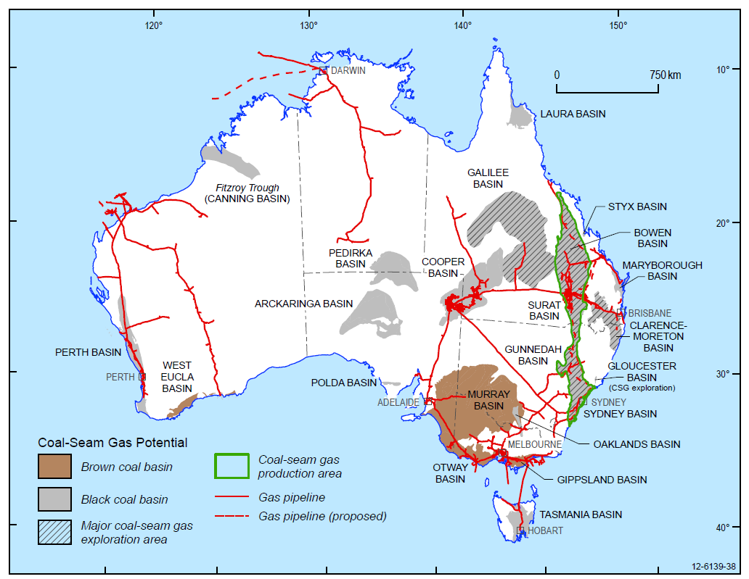

Source: Geoscience Australia and BREE (2012)

Figure 2.1 Basins with coal seam gas potential in Australia

Western Australia (WA) is generally considered to have a very low potential for onshore coal seam gas development. WA has only a few onshore basins that contain coal resources, and they are relatively small compared to those in eastern Australia. The main coal basins in WA occur in south-west WA, and include the Perth, Wilga, Collie and Boyup Basins. The Fitzroy Trough in the Canning Basin in north-west WA also contains some coal.

## Coal seam gas extraction

The extraction of coal seam gas involves several distinct phases of operational activity. These are often referred to in the literature as:

exploration

production

well decommissioning when gas resources eventually decline to unproductive levels.

Exploration involves identifying prospective areas through initial topographic and seismic studies and site investigations, which may include exploratory well drilling. Production involves gas field planning, construction of field infrastructure and monitoring and maintenance of gas production.

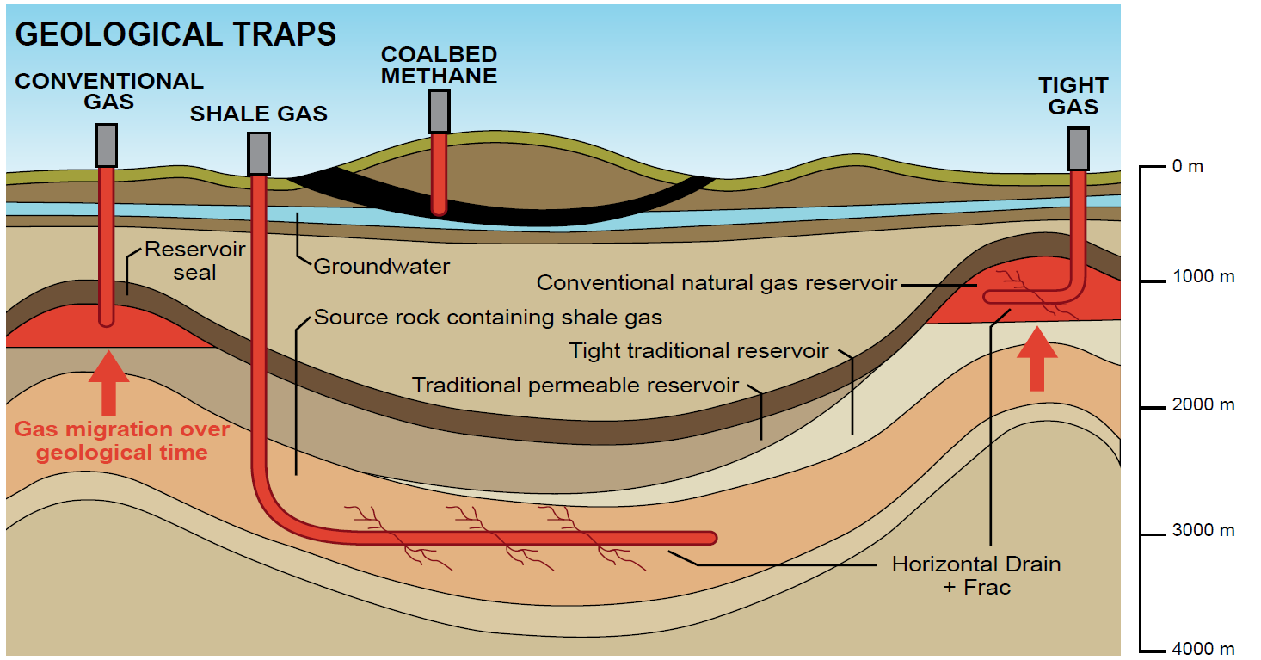

Source: DMP (2013).

Figure 2.2 Schematic occurrence of gas resources; unconventional gas includes coal seam, shale gas, and tight gas. Note: Coal bed methane is another term for coal seam gas.

Long-term gas production involves the drilling and installation of well infrastructure (Figure 2.2, Figure 2.3). Well construction comprises the installation of steel casings (pipes) through which gas and water flow to the surface. Production also involves installation of gas field surface infrastructure such as service corridors and storage/treatment facilities to support long-term gas extraction.

### Drilling

Drilling and completing coal seam gas wells consists of a series of separate, sequential activities (API 2009). First, a hole (or bore) is drilled using a drill rig powering a drill string consisting of a drill bit, drill collars (to put weight on the drill bit) and a drill pipe. When final depth is attained, the resulting hole is then 'logged' with sensing devices run down the hole to record subsurface conditions such as depths and thicknesses of formations. Next, steel casings are installed. Casings are steel pipes joined by couplings that provide a conduit between the coal seam and the surface for gas and water. Following placement, these casings are cemented in place. The purpose of the cement is to provide structural support for the well and zonal isolation between different subsurface formations. The cement placed between the casing and the walls of the hole is then 'logged' by running sensing devices down the casing to evaluate, through the casing, the quality and integrity of the cement. The final stage of completing a coal seam gas well is to perforate the steel casing and the cement at the level of the coal seam to allow access to the contents of the seam. The perforations are made by shaped pyrotechnic charges or abrasive fluid jets which puncture the steel casings at precise locations. The well can then enter production or be prepared for well stimulation (i.e. hydraulic fracturing).

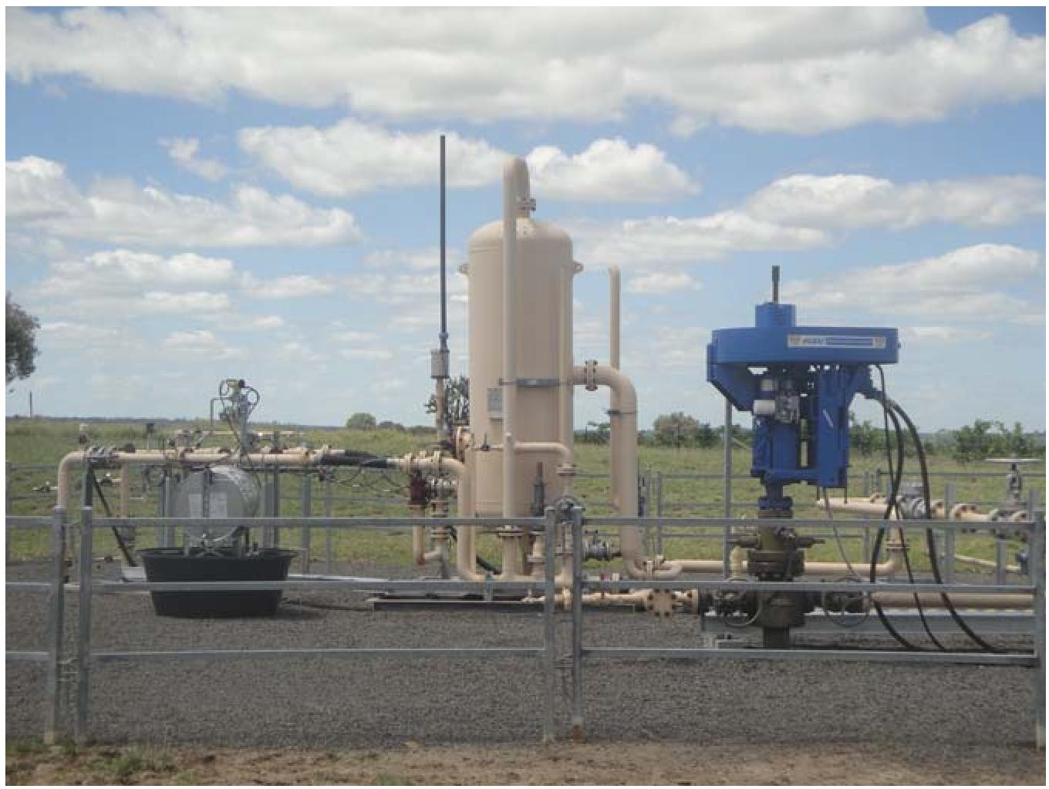

Source: © Copyright CSIRO; courtesy D. Mallants; photo taken 2013.

Figure 2.3 Gas production well in Origin’s Spring Gully Field

### Hydraulic fracturing

Not all gas reserves can flow readily through the coal seam to the well. Coal seam gas producers need to de-pressurise the coal seam layers by pumping large amounts of groundwater from the seam to release trapped gas and allow it to flow. However, some coal seams have such low permeability that the flow of water and gas is impeded to a level below the point of economical rate of gas recovery. In these cases, a technique known as hydraulic fracturing (also referred to as as 'fracking' or 'fraccing') is required to stimulate gas flows in order to increase gas and water production.

The process of hydraulic fracturing involves injecting fluid under high pressure into the coal seam layers to open up (i.e. fracture) the gas-containing coal layers and provide additional paths for gas and water to flow. The fluids used in hydraulic fracturing are typically water-based, comprising about 90 per cent water, seven to nine per cent proppant particles (mostly sand) to 'prop' open the seams, and up to approximately one to three per cent of different chemicals that increase the efficiency of fracturing. For example, one common way of increasing the efficiency of fracturing is to add chemicals to hydraulic fracturing fluids that form gels to increase the capacity of the fluids to carry proppant. Hydraulic fracturing is conducted using dedicated, mobile, fluid blending and pumping equipment. The need for hydraulic fracturing varies according to the permeability characteristics and gas content of the coal formations. Not all coal seams require hydraulic fracturing.

For Australian coal seam gas fields, the use of hydraulic fracturing is mainly geographically determined and depends on such parameters as the permeability of the coal seams. To date, the majority of production wells in Queensland and New South Wales have not required hydraulic fracturing (CSIRO 2012), because the permeability is sufficiently high for gas flow to occur due to natural fractures and companies are preferentially targeting these areas initially.

In Queensland, data from the Queensland Department of Natural Resources and Mines show that the total number of coal seam gas wells was 6 860 as at November 2013 (DNRM 2014). Previously, the total number of drilled coal seam gas wells was estimated at nearly 4 500 as of September 2011, the majority being in the Bowen and Surat Basins (DEEDI 2011). Hydraulic fracturing had been used at about eight per cent of these 4 500 coal seam gas wells, but estimates were that this could increase to 40 per cent over time (DERM 2011; Rutovitz et al. 2011).

The majority of future hydraulic fracturing operations will likely happen in the Surat Basin. Hydraulic fracturing will be applied to approximately 30 per cent of about 3 000 proposed coal seam gas wells located in the Surat Basin (URS Australia 2010). For the coal seam gas fields operated by Santos in Roma and Fairview (both in Queensland) the number of hydraulically fractured wells has been steadily increasing in the period 2008 to 2010 from 38 (seven per cent in 2008), 45 (33 per cent , in 2009) to 101 (78 per cent, in 2010) wells (Golder Associates 2010).

Some estimates are that coal seam gas extraction in New South Wales (NSW) could see hydraulic fracturing applied at possibly 25 per cent or more of all sites (Golder Associates 2010; URS Australia 2010; Rutovitz et al. 2011, NSW Parliament Legislative Council 2012). This amount is expected to increase over time as the more permeable areas are exhausted.

Hydraulic fracturing consumes significant volumes of water, of the order of up to 1.1 ML per well. The Camden Gas Project uses around 0.23 ML of total fluids per fracture event per well (Rutovitz et al. 2011). Other estimates of total fluid use are 0.15 ML of fluid per fracturing event with up to seven fracturing events per well (URS Australia 2010). Santos indicates that the total volume of fluid injected is proportional to the number of seams at each well. Up to 7 000 barrels (equivalent to 1.1 ML) of fluid are injected per well, with an estimated 3 to 12 seams and 95 to 227 kL required per seam (Golder Associates 2010).

The typical duration of a hydraulic fracturing operation is one to three days and involves several different stages consisting of initial preparatory water and acid flushes, followed by stages where fluids are pumped to create and maintain fractures.

### Hydraulic fracture growth

Predicting hydraulic fracture growth is integral to the design of efficient hydraulic fracture operations. Similarly, well integrity is an important consideration for proper design and construction of wells and their long-term operation. Pathways that a hydraulic fracture may provide for fracturing fluid to enter an aquifer, and the potential impacts on aquifers should this occur, were considered in the literature reviews (Jeffrey et al. 2017). Impacts on aquifers may occur when a hydraulic fracture grows vertically through an aquitard’s other rock layers to connect into the aquifer. Fracturing fluid may also enter an aquifer via intersections of fractures with natural faults that conduct fluid between the coal seam and the aquifer. Lastly, fracturing fluids may enter an aquifer when the coal seam being fractured is itself an aquifer, with potential water resource values, and fracturing fluid enters directly and deliberately as part of the fracturing operation.

Overall, the nature and size of fractures formed by hydraulic fracturing of coal have been well characterised. Data show that fractures commonly grow in both lateral and vertical directions. However, a feature of hydraulic fractures in coal is a propensity for secondary fracture sections to grow with a horizontal orientation along contact between coal and adjacent rock layers. Various different geological and hydrogeological factors and properties affect hydraulic fracture growth. These include the permeabilities of different rock layers above and below the target coal seam (Quinn 1994), stress contrasts between rock layers (Warpinski and Teufel 1987), rock elastic stiffness and fracture toughness (Prats and Maraven 1981; Economides and Nolte 2000), the presence of natural interfaces such as fractures, faults and shear zones (Thiercelin et al. 1987) as well as the fluid gradients generated by the flow of fracturing fluid in a fracture.

Lateral growth and vertical growth are coupled, meaning that additional lateral growth will reduce vertical growth and vice versa. Vertical growth of a vertical fracture is called height growth. Height growth is affected by layering in sedimentary rock that vertical fractures must grow through. A fracture that grows only in one zone or seam is regarded as 'contained' while a fracture that grows out of zone or seam is regarded as 'uncontained'. Although there are several factors that affect hydraulic fracture height growth, containment of fractures is affected most strongly by inherent stresses within adjacent rock layers.

Predicting fracture height growth is one of the most important considerations for hydraulic fracture design for maximising resource recovery. Current predictive modelling tools (e.g. Nagel et al. 2012; Weng et al. 2011; Meyer and Bazan 2011; Dershowitz et al. 2010) appear sufficient to support current coal seam gas activities. However, some improvements in modelling, such as the ability to model multiple layers and 3-dimensional effects, such as T-shaped growth, would enhance the prediction of fracture propagation. Careful site characterisation is essential for the design and prediction of fracture growth. Site characterisation is of particular importance during the early phases of development of new areas (new coal seam gas operations), where data are used to calibrate models used for the design of fracture treatments.

### Well integrity

Well integrity is defined within the petroleum industry as the application of measures throughout the lifecycle of a well that reduce the risk of uncontrolled release of formation fluids and gases (Standards Norway 2004). Well integrity is compromised when fluids or gases can move from the well into surrounding rock or soil, or along spaces between the steel casing within the well and surrounding rock.

Vertical wells include several concentric steel casings that are cemented in place to seal the space between the outside of the casing and the rock. The cement seal is vital to well integrity. One area of concern for well integrity is the wellbore condition at the time of cementing. An over-sized wellbore at the time of cementing will result in a lower cement velocity, and this will reduce the displacement of drilling mud by the cement and subsequently reduce the quality of the resulting cement seal (Cook and Edwards 2009). Another concern is that the drilling process may lead to rock fractures that extend some distance behind the immediate wellbore wall, which may enhance the movement of fluids along the outside of the cemented wellbore (Zoback 2007).

Several methods are available to test the quality of the cement seal around the casing after cementing has been completed. The state of the art in cement evaluation involves a combination of acoustic cement bond log (CBL), variable density log (VDL),and ultrasonic and flexural wave logs (Bellabarba et al. 2008), with each method having its own limitations.

Other risks with well integrity are associated with the methods used to seal wells during decommissioning. Abandoned or orphaned wells (whether from mining or agricultural activities) may exist in coal seam gas areas and if not plugged correctly may provide pathways for fluid and gas movement.

Globally, well integrity is an important issue in the oil and conventional gas industry. Sustained casing pressure (SCP) indicates the uncontrolled movement of pressurised gas from an underground formation, through compromised cement seals, into the spaces between casings or between the casing and the rock. Large-scale overseas studies indicate compromised integrity in a significant proportion of wells. For example, in the US Gulf of Mexico, approximately 10 per cent of wells experienced SCP within one year of being completed and approximately 50 per cent of wells have SCP after 15 years of production (Dusseault et al. 2014). Comparable studies of well leakage are not available for the Australian coal seam gas industry.

Well decommissioning involves well abandonment and site rehabilitation. Well abandonment involves permanently plugging wells with cement to prevent leakage of gas and water and removing surface infrastructure.

### Extraction of water for coal seam gas production

An important difference between coal seam gas wells and conventional natural gas wells is the need to remove water from coal seam gas wells to maintain gas flows. Flowback is the term used to describe the initial flow of water from the well that occurs after a treatment such as hydraulic fracturing and before the well enters production. Produced water (sometimes referred to as ‘co-produced water’) is the term used for water pumped from wells following commencement of production. Both flowback and produced water may contain hydraulic fracturing chemicals, naturally-occurring geogenic chemicals from the coal seam, as well as reaction products from interactions between fracturing fluids and coal seam chemicals (NICNAS 2017a; DoEE 2017a).

Flowback and produced waters are held in surface storage ponds for unspecified time periods pending re-use or disposal. Options for re-use or disposal include aquaculture, irrigation, dust suppression, discharge to waterways, injection via dedicated wells into aquifers, and as cooling water for industrial power generation. Re-use and disposal may be preceded by treatment such as filtration and reverse osmosis, which generate concentrated waste products. Untreated water may also be re-used or disposed of.

In a coal seam gas well, the volume of water produced is initially high, with low gas production rates but as the coal seam aquifer is progressively de-pressurised, gas rates continue to rise to a peak rate over a period of months or years (see Figure 3.1). The volume of produced water decreases over time. The extent of water removal depends on how well the coal seam is confined (i.e. when the coal seams are confined tightly between relatively impervious aquitards), water removal may be restricted to the coal seam aquifer; if it is only poorly confined, or even unconfined as is the case in some alluvial aquifers, water removal is not restricted to just the coal seam and can impact on a number of other hydrogeological layers.

There may be a number of de-pressurisation events interspersed with injection phases. The total duration of the de-pressurisation phase for an individual well is between 20 to 30 years.

The cessation of water extraction via a coal seam gas well does not necessarily result in rapid restoration of original groundwater levels. Restoration will depend, among others, on how fast groundwater can flow towards the zones that experienced dewatering. In other words, although the de-pressurisation phase has ended because water extraction has stopped, it may still take a very long time, if ever, to restore all groundwater levels to the pre-operational condition (Rutovitz et al. 2011).

## Chemicals associated with coal seam gas extraction

A major community concern with coal seam gas operations is the potential human health and environmental impacts of chemicals used in drilling and hydraulic fracturing. A related concern is the potential for chemicals naturally present in the coal to be liberated and brought to the surface as a result of coal seam gas extraction activities.

### Drilling and hydraulic fracturing chemicals

Chemicals are added to drilling fluids and hydraulic fracturing fluids for specific purposes determined by operator objectives, geologic conditions encountered during operations and the regulatory environment. These fluids are handled at the surface, often in considerable volumes.

Drilling fluids consist of a base liquid (water-based or oil-based) supplemented with chemical additives to stabilise clays, control pH, inhibit bacterial growth, increase viscosity to improve cutting removal, or for other specific purposes. The circulating fluids clear cuttings, lubricate the drill string and drill bit, and apply pressure to geological formations to prevent leakage of gas or fluids. Industry information indicates that drilling fluids used within the coal seam gas industry are commonly water-based (NICNAS 2017b).

Similar to drilling fluids, hydraulic fracturing fluids consist of a base liquid supplemented with chemical additives that serve specific purposes. As noted in Section 2.3.2, water and sand (or other types of granular ceramic materials) comprise the large majority of hydraulic fracturing fluid volume. Additional chemicals (typically present at up to 1 to 3 per cent) serve functions such as to adjust pH, inhibit bacterial growth, adjust viscosity, prevent scale formation (the accumulation of unwanted material such as calcium carbonate or iron hydroxides on solid surfaces) and reduce friction. Sand or other granular ceramics are used as the 'proppant' within the fracturing fluid, which (after being pumped at high pressure into the hydraulic fracture in the coal formation) has the function of lodging into and holding open fractures when pressure is released.

Where geological conditions require, gelling agents are added to hydraulic fracturing fluids to increase viscosity and enhance the capacity of the fluids to carry proppant.

Although actual volumes depend on geologic conditions, hydraulic fracturing generally uses considerable amounts of fluids. Multiple fracturing events may be conducted over the life of a well.

The amounts of chemical additives used in hydraulic fracturing reported as a percentage of the volume of fluid injected into the wellhead vary across the industry, with the following having been reported by several sources:

less than one per cent (API 2009)

two per cent and three per cent of water and gel-based fluids respectively (URS Australia 2010)

0.5 per cent to five per cent (NYSDEC 2011; US EPA 2011).

In a risk assessment on hydraulic fracturing operations in the Bowen and Surat Basins, Santos undertook mass balance and fate and transport modelling to estimate the mass and concentrations of chemicals left underground following hydraulic fracturing processes. The total mass of additives injected during the hydraulic fracturing process was estimated to represent approximately 2 600 kg per seam or 18 300 kg per well (Golder Associates 2010). If the chemical component is assumed to represent one per cent of the hydraulic fracturing fluid, then the injection masses of 2 600 and 18 300 kg equate to 0.26 ML and 1.8 ML of fluid, respectively.

Typical classes of chemicals used in drilling and hydraulic fracturing and their functions are shown in Table 2.1.

Table 2.1 A typical listing of chemicals used in drilling and hydraulic fracturing for coal seam gas recovery

| Type | Function | Additive |
| --- | --- | --- |
| Proppant | Keeps seam fractures open to allow gas/fluids to flow more freely to the well | Sand, sintered bauxite, zirconium oxide, ceramic beads |
| Clay stabiliser | Prevents clay swelling and helps improve the cement/formation bond | Calcium chloride, calcium chloride anhydrous, potassium chloride |
| Cement additive | Enhances strength of the well | Bentonite, calcium sulfate |
| pH control | Adjusts the pH of the fluid in order to maximise the effectiveness of other additives | Sodium hydroxide, potassium hydroxide, calcium hydroxide, citric acid, sodium bicarbonate, sodium carbonate, potassium carbonate, acetic acid |
| Bactericides | Inhibits growth of bacteria in the wells that interfere with hydraulic fracturing fluid chemistry and may restrict gas flow | Sodium hypochlorite, tetrakis(hydroxymethyl phosphonium sulfate, glutaraldehyde, 2-methyl-2H-isothiazol-3-one, sodium hypochlorite |
| Viscosity control | Thickens the fracturing fluid allowing the fluid to carry more proppant into the fractures. | Bentonite, polyanionic cellulose, carboxymethyl cellulose, hydroxyethyl cellulose, synthetic polymers, guar gum |
| Gel cross-linkers and stabilisers | To maintain gel stability | Borate salts, monoethanolamine, ethylene glycol, potassium hydroxide |
| Gel breakers | To break down gel for return to the surface | Sodium persulfate, hemicelluloses enzyme, t-butylhydroperoxide |
| Mineral dissolution | To dissolve clay minerals | Hydrochloric acid, acetic acid |
| Iron complexation | To prevent iron precipitation | Citric acid |
| Corrosion inhibitors | To prevent pipe corrosion | N,N’-dimethyl formamide, gelatine, methanol, ammonium bisulfate |
| Scale inhibitors | To prevent scale formation | Ethylene glycol, ammonium chloride |
| Friction reducers | To reduce surface tension | 2-butoxy ethanol, isopropyl alcohol, terpenes and terpenoids, sweet orange oil, polyacrylamides |
| Fluid loss | Fluid loss control | Modified polyacrylates, Lignosulfonates, Resins, Starch, Synthetic polymers |
| Foaming agent | - | Anionic surfactants |
| Surfactant | Reduces fracturing fluid surface tension and aids fluid recovery. | Methanol, ethanol, isopropanol, ethoxylated alcohol |

Source: US EPA (2004); DEHP (2013a).

### Naturally occurring chemicals released from coal seams

In addition to coal seam gas from coal seams, water pumped from coal seam gas wells may contain not just the chemicals added from hydraulic fracturing (Table 2.1), but also naturally occurring (i.e. geogenic) chemicals released from coal seams as a result of well drilling and fracturing processes. It is well established that produced water from coal seam gas operations contains a range of inorganic salts of geogenic origin (e.g. sodium chloride and sodium bicarbonate). However, coal also contains other naturally occurring ('geogenic') chemicals such as organic chemical compounds, trace elements and radioactive elements (radionuclides) (Apte et al. 2017).

This additional suite of chemicals present in coal seam groundwater or the coal matrix can be potentially brought to the surface in flowback and produced waters. Given the nature of chemicals present in hydraulic fracturing fluids and the elevated pressures used during hydraulic fracturing, the potential for naturally occurring chemicals to be mobilised from coal seams with or without the application of hydraulic fracturing was also assessed as part of the literature review (Apte et al. 2017).

#### Organic compounds

Coal is principally composed of organic compounds due to its plant-based origins. The organic compounds present in the macromolecular coal matrix range from loosely associated compounds (e.g. methane) through to tightly bound compounds. The compounds present can include BTEX (benzene, toluene, ethylbenzene, xylenes), polycyclic aromatic hydrocarbons (PAHs), phenols and total petroleum hydrocarbons (TPHs) (Orem and Finkelman 2003).

There is limited information on the identity or concentrations of natural organic compounds present in produced water from Australian coal seam gas activities or on how hydraulic fracturing chemicals interact with these compounds within the coal seam or during storage and / or treatment of produced water (Apte et al. 2017). A limited number of assessments of produced water have demonstrated the presence of BTEX, PAHs and phenols, although they are usually detected at concentrations close to the limits of quantification (low µg/L or parts per billion [ppb]). This is also the case for other classes of organic compounds, such as *n‑*alkanes, aromatic amines, biphenyls and heterocyclic compounds, which are also detected at low ppb concentrations. TPHs, which represent an integrated measurement of the array of organic compounds in produced water, are often detected at considerably higher concentrations, up to low mg/L (parts per million).

Potential mechanisms by which hydraulic fracturing may enhance the passage of natural organic compounds from coal into produced water were identified in the literature. Chemicals in hydraulic fracturing fluids such as salts, solvents and acids as well as elevated ambient temperatures and pressures can change the solubility of organic compounds so that they are more readily transported in produced waters. Also, virtually insoluble compounds can be transported on microscopically small coal particles produced from the well with the water.

#### Trace inorganic elements

Trace inorganic elements present in coal and other mineral formations and in groundwater have the potential to be brought to the surface in produced water. Hydraulic fracturing may increase the mobilisation of trace elements into both the initial flowback and subsequent produced waters. The trace element compositions of Australian coals have been well characterised by a number of studies (e.g. Dale 2003). Elemental composition varies depending on the coal origin, for example, marine versus freshwater peat. Coals with a marine origin typically contain higher pyrite, organo-sulfur and boron concentrations in comparison to those deposited as freshwater peats.

The extent to which trace elements can be mobilised into groundwater or into flowback and produced waters following hydraulic fracturing depends on their chemical form and associations within the coal matrix. Available laboratory data on the leachability of Australian coals (e.g. Riley et al. 2012) indicate that dilute acids and metal-binding additives used in hydraulic fracturing fluids have the potential to mobilise additional trace elements and increase their concentrations above those normally associated with coal seam groundwater.

#### Radionuclides

Coal also contains traces of naturally occurring radioactive elements (i.e. radionuclides). Available data indicate that the average uranium and thorium contents of Australian bituminous coals are 1.3 and 3.5 mg/kg, respectively, and that these values are quite close to the global averages for coal of 1.5 mg/kg and 4.6 mg/kg, respectively (Dale 2003).

The radioactivity of coal depends on the type of coal and its location but is generally below average radioactivity levels of soil. Australian thermal coal has a typical radioactivity of 432 to 1 025 becquerels/kg (Bq/kg) compared to the average radioactivity of the Earth's crust of 1 434 Bq/kg and Australian garden soil of 1 480 Bq/kg (Dale 2003).

The leaching of soluble radionuclides from coal has not been well studied. Similar to non-radioactive trace elements, hydraulic fracturing chemicals have the potential to mobilise radionuclides into produced water. Only limited information is available publicly in the literature on radionuclide concentrations in coal seam gas produced waters (APLNG 2011).

An additional identified issue with radionuclides is their fate in holding and storage ponds. Radionuclides may adsorb onto fine particles and concentrate with sludges and sediments present in storage ponds. This has been identified as a potential issue with the oil and conventional gas industries. However, no data are available relating to coal seam gas operations.

### Chemicals handling

For coal seam gas extraction, drilling and hydraulic fracturing chemicals, and fluids containing mixtures of these chemicals, are transported to, stored and handled at various worksites.

Understanding the chemical handling process is an important aspect of assessing the risk posed by chemicals used in coal seam gas extraction. The individual literature reviews by CSIRO (Mallants et al. 2017a; Apte et al. 2017), Department of the Environment (DoEE 2017a) and NICNAS (NICNAS 2017a) contain information from the published literature and other sources on the transport, storage and handling of drilling and hydraulic fracturing chemicals and flowback and produced waters. All four reports note that human health and environmental impacts from chemicals are possible via different types of uncontrolled releases of chemicals during these activities.

Although hydraulic fracturing chemicals are transported around Australia in concentrated solid or liquid form in sealed sacks, tanks or other types of containers, no specific data are available in the literature on the size or material of construction of the containers or current or proposed unit sizes for transportation. Nor are data available publicly on how transport routes may be selected to minimise potential human and environmental exposures in the event of an accident.

More data are available in the public domain for container types for chemicals used in shale gas operations in the US. Moreover, industry best practice guidelines in the US highlight the importance of having an area-wide transport plan for the transport of chemicals such as hydraulic fracturing fluids (API 2010). This includes route selection, avoidance of peak traffic hours, coordination with local emergency management agencies, upgrades and improvements to roads that will be travelled on frequently, and adequacy of delivery parking. Overall, the literature review uncovered a lack of quantitative information on parameters associated with the transport of chemicals for coal seam gas activities in Australia.

Regarding chemical storage and handling, although some overseas data are available, there is also limited information available in the literature for Australia on storage of chemicals, durations of storage, specific storage locations or the number of units or volumes of chemicals stored at sites associated with coal seam gas activities.

Available information indicates wide variations in the volumes and concentrations of chemicals stored and handled at worksites, and the time periods over which they require storage and handling. On the one hand, particular chemical additives for drilling and hydraulic fracturing are frequently handled in low volumes in concentrated form. If blending of chemical components is done simultaneously with drilling or hydraulic fracturing operations, requirements for on-site storage of concentrated chemicals are reduced. Water for drilling and hydraulic fracturing, or in the form of flowback and produced water, is stored and handled in high volumes and contains relatively low concentrations of chemical contaminants. Waters for drilling or hydraulic fracturing operations are stored at well sites commonly in lined, excavated ground ponds or above ground in engineered dams (flexi-ponds) (Santos 2010) (Figure 2.4). Water for drilling using a 'pitless drilling' technique may be transported and stored at sites in steel containers.

Transportation and storage of flowback and produced waters can occur via steel tankers, but occurs commonly via networks of underground gathering pipes connecting multiple coal seam gas wells to large capacity open storage ponds. Water is held in such open storage pending treatment, discharge, or re-use.

Available data indicate that the handling of chemicals at worksites for specific coal seam gas operations is conducted predominantly using dedicated automated processes. During drilling operations, drilling fluids are mixed and pumped down the drill string, returning to the surface with drilling solids, which are separated out prior to recirculation of the fluids. Other than for 'pitless drilling', drilling operations typically require the use of excavated ground pits or tanks for mixing water and additives in the formulation of drilling fluids (DEHP 2013b) as well as holding fluids that return to the surface during drilling to allow settling of the solids (APPEA undated).

The literature reviews (NICNAS 2017a, DoEE 2017a, Apte et al. 2017, Jeffrey et al. 2017, Mallants et al. 2017a) examined the availability of information on site containment methods used by Australian operators to provide mitigation in the event of on-site leaks and spillages. Some information is available for specific operators. One operator reported quantitative specifications for physical barriers (bunding) for single and multiple storage tanks, and for drum storage. In this case, procedures specify that bunds should be placed to allow containment of spillages equal in volume to the largest container on site plus an additional volume margin. However, there was a general lack of publicly available data on site containment measures for the coal seam gas industry as a whole, and so the extent to which such specifications for containment are common across operators is not known.

In the USA, the industry best practice guideline recommends that operators evaluate the potential for spills to determine the type and size of primary and secondary containment (e.g. bunding) that may be necessary (API 2011).

Best practice guidelines in the US also discuss mitigation measures such as sloping the well location away from surface water locations, positioning absorbent pads between sites and surface waters, and creating perimeter trenching systems and catchments to contain and collect any spilled fluids (API 2010, 2011).

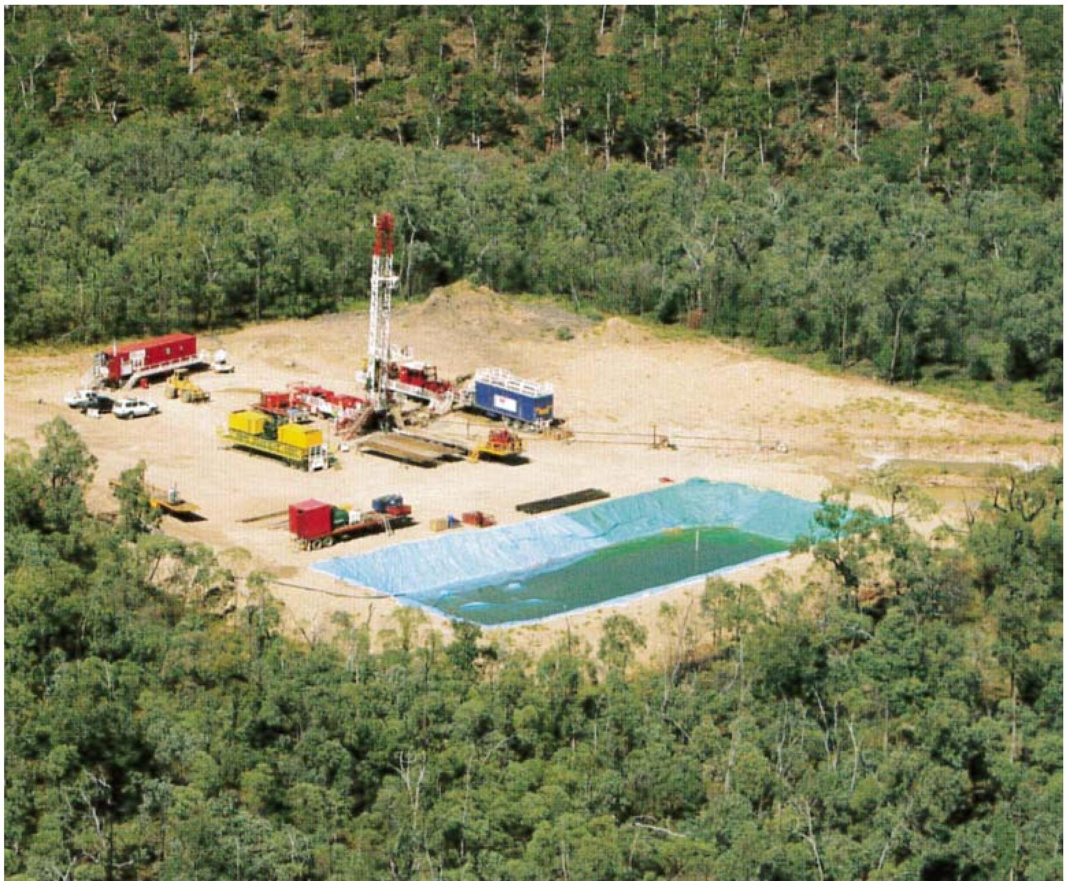

Source: © Copyright, CSIRO (Mallants et al. 2017a); courtesy Origin

Figure 2.4 Origin lease site showing a drilling rig and temporary water storage in an excavated ground pit

# Impacts of coal seam gas chemicals on water resources

## Potential impacts on surface waters

A major environmental concern associated with coal seam gas operations is for impacts on the health of aquatic and terrestrial ecosystems from contamination by introduced chemicals (drilling and hydraulic fracturing) and geogenic contaminants that may be present in both flowback and produced waters.

Water and gas production varies over time (Figure 3.1) and different types and levels of contamination can occur during different phases of coal seam gas production (Mallants et al. 2017a).

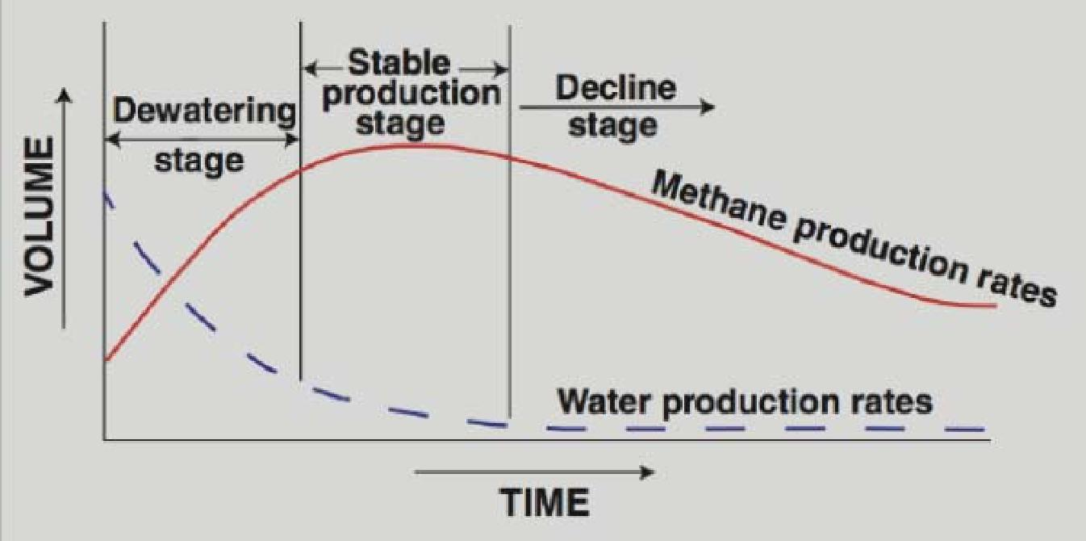

Source: Rutovitz et al. (2011); the de-watering phase may take days to months and it may take years to reach peak production.

Figure 3.1 Typical changes in water and gas production over time

As noted in Section 2.3.4, in coal seam gas production the volume of water produced is initially high, with low gas production rates, but as the coal seam aquifer is progressively de-pressurised, gas production rates continue to rise to a peak rate, months or years after water removal started (Figure 3.1). The volume of produced water then decreases over time.

Post-operational phases start at the end of the de-pressurisation phase and finish when groundwater levels return to a new, post-production equilibrium. Spills and leaks from transport, surface handling and storage of chemicals and waste waters during various phases of coal seam gas production represent potential sources of chemical contamination to both soils and surface waters (Mallants et al. 2017a). There is little available documentation across the coal seam gas industry on methods of storage and handling of drilling and hydraulic fracturing chemicals at Australian coal seam gas worksites. A risk assessment conducted by the US EPA (2011) highlighted the transfer of hydraulic fracturing fluids between multiple points of surface infrastructure as being a source of leaks or spillages.

An analysis of regulatory compliance reporting and auditing of the environmental performance of the Australian coal seam gas industry combined with media and community reports, information from company websites and other government reports (DoEE 2017a) reveals the importance of considering a variety of different types of spill incidents when considering the potential for environmental exposures. Around half of the spill and leak incidents reported in audits were categorised as spills or leaks occurring during hydraulic fracturing operations (e.g. as a consequence of faulty or open valves). Smaller numbers were regarded as inadvertent discharge incidents or incidents of overflow from produced water storage due to flooding. The analysis indicated that spill and leak incidents varied from small releases of concentrated fluids with small impact footprints to large volume releases of low chemical content associated with larger and more distant impact areas, such as from flooding.

The literature reviews by the Chemical and Biotetchnology Assessment Section (DoEE 2017a) and CSIRO (Mallants et al. 2017a) identified key sources of environmental contamination and the pathways by which contaminants could potentially migrate via surface and shallow groundwater to different types of receiving waters such as rivers, water wells, wetlands and springs. Additionally, these reviews identified that appropriate physical transport processes needed to be included for high-end or bounding estimates of exposure; and that appropriate quantitative models of contaminant transport should be used to simulate and assess the extent of chemical transport to these waters. In a first pass conservative (i.e. high-end or bounding estimates) approach (after US EPA 1992), chemical transformations and interactions between the contaminants and environmental solids (e.g. minerals and organic matter) that would act to reduce concentrations are ignored, with dilution and dispersion being the only processes that occur.

Flowback and produced waters can potentially be used for a number of industrial and agricultural applications, depending on quality and the prevailing regulatory regime. The methods for handling these discharges have evolved over time with some methods such as storage in open ponds and evaporation now restricted by regulation or industry codes. Environmental exposures may occur via direct (direct application) or via indirect pathways such as runoff from waste storages due to rainfall events and flooding (DERM 2011).

As coal seam gas extraction activities occur in many geographic regions with significant variations in physical parameters such as temperature, rainfall, evaporation, soil type, groundwater dependence and topography, the fate and behaviour of chemicals released to the environment and the extent of exposure to receptors is also likely to vary considerably between regions. In addition, coal seam gas extraction operations in each of these locations are likely to use different combinations of chemicals, and to release potentially different compositions of geogenic chemicals as a result of hydrogeological variability. The degradation, mobility and dilution of chemicals released to the surface environment are also likely to be site-specific (DoEE 2017a).

The environmental impacts of releases will also vary not just because of differences in physical parameters, chemical usage and handling, but also because of variations in ecological sensitivities and species present in particular areas. The literature review: Environmental risks from coal seam gas operations (DoEE 2017a), covering six priority bioregions (ERIN 2014), noted the presence of 'matters of national environmental significance' (MNES) such as threatened species and ecological communities, wetlands of international significance, and National Heritage places listed under the Commonwealth *Environment Protection and Biodiversity Conservation Act 1999,* and each with their own particular sensitivities, in most of the priority bioregions.

## Leakage of coal seam gas fluids to groundwater

### Impacts on shallow groundwater

As part of the consideration of human health impacts, there is a concern for the potential contamination of soil and shallow groundwater by fluids associated with surface handling of drilling and hydraulic fracturing chemicals (i.e. handling, storage, transport, mixing, injection, surface spills, etc.) and fluids associated with coal seam gas extraction (i.e. flowback water and produced water). The CSIRO literature review on leakage to shallow groundwater (Mallants et al. 2017a) revealed that this can result from:

intentional surface applications of treated water for beneficial use

spills or leaks

leakage from storage impoundments including during peak rainfall events and flooding

poor recovery of fluids injected during the hydraulic fracturing process

improperly constructed well casings.

As part of the literature review process, data were collected on the type and frequency of past incidents involving hydraulic fracturing fluids for coal seam gas extraction and their leakage to soils and shallow groundwater (DoEE 2017a). An important conclusion from the incident analysis is the need to consider in the Assessment a variety of surface spill types spanning small (several tens to hundreds of litres spilled on a few square metres (m2)), medium (relatively large volumes spilled on several tens to hundred square metres) and large (long-term leakage of mainly produced water from surface ponds with areas of several hectares (ha)) releases of contaminated waters. While the small spills are likely to have a well-defined chemical content (acids, single chemical or a defined mixture of chemicals), the medium to large volume spills are more likely to comprise produced water of poorly defined chemical composition and lower concentrations.

Assessments of potential impacts of contaminants from surface spills that are transported through soil and groundwater to receiving receptors (e.g. rivers, water wells, wetlands, and springs) during the production phase, need to consider a range of sources and pathways ( shown as Sources 1 to 4 and Pathways 9 and 10 in Figure 3.2).

It was evident from the review of leakage to shallow groundwater of fluids associated with hydraulic fracturing (Mallants et al. 2017a) that there was a lack of reliable quantitative information on the nature of surface water storages, mainly in terms of the volumes of water released to the subsurface and their chemical composition. This is reflective of the generally limited data available for the chemical composition and concentration of flowback and produced waters held in surface impoundments.

A summary of the data types needed for a quantitative source-pathway-receptor analysis has been provided (Mallants et al. 2017a). In addition, a suite of models was proposed for application to the different phases of the assessment. These range from simplified advective-dispersive transport models without biogeochemical processes (i.e. dilution, but with no chemical attenuation processes) to be used for upper bound assessments; to multi-species reactive transport models to be used for more realistic assessments of the fate and transport of those chemicals that are identified to be of high risk from the first stage conservative assessment.

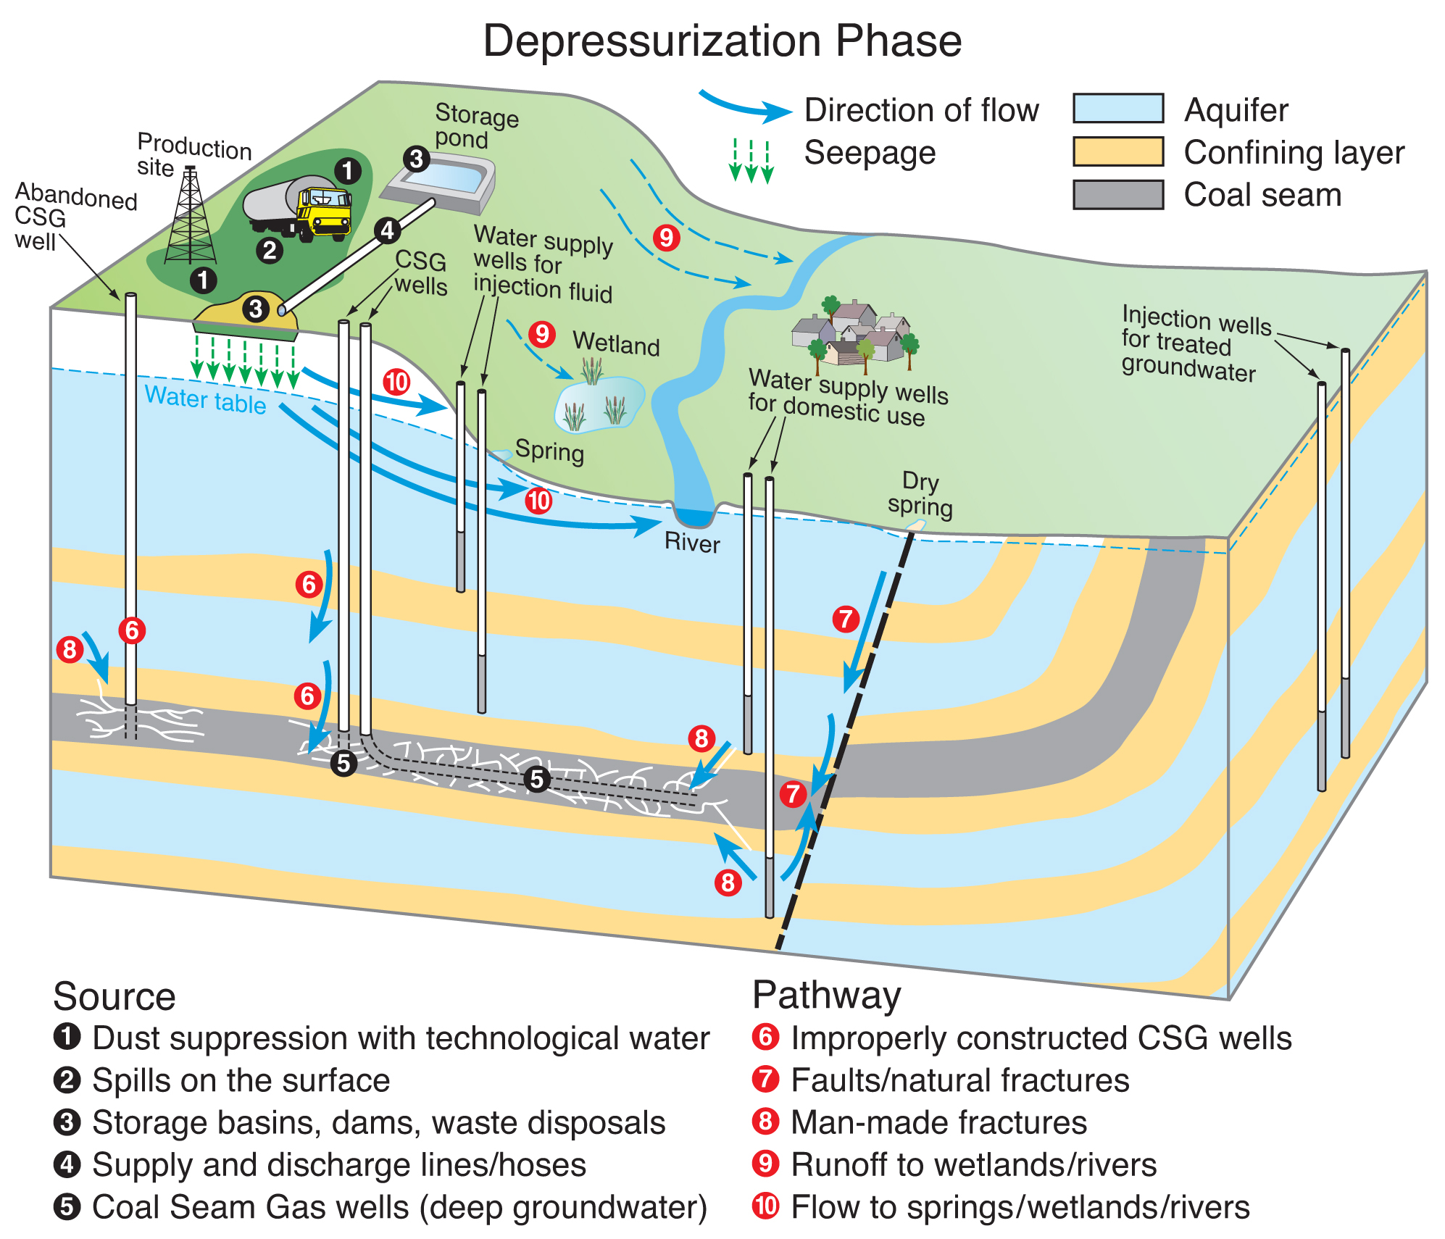

Source: CSIRO (Mallants et al. 2017a)

Figure 3.2 Possible contaminant sources at the coal seam gas site (1 to 5) and pathways for solute transport during the de-pressurisation phase (6 to 10)

### Impacts on deeper groundwater

Although the Assessment considered the risk of chemical impacts associated with surface and near-surface waters (for the reasons given above), the literature review of the leakage to shallow groundwater of fluids associated with hydraulic fracturing also sought available data on impacts of coal seam gas operations on deeper groundwater. Noting potential influences on the recoveries of fracturing chemicals and geogenic chemical mobilisation, the review examined how subsurface pressure changes induced during various operational phases of coal seam gas production can impact on deeper groundwater.

During the pre-operational phase, groundwater pressure is assumed to be lowest in the overlying aquifer and highest in the aquifer underlying the coal seam. The pressure in the coal seam aquifer is between these two. Whether or not there is any significant flow between these aquifers depends on the permeability of the confining layers (i.e. aquitards) (Mallants et al. 2017a).

During the hydraulic fracturing phase lasting several days, fluid is injected under high pressure into the coal seam aquifer with the water pressure in the coal seam generally exceeding the local water pressure (Harrison 1983; Harrison 1985). The volume of flow, and the transport of hydraulic fracturing chemicals, from the coal seam to adjacent aquifers will depend on the permeability of the aquitards and the integrity of the coal seam gas wellbore and any other wellbores in the vicinity of the operation. However, with the increased hydraulic gradient across the aquitards, flow and transport may be facilitated from the well as a result of opening existing faults or fractures or creating new fractures.

Following relaxation of the short-term increase in pressure induced by the hydraulic fracturing operation, the naturally higher pressure in the coal seam formation causes the injected fracturing fluids to flow back to low pressure zones around the well and to flow back up the well to the surface for recovery, storage, treatment, disposal, or re-use. Fast recovery of hydraulic fracturing fluids should be expedited to reduce the risk of fluids migrating out of the coal seams (Green et al. 2012), recognising that recovery rates will depend on the local geology and hydrogeology.

In the de-pressurisation phase, water pressure in the coal seam is reduced and consequently water pressure tends to be lower in the coal seam than in the overlying (and possibly even underlying) aquifers. Water flow between aquifers may now become reversed (i.e. into the coal seams).

During the post-operational phase, water removal ceases. However, it may take many years for the groundwater levels in all aquifers to be restored. The rate at which this recovery occurs depends on: i) boundary conditions such as the recharge rate, and ii) the permeability of the aquitards separating the coal seams from surrounding aquifers.

# Human health impacts from coal seam gas chemicals

Humans may be exposed to drilling and hydraulic fracturing chemicals, and fluids containing these chemicals, via direct exposures at the workplace (occupational exposures) or by indirect exposures via environmental contamination (exposure of the general public) (NICNAS 2017a).

Because drilling and hydraulic fracturing chemicals are handled and stored at (and transported between) worksites, exposures of humans to drilling and hydraulic fracturing chemicals may occur during worksite operations.

At worksites, the likelihood and extent of chemical exposures depends primarily on whether manual or automated chemical processes are used for the handling of chemicals. Inadvertent releases of vapours, aerosols, dusts and fluids from surface infrastructure such as pipes, wellheads, pumps, hoppers, blenders and storage containers at well sites and at other storage locations are potential sources of exposure. Exposures mainly via the skin or inhalation can occur from emissions or spill incidents during transport, storage and handling, including mixing of fluids, handling of produced water and during equipment cleaning.

Human exposures may also occur at locations distant to worksites via environmental contamination. The public may be exposed to drilling and hydraulic fracturing chemicals from transportation incidents, emissions from worksites during operations or inadvertent releases from chemical storage to the environment. For the public, if exposures do occur, they are most likely to occur via contamination of ambient air or water (groundwater or surface water used for drinking or recreational purposes).

Although human exposures to geogenic chemicals may also occur, an analysis of such exposures was not within the current scope of the National Chemicals Assessment project.

Overseas, as well as in Australia, a number of chemical release incidents have been reported in relation to unconventional (coal seam and shale) gas extraction (NICNAS 2017a). However, this review has noted a paucity of documented incidents of impacts of chemicals on human health. The overseas literature contains studies of levels of chemicals in ambient air and water, studies of potential human health effects based on the toxicity of chemicals, and surveys of health complaints linked to unconventional gas activities. These largely relate to shale gas activities in the US. There are anecdotal reports of detrimental impacts of coal seam gas extraction activities on human health in Australia, but there are few documented follow-up investigations of such impacts (NICNAS 2017a).

Particular data gaps identified in the review with regards to human health impacts include epidemiological information and monitoring data on levels of drilling or hydraulic fracturing chemicals in the atmosphere or water that could result in exposure of workers and populations in close proximity to coal seam gas operations in Australia (NICNAS 2017a).

# References

Adgate JL, Goldstein BD and McKenzie LM 2014, ‘Potential public health hazards, exposures and health effects from unconventional natural gas development’, *Environmental Science and Technology*, 48(15), pp. 8307-8320.

API 2011, *Overview of Industry Guidance / Best Practices on Hydraulic Fracturing; Selected industry guidance / best practices on hydraulic fracturing*, API document list, American Petroleum Institute (API). Accessed: http://www.api.org/~/media/files/policy/exploration/hydraulic_fracturing_infosheet.ashx

API 2010, *Water Management Associated with Hydraulic Fracturing*, 1st edn, API Guidance Document HF2, June 2010, American Petroleum Institute (API). Accessed: http://www.api.org/~/media/files/policy/exploration/hf2_e1.pdf

API 2009, *Hydraulic Fracturing Operations ‑ Well Construction and Integrity Guidelines*, 1st edn, API Guidance Document HF1, October 2009, American Petroleum Institute (API). Accessed: http://www.api.org/~/media/Files/Policy/Exploration/API_HF1.pdf

APLNG 2012, ‘Working with us’, Webpage, Australia Pacific Liquid Natural Gas (APLNG). Accessed: August 2012 at http://www.aplng.com.au/working-us/working-us

APLNG 2011, *Spring Gully Water Treatment Facility Discharge Water Quality Report*, public report, Australia Pacific Liquid Natural Gas (APLNG), pp 1-14. Accessed: https://www.aplng.com.au/content/dam/aplng/reports/2011/SGWTF_Report_public_11_August_2011.pdf

APPEA undated, ‘CSG well construction and bore specifications’, Fact sheet, Australian Petroleum Production and Exploration Association Ltd (APPEA). Accessed: 28 May 2012 at http://www.appea.com.au/images/stories/pdfs_docs_xls/NewsMedia/CSG_Factsheet_Wells.pdf

Apte SC, Kookana RS, Batley GE and Williams M 2017, *Literature review: geogenic contaminants associated with the hydraulic fracturing of coal seams*, Project report prepared by the Commonwealth Scientific and Industrial Research Organisation (CSIRO) as part of the National Assessment of Chemicals Associated with Coal Seam Gas Extraction in Australia, Commonwealth of Australia, Canberra.

Baker G and Slater S 2008, ‘The increasing significance of coal seam gas in eastern Australia’, *Proceedings of the* *PESA Eastern Australasian Basins Symposium III,* Sydney.

Bellabarba M, Bulte-Loyer H, Froelich B, Roy-Delage S, van Kuijk R, Gulliot D, Moroni N, Pastor S and Zanchi A 2008, ‘Ensuring Zonal Isolation Beyond the Life of the Well’, *Oilfield Review*, 20(1), pp. 18-31.

Cook J and Edwards S 2009, ‘Geomechanics’, In *Advanced Drilling and Well Technology*, eBook, B Aadnoy, I Cooper, S Miska, RF Mitchell and ML Payne (eds), Society of Petroleum Engineers.

CSIRO 2012, ‘What is hydraulic fracturing?’, Online article, Commonwealth Scientific and Industrial Research Organisation (CSIRO). Accessed: 12 June 2014 at http://www.csiro.au/news/coal-seam-gas

Dale L 2003, *Review of trace elements in coal*, Report prepared by CSIRO Energy Technology for the Australian Coal Association Research Program (ACARP), pp. 1‑59.

Day RW 2009, ‘Coal seam gas booms in eastern Australia’, Feature Paper, *Preview*, June 2009. Accessed: http://www.ucg-gtl.com/files/Coal%20Seam%20Gas%20booms%20in%20eastern%20Australia%20ASEG%20Preview%20June%202009.pdf

DEEDI 2011, *Code of practice for constructing and abandoning coal seam gas wells in Queensland*, Department of Employment, Economic Development and Innovation (DEEDI), Queensland Government.

DEHP 2014, *Coal Seam Gas / Liquid Natural Gas Compliance Plan, 2012-13 End of year report*, Report prepared by the Department of the Environment and Heritage Protection (DEHP), Queensland Government, Brisbane.

DEHP 2013a, ‘Chemicals used in fraccing’, Fact sheet, Department of Environment and Heritage Protection (DEHP), Queensland Government, Brisbane. Accessed: April 2013 at <http://www.ehp.qld.gov.au/management/non-mining/fraccing-chemicals.html>

DEHP 2013b, ‘Characterisation and Management of Drilling Fluids and Cuttings in the Petroleum Industry’, Fact sheet, Department of Environment and Heritage Protection (DEHP), Queensland Government. Accessed: 5 December 2013 at http://www.ehp.qld.gov.au/management/non-mining/documents/drilling-muds-fact-sheet.pdf

DERM 2011, *CSG / LNG Compliance Plan 2011, January 2011 to June 2011*, Department of Environment and Resource Management (DERM),Queensland Government. Accessed: 21 February 2013 at: http://www.ehp.qld.gov.au/management/coal-seam-gas/pdf/csg-lngcompliance-update1.pdf

Dershowitz W, Cottrell, Lim D and Doe T 2010, ‘A discrete fracture network approach for evaluation of hydraulic fracture stimulation of naturally fractured reservoirs’, *Proceedings of the 44th US Rock Mechanics Symposium*, American Rock Mechanics Association, Salt Lake City, Utah, USA.

DME 2012, ‘Unconventional Oil and Gas’, Webpage, Department of Mines and Energy (DME), Northern Territory Government. Accessed: <http://www.nt.gov.au/d/Minerals_Energy/index.cfm?header=Unconventional%20Oil%20and%20Gas>

DMP 2013, ‘Petroleum Fact Sheet: Gas resources types’, Fact sheet, Department of Mines and Petroleum (DMP), Government of Western Australia. Accessed: <http://www.dmp.wa.gov.au/documents/132499_resources_Type_Fact_Sheet.pdf>

DNRM 2014, *Queensland Spatial Catalogue ‑ QSpatial*, Online Database, Department of Natural Resources and Mines (DNRM), Queensland Government. Accessed: <http://dds.information.qld.gov.au/dds/>

DoEE 2017a, *Literature review: environmental risks from coal seam gas operations*, Project report prepared by the Chemicals and Biotechnology Assessment Section (CBAS) of the Department of the Environment and Energy as part of the National Assessment of Chemicals Associated With Coal Seam Gas Extraction in Australia, Commonwealth of Australia, Canberra.

DoEE 2017b, *Environmental exposure conceptualisation for surface to surface water pathways*, Project report prepared by the Chemicals and Biotechnology Assessment Section (CBAS) of the Department of the Environment and Energy as part of the National Assessment of Chemicals Associated with Coal Seam Gas Extraction in Australia, Commonwealth of Australia, Canberra.

DPI 2012, ‘Onshore Natural Gas: Coal Seam Gas’, Webpage, Department of Primary Industries (DPI), Victorian Government. Accessed: August 2012 at <http://www.dpi.vic.gov.au/earth-resources/community-information/landholders-info/coal-seam-gas-guidelines>

Dusseault MB, Jackson RE and MacDonald D 2014, *Towards a road map for mitigating the rates and occurrences of long-term wellbore leakage*, Report prepared by Geofirma Engineering Ltd for the University of Waterloo, Canada. Accessed: http://geofirma.com/wp-content/uploads/2015/05/lwp-final-report_compressed.pdf

Economides M and Nolte K 2000, ‘Fracturing fluid chemistry and proppants’, In *Reservoir Stimulation*, 3rd edn, MJ Economides and KG Nolte (eds), John Wiley and Sons Ltd, West Sussex, England.

ERIN 2014, *Protected Matters Search Tool*, Online database, Environmental Resources Information Network (ERIN), Department of Sustainability, Environment, Water, Population and Communities, Australian Government.

Flewelling SA and Sharma M 2014, ‘Constraints on upward migration of hydraulic fracturing fluid and brine’, *Groundwater,* 52(1), pp 9-19.

Freij-Ayoub R 2012, ‘Opportunities and challenges to coal bed methane production in Australia’, *Journal of Petroleum Science and Engineering*, 88-89, pp. 1-4.

Geoscience Australia 2010a, *Australian Landforms and their History*, Online database, National Location Information, Geoscience Australia, Australian Government, Canberra. Accessed: 19 February 2013 at: http://www.ga.gov.au/education/geoscience-basics/landforms/australian-landforms-and-their-history.html

Geoscience Australia 2010b, *Elevations*, Online database, National Location Information, Geoscience Australia, Australian Government, Canberra. Accessed: 19 February 2013 at: http://www.ga.gov.au/education/geoscience-basics/landforms/elevations.html

Geoscience Australia and BREE 2012, *Australian Gas Resource Assessment 2012*. Report prepared by Geoscience Australia (GA) and the Bureau of Resources and Energy Economics (BREE) for the Department of Resources, Energy and Tourism, Canberra. Accessed: <http://www.ga.gov.au/webtemp/image_cache/GA21116.pdf>

Golder Associates 2010, *Coal Seam Hydraulic Fracturing Fluid Environmental Risk Assessment; Response to the Coordinator: general requirements for coal seam gas operations in the Surat and Bowen Basins,Queensland,* Report prepared by Golder Associates for Santos Ltd. Accessed: September 2014 at <http://www.santos.com/library/Roma_Shallow_Gas_East_EMP_AppD.pdf>

Green C, Styles P and Baptie B 2012, *Preese Hall Shale Gas Fracturing: review and recommendations for induced seismic mitigation*, Report prepared by Frac Technologies; Keele University;and the British Geological Survey for the Department of Energy and Climate Change, UK.

Groat CG and Grimshaw TW 2012*, Fact-based regulation for environmental protection in shale gas development*, Report prepared by The Energy Institute, University of Texas at Austin.

Harrison SS 1985, ‘Contamination of aquifers by overpressuring the annulus of oil and gas wells’, *Groundwater,* 23(3), pp 317-324.

Harrison SS 1983, ‘Evaluating system for groundwater contamination hazards due to gas-well drilling on the glaciated Appalachian Plateau’, *Groundwater,* 21(6), pp. 689-700.

Jeffrey R, Wu B, Bunger A, Zhang X, Chen Z, Kear J and Kasperczyk D 2017, *Literature review: hydraulic fracture growth and well integrity*, Project report prepared by the Commonwealth Scientific and Industrial Research Organisation (CSIRO) as part of the National Assessment of Chemicals Associated with Coal Seam Gas Extraction in Australia, Commonwealth of Australia, Canberra.

Mallants D, Bekele E, Schmid W, Miotlinski K and Bristow K 2017a, *Literature review: Identification of potential pathways to shallow groundwater of fluids associated with hydraulic fracturing*, Project report prepared by the Commonwealth Scientific and Industrial Research Organisation (CSIRO) as part of the National Assessment of Chemicals Associated with Coal Seam Gas Extraction in Australia project, Commonwealth of Australia, Canberra.

Mallants D, Bekele E, Schmid W and Miotlinski K 2017b, *Human and environmental exposure conceptualisation: Soil to shallow groundwater pathways*, Project report prepared by the Commonwealth Scientific and Industrial Research Organisation (CSIRO) as part of the National Assessment of Chemicals Associated with Coal Seam Gas Extraction in Australia, Commonwealth of Australia, Canberra.

Meyer B and Bazan L 2011, ‘A discrete fracture network model for hydraulically induced fractures : theory, parametric and case studies’, *Proceedings of the Society of Petroleum Engineers (SPE) Hydraulic Fracturing Technology Conference*, 24 to 26 January 2011, The Woodlands, Texas, US, pp. 1-36.

Montoya D 2012, ‘Coal seam gas royalties in Australian States and Territories’, Newsletter, e-brief 3/2012, NSW Parliamentary Library Research Service, NSW Parliament. Accessed: http://www.parliament.nsw.gov.au/prod/parlment/publications.nsf/key/CoalseamgasroyaltiesinAustralianStatesTerritories/$File/Coal+seam+gas+royalties+in+Australian+States+&+Territories.pdf

Myers T 2012, ‘Potential contaminant pathways from hydraulically fractured shale to aquifers’, *Groundwater*, 50(6), pp. 872-882.

Nagel N, Sanchez M and Lee B 2012, ‘Gas shale hydraulic fracturing: a numerical evaluation of the effect of geomechanical parameters’, *Proceedings of the Society of Petroleum Engineers (SPE) Hydraulic Fracturing Technology Conference*, 6 to 8 February 2012, The Woodlands, Texas, US, pp. 1-19.

NICNAS 2017a, *Literature review: human health implications and regulation*, Project report prepared by the National Industrial Chemicals Notification and Assessment Scheme (NICNAS) as part of the National Assessment of Chemicals Associated with Coal Seam Gas Extraction in Australia, Commonwealth of Australia, Canberra.

NICNAS 2017b *Identification of chemical associated with coal seam gas extraction in Australia*, report prepared by the National Industrial Chemicals Notification and Assessment Scheme (NICNAS) as part of the National Assessment of Chemicals Associated with Coal Seam Gas Extraction in Australia, Commonwealth of Australia, Canberra.

NSW Parliament Legislative Council 2012, *Inquiry into coal seam gas (report no. 35)*, General Purpose Standing Committee No. 5, New South Wales Parliament Legislative Council, Sydney, May 2012.

NYSDEC 2011, *Supplemental Generic Environmental Impact Statement on the Oil, Gas and Solution Mining Regulatory Program (preliminary revised draft)*, Report prepared by the New York State Department of Environmental Conservation (NYSDEC). Accessed: 31 August 2012 at: <http://www.dec.ny.gov/data/dmn/rdsgeisfull0911.pdf>

Orem W and Finkelman R 2003, ‘Coal formation and geochemistry’, In *Treatise on Geochemistry*, HD Holland and KK Turekian (eds), Pergamon, Oxford, UK, pp. 191-222.

Prats M and Maraven S 1981, ‘Effect of burial history on the subsurface horizontal stresses of formations having different material properties’, *Society of Petroleum Engineers Journal*, 21(6), pp. 658-662.

Quinn T 1994, ‘Experimental Analysis of Permeability Barriers to Hydraulic Fracture Propagation’, PhD thesis, Massachusetts Institute of Technology.

QWC 2012, *Underground water impact report for the Surat cumulative management area*, Report prepared by the Queensland Water Commission (QWC) for the Department of Natural Resources and Mines, Brisbane.

Riley K, French D, Farrell O, Wood R and Huggins F 2012, ‘Modes of occurrence of trace and minor elements in some Australian coals’ *International Journal of Coal Geology,* 94, pp. 214-224.

Roarty M 2011, *The development of Australia’s coal seam gas resources*, Research publication, Background Note, Department of Parliamentary Services, Parliament of Australia, Canberra. Accessed: http://www.aph.gov.au/About_Parliament/Parliamentary_Departments/Parliamentary_Library/pubs/BN/2011-2012/CoalSeamGas

Rozell DJ and Reaven SJ 2012, *‘*Water pollution risk associated with natural gas extraction from the Marcellus Shale’, *Risk Analysis,* 32(8), pp. 1382-1393.

Rutovitz J, Harris SM, Kuruppu N and Dunstan C 2011, *Drilling down: Coal seam gas* – *a background paper*, Report prepared by the Institute for Sustainable Futures, University of Technology Sydney, pp. 1-83.

Santos 2010, *Upstream-Fairview Project Area Environmental Management Plan,* Report section, Appendix B ‑ Fairview Project Area Coal Seam Gas Water Management Plan, Santos GLNG.

Standards Norway 2004, *Well integrity in drilling and well operations*, Norsok Standard D-010, Lysaker, Norway. Accessed: http://www.standard.no/pagefiles/1315/d-010r3.pdf

Stringfellow WT, Domen JK, Camarillo MK, Sandelin WL and Borglin S 2014, Physical, chemical, and biological characteristics of compounds used in hydraulic fracturing. *Journal of Hazardous Materials*, 275, pp.37-54. Accessed: http://dx.doi.org/10.1016/j.jhazmat.2014.04.040

The Royal Society and The Royal Academy of Engineering 2012, *Shale gas extraction in the UK: a review of hydraulic fracturing,* Report prepared by The Royal Society and The Royal Academy of Engineering, UK. Accessed: 12 June 2014 at http://www.raeng.org.uk/shale

Thiercelin M, Roegiers J, Boone T and Ingraffea A 1987, ‘An investigation of the material parameters that govern the behavior of fractures approaching rock interfaces’, *Proceedings of the 6th International Society for Rock Mechanics (ISRM) Congress*, 30 Aug to 3 Sept 1987, Montreal, Canada, pp. 263-269.

URS Australia 2010, *Hydraulic Fracturing Environmental Assessment*, Report prepared by URS Australia Pty Ltd for Australia Pacific LNG, Brisbane. Accessed: http://www.aplng.com.au/pdf/talinga/Att4a_Hydraulic_fracturing_environmental_assessment.pdf

US EPA 2011, *Plan to study the potential impacts of hydraulic fracturing on drinking water resources*, EPA/600/R-11/122, Office of Research and Development, US Environmental Protection Agency (US EPA), Washington DC. Accessed: <http://www.epa.gov/hfstudy/>

US EPA 2004, *Evaluation of impacts to underground sources of drinking water by hydraulic fracturing of coalbed methane reservoirs,* EPA 816-R-04-003, US Environmental Protection Agency (US EPA), Washington DC, US. Accessed: <http://www.epa.gov/ogwdw/uic/pdfs/cbmstudy_attach_uic_ch04_hyd_frac_fluids.pdf>

US EPA 1992, *Guidelines for Exposure Assessment, EPA/600/Z-92/001*, Federal Register 57(104):22888-22938, Risk Assessment Forum, US Environmental Protection Agency (US EPA), Washington DC, pp. 139. Accessed: http://cfpub.epa.gov/ncea/cfm/recordisplay.cfm?deid=15263#Download

Vidic RD, Brantley SL, Vandenbossche JM, Yoxtheimer D and Abad JD 2013, ‘Impact of shale gas development on regional water quality’, *Science*, 340(6134). Accessed: http://science.sciencemag.org/content/340/6134/1235009

Warpinski N and Teufel L 1987, ‘Influence of geologic discontinuities on hydraulic fracture propagation’, *Journal of Petroleum Technology*, 39(2), pp. 209-220.

Weng X, Kresse O, Cohen C, Wu R and Gu H 2011, ‘Modeling of hydraulic-fracture-network propagation in a naturally fractured formation’, *Society of Petroleum Engineers Production and Operations*, 26(4), pp. 368-380.

Williams J, Stubbs T and Milligan A 2012, *An analysis of coal seam gas production and natural resource management in Australia: issues and ways forward,* Report prepared by John Williams Scientific Services Pty Ltd for the Australian Council of Environmental Deans and Directors. Accessed: http://www.wentworthgroup.org/uploads/An%20analysis%20of%20CSG%20production%20and%20NRM%20in%20Australia%20Oct%202012%20FULL.pdf

Yeo B 2012, ‘Ambassador Oil and Gas doubles coal seam gas resource to more than 13 trillion cubic feet’, Media release, *Proactiveinvestors*, 15 August 2012, Australia. Accessed: August 2012 at: http://www.proactiveinvestors.com.au/companies/news/32388/ambassador-oil-gasdoubles-coal-seam-gas-resource-to-more-than-13-trillion-cubic-feet-32388.html

Zoback M 2007, *Reservoir Geomechanics*, Cambridge University Press, Cambridge, UK.

1. See Mallants et al. 2017a; Jeffrey et al. 2017; Adgate et al. 2014; Flewelling and Sharma 2014; DEHP 2014; Stringfellow et al. 2014; Groat and Grimshaw 2012; Vidic et al. 2013; Myers 2012; Rozell and Reaven 2012; The Royal Society and The Royal Academy of Engineering 2012; Rutovitz et al. 2011.