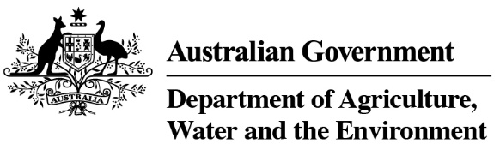 

**Country Specific Guideline for Thailand**

This guideline has been prepared by the Royal Forest Department with the assistance of the Australian Government. It is intended to assist businesses importing regulated timber products from Thailand into Australia in understanding the regulatory framework in Thailand in order for them to carry out their due diligence obligations under the *Illegal Logging Prohibition Regulation 2012*, which supports the *Illegal Logging Prohibition Act 2012*.

This guideline was co-endorsed by the Royal Forest Department and the Australian Government on 24 August 2021.

Contents

1. What is required under Australia’s illegal logging laws? 3

2. How to use the Country Specific Guideline (CSG) 3

3. Scope of the CSG for Thailand 4

3.1 Timber harvested outside of Thailand 4

3.2 Timber processed outside of Thailand 4

4. Overview of Forest Management in Thailand 4

4.1 Bans or limitations on harvest of specific species 5

4.2 Economic forest plantations 5

4.3 Natural Forests 7

4.4 Agencies responsible for managing and regulating forests 8

5. Laws and regulations governing forestry in Thailand 9

6. Identifying legal product from Thailand 10

7. Who should I contact for further information? 11

Appendix A: Restricted species under *Royal Decree B.E.2530* 12

Appendix B: List of CITES Appendix II listed species in Thailand 16

Appendix C: Example of permission to export under *Plant Act B.E. 2518 (1975)* 21

Appendix D: Example export license under Export And Import Of Goods Act, BE 2522 22

Appendix E: Laws relevant to the legal manufacturing process of timber products 23

Appendix F: Diagram of Thailand legislative supply chain control 24

Appendix G: Example Letter of Certification for Trade and Export of Timber, Wood Products and Charcoal (Ror Mor 8 Form) 25

Appendix H: Example Transport License 26

Appendix I: Example Export License issued by the Thailand Customs Department 28

# 1. What is required under Australia’s illegal logging laws?

Australia’s *Illegal Logging Prohibition Regulation 2012* (the Regulation) prescribes due diligence for individuals and businesses importing ‘regulated timber products’ and for Australian processors of domestic raw logs. Under the Regulation, importers and processors must undertake due diligence to minimise the risk of sourcing illegally logged timber.

The due diligence requirements include the following steps:

**Step 1:** Establish and maintain a due diligence system

**Step 2:** Gather information about the timber in the product that is being imported.

**Step 3:** Assess the risk (using one of the three methods outlined in the Regulation)

**Step 4:** Risk mitigation (if required)

**Step 5:** Keep records

Further information about the Regulation and the due diligence requirements is available at the Australian Government Department of Agriculture, Water and the Environment’s website (<http://www.agriculture.gov.au/illegallogging>)

# 2. How to use the Country Specific Guideline (CSG)

This CSG is intended to assist an importer of regulated timber products from Thailand to Australia to comply with the Regulation’s due diligence requirements.

In accordance with section 10 of the Regulation, an importer must gather information about the product they are seeking to import, this includes gathering the information or evidence described in this CSG.

The information listed in this CSG is not meant to be an exhaustive list of evidence or documentation required to satisfy the due diligence requirements under the Regulation.

The information gathered by applying this CSG, along with any other information gathered in accordance with the Regulation, needs to be assessed in accordance with the processes outlined in section 12 of the Regulation. This includes giving consideration to any other information the importer knows, or ought reasonably to know, but is not contained in the CSG.

All data included in this document is the most current as available at time of publishing.

# 3. Scope of the CSG for Thailand

This CSG provides detailed information on the control of pathways for timber harvested and originating from within Thailand and informs Australian importers of what is considered legal timber. It is only applicable for timber or timber products harvested, processed and (where applicable) manufactured in Thailand, and exported directly to Australia.

### 3.1 Timber harvested outside of Thailand

There may be timber, forest products or products which contain timber, wholly or in-part, which were harvested in another country before being imported to Thailand. These products do not fall within the scope of this CSG. However, the information contained in this document may assist Australian importers in conducting due diligence via one of the alternative risk assessment methods available under the Regulation.

### 3.2 Timber processed outside of Thailand

Timber that is harvested in Thailand, but then processed in another country, also does not fall within the scope of this CSG. As a result, importers may not use the CSG risk assessment method to carry out their due diligence on these products. However, the information contained in this document may still assist Australian importers in conducting their due diligence via one of the alternative risk assessment methods available under the Regulation.

# 4. Overview of Forest Management in Thailand

Thailand has approximately 4.28 million hectares of forestry plantations and 1.04 million hectares of mixed use forest, in addition to the 16.40 million hectares of conservation forest[1], covering 31.68 per cent of the land area ([Forest area of Thailand, 1973-2018](http://forestinfo.forest.go.th/Content.aspx?id=72)). In 1989, the Government cancelled all concessions for forest lands and promoted plantation forests to develop the economy and meet the increasing demand for timber. Thailand’s forest policy aims to recover the country’s forest area to 40 per cent of total land area, with 25 per cent allocated for conservation and 15 per cent for economic purposes.

### 4.1 Bans or limitations on harvest of specific species

Thailand identifies timber as a product that requires an export license in accordance with the *Export and Import Of Goods Act, BE 2522 (1979)*, except for *Dalbergia cochinchinensis* (commonly referred to as rosewood, Thailand’s rosewood, Siamese rosewood, or tracwood). Wood from this particular species is strictly prohibited from trade, both import and export, in accordance with the *Cabinet Resolution B.E. 2551* on 11 November 2008. However, if such rosewood grows on a land with title deed in Thailand, it can be cut and used within Thailand.

Teak logs and timber (excluding furniture) may only be exported by the Forest Industry Organization (described in section 4.3). Further information on the list of species restricted in natural forest area as declared under *Royal Decree B.E. 2530* can be found at Appendix A.

Thailand is a party to the Convention on International Trade in Endangered Species of Wild Fauna and Flora (CITES). Thailand bans and/or restricts the harvest or collection of flora and fauna species listed in accordance with the CITES Appendices. All trade in CITES listed species is strictly regulated and must be accompanied by the appropriate documentation where trade is permissible.

In cases where the species of wood is specified in Appendix II of CITES, such wood and wood products must be granted a permission by the Department of Agriculture according to *Plant Act B.E. 2518 (1975)* before being exported in accordance with *Export And Import Of Goods Act, BE 2522 (1979)*.

Tree species native to Thailand that are CITES listed are described in Appendix B, and an example of documents providing permission to export as provided by the Department of Agriculture according to *Plant Act B.E. 2518 (1975)* can be found at Appendix C.

### 4.2 Economic forest plantations

Thailand’s economic forest plantations are produced in both public and private land for which the ownership is granted. Ownership of public land for economic forest plantations can be granted by:

* Royal Forest Department under *National Reserved Forests Act, B.E. 2507 (1964)* and *Forests Act, B.E. 2484 (1941)*
* The Cooperative Promotion Department and Department of Social Development and Welfare under *Allotment of Land for Living Act, B.E. 2511 (1968)*
* The Agricultural land Reform Office under *Agricultural land Reform Act, B.E. 2518 (1975)*
* Ministry of Finance under *The Ratchaphatsadu Land Act, B.E. 2562 (2019)*

Ownership of private land is only granted by the Department of Lands under the *Land Code, B.E. 2497 (1954).*

As of 2017, the forest area for economic development in Thailand accounts for 8.28 per cent; with economic plantations making up 1.46 per cent, while rubberwood forests comprise another 6.82 per cent. Thailand aims to increase the forest area available for economic development by up to 15 per cent before 2036. This will be achieved by promoting the establishment of economic plantations in appropriate areas, including public lands that are allowed to be used for this purpose.

The most common commercial species within private commercial plantation in Thailand (from which the major raw materials used in lumber industry are comprised) include teakwood, rubberwood, and eucalyptus. Eucalyptus, rubberwood, and acacia harvested in Thailand comes exclusively from plantation forest.

The Private Forest Plantation Cooperative Limited was established in 1994 to help promote economic and social benefits to the members by seeking a fund for agriculturalists to plant forest in the area with license and encourage them to learn and share their wisdom on the standards of plants and plantation and it also helps improve marketing for its members.

### 4.3 Natural Forests

Natural forests in Thailand are owned by the public and primarily administered by the Ministry of Natural Resources and Environment. The management of each area is divided as follows:

* National reserved forests[2] are administered by the Royal Forest Department (RFD).
* National park[3],wildlife sanctuary areas[4], and non-hunting areas[5] are administered by the Department of National Parks, Wildlife and Plant Conservation.
* Mangrove Forest areas are administered by Department of Marine and Coastal Resources

### 4.4 Agencies responsible for managing and regulating forests

The Royal Forest Department (RFD), within the Ministry of Natural Resources and Environment (MoNRE), is the main authority responsible for forestry in Thailand. The RFD is responsible for the enforcement of forest laws and overseeing the management of state forests. The RFD is in charge of promoting plantations both in public and private land and administering permissions related to timber harvesting, transporting, processing and trading in the country. It also certifies the export of timber and timber products from the kingdom (for more information, please visit [www.forest.go.th](http://www.forest.go.th)).

The Forest Industry Organization, a state enterprise within the Ministry of Natural Resources and Environment, is in charge of managing economic plantations according to sustainable forest plantation management to support the plantation sector of timber industry, in addition to international trade and export. The major species under its management are teak and eucalyptus (for more information, please visit [www.fio.co.th](http://www.fio.co.th)).

The Department of Foreign Trade, within the Ministry of Commerce, is also responsible for aspects of timber export as specified in Export and Import of Goods Act, BE 2522 (1979) (for more information, please visit [www.dft.go.th](http://www.dft.go.th)). An example of this certificate (Aor2) can be found at Appendix D.

The Thai Customs Department, within the Ministry of Finance, is responsible for customs clearance in order to examine and collect import and export duties as specified in Customs Act B.E. 2469 (1926) and its Revisions (for more information, please visit [www.customs.go.th](http://www.customs.go.th)).

The Department of National Parks, Wildlife and Plant Conservation is responsible for the management of protected areas related to national parks and also has wildlife protection responsibilities. The Department of Marine and Coastal Resources is responsible for management of mangrove forest resources, and other coastal resources.

# 5. Laws and regulations governing forestry in Thailand

Laws and regulations related to the management of forest area and the utilization, industry, trade, and export of timbers and wood products are listed below.

* *Forest Act B.E. 2484 (1941)* and its revisions *-* regulates timber production, transportation, and lumber industry.This provides the authority for forest officers to control the timber supply chain, such as through issue of transport licenses, inspection of wood processing premises, and related trade controls.
* *National Reserved Forest Act B.E.2507 (1964) –* regulates, controls, and supervise the use of national reserved forest area and the permission to use such area. This Act conserves forest land and provides authority to allow the implementation of systems allowing some forest enterprises.
* *Commercial Forest Plantation Act B.E. 2535 (1992)* and its revisions - regulates woods and timbers produced from the area registered as a commercial forest plantation. The Act promote the forest plantation program by authorizing streamlined processes related to implementation of forest plantation activities. Under the Act, plantation owners hold authority to initiate harvest, transport, and processing activities.
* *Export and Import of Goods Act B.E. 2522 (1979)* and its revisions- regulates the export and import of products in the country. This Act describes the requirement for export permits to be issues for log and timber products.
* *Customs Act B.E. 2560 (2017)* and its revisions- regulates customs clearance. This Act generates the Customs' powers to inspect timber and timber products for HS code accuracy, and to collect relevant import and export tariffs.
* *Factory Act B.E. 2535 (1992)* and its revisions- regulates the operation of factories. This law requires sawmills to be operated according to relevant factory laws, and to maintain compliance with forest laws.
* *Town Planning Act B.E. 2518 (1975)* and its revisions *–* regulates the policy framework for using an area to be aligned with state policy, national strategy, and national economic and social development plan. Applications to establish a wood processing plant (sawmill) must comply with this Act.
* *Plant Act B.E. 2518 (1975)* and its revisions - regulates the trade of seeds to meet the conditions and quality. This Act establishes guildelines for issuing CITES licenses.

In considering the legality of timber or timber products sold in the market within the country or for the exportation, such timber or timber products must be in accordance with the related laws. The consideration of legality includes the land rights, import and export rights, the rights to process timber, the rights to sell, manage, cut, and transport timber, the rights to manage environment and society, welfare and protection of labors, tax, fee, and other expenditure by supervising, controlling, and regulating from the transportation of timber, the source of origin of such timber and timber products, the timber factory to market and exportation are described in Appendices E and F.

# 6. Identifying legal product from Thailand

The legality assessment of timber products exported from Thailand starts from planting, through harvest, transport, processing, trading, and export in order to indicate that such timber products are legal.

Products that require an export license are round logs, sawn timber, charcoal, and two species of a balled tree as specified in Appendix II of CITES subcontract (Appendix B).

Permission is not required to export rattan, bamboo, reeds, palms, roots, vines, veneer, vegetation, sawdust, woodchips, no matter whether they are bits, chunks, or pellets or similar forms, and timber which is processed to a finished product and cannot be further transformed.

Letter of Certification for Trade and Export of Timber, Wood Products, and Charcoal (Ror Mor 8 Form, Appendix G) issued by Royal Forest Department will be granted in the following cases:

1. A Ror Mor 8 Certificate is required for round logs and sawn timber (except rubberwood).
2. An exporter from Thailand may also request a Ror Mor 8 certificate to accompany products that do not require a Ror Mor 8 certificate, upon request from an Australian importer.
3. In the case of charcoal, the declaration of export license (Aor 2 license) can be used in combination with a transport certificate (Appendix H) instead of the Ror Mor 8 certificate.

After the organisation in charge has assessed and validated the said processes, such timber products will be granted a certificate as followings:

* 1. Royal Forest Department will assess the legality of timber and timber products as specified in Forest Act B.E. 2484 (1941) and its revisions. The timber and timber products required to achieve the license or certificate from RFD must be granted “Letter of Certification for Trade and Export of Timber, Wood Products, and Charcoal” (or Ror Mor 8 Form, Appendix G).
  2. Ministry of Commerce will grant Export License (or Aor 2 Form) as specified in Export and Import of Goods Act B.E. 2522 (1979) and its Revisions. The exporter is required to submit relevant documents coupled with the Letter of Certification issued by RFD (Ror Mor 8) as specified in 6.1 for the Ministry to consider the issue of Aor 2 Certificate (The example of AOR 2 Certificate is shown in Appendix D).
  3. Thai Customs Department will assess relevant documents and Aor 2 Certificate that is granted to the importer by Ministry of Commerce in order to issue the license in accordance with Customs Act B.E. 2496 (1926) and its Revisions. A duty shall be collected as customs officer calculate before issuing export license (an example of an export license is shown in Appendix I).

Therefore, what the importer will obtain when importing timber and timber products from Thailand include:

* an export license
* invoice(s)
* a packing list, and
* other documents such as documents for export control and booking confirmation.

# 7. Who should I contact for further information?



Australian Government

Department of Agriculture, Water and the Environment

GPO Box 858

Canberra ACT 2601

Phone: +61 (0) 2 6272 3933

www.agriculture.gov.au/illegallogging

E-mail: illegallogging@awe.gov.au



Thailand

Forest Economics Office

Royal Forest Department

61 Phahonyothin Road, Lat Yao, Chatuchak, Bangkok 19000

Phone: +66 (0) 2561 4292 Ext. 5249

http://www.forest.go.th

E-mail: forstand.rfd@gmail.com

**Disclaimer**

While reasonable efforts have been made to ensure that the contents of this guideline and the associated quick reference guide are factually correct, the Commonwealth of Australia and the Government of Thailand does not accept responsibility for the accuracy or completeness of the contents and expressly disclaims liability for any loss or damage, however caused, that may be occasioned directly or indirectly through the use of, or reliance on, the contents of this guideline or associated quick reference guide.

This guideline and its associated quick reference guide are made available on the understanding that the Commonwealth of Australia and the Government of Thailand are not providing professional advice. Before relying on this guideline or its associated quick reference guide, readers should obtain appropriate professional advice suitable to their particular circumstances.

Readers should also confirm that this is the most up-to-date available guideline by referring to the Department of Agriculture, Water and the Environment website.

## Appendix A: Restricted species under *Royal Decree B.E.2530*

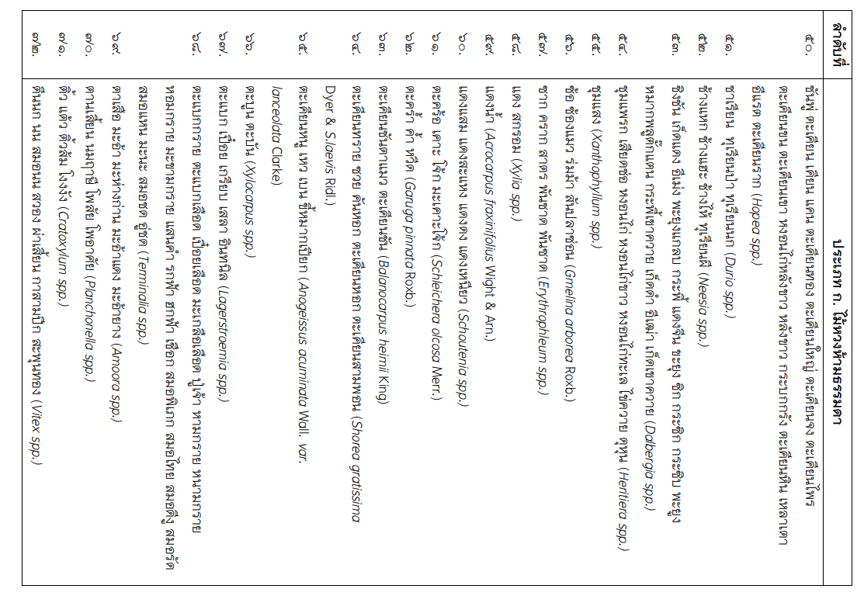 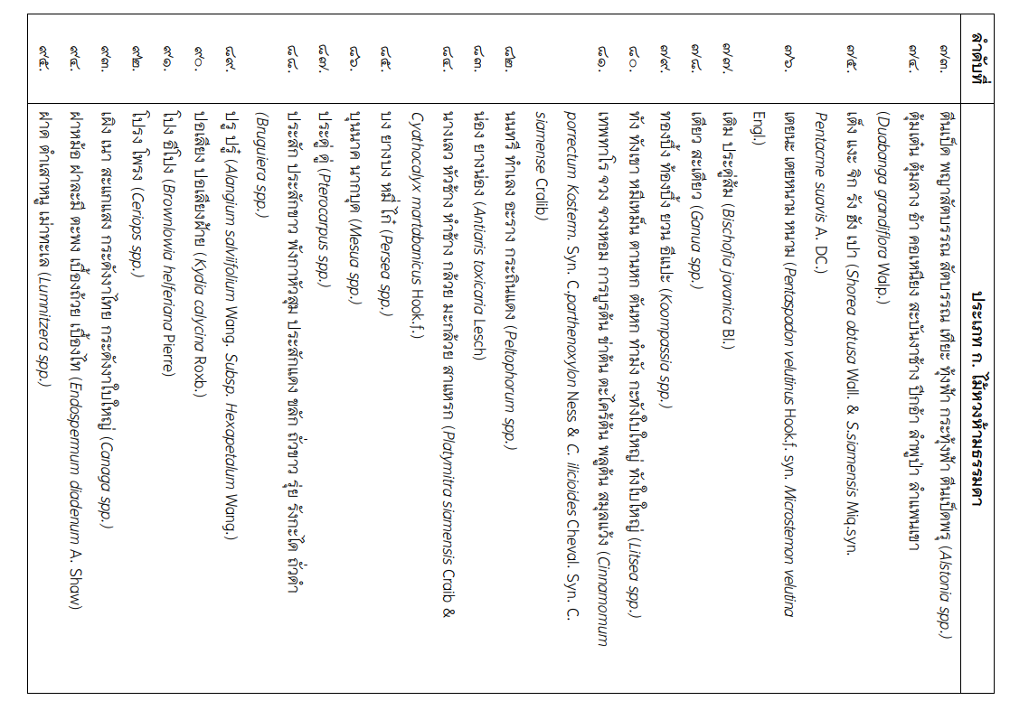

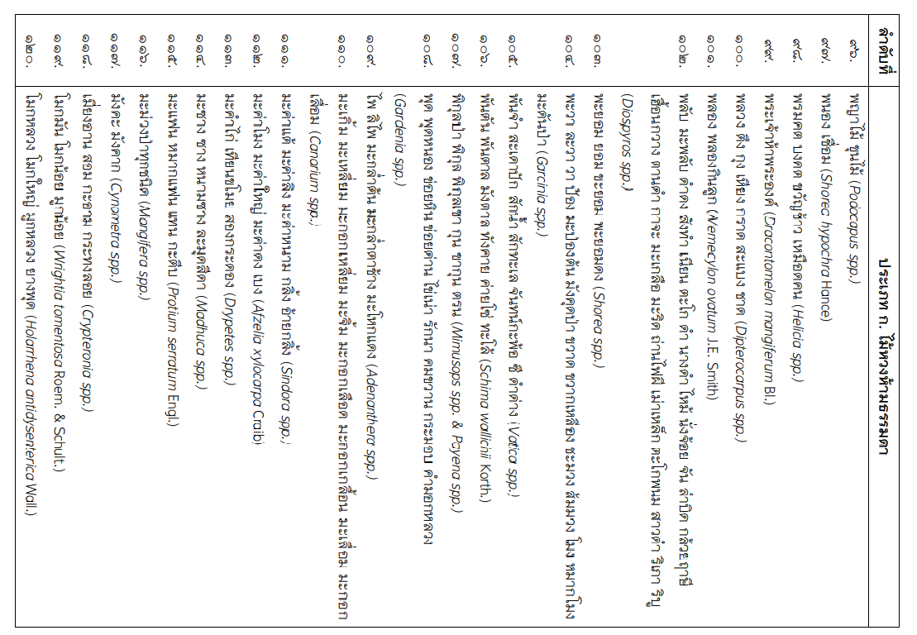 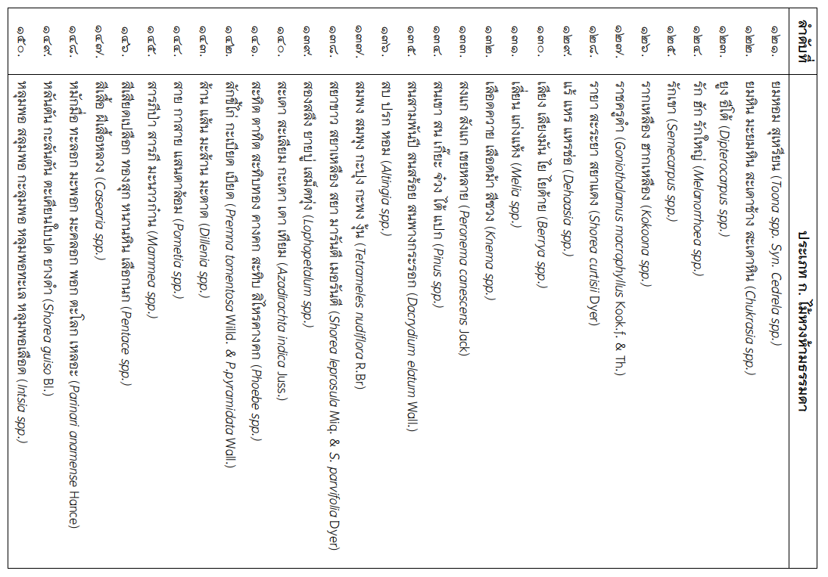

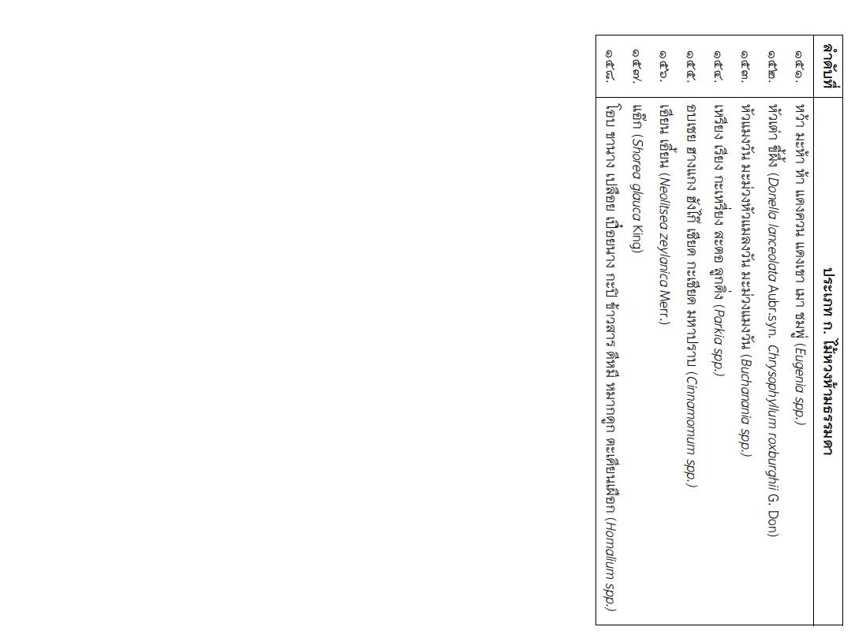

## Appendix B: CITES Appendix II listed species in Thailand

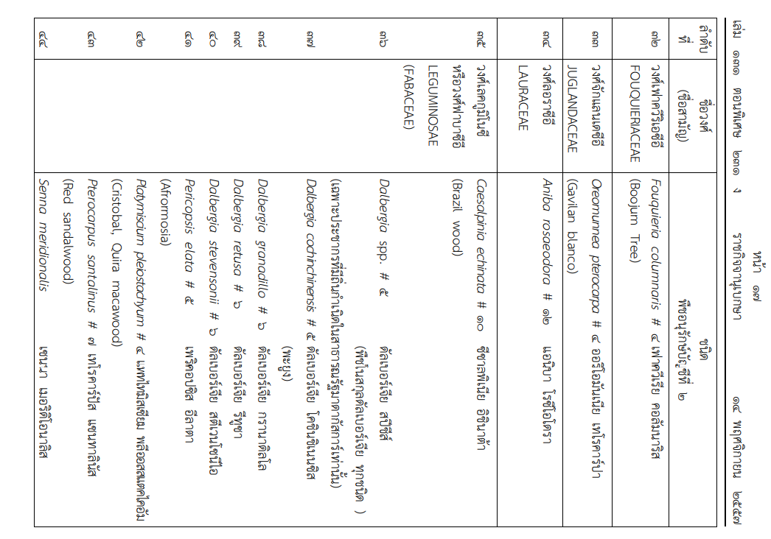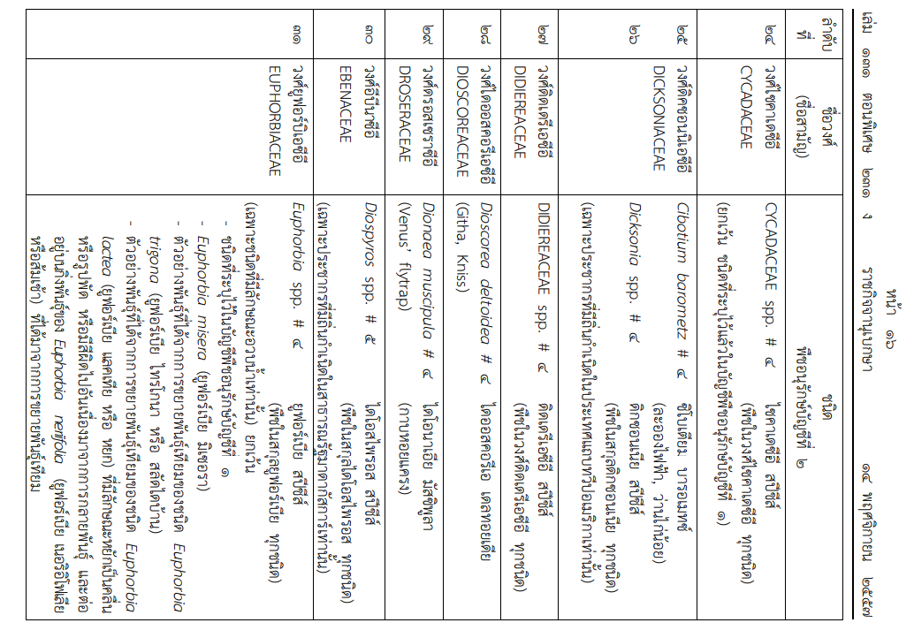

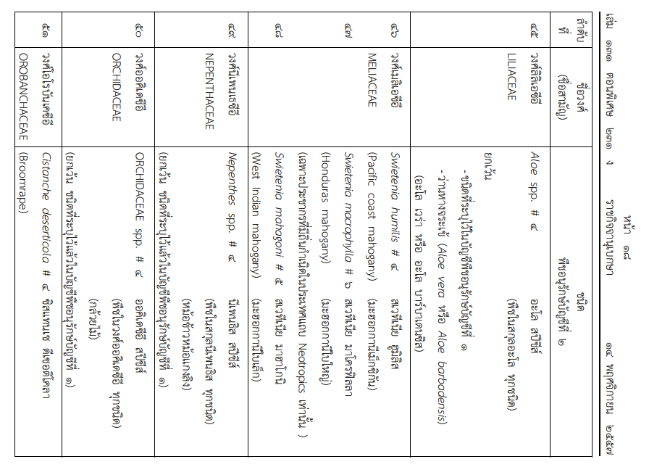 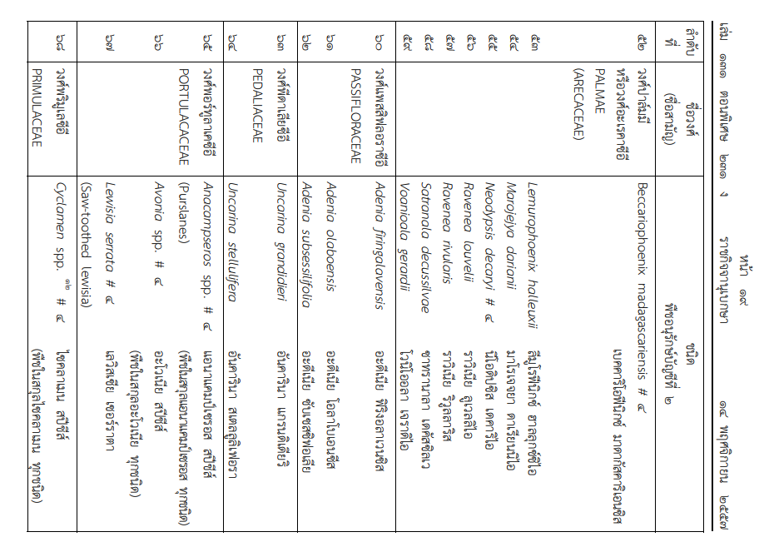 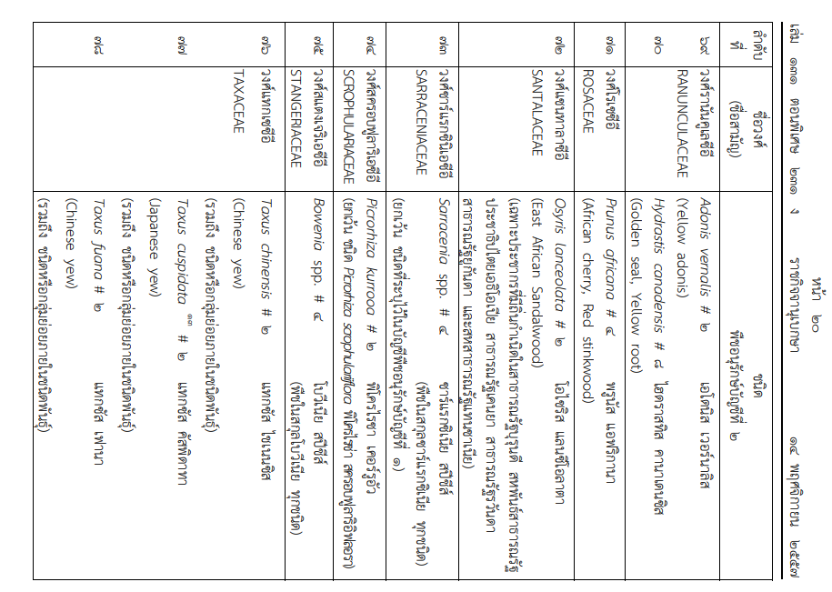 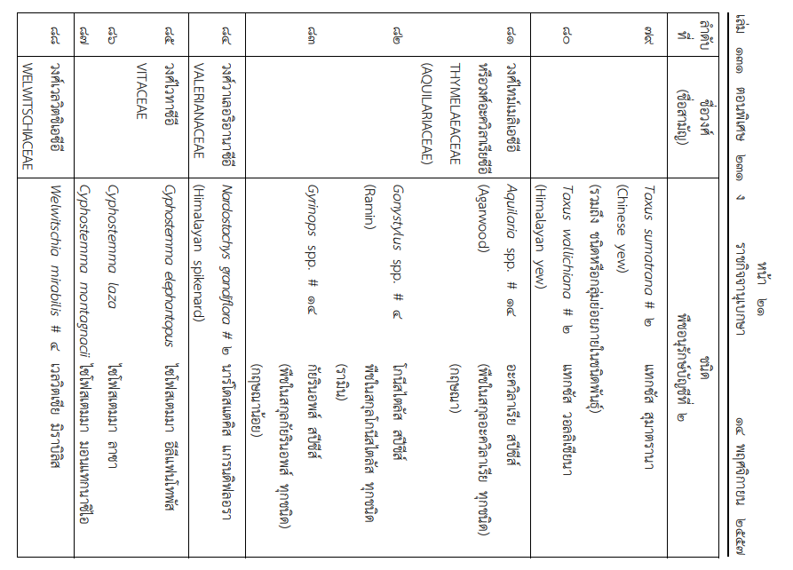 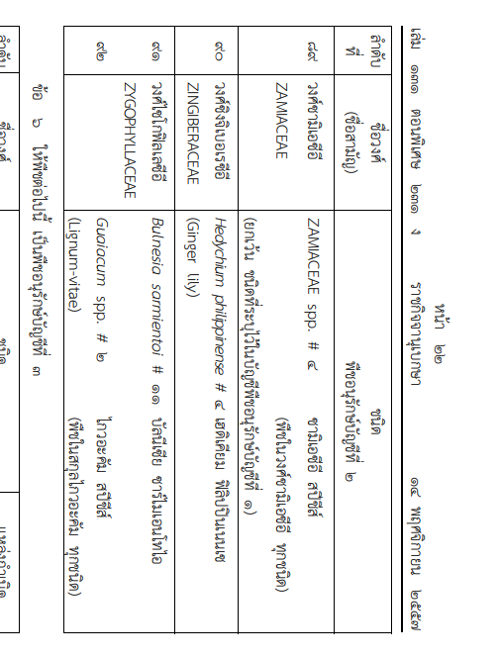

## Appendix C: Example of permission to export under *Plant Act B.E. 2518 (1975)*

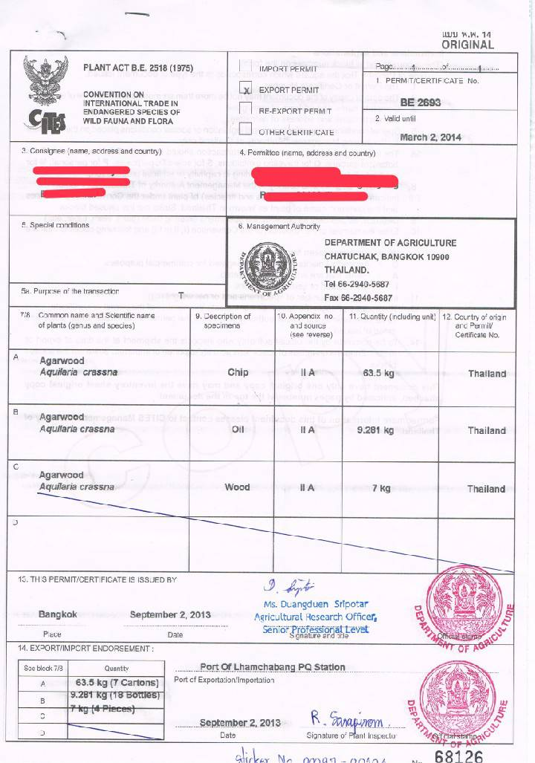

Appendix D: Example of export license under Export and Import of Goods Act, BE 2522 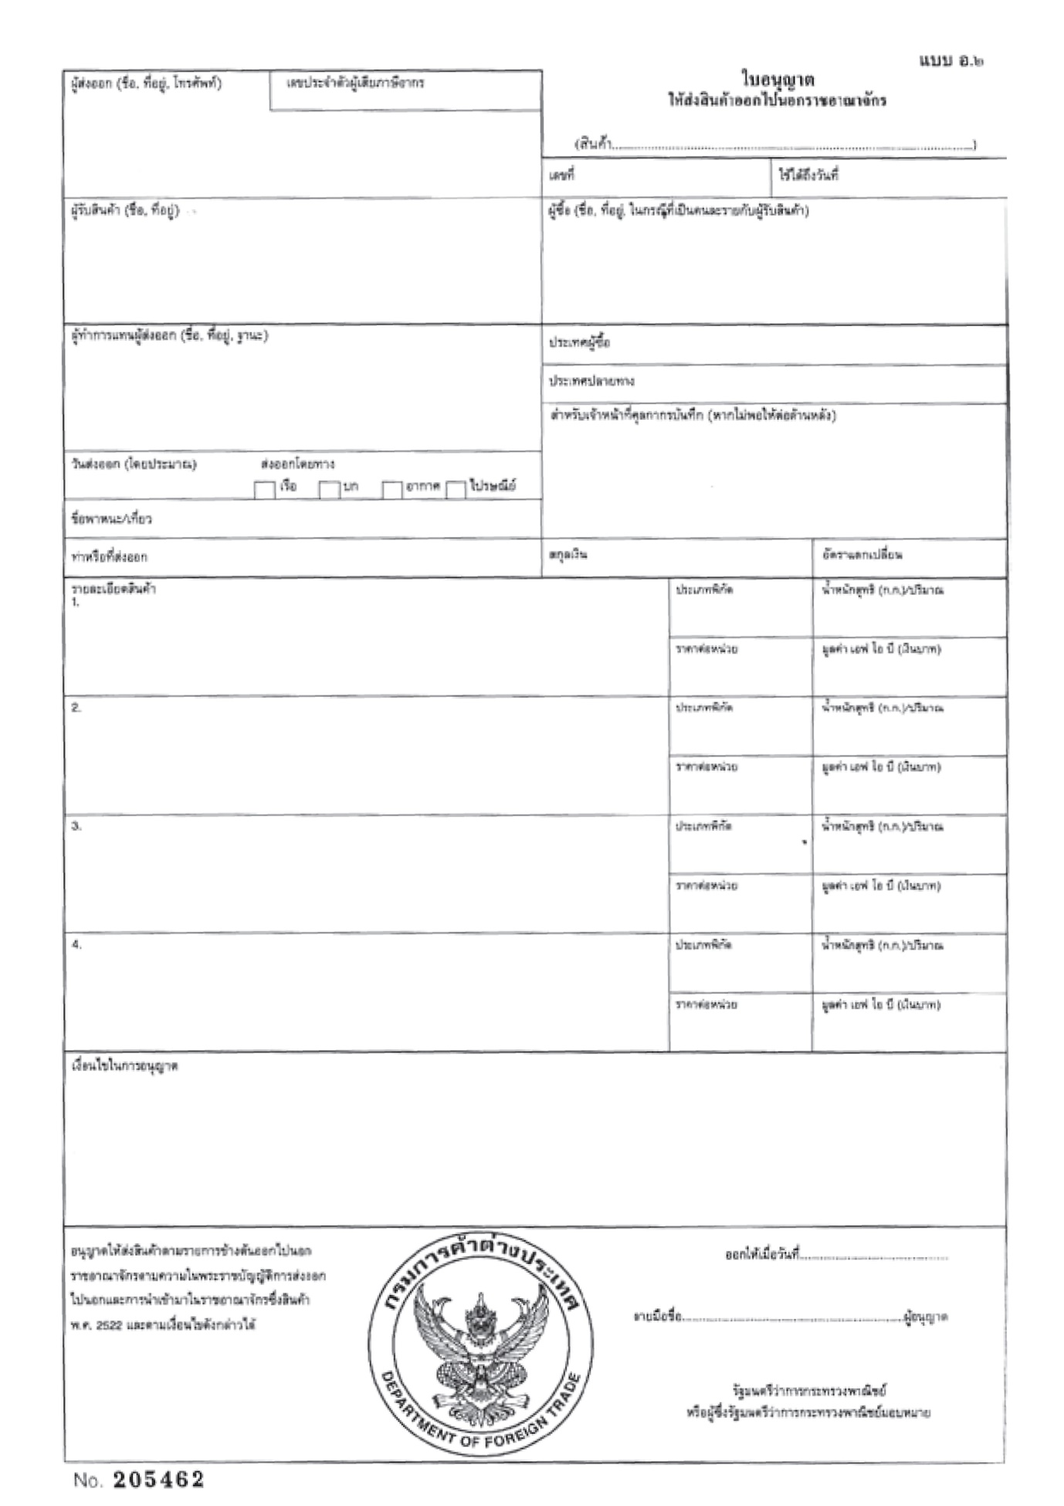

## Appendix E: Laws relevant to the legal manufacturing process of timber and timber products



**Relevant Laws**

**on**

**Source of Timber and Logging**

Forest Act B.E.2484 (1941)

National Reserved Forest Act B.E.2507 (1964)

Land Code B.E.2497 (1954)

The Cooperative Promotion Department and Department of Social Development and Welfare under Allotment of Land for Living Act, B.E. 2511 (1968)

The Agricultural land Reform Office under Agricultural land Reform Act, B.E. 2518 (1975)

Ministry of Finance under The Ratchaphatsadu Land Act, B.E. 2562 (2019)

## Appendix F: Diagram of Thailand’s legislative supply chain control

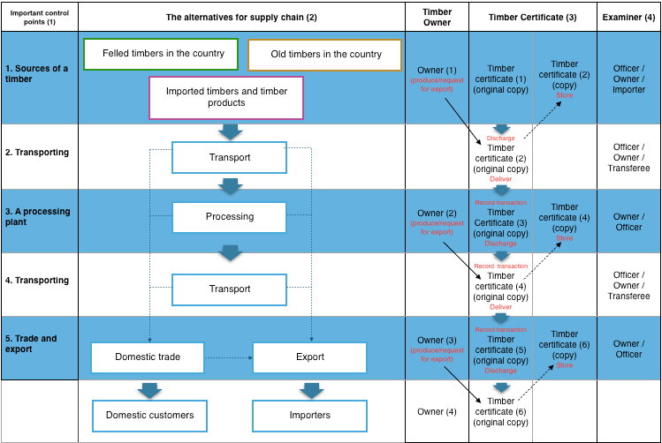

## Appendix G: Example of Letter of Certification for Trade and Export of Timber, Wood Products and Charcoal (Ror Mor 8 Form)

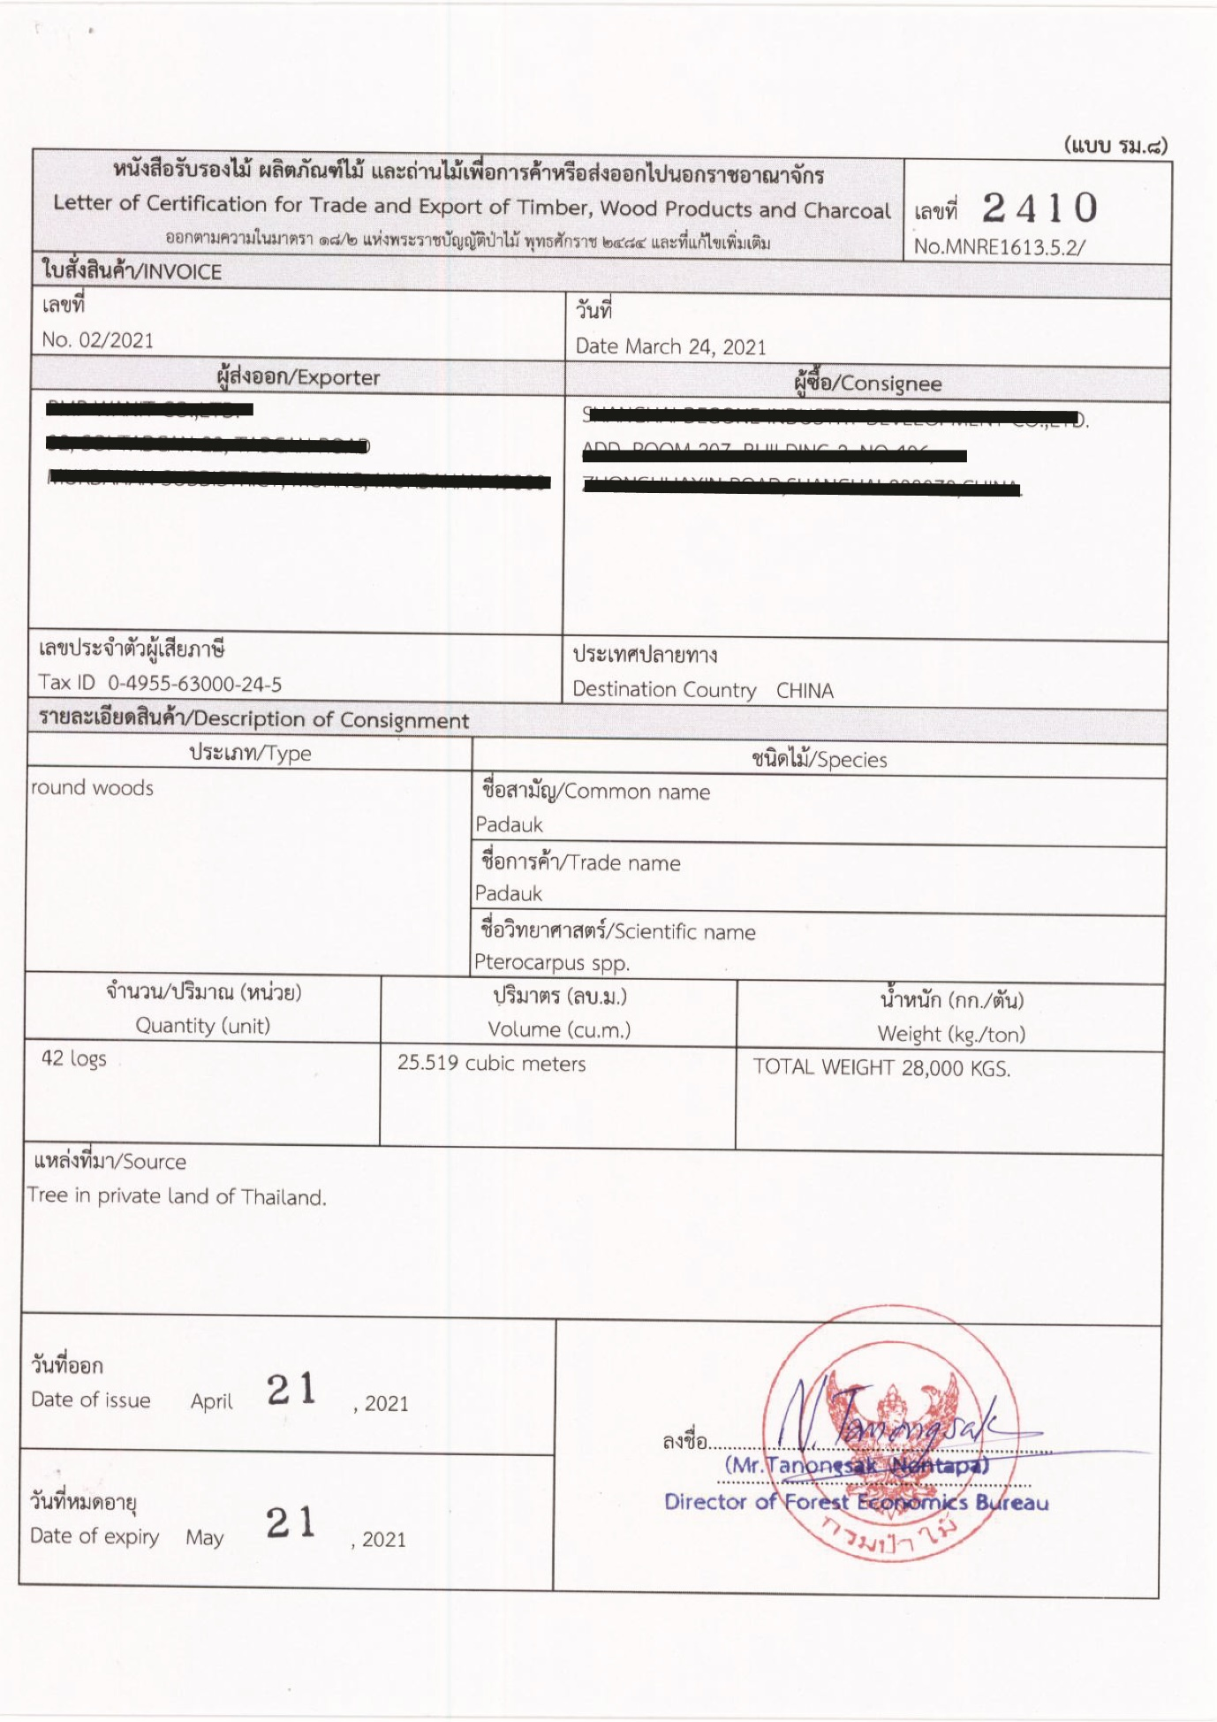

## Appendix H: Example of Transport License

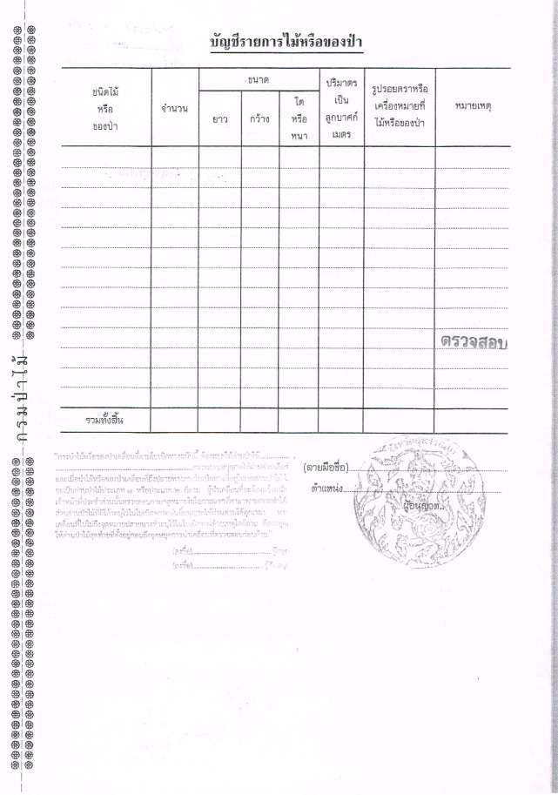

## Appendix I: Example Export License issued by the Thai Customs Department

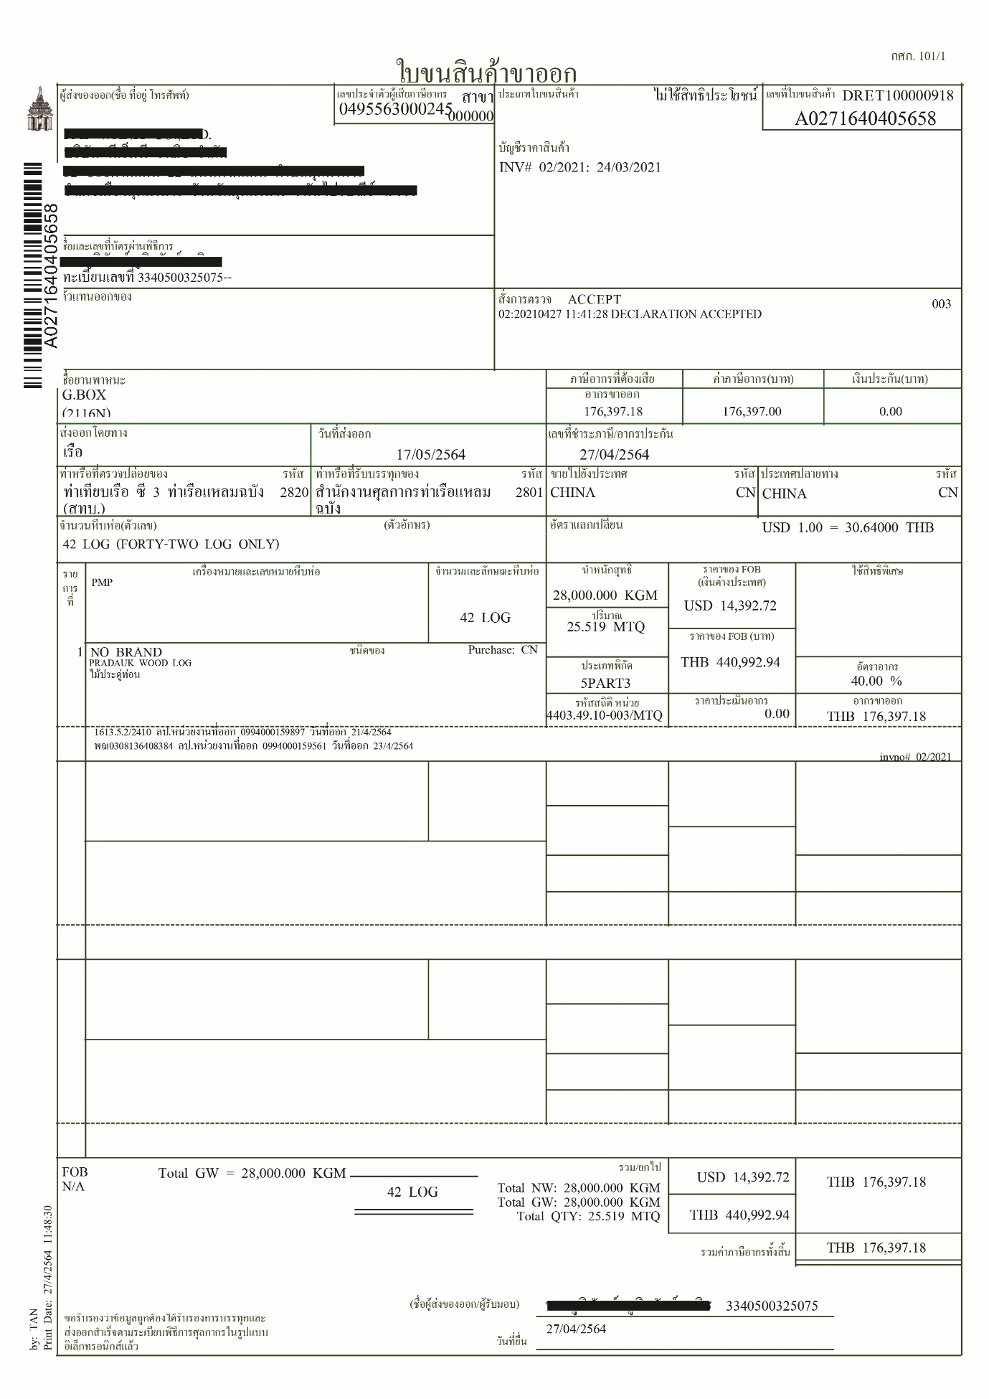

1. Forestry Statistic Data 2018, Royal Forest Department
2. National Reserved Forest is the forest area designated to be a national reserved forest with accordance to Forest Act B.E. 2507 (1964) Section 6, ‘The government may, if it is appropriate to reserve any forest to be national reserved forest so as to conserve forest condition, timber, forest product or other natural resources.’
3. A national park is the land which is determined as national park under National Park Act B.E. 2562 (2019) Section 6, ‘When it is deemed appropriate to determine any area of land, the natural feature of which is of interest, to be maintained with a view to preserving it for the benefit of public education and amenity.’
4. A wildlife sanctuary is under Wild Animal Reservation and Protection Act B.E. 2562 (2019) Section 47, ‘When it is deemed appropriate to determine any area of land with natural feature deserved to be maintained as a sanctuary of wild animals and reserved for wildlife species and natural resources or ecosystem for the benefit of wildlife and biodiversity conservation.
5. A non-hunting area is under Wild Animal Reservation and Protection Act B.E. 2562 (2019) Section 62, ‘When it is deemed appropriate to determine any area of land with natural feature deserved to be maintained as a protected land for habitats and food sources for any wild animals or from any specific species.