**The Three Bees**

Celebrating World Bee Day on 20th May 2021

This month, in honour of world bee day, we are delighted to bring you a special edition of the Three Chiefs Newsletter, 'The Three Bees'. The newsletter showcases three species of bees through specially commissioned artwork by Dan Power. The featured bees are the European honey bee (*Apis mellifera*), the great carpenter bee (*Xylocopa aruana*), and the blue-banded bee (*Amegilla cingulata*). The well-known European honey bee is the bee primarily used for honey production and pollination activities. The great carpenter bee is the largest bee in Australia, nesting in soft timber, while the beautiful native blue-banded bee is increasingly benefiting agriculture through its distinctive ‘buzz pollination’.

Bees are of major commercial value for their honey and beeswax production, and are vital in preserving ecosystem health, providing essential pollination services for plants, and assisting in maintaining plant fitness and genetic diversity. Bees are also an integral part of many global industries, helping to pollinate most of the planet’s crop species that feed humans and farm animals. Nearly two-thirds of Australia’s agricultural production benefit from bee pollination; Australian honey and beeswax production is valued at over $104 million, with pollination services worth an estimated $14.2 billion.

By observing World Bee Day, we raise awareness of the essential role bees play in keeping the planet healthy, and of the many challenges bees face. In December 2017 the United Nations General Assembly proclaimed 20th of May as World Bee Day – a proposal originating from Slovenia. This date marks the birth date of Anton Janša, a Slovenian beekeeper and pioneer of modern beekeeping. The day provides an opportunity to celebrate bees and all activities that will protect and enhance pollinators and their habitats, improve their abundance and diversity, and support the sustainable development of beekeeping.

Being free from many bee pests and diseases, Australia has the healthiest bees in the world.

*"There is a need to keep our bees healthy by the prudent use of pesticides and securing resources such as our trees, because we know that healthy bees = healthy people."*

*- Trevor Weatherhead AM, Chair of the Australian Honey Bee Industry Council Inc.*

## Bee Biosecurity

The Department of Agriculture, Water and the Environment remains committed to bee health and sustainable bee keeping. It is actively engaged in surveillance and other readiness activities, aiming to reduce the risk of bee parasites and diseases, and exotic pest bees entering Australia. Working collaboratively with the states, territories, and industry, the department is constantly on the alert to detect exotic bees, bee pests or diseases.

Biosecurity activities begin offshore, with prevention strategies including building capacity for intensive surveillance in high-risk countries such as Papua New Guinea, Solomon Islands, and Timor-Leste. Vessels and imported cargo entering Australia must adhere to strict pre-arrival biosecurity conditions; for example reporting the presence of insects including bees, followed by thorough inspection and treatment to manage bee pest and disease risks.

The department provides financial support for programs such as the National Bee Pest Surveillance Program (NBPSP) and the National Bee Biosecurity Program (NBBP). Both are administered by Plant Health Australia (PHA), the national coordinator of government-industry partnership for plant biosecurity in Australia.

The NBPSP is an early warning system for bee biosecurity threats at key border entry points, providing surveillance and early detection of exotic pest bees and pests and diseases. Activities include deploying sentinel hives and empty boxes at high-risk seaports to attract any exotic bee swarms and parasites that may arrive through international sea pathways. In addition, floral sweep netting, and dissection of rainbow bee-eater bird's pellets is undertaken in the vicinity of high-risk ports to detect exotics such as Asian honey bee (*Apis cerana*). Traps are also used in hives in several states for detection of small hive beetle.

The NBBP functions in improving the management of established bee pests and diseases, and increasing preparedness for exotic bee threats. This program provides a bee biosecurity officer to most jurisdictions who work with the relevant state agencies to educate and prepare for bee biosecurity risks.

**Varroa mite and the Purple Hive Project**

Australia’s native bees, agricultural industries and environment are at constant risk from both exotic bees and their parasites. Stopping these organisms from entering and establishing in Australia is of great importance to the Department of Agriculture, Water and the Environment, which has ranked both mites of bees and exotic bees as National Priority Plant Pests.

Varroa mites (*Varroa destructor* and *Varroa jacobsoni*) are tiny external parasites of honey bees. Although they can live on adult bees, they mainly feed and reproduce on larvae and pupae in the developing brood, causing malformation and weakening of bees as well as transmitting numerous viruses. Heavy infestations usually build up within 3–4 years, resulting in crippled and crawling bees with impaired flight performance and a reduced lifespan. Colony breakdown and death are common outcomes for infested hives.

The varroa mite has devastated honey bee colonies worldwide with Australia being the only populated continent in the world to remain free of the pest. If the varroa mite were to establish in Australia, it has the potential to severely damage the local beekeeping industry, with an estimated 20,000 cropping and horticulture industry businesses potentially being affected, as well as home gardeners and the wider community.

European honeybee with varroa mite, *Varroa destructor*, on its thorax

Credit: Scott Bauer, USDA Agricultural Research Service, Bugwood.org

Within Australia, ports have been identified as high-risk pathways for the entry of exotic bees and their parasites, with swarms having previously arrived via vessel from multiple countries. Currently, as part of the National Bee Pest Surveillance Program, sentinel hives are located at most Australian ports, with the aim of capturing a swarm on arrival. These hives are physically monitored for exotic pests and diseases, like varroa mite, approximately every six weeks. While these sentinel hives are an incredibly useful surveillance tool, it takes significant manpower to scrutinise them regularly for the presence of exotic bees.

To enhance Australia’s capability to respond to an incursion, new technology known as the Purple Hive Project is being trialled in Victoria. The Purple Hive Project is an initiative by Bega Cheese Limited’s B honey, created to support the viability of the honey industry by monitoring bee hives remotely for *Varroa destructor*. This technology is a solar-powered device that uses artificial intelligence and 360-degree camera technology to observe each individual bee entering the Purple Hive (in real time), and scans them to determine if *Varroa destructor* is present.

Exotic honey bee swarm on imported machinery

Photo credit: DAWE

If there is a detection, a notification will be sent immediately to state biosecurity officers which will allow for the Purple Hive to be checked and quarantined.

The Purple Hive has now been installed at the Port of Melbourne alongside sentinel hives as a trial for protection against these exotic pests. The initiative is backed by the Victorian Government and Agriculture Victoria in agreement with Bega Cheese Limited. You can learn more about the project at [www.purplehiveproject.com.au](http://www.purplehiveproject.com.au).

The Purple Hive at the Port of Melbourne

Credit: Bega Cheese Limited

Surveillance for early detection of the varroa mite remains crucial to protecting the health of the honey industry and Australian agriculture more broadly.

**Environmental Biosecurity Risk Mitigation Plan for Australian Native Bees**

When we think of bees, we most likely think of European honey bees (*Apis mellifera*). These are social animals that form hives with a complex social hierarchy. Around the world there are about 20,000 species of bees, however most do not form large hives and live in small colonies or alone (solitary bees).

Australia has over 1,500 species of native bees, the vast majority of which are solitary species that scientists have grouped into five families. Many of these species have not yet been studied. Australia’s native bees live in a range of habitats, with many adapting to specific places in the natural environment. Australia's only truly social bees occur in the northern half of Australia (with one species having a natural range that extends southwards to the Sydney region). Unlike European honey bees, this small group of native social bee species are stingless. Research into native stingless bees including their taxonomy, use in pollination and honey production has been of interest to researchers for several decades, and it is now becoming of interest to commercial agriculture.

Highly magnified Quasihesma bee of far northern Australia.

*"Australia's claim for the title of 'Smallest Bees in the World' are the minute yellow and black Quasihesma bees of far northern Australia. Australia’s smallest species, Euryglossina (Quasihesma) clypearis from Cape York, Queensland, has males that are just 1.8 mm long."* aussiebee.com.au Credit: Dr Bernie Wittwer, DAWE

From an environmental perspective, bees play a very important role in the ecosystems they inhabit, particularly for the reproduction of flowering plants. When bees fly from one plant to another, their bodies pick up pollen which contains the male genetic material that can fertilise the female structure of the flower or cone to produce seeds. In nature, flowers reward these pollinators - which also include other insects, birds and small bats - by producing nectar that provides them with energy. Pollen itself is also a source of protein and might be brought back to the hives to feed their brood.

There are around 100 known Australian bee species that have specialised relationships with one or very few Australian plant species. If something happened to the native bee, the native plant relying on it for pollination would have no way of reproducing. If native bees disappeared from our environment, the propagation of native Australian plants could be badly affected, with devastating flow on A picture containing text
effects for all the animals, birds and other species that rely on those plants for habitat and food.

*Austroplebeia essingtoni* at their nest entrance

(a social bee species from the Kimberley)

Credit: Dr Bernie Wittwer, DAWE

Significant research exists on viruses affecting *Apis* species, but little is known about pests and diseases that could come from outside Australia that may affect the native Australian bees. It is reasonable to assume however, that native Australian bees may be susceptible to viral, bacterial or fungal pathogens that are not present in Australia. There are also a range of insect bee pests which may affect native bees. It has been observed that weak or damaged stingless bee hives are susceptible to the small hive beetle that established in Australia recently. Such findings have highlighted the importance of good stingless bee hive management to ensure native bee hives remain healthy.

Highly magnified mouthpart from *Tetragonula carbonaria*, a common stingless bee, designed to collect nectar.

Credit: Dr Bernie Wittwer, DAWE

Changes in climate, bushfires, the growing use of insecticides in agriculture, and the increase in human populations, all affect the natural environment and the way bees live. These pressures are rising and with increasing volumes of trade it is important to understand the pathways by which other threats to bees might arrive.

The Chief Environmental Biosecurity Office is working with Plant Health Australia to develop a plan to better understand and manage biosecurity risks to Australian native bees. This project is expected to be completed in late 2022.

Highly magnified antenna from *Tetragonula carbonaria* using an electron microscope. Antennae are covered with structures and organs which are capable of detecting minute levels of chemistry or perfumes as bees fly around searching for flowers. *Tetragonula carbonaria* are an east coast species of Australian stingless, social bees which pollinate orchids. Credit: Dr Bernie Wittwer, DAWE

The office acknowledges the contribution of Plant Health Australia and Dr James Walker, DAWE.

**Bees and the World Organisation for Animal Health**

The World Organisation for Animal Health (OIE) is the intergovernmental organisation responsible for improving animal health and welfare worldwide. Their work covers a wide range of farmed and wild animals – including bees.

The OIE has broad responsibilities, which extend to supporting the bee industry to maintain healthy hives and quickly report significant disease outbreaks. Disease reports are coordinated through a publicly available online platform, the World Animal Health Information System (OIE-WAHIS). This platform allows beekeepers, government officials and scientists around the world to quickly identify and respond to disease outbreaks.

Inspecting a colony for adult small hive beetles

Credit: OIE Terrestrial Manual

OIE publications also play a key role in supporting the bee industry to diagnose and control bee diseases, and to manage the risk of disease spread when trading bees and bee products internationally. A section of the OIE’s Terrestrial Animal Health Code is dedicated to Apidae, providing guidance on bee disease status and safe international trade. The OIE Manual of Diagnostic Tests and Vaccines for Terrestrial Animals also contains a dedicated Apidae section, outlining internationally agreed diagnostic laboratory methods that facilitate effective disease surveillance and control.

The Terrestrial Code and Terrestrial Manual are regularly revised to maintain alignment with the latest scientific knowledge and practical trade developments. The next updates will be considered at the OIE’s key annual meeting, the 88th General Session, which commences the week after World Bee Day. One of the revised chapters that will be proposed for adoption is *Chapter 9.4 Infestation with Aethina tumida (small hive beetle).*

The small hive beetle is native to sub-Saharan Africa and feeds on honey bee brood, honey and pollen. While the beetles feed on food stores, the remaining honey ferments and the comb is destroyed, promoting structural collapse of hives and causing adult honey bees to abandon severely infested colonies. Australia has first-hand experience of the impact that this pest can have. Since its first detection in Australia in 2002 it has caused a major impact to honey bee colonies throughout the warm and humid coastal strip between Victoria and North Queensland.

Small hive beetle

Credit: OIE Terrestrial Manual

Dr Schipp at the OIE

Credit: DAWE

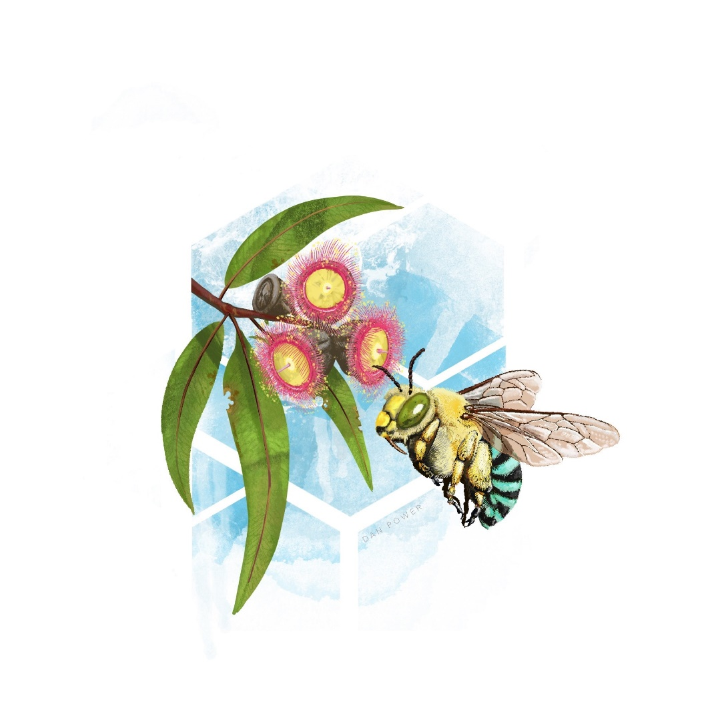The Australian Chief Veterinary Officer, Dr Mark Schipp, is the current President of the OIE and will chair the upcoming General Session, including the voting for new and revised technical chapters. For the last three years, it has been a great privilege for Dr Schipp to hold the Presidency of the OIE, an organisation founded in 1924 and which now has 182 Member Countries. While Dr Schipp’s Presidency will end at the conclusion of the General Session, he will remain on the OIE’s Council and Australia will continue to play a key role in advancing animal health and welfare internationally.

**World Bee Day 2021 Events**

**Australian Chief Plant Protection Webinar: World Bee Day**

Host and Chair: Dr Gabrielle Vivian-Smith

Thursday 20 May at 11 am AEST until 12 noon

**Dr Rebecca Laws**

**Preventing exotic and endemic bee pests – the role of the Australian beekeeper**

Bee pests and diseases are a major threat to the Australian honey bee industry, and also the plant industries that rely on bees for pollination. Fortunately, Australia is free from many of the most devastating bee pests and diseases that occur overseas, however in order to remain this way, every beekeeper needs to play their part in undertaking surveillance for pests such as varroa mite. There are also several endemic pests and diseases that beekeepers need to regularly monitor for in their hives, and undertake swift management to prevent these pests and diseases from spreading. The key pest and disease threats to the Australian honey bee industry, including aspects of prevention and preparedness, surveillance, detection, and reporting will be presented.

**Robert Stephens**

**National Varroa Mite Eradication Program Overview**

The National Varroa Mite Eradication Program (NVMEP) has run continuously in Townsville since mid-2016. In that time three separate incidents of *Varroa jacobsoni* have been detected and eradicated from within the Townsville local government area. The program is led by Biosecurity Queensland and has been nationally funded through a partnership between industry, the Australian Government and all state and territory governments. Extensive surveillance and monitoring activities were conducted as part of the program to ensure the mite had not spread.

To attend this event via Microsoft teams please contact the ACPPO office via email at acppo@agriculture.gov.au

World Bee Day Australia-wide events - [World Bee Day (Australia) – 20 May – Helping Protect our Bees](https://www.worldbeeday.org.au)

Embassy of Sweden event - [22 May 2021, 2-4pm, Canberra - World Bee Day 2021 - Sweden Abroad](https://www.swedenabroad.se/en/embassies/australia-canberra/current-affairs/calender/world-bee-day-2020/)

Embassy of Italy event - [A visit to the tiny wonderful world of bees and their gigantic significance - Tickets, Fri 21/05/2021 at 4:00 pm | Eventbrite](https://www.eventbrite.com.au/e/a-visit-to-the-tiny-wonderful-world-of-bees-and-their-gigantic-significance-tickets-152947164085)

**Want to know more about bees in Australia?**

[The Australian Honey Bee Industry Council- AHBIC website](https://honeybee.org.au)

[Size and scope of the Australian honey bee and pollination industr](https://agrifutures.com.au/product/size-and-scope-of-the-australian-honey-bee-and-pollination-industry-a-snapshot/)y

[Final report: Investigating factors that influence chalkbrood outbreaks in Australia](https://www.agrifutures.com.au/product/final-report-investigating-factors-that-influence-chalkbrood-outbreaks-in-australia/)

[Bee biosecurity webinars](https://beeaware.org.au/archive-news/bee-biosecurity-webinar-recordings-now-available/)

[Biosecurity, pests and diseases of native bees](https://www.youtube.com/watch?v=ARcwCHc6_SI)

[Eradicating varroa mites – the sweetest success | Department of Agriculture and Fisheries, Queensland](https://www.daf.qld.gov.au/news-media/podcasts/eradicating-varroa-mites-the-sweetest-success)

Happy World Bee Day from the Three Chiefs!

Artwork by Dan Power, commissioned by the Australian Chief Plant Protection Office in honour of World Bee Day