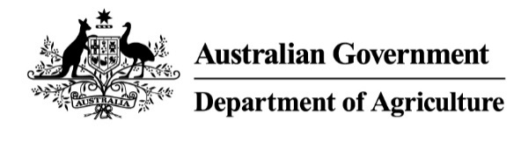

Imported food holding order—food posing a serious risk to human health
Sections 15(3) & (4) of the Imported Food Control Act 1992 (the Act)
Holding order number: | THO19001 | Date: | 06/02/2020

Section A: The basis for this Order
Section 15(3) of the Act
I am satisfied that there are reasonable grounds for believing that food of a particular kind may pose a risk to human health, and that this risk is serious.
or
Section 15(4) of the Act | x
The time period of the holding order made under Section 15 (3) may be extended, and an extension may be made more than once.
Section B: Food that this Order covers
This Order covers food identified in the table below that is imported into Australia after the making of this Order.
Country of origin | Republic of Korea
Product description | Salted manila clams
Producer name | GREENWELL FOOD CO LTD (NAMDOO FOOD CO LTD)
Until this Order is revoked, food that this Order covers, that is imported into Australia after the making of this Order, must be held in a place to be approved by an authorised officer in writing:
- for a period of 28 days commencing the day this Order is made; or
- if this order has been extended, until the end of the extended period; or
- until the time when this Order is revoked.

Section C: The circumstances under which this Order will be revoked
This Order remains in force until the Secretary (or delegate) revokes it. This Order will immediately be revoked under these circumstances:
Republic of Korea authorities provide assurances that appropriate corrective actions have been implemented to ensure future imports are safe.
Delegate position number Date
31823 | 06/02/2020
Delegate of the Secretary appointed under Section 41 of the Act for the purposes of Section 15 of the Act.

