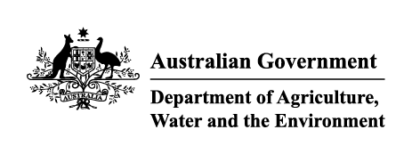

# Imported food holding order—food posing a serious risk to human health

Sections 15(3) & (4) of the *Imported Food Control Act 1992* (the Act)

| Holding order number: | THO21001 | Date: | 04/09/2021 |
| --- | --- | --- | --- |

## Section A: The basis for this Order

| Section 15(3) of the Act |  |
| --- | --- |

I am satisfied that there are reasonable grounds for believing that food of a particular kind may pose a risk to human health, and that this risk is serious.

or

| Section 15(4) of the Act | X |
| --- | --- |

The time period of the holding order made under Section 15 (3) may be extended, and an extension may be made more than once.

## Section B: Food that this Order covers

This Order covers food identified in the table below that is imported into Australia after the making of this Order.

| Country of origin | Jordan |
| --- | --- |
| Product description | Medjool dates |
| Producer name | WHITE SAND PALM DATES FARM AND AGRICULTURE PRODUCTS |

Until this Order is revoked, food that this Order covers, that is imported into Australia after the making of this Order, must be held in a place to be approved by an authorised officer in writing:

1. for a period of 28 days commencing the day this Order is made; or
2. if this order has been extended, until the end of the extended period; or
3. until the time when this Order is revoked.

## Section C: The circumstances under which this Order will be revoked

This Order remains in force until the Secretary (or delegate) revokes it. This Order will immediately be revoked under these circumstances:

The Secretary is satisfied that the basis for the order, being the risk of hepatitis A contamination in imports of Medjool dates from White Sand Palm Dates Farm and Agriculture Products in Jordan, has been mitigated such that there is no longer a serious risk to human health.

**Delegate position number Date**

| 100968 | 03/09/2021 |
| --- | --- |

Delegate of the Secretary appointed under Section 41 of the Actfor the purposes of Section 15 of the Act*.*