**Threat Abatement Advice for the key threatening process**

**‘Psittacine Circoviral (beak and feather) Disease affecting endangered psittacine species’**

This Threat Abatement Advice has been developed based on the best available information at the time of development (December 2015). This is not a statutory document.

Will be updated as needed. Last updated August 2016

To provide information updates, please email invasivespecies@environment.gov.au

Contents

1. Purpose 2

2. Description of the key threatening process 2

3. EPBC Act threatened parrot species 4

4. Listing Status 6

5. Documentation relevant to PBFD 6

6. Priority EPBC parrot species 10

7. Gaps in knowledge on PBFD 11

8. Abatement actions for PBFD 13

9. Information Sources 17

10. Maps 20

## 1. Purpose

The purpose of this threat abatement advice (TAA) is to identify actions and research to abate the key threatening process (KTP): ‘Psittacine Circoviral (beak and feather) Disease affecting endangered psittacine species’ listed under the *Environment Protection and Biodiversity Conservation Act 1999* (EPBC Act).

The document provides guidance for stakeholders on action and research that may abate the threat. It covers actions at the national, state and local level and is intended for the following audiences:

* individuals or organisations on recovery teams for recovery plans,
* government agencies,
* research organisations,
* avian veterinarians,
* natural resource management groups,
* local communities,
* wildlife carers, and
* interested individuals

Eradication of this ubiquitous disease is not possible at this stage, but further research and mitigation measures can assist in reducing its impact on threatened parrot populations. This TAA, used in partnership with parrot recovery plans, will consolidate the management of Psittacine Beak and Feather Disease (PBFD) impacts on native threatened parrots.

This threat abatement advice for ‘Psittacine Circoviral (beak and feather) Disease affecting endangered psittacine species’ does not necessarily encompass all actions that may abate the KTP, but highlights those that are currently of highest priority.

## 2. Description of the key threatening process

The nomination for listing 'Psittacine Circoviral (beak and feather) Disease' as a Key Threatening Process was originally submitted under the *Endangered Species Protection Act 1992* (ESP Act). Psittacine Beak and Feather Disease affecting endangered psittacine species (parrots and related species) was listed in April 2001 as a key threatening process under the *Environment Protection and Biodiversity Conservation Act 1999* (EPBC Act).

With beak and feather disease there are terms that describe the clinical disease, these are: psittacine beak and feather disease or psittacine circoviral disease. The terms that refer to the causative agent include: beak and feather disease virus or psittacine circovirus. This is an important distinction because not all birds that are infected with beak and feather disease virus (BFDV), will go on to develop psittacine beak and feather disease, so the terms should not be used interchangeably.

Many aspects of PBFD remain unknown. A categorised list of some of the gaps in our knowledge on PBFD can be seen further on in this document in section 7. PBFD is the most common and highly infectious viral disease among parrots. Its distribution is potentially Australia-wide, including Tasmania.

PBFD is most often seen in young birds up to three years of age; however birds up to 20 years of age have developed clinical signs after years of being clinically normal. PBFD can cause high juvenile mortality; long-term immunological suppression; and feather and beak abnormalities. Known methods of infection include: through crop secretions, fresh or dried excrement and feather and skin particles, as well as passed on through the mother to egg.

The seventeen species of threatened Australian psittacine parrots have small and sometimes isolated populations. They all face significant threats such as habitat loss and predation. Due to the continual stresses from threats, they are more likely to be susceptible and therefore significantly threatened by a virus, such as beak and feather disease virus, particularly if it affects juveniles and fledging rates.

The time period in which the disease develops varies; it can appear very suddenly (peracute), suddenly (acute) or over a long term (chronic). Peracute or acute disease is most common in young birds. Affected birds rapidly develop non-specific clinical signs which may include crop stasis, regurgitation, weight loss, green diarrhoea and urates, dehydration, weakness, fluffed appearance and swollen or painful wing tips. Acutely affected birds may die suddenly prior to the development of feather abnormalities.

The most common and readily recognisable manifestation of PBFD is the chronic form, characterised by feather and beak abnormalities. Table 1 shows an array of clinical signs that mature parrots may display when affected by PBFD. The first signs in mature birds can occur in the powder down and contour feathers; then the primary, secondary, tail and, if they have them, crest feathers, which become abnormal progressing to total baldness if birds survive long enough.

Table 1: Clinical signs of chronic PBFD for some species

|  |  |
| --- | --- |
| Clinical Sign | Description |
| Feather dust absent | Swiping hand between feathers should result in your hand being covered with feather dust. PBFD reduces the amount of feather dust produced because the contour feathers are not normal. |
| Shiny beak and feet | Instead of beak and feet being covered in feather dust their true colour is revealed. |
| Abnormal feather growth | Emerging feathers are small, twisted and very abnormal. Some feathers lack colour or have a different than normal colour. |
| Grubby looking | Feather dust cover keeps feathers looking nice and clean, lack of feather dust makes birds look very dirty. |
| Crest loss | Crest feathers missing. |
| Blood in feather shafts | Developing feathers normally close off blood supply when mature. Feathers affected by BFDV do not close off or are fractured, and dried blood can be seen in the calamus. |
| Beak deformed | Deformed beaks and unstable beak integrity. |
| Tail feathers missing | Some or all tail feathers missing. |
| Symmetrical wing feather loss | After moult, new feathers do not grow. Moult occurs symmetrically. |

Birds with chronic PBFD may present with some, but not necessarily all clinical signs in Table 1. These clinical signs are variable between species, and as such it is important to be familiar with the appearance of healthy birds so as to accurately evaluate whether a bird has beak and feather disease by their appearance.

These clinical signs do not apply equally to all psittacine species. For example, the absence of feather dust is normal in white cockatoos and galahs; however most black cockatoos do not have powder on their feathers that is visible on your hand after handling. This would also be true of many lorikeets, rosellas and other small parrots. A shiny beak is also normal in some species. Beak deformities caused by PBFD are common in cockatoo species, but less common in other parrots. Images of healthy looking EPBC protected parrots and species information can be seen in Table 2.

## 

## 3. EPBC Act threatened parrot species

Table 2: The seventeen species of Australian threatened psittacines

|  |  |  |  |  |
| --- | --- | --- | --- | --- |
| **Image** | \\pvac01file02\user2$\A18523\Profile\Desktop\Untitled.png | \\pvac01file02\user2$\A18523\Profile\Desktop\Untitled.png | \\pvac01file02\user2$\A18523\Profile\Desktop\Untitled.png | \\pvac01file02\user2$\A18523\Profile\Desktop\Untitled.png |
| **Threatened Parrot Species** | Baudin’s cockatoo | Carnaby’s cockatoo | Coxen’s fig parrot | Forest red-tailed black cockatoo |
| **Scientific name** | *Calyptorhynchus baudinii* | *Calyptorhynchus latirostris* | *Cyclopsitta diophthalma coxeni* | *Calyptorhynchus banksii naso* |
| **EPBC status** | Vulnerable | Endangered | Endangered | Vulnerable |

|  |  |  |  |  |
| --- | --- | --- | --- | --- |
| **Image** | \\pvac01file02\user2$\A18523\Profile\Desktop\Untitled.png | \\pvac01file02\user2$\A18523\Profile\Desktop\Untitled.png | *Untitled* | \\pvac01file02\user2$\A18523\Profile\Desktop\Untitled.png |
| **Threatened Parrot Species** | Glossy black cockatoo | Golden shouldered parrot | Green Rosella | Night parrot |
| **Scientific name** | *Calyptorhynchus lathami halmaturinus* | *Psephotus chrysopterygius* | *Platycercus caledonicus brownii* | *Pezoporus occidentalis* |
| **EPBC status** | Endangered | Endangered | Vulnerable | Endangered |

|  |  |  |  |  |  |
| --- | --- | --- | --- | --- | --- |
| **Image** | \\pvac01file02\user2$\A18523\Profile\Desktop\Untitled.png | \\pvac01file02\user2$\A18523\Profile\Desktop\Untitled.png | Untitled | \\pvac01file02\user2$\A18523\Profile\Desktop\Untitled.png | \\pvac01file02\user2$\A18523\Profile\Desktop\Untitled.png |
| **Threatened Parrot Species** | Norfolk Island green parrot | Orange-bellied parrot | Palm Cockatoo | Princess parrot | Red-tailed black cockatoo |
| **Scientific name** | *Cyanoramphus novaezelandiae cookii* | *Neophema chrysogaster* | *Probosciger aterrimus macgillivrayi* | *Polytelis alexandrae* | *Calyptorhynchus banksii graptogyne* |
| **EPBC status** | Endangered | Critically Endangered | Vulnerable | Vulnerable | Endangered |

|  |  |  |  |  |
| --- | --- | --- | --- | --- |
| **Image** | \\pvac01file02\user2$\A18523\Profile\Desktop\Untitled.png | \\pvac01file02\user2$\A18523\Profile\Desktop\Untitled.png | \\pvac01file02\user2$\A18523\Profile\Desktop\Untitled.png | \\pvac01file02\user2$\A18523\Profile\Desktop\Untitled.png |
| **Threatened Parrot Species** | Regent parrot | Superb parrot | Swift parrot | Western ground parrot |
| **Scientific name** | *Polytelis anthopeplus monarchoides* | *Polytelis swainsonii* | *Lathamus discolor* | *Pezoporus wallicus flaviventris* |
| **EPBC status** | Vulnerable | Vulnerable | Critically Endangered | Critically Endangered |

## 4. Listing Status

A) Under Commonwealth legislation

Psittacine Circoviral (beak and feather) Disease was listed as a KTP under the EPBC Act, as it meets the requirements of sections 188(4) (b) and 188(4) (c) of the EPBC Act, specifically:

* Psittacine Circoviral Disease may cause native species to be listed in a threat category representing a higher degree of endangerment. For example, without preventative action Endangered species may become Critically Endangered.
* The disease adversely affects a number of listed threatened bird species, including the Orange-bellied Parrot (*Neophema chrysogaster*) and the Norfolk Island Green Parrot (*Cyanoramphus cookii*), as well as other parrots listed in Table 2.

A *Threat Abatement Plan for Beak and Feather Disease Affecting Endangered Psittacine Species* was prepared in 2005. It contains useful background information, but is no longer considered the most feasible, effective and efficient way to address the key threatening process and is no longer current. Threat abatement will now be achieved through incorporating PBFD actions in individual species recovery plans or conservation advices, as well as the information provided in this advice.

B) Under state and territory legislation

New South Wales is the only jurisdiction in Australia that has legislation related to PBFD. Beak and Feather Disease affecting endangered psittacine species and populations was listed as a key threatening process under Schedule 3 of the *Threatened Species Conservation Act 1995* on 6 December 2002.

C) Under New Zealand legislation

In New Zealand, the Department of Conservation (DOC) introduced a national ban on moving parrots from areas with known PBFD exposure to areas of unknown or negative PBFD status in 2009. A nationwide programme investigating the presence of PBFD in native parrots is being led by the DOC with support from the Ministry of Agriculture and Forestry, and a long-term strategy is being developed to manage the risk of PBFD.

In the wild, PBFD is widespread in the North Island amongst exotic parrots, such as sulphur-crested cockatoos and eastern rosellas. The presence of the disease in the South Island is unknown. PBFD has been confirmed in native wild populations of red-crowned parakeets/kākāriki on Hauturu-o-Toi/Little Barrier Island, Tiritiri Matangi Island; and in yellow-crowned parakeets/kākāriki in Fiordland.

## 5. Documentation relevant to PBFD

A number of national and state based policies, strategies and plans have been adopted to provide information on the species threatened by PBFD**,** includingrecovery plans, listing assessments and conservation advices described below. There are also several othersources of information which are highly useful. See Table 3 for relevant documents.

1. Recovery plans define the research and management actions necessary to stop the decline of, and support the recovery of, listed threatened species or threatened ecological communities. The aim of a recovery plan is to maximise the long term survival in the wild of a threatened species or ecological community.
2. Listing assessments determine if a species or ecological community is eligible for listing as threatened in one of the categories under the EPBC Act, a rigorous scientific assessment of the species or ecological community's threat status is undertaken.
3. Conservation advices are developed to assist the recovery of a native species or ecological community when it is listed as threatened under the EPBC Act. They provide guidance on immediate recovery and threat abatement activities that can be undertaken to ensure the conservation of a newly listed species or ecological community. They include practical on-ground activities and may also include broader management actions.

Table 3: Documents related to Australian threatened psittacines and PBFD

| **Threatened Parrot Species** | **Scientific name** | **Information on PBFD included in documents** |
| --- | --- | --- |
| **Species with EPBC Act listing Recovery Plans as of 2016** | | |
| [Baudin’s cockatoo](http://www.environment.gov.au/system/files/resources/48e4fc8c-9cb7-4c85-bc9f-6b847cf4c017/files/wa-forest-black-cockatoos-recovery-plan.pdf) | *Calyptorhynchus baudinii* | Information on PBFD is not contained within this plan |
| [Carnaby’s cockatoo](http://www.environment.gov.au/system/files/resources/94138936-bd46-490e-821d-b71d3ee6dd04/files/carnabys-cockatoo-recovery-plan.pdf) | *Calyptorhynchus latirostris* | A study was conducted in the 2010 nesting season on prevalence of BFDV in Carnaby’s cockatoo nestlings. BFDV was detected in 8.5% of nestlings and in nest material from one nest (9%). The clinical significance of PBFD remains unknown and long-term research of the epidemiology and clinical significance in wild populations is required |
| [Coxen’s fig parrot](http://www.environment.gov.au/system/files/resources/9170039a-db76-4835-b541-5c08bb4a9775/files/cyclopsitta-diophthalma-coxeni.pdf) | *Cyclopsitta diophthalma coxeni* | Information on PBFD is not contained within this plan |
| [Forest red-tailed black cockatoo](http://www.environment.gov.au/system/files/resources/48e4fc8c-9cb7-4c85-bc9f-6b847cf4c017/files/wa-forest-black-cockatoos-recovery-plan.pdf) | *Calyptorhynchus banksii naso* | Information on PBFD is not contained within this plan |
| [Glossy black cockatoo](http://www.environment.gov.au/system/files/resources/eba7ed3d-80fa-4519-b39e-f1cff0dc71d2/files/c-lathami-halmaturinus.pdf) | *Calyptorhynchus lathami halmaturinus* | Information on PBFD is not contained within this plan |
| [Golden shouldered parrot](http://www.environment.gov.au/system/files/resources/f2ba8fe9-2091-4e37-84ac-dc1ee04c5179/files/p-chrysopterygius.pdf) | *Psephotus chrysopterygius* | Information on PBFD is not contained within this plan |
| Green Rosella: [link](http://www.environment.gov.au/cgi-bin/sprat/public/publicshowallrps.pl?proc=main&new_top_key=common_name&order=title&order=sci_name&order=community_name&order=date_adopted&order=common_name) for updates | *Platycercus caledonicus brownii* | This species does not yet have a Recovery Plan |
| Night parrot: [link](http://www.environment.gov.au/cgi-bin/sprat/public/publicshowallrps.pl?proc=main&new_top_key=common_name&order=title&order=sci_name&order=community_name&order=date_adopted&order=common_name) for updates | *Pezoporus occidentalis* | This species does not yet have a Recovery Plan |
| [Norfolk Island green parrot](http://www.environment.gov.au/system/files/resources/018b9480-6db8-4361-8db2-ab83d5fa5072/files/norfolk-island.pdf) | *Cyanoramphus novaezelandiae cookii* | PBFD was probably responsible for the deaths of many green parrots on Norfolk Island in the 1970s |
| [Orange-bellied parrot](http://www.environment.gov.au/system/files/resources/f493ebf4-a19b-412c-ac15-413b7d413a69/files/orange-bellied-parrot-recovery.pdf) | *Neophema chrysogaster* | PBFD caused a significant death event during the breeding program in 1991. The relocation of the captive-bred stock to a warmer, more sheltered facility site in Hobart has prevented another outbreak. The disease was detected in wild birds in 1993. A significant number of individuals are antibody positive to PBFD. Sub-clinical effects of PBFD are unknown |
| Palm Cockatoo: [link](http://www.environment.gov.au/cgi-bin/sprat/public/publicshowallrps.pl?proc=main&new_top_key=common_name&order=title&order=sci_name&order=community_name&order=date_adopted&order=common_name) for updates | *Probosciger aterrimus macgillivrayi* | This species does not yet have a Recovery Plan |
| Princess parrot: [link](http://www.environment.gov.au/cgi-bin/sprat/public/publicshowallrps.pl?proc=main&new_top_key=common_name&order=title&order=sci_name&order=community_name&order=date_adopted&order=common_name) for updates | *Polytelis alexandrae* | This species does not yet have a Recovery Plan |
| [Red-tailed black cockatoo](http://www.environment.gov.au/system/files/resources/829cef61-e8a0-4914-b037-84f7f4e2e747/files/c-b-graptogyne.pdf) | *Calyptorhynchus banksii graptogyne* | Information on PBFD is not contained within this plan |
| [Regent parrot](http://www.environment.gov.au/system/files/resources/f56d537f-55a5-46b2-981d-2af77e9aa93a/files/regent-parrot.pdf) | *Polytelis anthopeplus monarchoides* | Information on PBFD is not contained within this plan |
| [Superb parrot](http://www.environment.gov.au/system/files/resources/4d6611e8-0965-48f1-940d-1c32ec0e2b88/files/polytelis-swainsonii-recovery-plan.pdf) | *Polytelis swainsonii* | Information on PBFD is not contained within this plan |
| [Swift Parrot](http://www.environment.gov.au/system/files/resources/c3e20a20-8122-4a9c-bd06-455ea7620380/files/lathamus-discolor-swift-parrot.pdf) | *Lathamus discolor* | PBFD could potentially have serious implications if the general health of the population is reduced from stress. There may be an increased risk of PBFD through the rehabilitation and release of injured birds back into the wild. There is no capacity to control the interaction of two wild bird populations where their habitats overlap. The prevalence and pathogenicity of the disease is currently not known |
| [Western ground parrot](http://www.environment.gov.au/system/files/resources/52c306c7-9085-4b62-a1dc-4d98c6ebae41/files/south-coast-threatened-birds-2014.pdf) | *Pezoporus wallicus flaviventris* | Information on PBFD is not contained within this plan |
| **Species with EPBC Act Listing Assessments as of 2016** | | |
| [Forest red-tailed black cockatoo](http://www.environment.gov.au/biodiversity/threatened/species/pubs/67034-listing-advice.pdf) | *Calyptorhynchus banksii naso* | Information on PBFD is not contained within this advice |
| [Orange-bellied parrot](http://www.environment.gov.au/system/files/pages/d03fbf7b-2647-49f7-8e62-485866714d60/files/neophema-chrysogaster-listing.pdf) | *Neophema chrysogaster* | PBFD caused significant death among captive Orange-bellied Parrots during the breeding program in 1986-1991. It has also been detected in the wild population. There is a threat of disease transmission within the captive population and into the wild population, through the release of captive-bred birds |
| [Swift parrot](http://www.environment.gov.au/biodiversity/threatened/species/pubs/744-listing-advice.pdf) | *Lathamus discolor* | PBFD is known to affect swift parrots in the wild and in captivity, however its prevalence and pathogenicity is unknown |
| **Species with EPBC Act Conservation Advices as of 2016** | | |
| [Forest red-tailed black cockatoo](http://www.environment.gov.au/biodiversity/threatened/species/pubs/67034-conservation-advice.pdf) | *Calyptorhynchus banksii naso* | Information on PBFD is not contained within this advice |
| [Green Rosella](http://www.environment.gov.au/biodiversity/threatened/species/pubs/67041-conservation-advice-31102015.pdf) | *Platycercus caledonicus brownii* | Information on PBFD is not contained within this advice |
| [Night parrot](http://www.environment.gov.au/biodiversity/threatened/species/pubs/59350-conservation-advice.pdf) | *Pezoporus occidentalis* | Information on PBFD is not contained within this advice |
| [Palm Cockatoo](http://www.environment.gov.au/biodiversity/threatened/species/pubs/67033-conservation-advice-31102015.pdf) | *Probosciger aterrimus macgillivrayi* | Information on PBFD is not contained within this advice |
| [Princess parrot](http://www.environment.gov.au/biodiversity/threatened/species/pubs/758-conservation-advice.pdf) | *Polytelis alexandrae* | PBFD is considered one of the main potential threats to this species |
| [Orange-bellied parrot](http://www.environment.gov.au/system/files/pages/d03fbf7b-2647-49f7-8e62-485866714d60/files/neophema-chrysogaster-conservation.pdf) | *Neophema chrysogaster* | The species is threatened by stochastic factors such as diseases |
| **Species with a state or territory Threatened Species Information Sheet** | | |
| [Princess parrot](https://nt.gov.au/__data/assets/pdf_file/0017/206360/princess-parrot.pdf) | *Polytelis alexandrae* | Northern Territory information sheet: PBFD is not contained within this plan |
| **Background Documents** | | |
| The Australian Government [Threat Abatement Plan](https://www.environment.gov.au/system/files/resources/5764cda0-5e94-48c7-8841-49b09ff7398c/files/beak-feather-tap.pdf) for Psittacine Beak and Feather Disease Affecting Endangered Psittacine Species and information [webpage](http://www.environment.gov.au/biodiversity/threatened/publications/tap/beak-and-feather-disease-affecting-endangered-psittacine-species) | | |
| The Australian Government review of the TAP, [Psittacine](http://www.environment.gov.au/system/files/resources/9b85a93b-00c1-43d2-9e4f-bb6279e956e6/files/beak-feather-disease-and-other-threats-australian-threatened-parrots.pdf) Beak and Feather Disease and other identified Threats to Australian threatened Parrots | | |
| The Australian Government Psittacine Circoviral (beak and feather) Disease [Factsheet](http://www.environment.gov.au/biodiversity/invasive-species/publications/factsheet-beak-and-feather-disease-psittacine-circoviral-disease) | | |
| Hygiene Protocols | | |
| The Australian Government [Hygiene Protocols](http://www.environment.gov.au/resource/hygiene-protocols-prevention-and-control-diseases-particularly-beak-and-feather-disease) for the Prevention and Control of Diseases (Particularly Beak and Feather Disease) in Australian Birds | | |
| Australian Bird Groups | | |
| [The Parrot Society of Australia Inc.](http://www.parrotsociety.org.au/) | | |
| [Birdlife Australia](http://birdlife.org.au/) | | |
| [Bird watch Australia](http://www.birdwatch-australia.com.au/) | | |
| Psittacine Circoviral (beak and feather) Disease | | |
| A source of general information on Psittacine beak and feather disease ([PBFD](http://www.environment.gov.au/biodiversity/invasive-species/diseases-fungi-and-parasites/beak-and-feather-disease)) by the Australian Government, Department of the Environment | | |
| The [key threatening process](http://www.environment.gov.au/node/14594) of Psittacine Circoviral (beak and feather) Disease by the Australian Government, Department of the Environment | | |
| The New South Wales Office of Environment and Heritage information on [PBFD](http://www.environment.nsw.gov.au/threatenedSpeciesApp/profile.aspx?id=20003) | | |
| The New Zealand Department of Conservation (DOC) information on [PBFD](http://www.doc.govt.nz/nature/pests-and-threats/wildlife-health/nz-wildlife-diseases/) | | |
| **Health Resources** | | |
| [Australian Registry of Wildlife Health](http://arwh.org/) was founded at Taronga Zoo in 1985 and has since grown into a diagnostic and resource centre | | |
| [Wildlife Health Australia](https://www.wildlifehealthaustralia.com.au/Home.aspx) has the head office in Sydney and provides research outcomes to the public | | |
| [Standardised Diagnostic Tests](http://www.environment.gov.au/biodiversity/invasive-species/publications/diagnostic-tests-beak-feather-disease) is an extremely technical document by Murdoch University, an avian veterinarian should always be consulted regarding interpretation of test results | | |

## 6. Priority EPBC parrot species

A range of stakeholders are required to support and implement threat abatement work, including Australian, state, territory and local governments; researchers, avian veterinarians, natural resource management groups, recovery plan implementation team members, wildlife carers, interested individuals and community groups. Actions may be undertaken at a national, regional or local level.

Table 4 shows the current determined level of risk that the seventeen EPBC threatened psittacine species face in terms of being infected by PBFD. Most of this information was gathered during the PBFD Threat Abatement Plan review titled Psittacine Beak and Feather Disease and other identified Threats to Australian threatened Parrots. However, risk levels should be re-evaluated as new evidence comes to light.

Table 4: Level of risk EPBC species are facing from potential infection of PBFD

| **Parrots** | **Risk Level** | **Based on** |
| --- | --- | --- |
| Orange-bellied parrot | Very high | Data shows that PBFD was a significant cause of death among captive population previously. The species is very vulnerable to PBFD because it occurs in a single population |
| Glossy black cockatoo | High | Data shows PBFD has been detected in this species, it could pose a risk to the small isolated Kangaroo Island population |
| Norfolk Island green parrot | High | Data shows that PBFD can limit the population recovery and set back conservation goals |
| Red-tailed black cockatoo | High | Expert Opinion states that with only a single population in a small area, a great impact could occur |
| Western ground parrot | High | Limited Data/Expert Opinion shows that wild-caught birds did not have PBFD, however with species current numbers and small range a great impact could occur |
| Carnaby’s cockatoo | Moderate | Data shows the presence of PBFD virus infection in nestlings is sporadic, PBFD is present in wild populations but with species current numbers not great impact has been seen |
| Forest red-tailed black cockatoo | Moderate | Data shows PBFD is present in wild populations but with species current numbers not great impact has been seen |
| Regent parrot | Moderate | Limited Data/Expert Opinion shows with species current numbers not great impact has been seen |
| Superb parrot | Moderate | Limited Data/Expert Opinion shows PBFD could become a threat to the superb parrot in the future and it may pose a significant risk to the species. |
| Swift parrot | Moderate | Data shows the threat of PBFD is not as great as previously considered as seen from collected blood and feather samples |
| Coxen’s fig parrot | Low | Limited Data/Expert Opinion shows there is no evidence that PBFD contributed to the decline of the species and no PBFD in the population currently |
| Night parrot | Low | Limited Data/Expert Opinion shows strict quarantine and tight security protocols are in place on known sites of habitation |
| Baudin’s cockatoo | Unknown | To date, clinical evidence of PBFD has not been detected, the prevalence of PBFD is unknown. |
| Golden shouldered parrot | Unknown | PBFD testing has not occurred for species, and there is no data or expert opinion available |
| Green Rosella | Unknown | No data or expert opinion currently available |
| Palm Cockatoo | Unknown | No data or expert opinion currently available |
| Princess parrot | Unknown | Remoteness, low densities and highly dispersive distribution of the species over various states and territories hinders accurate knowledge. |

## 7. Gaps in knowledge on PBFD

Many aspects of PBFD remain unknown, and further knowledge will allow for better preventative measures to be put in place.

**Virus Characteristics**

* The level of dosage required to establish infection and or cause disease
* Understanding the rate at which the virus evolves and recombination occurs (a process that creates genetic diversity)
* The dynamics of viral replication (growth of biological viruses) in naturally infected birds
* Understanding if there are any differences in the biological significance of BFDV between different psittacine lineages
* Understanding the potential for, and gathering information on occurrences for species infection with PBFD outside of the psittacines

**Immunity**

* Antibody concentration that provides protection for birds exposed to the virus
* Whether the antibodies in adult birds remain constant or drop over time allowing the birds to become vulnerable to the virus
* Protective effects of passive transfer of maternal antibodies to chicks, and its rate of decay in nestlings allowing the nestlings to become vulnerable to the virus
* Infection causing immunosuppression and creating a predisposition to other infectious disease and parasites
* Existence of any host-species co-evolving with the virus to attain natural safeguards or create an attenuation effect

**Transmission**

* Vertical transmission (the transfer of PBFD virus directly from mother to developing egg) could be an important element of virus maintenance within populations
* An established level of known excretion rates of the virus from diseased and carrier birds to help in the quantification of environmental contamination
* Horizontal infection methods (transfer of PBFD virus from one bird to another by direct or indirect means) help identify the process of virus transfer and importance of faecal-oral, feather-oral and ingestion via crop impacts
* Presence of clinically normal carriers and their role in disseminating the virus

**Environment**

* Identifying the role of nest hollows as sources of infection, and where possible acting on procedures to prevent the spread of the virus
* The timeframe of the persistence of the virus in nest hollows and other environments is required to gauge when the most appropriate actions are needed
* Confirming the roles that manmade feeding and watering stations play in disseminating the virus and where possible acting on procedures to prevent its spread

**Population Dynamics**

* The effects of the virus on population viability of effected parrot species
* The effects of the virus on survivorship in common species and how this might change in fragmented populations or endangered species
* Current and continually updated mapping of both spatial and landscape dynamics of the infection would provide a clear record of its spread and allow for appropriate preventative actions
* The minimum population size required to maintain the infection, and what is the influence of spatial, temporal and landscape effects

**Reservoir Species**

* Examine if reservoir species exist naturally and determine their effect on threatened species
* Ability of non-psittacine species to carry and disseminate the virus
* Information on cross-species transmission, its rates, virulence, dynamics of infection and the interplay between different populations
* The serological responses (diagnostic identification of antibodies in the blood serum) & seroepidemiology (study of the patterns of infection by detecting antibody levels)

## 8. Abatement actions for PBFD

The actions shown in Table 5 do not encompass all potential actions to abate the KTP, but highlights those actions considered to be of highest priority at the time of preparing the threat abatement advice.

Table 5: Actions that may abate the threat from PBFD

|  | **Action** | **Priority/Timeframe** | | **Output** | **Outcome** | | **Responsibility** |
| --- | --- | --- | --- | --- | --- | --- | --- |
| **Research** | 1. Common species acting as a reservoir for PBFD coming into contact with threatened species | High priority & long term [Research] | | Report | Limit disease transmission through preventative actions | | Researchers, Recovery Planning teams |
| The role of common species in dispersing PBFD would be determined by this research, and will pinpoint potential disease crossover from one species to another. | | | | | | |
| 1. Exploring the role of stressor events | Medium priority & long term [Research] | Report | | Ability to directly influence and change the environment for the better | | Researchers |
| There is evidence to suggest that there is a connection between stressor events (such as inadequate construction of aviaries and excessive and unnecessary handling of psittacines) and the prevalence of PBFD in captive populations. Understanding the connections between stress and the disease expression may also help prioritise management actions for population of wild birds. | | | | | | |
| 1. **Determining if there is any recurring pattern in the disease (e.g. declining natural immunity)** | Low priority & long term [Research] | Informed actions | | Potential ability to correctly predict the current and future evolution of PBFD | | Governments, researchers, veterinarians |
| By determining patterns in development and progression of PBFD we can advance our ability to combat its effects on psittacine species. | | | | | | |
| 1. **Population information on the interaction of the virus with parrots** | Low priority & long term [Research] | | Informed actions | Potential ability to correctly respond to the threat at harmful levels | |  |
| The allocation of funds and resources can be placed more effectively by determining if PBFD can spread through a population at sub-threatening and sub-clinical levels, and thereby be undetected. It would also be useful if a natural decline in the disease can be distinguished from the absence of the disease in a population. | | | | | | |
| 1. **Vaccine production or other means of preventing PBFD** | High priority & long term [Research] | | Vaccine or the like | | Potential eradication of PBFD from populations of psittacines. | Researchers |
| By producing a vaccine or other means of preventing PBFD which incorporates effective distribution methods, host specificity and the possibility for variable pathogenicity there is the potential treatment of all infected parrot species. | | | | | | |
| 1. Investigations of mortality and morbidity events | Low priority & long term [On-ground] | | Source of data | | Reveal the situations where psittacines are susceptible to PBFD | Researchers, Recovery Planning teams, community, NRM groups, veterinarians |
| The knowledge of death and sickness events in a population or individual parrots could help reduce or recognise disease risks and improve the management of a species. | | | | | | |
| **Laboratory Management** | 1. **Waste biological material protocols** | High priority & long term [In progress] | | A set of protocols | | Safer internal and external workplaces and environments | Researchers, veterinarians |
| Having protocols on transport, handling and disposal procedures for dead birds and their tissues would prevent PBFD infected biological material from entering the outside environment and potentially infecting wild parrots. | | | | | | |
| 1. Preservation of biological samples | Low priority & long term [In progress] | | Source of data | A source of data to help in the understanding of PBFD | | Researchers, Recovery Planning teams, veterinarians |
| If there are insufficient resources for immediate testing of suspected PBFD infected birds, the collection and storage of biological samples to later confirm or disprove the existence of the PBFD in a population is essential. This data has the potential to inform in the updating of distribution maps and the location of hotspots. | | | | | | |
| **On-site Management** | 1. Increased on-ground prevention actions | High priority & long term [On-ground] | | Informed actions | Directly abate the threat from PBFD on the ground | | Researchers, Recovery Planning teams, NRM groups |
| Actions such as the sanitisation of equipment and persons between each handling of parrots, the implementation of isolation periods and testing for new birds introduced into a population, and sanitisation of artificial areas such as nest boxes and feeding stations will help limit the spread of PBFD. The use of feeding stations in bird recovery programs should be highly mindful of such hygiene requirements. | | | | | | |
| 1. **Produce readily available material** | High priority & long term [In progress] | | Education materials | An increase in the overall professional collective knowledge of PBFD | | Governments, Researchers, NRM groups, veterinarians |
| Education material including clinical evaluations and post-mortem protocols would be of high value for field workers, wildlife managers and veterinarians to guide their work. | | | | | | |
| 1. **Hygiene and disinfection protocols for Psittacines held in captivity** | High priority & long term [In progress] | | A set of protocols | Safer internal and external workplaces and environments | | Researchers, veterinarians, Recovery Planning teams |
| By having protocols in place there is a reduced chance of PBFD infected psittacines being released into the wild after treatment or time in captivity. It also reduces the risk of transfer of PBFD when birds are being moved between captive facilities. | | | | | | |
| **Australian wide Management** | 1. Identifying and assessing hotspots where the disease occurs more frequently in Australia (noting that high levels of observation does not always equal high frequency, e.g. remote locations may have lower rates of detection because of fewer observers). | High priority & short term [Research] | Set of maps | | Reveal situations and areas where psittacines are exposed to PBFD | | Governments, researchers |
| Once developed, these maps will provide a visual aid, created from data supplied from many sources, which will allow management improvements and responses. If kept updated, will be a highly useful tool to reduce the impact of PBFD. | | | | | | |
| 1. **Localised distribution mapping showing non-threatened and threatened parrot species** | Low priority & short term [Research] | | Set of maps | **Early warning systems for potential disease transmission** | | Governments, researchers |
| The maps and link in section 10 provide a visual aid created from data supplied from many sources. If combined with the maps produced in the first action (**Identifying and assessing hotspots where the disease occurs more frequently in Australia**) they could help interested parties pinpoint areas of concern for potential disease transmission from one species to another. If kept updated, and if new maps are created as the need and resources become available, they will be a highly useful tool in reducing the spread of PBFD. | | | | | | |
| 1. **An adopted definition of what level of disease constitutes an epidemic for PBFD** | Low priority & long term [Research] | | Definition & protocols | Unity and the potential ability to respond to a previously unmeasured threat | | Researchers, Recovery Planning teams |
| The agreement on a definition would allow for cohesive actions between interested parties. It would also help in the production of a set of protocols which would guide the identification of the initial indicators of a potential epidemic and allow for the proper actions to be taken. | | | | | | |
| **Public Education** | 1. **Community education** | High priority & long term [On-ground] | | Informed actions | An increase in the overall collective knowledge of PBFD | | Governments, NRM groups, Recovery Planning teams, veterinarians |
| PBFD hygiene protocols are unlikely to be in place at private feeding stations, which are commonly used in cities, rural and remote areas. These feeding stations can be used by EBPC listed species. By providing the public with advice and using educational tools to highlight the risks of private feeding stations, attention to high risk cross over points outside of discreet recovery programs can be considered. Citizen science initiatives, such as the [Australian Bird Feeding and Watering Study](https://csdb.org.au/feedingbirds/home.aspx), are also a good way to get the community thinking on these issues further. | | | | | | |
| 1. **Capture and share a greater amount of information on PBFD in a structured and coordinated way** | High priority & long term [In progress] | | Collection of data | An increase in the overall collective knowledge of PBFD | | Wildlife Health Australia & the Australian Registry of Wildlife Health |
| The Australian Wildlife Health Network and the Australian Registry of Wildlife Health has previously and is currently supporting the sharing of information with interested parties to assist in the increase in the overall collective knowledge of PBFD. | | | | | | |

## 9. Information Sources

Information relevant to the above actions and research include:

Australian Wildlife Health Network, 2009, Psittacine Circovirus Disease (PCD, PBFD) FACT SHEET, Australian Wildlife Health Network Available at: https://wildlifehealthaustralia.com.au/Portals/0/Documents/FactSheets/Psittacine%20Circovirus%20Disease%2010%20Jun%202014%20(2.0).pdf Accessed 29 April 2016

Department of Conservation, New Zealand wildlife diseases, http://www.doc.govt.nz/nature/pests-and-threats/wildlife-health/nz-wildlife-diseases/ Accessed 29 April 2016

Department of the Environment, 2015, Conservation advices, [online] Available at: http://www.environment.gov.au/biodiversity/threatened/conservation-advices

Department of the Environment, 2015, Recovery plans, [online] Available at: http://www.environment.gov.au/biodiversity/threatened/recovery-plans

Department of the Environment, 2015, Threat abatement plans, [online] Available at: http://www.environment.gov.au/biodiversity/threatened/threat-abatement-plans

Department of Primary Industries, Parks, Water and Environment (DPIPWE), 2015, DPIPWE Biosecurity and Disease Management Protocols for Captive and Wild Orange-bellied Parrots in Tasmania. Available at: http://dpipwe.tas.gov.au/Documents/DPIPWE%20Biosecurity%20and%20Disease%20Management%20Protocols%20for%20Captive%20and%20Wild%20Orange-bellied%20Parrots%20in%20Tasmania.pdf. Accessed 29 April 2016

Department of Sustainability, Environment, Water Population ad Communities, 2012, Review of the Threat Abatement Plan for Psittacine Beak and Feather Disease Affecting Endangered Psittacine Species (2005), Commonwealth Government, Canberra. Available at http://www.environment.gov.au/system/files/resources/5764cda0-5e94-48c7-8841-49b09ff7398c/files/tap-review-beak-and-feather.pdf Accessed 29 April 2016

Eastwood JR, Berg ML, Ribot RFH, Raidal SR, Buchanan KL, Walder KR, & Bennett ATD, 2014, Phylogenetic analysis of beak and feather disease virus across a hybridising host species complex, *Proceedings of the National Academy of Sciences USA* 39, 14153-14158

Eastwood JR, Berg ML, Spolding B, Buchanan KL, Bennett ATD and Walder K, 2015, Prevalence of beak and feather disease virus in wild *Platycercuselegans*: comparison of three tissue types using a probe-based real-time qPCR test, Australian Journal of Zoology, 2015, 63, 1–8

Jackson B, BVSc MVS (Con Med), 2014, Health and disease in Red-crowned Parakeets (*Cyanoramphus* *novaezelandiae*) on Tiritiri Matangi Island; causes of feather loss and implications for conservation managers, http://researchrepository.murdoch.edu.au/26687/1/whole.pdf

Jackson B, Clark N, Dillon N, Knight T and Murphy S, 2012, Pilot survey of New Caledonian parrots for Beak and feather disease virus (BFDV), Conservation Fund Auckland Zoo

Jackson B, Lorenzo A, Theuerkauf J, Barnaud A, Duval T, Guichard P, Bloc H, Baouma A, Stainton D, Kraberger S, Murphy S, Clark N, Dillon C, Knight T and Varsani A, 2014, Preliminary surveillance for beak and feather disease virus in wild parrots of New Caledonia: implications of a reservoir species for Ouvea Parakeets, Emu 114, 283

Jackson B, BVSc MVS (Con Med), 2014, Clinical Beak and feather disease virus (BFDV) infection in wild juvenile eastern rosellas of New Zealand; biosecurity implications for wildlife care facilities, New Zealand Veterinary Journal 62(5): 297-301

Kondiah K, 2008, Development of a DNA Vaccine for the Prevention of Psittacine Beak and Feather Disease, Department of Microbial, Biochemical and Food Biotechnology

Kundu S, Faulkes CG, Greenwood AG, Jones CG, Kaiser P, Lyne OD, Black SA, Chowrimootoo A, and Groombridge JJ, 2012, Tracking viral evolution during a disease outbreak: the rapid and complete selective sweep of a circovirus in the endangered Echo parakeet, Journal of Virology86 (9): 5221-9

Massaro M, Ortiz-Catedral L, Julian L, Galbraith JA, Kurenbach B, Kearvell J, Kemp J, van Hal J, Elkington S, Taylor G, Greene T, van de Wetering J, van de Wetering M, Pryde M, Dilks P, Heber S, Steeves TE, Walters M, Shaw S, Potter J, Farrant M, Brunton DH, Hauber M, Jackson B, Bell P, Moorhouse R, McInnes K, and Varsani A, 2012, Molecular characterisation of Beak and feather disease virus (BFDV) in New Zealand and its implications for managing an infectious disease, Archives of Virology 157: 1651-1663

Office of Environment and Heritage, Infection by Psittacine circoviral (beak and feather) disease affecting endangered psittacine species and populations - key threatening process listing, [online] Available at: <http://www.environment.nsw.gov.au/determinations/BeakAndFeatherDiseaseKTPListing.htm>

Ortiz-Catedral L, Kurenbach B, Massaro M, McInnes K, Brunton DH, Hauber ME, Martin DP, Varsani A, 2010, a new isolate of beak and feather disease virus from endemic red-fronted parakeets (*Cyanoramphus novaezelandiae*) in New Zealand, Archives of Virology 155: 613-620

Ortiz-Catedral L, McInnes K, Hauber ME and Brunton DH, 2009, First report of beak and feather disease virus (BFDV) in wild Red-fronted parakeets (*Cyanoramphus novaezelandiae*) in New Zealand, Emu 109: 244-247

Ortiz-Catedral L, 2010, No T-cell-mediated immune response detected in a red-fronted parakeet (*Cyanoramphus novaezelandiae*) infected with the Beak and Feather Disease Virus (BFDV), Notornis 57: 48-49

Peters A, Patterson EI, Baker BGB, Holdsworth M, Sarker S, Ghorashi SA, and Raidal SR, 2014, Evidence of Psittacine Beak and Feather Disease Virus Spill over Into Wild Critically Endangered Orange bellied Parrots (*Neophema Chrysogaster*), Journal of Wildlife Diseases, 50(2), 2014, pp. 288–296

Rose K, 2005, Common Diseases of Urban Wildlife: BIRDS, Australian Registry of Wildlife Health Available at: http://theregistry.org.au/sites/default/files/files-uploads/Common%20Diseases%20of%20Birds_Part%201.pdf Accessed 29 April 2016

Raidal SR, BVSc, PhD, FACVSc (Avian Health), Bonne NJ, BSc and Stewart M, BSc BAgrSc PhD, 2004, Development of Recombinant Proteins as a Candidate Vaccine for Psittacine Beak and Feather Disease, Murdoch University

Raidal SR, BVSc, PhD, FACVSc (Avian Health), Bonne NJ, BSc, PhD, Stewart M, BSc BAgrSc PhD, Shearer P, BSc BVMSc PhD, 2008, Standardised Diagnostic Tests for Beak and Feather Disease Virus, Department of the Environment, Water, Heritage and the Arts

Raidal SR, Sarker S, Peters A, 2015, A review of Psittacine Beak and Feather Disease and its impact on Australian endangered species. Australian Veterinary Journal 93(12): 466-470

Sarker S, Patterson EI, Peters A, Baker GB,. Forwood JK, Ghorashi SA, Holdsworth M, Baker R, MurrayN, Raidal SR, 2014, Mutability Dynamics of an Emergent Single Stranded DNA Virus in a Naı¨ve Host PLoS ONE 9(1): e85370. doi:10.1371/journal.pone.0085370

Sarker S, Forwood JK, Ghorashi SA, McLelland D, Peters A, Raidal SR, 2014, Whole-genome sequence characterization of a beak and feather disease virus in a wild regent parrot (*Polytelis anthopeplus* *monarchoides*), Genome Announc 30:2(1)

Velzeboer, 2013, Information sheet on PBFD, http://www.environment.sa.gov.au/managing-natural-resources/plants-and-animals/Living_with_wildlife Accessed 29 April 2016

## 10. Maps

Based on the best available information at the time of development, the full set of 22 maps can be viewed at: <http://www.environment.gov.au/biodiversity/invasive-species/diseases-fungi-and-parasites/beak-and-feather-disease>

1. Distributions - Threatened species which are known to be, or could be affected by PBFD

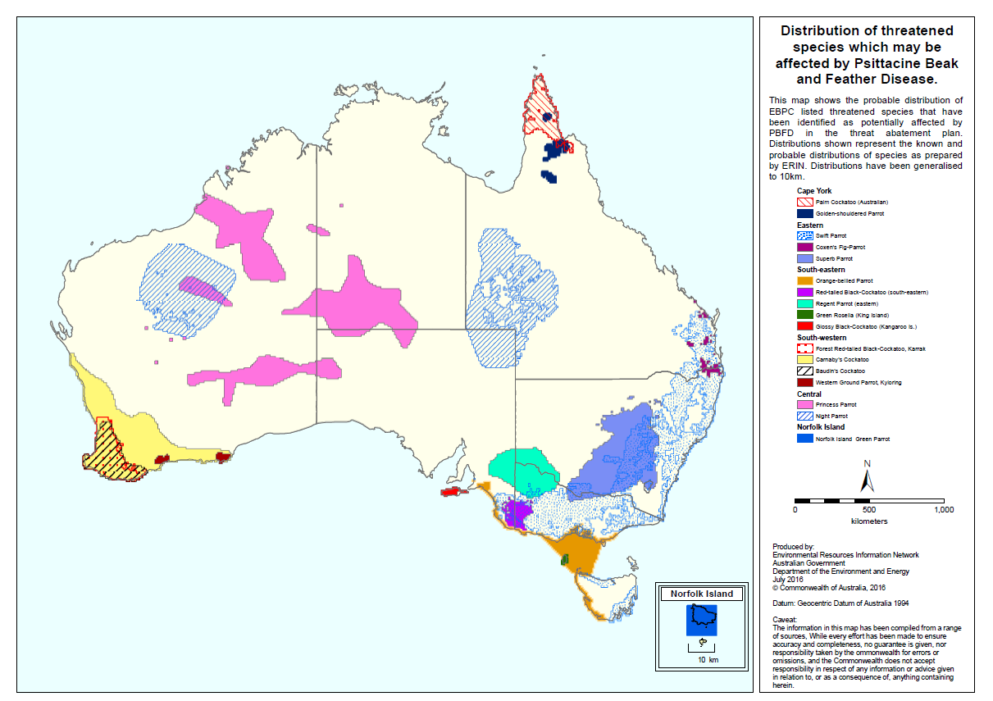

1. Observations – Spatial occurrence of non-listed parrots which may be affected by PBFD. Note this map is heavily influenced by where birdwatchers make observations, so bird observations from relatively remote areas will be substantially fewer, and confined to accessible areas (such as roadsides).

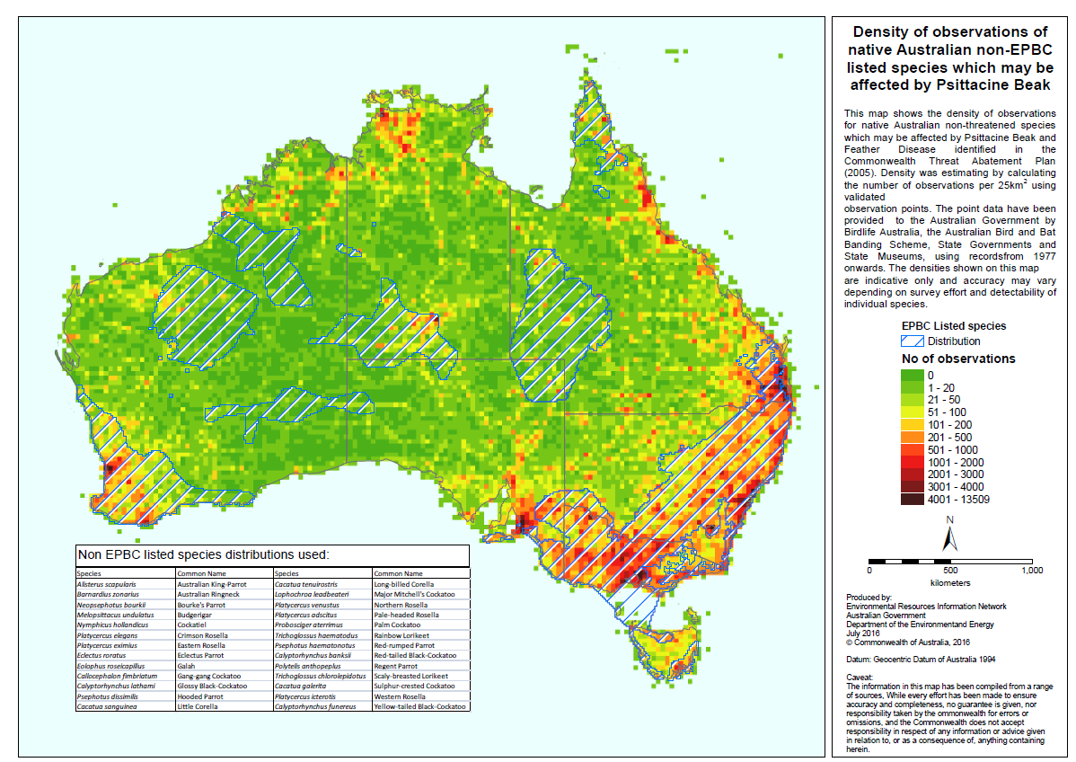

1. 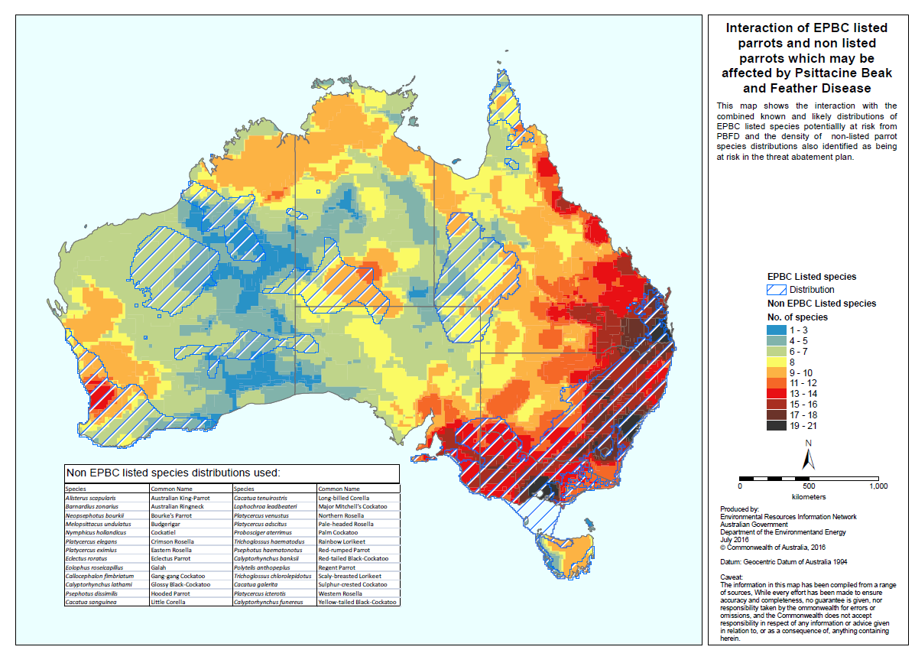Species – Spatial overlap of EPBC listed and non-listed parrots which may be affected by PBFD