Threatened Tasmanian Ferns

Flora Recovery Plan

 | 

ACKNOWLEDGMENTS
Much of the site and ecological information in this Recovery Plan is based upon the work of Garrett (1997), with some passages reproduced verbatim and without repeated citation. The preparation of this Plan was funded by the Australian Government Department of Sustainability, Environment, Water, Population and Communities.

Citation: Threatened Species Section (2011). Flora Recovery Plan: Threatened Tasmanian Ferns. Department of Primary Industries, Parks, Water and Environment, Hobart.

© Threatened Species Section
This work is copyright. It may be produced for study, research or training purposes subject to an acknowledgment of the sources and no commercial usage or sale. Requests and enquires concerning reproduction and rights should be addressed to the Manager, Threatened Species Section, Biodiversity Conservation Branch, Department of Primary Industries, Parks, Water and Environment, Hobart.

Disclaimer: The attainment of objectives outlined in this Recovery Plan may be subject to budgetary and other constraints. Recommended recovery actions may be subject to modification due to changes in knowledge or conservation status.

ISBN: 978-0-7246-6598-3 (web) 978-0-7246-6601-0 (book)

Abbreviations
ALCT Aboriginal Land Council of Tasmania
CAR Comprehensive, Adequate and Representative (Reserve System)
CLAC Crown Land Assessment and Classification project (DPIPWE)
DIER Tasmanian Department of Industry, Energy and Resources
DPIPWE Tasmanian Department of Primary Industries, Parks, Water and Environment
DSEWPaC Australian Government Department of Sustainability, Environment, Water, Population and Communities
EPBC Act Commonwealth Environment Protection and Biodiversity Conservation Act 1999
FPA Forest Practices Authority (DIER)
FT Forestry Tasmania
HEC Hydro Electric Corporation
MDC Management Decision Classification system (Forestry Tasmania)
MRT Mineral Resources Tasmania (DIER)
NRM Natural Resource Management
PWS Tasmanian Parks and Wildlife Service (DPIPWE)
RFA Regional Forest Agreement
RTBG Royal Tasmanian Botanical Gardens (DPIPWE)
SMZ Special Management Zone
TALSC Tasmanian Aboriginal Land and Sea Council
TSP Act Tasmanian Threatened Species Protection Act 1995
TSS Threatened Species Section, Biodiversity Conservation Branch (DPIPWE)

Taxonomy follows Buchanan (2009) except where otherwise noted, and common names follow Wapstra et al. (2005).
CONTENTS

BACKGROUND 1
Reasons for listing 2
Existing conservation measures 3
Tasmanian distribution 3
Known and potential threats 8
recovery & MANAGEMENT 10
Recovery strategy and progress evaluation 10
Objectives of the EPBC Act and TSP Act 10
International obligations 10
Affected interests 10
Social and economic impacts 11
Role and interests of indigenous people 11
Biodiversity benefits 11
Specific recovery objectives 12
Performance criteria 12
Recovery actions 12
Duration of Recovery Plan and estimated costs 15
Management Practices 18
SPECIES PROFILES 20
Anogramma leptophylla (L.) Link (annual fern) 20
Asplenium hookerianum Colenso (maidenhair spleenwort) 23
Blechnum cartilagineum Sw. (gristle fern) 26
Botrychium australe R.Br. (parsley fern) 29
Cheilanthes distans (R.Br.) Mett. (bristly rockfern) 31
Cyathea cunninghamii Hook.f. (slender treefern) 34
Cyathea Xmarcescens N.A.Wakef. (skirted treefern) 38
Doodia caudata (Cav.) R.Br. (small raspfern) 41
Hypolepis distans Hook. (scrambling groundfern) 44
Isoetes drummondii A.Braun subsp. drummondii (plain quillwort) 48
Phylloglossum drummondii Kunze (pygmy clubmoss) 51
Pilularia novae-hollandiae A.Braun (australian pillwort) 54
Pneumatopteris pennigera (G.Forst.) Holttum (lime fern) 57
Tmesipteris parva N.A.Wakef. (small forkfern) 61
BIBLIOGRAPHY 64

Figure 1. Threatened fern distributions in Tasmania 4

Table 1. Conservation status of Tasmanian ferns on the schedules of the TSP and EPBC Acts 1
Table 2. Summary statistics for threatened fern taxa covered by this Recovery Plan 7
Table 3. Prioritised Recovery Actions 16
Table 4. Population summary for Anogramma leptophylla in Tasmania 21
Table 5. Population summary for Asplenium hookerianum in Tasmania 25
Table 6. Population summary for Blechnum cartilagineum in Tasmania 27
Table 7. Population summary for Botrychium australe in Tasmania 29
Table 8. Population summary for Cheilanthes distans in Tasmania 32
Table 9. Population summary for Cyathea cunninghamii in Tasmania 36
Table 10. Population summary for Cyathea Xmarcescens in Tasmania 39
Table 11. Population summary for Doodia caudata in Tasmania 42
Table 12. Population summary for Hypolepis distans in Tasmania 46
Table 13. Population summary for Isoetes drummondii subsp. drummondii in Tasmania 49
Table 14. Population summary for Phylloglossum drummondii in Tasmania 52
Table 15. Population summary for Pilularia novae-hollandiae in Tasmania 55
Table 16. Population summary for Pneumatopteris pennigera in Tasmania 59
Table 17. Population summary for Tmesipteris parva in Tasmania 62

BACKGROUND
This Recovery Plan addresses the conservation requirements of fourteen Tasmanian threatened ferns that are currently listed on the schedules of the Tasmanian Threatened Species Protection Act 1995 (TSP Act) or Commonwealth Environment Protection and Biodiversity Conservation Act 1999 (EPBC Act; Table 1). The Plan relies heavily upon the work of Michael Garrett and other fern enthusiasts in the 1980s and early 1990s, culminating in the publication of The ferns of Tasmania – their ecology and distribution (Garrett 1996). Nine of the ferns to be considered in this Plan, those taxa deemed to occur in forested landscapes or at least in forest ecotones, were examined during the lead up to the Regional Forest Agreement between Tasmania and the Commonwealth of Australia (Garrett 1997).
In the fourteen years since the study of Garrett (1997) new populations of several of the threatened fern taxa have been discovered, while the reservation status of some species has been improved. This Plan provides up-to-date information on each of the fourteen fern taxa, and includes descriptions of the morphology, distribution and habitat of each taxon, identifies existing conservation measures, major threats and limiting factors, and proposes strategies and actions for their conservation over a five-year period. Adoption as a national Recovery Plan only refers to species listed under the EPBC Act.

Table 1. Conservation status of Tasmanian ferns on the schedules of the TSP and EPBC Acts

Scientific Name | Common Name | TSP Act Status | EPBC Act Status
Anogramma leptophylla | annual fern | vulnerable | –
Asplenium hookerianum | maidenhair spleenwort | endangered | Vulnerable
Blechnum cartilagineum | gristle fern | vulnerable | –
Botrychium australe | parsley fern | presumed extinct | –
Cheilanthes distans | bristly rockfern | endangered | –
Cyathea cunninghamii | slender treefern | endangered | –
Cyathea Xmarcescens | skirted treefern | endangered | –
Doodia caudata | small raspfern | endangered | –
Hypolepis distans | scrambling groundfern | endangered | Endangered
Isoetes drummondii subsp. drummondii | plain quillwort | rare | –
Phylloglossum drummondii | pygmy clubmoss | rare | –
Pilularia novae-hollandiae | Australian pillwort | rare | –
Pneumatopteris pennigera | lime fern | endangered | –
Tmesipteris parva | small forkfern | vulnerable | –

Classification of species
The Pteridophytes (ferns and fern allies) are vascular plants that reproduce from spores. They are separated from other vascular plant groups (angiosperms and gymnosperms) by lacking flowers and reproducing from spores. They are separated from other cryptogamic plant groups (mosses, liverworts, lichens, fungi and algae) in having separate and free-living gametophyte and sporophyte generations, and in their possession of an internal vascular system (Garrett 1996; Tindale 1998). The true ferns belong to the class Filicopsida. The fern allies belong to three classes, all different but closely related to the ferns — Lycopsida (represented in Tasmania by the genera Lycopodium, Lycopodiella, Isoetes and Selaginella), Psilotopsida (Tmesipteris) and Equisetopsida (no Tasmanian representatives). The fern allies are differentiated from the true ferns by their sporangia being borne on the upper surface of the leaf, by leaves containing single, unbranched veins, and by the absence of true fronds (Tindale 1998).
Pteridophytes have evolved from a time in Earth’s history when water availability to plant life was more consistent and abundant than it is today. This, in addition to the fact that (most) pteridophyte species have a subsequent necessity for available moisture to facilitate fertilisation, means that nearly all are found growing in forested habitats or other habitats where there is a greater availability of moisture all year round, and where there is protection from the drying affects of sun and wind.
There are currently 101 pteridophytes recognised as being indigenous to mainland Tasmania (Buchanan 2009), with a single introduced species having naturalised status (Marsilea mutica). Eight of the indigenous taxa are endemic to Tasmania, while another three have their entire Australian distribution within Tasmania but also occur in New Zealand. Of the total number of pteridophyte species indigenous to Tasmania, 62 occur in forested habitats and 17 occur predominantly in either coastal heathland or wetland scrub habitats (Garrett 1996). Of this last figure, all except three are known to extend out of these habitats and into forested habitats. The remainder of Tasmania’s pteridophyte species are found in alpine, aquatic or littoral habitats.

Reasons for listing
Since European settlement in Tasmania, large tracts of land containing pteridophyte forest habitats have been cleared for agriculture, forestry and residential settlement. However, the majority of Tasmania’s forest-dwelling pteridophytes are either widespread across the State or, because of their sheltered habitat requirement, are often found in terrain where the topography is unsuitable for development (e.g., in gorges, gullies, beside waterfalls). The list of pteridophyte species found growing in these latter sites usually mirrors that of the species found growing in other wet forest types that, because of their surrounding topography, are more susceptible to modification.
It is either the forest-dwelling pteridophyte species that are naturally very rare in Tasmania, or those that are rare and restricted to forested habitats where the surrounding topography has been historically conducive to modification, that are at most risk of becoming extinct in the State. Taxa in the latter category include Pneumatopteris pennigera, Hypolepis distans and Blechnum cartilagineum.
Nine of the fourteen fern taxa considered in this Plan are known from six or fewer locations, with extremely restricted habitats, while a large proportion of their total population may occur at one or a few locations.
Several of the fern taxa with populations on private land are threatened by land clearance, habitat degradation through trampling and grazing by stock, as well as by weed invasion. These include populations of Blechnum cartilagineum, Cheilanthes distans, Hypolepis distans and Pneumatopteris pennigera.
EPBC Act listing advice is available only for Hypolepis distans. The following information on the DSEWPaC website accompanied the species uplisting from vulnerable to endangered in October 2001:
Deemed to satisfy criterion 2, viz., ‘geographic distribution is precarious for the survival of the species and is restricted. The extent of occurrence is 1215 km² and the area of occupancy is 1.92 ha. The species is known from a total of three populations and ongoing decline is projected in the extent of occurrence, area of occupancy, area, extent and quality of habitat, the number of populations and number of mature individuals due to agricultural clearing’.

Existing conservation measures
Representation of the fern taxa in conservation reserves varies from Asplenium hookerianum which is entirely represented within reserves, to Isoetes drummondii subsp. drummondii in which almost all populations and/or individuals occur on private property (see Table 2). The reservation status of several ferns has been improved in the period since the report of Garrett (1997): Blechnum cartilagineum, Cyathea cunninghamii and Cyathea Xmarcescens in Little Beach State Reserve. Proposed activities within Tasmania’s formal reserve system are subject to the Tasmanian Reserve Management Code of Practice (PWS, FT & DPIWE 2003), wherein activities are considered systematically to ensure the reserve’s values, including threatened species, are not compromised.
The State Forests in Tasmania are managed using an internal management tool known as the Management Decision Classification (MDC) system (Orr & Gerrand 1998). The current MDC system classifies areas of State Forest into three primary classes (M. Yee, pers. comm.): Production (couped and uncouped), Protection and Interim Protection. This includes forest and non-forests. Areas in Protection include formal reserves (e.g., Forest Reserves) and informal reserves, and together they are recognised within Tasmania’s CAR reserve system. Land in any of these MDC classes can be attributed as Special Management Zones (SMZs) within which values such as threatened flora can be managed with special management prescriptions, while also allowing for wood production. Six of the eleven threatened fern subpopulations on State Forest (Table 2) are covered by existing SMZs.
Nine of the fourteen fern taxa were listed as priority species requiring consideration in the development of the private land component of the Tasmanian Comprehensive Adequate and Representative reserve system (Regional Forest Agreement 1997; DPIWE 1998), viz., Anogramma leptophylla, Asplenium hookerianum, Blechnum cartilagineum, Cheilanthes distans, Cyathea cunninghamii, Cyathea Xmarcescens, Doodia caudata, Hypolepis distans and Pneumatopteris pennigera. The Private Forest Reserves Program (DPIPWE) has negotiated conservation covenants under the Tasmanian Nature Conservation Act 2002 for two private properties, with small populations of Cyathea cunninghamii and Asplenium hookerianum, respectively. The covenants bind present and future landholders to retain native vegetation on their properties, with specific prescriptions in place to ensure the habitat of threatened species is managed appropriately.
Known threatened fern populations on State Forest and private land are protected from forestry activities by prescriptions in forest practices plans that are developed by the Forest Practices Authority (FPA) in consultation with the Tasmanian Department of Primary Industries, Parks, Water and Environment. Protocols are also in place to provide for the protection of currently unknown populations of threatened plants; the protocols exist to ensure that adequate surveys are undertaken prior to development approval from all levels of Government.
Fire management plans for reserves managed by the Tasmanian Parks and Wildlife Service (PWS) have generic prescriptions in place to exclude fire wherever possible from areas containing fire-sensitive vegetation and/or threatened species (e.g., Parks and Wildlife Service 2002, 2003 & 2006). However, many of the reserves that support threatened ferns do not as yet have fire management plans in place.
Ex situ collections of several of the fern taxa are held at the Royal Tasmanian Botanical Gardens, though these collections are essentially for display purposes and represent only a small sample of the wild populations. Taxa represented include Blechnum cartilagineum (two subpopulations), Doodia caudata (1), Hypolepis distans (1) and Pneumatopteris pennigera (1). As these collections are of limited value as a gene bank, collection of more genetic material from these species is required.

Tasmanian distribution
Figures 1–3 show the known Tasmanian distributions of the fourteen threatened fern taxa considered in this Plan, with population data summarised in Table 2. A number of the fern populations were last recorded in the early to mid 1990s during surveys by Garrett (1997) and for the purposes of this Plan have been presumed to be extant unless more recent targeted surveys have proven otherwise.

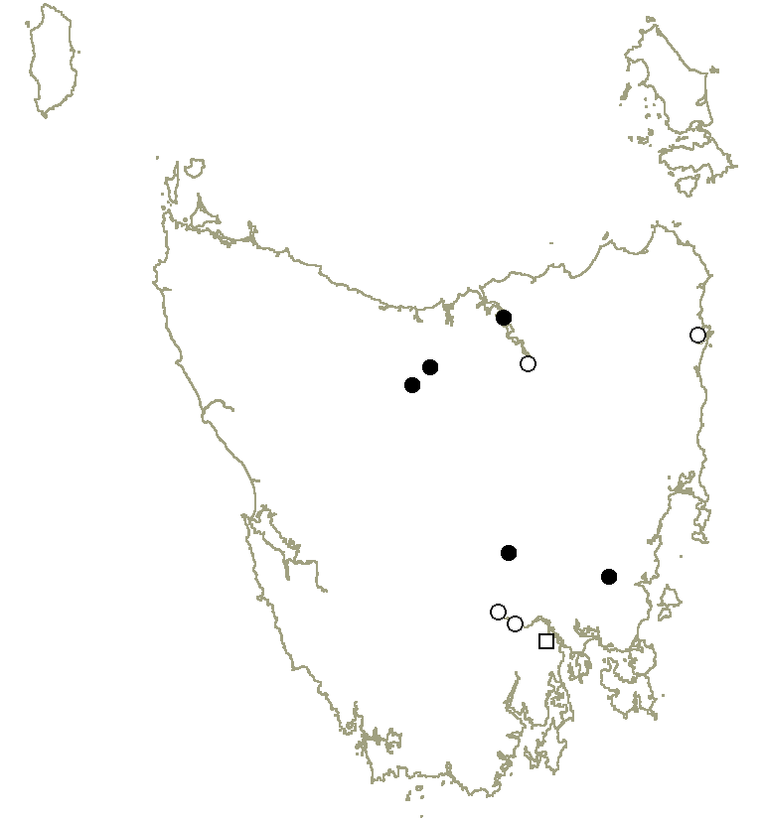 | 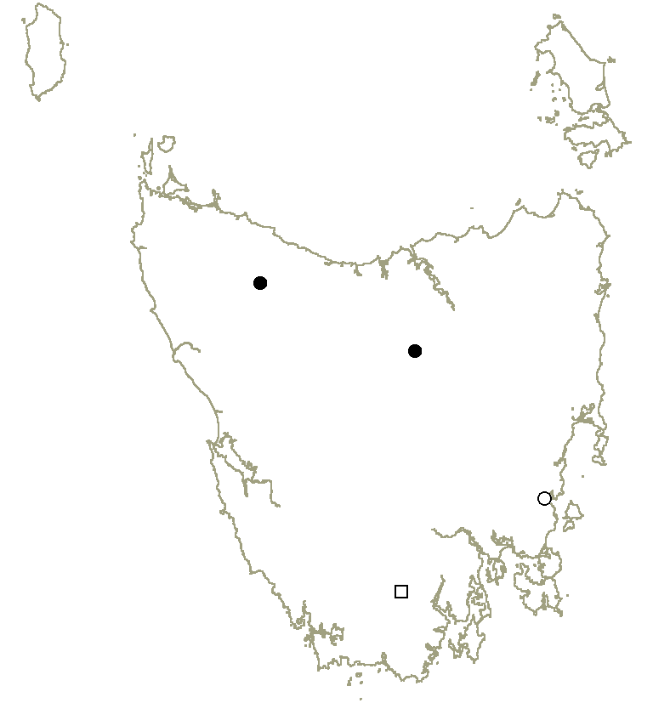
Anogramma leptophylla | Asplenium hookerianum
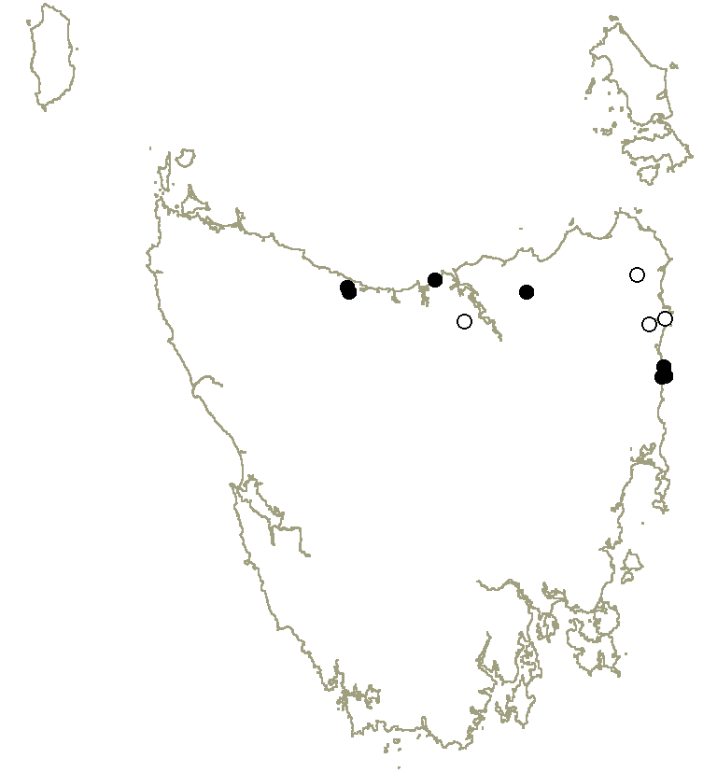 | 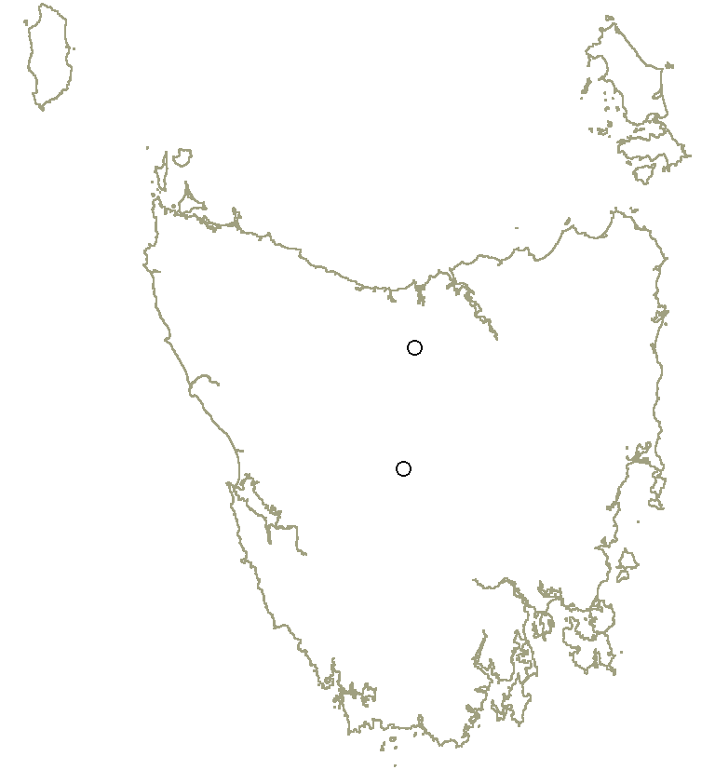
Blechnum cartilagineum | Botrychium australe
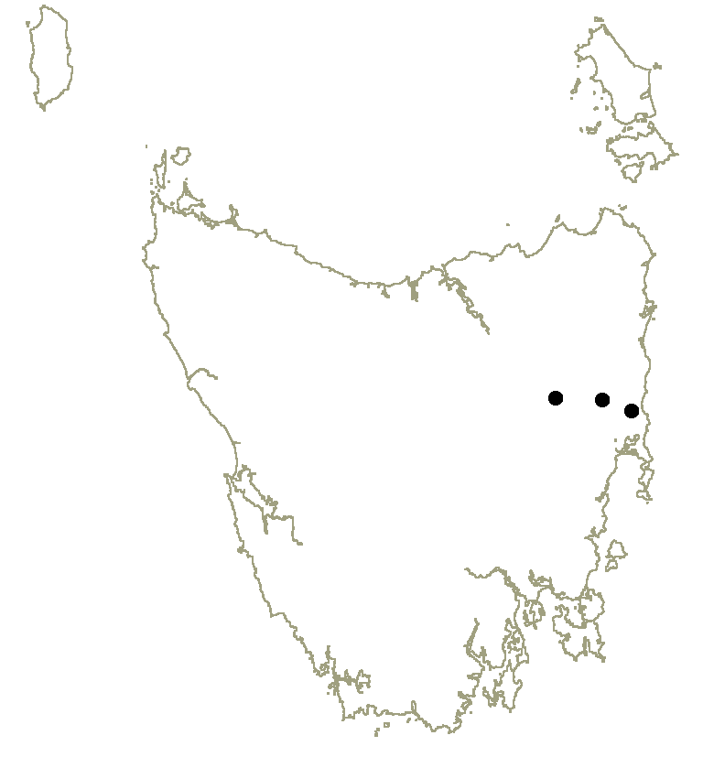 | 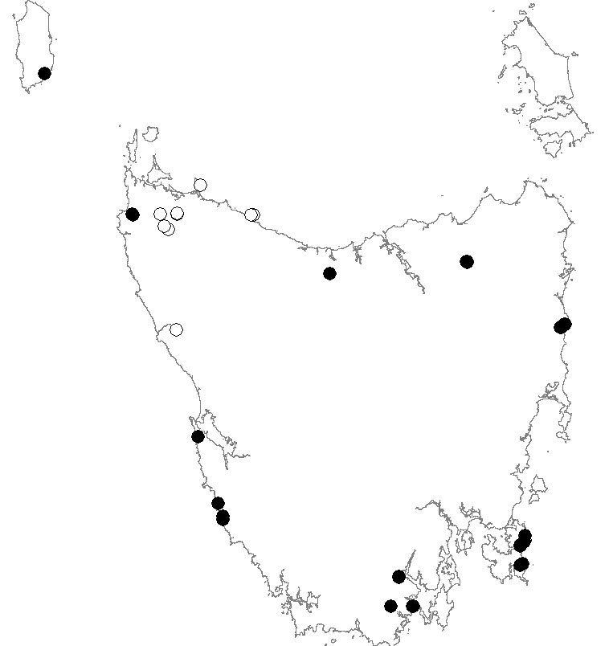
Cheilanthes distans | Cyathea cunninghamii

Figure 1. Threatened fern distributions in Tasmania
(Status: • = extant, o = presumed extinct, ◻ = uncertain)

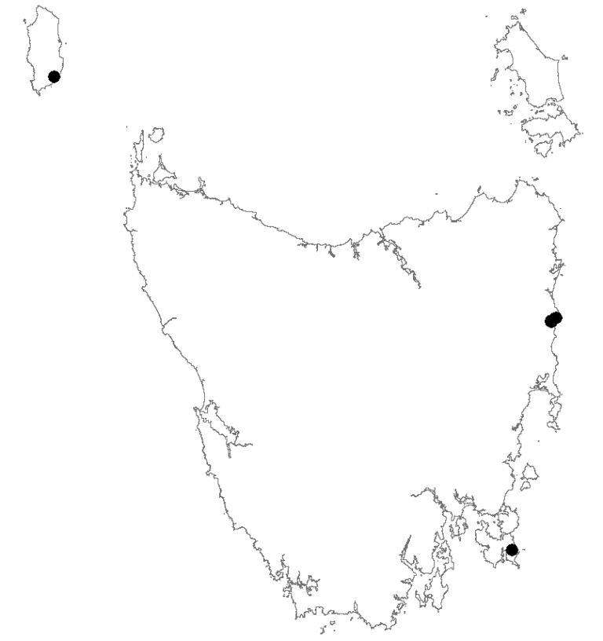 | 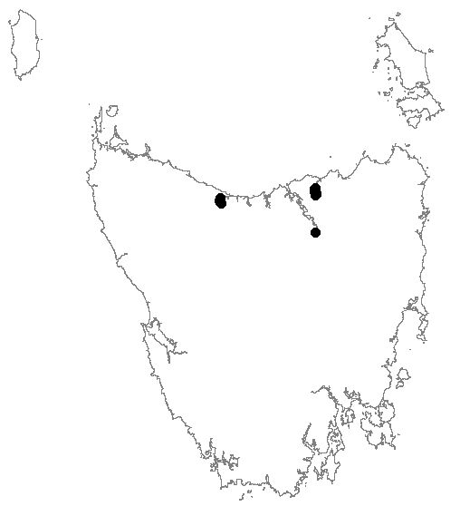
Cyathea Xmarcescens | Doodia caudata
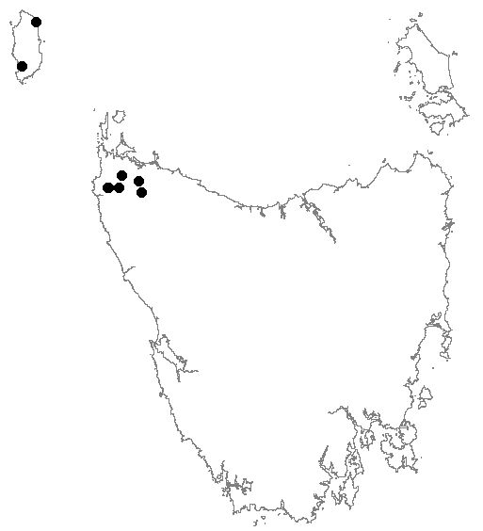 | 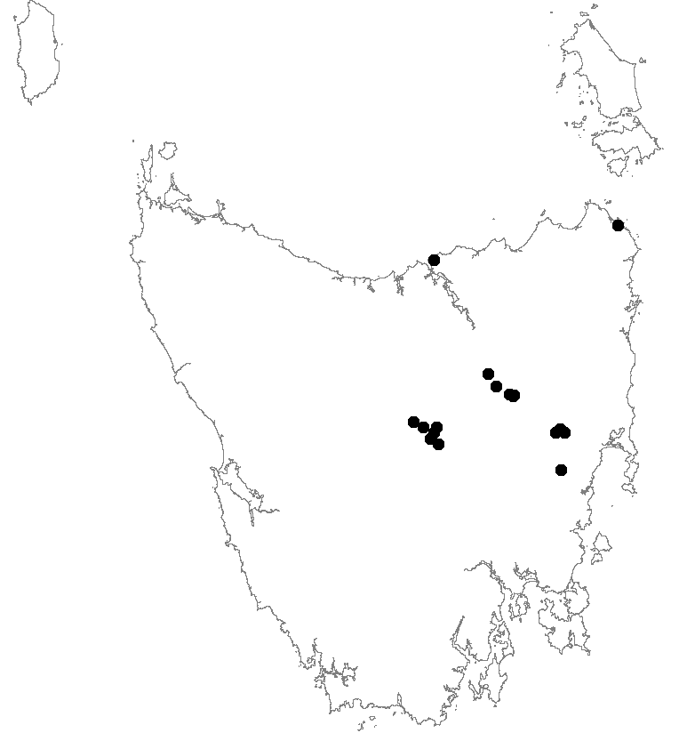
Hypolepis distans | Isoetes drummondii subsp. drummondii
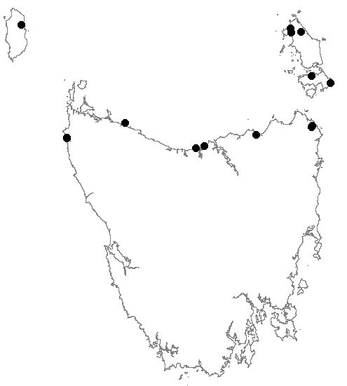 | 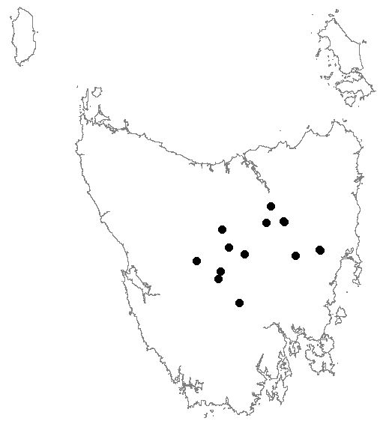
Phylloglossum drummondii | Pilularia novae-hollandiae

Figure 1. Threatened fern distributions in Tasmania (continued)
(Status: • = extant, o = presumed extinct)

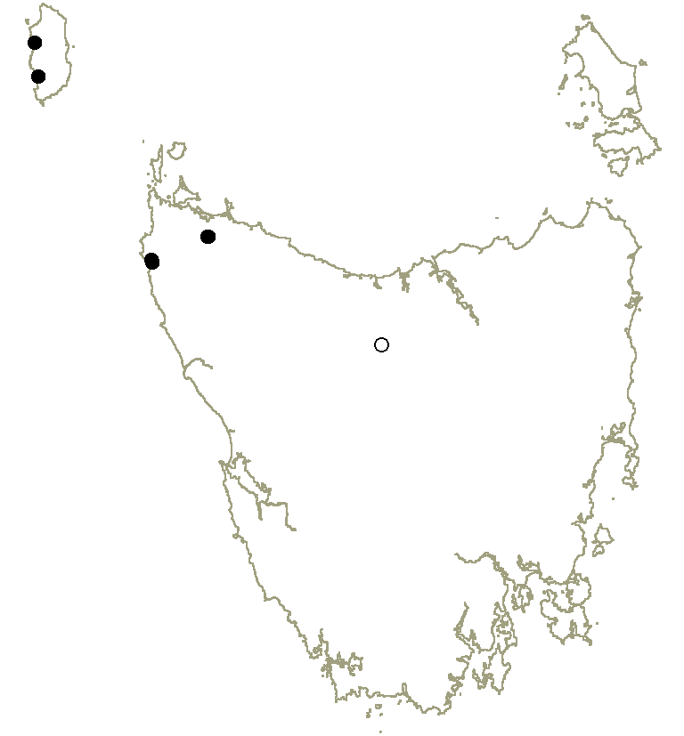 | 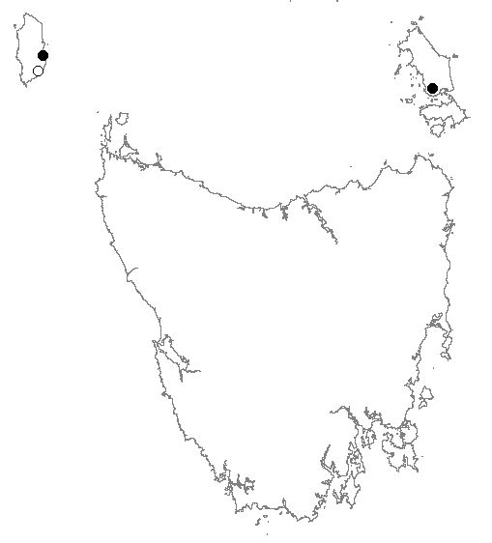
Pneumatopteris pennigera | Tmesipteris parva

Figure 1. Threatened fern distributions in Tasmania (continued)
(Status: • = extant, o = presumed extinct)

Table 2. Summary statistics for threatened fern taxa covered by this Recovery Plan

Taxon | Extent (km²) | Range (km) | Number of Populations | Populations within Formal Reserves |  |  |  |  |  |  |  | UCL | HEC | State Forest | Private | NRM Region
 |  |  |  | NP | SR | NR |  | CA | NRA | RR | FR
Anogramma leptophylla | 9,070 | 184 | 6 | 1, 1* | – | – | – |  | – | – | – | – | – | 1 | 3 | N, S
Asplenium hookerianum | n.a. | 111 | 2 | – | 1 | – | – |  | – | – | 1 | – | – | – | – | CC, N
Blechnum cartilagineum | 3,100 | 198 | 6 | 1 | 1 ½ | – | – |  | – | – | – | – | – | 2 | 1 ½ | CC, N
Botrychium australe | – | – | 0 | – | – | – | – |  | – | – | – | – | – | – | – | S
Cheilanthes distans | 100 | 48 | 3 | 1 | – | – | – |  | – | – | – | – | – | – | 2 | N
Cyathea cunninghamii | 70,000 | 480 | 18 | 5 | 2 | – | 4 |  | – | – | 1 | – | – | 3 ½ | 2 ½# | CC, N, S
Cyathea Xmarcescens | 33,300 | 470 | 4 | – | 1 | – | – |  | – | – | 1 | – | – | 1 | 1 | CC, N, S
Doodia caudata | 2,050 | 94 | 3 | – | ½ | – | – |  | 1 | – | – | – | – | ½, ½ | ½ | CC, N
Hypolepis distans | 3,800 | 165 | 7 | – | 1 | – | – |  | – | – | – | – | – | 3 ½ | 2 ½ | CC
Isoetes drummondii subsp. drummondii | 13,280 | 175 | 15 | 1 | – | 2 | 1 |  | – | – | – | – | 1 | – | 10 | N, S
Phylloglossum drummondii | 44,000 | 374 | 12 | 3 | – | 1 | 2 |  | 1 | – | – | 1 | – | – | 4 | CC, N
Pilularia novae-hollandiae | 7,500 | 135 | 11 | 1 | – | – | 2 |  | – | – | – | 1 | 3 | – | 4 | N, S
Pneumatopteris pennigera | 3,900 | 165 | 5 | – | – | – | 2 |  | – | – | – | 2 | – | – | 1 | CC
Tmesipteris parva | n.a. | 340 | 2 | 1 | – | – | – |  | – | – | – | – | – | – | 1 | CC, N
Extent = taxon’s extent of occurrence (= area of minimum convex polygon encompassing extant sites); Range = linear range of taxon;
Populations (extant) are defined as occurrences of plants separated by discontinuities of at least 1 km (Keith 2000);
Formal Reserves: NP = National Park (* = Wellington Park), SR =State Reserve, NR = Nature Reserve, NRA = Nature Recreation Area, CA = Conservation Area, RR = Regional Reserve; FR = Forest Reserve; UCL = Unallocated Crown land under consideration by the Crown Land Assessment and Classification project (CLAC Project Team 2005 and 2006); HEC = Hydro Tasmania; # = Conservation covenant under the Tasmanian Nature Conservation Act 2002;
NRM region = Natural Resource Management region: CC = Cradle Coast, N = North, S = South;
Managing authority: Formal Reserves (except for FRs) – Tasmanian Parks & Wildlife Service; Forest Reserves & State Forest – Forestry Tasmania; UCL – Department of Primary Industries, Parks, Water and Environment.

Habitat criticial to the survival of the species
Habitat characteristics defined in the EPBC Act that are critical to the survival of threatened ferns in Tasmania include:
- habitat that is used during periods of stress (e.g., flood, drought, fire; habitat surrounding key populations that acts to provide a buffer from desiccation or wind throw is also considered to be habitat critical to the survival of the species);
- habitat that is used to meet essential life cycle requirements (e.g., spore dispersal and germination processes);
- the extent to which the habitat is used by key populations;
- habitat that is necessary to maintain genetic diversity and long-term evolutionary development;
- habitat that is necessary to ensure the long-term future of the species or ecological community through reintroduction or re-colonisation;
- habitat that is in any other way critical to the survival of the taxon.
General habitat characteristics for each of the threatened fern taxa are provided in the species profiles. Within this general habitat, habitat that is critical to the survival of the species is considered to be that which supports important subpopulations and surrounding suitable habitat, including their local catchments.

Known and potential threats
Key threatening processes listed on the EPBC Act that are relevant to the management of threatened ferns in Tasmania include:
- land clearance;
- loss of climatic habitat caused by anthropogenic emissions of greenhouse gases.
Other known threatening processes include competition from weeds, disturbance (grazing and trampling) by stock and feral pigs, inappropriate fire regimes, forestry operations, inundation and modified flood flows in regulated rivers, and the stochastic risk of extinction for localised subpopulations. The threats specific to each of the ferns are identified in the individual species profiles. Minor threats include road and track development, lack of genetic variation and competition from native plants.
Climate change. Long-term climate change is likely to lead to an eventual diminution in available habitat for a number of threatened ferns in Tasmania as conditions become warmer and drier than at present. Species considered most at risk in the longer term include Anogramma leptophylla, Asplenium hookerianum, Cyathea cunninghamii, Cyathea Xmarcescens, Pneumatopteris pennigera and Tmesipteris parva.
Land clearance and development may contribute to an irreversible loss or degradation of habitat. Past local extinctions of some of the target fern species can be attributed to land clearance for agriculture and dairying, and to a lesser degree, timber harvesting. Consequential impacts have included weed invasion, trampling by livestock and changes to hydrology (including increased flood events and sediment loads, and drainage of wet areas).
Weed invasion is an increasing threat to populations adjacent to agricultural land, resulting in a loss of habitat due to competition for growing space, soil moisture, nutrients and light. The Tasmanian Weed Management Act 1999 provides the instrument to control or eradicate declared weeds from the habitats of threatened fern species. Weeds of concern include willow, gorse and blackberry, the latter being Weeds of National Significance.
Agricultural activities (apart from clearing) which are a threat to fern species include: stock grazing and trampling; local changes to hydrology (farm dams and drainage lines); herbicide, fertiliser and pesticide use; cultivation; and small-scale quarrying. Trampling by livestock at creek-side waterholes may cause soil disturbance and general degradation of sites, leading to erosion and the loss of habitat during flooding.
Forestry operations have the potential to impact upon the habitat of threatened ferns directly and indirectly. For taxa in gully habitats such as the treeferns Cyathea cunninghamii and Cyathea Xmarcescens, inappropriate logging of adjacent coupes may increase the likelihood of wind-throw of trees, increasing the risk of direct physical damage to the species, while also potentially leading to detrimental hydrological and microclimate changes. The latter are also likely to be affected by fire escape and/or scorching from nearby regeneration burns. Upstream logging activities also have the potential to increase the risk of damage to threatened ferns through changes to flood levels, sediment loads, deposition and scouring levels.
Inundation and downstream impacts of major dams: inundation presents an irreversible threat for riparian fern species, while regeneration conditions may be disrupted downstream due to modified flood flows and sediment transport.
Inappropriate fire regimes are considered to be a threat to some fern species. Garrett (1997) noted that fire has had little or no impact on threatened forest ferns in Tasmania, since, as a general rule, Tasmanian species of ferns either grow in habitats isolated from fire, or the structure of their plant parts is such that they are able to recover from such catastrophic events. Of the fourteen target species, for example, Anogramma leptophylla and Cheilanthes distans are insulated from the effects of fire due to their rock outcrop habitats; Asplenium hookerianum, Cyathea cunninghamii, Cyathea Xmarcescens and Tmesipteris parva grow in dark and very moist situations not usually associated with fire; Doodia caudata grows near the high-water mark on river banks and in such situations is usually immune from fire; Pneumatopteris pennigera (and to a lesser degree, Hypolepis distans) grows in very wet and boggy soils where vegetation is not usually susceptible to fire; and while all their top growth may be destroyed by fire, provided the organic layer is intact there is a strong recovery of growth from subterranean rhizomes of Blechnum cartilagineum and Hypolepis distans. Notwithstanding the above comments, frequent firing is considered capable of excluding most of the threatened ferns from their habitat, and most populations are yet to be included in fire management plans.
Stochastic risk of extinction is considered a threat to most species due to their fragmented distribution and small population size. Populations are at risk of extinction from events such as storms, fire, flood and disease.
Biology and ecology relevant to threatening processes
Ferns may reproduce from spores or via a variety of asexual forms. Spores may be produced in prodigious amounts, but only a minutely small proportion settle where conditions of light, moisture and substrate are ideal for germination, then survive and grow to reach an observable size. The time taken for a plant to reach maturity following spore germination varies considerably between species, the upper extreme being 25–30 years for Cyathea cunninghamii (Garrett 1996).
Asexual reproduction includes spread via creeping rhizomes or stolons (Blechnum cartilagineum, Cheilanthes distans, Hypolepis distans and Doodia caudata), while shooting from the base of old trunks has been observed in Pneumatopteris pennigera. Apogamic reproduction is a feature of the xerophytic species Cheilanthes distans, wherein vegetative buds arise directly from the prothallus, obviating the need for free water to facilitate fertilisation. Cyathea Xmarcescens is a sterile hybrid, its ‘recruitment’ requiring the presence of its putative parents Cyathea australis and Cyathea cunninghamii.
A number of the threatened ferns are adapted to cope with fire or other disturbance through survival of their underground parts, as noted above.
Some of the threatened ferns continue to be poorly understood in terms of their life cycles, e.g., Blechnum cartilagineum and Pneumatopteris pennigera, and studies are required to inform future management strategies — as outlined in the individual species profiles.

recovery & MANAGEMENT

Recovery strategy and progress evaluation
The overall objective of the Tasmanian Threatened Ferns Recovery Plan is to reduce the risk of extinction of threatened fern populations in the wild by ensuring habitat protection for all taxa, and to secure all populations under effective management regimes within the next five years.
A Recovery Team will be established once funding is secured to implement this Plan or parts of the Plan. Each year following establishment, the Recovery Team will monitor and evaluate progress against the performance criteria outlined in this Plan and report to the relevant sponsor organisations. Progress will be communicated to the general public through listing statement updates, websites, relevant newsletters and reports. The Plan will be formally reviewed within five years of adoption under the EPBC Act.

Objectives of the EPBC Act and TSP Act
The Tasmanian Threatened Ferns Recovery Plan satisfies the objectives of the Commonwealth Environment Protection and Biodiversity Conservation Act 1999 in that it seeks to:
- provide for the protection of the environment, especially those aspects of the environment that are matters of national environmental significance, viz., the nationally listed fern species Asplenium hookerianum and Hypolepis distans;
- promote ecologically sustainable development through the conservation and ecologically sustainable use of natural resources;
- promote the conservation of biodiversity by maintaining the conservation value of ecosystems in which threatened fern species occur;
- promote a co-operative approach to the protection and management of threatened fern species, involving governments, the community, landholders and indigenous peoples.
The Plan satisfies the objectives of the Tasmanian Threatened Species Protection Act 1995 in that it seeks to:
- ensure that Tasmania’s threatened ferns can survive, flourish and retain their potential for evolutionary development in the wild;
- ensure that the genetic diversity of threatened ferns is maintained;
- educate the community in the conservation of threatened ferns;
- encourage co-operative management of threatened ferns including the making of co-operative agreements for land management under the Act;
- assist landholders to enable threatened ferns to be conserved;
- encourage the conserving of threatened ferns through co-operative community endeavours.

International obligations
None of the fern species covered by this Recovery Plan are listed under any international agreement and the recovery plan does not affect Australia’s international responsibilities.

Affected interests
Recovery actions under this Plan include consideration of the roles and interests of a range of private landowners and government land managers. The interests of a number of landowners and/or land managers are affected, including the Parks and Wildlife Service, Forestry Tasmania, Forest Practices Authority, Hydro Tasmania, irrigation authorities, Mineral Resources Tasmania, Tasmanian Aboriginal Land and Sea Council, Royal Tasmanian Botanical Gardens, Wellington Park Trust, other reserve managers, and NRM regional committees. The suite of landowner and/or land manager interests will be reflected in the membership of the recovery team and via wide consultation on recovery actions.

Social and economic impacts
Tasmania’s threatened ferns have legal protection as listed species at the State and/or Commonwealth level, with some occurrences in threatened plant communities that are protected from clearance and conversion by State legislation. The threatened ferns occur variously within formal and informal reserves, as well as on State Forest and private land. Implementation of this Recovery Plan is considered unlikely to cause significant adverse social or economic impacts. The implementation of recovery actions with potential economic implications for private landholders (e.g., changing agricultural practices), will be undertaken in consultation with landholders, with advice and assistance provided where appropriate.

Role and interests of indigenous people
In the preparation of this Plan the important role Tasmanian Aboriginal people have played in land management was recognised, and the impact of European settlement on this role acknowledged.
The following Aboriginal organisations have been consulted on the significance of threatened Tasmanian ferns in Aboriginal cultural tradition, and on their knowledge, role and interest in their management: Aboriginal Land Council of Tasmania, Tasmanian Aboriginal Centre, and Tasmanian Aboriginal Land and Sea Council.
Implementation of this Plan will involve:
- knowledge sharing;
- participation in education and training relevant to threatened species management; and
- engagement in recovery actions where relevant to Aboriginal land management and communities.
If, during any recovery activity, suspected evidence of Aboriginal heritage significance is found, this will be reported to Aboriginal Heritage Tasmania, and, if the evidence is to be disturbed, the activity will be suspended pending appropriate follow-up.
Populations of Phylloglossum drummondii have been recorded from Cape Barren Island, which is owned and managed by the Aboriginal Land Council of Tasmania and the Cape Barren Island Aboriginal Association.

Biodiversity benefits
Recovery actions for threatened Tasmanian ferns considered in this Plan will have direct and indirect benefits for a range of other threatened species, as well as non-threatened species and ecological communities.
Species known to occur in close association with threatened ferns include two plants listed on the EPBC Act: Barbarea australis (riverbed wintercress) at Hellyer Gorge in association with Asplenium hookerianum, and Epacris exserta (south esk heath) along the lower South Esk River in association with Doodia caudata. Several plant species listed on the TSP Act will also benefit: the shrubs Hedycarya angustifolia, Elaeocarpus reticulatus, Hovea corrickiae and Pimelea axiflora subsp. axiflora (in association with Cyathea spp.), the herbs Alternanthera denticulata, Persicaria subsessilis and Persicaria decipiens (Doodia caudata), Scutellaria humilis (Cheilanthes distans), and Drosera glanduligera and Stylidium beaugleholei (Phylloglossum drummondii).
The habitat of some of the threatened ferns dealt with in this Plan include Eucalyptus brookeriana wet forest and riparian scrub. These vegetation communities are considered to be threatened within Tasmania, as listed under the Tasmanian Nature Conservation Act 2002. This Bill includes threatened forest communities listed in Attachment 6 of the Tasmanian Regional Forest Agreement between the Commonwealth of Australia and the State of Tasmania (Regional Forest Agreement 1997).
The general principles outlined here are also applicable to the conservation of other threatened ferns in Tasmania not considered specifically in this Plan.

Specific recovery objectives
- to protect fern habitat;
- to control the impact of all threatening processes;
- to implement effective and sustainable management regimes for all populations;
- to successfully coordinate the recovery program, increase knowledge and involvement of the community;
- to incorporate wider knowledge of the species into recovery management.

Performance criteria
- Recovery Team of varied stakeholders successfully coordinating implementation of actions and budget spending within 1 year, and annually monitoring success of recovery effort and adjusting implementation as necessary for the life of the Plan.
- Tenure Security.
  - Protection of at least one additional population for each taxon on private land (where relevant) by a vegetation management agreement or conservation covenant under the Tasmanian Nature Conservation Act 2002 within 5 years.
  - Inclusion of all populations on State Forest as ‘Flora – Threatened Species’ Special Management Zones in Forestry Tasmania’s Management Decision Classification system within 2 years.
- Surveys of potential habitat for threatened ferns undertaken by the end of Year 3.
- Life histories of Blechnum cartilagineum and Pneumatopteris pennigera better understood and knowledge incorporated into recovery and management within 5 years.
- Management.
  - No further decline in the habitat area occupied by populations due to recognised threatening process over 5 years.
  - Inclusion of populations on State Forest and Crown land in fire management plans as they are developed, with prescriptions appropriate for each species.
  - Threatened fern management principles disseminated to private habitat owners within 3 years.
  - Listing statement and spatial population data for each taxon updated as required and circulated to the wider botanical community and general public in the appropriate form; i.e., DPIPWE’s Natural Values Atlas updated and information circulated to the Tasmanian Flora Network, DPIPWE threatened species websites updated as necessary, data provided to relevant Commonwealth, State and local government agencies.
  - Ex situ collections of Asplenium hookerianum, Cheilanthes distans, Hypolepis distans and Pneumatopteris pennigera established at the Royal Tasmanian Botanical Gardens within 3 years.

Recovery actions
- Coordinate Recovery Program.
- Establish a Recovery Team including a wide representation of key stakeholders (as identified in Affected Interests) within the first 6 months operation of the Recovery Plan.
- Team to coordinate implementation of the Recovery Plan, including to: review progress of recovery annually, adjust recovery action implementation as necessary, manage budget and decide on funding priorities under the Recovery Plan. Where appropriate the Team will review the conservation status of listed fern taxa in the wake of updated information (and nominate, where appropriate, taxa that are currently not listed).
- Conduct full review of Recovery Plan within 5 years of adoption under the EPBC Act.
- Increase number of populations under protective tenures.
- Private land: Encourage landholders to consider protection of habitat through vegetation management agreements or conservation covenants under the Tasmanian Nature Conservation Act 2002, where relevant. Protection of specific sites (as detailed in Species Profiles) will be negotiated with landholders. Aim to place a protective vegetation management agreement or conservation covenant via DPIPWE’s Private Land Conservation Program on at least one additional site per taxon where relevant; (see Table 2 and the individual species profiles); management provisions for covenanted land to be implemented for each populations within 5 years.
- State Forest: Negotiate ‘Flora – Threatened Species’ Special Management Zones with Forestry Tasmania for all populations of threatened ferns on State Forest not currently covered by SMZs within 2 years.
- Undertake surveys for new populations.
Undertake extension surveys of potential habitat for undiscovered populations of threatened ferns (Table 3). This will include mapping of potential habitat, and will be undertaken during the first 3 years of the Plan. Where possible, extension surveys will be conducted in conjunction with the monitoring of known populations (Action 6), to minimise additional costs. If new populations of any threatened species are discovered, the population/s will be included in the monitoring program, and appropriate recovery actions implemented
- Conduct research.
Investigate the life histories of Blechnum cartilagineum and Pneumatopteris pennigera, and address other biological/ecological issues identified in the individual species profiles. Research will be conducted by suitably qualified researchers and results will be incorporated into recovery actions. Support research, liaise with the research community on research priorities and potential field sites, and source funding where possible.
- Manage threatening processes.
  - Undertake weed control in all populations threatened by weeds. Ensure that the requirements of all Weed Management Plans under the Tasmanian Weed Management Act 1999 are implemented on land affecting threatened fern habitat. This includes areas adjacent to and upstream of populations. Resources permitting, this will be undertaken by FT in State Forests and Forest Reserves, PWS in National Parks and other formal reserves, and local government, with assistance from volunteers.
  - Erect and maintain stock-proof fences in relevant sites (as detailed in Species Profiles), to prevent stock access. Maintain existing stock-proof fencing by checking condition annually and repairing as required.
  - Plan and implement fire management
    - On land managed by either FT or PWS, map populations and habitat considered critical to the survival of the species and include in GIS systems. Identify proposed burn units and the time and intensity of planned burning. Implement this action within 2 years, and provide mapped data to FT and PWS.
    - Incorporate relevant information from i) into fire management plans where they are developed.
    - Apply TSP Act permit provisions on private land. As part of action 7, private landholders will be made aware of the TSP Act fire permit provisions, and of the management guidelines for fire, including advice on the appropriate frequency and intensity of burning according to the site/s involved.
- Manage forestry activities for fern recovery. Best endeavours will be used to develop relevant Recovery Plan Management Practices, in accordance with the ‘Procedures for the management of threatened species under the forest practices system’ (April 2010), into ‘endorsed management prescriptions’.
- Reduce the impact of dams. Liaise with Hydro Tasmania re releases of water to mitigate flow changes/impacts.
- Develop an Adaptive Management Regime.
- Set decline thresholds that will trigger management responses for each species;
- Develop a decision support system including a recommended management response that conforms to the Management Practices and Recovery Actions within 3 years.
- Collect material from key populations and establish ex situ collections at the Royal Tasmanian Botanical Gardens. The highest priority species are those with few populations and individuals in the wild, viz., Asplenium hookerianum, Cheilanthes distans, Hypolepis distans and Pneumatopteris pennigera. Collection of suitable material will be conducted within the first 2 years by suitably trained personnel during survey activities (Action 2 and 6) to minimise additional costs. RTBG will establish ex situ collections of these species within 3 years of operation of the Plan.
- Minimise impact of all threats.
- Instil the principles of the Recovery Plan Management Practices into the Standard Operating Procedures of the Environmental Management Systems of FT, PWS, Mineral Resources Tasmania and relevant local government municipalities. The Management Practices are tenure neutral and cover development activities, stock, fire and weed management, timber harvesting and mineral exploration.
- Actions to reduce the impact of threats to threatened fern species, including those outlined in the Recovery Plan Management Practices, are to be included in all relevant Reserve management strategies and plans.
- Liaise with other landholders to ensure appropriate management regimes in areas upstream of populations of threatened fern species.
- Undertake surveys and monitoring.
- Undertake a population census of all populations within the first three years of the Plan. Priority areas for survey in Year 1 are those where the population has not been surveyed in the last 10 years and/or where the population size or area of occurrence are not known, plus unconfirmed records, as identified in each species profile. The census should measure attributes of each taxon’s distribution relevant to the conservation status, including range, area of occupancy, extent of occurrence, number and size of populations, threats, and areas of similar habitat adjacent to populations. This action will be conducted in consultation with private landholders and other land managers.
- Monitor populations of all species to determine when thresholds are met for management intervention and to assess the level of success of recovery and management actions, by determining changes in the attributes described above.
Survey and monitoring data is to be held in a central database that will be used as a basis for implementing the adaptive management regime (Action 5e).
- Educate and inform community.
- Update spatial population data (using data from actions 3, 4 and 6) and disseminate to the wider botanical community and general public in the appropriate form; i.e., the Natural Values Atlas, circulate information to the Tasmanian Flora Network, update DPIPWE threatened species websites as necessary, and provide data to the relevant Commonwealth, State and local government agencies.
- Advise all private landowners/managers of their obligations to protect habitat in accordance with the regulations of the EPBC Act, the TSP Act, the Nature Conservation Act 2002 and the Weed Management Act 1999, make available the recommended Management Practices within, and provide other management advice as appropriate, e.g., appropriate burning regimes. This includes disseminating threatened fern management principles to private habitat owners within 3 years.
- Develop or update listing statements for each taxon to assist the management of the entire distribution. The statements should incorporate the management principles detailed in the Management Practices and be adapted to new information gained from surveys, research and monitoring (Actions 3, 4 and 6). Listing statements will be circulated to all stakeholders via the DPIPWE website within 5 years.
- Conduct education activities to alert the botanical community to look for particular species, e.g., Botrychium australe, and to encourage involvement in recovery actions such as weed works, survey and monitoring.
- Provide advice on specific prescriptions for mineral exploration to the Mineral Exploration Working Group and to Mining companies.
- Progress on actions will be communicated to the general public through listing statement updates on the DPIPWE website, relevant newsletters and reports, newspaper articles, publication of success stories, educational activities in Reserves.
Table 3 details the priority level (very high, high, moderate, low) for each action for each species. Where no priority is given the action is not relevant for that species. Priorities are based on the number of populations, total populations size, tenure, threats and information requirements for each species.

Duration of Recovery Plan and estimated costs

Actions | Cost estimate | Timeframe | NRM region
1. Coordinate recovery | $10 000 | Year 1–5 | All Regions
2. Protective tenure | $200 000 | Year 1–3 | All Regions
3. Extension surveys | $50 000 | Year 1–3 | All Regions
4. Conduct research | $45 000 | Year 1–4 | All Regions
5. Manage threatening processes | $75 000 | Year 1–5 | All Regions
6. Survey & monitoring | $100 000 | Year 1–5 | All Regions
7. Educate and inform community | $20 000 | Year 3–5 | All Regions
Total | $500,000

Table 3. Prioritised Recovery Actions

Recovery Action | Anogramma leptophylla  Annual fern | Asplenium hookerianum  Maidenhair spleenwort | Blechnum cartilagineum  Gristle fern | Botrychium australe  Parsley fern | Cheilanthes distans  Bristly cloak fern | Cyathea cunninghamii  Slender tree fern | Cyathea Xmarcescens  Skirted tree fern
1. Coordinate recovery | very high | very high | very high | very high | very high | very high | very high
2a. Protect and manage populations on private land through conservation covenants and/or management agreements | moderate | – | moderate | – | very high | moderate | high
2b. Include all threatened fern habitat on State Forest in flora Special Management Zones | high | – | high | – | – | high | –
3. Extension surveys for new populations | moderate | very high | moderate | high | very high | high | very high
4. Conduct research | – | – | moderate | – | – | – | –
5. Manage threatening processes | moderate | moderate | high | – | very high | high | very high
6. Survey and monitor populations | moderate  (two yearly) | very high  (two yearly) | moderate  (three yearly) | – | very high  (annually) | high  (two yearly) | very high  (two yearly)
7. Educate and inform community | very high | very high | very high | very high | very high | very high | very high

Table 3. Prioritised Recovery Actions (continued)

Recovery Actions | Doodia caudata  Small rasp fern | Hypolepis distans  Scrambling ground fern | Isoetes drummondii  Plain quillwort | Phylloglossum drummondii  Pygmy clubmoss | Pilularia novae-hollandiae  Pillwort | Pneumatopteris pennigera  Lime fern | Tmesipteris parva  Small fork fern
1. Coordinate recovery | very high | very high | very high | very high | very high | very high | very high
2a. Protect and manage populations on private land through conservation covenants and/or management agreements | moderate | high | moderate | low | low | high | high
2b Include all threatened fern habitat on State Forest in flora Special Management Zones | high | high | – | – | – | – | –
3. Extension surveys for new populations | moderate | high | moderate | moderate | moderate | high | high
4. Conduct research | – | low | – | – | – | very high | –
5. Manage threatening processes | very high | very high | moderate | moderate | moderate | very high | high
6. Survey and monitor populations | high  (three yearly) | very high  (annually) | high  (three yearly) | high  (two yearly)* | high  (three yearly) | very high  (annually) | very high  (KI: annually FI, three yearly)
7. Educate and inform community | very high | very high | very high | very high | very high | very high | very high

* = Timing and frequency of monitoring dependent upon habitat having been burnt in the previous few years.

Management Practices
Surveys should be undertaken to determine if threatened fern species or their habitat would be impacted upon by proposed developments or land use changes, as required under the following State and Commonwealth legislation: the Tasmanian Land Use Planning and Approvals Act 1993, the Tasmanian Forest Practices Act 1985, the Tasmanian Nature Conservation Act 2002, the Tasmanian Threatened Species Protection Act 1995, and the Commonwealth Environment Protection and Biodiversity Conservation Act 1999. Issues which need to be considered include:
- Any proposed activity that requires land clearance in the habitat of threatened fern populations is likely to have a significant impact. All areas of known habitat and buffers need to be retained. If approval under the EPBC Act, TSP Act or Tasmanian Forest Practices Act 1985 is to be considered then substantial positive outcomes for the conservation of the species overall should be ensured;
- Any planned fire in threatened fern habitat that is likely to result injury or death of a threatened species will require a permit under the TSP Act;
- Any activity that impacts on a species’ riparian habitat and/or water quality should be avoided.
In considering approval or the provision of a permit to impact upon a threatened fern population the following management principles should be included:

Stock, Fire Management & Weed Control
- Stock should be excluded from all threatened fern populations, and from suitable habitat within 100 m, in addition to upstream areas, where trampling may result in soil disturbance and erosion;
- Fire should, as a general rule, be excluded from threatened fern populations, and from within 100 m of populations (species-specific advice should be sought from specialists within the Forest Practices Authority and the Tasmanian Department of Primary Industries, Parks, Water and Environment);
- Weed management plans should be developed and implemented in association with any activities in the habitats of threatened fern populations, and should include:
  - if required, use only of herbicides that are licensed for the control of the target weed species;
  - minimising drift of herbicides onto native vegetation;
  - follow up weed control activities to ensure the success of initial treatment and to prevent reinvasion of weeds; and
  - inspecting populations at least every five years.

Timber Harvesting
Under the Forest Practices Code (Forest Practices Board 2000), ‘Threatened species and inadequately reserved plant communities will be managed in wood production areas in accordance with procedures agreed between the Forest Practices Board and DPIWE . The agreed procedures will include the development of endorsed management prescriptions through consultation among landowners, Forest Practices Officers and specialists within the Board and DPIPWE’.

Mineral Exploration
Any mineral exploration activities should be in accord with the Tasmanian Mineral Exploration Code of Practice (Bacon 1999), with reference to the Mineral Exploration Working group (MEWG). The Code will guide MEWG to the level of prescription required, but individual prescriptions should be developed on a case-by-case basis depending on the level of risk associated with the proposed exploration operation, with specialist advice to be provided by the Threatened Species Section (DPIPWE).
WATER MANAGEMENT
Water regimes and effluent management imposed on regulated rivers that support threatened ferns should be such as to sustain the ecological values of riparian ecosystems at a low level of risk. Flows should be governed by a standard set of operating guidelines, operating rules and restriction management protocols.
OTHER AGRICULTURAL ACTIVITIES
- Avoid fertiliser and pesticide use within 100 m of populations and upstream areas; use only registered chemicals;
- Avoid cultivation with 100 m of populations;
- Avoid quarrying within 100 m of populations.

SPECIES PROFILES
Generic recovery actions have been described in the previous section. Specific recovery actions are given at the end of each of the following species profiles, and may include the identification of populations that require either conservation covenants or special zoning within Forestry Tasmania’s MDC system, on-ground management actions, extension surveys of specific areas, and research required to clarify poorly understood biological and/or ecological processes.

Anogramma leptophylla (L.) Link (annual fern)

Description of the Species
Anogramma leptophylla is a small annual fern in the Adiantaceae family with parsley-like fronds, known from several disjunct sites in northern and southern Tasmania. The species occurs in shallow soil layers over rock, on exposed or semi-exposed outcrops in dry or damp sclerophyll forest. Recruitment is from spores. Fronds die down during the hotter weather, with new fronds growing from a perennial gametophyte.
Anogramma leptophylla has a very short, poorly developed rhizome. Fronds are tufted, erect or spreading, delicate, very small, 5–12 cm long, sometimes dimorphic when a shorter, fan-shaped, basal barren frond is present; stipe slender, pale to reddish-brown, shiny, glabrous except for a few hairs at the base. Lamina are yellow-green, very deeply lobed to bipinnate, oblong-triangular, tender, glabrous. Pinnae are rather distant, stalked; pinnules wedge-shaped at base, rounded and deeply lobed; veins forked several times, free. Sori are located on the under-surface of the pinnae lobes, are unprotected, and clustered in bands along the veins, sometimes coalescing (Duncan & Isaac 1986).
Confusing species: Anogramma leptophylla may be confused with young plants of Cheilanthes austrotenuifolia. The rachis of the latter species has scattered pale scales: these are absent in Anogramma leptophylla.

Current Status
Commonwealth Environment Protection and Biodiversity Conservation Act 1999: Not listed
Tasmanian Threatened Species Protection Act 1995: vulnerable
The taxon qualifies for listing as vulnerable on the TSP Act under criteria (B), (C) and (D):
- area of occupancy less than 0.5 km² (50 hectares), known to exist at no more than 10 locations, and a continuing decline inferred in the area and quality of habitat;
- total population estimated to number fewer than 10,000 mature individuals, and no subpopulation estimated to contain more than 1,000 mature individuals;
- total population estimated to number fewer than 1,000 mature individuals.

Existing Conservation Measures
As a listed species Anogramma leptophylla is considered in the assessment of proposed reserves under DPIPWE’s Private Land Conservation Program, though no properties have been targeted to date. The Bluff River Gorge population is within a Forestry Tasmania Flora Special Management Zone (SMZ).

Distribution and Habitat
Anogramma leptophylla occurs in Tasmania, Victoria, South Australia, New South Wales and Western Australia, as well as New Zealand, South America, India Africa and Europe (Duncan & Isaac 1986; Walsh & Entwisle 1996; Bostock et al. 1998).
Anogramma leptophylla has a disjunct distribution across Tasmania, being known from the eastern side of the River Tamar near Spring Bay, Sensation Gorge and the Mersey River (both near Mole Creek), the Clyde and Bluff Rivers in the south, and Glenorchy near Hobart. The linear range of the extant sites in Tasmania is 184 km, the extent of occurrence 9,070 km², and the area of occupancy estimated to be less than 1 ha.
There are also historic records of Anogramma leptophylla at Cataract Gorge near Launceston, Georges Bay in the northeast, Macquarie Plains (Bushy Park), and Back River near New Norfolk (Garrett 1997; Rodway 1903).
Anogramma leptophylla grows in shallow soil layers over rock, on exposed or semi-exposed outcrops in dry or damp sclerophyll forest. Plants are mostly found on rock ledges, often on, or just inside, the drip line of the overhead rock-face; the substrate is variable, including dolerite, basalt and sandstone. Co-occurring species include the ferns Asplenium flabellifolium, Cheilanthes austrotenuifolia and Pleurosorus rutifolius, herbs and grasses and lilies such as Poa labillardierei and Bulbine semibarbata, as well as a plethora of mosses, lichens and liverworts. The altitude range of the extant sites is 60–320 m asl, while rainfall is low to moderate.

Populations
There are six known extant populations, and a further four presumed extinct records (Table 4). The total number of individuals is around 130 to 170. All known populations of Anogramma leptophylla and any new populations found are considered important for the survival of the species in Tasmania. As new populations have been discovered in recent years, it is considered likely that further populations will be found with targeted surveys.
Table 4. Population summary for Anogramma leptophylla in Tasmania
 | Location  Tenure | NRM region | 1:25 000 mapsheet | Year last (first) seen | Area occupied | Number of mature plants
1 | Sensation Gorge  Mole Creek Karst National Park | North | Mole Creek | 1996  (1996) | – | 20–40 *
2 | Glenorchy  Wellington Park | South | Collinsvale | 1985  (1890s) | – | 20–40 *  Status uncertain %
3 | Mersey River  Private | North | Gog | 1998  (1997) | – | –
4 | Spring Bay  Private | North | Beaconsfield | 1996  (1874) | 2 patches 400 m apart * | c. 40 *
5 | Clyde River  Private | South | Cawood | 2005 $  (2004) | 3 by 4 m $ | –
6 | Bluff River Gorge  State Forest | South | Woodsdale | 2005 $  (2005) | 30 by 40 cm $ | c. 50 $
7 | Cataract Gorge  Launceston Council | North | Launceston | 1984  (1874) | – | Probably extinct *
8 | Georges Bay | North | St Helens | 1900? # | – | Presumed extinct
9 | Back River | South | New Norfolk | 1900? # | – | Presumed extinct
10 | Macquarie Plains | South | Bushy Park | 1840 | – | Presumed extinct

* = Garrett (1997) and unpublished data; % = TSS 2005 surveys; $ = RTBG data; # = Rodway (1903).

Reservation Status
Reserved in Mole Creek Karst National Park and Wellington Park.

Threats and Management
Threats to the species include:
- competition from exotic plants;
- trampling by stock;
- an inappropriate fire regime;
- stochastic risk of extinction.
Anogramma leptophylla is an extremely small and delicate fern, and the deciduous nature of its sporophyte combined with the fragile nature of its ‘rootstock’ makes the plant susceptible to changes in its immediate environment. Competition from other plants, both native and introduced, would appear to be the species major threat, resulting in either excessive shading, deprivation of soil moisture and nutrients, or smothering of the rootstock and the consequent suppression of the sporophyte.
Most of the known Anogramma leptophylla sites are afflicted by exotic species, the degree of infestation reflecting the proximity to areas of major disturbance. The presumed extinct sites at Cataract Gorge and Macquarie Plains are both heavily infested with weeds, with briar rose (Rosa rubiginosa) being especially prominent in the latter case. The Glenorchy site is now heavily infested with exotic grasses and herbs such as cleavers, fumitory and chickweed, and the status of the population is uncertain (TSS 2005 surveys). Even sites with a good buffer of natural bush are not immune from exotic invasion, with potential habitat being colonised by species having wind-blown seeds, e.g., thistles at the Bluff River Gorge site.
Three of the extant Anogramma leptophylla populations occur on private land, and are therefore liable to be impacted upon by a range of activities including trampling by stock, though the species’ preferred cliff-face habitat does afford it some natural protection. Similarly, Anogramma leptophylla sites tend to be well protected from the direct effects of wildfire, though indirect adverse impacts may include changes wrought to the local hydrology and microclimate, and an increased likelihood of physical disturbance from falling trees.
The extremely localised nature of the Anogramma leptophylla populations also exposes them to the risk of extinction through unforeseen stochastic events.

Specific Recovery Actions
- Negotiate with landholders to ensure that the Spring Bay, Clyde River and Mersey River sites are protected. Encourage landholders to consider protection of habitat through a vegetation management agreement or conservation covenant under the Tasmanian Nature Conservation Act 2002
- Survey sites at Sensation Gorge, Glenorchy, Mersey River and Spring Bay to determine subpopulation size and structure, area of occupancy and threats;
- Weed control in all subpopulations;
- Extension surveys:, e.g., Bluff River Gorge, Sand River Gorge, Coal River Gorge;
- Reserve managers to include and implement threat reduction actions in all management strategies and plans.

Asplenium hookerianum Colenso (maidenhair spleenwort)

Description of the Species
Asplenium hookerianum is a small tufted fern in the Aspleniaceae family known from a few disjunct sites in northern, eastern and southern Tasmania. The species occurs in heavily shaded fissures on watercourse margins within rainforest or in very sheltered gullies within drier forest types. Recruitment is from spores.
Asplenium hookerianum arises from a short rhizome covered with lattice-like scales. Fronds are 5–15 cm long, and have scattered scales extending up the stipe and on to the rachises and veins. Lamina are mid to dark green, oblong-triangular, pinnate to bipinnate, and membranous; the pinnae have slender stalks, while pinnules are obovate to triangular, bluntly toothed or deeply lobed. Sori are present on the lower pinnule surface along the veins, distant from the pinnule margins; sori are short and oblong, each protected by a membranous indusium (Duncan & Isaac 1986).
Confusing species: Asplenium bulbiferum is generally larger and has less delicate fronds than Asplenium hookerianum. The secondary pinnae of Asplenium hookerianum are clearly and slenderly stalked, while those of Asplenium bulbiferum are sessile or shortly stalked. The latter species may also develop bulbils (plantlets) on its fronds, a feature not displayed by Asplenium hookerianum. Hybrids between Asplenium hookerianum and Asplenium bulbiferum have been observed in Tasmania, with frond and scale characters intermediate between the two parents (Garrett 1986).

Current Status
Commonwealth Environment Protection and Biodiversity Conservation Act 1999: Vulnerable
Tasmanian Threatened Species Protection Act 1995: endangered
The taxon qualifies for listing as endangered on the TSP Act under criterion (B):
- area of occupancy is less than 0.1 km² (10 hectares), known to exist at no more than 5 locations, and a continuing decline in the number of locations or populations.

Existing Conservation Measures
Asplenium hookerianum is listed as a priority species requiring consideration in the development of the private land component of the Tasmanian CAR reserve system (DPIWE 1998). The Private Forest Reserves Program has successfully negotiated a conservation covenant under the Tasmanian Nature Conservation Act 2002 with the owner of one population (at Rudd’s Hill near Orford, albeit primarily for protection of the nationally Endangered swift parrot, Lathamus discolor). However, the Asplenium hookerianum population at this location is now thought to be extinct (Garrett 2005, pers. comm.).
Blackberry infestations at the Hellyer Gorge site were partially addressed in the early 1990s through a project involving the Tasmanian Parks and Wildlife Service, the (then) Department of Roads and Transport, and the Rainforest Conservation Program.
Asplenium hookerianum was included in a multi-species Tasmanian Recovery Plan developed in the late 1990s (Barker & Johnson 1998), though the plan was neither formally adopted nor implemented. A national Recovery Plan for Asplenium hookerianum has been adopted (Sutter 2010).

Distribution and Habitat
Asplenium hookerianum occurs in Tasmania, Victoria and New South Wales. The species is very rare in Victoria, being known only from the watershed of the Wonnongatta River in the Alpine National Park, while in New South Wales there are historic records from the Upper Hume River (Wakefield 1975; Walsh & Entwisle 1996; Brownsey 1998a). Asplenium hookerianum also occurs in New Zealand, where it is reportedly one of the most common and widespread species of Asplenium (Brownsey & Smith-Dodsworth 1989).
Asplenium hookerianum has a disjunct distribution across Tasmania, being known from Hellyer Gorge in the northwest, Drys Bluff in the central north and, until recently, from Rudds Hill near Orford in the southeast (see below). The species was collected in Tasmania’s south from the Picton River in 1874 (MEL 114960), though its status at this site is unknown. The linear range of the two extant sites in Tasmania is 111 km, with an area of occupancy c. 2 ha. [The occurrence of Asplenium hookerianum in the valleys of the Franklin River in Tasmania’s west had been noted by Duncan and Isaac (1986). The collection on which this note was based has since been determined to be Polystichum proliferum (Garrett 2005, pers. comm.).]
Hellyer Gorge site: Asplenium hookerianum grows on the margins of the Hellyer River under tall rainforest dominated by Nothofagus cunninghamii. About 100–200 plants were recorded over an 800 m stretch of river in 1996 (Garrett 1997), though numbers had declined to less than 10 in 2009 (Larcombe & Garrett 2009). The altitude range is 250–260 m asl, while the underlying parent material is Permo-Carboniferous tillite, with extensive areas of Tertiary basalt upstream. Plants typically grow in moist, well-drained loamy soils on vertical or near-vertical banks, often on the lips of ground fissures or sinuses at or near high-water level. The species has also been observed growing on rock and on the lower trunks of the ferns Dicksonia antarctica and Blechnum nudum. Co-occurring ferns include Asplenium appendiculatum, Asplenium bulbiferum, Asplenium flabellifolium, Hymenophyllum rarum and Hymenophyllum cupressiforme, as well as Asplenium hookerianumXbulbiferum (Fatt 1984; Garrett 1986).
Drys Bluff site: Asplenium hookerianum is known from several unnamed creeks below the Bluff. Plants grow occur on near-vertical soil banks, rock outcrops and (rarely) tree bases. The vegetation of the adjacent slopes is Eucalyptus delegatensis wet forest, the elevation range 450–700 m asl, and the parent material Jurassic dolerite.
Orford site: A few mature Asplenium hookerianum plants were recorded in the early 1990s from a near-coastal gully dominated by the small broad-leaved trees Olearia argophylla and Zieria arborescens. The surrounding vegetation consisted of dry eucalypt forest dominated by the Tasmanian endemic peppermint Eucalyptus pulchella, with Eucalyptus globulus also present. Co-occurring ferns included Doodia australis and Asplenium flabellifolium. The elevation range at the Orford site is 80–90 m asl, the parent material Jurassic dolerite, with an annual rainfall less than 700 mm (about half that at the Hellyer and Drys Bluff sites).
The Orford site is very unlike those at either Hellyer Gorge or Drys Bluff. The climate is much drier and warmer, while the background vegetation is dry sclerophyll forest. These differences led Garrett (1997) to speculate that the Orford population was the chance result of wind-borne spores settling and germinating in a suitable microhabitat, as opposed to being a relict population in decline. Plants at the Orford site appear to have succumbed to drought in the early 2000s, a likely consequence of a single extremely dry summer (Garrett 2005, pers. comm.).

Populations
There are two known extant populations, one presumed extinct site and one site of uncertain status (Table 5). All known populations of Asplenium hookerianum, and any new populations found, are considered important for the survival of the species in Tasmania. The Hellyer Gorge and Drys Bluff populations are known to support at least 300–400 plants, with good recruitment at the latter site, though it should be noted that the full extent of the species at the two sites has yet to be determined (Larcombe & Garrett 2009). The Rudds Hill site near Orford consisted of two or three mature plants and several sporelings in 1996, but these have not been relocated in recent years. The status of the species along the Picton River is unknown.
Table 5. Population summary for Asplenium hookerianum in Tasmania
 | Location  Tenure | NRM region | 1:25 000 mapsheet | Year last (first) seen | Area occupied (ha) | Number of mature (& juvenile) plants
1 | Hellyer Gorge  Hellyer Gorge State Reserve | Cradle Coast | Parrawe | 2009  1996  (1979) | 0.0001 ^  1–1.5 * | 6 (3) ^  100–200*
2 | Drys Bluff  Drys Bluff Forest Reserve | North | Liffey | 2009  1996  (1992) | c. 1  < 0.5 * | 180 (136) ^  c. 390 *
3 | Rudds Hill (Orford)  Private (with conservation covenant) | South | Orford | 1996  (1993) | – | Presumed extinct *
4 | Picton River  State Forest or Forest Reserve | South | Picton | 1874 | – | Status uncertain

* = Garrett (1997) and unpublished data; ^ = Larcombe & Garrett (2009).

Reservation Status
Reserved in Hellyer Gorge State Reserve and Drys Bluff Forest Reserve.

Threats and Management
Threats to the species include:
- land clearance and/or disturbance by plantation forestry and agriculture to the upstream reaches of its riparian habitat;
- competition from exotic plants (very slight).
Substantial areas of the Hellyer River catchment upstream of the known Asplenium hookerianum site are devoted to plantation forestry and agriculture, the tenure being a combination of State Forest and private land, with the potential for adverse downstream impacts if sufficient streamside buffers are not maintained. Possible detrimental impacts include an increase in flooding, higher nutrient and sediment loadings, and herbicide contamination.
The Hellyer Gorge population was considered to be at some risk from blackberry (Rubus fruticosus) invasion in the mid 1990s (Garrett 1997), though a comparison of the extent of blackberry in 1997 and 2009 suggests that this risk is very slight (Larcombe & Garrett 2009).
The Drys Bluff population is free of any obvious threats. Plants occur along several unnamed creeks within the Drys Bluff Forest Reserve, while areas immediately upslope are within the Central Plateau Conservation Area.

Specific Recovery Actions
- Surveys of potential habitat at Drys Bluff, Hellyer Gorge and the Picton River;
- Upstream of Hellyer Gorge manage threats from agricultural and forestry land management practices, including riparian management, water management, herbicide and fertiliser use and clearing;
- Reserve managers to include and implement threat reduction actions in all management strategies and plans.

Blechnum cartilagineum Sw. (gristle fern)

Description of the Species
Blechnum cartilagineum is a tufted fern in the Blechnaceae family known from several sites in northern and northeastern Tasmania. The species favours sheltered sites with moist but well-drained fertile soils, within dry sclerophyll forest or on the margins of wet sclerophyll forest. Recruitment may be from stolons or spores.
Blechnum cartilagineum has a short, thick rhizome. Fronds are clustered towards the tip of the rhizome, erect, to 150 cm tall, somewhat harsh; the barren and fertile fronds are similar in shape; stipes are long, grooved, black and scaly at the base. Lamina mid-green, narrowly triangular to oblong, pinnate with pinnae decreasing only slightly in length towards the stipe. Pinnae sessile, alternate, close-set, attached to the rachis by abruptly widened bases (giving a zigzag effect), oblong to linear, 3–15 cm long, tips pointed and margins finely toothed; lateral veins numerous, parallel, conspicuous on lower surface. Sorus on under-surface of pinnules in a continuous band on each side of the mid-vein; indusium membranous, continuous and opening inwards (Duncan & Isaac 1986).
Confusing Species: tall, robust specimens of Blechnum minus may occasionally be mistaken for Blechnum cartilagineum; however, Blechnum cartilagineum has fertile and barren fronds that are morphologically similar. All other Blechnum species in Tasmania have dimorphic fertile and barren fronds (Garrett 1996).

Current Status
Commonwealth Environment Protection and Biodiversity Conservation Act 1999: Not listed
Tasmanian Threatened Species Protection Act 1995: vulnerable
The taxon qualifies for listing as vulnerable on the TSP Act under criterion (B):
- area of occupancy less than 0.5 km² (50 hectares), known to exist at no more than 10 locations, and a continuing decline inferred in the number of locations.

Existing Conservation Measures
Blechnum cartilagineum is listed as a priority species requiring consideration in the development of the private land component of the Tasmanian CAR reserve system (DPIWE 1998), though to date no populations have been targeted.
Collections from the Ferndene and Little Beach Creek sites have been cultivated at the Royal Tasmanian Botanical Gardens, with several plants now growing in the Gardens’ fernery and Tasmanian native section.

Distribution and Habitat
Blechnum cartilagineum occurs in eastern Australia from Queensland to northern Tasmania (Duncan & Isaac 1986; Walsh & Entwisle 1996; Chambers & Farrant 1998).
Within Tasmania Blechnum cartilagineum is known from McBrides Creek and Dial Creek near Penguin, an unnamed creek in the Asbestos Range, Lone Star Creek near Golconda, and Little Beach Creek and Tin Creek between Falmouth and Chain of Lagoons. There are also historic collections from Georges Bay and Glengarry, though fieldwork over the past 20 years has failed to relocate these sites. The linear range of the extant sites in Tasmania is 198 km, the extent of occurrence c. 3100 km², and the area of occupancy 2–3 ha.
Blechnum cartilagineum is a relatively hardy plant that favours sheltered sites along creek lines below 200 m asl, with moist but well-drained fertile soils. Sites are within dry Eucalyptus obliqua, Eucalyptus viminalis and Eucalyptus amygdalina forest; associated species may include the mesic shrubs Bedfordia salicina, Pomaderris apetala, Olearia argophylla and Olearia lirata. Co-occurring ferns close to creeklines include Cyathea spp., Dicksonia antarctica and Blechnum nudum, and in drier sites Calochlaena dubia and Pteridium esculentum may be common.

Populations
There are six extant populations known and a further four historic sites recorded (Table 6). All known populations of Blechnum cartilagineum, and any new populations found, are considered important for the survival of the species in Tasmania. There is insufficient data available to estimate the total number of individuals, though the largest known population at upper Little Beach Creek has been estimated to contain up to 24,000 plants (Garrett 1997). As new populations have been discovered in recent years, it is also possible that further populations will be found with targeted surveys.
Table 6. Population summary for Blechnum cartilagineum in Tasmania
 | Location  Tenure | NRM region | 1:25 000 mapsheet | Year last (first) seen | Area occupied (ha) | Number of mature plants
1 | McBrides Creek  Ferndene State Reserve | Cradle Coast | Stowport | 2007 #  (1990) | 0.003 | c. 180 **
2 | Dial Creek  State Forest | Cradle Coast | Ulverstone | 2007 *  (2004) | 0.09 * | 100s; 3 clumps over 250 m *
3 | Asbestos Range  Narawntapu National Park | Cradle Coast | Port Sorell | 2008 #  (1997) | 0.015 # | –
4a | Little Beach Creek  Little Beach State Reserve | North | Ironhouse | 2006 #  (1993) | 1–1.5 # | c. 24,000 **
4b | Little Beach Creek  Private | North | Ironhouse | 2007  (1984) | 0.003 | 6–8 clumps, each 4 m², over 100 m *
5 | Tin Creek  Private | North | Ironhouse | 1995  (1995) | < 2 | West of highway: 20 patches over 1.5 km (largest 50 by 20 m)*;  East of highway: 26 patches in 2700 m² ^
6 | Lone Star Creek  State Forest | North | Nabowla | 2007 *  (1999) | 0.06 * | 100s *
7 | Constable Creek | North | Pyengana | 1980s | – | Presumed extinct
8 | Tin Hut Creek  State Forest | North | Lanka | 1983  (1981) | 0.001 | Presumed extinct
9 | Glengarry | North | Exeter | 1930 | – | Presumed extinct
10 | Georges Bay | North | St Helens | 1893 | – | Presumed extinct

** = Garrett (1997) and unpublished data; * = ECOtas (2007); # = TSS surveys; ^ = TSS data.

Reservation Status
Reserved within Narawntapu National Park, Ferndene State Reserve and Little Beach State Reserve.

Threats and Management
Land clearance is considered to be the greatest threat to Blechnum cartilagineum in Tasmania, with large areas of suitable habitat cleared since European settlement. At least one population, Tin Hut Creek to the northwest of St Helens, appears to have been lost through logging activities (Fountain 1983; Garrett 1997), with another, at Tin Creek (on private property), impacted to an unknown degree (Garrett 1997). Populations at Georges Bay and Glengarry are presumed to be extinct as a result of land clearance for either agricultural purposes, mining and/or residential development.
Several plants at the lower Little Beach Creek site were destroyed during construction of the Chain of Lagoons – Four Mile Creek road in the 1980s, while up to a quarter of the small colony at Ferndene State Reserve is thought to have been lost during the construction of a walking track in the early 1990s (Garrett 1997). The latter site is also under some threat from infestations of the introduced evergreen shrub Prunus laurocerasus (cherry laurel).
Forestry activities in the headwaters of Tin Creek and Little Beach Creek have the potential to increase the impact of flash flooding in the area, with an as yet unknown impact through changes to deposition and scouring levels upon the Blechnum cartilagineum colonies downstream. Other threatened ferns at risk from the same processes in the latter area include Cyathea cunninghamii and Cyathea Xmarcescens.
Fertile fronds of Blechnum cartilagineum are considered to be uncommon to rare in Tasmanian populations. Garrett (1997) noted the apparent absence of fertile material and young plants from the upper Little Beach Creek site (the largest population known in Tasmania), leading to the possibility that the entire colony was a result of vegetative reproduction via underground stolons. TSS surveys in early 2006 have since revealed a few fertile fronds at the site, though again, obviously spore-grown plants were not found. Sporelings were not observed at any of the Blechnum cartilagineum populations surveyed by Garrett (1997), though it is known that spores of Tasmanian plants are viable (Garrett 1997). The species’ apparent low levels of sexual recruitment may be a limiting factor in dispersal, and may increase the likelihood of local extinctions due to the limited potential for adaptation to changes in habitat.

Specific Recovery Actions
- Negotiate with landholders to ensure the Tin Creek and Little Beach Creek sites are protected. Encourage landholders to consider protection of habitat through a vegetation management agreement or conservation covenant under the Tasmanian Nature Conservation Act 2002;
- Negotiate with Forestry Tasmania to include the Lone Star Creek and Dial Creek populations within prescribed Flora Special Management Zones;
- Address weed issues at the Ferndene State Reserve site;
- Extension surveys of suitable habitat in the Asbestos Range, Dial Range and Lone Star creek areas;
- Survey the Tin Creek site to determine subpopulation size and status, area of occupancy and threats;
- Investigate the species’ reproductive traits and the potential lack of genetic variation as a limiting factor;
- Reserve managers to include and implement threat reduction actions in all management strategies and plans.

Botrychium australe R.Br. (parsley fern)

Description of the Species
Botrychium australe is a fleshy perennial herb in the Ophioglossaceae family. The species is presumed to be extinct in Tasmania, having been last collected in the mid 19th century (Garrett 1996; Buchanan 2005).
Botrychium australe has a short, erect rhizome, with thick and fleshy roots. Fronds are solitary (rarely two), erect and 10–40 cm tall, fleshy, parsley-like, with a coarse stipe that is shared by both sterile and fertile parts. The sterile lamina are stalked, broadly triangular, 2- to 4-pinnate with the ultimate leaflets broadly toothed or lobed, the veins forking and free. Fertile lamina narrower, much branched on a long, erect, fleshy stalk; sporangia in two rows on the lateral branches, crowded, sessile, globose, resembling a bunch of grapes (Duncan & Isaac 1986; Kirkpatrick et al. 1988).
Confusing Species: The sterile lamina of Botrychium australe are divided and parsley-like, whereas those of Botrychium lunaria — the only other Botrychium species in Tasmania — are pinnate (Duncan & Isaac 1986).

Current Status
Commonwealth Environment Protection and Biodiversity Conservation Act 1999: Not listed
Tasmanian Threatened Species Protection Act 1995: presumed extinct

Distribution and Habitat
Botrychium australe occurs in Victoria, New South Wales and Queensland, and is presumed to be extinct in South Australia; the species also occurs in New Zealand and Papua New Guinea (Chinnock 1998a).
In Tasmania Botrychium australe was last collected in 1847 from grasslands in the Marlborough area by Ronald Gunn, where it was described as being very abundant (Garrett 1996). Gunn also collected a specimen from ‘Moriartys Plains’, possibly referring to the Dunorlan area southwest of Elizabeth Town (Garrett 1996). The species is thought to be extinct in Tasmania, a presumed consequence of heavy grazing, trampling and competition from introduced pasture species (Garrett 1996). However, there is a small chance that undiscovered populations may exist in the region.
Chinnock (1998a) describes the habitat of Botrychium australe on mainland Australia as ‘… along margins, tracks and open areas in sclerophyll forest and rainforest or in grassland and along stream banks from lowland to subalpine regions.’

Populations
There are no known extant populations and two historic sites recorded (Table 7). Any populations of Botrychium australe, found are to be considered important for the survival of the species in Tasmania
Table 7. Population summary for Botrychium australe in Tasmania
 | Location  Tenure | NRM region | 1:25 000 mapsheet | Year last seen | Area occupied (ha) | Number of mature plants
1 | Marlborough  Private land | South | ? | 1847 | – | Presumed extinct
2 | Moriartys Plains  Private land? | North? | ? | 1847? | – | Presumed extinct

Specific Recovery Actions
- Raise awareness of the species in Tasmanian botanical circles;
- Extension surveys of suitable habitat in the Marlborough area.

Cheilanthes distans (R.Br.) Mett. (bristly rockfern)

Description of the Species
Cheilanthes distans is a small resurrection fern in the Adiantaceae family known from exposed rocky hills in Tasmania’s Eastern Tiers and Fingal Valley. Recruitment appears to be primarily from rhizomes. The species is more-or-less deciduous over summer, though its distinctive frond vestiture means that it can be identified even in its desiccated state.
Cheilanthes distans has a short, coarse, scaly rhizome that is semi-erect or horizontal; scales are narrow and tapering, dark and shiny with paler borders. Fronds are clustered towards the tip of the rhizome, are stiffly erect and usually small (to 18 cm tall by 2–2.5 cm broad). The stipe is slender, dark brown, shiny, densely scaly when young, shallow groove in upper surface continues into rachis. Lamina greyish-green, narrowly oblong, 2-pinnate; rachis brown, shiny, covered with pale scales. Pinnae short and usually well separated along rachis; pinnules blunt, shallowly lobed, lower surface densely clad in pale, flat scales with fine tips; upper surface with or without scattered, long, white hairs. Sori more or less continuous beneath reflexed margins of shallow lobes; spores dark brown and spherical (Duncan & Isaac 1986).
Confusing Species: Cheilanthes distans can be distinguished from small forms of Cheilanthes sieberi or Cheilanthes austrotenuifolia by the presence of a thick coating of scales on the under-surface of its pinnules.

Current Status
Commonwealth Environment Protection and Biodiversity Conservation Act 1999: Not listed
Tasmanian Threatened Species Protection Act 1995: endangered
The taxon qualifies for listing as vulnerable on the TSP Act under criterion (D2):
- total population with an area of occupancy less than 0.1 km² (1 hectare), and typically in five or fewer locations that provide an uncertain future due to the effects of human activities or stochastic events.

Existing Conservation Measures
Cheilanthes distans is listed as a priority species requiring consideration in the development of the private land component of the Tasmanian CAR reserve system (DPIWE 1998). The Private Forest Reserves Program has targeted one of two known sites on private property for a conservation covenant, though approaches to date have been unsuccessful.

Distribution and Habitat
Cheilanthes distans is typically a small fern of the inland regions of Australia. The species is common along the east coast to mid-northern Queensland, with isolated occurrences in South Australia and Western Australia (Duncan & Isaac 1986; Quirk et al. 1983; Bostock et al. 1998). The species also occurs on Lord Howe Island and Norfolk Island, as well as in New Zealand and New Caledonia (Garrett 1996).
Cheilanthes distans was first recorded in Tasmania in 1993, and is currently known from three sites: (1) the southern end of the Douglas-Apsley National Park, (2) Red Rock to the northeast of Royal George, and (3) a rocky hill several km west of Avoca. The linear range of the three sites is 48 km, with an extent of occurrence 100 km², and an area of occupancy less than 1 ha.
Cheilanthes distans grows in shallow moss or lichen-covered soils on exposed rock outcrops within dry sclerophyll forest, in areas of low rainfall. The altitude range is 120–350 m asl. The three known sites occur on dolerite or sandstone with a northeasterly to northwesterly aspect. Co-occurring species may include Cheilanthes austrotenuifolia and Cheilanthes sieberi, as well as other xerophytic ferns such as Asplenium flabellifolium, Pellaea calidirupium and Pleurosorus rutifolius. The Apsley site is surrounded by low dry forest dominated by Allocasuarina verticillata, with occasional Bursaria spinosa, Acacia mearnsii, Callitris rhomboidea, Leptospermum grandiflorum and Dodonaea viscosa, as well as the rare Teucrium corymbosum, while the Avoca site also supports scattered Allocasuarina verticillata.

Populations
There are three known sites of Cheilanthes distans, all thought to be extant subpopulations (Table 8). All known subpopulations of Cheilanthes distans, and any new subpopulations found, are considered important for the survival of the species in Tasmania. Garrett (1997) estimated that the Apsley and Red Rock subpopulations each contained in the order of 1,000 individuals, though he also noted that the two subpopulations may be represented by only 1 and 6 genetically different individuals, respectively. The species’ rhizomatous character means there is some uncertainty in defining individual plants; the two subpopulations are made up of equal-sized plants in dense colonies in areas of less than 4 m², consistent with plants having spread from rhizomes rather than a result of growth following sporulation. The species has been described as being locally common at the Avoca site, though accurate estimates of plant numbers and area of occupancy are not available.
Given the small areas occupied by the species at the known sites, it is considered likely that intensive targeted surveys will result in the discovery of new subpopulations.
Table 8. Population summary for Cheilanthes distans in Tasmania
 | Location  Tenure | NRM region | 1:25 000 mapsheet | Year last (first) seen | Area occupied (ha) | Number of mature plants
1 | Apsley River  Douglas-Apsley National Park | North | Henry | 2011 #  (1993) | 0.0004 | 1–1200 *  (c. 1 genotype)
2 | Red Rock (Royal George)  Private | North | St John | 1996  (1993) | < 0.0004 | 6–1000 *  (c. 6 genotypes)
3 | Avoca  Private | North | Hanleth | 1996  (1996) | – | –

* = Garrett (1997); # = DPIPWE surveys.

Reservation Status
Reserved within Douglas-Apsley National Park.

Threats and Management
The extremely localised nature of the Cheilanthes distans populations exposes them to the risk of extinction through unforeseen stochastic events. Two of the three known sites in Tasmania occupy areas of 4 m² or less, while the extent of the third site has yet to be determined. Such small populations on private land may be susceptible to inadvertent losses from farm activities such as small-scale quarrying or physical disturbance by livestock.
The topography surrounding the species’ rock outcrop habitat renders the sites largely unsuitable for agricultural or forestry purposes, though the two sites on private property are open to grazing by sheep (with the Avoca site’s slab-like character making it susceptible to physical disturbance). Garrett (1995) found no field evidence of grazing of xerophytic ferns in Tasmania by either domestic, feral or native animals, and noted that Cheilanthes distans has been suspected of being toxic to cattle and sheep. Reports from mainland Australia indicate that the allied species Cheilanthes sieberi may give rise to ‘staggers’ in sheep, and haemorrhagic syndrome in cattle similar to that caused by ingestion of bracken. Stock has been known to feed on Cheilanthes species only during periods of severe food shortage (Everist 1974).
Disturbance of vegetation around the Cheilanthes distans sites has the potential to introduce weeds to the fern’s rocky habitat and further increase exposure levels, though the species is unlikely to be affected to any great degree by the latter due its xerophytic adaptations. One such adaptation is apogamic reproduction (Quirk & Chambers 1981), a decided advantage to species such as Cheilanthes distans since there is no requirement for free water to facilitate fertilisation.
Cheilanthes distans is also well adapted to survive fire by virtue of its protected rhizome or growing point, while the species’ sparsely vegetated habitat means that fires are unlikely to carry. The species is preconditioned to survive desiccation of its top growth, enabling it to also cope with temperature and water stress.

Specific Recovery Actions
- Negotiate with landholders to ensure the Royal George and Avoca sites are protected. Encourage landholders to consider protection of habitat through a vegetation management agreement or conservation covenant under the Tasmanian Nature Conservation Act 2002;
- Survey the Royal George and Avoca populations to determine subpopulation size and status, area occupied and threats;
- Extension surveys of suitable habitat in the foothills of the Fingal Valley;
- Reserve managers to include and implement threat reduction actions in all management strategies and plans.

Cyathea cunninghamii Hook.f. (slender treefern)

Description of the Species
Cyathea cunninghamii is a tall tree fern in the Cyatheaceae family with a slender trunk and small crown, typically occurring alongside creeks in sheltered coastal fern gullies below 150 m asl. Recruitment is from spores, with plants reaching maturity at an age of 25–30 years. It may be recognised in the field from other Cyathea species by considering stipe and scale characters, maturation heights and habitat.
Cyathea cunninghamii has an erect trunk to 20 m tall and 8–10 cm diameter, coated towards the base with adventitious roots; stipe bases are persistent above, crumbly. Fronds are 1.5–3 m long and form a relatively small crown; stipes short, coarse, black, dull, with numerous, very small, sharp tubercles; scales (at base of stipe) papery, shiny, pale fawn to light brown (often with dark central streaks), 1–4 cm long, ovate to linear with hair points, each with a dark seta at the tip. Lamina dark green, sub-triangular to sub-lanceolate, 3-pinnate with pinnae shorter near the stipe; primary and secondary pinnae narrowly oblong with secondary pinnae decreasing abruptly to linear tips; lower surface of rachises with scattered scales (usually membranous and flat, with a terminal seta). Pinnules sessile with adjacent, broad bases continuous, margins shallowly toothed when sterile, and deeply lobed when fertile; lower surface of veins with tiny, colourless, stellate hairs. Sori in two rows on the lower surface of the pinnules with one sorus per lobe, conspicuous; indusium prominent, deeply but incompletely cup-shaped with a notch towards its margin, membranous, dark at centre of base. On drying the cup may split and appear as two slightly concave half cups (Duncan & Isaac 1986).
Confusing Species: Trunk, stipe, pinnule and indusium characters may be used to distinguish Cyathea cunninghamii from the allied taxa Cyathea australis and Cyathea Xmarcescens. Cyathea cunninghamii has a trunk at maturity of < 20 cm in diameter, scales at the base of its stipes are often streaked, pinnules that are petiolate, and sori with large cup-like indusia. The other two taxa have trunk diameters > 20 cm, scales at the base of stipe that are varnished, pinnules that are joined to the rachis, and an indusium that is semi-circular for Cyathea Xmarcescens and absent for Cyathea australis (Duncan & Neyland 1986; Forest Practices Board 2003).
The three species also mature at different heights: Cyathea australis when < 1 m, Cyathea Xmarcescens 1–1.5 m, and Cyathea cunninghamii when 7–8 m (Garrett 1996; though mature Cyathea cunninghamii plants only 3 m high were recorded from Little Beach Creek by Mike Garrett in early 2006). Cyathea cunninghamii and Cyathea Xmarcescens also tend grow close to watercourses, while Cyathea australis usually occurs higher up the slopes (Garrett 1996).
In the genus Cyathea the frond butts (= stipe bases) have hard protuberances and are covered in long chaffy scales, while sori are situated on the forks of veins away from the edges of the pinnules. For the other common tree fern in Tasmania, Dicksonia antarctica, the frond butts are smooth and are clad with fine soft reddish-brown hairs, and the sori are marginal (Duncan & Isaac 1986; Garrett 1996).

Current Status
Commonwealth Environment Protection and Biodiversity Conservation Act 1999: Not listed
Tasmanian Threatened Species Protection Act 1995: endangered
The taxon qualifies for listing as endangered on the TSP Act under criteria (C) and (D):
- total population estimated to number fewer than 2,500 mature individuals, with a continuing decline observed in the number of mature individuals and no population estimated to contain more than 250 mature individuals;
- total population estimated to number fewer than 250 mature individuals.

Existing Conservation Measures
Cyathea cunninghamii is listed as a priority species requiring consideration in the development of the private land component of the Tasmanian CAR reserve system (DPIWE 1998). Part of a population near South Springfield has been protected by a conservation covenant under the Tasmanian Nature Conservation Act 2002 through the Private Forest Reserves Program.
Sites on State Forest, Dalco Creek, South Springfield (part) and Walkers Creek are included in flora Special Management Zones, with prescriptions in place to ensure that the Cyathea cunninghamii populations are protected.

Distribution and Habitat
Cyathea cunninghamii occurs in Tasmania, Victoria (from the Otways across into East Gippsland) and Queensland’s Lamington National Park (Duncan & Isaac 1986; Walsh & Entwisle 1996). The species is noted as being locally common in New Zealand (Brownsey & Smith-Dodsworth 1989).
Cyathea cunninghamii is thought to be extant at eighteen disjunct locations in Tasmania, the largest stands (including juveniles) being at Lower Marsh Creek and Dalco Creek. The species typically grows beside creeks in deep sheltered gullies in areas of moderate rainfall and between 20 and 150 m asl. The majority of the known extant sites occur within 3 km of the coast, exceptions being Hastings Creek (7 km), and a recently recorded site in the State’s northeast near South Springfield (27 km inland, 370 m asl).
Four unconfirmed sites on State Forest in the area between Springfield and Nabowla area dating from 1990 have been determined to be Cyathea australis (ECOtas 2007), as has a suspected site along Raffertys Creek on King Island (Barnes et al. 2002). There is an unconfirmed 1980s record from the North Pedder River near Sandy Cape (Garrett 2005, pers. comm.), and more recent anecdotal reports of occurrences along the lower reaches of the Pieman River (Chris Arthur 2008, pers. comm.).
Cyathea cunninghamii typically grows in deep fern gullies amidst Eucalyptus obliqua and/or Eucalyptus regnans wet, or less often, mixed forest. Understorey small tree species may include Pomaderris apetala and Acacia dealbata, while the tree fern Dicksonia antarctica is usually prominent. Plants grow in soil usually no more than several metres from a watercourse and are often in previously disturbed microsites.
Cyathea cunninghamii is believed to be extinct at the following locations in Tasmania: Table Cape, Rocky Cape, the Circular Head district (Togari/Christmas Hills), Pieman River, and Long Bay to the south of Woodbridge. The linear range of the known extant sites in Tasmania is 480 km, with an extent of occurrence c. 70,000 km², and an area of occupancy c. 20–25 ha.

Populations
There are eighteen extant subpopulations and a further four historic sites (Table 9). All known subpopulations of Cyathea cunninghamii, and any new subpopulations found, are considered important for the survival of the species in Tasmania. The extant subpopulations of Cyathea cunninghamii in Tasmania are thought to contain about 250 mature plants in total, while recruitment is evident at only a few sites. Given that some new, albeit small, subpopulations have been discovered in recent years, it is likely that more subpopulations will be located with an intensive survey effort.

Table 9. Population summary for Cyathea cunninghamii in Tasmania
 | Location  Tenure | NRM region | 1:25 000 mapsheet | Year last (first) seen | Area occupied (ha)* | Number of mature plants  (& trunked juveniles)
1 | Lower Marsh Creek  Lower Marsh Creek Forest Reserve | North | Piccaninny | 1996  (1982) | 6.2 | 60 (86) *
2 | Dalco Creek  State Forest | South | Partridge | 2005  (1991) | 5.4 | c. 50 (200) #
3 | Little Beach Creek  Little Beach State Reserve | North | Ironhouse | 2006 ^  (1993) | 1.5 | 4 (12) *
4 | Rheuben Creek  Southwest Conservation Area | Cradle Coast | Mainwaring | 1996  (1915) | 1.9 | 12 (43) *
5 | Cypress Creek  Southwest Conservation Area | Cradle Coast | Mainwaring | 1996  (1915) | 1.3 | 1 (11) *
6 | Pegg Creek  Southwest Conservation Area | Cradle Coast | Montgomery | 2006  (2006) | – | 3
7 | Dunes Creek  Southwest Conservation Area | Cradle Coast | Table Head | 2003  (2003) | 0.1 | 4 (6) *
8 | Redpa  Private | Cradle Coast | Marrawah | 2010  (2010) | 0.1 | 3 (6)
9 | Grassy River (King Island)  Private | Cradle Coast | Grassy | 2007 ^  (1990) | 0.1 | 1 (2) ^
10 | Marine Creek  State Forest | Cradle Coast | Railton | 2010  (2010) | 0.2 | 20 #
11 | Hastings Creek  Hastings Caves State Reserve | South | Hastings | 1996  (1975) | 0.6 | 10 (8) *
12 | Rileys Creek (Geeveston)  Private | South | Waterloo | 2007 ^  (1999) | 0.1 ^ | 5 (4) ^
13 | Walkers Creek  State Forest | South | Taranna | 2010  (2008) | 0.4  0.4 | 28 (1) ^  23 (5) #
14 | Bivouac Creek  Tasman National Park | South | Taranna | 2008  (1990?) | 0.00001 | 0 (1) ^
15 | Eaglehawk Neck  Tasman National Park | South | Taranna | 2007^  (1900?) | 1.8 | 9 (9 ) ^
16 | Walters Opening  Tasman National Park | South | Murdunna | 2007^  (2001) | 0.1 ^ | 7^
17 | South Springfield  State Forest and Private (with conservation covenant) | North | Lisle | 2003  (2001) | – | 10 (6) *
18 | West of Deep Glen Creek  Tasman National Park | South | Murdunna | 2010 ^  (2010) | 0.1 | 10 (2) ^
19 | Deep Glen Creek  Tasman National Park | South | Murdunna | 1996  (1984) | 0.5 | Possibly extinct ^  [1 (1) *]
20 | Pieman River  Pieman River State Reserve | Cradle Coast | Hardwicke | 1996  (?) | – | Presumed extinct
21 | Trowutta/Christmas Hills/Togari/Table Cape/Rocky Cape | Cradle Coast | ? | 1975  (1890s?) | – | Presumed extinct
22 | Long Bay | South | Blackmans Bay | 1881 | – | Presumed extinct

* = Garrett (1997 and unpublished data); # = Forestry Tasmania and Garrett (2005, pers. comm.); ^ = TSS 2007–2010 surveys.
Reservation Status
Reserved within Tasman National Park, Little Beach State Reserve, Hastings Caves State Reserve, the Southwest Conservation Area and Lower Marsh Creek Forest Reserve.
Threats and Management
Land clearance, forestry operations and a high fire frequency are likely to have been the major contributors to the decline of Cyathea cunninghamii in Tasmania, with the species now presumed extinct in the state’s northwest.
Large trunk-forming ferns such as Cyathea cunninghamii are susceptible to physical damage due to a range of disturbances, e.g., flash flooding, storm damage, fire, and the direct impact of stock (rubbing against the trunks) and machinery. A number of mature Cyathea cunninghamii plants were destroyed along Lower Marsh Creek and Little Beach Creek by a flood in 1988 (Garrett 1997), while anecdotal reports also indicate recent losses due to flood at Walters Opening (Marsden-Smedley, pers. comm.). Several mature plants at the Eaglehawk Neck site are known to have been felled during storms in recent years (pers. obs.), while a similar fate befell the solitary specimen along the Pieman River. Any activities that disturb the upper catchments of the creek systems in which Cyathea cunninghamii occurs will potentially increase the likelihood of such physical destruction, with an unknown impact on recolonisation opportunities due to changes in deposition and scouring levels etc. However, as Garrett (1997) has noted, such dynamic environments are likely to provide Cyathea cunninghamii with the conditions necessary for sporeling germination and establishment during the crucial first two years of growth.
Forestry operations have the potential to impact upon Cyathea cunninghamii in several ways: logging too close to the species’ gully habitat will increase the likelihood of wind-throw of trees, thereby increasing the risk of direct physical damage, while also leading to detrimental hydrological and microclimate changes. The local microclimate is also likely to be affected by fire escape and/or scorching from regeneration burns of adjacent coupes.
Based on our present knowledge, only 3 of the 16 extant Cyathea cunninghamii locations in Tasmania support more than 20 mature plants, while good numbers of trunked juveniles and sporelings have been observed at only the Lower Marsh Creek and Rheuben Creek sites. Cyathea cunninghamii does not become fertile until a trunk height of between 5–8 metres is reached, which equates to an estimated age of 25–30 years (Garrett 1996; pers. obs.). Due to the low number of mature individuals and the disjunct distribution of the species, stochastic events such as fire and flood pose a large risk, as they may cause local extinction of Cyathea cunninghamii.

Specific Recovery Actions
- Negotiate with landholders to ensure that any populations on private land are protected, with the highest priority being Grassy River (King Island), as this site also contains Cyathea Xmarcescens. Encourage landholders to consider protection of habitat through a vegetation management agreement or conservation covenant under the Tasmanian Nature Conservation Act 2002;
- Negotiate with Forestry Tasmania to manage the forests adjacent to, and upstream of, populations of Cyathea cunninghamii for threatened fern conservation;
- Include specific fire-exclusion provisions for Cyathea cunninghamii in fire management plans for Little Beach State Reserve and Lower Marsh Creek Forest Reserve;
- Extension surveys of suitable habitat along the West Coast;
- Survey Lower Marsh Creek, Rheuben Creek, Cypress Creek and Hastings Creek to determine the population size and status, area of occupancy and threats;
- Reserve managers to include and implement threat reduction actions in all management strategies and plans.

Cyathea Xmarcescens N.A.Wakef. (skirted treefern)

Description of the Species
Cyathea Xmarcescens is a tall tree fern in the Cyatheaceae family with a thick trunk and massive crown, known from four near-coastal fern gullies in Tasmania: Lower Marsh Creek and Little Beach Creek in the northeast, Walkers Creek in the southeast, and a tributary of the Grassy River on King Island. It was described as a separate species by Wakefield (1942), but is now considered to be a sterile hybrid between Cyathea australis and Cyathea cunninghamii (Duncan & Isaac 1986; Garrett 1996). Cyathea Xmarcescens has been retained as a distinct taxon due to its relatively consistent morphology wherever it occurs. It may be recognised in the field from other Cyathea species by considering maturation heights and habitat.
Cyathea Xmarcescens has an erect trunk to 8 m tall and 30 cm diameter. Stipe bases are persistent above, with a skirt of pendent, dead fronds sometimes present. Fronds are 3–5 m long and form a large crown; stipes are 20–30 cm long, coarse, black and shiny, with sharp conical protuberances; scales (at base) are coarse and glossy-brown, almost opaque but with fragile edges, 2–6 cm long and tapering, each with a dark red seta at the tip. Lamina mid-green to dark green, paler below, sub-triangular, 3-pinnate with pinnae slightly shorter near the stipe; primary and secondary pinnae narrowly oblong with shortly acuminate tips; lower surface of rachises with scattered scales. Pinnules attached by their full breadth, slightly decurrent, margins shallowly toothed to lobed. Sori in two rows on the pinnules, spherical, conspicuous; indusium membranous, almost semi-circular, slightly concave, pale with a dark centre and an irregular margin (Duncan & Isaac 1996).
Confusing Species: Cyathea Xmarcescens displays typical hybrid vigour when compared to its parents Cyathea australis and Cyathea cunninghamii, in terms of frond length and the overall size of pinnules and sori. (Duncan & Isaac 1986; Garrett 1996 & 1997; Bostock 1998a). Stipe and indusium characters may be used to distinguish Cyathea Xmarcescens from the allied taxa Cyathea australis and Cyathea cunninghamii. Cyathea Xmarcescens has scales at the base of its stipes that are varnished and dark brown, and its sori have a semi-circular indusium. Cyathea australis shares the varnished stipe base scales but they tend to be brown, while the indusium is absent. Cyathea cunninghamii has stipe base scales that are often streaked, and a large cup-shaped indusium (Duncan & Neyland 1986; Forest Practices Board 2003).

Current Status
Commonwealth Environment Protection and Biodiversity Conservation Act 1999: Not listed
Tasmanian Threatened Species Protection Act 1995: endangered
The taxon qualifies for listing as endangered on the TSP Act under criteria (B), (C) and (D):
- area of occupancy less than 0.1 km² (10 hectares), known to exist at no more than five locations and continuing decline in number of mature individuals;
- total population estimated to number fewer than 2,500 mature individuals, with a continuing decline observed in the number of mature individuals and no population estimated to contain more than 250 mature individuals;
- total population estimated to number fewer than 250 mature individuals.

Existing Conservation Measures
Cyathea Xmarcescens is listed as a priority taxon requiring consideration in the development of the private land component of the Tasmanian CAR reserve system (DPIWE 1998), though no properties have been targeted to date. The site on State Forest at Walkers Creek is within a flora Special Management Zone.

Distribution and Habitat
Cyathea Xmarcescens is known in Victoria from ‘rainforest jungles’ about Mount Drummer and Combienbar, the Tarra Valley in South Gippsland, and the Otway Ranges (Walsh & Entwisle 1996).
Cyathea Xmarcescens was first discovered in Tasmania in 1984 in a forested gully near Elephant Pass in the state’s northeast (at Lower Marsh Creek); the taxon was later found at nearby Little Beach Creek, and also on a tributary of the Grassy River on King Island, with an additional site located along Walkers Creek near Fortescue Bay in early 2010. Anecdotal records also suggest that the taxon was present in the Circular Head district (Garrett 1997). The linear range of the four extant sites in Tasmania is 470 km, the extent of occurrence c. 33,300 km², and area of occupancy c. 0.2 ha (Garrett 2005, pers. comm.)
Cyathea Xmarcescens typically grows in close association with Cyathea cunninghamii along watercourses in deep sheltered gullies amidst Eucalyptus obliqua wet forest; understorey small tree species may include Pomaderris apetala, Acacia dealbata and Hedycarya angustifolia (King Island only), while Dicksonia antarctica is usually prominent.

Populations
All known populations of Cyathea Xmarcescens, and any new populations found, are considered important for the survival of the taxon in Tasmania. There are four extant populations of Cyathea Xmarcescens in Tasmania, with fewer than 40 mature plants in total (Table 10). The likelihood of finding new populations is low, being dependent on the presence of Cyathea cunninghamii, a species now known in Tasmania from only 16 small populations.
Table 10. Population summary for Cyathea Xmarcescens in Tasmania
 | Location  Tenure | NRM region | 1:25 000 mapsheet | Year last (first) seen | Area occupied  (ha) | Number of ‘mature’ plants
1 | Lower Marsh Creek  Lower Marsh Creek Forest Reserve | North | Piccaninny | 1996  (1984) | – | 24 *
2 | Little Beach Creek  Little Beach State Reserve | North | Ironhouse | 2006 ^  1980s | – | 10 *
3 | Grassy River (King Island)  Private | Cradle Coast | Grassy | 2007 ^  (1990) | 0.0001 | 2 ^
4 | Walkers Creek  State Forest | South | Hippolyte | 2010 ^  (2010) | 0.0001 | 2 ^

* = Garrett (1996 & 1997); ^ = TSS surveys.

Reservation Status
Reserved within Lower Marsh Creek Forest Reserve and Little Beach State Reserve.

Threats and Management
The long-term future of Cyathea Xmarcescens in Tasmania is linked inextricably to that of its parents Cyathea australis and Cyathea cunninghamii. The latter species is now presumed to be extinct in the state’s northwest, and is listed as endangered in Tasmania. Land clearance and a high fire frequency are likely to have been the major contributors to its decline (Neyland 1986; Barnes et al. 2002).
Large trunk-forming ferns such as Cyathea Xmarcescens are susceptible to physical damage due to a range of disturbances, e.g., flash flooding, storm damage, fire, and the direct impact of stock (rubbing against the trunks) and machinery. A number of Cyathea Xmarcescens on King Island (all juveniles with trunks < 5 m tall) were destroyed in the period 1990–96 by falling trees following storms, while a very old and multi-crowned specimen was destroyed by flood at Lower Marsh Creek in 1988. Any activities that disturb the upper catchments of the creek systems in which Cyathea Xmarcescens occurs will potentially increase the likelihood of such physical destruction, with an unknown impact on recolonisation opportunities due to changes in deposition and scouring levels etc. The upper catchments of Lower Marsh Creek and Little Beach Creek are on State Forest, and are therefore at some risk of disturbance via logging activities.
Recruitment of Cyathea Xmarcescens at a particular site is dependent upon the nearby presence of its parents Cyathea australis and Cyathea cunninghamii, and the availability of microsites suitable for germination, Protection of Cyathea cunninghamii is especially critical, as this endangered species does not become fertile until about 30 years old, corresponding to a trunk height of 5–8 m (cf. the more common Cyathea australis which may be fertile when only 30 cm high). Cyathea Xmarcescens does not bear sori until the plant is 1–1.5 m tall (rarely 5 m), though as noted earlier, plants are sterile.
Due to the low number of mature individuals and the disjunct distribution of the taxon, stochastic events such as fire and flood pose a considerable risk to Cyathea Xmarcescens.

Specific Recovery Actions
- As specified under the Cyathea cunninghamii profile, negotiate with landholders to ensure that the Grassy River site is protected. Encourage landholders to consider protection of habitat through a vegetation management agreement or conservation covenant under the Tasmanian Nature Conservation Act 2002;
- Include specific fire-exclusion provisions for Cyathea Xmarcescens in fire management plans for Little Beach State Reserve and Lower Marsh Creek Forest Reserve;
- Negotiate with Forestry Tasmania to include State Forest in the upper catchments of Little Beach Creek and Lower Marsh Creek in streamside reserves of appropriate width;
- Implement recovery actions for the threatened parent species Cyathea cunninghamii;
- Survey all populations to determine population size and status, area of occupancy and threats;
- Reserve managers to include and implement threat reduction actions in all management strategies and plans.

Doodia caudata (Cav.) R.Br. (small raspfern)

Description of the Species
Doodia caudata is an erect tufted fern in the Blechnaceae family known from the River Leven, Pipers River and the lower reaches of the South Esk River in northern Tasmania. The species is strictly riparian, occurring amongst boulders and along the shaded banks of stream and creeks. Recruitment may be from spores or horizontal runners. Reproductive material is required for identification of the species.
Doodia caudata has a short rhizome covered with long, light brown scales and persistent stipe bases. Fronds are clustered, dimorphic with barren fronds short (10–25 cm long), spreading, membranous; fertile fronds longer (15–40 cm long), erect, harsher. Stipe short, pale but dark towards base, smooth; scales scattered, sessile, light brown and narrow. Lamina mid-green, pinnate with pinnae in lower half attached by midribs only and clearly separate; in upper part sessile with wide decurrent bases and close-set; rachis pale, often with short hairs and a few linear scales. Pinnae in lower part of frond stalked, small, broadly oblong with rounded tips, often with strongly lobed bases, others much longer than broad, margins thickened with strongly curved teeth; pinnae on fertile fronds very narrow. Veins well separated and a single row of narrow areoles on each side of midvein. Sori narrowly oblong, each longer than 1.5 mm, in a single row on each side of midvein and close to it, often confluent; indusium membranous, with small hairs (Duncan & Isaac 1986).
Confusing Species: Doodia caudata can be distinguished from Tasmania’s other species Doodia australis by the following features: pinnae attached by midrib only in lower half of lamina (cf. less than one third of lamina for Doodia australis), stipe and rachis smooth and more-or-less glabrous (cf. rough with dark-brown scales), sori more than 1.5 mm long in a single row either side of the pinna midrib, becoming confluent (cf. sori less than 1.5 mm long and in a single or double row, not confluent). There is reported to be some overlapping of characters between the two species, particularly with the rock forms of Doodia australis. (Garrett 1996; Chambers & Farrant 1998)

Current Status
Commonwealth Environment Protection and Biodiversity Conservation Act 1999: Not listed
Tasmanian Threatened Species Protection Act 1995: endangered
The taxon qualifies for listing as endangered on the TSP Act under criterion (B):
- area of occupancy less than 0.1 km² (10 hectares), known to exist at no more than five locations and continuing decline in quality of habitat.

Existing Conservation Measures
Doodia caudata is listed as a priority species requiring consideration in the development of the private land component of the Tasmanian CAR reserve system (DPIWE 1998), though no properties have been targeted to date.
Collections from the River Leven site have been cultivated at the Royal Tasmanian Botanical Gardens, with several plants now growing in the Gardens’ fernery.

Distribution and Habitat
Doodia caudata is known from Tasmania, New South Wales, Queensland and Victoria, and extends westward into South Australia (the only rasp fern to do so). The species also occurs on Lord Howe Island (Garrett 1996), and has been recorded variously from New Caledonia and New Zealand (Duncan & Isaac 1986; Walsh & Entwisle 1996; Chambers & Farrant 1998).
In Tasmania Doodia caudata is extant at three locations, the River Leven, the lower South Esk River close to Launceston, and Pipers River. The species had been collected along the South Esk River at Cataract Gorge in 1833 and 1841 (Garrett 1997), but had been presumed to be extinct at this location until a small colony was discovered at Duck Reach in 2001 (North Barker & Associates 2001). The species was first collected from the River Leven in the 1980s where it is known to occur discontinuously over a 9 km stretch of river (Garrett 1997). The Pipers River population was discovered in early 2007 and is known to have a patchy occurrence over at least 10 km (ECOtas 2007). Garrett (1996) noted that there were also early collections of the species at Georges Bay and an unknown location named ‘Bates Ford’; both collections have since been determined to be attributable to Doodia australis (Garrett 2005, pers. comm.). The linear range of the extant Doodia caudata sites in Tasmania is 94 km, the extent of occurrence 2050 km², with an area of occupancy of perhaps 1–2 ha (Garrett 2001, pers. comm.; ECOtas 2007).
Doodia caudata is a riparian species that grows in rich moist soil amongst boulders and along the shaded banks of streams, or sometimes in the crevices of rock outcrops. Along the River Leven the fern grows on the exposed margin of mixed forest, where Eucalyptus obliqua, Eucalyptus delegatensis, Acacia melanoxylon, Nothofagus cunninghamii, Atherosperma moschatum and Pomaderris apetala are the dominant overstorey species; the species occurs on the mossy riverbanks and occasionally at sites where disturbance has created a near-vertical substrate. At Duck Reach Doodia caudata is known from rock fissures on the northern banks of the South Esk River (North Barker & Associates 2001).

Populations
All known subpopulations of Doodia caudata, and any new subpopulations found, are considered important for the survival of the species in Tasmania. The subpopulations along the River Leven and Pipers River consist of at least 1000–2000 and 600–700 plants, respectively, though their full range remains to be determined. Fewer than 100 plants are known from the lower reaches of the South Esk River near Launceston (Table 11). The discovery of the Pipers River population in 2007 raises the possibility that the species may be found in other catchments east of the Tamar.
Table 11. Population summary for Doodia caudata in Tasmania
 | Location  Tenure | NRM region | 1:25 000 mapsheet | Year last (first) seen | Area occupied (ha) | Number of mature plants
1 | River Leven  Sith Cala Nature Reserve,  State Forest & Private | Cradle Coast | Kindred & Ulverstone | 2007  (1980s) | 0.5 * | 1,000–2,000 *
2 | South Esk River  Trevallyn Nature Recreation Area & Launceston Council | North | Prospect | 2010  (1833) | 0.1 # | 70–75 #
3 | Pipers River  State Forest & Private | North | Retreat | 2007  (2007) | c. 1 | 600–700 @

* = Garrett (1997) and unpublished data; @ = ECOtas (2007); # = TSS surveys.

Reservation Status
Reserved within Sith Cala Nature Reserve and Trevallyn Nature Recreation Area (Parks & Wildlife Service 2006).

Threats and Management
Doodia caudata, a strictly riparian species, is known with certainty in Tasmania from just three locations, with one of those supporting less than ten plants. Threats to the species include:
- land clearance and/or disturbance due to plantation forestry or agriculture to the upstream reaches of its riparian habitat;
- competition from weeds;
- stochastic risk of endangerment for the Duck Reach population.
The River Leven Doodia caudata population is under threat from land clearance along its upper reaches. Likely consequences include an increase in flooding, higher nutrient and sediment loadings, and possible herbicide contamination. Substantial areas of the River Leven catchment upstream of the known sites are devoted to plantation forestry and agriculture, with the potential for the adverse downstream impacts noted above.
The integrity of the Doodia caudata site at Cataract Gorge/Duck Reach has been compromised by changes to the natural flow regime of the South Esk River following construction of the Trevallyn Dam in the 1950s, compounding changes associated with the earlier Duck Reach power station. The loss of regular flood events and associated riverbank scouring is likely to have had a significant impact on the colonisation opportunities for Doodia caudata, while there has been a serious decline in habitat quality due to invasion by weeds such as Ulex europaeus (gorse), Salix spp. (willow), and Cyperus eragrostis (umbrella sedge) (North Barker & Associates 2001; Parks & Wildlife Service 2006). The small size of the population at Duck Reach means that the stochastic risk of endangerment is high.
The Doodia caudata population along the River Leven is also threatened by weed invasion (blackberry), with the potential for smothering of the fern and competition for habitat. Blackberry and willow also pose a threat to plants growing along Pipers River.

Specific Recovery Actions
- Negotiate with landholders to ensure that subpopulations on the River Leven and Pipers River are protected. Encourage landholders to consider protection of habitat through a vegetation management agreement or conservation covenant under the Tasmanian Nature Conservation Act 2002;
- Control of weed infestations at all known sites;
- Extension surveys at River Leven, Cataract Gorge/Duck Reach and Pipers River;
- Liaise with Forestry Tasmania to ensure streamside reserves of appropriate width are in place for those occurrences on State Forest along the River Leven and Pipers River areas;
- Liaise with Forestry Tasmania and other landholders to ensure appropriate management regimes in areas upstream of populations;
- Reserve managers to include and implement threat reduction actions in all management strategies and plans.

Hypolepis distans Hook. (scrambling groundfern)

Description of the Species
Hypolepis distans is a scrambling ground fern in the Dennstaedtiaceae family known from poorly drained areas in the northwest of Tasmania and King Island. Recruitment appears to be primarily from rhizomes. The species’ distinctive leaf venation and habit allows it to be identified in the absence of fertile material.
Hypolepis distans has a creeping, slender rhizome that is covered in dark, red-brown hairs. Fronds are distributed along the rhizome, erect, herbaceous, 30–60 cm long; stipe fine and rough, red-brown, glossy, with sparse hairs. Lamina mid-green, oblong-lanceolate, bipinnate (to tripinnate) with pinnae distant, opposite (or nearly so) and almost perpendicular to the axis; lowermost pinnae frequently dead before those near the tip have matured; rachis red-brown, grooved, sparsely hairy. Pinnae rather distant, subopposite; pinnules oblong with margins lobed, veins ending in slight indentations. Sori conspicuous, in two rows on larger pinnules, spherical, each partly protected by membranous, reflexed, irregular margin of a lobe (Duncan & Isaac 1986).
The common name of scrambling ground fern refers to the species’ habit of scrambling up through surrounding vegetation (to a height of 2 or 3 m) or forming tangled mounds, a consequence of its rather weak stipes.
Confusing species: Hypolepis distans can be distinguished from the other species of Hypolepis in Tasmania by the following features: (1) pinnule veins ending in slight indentations, (2) pinnae that are well separated and almost perpendicular to axis, (3) sorus partially covered by curled pinnule margin (Duncan & Isaac 1986; Brownsey 1998b)

Hypolepis distans is also cytologically distinct from other Australasian Hypolepis species, having a chromosome number of n = 28 (cf. n = 52 or 104), and has been touted in the past, along with Hypolepis nigrescens from Central America and Hypolepis brooksiae from southeast Asia, as possibly warranting taxonomic recognition at the subgeneric or even generic level (Brownsey & Chinnock 1984).

Current Status
Commonwealth Environment Protection and Biodiversity Conservation Act 1999: Endangered
Tasmanian Threatened Species Protection Act 1995: endangered
The taxon qualifies for listing as endangered on the TSP Act under criterion (B):
- area of occupancy less than 0.1 km² (10 hectares), known to exist at no more than five locations and continuing decline in quality of habitat.

Existing Conservation Measures
Hypolepis distans is listed as a priority species requiring consideration in the development of the private land component of the Tasmanian reserve system (DPIWE 1998). Attempts by the Private Forest Reserves Program to negotiate a conservation covenant for the Deep Lagoons subpopulation on King Island have been unsuccessful to date. However, the site was fenced in 2009 to exclude cattle as part of a threatened flora recovery project funded by the Cradle Coast Authority (Wapstra et al. 2009).
In 2004–2005, as part of an NRM-funded project, surveys of known and suspected sites on King Island were undertaken and pertinent management issues identified (Schahinger 2005).
The Barcoo Road population is within a Forestry Tasmania Flora SMZ. The surrounding area was fenced off in 2005 to prevent stock damage to the species, and a disturbed area within the SMZ is to be rehabilitated to allow opportunities for recolonisation. This will include control of blackberry and foxglove infestations.
The Salmon River Road population straddles the boundary between State Forest and private land — that part on State Forest is within a Forestry Tasmania Flora SMZ, while that part on private land is managed by prescription under a Forest Practices Plan.
Collections from the Edith Creek site have been cultivated at the Royal Tasmanian Botanical Gardens, with several plants now growing in the Gardens’ fernery and Tasmanian native section.

Distribution and Habitat
Hypolepis distans occurs in Tasmania and New Zealand (Duncan & Isaac 1986; Brownsey & Smith-Dodsworth 1989).
Hypolepis distans was considered to be endemic to New Zealand until its discovery in 1973 at the margins of Nook Swamps in the far northeastern corner of King Island (Chinnock 1976), with additional sites located in Tasmania’s northwest in the late 1980s and early 1990s at Barcoo Road (Fourteen Mile Plain), Edith Creek (Hopeless Plain) and to the east of Salmon River Road (Montagu Swamp) (Neyland 1988 & 1989; Garrett 1997). A further site was found on King Island in the early 2000s (Schahinger 2005), and two further sites on mainland Tasmania in 2008 during pre-logging surveys by Forestry Tasmania, with an unconfirmed sighting near Blowhole Creek on King Island in 1997 (G. Carr 2008, pers. comm.). The linear range of the known extant sites in Tasmania is 175 km, the extent of occurrence 4,300 km² (including extensive areas of unsuitable habitat) and the area of occupancy 2.5–3 ha.
Hypolepis distans has been recorded in Tasmania from Melaleuca squarrosa–Leptospermum scoparium–Acacia melanoxylon scrubland bordering Melaleuca ericifolia swamp forest, disturbance-induced Baloskion tetraphyllum sedgeland, as well as from disturbed areas in wet eucalypt or mixed forest co-dominated by Eucalyptus brookeriana and Acacia melanoxylon. Associated ferns include Histiopteris incisa, Pteridium esculentum, Hypolepis rugosula, Hypolepis glandulifera, Blechnum wattsii, Blechnum nudum, Gleichenia microphylla, Todea barbara, Dicksonia antarctica and Rumohra adiantiformis (Schahinger 2005). Soils tend to be high in organic matter with moderate to poor drainage, while all sites are in areas of moderate rainfall below 40 m asl.
Reports from New Zealand indicate that most Hypolepis species are short-lived in any one place, tending to rapidly colonise disturbed ground, via spores being blown in from surrounding populations, but being replaced by other forest plants within a few years. These species cannot tolerate competition and will rapidly die out unless given fresh ground to move into. Hypolepis distans is cited as being an exception to this general rule, in that it has been observed to survive on rotting tree stumps for ‘long’ periods (Brownsey & Chinnock 1984). The Tasmanian experience tends to support this notion, with Hypolepis distans persisting in ostensibly the same sites for at least 10–15 years at Edith Creek and Salmon River Road

Populations
All known subpopulations of Hypolepis distans, and any new subpopulations found, are considered important for the survival of the species. There are seven confirmed Hypolepis distans subpopulations in Tasmania, each comprising several patches within small areas, with the total number of mature individuals estimated to be in the order of 500–1,000 (Table 12). The discovery of two new subpopulations in 2008 suggests that there is a reasonable likelihood of additional subpopulations being uncovered in the State’s northwest.

Table 12. Population summary for Hypolepis distans in Tasmania
 | Location  Tenure | NRM region | 1:25 000 mapsheet | Year last (first) seen | Area occupied (ha) | Number of mature plants #
1 | Nook Swamps (King Island)  Lavinia State Reserve | Cradle Coast | Egg Lagoon | 2007 *  (1973) | 0.4 * | c. 200
2 | Deep Lagoons (King Island)  Private land | Cradle Coast | Pearshape | 2009 *  (2001) | 1.0 * | 40–50
3 | Redpa  State Forest | Cradle Coast | Marrawah | 2009  (2008) | < 0.2 | 100
4 | Barcoo Road  Forestry Tasmania (in Flora SMZ) | Cradle Coast | Mella | 2011 *  (1987) | 0.4 * | c. 50
5 | Salmon River Road  Forestry Tasmania (in Flora SMZ) and private land | Cradle Coast | Roger | 2011 *  (1994) | < 0.2 * | c. 100
6 | Edith Creek  Private land | Cradle Coast | Togari | 2009 *  (1990) | 0.4 * | c. 300
7 | Trowutta  State Forest | Cradle Coast | Tayateah | 2009  (2008) | < 0.2 | c. 100

* = TSS 2005–2011 surveys; # = numbers approximate only due to species’ rhizomatous nature.

Reservation Status
Reserved within Lavinia State Reserve.

Threats and Management
Threats to Hypolepis distans in Tasmania include:
- land clearance and drainage of habitat;
- stock damage and weed invasion;
- peat fires.
Substantial areas of Tasmania’s northwest and King Island have been cleared for agricultural purposes and artificially drained since European settlement, primarily for the production of dairy cattle, while substantive areas are also liable to forestry operations (Pannell 1992; Barnes et al. 2002). The net result of these processes has been considerable fragmentation of suitable habitat for Hypolepis distans. The Barcoo Road and Edith Creek sites are both within 10–20 m of improved and drained pasture, while the hydrology of the Nook Swamps site has been affected to an unknown degree by the drainage of the Egg Lagoon Swamp to its west in the early part of the 20th century (Jennings 1959), and the Deep Lagoons site by the relatively recent clearance of surrounding native vegetation and construction of drainage channels. The Barcoo Road, Edith Creek and Salmon River Road sites have each been subjected to past logging.
Cattle have been a threat in the past to Hypolepis distans at the Barcoo Road and Deep Lagoons sites, with physical damage to the fern itself and the creation of conditions unsuitable for regeneration, but are no longer considered an issue. The Barcoo Road, Edith Creek and Salmon River Road populations are each threatened to varying degrees by weed invasion, blackberry at the first two, and Spanish heath along tracks leading to the third. Blackberry in particular would appear to have the ability to smother Hypolepis distans where the two co-occur.
Fire may impact negatively on Hypolepis distans, especially if underlying peat is destroyed. In such cases all below ground tissues and mycorrhizal symbionts may be killed (Wein 1981), thereby confining sources of regeneration to unburned areas. The Nook Swamps subpopulation was partially burnt in January 2001 and again in February–March 2007: the relatively wet conditions in 2001 meant that the fire did not impact upon the underlying peat at the known site and the species recovered rhizomatously (Schahinger 2005). The 2007 fire occurred under extremely dry soil conditions, and extensive areas of peat in Nook Swamps were destroyed (Resource Management and Conservation Division 2007). Fortunately, the Hypolepis distans site survived the 2007 fire, possibly as a consequence of subtle changes in drainage at the Nook’s northern end. The longer-term response of Hypolepis distans to fire remains speculative, though one might expect the regenerating woody scrub species to reassert their dominance, with Hypolepis distans surviving in a subordinate state, its long-term survival at the site presumably depending upon the longevity of its rhizomes under such conditions.

Specific Recovery Actions
- Negotiate with landholders to ensure that the Deep Lagoons and Edith Creek sites are protected. Encourage landholders to consider protection of habitat through a vegetation management agreement or conservation covenant under the Tasmanian Nature Conservation Act 2002;
- Weed control at the Edith Creek, Barcoo Road and Salmon River Road sites;
- Identify the Nook Swamps site as a fire-exclusion zone within the King Island Wildfire Management Plan (King Island Fire Management Area Committee 2009) and, in the event of wildfire and where practicable, take measures to protect the site;
- Investigate the response of Hypolepis distans to fire;
- Maintain the stock-proof fence at the Deep Lagoons site — check condition annually;
- Survey areas of suitable habitat, e.g., Montagu Swamp and the Blowhole Creek area on King Island, and should new subpopulations be located, identify and address any threatening issues;
- Implement management actions within Flora Special Management Zones;
- Reserve managers to include and implement threat reduction actions in all management strategies and plans.

Isoetes drummondii A.Braun subsp. drummondii (plain quillwort)

Description of the Species
Isoetes drummondii subsp. drummondii is a freshwater aquatic or semi-aquatic species in the Isoetaceae family, occurring in still, shallow water or drying mud, ranging from lowland to alpine altitudes (Garrett & Kantvilas 1992).
Isoetes drummondii subsp. drummondii has a small 2- or 3-lobed corm-like stem and numerous dark roots. Leaves are tufted at the top of the stem, erect or spreading, 3–20 cm long, narrowly cylindrical and tapering; bases abruptly wider, flattened, overlapping and spoon-shaped with lateral margins having paler, papery wings. There are two types of sporangia, both of which are round to oval, shiny and brown sac-like structures, lying in the hollowed leaf bases; the outer leaves have sporangia that contains megaspores (10–300), while the inner leaves have sporangia that contain thousands of microspores. (Duncan & Isaac 1986; Garrett & Kantvilas 1992).
Confusing species: Isoetes drummondii subsp. drummondii can be distinguished from the other species of Isoetes in Tasmania by the following combination of features: sporangium lacking velum; leaves clean, soft and flexible, markedly flattened, rosette-forming; deciduous (Garrett & Kantvilas 1992).

Current Status
Commonwealth Environment Protection and Biodiversity Conservation Act 1999: Not listed
Tasmanian Threatened Species Protection Act 1995: rare
The taxon qualifies for listing as rare on the TSP Act under criterion (C):
- 90% of mature individuals occur in 15 or fewer subpopulations or locations and no more than 5 of these occur in an area that is free from sudden processes capable of causing largely irreversible loss of individuals or habitat.

Existing Conservation Measures
None specific to this species.

Distribution and Habitat
Isoetes drummondii subsp. drummondii occurs in southwestern Western Australia, southeastern South Australia, southeastern Queensland, northern and southern Victoria, and Tasmania (Chinnock 1998b).
Within Tasmania, Isoetes drummondii subsp. drummondii is known from scattered localities on the Central Plateau, as well as the Eastern Tiers on the shores of Tooms Lake and Lake Leake (and nearby Daisymead Marsh and Ladies Mile Marsh; Garrett & Kantvilas 1992 and Garrett 1995, pers. comm.). Plants have also been recorded in the northern Midlands and in the far northeast near Mt William, with an historic record from near Georgetown on the north coast. The species has an altitude range of 20–1000 m, a linear range of 175 km, and an extent of occurrence of 13,280 km². There are no reliable estimates for either plant numbers or area of occupancy.
Isoetes drummondii subsp. drummondii grows in mud in shallow, still waters, or at their seasonally dry margins. Associated plants include reeds, grasses and other Isoetes species. Garrett and Kantvilas (1992) note that the species is as equally abundant in man-made water channels and waterholes as in natural sites.

Populations
There are fifteen known sites with possible extant subpopulations, and a single presumed extinct subpopulation (Table 13). All known subpopulations of Isoetes drummondii subsp. drummondii, and any new subpopulations found, are considered important for the survival of the species in Tasmania. The discovery of several new subpopulations in 2009–2010 suggests that there is a high likelihood of additional subpopulations being uncovered throughout the species’ extent of occurrence.
Table 13. Population summary for Isoetes drummondii subsp. drummondii in Tasmania
 | Location  Tenure | NRM region | 1:25 000 mapsheet | Year last (first) seen | Area occupied (ha) | Number of mature plants *
1 | Camerons Lagoon  Private land | South | Miena | 1991 | – | –
2 | Shannon Lagoon  Private land | South | Miena | 1991 | – | –
3 | Arthurs Flume Road  HEC | South | Arthurs Lake | 1970 | – | –
4 | Ripple Creek  Private land | South | Wihareja | 1991 | – | Not common
5 | Wihareja Lagoon  Private land | South | Wihareja | 1991 | – | Common in small area
6 | Cider Marsh  Private land | South | Wihareja | 1970 | – | Presumed extinct
7 | Daisymead Marsh  Private land | North | Snow | 1993 | – | Uncommon
8 | Ladies Mile Marsh  Private land | North | Leake | 1990 | – | Common
9 | Lake Leake  Private land | North | Leake | 1991 | – | Common
10 | Tooms Lake  Council/Conservation Area? | North | Tooms | 1990 | – | Very rare
11 | Cleveland/Smiths Lagoon  Private land ^ | North | Cleveland | 2010  (1990?) | – | Occasional
12 | Diprose Lagoon  Crown land | North | Cleveland | 2010  (2010)
13 | Epping Forest  Tom Gibson Nature Reserve | North | Cleveland | 2010  (2009) | – | Several sites
14 | Powranna  Powranna Nature Reserve | North | Cressy | 2009  (2009) | – | Several sites
15 | Forester Kangaroo Drive  Mt William National Park | North | Musselroe | 2009  (2009) | – | –
16 | George Town  Private land | North | Low Head | 1955 | – | –

* = Tasmanian Herbarium specimen notes; ^ = covered by a conservation covenant under the Tasmanian Nature Conservation Act 2002

Reservation Status
Reserved within Mt William National Park, Powranna Nature Reserve and Tom Gibson Nature Reserve. Part of the Tooms Lake population may be within the Tooms Lake Conservation Area.

Threats and Management
Threats to Isoetes drummondii subsp. drummondii in Tasmania include:
- land clearance and drainage of habitat;
- hydrological changes as a result of hydro-electric activities, logging and land clearance;
- stock damage and weed invasion;
- stochastic risk of endangerment.
Many of the populations occur on private land and are at risk from land clearance, stock damage and hydrological changes. Plants at the Camerons Lagoon site were reported to have been heavily trampled by cattle, while the Cider Marsh population is presumed to be extinct as a result of conversion to pasture since it was recorded in 1970 (Tasmanian Herbarium collection notes).
Populations in dams or waterways subject to hydro-electric activities might be expected to be impacted upon through any changes to flow regimes and water levels, though the overall effect on the species is unclear. Similarly, activities in upstream areas, such as land clearance and logging, may also be expected to have an impact on the species through changes in water and sedimentation levels. Garrett (1996) noted that there is ‘evidence to suggest that disturbance or development (e.g. drainage of wet areas or redirecting drainage channels) has been both deleterious and advantageous to different populations of the species in Tasmania’.
The small size of a number of the populations exposes the species to stochastic risk of extinction.

Specific Recovery Actions
- Determine the status, size and area of occupancy for all recorded populations;
- Identify threatening processes at known sites and instigate appropriate management actions;
- Negotiate with landholders to ensure that populations on private land are protected. Encourage landholders to consider protection of habitat through a vegetation management agreement or conservation covenant under the Tasmanian Nature Conservation Act 2002;
- Survey the site of the unconfirmed record on Flinders Island;
- Reserve managers to include and implement threat reduction actions in all management strategies and plans.

Phylloglossum drummondii Kunze (pygmy clubmoss)

Description of the Species
Phylloglossum drummondii is a small terrestrial lycopod that may form colonies in wet, peaty soils, particularly after fire. Its top growth dies down during summer and re-shoots from a perennial underground tuber in winter. The species occurs along Tasmania’s northern coastline and the major Bass Strait islands.
Phylloglossum drummondii is a very small plant with a whitish tuber and usually one lateral root (which grows in association with a fungus). Leaves (<10) are tufted in a rosette at the top of the tuber, and are 1–2 cm long, linear with acute tips, fleshy and circular in cross-section. Strobilus terminal, 5–7 mm long, on a leafless and fleshy stalk up to 4 cm long; sporophylls are spirally arranged and closely overlapping, broadly ovate-triangular and narrowing abruptly to long points; sporangium in the axil of each sporophyll, broad, kidney-shaped, pale yellow; tiny spores numerous (Duncan & Isaac 1986; Chinnock 1998c).
Confusing species: Not likely to be confused with other species when fertile.

Current Status
Commonwealth Environment Protection and Biodiversity Conservation Act 1999: Not listed
Tasmanian Threatened Species Protection Act 1995: rare
The taxon qualifies for listing as rare on the TSP Act under criterion (C):
- total population consists of fewer than 10,000 mature individuals and no more than 2,500 mature individuals occur on land that is free from sudden processes capable of causing largely irreversible loss of individuals or habitat.

Existing Conservation Measures
None specific to this species.

Distribution and Habitat
Phylloglossum drummondii occurs in all Australian states (except Queensland), and also New Zealand (Duncan & Isaac 1986). In Tasmania the species is known from several sites along the northwestern and northern coastline between the Arthur-Pieman and Mt William, as well as King, Flinders and Cape Barren Islands (Garrett 1996). The linear range of the recorded sites in Tasmania is 374 km, and the extent of occurrence c. 44,000 km² (including extensive areas of unsuitable habitat). There are no reliable estimates available for the area of occupancy or number of mature plants.
Phylloglossum drummondii grows in sandy or peaty soils in heathlands and mixed shublands, typically in swampy areas (Duncan & Isaac 1986; Garrett 1996; Chinnock 1998c). Specimens held by the Tasmanian Herbarium have been collected from August to November and include the following habitat notes: ‘open wet sedgeland’, ‘wet, relatively bare soil’, ‘shallow peat/loam … open muddy microhabitat with sparse Selaginella uliginosa’ and, atypically, ‘dolerite rocks with soil between, open area … damp patch of soil’, while Utricularia is a commonly cited associate species.

Populations
All known populations of Phylloglossum drummondii are considered important for the survival of the species in Tasmania. There are only twelve recorded populations in Tasmania (Table 14), with little information on the size of colonies or the number of mature plants aside from that accompanying herbarium specimens.

Table 14. Population summary for Phylloglossum drummondii in Tasmania
 | Location  Tenure | NRM region | 1:25 000 mapsheet | Year last (first) seen | Area occupied (ha) | Number of mature plants #
1 | Mt Counsel  Crown land * | Cradle Coast | Saltwater | 1996 | – | Not uncommon, growing in colonies
2 | Bluff Hill  Arthur-Pieman Conservation Area | Cradle Coast | Bluff | 2009  (2008) | – | Possibly thousands
3 | Rocky Cape **  Rocky Cape National Park? | Cradle Coast | Rocky Cape? | ? | – | –
4 | Archers Knob ***  Narawntapu National Park | Cradle Coast | Port Sorell | 2008 | 0.001 | 50
5 | Hawley  Hawley Nature Reserve | Cradle Coast | Port Sorell | 1990 | – | Small colony
6 | Bridport  Private land? | North | Bridport | 1952 | – | –
7 | Mt William  Mt William National Park | North | Naturaliste | 1983 | – | –
8 | Cape Barren Island (Deep Bay)  TALSC | North | Anderson or Puncheon | 1988 | – | Locally abundant
9 | Cape Barren Island (east) **  ALCT | North | Thirsty? | ? | – | –
10 | Flinders Island 1  Private land | North | Tanner | 1966 | – | About 30 plants
11 | Flinders Island 2  Mt Tanner Nature Recreation Area | North | Tanner | 1967 | – | –
12 | Flinders Island 3  Foochow Conservation Area | North | Wingaroo | 2003 | – | –

* = status assessed as part of the Crown Land Assessment and Classification Project (CLAC Project Team 2005); ** = Garrett (1996); *** = TSS surveys; # = Tasmanian Herbarium specimen notes.

Reservation Status
Reserved within Arthur-Pieman Conservation Area, Foochow Conservation Area, Hawley Nature Reserve, Narawntapu National Park, Mt Tanner Nature Recreation Area, Mt William National Park, and possibly Rocky Cape National Park.

Threats and Management
Threats to Phylloglossum drummondii in Tasmania include:
- land clearance for agriculture and residential development;
- an inappropriate fire regime;
- stock damage;
- stochastic risk of endangerment.
Since European settlement the species’ near-coastal habitat has been subjected to land clearance for both agricultural and residential development. The Bridport and Rocky Cape populations may have been adversely impacted by such development, though the lack of precise locality and site information precludes a more definitive statement.
Phylloglossum drummondii grows in areas where there is little competition from other plants, and is known to form extensive colonies after fire (Garrett 1996; Duncan & Isaac 1986). The majority of populations lie within existing or proposed reserves for which there are no fire management plans — the exception being the Bluff Hill site in the Arthur-Pieman Conservation Area (Parks & Wildlife Service 2003), meaning that a number of populations may be at risk through an infrequent fire regime.
The localised nature of the Phylloglossum drummondii populations exposes them to the risk of extinction through unforeseen stochastic events.

Specific Recovery Actions
- Determine the status, size and area occupied by each subpopulation;
- Identify threatening processes at known sites and instigate appropriate management actions;
- Negotiate with landholders to ensure that populations on private land are protected. Encourage landholders to consider protection of habitat through a vegetation management agreement or conservation covenant under the Tasmanian Nature Conservation Act 2002;
- Negotiate with reserve managers to prepare and implement fire management plans;
- Reserve managers to include and implement threat reduction actions in all management strategies and plans.

Pilularia novae-hollandiae A.Braun (Australian pillwort)

Description of the Species
Pilularia novae-hollandiae is an aquatic or semi-aquatic grass-like species in the Marsileaceae family. It grows at the margins of rivers, lakes and dams in Tasmania’s Central Plateau and Midlands (Garrett 1996). Recruitment may be from rhizome or spore.
Pilularia novae-hollandiae has a creeping, branched rhizome that is glabrous and green. Fronds are scattered along the rhizome (often two or three together at nodes), and are simple, grass-like and tapering towards the tips, slender, deep green, 2–7 cm long; the young leaves have coiled tips. Sporocarps occur singly at the frond bases, are globular and 2–4 mm in diameter, moderately hairy, hard and woody, very shortly stalked, usually bent downwards and often buried. (Duncan & Isaac 1986; Jones 1998).
Confusing species: Pilularia novae-hollandiae may be confused with grasses, though its coiled young fronds serve to betray its fern character.

Current Status
Commonwealth Environment Protection and Biodiversity Conservation Act 1999: Not listed
Tasmanian Threatened Species Protection Act 1995: rare
The taxon qualifies for listing as rare on the TSP Act under criterion (C):
- 90% of mature individuals occur in 15 or fewer subpopulations or locations and no more than 5 of these occur in an area that is free from sudden processes capable of causing largely irreversible loss of individuals or habitat.

Existing Conservation Measures
None specific to this species.

Distribution and Habitat
Pilularia novae-hollandiae occurs in all Australian states except Queensland (Duncan & Isaac 1986; Garrett 1996). In Tasmania the species is known from 11 sites on the Central Plateau and Midlands. The linear range of the recorded sites in Tasmania is 135 km and the extent of occurrence 7,530 km². There are no reliable estimates available for either the area of occupancy or the number of mature plants, with only one new site recorded since 1991 (Lake Leake in 1997).
Pilularia novae-hollandiae grows in the mud or silt of shallow-moving rivers, on the seasonally inundated margins of lakes and depressions, as well as man-made impoundments, dams and drainage lines (Garrett 1996). Plants that are subjected to seasonal drought or stress are deciduous, with good sporocarp production, whereas plants submerged year-round are evergreen and have never been observed to be fertile (Garrett 1996). Specimens held at the Tasmanian Herbarium have been collected from October to March.

Populations
There are eleven known sites with possible extant subpopulations, and a single historic record (Table 15). All known subpopulations of Pilularia novae-hollandiae, and any new subpopulations found, are considered important for the survival of the species in Tasmania. The diminutive and inconspicuous nature of the species suggests that the chances of additional subpopulations being discovered given a targeted survey effort are relatively good.

Table 15. Population summary for Pilularia novae-hollandiae in Tasmania
 | Location  Tenure | NRM region | 1:25 000 mapsheet | Year last (first) seen | Area occupied (ha) | Number of mature plants #
1 | Lake St Clair  Cradle Mountain–Lake St Clair National Park | South | Rufus | 1991 | – | Common
2 | Nive River  HEC | South | Tarraleah | 1991 | – | –
3 | Bradys Lake  HEC | South | D’Arcy’s | 1991 | – | –
4 | Devils Den (River Ouse)  Central Plateau Conservation Area | South | Pillans | 1984 | – | Abundant
5 | Meadowbank Lake  HEC | South | Ouse | 1991 | – | Very common*
6 | Little Pine River  Public Reserve** | South | Miena | 1991 | – | *
7 | Wihareja Lagoon  Private land | South | Wihareja | 1991 | – | Abundant
8 | Perth  Private land | North | Longford | 1988 | – | –
9 | Midlands Highway  Private land | North | Ellinthorp | 1990 | – | –
10 | Epping Forest  Private land | North | Cleveland | 1988 | – | –
11 | Lake Leake  Lake Leake Conservation Area | North | Leake | 2008  (1997) | – | Patches
12 | Cressy  Private land | North | Delmont | 1848 | – | Presumed extinct

* = no fertile material observed; ** = status being assessed as part of the Crown Land Assessment and Classification Project (CLAC Project Team 2006); # = Tasmanian Herbarium specimen notes.

Reservation Status
Reserved within Lake Leake Conservation Area, Cradle Mountain–Lake St Clair National Park and Central Plateau Conservation Area, the populations within the two latter reserves also being within the Tasmanian Wilderness World Heritage Area.

Threats and Management
Threats to Pilularia novae-hollandiae in Tasmania include:
- changes to hydrology (dam levels etc);
- land clearance;
- stock damage;
- stochastic risk of endangerment.
Populations in dams or waterways subject to hydro-electric activities, that is, Nive River, Bradys Lake and Meadowbank Lake, might be expected to be impacted upon through any changes to flow regimes and water levels, though the overall effect on the species is unclear. Similarly, activities in upstream areas, such as land clearance and logging, may also be expected to have an impact on the species through changes in water and sedimentation levels.
Those populations on private land are at some risk from inadvertent destruction through land clearance, stock grazing and trampling, and local changes to hydrology (viz., farm dams and drainage lines).
The localised nature of some of the Pilularia novae-hollandiae populations, especially those in artificial situation in the Midlands, exposes them to the risk of local extinction through unforeseen stochastic events.

Specific Recovery Actions
- Determine the size, status and area of occupancy of all populations and initiate monitoring to gauge the impact of changes to hydrology etc;
- Identify other threatening processes at known sites and instigate appropriate management actions;
- Negotiate with landholders to ensure that populations on private land are protected. Encourage landholders to consider protection of habitat through a vegetation management agreement or conservation covenant under the Tasmanian Nature Conservation Act 2002;
- Targeted extension surveys of suitable habitat in vicinity of known sites;
- Reserve managers to include and implement threat reduction actions in all management strategies and plans.

Pneumatopteris pennigera (G.Forst.) Holttum (lime fern)

Description of the Species
Pneumatopteris pennigera is a robust erect, tufted fern in the Thelypteridaceae family, with old plants occasionally forming a small trunk to 1 m high. The species is known from several sites in northwest Tasmania and King Island, where it occurs on alluvial flats and the banks of rivers and creeks. Recruitment is primarily from spores, with the occasional plant shooting from the base or lower sections of trunks of old or dying specimens. The species can be identified at any time of year due its distinctive leaf venation.
Pneumatopteris pennigera has an erect to oblique rhizome covered with broad, brown scales. Fronds are tufted, erect, 40–110 cm long; stipe shorter than lamina, slightly succulent, glabrous, flattened above with a shallow groove; scales near base broadly ovate with attenuate tips, scales also scattered along stipe. Lamina light green to mid-green, oblong-lanceolate, pinnate with pinnae deeply lobed, membranous to herbaceous, almost glabrous. Pinnae more-or-less oblong with lower 3 to 4 pairs reduced in length and well separated; pinnae cut obliquely (to about halfway) into broad, rounded lobes with slightly crenate margins; lobes pinnately veined with the lowest veins from adjacent lobes uniting to form a single excurrent vein. Sori usually copious, unprotected, in two rows, nearer mid-vein than margin (Duncan & Isaac 1986).

Current Status
Commonwealth Environment Protection and Biodiversity Conservation Act 1999: Not listed
Tasmanian Threatened Species Protection Act 1995: endangered
The taxon qualifies for listing as endangered on the TSP Act under criterion (A1), (B2) and (C2):
- an observed reduction of at least 50% in number of mature individuals over the last 10 years.
- area of occupancy less than 0.1 km² (10 hectares), known to exist at no more than five locations and continuing decline in number of mature individuals.
- a continuing decline observed in the numbers of mature individuals and population structure, with no subpopulation estimated to contain more than 250 mature individuals.

Existing Conservation Measures
Pneumatopteris pennigera is listed as a priority species requiring consideration in the development of the private land component of the Tasmanian CAR reserve system (DPIWE 1998). Attempts by the Private Forest Reserves Program (DPIW) to negotiate conservation covenants for the significant subpopulation at Copper Creek in Tasmania’s northwest have been unsuccessful. The two subpopulation on King Island occur within Public Reserves that are being considered for Nature Reserve status under the Tasmanian Nature Conservation Act 2002 (see Reservation Status below).
The Arthur River subpopulations have been considered in the development of fire management plans for the Arthur-Pieman Conservation Area (Parks & Wildlife Service 2003). Hazard reduction and/or ecological burns have been excluded from the known sites for the period of the plan, 2003–2013.
Collections from the Copper Creek site have been cultivated at the Royal Tasmanian Botanical Gardens, with plants now growing in the Gardens’ fernery.
Targeted surveys for the species were undertaken in 2009 under the auspices of a project funded by the Cradle Coast NRM (Larcombe & Garrett 2009; Wapstra et al. 2009), and stock-proof fences were erected along the Ettrick River in early 2010 to prevent physical damage to the subpopulation (again with funding from the Cradle Coast NRM).
Distribution and Habitat
Pneumatopteris pennigera occurs in Tasmania, Victoria and Queensland, and is also known from New Zealand (Duncan & Isaac 1986; Bostock 1998b). Like other species in the family Thelypteridaceae, Pneumatopteris pennigera is a terrestrial or swamp fern. In Australia the species occurs primarily on calcareous soils, hence its common name.
Pneumatopteris pennigera is very rare in Victoria, having been first ‘discovered’ in the Otways as recently as 1943, and is currently known from the Glenelg River region in the State’s far southwest, and near Port Campbell (Duncan & Isaac 1986; Walsh & Entwisle 1996). In New Zealand Pneumatopteris pennigera is reportedly common near streams in lowland forest (Brownsey & Smith-Dodsworth 1989).
Until recently, the largest Pneumatopteris pennigera population in Tasmania occurred about nine km south of Smithton at Copper Creek (a tributary of the Duck River), with smaller stands along two creeks flowing into the Arthur River, and along the lower reaches of the Ettrick and Pass Rivers on King Island. Pneumatopteris pennigera was collected from the Duck River and Mole Creek areas in the early 1900s, though searches by fern enthusiasts in the period since have failed to relocate the latter population. The linear range of the known extant sites in Tasmania is 165 km, with an extent of occurrence 3,900 km², and an area of occupancy less than 2.5 ha.
Pneumatopteris pennigera occurs in Tasmania on sandy calcareous soils or limestone, in areas of moderate rainfall below elevations of 45 m. The species may be found on alluvial flats and the banks of rivers and creeks, typically in wet sclerophyll forest or beneath a canopy of tea-tree, paperbark or dogwood. Co-occurring ferns include Pteris comans, Pteris tremula, Blechnum wattsii, Blechnum nudum, Polystichum proliferum and Dicksonia antarctica (Fountain 1982; Garrett 1984).

Populations
There are five extant subpopulations in Tasmania, and a further two historic records (Table 16). All known subpopulations of Pneumatopteris pennigera, and any new subpopulations found, are considered important for the survival of the species in Tasmania. The five extant subpopulations support a total of less than 400 plants. The Copper Creek subpopulation has declined by more than 95% since the mid 2000s (Larcombe & Garrett 2009), while the more southerly of the three Arthur River stands could not be relocated during TSS surveys in 2005 and 2009 and is presumed to be extinct — the reasons for these declines remain unknown, though drought, hydrological changes and possibly thrip infestations have been suggested as causal factors (Larcombe & Garrett 2009). The Pass River subpopulation on King Island is also close to extinction, supporting only five plants in degraded habitat (Garrett 1997).
Reservation Status
The Arthur River populations occur within the Arthur-Pieman Conservation Area, while the Ettrick River and Pass River populations are within Public Reserves. These Public Reserves have been recommended for Nature Reserve status under the Nature Conservation Act 2002, as part of the ‘Reservation of Crown land on King Island’ process (CLAC Project Team 2005). Each reserve proposal included the following caveat: ‘It is recommended that the reserve not be proclaimed until, where there is no practical alternative, any necessary and suitable access points or arrangements, and impact protection measures to allow for stock watering have been identified. This will require on-site inspection.’

Table 16. Population summary for Pneumatopteris pennigera in Tasmania
 | Location  Tenure | NRM region | 1:25 000 mapsheet | Year last (first) seen | Area occupied (ha) | Number of mature plants
1 | Copper Creek  Private land (2 titles) | Cradle Coast | Lileah | 2009  1996  (1948?) | 0.5  5–6 | 55–70 #  > 2500 *
2 | Arthur River (north)  Arthur-Pieman Conservation Area | Cradle Coast | Bluff | 2009  2005  (1996) | < 1 | 160–190 #
3 | Sawards Creek (Arthur River)  Arthur-Pieman Conservation Area | Cradle Coast | Bluff | 2009  (2005) | < 0.1 | 80–90 #
4 | Ettrick River (King Island)  Public Reserve | Cradle Coast | Pearshape | 2009  (1966) | < 0.1 | 38 #
5 | Pass River (King Island)  Public Reserve | Cradle Coast | Loorana | 2007  (1960s?) | < 0.001 | 5 #
6 | Arthur River (south)  Arthur-Pieman Conservation Area | Cradle Coast | Bluff | 1996  (1980s) | – | Presumed extinct #
7 | Mole Creek  Private land? | North | Mole Creek | 1907?  (1907?) | – | Presumed extinct

* = Garrett (1997) and unpublished data; # = TSS 2005–2009 surveys.

Threats and Management
Threats to the species include:
- land clearance and stock damage for those populations on private land;
- changes to hydrology, including dam construction;
- weed invasion;
- drought and climate change;
- stochastic risk of extinction.
Clearance of vegetation for agricultural purposes is considered to be the greatest threat to Pneumatopteris pennigera in Tasmania, having affected the populations at Copper Creek, Pass River and Ettrick River. The potential impact on the species’ riparian habitat includes an increase in flood events, higher nutrient and sediment loadings, and possible herbicide contamination. The Ettrick River population has been under threat in recent years from a proposed dam some distance upstream. Subsequent changes to the flow regime of the river are likely to have an impact on the fern’s recolonisation opportunities due to changes in deposition and scouring levels.
Trampling by cattle is an ongoing issue for the Copper Creek, Pass River and Ettrick River sites, with clear signs of disturbance at the latter site in early 2009 (Wapstra et al. 2009). The river reserves on King Island that support the Pass River and Ettrick River populations are typically 50 m wide, and are mostly unfenced. This issue was addressed in early 2010, with fencing now in place along the southern bank of the Ettrick River.
The Copper Creek population is threatened by exotic species invasion (blackberry), with smothering of some of the ferns and competition for habitat, and the Pass River site has been overrun by dense infestations of the weedy grass Festuca arundinacea (tall fescue). The population at the Pass River site is not considered viable due to the level of habitat degradation and the very low plant numbers (5 plants spread over 4 m).
Drying conditions associated with climate change may lead to a diminution of available habitat for the species, while the small size of the extant populations means that the risk of extinction from stochastic events is high.

Specific Recovery Actions
- Negotiate with landholders to ensure that the Copper Creek and Ettrick River sites are protected. Encourage landholders to consider protection of habitat through a vegetation management agreement or conservation covenant under the Tasmanian Nature Conservation Act 2002;
- Check the condition of the stock-proof fences along the Ettrick River and repair as required;
- Remove blackberries and other weeds threatening the Copper Creek population;
- Investigate the feasibility of propagating plants from spores collected from the Ettrick River site to supplement the depleted site along the river’s lower reaches;
- Investigate the reasons behind the declines in the Copper Creek and Arthur River South populations;
- Reserve managers to include and implement threat reduction actions in all management strategies and plans.

Tmesipteris parva N.A.Wakef. (small forkfern)

Description of the Species
Tmesipteris parva is a small fern in the Psilotaceae family known in Tasmania from Flinders Island and King Island. The species occurs in sheltered gullies where it grows on the trunks of the tree ferns Cyathea australis and Dicksonia antarctica. Recruitment is primarily from spores.
Tmesipteris parva is a small, pendulous epiphyte, typically less than 15 cm long. The stem is green and unbranched; leaves are flattened into one plane and crowded (4–5 per cm). Leaves are 9–14 mm long, soft to firm, simple, gently curved (subfalcate) and lanceolate, with acute to shortly pointed tips. The fertile region of the plant may be near the tip, the middle, or towards the base of the stem; a capsule-like structure consisting of two fused sporangia (= synangium) occurs at the tip of a short lateral branch, in the axil of paired, leaf-like appendages that are smaller and narrower than the sterile leaves. The synangium is thick-walled, brown and brittle, splitting across the top; spores are numerous (Duncan & Isaac 1986).
Confusing species: Tmesipteris parva may be distinguished from the other fork ferns in Tasmania, Tmesipteris obliqua and Tmesipteris elongata, by its rounded synangia and very small and crowded stems. All three species have been reported to occur on the same tree fern trunk (Garrett 1996).

Current Status
Commonwealth Environment Protection and Biodiversity Conservation Act 1999: Not listed
Tasmanian Threatened Species Protection Act 1995: vulnerable
The taxon qualifies for listing as vulnerable on the TSP Act under criterion (D):
- total population with an area of occupancy less than 0.05 km² (5 hectares) and typically in five or fewer locations that provide an uncertain future due to the effects of human activities or stochastic events.

Existing Conservation Measures
Targeted surveys for Tmesipteris parva were conducted on King and Flinders Island by DPIPWE’s Threatened Species Section during 2007–2009 under the auspices of NRM-funded threatened flora projects (Wapstra et al. 2009; Schahinger 2009).
Tmesipteris parva is listed as a priority species requiring consideration in the development of the private land component of the Tasmanian reserve system (DPIWE 1998).

Distribution and Habitat
Tmesipteris parva occurs in Tasmania, Victoria, New South Wales and Queensland (Garrett 1996), and also reportedly from the Philippines (Duncan & Isaac 1986; Walsh & Entwisle 1996).
Within Tasmania Tmesipteris parva is known with certainty only from Bob Smiths Gully on Flinders Island, and a site near Naracoopa on King Island (Garrett 1996; Chinnock 1998d). A further site on King Island, along a tributary of the Grassy River, is presumed to be extinct, as intensive surveys by TSS personnel in early 2007 failed to locate the species. The linear range of the two extant sites in Tasmania is 340 km, while the area of occupancy is < 1 ha.
Tmesipteris parva grows within gully vegetation on the trunks of Cyathea australis and Dicksonia antarctica. The underlying substrate is Devonian granite on Flinders Island and Precambrian sandstones/siltstones on King Island; the altitude range of the sites is 30–240 m asl, while rainfall is low to moderate.
Populations
All known subpopulations of Tmesipteris parva, and any new subpopulations found, are considered important for the survival of the species in Tasmania (Table 17). The subpopulation along Bob Smiths Gully on Flinders Island consisted of about 1600 plants on 48 host plants (2008 estimate), while the Naracoopa subpopulation on King Island consisted of just 10 plants on a single host plant (2009 estimate).
Table 17. Population summary for Tmesipteris parva in Tasmania
 | Location  Tenure | NRM region | 1:25 000 mapsheet | Year last (first) seen | Area occupied (ha) | Number of plants
1 | Bob Smiths Gully (Flinders Island)  Strzelecki National Park | North | Loccota | 2008  (1990) | 0.6 | 1600 *
2 | Naracoopa (King Island)  Private | Cradle Coast | Naracoopa | 2009  (1970?) | 0.00001 | 10 *
3 | Grassy River (King Island)  Private | Cradle Coast | Grassy | 1970? | – | Presumed extinct *

* = TSS surveys 2007–2009.

Reservation Status
Reserved in Strzelecki National Park on Flinders Island.

Threats and Management
Threats to the species include:
- land clearance and stock damage for those populations on private land;
- changes to hydrology
- disturbance by feral pigs (Flinders Island population);
- an inappropriate fire regime;
- drought and climate change;
- stochastic risk of extinction.
One of the two extant Tmesipteris parva subpopulations in Tasmania is on private land, and is potentially at risk from the clearance of vegetation adjacent to the species’ creekline habitat, with resultant changes in hydrology and damage to host plants by stock. Sites on private land have stock-proof fencing in place, so stock is considered a potential threat only.
Feral pigs (Sus scrofa) are recognised as being a significant management problem for the vegetation on Flinders Island, particularly within Strzelecki National Park (Parks & Wildlife Service 2000):
‘Pigs are known to cause severe damage in wet gullies through rooting for underground tubers or invertebrates, selective feeding and trampling. These activities cause major ground disturbance leading to erosion and loss of ground species such as orchids. This in turn leads to habitat alteration and loss of species diversity. … Pigs need regular access to water and in winter tend to move from the higher parts of the park onto private land, using the wetter gullies as a means of travel. In summer they are generally confined to gullies and hollows where they can find water.’
Baseline studies on the impact of feral pigs on the vegetation within Strzelecki National Park were initiated in 2000 (Underwood 2000). Several monitoring plots were established on the eastern side of the Park, including one on private property in Bob Smiths Gully about a km downstream of the Tmesipteris parva population. The creeklines that support Tmesipteris parva on Flinders Island are known to have been heavily disturbed by feral pigs (Schahinger 2009). The soil disturbance may impact indirectly on the fern through a reduction in colonisation opportunities for its treefern hosts (Harris 2008, pers. comm.). Copson (2002) prepared a feral pig management plan for Flinders Island via an Australian Government Grant, though the plan has yet to be funded or implemented.
A high fire frequency is likely to be deleterious to Tmesipteris parva. This scenario might have been considered unlikely in the past given the fire-protected nature of its fern gully habitat. However, drought over the past 10–15 years has caused widespread mortality in treeferns in gullies and creeks across King Island, the consequence being a diminution of habitat for Tmesipteris parva and an increased likelihood of fire (Wapstra et al. 2009). Epiphytic ferns have all but disappeared from King Island as a result of the drought, with the probable extinction of Tmesipteris parva from the Grassy River catchment. Drying conditions associated with climate change would in all likelihood exacerbate these trends. Exclusion of fire should be a mandatory prescription in fire management plans for any reserve known to support Tmesipteris parva.
The small size of the extant subpopulation near Naracoopa, with just ten plants on a single treefern, means that the stochastic risk of endangerment is extremely high.

Specific Recovery Actions
- Conduct extension surveys of potential habitat in areas surrounding the three known sites;
- Implement the Feral Pig Management Plan: Flinders Island, Tasmania (Copson 2002);
- Ensure any fire management planning by the Tasmanian Parks and Wildlife Service for Strzelecki National Park includes a fire-exclusion prescription for gullies likely to support the species;
- Identify known sites on King Island as fire-exclusion zones in the King Island Wildfire Management Plan (King Island Fire Management Area Committee 2009) and, in the event of wildfire and where practicable, take measures to protect the sites;
- Negotiate with landholders to ensure that the Naracoopa site is protected. Encourage landholders to consider protection of habitat through a vegetation management agreement or conservation covenant under the Tasmanian Nature Conservation Act 2002
- Reserve managers to include and implement threat reduction actions in all management strategies and plans.

BIBLIOGRAPHY
Bacon, C.A. (1999). Mineral Exploration Code of Practice (Fourth Edition). Mineral Resources Tasmania, Hobart.
Barker, P.C.J., and Johnson, K.A. (1998). Recovery plan for selected Tasmanian forest associated plants. Forestry Tasmania, Hobart.
Barnes, R.W., Duncan, F., and Todd, C.S. (2002). The Native Vegetation of King Island, Bass Strait, Nature Conservation Report 02/6, Nature Conservation Branch, Department of Primary Industries, Water and Environment, Hobart.
Bostock, P.D. (1998a). Cyatheaceae, Flora of Australia 48: 193–204.
Bostock, P.D. (1998b). Thelypteridaceae, Flora of Australia 48: 327–358.
Bostock, P.D., Chambers, T.C., and Farrant, P.A. (1998). Adiantaceae, Flora of Australia 48: 224–286.
Brownsey, P.J. (1998a). Aspleniaceae, Flora of Australia 48: 295–327.
Brownsey, P.J. (1998b). Dennstaedtiaceae, Flora of Australia 48: 214–228.
Brownsey, P.J., and Chinnock, R.J. (1984). A taxonomic revision of the New Zealand species of Hypolepis. New Zealand Journal of Botany 22: 43–80.
Brownsey, P.J., and Smith-Dodsworth, J.C. (1989). New Zealand Ferns and Allied Plants. David Bateman, Auckland.
Buchanan, A.M. (2009). A Census of the Vascular Plants of Tasmania & Index to The Student’s Flora of Tasmania. Tasmanian Museum and Art Gallery, Hobart.
(Web edition for 2009: http://www.tmag.tas.gov.au/Herbarium/TasVascPlants.pdf)
Chambers, T.C., and Farrant, P.A. (1998). Blechnaceae, Flora of Australia 48: 359–393.
Chinnock, R.J. (1976). Notes on Hypolepis distans Hook. and Doodia aspera R.Br. New Zealand Journal of Botany 14: 113.
Chinnock, R.J. (1998a). Ophioglossaceae, Flora of Australia 48: 99–109.
Chinnock, R.J. (1998b). Isoetaceae, Flora of Australia 48: 55–65.
Chinnock, R.J. (1998c). Lycopodiaceae, Flora of Australia 48: 66–85.
Chinnock, R.J. (1998d). Psilotaceae, Flora of Australia 48: 47–53.
CLAC Project Team (2005). Consultation Report and Recommendations: Reservation of 20 parcels on King Island. Crown Land Assessment and Classification Project, Department of Primary Industries, Water and Environment, Hobart.
CLAC Project Team (2006). Consultation Report and Recommended Allocations for the Municipality of Central Highlands. Crown Land Assessment and Classification Project, Department of Primary Industries and Water, Hobart.
Copson, G. (2002). Feral Pig Management Plan: Flinders Island, Tasmania. Department of Primary Industries, Water and Environment, Hobart.
DPIWE (1998). Strategic plan for the private land component of the CAR reserve system. Department of Primary Industries, Water and Environment, Hobart.
Duncan, B.D., and Isaac, G. (1986). Ferns and Allied Plants of Victoria, Tasmania and South Australia. Melbourne University Press, Carlton, Victoria.
Duncan, F., and Neyland, M. (1986). Tasmanian tree ferns: a vegetative key and descriptions. Tasmanian Naturalist 85: 2–8.
ECOtas (2007). Extension Surveys for Threatened Flora: Epacris exserta and Barbarea australis in the North Esk River, Weavers Creek and St Patricks River Systems; Doodia caudata in the Pipers River System; Blechnum cartilagineum in the Eastern Dial Range, Lone Star and Tin Hut Creek Areas; Cyathea cunninghamii in the Springfield–Retreat Area; Austrocynoglossum latifolium in the Parramatta Creek Area; Miscellaneous Findings of Other Threatened Species. A Report to the Threatened Species Section (Department of Primary Industries & Water) by Environmental Consulting Options Tasmania (ECOtas) 21 December 2007.
Everist, S.L. (1974). Poisonous plants of Australia. Angus & Robertson, Sydney.
Fatt, O. (1984). Hellyer Gorge and Asplenium hookerianum. Tasmanian Fern Society Newsletter, Number 18 (March 1986).
Forest Practices Board (2000). Forest Practices Code. Forest Practices Board, Hobart, Tasmania.
Forest Practices Board (2003). Tree Fern Identification and Management. Forest Practices Board Flora Technical Note Series No. 5. Forest Practices Board Botany Section, Hobart.
Fountain, M. (1982). Copper Creek. Tasmanian Fern Society Newsletter, Number 2 (March 1982).
Fountain, M. (1983). Looking for Blechnum cartilagineum. Tasmanian Fern Society Newsletter, Number 8 (September 1983).
Garrett, M. (1984). Copper Creek, lime ferns and blackberries. Tasmanian Fern Society Newsletter, Number 13 (December 1984).
Garrett, M. (1986). Another Asplenium hybrid in Tasmania? Asplenium bulbiferum x hookerianum. Tasmanian Fern Society Newsletter, Number 19 (June 1986).
Garrett, M. (1995). Distribution and ecology of ferns on dry rock outcrops in Tasmania, with special reference to Fingal Tier. Tasforests 7: 77–92.
Garrett, M. (1996). The ferns of Tasmania. Their ecology and distribution. Tasmanian Forest Research Council Inc., Hobart.
Garrett, M. (1997). Rare or Threatened Tasmanian Forest Ferns. Report to the Tasmanian RFA Environment and Heritage Technical Committee, Tasmanian Public Land Use Commission, Hobart.
Garrett, M., and Kantvilas, G. (1992). Morphology, ecology and distribution of Isoetes L. in Tasmania. Papers and Proceedings of the Royal Society of Tasmania 126: 115–122.
Jennings, J.N. (1959). The coastal geomorphology of King Island, Bass Strait, in relation to changes in the relative level of land and sea. Records of the Queen Victoria Museum Launceston 11: 1–39.
Jones, D.L. (1998). Marsileaceae, Flora of Australia 48: 166–173.
Keith, D.A. (2000). Sampling designs, field techniques and analytical methods for systematic plant population surveys. Ecological Management & Restoration 1(2): 125–139.
King Island Fire Management Area Committee (2009). Draft King Island Wildfire Management Plan. King Island Fire Management Area Committee, Currie, King Island
Kirkpatrick, J.B., Gilfedder, L.A., and Fensham, R.J. (1988). City Parks and Cemeteries: Tasmania’s remnant grasslands and grassy woodlands. Tasmanian Conservation Trust, Hobart.
Larcombe, M., and Garrett, M. (2009). Priority Threatened Flora Management in the Cradle Coast NRM region: Threatened fern population assessments and extension surveys. Unpublished report to the Department of Primary Industries and Water, and the Cradle Coast Authority.
Neyland, M. (1986). Conservation and management of treeferns in Tasmania. Wildlife Division Technical Report 86/1, Parks and Wildlife Service, Tasmania.
Neyland, M. (1988). Vegetation survey of non-allocated crown land in Tasmania. Report No. 2. Surveys of twenty-two crown land blocks from the far north-west. Wildlife Section Internal Report 88/1, Department of Lands, Parks and Wildlife, Tasmania.
Neyland, M. (1989). Hypolepis distans – a new species record for mainland Tasmania. The Tasmanian Naturalist (October 1989), pp. 3–4.
North Barker & Associates (2001). Trevallyn State Reserve: Vegetation Management Guidelines. A report for the Parks and Wildlife Service, Department of Primary Industries, Water and Environment, Tasmania.
Orr, S., and Gerrand, A.M. (1998). Management Decision Classification: A system for zoning land managed by Forestry Tasmania. Tasforests 10: 1–14.
Pannell, J.R. (1992). Swamp Forests of Tasmania. Forestry Commission, Tasmania.
Parks and Wildlife Service (2000). Strzelecki National Park Management Plan 2000. Parks and Wildlife Service, Department of Primary Industries, Water and Environment, Hobart.
Parks and Wildlife Service (2002). King Island Reserves and Crown Land Fire Management Plan. Parks and Wildlife Service, Department of Tourism, Parks, Heritage and the Arts, Hobart.
Parks and Wildlife Service (2003). Arthur-Pieman Conservation Area: Fire Management Plan. Parks and Wildlife Service, Department of Tourism, Parks, Heritage and the Arts, Hobart.
Parks and Wildlife Service (2006). Trevallyn Nature Recreation Area: Draft Management Plan 2006. Parks and Wildlife Service, Department of Tourism, Parks, Heritage and the Arts, Hobart.
PWS, FT and DPIWE (Parks and Wildlife Service, Forestry Tasmania and Department of Primary Industries, Water and Environment) (2003). Tasmanian Reserve Management Code of Practice. Department of Tourism, Parks, Heritage and the Arts, Hobart.
Quirk, H.M., and Chambers, C.T. (1981). Drought tolerance in Cheilanthes with special reference to the gametophyte. The Fern Gazette 12: 121–129.
Quirk, H.M., Chambers, C.T., and Regan, M. (1983). The genus Cheilanthes in Australia. Australian Journal of Botany 31: 501–553.
Regional Forest Agreement (1997). Tasmanian Regional Forest Agreement. Commonwealth of Australia and the State of Tasmania.
Resource Management and Conservation Division (2007). King Island 2007 Fires: Impact on Natural Values. Unpublished report to the Tasmanian Parks and Wildlife Service. Biodiversity Conservation Branch, Resource Management and Conservation Division, Department of Primary Industries and Water, Hobart.
Rodway, L. (1903). The Tasmanian Flora. Government Printer, Hobart.
Schahinger, R. (2005). Security actions for the scrambling ground fern (Hypolepis distans Hook.) in Tasmania. Report to the Threatened Species Unit, Department of Primary Industries, Water and Environment, Hobart.
Schahinger, R. (2009). Flinders Island threatened flora surveys, 12–18 November 2008. A report to the Cradle Coast and Northern NRM Region Committees. Threatened Species Section, Department of Primary Industries and Water, Hobart.
Sutter, G. (2010). National Recovery Plan for the Maidenhair Spleenwort Asplenium hookerianum. Department of Sustainability and Environment, Melbourne.
Tindale, M.D. (1998). Introduction to the ferns and fern allies, Flora of Australia 48: 1–18.
Underwood, S. (2000). The impact of feral pigs (Sus scrofa) on Flinders Island, Tasmania: Baseline 2000. Report to the Nature Conservation Branch, Department of Primary Industries, Water and Environment, Hobart.
Wakefield, N.A. (1942). A new species of Cyathea. Victorian Naturalist 59: 33–34.
Wakefield, N.A. (1975). Ferns of Victoria and Tasmania (Revised edition by J.H. Willis). Field Naturalists Club of Victoria, Griffin Press, Adelaide.
Walsh, N.G., and Entwisle, T.J. (1996). Flora of Victoria, Volume 2. Inkata Press, Melbourne.
Wapstra, M., Schahinger, R., and Larcombe, L. (2009). Threatened Flora Extension Surveys, King Island 23–26 March 2009. A report to the Cradle Coast Natural Resource Management Committee. Threatened Species Section, Department of Primary Industries and Water, Hobart.
Wapstra, H., Wapstra, A., Wapstra, M., and Gilfedder, L. (2005). The Little Book of Common Names for Tasmanian Plants. Department of Primary Industries, Water and Environment, Tasmania.
Wein, R.W. (1981). Characteristics and suppression of fires in organic terrain in Australia. Australian Forestry 44(3): 162–169

Formerly the Tasmanian Department of Primary Industries, Water and Environment (DPIWE)
An additional four fern species listed as rare on the TSP Act have been flagged for delisting, namely, Hypolepis muelleri, Isoetes elatior, Isoetes humilior and Pellaea calidirupium.
A national Recovery Plan for Asplenium hookerianum has been adopted (Sutter 2010); recovery actions outlined here have been formulated in tandem with the species-specific Plan.
The Asplenium hookerianum population in question is now believed to be extinct due to ‘natural’ causes (Garrett 2005, pers. comm.); refer to the Asplenium hookerianum profile for more details.
Now the Forest Practices Authority.
Now DPIPWE.
There is an unconfirmed 2003 record for the species from Flinders Island, while Garrett (1996) has also noted the presence of a taxon along the Douglas and Apsley Rivers that appears to be intermediate in character between Isoetes drummondii subsp. drummondii and the rare Isoetes elatior — its status remains to be determined.

