Threatened Tasmanian Forest Epacrids

Flora Recovery Plan

 | 

ACKNOWLEDGMENTS
Much of the ecological and distributional information in this Plan has been included verbatim and without (repeated) citation from the previous Recovery Plan (Keith 1998). The preparation of this Plan was funded by the Australian Government Department of Sustainability, Environment, Water, Population and Communities.

Citation: Threatened Species Section (2011). Flora Recovery Plan: Threatened Tasmanian Forest Epacrids. Department of Primary Industries, Parks, Water and Environment, Hobart.

© Threatened Species Section
This work is copyright. It may be produced for study, research or training purposes subject to an acknowledgment of the sources and no commercial usage or sale. Requests and enquires concerning reproduction and rights should be addressed to the Section Head, Threatened Species Section, Biodiversity Conservation Branch, Primary Industries, Parks, Water and Environment, Hobart.

Disclaimer: The attainment of objectives outlined in this Recovery Plan may be subject to budgetary and other constraints. Recommended recovery actions may be subject to modification due to changes in knowledge or conservation status.

ISBN: 978-0-7246-6603-4 (web) 978-0-7246-6594-5 (book)

Abbreviations
CLAC Crown Land Assessment and Classification Project (DPIPWE)
DPIPWE Tasmanian Primary Industries, Parks, Water and Environment
EPBC Act Commonwealth Environment Protection and Biodiversity Conservation Act 1999
FT Forestry Tasmania
MDC Management Decision Classification system, Forestry Tasmania
NRM Natural Resource Management
PWS Tasmanian Parks and Wildlife Service (DPIPWE)
RFA Regional Forest Agreement
TSP Act Tasmanian Threatened Species Protection Act 1995
TSS Threatened Species Section, Biodiversity Conservation Branch (DPIPWE)
WPMT Wellington Park Management Trust

Taxonomy follows Buchanan (2009) except where otherwise noted, and common names follow Wapstra et al. (2005).
CONTENTS

BACKGROUND 1
Classification of species and taxonomic issues 1
Description of species 2
Reasons for listing 4
Existing conservation measures 4
Distribution 6
Known and potential threats 11
recovery AND MANAGEMENT 14
Recovery strategy and progress evaluation 14
Objectives of the EPBC Act and TSP Act 14
International obligations 14
Affected interests 14
Social and economic impacts 15
Role and interests of indigenous people 15
Biodiversity benefits 15
Specific recovery objectives 15
Performance criteria 16
Recovery actions 16
Duration of recovery plan and estimated costs 20
Management Practices 21
BIBLIOGRAPHY 23
Appendix 1. Epacris nomenclature 25
Appendix 2. Important Epacris populations 26

Table 1. Conservation status of forest epacrids listed on the schedules of the TSP and EPBC Acts 1
Table 2. Population summary for threatened forest epacrids in Tasmania 7

Figure 1. Epacris taxa distributions 8
Figure 2. Epacris taxa distributions 9

BACKGROUND
This Plan, a successor to the Tasmanian Forest Epacrids Recovery Plan 1999–2004 (Keith 1998), addresses the conservation of threatened forest taxa in the genus Epacris. The eleven taxa considered in this Plan are each endemic to Tasmania and are listed on the schedules of the Tasmanian Threatened Species Protection Act 1995 (TSP Act) and/or the Commonwealth Environment Protection and Biodiversity Conservation Act 1999 (EPBC Act; Table 1). Taxonomic and nomenclatural changes since the previous Plan are summarised in Appendix 1.
The Plan includes descriptions of the morphology, distribution and habitat of the eleven Epacris taxa, identifies existing conservation measures and major threatening processes, and proposes strategies and actions for their conservation over a five-year period. Adoption as a national Recovery Plan only refers to species listed under the EPBC Act.

Table 1. Conservation status of forest epacrids listed on the schedules of the TSP and EPBC Acts

Species | Common Name | TSP Act Status | EPBC Act Status
Epacris acuminata | claspleaf heath | – % | Vulnerable
Epacris apsleyensis | apsley heath | endangered | Endangered
Epacris barbata | bearded heath | endangered | Endangered
Epacris exserta | south esk heath | endangered | Endangered
Epacris glabella | smooth heath | endangered | Endangered
Epacris grandis | tall heath | endangered | Endangered
Epacris graniticola | granite heath | vulnerable | Critically Endangered
Epacris limbata | bordered heath | endangered | Critically Endangered
Epacris moscaliana | seepage heath | rare | –
Epacris virgata (Beaconsfield) | pretty heath | vulnerable * | Endangered *
Epacris virgata (Kettering) | twiggy heath | vulnerable * | –

% Delisted from TSP Act in March 2011; * as part of Epacris virgata Hook.f.

Classification of species and taxonomic issues
Epacris is a genus of some fifty species endemic to southeastern Australia and New Zealand. In the current classification the genus is placed in the sub-family Epacridoideae of the family Ericaceae (Crowden 2007). The Epacridoideae is comprised of seven tribes, viz., Richieae, Cosmelieae, Styphelieae, Oligarrheneae, Archerieae, Prionoteae and Epacrideae, all of which except Oligarrheneae are represented in the Tasmanian flora. Epacris is one of five genera in the tribe Epacrideae. The genus is distinguished by solitary, axillary flowers; petiolate leaves; style borne in a depression of the ovary; anthers coherent to the corolla tube; ovary always 5-locular, with each locule bearing numerous ovules on axile placentas; fruit a dry dehiscent capsule (Curtis 1963).
Formally described Epacris taxa dealt with in this Plan include Epacris acuminata, Epacris apsleyensis, Epacris barbata, Epacris exserta, Epacris glabella, Epacris grandis, Epacris graniticola, Epacris limbata and Epacris moscaliana (Table 1).
Epacris exserta (sensu Keith 1998) has been determined since the previous Plan to consist of three taxa (see Appendix 1): (1) Epacris exserta, which includes Keith’s populations EE2, EE3 and EE4; (2) Epacris virgata sensu Keith (1998), Keith’s population EE10; and (3) Epacris moscaliana (Crowden 2007), Keith’s populations EE1, EE5, EE6, EE7, EE8 and EE9. Epacris moscaliana also includes plants along the St Pauls River between Royal George and Avoca that were formerly included in Epacris tasmanica (Crowden & Menadue 1990; Crowden 2007).
The taxon referred to as Epacris sp. aff. exserta (Mt Cameron) in the previous Plan (Keith 1998) has in the interim been listed on the TSP and EPBC Acts under the name Epacris graniticola (Crowden 2007).
The previous Plan also included the taxon Epacris sp. aff. exserta (Union Bridge). This taxon has been subsumed within the resurrected riparian species Epacris franklinii, as has part of the range of the unlisted endemic species Epacris mucronulata (Crowden 2003).
Additional taxa dealt with by Keith (1998) in the previous Plan included the informally named Epacris virgata (Kettering) and Epacris virgata ‘var. autumnalis’, the latter being considered a variant of the former. Crowden (2007) considers that Epacris virgata ‘var. autumnalis’ falls within a newly circumscribed Epacris tasmanica (a non-listed taxon).
Crowden and Menadue (1990) had segregated Epacris tasmanica type ‘A’ from Epacris tasmanica s.str. (type ‘B’) on morphometric grounds, and included the former within a broad taxonomic concept of Epacris virgata that encompassed populations from the State’s north and south (viz., Beaconsfield and Kettering). Keith (1998) opted to treat Epacris tasmanica ‘A’ as a separate taxon, coining the aforementioned informal name Epacris virgata (Kettering), with the rider ‘E. virgata (Kettering) is maintained as a separate species from E. virgata s.str. [hereafter referred to as Epacris virgata (Beaconsfield)] … pending further systematic analyses of additional characters’. Keith’s decision has been reinforced (in part) by the molecular marker study of Gilmour et al. (2000) in which substantial genetic differentiation was detected between the morphologically similar Epacris virgata (Kettering) and Epacris virgata (Beaconsfield). The latter authors noted that the two entities ‘… were less closely related to each other than those taxa classified as different species’, being ‘… consistent with a model in which gene flow between populations is limited’. Crowden (2007 acknowledged the genetic variation between the Kettering and Beaconsfield entities, but noted that the variation was not ‘… manifest in any corresponding morphological differences which would enable visual separation of these taxa’.
In this Plan Epacris virgata (Kettering) is maintained as separate from Epacris virgata (Beaconsfield) on the basis of the taxa’s recognised genetic and ecological differences (Keith 1998; Gilmour et al. 2000). It is anticipated that morphometric and genetic analyses during the life of this Plan will formally resolve the situation.

Description of species
Epacris acuminata
Epacris acuminata is an erect shrub, usually branching near the base, and growing up to 1.5 m tall. Its branches are slender, bearing thin ovate-cordate concave stem-clasping leaves, 4–9 mm long and 3–5 mm wide with short stalks (< 1 mm long), an acuminate pungent-pointed apex, and 5–7 veins conspicuous on the lower surface. Flowering occurs in spring. Flowers are white, solitary in the leaf axils, petiolate and densely clustered along the terminal branches. Style 6–8 mm long; stigma and anthers exserted from the corolla tube which is 4–6 mm long and has five lobes 4–6 mm long. Fruits are capsules up to 2 mm long and enclosed until dehiscence within imbricate whorls of sepals and bracts. The species is distinguished by its stem-clasping leaves that lack hyaline margins and by its prominently exserted styles (Curtis 1963).
Epacris apsleyensis
Epacris apsleyensis is an erect sparsely branched shrub growing up to 1.5 m tall. Its branches are slender, bearing thin recurved lanceolate-elliptic leaves, 5–9 mm long and 2–3 mm wide with short stalks (< 1 mm long), with a conspicuous mid-vein on the lower surface; apex acute with a short mucro, barely pungent. Flowering commences in January, peaks in autumn and continues sporadically until late spring. Flowers are white, solitary in the leaf axils, subsessile and mostly clustered at the ends of branches but occasionally spreading down short lengths of new season’s growth. The style (1–1.5 mm long) and anthers are enclosed within the throat of the campanulate corolla tube which is 2–3 mm long and has five lobes 3–4 mm long. The species is distinguished by its enclosed stamens and style, and its loose inflorescences (Crowden 1986).
Epacris barbata
Epacris barbata is an erect multi-stemmed shrub growing up to 2 m tall. Its branches are robust, bearing thick recurved lanceolate leaves, 7–9.5 mm long and 3–5 mm wide with short stalks (< 1 mm long), a pungent apex and a conspicuous mid-vein on the lower surface. Flowering commences in early spring and is complete by late spring. Flowers are white, solitary in the leaf axils, subsessile and clustered at the ends of branches. Style 5–6.5 mm long; stigma and anthers half-exserted from the corolla tube which is 4–5.5 mm long and has five lobes 5–6.5 mm long. The species is distinguished by its densely pubescent sepals and large floral parts (Curtis 1963).
Epacris exserta
Epacris exserta is an erect multi-stemmed shrub up to 1.5 m high. The young stems are glabrous or nearly so. Leaves narrow-lanceolate to elliptical, 7–11 mm long by 1.1–1.3 mm wide, the apex acute, blunt, with a short mucro often slightly inturned. Flowers clustered in the axils of the top few leaves of the new season’s branchlets, and are on long, bract-clothed pedicels, which bend and project the flowers out from the leaves. Corolla tube cylindrical, longer than the calyx and the lobes, the filaments longer than the anthers, projecting the (exserted) anthers clearly above the plane of the corolla lobes. Style cylindrical; stigma at the top of the anthers and usually above them (Crowden 2003).
Epacris glabella
Epacris glabella is a 1–2 m tall shrub, with erect slender branches. Its branches are glabrous, slender, bearing thick ovate-elliptical flat leaves, 3.5–7 mm long and 2–3.5 mm wide with short stalks (< 1 mm long), an obtuse apex and inconspicuous venation. Flowering occurs in spring. Flowers are white, solitary in the leaf axils, subsessile and scattered along the upper parts of branches. Style 2.5–4.5 mm long; stigma and anthers prominently exserted from the campanulate corolla tube which is 2.5–3.5 mm long and has five ovate lobes 3–5 mm long. The species is distinguished by its flat, rounded, non-pungent leaves, glabrous branches and campanulate corolla tube (Jarman & Mihaich 1991).
Epacris grandis
Epacris grandis is an erect shrub, rarely branching near the base, and growing up to 2.5 m tall. Its branches are robust, bearing thin lanceolate slightly concave leaves, 10–15 mm long and 3–4 mm wide with short stalks
(< 1 mm long), an aristate, usually pungent-pointed, sometimes inflexed apex, and 5 veins conspicuous on the lower surface. Flowering occurs in late spring to early summer. Flowers are white, solitary in the leaf axils, petiolate, enclosed in hirsute bracts and sepals and densely clustered along the terminal branches. Style c.
2 mm long, enclosed within the campanulate corolla tube which is 4–5 mm long and has five lobes 5–6 mm long; anthers exserted from the corolla tube. The species is distinguished by its tall robust growth form, long leaves, hairy bracts and sepals, and short style (Crowden 1986).
Epacris graniticola
Epacris graniticola is a generally erect multi-stemmed shrub, growing up to 1.5 m tall. Its branches are divaricate and minutely hairy, bearing thick ovate-lanceolate to ovate convex leaves, 2.0–5.5 mm long and 1.3–2.9 mm wide with short stalks (< 1 mm long), an acute apex, with a prominent midrib and 3–5 veins evident on the lower surface. Flowering occurs in spring. Flowers are white, solitary in the leaf axils, subsessile and clustered at the ends of branches. Style 2.3–5.8 mm long; stigma and anthers exserted from the corolla tube which is
3–4 mm long and has five lobes 3.5–4.0 mm long. Fruits are capsules up to 2 mm long and enclosed within imbricate whorls of sepals and bracts until dehiscence (Keith 1998). The species is distinguished by its relatively small and broad recurved leaves (Crowden 2007).
Epacris limbata
Epacris limbata is an erect shrub growing up to 3 m tall. Its branches are long slender and ascending, bearing broadly ovate-acuminate concave stem-clasping leaves, 4–8 mm long and 3–5.6 mm wide with short stalks (< 1 mm long), hyaline margins, an acuminate pungent-pointed apex, cordate base, and 5–7 veins conspicuous on the lower surface. Flowering occurs in late spring to summer. Flowers are white, solitary in the leaf axils, petiolate, enclosed in ciliate bracts and sepals and densely clustered along the terminal branches. Style
0.9–1.3 mm long, enclosed within the campanulate corolla tube which is 2.2–3.5 mm long and has five broadly-ovate lobes 3–5.8 mm long; anthers exserted from the corolla tube. The species is distinguished by its slender ascending branches, prominently concave leaves with hyaline margins, ciliate bracts and sepals, and short styles (Williams & Duncan 1991).
Epacris moscaliana
Epacris moscaliana is an erect much-branched shrub to 1.5 m high. Its leaves are well spaced on young branches, erect, flat and semi-spreading, 2.1–3.5 (–5) mm long, 1.3–2.9 mm wide, and range in shape from narrow lanceolate to oblanceolate to ovate or rounded, the apex broadly acute or obtuse with a short mucro; midrib very prominent on lower surface. Flowers are white, tubular, solitary, and scattered along the upper parts of the branches in the leaf axils. The corolla tube is ± campanulate, 2.0–4.7 mm long; lobes longer than tube, spreading, overlapping slightly at base, apex rounded; anthers red 1.0–1.5 mm long, subtended by filaments which are longer and project the anthers well above the plane of the lobes; style slender with a slight basal swelling, 2.5–7 mm long; stigma exserted usually above the anthers. The taxon may be distinguished from Epacris virgata by the clustering of flowers at the branch tips and by its generally smaller, thickened leaves, and from Epacris exserta by its smaller, ovate to rounded, shortly mucronate leaves (Crowden 2007).
Epacris virgata (Beaconsfield)
Epacris virgata (Beaconsfield) is an erect shrub, branching near the base, and growing up to 1.5 m tall. Its branches are slender, bearing thick ovate flat leaves, 4–6 mm long and 2–3 mm wide with short stalks
(< 1 mm long), an obtuse-acute apex and semi-conspicuous mid-vein on the lower surface. Flowering occurs in spring. Flowers are white, solitary in the leaf axils, subsessile and scattered sparsely along long new branches. Style 4–4.5 mm long; stigma and anthers prominently exserted from the corolla tube which is 2.5–3 mm long and has five lobes 3.5–4.2 mm long. The species is distinguished by its long virgate ultimate branches, non-pungent leaves and prominently exserted floral parts (Crowden & Menadue 1990; Keith 1998).
Epacris virgata (Kettering)
Epacris virgata (Kettering) is an erect multi-stemmed shrub, sometimes branching near the base and growing up to 2 m tall. Its branches are slender, bearing thick lanceolate-ovate leaves, 4–6 mm long and 2–3 mm wide with short stalks (< 1 mm long), an acute apex and conspicuous midvein on the lower surface. Flowering occurs in spring. Flowers are white, solitary in the leaf axils, subsessile and scattered along the upper branches. Style 4–5.5 mm long; stigma and anthers prominently exserted from the corolla tube which is
3–4 mm long and has five lobes 3.8–4.7 mm long. The species is distinguished by its slender branches, lanceolate ‘prickly’ leaves and prominently exserted floral parts (Keith 1998).

Reasons for listing
The Epacris taxa are listed as threatened for a variety of reasons. Most of the taxa have small distributions and restricted habitats, and a large proportion of their total population may occur at one or a few locations.
All taxa are potentially threatened by high frequency fires that interrupt the maturation (for obligate seeders) or the development of fire-resistant basal stems (for resprouters) in juvenile plants. Some populations of taxa may also be threatened by long fire-free intervals (say > 20–30 years), particularly those occurring on rocky outcrops (Epacris barbata, Epacris graniticola), or in fragmented remnant vegetation (Epacris acuminata, Epacris virgata (Kettering)). The effects of adverse fire regimes may be compounded by failure of seedling recruitment if follow-up rains are not forthcoming.
All taxa are likely to be susceptible to the exotic fungal root rot disease, Phytophthora cinnamomi. Epacris barbata, Epacris limbata and Epacris apsleyensis are most threatened by the disease because their populations are already infected and declining (Barker 1996; Keith 2000, 2004). The disease is spread by running water and mud transported on footwear, vehicles and animals. Chemical treatments to mitigate disease symptoms in Tasmania have so far proven to be ineffective (Black, unpublished data).
Several taxa with populations on private land are threatened by continuing land clearance, inundation, habitat degradation and weed invasion (e.g., gorse, willow, blackberry, Spanish heath — also an issue on public land). Taxa at risk from such threatening processes include Epacris acuminata, Epacris exserta, Epacris moscaliana and Epacris virgata (Kettering).

Existing conservation measures
Representation of the Epacris taxa in conservation reserves varies from Epacris barbata, which is entirely represented within National Parks, to Epacris virgata (Kettering) and Epacris moscaliana for which only a small proportion of populations and/or individuals are represented in formal reserves (Table 2). The reservation status of some of the Epacris taxa has been improved since the previous Plan of Keith (1998): Epacris acuminata in Snug Tiers Nature Recreation Area and Devils Den Conservation Area; Epacris glabella in Savage River Regional Reserve; Epacris graniticola in Cameron Regional Reserve; Epacris virgata (Kettering) in South Bruny National Park, Tasman National Park, Wellington Park and Woodvine Nature Reserve. Proposed activities within Tasmania’s formal reserve system are subject to The Tasmanian Reserve Management Code of Practice (PWS, FT & DPIWE 2003), in which activities are considered systematically to ensure the reserve’s values, including threatened species, are not compromised.
The State Forests in Tasmania are managed using an internal management tool known as the Management Decision Classification (MDC) system (Orr & Gerrand 1998). The current MDC system classifies areas of State Forest into three primary classes (M. Yee, pers. comm.): Production (couped and uncouped), Protection and Interim Protection. This includes forest and non-forests. Areas in Protection include formal reserves (e.g., Forest Reserves) and informal reserves, and together they are recognised within Tasmania’s CAR reserve system. Land in any of these MDC classes can be attributed as Special Management Zones (SMZs) within which values such as threatened flora can be managed with special management prescriptions, while also allowing for wood production.
The Epacris taxa considered in this Plan were listed as priority species requiring consideration in the development of the private land component of the Tasmanian Comprehensive Adequate and Representative reserve system (RFA 1997; DPIWE 1998). Several threatened Epacris populations on private land have been protected by formal conservation covenants during the life of the previous Recovery Plan. These covenants are administered under the Tasmanian Nature Conservation Act 2002 (NC Act) and bind present and future landholders to retain native vegetation on their properties, with specific prescriptions in place to ensure the habitat of threatened species is managed appropriately. The covenants have been negotiated by the former Private Forest Reserves Program (DPIWE) and the Protected Areas on Private Land Program (DPIPWE), protecting populations of Epacris apsleyensis, Epacris virgata (Kettering) and Epacris moscaliana. A private land parcel supporting Epacris virgata (Beaconsfield) was purchased by the former Private Forest Reserves Program, with subsequent inclusion in Dans Hill Conservation Area.
Known threatened Epacris populations are protected by prescriptions detailed in forest practices plans. Management prescriptions are developed in consultation between the Forest Practices Authority and the Tasmanian Department of Primary Industries, Parks, Water and Environment. Protocols are also in place to provide for the protection of currently unknown populations of threatened plants; the protocols exist to ensure that adequate surveys are undertaken prior to development approval from all levels of Government.
Fire management plans for Freycinet and Douglas-Apsley National Parks prescribe measures to minimise the incidence of adverse fire regimes at locations known to support populations of Epacris apsleyensis, Epacris barbata, Epacris grandis and Epacris limbata (Parks & Wildlife Service 1998; Parks & Wildlife Service 2002), and similar prescriptions are in place for populations of Epacris acuminata and Epacris virgata (Kettering) within Wellington Park (WPMT 2000). An ecological burn of an Epacris virgata (Beaconsfield) population at Dans Hill was undertaken by DPIPWE and Forestry Tasmania (FT) during the life of the previous Recovery Plan, while a number of Epacris populations on State Forest occur within designated Special Management Zones (SMZs).
A number of the Epacris taxa also occur within designated Phytophthora cinnamomi management areas (Barker 1994; Schahinger et al. 2003). These areas are sited predominantly within the existing Tasmanian reserve system or on land managed by Forestry Tasmania. Ongoing management of the Phytophthora cinnamomi areas is implemented through mechanisms agreed to by the principal land managers, the Tasmanian Parks and Wildlife Service (PWS) and Forestry Tasmania (Schahinger et al. 2003). Processes have been established whereby any activity proposed for a Phytophthora management area is evaluated against the risk of introducing or spreading the pathogen and, where necessary, prescriptions implemented to mitigate that risk. Similarly, any mineral exploration activities proposed for the management areas are to be in line with the Mineral Exploration Code (Bacon 1999) and procedures agreed to by Mineral Resources Tasmania of the Department of Infrastructure, Energy and Resources (Schahinger et al. 2003).
During the period of the previous Recovery Plan a number of organisations and community groups were involved in field days aiming at controlling weeds threatening populations of Epacris virgata (Kettering) and Epacris acuminata, including the Kettering and Sandfly Bushcare Groups, Wildcare volunteers, the Tasmanian Parks and Wildlife Service, the Wellington Park Management Trust (WPMT) and the Kingborough and Glenorchy Councils. Habitat of Epacris moscaliana along the middle reaches of the St Pauls River has been subject to gorse control work since the late 1990s via a number of Australian Government-funded projects, including ‘Threatened Species Habitat Management along the St Pauls and Apsley Rivers’ (Zacharek 2000). On-ground work has been carried out by Green Corps, DPIPWE field staff and private landowners, as well as by volunteers organised by the Threatened Species Network. Since 2006 the Wellington Park Bushcare Group has attempted to control Spanish heath infestations in the vicinity of populations of Epacris acuminata and Epacris virgata ‘Kettering’.
New populations of several taxa were found in 2001–2002 as part of the implementation of the previous Recovery Plan, including Epacris acuminata, Epacris apsleyensis, Epacris barbata and Epacris grandis, and eight key populations were monitored for critical life history attributes. New populations of Epacris exserta and Epacris glabella were discovered during NRM-funded flora verification surveys undertaken in 2007–2008.
Recent taxonomic work and improvements to the Epacris information base have provided a basis for the reassessment of the conservation status of several taxa (Crowden 2003 & 2007), as well as a prioritisation of recovery efforts.
Ex situ collections of most the epacrid taxa are held at the Royal Tasmanian Botanical Gardens (RTBG) in Hobart, though these collections are essentially for display purposes and represent only a small sample of the wild populations. As these collections are of limited value as a gene bank, collection of more genetic material (seed) from these species is required. Seed has been collected from a limited number of species in 2008–2009 for long-term storage as part of the Millennium Seedbank (SeedSafe) Conservation Project, a joint project between Kew Gardens, the Tasmanian Herbarium, RTBG and DPIPWE.

Distribution
Population data for the Epacris taxa considered in this Plan are summarised in Table 2, with known distributions shown in Figures 1 and 2.
The eleven Epacris taxa are each endemic to Tasmania and occur variously in the southeast, east, north and west of the island. Linear geographic ranges vary from 5 km (Epacris limbata) to 156 km (Epacris moscaliana). Epacris barbata, Epacris grandis and Epacris limbata have restricted and mutually exclusive distributions on the central east coast, while Epacris glabella is restricted (largely) to ultramafic areas in the northwest. Epacris exserta occurs along the lower reaches of the South Esk, North Esk and Supply Rivers close to Launceston, while Epacris graniticola is restricted to granites in the vicinity of Mt Cameron and Mt Stronach, with an outlying population near Rossarden. Epacris virgata (Kettering) occurs in the Channel/Peninsula districts of the southeast. Epacris moscaliana occurs along the St Pauls River (and its headwaters in the Eastern Tiers), the West Swan River, the Nile River and the Mersey River. Epacris acuminata has the most widespread distribution of all the currently listed species, occurring from the Channel district in the southeast to the eastern edge of the Central Plateau, and also on rivers draining the Eastern Tiers.
Undiscovered populations remain a possibility for several taxa, and it is considered likely that additional populations will be uncovered given a well-resourced and targeted survey effort for species such as Epacris acuminata, Epacris exserta, Epacris graniticola and Epacris virgata (Kettering).

Table 2. Population summary for threatened forest epacrids in Tasmania

Taxon | Extent (km²) | Range (km) | Total Pop size | Number of Pops | Populations within formal reserves |  |  |  |  |  |  | Populations outside formal reserves |  |  |  |  | NRM Region
 |  |  |  |  | NP | SR | NR | CA | NRA | RR | FR | UCL | Council | HEC | SF | Private | NRM Region
Epacris acuminata | 8730 | 134 | 516,000 | 56 | 6 * | – | – | ½, ½ | 4 | – | 2 ½ | 1 ½ | – | 3 | 7 ½ | 30 ½ | N/S
Epacris apsleyensis | 11 | 8 | 370,000 | 7 | 1 | – | – | ½ | – | – | – | – | – | – | – | 5 ½ | N/S
Epacris barbata | 125 | 29 | 95,000 | 15 | 15 | – | – | – | – | – | – | – | – | – | – | – | S
Epacris exserta | 256 | 44 | 1,100 | 3 | – | – | – | – | ½ | – | – | 1 | ½ | – | – | 1 | N
Epacris glabella | 830 | 154 | 190,000 | 6 | 1 | – | – | – | – | 1 ½ | – | ½ | – | – | 2 ½, ½ | – | CC/S
Epacris grandis | 78 | 15 | 7,000 | 6 | 4 | – | – | – | – | – | 1 | – | – | – | – | 1 | N/S
Epacris graniticola | 1200 | 81 | 55,000 | 10 | – | – | – | – | – | 9 | 1 | – | – | – | – | – | N
Epacris limbata | 9 | 5 | 72,000 | 5 | 1 | – | – | – | – | – | 1 | – | – | – | 3 | – | N/S
Epacris moscaliana | 2500 | 156 | 100,000 | 10 | – | 1 | – | – | – | – | 3 | – | – | – | 3 ½, ½ | 2 # | N
Epacris virgata (Beaconsfield) | 100 | 44 | 1,700,000 | 2 | – | – | – | 1/2 | – | – | 1 1/6 | – | – | – | 1/6 | 1/6 | N
Epacris virgata (Kettering) | 2800 | 88 | 1,490,000 | 29 | 2 ½ | – | ½ | – | – | – | – | ½ | – | – | 1 | 24 ½ | S
Extent = taxon’s extent of occurrence (= area of minimum convex polygon encompassing extant sites); Range = linear range of taxon;
Populations are defined as occurrences of plants separated by discontinuities of at least 1 km (Keith 2000), except for Epacris barbata where a figure of 0.5 km has been employed (Keith 2004); Total pop size = mean estimates (Appendix 2);
Reserves: NP = National Park (* = Wellington Park), SR =State Reserve, NR = Nature Reserve, NRA = Nature Recreation Area, CA = Conservation Area, RR = Regional Reserve; FR = Forest Reserve; UCL = Unallocated Crown land under consideration by the Crown Land Assessment and Classification project (CLAC Project Team 2005a, 2005b, 2006a, 2006b); # = Conservation covenant under the Tasmanian Nature Conservation Act 2002;
HEC = Hydro Tasmania; SF = State Forest; NRM region = Natural Resource Management region: CC = Cradle Coast, N = North, S = South;
Managing authority: Formal Reserves (except for FRs) – Tasmanian Parks & Wildlife Service; Forest Reserves & State Forest – Forestry Tasmania; UCL – Department of Primary Industries, Parks, Water and Environment.

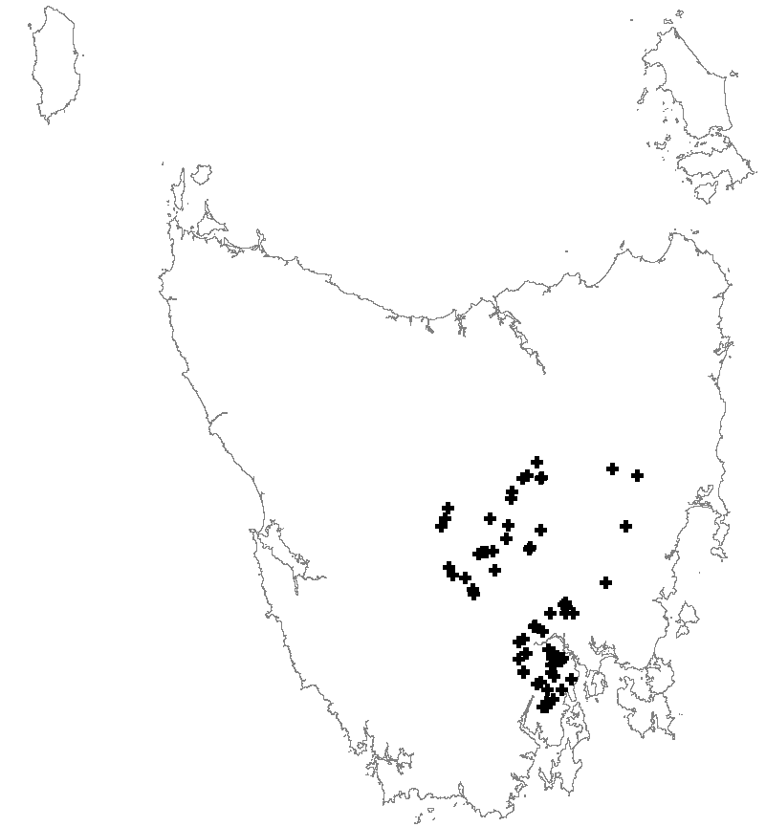 | 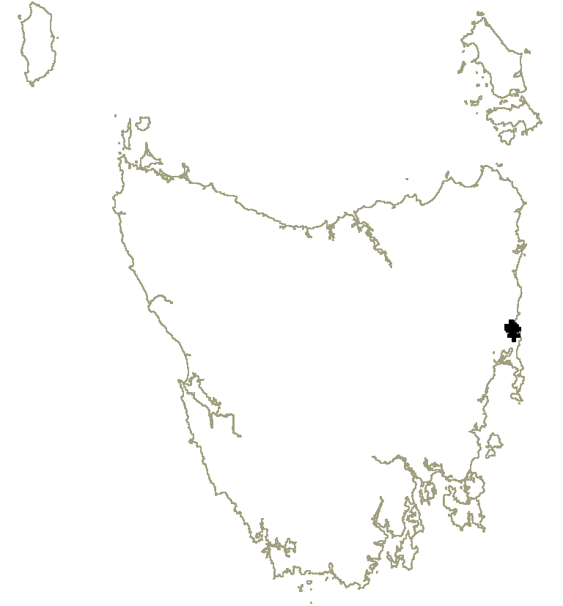
Epacris acuminata | Epacris apsleyensis
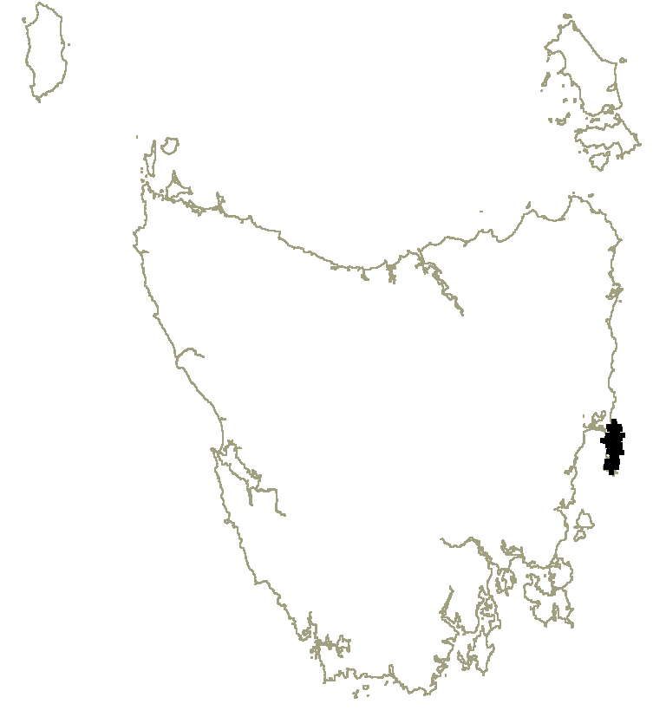 | 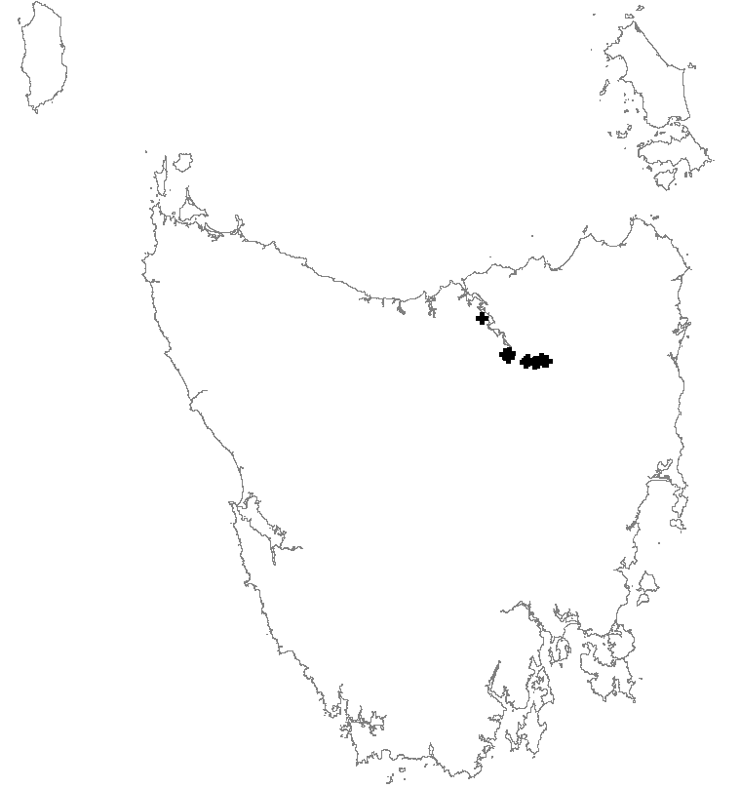
Epacris barbata | Epacris exserta
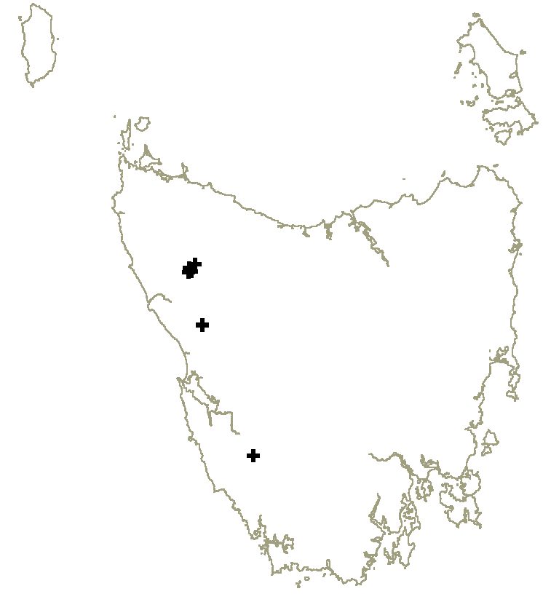 | 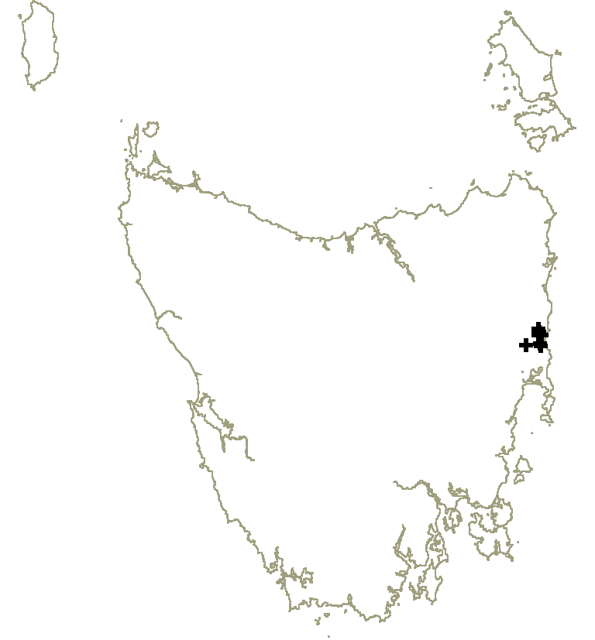
Epacris glabella | Epacris grandis

Figure 1. Epacris taxa distributions

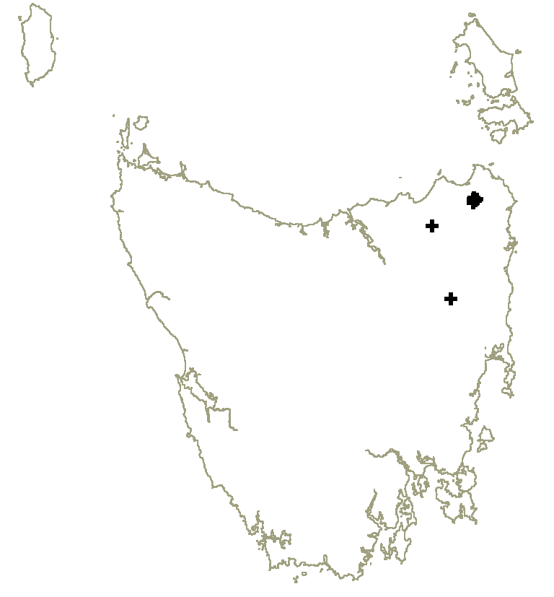 | 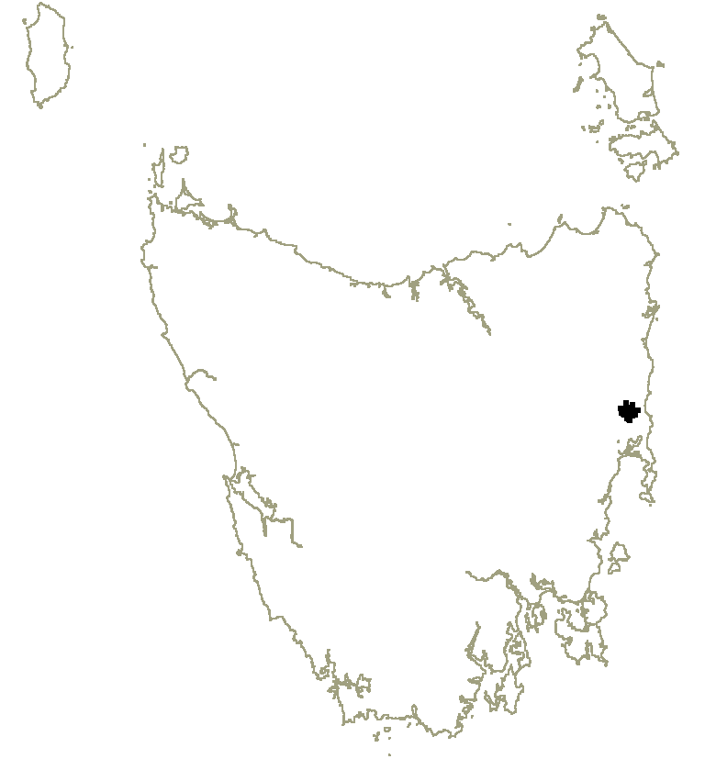
Epacris graniticola | Epacris limbata
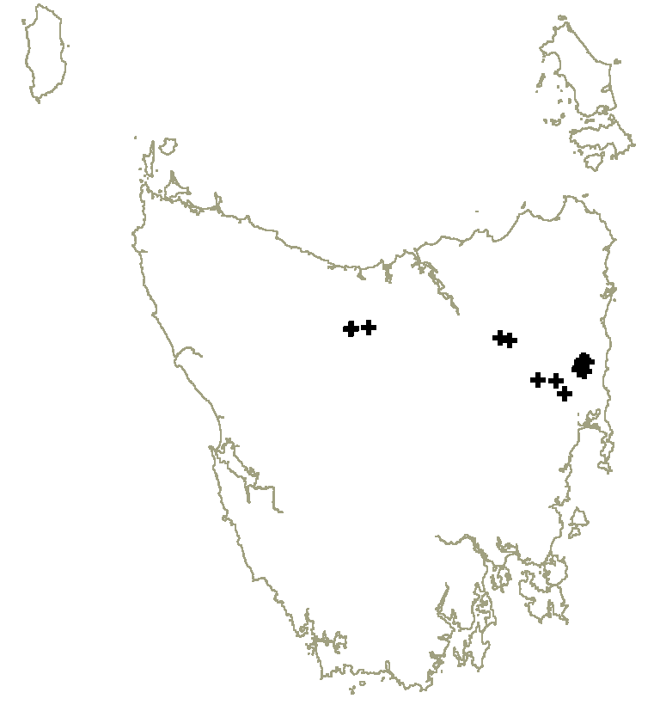 | 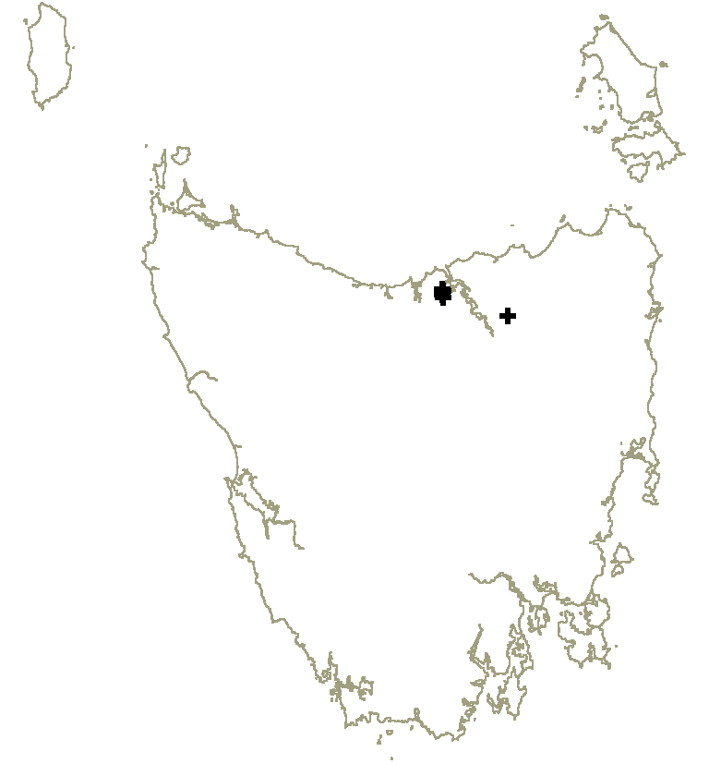
Epacris moscaliana | Epacris virgata (Beaconsfield)
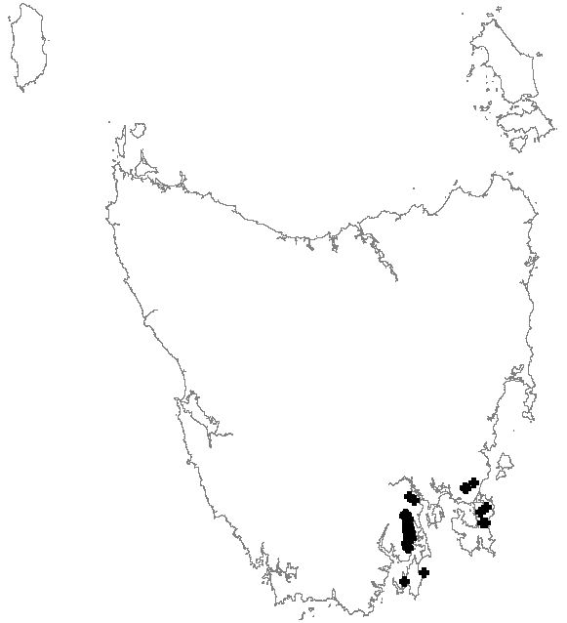
Epacris virgata (Kettering)

Figure 2. Epacris taxa distributions

Habitat critical to the survival of the species
Characteristics of habitat considered to be critical to the survival of the species as defined in the EPBC Act and relevant to the distribution of forest epacrids include:
- habitat that is used during periods of stress (e.g., flood, drought, fire);
- habitat that is used to meet essential life cycle requirements (e.g., seed dispersal processes);
- habitat that is used by important populations;
- habitat that is necessary to maintain genetic diversity and long-term evolutionary development;
- habitat that is necessary for use as corridors to allow the species to move freely between sites used to meet essential life cycle requirements;
- habitat that is necessary to ensure the long-term future of the species or ecological community through reintroduction or re-colonisation;
- habitat that is in any other way critical to the survival of the taxon.
General habitat characteristics for the Epacris taxa are described below. Within this general habitat, habitat that is critical to the survival of the species includes the local catchment known to support important populations (as described below and listed in Appendix 2) and adjacent habitat suitable for population expansion.

General habitat characteristics for the Epacris taxa
Epacris acuminata occurs between the Channel district in southeast Tasmania, the Midlands district and the eastern edge of the Central Plateau. It is found in subalpine heathy woodland, on mountain summits at
600–1100 m elevation, and in either riparian or ‘moist’ dry sclerophyll forest at 30–590 m elevation; the species occurs exclusively on Jurassic dolerite.
Epacris apsleyensis is restricted to the middle reaches of the Apsley River catchment west and south of Bicheno on the east coast. It occurs in dry sclerophyll eucalypt forest on ridges, lower and midslopes, and on moderately sheltered moist flats, on Jurassic dolerite at 20–250 m elevation.
Epacris barbata is restricted to the Freycinet Peninsula and Schouten Island on the east coast. It occurs exclusively on Devonian adamellite-granite in open heath and heathy woodland/forest in hilly and low-lying terrain from 30–500 m elevation.
Epacris exserta occurs on alluvium amongst dolerite boulders along the South Esk River below the Trevallyn Dam (Launceston), the lower North Esk River upstream of Corra Linn, and also the lower reaches of the Supply River. Early collections were made along the lower Nile River, though this population is believed to be extinct (Crowden 2003).
Epacris glabella is restricted to two areas of ultramafic soils in northwest Tasmania, one south of Renison Bell and another east of Savage River (Gibson et al. 1992), with a recently confirmed population below the First and Second Splits along the Gordon River. The Renison Bell and Savage River populations occur on hilly terrain in heath, woodland and dry sclerophyll forest at 300–470 m elevation, while the Gordon River population occurs on sparsely vegetated Precambrian quartzitic outcrops prone to occasional flooding at 50 m elevation.
Epacris grandis is restricted to a small area of foothills near Bicheno. It occurs in dry sclerophyll forest on sheltered slopes above the Apsley and Douglas Rivers, and along the banks of the Douglas River on Jurassic dolerite at 30–530 m elevation.
Epacris limbata occurs within a small range in the foothills of the Eastern Tiers southwest of Bicheno. The species is restricted to damp soils on Jurassic dolerite in heathy forest on flats associated with headwater swamps and drainage lines at 200–320 m elevation.
Epacris graniticola occurs among hills on the Mt Cameron range, Mt Stronach and south of Rossarden in northeastern Tasmania. It is locally restricted to skeletal soils on rocky outcrops of Devonian granitics, usually on summits, in heath and dry scrub-forest at 90–720 m elevation.
Epacris moscaliana occurs in the headwaters of the St Pauls, Dukes and Coal Rivers in the Eastern Tiers, where it occurs on dolerite soils, typically in dry sclerophyll woodland at the ecotone between marshes and adjoining lower slopes; the elevation range is 500–600 m. It also occurs in riparian vegetation along the mid to upper reaches of the St Pauls River from 270 to 530 m elevation, the West Swan River, and also along the Nile River from upstream of Lilyburn Bridge. Two populations are also known along the upper reaches of the Mersey River, one on Quaternary alluvium close to the river upstream of the Union Bridge at elevations of 225–240 m, and the other on a moist rock plate site on the steep southerly slopes of the adjoining Gog Range at elevations of 500–600 m (the latter site occurs on Cambro-Ordovician siliceous conglomerate and sandstone, and is characterised by the abundant presence of Sphagnum australe).
Epacris virgata (Beaconsfield) is restricted to a small area of undulating terrain in the foothills of the Dazzler range near Beaconsfield on the west side of the Tamar River, where it occurs on ultramafic soils in dry sclerophyll forest (Gibson et al. 1992); the elevation range is 40–80 m. An outlying population purportedly occurs on dolerite near Pipers River east of the Tamar (Crowden 2005, pers. comm.).
Epacris virgata (Kettering) occurs among foothills around the D’Entrecasteaux Channel and Tasman Peninsula in southeastern Tasmania. The species occurs in dry sclerophyll forest on hilly terrain at 10–300 m elevation, mainly on Jurassic dolerite, though sometimes close to the geological boundary of dolerite and Permian mudstone (Deep Bay Formation).

Important populations
Important populations for each of the Epacris taxa considered in this Plan are listed in Appendix 2. For those taxa with fewer than 10 populations in total all populations are considered ‘important’ (see Table 2), while for the other taxa ‘important’ populations are those that support at least 95% of the total number of mature individuals — taking into account the condition and degree to which populations are threatened. Any new populations discovered during the life of the Recovery Plan will be judged by the recovery team as to whether they are important populations. When necessary, the recovery team will also re-assess any other population currently judged not to be an important population, using data on the species concerned from survey and monitoring actions.

Known and potential threats
Key threatening processes listed on the EPBC Act that are relevant to the management of forest epacrids include:
- Dieback caused by the root-rot fungus (Phytophthora cinnamomi);
- Land clearance;
- Loss of climatic habitat caused by anthropogenic emissions of greenhouse gases.
Mitigation of ‘Loss of climatic habitat caused by anthropogenic emissions of greenhouse gases’ is recognised as a potential threat but is beyond the timeframe of this Recovery Plan and is not discussed further. Other threatening processes include inappropriate fire regimes, competition from weeds, inundation and modified flood flows in regulated rivers, mining and forestry activities, and habitat degradation by stock.

Biology and ecology relevant to threatening processes
Keith (1998) noted that established plants of Epacris generally have a low background rate of mortality, < 1% per annum. Keith estimated mortality at 10–23% for Epacris glabella and Epacris graniticola after 25–30 years without fire, and conjectured that the maximum life span of individual shrubs was probably in the order of 30–40 years. Barker (2003) measured mortality of only 1% on populations of Epacris sp. aff. exserta (Union Bridge) along the Mersey River after 65 years without fire. This may indicate that for some taxa fire is likely to be beneficial if applied before populations begin to senesce, while others — those of strictly riparian habitat, for instance (Epacris exserta and some Epacris moscaliana populations) — may be able to regenerate without fire.
Related to fire frequency is the decline in flowering as plants become more shaded a long time after fire (Keith 1998). Because the soil-stored seed may not survive for more than a couple of years after the last flowering event, obligate seed regenerators can be excluded from a site if fire does not stimulate regeneration when seed is available. On the other hand obligate seed regenerators can be removed from a site if fire is too frequent. This can happen if a second fire kills regenerating plants before they have had time to mature, set seed and establish a soil seed bank. The taxa that are able to resprout from basal stem buds can survive more frequent and more intense fire, and may also regenerate on sites where no soil seed remains after a long fire-free period. Keith (2000) inferred from plant growth forms post-fire that mature plants of the following species were able to resprout (at least after low intensity fire): Epacris apsleyensis and Epacris barbata. Gilmour et al. (2000) investigated the cues to seed gemination in Epacris tasmanica, concluding that fire-related dormancy-breaking cues such as heat shock, smoke and darkness act synergistically in promoting seed germination, and suggested that their level of influence may reflect the ecology of Epacris species. Some Epacris species also required ‘post fire’ rainfall to ensure seedling establishment
All of the Epacris taxa occupy habitats that are susceptible to Phytophthora cinnamomi, being in the climatic envelope that is suited to the pathogen (Podger et al. 1990). While Phytophthora cinnamomi may express itself on many soil types, those of low nutrient status, such as those found beneath coastal heaths and heathy eucalypt woodlands, tend to be the most conducive to disease expression. Episodic mortality of plants in excess of the background rates may occur in response to disease infection. Some of the Epacris taxa have been demonstrated to be susceptible to Phytophthora cinnamomi (Barker & Wardlaw 1994), while others may be presumed to be susceptible to varying degrees. It has been demonstrated that Phytophthora cinnamomi has caused catastrophic rates of decline in some Epacris barbata populations (Barker 1996 and unpublished data). Attempts at chemical treatment of diseased Epacris populations in Tasmania have thus far proved ineffective in improving survival rates (Black, unpublished data).

Identification of threats
Phytophthora cinnamomi and inappropriate fire management are the major threats to the Epacris taxa. Inappropriate land management practices, competition from weeds, inundation and modified flood flows in regulated rivers, and habitat degradation by stock also pose a threat.
Phytophthora cinnamomi is a significant threat to Epacris species.
- Differing management is required according to the susceptibility to P. cinnamomi infection, and the current infection status within and adjacent to populations. Some species have low susceptibility (e.g., Epacris acuminata), while others are highly susceptible (e.g., Epacris barbata and Epacris limbata), and the infection status varies in different areas.
- Commercial forestry and mineral exploration on State Forest and other Crown tenures are potential contributors to the introduction and spread of Phytophthora cinnamomi if not undertaken using appropriate hygiene measures;
- Non-commercial uses of State Forests and Reserves pose similar threats in specific areas, for example bushwalking and off-road vehicle use.
- Protocols for the control of Phytophthora cinnamomi are applied inconsistently, and additional controls are required to further reduce the risk to important epacrid populations, depending on the infection status and current access levels.
- Recommended actions to protect Phytophthora cinnamomi management areas (Barker 1994 and Schahinger et al. 2003) are yet to be implemented.
Inappropriate fire regimes are a serious threat to Epacris species.
- Lack of fire may result in population declines and even local extinctions.
- Frequent fire may exclude some taxa from the habitat.
- A number of important populations have not been included in fire management plans.
- Fire followed by drought may prevent recruitment in some species.
Issues to resolve include: the structure of each population in relation to the fire history; and how the regeneration strategy of each species relates to fire.
Inundation and downstream impacts of major dams
- Inundation presents an irreversible threat that is difficult to mitigate.
- Regeneration conditions may be disrupted downstream due to modified flood flows and sediment regimes.
Land clearance and development contribute to an irreversible loss or degradation of habitat.
- Residential development poses a threat through land clearance, weed invasion, disease spread and inappropriate fire regimes.
- Land clearance also occurs for the purposes of mining, logging, earthworks, quarrying and boundary clearance.
Weed invasion is an increasing threat to populations adjacent to agricultural land and other private land.
- The Tasmanian Weed Management Act 1999 is the instrument to control or eradicate declared weeds from the habitats of threatened flora species.
- The major weeds include gorse (Ulex europaeus), blackberry (Rubus fruticosus aggregate), hawthorn (Crataegus monogyna), Spanish heath (Erica lusitanica), willow (Salix spp.), and radiata pine (Pinus radiata) threatens two important populations.
Track, road, utility easement, and walking track construction, maintenance and use represent an indirect threat to many important epacrid important populations, in that they may act as conduits for the spread of disease and weeds.

Mineral exploration and extraction

A number of populations of threatened Epacris taxa occur in areas of mineral prospectivity, particularly those on soils derived from ultramafic rocks, Epacris glabella and Epacris virgata (Beaconsfield). The majority of populations for these species occur in categories of reserve that allow mineral exploration and development, namely, Conservation Areas, Nature Recreation Areas, Regional Reserves and Forest Reserves. Mineral exploration and associated activities, if undertaken without appropriate consideration for these species, may destroy plants and their habitat directly through earthworks or impact indirectly on their habitat by infection of soil-borne diseases, changes in hydrology or introduction of weeds.

Forestry activities including selective logging and firewood collection, pose a threat to some populations if undertaken without appropriate consideration for these species.
Grazing and trampling by livestock is a minor threat to a small number of epacrid populations on private land where appropriate management agreements are not in place, in particular Epacris acuminata and Epacris exserta.

Populations under threat
Most populations of the Epacris taxa included in this Plan are under threat. Populations that are currently in a healthy demographic state and are free of Phytophthora cinnamomi and weeds remain at risk, as they may have no specific fire or Phytophthora cinnamomi management prescriptions in place. Threats to important populations of each species are listed in Appendix 2.

recovery AND MANAGEMENT

Recovery strategy and progress evaluation
The overall objective of the Tasmanian Forest Epacrids Recovery Plan is to reduce the risk of extinction of forest Epacris taxa in the wild by ensuring habitat protection for all taxa and by securing all important populations under effective management regimes within the next five years.
Each year following establishment, the Recovery Team will monitor and evaluate progress against the performance criteria outlined in this Plan and report to the relevant sponsor organisations. Progress on actions will be communicated to the general public through listing statement updates, websites, relevant newsletters and reports. The plan will be formally reviewed within 5 years of adoption under the EPBC Act.

Objectives of the EPBC Act and TSP Act
The Threatened Tasmanian Forest Epacrids Flora Recovery Plan satisfies the objectives of the Commonwealth Environment Protection and Biodiversity Conservation Act 1999 in that it seeks to:
- provide for the protection of the environment, especially those aspects of the environment that are matters of national environmental significance, viz., the nationally listed Epacris species;
- promote ecologically sustainable development through the conservation and ecologically sustainable use of natural resources;
- promote the conservation of biodiversity by maintaining the conservation value of ecosystems in which threatened Epacris species occur;
- promote a co-operative approach to the protection and management of Epacris species involving governments, the community, landholders and indigenous peoples.
The Plan satisfies the objectives of the Tasmanian Threatened Species Protection Act 1995 in that it seeks to:
- ensure that Tasmania’s threatened Epacris species can survive, flourish and retain their potential for evolutionary development in the wild;
- ensure that the genetic diversity of threatened Epacris species is maintained;
- educate the community in the conservation of threatened Epacris species;
- encourage co-operative management of threatened Epacris species including the making of co-operative agreements for land management under the Act;
- assist landholders to enable threatened Epacris species to be conserved;
- encourage the conserving of threatened Epacris species through co-operative community endeavours.

International obligations
None of the Epacris species covered by this Recovery Plan are listed under any international agreement and the Plan does not affect Australia’s international responsibilities.

Affected interests
While recovery actions under this Plan consider the roles and interests of a range of private landowners and government land managers, some stakeholders may be affected. Affected interests, including stakeholders and those involved in implementing actions include: Forestry Tasmania, DPIPWE, the Department of Infrastructure, Energy and Resources (including the Forest Practices Authority and Mineral Resources Tasmania), Hydro Tasmania, irrigation authorities, forestry industries, Wellington Park Management Trust, local Councils, NRM regional committees, Bushcare, Tasmanian Flora Network and volunteer groups. The suite of landowner and/or land manager interests will be reflected in the membership of a recovery team, and where appropriate and practical their respective roles are identified in the actions of this Recovery Plan.

Social and economic impacts
A number of the Epacris taxa considered in this Recovery Plan are associated with riparian ecosystems. These systems and their associated aquatic communities have been identified as a high priority for conservation in Tasmania in all NRM regions. The protection of riparian ecosystems in farming areas is increasingly acknowledged as a benefit to agricultural production, maintenance of a high quality water supply and as a landscape amenity. There are no economic impacts in formal reserves already managed for nature conservation, and the implementation of recovery actions with potential economic implications for private landholders (e.g., changing agricultural practices), will be undertaken in consultation with landholders, with advice and assistance provided where appropriate.

Role and interests of indigenous people
In the preparation of this Plan the important role Tasmanian Aboriginal people have played in land management was recognised, and the impact of European settlement on this role acknowledged.
The following Aboriginal organisations have been consulted on the significance of threatened Tasmanian forest epacrids in Aboriginal cultural tradition, and on their knowledge, role and interest in their management: Aboriginal Land Council of Tasmania, Tasmanian Aboriginal Centre, and Tasmanian Aboriginal Land and Sea Council.
Implementation of this Plan will involve:
- knowledge sharing;
- participation in education and training relevant to threatened species management; and
- engagement in recovery actions where relevant to Aboriginal land management and communities.
If, during any recovery activity, suspected evidence of Aboriginal heritage significance is found, this will be reported to Aboriginal Heritage Tasmania, and, if the evidence is to be disturbed, the activity will be suspended pending appropriate follow-up.

Biodiversity benefits
Conservation of Epacris taxa will have numerous benefits for biodiversity values. The principal benefit will be the protection of a variety of significant and unusual habitats, including a range of dry eucalypt forests and heathlands, vegetation on soils derived from ultramafic rocks, riparian vegetation and remnant vegetation in agricultural landscapes.
A number of Epacris taxa co-occur with other species listed on the EPBC Act: Stonesiella selaginoides (EN) occurs with Epacris apsleyensis at Blindburn Creek and Lilla Villa Bridge. These two localities also support populations of Spyridium lawrencei (VU) and Callitris oblonga subsp. oblonga (VU), respectively. The latter two species and Bertya tasmanica subsp. tasmanica (EN) co-occur with Epacris moscaliana along the middle reaches of the St Pauls River, while Boronia gunnii (VU) and Boronia hippopala (VU) co-occur with Epacris moscaliana along the upper reaches of the same river and one of its tributaries. Tetratheca gunnii (CR) and Spyridium obcordatum (VU) each co-occur with Epacris virgata (Beaconsfield) on soils derived from ultramafic rocks near Beaconsfield. Conservation measures proposed to protect Epacris taxa will also benefit these species and the habitats in which they occur, including the implementation of fire, weed and disease control measures at locations that may not otherwise receive attention.

Specific recovery objectives
- Management: to use, and establish where necessary, processes within and between government bodies, private industries and landowners that facilitate effective and sustainable conservation management of all important populations;
  - to control the impact of all Threatening Processes in areas supporting important populations;
  - to implement effective and sustainable management regimes for all important populations;
  - to promote effective and sustainable management regimes in all other areas of known habitat;
  - to implement adaptive management changes in response to unacceptable declines in population sizes or quality of habitat; and
  - to ensure the effective transfer of relevant data to key stakeholders.
- To improve tenure arrangements for important populations under a range of agreements.
- To successfully coordinate the recovery program.
- To incorporate wider knowledge of the species into recovery management.
- To increase knowledge and involvement of the community.

Performance criteria
- Recovery Team of varied stakeholders successfully coordinating the implementation of actions and budget spending within 1 year, and annually monitoring success of recovery effort and adjusting implementation as necessary for the life of the Plan.
- Appropriate management implemented.
  - No further decline in the habitat area occupied by important populations due to any threatening process over the life of the Recovery Plan.
  - Inclusion of important populations on State Forest and Crown land in fire management plans that are appropriate for the taxon within 2 years and implementation of the plans within 3 years.
  - Seed of all taxa collected and in long term storage within 5 years.
  - Epacris recovery plan Management Practices information disseminated to key stakeholders and all private habitat owners within 1 year.
  - Listing statement and spatial population data for each taxon updated as required and circulated to all key stakeholders, the wider botanical community and general public in the appropriate form; i.e., the Natural Values Atlas updated, information circulated to the Tasmanian Flora Network, DPIPWE threatened species websites updated as necessary, data provided to relevant Commonwealth, State and local government agencies (including the relevant NRM region committees).
- Tenure secured.
  - Inclusion of all important populations on State Forest as ‘Flora – Threatened Species’ Special Management Zones in Forestry Tasmania’s Management Decision Classification system within 2 years.
  - At least one additional important population for each taxon on private land (where relevant) protected by a conservation covenant under the Tasmanian Nature Conservation Act 2002 within 5 years.
- The regeneration response to fire is known for each taxon and incorporated into management regimes within 5 years.

Recovery actions
- Coordinate Recovery Program
- Establish a Recovery Team including a wide representation of key stakeholders (as identified in Affected Interests), within the first 6 months operation of the Recovery Plan.
- Team to coordinate implementation of the Recovery Plan, including: review progress of recovery annually, adjust recovery action implementation as necessary, add to the list of important populations of each species as necessary, manage the budget, and decide on funding priorities under the Recovery Plan. Where appropriate the Team will review the conservation status of listed Epacris taxa in the wake of updated information (and nominate, where appropriate, taxa that are currently not listed).
- Conduct a full review of the Recovery Plan within 5 years of adoption under the EPBC Act.
- Managing Threatening Processes
  - Minimise impact of all threats
- Instil the principles of the Recovery Plan management practices into the operating procedures of the Environmental Management Systems of Forestry Tasmania, the Tasmanian Parks and Wildlife Service, Mineral Resources Tasmania and relevant local government municipalities. The Management Practices are tenure neutral and cover development activities, fire management, Phytophthora cinnamomi control, weed management, timber harvesting, road, track and utility easements, and mineral exploration.
- Actions to reduce the impact of threats to threatened epacrid species, including those outlined in the Recovery Plan Management Practices, are to be included in all relevant Reserve and National Park management strategies and plans.
  - Minimise the impact of forestry practices
Develop relevant Recovery Plan Management Practices, in accordance with the ‘Procedures for the management of threatened species under the forest practices system’ (April 2010), into ‘endorsed management prescriptions’.
  - Plan and implement fire management
    - On land managed by either the PWS or FT, map populations considered critical to the survival of the species as polygons and include in GIS systems. Identify proposed burn units and indicate the time and intensity of planned burning. A permit under the TSP Act to implement the burns will be required where planned burns are likely to result in the injury or death of a threatened Epacris species.
    - Incorporate relevant information from i) into fire management plans where they are developed.
    - Apply TSP Act permit provisions on private land. As part of action 7, private landholders will be made aware of the TSP Act permit requirements for proposed burns, and of the management practice guidelines for fire, and will be provided with advice on the appropriate frequency and intensity of burning according to the site/s involved.
  - Minimise the spread of Phytophthora cinnamomi
    - Ensure best practice Phytophthora hygiene controls are implemented in all catchments supporting threatened forest epacrids (DPIWE 2004).
    - Implement the recommendations and prescriptions detailed in Barker (1994) and Schahinger et al. (2003).
    - Where necessary establish Phytophthora cinnamomi management areas for important populations that are not included in Barker (1994) and/or Schahinger et al. (2003), and implement appropriate management procedures.
    - Determine and negotiate the implementation of additional controls for important populations. Normal protocols aim to control disease spread by modifying activities to reduce risk to acceptable levels. Additional controls should aim to reduce that risk further for important populations. Some important populations are infected while others are not. Steps in additional control include: reviewing the management of, and access to, important populations; protecting populations that are free of disease by quarantine where possible; altering access if current access poses a threat and where tracks pass through diseased populations; and developing a decision support system to minimise risk. Diseased populations are indicated in Appendix 2.
  - Undertake weed control, where practicable, in all important populations threatened by weeds (Appendix 2). Incorporate the principles included in the Recovery Plan Management Practices (below). Ensure that the requirements of all Weed Management Plans under the Tasmanian Weed Management Act 1999 are implemented on land containing Epacris habitat. This includes areas adjacent to and upstream of populations.
  - Seed should be collected, to the extent practicable, from widely separated populations of all Epacris taxa over the life of the Recovery Plan; seed will be stored at the Tasmanian Seed Conservation Centre (RTBG).
  - Reduce the impact of dams: liaise with Hydro Tasmania and the Tasmanian Irrigation Development Board re releases of water to mitigate flow changes/impacts, and maintain environmental flows and.
    - Liaise with Hydro Tasmania and the Tasmanian Irrigation Development Board re releases of water to mitigate flow changes/impacts, and maintain environmental flows
    - Liaise with the Assessment Committee for Dam Construction regarding environmental flow provisions of Dam Works Permits.
  - Reduce impacts of grazing and trampling by livestock through communication with relevant landowners; provide information on incentives and assistance with fencing where appropriate.
  - Reduce impact of roads, tracks, utility easements and walking tracks, through liaising with PWS, DIER (Department of Infrastructure, Energy and Resources), Aurora Energy and local Councils re vehicular tracks and walking tracks (existing and planned); and ensuring road, easement and track maintenance contractors are trained and provided with Management Practices Guidelines.
- Increase number of important populations under protective tenures
  - Include all important populations of threatened Epacris taxa on State forest in ‘Flora – Threatened Species’ Special Management Zones within 2 years, and develop and implement appropriate management prescriptions.
  - Place a protective conservation covenant on one important site per taxon where they occur on private land, where agreed by the landowner, and implement a management agreement/plan for each site during the life of the Plan. Identify and liaise with private landholders on covenants and provide management advice and assistance.
  - If required, develop management agreements/plans for populations already under conservation covenant, and implement these plans. Liaise with private landholders and provide management advice and assistance.
  - Establish new reserves (or upgrade the status of existing reserves) for those species for which all or the majority of important populations are either on public land not managed for nature conservation or on private land not under conservation covenants (Table 2).
  - Consider special management requirements for epacrids on soils derived from ultramafic rocks, Epacris glabella and Epacris virgata (Beaconsfield), and those poorly represented in the reserve system, Epacris apsleyensis, Epacris exserta and Epacris virgata (Kettering).
- Conduct surveys and monitoring
  - Undertake a population census of all important populations within a three-year period. The census should include all aspects of each taxon’s population dynamics, as well as attributes relevant to its conservation status:
- Range
- Area of occupancy
- Extent of occurrence
- Size of population (estimates should be statistically powerful and include the standard error).
- Rate of population growth or decline.
- Areas of similar habitat surrounding populations.
- Threats.
The highest priority to census within the first year are those populations not surveyed within the last 10 years, and those where there are gaps in the knowledge of the attributes listed above, especially the size of populations and threats.
  - After the initial population census monitor important populations of all species at 3 year intervals to determine when thresholds are met for management intervention and to assess the level of success of recovery and management actions by determining changes in the attributes described above.
  - Populations of each species which are not currently considered important populations should be monitored at regular intervals, preferably every 5 years, to determine their status, threats, and any major change in condition. This information, in conjunction with data from the actions above, will be used to determine whether these populations should be added to the list of important populations for each species (Action 1b).
  - Survey and monitoring data is to be held in a central database that will be used as a basis to develop an Adaptive Management Regime. Steps in developing this regime include:
    - Set decline thresholds that will trigger management responses for each important population of each species.
    - Develop a decision support system including a recommended management response that conforms to the Recovery Plan Management Practices and Recovery Actions.
- Investigate fire ecology
  - Undertake a systematic fire history and regeneration survey to determine if plants are derived from seed or are likely to have resprouted from rootstock after fire. Aspects to be measured include:
    - Age of plants versus time since last fire. This will require measuring an attribute of the population structure that can be related to the time since fire as determined by a fire history reconstruction based on fire scar ages of eucalypts and/or ages of fire-sensitive species such as acacias.
    - Regeneration strategy of each species
          - Obligate seed regenerator: collect evidence that the taxon cannot regenerate from root or basal stem buds. Populations that are obligate seed regenerators cannot be sustained with frequent fires that do not allow sufficient time to build a viable soil seed bank. Undertake soil seed bank research to determine the longevity of the seed bank and the response of the soil seed bank to fire.
          - Facultative resprouter: collect evidence that the taxon can regenerate from root shoots or basal buds. Determine if the response is dependent on fire intensity.
  - Use the information from this survey and research to inform fire management planning (Action 2b) and information provided to land managers (Action 7) within 4 years.
- Investigate taxonomy
Extend current taxonomic research to the point that the distinctions between Epacris virgata (Beaconsfield) and Epacris virgata (Kettering) can be formally resolved during the life of the Recovery Plan, and also review the status of the atypical Epacris virgata (Beaconsfield) subpopulation at Pipers River.
- Educate and inform stakeholders and community
  - Advise all private landowners/managers of their obligations to protect habitat in accordance with the regulations of the EPBC Act, the TSP Act, the NC Act (for known or potential occurrences in threatened vegetation communities) and the Wellington Park Act 1993, and distribute the recommended Management Practices (below) within year 1. This includes information on development and land use restrictions, damage to the species, and fire permit provisions of the TSP Act.
  - Provide advice to landowners/managers on the appropriate frequency and intensity of burning according to the site/s involved.
  - Update spatial population data (using data from Action 4 and 5) and disseminate to the wider botanical community and general public in the appropriate form. This will include: update the Natural Values Atlas, circulate information to the Tasmanian Flora Network, update DPIPWE threatened species websites as necessary, and provide data to the relevant Commonwealth, State and local government agencies.
  - Listing statement for each taxon will updated as required, using information gained from monitoring (Action 4), and circulated to all stakeholders via threatened species websites.
  - Provide advice on specific prescriptions for mineral exploration to the Mineral Exploration Working Group and to mining companies.
- Progress on actions will be communicated to the general public by through the publication of listing statements on the DPIPWE website, relevant newsletters and reports.

Duration of recovery plan and estimated costs

Actions | Cost estimate | Timeframe | NRM region
1. Coordinate Recovery Program | $40 000 | Year 1–5 | All Regions
2. Manage threatening processes | $150 000 | Year 1–5 | All Regions
3. Increase number of populations in protected tenure | $80 000 | Year 1–5 | All Regions
4. Conduct surveys and monitoring | $150 000 | Year 1–5 | All Regions
5. Investigate fire ecology | $80 000 | Year 1–5 | All Regions
6. Investigate taxonomy | $25 000 | Year 1–5 | All Regions
7. Educate and inform stakeholders and the community | $100 000 | Year 1-5 | All Regions
Total | $625,000

Management Practices
Surveys should be undertaken to determine if threatened Epacris species or their habitat would be impacted upon by proposed developments or land use changes, to satisfy relevant requirements under the following State and Commonwealth legislation: the Tasmanian Land Use Planning and Approvals Act 1993, the Tasmanian Forest Practices Act 1985, the Tasmanian Nature Conservation Act 2002 (for known or potential occurrences in threatened vegetation communities), the Tasmanian Threatened Species Protection Act 1995, and the Commonwealth Environment Protection and Biodiversity Conservation Act 1999.
- Any proposed activity that requires land clearance in the habitat of important populations will have a significant impact on any threatened Epacris species. Land clearance in the habitat of other populations may have a significant impact. If approval under the EPBC Act (for the loss of plants or habitat) and TSP Act (for the loss of plants) is to be considered then substantial positive outcomes for the overall conservation of the taxon should be secured in accordance with regulatory requirements.
- Any proposed development or activity that has the potential to introduce Phytophthora cinnamomi to the habitat of an important population is likely to have a significant impact on that species.
- Any planned fire in threatened Epacris habitat for fuel reduction or habitat management that will result in injury or death of an Epacris plant will require a permit under the TSP Act.
In considering approval or the provision of a permit to take a listed threatened epacrid species, as a result of a planned burn, the following management principles should be applied:

Fire Management prescriptions
- Allow fire intervals to vary between 8 to 25 years (species-specific advice should be sought from specialists within DPIPWE and FPA).
- Avoid repeating low intensity fires (fuel reduction burns) consuming < 6 tonnes/ha ground fuel in succession.
- Where practicable do not burn when droughts are predicted in the spring and summer of the following two years.
- Where practicable exclude fire from Epacris populations infected with Phytophthora cinnamomi for at least 6–10 years after infection.
- Where practicable use natural features as control lines, rather than bulldozed fire breaks, when conducting fuel reduction or ecological burns. If natural features are not sufficient then control lines should be cut by hand using a brush cutter and chainsaw to avoid soil disturbance and the possible introduction of weeds or Phytophthora cinnamomi.
- Epacris populations that are known to be infested with weeds should have a weed management plan implemented prior to any planned fire.
Disease hygiene prescriptions
- Implement Phytophthora cinnamomi hygiene guidelines (DPIWE 2004) when visiting or using machinery in catchments supporting threatened Epacris habitat.

Weed control
- Develop weed management plans in association with all activities in the habitats of important Epacris populations, and where possible other epacrid populations. The plans should include:
  - if required, only use herbicides that are licensed for the control of the target weed species;
  - minimising drift of herbicides onto native vegetation;
  - follow up weed control activities to ensure the success of the initial treatment and to prevent reinvasion of weeds;
  - inspecting populations at least once within five years; and
  - minimising the risk of new weed incursions.

RoadS, TRACKS and UTILITY EASEMENTS
- Minimise the amount of slashing required to provide for safe road/track/utility use.
- Do not use herbicide beyond the hardened shoulder of the road.
- Minimise disturbance of habitat.
- Do not drain water into Epacris populations at the edge of roads, tracks or easements.
- Close or re-align tracks (including walking tracks) if the track is resulting in disturbance to an important Epacris population.

timber harvesting
Under the Forest Practices Code (Forest Practices Board 2000), ‘Threatened species and inadequately reserved plant communities will be managed in wood production areas in accordance with procedures agreed between the Forest Practices Board and DPIWE. The agreed procedures will include the development of endorsed management prescriptions through consultation among landowners, Forest Practices Officers and specialists within the Board and DPIWE.’

mineral exploration
Any mineral exploration activities should be in accord with the Tasmanian Mineral Exploration Code of Practice (Bacon 1999), with reference to the Mineral Exploration Working Group (MEWG). The Code will guide MEWG to the level of prescription required, but individual prescriptions should be developed on a case-by-case basis depending on the level of risk associated with the proposed exploration operation, with specialist advice to be provided by DPIPWE.
GRAZING
Where possible stock should be excluded from threatened epacrid populations, and from suitable habitat adjacent to populations. Fences required to protect populations should be maintained, taking into account native wildlife movement, including the movement of animals to low-lying and riparian environments during drought periods.
WATER MANAGEMENT
Water regimes and effluent management imposed on regulated rivers that support threatened epacrids should be such as to sustain the ecological values of riparian ecosystems at a low level of risk. Flows should be governed by a standard set of operating guidelines and restriction management protocols.

BIBLIOGRAPHY
Bacon, C.A. (1999). Mineral Exploration Code of Practice (Fourth Edition). Mineral Resources Tasmania, Hobart.
Barker, P.C.J. (1994). Phytophthora cinnamomi: The susceptibility and management of selected Tasmanian rare species. Forestry Tasmania and Australian Nature Conservation Agency.
Barker, P.C.J. (1996). Extension surveys and long term monitoring plots for selected species threatened by Phytophthora cinnamomi in Tasmanian. Forestry Tasmania and Australian Nature Conservation Agency.
Barker, P.C.J. (2003). Geomorphic response of the Mersey River and population response of Epacris aff. exserta (Union Bridge) to flow regulation. A report for the Tasmanian Department of Primary Industries, Water and Environment by North Barker & Associates, Ecosystem Services.
Barker, P.C.J., & Wardlaw, T. (1994). The susceptibility to Phytophthora cinnamomi of rare and threatened plants in Tasmania. Australian Journal of Botany 43: 379–386.
Buchanan, A.M. (2009). A Census of the Vascular Plants of Tasmania & Index to The Student’s Flora of Tasmania. Tasmanian Museum and Art Gallery, Hobart.
(Web edition for 2009: http://www.tmag.tas.gov.au/Herbarium/TasVascPlants.pdf)
CLAC Project Team (2005a). Consultation Report and Recommended Allocations for the Municipality of West Coast. Crown Land Assessment and Classification Project, Department of Primary Industries, Water and Environment, Hobart.
CLAC Project Team (2005b). Consultation Report and Recommended Allocations for the Municipality of Kingborough. Crown Land Assessment and Classification Project, Department of Primary Industries, Water and Environment, Hobart.
CLAC Project Team (2006a). Consultation Report and Recommended Allocations for the Municipality of Dorset. Crown Land Assessment and Classification Project, Department of Primary Industries and Water, Hobart.
CLAC Project Team (2006b). Consultation Report and Recommended Allocations for the Municipality of West Tamar. Crown Land Assessment and Classification Project, Department of Primary Industries and Water, Hobart.
Crowden, R.K. (1986). Two new species of genus Epacris (Epacridaceae) from Tasmania. Papers and Proceedings of the Royal Society of Tasmania 120: 17–19.
Crowden, R.K. (2003). Reinstatement of Epacris franklinii Hook.f. (Epacridaceae). Muelleria 18: 67–73.
Crowden, R.K. (2007). Additions to Epacris (Epacridoidae, Ericaceae) in Tasmania. Muelleria 25: 115–128.
Crowden, R.K., & Menadue, Y. (1990). Morphometric analysis of variation in the ‘Epacris tasmanica Complex’ (Epacridaceae). Australian Systematic Botany 3: 253–264.
Curtis, W.M. (1963). The Student’s Flora of Tasmania. Part 2. Government Printer, Hobart.
DPIWE (2004). Tasmanian Washdown Guidelines for Weed and Disease Control: machinery, vehicles and equipment. Edition 1. Tasmanian Agricultural Contractors of Tasmania, Forestry Tasmania and the Department of Primary Industries, Water and Environment, Hobart.
DPIWE (1998). Strategic plan for the private land component of the CAR reserve system. Department of Primary Industries, Water and Environment, Hobart.
Forest Practices Board (2000). Forest Practices Code, Forest Practices Board, Hobart, Tasmania.
Gibson, N., Brown, M.J., Williams, K., & Brown, A.V. (1992). Flora and vegetation of ultramafic areas in Tasmania. Australian Journal of Ecology 17: 297–303.
Gilmour, C.A., Crowden, R.K., & Koutoulis, A. (2000). Heat shock, smoke and darkness: partner cues in promoting seed germination in Epacris tasmanica (Epacridaceae). Australian Journal of Botany 48: 603–609.
Gilmour, C.A., Crowden, R.K., Vaillancourt, R.E., & Koutoulis, A. (2000). Genetic variation in the Epacris tasmanica complex (Epacridaceae). Papers and Proceedings of the Royal Society of Tasmania 134: 75–78.
Jarman, S.J., & Mihaich, C.M. (1991). Additions to the Epacridaceae in Tasmania. Papers and Proceedings of the Royal Society of Tasmania 124(2): 99–103.
Keith, D. (1997). The distribution and population status of rare Tasmanian forest Epacrids. Unpublished report, Nature Conservation Branch, Tasmanian Parks and Wildlife Service, Hobart.
Keith, D. (1998). Recovery Plan – Tasmanian Forest Epacrids 1999–2004. Tasmanian Parks and Wildlife Service, Hobart.
Keith, D.A. (2000). Sampling designs, field techniques and analytical methods for systematic plant population surveys. Ecological Management & Restoration 1(2): 125–139.
Keith, D. (2004). Australian Heath Shrub (Epacris barbata): Viability under Management Options for Fire and Disease. Chapter 8 in Species Conservation and Management: Case Studies (Eds. H.R. Akcakaya, M.A. Burgman and O. Kindvall), Oxford University Press.
Orr, S., & Gerrand, A.M. (1998). Management Decision Classification: A system for zoning land managed by Forestry Tasmania. Tasforests 10: 1–14.
Parks and Wildlife Service (1998). Douglas-Apsley National Park Fire Management Plan. Department of Environment and Land Management, Hobart.
Parks and Wildlife Service (2002). Freycinet Reserves Fire Management Plan. Department of Primary Industries, Water and Environment, Hobart.
PWS, FT & DPIWE – Parks and Wildlife Service, Forestry Tasmania and Department of Primary Industries, Water and Environment (2003). Tasmanian Reserve Management Code of Practice. Department of Tourism, Parks, Heritage and the Arts, Hobart.
Podger, F.D., Mummery, D.C., Palzer, C.R., & Brown, M.J. (1990). Bioclimatic analysis of the distribution of damage to native plants in Tasmania by Phytophthora cinnamomi. Australian Journal of Ecology 15: 281–289.
RFA – Regional Forest Agreement (1997). Tasmanian Regional Forest Agreement. Commonwealth of Australia and the State of Tasmania.
Schahinger, R., Rudman, T., & Wardlaw, T. (2003). Conservation of Tasmanian Plant Species and Communities threatened by Phytophthora cinnamomi. Nature Conservation Branch Technical Report 03/03, Department of Primary Industries, Water and Environment, Hobart.
Wapstra, H., Wapstra, A., Wapstra, M., & Gilfedder, L. (2005). The Little Book of Common Names for Tasmanian Plants. Department of Primary Industries, Water and Environment, Tasmania.
WPMT – Wellington Park Management Trust (2000). Wellington Park Fire Management Strategy. AVK Environmental Management and IFERM Pty Ltd, Castle Hill, New South Wales.
Williams, K.J., & Duncan, F. (1991). Epacris limbata sp. nov., a localised heath from eastern Tasmania. Papers and Proceedings of the Royal Society of Tasmania 124(2): 95–97.
Zacharek, A. (2000). Community Recovery Plan: Eucalyptus ovata – Callitris oblonga Forest. Department of Primary Industries, Water and Environment, Hobart.

Appendix 1. Epacris nomenclature

Previous Recovery Plan (Keith 1998) | Present Recovery Plan | Current TSP Act & EPBC Act Status
Epacris acuminata | Epacris acuminata | –/Vulnerable
Epacris apsleyensis | Epacris apsleyensis | endangered/Endangered
Epacris barbata | Epacris barbata | endangered/Critically Endangered
Epacris exserta sensu stricto | Epacris exserta  Epacris moscaliana (Crowden 2007)  (Pipers River population (EE10) now part of Epacris virgata (Beaconsfield)) | endangered/Endangered  rare/–
Epacris sp. aff. exserta (Mt Cameron) | Epacris graniticola (Crowden 2007) | vulnerable/Critically Endangered
Epacris sp. aff. exserta (Union Bridge) | (Now part of Epacris franklinii) | Not listed  (previously vulnerable/–)
Epacris glabella | Epacris glabella | endangered/Endangered
Epacris grandis | Epacris grandis | endangered/Endangered
Epacris limbata | Epacris limbata | endangered/Critically Endangered
Epacris virgata sensu stricto | Epacris virgata (Beaconsfield) | vulnerable/Endangered
Epacris virgata (Kettering) | Epacris virgata (Kettering) | vulnerable/Not listed
Epacris virgata ‘var. autumnalis’ | Epacris tasmanica (Crowden 2007) | Not listed

Appendix 2. Important Epacris populations

Species | No. | Population ID | Population size (best estimate) | Location (reserve name) | Tenure (manager) | Threats (in order of significance) | Year last surveyed
Epacris acuminata | 1 | EAC8 | 200,000* | Goat Hills (Wellington Park) | PA (WPMT) | Weeds, inappropriate fire, powerline easement, track disturbance (minor) | 2005
Epacris acuminata | 2 | EAC3 | 139,500* | Pelverata Falls (Snug Tiers) | NRA (PWS) | Inappropriate fire, 4WD track disturbance (minor) | 2002
Epacris acuminata | 3 | EAC30 | 73,500* | Elizabeth River | Private | Inundation (via damming of river) | 2005
Epacris acuminata | 4 | EAC17 | 50,925* | East Bagdad  (Devils Den) | Private/  CA (PWS) | Private land: clearance & inappropriate fire  CA: inappropriate fire | 2005
Epacris acuminata | 5 | EAC22 | 12,278 | Serat | Private | Clearance, stock grazing, weeds | 1999
Epacris acuminata | 6 |  | 11,959* | Kundes Creek, Molesworth | Private | Clearance, inappropriate fire, road disturbance (minor) | 2005
Epacris acuminata | 7 | EAC5 | 4,000* | Cathedral Rock/Thumbs/Mt Montagu (Wellington Park) | PA (WPMT) | Drought; walking track disturbance (minor) | 2006
Epacris apsleyensis | 1 | EAP3 | 347,905 | Rosedale Road  (Apsley) | CA (PWS)  & Private | Private land: clearance, Phytophthora cinnamomi & fire  CA: Phytophthora cinnamomi & inappropriate fire | 2002
Epacris apsleyensis | 2 | EAP7 | 157,500 | Ferndale Road | Private | Clearance, Phytophthora cinnamomi, inappropriate fire, weeds | 2002
Epacris apsleyensis | 3 | EAP2 | 21,472 | Blindburn Creek  (Douglas-Apsley) | NP (PWS) | Phytophthora cinnamomi, inappropriate fire | 1995
Epacris apsleyensis | 4 | EAP1 | 1,200* | Denison Rivulet | Private | Clearance, Phytophthora cinnamomi, inappropriate fire | 2001
Epacris apsleyensis | 5 | EAP6 | 980 | Lilla Villa Bridge | Private | Clearance, weeds, stock grazing, inappropriate fire, road disturbance (minor) | 2001
Epacris apsleyensis | 6 | EAP5 | 112 | Bicheno Golf Club | Private | Clearance, Phytophthora cinnamomi, road disturbance (minor) | 1995
Epacris apsleyensis | 7 | EAP8 |  | Ferndale Road | Private | Clearance, Phytophthora cinnamomi, inappropriate fire | 2002
Epacris barbata | 1 | EB11 | c. 50,000* | Schouten Island (Freycinet) | NP (PWS) | Phytophthora cinnamomi, inappropriate fire | 2005
Epacris barbata | 2 | EB7 | 14,703 | Wine Glass Bay (Freycinet) | NP (PWS) | Phytophthora cinnamomi, inappropriate fire | 2002
Epacris barbata | 3 | EB2 | 12,231 | Middleton Creek (Freycinet) | NP (PWS) | Phytophthora cinnamomi, inappropriate fire | 2002
Epacris barbata | 4 | EB5 | 7,854 | Mt Amos (Freycinet) | NP (PWS) | Phytophthora cinnamomi, inappropriate fire | 2002
Epacris barbata | 5 | EB13 | 3,879 | Mt Parsons (Freycinet) | NP (PWS) | Phytophthora cinnamomi, inappropriate fire | 2002
Epacris barbata | 6 | EB14 | 3,388 | Mt Mayson (Freycinet) | NP (PWS) | Phytophthora cinnamomi, inappropriate fire | 2002
Epacris barbata | 7 | EB12 | 2,223 | Cape Degerando (Freycinet) | NP (PWS) | Phytophthora cinnamomi, inappropriate fire | 2002
Epacris barbata | 8 | EB15 | 1,038 | Mt Dove (Freycinet) | NP (PWS) | Phytophthora cinnamomi, inappropriate fire | 2002
Epacris exserta | 1 | EE4 | 1,000* | North Esk River between Corra Linn & St Patricks River | Private/  CL (DPIPWE) | Weeds (gorse, willow), stock, & potentially at risk from dam construction & altered flow regimes | 2007
Epacris exserta | 2 | EE2 & EE3 | 58* | South Esk River downstream of Trevallyn Dam (Trevallyn) | NRA (PWS) & Council | Regulated flow regimes (Trevallyn Dam); weeds (gorse, willow, hawthorn) | 2009
Epacris exserta | 3 | EE5 | 30–50* | Supply River | PR (DPIPWE) | Weeds (minor) | 2007 (part)
Epacris glabella | 1 | EGL3 | 137,087 | 19 Mile Creek & Gabbro Hill (Savage River) | RR (PWS) | Mining, inappropriate fire, Phytophthora cinnamomi | 2001
Epacris glabella | 2 | EGL2 | 51,318 | Brassey Hill | SF (FT) | Mining, inappropriate fire, Phytophthora cinnamomi | 2001
Epacris glabella | 3 | EGL1 | 2,368 | Serpentine Hill | SF (FT)/UCL# (DPIPWE) | Mining, inappropriate fire, Phytophthora cinnamomi, weeds (minor) | 1996
Epacris glabella | 4 | EGL6 | 500* | Splits, Gordon River  (Franklin–Gordon Wild Rivers) | NP (PWS) | Regulated river flows | 2007
Epacris glabella | 5 | EGL5 | 395 | Savage River  (Savage River) | RR (PWS)/  SF (FT) | Mining, forestry activities, inappropriate fire, Phytophthora cinnamomi, road disturbance (minor) | 2001
Epacris glabella | 6 | EGL4 | 14 | Bronzite Hill | SF (FT) | Mining, forestry activities, inappropriate fire, Phytophthora cinnamomi, track disturbance (minor) | 1996
Epacris grandis | 1 | EGD1 | 4,812 | Blindburn Creek  (Douglas-Apsley) | NP (PWS) | Inappropriate fire, Phytophthora cinnamomi | 2007
Epacris grandis | 2 | EGD2 | 1,670 | Lower Douglas River  (Douglas-Apsley) | NP (PWS) | Inappropriate fire, Phytophthora cinnamomi | 1996
Epacris grandis | 3 | EGD3 | 544 | Nicholls Cap (Douglas-Apsley) | NP (PWS) | Inappropriate fire, Phytophthora cinnamomi | 1996
Epacris grandis | 4 | EGD6 | 100 | Rosedale Road | Private | Inappropriate fire, Phytophthora cinnamomi | 2002
Epacris grandis | 5 | EGD5 | 10 | Hardings Falls (Hardings Falls) | FR (FT) | Inappropriate fire, Phytophthora cinnamomi | 1996
Epacris grandis | 6 | EGD4 | 5 | Heritage Falls (Douglas-Apsley) | NP (PWS) | Inappropriate fire, Phytophthora cinnamomi | 1996
Epacris graniticola | 1 | EMC5 | 30,000* | Mt Stronach (Mt Stronach) | FR (FT) | Inappropriate fire, Phytophthora cinnamomi, 4WD track disturbance (minor) | 2009
Epacris graniticola | 2 | EMC1 | 15,000* | Blue Lake track (Cameron) | RR (PWS) | Inappropriate fire, Phytophthora cinnamomi, 4WD track disturbance (minor), & potential mining activities | 2010
Epacris graniticola | 3 | EMC6 | 5,000* | Dalrymple Hill (Castle Cary) | RR (PWS) | Inappropriate fire, Phytophthora cinnamomi, drought | 2009
Epacris graniticola | 4 | EMC9 | 1,250* | Mt Cameron Sth (Cameron) | RR (PWS) | Inappropriate fire, Phytophthora cinnamomi | 2010
Epacris graniticola | 5 | EMC4 | 884 | Mt Cameron (Cameron) | RR (PWS) | Inappropriate fire, Phytophthora cinnamomi, walking track disturbance (minor) | 2006
Epacris graniticola | 6 | EMC2 | 436 | Wedgetail Peak (Cameron) | RR (PWS) | Inappropriate fire, Phytophthora cinnamomi | 2002
Epacris graniticola | 7 | EMC7 | 300 | Billy Bend(Cameron) | RR (PWS) | Inappropriate fire, Phytophthora cinnamomi | 2002
Epacris graniticola | 8 | EMC10 | 250 | Mt Cameron SW (Cameron) | RR (PWS) | Inappropriate fire, Phytophthora cinnamomi, drought | 2010
Epacris graniticola | 9 | EMC3 | 162 | Cube Rock (Cameron) | RR (PWS) | Inappropriate fire, Phytophthora cinnamomi | 1996
Epacris graniticola | 10 | EMC8 | n.a. | 1.5 km west of First Sugarloaf (Cameron) | RR (PWS) | Inappropriate fire, Phytophthora cinnamomi | 2002
Epacris limbata | 1 | EL5 | 32,100 | North Stringybark Swamp | SF (FT) | Phytophthora cinnamomi, inappropriate fire, forestry activities, road disturbance (minor) | 2001
Epacris limbata | 2 | EL4 | 28,191 | Apsley Gate, O Road | SF (FT) | Phytophthora cinnamomi, inappropriate fire, forestry activities, road disturbance (minor) | 2001
Epacris limbata | 3 | EL1 | 7,477 | 2.2 km ENE of Hardings Falls | SF (FT) | Phytophthora cinnamomi, inappropriate fire, forestry activities, road disturbance (minor) | 2001
Epacris limbata | 4 | EL2 | 3,844 | 2.9 km ESE of Hardings Falls | FR (FT) | Phytophthora cinnamomi, inappropriate fire, road disturbance (minor) | 2001
Epacris limbata | 5 | EL3 | 518 | 2.2 km WSW of Mt Andrew (Douglas-Apsley) | NP (PWS) | Phytophthora cinnamomi, inappropriate fire | 2002
Epacris moscaliana | 1 |  | 20,000* | Gog Range (Alum Cliffs) | SR (PWS) | Inappropriate fire | 2002
Epacris moscaliana | 2 |  | 20,000* | Dukes Marsh | SF (FT) | Forestry activities, inappropriate fire, track disturbance (minor) | 2004
Epacris moscaliana | 3 | EE7 | 7,320 | Horseshoe Marsh | SF (FT) | Forestry activities, inappropriate fire, track disturbance (minor) | 2003
Epacris moscaliana | 4 |  | 1,000s* | St Pauls River (Mt Puzzler) – includes Keith’s EE8. | FR (FT) &  SF (FT) | Forestry activities, changes to flow regime | 2003
Epacris moscaliana | 5 |  | 100s–1000s | St Pauls River: Township Flats to Avoca causeway | Private% | Inundation (proposed dam), clearance, weeds, stock grazing | 1999
Epacris moscaliana | 6 |  | 100s–1000s | Nile River (River Hill) | SF (FT) &  FR (FT) | Forestry activities, changes to flow regime | 2002
Epacris moscaliana | 7 | EE9 | 1,511 | Coal Marsh | SF (FT) | Forestry activities, inappropriate fire | 2003
Epacris moscaliana | 8 | EE5 | 268 | Lilyburn Bridge, Nile River | Private % | Clearance, weeds | 2002
Epacris moscaliana | 9 | EE1 | 66+ | Mersey River  (Dogs Head Hill) | FR (FT) | Changes to flow regime (dam upstream) | 2001
Epacris virgata (Beaconsfield) | 1 | EVN1 & EVN2 | 1,700,000 | Beaconsfield (Dans Hill CA & Andersons Creek FR) | CA (PWS), FR (FT), SF (FT) & Private | Mining, clearance, inappropriate fire, Phytophthora cinnamomi | 2010
Epacris virgata (Beaconsfield) | 2 | EE10 | 3,023 | Pipers River (Pipers River) | FR (FT) | Inappropriate fire, Phytophthora cinnamomi, road disturbance (minor) | 2003
Epacris virgata (Kettering) | 1 | EVS28 | 660,000* | Summerleas Road | Private | Clearance, weeds, inappropriate fire | 2006
Epacris virgata (Kettering) | 2 | EVS22 | 300,000 | Hickmans Hill, Margate | Private | Clearance, weeds, inappropriate fire, grazing | 2002
Epacris virgata (Kettering) | 3 | EVS2 | 240,000 | Birchs Bay | Private | Clearance, inappropriate fire, track disturbance (minor) | 1996
Epacris virgata (Kettering) | 4 | EVS24 | 60,000* | Old Bernies Road, Margate | Private | Clearance, inappropriate fire | 2004
Epacris virgata (Kettering) | 5 | EVS10 | 39,222 | Van Morey Road, Margate | Private | Clearance, weeds, inappropriate fire, road disturbance | 1996
Epacris virgata (Kettering) | 6 | EVS19 | 25,000* | Humphreys Rivulet (Wellington Park) | PA (WPMT) | Weeds (spanish heath, radiata pine), inappropriate fire, road disturbance, drought | 2010
Epacris virgata (Kettering) | 7 | EVS27 | 20,000* | Gumpit Road | Private | Clearance, inappropriate fire | 2006
Epacris virgata (Kettering) | 8 | EVS11 | 19,305 | Sandfly Road | Private | Clearance, inappropriate fire, road disturbance | 2002
Epacris virgata (Kettering) | 9 | EVS1 | 15,000* | Lighthouse Road, Bruny Island | Private | Clearance, weeds (radiata pine), inappropriate fire | 2009
Epacris virgata (Kettering) | 10 | EVS12b | 14,000* | Leslie Hill | Private | Clearance, weeds, inappropriate fire | 2005
Epacris virgata (Kettering) | 11 | EVS5a | 11,626 | Manuka Road, Kettering | Private | Clearance, weeds, inappropriate fire | 1996
Epacris virgata (Kettering) | 12 | EVS29 | 10,000s* | Gosling Flats, Blackman Rivulet | Private | Clearance (proposed dam), inappropriate fire | 2008
Epacris virgata (Kettering) | 13 | EVS30 | 10,000* | Margate Hills | Private | Clearance, weeds, inappropriate fire | 2009

Population ID after Keith (1997 & 1998) and Forest Epacrids database (data held by the Threatened Species Section, DPIPWE). Population size = number of mature individuals in population (= mean estimate as per Keith 1997 & Forest Epacrids database; * = recorder estimate). Tenure & manager abbreviations: NP = National Park, SR = State Reserve, NR = Nature Reserve, CA = Conservation Area, NRA = Nature Recreation Area, RR = Regional Reserve, FR = Forest Reserve, PR = Public Reserve, PA = Protected Area, SF = State Forest, UCL = unallocated Crown Land (# = status being assessed under the Crown Land Assessment & Classification Project (CLAC 2005a or b)). Tenure shown in bold = private land protected – wholly or partly (%) – by a conservation covenant under the Tasmanian Nature Conservation Act 2002.

Formerly the Tasmanian Department of Primary Industries and Water (DPIW) and the Department of Primary Industries, Water and Environment (DPIWE).
Now the Forest Practices Authority and DPIPWE.

