

Edition No. 2021/4

# December 2021

The Offices of the Three Chiefs have had a very productive year despite ongoing lockdowns and limited work travel. The work of pacific engagement has picked up pace, with the appointment of two Pacific Engagement Directors and the signing of a memorandum of understanding to strengthen the collaborative partnership between the department and DT Global to help deliver market access and biosecurity projects to strengthen trade between Australia and Pacific Island countries. The Chief Plant Protection and Chief Environmental Biosecurity Offices completed successful webinar series to record crowds, demonstrating the interest in biosecurity across our stakeholders. During World Antimicrobial Awareness Week, a joint statement was released by Australia’s Chief Medical Officer, Chief Veterinary Officer and Chief Environmental Biosecurity Officer to highlight the concern with overuse of antimicrobials in Australia. We are also preparing for the 2021 Crawford Fund annual conference in December on food and nutrition security - exploring the biosecurity, health and trade nexus.

We wish everyone a safe and peaceful holiday season to usher in 2022!

**Australian Chief Veterinary Officer (**[**ACVO**](http://www.agriculture.gov.au/animal/health/acvo)**)**

**AMR and** **World Antimicrobial Awareness Week**

The World Health Organization (WHO) has declared antimicrobial resistance (AMR) as one of the top ten global public health threats facing humanity. During the recent World Antimicrobial Awareness Week 2021 from 18 to 24 November, AMR was highlighted with the theme of ‘Spread Awareness, Stop Resistance’.

The department is involved in multiple initiatives working to combat AMR and raise awareness of the issue. ‘*Australia’s National Antimicrobial Resistance Strategy – 2020 and Beyond’* was released in 2020, outlining a 20-year vision to protect the health of humans, animals and the environment through minimising the development and spread of AMR.

Any effective response to antimicrobial resistance therefore requires a ‘One Health’ approach, involving coordinated action across all sectors where antimicrobials are used, as well as close alignment with global action.

The implementation of the 2020 strategy requires collaboration by all Australian governments, along with the private sector, industry, professionals, the research community and the general public. Only through working together can we ensure the continued availability of effective antimicrobials both now and into the future.

The department is funding a prescribing behaviour survey to investigate current prescribing by veterinarians, the reasons behind prescribing decisions, and the attitudes of animal owners. The results from the survey will inform the development of evidence-based antimicrobial prescribing guidelines and best practice industry supports.

Antimicrobial prescribing guidelines should be used in all health care settings where antimicrobials are used. The Australian Veterinary Association in conjunction with Animal Medicines Australia have developed antimicrobial prescribing guidelines for sheep, poultry and pigs, and are progressing similar guidelines for dairy cattle.

The AMR Vet Collective website is an excellent AMR resource for veterinarians, along with the recently updated veterinary antimicrobial stewardship (AMS) online training program, which has been designed to help veterinarians make optimal decisions when using antimicrobial agents in clinical practice.

The interactive modules incorporate scenario-centred learning for veterinarians across all areas of practice, and participants can achieve continuing education points. This collaborative project was developed by the Veterinary Schools of Australia and New Zealand, the University of Sydney, Charles Sturt University with funded contributed by the department.

The following resources were developed for World Antimicrobial Awareness Week:

* Joint statement on World Antimicrobial Awareness Week and AMR with Australia’s Chief Medical Officer, Chief Veterinary Officer, and Chief Environmental Biosecurity Officer <https://www.amr.gov.au/news/joint-statement-australias-chief-medical-officer-chief-veterinary-officer-and-chief>
* Joint video with Australia’s Chief Medical Officer Professor Paul Kelly and Chief Veterinary Officer <https://www.youtube.com/watch?v=01W4zu8zmi0>
* Ministerial media release about World Antimicrobial Awareness Week and AMR <https://www.health.gov.au/ministers/the-hon-greg-hunt-mp/media/continuing-advancements-to-curb-antimicrobial-resistance>
* Biosecurity Detect and Protect podcast about AMR featuring Chief Veterinary Officer <https://www.awe.gov.au/biosecurity-trade/policy/australia/public-awareness/detect-protect>
* World Antimicrobial Awareness Week featured on the DAWE website, including a digital toolkit of educational resources <https://www.awe.gov.au/agriculture-land/animal/health/amr>
* The Australian Government’s AMR website https://www.amr.gov.au/
* OCVO website incorporating AMR <https://www.awe.gov.au/agriculture-land/animal/health/acvo>
* DAWE internal news article <https://ausgovenvironment.sharepoint.com/sites/AWE-intranet/SitePages/Recognising-World-Antimicrobial-Awareness-Week.aspx>

Everyone has a role to play in spreading the word about AMR. For further information please visit: [www.amr.gov.au](http://www.amr.gov.au)

To access the AMR Vet Collective and AMS Online Training Program, please visit: [www.amrvetcollective.com](http://www.amrvetcollective.com)

**Chief Vet office creates pilot website to prioritise stakeholder engagement**

A Have Your Say website has been created by the Office of the Chief Veterinary Officer (OCVO) to encourage more Australian stakeholders to provide feedback on the World Organisation for Animal Health’s (OIE) draft standards.

The OIE updates existing international standards and adopts new standards by seeking comments from its 182 members countries and organisations - such as the World Trade Organization and the World Bank, and then asking members to vote on the proposed changes.

Before creating an Australian position on the draft standards, the OCVO asks in-country stakeholders for their feedback. The more feedback received from stakeholders such as veterinarians, industry representatives and state governments, the stronger the Australian position, and the more we can safeguard our animals and international trade.

Member countries of the OIE and World Trade Organization are obligated, where reasonable, to adopt standards published by the OIE.

In the past, in-country stakeholders involved with the consultations had to read through large email attachments to provide their feedback. With the new Have Your Say website, stakeholders will be able to identify topics of relevance to them with just the click of a mouse.

The new website will enhance and strengthen Australia’s position within the OIE and position us as a global leader in stakeholder engagement for animal health and welfare standards. No other member country offers a similar level of engagement to its in-country stakeholders.

The Have Your Say website is currently in the testing phase and scheduled to be launched in March 2022. For more information about the project contact: [ocvo@agriculture.gov.au](mailto:ocvo@agriculture.gov.au)

**Achievements**

**ACEBO**

Exotic Environmental Pest List (EEPL) Implementation Plan finalised through the Environment and Invasives Committee (EIC)

National Environment and Community Biosecurity Research, Development and Extension Strategy (NECBRDES) finalised through the National Biosecurity Committee (NBC)

Environmental Biosecurity Webinar series delivered

Production of Exotic Environmental Pests Calendar 2022

**OCVO**

Hosted the ACVO-Australian Veterinary Association Leadership Dialogue

Hosted the virtual Quads Alliance meeting with the US, Canada, UK & NZ

Soft launch of the OIE Consultation website

Development of a new One Health Surveillance proposal supported by OCVO and EBO

Recruitment: A new Strategic Future Advisor (Mihai Daian), Assistant Director for Pacific Engagement (Peter Thornber) and Executive Assistant (Louise English) joined the OCVO team

**ACPPO**

ACPPO webinar series resulted in increased collaboration between researchers and the department

Release of ACPPO National Priority Plant Pest videos

Rebuild of Pest and Disease Image Library (PADIL) commenced

Upgraded exotic plant pest reference specimen collections

Signing of MOU to strengthen agricultural trade ties between Australia and the Pacific Island Nations

Collaboration with Papua New Guinea to complete plant health survey

**Pacific Engagement**

As part of our commitment to stepping-up Australia’s engagement with Pacific Island and near neighbours, the Australian Chief Plant Protection Office (ACPPO, led by Dr Gabrielle Vivian-Smith) and the Office of the Chief Veterinary Officer (OCVO, led by Dr Mark Schipp) established dedicated Pacific Engagement Programs to build regional partnerships for enhanced biosecurity. Through reinforcing the biosecurity systems of our Pacific neighbours—and strengthening the multilateral organisations that support them—the Programs aim to safeguard animal and plant health across the region.

**Photo 1: Cattle herd in Tonga, Photo credit: Peter Thornber**

This strong focus on partnership activities with our Pacific neighbours is consistent with Australia’s whole of government objective to support regional economic prosperity and food security as part of Australia’s Pacific Step-Up foreign policy. Through their respective Pacific Engagement Programs, ACPPO and OCVO will jointly coordinate the development and implementation of the department’s Pacific Biosecurity Strategy under the Commonwealth Biosecurity 2030 strategic roadmap. A strategic action of this roadmap commits to increasing partnerships with Australia’s near neighbours to build capacity and strengthen national and regional engagement with key international bodies.

To build scientific and technical animal health services in the Pacific, the OCVO Pacific Engagement Program will strengthen regional multilateral organisations through targeted funding to support the Pacific Community to reinvigorate the Pacific Heads of Veterinary and Animal Production Services network; and to strengthen engagement with the World Organisation for Animal Health (OIE) through initiatives to increase OIE membership amongst Pacific Island Countries and Territories (PICTs).

The Program will also facilitate secondments to the Food and Agriculture Organization (FAO) regional and sub-regional offices in collaboration with the department’s Trade, Market Access and International Division under the Global Agricultural Leadership Initiative. The OCVO also looks forward to reinforcing existing relationships and forging new partnerships to deliver capacity development activities to PICTs and near neighbour countries. The ACVO visited Fiji in early December.

**Photo 2: Tongan boar**

**Photo credit: Peter Thornber**

From a plant biosecurity perspective, the ACPPO Pacific Engagement and International Plant Health section will continue to coordinate offshore surveys in near neighbour countries, with a focus on Timor-Leste and Papua New Guinea (as well as Australian External Territories), allowing collection of current pest status information for those countries that may facilitate trade and food security, as well as providing information regarding pest spread in our region. Additionally, engagement with the Pacific Plant Protection Organisation (PPPO), the FAO’s South West Pacific regional organisation through which Australia gains regional representation will continue through:

* Monthly Talanoa sessions with members to discuss phytosanitary and plant health experiences, concerns and support international participation of the region
* Annual International Plant Protection Convention (IPPC) workshops supporting consultation and development of regional and country comment to International Standards on Phytosanitary Measures

Additional areas of support will be investigated collaboratively within the region.

The ACPPO International Capacity Development Section coordinates the Pacific Biosecurity Partnership Program, funded through the Department of Foreign Affairs and Trade. This program delivers capacity development activities to support biosecurity, trade and market access through seven activities including operational training packages related to safe export trade pathways and sea container hygiene; implementation of a communication strategy and the Generic ePhyto National System; improvements in pest data management; trade and market access support and improving biosecurity in the Solomon Islands.

A better coordinated, multi-disciplinary approach will help both Australia and Pacific neighbours to protect our agriculture and food systems, stop the spread of pests and diseases, maintain and expand market access opportunities, and safeguard environmental values and our way of life.

**Detect & Protect –Australian biosecurity podcast**

The department is pleased to announce the launch of this exciting podcast series. Listeners will hear from leaders in biosecurity and get an insight behind the scenes, from frontline border security officers to researchers. You can listen to episodes on YouTube or your favourite podcast app. For more information please visit: [www.awe.gov.au/podcast-series](http://www.awe.gov.au/podcast-series)

The third podcast featured Dr. Mark Schipp, Australian Chief Veterinary Officer. In this podcast, find out about antimicrobial resistance (AMR), why it is a risk and what we can all do to help manage it.

**Australian Chief Environmental Biosecurity Officer (**[**ACEBO**](https://www.agriculture.gov.au/biosecurity/environmental/cebo)**)**

**2021 Frog Mortality Event**

Over the course of 2021 there have been more than 1,400 reports of sick and dead frogs, primarily coming from along the eastern seaboard. Seventy percent of the reports are from New South Wales, the remainder are mostly from Queensland and Victoria, and a small number from other states. The reports were received by the national citizen science project - FrogID, which is administered by the Australian Museum.

The amphibian chytrid fungus, *Batrachochytrium dendrobatidis*, in combination with the cold temperatures are suspected to be the cause, but other factors may be involved. Chytrid (pronounced ‘kitrid’) has been previously implicated in the extinction of at least four Australia frog species and the dramatic decline of at least 10 others.

In 2016 the Commonwealth developed the: Threat Abatement Plan - for infection of amphibians with chytrid fungus resulting in chytridiomycosis (2016). This plan recognises the threat that chytrid poses and presents guidance and actions for reducing its impact. The department has funded $7,088,350 for eight projects since 2015 addressing threats to frogs, which includes projects that manage chytrid and its disease.

Whilst frog mortalities following the first cold snap of winter are not unusual, this event has impacted a much larger number of animals across a larger geographic area than previously recorded.

**Photo 3: Dead Green Stream Frog (Litoria phyllochroa), Photo credit: Dr Jodi Rowley Australian Museum**

More than 30 different species of native frogs have been reported amongst the dead and dying, the majority are green tree frogs, which is a common species found around houses. Unusual numbers of dead cane toads have also been reported.

Sick frogs have been coming out in the open during the day, which is very unusual, and dying shortly after. Notable symptoms include lethargy, emaciation, and skin discolouration. Some frogs had red bellies and feet, and excessive sloughed skin.

Another class of virus pathogens called ranaviruses have also been associated with significant mortality and morbidity in wild amphibians in the past, but testing of dead frogs to date, have tested negative for ranavirus.

The Australian Registry of Wildlife Health and the Australian Museum in collaboration with other museums, Wildlife Health Australia, universities, and state government environment and biosecurity agencies are working together to further investigate this concerning event. The department will continue to provide support to these programs to help fully understand the causes and work to minimise the impacts.

**Release of the National Feral Pig Action Plan**

**Photo 4: Feral Pigs in the western Riverina**

**Photo credit: Riverina Local Land Services / Shutterstock**

Minister for Agriculture and Northern Australia, the Hon. David Littleproud released the National Feral Pig Action Plan on 27 October 2021 following endorsement by the National Biosecurity Committee.

The plan provides a national and coordinated approach to feral pig management and brings industry, governments, natural resource management groups, indigenous organisations, land managers and the wider community together to address the significant impact of feral pigs.

It aims to guide effective, coordinated, sustained and humane best practice management of feral pigs through three key priorities:

* providing leadership and strategic coordination for sustained feral pig management
* building community awareness of impacts of feral pigs and enhancing capacity and capability of land managers to apply humane, best practice management methods
* increasing the adoption of humane best practice management methods and systems by land managers.

The plan has been delivered as part of $1.4 million in funding provided by the Australian Government to Australian Pork Limited in 2019 to establish the role of the National Feral Pig Management Coordinator. Dr Heather Channon, the coordinator, has led the development of the plan and will lead its implementation together with the National Feral Pig Action Plan Implementation Committee.

As part of the implementation of the plan, an initial group of demonstration sites is being set up which will showcase how integrated best practice feral pig management and monitoring methods are being applied at a landscape-scale. You can read the National Feral Pig Action Plan 2021-2031 at: <https://feralpigs.com.au/the-plan>

**Finalisation of the Exotic Environmental Pest List Implementation Plan**

The National Priority List of Exotic Environmental Pests, Weeds, and Diseases (EEPL) Implementation Plan (the plan) has been endorsed and finalised by the Environment and Invasives Committee (EIC) in September 2021.

The plan provides a program of work and initiatives that will help reduce the environmental biosecurity risk posed by the EEPL species, similar but unlisted species. The EEPL identifies species that pose a significant environmental biosecurity risk to Australia and was published in 2020. The EEPL provides focus for the development of national approaches that coordinate risk reduction and to streamline messaging that aims to promote environmental biosecurity awareness.

The composition of the plan has been informed from a first-pass gap analysis, which identified gaps in environmental biosecurity risk mitigation. There were also several rounds of consultation with members of the EIC and the Environmental Biosecurity Advisory Group (EBAG) to identify priority work and list key-stakeholder perspectives.

**Photo 5: Didymo (*Didymosphenia geminata*) also known as rock snot**

**Photo credit: Ministry of Agriculture and Forestry Biosecurity New Zealand**

The majority of activities in the plan will be the responsibility of the Chief Environmental Biosecurity Officer (CEBO) to deliver; however, the plan’s success will depend upon tangible resource contributions from all stakeholders, including state and territory governments, community and environmental groups, industry and the research sector.

The Environmental Biosecurity Project Fund (EBPF) that is administered by the CEBO will support projects that deliver expanded environmental biosecurity risk reduction capability and address the objectives in the plan.

A number of the plan’s activities will be building and further developing existing risk reduction initiatives that are parts of other Commonwealth, and state and territory biosecurity programs. In many instances, these biosecurity programs should only require minor changes for environmental biosecurity risk to be addressed.

The plan and the composition of the EEPL are scheduled to be reviewed after 3-5 years. It is anticipated that the focus of attention brought to environmental biosecurity by the EEPL and the plan, at the national level, will reveal many opportunities to make substantial improvements and consequently the plan and list will require updating and refinement within five years.

**Australian Chief Plant Protection Officer (**[**ACPPO**](http://agriculture.gov.au/plant/health/acppo)**)**

**New National Khapra Beetle Action Plan 2021-2031 release**

As part of our preparedness work, the *National Khapra Beetle Action Plan 2021–2031* will shortly be published on the department’s website: [www.awe.gov.au/biosecurity-trade/pests-diseases-weeds/plant/national-action-plans](http://www.awe.gov.au/biosecurity-trade/pests-diseases-weeds/plant/national-action-plans). This plan has been developed in consultation with many stakeholders over the past two years and builds upon previous action plans to address National Priority Plant Pests: [www.awe.gov.au/biosecurity-trade/pests-diseases-weeds/plant/national-priority-plant-pests-2019](http://www.awe.gov.au/biosecurity-trade/pests-diseases-weeds/plant/national-priority-plant-pests-2019).

**Photo 6: An adult Khapra Beetle (A) and larva (B) on grains of rice**

**Photo credit: DAWE**

Khapra Beetle is Australia’s number two priority plant pest and has spread across the globe from its native India. A mature adult is smaller than a grain of rice and, as they can lie dormant for an extended period of time, they have been able to successfully spread through ‘hitchhiking’ in shipments of grain, personal effects, machinery, and a variety of other materials. Their size and lifecycle mean they are particularly challenging to detect and, if they reached Australia, they would likely be able to rapidly establish and put a variety of our agricultural products, particularly the grains industry at high risk.

**What can you do to help out?**

If you see what looks like khapra beetle, you can report it using the Report Hotline (1800 798 636).

Isolate the infestation by closing off the area, take a photo and, if safe, a sample of the beetles. They are most likely to be found in stored produce such as grain, rice, cotton seed, powdered milk and nuts, or in containers used for storing or moving produce.

**Photo 7: Khapra beetle larvae inside cardboard packaging corrugation**

**Photo credit: DAWE**

As well as destroying grain, khapra beetles pose a risk to human health through their contamination of stored products, which can result in gastrointestinal and/or respiratory issues. If you are handling grain, note that the larval skins that the beetles cast off can cause skin irritation.

**Partnering** **for a robust plant health surveillance system**

In August, a National Partnership Agreement was signed between the Australian Government and all states and territories, to significantly improve Australia’s national plant health surveillance system, with the Australian Government committing $1 million annually, matched through in-kind contributions by jurisdictions.

The National Plant Health Surveillance Program is designed for the early detection of high priority exotic plant pests entering Australia and provides evidence of Australia’s pest free status to support trade and market access. A national steering committee representing each participating government has also been established to oversee the implementation of the program, ensuring it delivers national biosecurity outcomes.

**Agricultural trade strengthened between Australia and the Pacific**

**Photo 8: Virtual MoU signing event**

**Photo credit: DAWE**

A Memorandum of Understanding (MoU) was signed virtually by the Australian Chief Plant Protection Officer Dr Gabrielle Vivian-Smith on behalf of the department and Mr Frank Maiolo, Managing Director of DT Global Asia-Pacific on 6 October 2021, to grow agricultural trade between Australia and Pacific Island Countries. DT Global is responsible for managing the Pacific Horticultural and Agricultural Market Access Plus (PHAMA Plus) Program, on behalf of the Australian and New Zealand Governments.

The PHAMA Plus program works with six Pacific Island Countries: Fiji, Papua New Guinea (PNG), Samoa Solomon Islands, Vanuatu and Tonga, as well as other countries under Australia's PACER Plus commitment (currently the Cook Islands, Kiribati and Niue). The MOU will strengthen the collaborative partnership between DAWE and DT Global to provide the following:

* support for Pacific Islands producers and exporters to improve and gain greater market access of plant and plant-products;
* support Pacific Island exporters to comply with Australian biosecurity requirements;
* strengthen the capacity of Pacific biosecurity authorities through training and knowledge-sharing; and
* support biosecurity systems and processes, including surveillance, diagnostics and emergency response and preparedness in the Pacific region to improve food security for Pacific people.

The PHAMA Plus program, which is funded by the Department of Foreign Affairs and Trade.

Find out more about our partnership by visiting:

<https://www.awe.gov.au/biosecurity-trade/market-access-trade/phama-plus-mou>, <https://phamaplus.com.au/media/growing-agricultural-trade-between-australia-and-the-pacific/>

*PHAMA Plus - Growing Pacific livelihoods and economies* video <https://youtu.be/jbOKJekZmA8>

**Biosecurity collaboration with northern neighbours**

The hard work of protecting our borders from biosecurity threats never stops. For the last month the Department’s International Plant Health Surveillance Program (IPHSP) and the Northern Australia Quarantine Strategy (NAQS) has taken this challenge to new shores by partnering with Papua New Guinea’s National Agriculture and Quarantine Inspection Authority (NAQIA) to survey plant health on the island of New Britain. This multidisciplinary survey ran for two weeks from 26 September, bringing together botanists, entomologists and plant pathologists to survey for weeds, pests and plant diseases.

Because of COVID-19 travel restrictions, IPHSP and NAQS, developed a remote system of real-time support. The Department’s NAQS scientists provided real time support whilst NAQIA is in the field using platforms like WhatsApp to send messages and share images.

**Photo 9: NAQIA team surveying bananas during the New Britain survey Photo credit: NAQIA**

Elizabeth McCrudden, from the Australian Chief Plant Protection Office, helped organise the survey and highlighted how collaboration was a crucial element in this project. She said it was made possible by the ‘professional, long-standing relationship between scientists, cultivated across many years. While this was the first survey using the new remote model, we have conducted surveys together for many years.’

Relevant plant species and pests from Australia’s National Priority Plant Pest list, Australia’s National Environmental Priority Pest List and NAQIA’s priority pest list were selected for this survey, with the aim to provide Australia and Papua New Guinea with distribution data and early warning of priority plant pests in the region. This will assist with the management of Australia’s border as we further understand the different pathways of pests and diseases to reach our shores.

IPHSP is also supporting NAQIA to deliver a second survey targeting Asian Citrus Psyllid and Huanglongbing in the Sanduan Province along the West Papua boarder. The NAQIA team departed on 25 November for two weeks and is being supported by NAQS via WhatsApp whilst in the field.

**Photo 10: New Britain survey locations, Photo credit: Google**

Given Australia’s proximity to Papua New Guinea, and the vital trade links between Papua and the Torres Strait, it’s important that we are armed with knowledge of what’s affecting our neighbours.

### **Plant Health Hero: Sarah Corcoran**

Sarah Corcoran recently was awarded the 2021 Dr Kim Ritman Award for Science and Innovation by the Department of Agriculture, Water and the Environment, being recognised for her outstanding contributions to biosecurity.

Throughout her career, Sarah Corcoran has delivered many significant eradication programs for agricultural and environmental pests. She has overseen investment in infrastructure and biosecurity research, including disease detection, management and response, which have enabled her to implement consistent approaches to biosecurity nationally.

As Director of the National Red Imported Fire Ant Eradication Program and National Electric Ant Eradication Program from 2014 to 2016, Sarah Corcoran guided the team through four rounds of treatment and surveillance of an incursion of red imported fire ants (RIFA) in Yarwun/Gladstone, Queensland. She engaged local media in a very successful community engagement campaign called ‘Ant Hunt’. In mid-2016, Yarwun/Gladstone was declared free from RIFA.

**Photo 11: Sarah Corcoran**

**Photo credit: Plant Health Australia**

Following the detection of browsing ants in Western Australia and the Northern Territory (NT), Sarah saw the benefits of training RIFA detection dogs to detect other ant species. She sourced funding for the training of these dogs, which are now considered a vital surveillance tool by both the WA and NT departments and are still in service today.

Phase four of the National Banana Freckle Eradication Program became Sarah’s responsibility on her appointment in 2016 as Chief Plant Health Officer with the NT government. In her new role as Executive Director Biosecurity and Animal Welfare for the Northern Territory, she felt privileged to formally declare that banana freckle had been eradicated from Australia. The successful eradication of banana freckle sent a clear signal to markets locally and globally that Australia was free of the disease.

Sarah Corcoran led the emergency response to the detection of citrus canker in the Northern Territory when the disease was reported to her in 2018. She was awarded the 2019 collaborative Industry/Government Australian Biosecurity Award in 2019, recognising her significant contribution to biosecurity and response to citrus canker in the Northern Territory.

On commencing her term as Plant Health Australia (PHA) Chief Executive Officer in 2020, Sarah shared her vision for PHA to become the repository of knowledge for plant health in Australia, with government, industry, peak bodies and growers working together to achieve an integrated national plant biosecurity system. During her time in the role, she has worked with industry, government, research and development councils to draft a new five-year strategic plan that will position and support PHA to deliver on these focus areas.

Video of Sarah Corcoran on receiving the award: <https://publish.viostream.com/play/bgoo5gydmkkd6w>

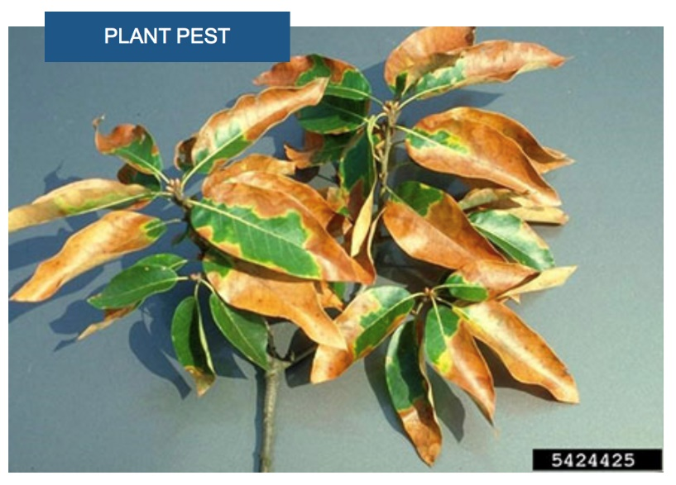**Pest Profile: *Xylella fastidiosa* – preparedness research**

Xylella is Australia’s number one priority plant pest. The disease is caused by the bacteria *Xylella fastidiosa* that infects the xylem of plants – its water conducting system. Xylella attacks more than 500 different plant species including commercial varieties of plants and native plants too. The physical symptoms of Xylella are generally nonspecific leaf scorching making it very difficult to diagnose. In fact, most plants infected by Xylella will be asymptomatic and show no signs of infection. There is no known treatment for Xylella.

**Photo 12: Bacterial leaf scorch caused by Xylella fastidiosa  
Photo credit: John Hartman, University of Kentucky**

One of the reasons for Xylella’s devastating impact is its rapid spread by insect vectors. These insect vectors feed on the sap within the xylem of plants and easily spread Xylella from plant to plant. Xylella has been found to survive within the foregut of these insects so once infected the insect can spread the bacteria throughout its life.

In 2017 ABARES estimated the potential economic impact of Xylella on the Australian wine industry to be $7.9 billion dollars over 50 years. Internationally, the economic costs of Xylella to Europe have already been estimated in the billions of Euros.

Xylella is a threat that could arrive in Australia on imported plant propagative material or insect vectors brought here through cargo, sea vessels and aircrafts, shipping containers, travellers and especially international mail. Our biosecurity inspections at the border and import permits for live plant material are designed to protect Australia. Plant material lawfully brought into Australia undergo inspections, treatments for insect vectors and several tests to ensure the plants are not infected by Xylella.

**Photo 13: Insect vector - Glassy-Winged Sharpshooter, Homalodisca vitripennis  
Photo credit: Alex Wild**

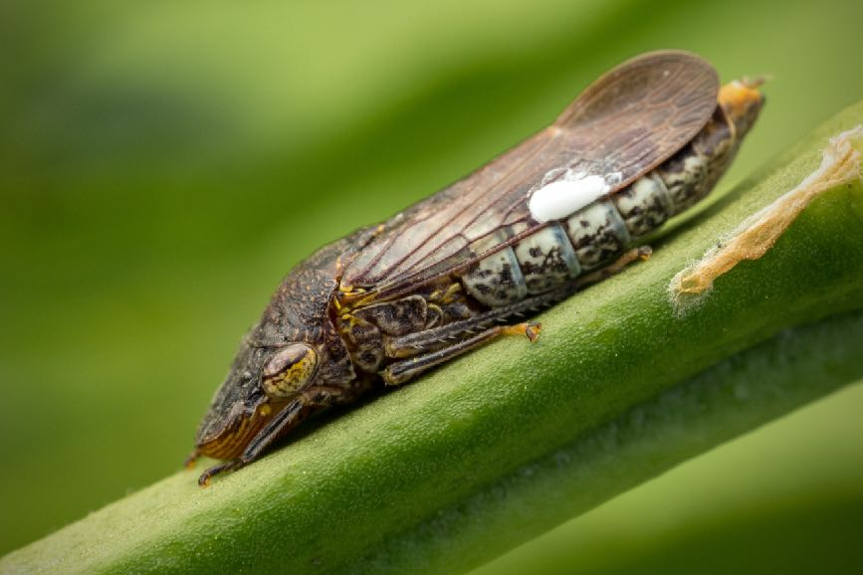

To address the threat of Xylella, the department has invested in innovation and research to enhance our capacity to detect Xylella in crops by airborne monitoring using hyperspectral imaging. This technology makes use of hyperspectral cameras which can take highly accurate measurements of the light spectrum of plants and cover thousands of hectares at one time. The analysis of the hyperspectral data by supercomputers allows identification of the effects of Xylella even before any visual symptoms appear.

Professor Pablo Zarco-Tejada and Dr Tomas Poblete, from the University of Melbourne recently published their international research in [*Nature Communications*](https://www.nature.com/articles/s41467-021-26335-3), demonstrating that hyperspectral imaging and a novel algorithm can distinguish the disease from water-induced stress and from other vascular pathogens, such as Verticillium wilt. This research is being adapted for Australian agriculture, with scans of healthy almond, citrus and olive trees with varying water and nutrient levels being used to develop baseline models.

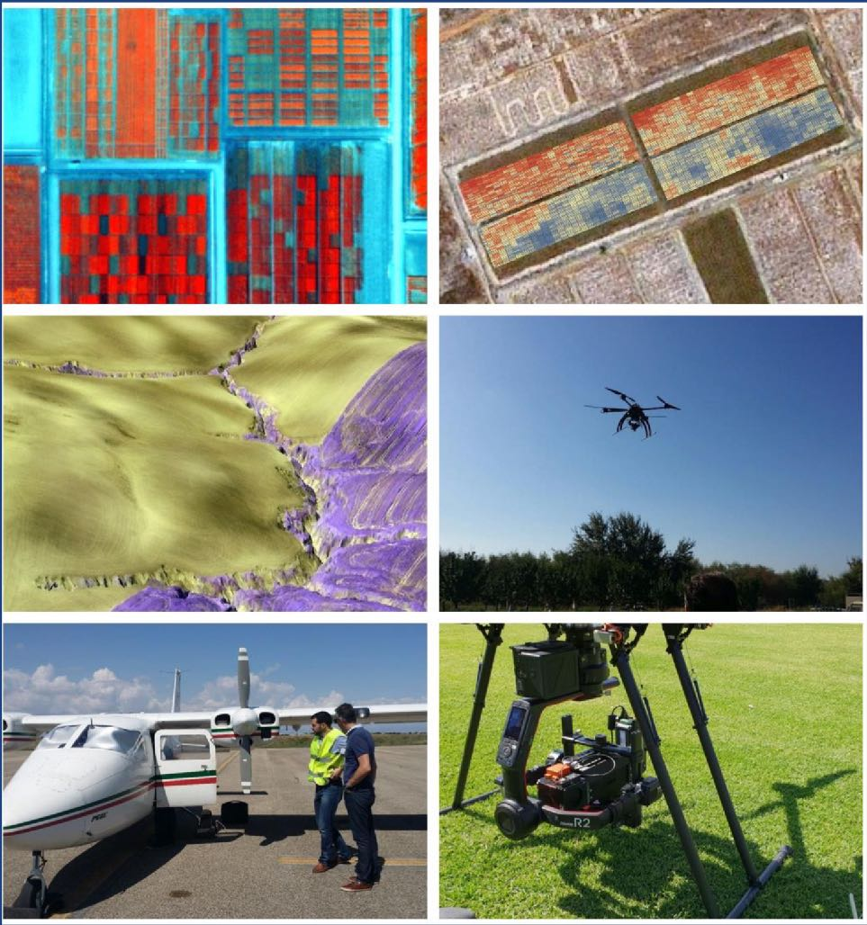

**Recent Events**

**21-23 November:** Australian Veterinary Antimicrobial Stewardship (AVAMS) Conference 2021

**23-24 November:** Exercise Gammalite – an equine influenza simulation exercise

**26 November:** Animal Health Committee (AHC) Stakeholder session

**2 December:** GF-TADS meeting, joint initiative of FAO and OIE to address transboundary animal diseases

**3 December** Animalplan Steering Committee

**Upcoming Events**

**December:** Environmental Biosecurity Advisory Group Meeting

**6-10 December:** ACVO visit to Fiji to meet with SPC, government officials, OIE delegates and university representatives

**7 December:** OIE Council Meeting

**13-14 December:** [Crawford Conference on the Biosecurity, Health, Trade Nexus](https://www.crawfordfund.org/news/food-nutrition-security-your-invitation-to-our-2021-annual-conference/)

**15 December:** Science Council

**March:** Environmental Biosecurity Office 2022 Webinar Series Launch

**Useful Links**

Environmental Biosecurity webinar series – all recordings are now available: <https://haveyoursay.awe.gov.au/2021-environmental-biosecurity-webinars>

New Department of Agriculture, Water and the Environment website:

<https://www.awe.gov.au/>

National Biosecurity Website  
[www.biosecurity.gov.au](http://www.biosecurity.gov.au)

Insect Watch:  
[www. invasives.org.au/insect-watch/](https://invasives.org.au/insect-watch/)

11th International Symposium on Fruit Flies of Economic Importance, Sydney  
[ISFFEI 2022 (11isffei.com)](https://www.11isffei.com/)

**Contact us**

**ACPPO:** [acppo@agriculture.gov.au](mailto:acppo@agriculture.gov.au)

**ACVO:** [ocvo@agriculture.gov.au](mailto:ocvo@agriculture.gov.au)

**ACEBO:** [acebo@agriculture.gov.au](mailto:acebo@agriculture.gov.au)

**Photo 14: Remote sensing project using hyperspectral imaging.  
Photo credit: Pablo Zarco-Tejada**

**New National Priority Plant Pest videos**

Check out Dr Gabrielle Vivian-Smith’s new videos on fall armyworm and fruit fly on our website and look out for more new videos on social media in the coming weeks.

<https://www.awe.gov.au/biosecurity-trade/pests-diseases-weeds/plant/exotic-armyworm>

<https://www.awe.gov.au/biosecurity-trade/pests-diseases-weeds/plant/fruit-flies>