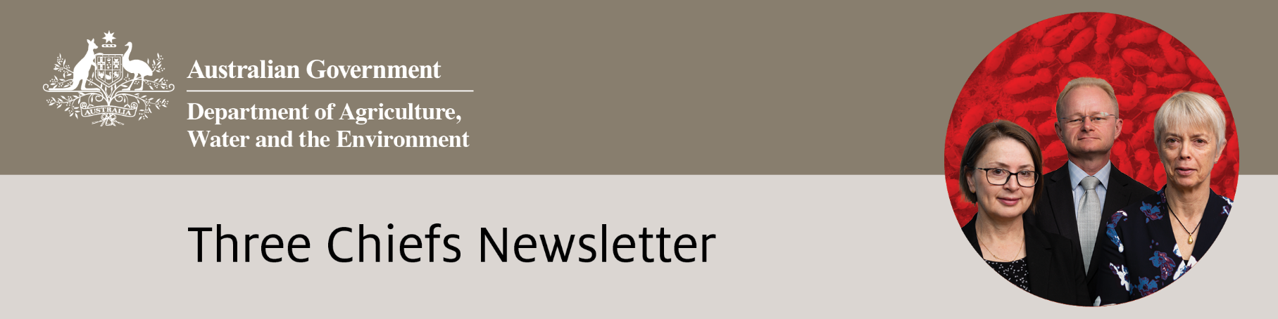

Edition No. 2022/2

# June 2022

It has been a busy period for Australia’s three biosecurity chiefs as they strengthen ties to bolster Australia’s biosecurity. Australian Chief Veterinary Officer (ACVO) Dr Mark Schipp travelled to the World Assembly of Delegates of the World Organisation for Animal Health in Paris. Dr Beth Cookson was appointed to a new role of Deputy ACVO. Together, they travelled to Indonesia to meet with government officials on the pressing topics of Lumpy Skin Disease and Foot and Mouth Disease. Australian Chief Plant Protection Officer Dr Gabrielle Vivian-Smith travelled to Fiji to strengthen plant biosecurity relationships in the Pacific. She also attended the Plant Biosecurity Research Initiative Symposium in Adelaide as well as the Australian Biosecurity Symposium in the Gold Coast together with the Chief Environmental Biosecurity Officer Dr Robyn Cleland. During this period Dr Cleland announced the provision of $49.1 million over four years to support communities to manage pest animals and weeds.

**Australian Chief Veterinary Officer (**[**ACVO**](http://www.agriculture.gov.au/animal/health/acvo)**)**

**New Australian Deputy Chief Veterinary Officer – Dr Beth Cookson**

Dr Beth Cookson has been appointed Australian Deputy Chief Veterinary Officer (Deputy ACVO) to support Dr Mark Schipp and the Office of the Chief Veterinary Officer. The new role will focus on animal health and biosecurity threats across northern Australia, along with strengthening Australia’s animal health ties with Indonesia.

A priority area for Dr Cookson will be helping to build the resilience of animal industries across northern Australia and working closely with regional partners to respond to significant disease threats like lumpy skin disease and foot-and-mouth disease.

Graduating from the University of Queensland in 2004, Dr Cookson spent time in private practice in South Australia and the Northern Territory before being employed as a field surveillance veterinarian with the Northern Australia Quarantine Strategy (NAQS). Her field work involved conducting surveillance for exotic animal diseases in northern Australia and delivering capacity building programs overseas in Papua New Guinea, Timor-Leste and Indonesia.

Photo 1. Australian Deputy Chief Veterinary Officer Dr Beth Cookson. Image: DAWE

During this time Dr Cookson developed strong networks and worked alongside private and government veterinarians, industry groups, indigenous ranger groups, research institutions, and not-for-profit organisations. Having developed a passion for veterinary epidemiology and surveillance, Dr Cookson completed her membership in epidemiology to the Australian and New Zealand College of Veterinary Scientists (ANZCVS) in 2013.

Dr Cookson became the animal health surveillance manager with NAQS, leading surveillance programs across northern Australia, before moving onto animal health policy work as the branch head of Animal Biosecurity in 2019. She led the development of import policy and trade protocol negotiations for animals and animal products and participated in overseas trade trips and worked closely with Australia’s peak industry organisations.

More recently, Dr Cookson held the position as Executive Director, Engagement at the National Recovery and Resilience Agency. In 2021, she completed the Executive Master of Public Administration through the Australian and New Zealand School of Government (ANZSOG).

Based in Cairns, Dr Cookson will also be acting Australian Chief Veterinary Officer when Dr Schipp is on leave.

**Dr Mark Schipp attends the World Organisation for Animal Health**

The World Organisation for Animal Health (OIE) held its 89th Annual General Session of the World Assembly of Delegates from 23 to 27 May. It used a uniquely hybrid format. Australian Chief Veterinary Officer, Dr Mark Schipp, joined OIE Council members, delegates and keynote speakers at Maison de la Chimie in Paris. Several delegations of member countries joined virtually.

During the four days, delegates discussed a variety of animal health and welfare topics, adopted important Resolutions, and voted on new and revised International Standards on terrestrial and aquatic animal health. The OIE were excited to introduce their new brand strategy, which saw the adoption of a new logo and acronym for the organisation. To enhance the organisation’s global profile and increase public awareness of their commitment to strengthening global animal health and welfare, the OIE will transition from its historical acronym to the name World Organisation for Animal Health (WOAH).

Photo 2. ACVO Dr Mark Schipp at the 89th OIE General Session. Image: OIE

As the world experiences the COVID-19 pandemic and the global spread of emerging diseases, adopting a One Health approach was a key focus of many discussions. Dr Schipp presented Australia’s One Health Resolution, ‘Contribution of the OIE and its Members to the negotiations related to an international instrument for pandemic prevention, preparedness and response’.

In support of reducing the risk of zoonotic disease emergence and spread at the animal, human and environment interface, the Resolution proposed the OIE amplify the voice of the animal health sector in international negotiations and continue to collaborate with the World Health Organization (WHO), Food and Agriculture Organization of the United Nations (FAO) and the United Nations Environment Programme (UNEP). The Resolution was well received and was adopted by the Assembly.

The technical item for 2022 was ‘OIE, Veterinary Services and Aquatic Animal Health Services engagement in global, regional and national emergency management systems.’ Defining the A picture containing text, indoor
objectives for veterinary services during an emergency can be challenging, as they often must compete with broader national priorities. National emergency management is moving towards an ‘all-hazards’ and ‘whole-of-government’ approach. By engaging in these discussions, veterinary and aquatic animal health services can establish a leadership role in national emergency prevention and preparedness activities.

The importance of collaboration with international partners was successfully demonstrated as several delegates collectively voiced concerns around the proposed chapter on Bovine Spongiform Encephalopathy (BSE), which if adopted had the potential to impact some countries’ official disease status for BSE.

Photo 3. OIE General Session presentations. Image: Mark Schipp

Australia spoke on behalf of the Quads Alliance countries (Canada, New Zealand, the United States of America and the United Kingdom) and supported the opportunity for other countries to express also their concerns. The OIE Terrestrial Animal Health Standards Commission agreed to delay the chapter’s adoption, recognising the need to allow Member countries adequate time to review and provide comments.

President of the Aquatic Animal Health Commission, Dr Ingo Ernst from Australia, presented changes to the Aquatic Code and Manual. The Commission was congratulated for their major work on revising the Aquatic Animal Health Surveillance chapter, which now provides further clarity on the different pathways a country can use to demonstrate freedom from disease.

The Wildlife Working Group acknowledged their most significant achievement in supporting the OIE with the Wildlife Health Framework, which was adopted by Member Countries in 2020. The Framework highlights and further supports the need for better management of emerging disease risk at the animal, human, environment interface. Australia provided an extraordinary contribution in the most recent financial year to support activities under the Framework.

Finally, in recognition of the OIE’s continued leadership and growing international profile, delegates endorsed an increase in statutory contributions by 30% over the next three consecutive years. This increase will ensure a sustainable and balanced budget for the organisation’s future and will contribute to the implementation of their 7th Strategic Plan 2021-2025 and ongoing activities in improving animal health and welfare.

**Japanese encephalitis virus**

Japanese encephalitis virus (JEV) was detected for the first time in southern Australia in February 2022. This began the largest multi-jurisdictional terrestrial animal disease response since the equine influenza outbreak in 2007. It is not known how the virus entered mainland Australia. However, recent rain events, combined with the movement of infected mosquitoes or migratory waterbirds may have played a part.

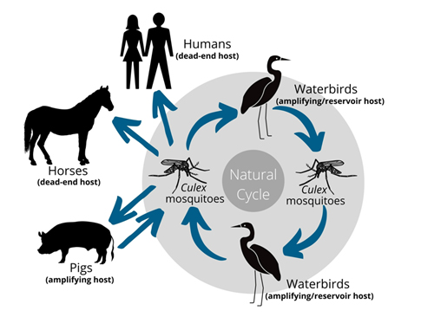As of 25 May 2022, there were 79 infected pig farms across QLD, NSW, VIC and SA. The disease has also been detected in feral pigs in the NT. There are several probable cases in horses in NSW and ongoing horse investigations in other jurisdictions. Fortunately, JEV detections are expected to decrease in southern areas over winter due to reduced mosquito activity. As such, affected jurisdictions are now moving from emergency response to stable program response.

**Achievements**

**ACVO**

Chaired the virtual Animal Health Quads Alliance meeting.

Hosted the first Human Animal Spillover and Emerging Diseases Scanning (HASEDS) Group meeting.

Hosted the ACVO-AVA Leadership Dialogue.

Travelled to Indonesia in April and May/June to meet with senior government officials, to discuss lumpy skin disease and foot-and-mouth disease.

**ACPPO**

Visited Fiji to engage with plant biosecurity stakeholders and enhance Pacific engagement.

Attended the Australian Biosecurity Symposium on the Gold Coast, presenting on Australia’s biosecurity outlook from a plant health perspective, including key threats and potential pathways.

Sponsored and attended the Plant Biosecurity Research Initiative Symposium in Adelaide.

Attended HortConnections industry conference in Brisbane.

**ACEBO**

Signed Environmental Biosecurity Project Fund agreement with Department of Planning and Environment, NSW.

Established the Environmental Biosecurity Project Fund agreement with Invasive Species Council.

Attended and presented at the Australian Biosecurity Symposium on the Gold Coast.

A One Health approach has been central to the response, with the department working closely with public health and jurisdictional counterparts. Response activities aim to minimise the impact of the disease to public health and animal health through enhancing surveillance, minimising mosquito numbers, preventing human-animal-mosquito contact, and vaccination. For more, go to:

[https://www.outbreak.gov.au/current-responses-to-outbreaks/japanese-encephalitis](https://www.outbreak.gov.au/current-responses-to-outbreaks/japanese-encephalitis%20)

**Lumpy skin disease**

Until 1984, lumpy skin disease (LSD) remained localised within countries of sub-Saharan Africa. In the 1990s, LSD spread throughout the Middle East. It emerged in eastern Europe in 2015. Effective control measures halted the disease in Europe, so it only persisted in Russia. LSD has been reported in 18 countries in our region since it emerged in Southeast Asia in 2019.

National priorities set out by the LSD National plan

Most recently, Indonesia reported an LSD outbreak to the OIE on 2 March. The outbreak occurred in Riau province of Sumatra but is suspected to have since spread to other regions. Indonesia's response actions include movement controls, insect vector control, surveillance, zoning, and a vaccination program.

Australia has assisted Indonesia by providing technical advice and with the procurement of vaccines. Dr Mark Schipp and Dr Beth Cookson also travelled to Indonesia in late May to meet with senior government officials on the matter.

Here in Australia, numerous preparedness activities are ongoing, with the most recent milestone being the drafting of the LSD national plan. The plan sets out national priorities for actions to strengthen Australia’s LSD biosecurity preparedness including market access, response and recovery. It outlines the systems that need to be established or strengthened to support Australia’s cattle industries to effectively manage LSD risks. The plan is now out for consultation with relevant stakeholders.

For more information, go to: [https://www.awe.gov.au/lumpyskin](https://www.awe.gov.au/lumpyskin%20)

**Foot-and-mouth disease**

On 9 May Indonesia notified the World Organisation for Animal Health (OIE) of a foot-and-mouth disease (FMD) outbreak. Until this outbreak, Indonesia has been FMD free since 1986, a status recognised internationally by the OIE in 1990. The outbreak was reported to involve serotype O. Indonesia has since made an emergency declaration, implemented movement restrictions, and are sourcing and looking to produce FMD vaccines.

FMD is endemic throughout many countries of the Middle East, Africa and most of South America. The seven immunologically distinct serotypes of FMD circulate in different virus pools and are endemic to different countries worldwide. These are serotypes A, O, C, SAT1, SAT2, SAT3, and Asia1. Each serotype has different strains of the virus, and the serotype and strain influence the choice of vaccine.

Dr Mark Schipp and Dr Beth Cookson travelled to Indonesia in late May, and FMD was a priority issue on their agenda. In Australia, the department is circulating communications materials to industry groups and the general community, reviewing import permits and continuing to assess different risk pathways for FMD entry.

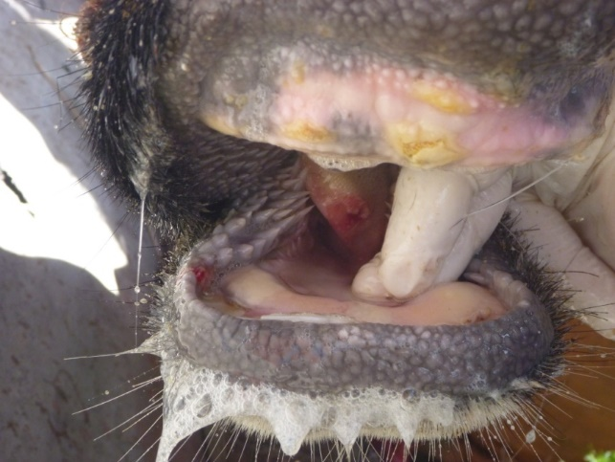The Office of the Chief Veterinary Officer recently completed a structured expert judgement workshop on FMD in partnership with the Centre for Excellence in Biosecurity Risk Assessment (CEBRA). It assessed the risk of an FMD outbreak occurring in Australia within the next 5 years. The results of the workshop will be available soon.

For more information, go to:

<https://www.awe.gov.au/footandmouthdisease>

Photo 4. FMD can cause painful blisters in the mouth and on the feet of animals. Image: DAWE/EUFMD

**Australian Chief Plant Protection Officer (**[**ACPPO**](http://agriculture.gov.au/plant/health/acppo)**)**

# **Building regional biosecurity in Fiji**

Australian Chief Plant Protection Officer, Dr Gabrielle Vivian-Smith travelled to Fiji in March with Dr Sophie Peterson, Director for Pacific Engagement and International Plant Health, to strengthen ties with key Fijian plant health representatives as part of the Pacific Engagement Program which is part of the Commonwealth Biosecurity 2030 strategic roadmap.

“The Pacific Engagement Program strengthens the biosecurity systems of our near neighbours and enhances regional plant health networks,” Dr Vivian-Smith said. “Building regional biosecurity with our Pacific neighbours will in turn strengthen Australia’s biosecurity and help protect us from exotic plant pests.”

During the trip Dr Vivian-Smith enhanced relationships with colleagues from the Fijian Ministry of Agriculture and the Biosecurity Authority of Fiji to better understand Fiji’s plant biosecurity arrangements and priorities, including opportunities to develop capacity in Fiji and neighbouring Pacific countries. The delegation attended the Executive Committee meeting of the Pacific Plant Protection Organisation to discuss the international phytosanitary standards proposed by Australia. They also visited the Pacific Community (SPC) Plant Health Laboratories at Narere Campus, Suva .

Photo 5. Dr Vivian-Smith inspecting a coconut rhinoceros beetle larvae. Image: DAWE

In addition, Dr Vivian-Smith met with staff from the Pacific Horticultural and Agricultural Market Access Program, a collaborative endeavour to grow agricultural trade between Australia, New Zealand and other Pacific Island countries including Fiji. The delegation attended laboratories working on the biological control program for coconut rhinoceros beetle. This invasive pest has devastated coconut and oil palms in the Pacific. They also met with kava industry stakeholders involved in the Australian Kava Pilot and learnt about how kava is processed.

Photo 6. Dr Vivian-Smith and Dr Peterson at a kava processing facility. Image: DAWE

“We will continue to strive to build our Pacific biosecurity partnerships to ensure Fiji and the Pacific are free of plant pests and diseases, allowing pest-free agricultural produce to be traded across the region,” said Dr Vivian Smith.

Subsequent to the trip, Dr Sophie Peterson was elected to the role of Chair for the Standards Committee of the International Plant Protection Convention, after being a member since February 2019. The Standards Committee sets the International Standards for Phytosanitary Measures (ISPMs) that help facilitate trade and enhance global food security. This appointment recognises Dr Peterson’s work representing the interests of the Pacific region and demonstrates the confidence in her by committee colleagues.

**Nine new phytosanitary measures adopted at CPM-16**

The sixteenth session of the International Plant Protection Convention (IPPC) Commission on Phytosanitary Measures (CPM-16) was held on 5, 7 and 21 April. It was the second virtual meeting of the IPPC governing body. Dr Gabrielle Vivian-Smith led the Australian delegation. More than 340 participants from 120 countries attended the meeting. Over 13 observer organisations also attended, including industry. The meeting discussed and adopted several items of importance to Australia, the South West Pacific region (from where Australia’s representative membership is taken) and the future direction of the IPPC.

The CPM adopted nine new International Standards for Phytosanitary Measures (ISPMs). These standards relate to topics including commodity standards, audits, phytosanitary certificates for re-export and also include five new phytosanitary treatments. For more information on the newly adopted standards and their significance go to <https://www.ippc.int/en/news/cpm-16-adopts-nine-new-plant-health-standards-to-enhance-plant-health-worldwide/>.

The CPM Recommendation *Reduction of the incidence of contaminating pests associated with regulated and unregulated articles to protect plant resources and facilitate safe trade* was also adopted. Australia led this topic proposal with the purpose of increasing awareness of the risks posed to global plant health by hitchhiker or contaminant pests not associated with the commodity being moved. The meeting agreed to establish a CPM Focus Group on sea containers, representing a positive step to fight these types of pests and promote safe trade. This Focus Group will continue the work of the now disbanded Sea Container Task Force. It will review viable options to contribute to pest risk management, including developing an ISPM.

Photo 8. Participants of CPM-16 attending virtually. Image: Emily Lamberton

Developing an ISPM for the ‘Safe provision of food and other aid to prevent the international spread of plant pests during an emergency situation’ is another urgent priority for the region. Championed by Australia, with support from several countries and regions including the Pacific Plant Protection Organisation (PPPO), the CPM agreed to establish a CPM Focus Group to discuss the issues and determine a way forward for this topic to be developed as a standard.

The meeting also announced that the United Nations General Assembly had adopted a resolution proclaiming 12 May as the International Day of Plant Health. This is one of the most significant legacies of the International Year of Plant Health (IYPH).

**ACPPO sponsors Plant Biosecurity Research Symposium**

The Chief Plant Protection Office recently sponsored and attended the Plant Biosecurity Research Initiative (PBRI) Symposium. Held on 12 May, this event coincided with the inaugural International Day of Plant Health.

Around 250 delegates attended the symposium which attracted a wide range of plant health stakeholders including PBRI partner organisations. The department’s Deputy Secretary Andrew Tongue opened the symposium and our Chief Plant Protection Officer, Dr Gabrielle Vivian-Smith chaired the opening session. A diversity of speakers presented on research and development on preparedness activities, diagnostics and surveillance and sustainable pest and weed management.

The second day of the symposium opened with a presentation by the department’s Principal Director in the Biosecurity Operations Division, Joel Willis, who spoke about the advances in technology in biosecurity risk detection. Attendees were treated to a partnerships panel who looked at future collaboration and co-investment opportunities. They also heard presentations on Trans-Tasman research, industry resilience and capability building.

Delegates were also able to learn more about plant biosecurity through the ACPPO plant health exhibitor stall, which provided educational resources on plant pests and diseases.

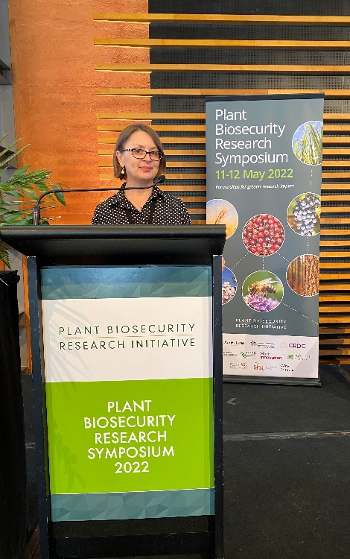To see highlights of the Symposium program, visit <https://www.pbri.com.au/wp-content/uploads/2022/05/PBRI-Symposium-Program-11.05.22.pdf>

Photo 9. Dr Gabrielle Vivian-Smith chairing a session at PBRI.   
Image: Mona Akbari.

Photo 10. Keira Beattie and Mona Akbari from the ACPPO team at the ACPPO information table at PBRI. Image: DAWE

**Fruit fly trapping in Papua New Guinea**

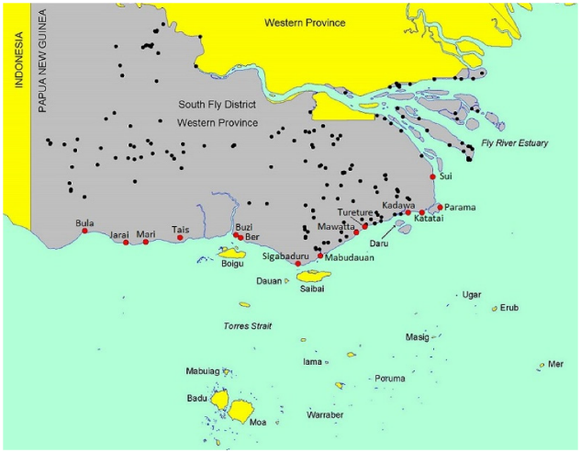The inaugural training for the Treaty Village Fruit Fly Trapping Program was successfully delivered face-to-face in Papua New Guinea (PNG) between 30 May and 3 June 2022. This training equips PNG Treaty Village Rangers with the skills to monitor for Oriental fruit fly (*Bactrocera dorsalis*), one of the world’s worst horticultural pests, to help identify population hotspots and shed light on current and future fruit fly management programs in the region.

Map showing Treaty Villages identified by red dots, highlighting the proximity to the Torres Strait Islands. Source: Australian National Audit Office

Photo 11. Treaty Village Rangers proudly show their Treaty Village Fruit Fly Trapping Program certificates after completing induction training, alongside trainers from NAQS and NAQIA. Image: E. Finlay

The Northern Australia Quarantine Strategy (NAQS) manages an extensive fruit fly trap network in the Torres Strait, which was established in the 1990s to monitor and control seasonal movements of exotic pest fruit flies into the Torres Strait from nearby PNG. Over the past six years, there has been a substantial increase in the number of detections of Oriental fruit fly. It is unclear why.

Over the next two years, the Treaty Village Fruit Fly Trapping Project will enable simultaneous trapping in both the Torres Strait and the Treaty Villages. The data and information gained from this project will improve our understanding of the origins of the annual influx of flies to the Torres Strait from PNG and provide insight into the impact the fruit flies have on village food security. The project will investigate the feasibility of controlling fruit fly populations within PNG before they reach the Torres Strait and ways to improve food security outcomes for villages. The three-year program is the result of collaborative effort between the Australian Chief Plant Protection Office’s International Plant Health Surveillance Program, NAQS and PNG’s National Agriculture and Quarantine Inspection Authority (NAQIA). The on-ground logistics are coordinated by INLOC Group who support the Ranger network.

Representatives from 11 Treaty Villages were chosen to participate in fruit fly training to become trainers of the broader Ranger network. NAQS developed excellent training resources for the Rangers and video footage was taken that will be turned into training videos to assist future cohorts of students.

Photo 12. Treaty Village Rangers demonstrate their skills under the watchful eye of NAQIA and IPHSP trainers. Image: E. Finlay

**HortConnections 2022**

Staff from the department, including ACPPO and Biosecurity Plant Division, attended the HortConnections Conference in Brisbane on 6-8 June. HortConnections is Australia’s largest gathering of horticultural industry and their supply chain players, government and researchers. Over 3000 delegates attended this year, and more than 200 exhibition booths highlighted the conference’s theme of ‘Growing Together’.

The conference included trade show talks and concurrent presentations on a range of topics, including a presentation by Acting First Assistant Secretary for Biosecurity Plant Division Peter Creaser on how biosecurity is helping to grow Australia’s agricultural industry. The trade show, the largest in Australian and New Zealand horticulture, showcased the latest products and services. The department’s exhibit focussed on biosecurity awareness. It also provided import and export information and highlighted some of our joint projects with Plant Health Australia. Hundreds of delegates spoke to department staff about biosecurity, took merchandise, and sought information on National Priority Plant Pests. Staff from the department also visited industry booths to network and exchange information, including on new biological control products for key pests and diseases. A contingent of key staff also met with conference organisers AUSVEG to discuss important industry issues.

Photo 13. Staff at the DAWE Stall at HortConnections.   
Image: Mona Akbari

The new Minister for Agriculture, Fisheries and Forestry, Senator the Hon Murray Watt attended on the last day of the conference and addressed delegates, emphasising his top three priorities of industry labour shortages, biosecurity and farm input costs. Minister Watt also visited the trade show including the department’s booth, taking the time to meet all the staff and hear about the interest generated by the biosecurity message. He also made time to attend the conference dinner and presented the 2022 National Awards for Excellence.

The conference provided an excellent opportunity for department delegates to meet in person with key industry connections and researchers. Find more information on the HortConnections conference program at: <https://hortconnections.com.au/program/>

Photo 14. Minister Watt showcasing the Biosecurity Matters cap and plush detector dog with Peter Creaser at HortConnections. Image: Mona Akbari

**Australian Chief Environmental Biosecurity Officer (**[**ACEBO**](https://www.agriculture.gov.au/biosecurity/environmental/cebo)**)**

**The Australian Biosecurity Symposium**

Last month, Three Chief’s staff participated in the 2nd Australian Biosecurity Symposium on the Gold Coast, Queensland. The Environmental Biosecurity Office coordinated the department’s platinum sponsorship of the event hosted by Animal Health Australia, Centre for Invasive Species Solutions, the Invasive Species Council and Plant Health Australia.

Over 400 delegates attended the symposium which attracted participants from the plant, animal and environment sectors to talk about mainstreaming biosecurity and working together. It was one of the first major face-to-face biosecurity events since the COVID-19 pandemic began.

Photo 15. Decade of Biosecurity ambassador Costa Georgiadis and Dr Robyn Cleland with Izzy the detector dog and her handlers. Image: DAWE

The symposium also saw the launch of the ‘Decade of Biosecurity’ (<https://biosecurity2030.org.au/> ), a call to action by the Biosecurity Collective to invigorate cross-collaboration, sustainable investment and raise awareness of the importance of biosecurity to Australia’s future. The initiative, along with [Commonwealth Biosecurity 2030](https://www.awe.gov.au/biosecurity-trade/policy/commonwealth-biosecurity-2030) and the imminent release of the National Biosecurity Strategy, will help drive biosecurity priorities for the next decade. The National Biosecurity Strategy draft was discussed at the symposium and received strong support. Delegates were also treated to a visit by Brisbane-based detector dog Izzy, accompanied by handlers Lisa and Tara, when they made an appearance at the department’s exhibitor stall.

The symposium featured a star line-up including MC and Decade of Biosecurity ambassador Costa Georgiadis and keynote speakers Dr Anika Molesworth and Dr Norman Swan. Chief Environmental Biosecurity Officer, Dr Robyn Cleland and Chief Plant Protection Officer, Dr Gabrielle Vivian-Smith also presented at the symposium and participated in several panel discussions, highlighting the biosecurity risks to Australia, new genetic technologies and the role of citizen science in general surveillance. To see highlights of the Symposium, visit <https://www.biosym.com.au/> , or check out the hashtag #biosym2022 on social media, where we reached and engaged thousands of users on Linkedin and Twitter.

Photo 16. Costa Georgiadis, Dr Robyn Cleland and Philippe Frost joined by sponsored delegates. Image: Kirkland Photography

While in Queensland, Dr Cleland and Dr Vivian-Smith were provided a first-hand look at the devastating impacts of myrtle rust during a field trip at Tallebudgera. A big thank you to Geoff Pegg, Angus Carnegie, Tilly Davis and Aj Perkins for sharing their personal experiences and knowledge about myrtle rust during the trip. The visit reinforced the need to be vigilant about hygiene when out enjoying our environment. If you’re out and about, make sure you arrive clean and leave clean.

Photo 17. Dr Gabrielle Vivian-Smith and Dr Robyn Cleland looking at the impact of myrtle rust in Tallebudgera. Image: DAWE

If you would like to learn more, the ‘Arrive Clean, Leave Clean’ guidelines are available at <https://www.awe.gov.au/sites/default/files/documents/arrive-clean-leave-clean.pdf>

**Supporting communities manage pest animals and weeds**

A range of successful projects totalling over $25 million were announced in April-May 2022, through the $49.1 million Supporting Communities Manage Pest Animals and Weeds Program.

Over the next four years (2021-22 to 2024-25) this funding will support the delivery of better solutions to combat established pests and weeds, which pose a significant threat to Australian primary production, the environment and Australia’s biodiversity.

The program has a strong focus on securing co-investment outcomes with key stakeholders and recognises the impact of bushfires, flood and drought on pest and weed control and prevalence.

The program will:

* deliver collaborative on-ground reduction and prevention activities for problematic pests and weeds – with $20 million in funding, matched by state and territory governments, to maximise impact and deliver a range of activities nationally
* fund research, development and extension grants to advance a range of breakthrough control solutions that improve pest and weed management tools

**Recent Events**

**12 May:** ACEBO held second webinar of the Environmental Biosecurity Webinar Series.

**10 June:** Exercise ‘Paratus’ Bravo commenced. This is the second part of a two-year biosecurity preparedness program.

**16 June**: ACPPO Webinar: Biological control of Queensland fruit fly with Paul Cunningham

**Upcoming Events**

**23 to 25 June:** Australian and New Zealand College of Veterinary Scientists (ANZCVS) annual conference

**23 June:** Environmental Biosecurity Webinar 3 ‘Detect’

**6 July:** World Zoonoses Day

**3 to 10 July:** NAIDOC week

**4-8 July:** G20 Agriculture Chief Scientists meeting in Indonesia

**21 July**: APPCO Webinar: Partnering with Indigenous Rangers on biosecurity

**1 to 5 August:** Australian Soilborne Disease Symposium

**4 August:** Environmental Biosecurity Webinar 4 ‘Respond’

**13 to 21 August:** National Science Week

**15 to 16 August:** Crawford Conference

**16 August:** ACPPO Webinar: National System for Diagnostics

**August:** Biosecurity Webinar Series on high pathogenicity avian influenza (HPAI)

**23 to 25 August:** [2022 National Landcare Conference](https://nationallandcareconference.org.au/), Sydney

**25 to 29 September:** [22nd Australasian Weeds Conference](https://eventstudio.eventsair.com/22awc/), Adelaide Oval

* engage national coordinators to improve coordination, extension, best practice management adoption and information sharing, to maximise management of priority pest animal and weed species, with the wild dog, feral deer, and cat and fox national pest animal management coordinators and support roles extended to 30 June 2023
* continue to build a greater understanding of the costs and distribution of pest animals and weeds in Australia
* provide on-ground support, through Indigenous Rangers and national resource management groups, for pest animal and weed reduction activities to protect and recover threatened species, ecological communities, and cultural values.

More information on projects recently funded is at: <http://www.awe.gov.au/biosecurity-trade/pests-diseases-weeds/pest-animals-and-weeds/supporting-communities>

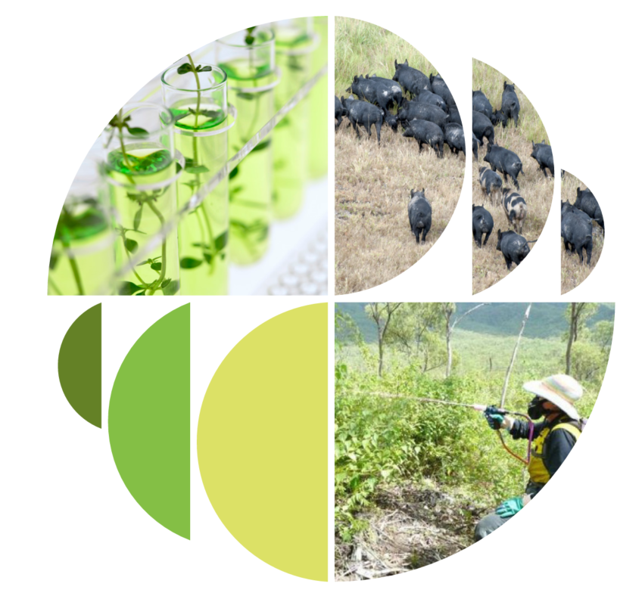**Recommendation to reduce contaminating pests adopted**

On 5 April 2022, draft CPM Recommendation: ‘*Reduction of the incidence of contaminating pests associated with regulated and unregulated articles to protect plant resources and facilitate safe trade (2019-002)*’ was adopted. This achievement occurred during the sixteenth session of the Commission on Phytosanitary Measures (CPM), the governing body of the International Plant Protection Convention (IPPC).

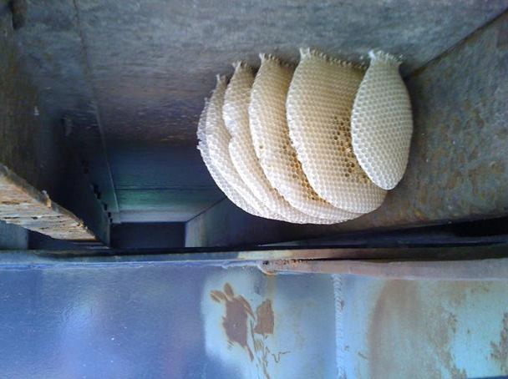CPM Recommendations are used to promote action on a specific phytosanitary issue where an international standard is not available. Due to the long-time frame required to draft and adopt an International Standard for Phytosanitary Measure (ISPM), an average of six years per standard, a CPM Recommendation can be an effective way to raise awareness for a phytosanitary issue in the interim.

The purpose of this CPM Recommendation is to reduce the incidence of contaminating pests on and in regulated and unregulated articles and other pathways. This will protect plant health, biodiversity and food security as well as facilitate safe trade. Australia is currently experiencing increased pest pressure from contaminating pests due to an ever-changing trade environment and climate change. To combat this elevated pest risk Australia led the CPM proposal to further increase awareness of the risks posed to global plant health by storage places, packaging, conveyances, containers, soil, and any other objects or materials capable of harbouring or spreading plant pests. The proposal was supported by a two-day symposium, held by the Environmental Biosecurity Office in March 2020 that highlighted the need for better global awareness and cooperation to ensure cleaner trade.

Photo 18. Contaminating pests: Beehives under a shipping container. Image: DAWE

Most of the exotic environmental pests intercepted in Australia are contaminating pests (also known as hitchhikers). By definition, these pests don’t infest the commodity directly, but may be carried by the commodity, packaging, conveyance, container or storage place. Global cooperation and collaboration is crucial to prevent contamination before it occurs.

A recent example of positive work in this area is the [Sea Container Hygiene System](https://www.awe.gov.au/biosecurity-trade/import/before/prepare/treatment-providers/sea-container-hygiene-system) (SCHS), a voluntary biosecurity agreement developed by industry in collaboration with the Department of Agriculture, Water, and the Environment and New Zealand’s Ministry for Primary Industries (NZMPI).

To view the contaminating pests recommendation, visit the IPPC website and go to topic R-10. <https://www.ippc.int/en/core-activities/governance/cpm/cpm-recommendations-1/cpm-recommendations/>

**Pest Profile: Black-spined toad**

Black-spined toad (*Duttaphrynus melanostictus)* is a highly invasive, ground dwelling toad. It is naturally found in Pakistan, Singapore, Indonesia and Southeast Asia. It has since been introduced to East Timor and Papua New Guinea. Due to its highly invasive nature, it has been listed in the National Priority List of Exotic Environmental Pests, Weeds and Diseases (EEPL) and is the target of risk reduction programs.

Black-spined toads are highly adaptable to new environmental conditions and have a strong defence mechanism against predators. They secrete toxins from glands on their backs. Contact with these toxins leave human skin irritable and itchy. Ingestion can cause severe illness and sometimes death in humans and predators. Likely predators that would succumb to these toxins in Australia include snakes, goannas, and quolls. Black-spined toads also have the potential to spread exotic parasites and diseases, infecting defenceless native plants and animals.

Photo 19: Asian black spined toad. Image: L. Shyamal

A female black-spined toad can produce 40,000 eggs at a time. Combined with their secreted toxins, this would lead to reduced biodiversity and threaten already endangered native species. Like the cane toad, they are adapted to living in urban areas, which would increase the health risks for children and pets as well as being an eyesore.

The department is keeping a close eye on the countries the black-spined toad is invading. There have been increases in the frequency of interception at the border. Black-spined toads are most often found within shipping containers and as stowaways amongst imported products. The devastating impacts of the cane toad in Australia provide clear reason why it is important to prevent similar species, like the black-spined toad from establishing.

Black-spined toads are stocky with a small head and short hind limbs. They are similar in appearance to the cane toad however do not grow as large. They are commonly yellow brown with raised black, warty looking spots, however their colour varies from greyish red to black. If you think you have seen a black-spined toad in your area, or if you are an importer or traveller returning home from overseas and think you have found a black-spined toad, report it on our **See.Secure.Report** hotline number**:**

**Contact the**

**Biosecurity Chiefs**

**ACPPO:**

[acppo@agriculture.gov.au](mailto:acppo@agriculture.gov.au)

**ACVO:**

[ocvo@agriculture.gov.au](mailto:ocvo@agriculture.gov.au)

**ACEBO:**

[acebo@agriculture.gov.au](mailto:acebo@agriculture.gov.au)

**1800 798 636**