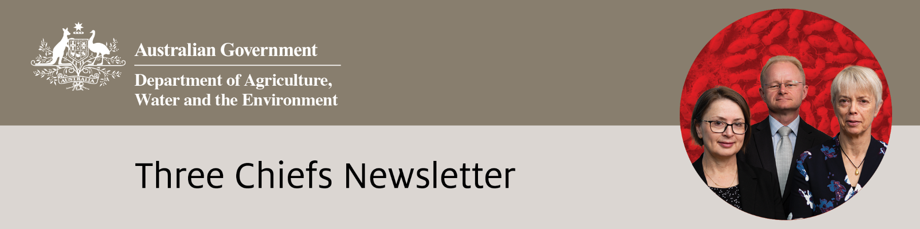

Edition No. 2021/1

# March 2021

We were delighted that Dr Gabrielle Vivian-Smith was recently announced as the new Australian Chief Plant Protection Officer, after she acted in the role over several periods since 2018. We were also very pleased that Dr Robyn Cleland will be acting as the Chief Environmental Biosecurity Officer for the next 12 months, following Ian Thompson’s retirement and Elyse Herald-Woods acting in the role since December 2020.

Dr Gabrielle Vivian-Smith’s scientific background and extensive knowledge of pests and diseases are highly regarded and will help ensure the ACPPO role continues to be a primary representative of, and an advisor to, the Australian Government on all matters relating to the management, maintenance and improvement of Australia’s plant health status and the systems underpinning it. Dr Robyn Cleland’s strong scientific background and knowledge of biosecurity matters will be valuable in the role of ACEBO as representative and advisor to government on environmental biosecurity risks. The Three Chiefs offices look forward to working together in taking a greater stakeholder engagement and communication role.

**Australian Chief Veterinary Officer (**[**ACVO**](http://www.agriculture.gov.au/animal/health/acvo)**)**

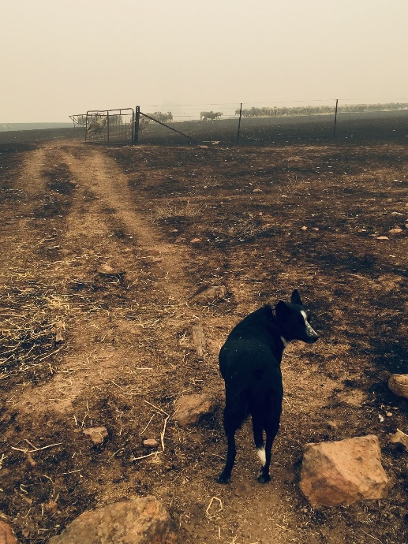**Australia’s Black Summer Bushfires: Reflections on recovery one year on**

Australia’s 2019-2020 ‘Black Summer’ saw unprecedented bushfires destroy over 12 million hectares across southern and eastern Australia. Thousands of injured livestock and wildlife required euthanasia, with veterinarians, farmers and wildlife professionals tasked with making this tough decision. A recent impact report has confirmed that almost 3 billion animals – mammals, birds, reptiles and frogs – were directly impacted, making this a one of the worst wildlife disasters in modern history. Furthermore, reports from the Department suggest 486 plant and 119 animal species now require urgent management intervention due to these fire-associated impacts.

During this last year, the determination and compassion of veterinarians, wildlife careers and volunteers working in the bushfire response team has been inspirational. The combined efforts of these individuals, alongside federal, state/territory and local governments, universities, wildlife advocacy and care organisations, have been instrumental to the recovery efforts.

*Photo 1: The day after the bushfires on a family farm in Corryong, VIC, where Stephen and his dog Patsy defended the farm on their own and saved 900 sheep.*

*Photo credit: Cath Hill, DAWE*

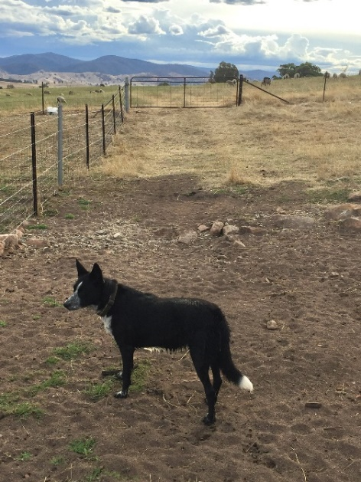To aid in the native wildlife recovery efforts, the Australian Government has pledged $200 million. This is being used for research, planning and field conservation work within bushfire-affected regions, especially around vulnerable or severely affected species. For example, $18 million will fund a national koala population census, as well as support vital health research, veterinary care and targeted habitat conservation. National coordination is assisted by the National Bushfire Recovery Agency, established to lead and coordinate the government-supported recovery.

A Royal Commission into the National Natural Disaster Arrangements was established immediately following the bushfires, specifically to examine coordination, preparedness for, response to, and recovery from disasters in Australia. Their recent report presented 80 recommendations to make Australia safer. Efforts to pursue improvements are led by a variety of institutions and projects, such as Melbourne University’s Centre for Emergency Response, which aims to revolutionise Australia’s response to animal emergencies.

*Photo 2: One year on, Patsy in the same area on the farm.*

*Photo credit: Cath Hill, DAWE*

Sadly, the effects of the ‘Black Summer’ bushfires will be felt for years to come. However, they have provided a new impetus to protect vulnerable and threatened species and charged innovations to improve the nation’s coordinated response to future animal emergencies.

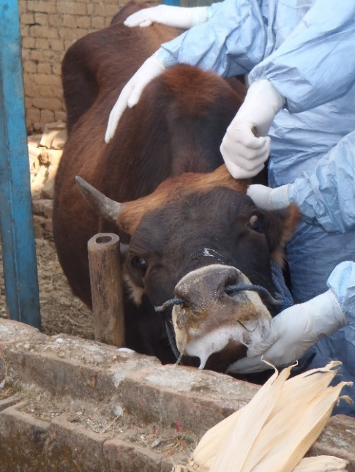**Foot and Mouth Disease UK 20-year anniversary**

This year marks 20 years ago that the United Kingdom (UK) suffered one of its most devastating agricultural disasters. Foot and mouth disease (FMD) shattered the farming community and saw approximately 6 million animals slaughtered to prevent the disease spreading even further. Scenes of burning mounds played out in front of the world and it felt like the UK farmers would never recover - they were, however, resilient.

As a result of being an island nation, preventing the entry of unwanted disease to Australia is far easier than it is for many other countries that share borders. However, that does not mean we should become complacent. If FMD were to take hold in Australia, it could result in the loss of billions of dollars and significant animal life.

The 2001 outbreak brought FMD into the global spotlight. Countries became more aware of the disease and associated impacts on farmers, their livelihoods, and trade. Similarly, they also became acutely aware of the mental health toll of FMD on farmers, veterinarians and the wider public.

*Photo 3: Foot and mouth disease in a cow seen during field training in Nepal.*

*Photo credit: DAWE*

These factors contributed to Australia’s control program. Vaccination is no longer viewed as a measure of last resort, and Australia has led work to advocate for a “vaccinate-to-live” policy at an international level. Additionally, vaccines are stored in vaccine banks for immediate distribution to affected areas if required, and vaccine sharing arrangements also exist with Australia’s partners (Canada, Mexico, New Zealand and the United States).

**Achievements**

**ACPPO**

Hosted and led Plant Health Quadrilateral annual meeting and Quadrilaterals Collaboration Working Group annual meeting with New Zealand, Canada and the USA

Collaborated on a number of plant health research projects

Hosted urban plant biosecurity webinar

Helped Plant Biosecurity Research Initiative organise a sea container hygiene RD&E workshop

**OCVO**

Virtually opened the World Organisation for Animal Health Regional Conference for Africa

Chaired meetings of the World Organisation for Animal Health Council in December 2020 and March 2021

Presentation to National Farmer’s Federation, Ministers Office, Department of Foreign Affairs & Trade and Prime Minister & Cabinet on African Swine Fever

Chaired virtual bilateral meeting with UK Chief Veterinary Officer

Freedom from highly pathogenic avian influenza regained 26 February 2021

**ACEBO**

Launched a new Atlas of Living Australia automated function which sends email notifications to the Environmental Biosecurity Office alerting of an exotic pest observation in the field by citizen scientists – and provides early-incursion awareness.

Hosted a series of focus groups and workshops to enable experts and system participants to inform and identify priorities for the new National Environment and Community RD&E Strategy.

Completed final rounds of internal and external stakeholder consultations for The National Priority List of Exotic Environmental Pests, Weeds, and Diseases Implementation Plan.

Collaboration was one of the strongest weapons the UK had in the fight against FMD – with many veterinarians and animal health specialists from all over the world coming together to augment the UK’s response team, including from Australia.

As a result of this approach, and to make further improvements for the future, the International Animal Health Emergency Reserve (IAHER) was created. An agreement between Australia, Canada, Ireland, New Zealand, the UK, and the United States, the IAHER facilitates the exchange of veterinary health specialists between the six countries in the event of an animal disease outbreak which provides surge capacity for the affected country but also invaluable response experience for the donor countries.

The 2001 FMD UK outbreak was horrific. It is imperative that we learn from the experience and continue to strengthen Australia’s own FMD preparedness, to protect Australians and their livestock from a similar fate.

**The role of the OCVO in equipping and training the next generation of veterinarians**

The Office of the Chief Veterinary Officer (OCVO) plays a pivotal role in equipping and training the next generation of veterinarians. OCVO coordinates Veterinary Science students from various universities who have the opportunity to complete part of their final year rotations with the Department. This provides important exposure to government veterinary work, which subsequently increases their government-industry links and assists with Departmental recruitment efforts. The following excerpt was written by Hamish, a final year Veterinary Science student from Charles Sturt University, Wagga Wagga, following a 3-week rotation with the OCVO in the Department of Agriculture, Water and the Environment (DAWE) in January.

*“During the final year of my Veterinary Science degree, I undertook a student placement at DAWE, and was fortunate enough to work within the Office of the Chief Veterinary Officer. My previous exposure to the roles of vets within Government was limited, but I was particularly interested in exploring career opportunities for vets outside clinical practice.*

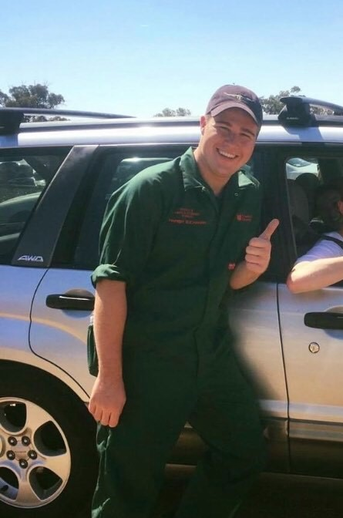*The OCVO was incredibly welcoming and supportive and were proactive in engaging me within team meetings and projects. I valued the collegiality amongst the staff, and their commitment to my learning. I was directly involved in work regarding recent emergency animal disease outbreaks in Australia and was able to liaise with highly trained professionals in fields such as epidemiology, policy and international relations. I also had the opportunity to discuss with past and present Chief Veterinary Officers, which provided a valuable insight into the roles and responsibilities of vets within Government.*

*Overall, this placement was a valuable learning opportunity and the collegiality of staff within DAWE meant that I was able to gain broad exposure to the roles and responsibilities of vets working within public service. My experience gave me a new perspective on the variety of careers available to vets outside clinical practice and made me strongly consider working for DAWE in the future.”*

*Photo 4: Hamish from Charles Sturt University (Photo supplied)*

**Australian Chief Environmental Biosecurity Officer (**[**ACEBO**](https://www.agriculture.gov.au/biosecurity/environmental/cebo)**)**

**2021 Environmental Biosecurity Webinar Series – Knock, Knock. Who’s there?   
Drawing attention to our most unwanted visitors**

The Environmental Biosecurity Office will be hosting a series of seven webinars between April and October to highlight the management of risks to Australia from exotic environmental pests, weeds and diseases.

The series coincides with the recent release of the National Priority List of Exotic Environmental Pests, Weeds and Diseases (EEPL) and will explore:

* Why a well-connected and collaborative biosecurity system is crucial to success.
* How and why the EEPL was developed and how it will help identify and manage the risk of exotic pests, weeds and diseases entering or establishing in Australia.
* What are pathways? What’s a ‘hitchhiker’? How do we know where to look?
* Which environmental pests, weeds and diseases are of most concern and what could they affect?

For more information about the series or to register. Visit the [Eventbrite registration page](https://www.eventbrite.com.au/e/knock-knock-whos-there-drawing-attention-to-our-most-unwanted-visitors-tickets-145807563347) or contact the [Environmental Biosecurity Office](mailto:acebo@awe.gov.au)

**New 3D X-ray technology to detect smuggled wildlife at the border**

Border security will shortly have an enhanced capability for detecting smuggled wildlife using new 3D X-ray detection technology. The new capability will allow the automated scanning and detection of smuggled wildlife in international mail and express freight items as these items move on conveyer belts for sorting and delivery.

The Environmental Biosecurity Office co-funded this project with the Biosecurity Innovation Program and the Modern Seamless Border Clearance Project as an expansion of the original 3D X-ray detection system that was also funded by the Department and developed by Rapiscan Systems Pty Ltd.

**Upcoming Events**

**23-25 March:** Myrtle Rust Symposium: Galvanising Action

**30-31 March:** Exercise Razorback movement control workshop

**30 March, 7, 9 April:** Animal Health Quads meeting

**March/April 2021:** Commission for Phytosanitary Measures meeting

**April-October:** [Environmental Biosecurity Webinar Series](https://www.eventbrite.com.au/e/knock-knock-whos-there-drawing-attention-to-our-most-unwanted-visitors-tickets-145807563347) - Knock Knock. Who’s there? Drawing attention to our most unwanted visitors

**26, 28 April and 4 May:** Third OIE Global Animal Welfare Forum

**17-18 May:** [Better Border Biosecurity](https://www.scienceevents.co.nz/b3conference) Conference, Wellington, New Zealand

**20 May:** World Bee day

**24-28 May:** OIE General Session

**7-9 June** [Hort Connections Conference](https://hortconnections.com.au/)

**30 June & 1 July:** Australasian Honey Bee Conference 2021, Perth

**14-22 August:** National Science week

**Useful Links**

Plant biosecurity in Australia timelines <https://planthealthyear.org.au/about/plant-biosecurity-in-australia/>

Serpentine leafminer: Industry Update: <https://youtube.com/playlist?list=PL4cJZzAUfvKBKZkHLn179Sb-WhJiVl20A>

Plant Health Australia [Biosecurity online training for researchers](https://www.planthealthaustralia.com.au/resources/training/biosecurity-online-training/)

Exotic Plant Pest Hotline <https://www.agriculture.gov.au/pests-diseases-weeds/report>

Environmental Biosecurity Webinar Series - Knock Knock. Who’s there? Drawing attention to our most unwanted visitors [Eventbrite registration page](https://www.eventbrite.com.au/e/knock-knock-whos-there-drawing-attention-to-our-most-unwanted-visitors-tickets-145807563347)

Growing the next generation of Australian Scientists [Growing the next generation of environmental scientists – CSIROscope](https://blog.csiro.au/growing-environmental-scientists/)

Recent changes arising from COVID-19 have seen a significant increase in mail and freight traffic – which provides greater opportunity for smugglers to avoid detection.

The wildlife detection capability uses 3D X-ray technology and specialist software that interprets 3D X-ray images to identify smuggled wildlife inside parcels and other items based on the image shape and density.

Illegal wildlife trade is a growing multibillion-dollar global trade that poses serious conservation and biosecurity risks for Australia. Rare and threatened species are high on the list for being stolen from the wild and sent abroad from Australia by criminal networks, which further undermines their survival chances.

Wildlife smuggled in from overseas poses a direct risk to the Australian environment. Exotic animals released into the Australian environment can impact badly on native plants and animals – rabbits, foxes and cane toads come to mind as obvious examples. In addition, imported smuggled wildlife can also be infected with disease and parasites that can wreak havoc on Australian flora and fauna.

The new 3D X-ray wildlife detection capability will greatly improve Australia’s ability to interrupt and detect the illegal wildlife trade at Australia’s border, efficiently, and without affecting the transit and delivery of parcels and freight.

**House of Representatives Inquiry into Feral and Domestic Cats in Australia**

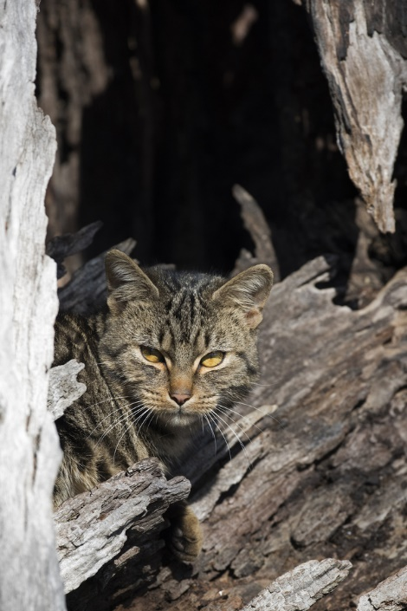The report *Tackling the feral cat pandemic: a plan to save Australian wildlife* was recently released*.* The inquiry sought to examine the prevalence and impact of feral, stray and domestic cats, and the effectiveness of various legislative, regulatory and collaborative responses across Australian jurisdictions. Recommendations are to improve the understanding of cat impacts, resetting the Australian Government’s current policy, planning and resourcing around the issue; strengthening collaboration across governments; and expanding feral-free fenced reserves and islands to assist threatened species recovery.

The Australian Government is in a good position to respond to the recommendations in the report because of substantial policy and practical work related to feral cats over the last six years including the establishment of a Feral Cat Taskforce, substantial research by the National Environmental Science Program’s Threatened Species Recovery Hub, targets in the Threatened Species Strategy, and more than $32 million being mobilised for projects that have a primary focus on supporting practical, on-ground action and action-based research to reduce the impacts of feral cats.

Photo 5: Feral cats have huge ecological impact on native species. (Shutterstock photo)

**Myrtle Rust Symposium: Galvanising Action**

A national symposium was held from 23-25 March bringing together experts and those well placed to take action on the myrtle rust plant disease caused by the invasive fungal pathogen *Austropuccinia psidii*. This includes Natural Resource Management groups, Indigenous ranger and land manager groups, universities and collections mangers, and government agencies (including New Zealand).

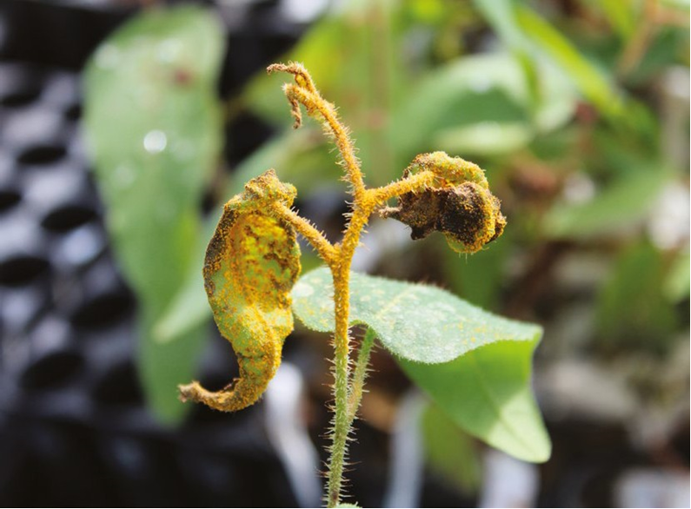Myrtle rust threatens over 350 native species in Australia with some of these listed as critically endangered under the EPBC Act. The symposium identified how myrtle rust is affecting Australia’s natural environment and looked at ways to implement the Australian Plant Biosecurity Science Foundation’s Myrtle Rust in Australia: National Action Plan. Attendance was at no cost and was open to anyone that was interested in better understanding the threat and impacts of myrtle rust.

The symposium was hosted by the Australian Plant Biosecurity Science Foundation and supported by the Environmental Biosecurity Project Fund and the NSW Government Saving Our Species program.

*Photo 6: Spotted Gum (Corymbia maculata) infected with Myrtle Rust in glasshouse screening program*

*Photo credit: Geoff Pegg*

Website: <http://www.apbsf.org.au/myrtle-rust/>

**Australian Chief Plant Protection Officer (**[**ACPPO**](http://agriculture.gov.au/plant/health/acppo)**)**

**Plant Health Quadrilaterals Meeting – Canberra 2021**

The Plant Health Quadrilaterals (PH QUADS) meeting is an annual event, allowing Australia, New Zealand, Canada and the United States to identify key priorities and initiatives to support plant health, and opportunities to advance the international safe trade of plant products. This year, the meeting was hosted virtually via Microsoft Teams in Canberra with Dr Gabrielle Vivian-Smith representing the Australian interests. Con Goletsos attended as Australia’s country coordinator for the Quadrilaterals Collaboration Working Group (QCWG), while Dr Sophie Peterson and Chris Dale provided advice as the International Plant Protection Convention Standards Committee and Implementation Committee representatives respectively.

The ACPPO team participated and acted as secretariat, while other Departmental officers attended to provide advice and context for specific agenda items under discussion. The American and Canadian contingents noted that the Australians were all able to attend from one meeting room, while the North Americans were still working remotely due to the COVID pandemic.

*Photo 7: Australian Contingent attending PH Quads meeting*

*Photo credit: Keira Beattie, DAWE*

The first day of proceedings began with country coordinators discussing the progress of QCWG plant health research projects, for example the Methyl Bromide Alternatives and the Digital Identification Tools projects and agreeing on next steps. The PH Quads meeting commenced with country updates, summarising plant health activities for each country and changes to legislation over the last year. Countries exchanged useful information in preparation for the March 2021 Commission Phytosanitary Measures meeting. PH QUADS also discussed significant pests such as khapra beetle, as well as 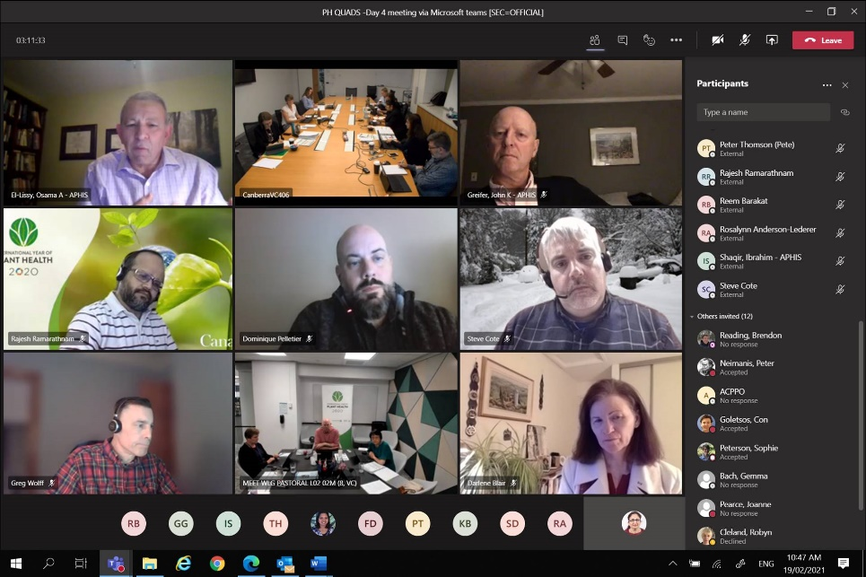the ongoing important issue of container cleanliness. Strategic discussion was held on the future of ePhyto and its long-term financial sustainability. There was also significant support for an *International Day of Plant Health* to be first held on 12 May 2022, as many planned activities for the International Year of Plant Health (2020) were not able to be carried out due to the COVID pandemic.

*Photo 8: Some of the PH Quads international contingent attending from USA, Canada and New Zealand virtually joining Australian hosts. Photo Credit: Mona Akbari, DAWE*

The next PH QUADS meeting will be hosted by USA in 2022, with the intention that representatives from all countries attend in person.

**Recipients for the 2021 Dr Kim Ritman Award for Science Excellence**

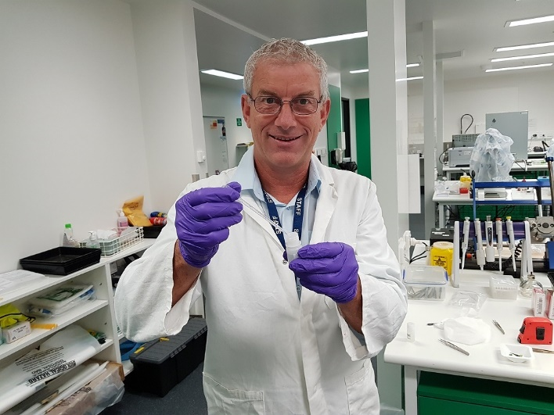Mark Whattam and Dr Dugald Maclachlan from the Department of Agriculture, Water and the Environment were presented with the inaugural 2021 Secretary’s award in memory of the late Dr Kim Ritman, Agricultural Chief Scientist and Australian Chief Plant Protection Officer. The award recognises individuals or teams who have made significant contributions to the scientific work of the Department.

Mark Whattam received the award in recognition of his exceptional dedication and impressive contributions in developing and nurturing Departmental scientific capability and introducing substantial innovative work practices and programs. Notably, establishing the Plant Innovation Centre at the Mickleham Post-Entry Quarantine Facility (known as PIC@PEQ) and initiating the High Throughput Sequencing project, which as a result of his vision will transform the detection of plant diseases to achieve Departmental objectives and ensure the effective management of biosecurity risk. The award was also in recognition of his outstanding commitment, enthusiasm, energy and drive in leadership, innovation, mentoring and promoting science and research across the Department, government and the wider scientific community.

*Photo 9: Mark Whattam testing Abraxis kit for devitalisation test  
Photo credit: DAWE*

Dr Dugald Maclachlan was recognised for his outstanding scientific expertise, professionalism and efforts to support market access priorities and negotiations for over 15 years. He also received the award in recognition of his excellent strategic leadership as a world renowned and respected expert on chemical residues and microbiology related to meat production that present a risk to Australian food exports.

**Sea Container Hygiene RD&E Workshop**

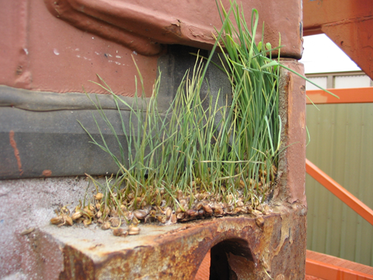In late February, Dr Jo Luck from the Plant Biosecurity Research Initiative (PBRI) hosted a Sea Container Hygiene Research and Development technology workshop with assistance from the ACPPO team.

Managing the biosecurity risk of sea containers is a complex, global problem, with approximately 20 million shipping containers in circulation making a total of around 200 million trips a year. Approximately 3 million containers are imported into Australia each year with around 70,000 being unpacked in rural locations throughout the country. Imported dirty containers are a huge biosecurity risk for Australia, in addition to being a trade and market access risk as imported dirty containers can be inadvertently loaded with Australian produce for export.

*Photo 10: Grass seed growing on the external part of a shipping container.*

*Photo credit: DAWE*

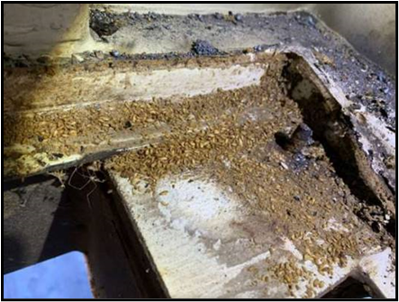With serious pests, such as khapra beetle, being able to ‘hitchhike’ as contaminants in shipping containers, the Department is looking at ways to strengthen biosecurity measures for sea containers throughout the biosecurity continuum.

The virtual workshop was opened by Dr Robyn Cleland in her capacity as Assistant Secretary, Plant Import Operations. In her introductory remarks, she described the efforts the Department is taking to manage this complex problem. She emphasised the need for further novel measures to improve inspection and detection of pests, and for sustainable treatment method options.

Researchers from CSIRO, Centre of Excellence for Biosecurity Risk Analysis (CEBRA), the Universities of Canberra and Sydney, Murdoch University, Iugotec Pty Ltd, Intelligent System Design and DAWE presented to potential investors from Research and Development Corporation (RDC).

*Photo 11: Cast Khapra beetle skins under the floor of a shipping container.*

*Photo credit: DAWE*

The topics covered included methods of identifying high risk containers, novel pest detection methods such as hyperspectral imaging, e-DNA for the detection of Khapra beetle, and container treatment methods (including Methyl Bromide alternatives).

The session was hugely successful, creating the opportunity for invited RDCs to identify and invest in current and proposed projects with the end goal of reducing the risk of importing and exporting unwanted pests in sea containers.

**Pest Profile – Serpentine leafminer (*Liriomyza huidobrensis)***

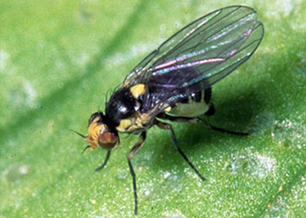In October 2020 a vegetable grower in Western Sydney reported the detection of suspected exotic leafminer to the Exotic Plant Pest Hotline. Investigation by NSW confirmed the presence of *Liriomyza huidobrensis,* commonly known as serpentine leafminer. Reports indicate that leafminer damage had been observed since February 2020, but it was suspected to be leafminers already present in Australia.

Serpentine leafminer is one of several exotic leafminer species that are national priority plant pests, posing a significant economic threat to Australia’s horticulture and nursery production industries. It has a wide host range which includes melons, vegetables such as broccoli, beet, spinach, peas, beans, and potatoes, in addition to many cut-flower and ornamental plant species. Adults are mostly spread via wind, while eggs, larvae and pupae can be spread through the movement of plant material, soil, clothing, and equipment.

*Photo 12: Serpentine leafminer adult*

*Photo credit: DAWE*

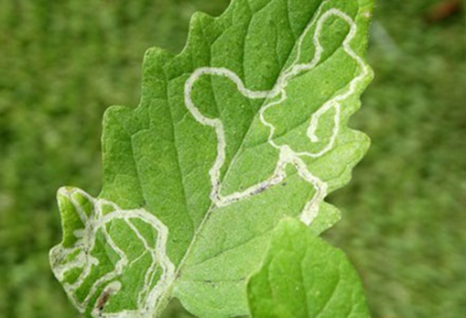Serpentine leafminers cause damage to plants by their larvae feeding under the leaf surface. This causes long, narrow, serpentine-shaped 'mines' which appear as white or grey lines on leaves. High levels of infestation affect the plant’s ability to photosynthesise, reducing plant growth and crop yields. There are several leafminer species native to Australia.

Surveillance and tracing in NSW at the end of 2020 confirmed a number of infested premises across the Sydney basin and some in rural NSW. Subsequent tracing from commercial nurseries in the Sydney basin resulted in the detection of serpentine leafminer at several sites in southern Queensland. Weeds were also detected infested with serpentine leafminer in NSW and Qld (e.g. fleabane and thistle).

*Photo 13: Serpentine leafminer larvae trails in leaf*

*Photo credit: DAWE*

*Photo 13: Serpentine leafminer larvae trails in leaf*

*Photo credit: DAWE*

It is unknown how the pest entered Australia, based on the widespread detection it is likely that the pest has only been noticed once it had reached economically damaging levels, indicating it has been present for some time.

The National Management Group agreed with advice from the Consultative Committee on Emergency Plant Pests that the pest is not eradicable from Australia due to the unknown entry pathway, wide host range which includes several weed hosts, large geographic range of the detections, high infestation levels and the pest’s biology. Elsewhere in the world the serpentine leafminer has not been eradicated and relies on effective integrated pest management.

**CONTACT ACPPO:** [acppo@agriculture.gov.au](mailto:acppo@agriculture.gov.au), **OCVO:** [ocvo@agriculture.gov.au](mailto:ocvo@agriculture.gov.au), **ACEBO:** [acebo@agriculture.gov.au](mailto:acebo@agriculture.gov.au)