

Edition No. 2021/3

# September 2021

In July, the Australian Chief Plant Protection Office, led by Dr Gabrielle Vivian-Smith, expanded to include a newly formed Pacific Engagement and International Plant Health Policy team as well as to incorporate the Plant Health Policy branch, headed by Dr Bertie Hennecke. The new division now brings under one umbrella the functions of international capacity building, preparedness and response, surveillance, diagnostics, national policy and implementation, national engagement, Pacific engagement and international plant health policy, as well as the Australian Plague Locust Commission. The Australian Chief Veterinary Officer, Dr Mark Schipp, also recruited a new Pacific Engagement Manager, Dr Corissa Miller, to focus on animal health work in Australia’s near neighbours. The office has increased their communications and outreach, and regularly trains graduates on rotation and veterinary science students.

In July the Environmental Biosecurity Office, led by Chief Environmental Biosecurity Officer, Dr Robyn Cleland, also expanded with the addition of the Established Pest Animals and Weeds team. This team manages a range of programs and policy efforts to improve national leadership and coordination to reduce the impact that feral animals and destructive weeds can have on our environment and agricultural production. Elyse Herrald-Woods, who acted as Chief Environmental Biosecurity Officer on two occasions, is leaving the Environmental Biosecurity Office to take up the role of acting Executive Director, Recovery Programs and Evaluation at the National Recovery and Resilience Agency. Having helped set up the Office in 2018, she led the Strategy and Support team, and will be greatly missed.

**Australian Chief Veterinary Officer (**[**ACVO**](http://www.agriculture.gov.au/animal/health/acvo)**)**

**Strengthening veterinary regulation in Southeast Asia**

When people in Australia visit a veterinarian, most assume that the vet has been adequately educated, undertaken continuing professional development, and will behave in an ethical and professional manner. This trust is well-placed.

Every jurisdiction in Australia has a Veterinary Statutory Body, an autonomous regulator with the legal power to maintain the integrity of the veterinary profession. Their key responsibilities are the registration of veterinarians, determining standards of veterinary education and maintaining standards of professional conduct. The Australasian Veterinary Boards Council provides a forum for advice and cooperation among the Veterinary Statutory Bodies in Australia and New Zealand.

Veterinary Statutory Authorities are recognised by the World Organisation for Animal Health (OIE) as essential for a veterinary profession to effectively fulfil its mandate of protecting animal health, animal welfare and public health. However, not all countries are as fortunate as Australia to have mature Veterinary Statutory Authorities with efficient and transparent governance processes. Over the last three years, the Australasian Veterinary Boards Council has been working hard to share Australia’s expertise with countries in our region under an OIE Veterinary Statutory Body Twinning Project.

OIE Twinning Projects are a partnership between a ‘parent’ and ‘beneficiary’ body to provide support, guidance and training for the beneficiary. In this case, the Australasian Veterinary Boards Council was paired with the Veterinary Council of Thailand, which holds a pivotal A picture containing text, sign, gambling house
position within the Association of Southeast Asian Nations (ASEAN) as coordinator of the ASEAN Veterinary Statutory Bodies Network.

Starting in 2019, the first component of the project developed the capacity of the Veterinary Council of Thailand as an effective and robust governing body. Workshops identified priority areas for policy development. Work then began on developing new accreditation standards, along with assessment rubrics and other supporting documents.

The second component focused on supporting the Veterinary Council of Thailand to strengthen the regional network and share their experience on legislation and policy development with neighbouring countries. Many of these countries have either newly established Veterinary Statutory Bodies, or no body at all. The role of the Veterinary Council of Thailand in mentoring and inspiring these countries was substantial. As well as assisting them individually, this work allowed more complex regional issues to be considered, such as recognition of foreign veterinary schools and trans-border mobility of veterinary professionals.

The COVID pandemic struck half-way through this initiative and disruptions to the project plan were significant as this centred around international travel and in-person workshops. However, following a rapid pivot to virtual meetings, the project was completed in July 2021 having successfully met its objectives.

Thanks are due to the Australasian Veterinary Boards Council for their professionalism and flexibility, to the Department of Foreign Affairs and Trade for funding through the APEC Economic Diplomacy Fund, and to the OIE for promoting twinning opportunities and providing specific project support.

In today’s globalised world, protecting Australia’s animals, environment and way of life is greatly assisted by improved control of disease in our neighbouring countries. Following this project, the veterinary profession in our region is better equipped to achieve this.

**Indospicine toxicity incident in dogs in Victoria**

Between May and July of this year, over 60 dogs in Victoria developed liver diseases which have been linked to a toxin contained in a domestically available pet food product. More than 20 mortalities were recorded and affected dogs exhibited clinical signs including anorexia, lethargy, jaundice, abdominal discomfort, and vomiting. Diagnostic tests detected elevated enzymes suggestive of liver damage.

PrimeSafe and Agriculture Victoria found the toxin indospicine to be the cause of illness. Indospicine is a natural toxin that occurs in native plants of the *Indigofera* genus, which mainly grow in far northern Australia. Ingestion of the plants can result in accumulation of the toxin in the tissues of some grazing species. Dogs can be particularly sensitive to this toxin. There have been no reports of adverse effects in humans from ingestion of meat containing indospicine.

Investigations found horses from the Northern Territory were considered the most likely source of the contaminated meat. Specifically, 26 horses originating from the Northern Territory in an area where *Indigofera* plants grow, were transported into Victoria on 16–17 A picture containing plant, flower
May 2021. Of these, 15 were reportedly processed by the knackery where the meat in the affected products was sourced. The flesh from these horses may have contained indospicine, which is impossible to detect without specialised laboratory tests. There were no cases of non-compliance within the supply chain, and no charges were laid.

**Photo 1: The Australian native plant *Indigofera linnaei***

**Photo credit: Mark Marathon (Wikimedia Commons)**

Many of the indospicine toxicity cases were initially reported to PetFAST. A joint initiative between the Australian Veterinary Association (AVA) and the Pet Food Industry Association of Australia (PFIAA), PetFAST is an online portal for reporting cat and dog health problems with suspected links to pet food, treats and meat. Any veterinarians registered in Australia can lodge reports. The AVA and PFIAA analyse these reports, and a joint committee is convened should any concerning disease patterns emerge.

The Australian Standard for the Manufacturing and Marketing of Pet Food (AS5812) serves as a voluntary national standard related to pet food manufacture. Members of the PFIAA are required to manufacture and market pet food in accordance with the Standard. Pet food products exported from Australia must also comply with the requirements of the importing country and of Australia’s *Export Control Act 2020*.

The department and other government bodies are looking into ways to improve pet food safety. A 2018 Senate Inquiry delivered recommendations around pet food production and labelling. The department is a member of the pet food review working group which also involves other government organisations, industry representatives, and the RSPCA. The group is currently considering these recommendations and developing regulatory and non-regulatory options for consideration by the state and territories.

**Graduate Program at the Department of Agriculture, Water and the Environment**

The department’s Graduate Program is a 12-month program designed to give graduates a valuable opportunity to develop their skills, knowledge, and understanding of the work of the department and wider Australian Public Service.

The Graduate Program offers eight streams including Generalist, Veterinary, Finance, Legal, Human Resources, the Australia Bureau of Agricultural and Resource Economics and Sciences (ABARES), and as of 2022 – Data and Digital streams.

The Veterinary stream of the Graduate Program commenced in 2020 and provides graduates with ongoing employment, valuable training and the opportunity to experience the variety of veterinary roles in the organisation as they rotate through various placements.

This includes rotations with the Office of the Chief Veterinary Officer, technical trade and policy sections, as well as in operational areas such as the Post Entry Quarantine facility in Melbourne, and the Veterinary and Export Meat Group in Melbourne and Sydney.

The first 2020 intake of graduates in the veterinary stream finished the program in May this year. One of these, Dr Sam Kopra, now works as a Senior Policy Officer in Market Intelligence and Engagement for the department’s Trade, Market Access and International Division.

“I had been working in a mix of small animal and emergency practice since graduating from university in 2016, and I was looking for another way to use my veterinary degree and accidentally found out about the veterinary stream on the department’s website,” said Dr Kopra.

“The Graduate Program really opened my eyes to the opportunities for vet work at the department. Vets aren’t just veterinarians in abattoirs, they work in export, imports, biosecurity, policy development and many other areas. I’d really encourage others to give it a go!”

Graduates in all streams of the program benefit from the department’s focus on collaboration and diversity, something Dr Gary He, a current participant in the program has experienced.

**Photo 2: Graduate Dr Gary He, Dr Mark Schipp & former graduate Dr Sam Kopra**

**Photo credit: Rob Atkinson**

“The department’s focus on diversity has given me the chance to meet and work with people with vastly different skillsets and knowledge. Ultimately, it’s just a fun time and a chance to see all that the department is involved in. The program will take you to different places, many of which will defy expectations with what they have to offer!” said Dr He.

Participants in the Graduate Program also achieve a Graduate Diploma in Government, and applications for the next intake will open in early 2022 to commence in 2023.

Dr Mark Schipp, Australian Chief Veterinary Officer, has extended his thanks and congratulations to former and current participants in the program, highlighting the contribution they are making to the department and wider community now and into the future.

“The Graduate Program provides a unique opportunity to explore, and contribute to, the wide variety of important work undertaken by our department,“ noted Dr Schipp.

“I am continually impressed by the talent and work of our Graduate Program colleagues, and with the program also playing an important part in supporting our department’s future - the future looks bright!”

For more information about the Graduate Program: <https://www.awe.gov.au/about/jobs/graduates>

**Australian Chief Plant Protection Officer (**[**ACPPO**](http://agriculture.gov.au/plant/health/acppo)**)**

**Achievements**

**ACEBO**

Finalised the National Environment and Community Biosecurity RD&E Strategy (NECBRDES) for the Environmental Invasives Committee endorsement.

Hosted [ACEBO 2021 webinar series](https://haveyoursay.awe.gov.au/2021-environmental-biosecurity-webinars):

-Where there’s a path, there's a way - An overview of pest entry pathways

-Pests & ecosystems - exploring risks to forests and parklands

-Pests & ecosystems - exploring risks to marine and freshwater environments

Participated in a committee with Animal Biosecurity to analyse the risk of white-nose syndrome affecting native bats

**ACPPO**

Represented Australia at the Pacific Plant Protection Organisation (PPPO) and Asia Pacific Plant Protection Commission (APPPC) annual workshops

Australian participant at the G20 workshops on antimicrobial resistance and agriculture and climate change

Hosted successful webinars on biopesticides for crop protection and the biological impacts of climate change

Launch of ACPPO’s new National Priority Plant Pest videos

National Partnership Agreement signed between Australian government and jurisdictions for the National Plant Health Surveillance Program

**OCVO**

Australia achieves Category A OIE member status following significant funding contribution to progress wildlife health initiatives

ACVO featured in cover story of Vet Practice Magazine

A new Pacific engagement manager joins the OCVO team – Dr Corissa Miller

Interviewed for the [Flynn's Talk podcast](https://podcasts.google.com/feed/aHR0cHM6Ly9mZWVkLnBvZGJlYW4uY29tL2ZseW5uc3RhbGsvZmVlZC54bWw/episode/Zmx5bm5zdGFsay5wb2RiZWFuLmNvbS8yYjFmNjU3Mi1lNTcyLTMzOGYtYTI2YS1iZTE2YzdlY2VmMDg?hl=en-AU&ved=2ahUKEwie5eCXgIXzAhXPcn0KHWbjD5sQjrkEegQIAxAL&ep=6) covering personal veterinary career journey, and discussion of the vet industry

**Regional workshop on honey bee diseases in Asia and the Pacific**

Recently, representatives of our Chief Plant Protection and Veterinary Offices, Plant Health Australia (PHA) and CSIRO and more than a dozen countries attended the virtual regional workshop on honey bee diseases in Asia and the Pacific. The workshop, which was organised by the World Organisation for Animal Health (OIE), was useful for Australia and South-East Asian countries to share information, learn how bee pests and diseases are managed by various governments, and learn about emerging risks in the region.

Bees play a significant role in plant-based agriculture and ecology as important pollinators and honey producers. If not properly managed, the movement of honey bees between countries can lead to the introduction and spread of disease within commercial and native bee colonies. Mass rearing of bees and frequent long-distance colony transport also have an impact on bee health and can make colonies more susceptible to diseases. The session was important for Australian bee biosecurity, as working in our near region improves our neighbour’s capability to identify and mitigate biosecurity risks, lessening the overall risk to Australia.

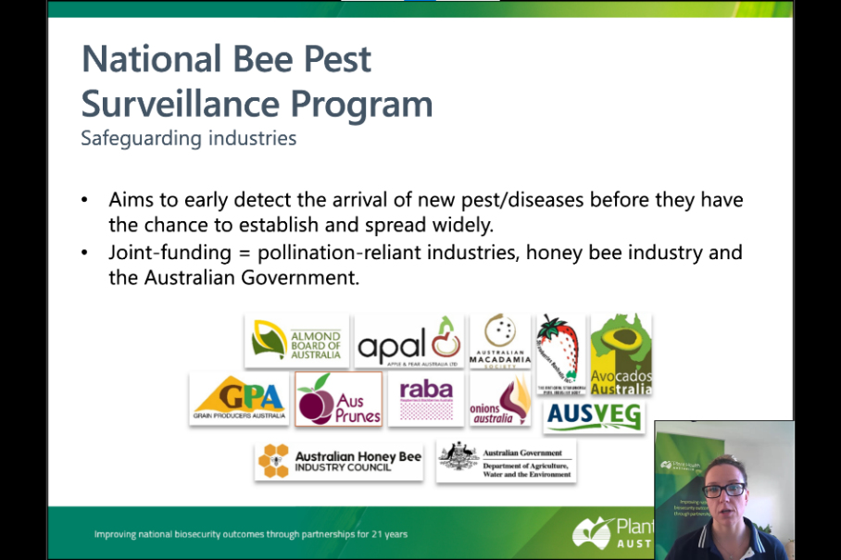

**Photo 3: Dr Jenny Shanks giving Australia’s presentation on the management of bee biosecurity. Photo credit: Dr Jenny Shanks**

The workshop was divided into sessions consisting of different aspects of honey bee health, with presentations including the role of the OIE in the region (as a European-based entity), expert sessions on specific bee pests and management strategies. The last session of the meeting began with country presentations from Australia, China and Malaysia. Australia’s presentation was provided by Dr Jenny Shanks, the manager of bee biosecurity and surveillance at PHA, whose talk outlined Australia’s complex bee biosecurity systems. Overall, the workshop was a huge success with many representatives wanting to learn more about Australia’s governance and surveillance processes. Australian representatives also gained insight into emerging bee pests in the region, and the processes Australia’s near neighbours have in place to manage them.

The PDF of Dr Shanks’ presentation may be found at the following link:

<https://rr-asia.oie.int/wp-content/uploads/2021/08/6-country-report_australia.pdf>

**Australia’s plant health engagement in the regional and international arena**

ACPPO represents Australia in international plant health engagement, including as its official contact point for the International Plant Protection Convention (IPPC). Australia draws its membership to the IPPC from the United Nations Food and Agriculture Organisation’s South West Pacific region and is very actively involved in contributing to the work of the region. It has membership in the Pacific Plant Protection Organisation (PPPO) and the Asia and Pacific Plant Protection Commission (APPPC), ensuring Australia and the region’s voice is heard at the international level.

Towards the progression of Pacific regional priorities, Australia is currently working with the PPPO to contribute to the development of a proposal for a new international standard on the safe provision of food and other humanitarian aid during emergency situations, the development of a regional standard setting process, a regional standard for the movement of sand and gravel and monthly participation in ‘Talanoa’ sessions together with the other PPPO members.

Both the PPPO and the APPPC held their annual regional workshops in late August and early September to discuss topics of regional biosecurity interest, including the implications of the detection of fall armyworm in the region and provide regional input into the development of new international standards and other documents being developed by the IPPC. These workshops are a good opportunity for Australia to strengthen relationships with Pacific and Asian biosecurity agencies and to confirm areas of mutual interest and priority.

**Photo 4: Pacific Plant Protection Organisation Executive Committee (ExCo) meeting in Fiji in March 2020. Photo credit: SPC-LRD**

To assist the department to move towards a more coordinated partnership with our Pacific neighbours, a new position of Director of Pacific Engagement and International Plant Health was created within the Australian Chief Plant Protection Office, designed to serve as the contact point for Pacific Island Countries and Territories for plant health related issues. Dr Sophie Peterson has been appointed to this role and leads the new team which will coordinate the development and implementation of the department’s Pacific Biosecurity Strategy under the Commonwealth Biosecurity 2030 Roadmap. The Pacific Engagement and International Plant Health Policy team coordinates and supports the department’s international obligations with the IPPC and engagement with regional plant protection organisations, including as the conduit for correspondence between the department and the national plant protection organisations of other countries. It is also engaged with the Plant Health Quadrilaterals (PH Quads) alliance for cooperation between Australia, USA, Canada and New Zealand on plant health and biosecurity.

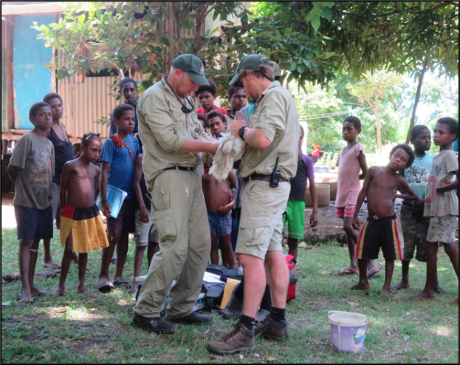The section is also responsible for the delivery of the department’s international and external territories surveillance programs. The International Plant Health Surveillance Program provides technical, operational and logistical support to risk-based surveillance activities and ongoing capacity improvement in collaboration with near neighbour countries (including Timor-Leste, Papua New Guinea and Solomon Islands). The External Territories Plant Health Surveillance Program delivers risk-based surveillance activities in Australia’s external territories in both the Indian and Pacific oceans

**Photo 5: Joint pest & disease surveys between Australia & PNG.  
Photo credit: DAWE**

**Euphresco plant health project – featuring Dr Cherie Gambley**

Dr Cherie Gambley, Principal Plant Pathologist, at the Queensland Department of Agriculture and Fisheries, leads a Euphresco plant health research project 2020-A-343 on *Resistance breaking strains of Tomato spotted wilt orthotospovirus: distribution and evaluation of their impact on tomato and pepper production.* The [Euphresco](https://www.euphresco.net/funding/current_calls) network coordinates transnational research programmes, by developing a common strategic research agenda and making the best use of limited national plant health research resources to avoid duplication and to achieve the best use of research outputs. Dr Gambley leads an international team of researchers hailing from Italy and Slovenia, to deliver this project’s outcomes by August 2023.

*Tomato spotted wilt orthotospovirus* (TSWV) is considered as one of the most economically important plant viruses, with significant damages up to 100% caused by the emergence of resistance-breaking isolates. Resistance-breaking (RB) isolates of TSWV are reported from Spain, Italy, Hungary, Turkey, USA, Brazil, Argentina, Australia, Serbia and South Africa in peppers and/ or tomatoes overcoming the resistance genes: *Tsw* in pepper and *Sw-5* gene in tomato. There is also some evidence of RB strains of *Tsw*-gene present in weed hosts in Australia without selection pressure.

**Photo 6: Cherie Gambley in a pepper field**

**Photo credit: Peter Nimmo, QDAF**

The goal of the Euphresco project is to further investigate the TSWV genome differences between RB isolates from tomato and pepper. This investigation seeks to clarify if previous reports of genetic components responsible for resistance are universally present in RB isolates from geographically distant areas such as Australia, Italy and Slovenia. The project will also review diagnostic protocols and develop new assays if required.

Dr Gambley explains that the most challenging aspect of her job is the short research funding cycles, typically only three years.

“It is often difficult to build substantial solutions to research questions within three years.”

“These short cycles result in slower resolution of complex science questions and occasionally a complete stop to that avenue of enquiry if funding agencies change priorities.”

Euphresco offers an opportunity to collaborate internationally and investigate these research questions more effectively.

The Australian Chief Plant Protection Office are Australia’s country coordinators for [Euphresco](https://www.euphresco.net/funding/current_calls) and can be contacted for further information on other projects. A new round of research topics will be announced in late 2021.

**Plant Health Hero**

**Felina Campion – Bawinanga Ranger harnessing traditional knowledge**

On 31 July, the department celebrated World Ranger Day to recognise the contributions our Indigenous Rangers make in protecting Australia from exotic pests and diseases.

The Australian landscape is dynamic, and ecosystems are ever-changing, so it can be difficult to detect when plant pests and invasive weeds are altering the landscape. Spotting invasive species requires a deep understanding of the landscape and lifelong monitoring of the land. The Bawinanga Rangers operate in the Djelk Indigenous Protected Area, harnessing traditional knowledge to understand contemporary environmental issues facing the ecosystems under their care.

Felina Campion is one of the Bawinanga Women Rangers. She is involved in managing the land using Indigenous knowledge to understand and monitor landscape health and biodiversity. She plays a critical part as a first respondent in identifying plant pests and invasive weeds that have the potential to hinder our ecosystems.

Felina is on the front lines of protecting Australian plants against plant pests and invasive weeds. It is due to her knowledge of the landscape where she lives and works that she is able to detect small changes in the ecosystems caused by the incursion of pests and weeds.

“We really know our native plants and animals and can easily identify when they are pests, diseases, or invasive plants,” said Felina.

Felina recounted that the establishment of the invasive neem trees (*Azadirachta indica*) on Djelk land was causing damage to the environment. Felina and the Women Rangers were able to recognise the neem tree as the source of the damage and subsequently informed authorities which allowed the Rangers to tackle its spread.

**Photo 7: Felina Campion  
Photo credit: Bawinanga Rangers**

“I love my job. It's hard work but I want to empower other women to be strong for their community,” said Felina.

The sharing of knowledge is a cornerstone of the land management practices employed by Indigenous ranger programs. The Bawinanga Ranger program spearheads the Djelk Intern Program which allows students to contribute to and join the ranger workforce. Students undergo formal training in conservation and land management as well as working closely with Rangers and other Bawinanga staff. This provides them with solid career pathways and a deep understanding of the land on which they work. These initiatives ensure that the custodianship of the land, with the complete understanding of the natural ecosystems, is continued for many generations to come.

“Essentially, we want to be able to pass on our knowledge to the next generation and hope they will be supported in pursuing this as a career,” said Felina.

**Photo 8: Felina Campion, identifying weeds**

**Photo credit: Bawinanga Rangers**

**New National Priority Plant Pest videos by ACPPO**

Dr Gabrielle Vivian-Smith has been progressively releasing a series of new videos on National Plant Priority Pests on social media to raise biosecurity awareness about Australia’s most unwanted plant pests and diseases.

Check out the videos on Xyllela , BMSB and Khapra on our website and look out for more new videos on social media in the coming weeks.

<https://www.agriculture.gov.au/pests-diseases-weeds/plant/xylella>

<https://www.agriculture.gov.au/pests-diseases-weeds/plant/brown-marmorated-stink-bug>

<https://www.agriculture.gov.au/pests-diseases-weeds/plant/khapra-beetle>

**Australian Chief Environmental Biosecurity Officer (**[**ACEBO**](https://www.agriculture.gov.au/biosecurity/environmental/cebo)**)**

**National Established Weed Priorities (NEWP) framework**

While the on-ground management of established pests and weeds is primarily the responsibility of state and territory governments and land managers, the Australian Government has a key role in providing national leadership, coordination and strategic investment support.

With this aim in mind, recently the department procured [Wild Matters](https://wildmatters.com.au/) to help revitalise national established weed management through development of a National Established Weed Priorities (NEWP) Framework and a plan for its implementation. Further, Wild Matters has also committed to develop and update five Weeds of National Significance best practice A field of yellow flowers
manuals for African boxthorn, fireweed, gamba grass, sagittaria and vines (cat’s claw creeper/Madeira vine).

**Photo 9: Cats claw creeper flowers_**

**Photo credit: Sheldon Navie**

A range of consultation has already been undertaken, including two series of online national workshops, held in March and August 2021, and an on-line survey. The most recent workshops were comprised of more than 130 people from multiple sectors, including Natural Resource Management, primary production, conservation, research and all levels of government.

The Wild Matters team are continuing to consult broadly across Australia to ensure that the framework and its implementation best meets the needs of people and organisations involved in weed management. Wild Matters are expected to complete their work in December 2022.

To get involved, we invite you to contact [weedpriorities@wildmatters.com.au](mailto:weedpriorities@wildmatters.com.au).

For more information about the project, visit the [NEWP website](https://wildmatters.com.au/national-established-weed-priorities/).

**Photo 10: Madeira vine_flowers_**

**Photo credit: Sheldon Navie**

**Approval of water weed munching weevil**

*Cabomba caroliniana* (Cabomba) is a submerged aquatic weed of permanent and slow-moving freshwater bodies. This weed affects water quality by stagnation of the water, excluding native plants by blocking sunlight and competing for space and nutrients, and making it hard for people to use and enjoy the waterways. It is a Weed of National Significance. It has a wide distribution in Australia from Melbourne to Darwin and can grow in a range of climate conditions from monsoonal tropics to cold temperate environments. Regular control is costly and difficult – chemicals are difficult to apply as it is a submerged plant and restrictions also apply to the use of herbicides in water bodies.

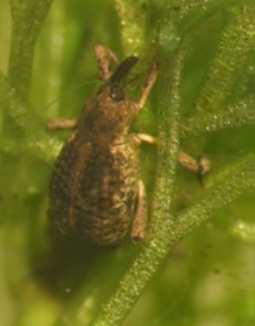Through targeted exploration for a control agent, CSIRO found a weevil, called *Hydrotimetes natans*, that eats only cabomba in South America and proposed to use this as a biological control agent for the weed in Australia. However, we know it is extremely important to be sure that any proposed biological control agent does not impact any other plant or animal in Australia. There are safeguards under both the *Biosecurity Act 2015* and the *Environment Protection and Biodiversity Conservation Act 1999*. A risk assessment for both Acts was conducted in collaboration with the department’s Plant Sciences and Risk Assessment Branch within Biosecurity Plant Division and the Environmental Biosecurity Office.

**Photo 11: Adult *Hydrotimetes natans*Photo credit: CSIRO**

The Minister for the Environment approved the adding of a weevil (*Hydrotimetes natans*) to the Live Import List for the biological control of the aquatic weed, cabomba (*Cabomba caroliniana*) in June 2021. This follows the approval for the release of the weevil from Quarantine under the Biosecurity Act in February 2021.

CSIRO are now busy breeding large numbers of the weevil to release when conditions are perfect so they can start munching their way through cabomba.

Cabomba is native to South America occurring in southern Brazil, Uruguay, Paraguay and north-eastern Argentina at the Parana River floodplain in South America. CSIRO imported the weevil from Paraguay and Argentina to Australia under quarantine conditions to conduct comprehensive host-specificity testing on a broad range of plant species, including native Australian species related to cabomba.

You can help stop further spread of cabomba by making sure that you carefully clean down and dry your boats, trailers and fishing equipment after you have been in an infested waterway to prevent small fragments from getting into other places.

**Photo 12: *Cabomba caroliniana***

**Photo credit: CSIRO**

Want to know more about cabomba?   
See <https://profiles.ala.org.au/opus/weeds-australia/profile/Cabomba%20caroliniana>

**Biosecurity Business Grantees announced**

This month we were excited to hear the [Minister’s announcement](https://minister.awe.gov.au/littleproud/media-releases/biosecurity-business-grants) of the first round of [Biosecurity Business Grants](https://www.agriculture.gov.au/biosecurity/australia/northern-biosecurity/biosecurity-business-grants) through the **Northern Australia Quarantine Strategy’s** *Indigenous Ranger Biosecurity Program.*

In recognition of northern Australia’s vast coastline and unique challenges facing the region, the grants encourage Aboriginal and Torres Strait Islander communities to view biosecurity as a business opportunity, to develop innovative business ideas that capitalise on achieving biosecurity outcomes for northern Australia, increase biosecurity awareness, surveillance and response and increase economic opportunities for Indigenous communities.

**Photo 13: Kuuku Ya’u Land and Sea Ranger, Photo credit: DAWE**

Of the 17 respondents, including a range of Indigenous businesses, ranger groups, local governments and not-for-profit organisations, five successful recipients received over $2.4 million over two years to:

* Improve remote Indigenous community animal health surveillance capacity, as part of a collaboration between Animal Management in Rural and Remote Indigenous Communities (AMRRIC) and over 20 indigenous communities in northern Australia.
* Build biosecurity capability of the Wuthathi Aboriginal Corporation ranger group to carry out biosecurity activities on Land and Sea Country in the Shelburne Bay area of eastern Cape York.
* Develop biosecurity protocols to assist in safeguarding Indigenous-led forestry in northern Australia, including socioeconomically important forestry enterprises such the 30,000 ha plantation hardwoods on the Tiwi Islands and the native forest sawmill and woodworks of Gumatj, East Arnhem, Northern Territory.
* Conduct a feasibility study and preliminary business plan to support the establishment of an Indigenous owned and run decontamination facility on Badu Island, and
* Develop a targeted *Waste and Material Biosecurity Management Plan* for the Torres Strait Island Regional Council that will underpin the guiding principles and objectives outlined in the *Torres Strait Regional Biosecurity Plan 2018-2023*.

For the full list of Biosecurity Business Grants recipients and projects visit:

<https://www.agriculture.gov.au/biosecurity/australia/northern-biosecurity/biosecurity-business-grants>

To keep up to date with opportunities like the Biosecurity Business Grants and to learn about the work the department is doing with Indigenous ranger groups in northern Australia subscribe to the [Frontline Ranger Newsletter](https://subscribe.agriculture.gov.au/subscribe).

**Pest Profile:  
Mouse-eared hawkweed (*Pilosella officinarum* or *Hieracium pilosella*)**

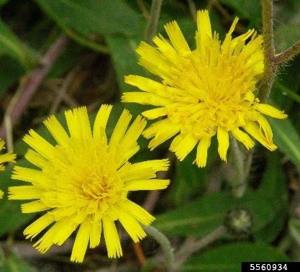**Mouse-ear hawkweed** **(*Pilosella officinarum*,** synonym - *Hieracium pilosella*)is a perennial flowering plant species in the daisy family. This species isnative throughout Europe, and northern and western Asia, and has spread rapidly to several other countries in Asia, North and South America, and New Zealand where it causes severe impacts. The mouse-ear hawkweed was assessed for inclusion and is now listed in the National Priority List of Exotic Environmental Pests, Weeds and Diseases.

Mouse-ear hawkweed can have a major impact on native plant communities and associated biodiversity in Australia by altering soil properties, nutrient cycling and overall community structure. It can outcompete native plants by secreting chemicals in the soil that prevent the germination and growth of other plants. The mouse-ear hawkweed can establish in a broad range of habitats, with south-eastern Australian tussock grasslands and tablelands in alpine regions the most vulnerable to invasion. It is the focus of an eradication programs in the alpine regions of Australia (New South Wales and Victoria).

**Photo 14: Mouse-ear hawkweed (*Pilosella officinarum*, synonym - *Hieracium pilosella*)**

**Photo credit: Janie Marlow, NameThatPlant.net, Bugwood.org**

The mouse-ear hawkweed is also known to rapidly displace native vegetation, including inter-tussock vegetation in alpine environments, which would lead to the loss of potentially rare and threatened plant and animals that are dependent on these alpine communities. It is also a serious risk to production lands or productivity, as it is unpalatable. Mouse-ear hawkweed changes the natural vegetation and landscape, depleting the aesthetic of our alpine regions for visitors and tourists.

Seeds of mouse-ear hawkweed are very small and could be unintentionally introduced into Australia from people’s clothing, outdoor equipment, shoes and luggage, as well as through the movement of contaminated plants and soil. There have also been detections of seeds at Australia’s border in shipments of various commodities packed in shipping containers.

This species can grow vigorously and reproduce asexually, and its seeds are easily spread by wind. It has the potential to spread across large areas of south-eastern Australia, including New South Wales, Victoria, Tasmania and South Australia. This species could persist across large areas of Australia in a number of different environments, if it establishes and spreads further.

**Detect & Protect –Australian biosecurity podcast**

**Recent Events**

**3 September:** Animal Health Committee meeting to progress AnimalPLAN

**8 September:** UK-Australia Chief Veterinary Officers Forum

**15/16 September:** OIE regional conference for the Asia Pacific

**Upcoming Events**

**15 September – 10 November:** Australasian Society for Infectious Diseases Zoonoses webinar series

**23 September:** ACPPO webinar – Sterile insect technique for management of Queensland fruitfly

**27 September:** Australian Biosecurity webinar – Protecting northern Australia from the risk of exotic fruit fly invasion

**28 September:** World Rabies Day

**28-30 September:** OIE Council meeting

**October:** Animal Health Quadrilateral Alliance meeting

**7 October:** Environmental Biosecurity webinar series: - Opening the toolbox

**12 October:** ACPPO webinar series – Citrus Canker eradication in the Northern Territory

**3 November:** One Health Day

**7 November:** Environmental Biosecurity webinar series: - Indigenous perspectives

**11 November:** ACPPO webinar series –Northern Australia risk pathways and incursion management

**16-18 November:** Plant Health Committee

**18-24 November:** World Antimicrobial Awareness Week

**23-26 November:** [Australasian Plant Pathology Society Virtual Conference](https://appsconference.com.au/)

**13-14 December:** [Crawford Conference on the Biosecurity, Health, Trade Nexus](https://www.crawfordfund.org/news/food-nutrition-security-your-invitation-to-our-2021-annual-conference/)

**Useful Links**

Environmental Biosecurity webinar series: <https://haveyoursay.awe.gov.au/2021-environmental-biosecurity-webinars>

National Biosecurity Website  
[www.biosecurity.gov.au](http://www.biosecurity.gov.au)

Insect Watch:  
[www. invasives.org.au/insect-watch/](https://invasives.org.au/insect-watch/)

Sterile Insect Technique:  
[www.agriculture.gov.au/pests-diseases-weeds/fruit-flies-australia/management/sterile-insect-technique](http://www.agriculture.gov.au/pests-diseases-weeds/fruit-flies-australia/management/sterile-insect-technique)

**Contact us**

**ACPPO:** [acppo@agriculture.gov.au](mailto:acppo@agriculture.gov.au)

**ACVO:** [ocvo@agriculture.gov.au](mailto:ocvo@agriculture.gov.au)

**ACEBO:** [acebo@agriculture.gov.au](mailto:acebo@agriculture.gov.au)

The department is pleased to announce the launch of this exciting podcast series. Listeners will hear from leaders in biosecurity and get an insight behind the scenes, from frontline border security officers to researchers. You can listen

to episodes on YouTube or your favourite podcast app. For more information please visit: [www.awe.gov.au/podcast-series](http://www.awe.gov.au/podcast-series)

[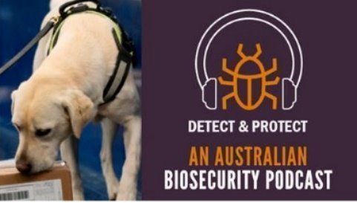](http://www.awe.gov.au/podcast-series)The first podcast featured Jeff and Colleen from the department’s detector dog team. In this podcast, find out how the detector dogs are selected and trained, and some of the new ways they are being utilise. Also hear dog teams’ interesting experiences at airports and mail centres.

The next podcast will look how we are managing growing risks of pests and diseases arriving in Australia to deliver a strong, future biosecurity system.

**Australian biosecurity webinar series**

This webinar series covers a broad range of biosecurity topics, such as Australia’s priority biosecurity risks, including how they are being managed, preparedness and response activities, innovation, and collaboration, and challenges for biosecurity. You will hear from government and industry experts about current priorities for our biosecurity work and learn about how Australia’s biosecurity system supports our industries, environment and communities.

The next webinar on 27 September is on protecting northern Australia from the risk of exotic fruit fly.

More information: [www.awe.gov.au/webinar-series](http://www.awe.gov.au/webinar-series)