Edition No. 2022/3

# September 2022

As pandemic restrictions ease, the Three Chiefs offices have seen a flurry of activity in their work to strengthen our biosecurity systems. To address the increased risks at our borders, they have been building capacity in our near neighbours to enhance regional biosecurity and engaging with our stakeholders through consultations and conferences. During the periods of travel for our Three Chiefs, Shalan Scholfield acted as Chief Environmental Biosecurity Officer, presenting at the National Landcare Conference. Dr Beth Cookson acted as Chief Veterinary Officer, travelling to Timor Leste to improve their biosecurity preparedness. Dr Bertie Hennecke acted as Chief Plant Protection Officer, while Dr Gabrielle Vivian-Smith travelled to Indonesia for the G20 Meeting of Agricultural Chiefs Scientists, Plant Health Committee in Darwin and the Pacific Plant Protection Organisation annual workshop in Fiji.

**Australian Chief Environmental Biosecurity Officer (**[**ACEBO**](https://www.agriculture.gov.au/biosecurity/environmental/cebo)**)**

**Landcare: Working together to protect what we love**

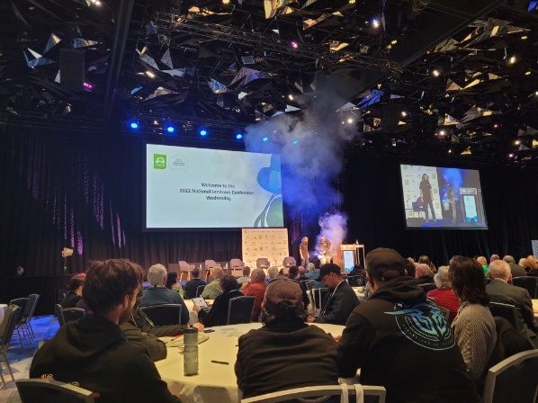Acting Chief Environmental Biosecurity Officer Shalan Scholfield delivered a great overview of environmental biosecurity at the 2022 National Landcare Conference, held in Sydney on 23-25 August 2022. The theme of this year’s conference was *the power of Landcare - shaping our future*, with around 1300 delegates attending both virtually and in person. Session topics included the environment and climate change, First Nations, community partnerships in action, urban Landcare and farming and emerging environmental markets.

Photo 1. Welcome to Country at opening of the 2022 National Landcare Conference. Photo credit: DAFF.

Landcare is a successful grassroots Australian institution and has a valuable role to play in Australia's biosecurity system. By working together, we can ensure the continuing success of our farmers and protect our valuable environment, biodiversity and way of life.

Shalan Scholfield spoke of the importance of Landcare and its team of over 140,000 volunteers in invasive species management and biosecurity surveillance:  
 “They are our eyes and ears on the ground to help detect biosecurity threats”.

**Achievements**

**ACEBO**

**•** Attended and presented at the 2022 National Landcare Conference in Sydney

• Participated in the Environment and Invasives Committee meeting in August

• Presented at a World Organisation for Animal Health (WOAH) and World Wide Fund for Nature joint workshop

**ACVO**

* Travelled to Indonesia in July with the Minister to meet with senior government officials, to discuss FMD and LSD
* Appointed an officer to be seconded to the FAO in Samoa
* Appointed officers to be seconded to WOAH headquarters in France
* Presented to numerous stakeholder engagement platforms on FMD and LSD
* Deputy ACVO travelled to Timor-Leste in August
* FMD real-time training reunion held 26 August

**ACPPO**

• Led Australian delegation, G20 Meeting of the Agriculture Chief Scientists, Indonesia

• Attended Plant Health Committee meeting, Darwin

• Field visit to the Polyphagous Shothole Borer incursion response, Perth

• Launched new National Action Plan for Hitchhiker pests

• Represented Australia at Pacific Plant Protection Organisation (PPPO) Executive meeting, Fiji

• Presented at Seed Federation Convention on the risk of illegal seeds to Australian biosecurity.

Senator the Hon Murray Watt, Minister for Agriculture, Fisheries and Forestry and The Hon Tanya Plibersek, Minister for the Environment,both delivered addresses as part of the plenary sessions, along with Andrew Metcalfe, secretary of the department.

Photo 2. Philippe Frost (left) and Corey Williams from the Environmental Biosecurity Office at the DAFF exhibitor booth. Photo credit: DAFF

**Applications open now for Agricultural Science & Innovation Awards!**

Applications are now open for the 2023 Science and Innovation Awards. These fund innovative projects in Australia’s agriculture, fisheries and forestry sectors to support the next generation of researchers.

Young Australians aged 18-35 years working or studying in a related industry are invited to undertake a project on an innovative or emerging scientific issue that will contribute to the ongoing success and sustainability of Australia's agricultural, fisheries and forestry industries.

Individual grants of up to $22,000 are on offer across multiple categories, including biosecurity and digital innovation. For more information and to apply by 23 September visit [www.agriculture.gov.au/scienceawards](https://www.agriculture.gov.au/scienceawards).

**100-year-old dog fence rebuilt in South Australia**

In 2019, the Australian Government committed $10 million toward the $25 million, five-year South Australian Dog Fence Rebuild Project. In partnership with the South Australian Government and industry, over two-thirds of the 100-year-old structure is being rebuilt or realigned.

Photo 3. SA map of sheep restocking due to rebuilt dog fence in March 2021 to March 2022. Source: Biosecurity SA, Department of Primary Industries and Regions.

SA Dog fence Rebuild Manager Lindell Andrews has overseen the commencement and completion of 802 kms of fence work to the end of July 2022. The work involves consultation with local Aboriginal communities and local land holders, heavy earthworks, realignment, design and building of new dog proof road crossings, and terrain specific design employing over 30 South Australian-based small businesses as part of the project.

The fence has already enabled local sheep producers to reintroduce or increase flock size in areas adjacent to the fence.

As recognition of the success of the project and Lindell’s efforts, despite record-breaking rains and material shortages, Lindell was an inductee into the 2021 Hall of Fame at the Australian Fencing Awards in May this year.

Photo 4. Lindell Andrews at her induction into the Australian Fencing Institute’s Hall of Fame. Photo Credit: Australian Fencing Industry.

**Australian Chief Veterinary Officer (**[**ACVO**](http://www.agriculture.gov.au/animal/health/acvo)**)**

**Indo-Pacific engagement for animal health and biosecurity**

The Office of the Chief Veterinary Officer’s (OCVO) Pacific Engagement Program for Animal Health is heading into its second year of operation, after a successful inaugural year. The program aims to support Pacific Island Countries and Territories (PICTs) to improve biosecurity, animal health and food security outcomes for the region. The program is committed to enhancing the department’s partnerships with Australia’s near neighbours to strengthen national and regional biosecurity systems, aligning with Australia’s Pacific Step-up foreign policy and the strategic objectives of the Commonwealth Biosecurity 2030 Roadmap.

Photo 5. Staff from the Office of the Chief Veterinary Officer met with Fiji’s Ministry of Agriculture Animal Health and Production team. Photo credit: OCVO.

In its first year, this program has established a strong partnership with the Pacific Community (SPC) and has developed collaborative relationships with colleagues in the Department of Foreign Affairs and Trade (DFAT) and the New Zealand Ministry of Primary Industries (NZMPI). In August 2022, the department co-convened with SPC a multi-stakeholder workshop on Pacific regional capacity needs to support animal health, welfare and production, veterinary public health, biosecurity and food security.

The workshop was held in Nadi, Fiji, with the OCVO represented by Program Manager for Pacific engagement, Dr Dan Edson, as well as Dr Peter Thornber, Dr Amber Beavis and Dr Raana Asgar. The officers were joined by colleagues from key bilateral and multilateral bodies, including SPC, the World Organisation for Animal Health (WOAH, formerly OIE), FAO, Biosecurity Authority of Fiji, Biosecurity Vanuatu, NZ MPI and many more.

During their visit to Fiji, the team also met with officials from the Fiji Ministry of Agriculture, the Australian High Commission in Suva, and staff from key organisations such as the Fiji Meat Industry Board, Fiji Cooperative Dairy Company Limited and PHAMA Plus. The trip also included field visits to research stations, abattoirs, the Fiji Veterinary Pathology Lab and the Vunikoka Beef Farm. A meeting with the Women in Dairy group provided the opportunity to talk to local women farmers who are leading change within their communities. Finally, a joint department and SPC planning day focused on the co-development of a workplan for partnership activities to be undertaken.

Next steps for the program will be to continue building strong and mutually beneficial bilateral and multilateral partnerships within the Pacific region, to strengthen the Pacific Heads of Veterinary and Production Services network, and continue supporting SPC in activities to improve animal health and biosecurity outcomes. A Regional Animal Health Capacity Development Plan for PICTs will be developed in collaboration with SPC, with input from the discussions held during the multi-stakeholder workshop.

Photo 6. Staff from OCVO met with the innovative Fiji Dairy Women’s group. Photo credit: OCVO.

Key areas of focus for the plan include improving veterinary and para-veterinary resources in the region, building disease surveillance and diagnostic testing capacity, support for smallholder farmers to improve food and income security, and strengthening disease preparedness and response systems for important transboundary animal diseases such as African swine fever (ASF) and foot-and-mouth disease (FMD).

Photo 7. Staff from OCVO met with Fiji’s Ministry of Agriculture Permanent Secretary Vinesh Kumar about animal health priorities. Photo credit: OCVO.

**Collaborating for preparedness in Timor Leste**

The department also provides important support to Papua New Guinea (PNG) and Timor-Leste, particularly around ASF, FMD and lumpy skin disease (LSD) preparedness activities. In early August 2022, Australian Deputy Chief Veterinary Officer, Dr Beth Cookson, and Dr Jenny Baird from Biosecurity Animal Division visited Timor-Leste, with a focus on improving quarantine and border biosecurity outcomes for the country.

Dr Cookson and Dr Baird met with officials from the Timor-Leste Ministry of Agriculture and Fisheries, the Quarantine Directorate and local stakeholders to collaborate on prevention and preparedness activities for FMD, LSD and avian influenza. Another important outcome from the trip was collaboration with the Market Development Facility on Timor-Leste’s public awareness campaign for FMD and LSD, including the delivery of educational and training resources.

Collaboration and establishment of strong relationships with our near neighbours are a cornerstone to the work undertaken by the OCVO and broader department. By engaging with and building capacity in the region, the department will continue working towards safeguarding Australia from significant offshore biosecurity threats and ensuring that animal health and food security systems in the region are upheld.

**Factsheets provide guidance on canine monocytic ehrlichiosis**

Canine monocytic ehrlichiosis (CME) is a tick-borne disease in dogs caused by infection with the bacterium *Ehrlichia canis*. First detected in Australia in May 2020, Ehrlichiosis has since been diagnosed in dogs in the northern regions of Western Australia and South Australia, all of the Northern Territory, and in north-west Queensland.

The Department of Agriculture, Fisheries and Forestry (DAFF), in consultation with stakeholders, has developed a range of Ehrlichiosis resources, including a guide for veterinarians and a series of factsheets that provide guidance for veterinarians, dog owners and for the rescue, adoption and relocation of dogs in Australia.

The factsheet for veterinarians is provided in addition to the national veterinary guide to ehrlichiosis and offers additional insights around the challenges and ethical considerations of managing infected dogs in Australia.

More information on the risks and management of confirmed or potentially infected dogs is provided in the following factsheets:

* A dog lying on the floor

  Description automatically generated with medium confidenceCanine ehrlichiosis: a guide for veterinarians
* Ehrlichiosis: additional veterinary guidelines for managing CME in Australia
* Canine ehrlichiosis: guidelines for dog owners
* Canine ehrlichiosis: guidelines for rescue, adoption and relocation of dogs in Australia

These are available on the department’s Ehrlichiosis webpage: <https://www.agriculture.gov.au/biosecurity-trade/pests-diseases-weeds/animal/ehrlichiosis-in-dogs>

The resources are also available on the department’s Animal Health webpage: <https://www.agriculture.gov.au/agriculture-land/animal/health>

Photo 8. Ocular and nasal discharge caused by ehrlichiosis infection. Photo credit: Dr John Beadle.

**Farewell to Dr Robyn Martin**

People really are the backbone of our department and as Dr Robyn Martin begins her extended leave likely leading into retirement from the public service, the Office of the Chief Veterinary Officer wants to extend our thanks and gratitude to Robyn for her tireless work and outstanding contribution to animal biosecurity in Australia and the region.

Robyn graduated with a veterinary degree from Murdoch University and then worked in private veterinary practice for several years before undertaking further study, including completing a PhD. Robyn went on to work for the Western Australian Department of Agriculture and Food joining the Department of Agriculture in Canberra in mid-1995 initially as a contractor!

Robyn has held several roles in the department including her most recent as First Assistant Secretary Biosecurity Animal Division. Robyn’s primary focus was on animal health, and technical animal biosecurity and national biosecurity preparedness. Her work saw her collaborate broadly with industry sectors, States and Territories and our regional neighbours on improving animal health and biosecurity outcomes.

We wish Robyn all the best and thank her for her expertise and many years of outstanding service and achievement.

Photo 9. Dr Robyn Martin. Photo credit: Dr Robyn Martin.

**Did you know…?**

Wild boars may be vectors of Foot and Mouth Disease, but they can also carry kilograms of soil from farm to farm as they travel.

This makes them a vector for some soil borne diseases, like Panama Disease (that effects banana plants).

That’s why a team from the department took an animal display to the Soilborne Disease Symposium in August.

Photo 10. Departmental display at the Soilborne Disease Symposium. Photo credit: Richard Davis.

**Australian Chief Plant Protection Officer (**[**ACPPO**](http://agriculture.gov.au/plant/health/acppo)**)**

**ACPPO attends G20 Meeting of Chief Agricultural Scientists in Bali**

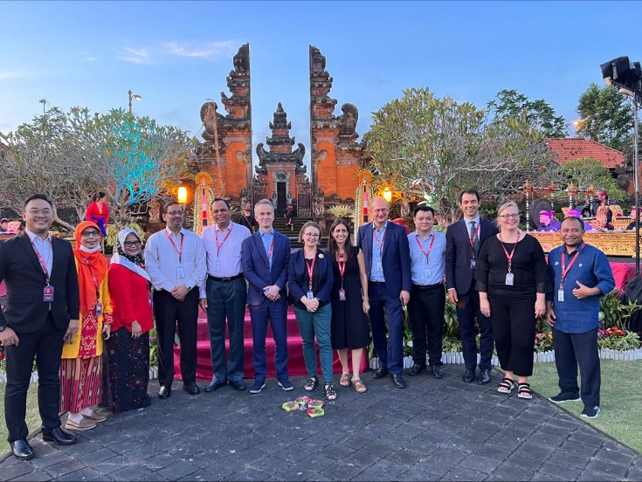Australia’s Chief Plant Protection Officer, Dr Gabrielle Vivian-Smith, along with Raj Patil, Executive officer, ACPPO represented Australia at the G20 Meeting of Agricultural Chief Scientists (MACS) on 5‒7 July 2022 in Bali, Indonesia. The focus of the meeting was on topics of interest to Australia – climate resilient agriculture, food loss and waste, food security policy post COVID−19, and digital agriculture and traceability. Presentations on each topic were followed by discussions among members.

Photo 11. Dr Vivian-Smith with delegates to the G20 MACS meeting. Photo credit: Raj Patil.

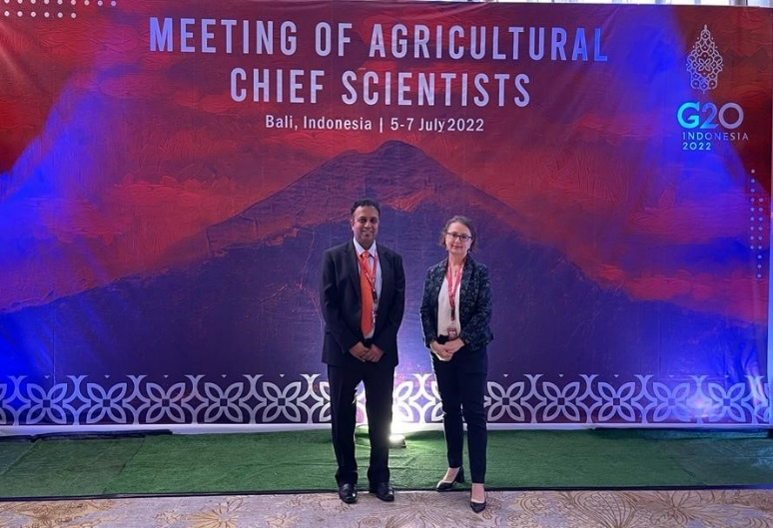On climate change, members agreed that extreme climatic events were impacting on food production and biodiversity as well as agricultural supply chains. They stressed taking a business-as-usual approach is not an option, and countries will need to adopt climate resilient agricultural practices.

The meeting emphasised one third of food produced globally is lost or wasted. This contributes around 8% of global greenhouse gas emissions, costing around US$940 billion, which is more than six times the Global Official Development Assistance budget in 2018. G20 MACS has facilitated collaboration over the years to develop baseline data, monitoring and waste reduction policies, and assess their effectiveness. Discussions on digital agriculture and traceability focused on benefits such as providing confidence in the integrity of supply chains as well as developing secure systems that are validated by governments to ensure their wider acceptance.

Photo 12. Executive Officer Raj Patil with Dr Gabrielle Vivian-Smith at the G20 MACS meeting. Photo credit: Raj Patil.

Dr Vivian-Smith made a presentation on the electronic certification system, ePhyto, developed by the International Plant Protection Convention as a good example of digitalisation and traceability systems. Australia encouraged G20 members to support its implementation, especially in the Asia-Pacific region and received significant support for this initiative.

Presentations from the meeting are accessible at <https://www.macs-g20.org/annual-meetings/current-meeting/indonesia-2022>

**Timor-Leste welcomes ACPPO team**

Departmental officers from the Australian Chief Plant Protection Office (ACPPO) and the Northern Australian Quarantine Strategy (Biosecurity Plant Division) visited Timor-Leste from 18-22 July to meet with National Directorate for Quarantine and Biosecurity (DQNB) colleagues for training and plant health surveys. The Department of Foreign Affairs and Trade also supported the team, with technical and historical program knowledge.

ACPPO has a long history of regular visits to Timor-Leste for coordination and delivery of joint plant biosecurity surveys and capacity building activities. The inability to travel to Timor-Leste due to the impacts of COVID-19 meant survey planning activities have been conducted remotely during the past two years. This trip was an important milestone marking the resumption of activities in person, and an opportunity to reconnect with our colleagues in Timor-Leste.

Photo 13. DNQB and Australian Government staff who developed the 2022/23 plant health surveillance program priories in Dili. Photo credit: DNQB.

The trip enabled discussions and co-planning of survey and other priority activities. The joint priorities will inform the survey and supporting activities undertaken in the next year. Detailed discussions on areas, locations and commodities of focus for the surveys, were held with DNQB colleagues and senior managers, along with discussions on how Association of Southeast Asian Nations and World Trade Organisation membership requirements are being addressed and could be supported.

The team took the opportunity to visit a range of facilities while in Dili. They visited Dili International Airport where they observed baggage inspections for incoming passengers and the DNQB inspecting seized plant material for potential contaminating insects. The team also visited the DNQB biosecurity laboratory and reviewed the samples that were collected during the 2022 surveys (remotely supported by the department). These were returned to Australia for further analysis by Northern Australia Quarantine Strategy scientists.

Photo 14. Mr Deoniso Nunes inspecting samples from the 2022 remotely supported survey. Image credit: DNQB.

**COVID, Climate Change and Conflict: Three Cs dominate 2022 Crawford Conference**

Dr Gabrielle Vivian-Smith and a team from ACPPO attended the annual Crawford Conference at Parliament House in August. The conference brought together policy makers, agricultural scientists and leaders of the future for an informative day of discussion, presentations and networking around issues shaping Australia’s participation in international agriculture for development. The Three Chiefs offices also took the opportunity to highlight the importance of biosecurity to agriculture at the biosecurity information table.

Photo 15. Dr Gabrielle Vivian-Smith with ACPPO staff, Jen Richards (left) and Raj Patil (right) at the Biosecurity information display table. Photo credit: Mona Akbari.

The conference kicked off with dinner and the Sir John Crawford Memorial address delivered by Dr Audrey Aumua, Chief Executive Officer of the Fred Hollows Foundation New Zealand. She spoke passionately about the challenges and opportunities facing the Pacific region and urged the audience to think big to ensure integrated food and nutrition security for the region.

The opening keynote from Professor Andrew Campbell, Chief Executive Officer of the Australian Centre for International Agricultural Research (ACIAR) covered the ‘hits and misses’ in the 40-year history of ACIAR. He introduced the three C’s that would recur throughout the day: COVID, climate change, and conflict and their impact on agriculture and food security.

Minister for Agriculture, Fisheries and Forestry, Senator the Hon Murray Watt addressed the conference saying biosecurity had rocketed up as a priority for Australia’s agriculture, especially working as partners with our near neighbours to protect our regional agriculture and food security. He also touched on how the government was addressing the challenges of COVID, climate change and conflict affecting the agricultural sector.

Dr Gabrielle Vivian-Smith chaired an afternoon panel featuring a well-received presentation by Professor Neena Mitter, Director of QAAFI Centre for Horticultural Science. She reported on the success of BioClay, a clay-based crop protection spray that delivers effective and stable RNA-based bio-pesticides. After demonstrating success at treating zucchini and capsicum viruses in the field, she and her team are now experimenting with BioClay to deliver treatments for white fly in cotton, botrytis in grapes and even myrtle rust.

For the full program, including slides of presentations go to [https://www.crawfordfund.org/events/2022-conference/2022-conference-program/](https://www.crawfordfund.org/events/2022-conference/2022-conference-program/%20%20)

**Modern diagnostics for plant biosecurity**

A summary provided for the Plant Health Committee highlighted some of the modern technologies being used by our department.

**Upcoming Events**

**6-8 September**: Animal Health Committee 42nd meeting

**7 September**: National Threatened Species Day

**8 September**: ACPPO webinar–Pacific Biosecurity Engagement

**15 September**: Environmental Biosecurity Webinar – ‘Protect’

**21-23 September**: First International Plant Health Conference, London

**26 September**: Friends of One Health meeting in Geneva

**25-29 September**: 22nd Australasian Weeds Conference

**27-29 September**: World Organisation of Animal Health (WOAH) Council Meeting

**28 September**: World Rabies Day

**30 September**: UK-Aus Chief Veterinary Officer Bilateral

**October**: ACVO-Australian Veterinary Assocication Leadership Dialogue

**14 October**: World Standards Day

**20 October**: ACPPO Webinar – Novel Triage Tools

**27 October**: Environmental Biosecurity Webinar – ‘Protect’

**2 November**: Mini QUADS

**9-10 November**: National Biosecurity Forum

**13-18 November**: International Fruit Fly Symposium

**17 November**: ACPPO Webinar - Australian Trogoderma

**Contact us**

**ACPPO:**

[acppo@agriculture.gov.au](mailto:acppo@agriculture.gov.au)

**ACVO:**

[ocvo@agriculture.gov.au](mailto:ocvo@agriculture.gov.au)

**ACEBO:**

[acebo@agriculture.gov.au](mailto:acebo@agriculture.gov.au)

**Biosecurity MinIONs at work**

Breakthrough MinION technology can sequence every gene in any plant, animal or microbe from a portable device that fits in the palm of your hand. Over the last year, the Plant Innovation Centre at Plant Entry Quarantine (PIC@PEQ) have developed a simple, reliable, and efficient MinION diagnostic method that takes mere hours to identify unknown specimens – a result that typically would have taken weeks. This fast, portable diagnostic tool is already yielding results in the field. It played a key role in identifying suspected banana freckle in the Northern Territory. It also recently confirmed two significant plant pests (black sigatoka and *Chilo terrenullus*) with just a 3-day turnaround.

Photo 16. Dr Louisa Parkinson demonstrating the MinION. Photo credit: DAFF

**Mass spectrometry in the spotlight**

MALDI-TOF (Matrix-Assisted Laser Desorption/Ionization Time-of-Flight) mass spectrometry technology is being piloted in the department’s Sydney laboratory. So far, the pilot indicates this technology is suitable as a core, primary diagnostic tool for isolated organisms (including invertebrates, bacteria, fungi and plants). MALDI-TOF mass spectrometry identified 70 bacterial isolates between March and June, including *Ewingella americana* and *Rhanella insusitata* on imported fresh produce and *Pectobacterium zantedeschiae, Pectobacterium aroidearum* on imported nursery stock. Should the pilot proceed as planned, this technology could soon provide rapid, cost-effective, species-specific diagnostics for plant biosecurity.

**New hitchhiker plan****launched**

Hitchhiking or contaminating plant pests are spreading around the globe. As part of lifting our preparedness and response to exotic pest and disease incursions, the *National Hitchhiker (Contaminating) Plant Pest Action Plan 2022–2032* was recently launched. Go to: <https://www.agriculture.gov.au/biosecurity-trade/pests-diseases-weeds/plant/national-action-plans>

**Pest Profile: Exotic Tobamoviruses**

Exotic Tobamoviruses are one of the top 40 national priority plant pests that pose a risk to Australia. They are a group of viral, highly infectious diseases that cause mosaic-like mottling and discolouration of leaves, distortion or absence of fruit on key agricultural crops. These viruses affect a range of plants including tomatoes, cucumbers, potatoes, melons and capsicums. They have a range of common names, depending on the type of plant they are infecting. Cucumber green mottle mosaic virus, tomato mottle mosaic virus, and zucchini green mottle mosaic virus are all examples of tobamoviruses.

These viruses don’t affect human health but they do damage plant production. There is no cure and destroying infected plants is the only treatment for tobamoviruses.

Photo 17. Symptoms of a tobamovirus Tomato brown rugose fruit virus on tomatoes. Photo Credit: Diana Godinez, EPPO database.

**Keeping tobamoviruses out of Australia**

Our biosecurity rules place strict conditions on the importation of all seeds. We have biosecurity detector dogs in airports and mail centres sniffing out seeds. Since November 2021, we have an immediate destruction policy for illegal seeds arriving in Australia via mail. We are developing targeted low energy X-ray technology and algorithms to intercept seeds in the mail. We are working with e-commerce platforms to develop policies to prevent the sale and illegal importation of exotic seeds and plants. We are also undertaking behavioural insights research to influence gardener groups purchasing seed online.

Photo 18. Tobamovirus can be spread through infected seeds. Biosecurity detector dogs are trained to detect seeds and are routinely used in airports and mail centres around Australia. Photo credit: DAFF.

Seeds that are imported for human or animal consumption must be devitalised to prevent germination so they cannot spread viruses to live plants. This is currently done through moist heat treatment which can take over 48 hours, but the department is continually working on finding newer, faster, less damaging alternative treatments.

For more information on tobamoviruses: <https://www.agriculture.gov.au/biosecurity-trade/pests-diseases-weeds/plant/tobamoviruses>