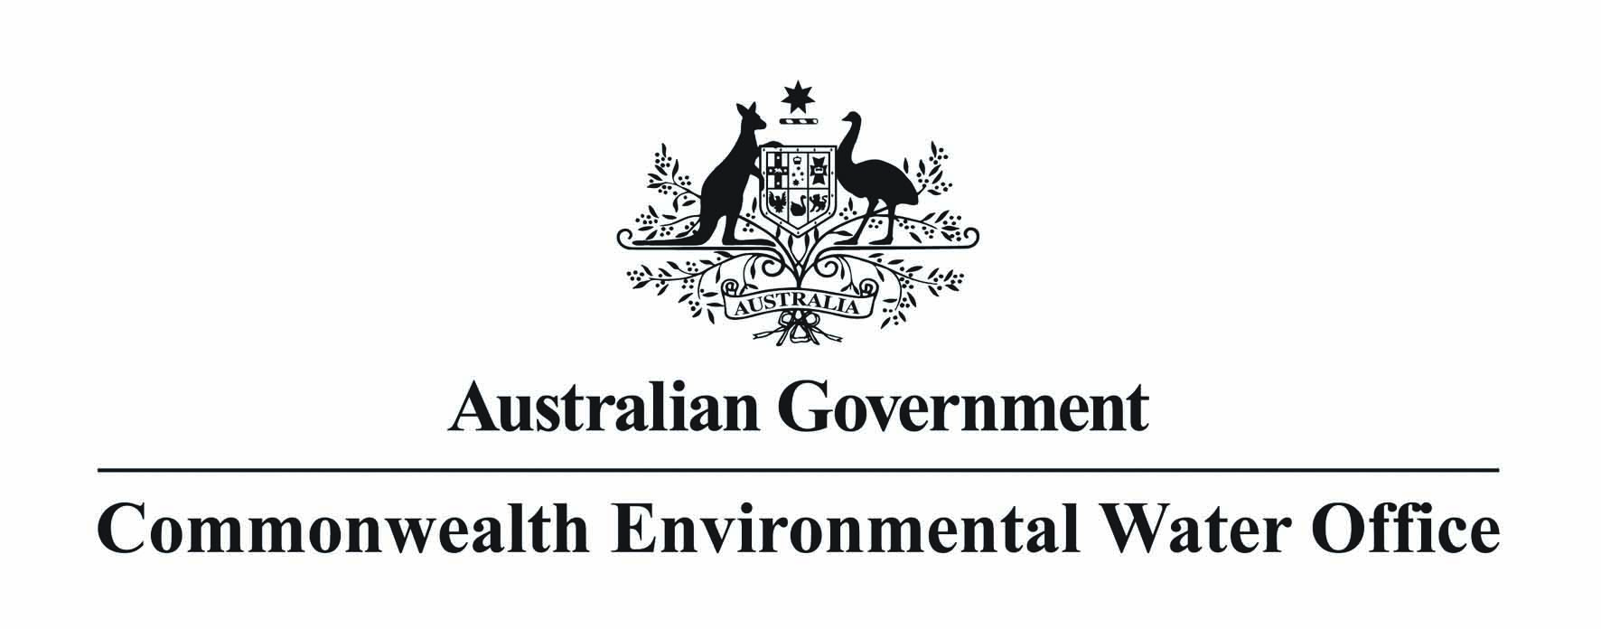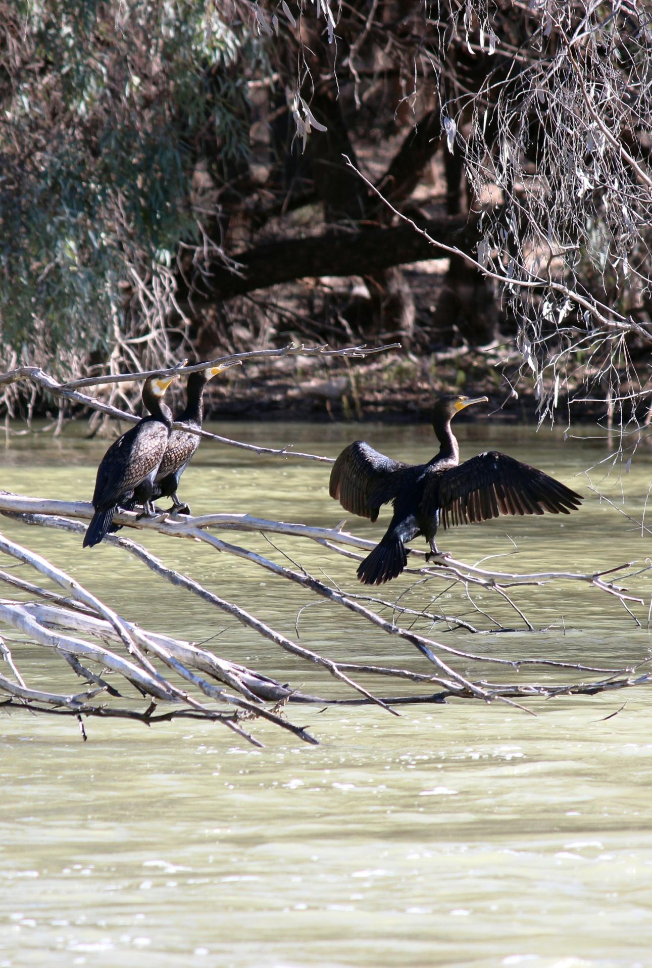

**Commonwealth Environmental Water**

**Trading Framework**

**November 2016**

**Acknowledgement of the Traditional Owners of the Murray-Darling Basin**

The Commonwealth Environmental Water Holder and the Commonwealth Environmental Water Office respectfully acknowledges the Traditional Owners, their Elders past and present, their Nations of the Murray– Darling Basin, and their cultural, social, environmental, spiritual and economic connection to their lands and waters.

This report should be cited as ‘*Commonwealth Environmental Water Trading Framework’*.

Published by the Commonwealth Environmental Water Holder for the Australian Government.  
­­© Commonwealth of Australia 2016.

This work is copyright. Apart from any use as permitted under the Copyright Act 1968, no part may be reproduced by any process without prior written permission from the Commonwealth. Requests and enquiries concerning reproduction and rights should be addressed to Department of the Environment, Public Affairs, GPO Box 787 Canberra ACT 2601 or email [public.affairs@environment.gov.au](mailto:public.affairs@environment.gov.au)

Information presented in this document may be copied for personal use or published for education purposes, provided that any extracts are fully acknowledged. The views and opinions expressed in this publication are those of the authors and do not necessarily reflect those of the Australian Government or the Minister for the Environment. While reasonable efforts have been made to ensure that the contents of this publication are factually correct, the Commonwealth does not accept responsibility for the accuracy or completeness of the contents, and shall not be liable for any loss or damage that may be occasioned directly or indirectly through the use of, or reliance on, the contents of this publication

Cover image credit: Great Darling Anabranch, NSW. Photo by Rebecca Gee © CEWO.

# EXECUTIVE SUMMARY

The Commonwealth Environmental Water Holder (CEWH) has legislated responsibility for decisions relating to Commonwealth environmental water. The purpose of Commonwealth environmental water is protecting or restoring the environmental assets of the Murray-Darling Basin. To maximise the benefits of environmental water, the Commonwealth environmental water portfolio is actively managed which means the water may be:

* delivered to meet environmental outcomes;
* carried over to the following year to meet future environmental outcomes; or
* traded.

The purpose of this document is to provide interested parties with the framework within which the CEWH and Commonwealth Environmental Water Office (CEWO) staff are required to behave when involved in commercial trading. The implementation of the Commonwealth Environmental Water Trading Framework (the Trading Framework) will ensure that the CEWH’s trading activities:

* support enhanced environmental outcomes;
* have regard to social and economic outcomes;
* consider impacts on the market, including any third-party impacts;
* are undertaken in a manner which meets legislative requirements;
* are financially responsible, fair, equitable, transparent and accountable; and that
* the CEWH and CEWO staff act with integrity and high ethical standards.

This revised version of the Trading Framework builds on the original version released in 2011 after stakeholder consultations, by incorporating changes arising from the amendments of the *Water Act 2007* which passed in May 2016.The Trading Framework consists of:

1. Legislative requirements that must be met by the CEWH as a statutory office holder and CEWO staff as Commonwealth government employees.
2. Operating rules, which are internal governance arrangements covering the CEWH and CEWO staff in relation to the different stages involved in trade.
3. Procedures and Protocols, which are the processes that support legislative requirements and the operating rules, and must be complied with by the CEWH and CEWO staff.

The focus of this paper is on the CEWH and CEWO’s legislative requirements and the operating rules. The operating rules provide clear guidance about the way the CEWH will behave through the trading process including:

* identifying trading opportunities that will enhance capacity to support environmental objectives;
* making a trade decision;
* approaching the market, including announcements;
* evaluation of offers;
* trade approvals; and
* announcement of results.

The Trading Framework will continue to be refined if necessary as the CEWH’s involvement in the water market matures. An independent review of the Trading Framework to establish its appropriateness and effectiveness is planned for 2019. The review will also assess the CEWO’s compliance with the Trading Framework.

David Papps  
Commonwealth Environmental Water Holder

November 2016

Table of Contents

EXECUTIVE SUMMARY 1

1. PURPOSE 3

1.1. Compliance with Commonwealth and State legislation 3

1.2. Operating Rules 4

1.3. Procedures and Protocols 4

1.3.1. Procedures 4

1.3.2. Protocols 4

Figure 1: Trading Framework and Trading Process 5

2. COMPLIANCE WITH COMMONWEALTH AND STATE LEGISLATION 6

2.1. The Water Act 6

Figure 2: Options for allocation sale under Section 106 of the Water Act 7

2.1.1. The Basin Plan 7

2.2. Public Service Act 1999 8

2.2.1. APS Values, Employment Principles and Code of Conduct 8

2.3. The Public Governance, Performance and Accountability Act 2013 (PGPA Act) 8

2.3.1. Commonwealth Procurement Rules 2014 (CPR) 9

2.4. Freedom of Information Act 1982 (FOI Act) 9

2.5. State water management legislation 9

3. OPERATING RULES 10

3.1. Governance 10

3.2. Trade decision making 11

3.3. Announcements 12

3.4. Review and audit 13

3.4.1. Independent review of the operating rules 13

3.4.2. Independent assessment of the impacts of trading activity 13

Revision history 14

# PURPOSE

The primary role of the Commonwealth Environmental Water Office (CEWO) is the delivery of Commonwealth environmental water. Trade is one of the tools the Commonwealth Environmental Water Holder[1] (CEWH) uses to effectively manage environmental water. As a Commonwealth entity the CEWH takes its trade responsibilities very seriously.

This paper sets out the framework within which the CEWH will trade. Implementation of a Trading Framework will ensure that CEWH’s trading activities: support enhanced environmental outcomes; are undertaken in a manner which meets legislative requirements; are financially responsible, fair, equitable, transparent and accountable; and that the CEWH and CEWO staff act with integrity and high ethical standards. In undertaking trade, the CEWH will also have regard to social and economic outcomes; will consider any impacts on the market, and adopt strategies to minimise potential impacts on third parties.

The Commonwealth Environmental Water Trading Framework, originally published in 2011, was developed after wide consultation with business, agricultural industry and community groups interested or involved with water markets. This version of the Trading Framework has been updated to reflect changes to the legislation governing the way in which the CEWH can trade water allocation and then invest the proceeds of trade. This is detailed in Section 2.1. The framework guiding how the CEWH will invest proceeds of trade is being developed separately.

There are three elements to the Trading Framework:

1. Compliance with Commonwealth and state legislative requirements.
2. Operating Rules.
3. Procedures and Protocols.

Figure 1 on page 5 illustrates the practical application of the Trading Framework, as well has how the framework influences the trade process.

|  |
| --- |
| **Note:** Within this paper, ‘trade’ is used in the sense of a commercial exchange, between two parties, of water allocation or entitlement for some form of consideration (typically monetary). The term is not intended to cover the transfer of water allocations between the accounts of one or more parties performed for the primary purpose of physically delivering water, such as to an environmental asset, or for managing carryover. This differs from the definition of trade in the Basin Plan’s trading rules, which defines trade as any change in ownership and/or location with or without consideration. |

# Compliance with Commonwealth and State legislation

As a government entity, the CEWH and CEWO staff must comply with a wide range of existing legislative requirements. This includes: financial management arrangements for Commonwealth agencies; freedom of information; and policies relating to information management, auditing, employee conduct and accountability. As the Commonwealth holds environmental entitlements across four states, the CEWO must also comply with the prudential , trade and water resource management frameworks of those states.

# Operating Rules

The Operating Rules provide clear guidelines on how the CEWH and CEWO staff will behave through the trading process including:

* The CEWH will not trade if aware of a water announcement that has not been made generally available.
* All trade will be undertaken using a competitive process.
* Decisions to trade will be informed by a market assessment.
* Price limits will be used in every trading action.
* Trade offers will be based on consistent, equitable and transparent assessments. The CEWH will provide regular guidance on trading intentions.
* Trading actions will be announced prior to trade.
* Market information will be released prior to each trading action.
* Public reporting will occur following trading actions.

# Procedures and Protocols

Procedures and protocols are internal documents which support the CEWH and CEWO staff in complying with Commonwealth and state legislative requirements and the operating rules.

# Procedures

The procedures support each step of the trade process and cover a number of areas including:

* the investigation of trading possibilities;
* the justification and approval to trade;
* development of an appropriate approach to market;
* internal financial processes;
* an evaluation plan which details how offers to sell or buy water will be assessed;
* the approval process; and
* public announcements and timely release of information.

# Protocols

The CEWH has developed Protocols to assist the CEWH and CEWO staff in meeting their requirements as per the Basin Plan water trading rules and to reflect the CEWO’s corporate values as an Australian Government Public Service agency.

The [protocols](http://www.environment.gov.au/water/cewo/trade/trading-framework#protocols) are available at: <http://www.environment.gov.au/water/cewo/trade/trading-framework> and include:

* ‘Chinese wall’ arrangements to preserve the integrity of advice within the CEWO;
* avoiding, exposure to inside information and conflicts of interest;
* disclosing and managing inside information and conflicts of interest if they arise ;
* record keeping and information management;
* being aware of water announcements and decisions to trade; and
* sanctions for breaches of the APS Code of Conduct.

## Figure 1: Trading Framework and Trading Process

**TRADING FRAMEWORK**

**Operating Rules**

**Commonwealth and State legislation**

**Procedures and Protocols**

**1. Trading opportunity that will enhance capacity to support environmental objectives identified.**

**3. Public announcement of trading intentions.**

**6. Trade approval, settlement and registration.**

**Monitoring and review of trading activities/outcomes**

*Includes ongoing monitoring and review of arrangements to support compliance with Water Act, Environmental Watering Plan, Water Trading Rules and operating rules. External reviews of Trading Framework and trade outcomes including market, third-party and socio-economic impacts. Ongoing review of compliance with departmental risk management and audit requirements.*

**2. CEWH trading decision that is consistent with the requirements of the *Water Act 2007.***

**4. Approach to market via a market mechanism tailored to suit particular circumstances of the trading action.**

**7. Public announcement of trading outcomes within 30 days of registration**

**5. Evaluation of offers received.**

**TRADING PROCESS**

**Monitoring and review of trading activities/outcomes**

*Includes ongoing monitoring and review of arrangements to support compliance with Water Act, Environmental Watering Plan, Water Trading Rules and operating rules etc. External reviews of Trading Framework and trade outcomes including market, third-party and socio-economic impacts). Ongoing review of compliance with Departmental risk management and audit requirements.*

# COMPLIANCE WITH COMMONWEALTH AND STATE LEGISLATION

Legislation is a necessary feature of the administration and accountability of government, and underpins a broad range of government functions. In addition, a significant body of law governs the operating environment of government agencies in their day-to-day activities.

Commonwealth legislation applies specifically to the way in which the CEWH and CEWO operates, including its trading function. State water management legislation sets out the rules that apply to all water entitlements, including those that form part of the Commonwealth environmental water holdings.

The CEWH and CEWO staff are required to comply with the following legislation and subservient regulations:

* The [*Water Act 2007*](https://www.legislation.gov.au/Details/C2016C00469) and the [*Basin Plan 2012*](https://www.legislation.gov.au/Details/F2016C00574);
* [*Public Service Act 1999*](https://www.legislation.gov.au/Details/C2016C00420)*,* [*Public Service Regulations 1999*](https://www.legislation.gov.au/Details/F2015C00713), the [*Australian Public Service* *Commissioners Directions 2013*](https://www.legislation.gov.au/Details/F2015C00944)*,* and the APS Values and Code of Conduct;
* The[*Public Governance, Performance and Accountability Act 2013*](https://www.legislation.gov.au/Details/C2014C00317) (PGPA Act) and the [*Commonwealth Procurement Rules 2014*](https://www.legislation.gov.au/Details/F2014L00912) (CPR);
* [*Freedom of Information Act 1982*](https://www.legislation.gov.au/Details/C2016C00745)(FOI Act); and
* Relevant State water management legislation.

# The Water Act

The Water Act and Basin Plan limit the circumstances under which trade can occur, and, the information that can be used when making a trade decision. The Water Act is the primary legislation governing the CEWH; it allows for the establishment of and carrying out of the functions of the CEWH.

Section 105 of the Water Act requires all decisions relating to use, carryover, or trade of Commonwealth environmental water made by CEWH to be justified (and documented) by reference to the objectives of managing the holdings for the purpose of protecting or restoring the environmental assets of the Basin. Trade is not an end unto itself but rather a tool for enhancing environmental watering capacity.

In relation to trade, Section 106 of the Water Act (Attachment A) outlines the powers of the CEWH, which includes under what circumstance trade can be undertaken, and the purpose of the trade. Figure 2 illustrates the two options under which the CEWH can undertake a sale of water allocation in accordance with Section 106 of the Water Act.

The Water Act also provides for the independence of the CEWH from direction by either the Minister or Secretary of the Department on functions related to trade.

## Figure 2: Options for allocation sale under Section 106 of the Water Act

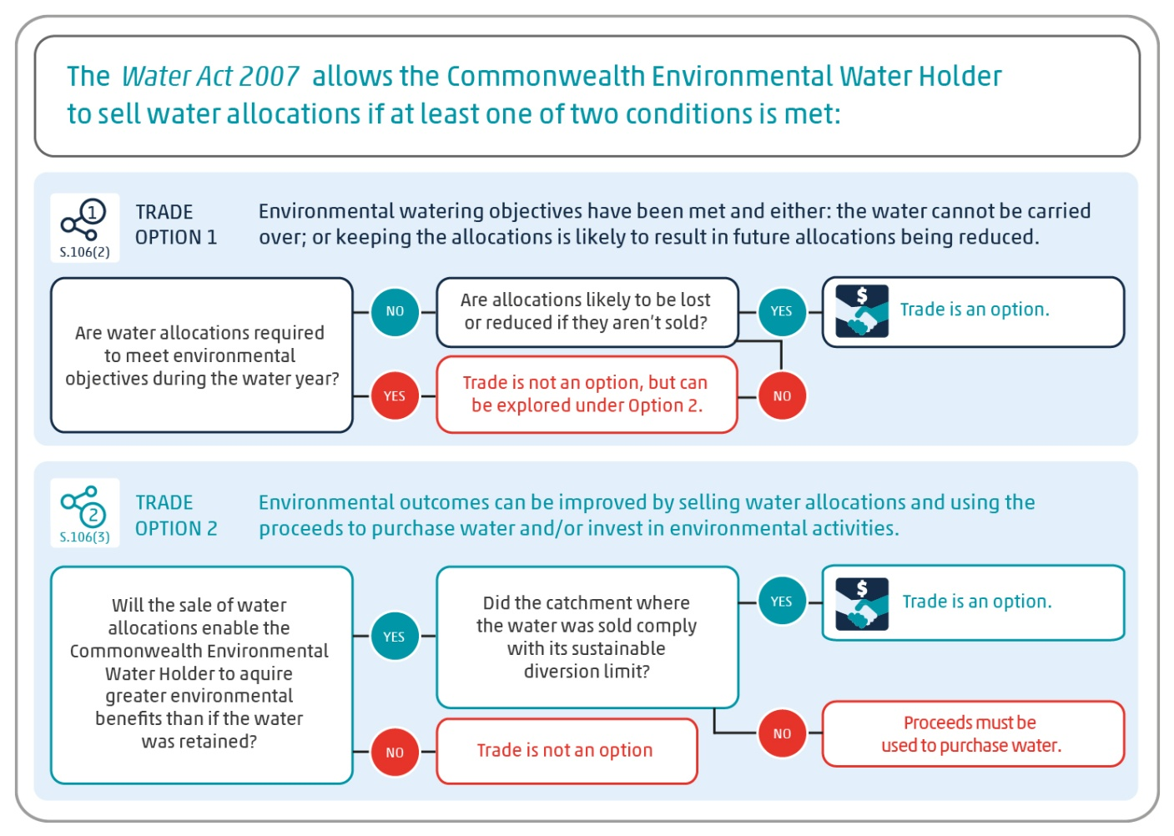

# The Basin Plan

The Water Act places an obligation on the CEWH “to perform its functions and exercise its powers consistently with and in a manner that gives effect to the Basin Plan”. The Basin Plan places a number of obligations on the use, trade and monitoring of Commonwealth environmental water, as well as reporting requirements.

Chapter 12 of the Basin Plan sets out the water trade rules. Requirements relating to information to be made available are expressly stated in Division 5. These rules govern how persons or agencies are to behave if they are aware of information that has not been made generally available and that could materially affect a person’s decision to trade water.

For the trade of Commonwealth environmental water, the key elements of the trade rules are:

* 12.49(1) – Definition of material effect;
* 12.49(2) – Definition of a water announcement;
* 12.49(3)(b) – Trading in accordance with a trading strategy;
* 12.50 – Water announcements to be made generally available;
* 12.51 – Person not to trade if aware of a water announcement not generally available; and
* 12.52 – Chinese Wall arrangements for agencies.

These rules have a number of ramifications for the CEWH and CEWO staff. The CEWH will have to structure water-trading practices to ensure that the trade rules are not breached. The CEWH and CEWO staff will have to consider whether decisions relating to government policies, programs and legislation, that have not been made generally available, that it has knowledge of, constitute a water announcement. If this is the case, the CEWH must consider whether the price or value of a water access right proposed to be traded could reasonably be expected to be materially affected by the information contained in the water announcement. If the answer to this question is ‘yes’, then the CEWH must not trade until the information has been made generally available.

# Public Service Act 1999

Together the *Public Service Act 1999*, *Public Service Regulations 1999*, and the *Australian Public Service Commissioners Directions 2013* provide the legislative framework governing APS employment*. The Public Service Act 1999* is the principal act governing the establishment and operation of, and employment in, the Australian Public Service. The Public Service Act contains the APS Values, Employment Principles and Code of Conduct.

# APS Values, Employment Principles and Code of Conduct

APS Values and Employment Principles are the basis of good public administration and are intended to provide the public with confidence in the way public servants exercise authority when meeting government objectives.

All APS employees are required to comply with the APS Code of Conduct, which includes behaving in a way that upholds the APS Values and Employment Principles, and the integrity and good reputation of the their agency and the APS. A breach of the Code of Conduct can result in sanctions, ranging from a reprimand to termination of employment. The APS Code of Conduct also outlines employees’ obligations and responsibilities with regard to conflicts of interest and use of inside information.

The specific aspects of the APS Code of Conduct that directly relate to behaviour of staff in relation to conducting trade of Commonwealth environmental water are:

* staff behave honestly and with integrity in connection with APS employment;
* take reasonable steps to avoid any conflict of interest (real or apparent) and disclose details of any material personal interest of the employee in connection with the employee's APS employment; and
* not improperly use inside information or the employee's duties, status, power or authority:
  + - to gain, or seek to gain, a benefit or an advantage for the employee or any other person; or
    - to cause, or to seek to cause, detriment to the employee's Agency, the Commonwealth or any other person.

# The [Public Governance, Performance and Accountability Act 2013](http://www.comlaw.gov.au/Details/C2014C00317) (PGPA Act)

The PGPA Act establishes the framework for managing resources by the Commonwealth and relevant entities. The [PGPA Act](http://www.comlaw.gov.au/Details/C2014C00317) has four objects including: to establish a coherent system of governance and accountability across Commonwealth entities; to establish a performance framework for all Commonwealth entities; and to require Commonwealth entities to: meet high standards of governance; meet high standards of performance; meet high standards of accountability; provide meaningful information to the Parliament; ensure that public resources are used and managed properly; and cooperate with others to achieve common objectives. The CEWO must comply with the PGPA Act and the broader Commonwealth financial management framework when acquiring and disposing of Commonwealth environmental water.

# Commonwealth Procurement Rules 2014 (CPR)

The CPRs are an instrument attached to the PGPA Act which outline the key principles and governance arrangements that CEWO must abide by when undertaking procurement. The CPRs mandate that CEWO’s affairs be managed in a way that:

* achieves value for money;
* encourages competition;
* ensures procurement is efficient, effective and ethical; and
* is accountable and transparent.

# Freedom of Information Act 1982 (FOI Act)

The FOI Act promotes government accountability and transparency by providing a legal framework for individuals to request access to government documents. This includes documents containing information about policy-making, administrative decision-making and government service delivery. The FOI Act also requires agencies to publish other specified classes of information online.

# State water management legislation

State governments have their own water management legislation. In general, these cover:

* water entitlement and planning frameworks;
* the determination of water allocations each year; and
* how water is shared, held, used and traded.

When water entitlements are purchased for the purpose of Commonwealth environmental watering they retain the same characteristics as existed before their acquisition and are governed by the same rules that apply to other holders of equivalent water entitlements.

As such, the CEWO environmental water portfolio is subject to the same carryover arrangements, fees and charges, allocations, and trade restrictions as any other water market participant and is not afforded priority over other rights held by other water users. State authorities are responsible for ensuring that these management frameworks are applied equitably and to manage third party impacts associated with these management frameworks.

# OPERATING RULES

Adding to the existing obligation imposed by Commonwealth and state legislation, the CEWH has put in place operating rules to guide water trading activities. The operating rules reflect the CEWO’s corporate values, and codify the conservative approach the CEWH intends to take in relation to the trade of Commonwealth environmental water.

Figure 1 (pg 7) demonstrates how the operating rules fit within the trading framework and influence the trade process. There are three elements to the proposed operating rules:

1. governance;
2. trade decision making; and
3. announcements.

While the CEWH is not subject to direction from the Minister or Secretary on specific decisions related to water trade, Section 109 of the Water Act provides for the Minister to make operating rules relating to trade of Commonwealth environmental water. In 2019 there will be a review of the operating rules to establish their appropriateness and effectiveness. The review will also consider whether there is a need for legislated operating rules, which would place a regulatory obligation on the CEWH to trade in a certain manner.

# Governance

These operating rules provide instruction to the CEWH and CEWO staff in relation to the overarching operations and behaviours relating to trade of Commonwealth environmental water. They support legislation and reflect the CEWH’s intention in relation to trade.

**The CEWH will not trade if aware of a water announcement that has not been made generally available [OR 1]**

The Basin Plan contains water-trading rules that govern how persons or agencies are to behave. The rules include provisions that limit the capacity of people or agencies to trade if:

* they are aware of a decision made by an agency of the Commonwealth or of a Basin State which would be the subject of a water announcement that has not been made generally available; and
* the trading action is in relation to a water access right whose price or value could reasonably be expected to be materially affected if the information were made generally available.

In addition, the CEWH and CEWO staff are legally required to comply with the APS Values, Employment Principles and Code of Conduct when carrying out the functions of the CEWH. Among other things, these values, principles and code of conduct place requirements on staff behavior in relation to managing inside information and conflicts of interest. Protocols have been developed to assist the CEWH and CEWO staff manage water trade related information. The protocols are available at [http://www.environment.gov.au/water/cewo/trade/trading-framework#protocols](http://www.environment.gov.au/water/cewo/trade/trading-framework%23protocols).

This rule will ensure that the CEWH and CEWO staff cannot use their position in government to take advantage of information which is not generally available.

**All trades will be undertaken using a competitive process [OR2]**[2]

In conducting a trade the CEWH will:

* ensure that processes  are consistent  with Commonwealth Procurement Rules and are efficient, effective, economical, appropriate, and provide value for money;
* seek to promote competition within the water market and opportunity for involvement of interested parties. This includes announcing trading actions; using market engagement mechanisms that encourage wide participation; and providing efficient means through which market participants can communicate an offer to buy or sell; and
* ensure that its processes do not unreasonably disadvantage certain categories of market participants (including small and medium enterprises);

For each trading action, the CEWH will approach the market in a way that reflects the nature of the market and the conditions associated with the proposed trade. CEWO staff will continue to investigate different market engagement mechanisms, including the ways in which water market intermediaries can support the trade of Commonwealth environmental water.

If the CEWH was to use water market intermediaries to trade, the engagement of and use of their services would need to comply with Commonwealth Procurement Rules.

# Trade decision making

These operating rules guide the CEWH and CEWO staff when engaging with the water market and making decisions to trade.

**Decisions to trade will be informed by a market assessment [OR3]**

In addition to existing legislative requirements, when making trading decisions the CEWH will give reasonable consideration to the matters that include, but are not limited to:

* the likely supply and demand of water within the relevant market at the expected time of trading, informed by current and historical market information; and
* potential market impacts of the proposed trade on the supply and market price of water.

This information could be used, for example, to inform the break-up of a large purchase or sale into smaller tranches that are traded over a more extended period of time. This approach aims to reduce market impacts by reducing the volatility in market prices and tailoring the volumes available for trade to the market circumstances at the time.

**Price limits to be used in any trading action [OR4]**

Prior to bids or offers being received, the CEWH will identify a price limit, informed by current and historical market conditions, based on the above market assessment. The price limit will be reviewed prior to each trading action. Setting such a price limit will:

* assist the CEWH in achieving value for money by establishing a price that the CEWH will not pay above (when buying) or accept below (when selling); and
* help minimise market impacts by being reflective of prevailing market conditions and limiting the range in which prices may move.

Depending on the trading mechanism used, the price limit may not be disclosed to the market - for example, where a competitive tender is used.

**Consistent, equitable and transparent assessment of trade offers [OR5]**

CEWO staff are developing, and will continue to refine, internal procedures to make certain that the assessment and decisions for each individual trade process are rigorous, consistent and equitable. This will include an evaluation plan, approved by the CEWH prior to undertaking a trading action, which outlines the process for evaluating the offers received.

# Announcements

The purpose of public announcements is to ensure transparency and accountability of the CEWO in relation to trade, and inform other market participants of the CEWH’s trading intentions. These operating rules cover announcements relating to trading intentions, decisions and outcomes.

**Regular guidance on trading intentions [OR6]**

The CEWH will provide the public with a summary of trading intentions early in the water year. These trading intentions are subject to review and will be updated quarterly, or more regularly as required, to reflect changing conditions. If trading intentions change, the CEWH will ensure that this information is made generally available, as is required by the Basin Plan trading rules. The timely provision and updating of information on the CEWO website will increase the transparency of CEWO operations and reduce uncertainty for water market participants

**Trading actions to be announced prior to trade [OR7]**

At least two days prior to undertaking a trading action, the CEWH will publicly announce its intention to trade. The announcement may include, but is not limited to:

* location of the trade;
* type of water product to be traded;
* proposed volume to be traded (subject to suitable offers);
* market engagement mechanism to be used for the trade;
* time period within which the trade is sought; and
* reason for the trade, referencing the requirements of the Water Act (including whether the trade is under Section 106(1) or 106(2)) and the Basin Plan.

The CEWH will make reasonable efforts to ensure that the announcement becomes generally available to interested water market participants.

**Market information to be released prior to each trading action [OR8][3]**

The CEWH will release market information at the time of announcing a trading action. Provided the information is readily available, the information will include, but is not limited to:

* the proportion of the total entitlements issued that are owned by the Commonwealth;
* the proposed volume to be traded compared to historical volumes traded within the catchment;
* current and forecast climate conditions within the catchment;
* historical and current season price information and trading patterns;
* historical and current season level of water use within the catchment; and
* current water availability.

The provision of this information should provide interested parties with confidence that current conditions and impacts have been considered when making a trade decision. It will also inform other parties interested in trading with the CEWH about market conditions.

**Public reporting following trading actions [OR9]**

To enhance public scrutiny, within 30 days of the registration of the last trade made through a given trading action, the CEWH will make information publicly available (in a way that protects the privacy of trading partners) on its website that includes, but is not limited to:

* actual and weighted average price at which trades occurred;
* the volume traded; and
* confirmation of details that were announced prior to the trading action being conducted (including a description of any variance).

Alternatively, if there were no successful trades in a given trading action, the CEWO will announce this on its website.

A summary of all trading activity undertaken in a given water year will be provided in the CEWH annual report and tabled in parliament.

# Review and audit

# Independent review of the operating rules

The operating rules will be refined if necessary as the CEWH becomes more experienced in the water market. It is anticipated that an independent review of the operating rules will be conducted in 2019 to ensure that they are appropriate, effective and efficient. The review will:

* identify if there is a need for any additional operating rules;
* identify if changes need to be made to existing operating rules;
* identify if there is a need to make legislated operating rules; and
* assess compliance of the CEWH and CEWO staff with the operating rules.

Additionally the review will include assessing the effectiveness of arrangements put in place to promote compliance with relevant legislation relating to conflicts of interest, inside information and access to information that is not made generally available. The findings of the review will be made publicly available.

At this time the Minister will be provided with advice on whether there is a need for legislated operating rules provided for under section 109 of the Water Act.

# Independent assessment of the impacts of trading activity

In 2019, the CEWH will commission an independent expert to conduct an assessment of the impacts of its trading on the water market, including consideration of third-party and socio-economic impacts. The findings of the assessment will be made publicly available.

## Revision history

|  |  |  |  |  |
| --- | --- | --- | --- | --- |
| **VERSION CONTROL AND REVISION HISTORY** | | | | |
| **Date** | **Version** | **Description** | **Author** | **Approved** |
| *January 2014* | 1.0 | Document creation | Michelle Bancroft  Assistant Director, Portfolio Management Section | David Papps  Commonwealth Environmental Water Holder |
| *December 2014* | 1.1 | Document revision | Jessica Hartmann  Director, Portfolio Management Section | Steve Costello  Assistant Secretary, Policy, Community Engagement & Portfolio Management Branch |
| *November 2016* | 1.2 | Document revision | Clare d’Arcy  A/g Director, Portfolio Management Section | David Papps  Commonwealth Environmental Water Holder |

**Attachment A**

Section 106 of the Water Act 2007, ‘Limitation on disposal of water and Commonwealth environmental water holdings’ states:

(1) The Commonwealth Environmental Water Holder may only dispose of water or Commonwealth environmental water holdings in accordance with subsection (2) or (3).

***Water or holdings that cannot be carried over, or that are likely to result in a reduced allocation***

(2) The Commonwealth Environmental Water Holder may dispose of water or Commonwealth environmental water holdings during a water accounting period if he or she reasonably believes that:

(a) the water or the water holdings are not required in the water accounting period to meet the objectives of:

(i) if the water is in, or the water holdings relate to water in, the Murray‑Darling Basin—the environmental watering plan; or

(ii) if the water is in, or the water holdings relate to water in, an area outside the Murray‑Darling Basin—any plans specified in the regulations in relation to that area; or

(iii) any applicable environmental watering schedules; and

(b) either:

(i) the water or the water holdings cannot be carried over into the next water accounting period; or

(ii) a water allocation in respect of particular Commonwealth environmental water holdings is likely to be reduced (including to nil) if the disposal does not occur.

***Proceeds of disposal used for new acquisitions or environmental activities***

(3) The Commonwealth Environmental Water Holder may dispose of water or Commonwealth environmental water holdings if:

(a) the Commonwealth Environmental Water Holder uses the proceeds of the disposal for either or both of the following activities:

(i) acquiring water or Commonwealth environmental water holdings;

(ii) for a disposal of a water allocation—environmental activities; and

(b) if the disposal is of a water allocation and any of the proceeds of the disposal are used for environmental activities—the long‑term annual diversion limit condition is satisfied in relation to the disposal (see subsections (5) and (6)); and

(c) in any case—the Commonwealth Environmental Water Holder reasonably believes, at the time of the disposal, that using the proceeds for activities of the kind mentioned in subparagraph (a)(i) or (ii) (if applicable) would improve the capacity of the Commonwealth environmental water holdings to be applied to meet the objectives of one or more of the following:

(i) the environmental watering plan;

(ii) a plan specified in the regulations in relation to an area outside the Murray‑Darling Basin;

(iii) protecting or restoring the environmental assets of an area outside the Murray‑Darling Basin in relation to which those regulations do not specify a plan.

Note: Paragraph (c) is modified in relation to water access rights acquired by the Commonwealth with amounts debited from the Water for the Environment Special Account (see subsection 86AE(2)).

(4) For the purposes of subparagraph (3)(a)(ii) and paragraph (3)(b), environmental activities do not include paying a fee or charge of the kind referred to in paragraph 91(1)(a), (b) or (c), or subparagraph 91(1)(d)(i), (ii), (iii) or (iv), in relation to Commonwealth environmental water holdings.

Note: Section 91 is about regulated water charges.

(5) For the purposes of paragraph (3)(b), the long‑term annual diversion limit condition is satisfied in relation to a disposal of a water allocation if:

(a) before the disposal, the Authority had published information indicating whether the long‑term annual diversion limit had been complied with for a water accounting period for the part of the water resources of the water resource plan area to which the water allocation relates; and

(b) the Commonwealth Environmental Water Holder is satisfied, at the time of the disposal and on the basis of information published as mentioned in paragraph (a), that, for the most recent water accounting period for which such information had been published, the limit had been complied with for that part of those water resources.

(6) The long‑term annual diversion limit condition is also satisfied in relation to a disposal of a water allocation if the Authority had not published information of the kind mentioned in paragraph (5)(a) before the disposal for any water accounting period.

**Section 106 of the Water Act 2007 Explanatory Memorandum**

***Subsection 106(1)***

1. The Commonwealth Environmental Water Holder can only trade to meet environmental objectives, not as a profit-making enterprise. Trade is enabled both when water is not required and would otherwise be forfeited or foregone, or when selling water or Commonwealth environmental water holdings would allow the Commonwealth Environmental Water Holder to better protect or restore environmental assets. This is to ensure that the highest priority environmental assets can receive water effectively.
2. The following subsections provide increased flexibility for the Commonwealth Environmental Water Holder to dispose of (sell) water and Commonwealth environmental water holdings and for the use the proceeds consistent with the existing overarching governance framework for the Commonwealth Environmental Water Holder, both in terms of its functions and objectives for trade.
3. Consistent with subsection 105(4) for the disposal of water or Commonwealth environmental water holdings in the Murray-Darling Basin, the environmental objectives are those in the Basin Plan environmental watering plan (Chapter 8 of the Basin Plan).

***Subsection 106(2)***

1. This subsection enables the Commonwealth Environmental Water Holder to sell water that is not required during the water year to meet relevant environmental objectives and cannot be carried over to the next water year (that is, it will be forfeited) or, if by retaining the water, it could reasonably be expected to result in reductions in future allocations (that is, water is likely to be foregone).
2. Allowing the sale of water that could otherwise lead to future allocations being foregone introduces new flexibility to sell water (allocations) and ensure that the Commonwealth’s portfolio of water entitlements is used as effectively and efficiently as possible to deliver environmental objectives.
3. This amendment gives effect to the Government’s response to recommendation 16 of the Water Act Review.

***Subsection 106(3)***

1. This subsection enables the Commonwealth Environmental Water Holder to sell water allocations and use the revenue to invest in environmental activities, and/or purchase water, where this is reasonably expected to provide greater capacity to achieve environmental objectives from Commonwealth environmental watering than retaining the allocations. It recognises that in some circumstances the intended environmental outcomes from the application of Commonwealth environmental water can be more effectively achieved by investing in works and measures that are complementary to environmental water use, and not always by purchasing additional water.
2. Environmental activities can encompass a broad range of investments that improve the effectiveness of Commonwealth environmental watering and could include, for example, fish-ways or carp exclusion screens that support the delivery of water to off‑river wetlands. By selling a small volume of allocations in one year to fund the construction of such works, it could improve the effectiveness of larger volumes of environmental water delivered over several years, thereby improving environmental outcomes. Particular environmental activities are not prescribed or defined, which provides the flexibility to respond to changing priorities and invest in the activities that provide the best environmental outcomes possible based on conditions at the time. This provision is intended to enable additional targeted activities that complement, rather than duplicate or replace, natural resource management programmes implemented by other entities. Proceeds from allocation sales will not be used for bridging the gap or supply, efficiency or constraints measures under the sustainable diversion limit adjustment mechanism. As these activities will be funded from other sources, selling allocations to substitute for other funding would not be likely to improve environmental outcomes compared to retaining the allocations. The definitions of supply and efficiency measures under the Basin Plan also preclude them from being funded from the proceeds of allocation sales by the Commonwealth Environmental Water Holder.
3. The amended subsection retains the requirement to use proceeds from the sale of water entitlements to purchase water or Commonwealth environmental water holdings (a key safeguard recommended in the Water Act Review). It also retains the Commonwealth Environmental Water Holder’s ability to use proceeds from the sale of water allocations to purchase water or Commonwealth environmental water holdings.
4. The amended subsection retains a number of other requirements for the use of proceeds from the sale of water and Commonwealth environmental water holdings. Trade proceeds will need to be credited to the Special Account in order to enable the Commonwealth Environmental Water Holder to give effect to his or her reasonable belief at the time of disposal that environmental outcomes would be improved. Funds from the Special Account need to be used in the performance of the functions of the Commonwealth Environmental Water Holder, consistent with requirements for the Account. Water and Commonwealth environmental water holdings in the Murray‑Darling Basin must be managed in accordance with the Basin Plan environmental watering plan, meaning that proceeds from the sale of water and Commonwealth environmental water holdings in the Basin must be invested in the Basin.
5. New subsection 106(3)(b) provides that the proceeds of a disposal of a water allocation may only be used for environmental activities if the requirement in relation to the long‑term annual diversion limit is satisfied. Subsections 106(5-6) set out the requirements that must be met to satisfy the long-term annual diversion limit condition referred to in subsection 106(3)(b). This is intended to ensure that the Commonwealth Environmental Water Holder’s ability to trade continues to support the Water Act’s object to return the Murray-Darling Basin to sustainable levels of extraction through the sustainable diversion limits under the Basin Plan and does not impact on the achievement of the sustainable diversion limits in the long-term, a key safeguard recommended in the Water Act Review.
6. This amendment, together with the additional subsections 106(4) to (6), gives effect to the Government’s response to recommendation 15 of the Water Act Review.

***Subsection 106(4)***

1. This subsection clarifies that proceeds from trade under section 106(3) cannot be used to pay for fees and charges for holding and delivering Commonwealth environmental water. The subsection is intended to support the environmental objects of the Water Act and Basin Plan by ensuring that these are not compromised as a result of water that has been acquired for the purpose of meeting environmental objectives being sold to meet non-discretionary fees and charges associated with operating costs. The subsection is also intended to limit the potential for adverse market impacts, which may arise if the Commonwealth Environmental Water Holder were required to approach the market with the aim of raising funds to cover its non-discretionary operating costs.
2. The Commonwealth Environmental Water Holder continues to pay all fees and charges for the holding and delivery of environmental water from appropriations made to the Special Account, and not from trade proceeds.

***Subsection 106(5)***

1. Subsection 106(3)(b) provides that the proceeds from a sale of water allocations may only be used for environmental activities if the Commonwealth Environmental Water Holder is satisfied that the long-term annual diversion limit has been complied with in the resource unit where the disposal is to take place.
2. Satisfaction that the long-term annual sustainable diversion limit has been complied with for the purposes of section 106(3)(b) is a decision for the Commonwealth Environmental Water Holder that must be based on information published by the Authority prior to the disposal. Under the Basin Plan, the Authority is required to publish registers of take that record any difference between annual actual take and annual permitted take and a cumulative balance for each sustainable diversion limit resource unit (see Part 4, Division 1 of Chapter 6 of the Basin Plan 2012).

***Subsection 106(6)***

1. This subsection provides that the condition relating to long-term sustainable diversion limits in new subsection 106(5) does not restrict the use of the proceeds of trade under section 106(3) before the sustainable diversion limits come into effect and registers of take are published by the Authority.

1. The CEWH is a statutory position created by the Water Act 2007 (the Water Act) to manage the Commonwealth’s environmental water holdings. The Operating Rules apply only to the CEWH. The CEWH is supported by CEWO in performing its functions under the Water Act. The CEWO will undertake its role to assist the CEWH’s compliance with the operating rules.
2. Consistent with the Commonwealth Procurement Rules, trades with a value above the FMA Act threshold of $80,000 will use an open approach to market, which includes the release of a market assessment. Trades below this threshold may use an approach that is efficient, effective and appropriate to the circumstances.
3. Consistent with the Commonwealth Procurement Rules, trades with a value above the FMA Act threshold of $80,000 will use an open approach to market, which includes the release of a market assessment. Trades below this threshold may use an approach that is efficient, effective and appropriate to the circumstances.