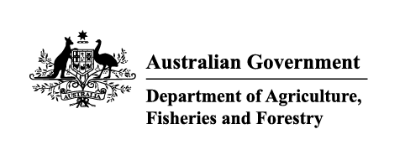

Transcript
On Country program
We're on our second program now.
It's about giving these people, our mob, the opportunity that they're not always going get, and to have some great careers at the end of it.
I just want to see them flourish. I've seen these kids actually come through this program and turn into inspiring young adults.
I wanted to change in a career. I wanted to build a future.
Being able to speak up in groups, speak to strangers and just put my voice out there at the end of the day.
This program supported my confidence heaps.
Biosecurity is a really important thing for our Country.
I've enjoyed it, so I think many other people would too.
Completing the program helped me see the Country differently, how we protect it and keep our environment healthy and safe.
We've had huge success with our first On Country Program, which was run last year in collaboration with the Aboriginal Health and Medical Research Council, and we're really looking forward to the 2026 program.
Take that leap of faith.
Contact us and find out what employment programs we have.

