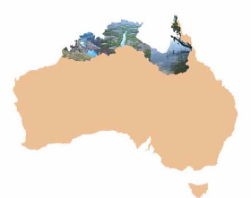
A Compendium of Ecological Information on Australia’s Northern
Tropical Rivers

REPORT 7

Freshwater Fish

Damien BurrowsA

AAustralian Centre for Tropical Freshwater Research, James Cook University, Townsville

Queensland 4811 Australia

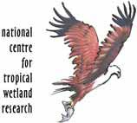
Authors

This report should be cited as follows:

Burrows, D. 2008. In G.P. Lukacs and C.M. Finlayson (eds) 2008. A Compendium of Ecological Information on Australia’s Northern Tropical Rivers. Sub-project 1 of Australia’s Tropical Rivers – an integrated data assessment and analysis (DET18). A report to Land & Water Australia. National Centre for Tropical Wetland Research, Townsville, Queensland.

Contact information

NCTWR
C/ Australian Centre for Tropical Freshwater Research
James Cook University
Townsville 4811
Queensland Australia

Funding statement

This project was funded by the Natural Heritage Trust Phase 2 (NHT2) and Land
& Water Australia (LWA) as part of the Tropical Rivers Inventory and
Assessment Project (TRIAP).

Disclaimer

The views and opinions expressed in this report do not necessarily reflect those of the National Centre for Tropical Wetlands Research and its partners. While reasonable efforts have been made to ensure that the contents of this report are factually correct, some essential data rely on the references cited and the NCTWR do not accept responsibility for the accuracy, currency or completeness of the contents of this report, and shall not be liable for any loss or damage that may be occasioned directly or indirectly through the use of, or reliance on, the report. Readers should exercise their own skill and judgment with respect to their use of the material contained in this report.

TABLE OF CONTENTS

Introduction ........................................................................................................... 4

Methods ................................................................................................................ 4

Results and Discussion......................................................................................... 5

Distribution of Survey Effort............................................................................... 5
Literature Results ............................................................................................ 11
Distribution of Survey Effort Over Time ........................................................... 11
Species Richness ............................................................................................ 12
Species of Conservation Value ....................................................................... 14
Exotic Species ................................................................................................. 16
Areas of Further Research .............................................................................. 17
Current Research ............................................................................................ 18

References ......................................................................................................... 19

Figure 1. Distribution of Freshwater Fish Survey Effort Across Northern
Australia ................................................................................................ 6
Figure 2. Number of Species Found at Each Fish Survey Site in
Queensland .......................................................................................... 8
Figure 3. Number of Species Found at Each Fish Survey Site in the
Northern Territory.................................................................................. 9
Figure 4. Number of Species Found at Each Fish Survey Site in Western
Australia .............................................................................................. 10
Figure 5. Plot of Species Richness Versus No. Sites Surveyed......................... 14

Table 1. Distribution of Survey Effort By Time ................................................... 11
Table 2. Level of Survey Effort and Species Richness by Catchment Across Northern Australia – listed in order of decreasing species richness for each state ........................................................................ 12

1. Introduction

With increasing attention being directed towards the development of northern Australia’s water resources, freshwater fish will play a major role as indicators of river health and as bio-monitors. The status of freshwater fish populations capture the attention of the general public and greatly increase their interest in aquatic habitat research and management. Understanding the status of freshwater fish communities requires a solid knowledge of the freshwater fish resources present, their biology and habitat requirements. Currently, this information is limited. The freshwater fishes of many of the catchments of northern Australia are relatively poorly known. Many entire catchments have never been adequately surveyed for their fish faunas or their fish habitats. For example, useful catchment-wide information exists for only eight of the 21 major river systems in the southern half of the Gulf of Carpentaria and three of these are within the same drainage basin (these being the Mitchell, Walsh and Palmer Rivers in the Mitchell catchment). The rivers of Cape York were surveyed for the Cape York Peninsula Land Use Study (CYPLUS) in 1992-1993 but most sites were only sampled once and many rivers had few sampling sites in them. Most of Arnhem Land and significant parts of the Kimberley have only received limited survey effort.

Although a more detailed process-understanding of how fish interact with their environments is required for better aquatic management, the basic knowledge of what species live where is first required. Apart from there being many gaps in our knowledge of this most fundamental element, there has been no compilation of the distributional knowledge that is known. Most studies on the distribution of freshwater fish that have been done to date have not been published in journal articles or other publications searchable through electronic bibliographic databases. Most of it exists in a very large number of unpublished reports and formats – the so-called ‘grey literature’ which generally has limited circulation. This makes obtaining this information for any area quite a time-consuming task. Thus, the purpose of this report is to analyse the extent of the literature and available records to determine where existing effort has been located and where it needs to be applied in the future.

2. Methods

Records for the presence of freshwater fishes across the study area were obtained from a wide variety of sources. Most of these were unpublished reports resulting from commissioned field survey in various catchments and also surveys associated with impact assessments and other forms of environmental management, undertaken most commonly with mining operations. Other sources included scientific journal articles. Museum records were also obtained from the Queensland Museum, Australian Museum and the Museum and Art Galleries of the Northern Territory. As fish surveys continue to be undertaken, and in fact at an increasing rate, the number of sites is increasingly regularly. This report used the end of 2005 as a cut-off date for the inclusion of data. The study area of this report is the Kimberley in Western Australia, all coastal catchment of the Northern Territory and in Queensland, the streams include those of the Gulf of Carpentaria catchments and western flowing streams of Cape York. This means, the many sites surveyed on the east coast of Cape York as part of the CYPLUS program of
1992-1993 are not included, though sites from westerly flowing streams of Cape York from that same study area are included.

The individual location of most survey sites (probably ~85%) were identified in most reports or obtained separately from the report authors, and included in the database. For those that were not explicitly located, the location of the survey site or fish record had to be determined by contacting the original authors or determining the site location from information provided in the report. In many cases, an approximate location was determined. In some cases, only general localities were provided and in these cases, a centroid was estimated for the purposes of mapping the distribution of survey sites.

All records obtained were entered into an excel spreadsheet database for analysis. As a rule, only surveys and records taken from freshwaters were included in the database. The vast majority of sites were clear on whether the survey occurred in fresh or brackish/estuarine waters. Even if the fish caught were of a species often known to inhabit freshwaters, if the survey or fish record came from a non-freshwater site, the record was not used. For some rivers, this rule reduced the number of fish recorded there, but the rule that the fish had to be caught in freshwaters to be included, was maintained.

For each record in the database, the current species name had to be verified. Many data sources either used incorrect names, were not able to fully identify their catch to species level, the accepted name has changed since the data was collected or the identification is dubious. Correcting taxonomic issues took a considerable amount of time. Current taxonomy followed that of Allen et al. (2002), Pusey et al. (2004) and the Zoological Catalogue of Australian - Fishes (three volumes 2006).

3. Results and Discussion

3.1 Distribution of Survey Effort

Survey data from a total of 883 sites from 50 catchments were entered into the database, with approximately 54% of survey sites located in the Northern Territory, 26% in northern Queensland, 20% from Western Australia. This includes 156 fish species.

A map of the distribution of survey sites across the project area is shown in Figure 1. From this, it can be seen that the most significant gaps in survey effort are in Arnhem Land (particularly streams of eastern Arnhem Land) and the Gulf of Carpentaria catchments on both the Qld and NT sides of the border. Until three years ago, the gaps in both of these areas were even greater as surveys have recently begun in these areas.

Eastern Arnhem Land streams were first surveyed during the American-Australian expedition of 1949 (reported in Taylor 1964) and remained almost unvisited until the survey work associated with the now abandoned Trans-Territory gas pipeline, whose route was proposed to cross Arnhem Land in an east-west direction. This work is reported in Brooks and Wilson (2004) and even though it generally involved only one site per river, the number of species consistently found in each river indicates the potential diversity to be found there.

Figure 1. Distribution of freshwater fish survey effort across northern Australia

The Flinders, Leichhardt and Gregory-Nicholson systems of the southern Gulf of Carpentaria were almost completely unsurveyed until the recent efforts of Hogan and Vallance (2005) and Davis and Dowe (2005), thus closing the gap in unsurveyed catchments of the southern Gulf region. However, the Staaten, Gilbert and Norman rivers on the Queensland side, remain almost unvisited, and the Settlement catchments (Qld/NT border), Calvert, Robinson, Foelsche/Wearyan and Limmen Bight system on the NT side are poorly sampled (and all of these occurred in the 1970’s-1980’s). The Gilbert catchment was sampled in 2005 and the Norman in 2006, but these data were unavailable for this report.

In WA, only the Cape Leveque system remains unsurveyed, although there has been limited survey in several catchments such as the Pentecost and upper Ord catchments. The lack of survey in the upper Ord River contrasts strongly with the more comprehensive species lists produced for the Ord River below Lake Argyle.

Figures 2-4 plot the number of species collected at each survey site. The number of species associated with each survey site is variable. This is partly a result of the number of species present, but also of the methods and level of sampling effort deployed at each site, which varied greatly. For instance, the surveys of many northern Cape York sites involved more limited methods and target species (smaller aquarium fish) than the more
comprehensive methods used during the CYPLUS study, hence the lower number of species generally found in each survey in the former. Similarly, the lower number of species per site in the Kimberley reflects the lesser effort applied at each site during the pioneering surveys there during the 1970’s. The high number of species found at sites in the Alligator Rivers (NT) and the lower Ord River (WA) reflects that these sites have been sampled a number of times as part of ongoing resource assessment and monitoring programs there for mine impacts and irrigation development, respectively, resulting in increased records of species presence at those sites. Sampling methods have changed greatly over time. The surveys of the 1970’s often used seine nets and even the fish poison rotenone, gill nets dominated the 1980’s and 1990’s surveys, whilst electrofishing now dominates contemporary studies.

Although nearly all publications mention the fish collections methods utilised, few detail the level of survey effort applied and few provide any quantitative indication of abundance, with most describing species in a presence/absence or relative abundance (abundant, common, uncommon, rare) format. For all of these reasons, it is not possible to analyse abundance patterns here, and even analysis of species richness would require some making significant assumptions about levels of effort applied.

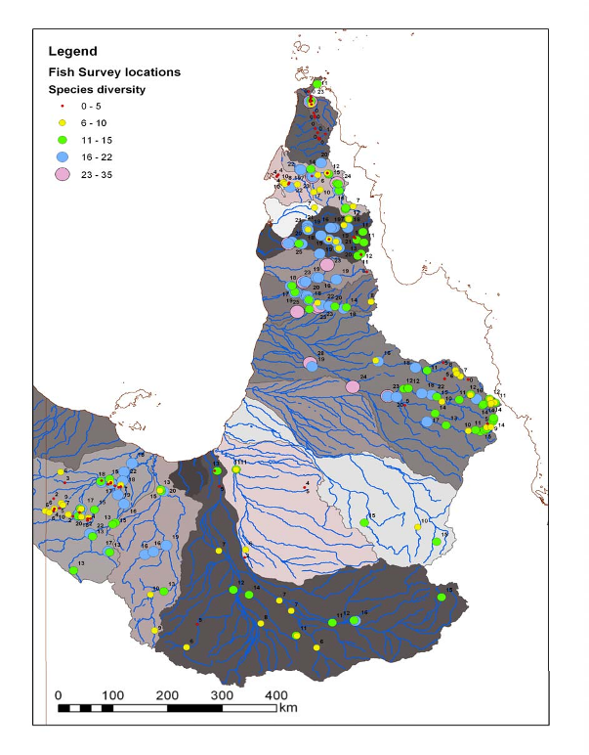
Figure 2. Number of species found at each fish survey site in Queensland

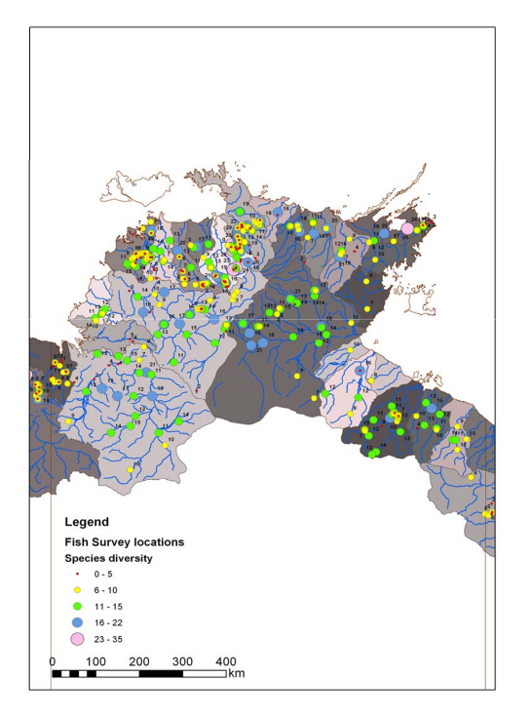

Figure 3. Number of species found at each fish survey site in the Northern Territory

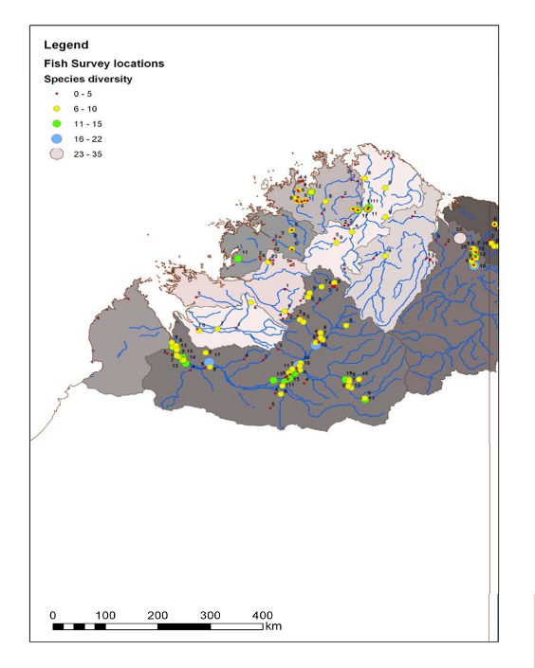

Figure 4. Number of species found at each fish survey site in Western Australia
3.2 Literature Results

Much of the species records have been concentrated into discrete phases of work. For instance, in WA, the early work of the Western Australian Museum in the Kimberley in the late 1970’s focused on collecting with low-tech equipment (nets and derris powder – i.e. rotenone). Very little further work occurred there until the more recent work on the Fitzroy and Prince Regent rivers by Morgan et al. (2004, 2006) has done these rivers comprehensively. In addition, there has been much work done in various studies below Lake Argyle on the Ord River, but very little above that dam.

In the Northern Territory, most of the work was done from 1972-1996 by Hamar Midgeley, and without his efforts, the knowledge of fish there would be very poor indeed. Considerable extra work since then has been done by Helen Larson of the Northern Territory Museum, with these two sources making up the majority of comprehensive survey in the Northern Territory. Similarly, work in Cape York is dominated by the Cape York Peninsula Land Use Survey (CYPLUS) work of 1992-1993 (Herbert et al. 1995), with substantial other collecting also occurring in the northernmost streams of Cape York, by naturalists (eg, Royal Society expeditions and ANGFA) and the Gulf of Carpentaria streams in recent years by Qld Department of Primary Industries and Fisheries and ACTFR.

3.3 Distribution of Survey Effort Over Time

Table 1. Distribution of survey effort by time

Time Period | No. Sites Surveyed
Pre-1970’s | 20
1970-1979 | 139
1980-1989 | 210
1990-1999 | 267
2000-2005 | 306

The number of sites surveyed by time period is shown in Table 1. Prior to the 1970’s, most survey effort was focused on collecting individual specimens, especially for museums, with less effort in comprehensive site collecting and little publishing of this work. The 1970’s and 1980’s were dominated by the surveys of Hamar Midgeley in the Northern Territory, work on the Alligator Rivers associated with the uranium mine there and in the later 1980’s consultancy reports associated with mine developments. The
1990’s included work in the Mitchell River catchment (NHT-funding), plus several biodiversity surveys in the NT but were dominated by the CYPLUS program (1992-
1993) which accounted for 149 of the 267 sites surveyed across the whole of northern Australia during that decade. Recent years have seen an increase in survey in the Gulf of Carpentaria and the Kimberley’s, largely with NHT-funding, but a decline in effort in the Northern Territory.
3.4 Species Richness

The number of sites surveyed and the number of fish recorded from each of the catchments of the study area are shown in Table 2. The greatest species richness is recorded from the Alligators River region of the Northern Territory with 58 species. This is also by far the most intensively sampled region of northern Australia, not only in terms of the number of sites sampled, but also that many of these have been sampled repeatedly. Both the Mitchell and Wenlock rivers of Cape York have similar numbers of species present. For the Mitchell, this reflects the number of sites sampled, the perennial flow and the variety of habitats present within this large catchment. For the Wenlock catchment, in northern Cape York, the high species diversity probably relates to its perennial flow and its connections with the Papua New Guinean freshwater fish fauna.

That two of the three catchments with the highest recorded species richness are also the most intensively sampled, indicates that most other catchments are undersurveyed and that additional species would be found in them with additional survey. A number of Cape York and Gulf of Carpentaria catchments have 30-35 species recorded from only 8-
11 sites. In Arnhem Land, many rivers appear likely to have high richness. For example,
38 species have been recorded from the Liverpool River with only five sites surveyed.

Table 2. Level of survey effort and species richness by catchment across northern Australia – listed in order of decreasing species richness for each state

Catchment | No. Sites  Surveyed | No. Fish Species  Recorded
NT Catchments
East Alligator River | 143 | 58
Finniss River-Darwin area | 28 | 46
Adelaide River | 23 | 44
Daly River | 40 | 44
Roper River | 36 | 41
Victoria River | 26 | 40
Buckingham River – Arnhem Land | 15 | 38
Liverpool River – Arnhem Land | 5 | 38
Mary River | 21 | 34
Blyth-Cadell River – Arnhem Land | 8 | 32
Goyder River – Arnhem Land | 9 | 32
McArthur River – SW Gulf | 29 | 32
Keep River | 20 | 26
Cato River – Arnhem Land | 1 | 25
Limmen Bight River – SW Gulf | 5 | 25
Goomadeer River – Arnhem Land | 2 | 22
Wildman River | 3 | 22
Koolatong River – Arnhem Land | 4 | 20
Habgood River – Arnhem Land | 1 | 19
Giddy River – Arnhem Land | 2 | 14
Moyle River | 8 | 19
Tiwi Islands (incl. Melville) | 17 | 18
Robinson River – SW Gulf | 7 | 17

Foelsche/Wearyan River – SW Gulf | 4 | 15
Calvert River – SW Gulf | 5 | 15
Groote Eylandt | 5 | 14
Koolatong River – Arnhem Land | 1 | 10
Walker River – Arnhem Land | 2 | 10
Towns River – SW Gulf | 1 | 9
Vanderlin Island – SW Gulf | 6 | 9
Fitzmaurice River | 2 | 7
Rosie Creek – SW Gulf | 1 | 6
Qld Catchments
Mitchell River | 53 | 57
Wenlock River – W Cape York | 26 | 57
Nicholson River – Sthn Gulf | 31 | 46
Jardine River – W Cape York | 26 | 42
Flinders River – Sthn Gulf | 19 | 41
Archer River – W Cape York | 37 | 40
Edward River – W Cape York | 8 | 35
Holroyd River – W Cape York | 9 | 34
Coleman River – W Cape York | 11 | 33
Leichhardt River – Sthn Gulf | 10 | 30
WA Catchments
Ord River | 33 | 41
Fitzroy River | 77 | 37
Drysdale River | 27 | 21
Prince Regent River | 15 | 16
Isdell River | 11 | 13
Lennard River | 5 | 9
Pentecost River | 6 | 8

Figure 5 plots the data presented in Table 2. The point representing the Alligator Rivers is positioned off the right side of the graph (hence the blue line continuing in that direction) as it was a significant outlier in terms of the number of sites surveyed. From this figure, it can be seen that the line of best fit for all three regions follows a similar slope, but that each has different species richness. If it is assumed that survey sites had similar levels of survey effort, or that variations from this assumption are randomly distributed across the study area, then this would imply that the Queensland fauna is richer than the Northern Territory, with Western Australia the least. The dataset is confounded by the variation in survey methods used, effort deployed at each site, the number of times each site was surveyed and by the number of sites surveyed within catchment (ie, do larger catchment have more species because of their greater size or because a greater number of sites are surveyed in larger catchments).

The graphs in Figure 5 show that the number of species recorded in most catchments is below what could be expected with further survey effort. Only the Alligator Rivers, with well over 100 sites sampled, many of them on numerous occasions, can be said to have had its species richness fully explored. Even the Mitchell and Wenlock Rivers in Queensland appear likely to have more species detected there with further survey effort. Interestingly, an additional official species record was located in the Mitchell catchment
in late 2006 (ACTFR unpublished data), despite this being the most intensively sampled catchment in the Queensland part of the study area. From this analysis, it would seem that all catchments within the study area, with the exception of the Alligator Rivers, are under-sampled with respect to confirming the presence of all fish species that are likely to be found in freshwaters.

70

60

50

40

30
Number of Species Recorded

20

10

0
0 10 20 30 40 50 60 70 80 90
NT QLD WA

Number of Sites Surveyed

100

Figure 5. Plot of species richness versus number of sites surveyed

3.5 Species of Conservation Value

In general, most species in northern Australia have very wide distributions and broad habitat tolerances, in rivers with limited development, and are thus considered to be secure. There are some exceptions however.

Within the study area, there are three species with formally-recognised conservation value. These are the freshwater sawfish, Pristis microdon, the speartooth shark, Glyphis sp. A and the northern river shark, Glyphis sp. C - the largest freshwater fishes in Australia. The sawfish is listed as Vulnerable under the Commonwealth EPBC Act, Endangered on the 2000 IUCN Red List of Threatened Species and Critically Endangered in SE Asia. It has recently been nominated for listing as ‘Vulnerable’ under the Queensland Nature Conservation Act. Due to their saw-shaped rostrum, sawfish are easily identified by non-experts, although there are a number of sawfish species and the taxonomy of individual species remains uncertain. The freshwater sawfish is known

from at least 15 rivers across northern Australia as well as many parts of SE Asia and
India (Peverell 2005, Thorburn et al. 2003).

Pristis microdon (also referred to as Pristis pristis in many previous reports) is the most freshwater adapted of the sawfish species and may even be able to breed in freshwater (Pogonoski et al. 2002). Although often caught in estuaries, only a few specimens are reported from offshore areas. Freshwater sawfish can grow up to seven metres in length, though Australian specimens are generally only up to two metres long (Last and Stevens
1994). Freshwater sawfish may occur up to 500km upstream from the river mouth (eg, Lynd River, Mitchell River Catchment, Qld - Allen et al. (2002). Given their size and the unwieldy saw-shaped rostrum, it is unlikely that sawfish would be able to negotiate instream passage barriers as well as other fish. However, given that they are common in both freshwaters and estuaries, movements between those environments may be important and any artificial passage barriers may have a significant effect. Being large predators, they may also be subject to declining habitat condition along rivers in the catchment and be affected by droughts. Relatively little is known of their biology or habitat requirements, though they are known to feed on benthic animals such as crustaceans and molluscs and also upon fish. Because of their large size and slow reproductive rate, populations will recover more slowly than other fish species.

All sawfish species are susceptible to fishing pressures being targeted for their fins, getting caught in nets and also being caught by line fishing. They are caught in the commercial bycatch of the Gulf of Carpentaria and NE Qld, the NT shark fishery and in beach protective shark nets in the Qld Shark Control Program (Pogonoski et al. 2002). Stobutski et al. (2000) considered the bycatch of sawfishes in the northern prawn trawl fishery (does not include P. microdon) as least likely to be sustainable, due to their benthic nature making them more susceptible to capture. All known populations of P. microdon and indeed all sawfish species worldwide, have undergone serious population declines (Pogonoski et al. 2002). Research into this species is currently ongoing and the Commonwealth Department of Environment and Heritage is preparing a recovery plan.

There are many anecdotes about how the various sawfish species used to be more abundant than they currently are and that their range has declined. There is however, a lack of data upon which to substantiate these statements, so it cannot be fully verified. It is difficult to catch in conventional fish surveys, so the number of anecdotal records for freshwater sawfish in riverine habitats greatly outnumber the number of official records. Given the size and distinctive shape of freshwater sawfish, anecdotal reports should be reliable (at least for identification). The collection and collation of such anecdotal information would provide significant valuable information on the distribution (current and historical) of this species and be a valuable resource for planning and management purposes.

The speartooth shark, Glyphis sp. A is listed as Critically Endangered under the EPBC, Critically Endangered by the IUCN (2002), and has been nominated for listing as Endangered under the Qld Nature Conservation Act. It occurs in both estuarine and freshwaters and is only known from the Bizant River (east coast Cape York catchment) in Queensland and the Adelaide River in the Northern Territory (Last 2002, Pogonoski et al.
2002, Thorburn et al. 2003). This distribution suggests that with further effort, it may be found to occur more widely in tropical Australian waters. However, no confirmed specimens of Glyphis sp. A have been collected from Queensland waters for more than
20 years, but a specimen identified as Glyphis sp. has been recently collected from the
Ducie River on Cape York (S. Peverell pers. comm.).

The northern river shark, Glyphis sp. C, is listed as Endangered under the EPBC and Critically Endangered by the IUCN (2002). This species has been reported from the Alligator and Adelaide Rivers in the Northern Territory and the Fitzroy River and Doctors Creek (north of Derby) in Western Australia (Thorburn et al. 2003).

The giant freshwater whipray, Himantura chaophraya, is also poorly known, only being recognized as present in Australian freshwaters in 1989 (Tanuichi et al. 1991). Prior to that, all long-tailed sting rays from tropical Australian freshwaters were incorrectly referred to as Dasyatis fluviorum – an estuarine sting ray (Last and Stevens 1994, Thorburn et al. 2006). The giant whipray can grow up to 200cm disc width and weigh up to 600kg, although the largest recorded Australian specimen was 160cm disc width and
120kg (Last 2002). In Australia, it is only known from the Daly, Alligator and Roper rivers (NT), the Pentecost and Ord, Fitzroy and Pentecost Rivers (WA) and the Gilbert, Mitchell, Wenlock and Normanby rivers in Qld (Last and Stevens 1994, Thorburn et al.
2005), but as it also occurs in PNG and SE Asia, so it may, with further survey, be found in more northern Australian rivers (Pogonoski et al. 2002). This species is listed as
Vulnerable under the 2000 IUCN Red List (Critically Endangered in Thailand). Like P.
microdon, this species is vulnerable to fishing as prey and bycatch, drought and fish passage barriers.

Although it has no formal conservation listing, the lake grunter, Variichthys lacustris, is only known from two sites in Australia (Allen 1991, ACTFR unpublished data). These two sites are closely located in the Mitchell River catchment. However, the species is common in floodplain lagoons of the Fly River system in southern PNG. Only six specimens have ever been caught in Australia (three from 1991 - Allen 1991, and three in late 2006 – ACTFR unpub data). This gap in its distribution suggests either that this population is a remnant of its former distribution, or that it occurs in more as yet undiscovered locations on Cape York and in the Mitchell catchment. Although it would seem likely that this species does occur in further locations on Cape York, suitable sites for the occurrence of lake grunter within Cape York have been surveyed by ACTFR and during the CYPLUS study, suggesting that’s its rarity, although very difficult to explain, may indeed be real. This fish is so rare that it usually escapes mention, even in most fish texts. A genetic and morphological comparison of PNG and Australian lake grunter is warranted as a high priority, as is a review of the conservation status of this species.

A number of other freshwater fish species also have very limited distributions in selected parts of northern Australia, though in most cases, this is due to limited survey effort and taxonomic investigation. Further survey (especially in Kimberley plateau country, eastern Arnhem Land and northern Cape York), and particularly genetic investigations, will likely reveal additional species with conservation significance.

3.6 Exotic Species

Fortunately, the number of exotic species records obtained are very few. In the Queensland section of the study area, the only confirmed records of exotic fishes are that of the guppy, Poecilia reticulata, from the upper Walsh River (Ryan et al. 2002, Mitchell
Catchment, Qld). Numerous anecdotal reports of tilapia, a highly invasive African species common in east coast catchments of NE Queensland have proved false thus far. Previous records of mosquitofish (Gambusia holbrooki) from the Gregory-Nicholson system (Allen 1989) have proved to be unfounded (Davis and Dowe 2005), though anecdotes of other exotic species from the southern Gulf of Carpentaria catchments persist. Climbing perch (Anabas testudineus), a species translocated from western Indonesia to the southern catchments of New Guinea, have recently been confirmed from Sabai Island in the Torres Strait (Hitchcock 2006), thus posing a significant threat to Cape York Rivers.

Records of exotic species from coastal catchments of the Northern Territory section of the project area, are limited to guppies in the Darwin area. No exotic fishes have been officially recorded from streams of the WA project area, though anecdotal reports exist of species such as tilapia (an African species common on the NE and SE coastal catchments of Qld).

3.7 Areas of Further Research

The distribution of freshwater fishes across northern Australia requires further survey to fill in key gaps in survey effort. However, this should be done in conjunction with an extensive effort to analyse the genetics of many species, as it is highly likely that additional species and/or significant populations will be located. Future survey effort should also be coordinated using similar survey methods and levels of effort so that the data can be analysed in a way that the current metadataset cannot.

The catchments in greatest need of survey are:
1.) Those without any survey to date: Staaten, Norman, Settlement
2.) Those with limited survey: Calvert, Robinson, Limmen Bight, all Arnhem Land streams (except the Alligator Rivers), Finnis, King Edward, Lennard, Pentecost, upper Ord
3.) Those with incomplete knowledge: Holroyd, Coleman, Edward

It should be noted that from the above list, the Norman, Settlement, Nicholson, Calvert, Macarthur, upper Ord, and King Edward rivers have all been recently surveyed, but the data was not available in time for this report.

Species of conservation concern should also be targeted for further research. Very little is known about these species, yet they comprise our largest freshwater fishes (sawfish, freshwater sharks and whiprays).

The rivers of northern Australia are a rich source of undiscovered biological information and undoubtedly, many new species await discovery within northern Australia. The CYPLUS work on the early 1990’s (Herbert et al. 1995) found many new species and distributional records, as did the first surveys of the southern Gulf of Carpentaria in 2004 (Hogan and Vallance (2005). Further survey in the Gulf rivers will fill in distributional gaps, surveys of Arnhem Land and the Kimberley plateau are most likely to yield new species, many of which may have restricted ranges or be regional endemics.
Revisions of existing groups are also likely to yield better knowledge of species distribution. For instance, preliminary genetic testing of sooty grunter and barred grunter from the east and west coasts of north Queensland show substantial differences, significant enough to warrant specific status (Pusey et al. 2004). Similarly, all Scortum grunters from Cape York and the Gulf of Carpentaria are currently officially all considered to be the one species – the gulf grunter, Scortum ogilbyi (Allen et al. 2002), though there are many clear differences between the specimens caught. A genetic and morphological revision of the terapontid grunters, the dominant and most recreationally important freshwater fish family in northern Australia is currently underway (led by Dr. Brad Pusey, Griffith University).

3.8 Current Research

Currently, there exist a number of projects that are filling in the distributional knowledge of freshwater fishes of northern Australia. The Gilbert River has recently been surveyed, and the Staaten River is soon to be surveyed, under funding from the Northern Gulf Resource Management Group (a regional body formed under the NHT2 arrangements). The King Edward River was also recently surveyed (funded through Land and Water Australia – Morgan et al. 2006). Surveys are occurring in the Macarthur River associated with the proposed mine expansion there and the fishes of the Daly River are being studied as part of an environmental flows project funded by Land and Water Australia. The NHT National Competitive Component project “Comprehensive Analysis of Freshwater Fish Faunas Across Northern Australia, and Their Key Management Needs” is filling in remaining gaps (see www.actfr.jcu.edu.au). Completed surveys to date under this latter program include the Lynd River (part of the Mitchell Catchment), Norman, Nicholson, Settlement, Calvert, Finniss rivers, as well as rivers on the east coast of Cape York which are not included in scope of the current project. Rivers on Cape York, Arnhem Land and in the Kimberley are planned for the 2007 dry season. This project is also collecting specimens from these rivers for genetic analysis and further morphological comparison, in order to define new species and their distribution.

The significant level of current activity reflects the identified gaps in our knowledge of freshwater fish distribution across northern Australia. Several hundred sites are expected to be surveyed over the next two years. The methods and levels of effort being applied are also greater than has occurred in many previous studies, and the taxonomy better known. Thus, the patterns of fish distribution will be readily determined once this extra work is completed. Under the NHT National Competitive Component project mentioned above, the results of All these surveys (many of which are funded through this program) these will all be added to the current dataset and a more detailed analysis of the data will result at that time.
4. References

Allen, G.R. 1991. Variichthys, a replacement name for the terapontid fish genus Varia and first record of V. lacustris from Australia. Records of the Western Australian Museum 16: 459-460.

Allen, G.R., Midgley, S.H. and Allen, M. 2002. Field Guide to Freshwater Fishes of
Australia. Western Australian Museum.

Bureau of Flora and Fauna. 2006. Zoological Catalogue of Australia. Volume 35.1, 35.2,
35.3 – Fishes. Australian Government Publishing Service, Canberra.

CSIRO. 2002. Freshwater and Estuarine Shark and Ray Fauna of Australia. CSIRO Marine Research Information Sheet No. 52. August 2002.

Davis, A. and Dowe, J. 2005. Ecological Assessment of the Freshwater Wetlands in the Nicholson-Gregory Catchment, North-Western Queensland. Report No. 04/10, Australian Centre for Tropical Freshwater Research, James Cook University, Townsville.

Herbert, B.W., Peeters, P.A., Graham, P.A. and Hogan, A.E. 1995. Freshwater Fish and Aquatic Habitat Survey of Cape York Peninsula. Report prepared for the Cape York Peninsula Land Use Strategy. Queensland Department of Primary Industries.

Hitchcock, G. 2006. Climbing Perch (Anabas testudineus) on Sabai Island, Northwest
Torres Strait: First Australian Record of This Exotic Pest Fish. Unpublished report.

Hogan, A. and Vallance, T. 2005. Rapid Assessment of Fish Biodiversity in Southern Gulf of Carpentaria Catchments. Report to Queensland Department of Primary Industries and Fisheries, Walkamin.

IUCN. 2002. IUCN Red List of Threatened Species (for Australia). International Union for the Conservation of Nature. www.redlist.org/

Jebreen, E., Helmke, S., Bullock, C. and Hutchison, M. 2002. Fisheries Long-Term Monitoring Program: Freshwater Report 2001-2002. Report to Department of Primary Industries, Brisbane.

Last, .P.R. 2002. Freshwater and estuarine elasmobranchs of Australia. Pages 185-193
In: Fowler, S.L., Reed, T.M. and Dipper, F.A. (eds.). Elasmobranch Biodiversity, Conservation and Management. Proceedings of the International Seminar and Workshop, Sabah, Malaysia, July 1997. IUCN Shark Specialist Group. IUCN, Gland, Switzerland and Cambridge, UK. Xv+258pp.

Last, P.R. and Stevens, J.D. 1994. Sharks and Rays of Australia. CSIRO Division of
Fisheries, Australia. 513 pp.+84 plates

Morgan, D. L., Allen, M.G., Bedford, P. and Horstman, M. 2004. Fish fauna of the Fitzroy River in the Kimberley region of Western Australia - including the Bunuba, Gooniyandi, Ngarinyin, Nyikina and Walmajarri aboriginal names. Records of the Western Australian Museum 22: 147-161.

Morgan, D., Cheinmora, D., Charles, A., Nulgit, P. and Kimberley Language Resource Centre 2006. Fishes of the King Edward and Carson Rivers with their Belaa and Ngarinyin Names. Report to Centre for Fish and Fisheries Research, Murdoch University, Perth.

Peverell, S.C. 2005. Distribution of sawfishes (Pristidae) in the Queensland Gulf of
Carpentaria, Australia, with notes on sawfish ecology. Environmental Biology of Fishes
73: 391-402.

Pogonoski, J.J., Pollard, D.A. and Paxton, J.R. 2002. Conservation Overview and Action Plan for Australian Threatened and Potentially Threatened Marine and Estuarine Fishes. Environment Australia 375pp.

Pusey, B.J., Kennard, M. and Arthington, A. 2004. Freshwater Fishes of north-eastern
Australia, CSIRO Publishing, Collingwood, Victoria.

Ryan, T.J., Aland, G. and Cogle, A.L. 2002. Environmental Condition of the Upper Mitchell River System: Water Quality and Ecology. Report for the Natural Heritage Trust. Queensland Department of Natural Resources and Mines. 103pp.

Stobutski. I. et al. 2000. Ecological Sustainability of Bycatch and Biodiversity in Prawn Trawl Fisheries. Final Report to the Fisheries Research and Development Corporation, Project No. 96/257. 512 pp.

Taniuchi, T., Schimizu, M., Sano, M., Baba, O. and Last, P.R. 1991. Description of freshwater elasmobranches collected from three rivers in northern Australia. University Museum, University of Tokyo, Nature and Culture, 3:11-26.

Taylor, W. R. 1964. Fishes of Arnhem Land. Pages 45-307 In: R. L. Specht (eds.). Records of the American-Australian Expedition to Arnhem Land. Melbourne University Press, Melbourne.

Thorburn, D., Peverell, S., Stevens, J.D., Last, P.R. and Rowland, A.J. 2003. Status of Elasmobranchs in Northern Australia. Department of Environment and Heritage, Canberra..

