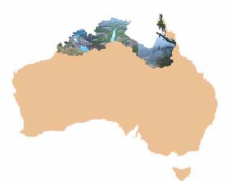

A Compendium of Ecological Information on Australia’s Northern
Tropical Rivers

GENERAL SUMMARY

C.M. FinlaysonA and G.P. LukacsB

AInstitute for Land, Water and Society, Charles Sturt University, Albury, New South
Wales, Australia
BAustralian Centre for Tropical Freshwater Research, James Cook University, Townsville, Queensland, Australia

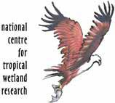
Authors

C.M. Finlayson - Institute for Land, Water and Society, Charles Sturt
University, Albury, New South Wales, Australia

G.P. Lukacs - Australian Centre for Tropical Freshwater Research, James Cook University, Townsville Queensland 4811
Australia

This report should be cited as follows:

Finlayson, C.M. and Lukacs G.P. 2008. General Summary. In G.P. Lukacs and C.M. Finlayson (eds) 2008. A Compendium of Ecological Information on Australia’s Northern Tropical Rivers. Sub-project 1 of Australia’s Tropical Rivers – An Integrated Data Assessment and Analysis (DET18). A report to Land & Water Australia. National Centre for Tropical Wetland Research, Townsville, Queensland.

Contact information

NCTWR

C/ Australian Centre for Tropical Freshwater Research

James Cook University

Townsville 4811

Queensland Australia

Funding statement

This project was funded by the Natural Heritage Trust Phase 2 (NHT2) and Land & Water Australia (LWA) as part of the Tropical Rivers Inventory and Assessment Project (TRIAP).

Disclaimer

The views and opinions expressed in this report do not necessarily reflect those of the National Centre for Tropical Wetlands Research and its partners. While reasonable efforts have been made to ensure that the contents of this report are factually correct, some essential data rely on the references cited and the NCTWR do not accept responsibility for the accuracy, currency or completeness of the contents of this report, and shall not be liable for any loss or damage that may be occasioned directly or indirectly through the use of, or reliance on, the report. Readers should exercise their own skill and judgment with respect to their use of the material contained in this report.
TABLE OF CONTENTS

1. General Summary ................................................................................................ 4

2. Approach .............................................................................................................. 5

3. Data Acquisition................................................................................................... 7

4. Synopsis................................................................................................................. 8
4.1 Spatial data ................................................................................................... 8
4.2 Geomorphology .......................................................................................... 10
4.3 Estuaries...................................................................................................... 12
4.4 Hydrology ................................................................................................... 12
4.5 Riparian vegetation.................................................................................... 16
4.6 Water Quality ............................................................................................. 16
4.7 Invertebrates .............................................................................................. 18
4.8 Freshwater Fish.......................................................................................... 19
4.9 Aquatic Reptiles ......................................................................................... 21
4.10 Waterbirds.................................................................................................. 22

5. Conclusions ......................................................................................................... 23

6. References ........................................................................................................... 25

Figure 1. Tropical rivers catchments…………………………………………………………4
Figure 2. Information collation and consultation processes………………………..……...6
Figure 3. Hierarchical approach used in the collation and integration of spatial data…..9
Figure 4. Steps used for data integration…………………………………….………..........9
Figure 5. Continental-scale classification of tropical rivers across northern Australia...10
Figure 6. Mapped river types found for the Daly, Fitzroy and Flinders catchments…...12
Figure 7. Mean annual rainfall patterns across the tropical rivers region………..……..13
Figure 8. Mean annual runoff and coefficient of variation of total annual flow across the tropical rivers region………….…………………..……………………………….15
Figure 9. Stream flows at gauge stations within the Fitzroy, Daly and Flinders catchments…………………………………………………………………………17
Figure 10. Distribution of Eucalyptus camaldulensis and Lophostemon grandiflorus in
relation to lithological associations………………………………………………19
Figure 11. Distribution of AUSRIVAS sampling sites………………………………………20
Figure 12. Macro-invertebrate sampling sites (from AUSRIVAS) imposed on the geomorphic classification for the Daly River catchment……………………....21
Figure 13. Number of fish species found at survey sites in the Northern Territory, Queensland and Western Australia……………………………………………..23
Figure 14. Crocodile and reptile data for the Finniss River catchment…………………..24
Figure 15. Distribution of waterbird data held in various datasets……….……………….25
1. General Summary
The “Tropical Rivers Inventory and Assessment Project” was a multiple-stakeholder and multiple-disciplinary initiative in northern Australia that sought to treat the wetlands and waterways within Australia’s two northern drainage divisions as one region with common issues surrounding the biota, hydro-geomorphology and management. Previous analyses of the biodiversity and distribution of wetlands and rivers had pointed out that much of the available information and management was fragmented and insufficient for addressing the management needs of the future (Storrs
& Finlayson 1997; Finlayson et al 1997; Land & Water Australia 2004; Finlayson & Lukacs 2004; Gehrke et al 2004). The current project was undertaken with the aim to collate existing information to establish an integrated information base and framework for assessing the status and change in Australia’s tropical rivers, and support ongoing research and natural resource management.

The history of scientific information collection and analysis for northern Australia has a long, but chequered history; being characterised by intense efforts and energy in response to specific drivers, such as the development of agriculture, including grazing and forestry, water resources, and or mining, followed by a seemingly “loss” of experience, information and data as the effort declined and the experts migrated to other activities or geographic regions. Data management and knowledge retention issues under such circumstances are not new – they have been outlined previously and are well known. This initiative was therefore predicated on the basis that an inventory and assessment effort was needed to both inform current management and support further effort, including the development of further capacity within research and natural resource management institutions.

The geographic region considered in this initiative covered 51 catchments within the Timor Sea and Gulf of Carpentaria drainage divisions with three focal catchments chosen for further attention (Figure 1).

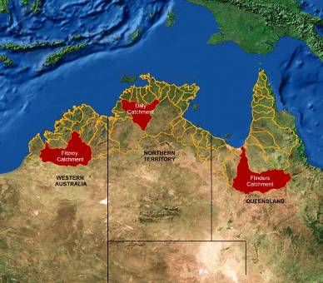

Figure 1. Tropical rivers catchments (from Bartolo et al 2008)
The project was planned as a catalyst for further ecological studies and to provide support for ongoing assessment and monitoring, and to support capacity building. The information base was also planned to complement that already prepared by NGIS Australia (2004); an effort that again exposed deficiencies in data collation and access. The rationale for the initiative recognised that sustainable management of Australia’s tropical rivers and wetlands required an integrated information base that could be used to support the assessment of their ecological character (including benchmarking their status and establishing trends) and the development of inter- connected land, water and biodiversity-related policy. Further, it was recognised that the information should be readily accessible by those engaged with tropical rivers and wetlands.

2. Approach
The inventory component of the initiative was integrated with two further components conducted by the same institutions. These covered ecological risk assessments of major pressures on rivers and wetlands across the region and for various focus catchments (Bartolo et al 2008) and an initial valuation of ecosystem services derived from the rivers and wetlands in several basins (de Groot et al 2008). In this respect the project extended the concepts outlined in an earlier inventory and assessment of rivers and wetlands in the Daly Basin in the Northern Territory (Begg et al 2001) and was in line with the integrated concepts promoted through previous initiatives in northern Australia (e.g. Bayliss et al 1997).

The mainstay of the inventory component of the initiative was the collation of information on specific topics from multiple sources, including published materials, noting that a lot of information is contained within technical documents outside of the peer-reviewed scientific literature (e.g. see Gardner et al 2002), as well as databases and from consultation and interaction with stakeholders and local communities (as outlined, for example by Finlayson & Eliot 2001). It also drew heavily on the Integrated Framework for Wetland Inventory, Assessment and Monitoring (IF- WIAM) adopted by the Ramsar Convention on Wetlands. The IF-WIAM has been outlined in the introductory paper for this project (Lukacs & Finlayson 2008) with more specific details in publications covering inventory (Finlayson & van der Valk
1995; Finlayson et al 2002), assessment (Humphrey et al 1999, de Groot et al 2006)
and monitoring (Finlayson 1996; Finlayson & Mitchell 1999).

The information collated is available in a set of separate reports that reflect the extent of information available and readily accessible. The latter has been an ongoing issue and despite agreement reached between officials from different jurisdictions has been difficult to resolve (NGIS Australia 2004). These difficulties have also been compounded by the “loss” of information from the region; an issue raised by governmental agencies and community-based organisations that deal with the twin problems of i) retaining experts within northern Australia for sufficient time periods to ensure projects are completed and the data and knowledge transferred, and ii) obtaining suitable feedback and data from projects undertaken principally by experts based elsewhere in Australia. Even with the best intent on the behalf of individuals involved these problems too regularly impact adversely on locally-based institutions and individuals. These are not new issues; they have dogged research and natural resource management in northern Australia for some time.

With these issues and very real constraints in mind an “information trawl” was undertaken to gather and summarise information on the rivers and wetlands of tropical Australia. The information base covered both wetlands and rivers in recognition of i)
the wide use of such terms (e.g. by the definition of wetlands to include swamps, marshes, lakes, rivers, mangroves and tidal flats etc, adopted internationally through the Ramsar Convention), and ii) their inter-connectivity in northern landscapes. This broad definition though has not been used in all data collection or previous collation exercises – there are many instances where narrower foci have been adopted – a fact shown in the information and data available for this collation and in the collations themselves (see references given below).

Information was obtained from many literature sources, with access greatly facilitated by web-based publication of valuable technical documents in addition to peer- reviewed journals, and through consultation mechanisms involving local communities and experts from agencies and organisations with an interest in the wetlands and rivers of northern Australia (Figure 2).

Information collation

Databases & National Records

Publications
Consultation

Peer Reviewed*

Grey Literature** Journals

Technical
Scientific
Institutions

Indigenous
Organisations

Books

Technical
Reports
Reports

Conference
Proceedings

Local Community
Organisations

Conservation
Agencies
Government Agencies

Natural Resource
Agencies

Figure 2. Information collation and consultation processes (* including peer-reviewed reports and books produced by many organisations as well as papers in scientific journals; ** unpublished and/or narrowly distributed documents)

Information on the wetlands and rivers was gathered by a team of experts based in the tropics and with strong local knowledge obtained from numerous years spent working in the area. The value of such a team is most evident in its understanding of the spatial and temporal variability in the components and processes that comprise the wetlands and streams of the study region.

A general summary of the information collated through the above mentioned processes is presented below. This covers information obtained from across the 51 tropical catchments included within the project area and covering the following topics:

• Acquisition of spatial data

• Hydrology and geomorphology of freshwater wetlands and streams

• Water quality characterisations

• Description and classification of estuaries

• Biological information on riparian vegetation, waterbirds, fish, invertebrates and reptiles.

Information on management issues in relation to these topics was not on the whole collated within these analyses; being left to the risk assessment component of the overall project and which has been reported separately (Bartolo et al 2008).

The information contained in the various reports can be combined to provide an overview of the ecological character of the wetlands and streams within Australia’s northern drainage basins. The usefulness of the description is dependent on the detail required and the information available – for many wetlands and rivers the information base is known to be inadequate for a comprehensive description of the ecological character. The investigations presented by Bartolo et al (2008) and de Groot et al (2008) provide a basis for prioritising further data collection.

The summary given below provides a brief synopsis of the information available for the ecological components and processes of the wetlands and rivers across the catchments. It also provides some guidance on the nature of work still needed to provide a more comprehensive data resource to better inform decision-makers on the protection and sustainable use of these important assets.

3. Data Acquisition
Data acquisition was based within the context of the hierarchical approach for inventory and mapping outlined in the IF-WIAM, with scale and data issues being addressed concomitantly (i.e. ensuring coarser data was used at coarser scales, and the more detailed data used at finer scales). With this in mind the following approach was adopted for the acquisition of data, in particular that with a spatial element (Lowry et al 2005):

• Across the entire study area make use of all available national datasets (such as that from AUSRIVAS, OZCAM, Birds Atlas, AUSLIG 1:250K topographical data, etc.) as well as datasets from State/Territory agencies and projects that cover all or a significant portion of the State/Territory (e.g. the Northern Territory Parks
& Wildlife datasets).

• For focus catchments make use of the above datasets where relevant, but also access other relevant spatial datasets that exist for the particular catchment (such as those covering floodplain vegetation, wetland distribution/extent, fauna surveys, flow data). It was expected that for some attributes, data for the specific focal catchments would not exist.

• Acquire key non-spatial datasets or at the very least acquire the publications that describe these data. This effort was targeted towards key studies and reviews that described the broad features (e.g. species distributions, population sizes, habitat
requirements). Highly specific papers/reports focusing on particular species in small areas, such as individual lagoons or channels) were less important unless they provided the only known information on the species within a focus catchment.

It was also recommended that where the data existed that a “data narrative” was recorded with information covering: i) the approach adopted for acquiring the data (the methods used; any criteria or rules used for selecting the data, and why; and what datasets were accessed); ii) a general description of the data (the number and types of species, and whether they were listed as threatened, vulnerable, endangered, or protected; broad patterns of species distribution, including species with restricted ranges; comparison of species information with existing descriptions of distribution patterns; and data gaps), and iii) evaluation of datasets against the geomorphic classification that was developed as a basic planning unit for the biophysical attributes.

Ultimately, it was the decision of the authors of the individual reports to determine how they could best present the information about their subject as it was expected that not all attributes being considered could be presented by a single approach. Progress on the data collection and mapping of the selected biophysical attributes of the northern wetlands and rivers is detailed below. It is immediately evident that progress differed greatly across the attributes considered; a reflection of the existing information sources and the amount of information already readily available in the public domain.

4. Synopsis

4.1 Spatial data
Lowry et al (2005) provided an overview of the spatial data analyses prepared for the project. As the study area (Figure 1) covered 1,190,973 km2 and extended across all catchments from the Kimberley in Western Australia, through the Top End of the Northern Territory, to the west side of Cape York in Queensland, a hierarchical and multi-scalar approach was used to enable the collation and integration of spatial information. The model used was adapted from that developed by Finlayson et al (2002) for the Asian Wetland Inventory (Figure 3). The essence of this approach was the collation of data at a number of scales, with progressively more detailed information being collated as the scale of the data increases.

For the purposes of this study, data was collected at two scales: i) a broad, “continental” scale, with data collated to a nominal scale of 1:2,500,000; and ii) a “catchment” scale, with data collated to a nominal scale of 1:250,000. In addition, data was collated to a nominal scale of 1:100,000 for selected “focus” catchments: the Fitzroy in Western Australia (93 953 km2), the Daly in the Northern Territory (53 282 km2), and the Flinders in Queensland (109 714 km2).

In addition to accessing data resources identified by NGIS Australia (2004) extensive searches of meta-databases maintained by environmental and natural resource agencies were undertaken and access to the data obtained through liaison and consultation with the respective data custodians. As data was identified its suitability for establishing the ecological character of the wetlands and rivers was assessed. Once the data was selected, it was integrated into a central database, using the process shown in Figure 4. Data that was inappropriate for this investigation was not considered further.
Datasets were managed using a hierarchical, multi-scalar structure, in which they were integrated into thematic geodatabases in the ArcGIS environment. All data were converted to the Geocentric Datum of Australia (GDA94), and in the case of data collated for the focus catchments, projected into the relevant Map Grid of Australia (MGA) zones. Metadata records were created and updated using the ANZLIC II metadata standard. The data were used to support analyses of the biophysical attributes, as outlined in Lowry et al (2005). The database is accessible on a DVD (ERISS 2008) and from the internet (enquiries_ssd@environment.gov.au).

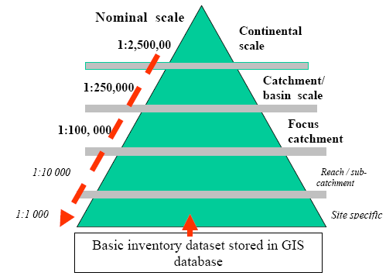

Figure 3. Hierarchical approach used in the collation and integration of spatial data
(from Finlayson et al 2002)

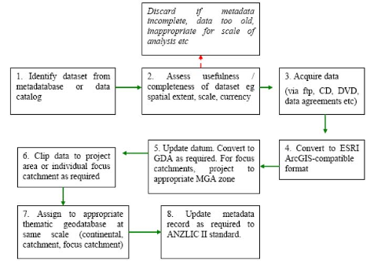

Figure 4. Steps used for data integration (from Lowry et al 2005).
4.2 Geomorphology
The geomorphic classification for the tropical rivers was developed from a preliminary nine-class typology of Australian tropical rivers proposed by Erskine et al (2005). Through a process of consultation, the typology was revised to produce a seven-class typology that was applied to all the all rivers represented on the
1:2,500,000 digital drainage dataset in the 51 catchments in the study area (Saynor et al 2008; Figure 5). The classification was based on querying existing soils and landform datasets in a GIS environment; ground surveys were not undertaken to validate the typology and there has not been any on the ground validation.

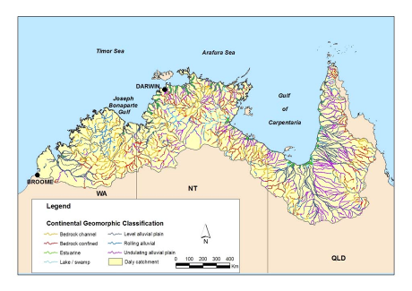

Figure 5. Continental-scale classification of tropical rivers across northern Australia
(from Saynor et al 2008)

When applied at the focus catchment scale, specifically to the complete channel network extracted from digital 1:250,000 hydrological drainage datasets for the three focus catchments the preliminary typology proposed by Erskine et al (2005) required major revisions. The initial 9 river types were revised to 12 to accommodate the full range of river types: 1) bedrock rivers; 2) confined and constrained rivers; 3) low sinuosity rivers; 4) meandering rivers; 5) wandering rivers; 6) anabranching rivers; 7) chain of ponds; 8) gullies; 9) floodouts; 10) lakes, swamps or billabongs; 11) non- channelised valley floors; and 12) estuarine rivers. The floodplains associated with each river type were also included. At scales larger than 1:250,000, subdivision of each river type is recommended.

The classification was also applied to the focal catchments with the following outcomes (Saynor et al 2008; Figure 6):

- Daly River - confined and constrained rivers dominate, with bedrock, meandering and anabranching rivers subdominant;

- Fitzroy River - confined and constrained rivers and anabranching rivers dominate, with bedrock, meandering and low sinuosity rivers subdominant;

- Flinders River - anabranching rivers predominate, with confined and constrained rivers also present.
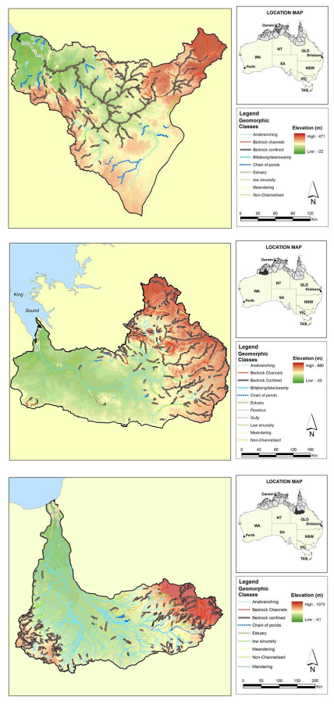
Figure 6. Mapped river types found for the Daly (top), Fitzroy (middle) and Flinders
(bottom) (from Saynor et al 2008)
The classification developed by Erskine et al (2005) was cross correlated with that being developed by Brooks et al (2005; 2007) for classifying the diversity of rivers in the Gulf of Carpentaria; a large subset of the area considered in the tropical wetlands and rivers analysis. Brooks et al (2005; 2007) were developing a hierarchical multivariate classification that was predicated on the use of remotely sensed data with limited ground truthing given the remoteness of the areas being considered. The classification proposed by Saynor et al (2008) for the focus catchments seemed to be consistent with the 3rd Order classification proposed to be applied at a similar scale by Brooks et al (2005).

The remoteness and inaccessibility of such areas places well recognised limitations on ground-based analyses with remote sensing being proffered as a way towards providing some of the data needed for such areas; hence the development of the geomorphic classifications with remotely-sensed data.

4.3 Estuaries
The variation in the morphology of estuaries across northern Australia is not matched by a similarly detailed description of the processes of estuary formation and continuing development (Eliot & Eliot 2008). Such knowledge is available for a few locations only and cannot be inferred for others from ‘snapshots’ of estuarine morphology and vegetation. Monitoring of geomorphic change, including observation of the interaction of process and landform is lacking. Eliot & Eliot (2008) consider that there is a lot of scope to develop a focussed classification of estuarine geomorphology and to establish sites to monitor ongoing change. Monitoring of geomorphic change, which combines observation of the interaction and dynamics of processes and landforms is though notably lacking (Eliot et al 2000).

Eliot & Eliot (2008) consider that estuaries in northern Australia include a variety of forms. This includes rias, coastal plain basins, bar built estuaries, blind estuaries and delta front estuaries, with the diversity of estuarine landforms indicating the importance of the geological structure and the relative relief of bedrock topography as major determinants of estuary type. As a result, the physical location of estuaries around Australia has been determined by global sea levels, the inherited geomorphology and the subsequent evolution of coastal plains with the most significant features affecting estuarine structure being the regional geology, which affects geomorphology, pedology and provides preferential paths for river development along major fault lines. The marked seasonality of the climate has direct ramifications for estuarine water quality and flow, with river floodwaters prevailing in the wet season and marine waters penetrating the upper reaches of estuaries during tidal conditions in the dry season. The occurrence of an average 8 cyclones each year also represents a major influence on estuaries and estuarine processes.

4.4 Hydrology
The basic flow characteristics of the rivers in region were assessed by Moliere (2008) using observed flow data collected at gauging stations within the region. Only stations with at least 20 years of complete annual flow data were used to estimate the long- term trends of streams.

The historical rainfall data for the region was readily available with records over a 30- year period from 1961-1990 (NGIS Australia 2004). The mean monthly rainfall data (Figure 7) indicate a distinct wet season period in which almost the entire annual rainfall occurs during six months of the year (November to April) with relatively little rainfall occurring during the dry season (May to October).
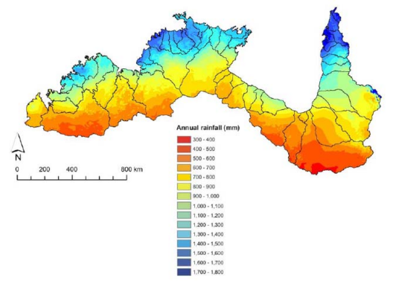

Figure 7. Mean annual rainfall patterns across the tropical rivers region
(from Moliere 2008)

Moliere (2008) assessed the data availability from approximately 630 flow gauging stations; 241 stations had a period of record greater than or equal to 20 years, although only 105 had complete annual runoff data. The data collected at these 105 stations were used to determine the mean annual runoff and the coefficient of variation of total annual flow at each station and the statistics used to produce contour maps showing the spatial variation in mean annual runoff and coefficient of variation across the region (Figure 8). A significant correlation was found between the mean annual runoff and the coefficient of variation of total annual flow for the region. In general, where mean runoff was relatively low the coefficient of variation was high.

The majority of flow within the region occurred during the wet season, particularly from January to March, and ceased by late-dry. On the basis of these data the majority of streams throughout the wet-dry tropics can be considered seasonally-flowing with a few in northern Queensland and some of the larger catchments throughout the Northern Territory being considered as perennial. As many parts of region have limited data the monthly runoff maps are not sufficiently accurate to reliably classify specific streams in these areas as ‘seasonal’ or ‘perennial’. The accuracy and continuity of data records across the regions is a serious constraint on further analyses or extrapolations.

Stream flow characteristics were derived in more detail for the three focus catchments (Figure 9) based on 28 gauging stations with at least 20 years of complete annual flow data. Flow variability, flood regime pattern and intermittency were used to classify streams within these catchments into four flow regime groups: perennial, seasonal, dry seasonal, and seasonal-intermittent streams. The coefficient of variation of total annual flow and the mean annual number of zero flow days were the most significant variables for classifying streams into flow regime types and were seen to be suitable for classifying the flow regimes of streams elsewhere in the tropical rivers region.

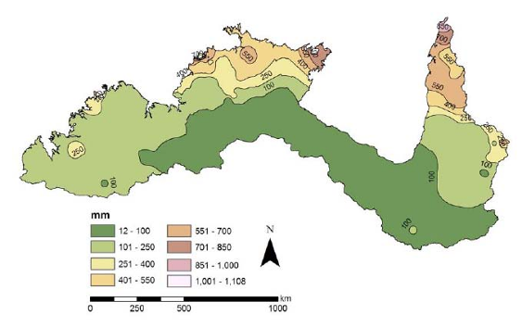

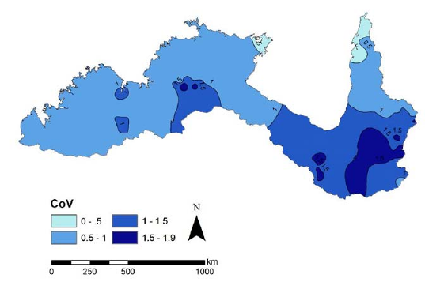

Figure 8. Mean annual runoff (top) and coefficient of variation of total annual flow
(bottom) across the tropical rivers region (from Moliere 2008)

Figure 9. Stream flows at gauge stations within the Fitzroy (top), Daly (middle) and
Flinders (bottom) catchments (from Moliere 2008)
4.5 Riparian vegetation
The distribution of plant species within the riparian zone of rivers in tropical Australia was investigated by Dowe (2008). The ecology of some riparian plants is relatively well known, but for the majority of species there seems to be little knowledge about their ecology and environmental responses. Based on an analysis of herbaria records a relatively small number of plant species was found to occur only within the riparian zone. This contrasts with the greater diversity of riparian vegetation in areas such as the wet regions of north-eastern Queensland and Tasmania for example.

While there was a low level of species diversity in the tropical riparian zones there was a high level of individual species coverage. Of the 263 species recognized as occurring in the riparian zone only 23 were obligate riparian species. Of these 23 species, 12 were recorded from all three focus catchments, thus indicating that these at least are widespread species, whilst the remaining 11 have a more restricted distribution. Analysis of the 12 co-occurring species indicated that they vary considerably as to their adaptation to either a broad or narrow range of environmental conditions, with some most common in, or restricted to, certain rainfall regimes, geomorphological formations and lithologies. For example some species (Cathormion umbellatum, Melaleuca leucadendra, Lophostemon grandiflorus and Persicaria attenuate) are most common areas with high rainfall (> 900 mm per annum) within the catchments, whilst other species (Aeschynomene indica, Melaleuca bracteata and Cyperus difformis) are most common in drier parts (< 700 mm per annum). While rainfall seems to impose some constraint on the distribution of riparian species it is not by itself a reliable indicator for in predicting distribution.

Many species varied greatly as to their preference for soil types. As an example, widespread species such as Eucalyptus camaldulensis (Figure 10) occurred on 56 soil types and was predominant on 11; Lophostemon grandiflorus occurred on 32 soils types and was predominant on 8; and Sebania cannabina occurred on 27 soil types and was predominant on 6. On the other hand, there are some species that, although occurring on many soil types, are strongly associated with a single or few of those types. For example, Corymbia bella occurred on 25 soil types, but was predominant on only 4; and Cyperus difformis occurred on 20 soil types but was predominant on only a single type.

Many riparian species were associated with alluvial formations. However, some expressed a strong preference for other formations; for example, Melaleuca bracteata was most common on bedrock channel formations; Sesbania cannabina and Flueggea virosa occurred most commonly on bedrock confined sites; and Cathormoin umbellatum with an equal preference for alluvial and lake/swamp formations. Overall it was concluded that the geomorphology was a primary constraint for distribution of riparian species.

4.6 Water Quality
Butler (2008) provided an analysis of water quality parameters for rivers and wetlands in tropical Australia and pointed out that the most important water quality variables were optical depth and dissolved oxygen status. Salinity, or more specifically, the salinity regime was also seen as a fundamentally important determinant of ecosystem type and function for all waters that are potentially subject to marine influences, but it was a much more secondary concern in freshwater systems.
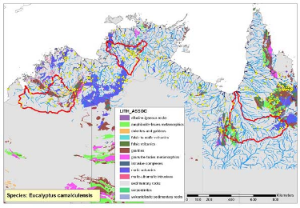

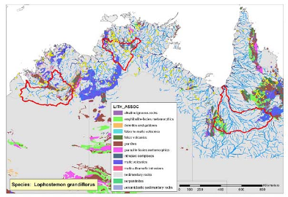

Figure 10. Distribution of Eucalyptus camaldulensis (top) and Lophostemon grandiflorus (bottom) in relation to lithological associations (from Dowe 2008).

Butler (2008) also outlined the importance of oxygen deficient conditions that tended to occur in many freshwater systems at some stage of the year. They are likely to occur during the pre-wet season, and are often precipitated by storm events that do not generate sufficient flow to flush the system. Since most aquatic organisms can asphyxiate if dissolved oxygen concentrations get too low, annual ecological outcomes for many biological communities can hinge on whether or not they survive a single brief hypoxia event. Daily sags in dissolved oxygen can occur daily in most waterbodies and many contain water layers and benthic habitats that are severely hypoxic most of the time.

The productivity of aquatic ecosystems is reliant upon nutrient availability; however, nutrient concentrations are not considered a reliable indicator of trophic status in this region as many experience natural seasonal cycles in nutrient availability. Over the course of a year it is possible for an individual site to pass through sequential states where productivity is alternately dominated by limnetic heterotrophy, light-limited limnetic autotrophy, nutrient-limited limnetic autotrophy, light-limited benthic autotrophy and nutrient-limited benthic autotrophy. As a result the relationship between primary productivity and nutrient concentrations within the water column can also vary enormously.
Butler (2008) recommends that earth observation is used to obtain, not only valuable information about the location, size, permanency and morphology of most of the waterbodies contained within the river system, but also useful insights into their optical depth characteristics. Further, a classification scheme capable of recognising inherent differences in the trophic dynamics of different waterbodies is needed along with bathymetric data to understand many of the processes that govern habitat quality and availability, such as mixing and stratification, evapo-concentration, standing water volume and water residence time.

4.7 Invertebrates
Humphrey et al (2008) compiled an overview of aquatic macro-invertebrates from wetlands and rivers of tropical Australia based on the Australian River Assessment Scheme (AUSRIVAS) data sets for the region. The geographic spread of data used in shown in Figure 11.

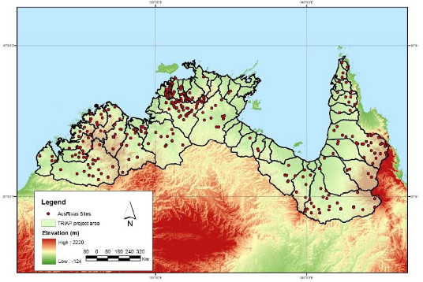

Figure 11. Distribution of AUSRIVAS sampling sites (from Humphrey et al 2008)

Given the size of the data sets it quickly became apparent that it was impractical to extract and compile macro-invertebrate species-level data from northern Australian streams. The task was enormous, involving thousands of species, and there were likely to be many time consuming issues associated with data custodianship and ownership. Instead, extensive consultations were undertaken to compile meta-data descriptions of the macro-invertebrate species-level data available to assist others to source and compile species-level data should this need be identified, prioritised and adequately resourced. A number of government agency staff and other specialists contributed to this task.

The relationships between family level data for macro-invertebrates and geomorphic features of rivers and wetlands in tropical Australia were investigated using statistical means (Humphrey et al 2008). The continental-scale geomorphic classification was
significantly correlated with family-level macro-invertebrate community data from the Kimberley region in Western Australia, but the geomorphic classification generally subsumes real biological separation and pattern. Distinct zoogeographic separation of macro-invertebrate communities was also evident within northern Western Australia and within Queensland to distinguish gulf-flowing streams from western flowing streams (based on rainfall patterns). At a smaller scale, within the Daly catchment, (Figure 12) a distinct biological pattern was revealed and found to be associated mainly with stream water chemistry and local hydrological conditions. Some association between macro-invertebrate communities and water quality (viz conductivity) was evident in Kimberley streams but these relationships were rather weak and are consistent with past analyses suggesting a lack of major geographic and climatic barriers. Further work is needed on inventory and taxonomy but also database management to allow for cross-regional comparisons.

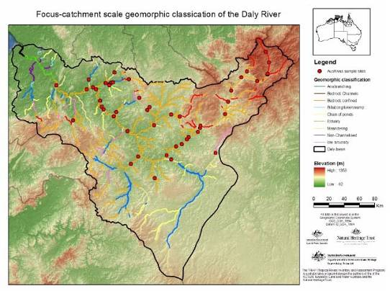

Figure 12. Macro-invertebrate sampling sites (from AUSRIVAS) imposed on the geomorphic classification for the Daly River catchment (from Humphrey et al 2008)

4.8 Freshwater Fish
Burrows (2008) pointed out that the freshwater fishes of many of the catchments of northern Australia are relatively poorly known and with few having been adequately surveyed for their fish faunas or their fish habitats. For example, useful catchment- wide information exists for only eight of the 21 major river systems in the southern half of the Gulf of Carpentaria and three of these are within the same drainage basin. The rivers of Cape York were surveyed in 1992-1993 but most sites were only sampled once and many rivers had few sampling sites in them. Most of Arnhem Land and significant parts of the Kimberley have only received limited survey effort.

The number of species collected at documented recording sites is shown in Figure 13. The number of species associated with each survey site is variable, partly a result of
the number of species present, but also of the methods and level of sampling effort deployed at each site, which varied greatly. Catchments with the highest recorded species richness are often also the most intensively sampled, indicating that most catchments are under-surveyed and additional species would be found with additional survey. Only the Alligator Rivers can be said to have had its species richness fully explored. For example, a number of Cape York and Gulf of Carpentaria catchments have 30-35 species recorded from only 8-11 sites. Further survey (including of genetics) is needed in several catchments without any survey to date (e.g. the Staaten), as well those with those with limited survey.

Figure 13. Number of fish species found at survey sites in the Northern Territory (top), Queensland (middle) and Western Australia (bottom) (from Burrows 2008)
In general, most freshwater fish species in northern Australia have very wide distributions and broad habitat tolerances, in rivers with limited development, and are thus considered to be secure. There are some exceptions however, with 3 species with formally- recognised conservation value: the freshwater sawfish, Pristis microdon, the speartooth shark, Glyphis sp. A and the northern river shark, Glyphis sp. C - the largest freshwater fishes in Australia.

4.9 Aquatic Reptiles
Fox (2008) compiled an overview of the distribution of reptiles across wetlands and rivers in northern Australia by accessing data from 4 datasets for some 30 species of reptiles (considered aquatic or semi-aquatic). This identified some 13,684 records, of which two thirds (9,137) were of the estuarine crocodile (Crocodylus porosus). There were many data deficiencies in many catchments with most records typically restricted to the most accessible areas of each catchment. These patterns are shown by the data for the Finniss River catchment (Figure 14). The accuracy of some older catchment data is also problematic. In summary, one catchment contained no records while 17 catchments had 20 records or less; 30 catchments, or nearly 60%, had 50 records or less spread across a maximum of 30 species. There has previously been no systematic review or collation of existing data for tropical reptiles; significant further research is required. Data gaps included the focus catchments with the Flinders having
13 records for seven species, and the Fitzroy 40 records for 10 species. In contrast the Daly had 729 recordings with almost 70% being for crocodiles.

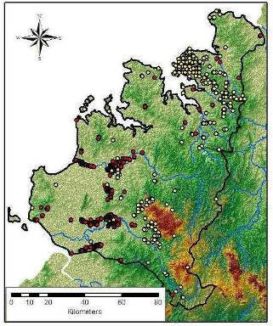

Figure 14. Data for the Finniss River catchment. Crocodile survey data points are shown in red and that for all other reptile species in yellow (from Fox 2008)
The analysis of the datasets also showed that 21 of the 30 species investigated were restricted mainly to freshwater. This included all 14 turtle species, the freshwater crocodile, water python and three species of colubrid snakes, Enhydris polylepis, Stegonotus cucullatus and Tropidonophis mairii, as well as the two goannas Varanus mertensi and Varanus mitchelli. Three species of colubrid snake, Cerberus rynchops, Fordonia leucobalia, and Myron richardsonii, and the little file snake, Acrochordus granulatus are restricted to estuarine and marine habitats. The saltwater crocodile, Crocodylus porosus, moves between freshwater and estuarine and marine habitats while the Arafura file snake, Achrochordus arafurae, is largely restricted to freshwater streams and lagoons, but will freely enter estuarine waters and the sea. Two varanid species, Varanus indicus and Varanus semiremex, have been recorded from coastal and estuarine mangrove habitats as well as freshwater streams, and the yellow spotted monitor, Varanus panoptes, forages mainly in freshwater areas, but also along the banks of tidal estuaries.

4.10 Waterbirds
Franklin (2008) in an analysis of waterbirds considered that given the remoteness of much of the area, data coverage was surprisingly substantial and well-dispersed (Figure 15). Nevertheless, there were major gaps and considerable unevenness in the data. Coverage was heavily concentrated in the Darwin-Kakadu-Katherine region of the Northern Territory and the Kununurra-Ord River region of Western Australia, along with other smaller foci. The unevenness is related primarily to accessibility and proximity to major settlements. Franklin (2008) provided an extensive literature and data analysis while pointing out the limitations of the data including spatial and temporal gaps.

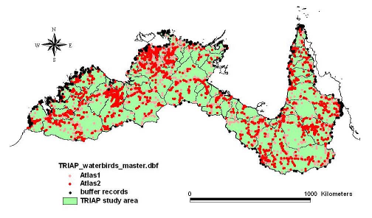

Figure 15. Distribution of waterbird data held in various datasets (from Franklin 2008)

With these data limitations Franklin (2008) used some 94,148 data records to identify a waterbird fauna comprising 145 species from twenty families and a foraging guild classification of 12 types based on a categorization of foraging substrate, foraging methods and food types. The analyses indicated that no waterbirds were endemic to the study area. Few species other than vagrants have restricted ranges within the
wetlands and rivers of northern Australia, but there is a weak declining gradient in species richness from east to west.

The distribution of waterbird families, foraging guilds and threatened species were compared with a waterbody classification and groups associated with deep water and saline habitats were clearly identifiable. An alternate geomorphic classification of rivers provided only linear data and poor spatial correspondence with waterbird records. Neither classification provided a direct measure of the wetland features most relevant to most species. Whilst quantitative analysis could be pursued, it appears unlikely to identify many definitive habitat relationships.

5. Conclusions
The two northern drainage basins that comprised the study area for the Tropical Rivers Inventory and Assessment Project is a vast expanse of Australia that is mostly poorly known to ecological science and which, broadly, is not subject to intensive development. Aquatic ecosystems (streams, wetlands, estuaries) are almost invariably still connected through geomorphological, hydrological and biological processes. Stream banks erode, water floods, fish migrate and plants disperse fundamentally as they have for thousands of years. Hot spots of anthropogenic pressure exist (e.g. towns, mine sites), but most impacts are spatially and temporally dispersed (e.g. cattle grazing, weed invasions, increased climate variability). This is not to say that these impacts are not significant (e.g. witness the extent of grazing and bank collapse along many streams, and the spread of Mimosa pigra along rivers and across floodplains) but that natural resource management is generally not hampered by obstructive infrastructure or a myriad of different and competing land uses and administrative regimes.

However, it is well recognised that the ecological information base to support the conservation of aquatic ecosystems and the sustainable use of natural resources is significantly less than that for southern Australia. Whilst population demographics are largely responsible, there have historically been few concerted efforts to systematically describe the aquatic ecosystems of the northern half of the continent with the exception of the effort in Kakadu National Park (Gardner et al 2002; Finlayson et al 2005, 2006).

Within this study, the biophysical analyses in the three focal catchments did illustrate a number of outcomes relevant to further analysis in tropical wetland/stream environments. A key issue in most analyses was the availability of suitable data – the availability of suitable data sets being a constraint for further catchment-scale analyses and assessments. This was particularly the case for the biological data with large spatial and temporal unevenness in data collection that undermined the usefulness of overlaying such data on the geomorphic river typology – a key and not unexpected outcome being that further systematic biological data collection is undertaken as a component of further research initiatives. The development of an effective predictive capability for biological purposes is currently undermined by the available biological data. Despite intensive data collection in recent decades there are many gaps; the data problems are real and exacerbated by accessibility (NGIS Australia 2004) and familiarity with the data resource and publications – the problems are not new.

Even with the constraints on data sources and the generally weak predictive capacity from existing data sets and knowledge bases about species distribution in relation to the landscape features, the analyses within the focal catchments provided some
general outcomes for addressing further investigations. In addition to the often stated imperative for further systematic data collection and development of local capacity these included:

- Geomorphology (Saynor et al 2008) - The focal catchments were characterised by application of a 12-class geomorphic river typology that was developed from soil and landform datasets, but was not validated by ground survey. While the remoteness and inaccessibility of much of the tropical region makes suitable ground survey difficult and/or expensive better topographic, landform and geological data could result in revision of the boundaries shown for the river reaches in these catchments.

- Hydrology (Moliere 2008) - Flow variability, flood regime pattern and intermittency were used to classify streams within the focal catchments into four flow regimes: 1) perennial; 2) seasonal; 3) dry seasonal; and 4) seasonal- intermittent streams. The most significant variables in the classification were the coefficient of variation of total annual flow and the mean annual number of zero flow days. The classification seemed robust and suitable for application across other streams in the tropical rivers region. Where flow data are not available it may be possible to classify the streams by determining whether there is a link between these variables and the rainfall and geomorphology of the streams (but see Moliere et al (2008) for a recent analysis of hydrology and catchment characteristics).

- Riparian vegetation (Dowe 2008) - Riparian plant species in the focal catchments occurred most commonly on alluvial formations with the geomorphology considered a primary constraint for the distribution of riparian plants. Catchment lithology is also a constraint on the distribution of riparian plant species with most of the species examined occurring on sedimentary formations. Although the resolution of species distribution and soil types was relatively coarse, soil types were not considered a major constraint on species distribution.

- Water quality (Butler 2008) - The importance of obtaining suitable data on the optical depth characteristics of aquatic ecosystems was emphasised along with a proposal for developing a classification scheme capable of recognising inherent differences in the trophic dynamics of different waterbodies is needed along with bathymetric data to understand many of the processes that govern habitat quality and availability, such as mixing and stratification, evapo-concentration, standing water volume and water residence time.

It should also be noted that the absence of widespread development pressure, coupled with remoteness and the comparably high levels of variability and unpredictability associated with the components and processes of dry tropical aquatic ecosystems, continues to be a barrier to building both scientific capacity and the knowledge necessary for improved management. Recent research initiatives (e.g. Tropical Rivers and Coastal Knowledge) will advance our understanding of many issues, but considerable gaps remain. For example, key science issues include:

- Understanding of migratory waterbirds: identifying and modelling the patterns of usage of different wetland types;

- Understanding of biodiversity: riparian vegetation communities;

- Further field inventory and assessment of aquatic fauna: especially amphibia, reptiles and significant fish;
- Understanding the inter-relationship between water quality and biodiversity; Perhaps more urgently, a number of resource management gaps also exist:
- Regional guidance on water quality: tools for the selection of parameters for inventory, assessment and monitoring at multiple scales; and

- Conceptual linkages between wetland components/processes and the derived ecosystem services/values.

Based on the analyses undertaken in the Tropical Rivers Inventory and Assessment Project it is recommended i) that the gaps in the scientific information are brought to the attention of the Tropical Rivers and Coastal Knowledge initiative and, ii) a similar integrated approach is adopted for a more detailed inventory and assessment of high value aquatic conservation sites in northern Australia and elsewhere, for example, in the Lake Eyre Basin where management planning is also constrained by data limitations, accessibility and fragmentation, and iii) the experience in implementation of the integrated approach to wetland inventory and assessment is brought to the attention of the Ramsar Convention.

The reasons for the latter are not greatly different – land /water agencies could benefit directly by understanding the value of developing and sustaining systematic as well as strategic integrated data collection and collation while the Convention is well placed to disseminate such information through its international constituency. The case for integrated approaches is not new – the message has been paraded through many fora and reports – the pitfalls of previous disconnected and non-systematic approaches need to be highlighted along with the value of integration. The outcomes in this summary paper provide further support for the case for integrated and systematic investigations.

6. References
Bartolo, R., Bayliss, P. and van Dam, R 2008. Ecological risk assessment for Australia’s northern tropical rivers. Sub-project 2 of Australia’s Tropical Rivers – an integrated data assessment and analysis (DET18). A report to Land
& Water Australia. Environmental Research Institute of the Supervising
Scientist, National Centre for Tropical Wetland Research, Darwin NT.

Bayliss, B.L., Brennan, K.G., Eliot, I., Finlayson, C.M., Hall, R.N., House, T., Pidgeon, R.W.J., Walden, D. and Waterman, P. 1997. Vulnerability assessment of the possible effects of predicted climate change and sea level rise in the Alligator Rivers Region, Northern Territory, Australia. Supervising Scientist Report 123, Supervising Scientist, Canberra. 134 pp.

Begg G.W., van Dam R.A., Lowry J.B., Finlayson C.M. and Walden D.J., 2001.
Inventory and risk assessment of water dependent ecosystems in the Daly basin, Northern Territory, Australia. Supervising Scientist Report 162, Supervising Scientist, Darwin NT.

Brooks, A., Brunner, P and Lin, P. 2005. Classifying the diversity of Gulf rivers. Land
& Water Australia, RipRap 28, 5-10.

Brooks, A., Spencer, J. and Knight, J. 2007. Alluvial gully erosion in Australia’s tropical rivers: a conceptual model as a basis for a remote sensing mapping procedure. Wilson, A.L., Dehaan, R.L., Watts, R.J., Page, K.J., Bowmer, K.H.,
& Curtis, A. (2007). Proceedings of the 5th Australian StreamManagement
Conference. Australian rivers: making a difference. Charles Sturt University, Thurgoona, New South Wales.

Burrow, D. 2008. Report 7: Freshwater fish. In G.P. Lukacs and C.M. Finlayson (eds) 2008. A Compendium of Ecological Information on Australia’s NorthernTropical Rivers. Sub-project 1 of Australia’s Tropical Rivers – An Integrated Data Assessment and Analysis (DET18). A report to Land & Water Australia. National Centre for Tropical Wetland Research, Townsville, Queensland.

Butler, B. 2008. Report 5: Water quality. In G.P. Lukacs and C.M. Finlayson (eds)
2008. A Compendium of Ecological Information on Australia’s Northern Tropical Rivers. Sub-project 1 of Australia’s Tropical Rivers – An Integrated Data Assessment and Analysis (DET18). A report to Land & Water Australia. National Centre for Tropical Wetland Research, Townsville, Queensland.

De Groot, R.S., Stuip, M.A.M., Finlayson, C.M. and Davidson, N. 2006. Valuing wet- lands: guidance for valuing the benefits derived from wetland ecosystem services. Ramsar Technical Report No. 3/CBD Technical Series No. 27. Ramsar Convention Secretariat, Gland, Switzerland & Secretariat of the Convention on Biological Diversity, Montreal, Canada.

De Groot, R., Finlayson, M., Verschuuren, B., Ypma, O. and Zylstra, M. 2008.
Integrated assessment of wetland services and values as a tool to analyze policy trade-offs and management options: A case study in the Daly and Mary River catchments, northern Australia. Supervising Scientist Report 198, Supervising Scientist, Darwin, NT, Australia.

Dowe, J.L. 2008. Report 4: Distribution and ecological preferences of riparian vegetation in northern Australia In G.P. Lukacs and C.M. Finlayson (eds) 2008. A Compendium of Ecological Information on Australia’s Northern Tropical Rivers. Sub-project 1 of Australia’s Tropical Rivers – An Integrated Data Assessment and Analysis (DET18). A report to Land & Water Australia. National Centre for Tropical Wetland Research, Townsville, Queensland.

Eliot, M. and Eliot, I. 2008. Report 2: Estuaries . In G.P. Lukacs and C.M. Finlayson (eds) 2008. A Compendium of Ecological Information on Australia’s Northern Tropical Rivers. Sub-project 1 of Australia’s Tropical Rivers – an Integrated Data Assessment and Analysis (DET18). A report to Land & Water Australia. National Centre for Tropical Wetland Research, Townsville, Queensland.

Eliot, I., Saynor, M., Eliot, M. and Finlayson, C.M. 2000. Assessment and monitoring of coastal change in the Alligator Rivers Region, Northern Australia. Supervising Scientist Report 157.

Erskine, W.D., Saynor, M.J., Erskine, L., Evans, K.G. and Moliere, D., 2005. A preliminary typology of Australian tropical rivers and implications for fish community ecology. Marine and Freshwater Research 56(3): 253-267.

Finlayson, C.M. 1996. Framework for designing a monitoring programme. In P Tomas Vives (ed), Monitoring Mediterranean Wetlands: A Methodological Guide. MedWet Publication, Wetlands International, Slimbridge, United Kingdom and ICN, Lisbon. pp 25-34.

Finlayson, C.M. and Eliot, I. 2001. Wetland monitoring in the wet-dry tropics - a paradigm for elsewhere in Australia? Coastal Management 29, 105-115.
Finlayson, C.M. and Lukacs, G.P., 2004: Status of wetlands in northern Australia
2004. In: Dawson N, Brodie, J, Rayment G and Porter C. (eds), Protecting the Values of Rivers, Wetlands and the Reef, Conference abstracts, papers, posters and presentations, Townsville, November 2001, Department of Natural Resources and Mines, Queensland, Australia.

Finlayson, C.M. and Mitchell, D.S. 1999. Australian wetlands: the monitoring challenge. Wetlands Ecology and Management 7, 105-112.

Finlayson, C.M. and van der Valk, A.G. (eds) 1995. Classification and Inventory of the World’s Wetlands. Advances in Vegetation Science 16, Kluwer Academic Publishers, Dordrecht. 192 pp.

Finlayson, C.M., Hall, R.N. and Bayliss, B.L. 1997. Regional review of wetland management issues: Wet-dry tropics of northern Australia. LWRRDC Occasional Paper 03/97, Canberra. 35 pp.

Finlayson, C.M., Bellio, M.G. and Lowry, J.B. 2005. A conceptual basis for the wise use of wetlands in northern Australia – linking information needs, integrated analyses, drivers of change and human well-being. Marine and Freshwater Research 56, 269-277.

Finlayson, C.M., Begg, G.W., Howes, J., Davies, J., Tagi, K. and Lowry, J. 2002. A manual for an inventory of Asian wetlands (version 1.0). Wetlands International Global Series 10, Wetlands International, Kuala Lumpur, Malaysia. 72 pp.

Finlayson, C.M., Lowry, J., Bellio, M.G., Walden, D., Nou, S., Fox, G., Humphrey, C.L. and Pidgeon, R. 2006. Comparative biology of large wetlands: Kakadu National Park, Australia. Aquatic Sciences 68, 374-399.

Fox, G. 2008. Report 8: Semi-aquatic and aquatic reptiles. In G.P. Lukacs and C.M.
Finlayson (eds) 2008. A Compendium of Ecological Information on Australia’s Northern Tropical Rivers. Sub-project 1 of Australia’s Tropical Rivers – an Integrated Data Assessment and Analysis (DET18). A report to Land & Water Australia. National Centre for Tropical Wetland Research, Townsville, Queensland.

Franklin, D. C. 2008. Report 9: The waterbirds of Australian tropical rivers and wetlands. In G.P. Lukacs and C.M. Finlayson (eds) 2008. A Compendium of Ecological Information on Australia’s Northern Tropical Rivers. Sub-project 1 of Australia’s Tropical Rivers – an integrated data assessment and analysis (DET18). A report to Land & Water Australia. National Centre for Tropical Wetland Research, Townsville, Queensland.

Gardner, S., Finlayson, C. M. and Pidgeon, R. 2002. Description and literature review of the flora and vertebrate fauna of Magela Creek, Alligator Rivers Region, northern Australia. Supervising Scientist Report 169, Supervising Scientist, Darwin, Australia.

Gehrke, P., Bristow, K., Bunn, S., Douglas, M., Edgar, B., Finlayson, M., Hamilton, S., Loneragan, N., Lund, M., Pearson, R., Prosser, I. and Robson, C. 2004. Sustainable futures for Australia’s tropical rivers. A strategy for developing research directions for Australia’s tropical river systems. Outcomes from a forum at Charles Darwin University, 1-3 February 2004. CSIRO Land and Water Technical Report No 17/04.
Humphrey, C.L., Thurtell, L., Pidgeon, R.W.J., van Dam, R.A. and Finlayson, C.M.
1999. A model for assessing the health of Kakadu’s streams. Australian
Biologist 12, 33-42.

Humphrey, C., Hanley, J. and Camilleri, C. 2008. Report 6: Aquatic invertebrates. In G.P. Lukacs and C.M. Finlayson (eds) 2008. A Compendium of Ecological Information on Australia’s Northern Tropical Rivers. Sub-project 1 of Australia’s Tropical Rivers – an Integrated Data Assessment and Analysis (DET18). A report to Land & Water Australia. National Centre for Tropical Wetland Research, Townsville, Queensland.

Land & Water Australia 2004. Australia’s tropical rivers program plana and prospectus 2005–2010. Report No. PR040737, Land & Water Australia, Canberra, ACT.

Lowry, J. Bartolo, R. and Alewijnse, M. 2005. Integration of data for inventory and assessment of Australia’s northern rivers. Proceedings of SSC2005 Spatial Intelligence Innovation and Praxis: The national biennial conference of the Spatial Sciences Institute, September, 2005. Melbourne: Spatial Sciences Institute.

Lukacs, G.P. and Finlayson, C.M. 2008. General Introduction. In G.P. Lukacs and C.M. Finlayson (eds) 2008. A Compendium of Ecological Information on Australia’s Northern Tropical Rivers. Sub-project 1 of Australia’s Tropical Rivers – an Integrated Data Assessment and Analysis (DET18). A report to Land & Water Australia. National Centre for Tropical Wetland Research, Townsville, Queensland.

Moliere, D.R. 2008. Report 3: Preliminary analysis of streamflow characteristics of the tropical rivers regionIn G.P. Lukacs and C.M. Finlayson (eds) 2008. A Compendium of Ecological Information on Australia’s Northern Tropical Rivers. Sub-project 1 of Australia’s Tropical Rivers – An Integrated Data Assessment and Analysis (DET18). A report to Land & Water Australia. National Centre for Tropical Wetland Research, Townsville, Queensland.

Moliere, D.R., Lowry, J.B.C., Humphrey, C.L. (2008) Classifying the flow regime of data-limited streams in the wet-dry tropical region of Australia, Journal of Hydrology doi: 10.1016/j.jhydrol.2008.12.015.

NGIS Australia 2004. Australia’s tropical rivers – Data audit. Report No. PR040674, Land & Water Australia, Canberra, ACT.

Saynor, M.J., Erskine, W. and Lowry, J. 2008. Report 1: Geomorphology. In G.P.
Lukacs and C.M. Finlayson (eds) 2008. A Compendium of Ecological Information on Australia’s Northern Tropical Rivers. Sub-project 1 of Australia’s Tropical Rivers – an integrated Data Assessment and Analysis (DET18). A report to Land & Water Australia. National Centre for Tropical Wetland Research, Townsville, Queensland.

Storrs, M.J. and Finlayson, C.M. 1997. Overview of the conservation status of wetlands of the Northern Territory. Supervising Scientist Report 116, Supervising Scientist, Canberra. 90 pp.
Acknowledgements

This project was an initiative of Land & Water Australia and the National Heritage Trust as part of the (Australian) National Rivers Consortium. The project benefited from the valuable support from many colleagues within eriss, ACTFR, nctwr and LWA and its partners in the National River Consortium. The authors of the individual reports within this component of the Tropical Rivers Inventory and Assessment Project are particularly thanked for their contribution. A special appreciation is extended to the local communities and agencies who contributed so much knowledge and effort over many decades to compile much of the information that was made available to the authors; northern Australia is a special place that is only outshone by the specialness of these many people.

