Report on the technical visit to the Philippines Assessment of alternative measures for the importation of fresh Cavendish bananas from the Philippines
June 2026
We undertook a technical visit to the Philippines from 23 to 27 March 2026. This visit formed part of Australia’s assessment of a request from the Philippines to consider alternative biosecurity measures for the importation of fresh Cavendish bananas.
The purpose of this visit was to better understand how bananas are commercially grown, managed and exported in the Philippines, and how pests and diseases are controlled.
We are using the information from the technical visit to support our science-based assessment of biosecurity risk.
This report provides a summary of the technical visit including locations visited, key observations and next steps.

Who attended the visit
The officials who conducted the technical visit were a risk assessor, an auditor, a technical expert in banana production systems and a tropical plant pathologist. Australia’s Agriculture Counsellor to the Philippines was also present on the visit.
As part of the technical visit, officials met with national and regional representatives of the Philippines’ Bureau of Plant Industry (BPI), and representatives of companies producing Cavendish bananas for export.

Where we visited
Our assessment of alternative measures applies to the following provinces in Mindanao:
- Davao del Sur, Davao del Norte, Davao Occidental, Davao Oriental and Davao de Oro in the Davao region
- South Cotabato, North Cotabato and Sarangani in the SOCCSKARGEN region
- Bukidnon in the Northern Mindanao region.
We visited production areas in Davao del Norte, Bukidnon and Davao de Oro (Map 1), which are the 3 provinces in the Philippines that produce the most Cavendish bananas for export. In 2024, Davao del Norte produced 31% of the Philippines’ Cavendish bananas for export, Bukidnon 29% and Davao de Oro 13%.
Davao de Oro was included in the itinerary because the Philippines Government has requested the assessment of market access be expanded to include this province, which was not previously considered in the 2008 Philippine bananas import risk analysis.
Map 1 - Location of production areas visited in Mindanao
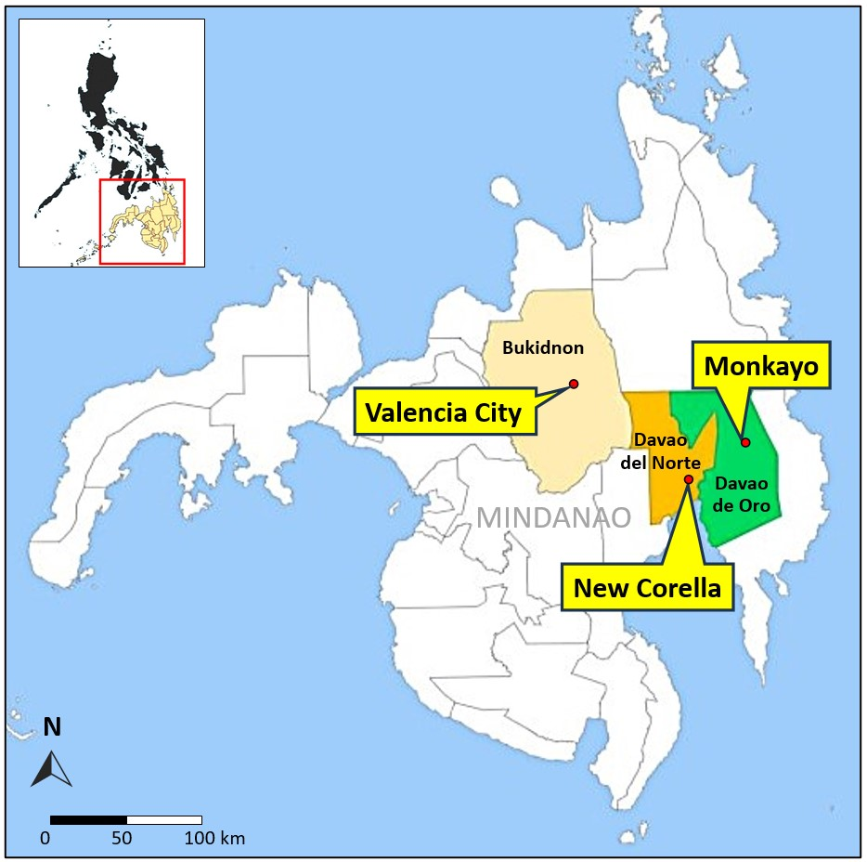
We visited 5 farms that produce Cavendish bananas for export, each with their own packing facilities. The farms and packing houses we visited were owned and operated by 4 different companies at varied scales of operation. More information on where we visited is available at Appendix 1.

Key observations
We observed a range of production sites and systems, including highland farms in the Northern Mindanao region (Figure 1) and lowland farms in the Davao region (Figure 2), irrigated and non-irrigated production, and different scales of operations. These farms ranged in size from 26 hectares to 546 hectares, and all were exporting Cavendish bananas.
Banana diseases of concern to Australia, including Moko, black Sigatoka, banana freckle and Panama disease Tropical Race 4 (TR4), were observed to be present at the farms we visited. We observed that the primary means of managing these diseases were high intensity monitoring and control programs and the use of tolerant cultivars.
Figure 1 - Cavendish banana farm in Valencia City
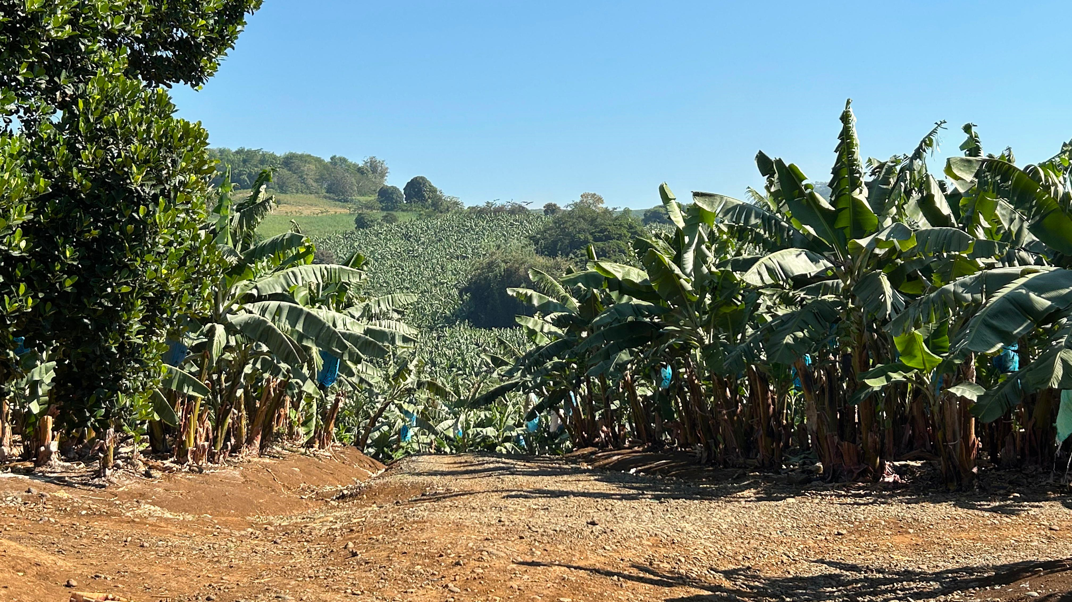
Figure 2 - Cavendish banana farm in New Corella
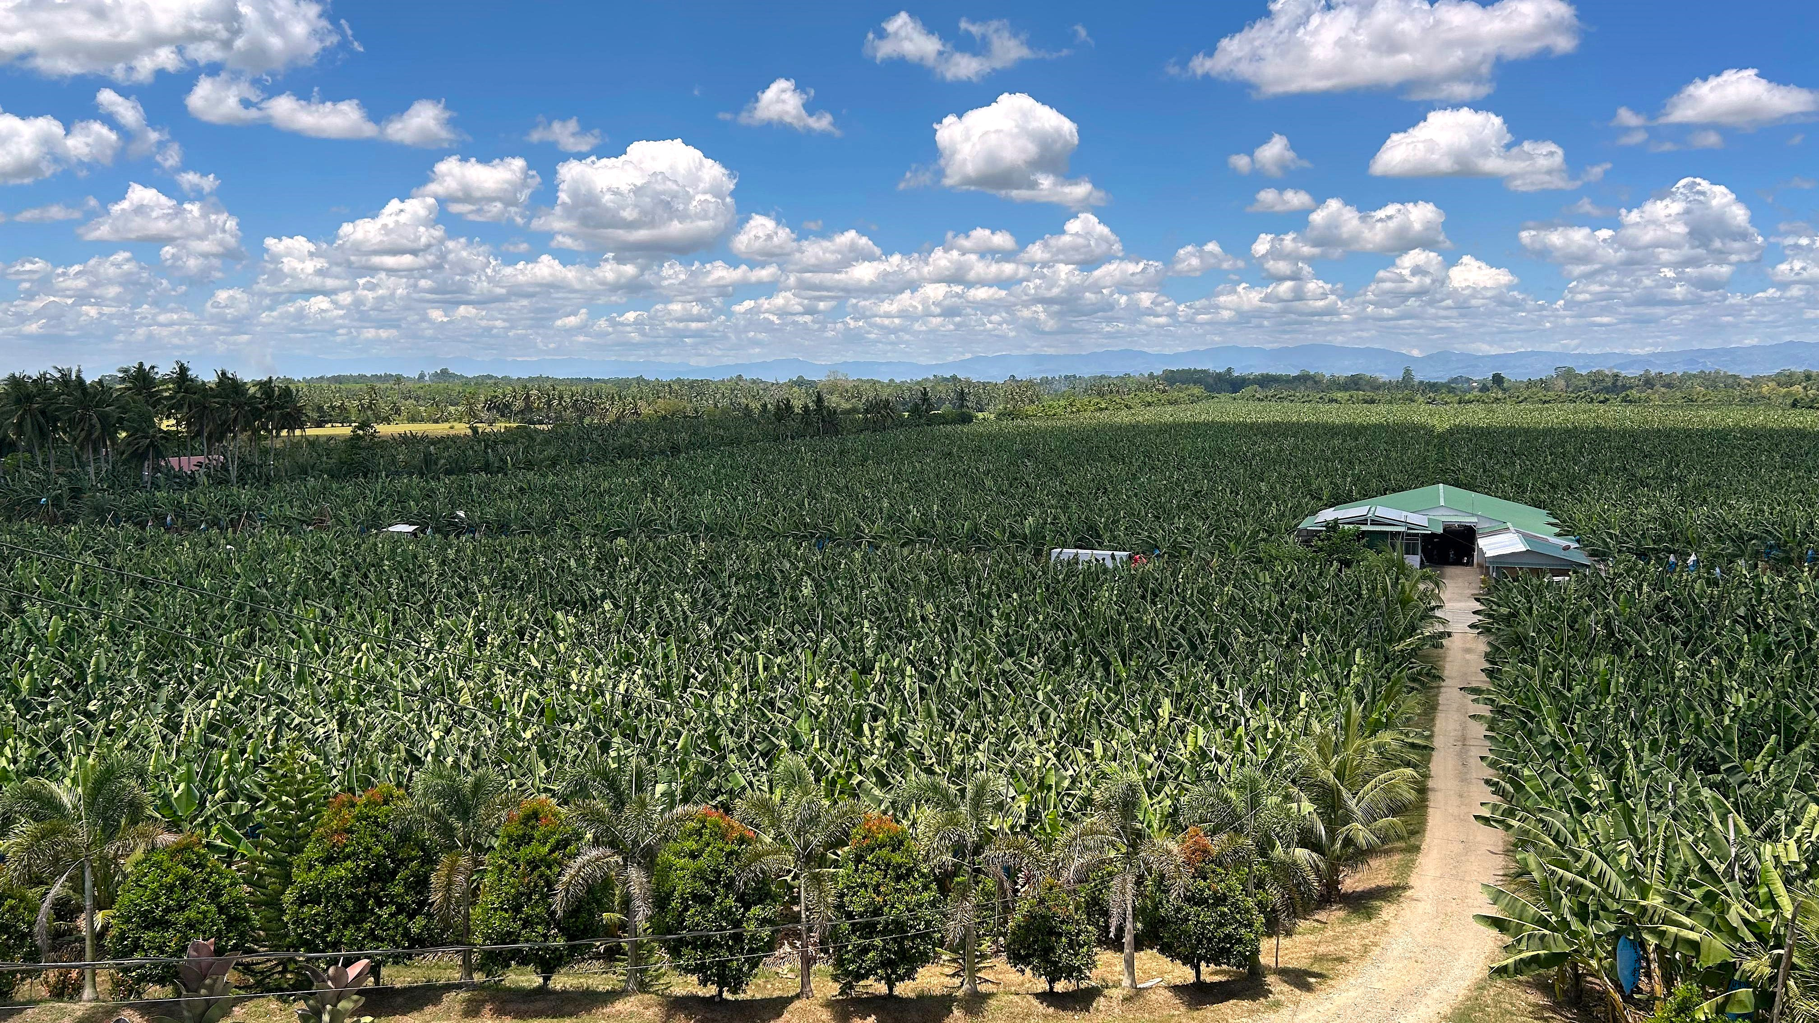
The farms we visited demonstrated pest and disease management practices that support the production of banana fruit for their current destination markets.
Whilst there was some variation in specific production and export practices between farms, the key elements that were observed to be consistently applied were:
- The use of Panama TR4-tolerant Cavendish cultivars is widespread. Grand Nain and Williams, or variants of these cultivars, were also being grown.
- All farms observed had similar fruit care programs and used bagging and sprays to reduce impacts of arthropod pests and diseases on the developing fruit.
- Each farm had monitoring and control programs for diseases and arthropod pests. These farms had specialist teams that undertook regular inspections of all plants to identify those affected by pests and diseases. There were, however, some differences in how affected plants were managed.
- The harvesting method was relatively consistent, except that on one farm the bunches were de-handed in the field as they did not have a cable system to transport the bunches to the packing house. At the other farms, the bunches were cut down and carried to a cableway (Figure 3) for transport to the packing house.
Figure 3 - Cable transport of bunches to the packing house, New Corella
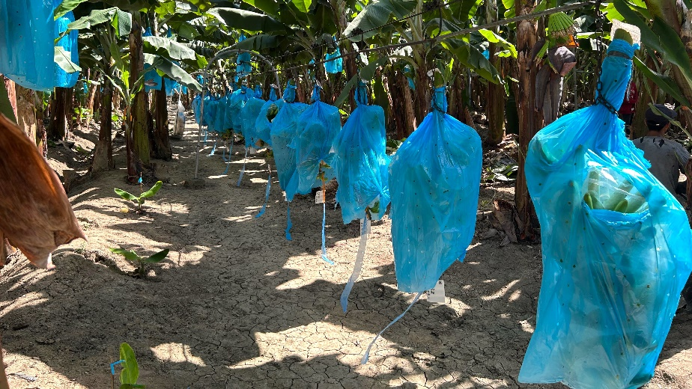
- The process for receival of the bunches at the packing house was broadly the same, and all included a quality inspection step.
- The de-handing process was similar at the 4 farms that de-handed the bunches in the packing house. The hands were removed using a specialised blade and immediately placed into a large tank of water to remove any dust and debris, as well as latex that may exude from the cut surface when the hands are separated from the bunch.
- Following de-handing, some packing houses had a soaking and spraying step if mealybugs were detected. The affected hands or clusters were sprayed with water and soaked in detergent to remove mealybugs before being transferred to the wash tanks.
- All packing facilities employed similar procedures for preparing clusters or hands, according to preference of the destination market.
- All packing facilities immersed the bananas in 2 sequential wash tanks for washing and latex removal (Figure 4). After washing in the first tank the hands were removed and the crowns were trimmed, and any remnant flower material and excess or unwanted fingers, were removed before the hands were immersed in the second tank for further washing.
Figure 4 - Tanks for washing banana fruit, Valencia City
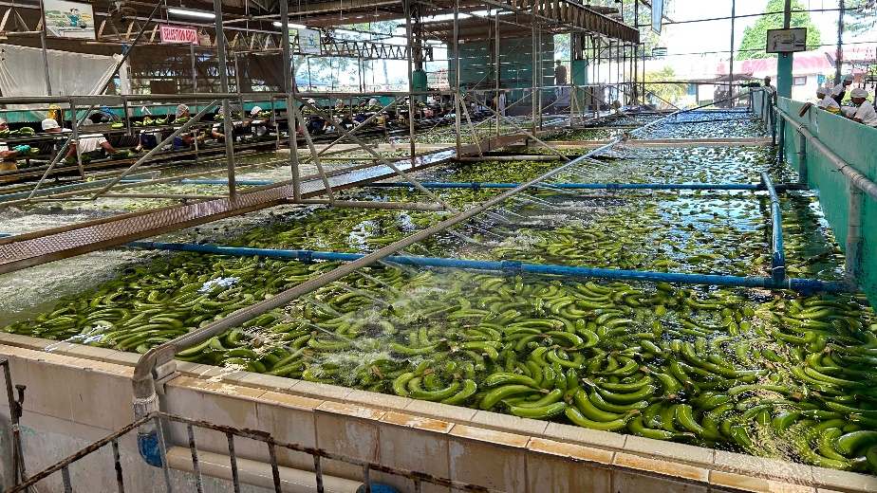
- All packing facilities sprayed the fruit with fungicide after washing to combat crown rot.
- The method for packing cartons varied, depending on destination market preference.
- There were 4 main points for monitoring fruit quality: in the field, on arrival at the packing house, during preparation for packing after washing, and finally a quality inspection after packing.
- All growers and packing houses were observed to have systems to ensure traceability of fruit.
- All farms had monitoring programs for pests and diseases. Growers are required to collect and provide this data to BPI as part of their national monitoring program.
- BPI has an established export regulatory system with processes for the registration of banana growers and packing facilities, and for the inspection of goods for export.

Next steps
We are using the information from the technical visit to inform our assessment of the Philippine’s request for alternative measures for bananas for export to Australia. The information will inform the assessment of biosecurity risk and the identification of appropriate risk management measures, where applicable. We have obtained sufficient information from the visit to progress the assessment and do not have any further technical visits planned at this stage.
We have released an issues paper that outlines the assessment process in more detail. It also provides background information on the Philippines’ requests, what will be considered during the assessment and how and when stakeholders will be engaged.
The key next step in the assessment process is the release of a draft report for a minimum 60 calendar day public consultation period. We expect to release the draft report in early 2027 (timing subject to change). The draft report will include the biosecurity risk assessment and details of any proposed risk management measures. It will also include detail on how we considered information from the technical visit when conducting the assessment.
Australia maintains strict biosecurity settings to protect our biosecurity status and protect domestic industries from pest and disease threats. We will only agree to alternative measures if our assessment concludes the measures effectively manage the biosecurity risks associated with importing bananas from the Philippines to achieve Australia’s appropriate level of protection (ALOP).

Appendix 1 – High-level itinerary for the technical visit to the Philippines
Location | Activity
Monday 23 March 2026
Valencia City, Bukidnon province, Northern Mindanao region | Entry meeting with the Bureau of Plant Industry (BPI)  - Discussion of the purpose and scope of the visit and confirmation of the itinerary  Visit to banana farm 1 and packing facility at Dabong-Dabong, Valencia City
Tuesday 24 March 2026
Valencia City, Bukidnon province, Northern Mindanao region | Visit to banana farm 2 and packing facility at Borobo, Valencia City
Wednesday 25 March 2026
New Corella, Davao del Norte province, Davao region | Visit to banana farm 3 and packing facility at Del Pilar, New Corella  Visit to banana farm 4 and packing facility at San Roque, New Corella
Thursday 26 March 2026
Monkayo, Davao de Oro province, Davao region | Visit to banana farm 5 and packing facility at Macopa, Monkayo
Friday 27 March 2026
Buhangin, Davao City, Davao region | Visit to BPI regional office  - Observation of export certification process  - Exit meeting with the Bureau of Plant Industry

© Commonwealth of Australia 2026
Unless otherwise noted, copyright (and any other intellectual property rights) in this publication is owned by the Commonwealth of Australia (referred to as the Commonwealth).
All material in this publication is licensed under a Creative Commons Attribution 4.0 International Licence except content supplied by third parties, logos and the Commonwealth Coat of Arms.
The Australian Government acting through the Department of Agriculture, Fisheries and Forestry has exercised due care and skill in preparing and compiling the information and data in this publication. Notwithstanding, the Department of Agriculture, Fisheries and Forestry, its employees and advisers disclaim all liability, including liability for negligence and for any loss, damage, injury, expense or cost incurred by any person as a result of accessing, using or relying on any of the information or data in this publication to the maximum extent permitted by law.

