# Tuart Woodlands and Forests of the Swan Coastal Plain: A Nationally Significant Ecological Community

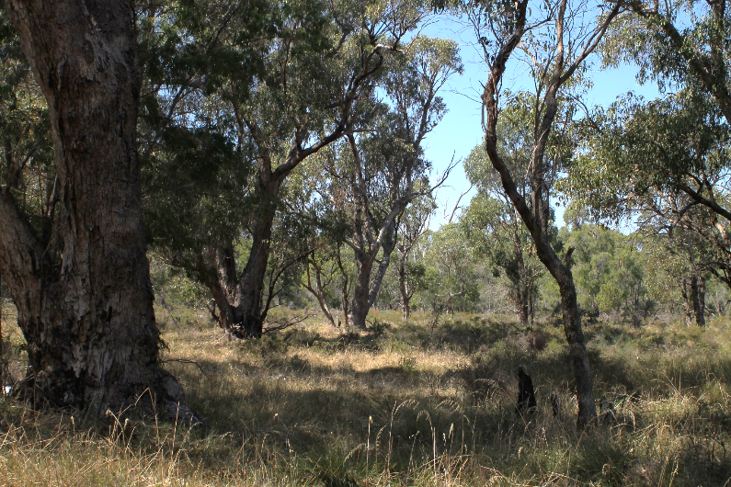

This guide is designed to assist land managers, owners and occupiers, as well as environmental assessment

officers and consultants, to identify, assess and manage the Tuart (*Eucalyptus gomphocephala*)Woodlands and Forests of the Swan Coastal Plain ecological community; a threatened ecological community, listed as critically endangered under Australia’s national environmental law, the *Environment Protection and Biodiversity Conservation Act 1999* (EPBC Act)*.*

This guide is a companion document to the approved Conservation Advice, which can be found on the

Australian Government’s Species Profile and Threats (SPRAT) database at: [www.environment.gov.au/cgi-bin/sprat/public/publiclookupcommunities.pl](http://www.environment.gov.au/cgi-bin/sprat/public/publiclookupcommunities.pl). Click on the ‘Details’ link alongside the ecological community name to download the documents and map for the listed ecological community.

**© Copyright Commonwealth of Australia, 2019.**

*Tuart Woodlands and Forests of the Swan Coastal Plain: A Nationally Significant Ecological Community*

is licensed by the Commonwealth of Australia, for use under a Creative Commons By Attribution 4.0 Australia license with the exception of the Coat of Arms of the Commonwealth of Australia, the logo of the agency responsible for publishing the report, content supplied by third parties, and any images depicting people. For license conditions see: <http://creativecommons.org/licenses/by/4.0/>

This guide should be attributed as ‘*Tuart Woodlands and Forests of the Swan Coastal Plain: A Nationally Significant Ecological Community, Commonwealth of Australia 2019’*.

The Commonwealth of Australia has made all reasonable efforts to identify content supplied by third parties using the following format ‘© [name of third party] ’.

**Disclaimer**

The views and opinions expressed in this publication are those of the authors and do not necessarily reflect those of the

Australian Government.

While reasonable efforts have been made to ensure that the contents of this publication are factually correct, the Commonwealth does not accept responsibility for the accuracy or completeness of the contents, and shall not be liable for any loss or damage that may be occasioned directly or indirectly through the use of, or reliance on, the contents of this publication.

**Images**

*Front cover*— Tuart Woodlands at Lake Clifton town site © The Department of the Environment and Energy

*Back cover*— Tuart Woodlands on Quindalup Sand Dunes in Maidens Reserve Bunbury © Trudy O’Connor

***The Department acknowledges the traditional owners of country throughout Australia and their continuing connection to land, sea and community. We pay our respects to them and their cultures and to their elders both past and present.***

# Contents

Summary 4

National Ecological Communities 7

The Tuart Woodlands and Forests Ecological Community 8

What is it? 8

Snapshot: Tuart Woodlands and Forests Vegetation 10

Where does it occur? 12

Why is the Tuart Woodlands and Forests ecological community important? 14

Why does the ecological community need national protection? 18

Are all sites which contain the ecological community protected under the EPBC Act listing? 20

Further information to assist in assessing patches of the Ecological Community (to avoid significant impacts) 22

What is a ‘patch’ of the ecological community? 22

Variation within a patch 22

Buffer zones 23

What are the benefits of listing the ecological community as nationally threatened? 23

What does the listing mean for landholders? 25

What can I do to look after the ecological community? 27

Are there other nationally protected ecological communities within this area? 28

Do state or local laws also apply? 28

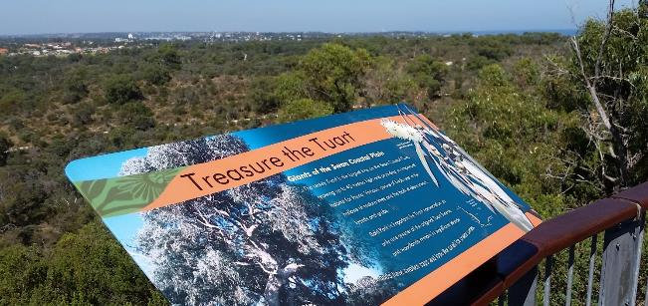Where can I get further information? 28

## Summary

Reabold Hill summit walk at Bold Park, Floreat © Peel-Harvey Catchment Council

* The Tuart (*Eucalyptus gomphocephala*) Woodlands and Forests of the Swan Coastal Plain are a nationally significant ecological community. The ecological community was listed as critically endangered by the Hon. Minister Ley MP on 4 July 2019 under national environmental law (the *Environment Protection and Biodiversity Conservation Act 1999* or EPBC Act).
* This nationally protected ecological community is comprised of woodlands or forests within which the presence of Tuart (*Eucalyptus gomphocephala*) trees in the uppermost canopy are the primary defining feature. The community also often contains other native trees such as Peppermint, Bull Banksia, Candlestick Banksia or Jarrah, with a substantial diversity of understorey plants.
* Southwest Australia, where the ecological community is found, is recognised as one of only two global biodiversity hotspots in Australia. The Tuart Woodlands and Forests are an important part of this providing habitat for a range of animal species, including some that are nationally threatened, such as Black Cockatoos and the Western Ringtail Possum.
* The Tuart Woodlands and Forests occur on the Swan Coastal Plain in Western Australia between Jurien in the north and Busselton in the South, including some remnants in the Perth metropolitan area. The ecological community is mainly found on the calcareous soils of the Spearwood and Quindalup sand dune systems on the western part of the plain.
* The national Threatened Species Scientific Committee found that approximately 80‑86% of the ecological community has been lost.
* This land is the country of the Noongar people who are the traditional owners of southwest Western Australia. The Noongar nation have, over many generations, lived with and held connection to the ecological communities of the Swan Coastal Plain.
* Prior to European arrival, the Tuart Woodlands and Forests occupied approximately 125,400 hectares. After clearing for agriculture, grazing, logging, mining and urban development as few as 17,000 hectares are estimated to remain.
* All remaining patches have been disturbed to some degree and are at risk of losing further plant and animal species unless they are conserved and managed to prevent further degradation.
* Given the high level of past damage to the ecological community and ongoing risk of degradation it faces, the ecological community is likely to be completely lost if it is not protected and restored.
* Currently, the ecological community is vulnerable to threats from: land clearing (e.g. for urban development and mineral extraction); changes to climate and availability of water; invasion by weeds, and non-native animals; loss of native species; and unsuitable burning.
* National listing can now help to manage threats and protect and restore the many values and services provided by Tuart Woodlands and Forests. These include: reducing erosion; supporting other characteristic native plants; providing clean air and water, feed and shelter; helping to keep cities cool and liveable; and providing significant community and cultural values to the people of the region.
* Therefore, it is now more important than ever to retain and restore the remaining hectares of the Tuart Woodlands and Forests. National listing is a critical step in securing the future of the animals, plants and ecosystem functions within the Tuart Woodlands and Forests because it:
* defines Tuart Woodlands and Forests as a single ecological community on a national scale for the first time, promoting a co-ordinated, ecosystem-scale approach to threat abatement and recovery
* ensures the woodlands and forests are taken into account during planning and approval processes for major new developments that may have a significant impact
* encourages further research on regional biodiversity and ecosystems, and the critical services they provide to society
* 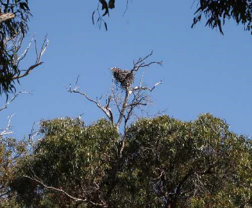makes it a priority for relevant government funding programs and supports land managers and community groups in their conservation and recovery efforts.
* While protecting the ecological community does not affect native title, it can help to provide greater recognition of the value of Tuart Woodlands and Forests, including Noongar cultural values.
* The national [**Conservation Advice**](http://www.environment.gov.au/biodiversity/threatened/communities/pubs/153-conservation-advice.pdf) outlines a range of priority research and management actions that provide guidance on how to protect, manage and restore the ecological community.
* Activities likely to have significant impacts on the ecological community need to be considered under national environment law to avoid or mitigate damage—activities such as large new developments, works or infrastructure that involve permanently removing or impacting on large and relatively high quality areas of the woodlands or forests. Such activities will need to be referred to the Australian Government for approval.

Eagle's nest in a Tuart stag at the Caddadup Reserve   
© The Department of the Environment and Energy

* Activities which were routine or began before the listing of an ecological community can typically continue without any further approval. This is either because the protected ecological community is not present, the impacts are not significant or because exemptions apply to activities that were either already legally approved (termed ‘prior authorisation’), or are ongoing (termed ‘continuing use’). This includes almost all activities by residents and farmers, and ongoing maintenance work by local Councils.
* Overall, national listing reduces the risk of this unique and important ecological community being lost for future generations and supports efforts to restore biodiversity and ecosystem health on the Swan Coastal Plain.

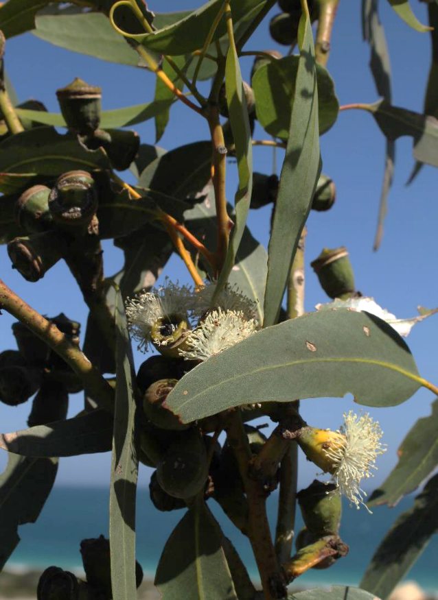

Tuart (*Eucalyptus* *gomphocephala*) are the defining tree species of the Tuart Woodlands and Forests. Tuart trees on the Swan Coastal Plain are tall, beautiful fixtures in the native landscape. Tuart trees can live for hundreds of years, providing vital habitat, shelter and critical ecosystem services for a range of native species. © The Department of the Environment and Energy

## National Ecological Communities

Australia’s national environment law provides a legal framework to list, protect and manage Matters of National Environmental Significance, which include nationally threatened species and ecological communities.

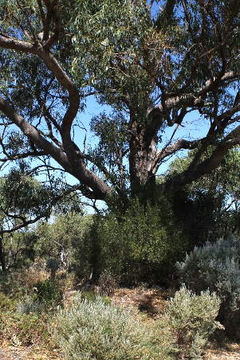National environment law defines an ecological community as an assemblage of native species which inhabits a particular area in nature. In other words, ecological communities are groups of native plants, animals and other organisms that naturally live together and interact in a unique habitat. The native plants and animals in an ecological community have different roles and relationships that, together, contribute to a healthy functioning natural environment.

Listed ecological communities are likely to become extinct, through loss of extent, loss of characteristic species, and/or loss of natural function throughout their range, unless threats are removed or better managed. Even though ecological communities listed as threatened are compromised, remnants retain important natural values. They also have the potential to provide more habitat and ecosystem services if threats are eliminated or managed to reduce impacts, and the natural composition and function are restored.

Tuart Woodland at Reabold Hill in Bold Park Western Australia © Trudy O’Connor

Protecting ecological communities also safeguards ecosystem services such as clean air and water, healthy soils and pollination. Conserving and restoring ecological communities also helps protect people, stock and property from weather extremes and climate change. These services benefit people and society both within and beyond the local area and are essential to the greater productivity of our land and water.

## The Tuart Woodlands and Forests Ecological Community

### What is it?

The nationally-listed Tuart Woodlands and Forests ecological community includes the assemblage of plants, animals and other organisms that occur in association with Tuart (*Eucalyptus gomphocephala*)on the Swan Coastal Plain of Western Australia. It occurs where there are multiple Tuart trees with crowns separated by a distance of no more than 60 m, with an understorey containing a minimum number of native plant species or demonstrating other important conservation values.

In most locations, the ecological community occurs as a woodland, but can occur in forms different across its range. The trees can also have single trunks or multiple trunks (mallee form). Generally in the southern area the trees are larger than in the northern part of the ecological community. The various forms are indicated in the Tuart Woodlands and Forests Snapshot in the following section.

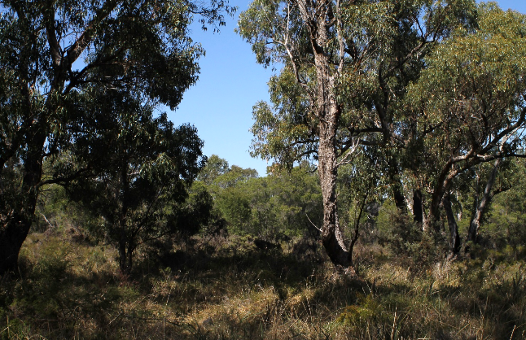

Tuart Woodlands at Lake Clifton town site © The Department of the Environment and Energy

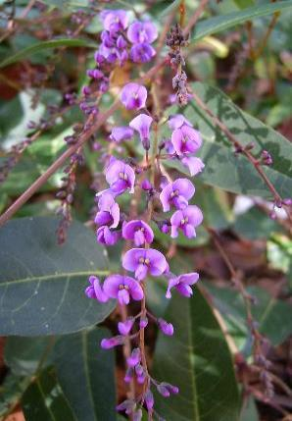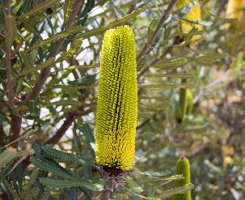Tuart trees are primary defining feature of this ecological community. Other trees can also form part of the canopy, and commonly include: Peppermint (*Agonis flexuosa*), Bull Banksia (*Banksia grandis*); Candlestick Banksia (*Banksia attenuata*), or Jarrah (*Eucalyptus marginata*).

Native Wisteria (*Hardenbergia comptoniana*)   
© Jenny Tomkins

Candlestick Banksia (*Banksia* *attenuata*) © Michael Marriott

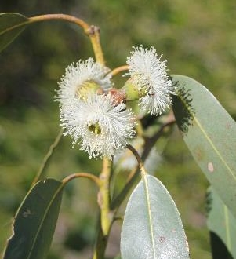Plant species in the understorey vary from the north to the south of the Swan Coastal Plain and may include herbs, grasses and shrubs. The more common species found at many locations include: Native Wisteria(*Hardenbergia comptoniana*)*,* Australian Carrot (*Daucus glochidiatus*) andNative Parsnip (*Trachymene pilosa*).

A complete list of plants commonly found in the ecological community can be found in the approved [**Conservation Advice**](http://www.environment.gov.au/biodiversity/threatened/communities/pubs/153-conservation-advice.pdf).

In some locations the ecological community may occur near other nationally protected ecological communities, such as Banksia Woodlands of the Swan Coastal Plain.

Tuart Blossom © Trudy O’Connor

## A photo of Tuart Walk at the Usher Shearwater Forest BunburySnapshot: Tuart Woodlands and Forests Vegetation

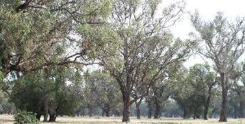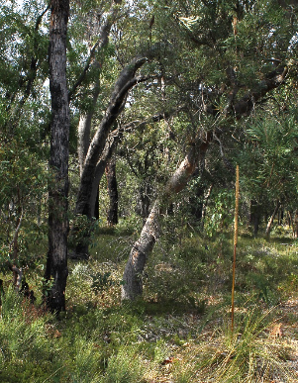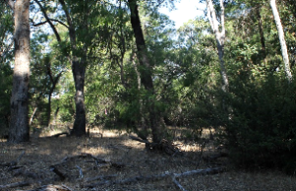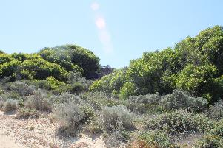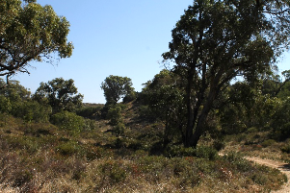These pictures show some of the ways that Tuart Woodlands and Forests can appear across their range, demonstrating the varied floristic composition and structure of the ecological community.

Mature Tuart canopy with a modified understorey at Myalup © The Department of the Environment and Energy

Tuart Woodlands and Forests with a Banksia sub-canopy at College Grove Bunbury © The Department of the Environment and Energy

Tuart Walk at the Usher Shearwater Forest Bunbury   
© The Department of the Environment and Energy

Tuart Ludlow Forest © The Department of the Environment and Energy

Mallee form Tuart on sand dunes at Guilderton   
© The Department of the Environment and Energy

Tuart Woodland on Quindalup sand dunes at Maidens Reserve Bunbury © The Department of the Environment and Energy

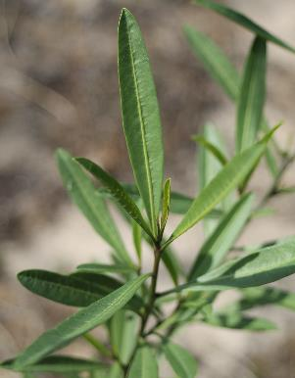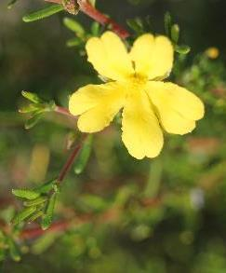

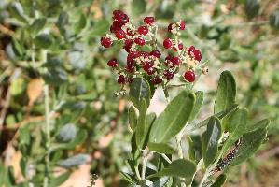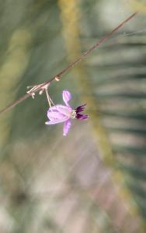

The native understorey plant *Solanum symonii*   
© The Department of the Environment and Energy

Guinea Flower (Ballyion, *Hibbertia glomerosa*) is a native flower found in the ecological community with Noongar people using it as a medicinal antiseptic © The Department of the Environment and Energy

Seaberry Saltbush (*Rhagodia baccata*) is often found in the Tuart Woodland and Forests. The coastal plant has edible berries and leaves which become succulent and tender when cooked © The Department of the Environment and Energy

The Blue Flax-lily (*Dianella revoluta*) is another native flowering plant found in the ecological community. The Noongar people have traditionally used the fruit, leaves, bulbs and roots of the flax-lily for a range of edible and medicinal uses © The Department of the Environment and Energy

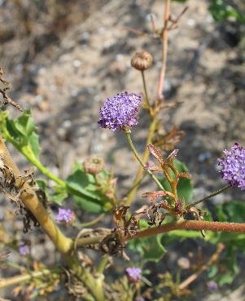

Blue Lace Flower (*Trachymene coerulea*) emerging from burnt understory in the Tuart Woodlands and Forests. The Blue Lace Flower thrives in sandy conditions and the bulbs and leaves are used traditionally by the Noongar people to relieve aches, pains and headaches © The Department of the Environment and Energy

### A photo of the view from Reabold Hill in Bold Park – overlooking Tuart and heath woodlands and metropolitcan PerthWhere does it occur?

The view from Reabold Hill in Bold Park – overlooking Tuart and heath woodlands and metropolitcan Perth © Trudy O’Connor

The Tuart Woodlands and Forests occur on the Swan Coastal Plain in Western Australia, from Jurien, approximately 200 km north of Perth, to the Sabina River, near Busselton, 225 km south of Perth. While the distribution of the ecological community was historically continuous between the Sabina River and Lancelin, its occurrence is now more fragmented.

The Tuart Woodlands and Forests can most commonly be found on the calcareous soils of the Spearwood dune systems, the Quindalup dune systems, and in some places, also found on the Bassendean dune systems. It also occurs in between the dunes in sheltered swales and on the margins of wetlands, as well as on the margins of rivers further inland, including some on very saline soils.

As of July 2019 the ecological community is known to exist within the territory of the following local governments: Bunbury, Busselton, Cambridge, Capel, Cockburn, Dandaragan, Dardanup, Fremantle, Gingin, Harvey, Joondalup, Kwinana, Mandurah, Murray, Nedlands, Rockingham, South Perth, Stirling, Wanneroo and Waroona.

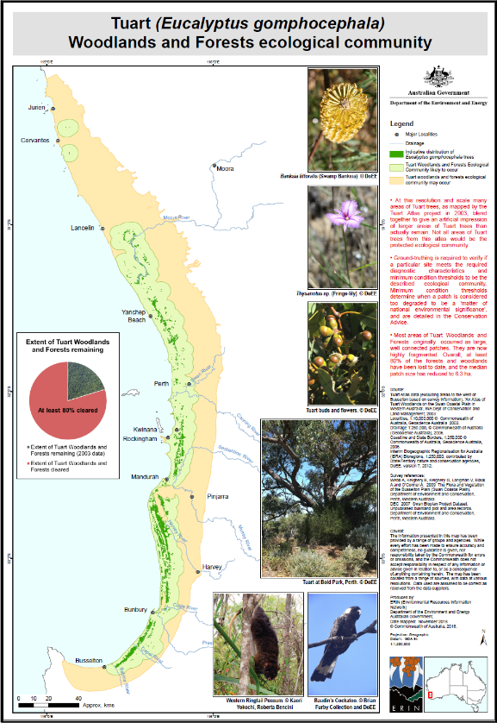

This map is published on SPRAT at <http://www.environment.gov.au/cgi-bin/sprat/public/publicshowcommunity.pl?id=153>

## Why is the Tuart Woodlands and Forests ecological community important?

There are several reasons why the Tuart Woodlands and Forests are important.

### The Tuart Woodlands and Forests provide habitat for a range of native plants and animals, including threatened species

Tuart Woodlands and Forests ecological community provides habitat for a range of native plants and animals. Detailed below are several examples which illustrates how critical the ecological community is as a primary habitat for a diverse range of fauna.

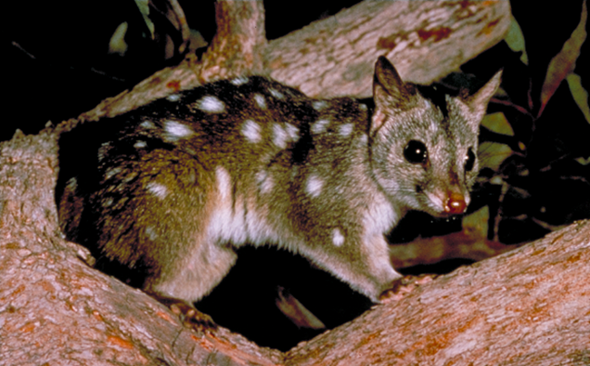The Tuart Woodlands and Forests with peppermint sub-canopy provide the primary sustenance for the Swan Coastal Plain populations of Western Ringtail Possum (*Pseudocheirus occidentalis*) (listed as ‘Critically Endangered’ in both Western Australian and National jurisdictions).

Chuditch (*Dasyurus* *geoffroii*) is Australia’s largest carnivorous marsuipial. This nocturnal animal feeds mainly on large invertebrates but is threatened by loss of habitat and the presence of introduced carnivores such as cats and foxes   
© Todd Soderquist

Tree hollows in the Tuart trees also provide vital daytime refuge for nocturnal species such as the Western Ringtail Possum, theBrushtail Possum (koomal, *Trichosurus vulpecula*) and the Southern Brush-tailed Phascogale (wambenger, *Phascogale tapoatafa*). These hollows are also critical habitat for other hollow-dependant animals including bat species which use Tuart hollows for daytime roosting. Other mammal species that have broadly declined, but still rely on the ecological community for habitat include Chuditch(*Dasyurus geoffroii*), Quenda (*Isoodon obesulus fusciventer*) and Quokka (*Setonix brachyurus*).

The ecological community is also home to at least 16 other mammal species and at least 43 diverse reptile species, this represents more than half the reptile species occurring on the Swan Coastal Plain. The Tuart Woodlands and Forests provide important refuge for these species in a largely cleared and fragmented landscape.

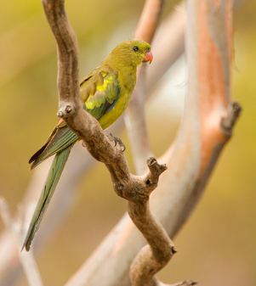The ecological community provides a wide variety of habitat niches for birds and woodland species in decline across the Swan Coastal Plain.

The association of the ecological community with some rivers and wetlands means that several duck species use mature Tuart trees for roosting and nesting sites.

Parrots are also amongst the many taxa likely to benefit from hollows in mature Tuarts including Red-capped Parrot(*Purpureicephalus spurius*) and the Australian Ringneck(*Barnardius zonarius*). At some locations Tuart trees provide critical breeding and nesting sites for the threatened Carnaby’s Cockatoo(*Calyptorhynchus latirostris*) and the Forest Red-tailed Black Cockatoo (*Calyptorynchus banksii naso*).

Regent Parrot (*Polytelis anthopeplus*) © Nick Rains

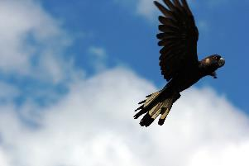The ecological community is also of high importance for some raptors, scavengers and aerial insectivores which utilise the high vantage points provided for by tall Tuart. The ecological community also helps to protect aquatic or semi-aquatic habitat for amphibians and other aquatic fauna. With at least seven amphibian species having been recorded in the Tuart Woodlands and Forests in association with riparian and wetland areas.

Carnaby's Black Cockatoo (*Calyptorhynchus latrirostris*) in flight © The Department of the Environment and Energy

The listing of this ecological community helps to protect these native species, granting additional protection to those native plants and animals already recognised at threatened (or migratory) under state and/or national laws.

A comprehensive list of plants and animals that may be present in the ecological community, including theatened species, can be found in the approved [**Conservation Advice**](http://www.environment.gov.au/biodiversity/threatened/communities/pubs/153-conservation-advice.pdf).

### A photo of flowering of the Mudjar (Nutsia floribunda; Western Australian Christmas Tree) The ecological community has significant cultural and heritage values for Indigenous peoples

The Tuart Woodlands and Forests have considerable cultural heritage value for the Noongar (Nyoongar, Nyungar) people who are the traditional owners of southwest Western Australia.

The Noongar people have a rich legacy of highly organised, sustainable land management on the Swan Coastal Plain. They have traditionally engaged with the ecological community and surrounding environment in a way which ensures the sustainable provision of food, shelter, medicine, clothing, tools and spiritual wellbeing and connection.

The golden flowering of the Mudjar (*Nutsia floribunda*; Western Australian Christmas Tree) heralded the beginning of warmer weather, prompting the return of the Noongar community to coastal lands for the new season. Its flowers were soaked to make a sweet drink and the suckers on its roots eaten. © Gnangarra- commons.wikimedia.org

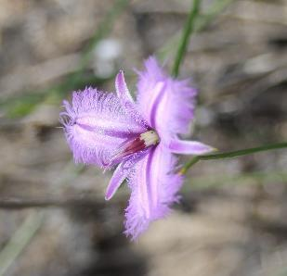Over the course of their long and enduring relationship to the landscape, the Noongar have accumulated a wealth of traditional knowledge about the land, seasons, plans and animals, as well as the interactions between these elements. This knowledge is strongly associated with culture and spirituality.

Traditional Noongar life on the Swan Coastal Plain was structured around a calendar which mapped and tracked the availability of food and water resources across six seasons. Warmer seasons (*Kambarang, Birak* and *Bunuru*)were spent utilising coastal resources; sourcing food from the wetlands, such as freshwater crayfish, frogs, tortoises, waterfowl and fish, with eggs and birds (including parrots, pigeons, cockatoos and raptors) sourced from the surrounding forests.

In colder seasons (*Djeran* and *Makuru*),water was more reliable in higher regions and efforts were focused more on the sustenance hunting of *marli* (Black swans; *Cygnus atratus*), *yonger* (kangaroos), Emus, Quenda and possums. *Mia* shelters were built and repaired at this time and kangaroo skins prepared to make cloaks.

Seasonal food sources were abundant in the ecological community, forming crucial pillars of Noongar life which are passed on through traditional land knowledge today. For example, seeds from the *baio* (Zamia Palm) were harvested, soaked to remove toxins, then roasted and eaten. Similarly, *yanjet* (Bulrush) rhizomes were pounded to remove the fibre then made into a flattened damper and roasted. The *bohn* or *mardje* (Blood Root) was used for both food and medicinal properties. *Warrain* (Yams; *Dioscorea hastifolia*) were also collected by women using their wanna digging sticks, with tips replanted to be harvested the following season. Such careful planning and sustainable resource management was characteristic of Noongar practice.

Tjunguri (Fringe Lily) has an edible stem and flower which could be roasted, ground and then eaten with Manna gum. Its tubers were also eaten raw or roasted © The Department of the Environment and Energy

The Tuart trees themselves are the characteristic species of this ecological community and have the Noongar names *Morrol*, *Duart*, *Mooarn*, *Moorun*, *Mouarn*, *Tuart* and *Tooart*. The trees can be used for a range of purposes. The gum was used as a mild anaesthetic and the bark was often used as roofing for shelters.

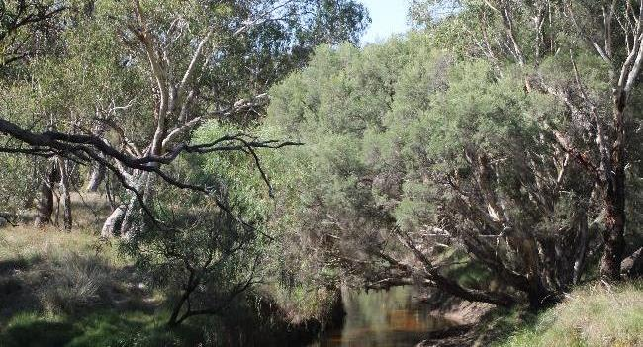Several of the traditional snacks eaten by the Noongar are still found in the woodlands and forests. These include a range of berries, particularly *cadgeegurrup* (Native Cranberry; *Astroloma*) and wild pear (*Persoonia*).

Watercourses within the Tuart Woodlands and Forests ecological community were a primary focus of life and resource gathering for the Noongar people. Moore River © Trudy O’Connor

Permanent and seasonal water sources, such as those within Tuart Woodlands and Forests, were a focus for life and resource gathering for the Noongar people. At Perry Lakes, near where the ecological community is still present, Noongar women would collect turtles by wading in the wetlands and feeling with their feet. Similarly, Lake Joondaulup, another site where the ecological community occurs, was a favoured camping area where waterfowl and *yargun buyi* (long-necked tortoise) were hunted.

The retention and recovery of these culturally significant sites is important because it will enable the Noongar people today to continue traditional cultural practices, to pass on traditional knowledge and to nurture their spiritual connection to country.

### Retaining and restoring patches of the Tuart Woodlands and Forests contributes to the broader ecological and social health of the Western Australian environment

The native vegetation in Australia is an integral part of our national identity. As part of this native heritage, Tuart Woodlands and Forests provide significant environmental, economic and socio-cultural value.

The ecological community contributes to the broader socio-cultural, economic and ecological health of the Western Australian environment by: helping to maintaining the area’s air and water quality, mitigating climate change, helping to protect soils from erosion, supporting agricultural productivity, providing recreational opportunities (for example, in reserves such as Yalgorup, Yanchep and Tuart Forest National Parks) and supporting people’s health.

Many of the ecological functions of the ecological community occur at a larger scale, or require populations of plants and animals to interact across various remnants of vegetation in the broader landscape. For example, transfer of seeds and pollen between remnants protects the health of plant populations by promoting genetic diversity and greater resilience to pests, diseases and other threats such as climate change. Many animal species found in the ecological community also benefit from other native vegetation across the landscape, including other listed ecological communities like Banksia Woodlands. Greater areas of habitat within the region support larger populations of many species, and greater total diversity. For this reason it is important to protect not just isolated examples of the ecological community, but consider patches of Tuart Woodlands and Forests as part of a functioning landscape.

It is important to help prevent further decline of the Tuart Woodlands and Forests by promoting recovery through landholder and community efforts. Listing this ecological community is helping to protect it from future damage while creating opportunities for its management and restoration.

## Why does the ecological community need national protection?

The landscape where the ecological community occurs has been heavily cleared for agriculture, mineral extraction, and urban and suburban development. In total, approximately 80–86 per cent of the estimated original extent of the ecological community has been cleared.

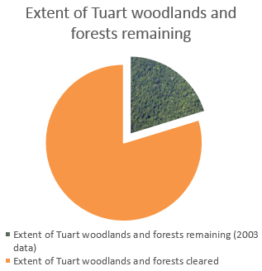

Most remaining patches of the ecological community have been very heavily disturbed and many have lost most of their native understorey species, or are under threat from the invasion of introduced plants and animals. This is a problem particularly when a patch is no longer surrounded by other native vegetation.

Many of the native animals that were once part of the ecological community are now no longer there, or are themselves threatened. These animals together played important roles in helping the ecological community to function well as an ecosystem, for example: by pollinating plants; digging to conserve healthy soil function and assist plant regeneration; or managing pest species.

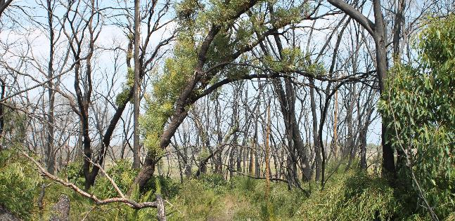There are also a range of ongoing and evolving threats to the region. As the climate of the region changes, particularly with the reduced rainfall, pressures on plants and animals of the region are expected to increase. At the same time, the rising population of the region means that development will continue to intensify, resulting in the continued clearing and degradation of native vegetation. Additionally, changing fire patterns, which hold an important role in maintaining balance in ecological communities, pose significant ongoing risk to the integrity of the ecological community.

The Threatened Species Scientific Committee (the Committee) provided advice to the Minister for the Environment on the conservation of the ecological community. They found that the Tuart Woodlands and Forests have experienced a severe reduction in ecological community integrity as a result of the damages outlined above. Furthermore, this reduction in ecological integrity of the patches further *reduces* and threatens their resilience to future disturbances.

To support the health and function of the ecological community it is important to protect, manage and restore native vegetation and animal populations across the landscape. Listing Tuart Woodlands and Forests as threatened under national environmental law will help to protect it from future damage and create opportunities for its recognition, management and restoration.

The [**Conservation Advice**](http://www.environment.gov.au/biodiversity/threatened/communities/pubs/153-conservation-advice.pdf), found on the Department’s website, outlines a range of priority research, management and guidance on how to manage, restore and protect the ecological community.

Burnt Tuart Woodland in Yalgorup National Park © Trudy O'Connor

## Are all sites which contain the ecological community protected under the national listing?

The national listing of the Tuart Woodlands and Forests ecological community protects only the best remaining patches. Not all patches will be covered by this listing. For example, if a small patch has an understorey that is completely degraded or the patch is extremely small, it is not protected nationally (but other local or state laws may apply). This is so that national efforts to protect and restore the ecological community are concentrated on the most ecologically important areas.

**Determining if a patch is protected or not is a two-step process**.

* 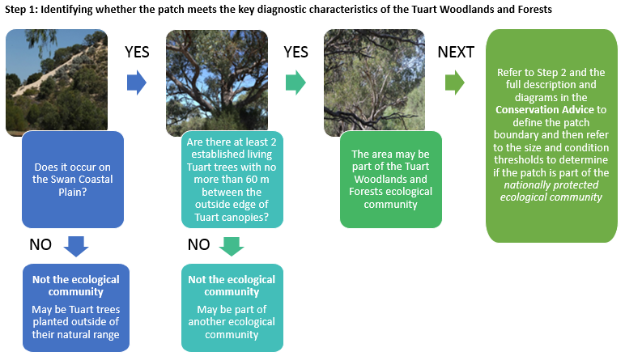**Step 1**: A patch must be identified as the Tuart Woodlands and Forests ecological community against the description and key diagnostics in the approved [**Conservation Advice**](http://www.environment.gov.au/biodiversity/threatened/communities/pubs/153-conservation-advice.pdf).
* **Step 2:** If a patch meets the description of the Tuart Woodlands and Forests ecological community, then its condition can be categorised under the condition thresholds in the approved **Conservation Advice.** *The size and condition of the patch will determine whether national protection applies*.

The following sections and flow charts are explanatory tools to assist with identification of the ecological community. The definitive source of information for identifying the ecological community is the approved [**Conservation Advice**](http://www.environment.gov.au/biodiversity/threatened/communities/pubs/153-conservation-advice.pdf).

### Step 1: Identifying a patch of the ecological community against key diagnostics

This flow chart demonstrates the key questions which assist in identifying if the patch is part of the Tuart Woodlands and Forests ecological community.

### Step 2: Categorising patches of the ecological community against condition thresholds to determine national protection

After the patch has been identified as meeting the key diagnostic characteristics of the Tuart Woodlands and Forests ecological community, the **second step** is to define the *boundary* and *condition class* of the patch in accordance with the approved [**Conservation Advice**](http://www.environment.gov.au/biodiversity/threatened/communities/pubs/153-conservation-advice.pdf). This examination will determine whether or not the patch is *nationally protected*.

The patch boundary extends 30 m beyond the outer edge of the canopy of established Tuart trees.

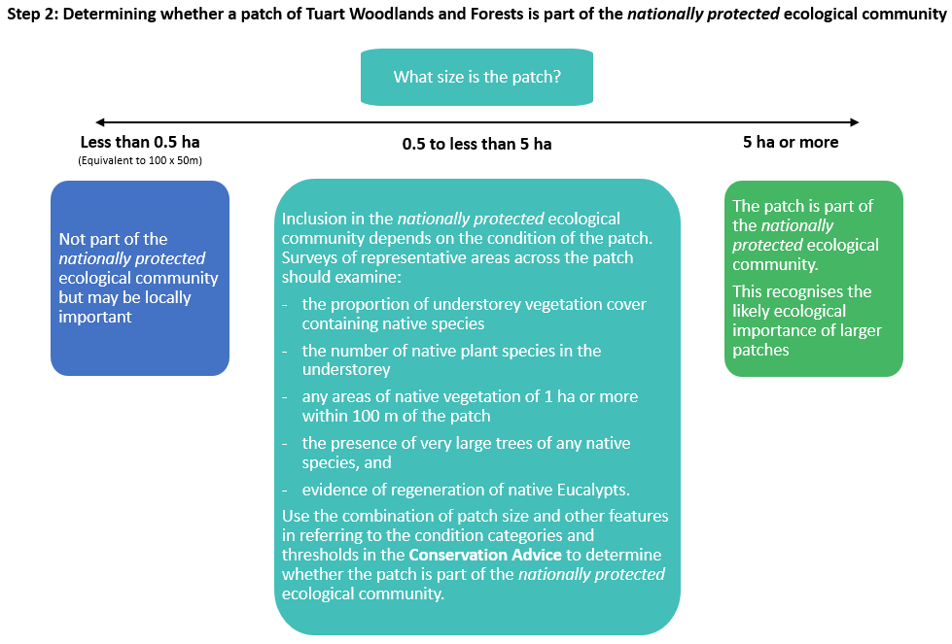Next, condition classes are applied which determine the ecological importance of the patch. Condition classes are detailed criteria which can be used for deciding if a patch of the ecological community is nationally protected. These condition thresholds are necessary to help determine which patches hold the most ecological importance, requiring status as a nationally protected ecological community.

The process for examining these condition classes is briefly summarised in the flow chart below. If, under the condition classes, the patch is determined as part of the *nationally* *protected ecological community*, any actions likely to have a significant impact on Tuart Woodlands and Forests need to be considered under national environmental law.

### Further Details

For further details as to how to determine whether a patch of vegetation meets the definition and condition thresholds for the national ecological community see the [**Conservation Advice**](http://www.environment.gov.au/biodiversity/threatened/communities/pubs/153-conservation-advice.pdf) at: [www.environment.gov.au/cgi-bin/sprat/public/sprat.pl](http://www.environment.gov.au/cgi-bin/sprat/public/sprat.pl)

## Further information to assist in assessing patches of the Ecological Community (to avoid significant impacts)

### What is a ‘patch’ of the ecological community?

A patch is defined as a discrete and mostly continuous area of vegetation that meets the key diagnostic characteristics. The boundaries of each patch are defined at 30 m beyond the outer canopy of the established tuart trees.

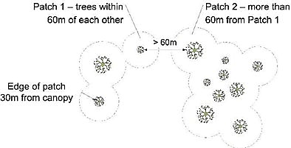Permanent manufactured structures, such as roads and buildings, are typically excluded from patch size calculations.

Patches of the ecological community extend to 30 m beyond the outermost canopy of the Tuart trees

### Variation within a patch

Variation in quality or condition of vegetation across a patch should not necessarily be considered to be evidence of multiple patches. Tuart Woodlands and Forests patches may contain variations in structural or biological vegetation complexity. A single patch may include one section with a large number of mature trees and more ecological diversity, whilst also including a section with fewer mature trees and less ground cover.

A patch may include small areas without understorey vegetation, such as bare ground, waterbodies or hardscape (e.g. roads, paths, car parks, or buildings), that do not significantly alter the overall function of the ecological community.

As long as there are some parts of the canopy within 60 m of the outer edges of the canopies of adjacent Tuart trees, these small areas do not break up a patch, or divide a patch into multiple patches. Existing buildings and other human-made structures and gardens are not part of the nationally protected ecological community and should be excluded from the calculation of patch size and condition.

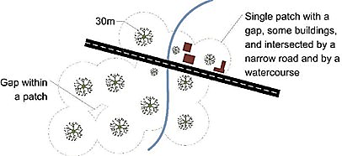Patches of the ecological community can be spatially variable and are often characterised by one or more areas within a patch that meet higher condition thresholds amongst areas of lower condition.

This diagram demonstrates variation within a patch, including small areas without understorey vegetation, and a small gap within a patch due to part of the Tuart canopy being >60 m apart.

If an area meets the key diagnostic characteristics but the average condition across that area falls *below* the minimum condition thresholds, the largest area or areas of at least 0.5 ha that meet minimum condition thresholds on average, should be specified as the patch or patches of the nationally listed ecological community.

Buffer zones

A buffer zone is a contiguous area adjacent to a patch that is important for protecting the integrity of the ecological community. While buffer zones are incorporated into the definition of a patch boundary, they do not form part of the ecological community.

As the risk of damage to an ecological community is usually greater where actions occur close to a patch, the *purpose* of the buffer zone is to minimise this risk by guiding land managers to be aware that the ecological community is nearby and to take extra care.

This diagram demonstrates the operation of buffer zones around a patch of the listed ecological community.

For instance, the buffer zone will help protect the root zone of edge trees and other components of the ecological community from spray drift (fertiliser, pesticide or herbicide sprayed in adjacent land), weed invasion, water runoff, water extraction and other damage.

The minimum buffer recommended for this ecological community is 30 m beyond the outer edge of each patch. In some cases a greater distance will be needed to protect the patch.

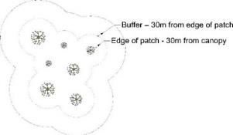

## What are the benefits of listing the ecological community as nationally threatened?

Some reasons why the Tuart Woodlands and Forests are important have already been provided. The intent of listing ecological communities under national environmental law is to ensure that these important values, functions and services are protected and maintained for the future. Benefits of national listing include the following:

* 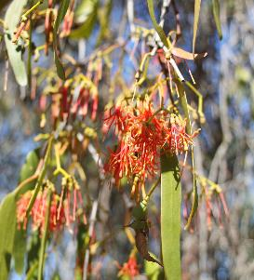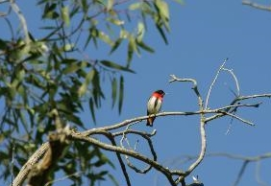It helps protect ecological communities from future activities having significant impacts and causing further decline. The aim of national environmental law is for Australia to meet international commitments and national expectations to ensure matters of national environmental significance are given due consideration, along with broader economic, social and other issues in the planning of major projects. Significant adverse impacts to threatened ecological communities should be avoided. If the impacts are unavoidable, they must be mitigated, reduced or, as a last resort, offset.

Mistletoes are important sources of nectar for a range of species. The fruits are eaten by Mistletoe Birds pictured left © Trudy O’Connor

* It encourages landholders, community groups and organisations to undertake conservation and recovery works that will address threats to the ecological community. The Australian Government often has natural resource management programs that can help land managers and community groups to conserve biodiversity. Recovery of nationally threatened ecological communities are often a priority under such programs.
* Listing ensures that the key knowledge about a threatened ecological community or species is collated and published at the time of listing. This is in an approved [**Conservation Advice**](http://www.environment.gov.au/biodiversity/threatened/communities/pubs/153-conservation-advice.pdf)**,** which includes guidance on identifying the ecological community, and environmental decision-making, including priority research and restoration actions.

The Mistletoe Bird (*Dicaeum hirundinaceum*) is an important distributer of seeds of a range of mistletoe species in the ecological community © Brian Furby Collection

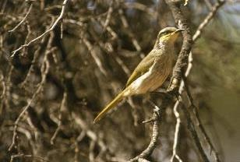**In the case of the Tuart Woodlands and Forests ecological community, the listing aims to:**

Singing Honeyeater © Brian Furby Collection

* + Raise awareness about the ecological community, the threats it faces and priority action to combat threats.
  + Mitigate the risk of extinction of the ecological community, and help recover its biodiversity and function through protecting it from significant impacts as a Matter of National Environmental Significance under national environmental law.
  + Guide the implementation of management and recovery activities, consistent with the recommended priority conservation and research actions set out in the [**Conservation Advice**](http://www.environment.gov.au/biodiversity/threatened/communities/pubs/153-conservation-advice.pdf).

## What does the listing mean for land managers?

How you may be affected depends on the size and quality of the patch or patches of the ecological community in question; and what you intend to do with any such patches.

National listing does not change the ownership of land or access to land. Neither does it change native title nor access for traditional cultural practices.

### A photo of Western Yellow RobinI want to keep or improve patches of Tuart Woodlands and Forests

Western Yellow Robin © Brian Furby Collection

Listing may open up funding opportunities for you. Land managers who want to retain good quality Tuart Woodlands and Forests, or intend to restore any patches of the Tuart Woodlands and Forests on their properties may be eligible for funding to help with their conservation work, through programs such as National Landcare. Many projects specifically target nationally listed threatened ecological communities.

Regional Catchment or National Resource Management (NRM) groups and Local Councils also often offer funding and advice support to help landholders look after threatened ecological communities.

### I have a new development that involves clearing or damaging Tuart Woodlands and Forests

If you are planning an activity that is likely to have a significant impact on the ecological community you must seek approval from the Minister for the Environment.

The activity which is likely to have a significant impact on the ecological community is permanently clearing large or otherwise important areas of intact or high-quality native vegetation. Some examples of projects likely to do this are: major mining, residential, commercial or other industrial development; building new roads or widening existing roads or tracks (e.g. for electricity transmission lines).

I want to continue the activity I am already doing in Tuart Woodlands and Forests

Activities that were routine, or began before the year 2000 may generally continue without referral/approval under the EPBC Act. Exemptions apply to activities that were already legally approved or are ongoing.

The ongoing and routine activities that are unlikely to require approval from the Australian Government include:

* unchanged grazing, horticultural or cropping activities
* maintaining existing fences, roads, internal access tracks and firebreaks
* maintaining existing gardens and orchards
* maintaining existing farm dams or water storages
* replacing and maintaining sheds, yards and other existing buildings
* targeted control of weeds and spraying for pests on individual properties
* management of feral pest species
* traditional cultural practices.

In all these cases land managers should aim to avoid damage to patches of the Tuart Woodlands and Forests, but are unlikely to need to refer for approval by the Australian government.

### Referral required for actions ‘likely to have a significant impact’

National environmental law is triggered if an action is likely to have a significant impact on the Tuart Woodlands and Forests ecological community. If you are planning an activity that may have such an impact you will need to:

* Make a referral to the Department of the Environment and Energy to clarify whether the action is a ‘controlled action.’

If the proposed action is a ‘controlled action’:

* Wait for the Department to make an assessment and provide advice to the Minister.
* Wait for a decision by the Minister on whether the activity is approved and any conditions that apply.

In making this decision the Minister must also consider social and economic matters relevant to individual projects. Strict timeframes apply to assessments to ensure decisions are made as quickly as possible. The Department encourages people to consider the presence of the ecological community early in planning any activities.

If significant impacts are avoided through good planning then national referral is not needed. This is the most cost effective and efficient way to allow land management and development while protecting the most important areas of this threatened ecological community.

## What can I do to look after the ecological community?

You can help look after Tuart Woodlands and Forests in your area:

* Avoid any activities that involve clearing the ecological community.
* Use established roads and paths and avoid trampling plants.
* Practise responsible pet ownership: keep dogs on a leash when walking and ensure cats do not roam into natural areas.
* Dispose of waste wisely.
* Report illegal or damaging behaviour, including unauthorised lighting of fires or dumping of rubbish to your council.
* Allow dead trees and fallen timber to remain and provide fauna habitat (do not collect these for firewood).
* 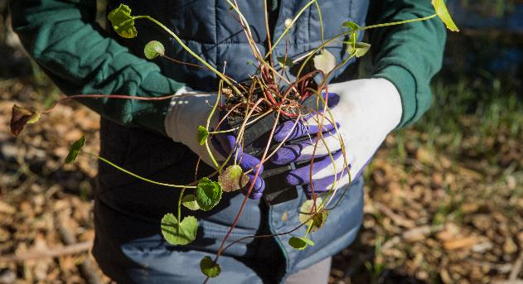Plant local species in your garden, including those outlined in the [**Conservation Advice**](http://www.environment.gov.au/biodiversity/threatened/communities/pubs/153-conservation-advice.pdf). Avoid planting potential environmental weeds.

Planting suitable native plants is one way to restore patches of the ecological community. This volunteer is helping to restore Lake Claremont, where there is a locally significant remnant of Tuart woodland © Tony McDonough

* Support local efforts to conserve native vegetation and wildlife in your area (e.g. by joining a local organisation such as a Landcare or catchment care group, natural history or a ‘friends of’ group).
* Learn about the ecological community, and participate in activities such as tree planting and weeding.

Many of the ecological interactions that support the ecological community happen at a larger scale. To assist these landscape functions it is important to plan and coordinate conservation actions across the region.

The [**Conservation Advice**](http://www.environment.gov.au/biodiversity/threatened/communities/pubs/153-conservation-advice.pdf) gives further details of priority conservation actions for the ecological community.

## Are there other nationally protected ecological communities within this area?

The Tuart Woodlands and Forests ecological community is often found integrated or interacting with other ecological communities of the Swan Coastal Plain. This includes some listed under national environmental law:

* The Banksia Woodlands of the Swan Coastal Plain
* Sedgelands in Holocene Dune Swales of the Southern Swan Coastal Plain
* Aquatic root mat community in caves of the Swan Coastal Plain

Information on these ecological communities can be found online at: [www.environment.gov.au/cgi-bin/sprat/public/publiclookupcommunities.pl](http://www.environment.gov.au/cgi-bin/sprat/public/publiclookupcommunities.pl)

## Do state or local laws also apply?

The Western Australian Government and local councils also have laws on vegetation clearance and protecting vegetation communities that may apply to patches of the ecological community. These state and local laws do not replace or stop the operation of national environmental law.

There also may be other nationally-protected matters that need to be considered, for instance any nationally threatened and migratory species likely to use patches of the ecological community as habitat. Birds, including black cockatoos, and other mobile species, are known to use Tuart Woodlands and Forests as feeding and nesting habitat. Other listed species, including mammals and plants, may also occur at some sites.

## Where can I get further information?

If you need help to identify if the ecological community or other Matters of National Environmental Significance may be present in your area of interest:

* Check the protected matters search tool at: [www.environment.gov.au/epbc/pmst/](http://www.environment.gov.au/epbc/pmst/)
* Check the species profile and threats (SPRAT) database at : [www.environment.gov.au/cgi-bin/sprat/public/sprat.pl](http://www.environment.gov.au/cgi-bin/sprat/public/sprat.pl)
* Consult with relevant expert, such as an ecological consultant, local NRM organisation or Catchment Council. They may be useful to help identify the ecological community and its condition.

The Conservation Advice for the Tuart woodlands ecological community is the definitive source of information on the listing of this ecological community. This is available on the Department of the Environment and Energy website:

* [**Conservation Advice**](http://www.environment.gov.au/biodiversity/threatened/communities/pubs/153-conservation-advice.pdf) for the Tuart (*Eucalyptus gomphocephala*) Woodlands and Forests of the Swan Coastal Plain ecological community: [www.environment.gov.au/cgi-bin/sprat/public/sprat.pl](http://www.environment.gov.au/cgi-bin/sprat/public/sprat.pl)
* National environment impact referral and approval process:   
  [www.environment.gov.au/protection/environment-assessments/assessment-and-approval-process](http://www.environment.gov.au/protection/environment-assessments/assessment-and-approval-process)
* Australian Government natural resource management initiatives: [www.nrm.gov.au](http://www.nrm.gov.au/)

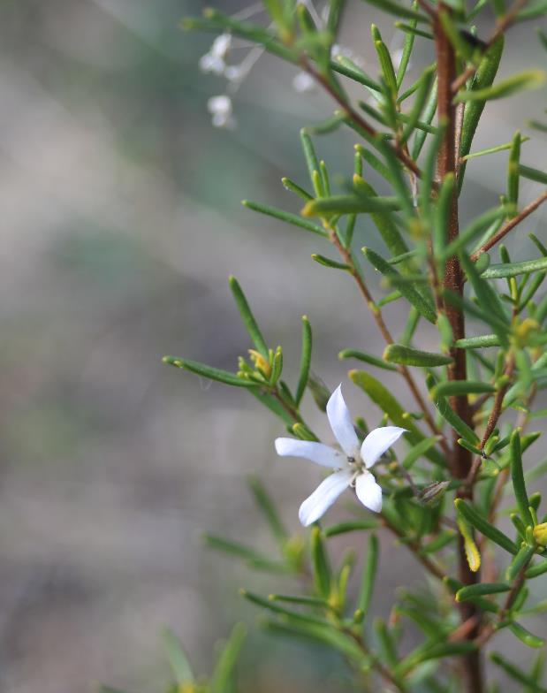For further information contact the Department’s Community Information Unit by phone on 1800 803 772 (freecall), or email at [ciu@environment.gov.au](mailto:ciu@environment.gov.au)

Re-emerging natives in the burnt understorey of Tuart Woodland in Yalgorup National Park © Trudy O’Connor

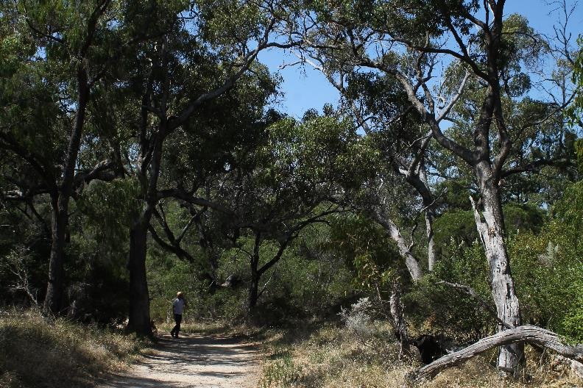**environment**.gov.au