Report prepared by


Report prepared for
Department of the Environment and Energy

Tyre flows and recycling analysis

Project report
Final report

28 October 2019

Project title: | Tyre flows and recycling analysis
Report title: | Project report (Final report)
Client: | Department of the Environment and Energy
Author: | Kyle O’Farrell
Reviewer: | Fiona Harney
Project reference: | A21508
Document reference: | R01-02
Date: | 28 October 2019
Report citation: | N/A
Disclaimer
This report has been prepared on behalf of and for the exclusive use of the Department of the Environment and Energy, and is subject to and issued in accordance with the agreement between the Department of the Environment and Energy and Envisage Works. Envisage Works accepts no liability or responsibility whatsoever for any use of or reliance upon this report by any third party.
Envisage Works contact details
ABN: 12 584 231 841
Post: PO Box 7050, Reservoir East VIC 3073
E-mail: admin@envisageworks.com.au
Phone: +61 (0)3 9016 5490

CONTENTS
Glossary / Abbreviations iv
1 Introduction 1
1.1 Project purpose and scope 1
1.2 Data limitations and assumptions 1
2 Tyres flow diagram 2
3 Tyre flows in Australia 3
3.1 Composition of tyres 3
3.2 Tyre sales 5
3.3 Tyre stocks (in-use) 8
3.4 Used tyre end-of-life arisings 10
3.5 End-of-life tyre fates 13
4 Used tyre recycling 18
4.1 Mechanical recycling of tyres 18
4.2 Chemical recycling of tyres 20
4.3 Tyre recyclers in Australia 21
5 References 23

Glossary / Abbreviations
Bitumen crumb rubber asphalt | An asphalt product which uses crumb rubber as a binder, typically for high traffic roads.
Casings | The rigid, inner of a tyre upon which a tread is placed. Typically, tyres good enough for retread or resale as seconds are referred to as casings.
Civil engineering | Engineering discipline that deals with the built environment, including works like roads, bridges, canals, dams, and buildings.
Crumb rubber | A highly refined rubber product, typically less than 1mm in diameter, made from recycled tyres.
Domestic recycling | Activities that occur to recycle or reprocess waste tyres within Australia.
End-of-life fates | The destination of an EOLT when it reaches the end of its useful life, including recycling, energy recovery and disposal to landfill
End-of-life tyres (EOLTs) | A tyre that is deemed no longer capable of performing the function for which it was originally made.
Energy recovery | The use of EOLTs in a thermal process to recover energy for electricity generation or industrial process.
Equivalent passenger units (EPUs) | A standard measure, based on the typical weight of a standard passenger tyre, used to quantify EOLTs in Australia.
In-use | Tyres that are in demand for the purpose for which they were originally made.
Landfill / unknown | End-of-life fates for EOLTs that include licensed and unlicensed landfill, illegal dumping, burning, stockpiling or unreported exports.
Off-the-road (OTR) tyres | Tyres from mining sites, heavy industry and other unregistered off-the-road applications.
Recovery | EOLT that are collected and either reused, recycled or combusted for energy recovery either in Australia or overseas.
Recycling | Process to recovery constituent materials from end-of-life tyres and use those materials to manufacture other products.
Retreading | The preparation of used tyres for reuse by replacing the outer tread.
Reuse | The use of tyres for the purpose for which they were originally made, including use of retreaded tyres and second-hand tyres
Rubber granule | A refined rubber product, typically 2mm – 15mm, made from recycled tyres.
Rubber modified sprayed seals | A road surfacing product that uses crumb rubber as a binder, typically on high stress road areas.
Tyre derived fuel (TDF) | Shredded tyres prepared to a specification for use in energy recovery.
Tyre Stewardship Australia | The not-for-profit company established to deliver the National Tyre Product Stewardship Scheme.
Tyre derived aggregate (TDA) | Shredded tyres prepared to a specification for use as aggregate in civil engineering applications.
Tyre derived products (TDPs) | Any product produced from rubber, steel, textiles or other material recovery from the recycling of EOLTs.

Introduction

Project purpose and scope
The purpose and scope of this project is to inform, in relation to tyres placed on the market in Australia and subsequently recovered either locally or overseas, across the following areas:
- A simple flow diagram including source streams, sorting and processing, landfilling and other key flows.
- Brief descriptions of the lifecycle flow of tyres – imports, uses, waste streams, and local and export reprocessing. Note that there has been no local manufacture of tyres in Australia since 2010.
- Brief descriptions of the types and grades of used tyre recovered materials and where they come from.
- Descriptions of the waste infrastructure types and wastes received, including information on capacity and quantities received to the extent this is available.
- Descriptions of recycled product types and markets.
The structure of this report largely parallels each of the scope elements outlined above.
The tyres material flow analysis (MFA) modelling presented in this report is an update of the MFA modelling used in the 2017 national project led by Sustainability Victoria, National market development strategy for used tyres 2017-2022 (REC, et. al., 2017). That report is available publicly and the MFA method and model adopted in this report are described in detail in that report.
The base year for the analysis in this report is the 2018–19 financial year.

Data limitations and assumptions
It is important to note that the data outlined in Section 3 of this report is based on a review and updated analysis of existing tyre flows data, primarily an extensive study undertaken in 2017 (REC, et. al., 2017), and the most recent Australian Border Force (Customs) data on tyre imports and exports from Australia. No direct industry consultation has been undertaken under the scope of this project to support the tyres flow quantification estimates. However, industry representatives have reviewed this report in draft, and provided feedback on the report, which has been incorporated into the report where possible.
In the tables presented in this report, minor discrepancies may occur between summed totals presented in tables, and the apparent sums of the component items in tables, as summed totals are calculated using component item values prior to rounding.
Data in this report should be interpreted as having a maximum of three significant figures. However, to obtain a balance between the proper statement of the accuracy of the data, while minimising the apparent summation discrepancies previously mentioned, weight data in this report has generally been rounded to the nearest 1 000 tonnes.

Tyres flow diagram
Figure 1 – Australian tyre flows in 2018–19
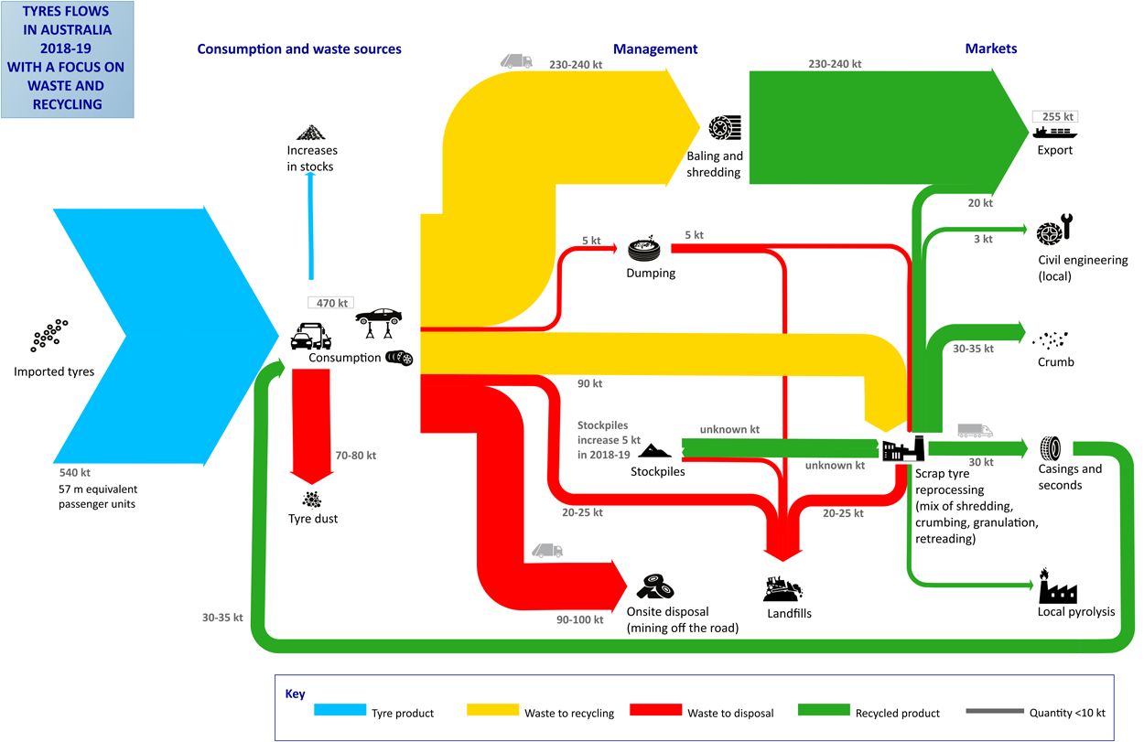

Tyre flows in Australia

Composition of tyres
Tyres are a composite product and are made from a combination of:
- natural and synthetic rubbers
- steel
- fibre (nylon and/or polyester)
- carbon black
- bonding agents.
The composition of tyres differs across the three main application areas of passenger, truck and off-the-road (OTR). The key compositional difference is that the rubber component of truck and OTR tyres is around 70% natural rubber and 30% synthetic on average, and passenger tyres are 35% natural rubber and 65% synthetic rubber. Natural rubber is currently preferred over synthetic rubber for the manufacturing of rubber crumb.
In addition, around 7% of passenger tyres is fabric, which does not currently have a market and when generated by tyre recyclers is disposed of to landfill. Fabric is generally not used in truck and OTR tyres.
This currently results in truck tyres being the preferred feedstock for reprocessing by local reprocessing facilities, as well as being sent to export. Passenger tyres are almost entirely sent to export, and there is little local reprocessing. There is also little OTR tyre reprocessing due to the highly variable sizes and large proportion of on-site disposal (which is not made available to recyclers).
The estimated quantities of tyres reaching end-of-life in 2018–19, by material type and tyre group, are presented in Table 1 and Figure 2.
Table 1 – Australian tyres reaching end-of-life in 2018–19, by material type and tyre group (tonnes)
Material | Passenger | Truck | OTR | Total
 | (tonnes) | (tonnes) | (tonnes) | (tonnes)
Rubber – natural | 27,000 | 42,000 | 31,000 | 100,000
Rubber – synthetic | 51,000 | 18,000 | 13,000 | 82,000
Metal – steel wire | 39,000 | 51,000 | 38,000 | 128,000
Plastic fibre/fabric – nylon | 7,000 | 0 | 0 | 7,000
Plastic fibre/fabric – polyester | 7,000 | 0 | 0 | 7,000
Rubber additive – carbon black | 20,000 | 17,000 | 13,000 | 50,000
Rubber additive – silica | 20,000 | 17,000 | 13,000 | 50,000
Rubber additive – zinc oxide | 2,000 | 3,000 | 2,000 | 7,000
Rubber additive – sulfur | 2,000 | 1,000 | 1,000 | 4,000
Rubber additive – other | 14,000 | 9,000 | 6,000 | 29,000
Total | 190,000 | 158,000 | 118,000 | 465,000
Source: REC, et. al. (2017) analysis (updated).

Figure 2 – Australian tyres reaching end-of-life in 2018–19, by material type and tyre group (tonnes)
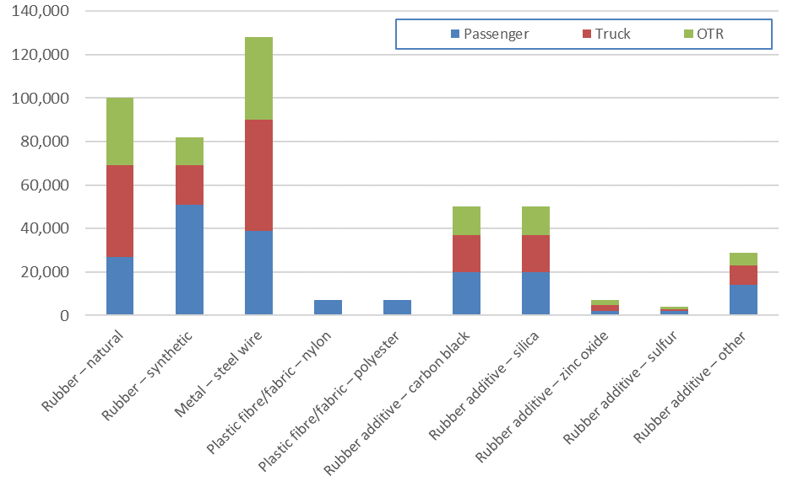

Tyre sales
In 2018–19, the Australian new tyre market (tyre sales or consumption) was 543,000 tonnes or 57.2 million equivalent passenger units (EPUs). Tyre sales by jurisdiction and tyre type are presented in Table 2 and Figure 3.
Around 43% (by weight) of tyres sold in 2018–19 were passenger tyres, 33% truck, and the remainder OTR tyres. All these tyres were imported, as passenger and truck tyres have not been manufactured in Australia since 2010, with the closure of the Bridgestone plant in Adelaide.

Table 2 – Australian tyre sales in 2018–19, by tyre type and jurisdiction
Jurisdiction | Passenger | Truck | OTR | Total
 | (tonnes) | (tonnes) | (tonnes) | (tonnes)
ACT | 4,000 | 2,000 | 1,000 | 7,000
NSW | 66,000 | 54,000 | 38,000 | 157,000
NT | 2,000 | 3,000 | 2,000 | 6,000
QLD | 45,000 | 49,000 | 25,000 | 120,000
SA | 17,000 | 13,000 | 7,000 | 36,000
TAS | 5,000 | 6,000 | 2,000 | 13,000
VIC | 59,000 | 44,000 | 30,000 | 132,000
WA | 25,000 | 24,000 | 22,000 | 71,000
Australia | 223,000 | 195,000 | 127,000 | 543,000
Source: REC, et. al. (2017) analysis (updated).

Figure 3 – Australian tyre sales in 2018–19, by tyre type and jurisdiction (tonnes)
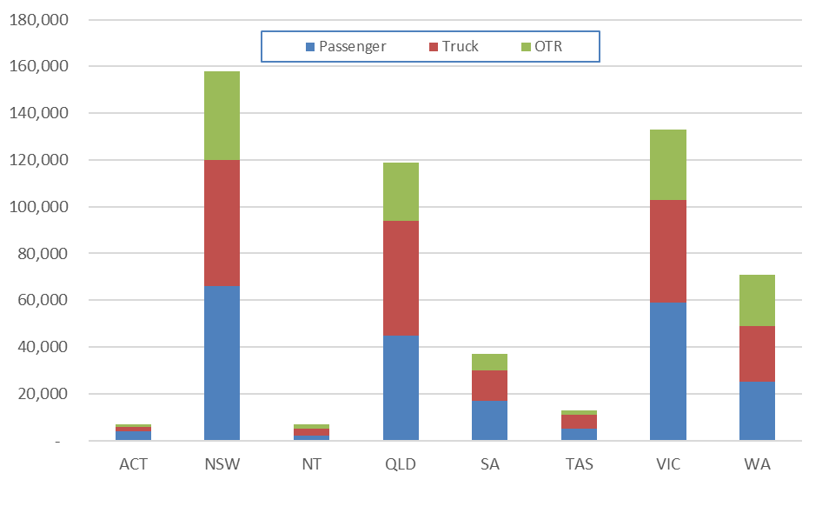

Projections of tyre sales data across the period of 2013–14 to 2024–25 are also available, and are presented in Table 3 and Figure 4.

Table 3 – Australian tyre sales 2013–14 to 2024–25, by tyre group
Year | Passenger | Truck | OTR | Total
 | (tonnes) | (tonnes) | (tonnes) | (tonnes)
2013–14 | 212,000 | 176,000 | 162,000 | 550,000
2014–15 | 217,000 | 170,000 | 152,000 | 539,000
2015–16 | 225,000 | 172,000 | 129,000 | 526,000
2016–17 | 227,000 | 176,000 | 124,000 | 527,000
2017–18 | 234,000 | 185,000 | 140,000 | 559,000
2018–19 | 223,000 | 194,000 | 126,000 | 543,000
2019–20 | 226,000 | 197,000 | 128,000 | 551,000
2020–21 | 229,000 | 200,000 | 130,000 | 559,000
2021–22 | 233,000 | 203,000 | 132,000 | 568,000
2022–23 | 236,000 | 206,000 | 133,000 | 575,000
2023–24 | 240,000 | 209,000 | 135,000 | 584,000
2024–25 | 243,000 | 212,000 | 138,000 | 593,000
Source: REC, et. al. (2017) analysis (updated).

Figure 4 – Australian tyre sales 2013–14 to 2024–25, by tyre group (tonnes)
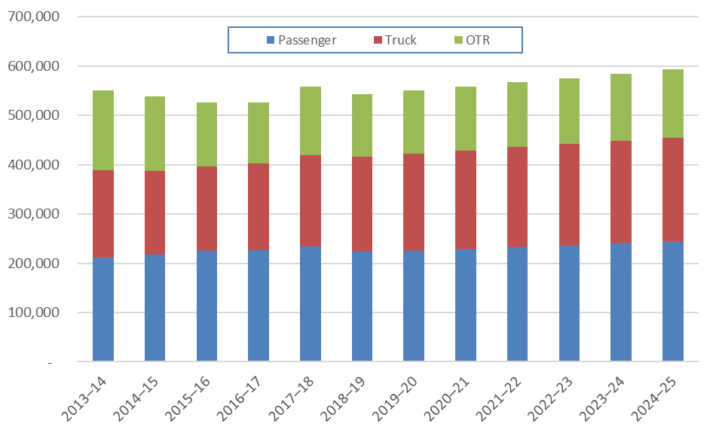

Per capita sales of tyres in 2018–19 are estimated at 21.3 kg/person.yr, and are forecast to remain at around this level until 2024–25.

Tyre stocks (in-use)
The useful life of a tyre is spent ‘in-use’, also known as ‘tyre stocks’. This refers to the period in a tyre’s lifecycle where it is utilised in the purpose for which it was made. Retreaded tyres and second-hand tyres are also included in the estimated tyre stocks provided in this section of the report.
Average tyre lifespans are estimated at 3.4 years for passenger tyres, 1.5 years for truck tyres, and 1 year for OTR tyres (Hyder, 2015).
In 2018–19 around 754,000 tonnes of tyres (86.2 million EPUs) were in-use in Australia. Table 4 and Figure 5 present Australian tyre stocks in 2018–19 by jurisdiction and tyre type.

Table 4 – Australian tyre stocks in 2018–19, by tyre type and jurisdiction
Jurisdiction | Passenger | Truck | OTR | Total
 | (tonnes) | (tonnes) | (tonnes) | (tonnes)
ACT | 9,000 | 1,000 | 1,000 | 11,000
NSW | 151,000 | 36,000 | 35,000 | 222,000
NT | 4,000 | 2,000 | 2,000 | 8,000
QLD | 103,000 | 33,000 | 23,000 | 159,000
SA | 38,000 | 8,000 | 6,000 | 52,000
TAS | 12,000 | 4,000 | 2,000 | 18,000
VIC | 136,000 | 29,000 | 27,000 | 192,000
WA | 58,000 | 16,000 | 20,000 | 94,000
Australia | 510,000 | 128,000 | 116,000 | 754,000
Source: REC, et. al. (2017) analysis (updated).

Figure 5 – Australian tyre stocks in 2018–19, by tyre type and jurisdiction (tonnes)
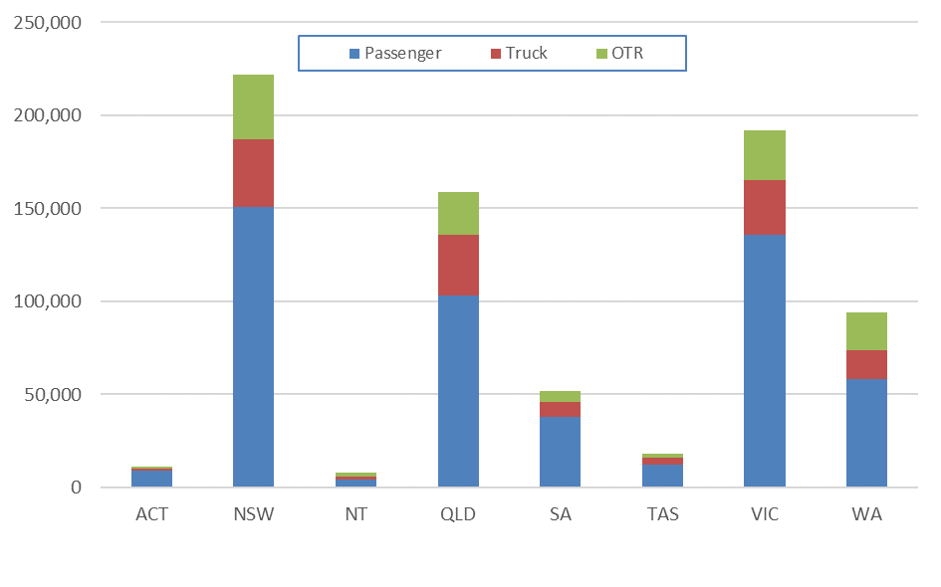

Projections of tyre stocks data across the period of 2013–14 to 2024–25 are also available, and are presented in Table 5 and Figure 6.

Table 5 – Australian tyre stocks 2013–14 to 2024–25, by tyre group
Year | Passenger | Truck | OTR | Total
 | (tonnes) | (tonnes) | (tonnes) | (tonnes)
2013–14 | 466,000 | 110,000 | 149,000 | 725,000
2014–15 | 476,000 | 109,000 | 140,000 | 725,000
2015–16 | 489,000 | 111,000 | 119,000 | 719,000
2016–17 | 500,000 | 115,000 | 114,000 | 729,000
2017–18 | 512,000 | 121,000 | 129,000 | 762,000
2018–19 | 510,000 | 128,000 | 116,000 | 754,000
2019–20 | 508,000 | 131,000 | 118,000 | 757,000
2020–21 | 509,000 | 135,000 | 119,000 | 763,000
2021–22 | 515,000 | 138,000 | 121,000 | 774,000
2022–23 | 522,000 | 142,000 | 123,000 | 787,000
2023–24 | 530,000 | 145,000 | 125,000 | 800,000
2024–25 | 538,000 | 149,000 | 127,000 | 814,000
Source: REC, et. al. (2017) analysis (updated).

Figure 6 – Australian tyre stocks 2013–14 to 2024–25, by tyre group (tonnes)
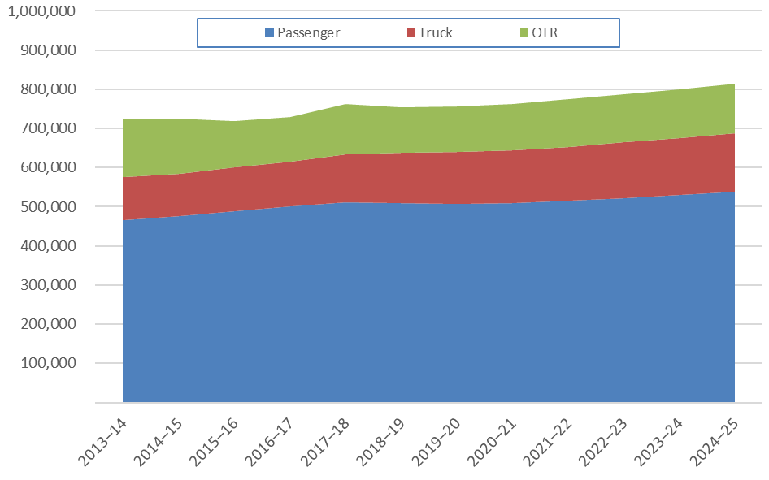

Based on projected rates of tyre consumption, Australian tyre stocks are expected to reach more than 800,000 tonnes by 2024–25.

Used tyre end-of-life arisings
The generation of end-of-life tyres (EOLTs) is determined by rates of consumption, stocks and the average lifespan of tyres. EOLT arisings in Australia were 465,000 tonnes or 58.2 million EPUs in 2018–19. Table 6 and Figure 7 present EOLT arisings in Australia in 2018–19.
During the use phase of tyres an estimated 15% of the tyre weight is dispersed as tyre dust to the open environment due to tyre wear. It is estimated that in 2018–19, 80,000 tonnes were lost to the environment through this pathway. Tyre wear losses are not included in the data reported in the tables and figures of this section.

Table 6 – Australian EOLT in 2018–19, by jurisdiction and tyre group
Jurisdiction | Passenger | Truck | OTR | Total
 | (tonnes) | (tonnes) | (tonnes) | (tonnes)
ACT | 3,000 | 1,000 | 1,000 | 5,000
NSW | 56,000 | 44,000 | 35,000 | 135,000
NT | 1,000 | 2,000 | 2,000 | 5,000
QLD | 38,000 | 40,000 | 24,000 | 102,000
SA | 14,000 | 10,000 | 6,000 | 30,000
TAS | 4,000 | 5,000 | 2,000 | 11,000
VIC | 51,000 | 35,000 | 28,000 | 114,000
WA | 21,000 | 19,000 | 21,000 | 61,000
Australia | 188,000 | 156,000 | 119,000 | 465,000
Source: REC, et. al. (2017) analysis (updated).

NSW was the largest generator of EOLTs in 2018–19 at around 135,000 tonnes (16.9 million EPUs), with Victoria and Queensland generating around 114,000 tonnes (14.3 million EPUs) and 102,000 tonnes (12.8 million EPUs) respectively.

Figure 7 – Australian EOLT in 2018–19, by tyre type and jurisdiction (tonnes)
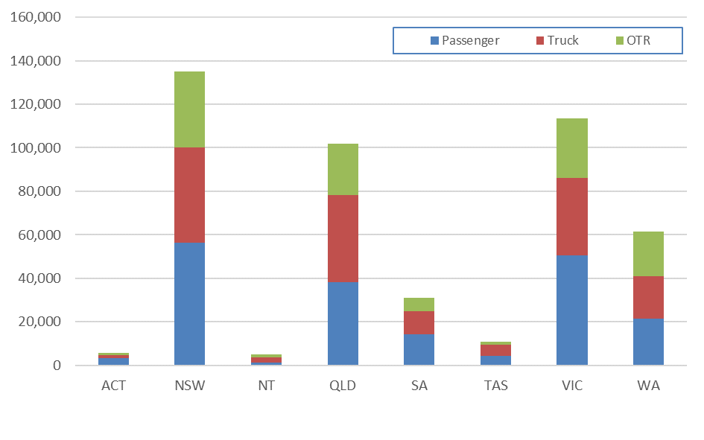

Projections of tyres reaching end-of-life across the period of 2013–14 to 2024–25 are also available, and are presented in Table 7 and Figure 8. It is estimated that around 488,000 tonnes or 61 million EPUs will reach end-of-life in 2024–25, up 5% from 2018–19.

Table 7 – Australian EOLT 2013–14 to 2024–25, by tyre group
Year | Passenger | Truck | OTR | Total
 | (tonnes) | (tonnes) | (tonnes) | (tonnes)
2013–14 | 171,000 | 145,000 | 134,000 | 450,000
2014–15 | 174,000 | 144,000 | 136,000 | 454,000
2015–16 | 177,000 | 142,000 | 128,000 | 447,000
2016–17 | 181,000 | 145,000 | 109,000 | 435,000
2017–18 | 186,000 | 150,000 | 104,000 | 440,000
2018–19 | 190,000 | 158,000 | 118,000 | 465,000
2019–20 | 192,000 | 163,000 | 106,000 | 461,000
2020–21 | 192,000 | 165,000 | 108,000 | 465,000
2021–22 | 191,000 | 168,000 | 109,000 | 468,000
2022–23 | 192,000 | 170,000 | 111,000 | 473,000
2023–24 | 195,000 | 173,000 | 112,000 | 480,000
2024–25 | 198,000 | 176,000 | 114,000 | 488,000
Source: REC, et. al. (2017) analysis (updated).

Figure 8 – Australian EOLT 2013–14 to 2024–25, by tyre group (tonnes)
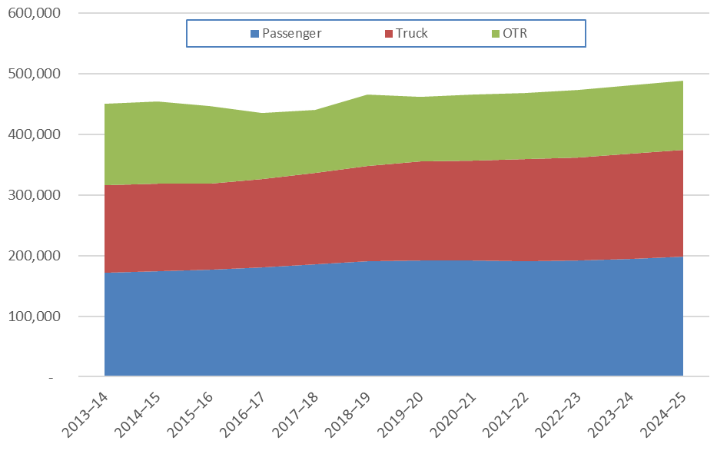

End-of-life tyre fates
It is estimated that a little over 460,000 tonnes of EOLTs were generated in Australia in 2018–19, of which around 208,000 tonnes (26.0 million EPUs) or 45% were processed locally, disposed of onsite (mainly mining tyres), or sent to landfill.
A further 255,000 tonnes were exported, which is sold mostly into tyre derived fuel (TDF) related applications. Those being, either shredded tyres as fuel for cement kilns or electricity generation, or pyrolysis for fuels and steel recovery.
Note that most states and territories do not allow landfilling of whole tyres to licensed landfills, and it is not common practice to shred tyres and send them to landfill.

Table 8 – Indicative EoL tyre fates in 2018–19, domestic and export destinations
Destination | Passenger | Truck | OTR | Total
 | (tonnes) | (tonnes) | (tonnes) | (tonnes)
Domestic | 30,000 | 71,000 | 107,000 | 208,000
Export | 158,000 | 85,000 | 12,000 | 255,000
Total | 188,000 | 156,000 | 119,000 | 463,000
Source: REC, et. al. (2017) analysis (updated).

Figure 9 – EoL tyre fates in 2018–19, domestic and export destinations (tonnes)
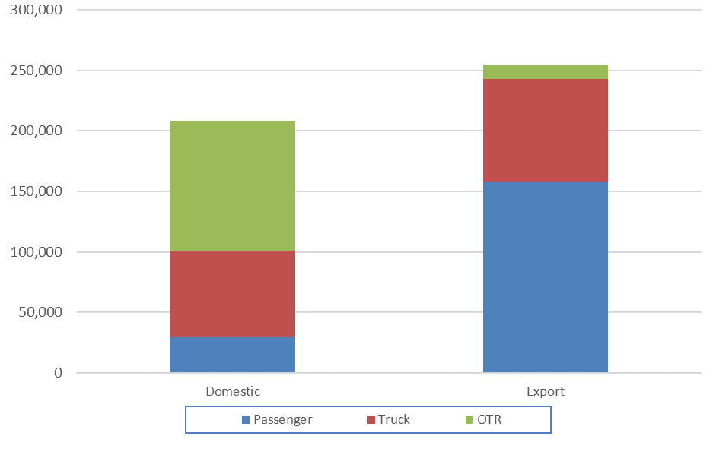

Domestic EOLT fates in Australia are summarised in Table 9 and Figure 10 below. Domestic material recycling of EOLTs in Australia remains a relatively minor contributor to overall end-of-life fates with only 65,000 tonnes (14% of all EOLT) being locally recovered in 2018–19.

Table 9 – Domestic EoL tyre fates in 2018–19
Fate | Passenger | Truck | OTR | Total
 | (tonnes) | (tonnes) | (tonnes) | (tonnes)
Casings & seconds | 2,000 | 30,000 | 0 | 32,000
Civil engineering | 1,000 | 1,000 | 1,000 | 3,000
Crumb, granules and buffings | 6,000 | 27,000 | 0 | 33,000
Pyrolysis¹ | NR | NR | NR | NR
Stockpiles | - | - | - | 5,000
Landfill | 21,000 | 8,000 | 5,000 | 34,000
Onsite disposal (mining OTR) | 0 | 0 | 96,000 | 96,000
Dumping | 1,000 | 2,000 | 2,000 | 5,000
Total | 32,000 | 70,000 | 107,000 | 208,000
Source: REC, et. al. (2017) analysis (updated).
1. Local pyrolysis processed tyre data not reported due to commercial confidentiality constraints. Quantity is currently well under 5,000 tonnes/yr.

See Section 4.1 for an outline of the related applications for the fates listed in Table 9.
There was no up-to-date information available for this project on interstate transfers of tyres prior to local reprocessing. Most EOLTs are exported, and these will generally be exported directly from the jurisdiction in which they were generated.
Another important potential domestic fate for used tyres is stockpiles. There was some growth in stockpiles reported in 2018–19 of around 5,000 tonnes of tyres (TSA, 2019). The current total quantity of tyres in stockpiles nationally is unknown, but may be in the order of 100,000–300,000 tonnes. It is very important to note that these estimates are indicative only, and significant additional work is required to verify these stockpile change and total estimates.
Figure 10 – Domestic EoL tyre fates in 2018–19 (tonnes)
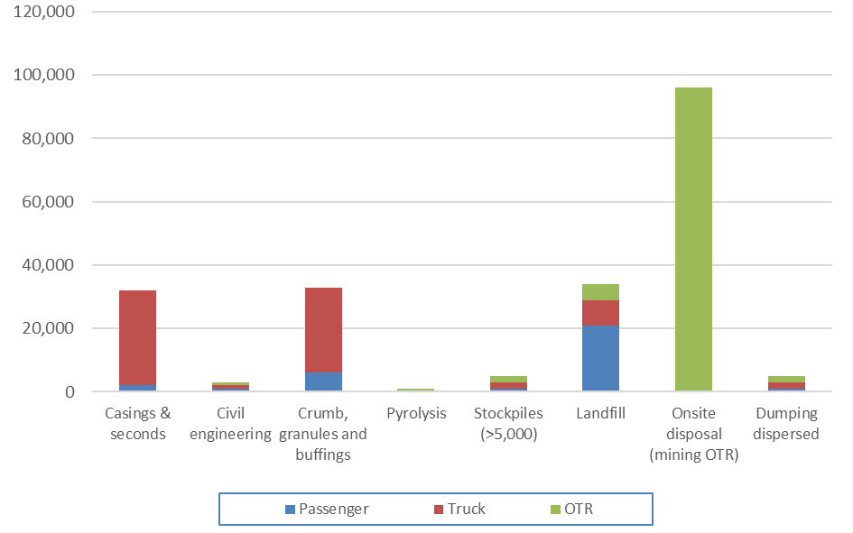

The major destination for EOLT is the export market for baled tyres and TDF for energy recovery. It is estimated that around 255,000 tonnes (31.9 million EPUs) or 55% of all tyres reaching end-of-life are exported. The available (indicative) data on export fates is presented in Table 10 and Figure 11 below.

Table 10 – Exported EoL tyre fates in 2018–19
Fate | Passenger | Truck | OTR | Total
 | (tonnes) | (tonnes) | (tonnes) | (tonnes)
TDF and unknown¹ | 150,000 | 80,000 | - | ~235,000
Casings & seconds | - | - | - | ~20,000
Crumb, granules and buffings | - | - | -
Total | 158,000 | 85,000 | 12,000 | 255,000
Source: REC, et. al. (2017) analysis (updated).
1. Assumed mostly into TDF related applications.

No export of retreaded tyres from Australia has been identified, however some may occur. It is anticipated that generally (unretreaded) casings will be exported for retreading overseas.
Figure 11 – Exported EoL tyre fates in 2018–19 (tonnes)
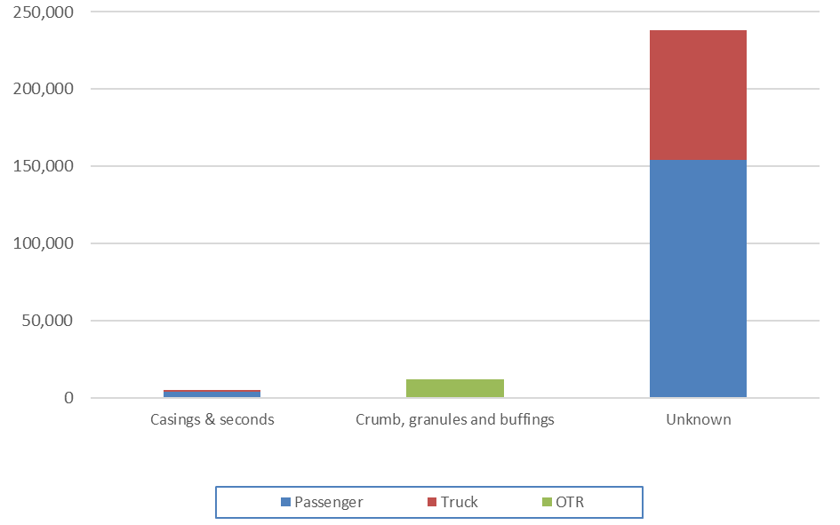

In 2018–19 the major receiving countries for exported EOLTs is summarised in Table 11 below. India was the major receiving country, importing around 39% of Australian EOLTs where the destination country was identifiable. These tyres are likely to be either burnt or pyrolyzed for fuel and steel recovery. Malaysia and South Korea received 28% and 19% of EOLTs respectively, where the destination country was identifiable.
There is a significant mismatch between the used tyre exports that are readily identifiable in the Customs export dataset, and exports as reported by local collectors and processors in 2018–19 (TSA, 2019). Around twice as many tyres are reported as exported by industry (through direct survey) as are identifiable in the Customs data. For this reason, the destination countries of around 50% of exported tyres are unknown. This means that the exports to the countries listed in Table 11 are probably significantly understated, so should be regarded as minimums.

Table 11 – Exported EoL tyre fates in 2018–19
Destination | Passenger | Truck | OTR | Total | Reported typical major applications
 | (tonnes) | (tonnes) | (tonnes) | (tonnes)
India | 31,000 | 14,000 | 4,000 | 48,000 | Whole tyres into pyrolysis facilities and various industrial furnace and kilns.
Malaysia | 22,000 | 10,000 | 3,000 | 35,000 | Whole and shredded tyres into pyrolysis facilities and various industrial furnace and kilns.
Republic of Korea (South) | 21,000 | 2,000 | - | 23,000 | Shredded tyres into electricity generation and cement kilns.
United States | 4,000 | - | - | 4,000 | Possibly dominated by retreads and casings.
Singapore | 2,000 | - | - | 2,000 | Unknown.
Liberia¹ | 1,000 | - | - | 2,000 | Whole tyres into pyrolysis facilities and various industrial furnace and kilns.
China | 1,000 | - | - | 1,000 | Unknown.
Japan | 1,000 | - | - | 1,000 | Shredded tyres into electricity generation and cement kilns.
Other known countries | 7,000 | 1,000 | - | 8,000 | Various.
Other unknown countries² | 68,000 | 58,000 | 5,000 | 131,000 | Assumed commonly whole tyres into pyrolysis facilities and various industrial furnace and kilns.
Total | 158,000 | 85,000 | 12,000 | 255,000
Source: REC, et. al. (2017) analysis (updated).
1. Identifiable aggregated exports to African countries as a group were at least 4,000 tonnes in 2018–19.
2. These ‘unknown country’ destinations are anticipated to primarily be India and South Korea.

Used tyre recycling

Mechanical recycling of tyres
Australia tyre recycling is dominated by mechanical recycling methods which use a series of shredders, screens and granulators to separate materials, and manufacture a range of tyre derived products (TDPs). An overview of the related TDPs and applications are outlined below.

Figure 12 – Overview of mechanical recycling TDPs and applications
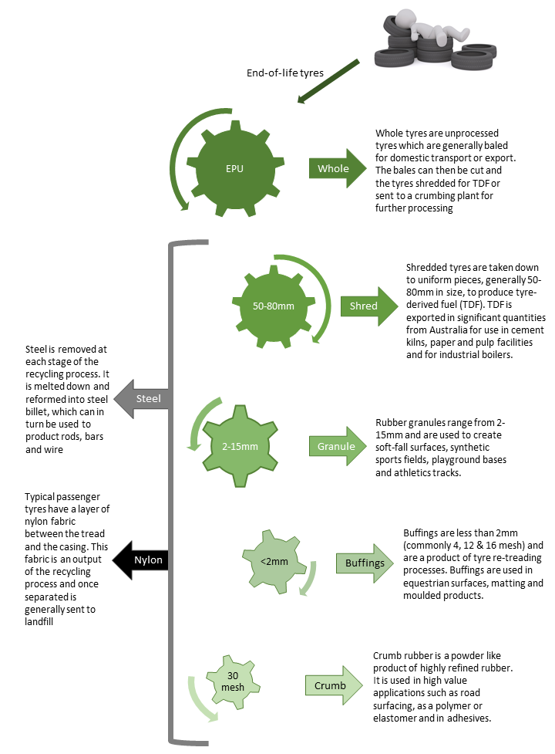
Source: REC, et. al. (2017, p. 9).

Whole tyres / casings
Whole recovered tyres (commonly referred to as “casings”) are unprocessed tyres which can be sold locally or exported for second-hand reuse or retreading.
The domestic market for casings has declined significantly over the last decade with Australian consumers moving away from passenger tyre retreads. However, truck and light truck casings are still recovered for retreading with facilities operating in most capital cities. There is a strong casings export market from Australia into Asia and Africa.

Baled tyres
Whole tyres are compressed using a hydraulic bale press and then bound with high tensile wire to form a block shape. Baling is a fast and relatively cheap process that can greatly improve efficiencies for both interstate and international transport. However, tyres are rarely baled for transport to local recyclers.
It is reported that tyres are particularly sought after in India, as the bales can be handled manually, unlike containerised shredded tyres.
Bales typically contain more than 100 EPUs and range from 500 kg up to two tonnes in weight.
It is worth noting that the cost of baling tyres has been estimated at around $70 per tonne, compared with shredding costs of around $80–$120 per tonne (REC, et. al., 2017). The off-shoring cost for baled or shredded tyres is around $30–$40 /tonne. These are 2017 estimates.

Shredded tyres
Most EOLTs in Australia that are recovered for recycling end up in the form of shredded (chipped) tyres with the dominant product in this market being tyre-derived fuel (TDF). Exports of EOLTs for energy recovery (which includes TDF and baled tyres) accounts for approximately 80% of the local and export used tyre market.

Granulate / buffing
Rubber granulate is generally in the order of 2mm – 15mm and is produced via a series of granulators and screens that further process shredded tyres into a refined, uniform product. Granulate is mostly free from contaminants with the metal and fabric removed via magnets and air separation respectively.
Buffings are pure tyre rubber that are effectively shaved off the remaining tread on a tyre casing during the retreading process. Casings are mounted on a rotating disk and a series of blades strip the tread to the point that the casing is ready for the new tread to be applied. Buffings are around 10–20mm in length and are highly valued due to the very low contamination levels.
Granule and buffings are used in soft-fall surfacing, moulded product, playgrounds and equestrian surfaces (REC, et. al., 2017).

Crumb rubber
The most highly refined product from traditional tyre recycling is crumb rubber (also known as rubber crumb, crumb or powder). Crumb rubber is less than 1 mm in particle size diameter and is produced using a three-stage grinding process to separate rubber, fabric and steel. Less commonly, crumb rubber can be produced using a cryogenic process where the rubber is frozen with liquid nitrogen and ground in a hammer mill. Cryogenic crumbing is no longer undertaken in Australia due to the processing cost.
Crumb rubber makes up a significant part of the domestic market for TDP with applications ranging from asphalt pavements to high value polymer products and explosives. However, infrastructure costs are high with a commercial scale crumbing plant likely to cost in excess of $10 million (REC, et. al., 2017).

Steel
Tyres often contain two steel products. A thin layer of high tensile steel known as “steel belt”, sits beneath the tread to provide reinforcement for the rubber and give the tyre strength in supporting heavy loads. In addition, the sidewall of a tyre contains steel beading or wire which keeps the tyre locked safely onto the bead of the wheel rim.
Recovered steel is processed by metal recyclers back into commercial grade steel billet. The scrap steel recovered from tyres is a low value form of steel scrap.
Passenger tyres are around 16% steel by weight, and truck/OTR tyres are typically 25% steel by weight (REC, et. al., 2017).

Nylon and polyester fabric
Passenger tyres commonly have a layer of nylon fabric beneath the tyre tread and the steel belt as further reinforcement. This is typically either nylon or polyester and can be extracted during the recycling process using air separation. The resultant material is typically sent to landfill in Australia.

Chemical recycling of tyres
There is ongoing development of chemical recycling technologies designed to use EOLTs as a feedstock. These are typically based on pyrolysis and gasification processes. See Figure 13 overview of TDPs from this type of used tyre processing technologies.
There are a number of facilities in the early commercialisation phase in Australia. These include (but are not limited to):
- Green Distillation Technologies (Warren NSW)
- Pearl Global (Willetton WA)

Figure 13 – Overview of chemical recycling TDPs and applications
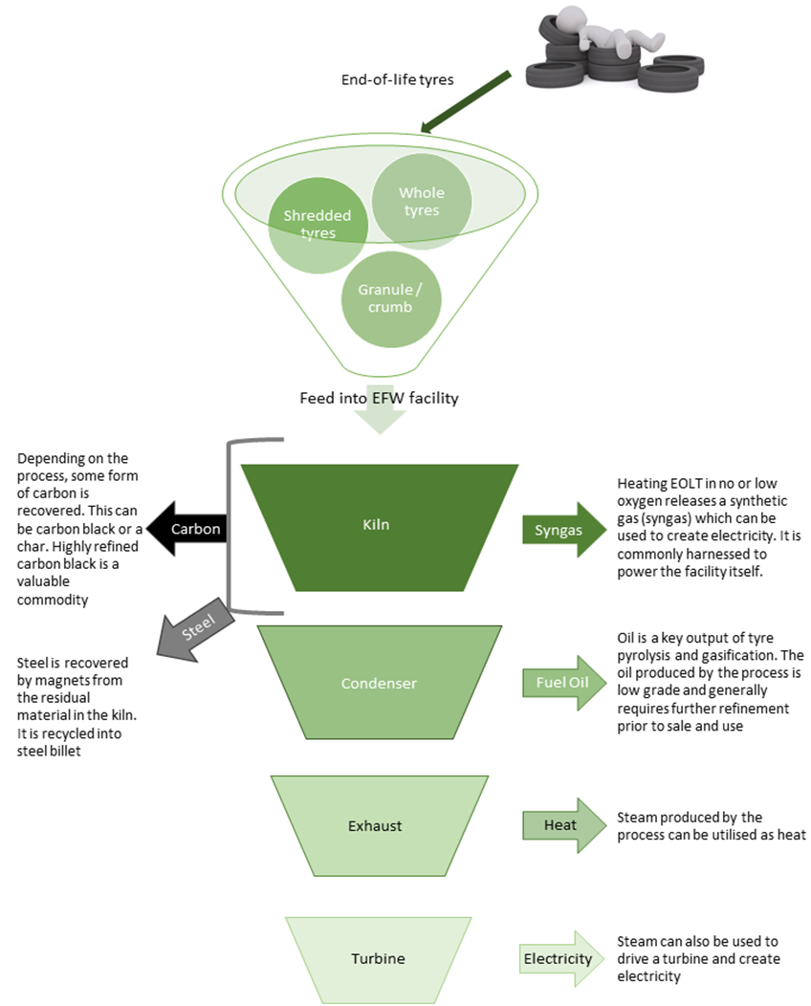
Source: REC, et. al. (2017, p. 12).

Tyre recyclers in Australia
Summarised in Table 12 are the larger EOLT recyclers currently operating in Australia that have been identified, along with a short description of their main tyre related recycling activities. In total, seven companies undertaking crumbing have been identified, two specialising in baling, two specialising in using whole tyres in civil works, three in casings/retreads, and three pyrolysis facilities.
This list is presented here to provide an understanding of the approximate number and spread of business activities in the used tyre management sector.
It is important to note that the list is not comprehensive, and in particular there are likely to be a number of companies specialising in baling and exporting of tyres that are not listed.

Table 12 – EOLT recyclers in Australia
Company | State/Territory | Main activities
Australian Tyre Processors | QLD | Shredding.
Bandag | QLD | Retreading.
BG & JM Barwick | TAS | Shredding.
BSV Tyre Recycling Australia | NSW | Baling, shredding and crumbing.
Chip Tyre | QLD | Shredding and crumbing.
D&N Rubber Refinery | NSW | Shredding and crumbing.
Ecoflex International | NSW | Whole tyres into civil works.
Elan | WA | Pyrolysis facility and baling.
Green Distillation Technologies | NSW | Pyrolysis facility.
JLW Services | NSW | Shredding and crumbing.
Lomwest Enterprises | WA | Whole tyres into civil works.
Oz Tyre Recyclers | VIC | Baling.
Ozcom Recycling | QLD | Casings.
Pearl Global | WA | Pyrolysis facility.
Ray Johnson Scrap Tyre Disposals | NSW | Casings.
Seven Star Rubber Crumb | QLD | Shredding and crumbing.
Tyre Crumb | VIC | Shredding and crumbing.
Tyre End | QLD | Casings.
Tyrecycle (ResourceCo) | National | Shredding and crumbing. Recycling facilities in all states.
Source: Envisage Works and REC, et. al. (2017).

References
Blue Environment, 2019. ABS waste data export from Australia, Melbourne: Report prepared by Blue Environment on behalf of the Department of the Environment and Energy.
Hyder, 2015. Stocks & fate of end of life tyres – 2013–14 study, Melbourne: Report prepared by Hyder Consulting on behalf of the National Environment Protection Council.
REC, et. al., 2017. National market development strategy for used tyres 2017-2022, Melbourne: Report prepared by Randell Environmental Consulting, Reincarnate and Envisage Works on behalf of Sustainability Victoria.
TSA, 2019. Survey of Australian tyre reprocessors (unpublished), Melbourne: Tyre Stewardship Australia.
VicRoads, 2019. Literature Review on Passenger Vehicle Tyre Usage in Bitumen, Melbourne: Report prepared by the Australian Road Research Board (ARRB) on behalf of VicRoads.

Adopted new passenger tyre weight of 9.5 kgs.
Assumes an average in-use passenger tyre weight of 8.75 kilograms (due to wear).
Assuming an EOLT EPU weight of 8 kilograms.

