

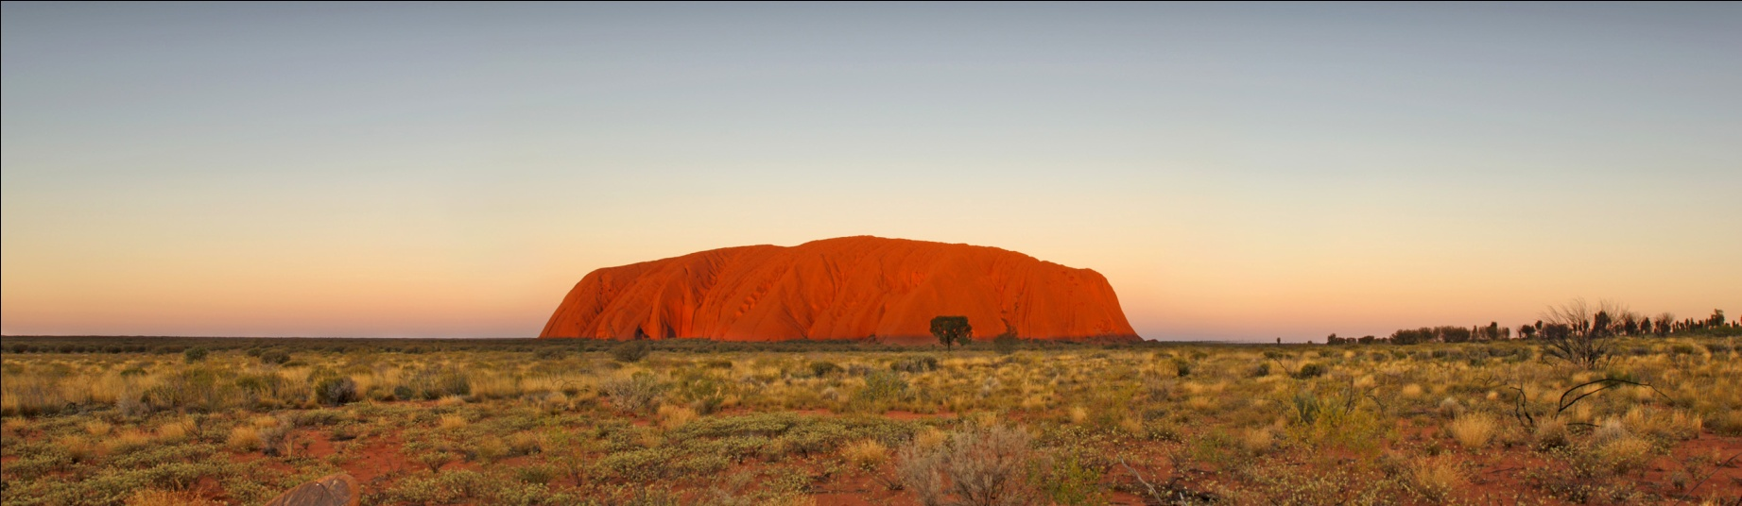

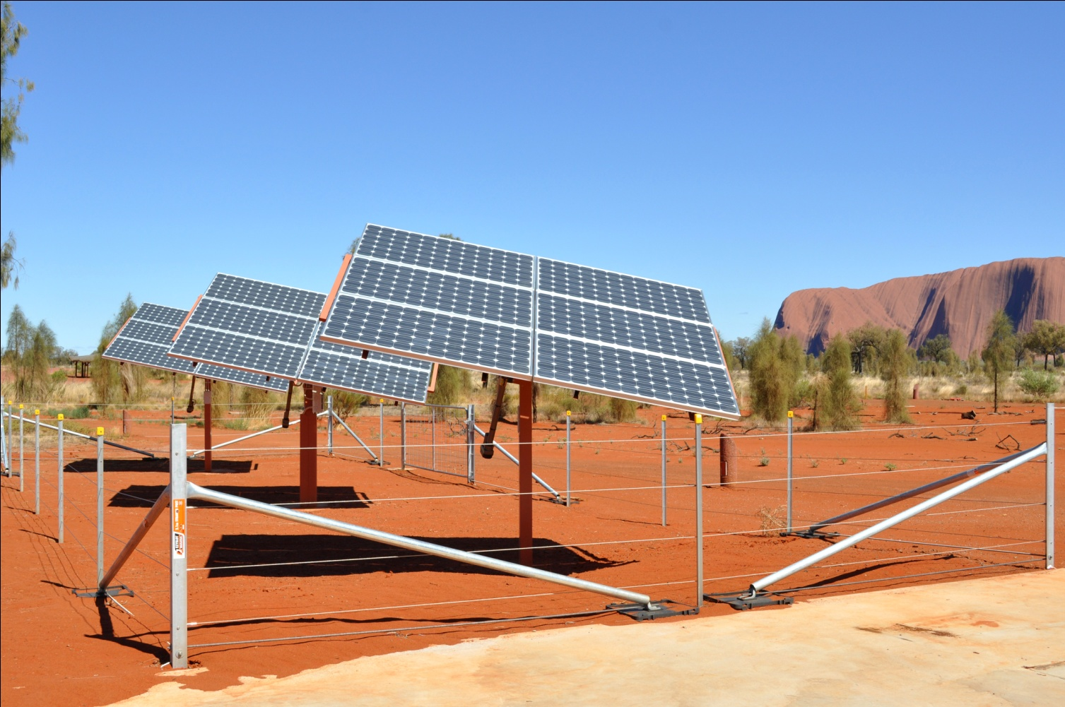



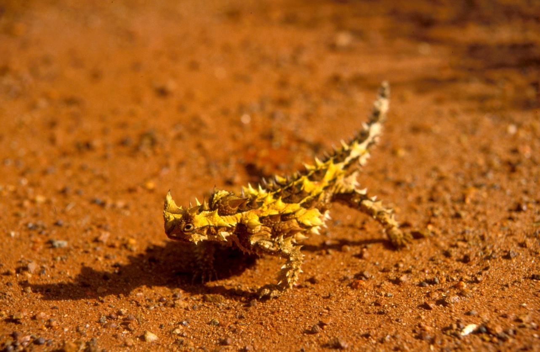

Uluru-Kata Tjuta National Park

Climate Change Strategy 2012-2017



Prepared by: Director of National Parks

© Commonwealth of Australia 2012

This publication is copyright. Apart from any use permitted under the *Copyright Act 1968*, no part may be reproduced by any process without prior written permission from the Commonwealth. Inquiries regarding reproduction should be addressed to:

Director of National Parks

Department of Sustainability, Environment, Water, Population and Communities

GPO Box 787

CANBERRA ACT 2601

Note: This strategy sets out the preliminary strategies and tools necessary to manage the consequences of climate change at Uluru-Kata Tjuta National Park. While the Australian Government is committed to acting in accordance with the strategy, the attainment of objectives is subject to budgetary and other constraints affecting the parties involved. Proposed strategies may be subject to modification over the life of the strategy due to changes in knowledge and policy direction.

This plan should be cited as:

Director of National Parks 2012. *Uluru-Kata Tjuta National Park Climate Change Strategy 2012-2017*. Department of Sustainability, Environment, Water, Population and Communities, Canberra, Australia.

This strategy is available online from: environment.gov.au/parks/climate.html

**1. Background**

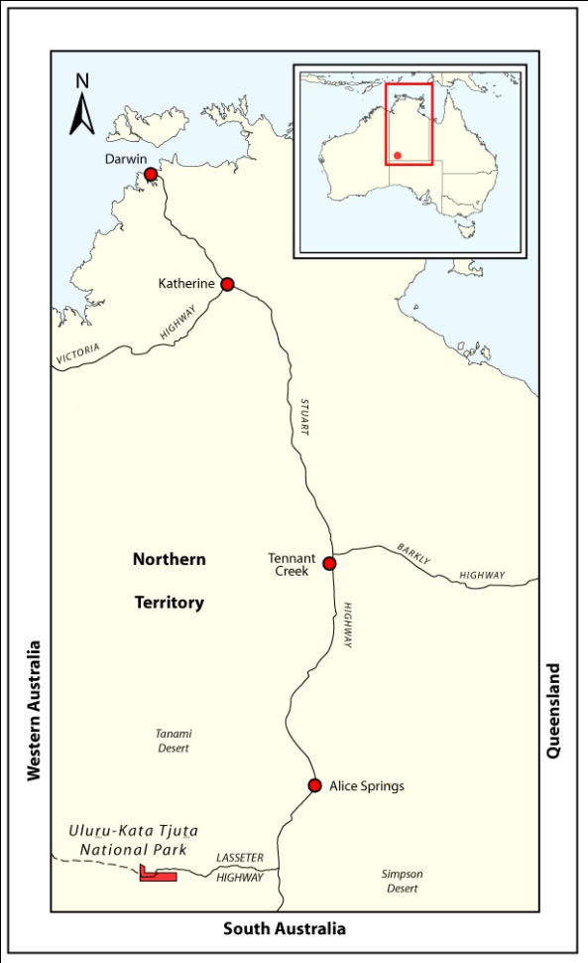The Intergovernmental Panel on Climate Change Fourth Assessment Report concluded that human induced climate change is expected to have a discernable influence on many physical and biological systems. The resilience of many ecosystems is likely to be exceeded over the course of the twenty-first century and approximately a quarter of all plant and animal species are likely to be at increased risk of extinction if increases in global average temperature continue to match current projections (IPCC 2007).

Uluru-Kata Tjuta National Park covers an area of 132,566 hectares within the Greater Sandy Desert bioregion of the Northern Territory (Figure 1). The park’s landscape is dominated by the iconic massifs of Uluru and Kata Tjuta. Uluru is 9.4 kilometres in circumference and rises about 340 metres above the surrounding plain. Kata Tjuta comprises 36 rock domes of varying size. One of the domes, rising about 500 metres above the plain (or 1,066 metres above sea level), is the highest feature in the park. These two geological features are striking examples of geological processes and erosion occurring over time.

The contrast of these monoliths with the surrounding sandplains creates a landscape of exceptional natural beauty of symbolic importance to both Anangu and non-Aboriginal cultures. The Uluru and Kata Tjuta massifs, rocky slopes and foothills contribute to the park’s high biodiversity. The many other patterns and structures in the landscape reflect the region’s evolutionary history and give important clues about limitations on natural resource use and management (Gillen et al. 2000).

**Figure 1: Location of Uluru-Kata Tjuta National Park**

The Greater Sandy Desert bioregion has less than five per cent of its total area within protected areas – the park is one of only five reserves and plays a significant role in contributing to long-term biodiversity conservation in the region. Within the bioregion, the park is representative of a broad landform structure that is a recurring pattern in arid Central Australia (Gillen et al. 2000).

The Uluru–Kata Tjuta landscape is a representative cross-section of Central Australian arid ecosystems. The main ecological zones in the park are:

* *puli* – rock faces and vegetated hill slopes
* *puti – woodlands, particularly the mulga flats between sandhills*
* *tali and pila – sand dunes and sandplains*
* *karu – creek beds.*

The park has a particularly rich and diverse suite of arid environment species, most of which are unique to Australia. The park supports populations of a number of relict and endemic species associated with the unique landforms and habitats of the monoliths. Uluru and Kata Tjuta provide runoff water which finds its way into moist gorges and drainage lines where isolated populations persist in an environment otherwise characterised by infertile and dry dunefields. In addition, exceptionally high species diversity is associated with the transitional sandplain that lies between the mulga outwash zone around the monoliths and the dunefields beyond.

Across the park’s ecological zones 619 plant species have been recorded, among them seven rare or endangered species, which are generally restricted to the moist areas at the base of Uluru and the base of the domes of Kata Tjuta. The park’s flora represents a large portion of plants found in Central Australia.

A total of 26 native mammal species, including several species of small marsupials and native rodents and bats, have been recorded in the park. These include the recently reintroduced mala. Reptile species are found in numbers unparalleled anywhere in the world and are well adapted to the arid environment; 74 species have been recorded to date, including a newly described species in 2006 (the western desert taipan, *Oxyuranus temporalis*). As well, 176 native bird species, four amphibian species and many invertebrate species have been recorded. An unusually diverse fauna assemblage occurs in an area extending north from Uluru to the west of Yulara town site and west to the Sedimentaries.

As a cultural landscape representing the combined works of nature and Anangu, the landscape of the park is in large part the outcome of millennia of management using traditional Anangu methods governed by *Tjukurpa*.

Anangu’s knowledge of sustainable land use derives from a detailed body of ecological knowledge which includes a classification of ecological zones. This knowledge continues to contribute significantly to ecological research and management of the park. Anangu landscape management followed a traditional regime of fire management, and temporary water resources were husbanded by cleaning and protecting soaks and rockholes; Anangu landscape management methods are now integral to management of the park.

Aboriginal people have always been associated with Uluru. According to Anangu, the landscape was created by ancestral beings. Anangu are their direct descendants and are responsible for protecting and managing country. The knowledge to fulfil these responsibilities has been passed down from generation to generation through *Tjukurpa*. Looking after country in accordance with *Tjukurpa* is a prime responsibility shared by Parks Australia and Anangu within the framework of joint management.

It is this ongoing relationship with the land that led to the park being included on the World Heritage List for its cultural landscape values in 1994, the Commonwealth Heritage List in 2004 and the National Heritage List in 2007 (Director of National Parks 2000).

The *Uluru-Kata Tjuta National Park Climate Change Strategy 2012-2017* identifies the preliminary adaptation, mitigation and communication strategies that park managers and key stakeholders will need to implement to manage the consequences of climate change and reduce the carbon footprint of the park. This strategy is consistent with the policies and actions of the *Uluru-Kata Tjuta National Park Management Plan 2010-2020* and the objectives identified in the *Parks Australia Climate Change Strategic Overview 2009-2014.*

Climate change is a long term issue and this strategy is but an incremental ‘first step’ to what must be a far longer and enduring response. The strategy is an adaptive tool subject to ongoing review and management responses will be amended to take account of improvements in the understanding of the implications of climate change on the park.

**2. Regional Climate Change Projections**



The predicted effects of climate change for the Central Australia region include a rise in average temperatures, a reduction in the number cold nights (below 0°C) and an increase in evaporation rates. Whilst annual average rainfall is projected to have no change in the region (Hyder 2008), a marginal increase in the occurrence of hot days and rain events is likely to occur (ANU 2009).

A summary of the climate change scenarios for Central Australia based primarily on data obtained from the Alice Springs weather station are provided in Table 1. Alice Springs data was deemed to be appropriate for initial broad scale predictions for UKTNP on advice from the CSIRO Climate Change Adaptation Flagship.

These projections are based on historic trends and show high range or worst case global warming scenarios (uncertainties shown in brackets).

**Table 1: Climate change scenarios for central Australia (Hyder 2008)**

|  |  |  |  |
| --- | --- | --- | --- |
| **Climate change factor** | **Baseline**  **(1975-2004)** | **2030 scenarios** | **2070 scenarios** |
| Annual average temperature | Max 30.5°C, Min 15.8°C | +1.7°C (±0.6°C) | +5.1°C (±1.7°C) |
| Annual average no. of hot days (>35°C) | 89 days  (Alice Springs) | +36 days | +102 days |
| Annual average no. of cold nights (<0°C) | 16 days | -11 days | -16 days |
| Annual average rainfall[1] | 296mm | 0% (±15%) | 0% (±45%) |
| Seasonal average rainfall |  |  |  |
| Summer | 152mm | 0% (±15%) | 0% (±45%) |
| Autumn | 73mm | 0% (±15%) | 0% (±45%) |
| Winter[2] | 29mm | N/A | N/A |
| Spring | 42mm | N/A | N/A |
| Annual average potential evaporation | N/A | +6% (±3%) | +17% (±9%) |
| Annual average relative humidity | 32% | -1.1% (±1.9%) | -3.4% (±5.7%) |
| Annual daily extreme wind-speed | N/A | +1.2% (±2.5%) | +3.8% (±7.5%) |
| CO2 concentration | 353ppm | +165ppm | +365ppm |

**3. Impacts of Climate Change for Uluru-Kata Tjuta National Park**

Hyder (2008) identified the key threats of climate change to the Central Australia region as:

* increase in annual average temperatures
* increase in CO2 concentrations
* increase in potential evaporation
* increase in the number of hot days (>35°C)
* change in fire regimes

The Australian National University (2009) has flagged a tendency for more severe droughts, extreme weather events and flash flooding.

There is a degree of uncertainty regarding how some of these projections of climate change will specifically affect the natural, cultural and economic values of Uluru-Kata Tjuta National Park. However, based on regional climate change projections the following implications are likely.

**Impacts on biodiversity from increased annual average temperatures**

Because projected rates of climate change are likely to occur faster than the natural rate and frequency of climatic variation, our plants and animals will probably not have enough time to adapt. It will be crucial to develop an adaptive approach to park management, which mitigates pressures on species and communities and supports their capacity to cope with likely changes in climate.

Different landforms such as rocky ranges and outcrops, sand plains, sand dunes and uncoordinated drainage systems will be important as biodiversity refugia when adapting to climate change. If today’s species are unable to diversify their range or use local refugia as the expansion front of environmental change progresses, then species will be lost from the region. (Smyth et. al. 2010).

Annual average temperatures in Central Australia are projected to increase by an additional 5.1°C by 2070. In the case of Uluru-Kata Tjuta National Park the following may apply:

* Pressures on native fauna and flora may be exacerbated by higher annual average temperatures and more frequent severe droughts, increasing competition for resources from introduced pests such as rabbits and cats (Hyder 2009).
* Reduced or changed ground and surface water may have significant impact on refuge-dependant native flora and fauna (Dunlop & Brown 2008).
* Species with less temperature tolerance that are normally dependant upon shelter at the base of the monoliths that require cooler/damper conditions, may be more susceptible to dehydration and heat stress as a result of increased annual average temperatures (Hyder 2009).

**Increased growth of invasive grasses**

Arid and semi-arid ecosystems are predicted to be one of the most responsive ecosystem types to elevated CO2  and associated climate change. Raised atmospheric CO2 concentration improves water efficiency by increasing the rate of photosynthesis whilst decreasing the stomatal opening time[3] (Lioubimtseva 2004).

Further, differences among species in their responses to elevated CO2 may affect competitive interactions and thus community structure and composition in the park. Experimental manipulations in other arid systems have shown that invasive annual grasses may be relatively advantaged over native species, thus promoting increased invasion (Smith et al 2000). Where these grasses increase fuel loads, an accelerated fire cycle may also be promoted.

The most threatening weed in the park is the perennial buffel grass (*Cenchrus ciliaris*). Buffel grass is recognised as being capable of affecting ecosystem-level function. Buffel grass has been shown to be more responsive to elevated CO2 than some other C4 grasses (Hyder 2008). It out-competes native plant species and as a result removes suitable habitat for many native animals. Buffel grass also alters natural surface hydrology and chokes drainage lines, exacerbating erosion. Landscapes dominated by buffel grass can also burn more frequently and at higher intensity than uninvaded vegetation.

**Arrival of new species**

Climate change is likely to change the species composition of communities and ecosystems. Invasive weeds and pests will be more likely to establish due to increased disturbance and less suitable conditions for local species. While some of these new arrivals may be exotic species spreading from naturalised populations, some of them will be native species that will spread from their current distribution. All new arrivals (exotic or native) are likely to have an impact on existing resident populations (Dunlop & Brown 2008).

It is likely that many exotic species that are currently recognised as problems will increase in their distributions as the climate changes and there may be significant advantages in anticipating the spread of these species.

With the exception of buffel grass and red natal grass (Melinis repens), other weed species that occur in the park are generally not currently considered to have a major impact on the park’s ecosystems. It is recognised that new weed species have the potential to be introduced through a range of vectors, including vehicles, winds and animals (camels in particular).

Introduced predators are recognised as a major factor in the decline of native species occurring in Central Australia. Feral animal issues extend well beyond the boundaries of the park. Effective management will require a regional approach to feral animal control. Cooperation with neighbors and regional bodies is acknowledged as essential in reducing such impacts (Director of National Parks 2010).

Further research and monitoring is required to determine species movement and establishment, the effects of altered ecological interactions between species, and the role habitat heterogeneity may have in ameliorating the impacts of new species (Dunlop & Brown 2008).

Research concerning the predictability and management of potential transformer-species under a climate change scenario is also critical to understanding the potential impacts of climate change in the arid zone. Transformer species are “species that are more likely than others to dominate the vegetation, or at least the stratum they invade and so have serious consequences for the flora and fauna of these communities” (Grice 2006). Of known transformer species, many are perennial grasses, particularly buffel grass which as indicated above is already present at UKTNP. The trees *Acacia nilotica* (prickly acacia) *and Tamarix aphylla* (athel pine) may also be considered as potential threats due to their ability to act as transformer species (Grice 2006) and their proximity to the national park and/or potential to invade due to climate change (Weeds Australia 2011).

**Reduced groundwater and surface water availability**

Groundwater is the only reliable water supply in the region. There are two main aquifer systems in the park: the Dune Plains Aquifer, from which Yulara draws its water supply via a bore under licence from the Northern Territory Controller of Water; and the Southern Aquifer, on which the Mutitjulu Community, Park Headquarters and the Cultural Centre depend.

Annual average temperature and potential evaporation are projected to increase; however, whilst estimates of annual average rainfall project no change in the amount of rainfall, there is a large degree of uncertainty surrounding these estimates i.e. in the order of ±45%. Should rainfall decrease or change in variability, further constraints on water resources may result in the following:

* Increased competition between species for water resources and declines in the population and robustness of flora and fauna species restricted to moist areas and waterholes at bases of monoliths, including rare and endangered plant species such as *Stylidium inaequipetalum* and *Ophioglossum lusitanicum* and frogs such as the water-holding frog *Cyclorana* *mainii*.
* Increased demands on the region’s aquifers may also have a detrimental impact on groundwater dependent ecosystems and the habitat of a range of animals of conservation significance including the southern marsupial mole (*Notoryctes typhlops*), woma python (*Aspidites ramsayi*) and great desert skink (*Egernia kintorei*).
* By 2070, increases in fire frequency and intensity and pressures on water resources are likely to place significant additional pressure on rare, endangered and vulnerable species and habitats. These additional pressures emphasise the need for protection and may inhibit efforts to reintroduce species such as the mala (*Lagorchestes hirsutus*) and burrowing bettong (*Bettongia lesueur*) (Hyder 2008).

Surveys have highlighted the significance of the transitional sand plain area between the northern part of the park and Yulara, known as the Borefields. This area provides habitat for a range of animals of conservation significance. There is currently insufficient information to determine the extent to which the state of the Dune Plains Aquifer and the biological richness of the Borefields are linked (Director of National Parks 2000).

**Increased incidence of fire events**

Projected increases in temperature and evaporation rates with no change in rainfall will result in an increase in fuel dryness but may also be expected to reduce plant growth in native species and therefore potentially lower fuel loads.

However, differences among species in their responses to elevated CO2 may precipitate changes in community structure (Smith et al 2000). Where these compositional changes increase fuel loads (eg annual grasses) an accelerated fire cycle may be expected (smith et al 2000).

Further, invasive buffel grass has been shown to be more responsive to elevated CO2 than some other C4 grasses (Rudmann et al 2001). Grasses such as this are “fire-weeds” which can change fire regimes via a ‘grass-fire cycle’. Grass-fire cycles of invasive weeds have been documented in Hawaii, North America, Central and South America, and Australia. The spread of these weeds can increase fuel loads resulting in increased fire frequency and intensity. A combination of the change in species composition and increased fuel loads caused by the increase in these grasses can reduce native vegetation cover and may therefore reduce the habitat available for the range of species in the park.

More frequent or intense fires may also result in restrictions on visitor access to ensure visitor safety.

**Indigenous and cultural impacts**

Uluru-Kata Tjuta National Park is part of a living cultural landscape with strong Anangu law, *Tjukurpa*. Anangu continue to have a strong cultural relationship with the land and a cultural responsibility to ‘keep the Law straight’ by managing cultural sites and using the land in accordance with *Tjukurpa*.

An essential component of keeping *Tjukurpa* strong is the maintenance of traditional ceremonial activities. These often occur during the summer months and there is a long history of successfully responding to the challenges of extreme weather events and high temperatures traditionally associated with these times.

All aspects of the park are related to *Tjukurpa*. Potential impacts of climate change to biodiversity and fire regimes for example, have implications for looking after *Tjukurpa* and keeping it strong.

Anangu landscape management includes a regime of adaptive fire management, and regular maintenance of what are primarily temporary water resources within the region.

It is likely that the timing and frequency of fires will change if there are changes to the time it takes various grasses to mature and dry out. These fires are lit to regenerate country, stimulate bush foods and fresh growth for animals like the kangaroo, consistent with *Tjukurpa*.

The ongoing need to clean and protect ephemeral soaks and rockholes will continue to be directly related to the unpredictable rainfall events of the region. Changes in the patterns of rainfall leading to extended droughts are recognised as a great threat to biodiversity. These patterns are not currently predicted to change.

The ability of Anangu to maintain a detailed body of knowledge of the ecology of the park and the response of plants and animals to changes in temperature, rainfall and fire regimes will contribute greatly to responding to the challenges of climate change. This knowledge will continue to contribute significantly to co-operative research into the implications of climate change, associated monitoring activities and management of the park to maintain Anangu cultural values.

**Visitor impacts and human health**

An increase in annual average temperatures and the incidence of the number of hot days (projected to reach 191 days a year by 2070, compared to a current annual average of 89 days) may affect visitor comfort and satisfaction and increase the incidence of heat stroke and heat stress for visitors, members of the Mutitjulu community and park staff. An increase in the number of extreme temperature days will also result in more frequent closure of the Uluru climb, the Valley of the Winds walk and other areas of the park (Hyder 2008).

**Buildings and infrastructure**

More extreme climatic conditions are expected to place additional pressure on the resilience and suitability of park infrastructure, which is likely to have flow-on implications for maintenance costs.

Increased average temperatures and the number of hot days will require the provision of additional shelters throughout the park for visitors and water points to reduce the incidence of dehydration. Similarly, the health and safety messages provided by the park to visitors will need to be continued and strengthened where possible.

Higher temperatures are also likely to increase the demand for energy and water for cooling systems. Infrastructure to meet this growth in demand for peak generating capacity needs to be managed to ensure that the park’s carbon footprint is minimised as much as practicable.

**4. Recommended Management Strategies**

The recommended management strategies align with the five objectives of the Parks Australia Climate Change Strategic Overview 2009-2014 outlined below.

* To understand the implications of climate change.
* To implement adaptation measures to maximise the resilience of our reserves.
* To reduce the carbon footprint of our reserves.
* To work with communities, industries and stakeholders to mitigate and adapt to climate change.
* To communicate the implications of, and our management response to, climate change.

The sections below provide background on each of these objectives followed by a table outlining the recommended management strategies. Each strategy has been assigned an indicative timeframe within which the strategy may be achieved.

***4.1 Understanding the implications of climate change***

A good knowledge of the potential impact of climate change is necessary to enable us to prepare and implement effective response options. Given the uncertainties of climate change, and our current knowledge gaps, the task of improving our understanding will be an on-going effort.

Central Australia is subject to extremes, with recent temperatures ranging from -0.9°C to 27°C in winter 2009 and 19.1°C to 44.2°C in summer 2009. Rainfall in the arid zone is low with an annual average for Central Australia of 296mm. Rainfall is highly unpredictable and highly variable, temporally and spatially. Major rainfall events are rare and very important, eliciting a massive pulse of life through ecosystems. Irregularity of rainfall and associated sudden population growths and declines make it difficult to provide definitive observations on population trends and responses to relatively small variations in average temperature.

Understanding how various natural and cultural elements of the landscape may respond to changing conditions, and designing long term research and monitoring programs that inform management responses is a priority.

| **Recommended Management Actions** | **Timeframe** |
| --- | --- |
| * + 1. Identify critical knowledge gaps in baseline data and climate change impacts on biodiversity and cultural values in conjunction with key stakeholders and scientists, in particular the Cultural Heritage and Scientific Consultative Committee. (see also MP 5.4.2) | Ongoing |
| * + 1. Partner with research institutions on projects that target identified knowledge gaps and improve understanding of the resilience of species and communities in the park. | Ongoing |
| * + 1. Partner with traditional owners and research institutions to improve understanding of the climate change impacts on cultural values and sites and the mitigation measures required. | Ongoing |
| * + 1. Undertake modelling to better understand the likely changes in the distribution and abundance of invasive species to guide future management options. | By 2017 |
| * + 1. Continue existing long term monitoring programs for significant fauna species (e.g. Tjakura - Great Desert skink (*Egernia kintorei*), Murtja - mulgara (*Dasycercus blythi*), Striated grasswren (*Amytornis striatus*)) and significant flora species and communities. | Ongoing |
| * + 1. Identify, prioritise and monitor indicator species (including feral animals and invasive weeds) and communities to improve understanding of the long term impacts of climate change. | Ongoing |
| * + 1. Liaise with relevant bodies to consider water management issues affecting the park and Yulara including:        - improving understanding of the aquifer systems, the Dune Plains Aquifer in particular, and establish sustainable extraction levels        - improving understanding of the link between the Dune Plains Aquifer and biological richness on the Borefields        - commissioning an aquifer vulnerability study to assess the risk of potential groundwater contamination.(MP 5.5.5) | Ongoing |
| * + 1. If parts of the landscape are changing in ways that are of concern the Director and the Board, in consultation with relevant stakeholders, determine further monitoring requirements. (MP 5.4.1) | Ongoing |
| * + 1. Identify habitat requirements for listed and restricted species, species of particular cultural significance, and other species of significance. Incorporate conservation of these requirements into management approaches for each fire management zone. (MP 5.9.11) | Ongoing |

***4.2 Implementing adaptation measures to maximise the resilience of our reserves***

The park is likely to be most vulnerable to increased annual average temperatures and increased potential evaporation.

While climate change projections are uncertain, reducing existing threats to particularly vulnerable species can help to optimise their resilience to changing climatic conditions. Some species dependent on refuges with ephemeral water supplies may be particularly susceptible. Changing conditions could lead to altered vegetation structure and therefore altered fire regimes.

The park needs to be managed within the broader landscape, in partnership with park neighbours, in order to maximise opportunities for changes in the distribution of species or populations.

| **Recommended Management Actions** | **Timeframe** |
| --- | --- |
| * + 1. Finalise and implement a buffel grass management program and map buffel grass distribution throughout the park (MP 5.7.8) | Plan finalised implementation ongoing |
| * + 1. Develop and implement strategies for the control of feral animals and weeds which:        - adopt a rapid response approach in the event a new invasive species is found in the park so it can be identified, appropriately dealt with and the risk of establishment assessed        - identify where the greatest potential is for invasive species being inadvertently brought into the park and actions to reduce the threat. (MP 5.7.9 and 5.8.12) | Vertebrate Pest strategy finalised-implementation ongoing |
| * + 1. In conjunction with traditional owners and the Central Land Council, continue weed control programs in accordance with the Management Plan Policies 5.7.1 to 5.7.6. (MP 5.7.7) | Ongoing |
| * + 1. In conjunction with traditional owners, finalise the strategy for the control of feral animals and implement feral animal control programs in accordance with Management Plan Policies 5.8.1 to 5.8.8 and the strategy. (MP 5.8.9) | Ongoing |
| * + 1. Implement appropriate management programs according to the park’s fire and vegetation management strategy. Monitor program results and review strategies as necessary to ensure desired objectives are met. (MP 5.9.10) | Ongoing |
| * + 1. Identify species and habitats where impacts from feral pests, weeds and fire are likely to be exacerbated by climate change and revise existing feral pest, weed and fire management programs accordingly. | Ongoing |
| * + 1. Work with agencies and businesses located in Yulara that have a fire management role or responsibility including the Central Land Council, Anangu, other neighbours and the Northern Territory Government to coordinate fire management activities at the regional level. (MP 5.9.14) | Ongoing |
| * + 1. Modify park management programs as required in response to improved understanding of climate change impacts. (MP 5.4.4) | Ongoing |

* 1. ***Reducing the carbon footprint of our reserves***

The Director supports environmental best practice principles on the use of resources and management of waste products in the park. These principles are consistent with the need to conserve the park’s natural and cultural resources; the park’s status as a World Heritage area; meeting broader commitments to reduce greenhouse gas emissions, water use and waste; and minimising the potential impacts associated with waste management practices.

There are particular challenges in providing and using resources such as water and power in a remote and arid area. As rainfall is comparatively low in the region, the main source of reliable potable water is groundwater. Climate change has the potential to reduce rainfall or increase evaporation and thereby reduce the amount of recharge entering the aquifers, so water availability is likely to become an increasing challenge.

There is currently a strong dependency on diesel generators for providing power to park buildings, staff and community houses and other buildings. The park’s remote location also presents particular challenges for recycling and disposal of waste. Recycling of materials other than aluminium cans is not an economic or energy efficient proposition due to the emissions produced when freighting recyclable material long distances to the nearest bulk recycling facility (in Adelaide). Aluminium is an energy intensive product to make but requires relatively much less energy to recycle (CSAT 2006). There are potential benefits in the introduction of recycling aluminium cans in the park and the resort. Most of the waste generated in the park, including Mutitjulu Community, is currently disposed of in a landfill site in the park. Some waste, chiefly from commercial operations at the Cultural Centre, is disposed of at the landfill site near Yulara.

Careful management of the use of resources and the disposal of waste can help to reduce overall emissions. Parks Australia will aim to reduce greenhouse gas emissions from park operational activities to 10% below 2007-08 levels by mid 2015.

| **Recommended Management Actions** | **Timeframe** |
| --- | --- |
| * + 1. Undertake a carbon emissions audit (consistent with ISO14064-1) that considers energy use, waste, water and support infrastructure (e.g. insulation) across all buildings, vehicles and equipment used in the park. | By 2012 |
| * + 1. Develop an environmental management plan for the park that identifies actions to reduce the carbon footprint of park operations and the level of carbon emission reductions associated with each mitigation action. | By 2017 |
| * + 1. Until an environmental management plan is developed (as per Action 4.3.2), investigate the feasibility of:        - using alternative energy systems and implementing energy saving strategies to reduce dependence on diesel fuel.        - replacing older vehicles with more energy efficient vehicles        - establishing guidelines to formalise waste reduction strategies into standard park practices (e.g. reducing consumption, printing double sided, recycling) | Ongoing |
| * + 1. Utilise telephone and video conferencing facilities to reduce reliance on air travel. | Ongoing |
| * + 1. Where practical, use recycled and renewable resources and technologies that reduce environmental impacts and energy use. (MP 8.7.1) | Ongoing |
| * + 1. Investigate, and where possible and cost effective implement, alternatives to the disposal of waste materials in the park  (MP 8.7.4) | Ongoing |
| * + 1. Investigate options for using best available energy efficient technologies in the development of new infrastructure, and in existing infrastructure where possible and as needed. (MP 8.7.5) | Ongoing |
| * + 1. Continue to implement existing strategic weed and feral pest control programs (particularly ruminants) to reduce the carbon footprint of the park. | Ongoing |
| * + 1. Investigate opportunities for the park to participate and capitalise on future carbon trading schemes. | Ongoing |
| * + 1. Work with the Yulara resort and other partners to investigate the possibility increasing the use of aluminium cans over plastic bottles and the introduction of an aluminium can recycling scheme in the park and the resort. Implement where feasible. | Ongoing |

***4.4 Working with communities, industries and stakeholders to mitigate and adapt to climate change***

Commercial operators, the resort at Yulara and associated supporting infrastructure are dependant upon Uluru-Kata Tjuta National Park to attract visitors. To effectively manage the park in the face of changing climatic conditions, we need to progressively adapt our activities in partnership with industries and stakeholders.

The park will work with the resort, the Mutitjulu Community and relevant stakeholders to identify and support proactive measures to reduce our combined emissions and carbon footprint and to adapt where the impacts of climate change are unavoidable.

Projected increases in extreme weather events and maximum daily temperatures will necessitate the development of coordinated risk control measures to protect life and infrastructure and to conserve the natural and cultural values of the park.

| **Recommended Management Actions** | **Timeframe** |
| --- | --- |
| * + 1. Continue to work with the resort, Mutitjulu, relevant Homelands and other park stakeholders to promote alternative energy projects and implement alternative energy systems to reduce reliance on diesel use in power generation. | Ongoing |
| * + 1. Work with other organisations, suppliers, contractors and other relevant people to take a regional approach to promote and implement best practice environmental standards and work practices in the park and the region (MP 8.7.4) | Ongoing |
| * + 1. Work with traditional owners to develop a communication strategy to reduce waste and carbon emissions in Mutitjulu and Rangerville. | Ongoing |
| * + 1. Maintain an emergency response plan to protect human life in the event of a wildfire. (MP 5.9.3) | Ongoing |
| * + 1. Provide an emergency contact radio network at key visitor locations in the park. (MP 6.8) | Ongoing |
| * + 1. Adapt visitor management programs as necessary to continue to ensure visitor comfort and safety under changing climatic conditions, including raising visitor awareness of climatic conditions and ways to minimise health risks. (MP 6.8.3) | Ongoing |

***4.5 Communicating the implications of, and our management response to, climate change***

Climate change is a global issue affecting all aspects of our community and it is vital we share our knowledge with the traditional owners of the park (Nguraritja), stakeholders, government bodies and the general public. This will ensure that stakeholders and the public are informed about potential climate change impacts and the management directions that are being taken. This also ensures that efforts between government agencies, scientific researchers and the community are well coordinated.

|  |  |
| --- | --- |
| **Recommended Management Actions** | **Timeframe** |
| * + 1. Develop and implement a communications strategy to better inform staff, traditional owners, stakeholders and the general public of the implications of, and our management response to, climate change. | By 2012 |
| * + 1. Maintain a publicly available internet node on the Parks Australia and Uluru-Kata Tjuta websites for climate change policies, strategies and other documents relevant to the park. | Ongoing |
| * + 1. Keep traditional owners and stakeholders informed as knowledge of the potential impacts of climate change develops. (MP 5.4) | Ongoing |



**5. Implementation and Review**

The *Uluru-Kata Tjuta National Park Climate Change Strategy 2012-2017* is to be implemented over a five year period. The strategy is consistent with the *Uluru-Kata Tjuta National Park Management Plan 2010-2020* and implementation of the recommended management actions is subject to budgetary and resource constraints. The strategy will be reviewed on a rolling basis to take account of new information or changes in policy directions.

**6. References**



Australian National University 2009. *Implications of climate change for Australia’s World Heritage properties: A preliminary assessment*. Report to the Department of Climate Change and the Department of the Environment, Water, Heritage and the Arts by the Fenner School of Environment and Society, ANU, Canberra, Australia.

Centre for Sustainable Arid Towns (CSAT), 2009. *Feasibility study of integrated recycling within central Australian towns and communities*. A report to the Litter Abatement and Resource Recovery Advisory Committee, Department of Natural Resources, Environment, the Arts and Sport, Darwin, Australia.

CRES 2006 *The Vulnerability of the World Heritage Values of Australia’s World Heritage Properties to Climate Change Impacts.* Report to: The Australian Greenhouse Office Department of Environment and Heritage (Centre for Resource and Environmental Studies The Australian National University) (Draft) Department of Environment and Heritage, Canberra, Australia

Department of Climate Change 2007. *Climate Change Science – Frequently Asked Questions*. Department of Climate Change, Canberra, Australia.

Director of National Parks 2010. *Uluru-Kata Tjuta National Park Management Plan 2010-2020*. Commonwealth of Australia, Canberra, Australia.

Dunlop, M. & Brown, P.R. 2008. *Implications of climate change for Australia’s National Reserve System: A preliminary assessment.* Report to the Department of Climate Change, February 2008. Department of Climate Change, Canberra, Australia.

Gillen, JS, Hamilton, R, Low, WA, Creagh, C (eds) (2000) *Biodiversity and the re-introduction of native fauna at Uluru–Kata Tjuta National Park.* Proceedings of the cross-cultural workshop on fauna re-introduction, Yulara, NT. Bureau of Rural Sciences, Canberra.

Hennessy, K., Page, C., McInnes, K., Walsh, K., Pittock, B., Bathols, J. and Suppiah, R. 2004. *Climate Change in the Northern Territory*. Consultancy report prepared by CSIRO and the School of Earth Sciences, Melborne University, for the Northern Territory Department of Infrastructure, Planning and Environment, Darwin.

Hyder Consulting Pty Ltd 2008. *The Impacts and Management Implications of Climate Change for the Australian Government’s Protected Areas*. A report to the Department of the Environment, Water, Heritage and the Arts and the Department of Climate Change. Department of Climate Change, Canberra, Australia.

Intergovernmental Panel on Climate Change (IPCC) 2007. *Climate Change 2007: Synthesis Report. Contribution of Working Groups I, II and III to the Fourth Assessment Report of the Intergovernmental Panel on Climate Change*. IPCC, Geneva, Switzerland.

Smyth, A.K., Hilbert, D., Ferrier, S., Dunlop, M. 2010. *The implications of climate change for biodiversity, conservation and the National Reserve System: Hummock grasslands*. CSIRO Climate Adaptation Flagship. A report prepared for the Department of Environment, Water, Heritage and the Arts, Canberra

Sutherst, R. W., Baker, R. H. A., Coakley, S. M., Harrington, R., Kriticos, D. J. and Scherm, H. (2007). Pests under global change - meeting your future landlords. In ‘Terrestrial Ecosystems in a Changing World’. (Eds. J. G. Canadell, D. E. Pataki, and L. F. Pitelka.) pp. 211-226. (Springer: Berlin.)

Williams SE, Shoo LP, Isaac JL, Hoffmann AA, Langham G (2008) *Towards an integrated framework for assessing the vulnerability of species to climate change*. PLoS Biol 6(12): e325. doi:10.1371/journal.pbio.0060325

1. Uncertainty surrounding annual and seasonal rainfall projections in this region are high. Planning for these impacts will need to take into consideration that rainfall trends may increase or decrease.
2. Percentage changes were not available for seasons with very low rainfall.
3. Stoma are the minute pores in the epidermis of a leaf or stem through which gases and water vapor pass