# C:\Users\A22819\AppData\Local\Microsoft\Windows\Temporary Internet Files\Content.Outlook\LHJJGOKM\ACTGov_inline_rev (002).png

# Understanding drivers of recycling behaviour in A.C.T. Multi-Unit Dwellings

**A human centred design approach to designing an effective recycling communication strategy**

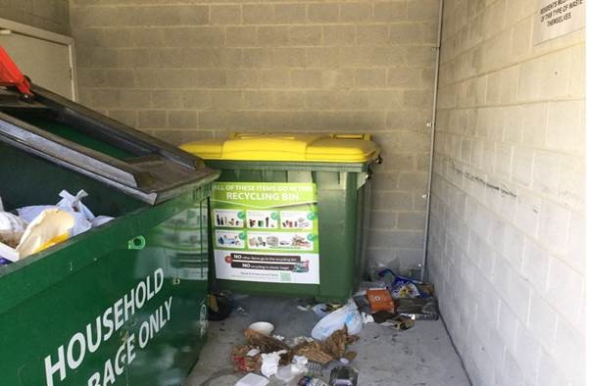

**Final Research Report**

***May 2019***

***Department of the Environment and Energy***

Authored by: Sebastian Jarvoll

© Commonwealth of Australia 2019

**Copyright Notice**

With the exception of the Commonwealth Coat of Arms, this work is licensed under a Creative Commons Attribution 4.0 International license (CC BY 4.0) https://creativecommons.org/licenses/by/4.0/deed.en

**Third party copyright**

Wherever a third party holds copyright in this material, the copyright remains with that party. Their permission may be required to use the material. Please contact them directly.

**Attribution**

This publication should be attributed as follows: Understanding Drivers of Recycling Behaviour in ACT Multi-Unit Dwellings.

**Use of the Coat of Arms**

The terms under which the Coat of Arms can be used are detailed on the following website: http://www.itsanhonour.gov.au/coat-arms

**Other uses**

Enquiries regarding this license and any other use of this document are welcome at:

Director Behavioural Analysis Team, Department of the Environment and Energy, Barton ACT 2600 Email: [behaviouralanalysis@environment.gov.au](mailto:behaviouralanalysis@environment.gov.au)

The views expressed in this paper are those of the authors and do not necessarily reflect those of the Department of Environment and Energy, the Australian Government or the Behavioural Analysis Team.

**Project Team**

This trial was a collaborative effort between the Behavioural Analysis Team of the Department of Environment and Energy and ACT NoWaste from the ACT Government.

|  |  |
| --- | --- |
| **Behavioural Analysis Team** | **ACT NoWaste Team** |
| [behaviouralanalysis@environment.gov.au](mailto:behaviouralanalysis@environment.gov.au) | No\_Waste@act.gov.au |
| Ms Amy Arbery | Ms Cathie Kennedy |
| Dr Trish Lavery | Ms Catherine Higgins |
| Mr Sebastian Jarvoll | Ms Robbie Ladbrook |
| Ms Angela McGregor | Mr Greg Haraldson |
| Mr Peter Collis |  |
| Mr Evan Turner |  |
| Ms Emma Davensen |  |

**Acknowledgements**

Participating residents of ACT multi-unit dwellings

The building and strata managers who participated in this research

The Waste Strategy Taskforce

## Executive Summary

Waste management, recycling and materials recovery are a significant part of Australia’s economy. Waste related activities add a total value of $6.9 billion to the economy per annum. It is therefore important to harness the value of materials we dispose of and return them to productive use.1 The National Waste Policy sets out a framework for collective action by government, business and individuals until 2030. The role of the Department of the Environment and Energy (‘the Department’) is focussed on ensuring our international obligations are met, supporting global environmental outcomes through co-operation and international engagement, and providing effective national leadership and co-ordination.

One of the National Waste Policy’s strategies is ‘Knowledge sharing, education and behaviour change’. In 2018, the Department consulted with state and local governments, non-profit organisations and academia on the current state of the waste sector relating to this strategy. We found that state and local governments conduct extensive waste education and behaviour change programs, but usually do not quantitatively evaluate their results. Furthermore, reviews of academic research literature on waste education and behaviour change found similar gaps.

To provide national leadership on evaluating change programs while contributing to knowledge of specific behaviour change techniques’ success in waste management, the Department’s Behavioural Analysis Team, in partnership with ACT NoWaste, conducted research into the recycling contamination and resident knowledge and beliefs in multi-unit dwellings (‘MUD’: apartment buildings and townhouse complexes) in the Australian Capital Territory. The research aimed to evaluate the extent and types of contamination, the effectiveness of an ACT NoWaste communication campaign, and gather contextual information about certain recycling behaviours and attitudes.

The results will feed into future trials in a continuing partnership with ACT NoWaste, and will contribute to a growing evidence base to improve waste management outcomes across Australia.

### Summary of results

* We measured many types of contamination in ACT MUD recycling streams, of which the two largest categories were ‘other’, including bulky items like bicycles and prams, and items in closed plastic bags.
* We discovered that many buildings arrange for staff to improve the quality of the bin load before it is collected. We conclude in part that this implies that, across the country, measures of load quality are likely to underestimate problems in tenant waste behaviour.
* There were several common types of resident with distinctive characteristics that we repeatedly encountered. These personas are characterised by different fundamental beliefs and are likely to respond best to different communication techniques.
* We found evidence that the ACT NoWaste campaign, which consisted of newly designed signs for bins and bin areas in addition to an informational brochure, was effective at reaching residents and changing their behaviour.

## Introduction

### Background

A high priority area for the Department is delivering on our obligations relating to the National Waste Policy (NWP), agreed to by the November 2018 Meeting of Environment Ministers. This is especially important given the public pressure and scrutiny on the industry due to events such as the “China waste ban” and ABC television’s ongoing War on Waste series. The Behavioural Analysis Team (BAT) is leading the Department’s contribution to the NWP Strategy 3: ‘Knowledge sharing, education and behaviour change’.

‘Contamination’ of recyclable waste (that is, unintentional inclusion of non-recyclable materials in loads of recyclables) negatively impacts the economic viability of recycling, creating difficulty in sorting and reducing the quality of recycled materials. According to the National Waste Report 2018, contamination rates currently range from four to sixteen per cent across Australia. Contamination often results from unsophisticated recycling systems, regional variation in what materials can and cannot be recycled, and a lack of effective consumer education and understanding on how to recycle correctly in a given region.

While studying local council recycling improvement programs, the BAT identified a general lack of rigorous measurement to determine the effectiveness of consumer education interventions. To address this gap, BAT partnered with ACT NoWaste (part of the Australia Capital Territory government) to conduct in-depth research about household recycling behaviours and provide evaluation of the effectiveness of a communication campaign designed by ACT NoWaste. It was agreed that initial research should focus on individual residents of MUDs, because this is a source of higher contamination levels in many jurisdictions across Australia, and findings would therefore have a broad potential relevance.

### ***Research goals***

The research had three main goals:

1. To investigate and gather a baseline measurement of the extent and types of contamination present in MUDs’ recycling bins.
2. To evaluate the effectiveness of a communication campaign run by ACT NoWaste, which comprised updated signs on bins and in bin areas, and informational brochures mailed to residents.
3. To explore the rich context of residents’ broader recycling knowledge, attitudes and behaviours.

This report outlines the methods and results of this research and concludes with recommendations for further recycling research in 2019.

## Methods

The research involved three main data collection activities, each contributing to all three research goals. The three activities were audits of MUDs’ recycling bins, surveys of MUD residents, and in-depth interviews with individual residents. An example survey is included at Appendix B.

ACT NoWaste liaised with ACT strata management corporations to secure their cooperation in running these activities. They used information from ACT strata management corporations and waste industry contractors to identify eight MUDs, representing a broad range of MUD types, with particularly problematic recycling contamination. These MUDs’ residents formed the population for each activity.

### ***Bin audits***

ACT NoWaste and the BAT contracted Suez Recycling and Recovery to collect and analyse the contents of the communal recycling bins from each of the MUDs identified for this research. Using industry-standard methods, Suez analysed the contents of the recycling bins in the selected MUDs both before and after the rollout of the campaign. This provided weights and percentages of common types of recyclable material and contaminants.

During the research design phase, we identified disposal of recycling within plastic bags as a behaviour that would provide a particularly good opportunity for meaningful impact using behavioural analysis and intervention. When this behaviour occurs, the bags are sent to landfill because recycling facility staff cannot safely open them, so the behaviour represents both wasted recycling effort and also an opportunity to improve contamination rates with minimal behavioural change. This is a common problem in jurisdictions across Australia. To investigate this issue, ‘bagged items’ were separately recorded in bin audits, and we asked specific questions about plastic bagging behaviour during interviews (see below).

### ***Surveys***

The BAT designed a one-page survey, in both paper and digital forms, in consultation with ACT NoWaste. The questions were targeted at measuring whether or not residents became aware of the new communications materials distributed by ACT NoWaste, in addition to questions about behaviour change and communication preferences.

The BAT distributed and collected survey forms for half of the selected MUDs’ residents (defined as those living in odd-numbered units) before the campaign, and for the other half of MUDS’ residents (even-numbered units) after the campaign. Residents could choose to complete the paper survey and return it to a box or mailbox that was placed in their mail area, or to use the URL on the survey form to participate online. Differences between results from the before- and after-campaign surveys were used to measure the effectiveness of campaign materials.

### ***Interviews***

Finally, the BAT conducted in-depth, semi-scripted face to face interviews with individual residents on location at their MUDs. These interviews were conducted after the deployment of the communication campaign, and were designed to explore residents’ recycling knowledge, attitudes, and behaviours and how they might be changed.

Each interview lasted between 10 and 45 minutes (a typical interview lasted 15 minutes) and was conducted in public common areas of each MUD. One member of the BAT conducted the interview, while another took handwritten notes of the resident’s responses. In total 39 interviews were conducted. Interviewees had a wide range of ages, education levels, and cultural backgrounds.

## Results

### Extent of recycling contamination

The bin audits measured contamination in five main categories: organic compostable, other organic, household hazardous, bagged items, and ‘other’. Typical items counted as ‘other’ included textiles, and bulky multi-material items like prams or bicycles. Overall, contamination in this study’s MUDS ranged from 11.8% to 84.5% of total bin-load weight, with a median of 19%. Almost all contamination found was in just two categories, ‘other’ (60% of contamination) and bagged items (37% of contamination) (Figure 1). Some loads included materials likely to have been dumped illegally by non-residents: for example, 35kg of light globes were recorded in a MUD that neighboured a construction site.

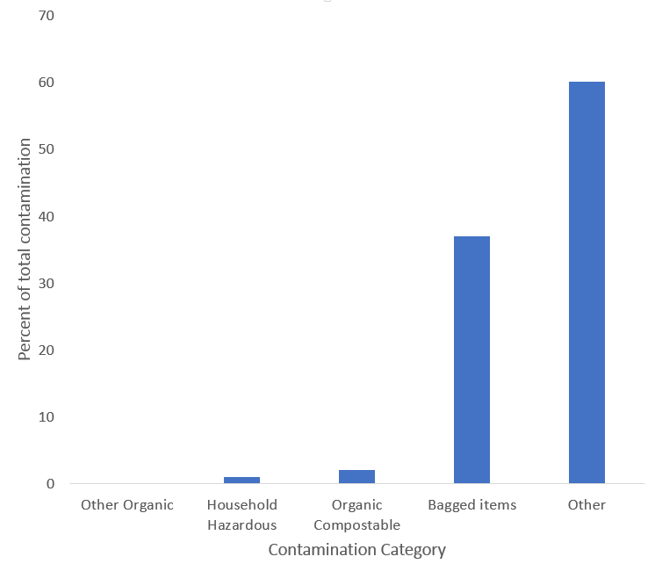

*Figure 1: Proportion of contamination across all MUDs and bin audits, by category*

In the process of communicating with the managers of the selected MUDs, ACT NoWaste discovered that strata managers had been asking building managers or cleaners to ‘clean’ the contents of building recycling bins before collection. This means that contamination rates were not a true measure of residents’ behaviour but were ‘artificially’ improved before collection. Strata managers considered bin cleaning to be necessary for many reasons, including to counteract bin capacity constraints from unflattened cardboard boxes, to ensure access for collection vehicles, and to respond to resident pressure to maintain cleanliness of the bin area. Bin cleaning is done in the majority of the MUDs we worked with, and discussion with strata managers suggests that this is likely to be practiced across the country. Notably, larger MUDs tend more to have regular bin cleaning than smaller MUDs.

To understand the possible effects of bin cleaning on contamination rates, a second bin audit was conducted after asking MUDs to refrain from their usual cleaning in the period leading up to the audit. In most MUDs where we know cleaning normally occurs, the second audit showed that contamination without cleaning increased on average by 37% compared to contamination after cleaning (Figure 2). This increases to 42% when including a MUD where cleaning may or may not have occurred. Notably, this difference occurred despite known improvements to resident behaviour as a result of ACT NoWaste’s communication campaign (detailed below). These results therefore represent a lower bound for the true effect of cleaning on contamination rate measurement.

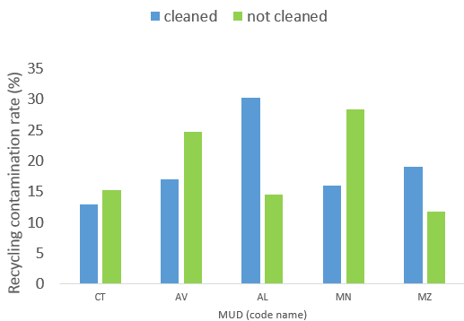

*Figure 2: Contamination rate with and without pre-collection cleaning in MUDs where cleaning was known to occur. The ‘not cleaned’ status is potentially doubtful, which may account for AL and MZ.*

This suggests that contamination rates in MUDs across Australia are likely significantly higher than is currently reported in sources which do not account for pre-collection bin cleaning, and in turn further underscores the need for improving household recycling communication.

### Effectiveness of the ACT NoWaste communication campaign

Results from all three research activities indicated that the ACT NoWaste campaign was effective at informing and changing behaviour of residents.

After the campaign, survey respondents reported having:

* seen more recycling information,
* changed their recycling behaviour, and
* less need of recycling information,

compared to before the campaign.

Of those who had seen recycling information, residents reported having seen that information more on bins, in bin areas, and in brochures than in other media (such as TV or social media), suggesting these results relate to the ACT NoWaste campaign specifically rather than other information sources. Finally, respondents in the second survey reported being less in need of information, compared to the first survey, about specific topics mentioned by the campaign (such as what to do with bulky items) but not topics absent from the campaign (such as such as examples of how other people recycle well).

Further, interview data showed clearly that some residents saw and acted on the communication campaign. All residents approached for interview were offered ACT NoWaste’s brochure (regardless of interview participation) and upon inspecting it many stated that they already had a copy in their kitchen. In addition, several residents spontaneously mentioned during interviews that they had discovered from the brochure that they had been making significant recycling mistakes, and had updated their behaviour as a result. Most also mentioned trusting signs in the bin area as an information source, although only a couple directly mentioned having read or acted on ACT NoWaste’s new signs. Of the broad resident types we identified (see next section), new recyclers were most likely to engage but least likely to understand the campaign, and the overconfident majority most likely not to notice or pay close attention to it. We interviewed several residents whom we would have identified as plastic baggers (see ‘The Plastic Bagger’), except that they had seen the campaign and specifically stopped their plastic bagging behaviour as a result. There were roughly as many of these residents as there were residents who continued plastic-bagging following the campaign.

Finally, some bin audit data is suggestive of strong improvements due to the campaign. In two MUDs where we believe bin cleaning does not normally occur, contamination decreased on average by 58% in the audit that followed deployment of the communication materials. Contamination also decreased, by 48%, in one MUD where we believe cleaning did occur, suggesting the communication campaign made improvements in that MUD that outweighed the otherwise strong effect of bin cleaning. We cannot take these figures as indicative of the size of the effect, but they strongly suggest the campaign did have an effect.

Taken together, we conclude that results from bin audits, surveys and interviews suggest that the ACT NoWaste campaign was effective at informing and changing behaviour of residents. Future research will focus on designing interventions for MUDs where such a campaign has already been used and further improvements to recycling outcomes are desired.

### Residents’ recycling knowledge, attitudes, and behaviours

The primary goal of the in-depth interviews was to explore the context of residents’ recycling knowledge, attitudes, and behaviours. We spoke to 39 residents and gathered a range of insights. Residents were united in being enthusiastic for recycling in general, and in trusting the local government and building managers as sources of communication about recycling. We found very little evidence of a general lack of trust in the system; in fact many residents reported being unaware of any problems with the system at all.

Other common findings included:

* All residents who reported having a ‘rule of thumb’ to resolve ambiguous items reported that the rubbish bin was the default in these uncertain cases.
* All residents who had some knowledge of where recycling goes after collection believed that it was mostly sorted by hand, rather than by machine.

In addition to the above views which were held by most interviewed residents, on other topics we found a broad variety of views. In particular, three different ‘personas’, or composites of views, emerged from the interviews. Personas are a method for surfacing themes in qualitative findings, and are widely used in user-centred design to help decision-makers think about a problem from different users’ perspectives. The three main personas that summarise our findings are discussed in the following sections. Also discussed is the possible fourth persona, the Influencer.

#### The Plastic Bagger

We interviewed five residents who reported disposing of their recycling inside plastic bags. Several additional residents mentioned having been plastic baggers until the ACT NoWaste campaign prompted them to change their behaviour (see ‘Effectiveness of the ACT NoWaste campaign’ above). All of these residents identified that ease was the primary motivation for plastic bagging behaviour. In particular, residents cited steady, effortless supply or even oversupply of plastic bags in their household as a key factor that made this behaviour easy and desirable. For example, one resident said “*I was just chucking the bags in the bin, we have an overflow of bags, it’s ridiculous*”. Further, those residents using plastic bags believed that those bags, or even all plastics both hard and soft, are themselves recyclable. We found no residents who had engaged in plastic bagging behaviour who knew that it was wrong. It is unlikely this was a research effect of interviewees giving answers they thought we wanted to hear, because they were very open about engaging in other recycling behaviours they knew were wrong.

Our finding that steady supply of plastic bags contributes to bagged recycling has a parallel in other ‘transport vessels’ for recycling, suggesting a more general pattern. Residents who used cardboard boxes rather than plastic bags to transport their recycling reported very similar motivations for that behaviour: having a regular, convenient source of the boxes, combined with the knowledge that they are recycling, were the key motivators for that behaviour.

|  |
| --- |
| “  *I was just chucking the bags in the bin, we have an overflow of bags, it’s ridiculous.*  ” |

Some plastic baggers reported believing the bags would be opened by staff at the recycling facility. This may relate to the general misunderstanding about recycling facilities mentioned above, namely that most interviewees believed that recycling was sorted by hand rather than by machine. This may make hand-sorting of bagged recycling seem more plausible than in reality, where line workers are only the first stage in mostly machine-based facilities.

Finally, some other residents reported using plastic bags to transport their recycling, but instead of disposing of the recycling within the sealed plastic bag, they tip the recycling into the bin and then either retain the bag for re-use, or throw it into the rubbish bin. One resident said “*For example, if we have bottles, we put them in a bag in a bag, take them down [to the bin room] but then we bring the bag back up.*” This represents a potential target behaviour requiring minimal change from those who currently plastic-bag their recycling, and will be considered in intervention design work.

|  |
| --- |
| “  *For example, if we have bottles, we put them in a bag, take them down [to the bin room], but then we bring the bag back up.*  ” |

While some plastic baggers were confident in their recycling ability, many were not, especially those who had seen the ACT NoWaste campaign and stopped plastic bagging as a result. This variability in confidence and attention to the campaign makes a notable contrast to the next persona, The Overconfident Majority.

#### The Overconfident Majority

We found that the majority of interviewed residents believed that they were fully informed about recycling, but at the same time made at least one significant mistake in their recycling practice.

There were several aspects to the confidence of this group. In addition to general belief that they were recycling completely correctly, these residents also typically mentioned trusting all the information on signs on bins and in bin areas, right before saying that they had not actually read the signs themselves. Unlike current or recent plastic baggers, they did not mention specific changes to their behaviour in response to the campaign.

We found that this confidence was excessive, however, as these residents reported a wide variety of ‘mistaken’ recycling practices. Mistakes included not recycling metal, not recycling paper, false belief that thorough cleaning of each item is required (leading them to avoid recycling entirely), recycling food organics, and recycling polystyrene and other non-recyclable plastics because they misunderstood the numbered recycling triangle symbol. In addition to being confident about their own abilities, most residents believed the solution to any system problems would be to make *everyone else* behave better. They commented on the results of others’ behaviour which came easily to mind, such as dumping of furniture in bin areas, so this finding may be due to these problems having more visible consequences than the invisible consequences of (for example) not recycling paper.

A small subset of this group shared the additional characteristics of being especially enthusiastic about promoting positive change in their MUD’s recycling practice, and mentioned concrete actions they had taken to promote what they saw as good practice. For example, one resident went as far as creating and displaying their own additional signs in the bin area of their MUD.

#### The New Recycler

Finally, we interviewed many residents who had migrated in the last five years from countries where recycling was significantly different or non-existent.

Most were highly educated, in contrast to both other personas who varied greatly and include people with only grade 10 certificates. Similarly, New Recyclers were typically in their 20s or 30s, where the other personas had representatives over a much greater age range.

These residents were enthusiastic recyclers, but despite their education were substantially less-well informed about recycling than the majority. Their response to the campaign was unclear – they reported gratefully receiving it but did not mention having made specific behavioural changes as a result. New Recyclers were much more likely to mention having learnt their recycling behaviour from friends when they first moved in, compared to the other personas who reported learning from family or a partner.

#### The Influencer

We found some evidence for a kind of resident who is so confident about their recycling ability and knowledge that they proactively try to change the behaviour of fellow residents. They are similar in characteristics to the Overconfident Majority, with the key difference appearing to be the degree of willingness to act on the common belief that other people’s behaviour is the main problem. Focusing education on these residents could benefit from positive spill-over as they teach their new knowledge to other residents without further government effort being required.

## Next Steps

These results constitute a rich source of information for future intervention design. The BAT is, at time of writing, preparing design sessions in consultation with ACT NoWaste to identify opportunities for further improving the target behaviour of recycling in plastic bags, and potentially other behaviours as well.

Once an intervention is designed, we will work with ACT NoWaste to trial it empirically in MUDs in the ACT. We will measure the effectiveness of this intervention with a further bin audit. This will constitute the second phase of this research, as part of an overall research design which draws on the BehaviourWorks Australia model for trialling behavioural interventions. We expect to report Phase 2 results around August 2019.

## References

1. Commonwealth of Australia (2018). *National Waste Policy: less waste more resources.*

## Appendix A: Persona summary

|  |  |  |  |  |
| --- | --- | --- | --- | --- |
|  | **The Plastic Bagger** | **The Overconfident Majority** | **The New Recycler** | **The Influencer** |
|  | Decorative image | Decorative image | Decorative image | Decorative image |
| **Group Description:** | Dumps recyclables inside plastic bags. Has a steady supply of plastic bags and believes the bags are recyclable. | Believe they are already fully informed about recycling, but make at least one significant error. | Has migrated from somewhere with a less robust recycling system. Is enthusiastic but inexperienced, so is sometimes confused. | Passionate about recycling and frustrated when neighbors make recycling mistakes. Will take opportunities to influence their neighbors |
|  |  | | | |
| **Illustrative quotes:** | *“I don’t get how come plastic bags can’t go in the recycle bin…it should go in the recycle bin. They could melt it down”.* | *“I’m fairly switched on. I know what you can and can’t recycle.”*  *“[S]traight in the bin, because it’s metal. I just assumed you can’t recycle metal.”* | “*The first time I come here I see the roommates come here. I do what the roommate does.”*  *“Plastic bag is recyclable for sure […] Some bag it says recycling on bag.”* | *“I get quite annoyed if people put plastic bags in the recycling bin. I open them up and tip them out.”*  *“I’ll leave a note on the bin but I won’t put my name on it.”* |
| **Motivations:** | Ease for transporting recycling | Recycles to “protect the oceans” and because of “climate change” | Impressed by the “cleanliness of Australia” | To prevent others from doing the wrong thing and  make a bigger impact |
|  |  | | | |
| **Beliefs:** | Plastic bags are recyclable & opened by hand at the recycling facility | Very confident that they are doing everything correct | Enthusiastic about recycling but concerned about doing the wrong thing | Would like to help others make correct decisions about recycling |
| **Interaction with education campaign:** | Rarely noticed, but where seen behavior changed as a result | Noted brochure but disposed of it without reading | May not have seen, but where they did see they were still confused | Spoke to neighbours, may have corrected signs |
| **Possible communication strategies:** | Non-standard information mechanisms to catch their eye | Messaging designed to stimulate them to update their knowledge, e.g., “recycling has changed” | Clear basic information in multiple languages, promoting a “clean Australia” theme | Empower them to spread correct information (e.g., by providing materials or communication strategies for them to share) |

## Appendix B: Example Survey

The cover page of an example survey released by the Department of the Environment and Energy with ACT Government reads: Want to help improve recycling in the ACT? Please visit http://bit.ly/ACTrecycle to complete an online survey. Or if you prefer, complete the survey on the back, and drop it in your body corporate's letter box. The survey shuold take less than five minutes and is a great opportunity to have your say about what works best for you. Please submit the survey by next Tuesday, 30 October. Thank you! The information you provide is anonymous and will be used to help the federal and ACT governments understand recycling preferences and behaviour. This will help improve recycling information.
The survey results may be shared with other organisations interested in recycling (such as state governments and non-profits).

**Question 1: In the last 3 weeks, have you seen information about how to recycle?**

*Please choose* one *answer* only

1. No, I have not.  *Go to Question* **4**
2. Yes, I have.  *Go to Question* **2**
3. I’m not sure.  *Go to Question* **4**

**Question 2: Where have you seen information about how to recycle in the last 3 weeks?**

*Please select all that apply*

1. On the building’s **bins**
2. In the building’s bin **area**
3. Next to a bin **chute**
4. On a fridge magnet
5. In a brochure
6. In a letter
7. On TV
8. In an email
9. On social media
10. On the internet
11. Other – please specify:

**Question 3: Thinking about all the recycling information that you have seen in the last 3 weeks, what topics did it cover?**

*Please select all that apply*

1. The importance of recycling
2. What I should do with things like furniture, batteries and computers
3. The importance of reusing things
4. How I can reduce my waste
5. Buying recycled products
6. What I can and can’t recycle in my local area
7. Other – please specify:

**Question 4: In the last 3 weeks, have you changed anything about your recycling behaviour, or not?**

*Please choose one answer only*

1. No, I have not.  *Go to Question* **6**
2. Yes, I have.  *Go to Question* **5**
3. I’m not sure.  *Go to Question* **6**

**Question 5: What have you changed about your recycling behaviour in the last 3 weeks?**

*Please select all that apply*

1. I have changed what items I put in the recycling bin
2. I have changed the way I place items in the recycling bin
3. I have changed how I take my recycling from my home to the building’s bins or chute
4. I have talked with others about how I recycle
5. I have changed what items I buy
6. Other – please specify:

**Question 6: Would you like more information about recycling, or not?**

*Please choose one answer only*

1. No, I would not.  *Go to Question* **8**
2. Yes, I would.  *Go to Question* **7**
3. I’m not sure.  *Go to Question* **8**

**Question 7: What parts of recycling would you like more information about?**

*Please select all that apply*

1. What types of plastic can and can’t be recycled
2. What items go in the recycling bin, and what items go in the rubbish bin
3. What I should do with things like furniture, batteries and computers
4. What happens to the recycling after it is collected
5. Examples of how other people recycle well
6. Examples of common mistakes
7. Other – please specify:

**Question 8: Where would be the most helpful places for the ACT Government to give you information about recycling?**

*Please select all that apply*

1. On the building’s bins
2. In the building’s bin area
3. Next to a bin chute
4. On a fridge magnet
5. In a brochure
6. In a letter
7. On TV
8. In an email
9. On social media
10. On the internet
11. Other – please specify:

**Appendix C: Example Communications Materials**

### Cleaner Apartment Living brochure

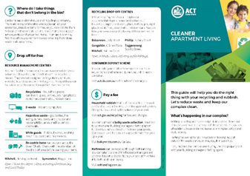

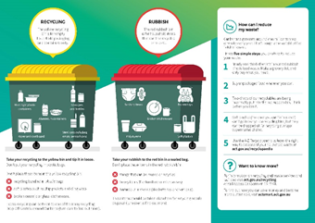

### Brochure from the ACT Government

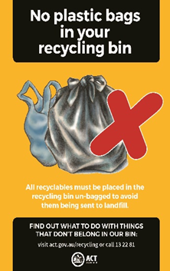

**Bin-room signs**

