Veterinary Health Certificate reference number:

**VETERINARY HEALTH CERTIFICATE - IMPORTATION OF FROZEN CANINE SEMEN FROM APPROVED COUNTRIES**

**TO AUSTRALIA**

**Section A: Details of the consignment**

Name of donor dog:

Breed of donor dog:
  
Microchip number:

|  |  |  |
| --- | --- | --- |
| **Number of straws/cryovials in the consignment** | **Date(s) of semen collection** | **Identification of straws/cryovials** |
|  | DD/MM/YYYY |  |
|  | DD/MM/YYYY |  |
|  | DD/MM/YYYY |  |

Name and address of importer:

Name and address of exporter:

Name and address of Department of Agriculture, Fisheries and Forestry regional office of arrival:

Scheduled date of export (*Optional*): DD/MM/YYYY

Scheduled flight number (*Optional*):

DEPARTMENT OF AGRICULTURE, FISHERIES AND FORESTRY Page **1** of **6**

Version 6 (Updated March 2025)

Veterinary Health Certificate reference number:

**Section B: Preparing veterinarian1 declaration**

1. I am satisfied the donor dog (*Canis lupus familiaris*) has been continuously residing in a listed country for canine semen (an Australian ‘approved country’) and was not under biosecurity restriction between the first and last semen collection for this consignment (see additional notes for the List of Countries for Canine Semen (approved countries)).
2. The donor dog was examined by a government approved veterinarian or an official government veterinarian on the day(s) of semen collection and again 30 to 45 days after the date of the last semen collection, and was found to be healthy and free from evidence of infectious or contagious diseases (including venereally transmitted diseases).

|  |  |
| --- | --- |
| **Date of final examination** | DD/MM/YYYY |

1. *Brucella canis****:***

The donor dog has tested negative for *Brucella canis* using a rapid slide agglutination test (RSAT), a tube agglutination test (TAT) or an indirect fluorescent antibody test (IFAT) on a blood sample collected 30 to 45 days after the last semen collection

|  |  |  |
| --- | --- | --- |
| **Date of sample collection** | **Test Used** | **Test Result** |
| DD/MM/YYYY |  |  |

1. *Leishmania infantum****:***

The donor dog has tested negative for *Leishmania infantum* using either an indirect fluorescent antibody test (IFAT) or an enzyme linked immunosorbent assay (ELISA) on a blood sample collected 30 to 45 days after the last semen collection

|  |  |  |
| --- | --- | --- |
| **Date of sample collection** | **Test Used** | **Test Result** |
| DD/MM/YYYY |  |  |

1. *Leptospira interrogans* serovar Canicola***:***

**EITHER** The donor dog has tested negative (less than 50% agglutination) at a serum dilution of 1:100 for *Leptospira interrogans* serovar Canicola using a microscopic agglutination test (MAT) on a blood sample collected 30 to 45 days after the last semen collection

|  |  |  |
| --- | --- | --- |
| **Date of sample collection** | **Test Used** | **Test Result** |
| DD/MM/YYYY |  |  |

1 **A preparing veterinarian can be a government approved veterinarian or an official government veterinarian who assisted the frozen semen preparation process.**

DEPARTMENT OF AGRICULTURE, FISHERIES AND FORESTRY Page **2** of **6**

Version 6 (Updated March 2025)

Veterinary Health Certificate reference number:

**OR** The donor dog has been fully vaccinated against *Leptospira interrogans* serovar Canicola at least 14 days before the first semen collection and the vaccination was current at the time of the last semen collection.

|  |  |  |  |
| --- | --- | --- | --- |
| **Date(s) of vaccination** | **Date of first semen  collection** | **Date of last semen  collection** | **Vaccination Used** |
| DD/MM/YYYY | DD/MM/YYYY | DD/MM/YYYY |  |
| DD/MM/YYYY | DD/MM/YYYY | DD/MM/YYYY |  |

1. All the laboratory testing was collected in a listed country for canine semen (an approved country) and testing performed in a laboratory recognised by the competent authority of the country of export. Blood samples for laboratory testing were collected by a government approved veterinarian or official government veterinarian.
2. A government approved veterinarian or official government veterinarian collected the semen identified above from the donor dog in section A.
3. At the time of semen collection, each semen straw/cryovial was permanently marked with the microchip number of the donor animal, the species and breed of the donor animal, and the date of semen collection.
4. The semen was stored under the supervision of a government approved veterinarian or official government veterinarian and stored as follows: (*please tick as appropriate*)

**EITHER** in a new shipping container

**OR** in a shipping container that was emptied and inspected with any loose straws/cryovials removed prior to loading. The shipping container and all surfaces contacting the straws/cryovials was disinfected

on __ __ / __ __ /__ __ __ __ (*dd/mm/yyyy*) using

(acceptable disinfectants are 2% available chlorine, Virkon, or irradiated at 50kGray)

**AND** only new liquid nitrogen has been added to the shipping container

1. The shipping container was sealed with an official government seal.

**Official government seal number**

DEPARTMENT OF AGRICULTURE, FISHERIES AND FORESTRY Page **3** of **6**

Version 6 (Updated March 2025)

Veterinary Health Certificate reference number:

**Declaration by the preparing veterinarian**

I (print name), official government veterinarian of the

government veterinary authority **OR** a government approved veterinarian* of (country), certify after due enquiry that all the information provided in this veterinary health certificate is true and correct.

\**delete as appropriate*

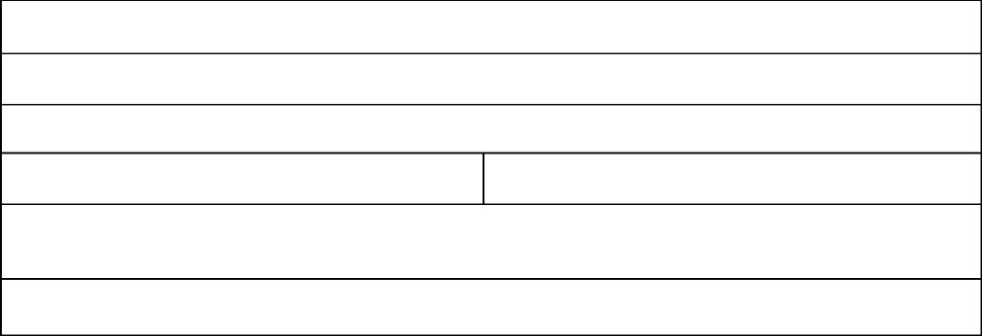

**Address:**

**Signature of preparing veterinarian:**

**Country of export:**

**Name of preparing veterinarian:**

**Phone:**

**Date signed:** DD/MM/YYYY

**Email:**

DEPARTMENT OF AGRICULTURE, FISHERIES AND FORESTRY Page **4** of **6**

Version 6 (Updated March 2025)

Veterinary Health Certificate reference number:

**Section C: Official government veterinarian declaration**

I (print name), being an official government veterinarian of the

government veterinary authority of (country), certify after due enquiry that all the information provided in this veterinary health certificate is true with respect to the donor dog and canine semen identified above.

**Name of official government veterinarian:**

**Country of export:**

**Competent authority:**

**Address:**

**Phone:**

**Email:**

**Signature of official government veterinarian:**

**Date signed:** DD/MM/YYYY

**Stamp of official government veterinarian:**

DEPARTMENT OF AGRICULTURE, FISHERIES AND FORESTRY Page **5** of **6**

Version 6 (Updated March 2025)

Veterinary Health Certificate reference number:

**Additional notes:**

1. The following documents must be presented to the department with the consignment and must have been signed and stamped by the official government veterinarian in the country of export:

* *Brucella canis* laboratory report
* *Leishmania infantum* laboratory report
* *Leptospira interrogans* sv. Canicola laboratory report (if not vaccinated)

1. The List of Countries for Canine Semen (approved countries) can be found at the following website: <https://www.agriculture.gov.au/biosecurity-trade/policy/legislation/countries-canine-semen>
2. A separate veterinary health certificate must be completed for each donor dog.
3. Any corrections made to the veterinary health certificate must be struck through, remain legible and be signed and stamped by an official government veterinarian (correction fluid must not be used).

DEPARTMENT OF AGRICULTURE, FISHERIES AND FORESTRY Page **6** of **6**

Version 6 (Updated March 2025)