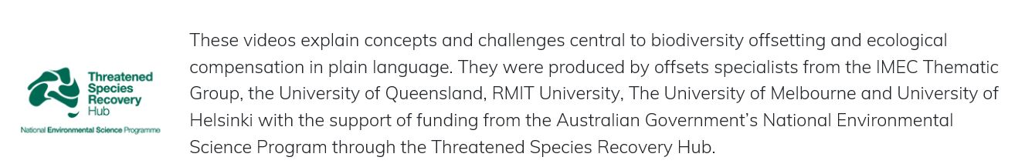

**Video 1**

**Introduction to biodiversity offsetting: The basics of what biodiversity offsetting involves**

Protecting biodiversity is important. We rely on biodiversity for our air, food, water and wellbeing. But we have already lost species and ecosystems, and what remains is under pressure. Some of these pressures include development of infrastructure, housing, mining, and expansion of primary industries. Now, most countries and some financiers and corporations have environmental safeguards that mean any losses of biodiversity caused by certain developments must be, ideally, avoided, minimised, rehabilitated or restored on site, and finally, if there is still an unavoidable residual impact, offset, by creating a biodiversity benefit elsewhere. This series of steps is called the mitigation hierarchy.

Strict application of the mitigation hierarchy to any development that potentially causes biodiversity loss is international best practice. However, while it sounds simple, there are many quite complex and even unintuitive concepts involved – especially in the final step – offsetting.

This series of short videos is going to focus on biodiversity offsetting, the final step in the mitigation hierarchy. Biodiversity offsetting is very challenging, and many impacts simply cannot be offset. This is why it is crucial to first avoid, minimise, and rehabilitate or restore biodiversity losses as much as possible, before a biodiversity offset is chosen as a part of a response to a proposed biodiversity loss.

First, what is a biodiversity offset? A biodiversity offset is a very specific type of compensation for a biodiversity loss. It involves taking action to create a biodiversity gain that counterbalances a biodiversity loss, so that an outcome of at least ‘no net loss’ is achieved. Simple in theory, this idea involves a lot of complexity. Let’s start with the idea of equivalence.

First, the gain has to be of the same type of biodiversity as the loss – this is called ‘like for like’ or ‘in kind’ offsetting. But there can be exceptions to this, and we discuss those in video 3.

Second, the gain has to be of at least the same size as the loss. Importantly, for a biodiversity benefit to count as an offset gain, it has to be additional to what would otherwise have happened, if the offset action wasn’t done. That means that estimating the size of offset gains requires you to estimate likely future scenarios both with, and without, the offset action, so that you can decide whether the additional gain is likely to be equivalent to the loss. Doing this well, and in a logically robust way, is very challenging, and we cover this topic in video 4.

Third, there is usually more uncertainty about the potential gain than about the better-known loss – and gains might be in the future, whereas the loss happens now, so there is a time lag. How do we factor all this in so that we genuinely achieve biodiversity no net loss, and a successful offset?

These videos will set out these core concepts and more, explain why they are so important for offset design, and provide guidance on how to ensure offsets are designed to maximise the chance of success – and achieve no net loss of biodiversity.