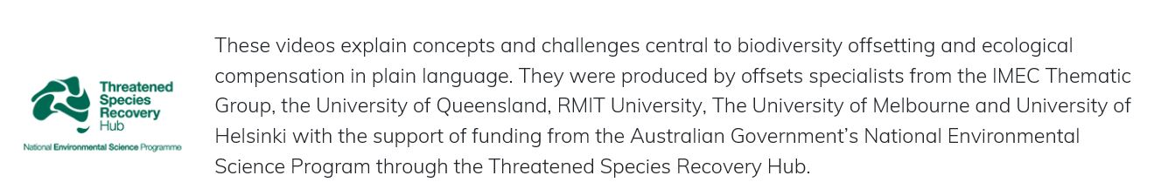

Video 2

Why do we offset: Under what circumstances might we consider doing a biodiversity offset?
Around the world, biodiversity is declining from human impacts. There are many causes, including the spread of invasive animals & exotic plants, overharvesting, and habitat loss. And humanity’s ever-growing demand for resources and infrastructure is also playing a significant role. Every piece of forest or wetland or seagrass that is removed for a new development contributes to the decline of biodiversity.
Offsetting, as the final step of the mitigation hierarchy, aims to counterbalance biodiversity losses that occurs as a result of development projects such as new mines or roads. Nearly one hundred countries now have policies in place that require the proponents of such development to follow the mitigation hierarchy. These policies are often associated with Environmental Impact Assessment regulations, or they might be required under biodiversity conservation laws. Some organisations that finance development projects, such as the International Finance Corporation, also have polices that require strict adherence to the mitigation hierarchy, so that the provision of funding depends on companies demonstrating that losses to biodiversity have been assessed and residual impacts on important habitats offset to at least a no net loss, or even a net gain, standard. Some companies also have their own procedures requiring the mitigation hierarchy to be followed, and voluntarily offset their impacts.
Typically, offset policies specify the particular types of biodiversity for which an offset must be provided if there is a loss from development. In Australia for example, offsets can apply where a project has negative impacts to threatened species, threatened ecosystems and biodiversity protected under global conventions like internationally-important wetlands and migratory species. These specific rules for what needs to be offset under a policy are sometimes called triggers. The types of biodiversity that trigger the requirement for an offset differ depending on the jurisdiction that you are working in.
Once you know the project has the potential to affect biodiversity that is covered under an offset policy, how can you work out what an appropriate offset might be? The rest of these videos will describe this process, but the first step is to assess and quantify the specific impacts of the proposed development on local biodiversity. Often, this is done through a process such as an Environmental Impact Assessment. In this assessment, information from a range of sources, including field studies, scientific literature, government databases and biodiversity experts is brought together to provide a detailed description of the species, habitats and ecosystems that occur at and surrounding the site of the proposed development.
Next, the amount and types of biodiversity that will be negatively affected by the proposed development, and for which offsets will be required, needs to be determined. After strict application of the mitigation hierarchy, where these negative impacts are first avoided, then minimised and rehabilitated, the unavoidable residual negative impacts can be identified. The amount of residual impact is one side of the offsets equation. This is the loss that must be counterbalanced by appropriate gains.

